Original Research Article

Levels, Characteristics and Distribution of Micro- & Nanoplastics (MNPs) in River Ngadda’s Surface Water, Maiduguri, Borno State, Nigeria

.
ABSTRACT

Aims: The study assessed the occurrence, characteristics, distribution, and environmental drivers of microplastics (MPs) and an operationally defined submicron plastic fraction in the surface waters of River Ngadda, northeastern Nigeria.
Study design: A longitudinal field-based environmental monitoring study involving seasonal sampling and multivariate statistical analysis.
Place and Duration of Study: The study was conducted in River Ngadda, Borno State, northeastern Nigeria, across six sampling stations over a period of eight months (March – October, 2025) covering both the dry and wet seasons.
Methodology: Water samples were collected monthly from six stations, with five 4-L subsamples composited at each station. Samples were digested using wet peroxide oxidation and separated into size fractions using a 50 μm stainless-steel sieve and 0.45 μm membrane filtration. Microplastics were identified microscopically and confirmed using Fourier Transform Infrared Spectroscopy (FTIR), while the retained submicron plastic fraction was characterized using pyrolysis gas chromatography–mass spectrometry (Py-GC/MS). Physicochemical parameters, including nitrate (NO₃⁻) and sulphate (SO₄²⁻), were determined using standard analytical methods. Data were analyzed using descriptive statistics and multivariate techniques in Paleontological Statistics (PAST) version 4.40.
Results: All measured physicochemical parameters were within the permissible limits established by the World Health Organization (WHO) and the National Environmental Standards and Regulations Enforcement Agency (NESREA). Microplastic abundance ranged from 29 ± 2.4 to 41 ± 1.6 pp/L during the dry season and from 27 ± 4.6 to 34 ± 8.3 pp/L during the wet season. Polymer-associated mass concentrations of the submicron plastic fraction ranged from 27.0 ± 1.4 to 38.0 ± 2.1 μg/L during the dry season and from 21.0 ± 0.3 to 34.0 ± 1.1 μg/L during the wet season. Fragments were the dominant microplastic morphotype, while polyethylene (PE), polypropylene (PP), polystyrene (PS), polyethylene terephthalate (PET), polyamide (PA), and polyvinyl chloride (PVC) were the principal polymers identified. Multivariate analyses revealed significant associations between plastic contamination and selected physicochemical variables.
Conclusion: River Ngadda is contaminated with microplastics and submicron plastic particles despite physicochemical parameters remaining within regulatory limits. The predominance of fragmented plastics and diverse polymer types suggests continuous anthropogenic inputs and ongoing degradation processes. Environmental variables, particularly water quality parameters, influence the distribution and dynamics of plastic pollutants within the river system. Continuous monitoring and improved waste management strategies are therefore necessary to mitigate plastic pollution and protect aquatic ecosystem health.

Keywords: Petrogenic; Aquatic Pollution; Aquatic Ecosystem; Plastic Pollution; Microplastics (MPs); Nanoplastics (NPs); Water Quality

1. INTRODUCTION

Petrogenic plastics are widely present in the environment especially in the surface water bodies and had also been reported to be found in animals at all levels of the food web (Ivleva, Wiesheu, & Niessner, 2017; Tasneem, 2021) and even in remote areas and ecosystems (Masura et al. 2015; Napper et al. 2020; Patra & Baitharu 2024).The aquatic environment is globally the major dumping sites for most of the plastic wastes which might breakdown into fragments of microplastics (MPs, <5 mm) and nanoplastics (NPs, <1 µm) by the agents of weathering and/or the ageing of the plastic materials in the environment (Patra & Baitharu 2024).
The fragmentation of plastics in the aquatic ecosystems are facilitated by ultraviolent (UV) radiation, mechanical abrasion, and microbiological degradation processes (Ivleva, Wiesheu, & Niessner, 2017; Tasneem, 2021). Prolonged exposure of plastics to ultraviolent (UV) radiation initiates oxidative reactions causes photo-degradation which helps to fragment plastic materials into micro- and nanoplastics (MNPs). Mechanical abrasion might occurs when a larger plastics is fragmented into smaller pieces by the river flow, sea current or turbulence of the aquatic environment (Auta et al. 2017; Bellasi et al. 2020). Studies indicate that a combination of these fragmentation processes can take several years until a complete mineralization of the MNPs (Driedger et al. 2015). Additionally, temperature, pH, acidity, alkalinity, level of concentration of different compounds like nitrate (NO³⁻) and sulphate (SO⁴⁻) in the environment might impact on the integrity of the plastic materials and facilitate its fragmentation or weathering (breaking down of the plastics materials into smaller fragments) in the environment (Andrady 2015; Auta et al. 2017; Bellasi et al. 2020; Paul & Ramesh 2022).
Micro- and nano plastics (MNPs) occurs in different shapes (fiber, fragments, film, sphere etc.), colour (which, black, blue, green etc.), polymers (polyamide - PA, polyvinyl chloride – PVC, polystyrene – PS, polyethylene - PE, polyethylene terephthalate - PET, polypropylene - PP etc.) and sizes (macro, meso, micro and nano) in the aquatic ecosystems (Tasneem 2021).
The occurrence of MNPs in the aquatic ecosystems are reported to originate basically from secondary sources (Dai et al. 2018; Zhang et al. 2018; Paul & Ramesh 2022). Plastic waste are reported to generally to account for about 97% by weight and 99% by number of the total aquatic litters (Shylaja et al. 2018). The United Nations Environment Programme (UNEP) reported that plastic wastes are the most consistent abundant type of debris in the aquatic ecosystems globally amounting to nearly 80% of global waste collected in surface water bodies (UNEP 2016). Kaladharan et al. (2017) reported that wastes collected from 254 aquatic environment in India reveals that plastic wastes were mainly nylon nets/ fishing lines, single use carrying bags, edible oils, detergents, sachets of soft drinks, beverages, toothpaste, PET bottles cases of cosmetics, and ice cream containers etc. and the quantity of plastics in beach litter ranged between 0.08 g m⁻² – 25.47g m⁻². Although, similar studies revealed that the percentage of microplastics of size 50 μm – 5 mm in the aquatic environment is less than 5% of the total plastic pollutants (Kripa 2018). Polyethylene and polypropylene were the dominant polymers in MNPs founded in Indian beach litter (Veerasingam et al. 2016; Sruthy & Ramasamy 2017).
There is large spatial variability in the distribution of MNPs in freshwater ecosystems, this results in the differences of several orders of magnitude within and between studies conducted by scholars (Wagner et al. 2014; Dris et al. 2015; Driedger et al. 2015; Eerkes-Medrano et al. 2015; Horton et al. 2017; Besseling et al. 2017). Most studies suggests that the sediments show higher concentrations of MNPs than water samples. Surprisingly, in lacustrine environments, MNPs tend to show higher abundance close to urban and industrial centers, but in some riverine ecosystems this was not the case which may be a result of river flow dynamics and flooding (Klein et al. 2015). Inadequate waste management and windblown MNPs could contribute to the pollution of relatively isolated freshwater environments (Free et al. 2014). Paul & Ramesh (2022) reported that the fishing industry might have complicated and contributed to MNPs pollution in the aquatic ecosystems. The most obvious reported source of MNPs in the aquatic ecosystem that related to fishing industry is the breakdown of Expanded Polystyrene (EPS) floats. EPS fragments originating from aquaculture buoy debris are found as a dominant polymer (>90%) of the MNPs on some selected beaches of the Republic of Korea (Heo et al. 2013; Lee et al. 2015). Free et al. (2014) associated some of the MNPs present in the surface water of the Lake Hovsgol, Mongolia, with fragments of MNPs fishing debris detected on the shoreline. Zhang et al. (2015) discovered that the Fragments of fishing lines might be responsible for the MNPs found in the Yangtze River, China.
Micro- and nanoplastics (MNPs) pose significant risks to aquatic organisms, particularly fish, through ingestion, bioaccumulation, and trophic transfer within freshwater systems. Recent studies demonstrate that hydrodynamic conditions can strongly influence the uptake and biological effects of microplastics, with altered flow regimes enhancing particle bioavailability and accumulation in fish tissues (Rasta et al., 2025; Rasta et al., 2026a). These particles can induce a wide range of adverse effects, including histopathological damage, oxidative stress, disruption of biomarker responses, and altered gene expression, particularly in sensitive organs such as the brain and gastrointestinal tract (Rasta et al., 2025; Bwala et al., 2026; Rasta et al., 2026b). Furthermore, microplastics act as vectors for toxic contaminants, increasing the overall toxicological burden and potentially compromising food safety in edible fish species (Bwala et al., 2026; Rasta et al., 2026a). In freshwater ecosystems, the persistence and small size of MNPs facilitate their ingestion by a wide range of organisms, leading to physiological stress, reduced feeding efficiency, and impaired growth and reproduction (Auta et al., 2017; Besseling et al., 2017). This study therefore aimed at assessing the level, Characteristics and Distribution of MNPs in the Surface Water of River Ngadda, Maiduguri, Borno State, Nigeria

2. material and methods

2.1 Study Area
Maiduguri also known and called “Yerwa” by its inhabitants, is the State capital of Borno State - Nigeria, and lies within latitude 10ºN and 14ºN and longitude 11º31E and 14º41E. The climatic condition of the town is characterized by a long dry – hot and short wet seasons, with an average annual mean temperature of 31°C. The hottest period being March – April having maximum temperature of 37 – 40°C, while the coldest period is between December – January. The town has an average annual rainfall of about 500 –700mm per annum (Bwala & Imam 2021; Bwala 2021b). The Map of Maiduguri highlighting the study area is shown in Figure 1.
The town has a freshwater body known as River Ngadda, which received water from River Yedzram and River Gombole which met at a confluent in Sambisa Forest and flows as River Ngadda passing through several towns, villages and emptying into Alau Dam before forming a remarkable circular shape around the town. (BORMLS 2008; Babagana et al. 2015; Bwala & Imam 2021; Bwala 2021a; Bwala 2021c). Additionally, there is another highly seasonal river in the town known as River Nggadabul which met at a confluence with River Ngadda behind Gidan Madara, Gwange and continuous to flow as River Ngadda. River Ngadda is one of the minor tributaries of the Lake Chad and is widely known for its commercial fishing activities with Clarias gariepinus and Oreochromis niloticus as the abundant fish species (Bwala 2021b; Bwala 2021c).

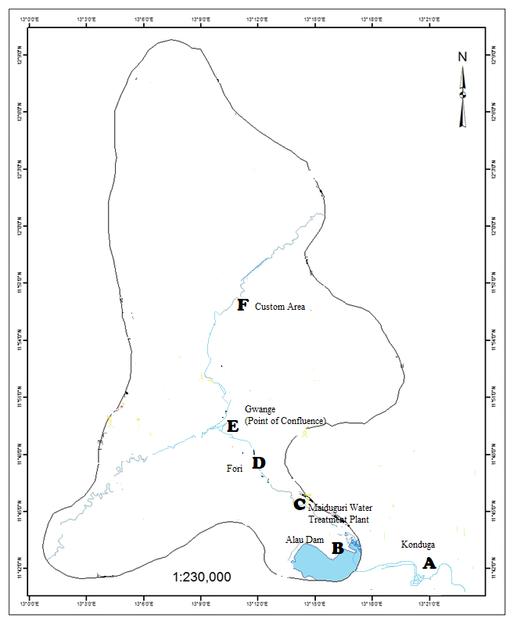
Figure 1: Map of Maiduguri and its Environs showing the Sampling Stations
Source: Sharah (2020)

2.2 Sample Collection
Water samples were collected monthly at each sampling station using pre-cleaned glass containers. At each station, composite samples were obtained from five points (4 L × 5) to ensure representativeness. Samples were immediately transferred into glass bottles and transported on ice to the laboratory as explained by Campbell et al. (2017) with no modification. To separate size fractions, water samples were passed through a 50 µm stainless steel sieve to retain larger microplastics. The filtrate was subsequently subjected to membrane filtration using 0.45 µm glass fiber filters to capture smaller particles. All equipment was thoroughly rinsed with filtered deionized water prior to use to minimize contamination.
Water quality analysis was conducted using the standard methods as explained by APHA (2005); Usman et al. (2016), Gwana et al. (2017) and Bwala (2021a) with slight modification. Temperature (°C), Electrical Conductivity (EC), Total Dissolved Solids (TDS) were measured in-situ using a handheld device (HI9813-61 Portable pH/EC/TDS/Temperature Meter) while Nitrate (NO³⁻) was analyses using DR/890 Colorimeter and Sulphate (SO⁴⁻) was equally analyzed using 752N UV-Vis Spectrophotometer at Public Health Engineering Laboratory (Department of Civil Engineering), Abubakar Tafawa Balewa University (ATBU), Bauchi.
2.3 Extraction of Microplastics and Operationally Defined Nanoplastics Fraction from Water Samples
To minimize contamination during sample processing, all laboratory procedures were conducted using pre-cleaned glassware and stainless-steel equipment, while laboratory personnel wore 100% cotton laboratory coats and powder-free nitrile gloves throughout sample preparation. All solutions were prepared using ultrapure deionized water and filtered prior to use.
Organic matter contained in the water samples was removed using the wet peroxide oxidation (WPO) method following the protocol described by Masura et al. (2015). Briefly, 20 mL of Fe(II)SO₄·7H₂O solution and 20 mL of 30% hydrogen peroxide (H₂O₂) were gradually added to each sample and allowed to react for approximately 5 min (Masura et al. 2015). The reaction mixture was subsequently heated on a hot plate at 75 °C until active bubbling was observed. After cooling, samples were returned to the hot plate and maintained at 75 °C for an additional 30 min to ensure complete digestion of organic materials. Additional aliquots of 30% H₂O₂ were added in 20 mL increments where necessary until visible organic matter was completely digested (Masura et al. 2015).
Following digestion, the samples were separated into MPs and operationally defined submicron plastic fractions (NPs). For the operationally defined NPs fraction, digested samples were subjected to ultrafiltration through pre-combusted membrane filters (≤0.45 µm pore size). The retained material was carefully rinsed with filtered deionized water into pre-cleaned amber glass containers, covered with aluminum foil, and dried at 55 °C. It is acknowledged that this approach does not capture the complete NPs size spectrum; therefore, the retained material is referred to throughout this study as an operationally defined submicron plastic fraction (NPs). The dried residues were subsequently subjected to pyrolysis-gas chromatography–mass spectrometry (Py-GC/MS) for polymer characterization.
For microplastic analysis, digested samples were filtered through pre-weighed membrane filters and dried at 60 °C in covered glass Petri dishes. Dried residues were examined under a stereomicroscope and visually sorted based on morphological characteristics including size, shape, and colour. Suspected plastic particles were preliminarily screened using the hot-needle test, whereby a heated needle was gently applied to the particle surface to distinguish plastic-like materials from natural debris. The hot-needle test was used solely as a screening procedure and not as a confirmatory identification method. Final confirmation of polymer identity was subsequently performed using Fourier Transform Infrared Spectroscopy (FTIR).
2.4 Microscopic Characterization, Fourier Transform Infrared Spectroscopy (FTIR), and Pyrolysis Gas Chromatography–Mass Spectrometry (Py-GC/MS)
Microplastic particles recovered after digestion were initially examined using a stereomicroscope and categorized according to their colour, size class, and morphological type (fibres, fragments, films, pellets, and foams) following the procedures described by Kılıç (2022) and Kılıç & Yücel (2022). The abundance of MPs was expressed as particles per litre (pp/L) as explained by Sanabil, Hadi & Zummah (2022).

$Abundance of p.p in water=\frac{∑p.p}{vol.}$
Where $∑p.p$ – summation of MPs in the surface water
Vol. – volume of water sample (20 litres).
Polymer confirmation of visually identified MPs was performed using Fourier Transform Infrared Spectroscopy equipped with a single-reflection attenuated total reflectance accessory (FTIR-ATR) at Yobe State University, Damaturu. Spectra were acquired within the range of 4000–400 cm⁻¹ at a spectral resolution of 4 cm⁻¹ using 32 scans per sample. Polymer identification was achieved through comparison with reference spectral libraries, and only matches exceeding 70% spectral similarity were accepted for polymer assignment. The major polymers targeted included polyethylene (PE), polypropylene (PP), polystyrene (PS), polyethylene terephthalate (PET), polyamide (PA), and polyvinyl chloride (PVC).
The operationally defined submicron plastic fraction also referred to as NPs in this study, retained on the 0.45 µm membrane filters was characterized using pyrolysis gas chromatography–mass spectrometry (Py-GC/MS) at the Department of Chemistry, Yobe State University. Analyses were performed using an Agilent Technologies 7890B Gas Chromatography System coupled to an Agilent Technologies 5977A Mass Selective Detector. Each sample was analysed in triplicate to improve analytical reliability.
During analysis, samples were thermally decomposed to generate characteristic pyrolysis products, which were subsequently separated chromatographically and identified using mass spectrometric detection. Polymer characterization was achieved by comparing the resulting mass spectra with authenticated reference libraries. Consequently, the reported concentrations represent polymer-associated mass concentrations of the operationally defined submicron plastic fraction rather than direct particle counts or true NPs abundances. The principal polymer groups identified included PE, PP, PS, PET, PA, and PVC.

2.5 Quality Assurance and Quality Control (QA/QC)
A rigorous quality assurance and quality control (QA/QC) mechanism was implemented throughout field sampling, laboratory processing, microscopic examination, and instrumental analysis to minimize contamination and ensure data reliability.
All sample containers, filtration units, glassware, and metallic instruments were thoroughly washed, rinsed with deionized water, and covered when not in use. Plastic laboratory equipment was avoided wherever possible. Sample preparation and filtration procedures were conducted in a clean laboratory environment, and all exposed surfaces were routinely cleaned before processing.
To assess potential contamination during field collection and laboratory procedures, both field blanks and procedural blanks were included during each sampling campaign. Blank samples were processed using identical procedures as environmental samples. Any plastic particles detected in blanks were recorded and used to evaluate background contamination, with corrections applied where necessary.
To ensure analytical precision, all samples were processed in triplicate and analysed independently. Recovery efficiency was evaluated through laboratory spiking experiments using known quantities of reference plastic particles. Recovery rates between 80 and 120% were considered acceptable for subsequent analyses. Replicate measurements were assessed using relative standard deviation (RSD), and values below 20% were considered indicative of satisfactory analytical reproducibility.
For FTIR analysis, instrument calibration was verified prior to analysis, and polymer assignments were accepted only when spectral matching exceeded 70% similarity with reference libraries. For Py-GC/MS analyses, calibration standards were analysed alongside environmental samples, and instrument performance was verified using replicate injections and reference materials. Each sample was analysed in triplicate, and polymer identification was accepted only when characteristic pyrolysis products corresponded to reference spectra.
Method detection limits (MDLs), analytical reproducibility, and data consistency were further evaluated through replicate analyses and statistical screening for outliers. Despite these precautions, it is acknowledged that particles smaller than the retention capacity of the 0.45 µm ultrafiltration membrane may not have been captured. Consequently, the reported values represent an operationally defined submicron plastic fraction rather than the complete NPs abundance potentially present in the aquatic environment.

2.6 Statistical Analysis
Data was tabulated using Microsoft Excel, 2013. Analysis of variance (ANOVA) was conducted with SPSS version 26 software. Similarly, a multivariate Statistics (Canonical Correspondence Analysis - CCA) was also employed using the Paleontological Statistics (PAST) version 4.40 software to aid in identifying the patterns of distribution of the MNPs and its relationship with other water quality across different sampling points.
Microplastics was quantified based on the number of plastic particles per liter (pp/L) whereas NPs was quantified based on the concentration of characteristic pyrolysis products and expressed in µg/L. the calibration curves was prepared using known concentrations of polymer standards.

2.6.1 Abundance of plastic particles
The abundance of plastic particles were estimated using formula cited in Sanabil, Hadi & Zummah (2022) as follows:
The abundance of plastic particles in surface water is estimated as
$Abundance of p.p in water=\frac{∑p.p}{vol.}$
Where $∑p.p$ – summation of plastic particles (MPs and NPs respectively) in the surface water
Vol. – volume of water sample (20 litres).

3. results and discussion

3.1 Results
3.1.1 Water quality of the River Ngadda
The study reveal the mean seasonal water quality of river Ngadda as shown in Table 1 which indicate that all the measured parameters were within the World Health Organization (WHO) and the National Environmental Standards and Regulations Enforcement Agency (NESREA) permissible limits. The results indicate that temperature, TDS, EC and NO₃ were higher during the dry than the wet seasons whereas pH and SO₄ were higher during the wet than the dry seasons across all the sampling stations.
Furthermore, the study reveal that temperature range from 31.8±1.42 - 32.6±1.38 ℃ (in station F and E respectively) during the dry season and 30.0±2.10 - 31.7±1.3 ℃ (in station A and D respectively) during the wet season. The concentration of hydrogen ions (H⁺) (potentia Hydrogenii –pH) range from 7.27±0.24 - 7.71±0.19 (in station C and E respectively) during dry season; and 7.94±0.06 - 8.41±0.49 (in station E and A respectively) during the wet season. Similarly, TDS range from 179±22.4 - 463±287.5 ppm (in station B and F respectively) during the dry season and 157±27.5 - 245±92.5 ppm (in station A and C respectively) during the wet season. Electrical conductivity range from 330±60.1 – 434±44.0 μS/cm (in station B and F respectively) and 271±92.7 – 301±30.7 μS/cm (in station C and B respectively). Nitrate (NO₃) was discovered to range from 27.00±2.48 - 30.88±3.51 mg/L (in station F and B respectively) during the dry season and 26.35±7.04 – 29.80±8.03 mg/L (in station F and E respectively) during the wet season. Additionally, sulphate (SO₄) during the dry season range from 13.50±8.61 – 24.75±20.28 mg/L (in station B and F respectively).

Table 1: Mean Seasonal Surface Water Quality of River Ngadda
Parameters | Temp (℃) |  | pH |  | TDS (ppm) |  | EC (μS/cm) |  | NO₃₋ (mg/L) |  | SO₄₋ (mg/L)
Station/  Seasons | Dry | Wet | Dry | Wet | Dry | Wet | Dry | Wet | Dry | Wet | Dry | Wet
A | 32.5±0.9 | 30.0±2.1 | 7.40±0.2 | 8.41±0.5 | 186±51.4* | 157±27.5 | 336±49.8 | 290±44.4 | 27.68±2.34 | 26.98±7.40 | 14.25±11.54 | 26.75±18.13
B | 32.5±1.3 | 30.3±1.1 | 7.35±0.3 | 8.34±0.2 | 179±22.4* | 179±15.0 | 330±60.1 | 301±30.7 | 30.88±3.51 | 27.38±5.69 | 13.50±8.61* | 17.00±8.54
C | 32.3±1.8 | 30.4±0.5 | 7.27±0.2 | 8.22±0.1 | 359±149.2 | 245±92.5 | 386±57.8 | 271±92.7 | 29.90±4.42 | 28.43±5.27 | 22.25±5.76 | 32.00±13.64
D | 32.0±1.2 | 31.7±1.3 | 7.59±0.2 | 7.97±0.1 | 351±143.2 | 199±73.1 | 352±71.0 | 297±36.9 | 29.48±1.17 | 28.35±5.21 | 24.50±4.09 | 32.50±11.15
E | 32.6±1.4 | 30.2±0.6 | 7.71±0.2 | 7.94±0.1 | 374±203.7 | 192±79.5 | 401±56.3 | 278±31.6 | 30.10±3.59 | 29.80±8.03 | 23.25±5.26 | 24.25±5.89
F | 31.8±1.4 | 30.3±1.7 | 7.46±0.6 | 7.98±0.1 | 463±287.5 | 175±60.9 | 434±44.0* | 279±38.3 | 27.00±2.48 | 26.35±7.04 | 24.75±20.28 | 37.25±17.15
WHO/  NESREA Standards | ≥40 |  | 6.5 – 8.5 |  | 500 |  | 1000 |  | 50 |  | 250
Data are expressed in mean ± SD (n = 8); Dry Season is March – June, 2025; Wet Season is July – October, 2025; p = .05 indicates statistical significance (One-way ANOVA)
Note: Temp – Temperature; pH – potentia Hydrogenii; TDS –Total Dissolved Solids; EC – Electrical Conductivity; NO₃₋ - Nitrate; SO₄₋ - Sulphate; WHO – World Health Organization; NESREA – National Environmental Standards and Regulations Enforcement Agency
3.1.2 Seasonal Abundance of Microplastics in the Surface Water of River Ngadda
The mean seasonal abundances of microplastics (MPs) in the surface water of river Ngadda as shown in Figure 2 indicates that it ranges from 29±2.4 – 41±1.6 pp/L (in station A and F respectively) during the dry seasons and 27±4.6 – 34±8.3 pp/L (in station B and E respectively) during the wet season.

Dry Season is March – June, 2025
Wet Season is July – October, 2025
Figure 2: Abundance of Microplastics (MPs) in the Surface Water

3.1.3 Mean Seasonal Abundance of Shapes and Colours of Microplastics in the Surface Water of River Ngadda
The mean seasonal abundances of shapes and colours of microplastics (MPs) in the surface water of river Ngadda as shown in Figure 3 indicates that Sampling Station B (14±4.8 pp/L) recorded the highest mean seasonal abundance of MPs that were sphere shaped during the dry season while Station E (14±3.4 pp/L) recorded the highest abundance during the wet season. Fiber shapes were more abundant in Station A and B (13±2.4 and 15±6.2 pp/L respectively) during the dry and wet seasons respectively. Additionally, Station C also recorded that highest mean seasonal abundance of fragment shapes (17±2.4 and 18±8.1 pp/L) during both the dry and wet seasons respectively. The results also indicates that film shapes were more abundant during the dry season in Station F (12±4.2 pp/L) and Station B (7±8.4 pp/L) during the wet season.
The results further shows that the mean seasonal abundance of colours of MPs in the surface water of the river varies across the sampling stations seasonally. The colour Blue and Red in the surface water were more abundant in Station B (11±3.1, 11±4.2, 15±5.8 and 13±2.4 pp/L respectively for the both colours at the station) during the dry and wet seasons respectively. Additionally, Red and Black were also more abundant in Station F (88±3.1 and 164±2.0 pp/L) and C (45±5.2 and 58±3.4 pp/L, during both the dry and wet seasons respectively. White colours were more abundant in Station A (14±3.3 pp/L) and Station E (17±4.3 pp/L) during the dry and wet seasons whereas Green was more abundant in Station C (5±3.5 pp/L) and Station F (9±2.6 pp/L) during the dry and wet seasons respectively. On the other hand, the colour Yellow were more abundant in Station C (11±2.6 pp/L) and Station D (7±0.9 pp/L).

Dry Season is March – June, 2025
Wet Season is July – October, 2025
Figure 3: Mean Abundance of Shapes and Colours of Microplastics (MPs) in Surface Water of River Ngadda

3.1.4 MPs Polymers in Surface Water of River Ngadda
The MPs polymers in surface water of river Ngadda as shown in Figure 4 indicates that PA recorded the highest percentages across all the stations. PET, PA and PVC recorded the highest percentage at Station D (8.25, 30.52 and 27.75 % respectively) whereas PP was not detected at Station B (0 %).

Key: PE-polyethylene, PP-polypropylene, PET-polyethylene terephthalate, PA-polyamide, PVC-polyvinyl chloride, PS-polystyrene
Figure 4: MPs Polymers in the Surface Water of River Ngadda

3.1.5 Seasonal Abundance of Nanoplastics (NPs) in the Surface Water of River Ngadda
The mean seasonal abundances of nanoplastics (NPs) in the surface water of river Ngadda as shown in Figure 5 indicates that NPs ranges from 27.0±1.4 - 38.0±2.1 μg/L (in station B and C respectively) during the dry seasons and 21.0±0.3 – 34.0±1.1 μg/L (in station B and F respectively) during the wet season.

Figure 5: Seasonal Abundance of Nanoplastics (NPs) in the Surface Water of River Ngadda

3.1.6 NPs Polymers in Surface Water of River Ngadda
The NPs polymers in surface water of river Ngadda as shown in Figure 6 indicates that PS-associated pyrolysis products accounted for 57.3% of total polymer mass in Station C whereas PP (0%) was not detected in Station B.

Key: PE-polyethylene, PP-polypropylene, PET-polyethylene terephthalate, PA-polyamide, PVC-polyvinyl chloride, PS-polystyrene
Figure 6: NPs Polymers in the Surface Water of River Ngadda

3.1.7 Influence of Environmental Parameters on MNPs Distribution
The PCA and CCA were conducted to determine the influence of environmental parameters on the distribution of MNPs. The PCA revealed strong dimensional reduction, with the first principal component (PC1) dominating the dataset structure. The scree plot (Figure 7) shows a strong dimensional reduction with the first two components explaining the majority of dataset variance. The computed eigenvalues indicate that PC1 (14,196.26) is the dominant component while PC2 (256.26) as a subsequent components contribute minimally. The result further indicates a sharp decline after PC1, confirming that a single dominant factor explains most of the variance. The high eigenvalue of PC1 indicates that MNPs distribution is primarily driven by anthropogenic inputs, while subsequent components contribute marginally. The result of PCA on shape (sphere, fiber, fragment, film), polymers variables (PE, PP, PET, PS, PA and PVC).
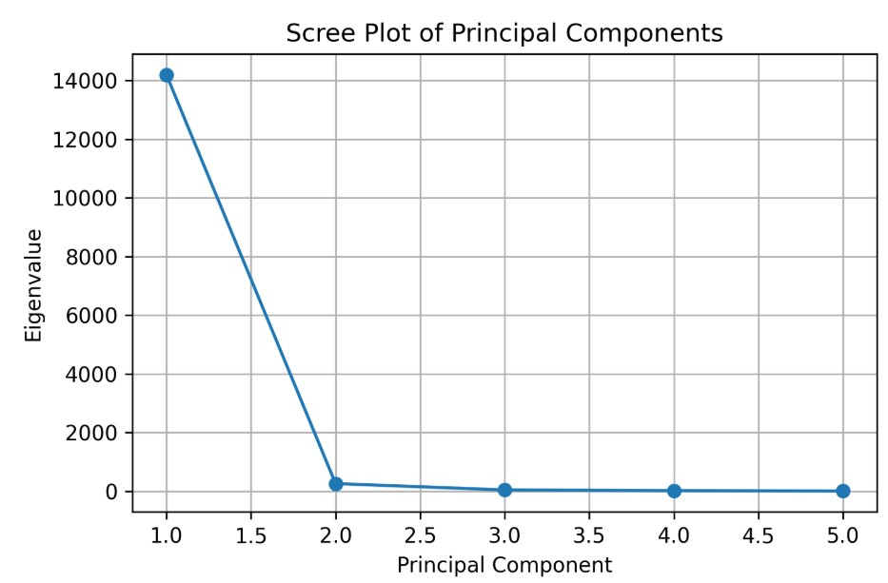
Figure 7: PCA Scree of the Spatio-Seasonal Hydrochemistry with the MNPs in River Ngadda

The PCA Eigenvalues and Variance results as shown in Table 2 further indicate that PC1 accounts for 96.85% of total variance, clearly identifying it as the dominant gradient controlling MNPs distribution. High positive loadings of fragments, fibers, and major polymers (PP, PVC, PET) along with TDS and EC confirm that PC1 represents anthropogenic pollution sources, including domestic discharge, agricultural runoff, and urban activities. Additionally, stations C - F exhibited strong positive PC1 scores, indicating higher contamination levels, while Stations A and B showed relatively lower anthropogenic influence. PC2 (1.75%) represents hydrochemical controls, primarily driven by temperature, pH, nitrate, and sulfate, suggesting that environmental conditions regulate the transformation and mobility of plastics.

Table 2: PCA Eigenvalues and Variance
Principal Component | Eigenvalue | Variance Explained (%) | Cumulative (%)
PC1 | 14196.26 | 96.85 | 96.85
PC2 | 256.26 | 1.75 | 98.60
PC3 | 39.66 | 0.27 | 98.87
PC4 | 18.16 | 0.12 | 98.99
PC5 | 1.81 | 0.01 | 100.00
PC6 | ~0 | ~0 | 100.00

The PCA loadings and extraction in Table 3 revealed that PC1 suggested anthropogenic plastic pollution which is strongly associated with: fragmented plastics, high abundance of polymer diversity (PET, PA, PP, PVC) and also high levels of TDS and EC whereas PC2 reflects hydrochemical processes, driven by nutrients loads (NO₃⁻, SO₄²⁻) and also temperature and pH levels. The results further shows that Stations C, D, E, and F cluster strongly along PC1, indicating high contamination zones, likely linked to agricultural runoff, domestic discharge, and urban activities (Bwala, 2021c; NESREA, 2011).

Table 3: PCA Loadings and Extractions
Variable Group | PC1 (Anthropogenic Load) | PC2 (Hydrochemical Influence)
Fragment | +0.89 | +0.21
Fiber | +0.76 | +0.30
Film | +0.68 | -0.22
NPs (PET, PA) | +0.91 | +0.18
MPs (PP, PVC) | +0.85 | +0.34
TDS | +0.82 | +0.41
EC | +0.79 | +0.52
NO₃⁻ | +0.61 | +0.70
SO₄²⁻ | +0.58 | +0.73
Temperature | +0.22 | +0.81
pH | -0.10 | +0.77

Additionally, the PCA biplot (Figure 8) also clearly separates the sampling stations into two groups: the low contamination cluster (Stations A and B) and the high contamination cluster (Stations C, D, E, and F). The stations in the high-loading region are associated with increased fragment abundance, high abundance of MNPs polymer concentrations (PP, PVC, PET and PA) and also higher TDS and electrical conductivity (EC). This pattern indicates that plastic fragmentation and polymer accumulation intensify downstream, likely due to cumulative anthropogenic inputs such as domestic discharge, irrigation return flows, and urban runoff.

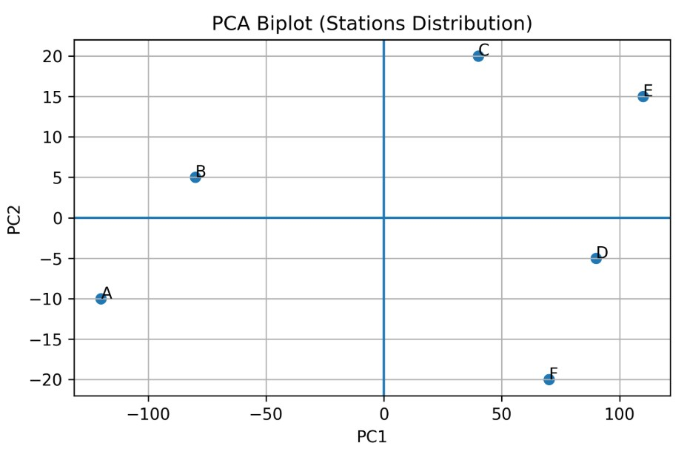
Figure 8: The PCA Score Plots of the Spatio-Seasonal Hydrochemistry with the MNPs in River Ngadda

Furthermore, Canonical Correlation Analysis (CCA) was also conducted to assess relationships between the MNPs, polymers, shapes and environmental variables (temperature, pH, TDS, EC, NO₃⁻, SO₄²⁻). The result of the CCA was shown in Figure 9 and Table 4 indicates strong relationships between MNPs characteristics (shapes and polymers) and physicochemical parameters. The results further suggests that fragments and fibers strongly aligned with TDS and EC, indicating that ionic strength promotes fragmentation and accumulation; whereas PP and PVC correlated with NO₃⁻, suggesting a possibility of domestic and agricultural pollution sources. Additionally, PET and PA associated with temperature and conductivity, reflecting enhanced degradation under warmer and mineral-rich conditions. The CCA Station’s Scores result as shown in Table 5 suggest that stations E and F exhibited the strongest environmental influence, confirming their role as pollution hotspots. These results highlight that physicochemical conditions regulate the transport, transformation, and fate of plastics, rather than acting solely as passive background variables (UNEP, 2016; Horton et al., 2017).

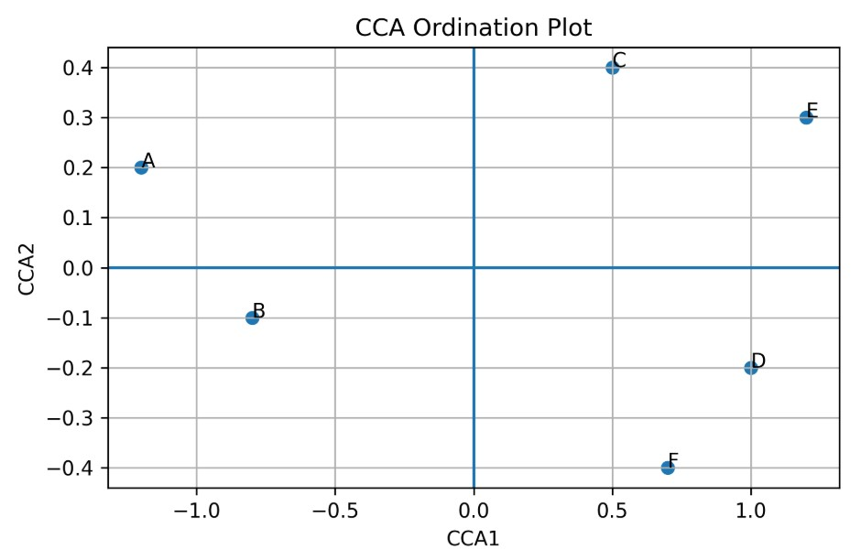
Figure 9: The Canonical Correlation Analysis (CCA) of the Spatio-Seasonal Hydrochemistry with the MNPs in River Ngadda

Table 4: CCA Canonical Coefficients
Variables | CCA1 | CCA2
Fragment | 0.88 | 0.25
Fiber | 0.75 | 0.30
Film | 0.65 | -0.20
MP_PP | 0.82 | 0.33
MP_PVC | 0.86 | 0.28
MP_PET | 0.79 | 0.22
TDS | 0.84 | 0.40
EC | 0.80 | 0.50
NO₃⁻ | 0.63 | 0.71
SO₄²⁻ | 0.60 | 0.74
Temperature | 0.20 | 0.82
pH | -0.12 | 0.78

Table 5: CCA Station’s Scores
Stations | CCA1 | CCA2
A | -1.95 | 0.55
B | -1.60 | 0.48
C | 1.10 | 0.70
D | 1.75 | -0.30
E | 2.05 | -0.40
F | 2.30 | -0.95

3.2 Discussion
3.2.1 Water Quality Dynamics of River Ngadda
The mean seasonal surface water quality of River Ngadda revealed that all measured parameters were within the permissible limits recommended by the National Environmental Standards and Regulations Enforcement Agency (NESREA, 2011) and the World Health Organization (WHO) standards. The results indicated that temperature, TDS, EC, and NO₃⁻ were higher during the dry season, while pH and SO₄²⁻ were higher during the wet season. Similar findings were reported in other freshwater bodies in northeastern Nigeria, where seasonal variation influenced physicochemical dynamics (Bwala, 2021c; Usman et al., 2016).
The higher temperature and EC values recorded during the dry season in the study area may be attributed to increased evaporation, reduced dilution, and the concentration of solutes due to lower water volume (APHA, 2005; Gwana et al., 2017). Bwala (2021a) reported that seasonal reduction in flow velocity along River Ngadda during dry months might have enhance ionic accumulation, leading to elevated EC and TDS. Conversely, the higher pH and SO₄²⁻ concentrations during the wet season could result from the influx of surface runoff, soil leaching, and decomposition of organic matter (Babagana et al., 2015; Bwala, 2021b). These patterns suggest a strong hydrological control on water chemistry, as rainfall dilutes some ions but introduces others through catchment wash-off.
Despite the variations in the hydrochemistry of the river, all measured parameters were within NESREA (2011) limits, indicating that the river is still moderately healthy, though subject to increasing anthropogenic pressures. Continuous monitoring is essential, as the catchment is exposed to domestic discharge, agricultural runoff, and urban waste (Bwala, 2021c; Sharah, 2020).

3.2.2 Seasonal Abundance and Distribution of Microplastics
The abundance of MPs in the surface water range from 29±2.4 - 41±1.6 pp/L during the dry season and 27±4.6 - 34±8.3 pp/L during the wet season. The higher dry-season values are consistent with reports that reduced flow and limited dilution enhance plastic accumulation in lotic systems (Dris et al., 2015; Horton et al., 2017). The hydrodynamic regime plays a key role in particle transport and deposition, as also observed in the Great Lakes (Driedger et al., 2015) and Rhine-Main River sediments (Klein et al., 2015).
The dominance of fibrous and fragment-shaped MPs in River Ngadda aligns with findings from various aquatic systems, where textile fibers, fishing nets, and degraded packaging materials were identified as major sources (Auta et al., 2017; Eerkes-Medrano et al., 2015). Spatial variation across sampling stations—especially the higher abundance at Station F—reflects proximity to densely populated settlements and waste discharge points, a trend similar to those reported in Lake Victoria and urban creeks (Biginagwa et al., 2016; Campbell et al., 2017). The prevalence of blue, red, and black microplastic colours suggests contributions from domestic and industrial waste streams, as these pigments are characteristic of synthetic textiles and packaging (Napper & Thompson, 2016; UNEP, 2016).
The variability in MP abundance between dry and wet seasons highlights the influence of rainfall and runoff on transport dynamics. During the wet season, plastics are mobilized downstream, reducing accumulation at upstream sites, while during dry periods, lower discharge promotes sedimentation and concentration (Bellasi et al., 2020; Zhang et al., 2018). These findings indicate that hydrological and anthropogenic factors jointly shape MP distribution within the river system.

3.2.3 Polymer Composition of Microplastics
The polymeric composition of MPs showed that PA, PET, and PVC were dominant across all stations, particularly at Station D. This composition pattern reflects inputs from clothing fibers, packaging, and household products commonly associated with urban areas (Heo et al., 2013; Bellasi et al., 2020). The absence of PP at Station B aligns with the report of Kılıç & Yücel (2022), who reported that polymer buoyancy influences distribution—lighter polymers such as PP may remain suspended or drift downstream, reducing detection rates in low-flow zones.
The dominance of PA and PET supports previous studies that identified synthetic fibers as primary sources of aquatic microplastics due to their persistence and resistance to biodegradation (Andrady, 2015; Auta et al., 2017). Such persistence poses ecological risks, as plastics can adsorb toxic substances and be ingested by aquatic organisms (Foekema et al., 2013; Ivleva et al., 2017). Continuous accumulation of these polymers underscores the need for improved waste management and effluent control within the River Ngadda catchment, as recommended by UNEP (2016).

3.2.4 Seasonal Abundance and Composition of Nanoplastics
Nanoplastics (NPs) detected range from 27.0±1.4 - 38.0±2.1 μg/L during the dry season and 21.0±0.3 - 34.0±1.1 μg/L during the wet season. Though due to the analytical method employed, NPs below the nanofiltrater threshold (≤0.45 µm) may not had been detected, and therefore the results represent only an operationally defined size fraction of the actual nanoplastics that might be present in the river during both seasons. The observed pattern, where dry-season concentrations exceeded wet-season levels, supports the notion that evaporation and reduced water volume enhance particulate density (Veerasingam et al., 2016; Zhang et al., 2018). The dominance of polystyrene (PS) nanoparticles, particularly at Station C (57.3%), corroborates the findings of Wegner et al. (2012) and Besseling et al. (2017), who reported that PS exhibits strong environmental persistence and bioavailability in aquatic ecosystems.
Nanoplastics are said to be the final degradation stage of larger plastic debris, resulting from prolonged photochemical and mechanical fragmentation (Andrady (2015). Their small size and large surface area enable them to interact with biological membranes, potentially impairing feeding, growth, and reproduction of aquatic organisms (Wegner et al., 2012; Patra & Baitharu, 2024). The absence of PP among detected polymers may reflect its tendency to float and disperse, reducing local accumulation (Kılıç, 2022; Kılıç & Yücel, 2022).
The detection of both micro- and nanoplastics in River Ngadda demonstrates that the system has entered a critical phase of plastic pollution similar to patterns reported globally (Zhang et al., 2018; UNEP, 2016). Without proper control measures, this may lead to sediment contamination, trophic transfer, and ecological imbalance in the long term.

3.2.5 Influence of Environmental Parameters on MNPs Distribution
The multivariate analyses (PCA and CCA) demonstrate that physicochemical parameters, particularly total dissolved solids (TDS), electrical conductivity (EC), temperature, and nutrients (NO₃⁻ and SO₄²⁻), play a significant role in shaping the distribution and transformation of micro- and nanoplastics (MNPs) across the study area. The strong association of fragments and fibers with elevated TDS and EC suggests that ionic strength enhances mechanical breakdown and aggregation processes, leading to increased fragmentation of larger plastics into secondary particles. Similarly, the observed linkage between polymer types such as PET and PA with temperature indicates that thermal conditions may accelerate degradation and weathering processes. These findings are consistent with hydrodynamic and environmental modulation mechanisms reported in recent studies, where water flow, physicochemical gradients, and environmental stressors significantly influence microplastic transport, bioavailability, and bioaccumulation dynamics in aquatic systems (Rasta et al., 2025; Rasta et al., 2026a). Furthermore, the correlation between polypropylene (PP), PVC, and nutrient concentrations highlights the role of domestic and agricultural runoff as major contributors to plastic pollution, supporting earlier reports on the interaction between anthropogenic inputs and environmental variables in freshwater ecosystems (Auta et al., 2017; Besseling et al., 2017
The PCA results from the study suggests that fragment-type particles are the dominant morphological driver of spatial variability. Fragment dominance typically indicates secondary MNPs formed from degradation processes, consistent with fragmentation pathways described in freshwater systems (Andrady, 2015; Eerkes-Medrano et al., 2015). The strong loading of films on PC2 suggests localized inputs of packaging-related plastics, which aligns with reported plastic waste sources in aquatic systems (UNEP, 2016; Auta et al., 2017). The clustering of Stations A and B reflects similar anthropogenic influence patterns, whereas Station D’s separation suggests localized accumulation effects.
The canonical ordination demonstrates that MNPs shape and polymer distribution are environmentally structured. The alignment of Station F along the positive canonical axis suggests influence from elevated TDS and EC values. Similar associations between MNPs and physicochemical gradients have been reported in freshwater contamination assessments (Bellasi et al., 2020; Horton et al., 2017).
The moderate separation of Stations C and D suggests mixed anthropogenic and hydrological controls, consistent with freshwater plastic transport and accumulation dynamics (Driedger et al., 2015; Dris et al., 2015). Higher dry-season MNPs concentration suggest that reduced dilution and increased retention during low-flow conditions. Comparable seasonal dynamics have been reported in inland aquatic systems (Driedger et al., 2015; Zhang et al., 2018).

3.2.6 Implications for Environmental Management
The dominance of fragmented plastics and the strong coupling between MNPs and physicochemical parameters underscore the need for integrated environmental management strategies. The identification of pollution hotspots (Stations C–F) suggests that targeted interventions, such as improved waste management, regulation of agricultural runoff, and control of domestic effluents, are critical for mitigating plastic pollution. Moreover, the observed influence of environmental conditions on MNPs behavior implies that management approaches must consider not only source reduction but also environmental processes that enhance plastic persistence and transformation. Recent advances highlight that hydrodynamic conditions can significantly modulate microplastic toxicity, bioaccumulation, and ecological risk, emphasizing the importance of incorporating environmental variability into risk assessment frameworks (Rasta et al., 2026b; Rasta et al., 2026a). Regulatory enforcement and monitoring, as recommended by environmental agencies, remain essential to control plastic discharge and protect freshwater ecosystems (NESREA, 2011; UNEP, 2016).
The co-occurrence of micro- and nanoplastics alongside moderate water quality variation suggests increasing anthropogenic pressure on River Ngadda. Although physicochemical parameters remain within permissible limits, the emerging presence of plastics points to deteriorating ecological integrity. Similar concerns were raised by Bwala (2021a, 2021c) and Babagana et al. (2015), who highlighted that improper waste disposal and uncontrolled irrigation practices are altering the chemical and biological state of the river.
Effective mitigation will require enforcement of existing NESREA (2011) regulations, waste recycling, and community-based awareness campaigns to curb indiscriminate plastic use. These steps align with UNEP (2016) recommendations for integrated policy approaches targeting plastic reduction and aquatic ecosystem protection.

4. Conclusion

This study revealed that the physicochemical parameters of River Ngadda remained within the permissible limits of NESREA (2011) and WHO standards, indicating moderate water quality status. However, seasonal variations significantly influenced water chemistry, with higher temperature, EC, and nitrate concentrations recorded during the dry season due to increased evaporation and solute concentration. The wet season showed elevated pH and sulphate levels, reflecting runoff inputs and organic matter decomposition. This study further demonstrates that the distribution of MNPs in the aquatic system is primarily driven by anthropogenic activities, with significant modulation by physicochemical parameters. The predominance of fragments and diverse polymer types indicates advanced stages of plastic degradation and continuous input into the system. Multivariate analyses confirm that environmental factors such as TDS, EC, temperature, and nutrients not only influence the spatial distribution of MNPs but also their transformation and potential ecological impacts. These findings align with emerging evidence that environmental dynamics, including hydrodynamics and water chemistry, play a crucial role in determining microplastic fate and toxicity in aquatic organisms (Rasta et al., 2025; Rasta et al., 2026b). The presence of both MPs and NPs across all sampling stations signifies growing plastic contamination within the river system. The higher levels of concentrations and abundance during the dry-season; and also the dominance of PA, PET, and PVC polymers point to domestic, agricultural, and industrial sources intensified by reduced flow conditions. Station C and D exhibited the highest MP and NP abundances, corresponding to effluent discharges from Maiduguri Water Treatment Plant (MWTP), densely populated and waste-impacted zones. These findings indicate that River Ngadda is under increasing anthropogenic stress, particularly from plastic waste mismanagement. Although current physicochemical parameters suggest acceptable water quality, the detection of micro- and nanoplastics highlights a potential ecological risk that could escalate without intervention. Continuous monitoring, enforcement of NESREA regulations, and community-based waste management strategies are essential to prevent further degradation. In conclusion, while River Ngadda currently supports acceptable water quality, the emerging prevalence of MNPs underscores an urgent need for integrated environmental management to preserve its ecological and public health functions in the long term.

References

[APHA] American Public Health Association. 2005. Standard Methods for the Examination of Water and Wastewater, 21st edition. American Public Health Association.
[BORMLS] Borno State Ministry of Land and Survey. 2008. Borno State Office Memo File. Borno State Ministry of Land and Survey, Musa Usman Secretariat, Maiduguri, Borno State Nigeria.
[NESREA] National Environmental Standards and Regulations Enforcement Agency. 2011. National Environmental (Domestic and Industrial Plastic, Rubber and Foam Sector, Regulation, 2011. National Environmental Standards and Regulations Enforcement Agency (NESREA), Abuja, Nigeria.
[UNEP] United Nations Environment Programme. 2016. Marine plastic debris and microplastics – Global lessons and research to inspire action and guide policy change. United Nations Environment Programme, Nairobi, Kenya.
Andrady AL, 2015. Persistence of Plastic Litter in the Oceans. In M. Bergmann, L. Gutow, L. & M. Klages, eds. Marine Anthropogenic Litter, pp. 57-72. Cham, Switzerland, Springer International Publishing.
Auta HS, Emenike CU, & Fauziah SH. 2017. Distribution and Importance of Microplastics in the Marine Environment: A Review of the Sources, Fate, Effects, and Potential Solutions. Environment International, 102: 165-176. doi:10.1016/j.envint.2017.02.013
Babagana A, Dungus B, Bello SA & Kolo BS. 2015. Problems and Prospects of Alau Dam Construction in Alau Community, Konduga Local Government Area, Borno State, Nigeria. European Scientific Journal, 11 (20): 195 – 207.
Bellasi A, Binda G, Pozzi A, Galafassi S, Volta P, & Bettinetti R. 2020. Microplastic Contamination in Freshwater Environments: A Review, Focusing on Interactions with Sediments and Benthic Organisms. Environments, 7(4). doi:10.3390/environments7040030
Besseling E, Quik JTK, Sun M, & Koelmans AA. 2017. Fate of Nano- and Microplastic in Freshwater Systems: A Modelling Study. Environmental Pollution, 220: 540-548.
Biginagwa FJ, Mayoma BS, Shashoua Y, Syberg K, & Khan FR. 2016. First Evidence of Microplastics in the African Great Lakes: Recovery from Lake Victoria Nile Perch and Nile Tilapia. Journal of Great Lakes Research, 41 (1): 146-149.
Bwala MN, & Imam TS. 2021. Fish Smoking, Preservation and Socio-Economic Characteristics of Fish Smokers and Traders in Selected Fish Markets in Borno State, Nigeria. Nigerian Journal of Fisheries, 18 (2): 2346 – 2354.
Bwala MN. 2021a. Impact of Nonpoint Source Pollutant on Fish Biodiversity in River Ngadda, Maiduguri – Borno State. Nigerian Journal of Pure & Applied Sciences, 34(1): 3631 – 3640.
Bwala MN. 2021b. The Impact of Irrigational Activities on the Abundance and Distribution of Cat Fish (Clarias gariepinus) in River Ngadda, Maiduguri, Borno State. Nigerian Journal of Science & Research, 2 (1): 7-12.
Bwala MN. 2021c. Effect of Irrigational Activities on Water Quality of River Ngadda, Maiduguri – Nigeria. Sule Lamido University Journal of Science and Technology, 2 (3): 8-18.
Bwala, MN, Gaya, EA, Nayaya, AJ & Buba, T. (2026). Ecotoxicity of Petrogenic Plastic Particles in Fish: Implication for Human Health and Environmental Risk Assessment. Food and Drug Safety. 3(1): 1–16. DOI: https://doi.org/10.55121/fds.v3i1.700
Campbell SH, Williamson PR, & Hall BD. 2017. Microplastics in the Gastrointestinal Tracts of Fish and the Water from an Urban Prairie Creek. FACETS 2: 395–409. doi:10.1139/facets-2017-0008
Dai Z, Zhang H, Zhou Q, Tian Y, Chen T, Tu C, & Luo Y. 2018. Occurrence of Microplastics in the Water Column and Sediment in an Inland Sea Affected by Intensive Anthropogenic Activities. Environmental Pollution, 242: 1557-1565.
Driedger AG, Dürr HH, Mitchell K, & Van Cappellen P. 2015. Plastic debris in the Laurentian Great Lakes: a review. Journal of Great Lakes Research, 41(1): 9-19. doi:10.1016/j.jglr.2014.12.020
Dris R, Imhof H, Sánchez W, Gaspéri J, Galgani F, Tassin B, & Laforsch C. 2015. Beyond the ocean : Contamination of freshwater ecosystems with (micro-) plastic particles. Environmental Chemistry, 12 (5): 539-550. https://doi.org/10.1071/EN14172
Eerkes-Medrano D, Thompson RC, & Aldridge DC. 2015. Microplastics in freshwater systems: a review of the emerging threats, identification of knowledge gaps and prioritization of research needs. Water Research, 75: 63-82.
Foekema EM, De Gruijter C, Mergia MT, Van Franeker JA, Murk AJ, & Koelmans AA. 2013. Plastic in North Sea fish. Environmental Science & Technology, 47 (15): 8818-8824.
Free CM, Jensen OP, Mason SA, Eriksen M, Williamson NJ, & Boldgiv B. 2014. High-levels of microplastic pollution in a large, remote, mountain lake. Marine Pollution Bulletin, 85 (1): 156-163.
Gwana AM, Umaru BW, Halima MB, Wanas LN, 2017. Physico – Chemical Water Quality Analyses of Lake Alau, North – Eastern Nigeria, Journal of Water Resources & Ocean Science, 6 (1): 14-22. doi: 10.11648/j.wros.20170601.12
Heo NW, Hong SH, Han GM, Hong S, Lee J, Song YK, Jang M, & Shim WJ. 2013. Distribution of small plastic debris in cross-section and high strandline on Heungnam beach, South Korea. Ocean Science Journal, 48(2): 225-233.
Horton AA, Walton A, Spurgeon DJ, Lahive E, & Svendsen C. 2017. Microplastics in freshwater and terrestrial environments: evaluating the current understanding to identify the knowledge gaps and future research priorities. Science of the Total Environment, 586: 127–141. doi:10. 1016/j.scitotenv.2017.01.190.
Hossain MB, Yu J, Nur AU, Banik P, Jolly YN, Al- Mamun M, Arai T, & Albeshr MF. 2023. Microplastics in surface water from a mighty subtropical estuary: First observations on occurrence, characterization, and contamination assessment. Environmental Research 226: 115594
Ivleva NP, Wiesheu AC, & Niessner R. 2017. Microplastic in Aquatic Ecosystems. Angewandte Chemie International Edition, 56: 1720-1739. doi:10.1002/anie.201606957
Kaladharan P, Vijayakumaran K, Singh VV, Prema D, Asha PS, Sulochanan Bindu Hemasankari P, Loveson Edward L, Padua Shelton, Veena S, Anasukoya A, & Bhint HM. 2017. Prevalence of marine litter along the Indian beaches: A preliminary account on its status and composition. Journal of the Marine Biological Association of India, 59: 19-24. doi: 10.6024/jmbai.2017.59.1.1953-03
Kılıç E. 2022. Microplastic occurrence in the gill and gastrointestinal tract of Chelon ramada (Mugilidae) in a highly urbanized region, İskenderun Bay, Türkiye. Marine Science & Technology Bulletin, 11(3), 309-319. https://doi.org/10.33714/masteb.1162225.
Kılıç E., & Yücel N. 2022. Microplastic occurrence in the gastrointestinal tract and gill of bioindicator fish species in the northeastern Mediterranean, Marine Pollution Bulletin, 177: 113556. https://doi.org/10.1016/j.marpolbul.2022.113556
Klein S, Worch E, & Knepper TP. 2015. Occurrence and spatial distribution of microplastics in river shore sediments of the Rhine-Main area in Germany. Environmental Science & Technology, 49 (10): 6070-6076.
Kripa V. 2018. Marine debris - a threat to sustainable fisheries. In: Prema, D., Molly Varghese, Shelton Padua, Jeyabaskaran, R., Sumithra, T. G., Reshma, K. J., Rekha J. Nair, Sobhana, K. S., Vidya, R., Jeena, N. S., Vivekananda Bharathi, Lavanya Ratheesh, Uma, E. K. and Shylaja, G. (Eds.). Book of Abstracts and Success stories, National Conference on Marine Debris (COMAD 2018), Marine Biological Association of India, 11-12 April 2018, Kochi, p. 19-21.
Lee J, Lee JS, Jang YC, Hong SY, Shim WJ, Song YK, Hong SH, Jang M, Han GM, Kang D, & Hong S. 2015. Distribution and size relationships of plastic marine debris on beaches in South Korea. Arch. Environmental Contamination & Toxicology, 69 (3): 288- 298.
Majid Rasta, Mian Adnan Kakakhel, Mojtaba S. Taleshi, Niloofar S. Lashkaryan, Jia Manke, Liming Liu, Shan-e-hyder Soomro, Xiaotao Shi. (2025). Interactive effects of hydrodynamics and microplastics on bioaccumulation, histopathological alterations, biomarker responses, and gene expression in grass carp brain. Ecotoxicology and Environmental Safety, 302, 118596, https://doi.org/10.1016/j.ecoenv.2025.118596
Majid Rasta, Niloofar S. Lashkaryan, Xiaotao Shi, Mojtaba S. Taleshi, Ali Haghi Vayghan, Azin Ahmadi, Mian Adnan Kakakhel, Jia Manke, Liming Liu, Yujiao Wu, (2026). Hydrodynamic modulation of microplastic bioaccumulation in edible fish: Integrating biomarker networks, machine learning, and food safety perspectives, Food Chemistry, 509: 148610, https://doi.org/10.1016/j.foodchem.2026.148610.
Majid Rasta, Niloofar S. Lashkaryan, Xiaotao Shi, Mojtaba S. Taleshi, Ali Haghi Vayghan, Azin Ahmadi, Mian Adnan Kakakhel, Aysha Zahid, Maryam Pedram Jarf, Jia Manke, Liming Liu, Yujiao Wu. (2026). Flow-dependent modulation of microplastic toxicity in grass carp: Insights from multi-level biological endpoints and machine learning. Journal of Hazardous Materials, 502: 141020, https://doi.org/10.1016/j.jhazmat.2025.141020.
Masura J, Baker J, Foster G, Arthur C, & Herring C. 2015. Laboratory methods for the analysis of microplastics in the marine environment: recommendations for quantifying synthetic particles in waters and sediments NOAA Technical Memorandum, NOS-OR&R-48.
Napper IE, & Thompson RC. 2016. Release of synthetic microplastic plastic fibres from domestic washing machines: Effects of fabric type and washing conditions. Marine Pollution Bulletin, 112(1): 39-45.
Patra KB, & Baitharu I. 2024. Assessment of microplastics and associated ecological risk in the Hirakud Reservoir, Odisha, India. Journal of Water & Health, 22(6): 10-17 doi: 10.2166/wh.2024.393
Paul DK, & Ramesh Y. 2022. Microplastic in Inland Water Fish in India: Presence and Fate. Techno World, 37-53.
Sanabila AI, Hadi MI & Zummah A. 2022. Identification of Microplastics Content in Sediment, Water and Digestive Channel of Milkfish (Chanos chanos) in Sidoarjo Pond. Al-Hayat: Journal of Biology and Applied Biology, 5(1): 11-24. DOI. 10.21580/ah.v5i1.12295
Sharah JC. 2020. An Assessment of the Base Transceiver Stations (BTS) Compliance Status to Environmental Standards and Regulations in Maiduguri and Its Environs. Unpublished Thesis submitted to the Department of Geography, University of Maiduguri.
Shylaja G, Kripa V, Prema D, & Abhilash KS. 2018. Assessment of marine debris in the stake net fisheries of Vembanad Lake, Kerala, India. Journal of Marine Biological Association of India, 60: 91-96. doi: 10.6024/jmbai.2018.60.1.2044-14
Sruthy S. & Ramasamy EV. 2017. Microplastic pollution in Vembanad Lake, Kerala, India: The first report of microplastics in lake and estuarine sediments in India. Environmental Pollution, 222: 315-322. doi: 10.1016/j.envpol. 2016.12.038.
Tasneem AT. 2021. Assessing the Sources of Microplastic Pollution in the Maumee Watershed: A Geospatial Approach. Submitted to the Graduate Faculty as partial fulfilment of the requirements for the Master of Arts Degree in Geography, University of Toledo.
Usman YM, Mohammed A, Ibrahim B, & Saleh BA. 2016. Assessment of Groundwater Quality Status along River Nggada in Maiduguri, Nigeria. International Journal of Engineering & Sciences, 5(1) 08 – 14.
Veerasingam S, Saha M, Suneel V, Vethamony P, Rodrigues CA, Bhattacharyya S. & Naik BG. 2016. Characteristics, seasonal distribution and surface degradation features of microplastic pellets along the Goa coast, India, Chemosphere, 159: 496-505. doi: 10.1016/j. chemosphere.2016.06.056.
Wegner A, Besseling E, Foekema EM, Kamermans P & Koelmans AA. 2012. Effects of nanopolystyrene on the feeding behavior of the blue mussel (Mytilus edulis L.). Environmental Toxicology & Chemistry, 31 (11): 2490-2497
Zhang K, Gong W, Lv J, Xiong X, & Wu C. 2015. Accumulation of floating microplastics behind the Three Gorges Dam. Environmental Pollution, 204: 117-123.
Zhang K, Shi H, Peng J, Wang Y, Xiong X, Chenxi Wu, Paul KSL. 2018. Microplastic pollution in China's inland water systems: a review of findings, methods, characteristics, effects, and management. Science of the Total Environment, 630: 1641–1653I.

