HARNESSING NUCLEAR ENERGY FOR ECONOMIC GROWTH AND DEVELOPMENT IN THE FEDERAL REPUBLIC OF NIGERIA

ABSTRACT
A considerable section of Nigeria's population lacks access to electricity, which severely impedes the country's economic growth. This study looks at how nuclear energy can help Nigeria overcome its energy deficit by offering a steady and dependable power supply, promoting economic development and sustainability.
The potential of using nuclear energy as a stimulus for the Federal Republic of Nigeria's economic development is examined in this article. Nuclear energy appears to be a workable solution to Nigeria's growing electricity demand as the nation continues to struggle with issues of energy access, sustainability, and dependability. The article describes Nigeria's present energy situation, emphasizing the shortcomings of conventional energy sources and the need for diversification. It also looks at the advantages of nuclear energy, such as its capacity to produce a steady, low-carbon power supply, lessen reliance on fossil fuels, and promote technical development and job creation across a range of industries. The regulatory frameworks necessary for the safe application of nuclear technology are also covered, along with the significance of public acceptance and understanding. The study offers insights into best practices that Nigeria might use by examining case studies from other nations that have effectively used nuclear energy. In order to promote sustainable economic growth and advance national development, the paper concludes by arguing for a calculated strategy to incorporate nuclear energy into Nigeria's energy mix.
Keywords: Nuclear energy, Economic development, Conventional energy sources, Diversification, Sustainability, Sustainable economic growth, Energy mix.
INTRODUCTION
The world's energy environment is changing dramatically as nations look for dependable and sustainable electricity sources to spur economic expansion [1, 2]. An effective energy solution is more important than ever in Nigeria, a country endowed with a youthful population and abundant natural resources [1]. In order to overcome these obstacles and realize Nigeria's potential for sustainable development, nuclear energy offers a feasible solution [3]. Despite having an abundance of natural resources, Nigeria has been experiencing energy shortages that are impeding its economic progress. The country is mostly dependent on fossil fuels, especially gas and oil, but this reliance creates sustainability issues and is insufficient to fulfil the growing demand for energy [1]. Nigeria's energy needs can be met and sustained economic development can be achieved by utilizing nuclear energy as a solution to these problems.
Nigeria's growing population and expanding economy have made it difficult for the country to meet its energy needs in recent years. In addition to raising environmental issues, the nation's reliance on fossil fuels, especially gas and oil, has left the economy susceptible to changes in the price of oil globally. Nigeria needs to look into alternate energy sources in order to guarantee sustainable economic growth and development. Among these, nuclear energy stands out as a practical choice that has the potential to revolutionize the country's energy landscape and spur economic growth [4, 5].
The hard reality of a 33% unemployment rate confronts Nigeria's expanding youth population, which is full of potential and aspiration [6]. This lack of opportunity causes instability and frustration, which hinders the nation's progress for a long time. Nuclear power plants, however, can provide some hope. Opportunities in engineering, construction, health, and safety are created by the need for specialized labor in their creation, operation, and maintenance [6]. Imagine how thousands of ideas might empower people, families, and entire communities throughout Nigeria. Millions of people will be lifted out of the shadow of unemployment as a result of this knock-on impact, which will generate economic momentum and spark job engines across. Electricity is the lifeblood of the business and is necessary for economic growth [6, 7]. Nuclear power facilities generate electricity continuously without the need for sunlight or significant wind maintenance, in contrast to weather-dependent renewable energy sources. Eventually, this creates jobs, increases output, and stimulates creativity. Nigeria will be able to diversify its economy, increase the value of its numerous resources, and realize its industrial potential through the use of nuclear energy [8]. A nation pulsating with rhythmic advancement, humming machinery, and buzzing factories are all made possible by a consistent supply of power. Imagine a future driven by dependable nuclear power that is "Made in Nigeria," high-quality, and innovative.
Nigeria is crucial in the global battle against climate change, even if it may be a relatively low emitter. Although the use of renewable energy is admirable, it is still difficult to use the resource on a large scale. On the other hand, nuclear power presents a strong substitute. It is a clean and sustainable energy source because it emits no greenhouse gases when in use. Nigeria can ensure its energy security, contribute to global de-carbonization efforts, and pave the route for a greener future by adopting nuclear responsibility [6, 7]. "Imagine a nation that contributes to a healthy planet, is powered by clean energy, and is illuminated by progress" [3].
In 2007, the Nigerian government approved a "roadmap and strategy" for nuclear power development. The first nuclear power plant was supposed to begin supplying electricity to the national grid by 2030, and by 2035, there would be about 4,000 megawatts of nuclear producing capacity [5 - 8]. Nigeria has determined two "preferred sites" - Geregu in the central area and Itu in the south-south - that have been suggested for in-depth assessment based on the findings of preliminary siting operations.
Russia has previously been identified as a possible partner for the construction and funding of Nigeria's nuclear infrastructure. With Russia's national nuclear energy company, Rosatom, a collaboration agreement was signed in June 2012 and revised in 2020 [6 - 8]. As a result, further agreements are also being considered. Opportunities for related infrastructure investment will also include expanding the transmission network and getting the nuclear plant locations ready for the construction.
1.0 ENERGY DEMAND AND ECONOMIC CHALLENGES
Nigeria's economy is the biggest in Africa, but it faces difficulties due to its reliance on fossil resources, rising energy consumption, and erratic electricity supplies. According to World Bank estimates, Nigeria's economy loses $28 billion a year due to inadequate access to power [9, 10]. The need for energy is predicted to climb sharply as urbanization and industrialization continue to grow, making the investigation of alternate energy sources necessary [7].
Nigeria, the largest economy and most populated country in Africa, paradoxically has a significant internal energy shortage despite being a major worldwide energy exporter [8]. Details about the country's growing energy demand, the ongoing difficulties in supplying it, and the significant economic ramifications of this energy insecurity are provided below.
1.1 The High-Stakes Energy Demand in Nigeria
Due to basic socioeconomic considerations, Nigeria's energy consumption is strong and continuously rising [6]. But this need is constantly unmet by the current infrastructure, leaving a huge "unserved demand" gap. The following are some important factors influencing demand growth:
- Demographic Pressure: The demand for energy services (lighting, cooking, and cooling) in the residential sector is a major factor due to the fast-expanding population, which is expected to be the third biggest in the world by 2050 [6].
- Economic Expansion: A developing economy that aspires to industrialized (such as the Vision 20:2020 and its successors) requires substantial, dependable power for services, manufacturing, and trade. Electricity consumption is positively and significantly correlated with economic growth and industrial output [8].
- Urbanization: Demand is concentrated and the current transmission and distribution infrastructure is strained as a result of the fast migration of people to urban regions, which also increases grid access rates in certain areas.
- Suppressed Demand: It is often believed that the real demand for electricity is many times more than what the national grid can provide. According to experts, the difference is enormous, with peak demand expected to be about 20 GW compared to an all-time high generation of less than 6 GW.
1.2 The Current Energy Mix and Consumption Pattern
Nigeria can generate over 13,000 megawatts of energy, but because of poor infrastructure and poor management, the country's actual output frequently falls short [5 - 7]. Most people don't have access to cheap, dependable power, which hinders industrial development and raises operating expenses. Energy poverty continues to be a major obstacle to economic growth, impacting industries including technology, manufacturing, and agriculture. Millions of people lack access to dependable electricity due to the energy sector's persistent power outages [5 - 7]. The nation struggles to produce enough electricity to serve its expanding population and businesses, while having abundant natural resources [1, 2]. In 2023, the World Bank reports that Nigeria's electrification rate is still below 60%, which impedes growth and productivity. In order to improve energy security and promote economic growth, the government has acknowledged the critical necessity for energy source diversification [8]. Nigeria's energy landscape is complex and dynamic, marked by its abundant resources, rising electricity consumption, and a number of obstacles that prevent the best possible use of energy.
Nigeria's electricity consumption during the October 2024 - September 2025 period was marked by a predominance of fossil fuels. The energy landscape is dominated by fossil fuel sources like gas, which contribute about 24 TWh. Nigeria does, however, also manage to generate about 10 TWh of electricity from low-carbon sources, mostly hydropower. This indicates that nearly one-third of the total electricity mix is made up of low-carbon energy. However, Nigeria's electricity use is still much lower than the global average of 3649 kWh per person. This leads to restricted industrial development, slow economic growth, and difficulties raising the population's standard of life [8].
The following are some important details regarding Nigeria's electricity production: Nigeria's electricity production increased from 8,554 GWh to 8,879 GWh in September 2024. Nigeria's electricity production statistics is updated every three months, with an average of 7,111 GWh from March 2005 to September 2024 (see figure 1). The statistics showed a record low of 3,247 GWh in June 2009 and an all-time high of 9,936 GWh in September 2015. By multiplying the quarterly Electricity Generation Average per Hour by the number of hours in the quarter, Circular Economy Innovation Communities CEIC, a major provider of global economic and financial statistics, determines the amount of electricity generated. There are 24 x 90 hours used. Figure 1 displays the Electricity Generation Average per Hour provided by the Central Bank of Nigeria.
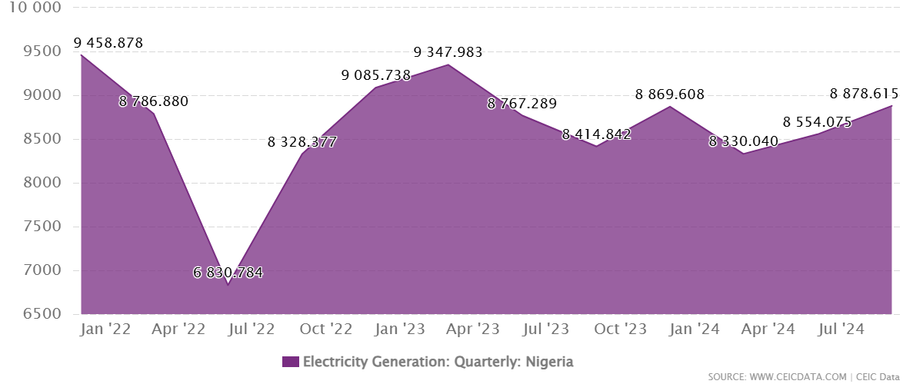
Figure 1. Showing the Quarterly Electricity Generation in Nigeria.
Nigeria uses a combination of commercial and traditional energy sources [11, 12]: Conventional Biomass: Fuelwood, charcoal, and agricultural waste continue to make up a significant amount of the primary energy used, especially for cooking and heating in rural and low-income urban families. Air pollution and deforestation are exacerbated by this. Fossil Fuels: Natural gas accounts for more than 80% of on-grid power generation [13, 14]. Transportation and, most importantly, self-generation rely significantly on crude oil and its refined products, such as gasoline and diesel. Low Modern Energy Penetration: Although off-grid solutions (such as solar mini-grids) are growing, modern renewable energy's contribution to the national grid is still quite little despite the abundance of solar, wind, and hydro resources.
Table 1. Nigeria energy mix data [13].
Energy Source | Share (%)
Natural Gas | 70
Oil | 15
Hydropower | 7
Solar | 4
Wind | 1
Coal | 2
Biomass and Others | 1

Fossil Fuels:
Nigeria has substantial natural gas reserves and is one of Africa's biggest producers of oil. The nation's government primarily depends on oil exports and is a member of OPEC [5 - 7]. The nation is the biggest oil producer in Africa, producing more than 1.5 million barrels of oil every day. Nigeria is a significant participant in the world market for LNG (liquefied natural gas), with proven reserves estimated at more than 200 trillion cubic feet. The majority of electricity is generated using natural gas, with hydropower serving as a complement [5 - 7]. Biomass and garbage make up a large portion of the total energy supply, with oil and natural gas coming in second. The government of Nigeria is working to encourage the development and integration of renewable energy sources, such as solar, wind, and hydro, into the country's system [7]. Through initiatives like the Power Sector Recovery Program, which seeks to promote accountability, financial sustainability, and dependability, the government is actively working on reforms to strengthen the power sector [7].
More than 80% of the nation's primary energy comes from oil and gas. Gas-fired generation dominates the electricity industry (see Figure 2), which is plagued by persistent underinvestment, inefficiency, and instability that lead to low electrification rates and frequent blackouts [11, 12]. The per capita electricity use is among the lowest in the world, and only roughly 55% of the population has access to grid electricity, according to the World Bank. Additionally, at least 60% of people cook using traditional biomass, including charcoal and firewood, which results in indoor air pollution and health issues.
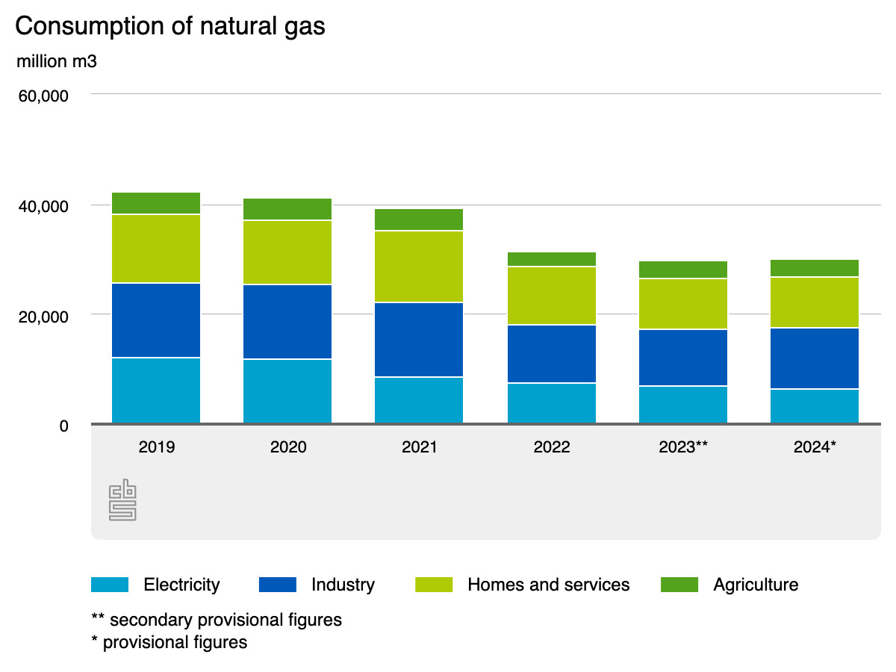
Figure 2. Showing the Consumption of Natural Gas in Nigeria.
Nigeria's dependence on fossil fuels exposes it to the hazards of stranded assets in the face of a decline in the world's oil demand as well as the volatility of global oil prices. According to Figure 3, Nigeria has proven crude oil reserves of up to 37 billion barrels. The global energy transition and the Paris Agreement, which seeks to keep global warming well below 2°C, are still putting increasing pressure on the oil industry, which accounted for 5.34% of the nation's GDP in Q2 2023 and is expected to generate 41.98% of government revenue in 2024 [8]. The International Energy Agency (IEA) estimates that the world's oil demand may reach its peak by 2030 and stay somewhat steady until 2050, at which point oil-producing nations should anticipate a sharp fall. This suggests that if Nigeria doesn't diversify its economy and make investments in low-carbon alternatives, its oil export and revenue boom may end within the next thirty years [8].
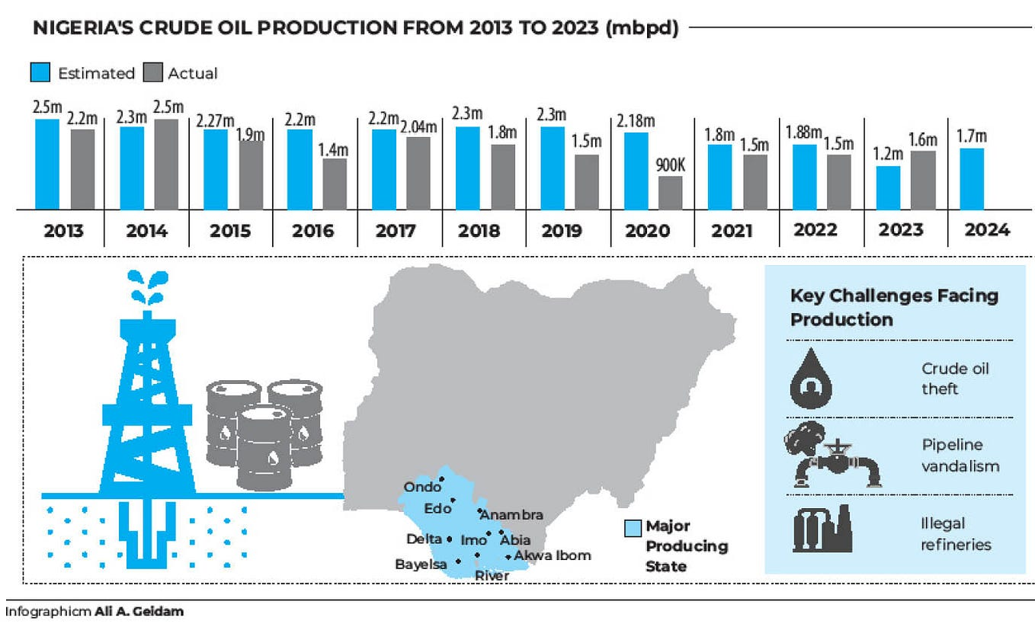
Figure 3. Showing the Production of Crude Oil in Nigeria from 2013 - 2023.
Renewable Energy:
Wind Energy: In Nigeria, wind speed and wind energy potential range from about 2 m/s in the coastal region to 4 m/s in the far north. Because of the quick advancement of technology, using wind to generate electricity is relatively new. A variety of conversion devices, including wind turbines, generators, and dynamos, can be employed to convert the energy in flowing air into mechanical energy [13]. Nigeria's wind energy resources were mapped as a result of a wind mapping project conducted by the Ministry of Science and Technology. This suggested a relatively limited and regional wind energy potential. Nigeria actually has a weak to moderate wind regime. Despite this, there are two large wind farm projects in Nigeria; a 10 MW project in Katsina and a 100 MW project in Plateau State.
Hydropower Energy: Currently making up 16% of the world's total power supply, hydropower is the largest source of renewable electricity generation, accounting for 70 - 80% of the total [13, 14]. With eleven major river basins spread around the nation, Nigeria is blessed with a variety of bodies of water, including sizable rivers and natural waterfalls. According to research, the river systems can support 86 small hydropower sites, 126 mini dams, and 70 micro dams [13]. Nigeria's hydropower resources have a total usable capacity of 11,250 MW for major hydropower and 3500 MW for minor hydropower, which is sufficient to power Nigerian electricity production alone. Nevertheless, only 17% of major hydropower and 2% of minor hydropower are now being used. As a result, only 18.2% of electricity generation in Nigeria is derived from hydroelectric sources [13].
Solar Energy: Because of its seemingly "limitless" potential, solar energy is one of the most promising renewable energy sources. Nigeria, which is situated just north of the equator and in the "high sunshine belt," offers enormous potential for solar energy. In coastal areas, the average yearly total solar radiation is roughly 4 kWh/m2.day, while in the north, it is roughly 6.5 kWh/m2.day. Between 1994 and 2018, Nigeria's long-term average GHI (Global Horizontal Irradiation) was roughly 1534 kWh/m2 annually in coastal states like Port Harcourt, while it rose to roughly 2264 kWh/m2 annually in northern states like Sokoto, Kano, and Maiduguri. Six hours a day are thought to be the average amount of sunshine. Owing to Nigeria's high radiation levels, studies have revealed that if 1% of the country's land mass (920 km2) is covered with solar PV, it could produce over 200 GWh a year, which is over ten times more than the country now produces [13, 14]. However, because of the levelized cost of electricity (LCOE), the economic feasibility of solar PV is sometimes questioned.
1.3 The Structural and Financial Challenges
Underinvestment, inefficiency, and volatility plague the power sector despite its enormous potential, resulting in frequent blackouts and a low electrification rate for a major section of the population [15]. The whole Nigerian energy value chain is beset by a complicated web of structural, operational, and financial issues that make it impossible to meet demand. There are deficiencies in the power sector (generation, transmission, and distribution), particularly with regard to gas supply constraints: Despite the nation's abundance of gas, pipeline vandalism, pricing problems, and poor infrastructure plague the gas-to-power value chain, causing frequent disruptions in the fuel supply to thermal power plants [5]. Infrastructural Deficits/Weak and Aging Infrastructure: Inadequate networks for the distribution and transmission of electricity cause inefficiencies and outages. Often referred to as a "single line," the national transmission system is brittle and prone to failure. Due to technical issues, electricity theft, and inefficient invoicing, Transmission and Distribution Companies (DisCos) have large Aggregate Technical, Commercial, and Collection (ATC&C) losses, which can often surpass 40% [5]. Another problem is the Tariff and Liquidity Crisis: There is a huge liquidity imbalance in the electrical market. Tariffs have consistently failed to account for the cost of production and distribution, despite recent increases [15]. Government subsidies were unsustainable, resulting in enormous debts owing to gas suppliers and Generation Companies (GenCos), which prevented maintenance and investment.
Crude oil theft and vandalism are common in the oil and gas industry, along with import dependence and insecurity. Large-scale oil theft and pipeline vandalism are caused by insecurity, especially in the Niger Delta, which lowers national output and income [11, 12]. The importation of refined products is another problem. Nigeria imports more than 70% of its refined petroleum products (PMS, diesel, and kerosene) while being a significant producer of crude oil. This increases the country's import bill and makes the domestic fuel price extremely susceptible to fluctuations in foreign exchange and world oil prices [12]. The public is now subject to full market prices due to the recent elimination of the gasoline subsidy and the participation of the Dangote local refinery fully operational in the country. Foreign Exchange (Forex) Pressure: Additionally, the Power sector's activities are very susceptible to the Naira's depreciation because they heavily rely on foreign currency for equipment purchases, foreign loan repayments, and spare part imports [16]. Policy and Regulation: The regulatory landscape can be erratic, with problems with pricing, tariffs, and investment incentives impeding expansion. Corruption and Governance: Effective energy management and policy implementation continue to be significantly hampered by corruption [11, 12]. Funding: Investments in the traditional and renewable energy sectors are hampered by limited financial access.
1.4 Profound Economic and Social Impact
Nigeria's ongoing energy shortage severely hinders the country's economic growth, causing enormous financial losses that have an effect on the social welfare of the people [17]. The following are a few examples of financial losses and operating expenses:
- Dependency on Self-Generation: To generate electricity, families and businesses turn to expensive and environmentally harmful diesel and gasoline generators. It is believed that this self-generation capability is about 40 GW, which is much larger than the operational national grid. An estimated billions of dollars are spent each year on fuelling these generators.
- Decreased Industrial Competitiveness: Nigerian industry is not competitive internationally due to the high and unstable cost of electricity. Some large enterprises are forced to transfer to neighbouring nations as a result of frequent outages that cause production interruptions, equipment damage, and higher operating costs [16, 17]. An estimated $26 billion is lost economically each year as a result of power outages.
- Inflationary Pressures: Nigeria's ongoing high inflation, which reduces consumer purchasing power, is a direct result of the elimination of the fuel subsidy and the high cost of alternative power sources.
  - The following are some obstacles to Nigeria's developmental goals:
- Energy Poverty: Nigeria has the greatest rate of electricity deprivation in the world, with over 86 million people. Due to the shortage of power for cold chains and equipment, this severely restricts access to modern communication, healthcare, and high-quality education [14].
- Impact on the Environment and Health: Air pollution, respiratory ailments, and climate change concerns (such as gas flaring) are greatly exacerbated by the extensive use of conventional biomass and ineffective, polluting diesel/petrol generators.
1.5. Government Policies and Initiatives. National Electricity Policy
Renewable Energy Master Plan: This initiative is focused on increasing the share of renewables in Nigeria's energy mix to reduce reliance on fossil fuels and enhance energy security [7, 8]. Private Sector Involvement: The energy sector in Nigeria has seen increased participation from private investors, both local and foreign, particularly in solar energy and independent power generation. Several companies are deploying off-grid and mini-grid systems to provide electricity to underserved communities. With the help of international finance and collaborations, the Nigerian government is also pushing off-grid and mini-grid options to improve access in rural areas. Nigeria works with other nations and international organizations to enhance its energy environment [18, 19]. Such initiatives include capacity building, technical support, and investments in renewable energy. By boosting investment in renewable energy technology and enhancing energy efficiency, there is increased interest in diversifying the nation's energy mix [17, 19]. Nigeria's energy policy is being impacted by the worldwide trend toward cleaner energy sources, which is encouraging more sustainable practices and energy transition plans.
1.6 Nigeria Economic Outlook
Due to rising inflation and weak development in the world economy, which fell from 3.5% in 2022 to 3.2% in 2023, Nigeria's economic growth decreased from 3.3% in 2022 to 2.9% in 2023 [8]. Services and agriculture drove growth on the supply side, while investment and consumption drove growth on the demand side. Due to growing fuel prices and a weakening naira, inflation increased from 18.8% in 2022 to 24.5% in 2023. From naira 254 per litre in May 2023 to naira 671 in December 2023, the cost of gasoline rose by 167% [8]. Due to the naira's floating in June 2023, the exchange rate fell by 95.6% in 2023. The policy rate was raised from 17.5% in January 2023 to 18.75% in December 2023 in an effort to rein in inflation. While general government income increased from 6.7% of GDP in 2022 to 7.6% in 2023, the fiscal deficit decreased from 5.4% of GDP in 2022 to 5.1% of GDP [8]. The primary source of funding for the deficit was domestic borrowing, including Ways and Means from the Central Bank. In 2023, the federal government's debt service to revenue ratio was high at 111% due to poor revenues, although public debt stayed low at 40% of GDP. Due to increased oil prices and exports, the current account surplus increased from 0.2% of GDP in 2022 to 0.9% in 2023. Although international reserves were still strong, they decreased from 6.6 months of import coverage in 2022 to 5 months in 2023 due to the challenging global financing environment. With multidimensional poverty at 63% and income poverty at 40%, the rate of poverty is still high. With a Gini value of 0.35, income inequality is less than in many middle-income nations [8].
Nigeria's mid-year economic outlook for H2 2025 highlights a stabilizing economy influenced by both international unpredictability and home changes. With a 3.13% growth in Q1 2025, the Finance & Insurance, ICT, Construction, and Real Estate sectors led the recent GDP rebasing to 2019, which increased national production to ₦372.8 trillion. Due to targeted actions by the Central Bank of Nigeria (CBN) and foreign exchange stability, inflation has decreased to 21.9% in July 2025. However, households still face difficulties due to rising food and transportation expenses [8, 17]. Following the CBN's liquidity assistance measures, the naira has showed signs of stability, but interest rates are still high because monetary policy is still firmly focused on reducing inflation.
The fiscal deficit, financed by domestic borrowing, is predicted to narrow to 4.3% of GDP in 2024 and 4.1% in 2025 as both oil and nonoil revenues improve; the current account surplus is expected to improve to 3.0% of GDP in 2024 and 3.6% in 2025 due to higher oil exports; economic growth is predicted to increase to 3.2% in 2024 and 3.4% in 2025 due to improved security, higher oil production, and stronger consumer demand. Headwinds include insecurity, lower oil production, rising fuel and food prices, and further exchange rate depreciation [8]. Tailwinds include new oil production from the Dangote refinery, which is expected to lower energy prices as it starts supplying the local market.
The largest economy in Africa, Nigeria, has recently demonstrated resiliency. The nation has maintained a strong growth trajectory in spite of global economic challenges. One important measure of the state of the economy is the GDP growth rate, which has been consistent [8]. The performance of non-oil sectors is primarily at blame for this [17]. Inflation rates, however, continue to be an issue. Consumer spending has been impacted by high inflation, which has reduced purchasing power. Nigeria continues to draw foreign direct investment despite these obstacles. This demonstrates the nation's economic potential and strategic significance in Africa. If this attractiveness is repeated in the nuclear energy implementation program, it will provide the nation optimism and a positive image.
GDP Growth Rate and Contributing Factors: Economists and investors have been interested in Nigeria's GDP growth rate. It is a crucial indicator of the nation's economic success [8, 17]. Numerous factors have affected the growth rate (see Figure 4). These include governmental regulations, international economic trends, and the performance of different sectors. The agricultural industry, which has demonstrated tenacity in the face of difficulties, is one of the main drivers of Nigeria's GDP development. The services industry has benefited from digital innovation [8]. Despite changes in the price of oil globally, the oil industry continues to provide a substantial contribution [17]. Making wise business and financial decisions requires an understanding of these elements.
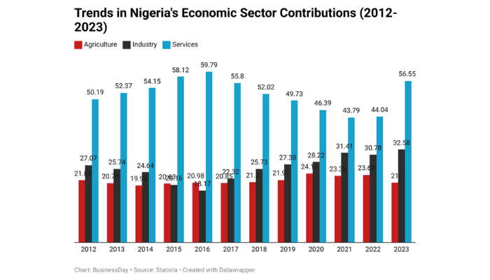
Figure 4. Showing the Trends in Nigeria’s Economic Sector Contribution from 2012 - 2023.
In order to sustain industrialization, urbanization, and technological improvements, Nigeria's economy is expected to increase, requiring a more resilient and diverse energy infrastructure [8, 17]. Nigeria needs to build a more resilient and diverse energy infrastructure in order to facilitate industry, urbanization, and technological advancement, given forecasts of sustained economic growth.
2.0 THE CASE FOR NUCLEAR ENERGY
By offering a clean, dependable, consistent source of electricity and promoting technological developments, nuclear energy has so many benefits (see Figure 5) and had contributed significantly to the economic development of many countries [20, 21].
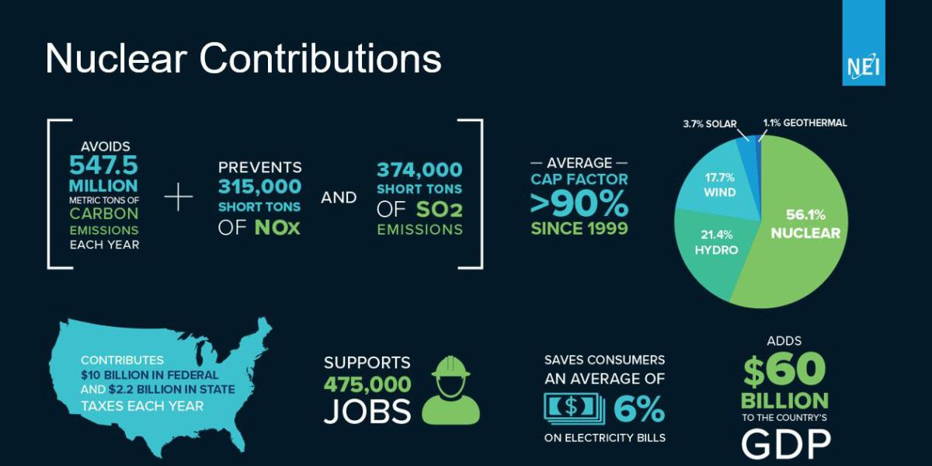
Figure 5. Showing the Contribution of Nuclear Energy in the Energy Mix (NEI).
The following are some ways that nuclear energy has aided in economic growth:
Stable Energy Supply: For steady industrial operations, nuclear energy offers a steady and uninterrupted supply of electricity [22, 23]. Nuclear power can operate continuously to provide base-load energy demands, in contrast to solar or wind power, which are sporadic.
Economic Diversification: Nigeria's economy may be diversified away from fossil fuels by incorporating nuclear energy into its energy mix [8, 17]. Nigeria could achieve energy security, spur innovation, generate employment, and build a trained labor force in high-tech industries by investing in nuclear technologies.
Reducing Greenhouse Gas Emissions: Nuclear energy provides a low-carbon substitute for fossil fuels as climate change becomes a major worldwide problem [8, 20 - 22]. Nigeria can lower its greenhouse gas emissions by switching to nuclear power, meeting its obligations under international climate agreements and advancing environmental sustainability. Nuclear energy offers a chance to lower greenhouse gas emissions as Nigeria struggles with climate change and environmental deterioration. In line with international climate goals and promoting sustainable development, it offers a low-carbon substitute for fossil fuels [7].
Attracting Foreign Direct Investment: Foreign direct investment (FDI) can be drawn to a strong nuclear energy program. A dedication to nuclear energy can increase Nigeria's attractiveness as an investment location because investors are interested in stable and dependable energy supplies [8]. Nigeria can become more appealing to foreign investors by investing in nuclear energy. When making investment decisions, a steady and dependable energy source is essential. Nigeria can establish itself as a leader in energy generation in the West African region and draw investments that would boost economic growth by building a strong nuclear sector.
Dependability and Effectiveness: It is well known that nuclear energy can produce a steady and dependable power supply [22]. Nuclear power facilities can run constantly, producing large amounts of electricity around-the-clock, in contrast to renewable energy sources like solar and wind, which depend on the weather [7]. For industries that depend on steady power for operations, this dependability is essential.
Technological Innovation and Advancement; Nigeria's total technological capabilities can be improved by investing in nuclear technology, which can spur innovation and breakthroughs in related disciplines.
Opportunities for Education: Nigeria may become a leader in nuclear education by establishing nuclear programs in universities, which can foster scientific inquiry and develop a trained workforce.
Land and Resource Efficiency: Compared to renewable energy sources like solar panels or wind turbines, nuclear reactors require relatively less land, making it possible to use available land resources more effectively [7].
As a result, highly skilled workers - including engineers, scientists, technicians, and health and safety specialists - are needed for the building, running, and maintenance of nuclear power facilities. High-value jobs are produced as a result, and a solid foundation of scientific and technical knowledge is developed that may branch out into other cutting-edge industries. Additionally, creating a nuclear program requires strict regulations and cutting-edge technology, encouraging international cooperation and technology transfer, and enhancing the country's total technological capacity [18, 19].
Beyond producing energy, nuclear technology has uses in the medical field, including the use of radioisotopes for cancer treatment, medical imaging, and equipment sterilization [5]. Agriculture: Increasing crop production and managing pests. Industry: used in process control and non-destructive testing. Utilizing nuclear energy has the potential to significantly boost economic growth and development in the Federal Republic of Nigeria, mainly by resolving the country's severe and ongoing electricity shortage [8, 17].
Nigeria's economy could benefit from the deployment of such technology in a number of ways [23, 24]: Reliable Baseload Power: Because nuclear power plants run around the clock, they provide a steady, continuous supply of electricity (baseload), which is necessary for the smooth operation of energy-intensive industries like mining and manufacturing. By reducing Nigeria's excessive reliance on gas and hydropower, nuclear power would lessen the nation's susceptibility to price swings for fossil fuels, pipeline vandalism, and seasonal variations that impact hydropower [21–24]. Investment is drawn to this long-term energy security.
2.1 Challenges to Nuclear Energy Development
Despite the benefits, Nigeria's nuclear energy growth is hampered by a number of issues: Public Perception and Awareness (Acceptance): Concerns about radiation and safety are the main causes of the public's considerable anxiety about nuclear energy [25]. To inform the public about the advantages and safety precautions related to nuclear energy, focused awareness campaigns are required. Regulatory Structure: For nuclear facilities to operate safely, a thorough regulatory framework must be established. Nigeria needs to make sure that the International Atomic Energy Agency's (IAEA) international safety standards are followed and bolster its nuclear regulatory agencies. Capital and Infrastructure: Large sums of money and sophisticated infrastructure are needed to develop nuclear power facilities. Nigeria must give financial sources and alliances with nations with nuclear technical expertise top priority. Training and Capacity Building: The operation of nuclear reactors depends on skilled personnel. Nigerians will acquire the skills required for the nuclear energy industry by funding educational and training initiatives in partnership with foreign specialists [19, 24]. Waste Management: Long-Term Remedies To reduce environmental dangers and maintain public safety, safe and efficient long-term nuclear waste disposal methods must be developed. Security and Geopolitical Risks: Maintaining high levels of security and abiding by international treaties on safety, security, and safeguards is essential given the strict international requirements for nuclear materials and technology.
2.2 Success Stories and Lessons from other Countries Operating Nuclear Energy Technology
Numerous nations throughout the world have found that nuclear energy is a valuable component of their energy strategy [5, 7]. The success stories and economic effects of countries that successfully use nuclear energy technology are discussed here.
2.2.1. France: The Nuclear Powerhouse. Success Story: After the oil crisis in the 1970s, France started a significant expansion of its nuclear energy program. The nation achieved economies of scale by building a fleet of standardized nuclear reactors. Currently, nuclear power accounts for over 70% of France's electricity production, making it one of the nations with the lowest carbon emissions. Economic Impact: By fostering a strong supply chain, the nuclear industry has directly and indirectly supported some 220,000 employments in France. Additionally, France generates income and improves energy security by exporting electricity to its neighbours. France serves as an example of the importance of a unified, long-term energy policy supported by the government.
2.2.2. South Korea: Rapid Expansion and Technology Export. Success Story: The country's APR1400 reactor was successfully exported to the United Arab Emirates in the 1970s, establishing South Korea as a major player in nuclear technology. Economic Impact: The nuclear industry is an essential component of the Korean economy, supporting thousands of jobs in construction, engineering, and operations as well as contributing to energy stability. Exports of nuclear technology have generated significant foreign revenue and improved geopolitical standing. Strong government backing in Korea was crucial in mobilizing resources and guaranteeing the development of infrastructure.
2.2.3. Canada: Diverse Energy Landscape and Environmental Stewardship. Success Story: Canada operates CANDU reactors, which are renowned for their capacity to use natural uranium and support heavy water moderation. About 15% of Canada's electricity comes from nuclear power, complementing hydroelectric and renewable sources. Economic Impact: Canada's commitment to reducing greenhouse gas emissions has bolstered investments in nuclear technology as a clean energy source; its energy policy of integrating nuclear with renewables promotes energy security and stability; and its involvement of local communities in decision-making processes has helped allay worries and increase support for nuclear technology.
2.2.4. Japan: Resilience and Innovation Post-Fukushima. Success Story: Japan temporarily closed its nuclear facilities after the Fukushima accident in 2011. Nonetheless, the nation is progressively bringing back nuclear power while enforcing strict safety regulations and advancements in reactor design. Japan has pledged to implement a long-term energy strategy that strikes a balance between nuclear and renewable energy sources. Effect on the Economy: The economy was pressured as a result of the substantial rise in fossil fuel imports brought on by the loss of nuclear energy. It is believed that reviving the nuclear industry is essential for both economic stability and energy security. Japan is positioned as a leader in nuclear safety innovation thanks to investments in cutting-edge safety systems. After the incident, Japan was able to win back the public's trust by being open and truthful about the dangers and safety precautions associated with their nuclear power program.
2.2.5. United States: Leadership in Nuclear Technology Success Story: About 20% of the country's electricity comes from the United States, which has the most nuclear reactors in operation worldwide. Innovations like next-generation reactors and Small Modular Reactors (SMRs) are driving the industry ahead [26]. Economic Impact: In the United States, local economies greatly benefit from nuclear energy. High-paying positions in engineering, skilled trades, and management are produced by nuclear facilities. For example, they support many indirect employments in the community and directly employ thousands of people. Nearly 500,000 employments are supported by the nuclear industry, which also adds $60 billion to the US economy each year. The United States is a major player in establishing worldwide safety standards and regulations since it is a leader in nuclear technology.
By striking a balance between regulation and technical growth, the United States' Nuclear Regulatory Commission (NRC) has developed principles that improve safety and permit innovation. Other nations, including Nigeria, can make well-informed judgments about incorporating nuclear energy into their energy portfolios, striving for sustainable and effective energy production while addressing safety and environmental concerns, by taking note of these success stories and lessons. Additionally, nations like Brazil, India, and South Africa have taught us important lessons about how to successfully integrate nuclear energy into their national grids. For example, since the 1970s, South Africa has included nuclear energy in its energy mix, greatly boosting both its economic growth and energy security. In order to promote nuclear energy, these countries stress the significance of robust governmental backing, public participation, and strict regulatory frameworks.
2.3 Strategic Approaches for Nuclear Energy Implementation in Nigeria
Public Awareness and Engagement; Communication Strategies: Developing community support and acceptance can be facilitated by launching extensive public awareness initiatives to educate Nigerians about the advantages and security of nuclear energy. Including Stakeholders Addressing concerns and promoting consensus can also be achieved by actively involving Nigerian businesses, environmental organizations, and local communities in nuclear energy debates. International Cooperation; Collaborations with Nuclear States: Nigeria can gain invaluable experience and simplify technology transfer by working with nations that have developed and established nuclear programs. Respecting International Standards: Nigeria's safety procedures and legal frameworks can be strengthened by conforming to international nuclear safety standards and best practices. Pilot Projects and Incremental Development: Starting pilot nuclear energy projects, such as the SMRs in Nigeria, can be a useful way to assess viability and efficacy while also developing local expertise and capacity. Phased Development: Scaling up nuclear energy projects in Nigeria gradually will enable necessary adjustments based on new technologies and insights gained. Legislative Support: The long-term success of the program depends on establishing a thorough legal and regulatory framework to govern nuclear energy development in Nigeria, including safety standards and waste management procedures.
3.0 CONCLUSION
Nigeria, a country with abundant natural resources and a growing population, is facing a serious energy issue that hinders its socioeconomic development. Nuclear energy is becoming a more attractive alternative as the nation works to diversify its energy sources and satisfy the growing demand for electricity.
A strong argument for the deliberate incorporation of nuclear energy into Nigeria's energy portfolio is made in Harnessing Nuclear Energy for Economic Growth and Development in the Federal Republic of Nigeria. It emphasizes how urgently the nation needs dependable and sustainable energy sources to meet its expanding demographic and economic goals. The research highlights the potential advantages of nuclear energy, including increased energy security, economic diversification, and major industrialization contributions. Nigeria can solve environmental issues related to climate change by using nuclear energy to meet its growing electrical needs while lowering its dependency on fossil fuels. The use of this technology can be crucial in supplying a steady energy supply, which is necessary to promote industrial growth and draw in foreign investment. However, there are issues and worries related to nuclear energy, including as public views, waste management, and safety. It has been demonstrated that establishing strong regulatory frameworks and open communication techniques is crucial to fostering public confidence and reducing concerns about nuclear technology.
This research called for cooperation between the public and private sectors as well as alliances with international organizations to manage the challenges of nuclear energy development. It also emphasized the necessity of government commitment and political will to build the infrastructure and invest in human capital required to support a nuclear energy program. Additionally, this study promotes an innovative approach to energy policy that accepts nuclear energy as a workable remedy for Nigeria's energy crisis. Nigeria may set itself up for long-term economic growth by utilizing nuclear energy, which would ultimately raise the standard of living for its people and help the country reach its development objectives.
Nigeria has a great chance to solve its energy crisis, spur economic expansion, and advance sustainable development by embracing nuclear energy. Strategic planning, public participation, and international cooperation can set the foundation for a successful nuclear energy effort, even though a number of obstacles must be overcome. Nigeria can ensure a more promising and sustainable energy future by investing in nuclear technology, which would ultimately improve the standard of living for its people and support national and economic growth.
4.0 STRATEGIC STEPS RECOMMENDED
Government, business, and civil society groups must work together to investigate the enormous potential of nuclear energy as Nigeria considers its energy future. By putting up careful planning and cooperative efforts, Nigeria may utilize this potent resource for the benefit of its people and the development of its economy. Nigeria's plan, which is presently in Phase 2 (preparatory activities) of the IAEA's Milestone Approach, must concentrate on the following in order to effectively harness nuclear energy:
Phased Deployment: Giving priority to smaller, easier-to-manage projects, such as Small Modular Reactors (SMRs), which can be more easily incorporated into a developing grid and have lower capital costs and shorter construction timetables.
Strong Financial and Legislative Frameworks: Create an all-encompassing policy framework that outlines the vision, mission, and goals for nuclear energy usage within the country, including risk-sharing arrangements and legislative incentives (credit guarantees, tax breaks) to draw in and reduce the risk of foreign private investment. Strengthen institutions like the Nigeria Atomic Energy Commission (NAEC) to ensure safety, compliance, and effective regulation of nuclear energy projects.
Increased Capacity Building and R&D: Through collaborations with foreign organizations (such as the US, Russia, China, Korea, and the IAEA), Nigeria must consistently invest in the education and training of Nigerian scientists, engineers, and technicians for knowledge transfer and capacity building. Create specialized training programs and universities in Nigeria, focused on nuclear science and engineering to develop a skilled workforce. Encourage research in innovative nuclear technologies and their applications in various sectors such as medicine, agriculture, and industry. Facilitate local inventors and scientists in developing solutions tailored to Nigeria’s unique challenges and needs.
Grid Modernization: More government initiatives should be undertaken, with a commitment to concurrent large-scale investments in modernizing and growing the country's transmission and distribution network. Improve existing infrastructure to facilitate the efficient distribution of electricity generated from nuclear sources.
Government Commitment and Sustainability: Developing a cogent nuclear energy strategy and obtaining the required resources depend heavily on the government's political will and unshakable commitment. Establish clear metrics to assess the contribution of nuclear energy to Nigeria's economic development and adjust strategies accordingly. Conduct periodic reviews of nuclear projects to ensure they meet safety standards and economic goals. Ensure that all nuclear energy initiatives are aligned with sustainable development goals, focusing on minimizing environmental impact.
Public Awareness and Engagement Strategies: In order to foster community support and acceptance, Nigeria must launch extensive public awareness campaigns educating her people about the advantages and security of nuclear energy focusing on safety, environmental sustainability, and economic potential. Additionally, engage with government agencies, private sectors, civil society organizations, and local communities to build support and address concerns regarding nuclear energy.
Economic Diversification and Job Creation: Encourage the establishment of industries in Nigeria related to nuclear energy, such as nuclear fuel production, waste management, and technology manufacturing. Focus on creating employment opportunities in renewable energy sectors alongside nuclear energy to promote sustainable development.

REFERENCES
- Abdallah, A., & Odetokun, B.O. (2023). Energy security in Nigeria: Challenges and prospects. 1.
- Okafor, B. C., (2020). Power outage and its implications for economic growth and development in Nigeria. International Journal of Research in Social Sciences, 10(2), 134-149.
- Bello, Suleiman & John, Simon & Saad, Alhassan Aliyu & Abdulqadir, A & Usman, & El-Taher, Atef. (2024). The Use of Nuclear Energy to Solve Nigeria's Energy Crisis and Help the Country Achieve its SDGs. Journal of Radiation and Nuclear Applications. 9. 77. 10.18576/jrna/090111.
- Ezrel Tabiowo. 2025. “Economic Viability of Nuclear Energy in Nigeria and the Need for Legislative Incentives and Risk Mitigation”. Journal of Energy Research and Reviews 17 (9):91–100. https://doi.org/10.9734/jenrr/2025/v17i9458.
- Furo Ebiere, Orumo Beinmotei Kenoll. Evaluation of the Security Risks Associated with the Construction and Operations of a Nuclear Power Plant in the Federal Republic of Nigeria. Journal of Nuclear Engineering & Technology. Vol. 10, № 1. JoNET (2020), pp. 15-23.
- Orumo Kenoll, Elokhin A.P., Ksenofontov A.I. Ecological and socio-economic aspects of the possible development of Nuclear Energy in the Federal Republic of Nigeria. International Journal of Nuclear Governance, Economy and Ecology. Vol. 4, No. 4. (2019), pp. 256-272.
- Orumo B. Kenoll and Agedah Ebisomu, Nuclear energy option as a viable means for generating 30% of cleaner and reliable electricity in Nigeria. Journal of Sustainable Energy & Environment (JSEE), 14 (2023) 23-30.
- Kenoll O.B. and Agedah E.C. (2024) The Need for Diversification of the Nigerian Economy through a Low-Carbon Energy Mix Programme Using Nuclear Power, International Journal of Energy and Environmental Research, 12 (2), 55-82.
- https://africa-energy-portal.org/news/nigeria-businesses-lose-29-billion-annually-poor-electricity
- International Energy Agency: Africa Energy Outlook 2019. IEA World Energy Outlook Special Report 2019; 1-288. Available at: www.iea.org/africa2019.
- Orumo K.B., Elokhin A.P., Ksenofontov A.I. Legal and economic mechanisms of environmental protection in the Federal Republic of Nigeria. / Eurasian Union of Scholars (EUS) No.6(75), Part 7, (2020), pp.13-27.
- Orumo B.K., Elokhin A.P., Ksenofontov A.I. Analysis, Adaptation and Implementation into the Legal Framework of Nigeria of Legal and Economic Mechanisms used in Protecting the Environment. Journal of Global Ecology and Environment. (2021). 13 (2): 35-48. ISSN: 2454-2644.
- Yan Shao, Zhe Yang, Yongbing Yan, Yuan Yan, Feruza Israilova, Nawal Khan, Liu Chang. Navigating Nigeria's path to sustainable energy: Challenges, opportunities, and global insight, Energy Strategy Reviews, Volume 59, 2025, 101707, ISSN 2211-467X, https://doi.org/10.1016/j.esr.2025.101707.
- Ugwoke B et al.: A Review of Nigerian Energy Access Studies: The Story Told So Far. Renewable and Sustainable Energy Reviews, Elsevier 2020; 120: 109646, 1-17; DOI: 10.1016/j.rser.2019.109646.
- Adhekpukoli Elo: The Democratization of Electricity in Nigeria. The Electricity Journal, Elsevier 2018; 31(2), 1–6; DOI: 10.1016/j.tej.2018.02.007.
- United States Agency for International Development (USAID): Power Africa in Nigeria, 2019. Available at: https://www.usaid.gov/powerafrica/nigeria.
- Orumo B.K., Elokhin A.P., Ksenofontov A.I., Burkhanov A.K. The Economy of Nigeria and the Need for Its Diversification Through the Use of Nuclear Energy. BULLETIN OF THE ALTAI ACADEMY OF ECONOMICS AND LAW, 2022, No. 6 (1), pp. 139-153.
- Еlokhin A.P., Ksenofontov A., Orumo B.K. International Cooperation on Environmental Issues in Nigeria. Environmental law. (2021), No. 2, p. 28-33.
- Orumo K.B., Elokhin A.P., Ksenofontov A.I. Some Aspects of International Cooperation on Environmental Issues in Nigeria. Global Nuclear Safety, (2021), No. 2(39), p. 25-34.
- Ejiogu Amanze Rajesh: A nuclear Nigeria: How feasible is it? Energy Strategy Reviews, Elsevier 2013; 1(4), 261–265; DOI: 10.1016/j.esr.2012.12.007.
- Umar Abubakar Malah: Nuclear Energy in Nigeria: A Policy Book. Parrésia Publishers Ltd., Lagos Nigeria, 2021, 1-148; ISBN: 978-978-59213-2-8.
- Nathaniel Lowbeer-Lewis: Nigeria and Nuclear Energy: Plans and Prospects. The Centre for International Governance Innovation, Nuclear Energy Futures Papers, 11, 2010, 1- 13; ISSN 1919-2134.
- Mari Carlo: The Costs of Generating Electricity and the Competitiveness of Nuclear Power. Progress in Nuclear Energy, Elsevier 2014; 73: 153–161; DOI: 10.1016/J.PNUCENE.2014.02.005.
- Ewim Daniel R.E. et al.: Exploring the Perception of Nigerians Towards Nuclear Power Generation. African Journal of Science, Technology, Innovation and Development, 2022; 14(4), 1059–1070; DOI: 10.1080/20421338.2021.1930848.
- Sambo Isa, Rafiu Abuh: A Quantitative Study of Public Perception on Nuclear Power in Nigeria. International Journal of Scientific Research and Engineering Development, 2019; 2(1), 41-50; ISSN: 2581-7175.
- Zaf Coelho et al.: Africa SMR Report 2022. Nuclear Business Platform, 2022; 3-4.

