Short communication
Dendrophthoe annamalayana (Loranthaceae), a new Species from Tamil Nadu, India

.
ABSTRACT

Dendrophthoe annamalayana S. Akash, K. Manikandan, and A. Rajesh sp. nov. is described and illustrated from the Villupuram District of Tamil Nadu. The species is closely allied to Dendrophthoe falcata. However, it can be easily distinguished by its leaves opposite or alternate, lanceolate, 8–10 × 1.5–2 cm, with a rounded apex, yellow margin, and petiole 2–4 mm long; bract reniform; flowers 5–5.6 cm long, golden yellow, with pedicels 6.5–7 mm long, and axis 3.5–5 cm long; corolla tube in opened flowers 4–5 cm long, and the corolla lobes on both sides dark green, 7–8 mm long; stamens 5, filaments 7–8 mm long, anthers 3–4 mm long; style 5–5.7 cm long, ovary 4.5–5 mm long, and fruit 6–8 mm long. A comparison table, detailed morphological description, and colour photograph are provided. According to IUCN guidelines 2024, version 16, the conservation status of the recorded species is Data Deficient (DD),

Keywords: Endemic species, taxonomy, Sanjeevi hill, Panamalai pettai.

1. INTRODUCTION

The genus Dendrophthoe Mart. was first described in 1830 by the German naturalist Carl Friedrich Philipp von Martius (Singh et al. 2020). The genus is closely allied to Taxillus and Scurrula, but can be readily distinguished by its morphological characters, particularly in its inflorescence and floral structure (Barlow 1990). The genus comprises approximately 35–40 accepted species distributed across Australia, tropical Africa, and Asia. India harbours seven species, of which five are endemic, along with three varieties recorded from the country (POWO 2025). Recently, Dendrophthoe gamblei L.J.Singh, Ranjan, Rasingam & J.Swamy (2020: 489), Dendrophthoe laljii Sivaram, Yugandhar & Ekka (2021: 454) and Dendrophthoe longensis L.J.Singh (2022: 55) were described from India.
During the documentation of vegetation at Sanjeevi Hill, Panamalai Pettai, the first author observed an interesting species of the genus Dendrophthoe Mart. growing parasitically on trees, and specimens were collected for identification. Upon critical examination using standard floras and relevant literature (Hooker, 1890; Gamble and Fischer, 1967; Singh, 2023; Subhashini et al., 2019; Singh and Murugan, 2013; Sivaramakrishna et al., 2021; Singh et al., 2020), and comparison with specimens from online herbaria including the Calicut University Herbarium (CALI), Madras Herbarium (MH), Linnaean Herbarium (LINN), and Central National Herbarium (CAL), the specimen did not match any known species. Therefore, the first author concluded that the collected specimen represents a new taxon. The specimen of the new species was compared with live specimens of morphologically allied taxa, namely Dendrophthoe falcata (L.f.) Ettingsh. (1872: 52). The specimen was dissected and documented with detailed photographs and illustrations. Additionally, a comparison table, distribution map, phenology, and conservation status are provided to facilitate a comprehensive understanding of the species.

2. Materials and methods

New species were collected from the study area, along with GPS coordinates and elevation data. The phenology of these species was documented over 12 months, from January 2025 to January 2026. The plant specimen was dissected under a dissection microscope and with an OLYMPUS CX31 light microscope equipped with an OPTIKA camera. Images were captured using a Nikon D5300 camera to create a Lankester Composite Dissection Plate (LCDP). A map of the study area and a distribution map were generated using QGIS, and the extent of occurrence (EOO) and area of occupancy (AOO) were estimated. The conservation status of the species was assessed according to the IUCN Red List Categories and Criteria (Version 16, 2024). Standard herbarium specimens were prepared for deposition in indexed herbaria, with the holotype deposited at the Rapinat Herbarium (RHT) and the isotype at the Madras Herbarium (MH).

3. results and discussion

3.1 TAXONOMIC TREATMENT

Dendrophthoe annamalayana S. Akash, K. Manikandan and A. Rajesh sp. nov. (Figures 1 and 2).

Type: India, Tamil Nadu, Viluppuram District, Panamalai Pettai, Sanjeevi hill, Tropical dry forest, 12°05'21.4"N 79°22'07.0"E; 69 m elev., 15 April 2025, S. Akash, K. Manikandan & A. Rajesh 657 (holotype RHT! and isotype MH!)

3.1.1 Diagnosis Dendrophthoe annamalayana is morphologically related to Dendrophthoe falcata. However, it can be easily distinguished by its leaves opposite or alternate, lanceolate, 8–10 × 1.5–2 cm, with a rounded apex, yellow margin, and petiole 2–4 mm long; bract reniform; flowers 5–5.6 cm long, golden yellow, with pedicels 6.5–7 mm long, and axis 3.5–5 cm long; corolla tube in opened flowers 4–5 cm long, and the corolla lobes on both sides dark green, 7–8 mm long; stamens 5, filaments 7–8 mm long, anthers 3–4 mm long; style 5–5.7 cm long, ovary 4.5–5 mm long, and fruit 6–8 mm long. (Table 1).

Table 1. Diagnostic characters of Dendrophthoe annamalayana and the allied species of Dendrophthoe falcata.

Characters | Dendrophthoe annamalayana | Dendrophthoe falcata
Leaf arrangement | Opposite or alternate | Opposite or decussate
Leaves | Lanceolate, apex rounded, base cuneate, | Ovate, obovate or elliptical, apex acute, obtuse or retuse, base cuneate or attenuate
Leaf size | 8–10 × 1.5–2 cm | 14–16 × 7–9.5 cm
Leaf margin | Entire and undulate, border yellow colour | Entire and undulate, border red colour
Petiole | 2–4 mm long | 5-8 mm long
Flower length | 5–5.6 cm long, golden yellow | 3.8–4 cm long, dark red
Axis | 3.5–5 cm long | 4–8 cm long
Bract | Reniform 1-2mm | Round 1.5-1.8 mm
Pedicel | 6.5–7 mm | 2.7–3.1 mm
Corolla | 7–8 mm, dark green on both sides | 1.3–1.4 cm, above yellowish to red and below pale red
Corolla-tube in the open flower | 4–5 cm long | 2.8–3.1 cm
Stamen | 5 | 4–5
Anther | 3–4 mm long | 6–6.2 mm long
Filament | 7–8 mm long | 5.4–6.8 mm long
Style | 5–5.7 cm long | 4.3–4.5 cm long
Ovary | 4.5–5 mm long | 3.5–4 mm long
Fruit | 6–8 mm long | 1.3–1.5 cm long

3.1.2 Description Perennial evergreen hemiparasitic plant up to 50–80 cm long with a haustorial root attached to the host plant. Stem woody, solid, cylindrical, weak, 2–3 cm in diameter and much irregularly branched at the base, bark green to brown, cracked when mature, glabrous. Leaves cauline and ramal, opposite or alternate, lanceolate, 8–10 × 1.5–2 cm, apex rounded, base cuneate, margin entire and undulate with yellowish white border, reticulate venation, red colour veins in abaxial side, surface adaxial dark green and abaxial pale green, leathery, glabrous, petiole 2–4 mm exstipulate. Inflorescence axillary raceme, 15–25 flowered, axis 3.5–5 cm long, glabrous. Bract 1, reniform, apex round, 1–2 × 2–4 mm, margin entire, green, glabrous, attached to the base of the ovary. Flower 5–5.6 cm long, pedicel 6.5–7 mm long, zygomorphic, hermaphrodite, epigynous ovary, valvate aestivation. Calyx 1, fused, tubular shape, 1 × 1 mm, dark green, glabrous. Corolla is fused to form a tubular, tube 4–5 cm long, slightly curved, golden yellow in colour, glabrous, tube splitting into five equal lobes, lobes linear-oblanceolate, apex acuminate, 7–8 × 2–3 mm long, deflexed, margin entire, dark green, glabrous. Stamen 5, filament 7–8 mm long, alternisepalous, didymous, epipetalous, exserted, adnate, yellowish green colour, glabrous, anthers 3-4 mm long, linear, apex obtuse, brown colour. Stigma 0.2 mm diameter, globular or ovate, simple, grey colour, style 5–5.7 cm long, terminal, green, glabrous. Ovary 4.5–5 × 2–2.5 mm, nectriferous, cylindrical, glabrous, green. Fruit 6-8 mm long and 4 mm in diameter, ellipsoid, persistent calyx at the apex of the fruit, green to red when ripe, glabrous. Seed 1, size 2.5– 3 × 1.5–2 mm, ovate.

3.1.3 Etymology The epithet of the new taxa is named after the study institution of Annamalai University.

3.1.3 Phenology September to February.

3.1.4 Distribution and ecology Dendrophthoe annamalayana is currently known only from the tropical dry forest of Sanjeevi Hill, Panamalai Pettai, Viluppuram District, Tamil Nadu, India, where it grows hemiparasitically on host plants such as Azadirachta indica A. Juss. (1830 publ. 1831: 221), Mangifera indica L. (1753: 200), Casuarina equisetifolia L. (1759: 143), Syzygium cumini (L.) Skeels (1912: 25), Albizia lebbeck (L.) Benth. (1844: 87), and Lannea coromandelica (Houtt.) Merr. (1938: 353).

3.1.5 Conservation status: The species is currently known only from the type locality of Sanjeevi Hill, Panamalai Pettai, with 346 individuals distributed within an Area of Occupancy (AOO) of 24.000 km² and an Extent of Occurrence (EOO) of 5.901 km², estimated using the Geospatial Conservation Assessment Tool (GeoCAT). However, due to the lack of additional distributional data, the species is here proposed as Data Deficient (DD) following the IUCN Red List Categories and Criteria (Version 16, 2024).

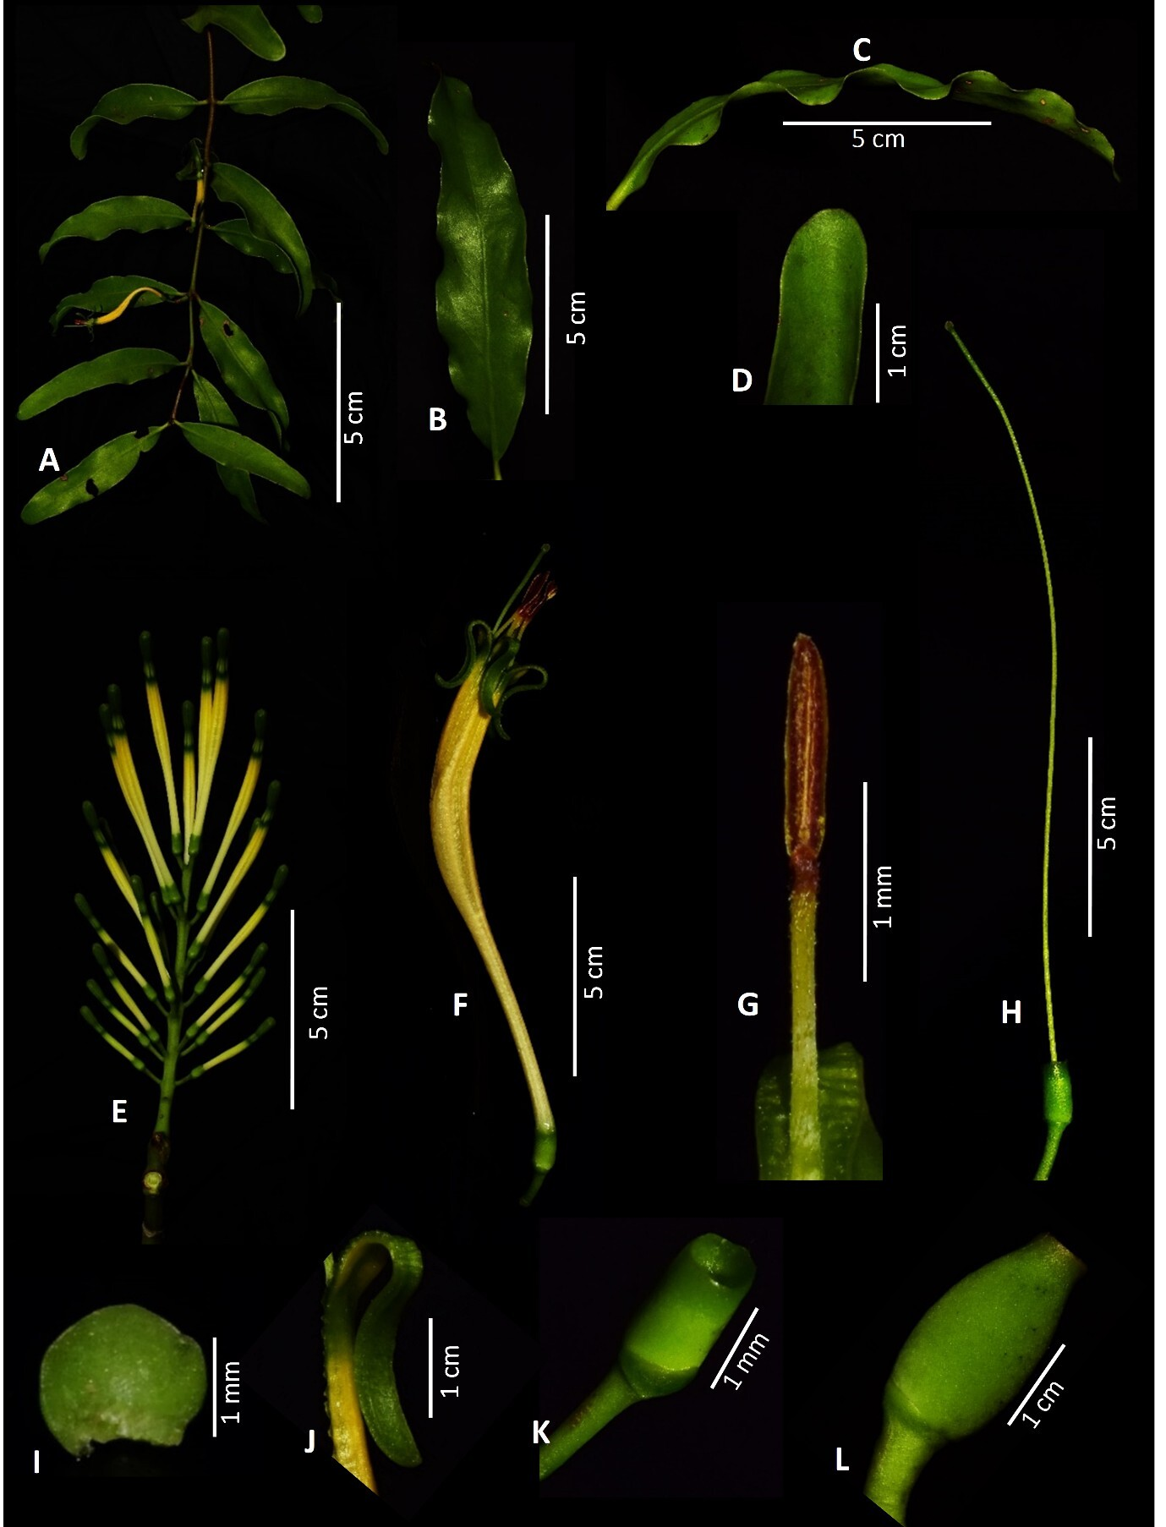

Fig. 1. A Flowering twig; B Leaf; C Leaf margin; D Leaf apex; E Inflorescence; F Flower; G Stamen; H Gynoecium; I Bract; J Corolla; K Calyx; L Fruit.
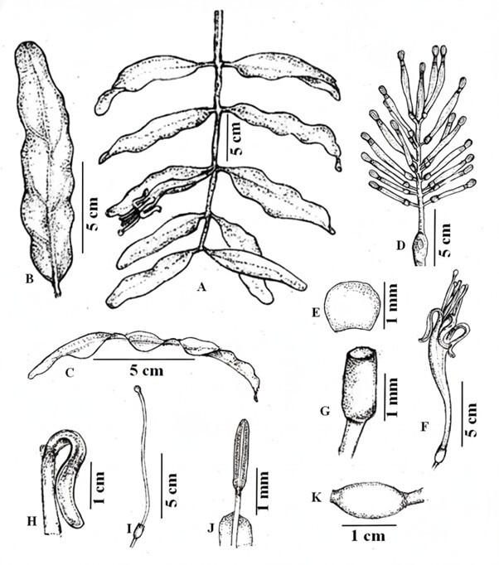

Fig. 2. A Flowering twig; B Leaf; C Leaf margin; D Inflorescence; E Bract; F Flower; G Calyx; H Corolla; I Gynoecium; J Stamen; K Fruit.
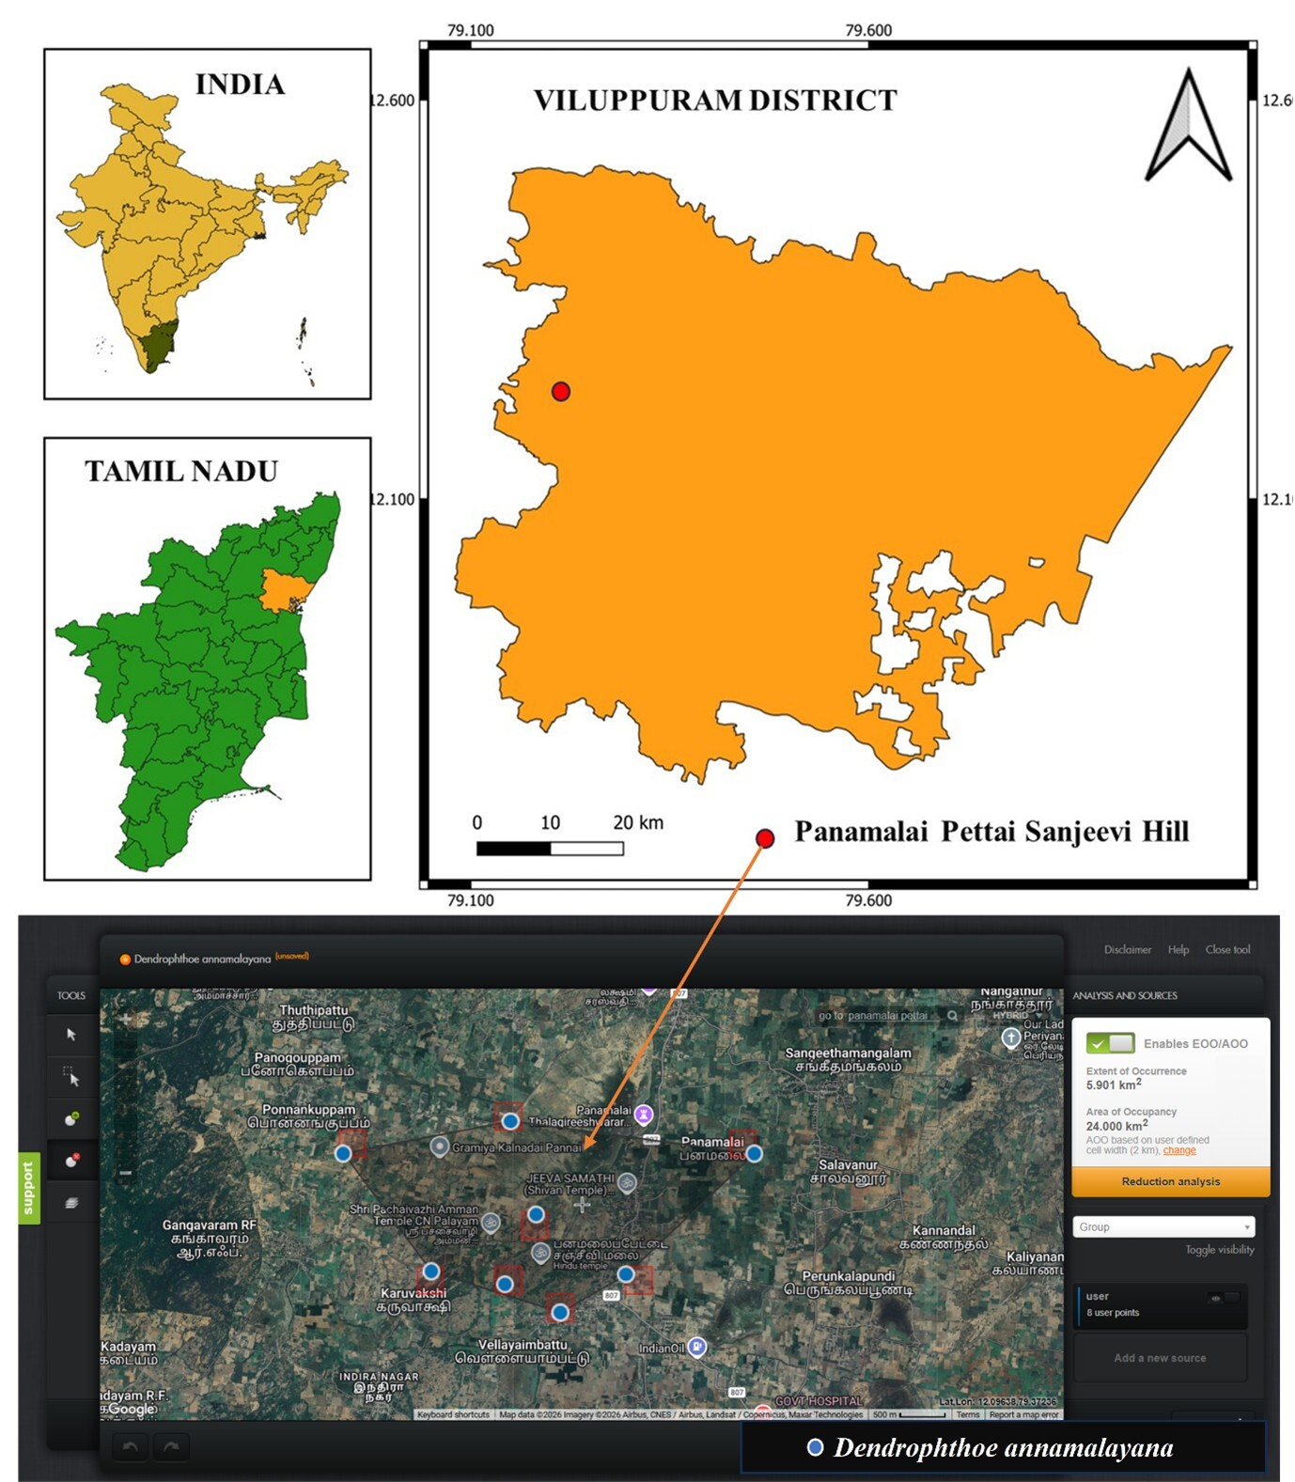

Fig. 3. The study area map shows the distribution of Dendrophthoe annamalayana S. Akash, K. Manikandan and A. Rajesh sp. nov.

4. Conclusion
The new spcies is easily identified by leaves opposite or alternate, lanceolate, 8–10 × 1.5–cm, with a rounded apex, yellow margin, and petiole 2–4 mm long; bract reniform; flowers 5–5.6 cm long, golden yellow, with pedicels 6.5–7 mm long, and axis 3.5–5 cm long; corolla tube in opened flowers 4–5 cm long, and the corolla lobes on both sides dark green, 7–8 mm long; stamens 5, filaments 7–8 mm long, anthers 3–4 mm long; style 5–5.7 cm long, ovary 4.5–5 mm long, and fruit 6–8 mm long.

Disclaimer (Artificial Intelligence)
Author(s) hereby declare that NO generative AI technologies such as Large Language Models (ChatGPT, COPILOT, etc.) and text-to-image generators have been used during the writing or editing of this manuscript.

Competing interests

The authors declare no compteting of intrests.

Consent

The authors declare that they have no objections to the publication of this manuscript.

Ethical approval

The plant material was collected from an unreserved forest area, and no specific permission was required. All collections were carried out in compliance with institutional and national guidelines.

References

Barlow, B. A. (1990). Biogeographical relationships of Australia and Malesia: Loranthaceae as a model. In C. G. G. J. van Steenis (Ed.), The plant diversity of Malesia: Proceedings of the Flora Malesiana Symposium commemorating Professor Dr. C. G. G. J. van Steenis, Leiden, August 1989 (pp. 273–292). Dordrecht: Kluwer Academic Publishers.
Cook, O. F., & Doyle, W. T. (1912). The coconut palm in the Philippines. Bulletin of the Bureau of Plant Industry, United States Department of Agriculture, 248, 25.
Danser, B. H. (1938). A revision of the genus Dendrophthoe (Loranthaceae). Journal of the Arnold Arboretum, 19, 353.
Desrousseaux, L. A. J. (1831). Mémoire sur quelques espèces de plantes nouvelles. Mémoires du Muséum d’Histoire Naturelle, 19, 221.
Don, G. (1844). Description of new species. The London Journal of Botany, 3, 87.
Gamble, J. S., & Fischer, G. E. C. (1967). Flora of the Presidency of Madras (Vol. 2). Calcutta: Botanical Survey of India.
Hooker, J. D. (1890). The flora of British India (Vol. 5). London: L. Reeve & Co.
IUCN. (2024). Guidelines for using the IUCN Red List categories and criteria (Version 16). IUCN Standards and Petitions Committee. Available from: https://www.iucnredlist.org/documents/RedListGuidelines.pdf
Linnaeus, C. (1753). Species Plantarum (Vol. 1, p. 200). Stockholm: Laurentius Salvius.
Linnaeus, C. (1759). Amoenitates Academicae (Vol. 4, p. 143). Stockholm: Laurentius Salvius.
POWO. (2025). Plants of the World Online. Royal Botanic Gardens, Kew. Available from: https://powo.science.kew.org/
Singh, L. J., & Murugan, C. (2013). Genus Dendrophthoe Mart. (Loranthaceae) from Bay Islands with a new record for India and inventory of host species. Genus.
Singh, L. J. (2023). Dendrophthoe longensis L. J. Singh, a new species of Dendrophthoe (Loranthaceae) from Andaman and Nicobar Islands, India. Feddes Repertorium, 134(1), 54–65. https://doi.org/10.1002/fedr.202200034
Singh, L. J., Ranjan, V., Rasingam, L., & Swamy, J. (2020). A new species of genus Dendrophthoe Mart. (Lorantheae–Loranthaceae) from peninsular India. Journal of Asia-Pacific Biodiversity, 13(3), 487–493. https://doi.org/10.1016/j.japb.2020.03.017
Sivaramakrishna, P., Yugandhar, P., & Ekka, G. A. (2021). A new species, Dendrophthoe laljii (Loranthaceae), infesting Artocarpus heterophyllus Lam. (Moraceae) in Andaman and Nicobar Islands, India. Journal of Asia-Pacific Biodiversity, 14(3), 452–459. https://doi.org/10.1016/j.japb.2021.03.010
Subhashini, K., Kumar, P. R., & Gaddeyya, G. (2019). A comprehensive review on Dendrophthoe falcata (L.f.) Ettingsh. (Loranthaceae). Tropical Plant Research, 6(3), 514–520. https://doi.org/10.22271/tpr.2019.v6.i3.064.

