Case report
Black Hairy Tongue: Clinical Presentation and Successful Conservative

13
14 ABSTRACT
Aims: Black hairy tongue is a benign oral condition characterized by elongation and discoloration of the filiform papillae on the dorsal surface of the tongue. It is commonly associated with poor oral hygiene, smoking, and certain medications.

Case Presentation:
We report a case of black hairy tongue in a patient presenting with discoloration and coating over the dorsal surface of the tongue. There was no significant medical or drug history. Clinical examination revealed elongated, pigmented filiform papillae. The condition was diagnosed based on clinical findings.

Management and Outcome:
The patient was managed with conservative measures including improvement of oral hygiene, tongue brushing, and patient education. Significant clinical improvement was observed over follow-up visits.

Conclusion:
Black hairy tongue is a benign and reversible oral condition that can be effectively managed with conservative measures. Early diagnosis, patient reassurance, and maintenance of proper oral hygiene play an important role in successful treatment and prevention of recurrence.

15
16 Keywords: Black hairy tongue; Filiform papillae; Oral pigmentation; Conservative
17 management; Denture hygiene
18
19 1. INTRODUCTION

20 Black hairy tongue (BHT) is a benign, acquired condition of the oral cavity characterized by
21 elongation and defective desquamation of the filiform papillae on the dorsal surface of the
22 tongue, resulting in a characteristic “hairy” appearance. The discoloration may range from
23 black to brown, yellow, or green due to the accumulation of chromogenic microorganisms,
24 food debris, and extrinsic staining factors.[1]
25 The condition is relatively uncommon, with a reported prevalence of less than 1% in the
26 general population, although higher rates have been observed in elderly individuals and
27 those with predisposing factors.[2] The pathogenesis involves impaired desquamation of the
28 keratinized layer of filiform papillae, leading to their hypertrophy and elongation, which in turn
29 promotes retention of debris and microorganisms.[3]

30 Several contributing factors have been implicated, including poor oral hygiene, tobacco use,
31 excessive intake of coffee or tea, xerostomia, and the use of certain medications such as
32 antibiotics.[4] However, in some cases, no clear etiological factor can be identified, making
33 diagnosis primarily clinical.

34 Clinically, BHT is usually asymptomatic and often detected incidentally, though some
35 patients may present with halitosis, altered taste sensation, or aesthetic concerns. Despite
36 its striking appearance, the condition is benign and carries no risk of malignant
37 transformation. [5]

38 Management is primarily conservative and includes elimination of predisposing factors,
39 maintenance of proper oral hygiene, and mechanical debridement of the tongue. Most cases
40 respond well to these measures, with gradual resolution.

41 The present case report describes the clinical presentation and successful conservative
42 management of black hairy tongue in an elderly patient, emphasizing the importance of early
43 recognition and patient education.

44 2. CASE PRESENTATION

45 A 72-year-old male patient presented to the outpatient department with a chief complaint of
46 persistent dark discoloration of the tongue for the past 2–3 years. The patient reported no
47 associated symptoms such as pain, burning sensation, altered taste, or halitosis. His primary
48 concern was the aesthetic appearance of the tongue.

49 The patient’s medical and drug history was non-contributory. There was no history of
50 tobacco use, alcohol consumption, or other deleterious oral habits. However, the patient had
51 been a complete denture wearer for the past 7 years.

52 On intraoral examination, the dorsal surface of the tongue, predominantly involving the
53 posterior two-thirds, exhibited a diffuse blackish-brown discoloration with a characteristic
54 hairy or carpet-like appearance. The lesion was non-scrapable and demonstrated elongated
55 filiform papillae. The lateral borders and tip of the tongue appeared relatively normal, with
56 preserved mucosal integrity. (Figure 1).

57 Based on the clinical findings, a diagnosis of black hairy tongue was established. No
58 additional laboratory investigations were performed, as the diagnosis was made clinically
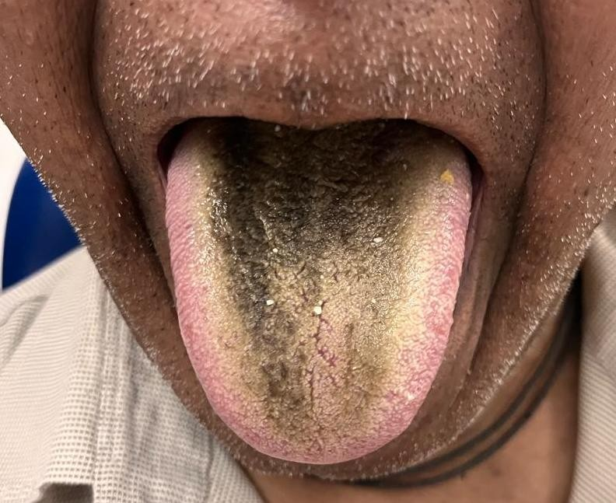

Figure 1: Dorsal surface of the tongue showing blackish brown discoloration with elongated filliform papillae characteristics of black hairy tongue

59
60 2.1 Management

61 Mechanical debridement:
62 The patient was instructed to perform gentle brushing of the dorsal surface of the tongue
63 twice daily using a soft toothbrush, along with the use of a tongue cleaner/scraper to aid in
64 removal of elongated filiform papillae.

65 Oral hygiene maintenance:
66 Reinforcement of optimal oral hygiene practices including regular tooth brushing and
67 cleansing of the oral cavity.

68 Adjunctive mouthwash therapy:
69 The patient was advised to use an antiseptic mouthwash (chlorhexidine 0.12% or hexetidine
70 mouthwash) once daily to reduce microbial load and prevent further accumulation of debris.

71 Hydration:
72 Adequate fluid intake was encouraged to reduce oral dryness and facilitate natural
73 desquamation.

74 Denture hygiene:
75 Considering the patient’s long-term denture use, instructions were given for:

76 • Regular cleaning of the denture
77 • Removal during night time
78 • Use of appropriate denture cleansing solutions

79 Patient education and reassurance:
80 The patient was reassured about the benign and reversible nature of the condition and
81 motivated to maintain compliance with oral hygiene measures. Follow-up
82 2.2 Follow up

83 At follow-up, the patient showed marked reduction in pigmentation and improvement in the
84 texture of the tongue, with gradual resolution of the hairy appearance, confirming a favorable
85 response to conservative management. (Figure 2).”

86
87
88

89

90
91
92
93
94
95
96
97
98
99
100
101
102
103
104
105
106
107
108
109
Antifungal agents and keratolytic therapies have been reported in literature; however, they were not indicated in the present case due to absence of infection and satisfactory response to conservative measures

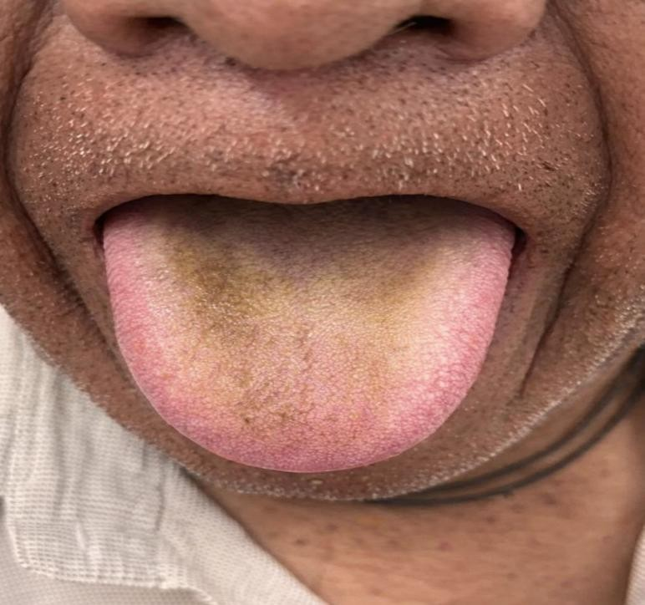Figure 2: Post treatment images showing reduction in pigmentation and improvement in tongue appearance.

3. DISCUSSION

Black hairy tongue (BHT), or lingua villosa nigra, is a benign clinical entity characterized by the marked hypertrophy and elongation of the filiform papillae on the dorsal surface of the tongue [1,2]. While historical reviews from 1939 and 1940 describe BHT as a condition of “ little clinical significance ,” it remains a source of significant aesthetic concern and diagnostic interest in oral medicine [ 12,17]. Pathogenesis and Architectural organization - The primary defect in BHT is the failure of the filiform papillae to undergo normal desquamation, leading to an accumulation of keratin [2,6,8]. Under normal physiological conditions, these papillae are less than 1 mm in length, however, in BHT, they can reach lengths exceeding 12 to 18mm. [9]
The 3- dimensional cytoarchitecture of this condition was detailed by Manabe et al, who showed that “hairs” are secondary papillae composed of a central column of epithelial cells expressing hair- type keratins [4,11] These structures fail to shed, creating what early researchers described as a “field of corn laid low by the wind”[12,17]. Scanning electron microscopy further confirms that these elongated papillae consist of accumulated keratinized layers that trap debris and chromogenic microorganisms.[7] Etiology in the Edentulous Patient – While BHT is frequently associated with tobacco use and antibiotic therapy, cases
110
111
112
113
114
115
116
117
118
119
120
121
122
123
124
125
126
127
128
129
130
131
132
133
134
135
136
137
138
139
140
141
142

143
144
occurring in the absence of these factors- as seen in the present case- highlight the importance of local oral environment shifts[1,15]. In edentulous patients, long-term denture wear (7 years in this case) plays a critical role in the pathogenesis.
According to literature on older edentulous individuals, the presence of prosthesis can alter the oral microfolra and decrease the natural mechanical friction between the tongue and hard palate during mastication and speech. [2,13] This lack of “mechanical debridement” is a key factor in the retention of keratinized layers on the filiform papillae.[1,8]. Furthermore, dentures can act as a reservoir for chromogenic (porphyrin-producing) bacteria and fungi, which migrate to the dorsal tongue and produce the characteristic black pigmentation within
the elongated papillae. [1316]
Differential Diagnosis in Oral Medicine- From a diagnostic perspective, it is essential to distinguish BHT from oral hairy leukoplakia (OHL)-a viral condition associated with the Epstein- Barr virus – and pseudo-BHT, which involves extrinsic staining of the tongue without the hallmark papillary hypertrophy. [2,8,15]The success of conservative management through mechanical debridement and improved oral hygiene in this case further confirms the diagnosis of true BHT by addressing the defective desquamation of the filiform papillae.[1,10]

4. CONCLUSION
Black hairy tongue is a benign and reversible oral condition that can be effectively managed with conservative measures. Early diagnosis, patient reassurance, and maintenance of proper oral hygiene play an important role in successful treatment and prevention of recurrence.

COMPETING INTERESTS
Authors have declared that no competing interests exist

CONSENT (WHERE EVER APPLICABLE)
Written informed consent was obtained from the patient for publication of this case series and accompanying images.

REFERENCES

145 | 1. | Gurvits GE, Tan A. Black hairy tongue syndrome. World J Gastroenterol.
146 |  | 2014;20(31):10845-50.
147 | 2. | Schlager E, St Claire C, Ashack K, Khachemoune A. Black hairy tongue: predisposing
148 |  | factors, diagnosis, and treatment. Am J Clin Dermatol. 2017;18(4):563-9.
149 | 3. | Thompson DF, Kessler TL. Drug-induced black hairy tongue. Pharmacotherapy.
150 |  | 2010;30(6):585-93.
151 | 4. | Manabe M, Lim HW, Winzer M, Loomis CA. Architectural organization of filiform papillae
152 |  | in normal and black hairy tongue epithelium. Arch Dermatol. 1999;135(2):177-81.
153 | 5. | Acosta Torres J, Matamoros Fernández S, Santamarina Álvarez L, López Toro ML. Lengua
154 |  | vellosa negra en lactante [Black hairy tongue in infant]. Rev Cubana Pediatr.
155 |  | 2022;94(2):e1521. Spanish.
156 | 6. | Vañó-Galván S, Jaén P. Black hairy tongue. Cleve Clin J Med. 2008;75(12):847-8.
157 | 7. | Harada Y, Gaafar H. Black hairy tongue: a scanning electron microscopic study. J Laryngol
158 |  | Otol. 1977;91(1):91-6.
159 | 8. | Reamy BV, Derby R, Bunt CW. Common tongue conditions in primary care. Am Fam
160 |  | Physician. 2010;81(5):627-34.

 | 161 | 9. | Hamad Y, Warren DK. Black hairy tongue. N Engl J Med. 2018;379(10):e16.
 | 162 | 10. | Okumura H, Kawashima A. Black hairy tongue due to antibiotics. BMJ Case Rep.
 | 163 |  | 2023;16(8):e255112.
 | 164 | 11. | Aryal E, Rajbhandari M, Bhattarai S. Lansoprazole-induced black hairy tongue: a case
 | 165 |  | report. Nepal J Dermatol Venereol Leprol. 2017;15(1):54-7.
 | 166 | 12. | Swinburne G. Black hairy tongue. J Laryngol Otol. 1939;54(7):386-99.
 | 167 | 13. | Ren J, Zheng Y, Du H, Wang S, Liu L, Duan W, et al. Antibiotic-induced black hairy
 | 168 |  | tongue: two case reports and a review of the literature. J Int Med Res.
 | 169 |  | 2020;48(10):300060520961279.
 | 170 | 14. | Khasawneh FA, Moti DF, Zorek JA. Linezolid-induced black hairy tongue: a case report. J
 | 171  172  173 | 15. | Med Case Rep. 2013;7:46.  Tsioutis C, Symvoulidis P, Haralambous MS, Lambrianides S, Zavridis P, Papakostas P, et al. Black hairy tongue syndrome: case report and review of the literature. BioMed.
 | 174 |  | 2025;5(4):22.
 | 175 | 16. | Unal O, Turker AH, Akcam FZ. A case report of black hairy tongue (melanotrichia linguae
 | 176 |  | or lingua pilosa nigra). Cureus. 2024;16(5):e60685.
 | 177 | 17. | Kennedy CB, Howles JK. Black hairy tongue: a report of three cases. Arch Derm Syphilol.
 | 178 |  | 1940;42(4):566-9.
179

