Evaluation of the physicochemical and biochemical composition of seeds from vigorous plants of Hibiscus cannabinus L. grown in Burkina Faso

ABSTRACT
Aims: Hibiscus cannabinus L. is used as a leafy vegetable in many countries, but its seeds also have high nutritional value. It is a multipurpose plant offering numerous socioeconomic benefits in Burkina Faso. However, the plant is facing genetic erosion due to the introduction of exotic vegetables. Awareness is therefore necessary to establish the scientific basis for its nutritional potential, thereby reviving interest in the use of the seeds in the diet. Hence the relevance of this study, which aims to deepen understanding of the mineral and nutritional value of Hibiscus cannabinus L. seeds.
Methodology: The study involved fifteen (15) samples of powder derived from the seeds. They were shade-dried and stored in the laboratory of the Plant Genetics and Breeding Team (EGAP).
The determination of moisture, ash, fat, protein, and carbohydrate content began with the collection of a 5-g sample; in accordance with the protocols of the respective standards, the content of each parameter was determined using appropriate formulas. The contents of K, Mg, Ca, Fe, Zn, and Na were measured by atomic absorption spectrophotometry according to the AOAC (1990) digestion method using strong acids and 0.5 g of ash obtained from the complete incineration of each sample.
Results: The results show calcium contents ranging from 10.50 mg/100 g to 0.5 mg/100 g, and iron contents ranging from 1.05 mg/100 g to 0.3 mg/100 g. The potassium, magnesium, sodium, and zinc ranged from 38 mg/100 g to 58 mg/100 g; 25 mg/100 g to 37 mg/100 g; 23 mg/100 g to 65 mg/100 g; and 1.25 mg/100 g to 4.5 mg/100 g, respectively.
Conclusion: These results indicate that Hibiscus cannabinus L. could be an important source of minerals and play a significant role in improving the nutritional intake of rural and urban populations. It therefore appears necessary to encourage the cultivation, consumption, and commercial utilization of Hibiscus cannabinus L. seeds.

Keywords: Hibiscus cannabinus L., biochemical and mineral composition, vigorous plants, Burkina Faso.
- Introduction
Hibiscus cannabinus is a plant belonging to the Malvaceae family(Onyeukwu et al., 2023). This species is an herbaceous plant characterized by its highly fibrous nature. Hibiscus cannabinus has traditionally been used for its therapeutic properties(Szymański et al., 2024). In addition to being prized for its nutritional value, it is a plant that commands admiration among populations in both rural and urban areas(Borelli et al., 2020). This widespread interest in this multifaceted plant can be attributed to the variety of products derived from it, as well as the ease with which it can be cultivated (Chaachouay et al , 2024). Beyond its many practical applications, this plant is also regarded as an ornamental species—a fact that explains its cultivation in local gardens(Francini et al., 2022). Hibiscus cannabinus is an industrial plant whose seeds are rich in nitrogenous matter (21.4%), oil (20.4%), and potassium ash (6%) (Shikha et al., 2023a). According to Shen (2022), the oil has anticarcinogenic properties. According to Latifah (2011.), it is cytotoxic to ovarian cancer cells. The oil has phytotoxic, fungitoxic, and antioxidant properties. Due to it high content of unsaturated fatty acids and low phenolic pigment content, it is an essential source for health (cholesterol reduction) and growth (Rudzińska et al., 2023). All of the essential nutrients and micronutrients contained in this plant make it critically important in the fight against childhood malnutrition and nutritional deficiencies (Wakeel et al., 2018). Consequently, to better explore its nutritional potential, research has been conducted by researchers around the world to assess the plant’s nutritional value. For example, phytochemical studies indicate that the seeds contain an average of 23.7% oil, 21.4% nitrogenous matter, and 12.9% crude fiber (Ojelere, 2016). The oil extracted from the seeds has a high content of unsaturated fatty acids, which are essential for health and normal growth, as well as for lowering blood cholesterol levels. This oil contains 45.3% oleic acid, 23.4% linoleic acid, 14% palmitic acid, and 6% stearic acid (Ojha et al., 2024). Plant-based products are enjoying renewed confidence in light of new approaches to local consumption(Sharma et al., 2024). This trend is also underpinned by the need to support these approaches with high-quality scientific data. The "consume local" policy is a key driver of development actively promoted in Burkina Faso(Patel, 2020). Products derived from Hibiscus cannabinus L. are highly prized for their nutritional and functional potential (Shikha et al., 2023b). In Burkina Faso, the seeds are most commonly consumed by the Mossi and Gurunsi ethnic groups, where they are processed into a spice called “bicalga” by the Mossi and “gio-sola” by the Gurunsi-Lyele (Nikodème et al., 2019). However, the plant is facing genetic erosion due to the introduction of exotic vegetables (FAO, 2013). Awareness is therefore necessary to establish the scientific basis for its nutritional potential, in order to revive interest in the use of the seeds in the diet. Hence the relevance of this study, which aims to evaluate the physicochemical and biochemical composition of the seeds of several accessions of Hibiscus cannabinus L. cultivated in Burkina Faso. Specifically, the study will determine the content of minerals and macronutrients and assess the relationships among these evaluated parameters.
- Materials and Methods
2.1 Plant Material
The plant material consisted of 15 samples of Hibiscus cannabinus seeds, selected following the harvest of seeds from propagation carried out from July to October 2025 at the experimental site of the Institute for Rural Development (IDR) in Gampela, a locality located in Kadiogo Province at 12°15’ north latitude and 1°12’ west longitude. The climate is of the Sudano-Sahelian type with an average annual precipitation of 852.7 mm and 850 mm recorded per year (Yaméogo, 2024). The soil texture is predominantly sandy loam, consisting of 32.5% fine silt, 23.98% coarse silt, 21.32% fine sand, and 3.2% coarse sand. The 15 samples were selected based on seed consistency. They were subsequently ground into powder using a NINJA brand electric blender and finally sieved to obtain the powder. This phase and the subsequent work were carried out at the National Public Health Laboratory (L.N.S.P), now known as the “National Agency for Environmental, Food, Occupational, and Health Product Safety (ANSSEAT),” from October 8 to 22, 2025.
2.2 Evaluation of biochemical and mineral composition
Powder samples of Hibiscus cannabinus L. seeds were analyzed to determine their physicochemical and nutritional parameters, including moisture content, ash content, fat content, protein content, carbohydrate content, and mineral content (K, Mg, Ca, Fe, Zn, and Na). The moisture content was determined by differential weighing after drying in an oven at 105 ± 2 °C according to standard NF V03-707 (2025). Ash content was determined by differential weighing after oven drying the samples in accordance with standard NF EN ISO 2171 (2021a). The lipid content of the samples was determined by the Soxhlet method, in accordance with standard ISO 659 (2021b). Protein content was determined using the Kjeldahl method (AOAC, 1984) in accordance with NF V03-050 (2019). (Nielsen, 2024) The determination of these parameters began with the collection of 5 g of a powdered sample of young Hibiscus cannabinus leaves. In accordance with the protocols of the respective standards, the content of the various parameters was determined using the formulas listed in Table I.
The minerals were determined by atomic absorption spectrophotometry according to the AOAC digestion method (2016) using strong acids. Thus, 0.5 g of ash from the incineration of each sample powder was dissolved in 31 mL of a mixture consisting of perchloric acid (11.80 mol/L), nitric acid (14.44 mol/L), and sulfuric acid (18.01 mol/L). The resulting mixture, thoroughly stirred under a fume hood, was heated on a hot plate until thick white fumes appeared. The reaction mixture was then cooled on the lab bench for 10 min, then diluted in 50 ml of distilled water. It was brought to a boil again for 30 minutes, then cooled under the same conditions. The mixture was then filtered through Whatman filter paper, and the filtrate was made up to the mark on the flask (50 mL) with distilled water. The content of each mineral element was determined using a VARIAN AA.20 flame atomic spectrophotometer at a specific wavelength by comparison with standard solutions. The contents were expressed in mg/100 g of dry matter (DM).

Table I: Formulas used for estimating physicochemical parameters

N⁰ | Parameters | Formulas used
1 | moisture (%) | H (%) = [Pe - (Pf-Pv) / Pe] x 100
2 | Ash (%) | C (%) = (Pf – Pv / Pe) x 100
3 | Fat (%) | MG (%) = [Pf – Pv / Pe] x 100
4 | Protein (%) | P (%) = [N (%) x 6,25] ; N (%) = [0,014 x 0,1 x (Ve - Vb) x 100] / Pe
5 | Glucides (%) | G (%) = 100 – [H (%) + P (%) + MG (%) + C (%)]
Pe: test sample; Pf: final weight (weighing pan + dehydrated sample, or crucible + calcined sample, or flask + fat); Pv: empty weight of weighing pans, crucibles, or flasks in g; Ve: burette drop (sample), Vb: burette drop (blank), 0.1: sulfuric acid strength, 0.014: molar weight of nitrogen × 10⁻³, 6.25: conversion factor to sulfuric acid equivalent.

2.3 Collection of morphological data
The characteristics of vigorous genotypes are illustrated by seven (07) quantitative variables derived from the H. cannabinus descriptor of the National Bureau of Plant Genetic Resources. With the exception of the number of days to 50% flowering (DFL), which was assessed across the entire line, the other six (06) quantitative traits were measured at the flowering stage on four plants randomly selected per line (Table II).
Table II : Quantitative variables of H. cannabinus genotypes and measurement techniques

Parameters | Measurement Techniques
Date of flowering (DFL)  [days] | By counting the number of days between sowing and flowering of at least 50% of the plants in the entire row containing the accession
Plant height (HPL)  [m] | Measured from the ground to the top leaf of the main stem using a well-calibrated ruler
Stem diameter (SD)  [cm] | Measured at the stem base using a caliper
Fruit length (FL)  [cm] | Determined by measuring 4 fruits from the four selected plants using a tape measure
Fruit diameter (FD)  [cm] | Determined by measuring 4 fruits from the four selected plants using a caliper
Number of fruits (NFR) | Determine by counting the total number of fruits on the four selected plants
Weight of 100 seeds (PCG)  [g] | Determine by weighing 100 dry seeds per plant

2.4 Statistical Analysis of the Data
Excel 2016 was used for data entry and table management. The collected data were analyzed using the statistical software R version 4.0.3 (R Core Team 2020). Thus, analysis of variance (ANOVA), followed by Pearson’s correlation matrix, was performed to compare and establish relationships between the agro morphological parameters of Hibiscus cannabinus and the physicochemical and biochemical parameters of the leaves. The data were presented as means with corresponding standard deviations, and each experiment was conducted in a series of two separate replicates (n = 2) for the physicochemical parameters (water, ash, Fe, Mg, Ca, Zn, K, Na) and three separate replicates (n = 3) for the biochemical parameters (lipids, proteins, carbohydrates). To characterize the collected samples based on their physicochemical and nutritional profiles, a principal component analysis (PCA) was performed using only the parameters that could distinguish between accessions. In addition, a global heat map of performance was created to evaluate the specific performance of the accessions, which resulted in the grouping of individuals based on phenotypic and chemical similarity using Hierarchical Classification.

- Results
Analysis of variance reveals heterogeneity among the accessions studied, as evidenced by the high variability of agro morphological, biochemical, and physicochemical parameters relative to the mean (Table I). This variability is partly explained by the high values of the standard deviations and coefficients of variation calculated, which range from 0.16 to 18.44 and from 1.50% to 158.10%, respectively. Indeed, the standard deviations were relatively high for the number of fruits (NFR = 53.82 ± 14.50), potassium (K = 47.47 ± 14.01), sodium (Na = 42.72 ± 18.44), and carbohydrate (38.52 ± 15.06), with similarly high coefficients of variation of 26.95%, 29.51%, 43.16%, and 39.10%, respectively. Furthermore, the standard deviations were relatively low for the parameters fruit length (FRL = 2.28 ± 0.84), iron content (Fe = 0.40 ± 0.18), calcium content (Ca = 1.53 ± 2.42), ash content (11.18 ± 9.04), and lipid content (Lipid = 18.58 ± 6.19), while the respective coefficients of variation were high (FRL = 36.97%; Fe = 44.90%; Ca = 158.10%; Ash = 80.87%; and Lipid = 33.33%). All these parameters showed high coefficients of variation (CV > 30%), indicating significant heterogeneity among the accessions studied for these traits. However, the coefficients of variation were low (CV < 30%) for the majority of the traits studied, reflecting low heterogeneity of the plant material for these various traits.
H. cannabinus accessions flowered between 59 and 91 days after sowing, reaching an average height of 2.77 m with stems 3.30 cm in diameter. The majority of accessions produced fruits 2.28 cm long, with an average diameter of 1.55 cm.

Table III: Average performance of the H. cannabinus accessions studied
Parameters | Minimum | Maximum | Mean | Standard Deviation | CV (%)
FLD | 59.00 | 90.75 | 73.88 | 8.87 | 12.01
NFR | 22.00 | 93.50 | 53.82 | 14.50 | 26.95
PLH | 1.42 | 4.17 | 2.77 | 0.47 | 16.94
SHD | 2.22 | 6.12 | 3.30 | 0.72 | 21.90
FRL | 1.35 | 7.07 | 2.28 | 0.84 | 36.97
FRD | 1.22 | 2.00 | 1.55 | 0.16 | 10.12
WHS | 2.20 | 3.40 | 2.83 | 0.33 | 11.95
Fe | 0.33 | 1.04 | 0.40 | 0.18 | 44.90
Zn | 1.23 | 4.53 | 3.44 | 0.82 | 23.93
Ca | 0.31 | 10.27 | 1.53 | 2.42 | 158.10
Mg | 1.10 | 36.27 | 29.97 | 8.29 | 27.67
K | 1.80 | 57.26 | 47.47 | 14.01 | 29.51
Na | 1.91 | 62.65 | 42.72 | 18.44 | 43.16
Humidity | 91.15 | 96.87 | 93.53 | 1.40 | 1.50
Ash | 3.58 | 31.16 | 11.18 | 9.04 | 80.87
Lipid | 13.30 | 39.92 | 18.58 | 6.19 | 33.33
Protein | 25.98 | 41.47 | 31.71 | 4.17 | 13.16
Carbohydrate | 2.09 | 52.77 | 38.52 | 15.06 | 39.10
FLD: Flowering Date; NFR: Number of fruits; PLH: Plant Height; SHD: Shank Diameter; FRL: Fruit Length; FRD: Fruit Diameter; WHS: Weight of 100 seeds; Ca: Calcium content; Mg: Magnesium content; Na: Sodium content; Fe: Iron content; Zn: Zinc content; K: Potassium content; Humidity: Water content; Ash: Ash content; Lipid: Lipid content; Protein: Protein content; Carbohydrate: Carbohydrate content.

3.1 Analysis of the chemical composition of Hibiscus cannabinus L. seeds
Analysis by atomic absorption spectrophotometry of the mineral content (Ca, Fe, K, Mg, Na, and Zn) for all the accessions studied reveals that calcium (Ca) and iron (Fe) are rare minerals in the seeds of Hibiscus cannabinus L (Figure 1). In fact, a calcium (Ca) content of 10.50 mg/100 g DM was measured in H. cannabinus seeds from accession NAG1, whereas in the remaining accessions, calcium content values ranged from 2 mg/100 g DM for KOT1 to 0.5 mg/100 g DM for OUT1. Furthermore, the iron (Fe) content was 1.05 mg/100 g DM for accession OUT1, whereas for the remaining accessions studied, the contents ranged from 0.5 mg/100 g DM for KOT1 and NAL2 to 0.3 mg/100 g DM for SID2 and OUO2. Furthermore, accession OUT1 exhibits an extremely low content (0 mg/100 g DM to 1 mg/100 g DM) for all minerals (Ca, Fe, K, Mg, Na, and Zn). However, most individuals—90%—had potassium (K), magnesium (Mg), sodium (Na), and zinc (Zn) levels ranging from 38 mg/100 g DM to 58 mg/100 g DM; 25 mg/100 g DM to 37 mg/100 g DM; 23 mg/100 g DM to 65 mg/100 g DM, and 1.25 mg/100 g DM to 4.5 mg/100 g DM, respectively.
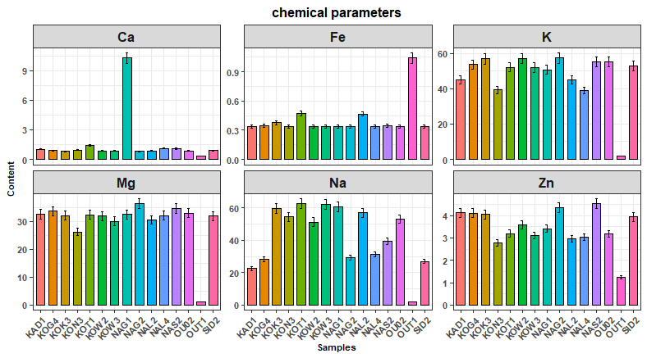
Figure 1: Mineral composition per 100 g of dry matter (DM) of Hibiscus cannabinus L. seeds
Code = The first two initials of the province of origin of the accession + the first initial of the village + the sample's order number within the locality
3.2 Analysis of the physical composition of Hibiscus cannabinus L. seeds
Analysis of physical parameters by differential weighing for all studied accessions reveals significant levels of total ash and moisture (Figure 2). Indeed, high ash contents were obtained for accessions KOG4 (32 ± 0.24%), OUO2 (29 ± 0.13%), and NAG2 (21 ± 0.05%). Furthermore, ash content values ranged from 14 ± 0.03% to 4 ± 0.03% in the remaining Hibiscus cannabinus L. seed accessions. The lowest ash content was measured in accession SID2. Furthermore, the determination of moisture content in Hibiscus cannabinus L. seeds revealed a range of relatively high values for all the accessions studied. Indeed, the highest moisture contents were measured in accessions KOT1 (93.99 ± 0.07%) and OUT1 (92.94 ± 0.08%). For the remaining accessions, moisture content values ranged from 90.03 ± 0.01% to 88.59 ± 0.05%.

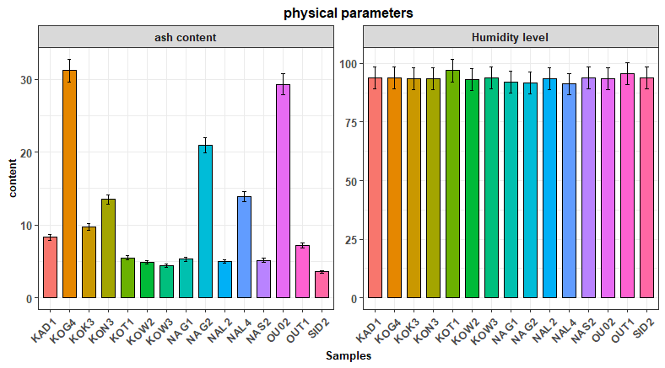
Figure 2: Chemical composition per 100 g of dry matter (DM) of Hibiscus cannabinus L. seeds
Code = The first two initials of the province of origin of the accession + the first initial of the village + the sample's order number within the locality

  - Analysis of the biochemical composition of Hibiscus cannabinus L. seeds
The biochemical parameters analyzed included the carbohydrate, lipid, and protein contents of Hibiscus cannabinus L. seeds (Figure 3). Carbohydrate analysis revealed contents strictly above 40% for the majority of accessions (KAD1, KOK3, KOT1, KOW2, KOW3, NAG1, NAL2, NAL4, NAS2, and SID2), with the highest contents observed in KOW3 (55 ± 2.81%); NAL2 (52 ± 1.51%), and KOT1 (50 ± 2.81%). In contrast, NAG2 is very low in carbohydrates (2 ± 0.00%). Determination of the lipid content of Hibiscus cannabinus L. seeds yielded values strictly above 15% for the majority of the accessions studied. In fact, with the exception of accession KOW3, all others contain a lipid content ranging from 16.80 ± 0.08% to 40 ± 0.68%, with accession NAG2 standing out from the others as having the highest content. Furthermore, all samples of Hibiscus cannabinus L. seeds used contain a protein content strictly above 25%. However, some accessions stand out for their relatively high protein content, notably KON3 (42 ± 1.77%), OUT1 (38 ± 0.37%), and NAG2 (37.5 ± 0.13%).
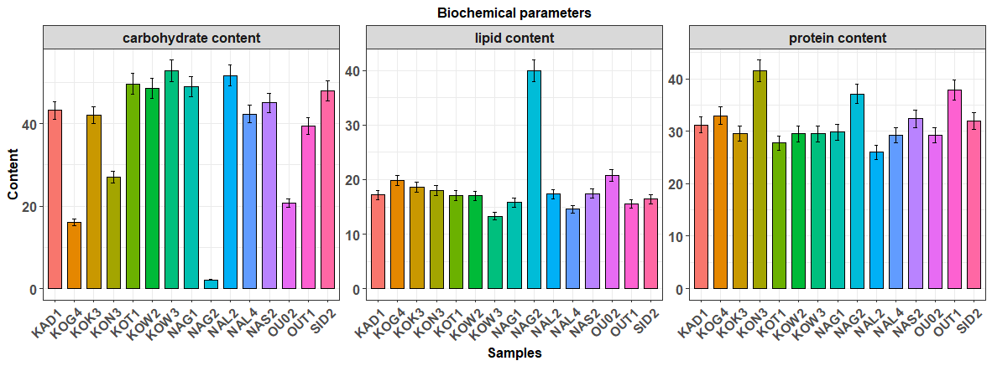
Figure 3: Biochemical composition per 100 g of dry matter (DM) of Hibiscus cannabinus L. seeds
Code = The first two initials of the province of origin of the accession + the first initial of the village + the sample's order number within the locality

3.4 Interactions between agro morphological, physicochemical, and biochemical parameters
The study of the relationships between the measured quantitative parameters revealed numerous significant correlations at the 1% level (Table II). Indeed, positive and significant correlations were observed between the flowering date and each of the variables, fruit diameter (r = 0.59) and moisture content (r = 0.66). Furthermore, a positive and significant correlation was also observed between plant height and stem diameter (r = 0.66). Furthermore, highly significant correlations were observed between zinc content and each of the variables—magnesium and potassium content (r = 0.86, respectively)—as well as between magnesium content and potassium content (r = 0.94). In contrast, highly significant negative correlations were found between iron content and each of the variables: zinc content (r = -0.79), potassium content (r = -0.88), and magnesium content (r = -0.94); between carbohydrate content and each of the variables: protein content (r = -0.66), lipid content (r = -0.82), and ash content (r = -0.86).

Table IV: Pearson correlation matrix between the variables
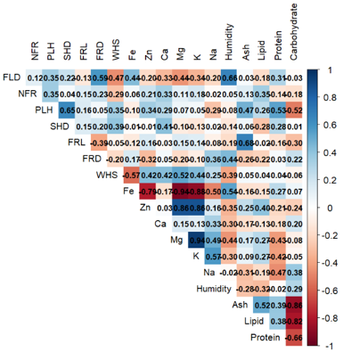
FLD: Flowering Date; NFR: Number of fruits; PLH: Plant Height; SHD: Shank Diameter; FRL: Fruit Length; FRD: Fruit Diameter; WHS: Weight of 100 seeds; Ca: Calcium content; Mg: Magnesium content; Na: Sodium content; Fe: Iron content; Zn: Zinc content; K: Potassium content; Humidity: Water content; Ash: Ash content; Lipid: Lipid content; Protein: Protein content; Carbohydrate: Carbohydrate content.
3.4 Association of the studied agro morphological, physicochemical, and biochemical parameters with the axes
The contribution and correlation of the variables on the 1-2 factorial plane are illustrated through the results of the Principal Component Analysis (PCA) (figure 4), which explains a total of 48.2% of the variance (Axis 1: 28.8%; Axis 2: 19.4%). In the ½-plan (Figure 4), Axis 1, accounting for 28.8% of the total inertia, is strongly defined by a group of nutritional and mineral variables that are positively correlated with one another, such as magnesium content (r = 0.90), potassium content (r = 0.85), zinc content (r = 0.75), and the weight of 100 seeds (r = 0.60). Magnesium, potassium, and zinc content, as well as the weight of 100 seeds, have the highest contributions on this axis, which negatively correlates with iron content (r = -0.95), moisture content (r = -0.60), and flowering date (r = -0.55). This axis reveals a clear negative correlation between the parameters mentioned above and carbohydrate content (r = -0.95). It characterizes tall accessions with sturdy stems, such as KON3, KOG4, KOW2, NAL2, and KOW3, whose seeds are rich in lipids and protein but low in carbohydrates (figure 5).
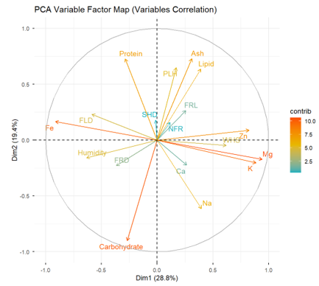
FLD: Flowering date; NFR: Number of fruits; PLH: Plant height; SHD: Stem diameter; FRL: Fruit length; FRD: Fruit diameter; WHS: Weight of 100 seeds; Ca: Calcium content; Mg: Magnesium content; Na: Sodium content; Fe: Iron content; Zn: Zinc content; K: Potassium content; Moisture: Water content; Ash: Ash content; Lipids: Lipid content; Proteins: Protein content; Carbohydrates: Carbohydrate content.
Figure 4: Projection of variables onto the 1-2 plane of the Principal Component Analysis (PCA)
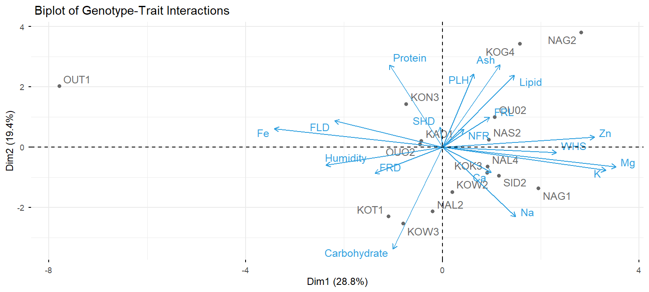
Code = The first two initials of the province of origin of the accession + the first initial of the village + the sample's serial number within the locality. FLD: Flowering date; NFR: Number of fruits; PLH: Plant height; SHD: Stem diameter; FRL: Fruit length; FRD: Fruit diameter; WHS: Weight of 100 seeds; Ca: Calcium content; Mg: Magnesium content; Na: Sodium content; Fe: Iron content; Zn: Zinc content; K: Potassium content; Moisture: Water content; Ash: Ash content; Lipids: Lipid content; Proteins: Protein content; Carbohydrates: Carbohydrate content.
Figure 5: Statistical representativeness of accessions in the 1-2 factorial design
3.5 Analysis of the global heat map of accession performance
The factual analysis of the overall heat map of performance provides a visual summary of standardized performance (Z-scores) for each genotype (accession) across all measured variables (Figure 6). Indeed, regarding the specific high performances recorded, NAG1 exhibits the highest calcium content (Ca: 3.72). The OUT1 accession stands out for its high iron content (Fe: 3.62), while NAG2 has higher values for lipid content (Lipid: 3.57) and stem diameter (SHD: 2.31).
The highest ash contents were observed in accessions KOG4 and OUO2 (Ash: 2.29 and 2.07, respectively). Seeds from genotype KOT1 had high moisture content (Moisture: 2.46), while KOG4 produced long fruits (FRL: 3.12). In summary, the OUT1/NAG2/NAG1/KON3 group has positive Z-scores (above average) for almost all minerals, lipids, and proteins. However, some genotypes showed low performance. Indeed, genotypes such as OUT1 and NAG2 exhibit a systematic deficit in seed yield and nutritional traits (WHS: -1.91; Na: -2.29; K: -3.27; Mg: -3.60; Zn: -2.77) and (Carbohydrate: -2.50).
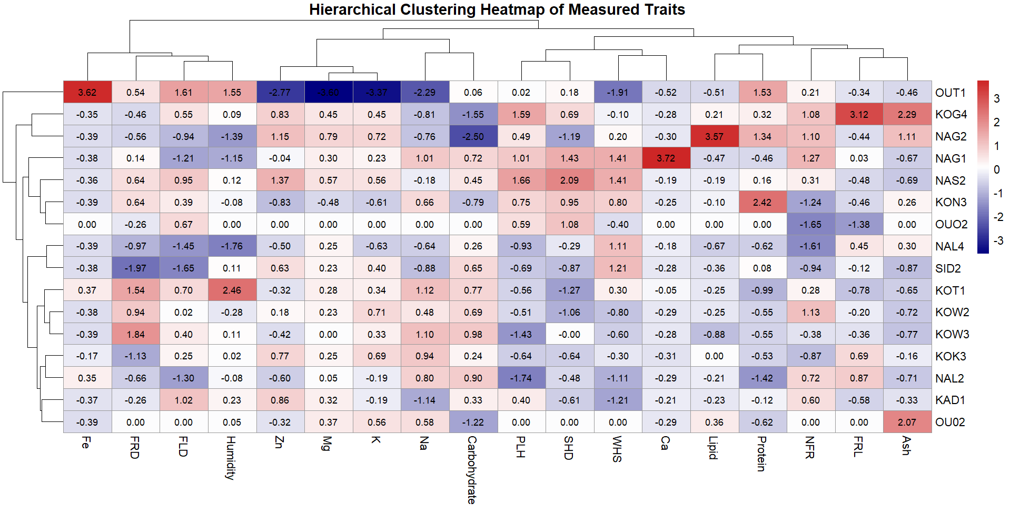
Figure 6: Overall heat map of accession performance
Code = The first two initials of the province of origin of the accession + the first initial of the village + the sample's order number in the locality. FLD : Flowering Date ; NFR: Number of fruits ; PLH : Plant Height ; SHD : Shank Diameter ; FRL : Fruit length ; FRD : Fruit diameter ; WHS : Weight of 100 seeds ; Ca : Calcium content ; Mg : Magnesium content ; Na : Sodium content ; Fe : Iron content ; Zn : Zinc content ; K : Potassium content ; Humidity : Water content ; Ash : Ash content ; Lipid : Lipid content ; Protein : Protein content ; Carbohydrate : Carbohydrate content.
3.5 Diversity pattern of the 15 Hibiscus cannabinus accessions
The dendrogram confirms a structure comprising three main classes, highlighting phenotypic and biochemical variability among the collected Hibiscus cannabinus L. seed accessions (Figure 7). The first class is represented by the isolated accession OUT1, whose seeds have high iron and water content but very low levels of Ca, Mg, K, Na, and Zn. The second class consists of the accessions KOG4, KON3, NAG2, and OU02, which are very rich in ash, lipids, and proteins but low in carbohydrates. The third group includes the accessions KAD1, KOK3, KOT1, KOW2, KOW3, NAG1, NAL2, NAL4, NAS2, and SID2, which have an intermediate mineral profile and are high in Zn, Mg, K, and carbohydrates. This diversity is sufficiently pronounced to provide a basis for classifying the seeds by nutritional type and for targeted utilization. The NAG2 accession appears particularly interesting for magnesium, potassium, and lipids; NAG1 stands out for calcium; NAS2 for zinc; KON3 for protein content; and OUT1 for iron, though with an overall unbalanced profile. The group comprising KOG4, KON3, NAG2, and OU02 deserves special attention for development focused on lipid and protein reserves.

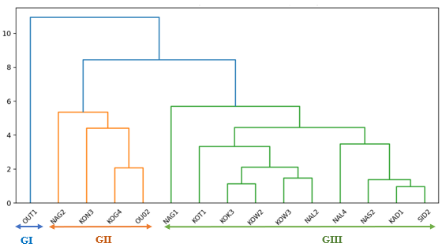
Figure 7: Dendrogram of the hierarchical classification of accessions based on the variables
Code = The first two initials of the province of origin of the accession + the first initial of the village + the sample's order number within the locality.

- Discussion
Analysis of the average performance of the Hibiscus cannabinus L. seed accessions studied reveals that approximately 40% of the measured parameters exhibited high coefficients of variation (CV > 30%), indicating significant heterogeneity among the accessions for these variables. Furthermore, the coefficients of variation for the majority of the parameters studied were low (CV < 30%), reflecting low heterogeneity of the plant material for these various traits (Wang et al., 2024). This wide range of phenotypic variation thus increases the chances of identifying promising genetic resources for the improvement of traits of interest, particularly parameters related to mineral compounds (Mg, Ca, Fe, Zn, K, and Na), organic substances (proteins, carbohydrates, lipids), and chemical parameters such as ash and water content, in addition to parameters related to plant vigor(Maduna, 2025). Such improvement could reignite interest in the consumption of Hibiscus cannabinus L. seeds, which are processed into a spice called “bicalga” by the Mossi and “gio-sola” by the Gurunsi-Lélé (Nikodème et al., 2019). Indeed, minerals play a crucial role in human nutrition as they act as cofactors for various physiological and metabolic processes (Alghamdi et al., 2023). The content of metabolites of interest in plant-based products could serve as an indicator of quality (N’do et al., 2025).
The results of the chemical composition analysis of the seeds revealed high mineral content, which could help prevent certain deficiencies that might cause serious health problems(N’Do et al., 2024). The various significant correlations observed could aid in the development of selection methods for plant breeding. Thus, the positive and significant correlations observed between the flowering date and each of the variables fruit diameter and moisture content, and between plant height and stem diameter, indicate that accessions with a late cycle are generally tall with vigorous stems producing large fruits containing seeds with high water-holding capacity (Ahmed et al., 2023). Zinc content was strongly correlated with magnesium and potassium content. In fact, iron is essential for hemoglobin synthesis and for the transport of oxygen from the lungs through the bloodstream (Benjamin Ya.n. et al., 2026). Calcium contributes to bone health by protecting them (Benjamin Ya.n. et al., 2026). It is essential for the process of ossification, participates in muscle contraction, and aids in the absorption of vitamin B12 (Vieira et al., 2025) . It also plays a role in blood clotting and synaptic transmission (Ben Shimon et al., 2015). Potassium plays a role in controlling skeletal muscle contraction and the transmission of nerve impulses. Patients with bone problems are generally prescribed plant-based meals rich in potassium (Morris et al., 2025). A diet high in sodium is a risk factor for the development of hypertension (Grillo et al., 2019). The ash content values, ranging from 14 ± 0.03% to 4 ± 0.03% in the majority of Hibiscus cannabinus L. seed accessions, were significantly higher than those of Nere soumbala reported by Compaoré et al. (2020), which ranged from 1.77–2.11%, and were also higher than the ash content of nere soumbala reported by (Souley et al., 2020) , which was 2.55 ± 0.07%. These relatively high levels indicate that the ash content reflects the totality of the inorganic matter present in a food sample. These high ash levels could point to a high mineral content in the food product derived from this natural source (Elegbede et al., 2023). Furthermore, the determination of the moisture content of the Hibiscus cannabinus L. seed powder reveals a range of relatively high values for all the accessions studied, ranging from 93.99 ± 0.07% to 88.59 ± 0.05%. These results are higher than those reported by Abd (Shikha et al., 2023), which ranged from 73% to 90% for Hibiscus cannabinus L. seeds as well.
The differences observed between these various values could be explained by various environmental factors (N’Do et al., 2024): ambient humidity, soil characteristics, irrigation methods and frequency, as well as the time of year when the crop is harvested, all of which can have a significant influence on the water content of the seeds and may compromise their quality (N’Do et al., 2025). Indeed, high moisture content promotes microbial growth and negatively affects the organoleptic, commercial, and hygienic qualities of foodstuffs (N’do et al., 2025). Carbohydrate analysis reveals levels strictly above 40% for the majority of accessions (55 ± 2.81%). Our results are higher than those reported by Souley et al. (2020) for soumbala made from nere seeds, which were 33.91 ± 1.51%. Furthermore, (Abd El-Hack et al., 2022)et al. (2022) also obtained lower results for traditional broths made from Piper guineense (black pepper), which were 25.70 ± 3.50%. The determination of lipid content yielded values consistently above 15% for the majority of the accessions studied (16.80 ± 0.08% to 40 ± 0.68%). These high values represent a nutritional advantage, as lipids contribute significantly to the product’s energy value and enhance the bioavailability of fat soluble vitamins (Zhang et al., 2021) Margier et al., 2017). All samples used contain a protein content strictly above 25% (42 ± 1.77% to 37.5 ± 0.13%). These high protein contents are an asset for all consumers of soumbala made from Hibiscus cannabinus L. seed cakes in meeting their nutritional protein needs, especially those in developing countries (Compaoré et al., 2020). Furthermore, consuming protein-rich foods helps meet the daily requirement of 23.6 g for adults, as recommended by the National Research Council of Canada (O. Aremu et al., 2021). Furthermore, regular consumption of plant-based proteins reduces the long-term risk of high blood pressure(Buendia et al., 2015) .

Conclusion
Hibiscus cannabinus L. is a multifunctional and valuable resource with high nutritional value. The results show that it is a good source of copper, magnesium, potassium, zinc, fat, protein, and carbohydrates. Calcium and iron are rare minerals in the seeds of Hibiscus cannabinus L. In fact, only the accessions NAG1 and OUT1 are the richest in calcium and iron, respectively, compared to the others. However, most individuals (90%) are rich in potassium, magnesium, sodium, and zinc. High ash contents were found in the accessions KOG4, OUO2, and NAG2, while KOT1 and OUT1 had the highest water contents. Analysis of biochemical components reveals that the highest carbohydrate contents were found in accessions KOW3, NAL2, and KOT1, while accession NAG2 stood out from the others with the highest lipid content. Accessions KON3, OUT1, and NAG2 were notable for their relatively high protein contents. In general, accessions OUT1 and NAG2 exhibited the highest levels of most of the physicochemical and biochemical parameters characterized. All these findings demonstrate that the seeds of Hibiscus cannabinus L. constitute a potential source of essential nutrients, which could help combat nutritional deficiencies among populations. Consequently, the cultivation of Hibiscus cannabinus L. for its seeds appears to be a viable approach to enhancing food security.

Reference
1. Onyeukwu, O., Ezeokafor, D. & Njideaka, O. Hibiscus sabdariffa -uses, nutritional and therapeutic benefits -A review. Journal of Bioscience and Biotechnology Discovery 8, 18–23 (2023).
2. Szymański, M., Długaszewska, J., Mikoła, P. & Dobrucka, R. Développement de solutions innovantes pour la sécurité environnementale : films de pectine rouge à base d’extrait de fleurs d’Hibiscus sabdariffa, composés bioactifs contre les bactéries pathogènes, pour une économie circulaire. https://www.mdpi.com/2079-6412/14/12/1500 (2024).
3. Borelli, T. et al. Born to Eat Wild: An Integrated Conservation Approach to Secure Wild Food Plants for Food Security and Nutrition. Plants 9, 1299 (2020).
4. Chaachouay, N. & Zidane, L. Produits naturels d’origine végétale : une source pour la découverte et le développement de médicaments. https://www.mdpi.com/2813-2998/3/1/11 (2024).
5. Francini, A., Romano, D., Toscano, S. & Ferrante, A. The Contribution of Ornamental Plants to Urban Ecosystem Services. Earth 3, 1258–1274 (2022).
6. Shikha, D., Kashyap, P., Thakur, A. & Sharma, M. Hibiscus cannabinus. in Harvesting Food from Weeds 267–326 (John Wiley & Sons, Ltd, 2023). doi:10.1002/9781119793007.ch8.
7. Shen, Y. et al. Physicochemical, Antioxidant and Anticancer Characteristics of Seed Oil from Three Chenopodium quinoa Genotypes. Molecules 27, 2453 (2022).
8. (PDF) Effect of kenaf seed oil from different ways of extraction towards ovarian cancer cells. https://www.researchgate.net/publication/228058186_Effect_of_kenaf_seed_oil_from_different_ways_of_extraction_towards_ovarian_cancer_cells.
9. Rudzińska, A. et al. Phytochemicals in Cancer Treatment and Cancer Prevention—Review on Epidemiological Data and Clinical Trials. Nutrients 15, 1896 (2023).
10. Wakeel, A., Farooq, M., Bashir, K. & Ozturk, L. Micronutrient Malnutrition and Biofortification: Recent Advances and Future Perspectives. in Plant Micronutrient Use Efficiency 225–243 (Academic Press, 2018). doi:10.1016/B978-0-12-812104-7.00017-4.
11. Ojelere, O. PHYTOCHEMICALS, PROXIMATE, MINERAL ELEMENT COMPOSITION AND ANTIMICROBIAL ACTIVITY OF SOME SELECTED MEDICINAL PLANT SEEDS. (2016). doi:10.13140/RG.2.1.2160.2808.
12. Ojha, P. K. et al. Chemical Compositions and Essential Fatty Acid Analysis of Selected Vegetable Oils and Fats. Compounds 4, 37–70 (2024).
13. Sharma, N., Yeasmen, N., Dube, L. & Orsat, V. Rise of Plant-Based Beverages: A Consumer-Driven Perspective. Food Reviews International 40, 3315–3341 (2024).
14. Patel, V. Ethics of Food Production and Consumption. in Zero Hunger 282–292 (Springer, Cham, 2020). doi:10.1007/978-3-319-95675-6_16.
15. Shikha, D., Kashyap, P., Thakur, A. & Sharma, M. Hibiscus cannabinus. in Harvesting Food from Weeds 267–326 (John Wiley & Sons, Ltd, 2023). doi:10.1002/9781119793007.ch8.
16. Nikodème, K. V. et al. Genetic diversity of Hibiscus cannabinus L. of Burkina Faso using SSRs markers. (2019).
17. FAO. La situation mondiale de l’alimentation et de l’agriculture 2013. (2013).
18. Yaméogo, J. Changes in the seasonal cycles of extreme temperatures in the Sudano-Sahelian domain in West Africa: a case study from Burkina Faso. Meteorology Hydrology and Water Management. Research and Operational Applications 12, 1–25 (2024).
19. Kone, S. et al. Nutraceutical potentiality of Moringa oleifera and Senna occidentalis grown under organic conditions from Burkina Faso. Food Science and Applied Biotechnology 8, 264–276 (2025).
20. Cortés-Herrera, C. et al. Nitrogen/protein and one-step moisture and ash examination in foodstuffs: Validation case analysis using automated combustion and thermogravimetry determination under ISO/IEC 17025 guidelines. Current Research in Food Science 4, 900–909 (2021).
21. Cortés-Herrera, C. et al. Nitrogen/protein and one-step moisture and ash examination in foodstuffs: Validation case analysis using automated combustion and thermogravimetry determination under ISO/IEC 17025 guidelines. Current Research in Food Science 4, 900–909 (2021).
22. AOAC. AOAC (1984) Méthodes officielles d’analyse. Association des chimistes analystes officiels. 14e édition, AOAC, Arlington. - Références - Scientific Research Publishing. https://www.scirp.org/reference/ReferencesPapers?ReferenceID=1300500.
23. Kane, A. et al. Identification of roselle varieties through simple discriminating physicochemical characteristics using multivariate analysis. Food Sci. Technol 39, 321–327 (2019).
24. Nielsen, S. S. Total Carbohydrate by Phenol-Sulfuric Acid Method. in Nielsen’s Food Analysis Laboratory Manual (eds Ismail, B. P. & Nielsen, S. S.) 147–151 (Springer International Publishing, Cham, 2024). doi:10.1007/978-3-031-44970-3_17.
25. Uddin, A. H. et al. Comparative study of three digestion methods for elemental analysis in traditional medicine products using atomic absorption spectrometry. J Anal Sci Technol 7, 6 (2016).
26. Wang, Y. et al. Spatial heterogeneity of soil factors enhances intraspecific variation in plant functional traits in a desert ecosystem. Front. Plant Sci. 15, (2024).
27. Maduna, M. K. Growth and productivity assessment of four cowpea genotypes under variable phosphorus levels and soil-moisture conditions. (2025).
28. Alghamdi, M., Gutierrez, J. & Komarnytsky, S. Essential Minerals and Metabolic Adaptation of Immune Cells. Nutrients 15, 123 (2023).
29. N’do, J. Y. et al. Ethnobotany and quality control of bioproducts: Sustainable management of natural resources in urban environments. Results in Engineering 27, 106300 (2025).
30. N’Do, J. Y. et al. Indigenous knowledge and uses of medicinal plants in Ouagadougou, Burkina Faso. Ethnobotany Research and Applications 29, 1–15 (2024).
31. Ahmed, S. F., Ahmed, J. U., Hasan, M. & Mohi-Ud-Din, M. Assessment of genetic variation among wheat genotypes for drought tolerance utilizing microsatellite markers and morpho-physiological characteristics. Heliyon 9, (2023).
32. Benjamin Ya.n., Édith Kkn, Lacina Gk, & Kablan T. Caractérisation De Quelques Légumes-Feuilles Les Plus Consommés Dans La Ville De Daloa (Centre-Ouest, Côte d’Ivoire). https://doi.org/10.19044/esj.2020.v16n36p257 (2026) doi:10.19044/esj.2020.v16n36p257.
33. Vieira, B. M., de Mello e Silva, G. N. & Silva, M. I. Nutritional Elements II: Vitamins and Minerals. in Fundamentals of Drug and Non-Drug Interactions: Physiopathological Perspectives and Clinical Approaches (ed. Fajemiroye, J. O.) 57–86 (Springer Nature Switzerland, Cham, 2025). doi:10.1007/978-3-031-80107-5_3.
34. Ben Shimon, M. et al. Thrombin regulation of synaptic transmission and plasticity: implications for health and disease. Front. Cell. Neurosci. 9, (2015).
35. Morris, A. & Lambert, K. Dietary potassium and plant-based diets: a practical guide for kidney healthcare professionals. Journal of Kidney Care 10, 174–180 (2025).
36. Grillo, A., Salvi, L., Coruzzi, P., Salvi, P. & Parati, G. Sodium Intake and Hypertension. Nutrients 11, 1970 (2019).
37. CompaorÃ©, C. S. et al. Development of starter cultures carrier for the production of high quality soumbala, a food condiment based on Parkia biglobosa seeds. AJB 19, 820–828 (2020).
38. Souley, R. A., Diadié, H. O., Abdelkader, A. S., Yacoubou, B. & Balla, A. Caractérisation Biochimique et Microbiologique de Soumbala de néré (Parkia biglobosa) et d’oseille de Guinée (Hibiscus sabdariffa) Produits au Niger. ESJ 16, (2020).
39. Elegbede, I., Lawal-Are, A. & d’ogunlana, F. Chemical compositions of bivalves shells: Anadara senilis, Crassostrea gasar, and Mytilus edulis and their potential for a sustainable circular economy | Discover Applied Sciences | Springer Nature Link. https://link.springer.com/article/10.1007/s42452-022-05267-7 (2023).
40. Shikha, D., Kashyap, P., Thakur, A. & Sharma, M. Hibiscus cannabinus. in Harvesting Food from Weeds 267–326 (John Wiley & Sons, Ltd, 2023). doi:10.1002/9781119793007.ch8.
41. N’Do, J. et al. Evaluation of Phytochemical Composition and Antimicrobial Activities of Terminalia avicennoides, Terminalia macroptera, and Argemone mexicana Used as Traditional Medicine in Burkina Faso. Journal of Advances in Microbiology 25, 21–36 (2025).
42. Abd El-Hack, M. E. et al. The use of black pepper (Piper guineense) as an ecofriendly antimicrobial agent to fight foodborne microorganisms. Environ Sci Pollut Res 29, 10894–10907 (2022).
43. Zhang, Y., Zhang, T., Liang, Y., Jiang, L. & Sui, X. Dietary Bioactive Lipids: A Review on Absorption, Metabolism, and Health Properties. J. Agric. Food Chem. 69, 8929–8943 (2021).
44. O. Aremu, M. et al. Nutrient, Antinutrient and Sugar Contents in Desert Date (Balanites aegyptiaca (L.) Del) Seed and Pulp. ijSciences 10, 12–21 (2021).
45. Buendia, J. R., Bradlee, M. L., Singer, M. R. & Moore, L. L. Diets Higher in Protein Predict Lower High Blood Pressure Risk in Framingham Offspring Study Adults. Am J Hypertens 28, 372–379 (2015).

