Habitats and Morphometric characteristics of an economically important frog (Hoplobatrachus occipitalis) in the savanna region of Côte d'Ivoire: A step towards its rearing in the wild

ABSTRACT
Aims: This research aims to describe habits and some morphometric aspects of the common frog (Hoplobatrachus occipitalis) captured in the urban and peri-urban areas of Korhogo.
Study design: Qualitative field survey.
Place and duration of study: Frog specimens were collected in urban and peri-urban areas (rivers, lowlands, wells, lakes, and rice paddies) of Korhogo, from april 2024 to march 2025.
Methodology: The methodology consisted of recording, for each Hoplobatrachus occipitalis specimen identified from fishermen, the average weight, total length, snout-vent length, and head length and width. Direct field observations have allowed for the characterization of frog habitats.
Results: The wetlands constituting the habitats of Hoplobatrachus occipitalis identified in this study are wells, lakes, rivers, rice paddies and lowland. Lakes (25.29%) present the high frequency of Hoplobatrachus occipitalis occurrences. These are followed by rice paddies (23.87%), wells (22.70%), rivers (15.05%), and lowland areas (13.09%).The results of this study show against that Hoplobatrachus occipitalis specimens living in rivers and lowlands areas had significantly lower total weights and lengths (p<0.05) than those inhabiting lakes, rice paddies, and wells. Snout-vent length measurements were also lower in rivers and lowlands areas than in wells, lakes, and rice paddies. The variation in parameters according to sex indicates that female Hopplobatrachus occipitalis were significantly larger (p<0.05) in lakes, rice paddies, and lowlands. These females were only larger (p<0.05) in lakes and rice paddies. The recorded Snout-to-Cloacus Length values ​​showed no significant difference (p>0.05) in any habitat except rice paddies, where females exhibited significantly larger proportions (p<0.05) than males.
Conclusion: this database which describes the habitats and the morphometric parameters of the Hoplobatrachus occipitalis frog will provide fisheries managers with reliable information on this species to promote its rearing in the wild.
Key words: Savanna locality, Halieutic resource, Management, Morphometric parameters, Frogs.

1. Introduction
In West African regions, particularly in Côte d'Ivoire, Nigeria, Ghana, Senegal, and Benin, Hoplobatrachus occipitalis is the most consumed frog species (Onadeko et al., 2011). In some communities, this meat is used as a substitute for fish, leading to a growing demand for it in the market. This situation has driven many young people to frog fishing, resulting in the heavy exploitation of wild populations of this edible species (Coulibaly & Zigui, 2021). Becker et al. (2007) noted a decline in H. occipitalis stocks in the 1980s, influenced by human activities. Beyond their nutritional value, Codjo et al. (2021) consider frogs to be indicators of the quality of their environment (Godome et al., 2018). In agriculture, the species H. occipitalis plays an important role as it consumes insects that devastate crops (Penner et al., 2010). Managing wild frog populations requires reliable scientific data on biology and ecology, particularly morphological parameters and feeding habits (Codjo et al., 2021). In Africa, and primarily in Benin, these same authors presented data on H. occipitalis. In Côte d’Ivoire, Oungbé et al. (2018) and N’Guessan et al. (2022) conducted research on these aspects in the southern and western parts of the country, respectively. Very few researchers have studied frog biology in northern Côte d’Ivoire. Furthermore, the work of Ernst & Rodel (2002), Kouamé et al. (2015), and N’Guessan et al. (2022) suggests that frog growth depends on the region, habitat quality, and season. Research in this northern part of Côte d’Ivoire, where frog habitats are used for human activities, is essential to better understand the biology of this species, the only edible frog in the country. This study is therefore conducted in wetlands (lakes, wells, rivers, lowlands, rice paddies) where frogs, market gardens, and mining operations coexist. The objective is to characterize the morphometry of the African tiger frog Hoplobatrachus occipitalis, to obtain reliable scientific information for its sustainable management. Specifically, this involves describing its spatial variation and variation according to sex.

2. Materials and methods
2.1 Study Area and sampling sites
The municipality of Korhogo, located between 9°34' N and 5°37' W in the savanna region of northern Côte d'Ivoire, has a population of 440926 inhabitants and an area of ​​12500 km², representing 3.9% of the Ivorian territory (Boko-Koiadia et al., 2016). Site selection was based on the intensity of frog harvesting and the presence of frog markets. Thus, the lowlands, lakes, rice paddies, rivers, and wells (Fig. 1) in the urban (Koko, Soba, and the Peleforo Gon Coulibaly University garden) and peri-urban (Lataha, Nangakaha, Nangounkaha, and Pignon) areas of Korhogo were sampled.
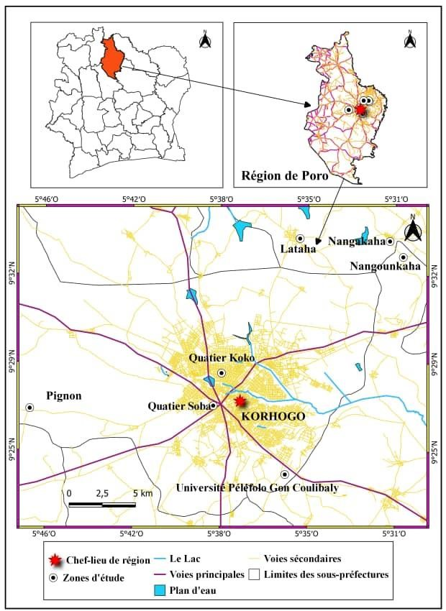

Fig. 1. Location of sampling sites in the city of Korhogo and its surroundings (Kien et al., 2024).
2.2 Data Collection
Frog specimens were collected from April 2024 to March 2025 in the lowlands, lakes, rice paddies, rivers, wells, and gardens of urban and peri-urban areas in the municipality of Korhogo, in northern Côte d'Ivoire. For capture, the frogs were immobilized at night by shining strong beams of light into their eyes. This data was supplemented by catches reported by fishermen. The identification key of Rödel (2000) was used to identify the sampled frogs (Hoplobatrachus occipitalis). The individuals were then separated into two groups based on sex (male and female). For each specimen, the following morphological parameters were measured: Mean Individual Weight (MIW, in g), Total Length (TL, in cm), and Snout-to-Cloacus Length (SCL, in cm), as well as Head Length and Width (L and l, in cm). Individual weight was measured using a Denver electronic balance with a precision of 0.01 g. ACIAP calipers (120 mm) were used to measure lengths and widths. Total length is the distance from the anterior snout of the mouth to the tips of the longest toes on the forelegs; snout-to-ventilation length is the horizontal distance from the anterior snout of the mouth to the vent (Codjo et al., 2021).
2.3 Statistical Analysis
A two-way Analysis of Variance (ANOVA 2) was used to compare the different means of the morphometric variables according to sex and site. All these analyses were performed using STATISTICA software version 6.1, and the significance level (p) was set at 5%.
3. Results and discussion
3.1 Habitats and Occurrence of Hoplobatrachus occipitalis
Within the study area, wetlands represent the habitats of frogs, particularly Hoplobatrachus occipitalis. These include (Fig. 2)
- wells, surrounded by wooded savanna with mango trees, cashew trees, néré trees, baobab trees, and shea trees. Chili pepper, eggplant, tomato, and rice crops are also found there. These bodies of water also serve as watering holes for cattle, frequently attracting insects to the area;
- lakes, which support human activities such as fishing and market gardening (mints, lettuce, and cabbage). These reservoirs are used as watering holes by domestic animals, which leave their fecal waste there, attracting insects that are very common in this area;
- rivers, bordered by vegetation shaped by humans, who have created néré and shea parks;
- rice paddies surrounded by wooded savanna and hills. These rice fields attract a significant number of insects, visible on the leaves of the rice plants;
- lowland areas used for vegetable crops (mints, lettuce, and cabbage).
Considering the frequency of frog occurrences, the area with the highest number of H. occipitalis is the lakes (195, or 25.29%). These are followed by rice paddies (184, or 23.87%), wells (175, or 22.70%), rivers (116, or 15.05%), and lowland areas (101, or 13.09%).
The population of Hoplobatrachus occipitalis varies from site to site. The present results indicate that lakes (25.29%), rice paddies (23.87%), and wells (22.70%) have the highest occurrences. This finding is likely linked to the availability of insects, which are by far the main food source for anurans, as reported by Codjo et al. (2021). Furthermore, frogs are recognized by Rödel (2000) and Assemian et al. (2006) as characteristic species of degraded habitats. This could explain their low occurrence in rivers, which are less disturbed than lakes and rice paddies.

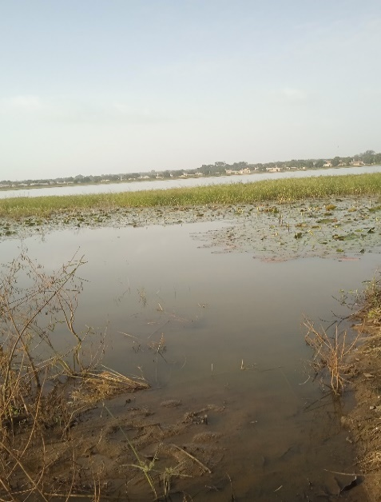
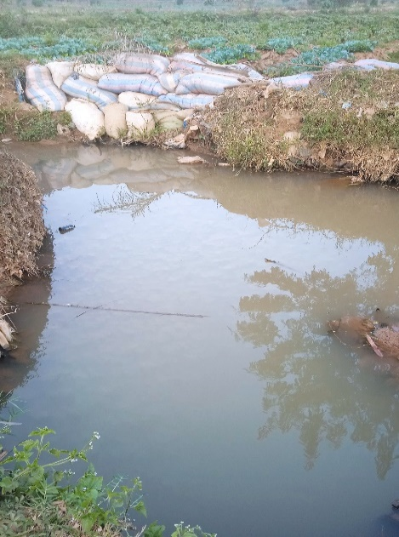

A
B
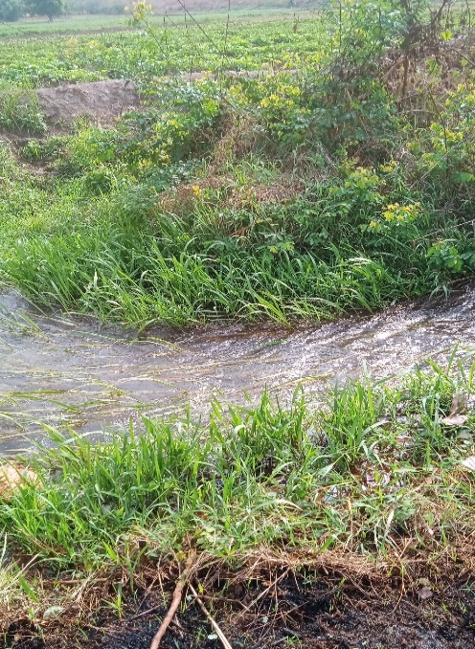
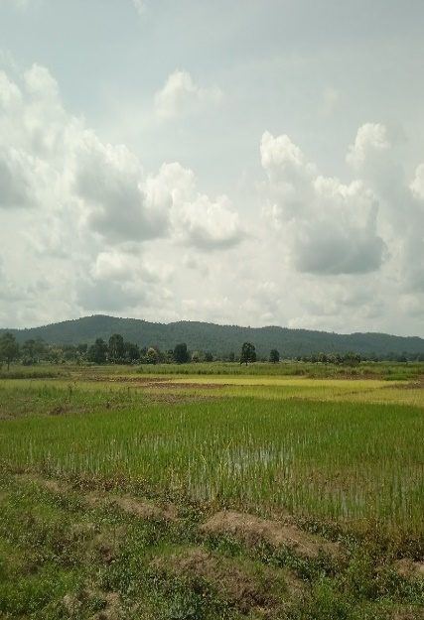

D
C

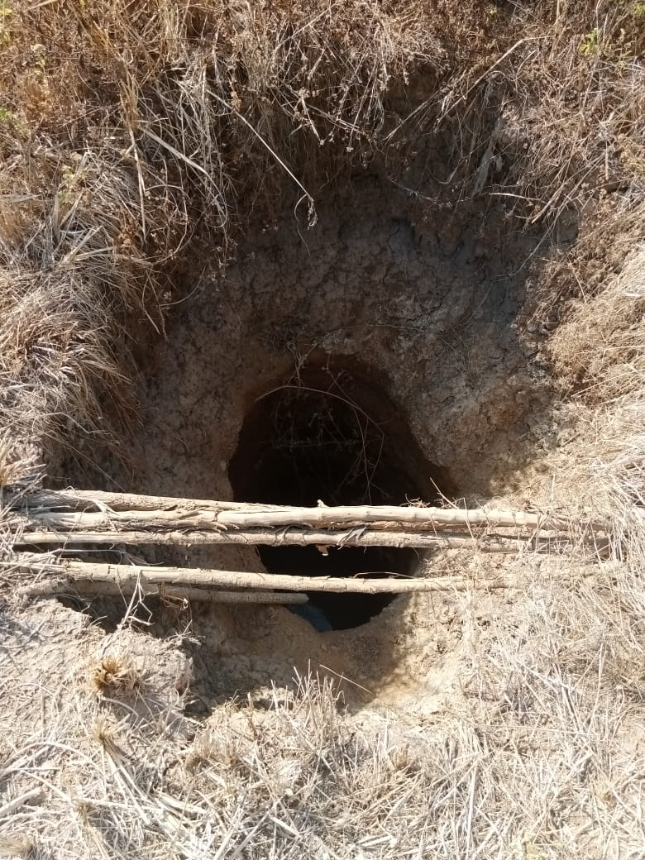

E

Fig. 2: Sampling sites (A: Lake; B: Lowland; C: Rice paddy; D: River; E: Well)
3.2 Morphometric parameters of Hopplobatrachus occipitalis
Table 1 presents the mean values ​​of Mean Individual Weight (MIW), Total Length (TL), Snout-to-Cloacus Length (SCL), width (W), and head length (L) of H. occipitalis according to sites studied.
The Mean Individual Weight (MIW) of H. occipitalis calculated in this study yields values ​​that vary from one environment to another. They are 74.99 ± 36.89 g in wells; 75.83 ± 32.99 g in lakes; 47.69 ± 16.23 g in rivers; 71.11 ± 21.53 g in rice paddies and 53.59 ± 27.00 g in lowlands. Analysis of these values ​​shows that specimens captured in rivers and lowlands had significantly lower weights (p<0.05) than those found in wells, rice paddies, and lakes. Specimens found in lakes had the highest average weight.
The Total Length (TL) of H. occipitalis was significantly (p<0.05) shorter in rivers (17.54 ± 1.94 cm) and lowlands (17.72 ± 2.46 cm) than in wells (20.42 ± 2.79 cm), lakes (20.68 ± 2.75 cm), and rice paddies (20.52 ± 2.64 cm). These specimens were much larger in lakes (20.68 ± 2.75 cm). This same trend was also observed for Snout-to-Cloacus Length (SCL). These values ​​are noted to be lower at the level of rivers (7.75 ± 0.93 cm) and lowlands (7.75 ± 1.23 cm) and higher in wells (10.01 ± 8.96 cm), lakes (9.94 ± 8.68 cm) and rice paddies (8.94 ± 1.11 cm).
The dimensions of the heads of H. occipitalis also varied from one site to another. Regarding the head length (L), the values ​​obtained at the wells (3.50 ± 4.87 cm) and the rice paddies (3.20 ± 0.66 cm) are significantly higher (p<0.05) than those noted in the lakes (2.94 ± 0.60 cm), the rivers (2.60 ± 0.66 cm) and the lowlands (2.45 ± 0.44 cm). Nevertheless, these heads are significantly wider (p<0.05) in specimens living in rice paddies (4.01 ± 0.65 cm), lakes (4.06 ± 3.18 cm) and wells (3.92 ± 0.65 cm) than those analyzed in rivers (3.59 ± 2.46 cm) and lowlands (3.34 ± 0.52 cm).
Table 1. Morphometric parameters of Hoplobatracus occipitalis according to study sites
a: highest parameters; b: lowest parameters
Characteristics | Study sites
Characteristics | Wells | Lakes | Rivers | Rice paddies | Lawlands | P value
MIW (g) | 74.99 ± 36.89ª | 75.83 ± 32.99ª | 47.69 ± 16.23^{b} | 71.11 ± 21.53ª | 53.59 ± 27.00^{b} | 0.000001
TL (cm) | 20.42 ± 2.79ª | 20.68 ± 2.75ª | 17.54 ± 1.94^{b} | 20.52 ± 2.64ª | 17.72 ± 2.46^{b} | 0.000001
SCL (cm) | 10.01 ± 8.96ª | 9.94 ± 8.68ª | 7.75 ± 0.93^{b} | 8.94 ± 1.11^{b} | 7.75 ± 1.23^{b} | 0.000001
L (cm) | 3.50 ± 4.87ª | 2.94 ± 0.60^{b} | 2.60 ± 0.66^{b} | 3.20 ± 0.66ª | 2.45 ± 0.44^{b} | 0.00956
l (cm) | 3.92 ± 0.65ª | 4.06 ± 3.18ª | 3.59 ± 2.46^{b} | 4.01 ± 0.65ª | 3.34 ± 0.52^{b} | 0.013349

Table 2 presents the morphometric parameters of the H. occipitalis frog by sex at the different sampling sites. Analysis of the table indicates a significant difference in these parameters for females between different habitats (p<0.05). For males, the difference is markedly non-significant (p>0.05) only for head length and width between habitats.
Analysis of the Mean Individual Weight (MIW) of the collected H. occipitalis specimens shows a significant difference (p<0.05) between males and females in lakes, rice paddies, and lowlands, where females are generally larger. Average weights ranged from 62.29 ± 37.57 g (Lowland) to 88.01 ± 33.93 g (Lake) for females and from 44.65 ± 27.04 g (Lowland) to 69.64 ± 31.27 g (Wells) for males. There was no significant difference (p > 0.05) between the average weights of males and females in rivers and wells. However, females remained larger than males in wells but smaller than males in rivers.
Regarding Total Length (TL), there was a significant difference (p<0.05) only in lakes and rice paddies, where females were larger, with measurements ranging from 21.57 ± 2.57 cm (Lake) to 21.64 ± 2.17 cm (Rice paddies). In wells, rivers, and lowlands, there was no significant difference (p>0.05). However, these values ​​were higher for females in wells and lowlands compared to rivers.
Regarding Snout-to-Cloacus Length (SCL), there was no significant difference (p>0.05) in any habitat except rice paddies, where females (9.43 ± 1.17 cm) were significantly larger (p<0.05) than males (8.64 ± 0.90 cm). Regarding head length (L), there was no significant difference (p>0.05) between males and females in any of the basins.

Table 2. Morphometric parameters of Hoplobatrachus occipitalis according to sex and study sites
 | Sex | Study sites
 | Sex | Lakes | Wells | Riviers | Rice paddies | Lowlands | P value
MIW (g) | M | 68,09 ± 27,14 | 69,64 ± 31,27 | 49,73 ± 20,71 | 61,61 ± 19,03 | 44,65 ± 27,04 | 0,000001
MIW (g) | F | 88,01 ± 33,93 | 81,88 ± 42,41 | 45,70 ± 22,19 | 84,02 ± 35,79 | 62,29 ± 37,57 | 0,000003
MIW (g) | P | 0,000257 | 0,081556 | 0,13089 | 0,000018 | 0,025661
TL (cm) | M | 20,08 ± 2,71 | 20,09 ± 2,26 | 17,95 ± 2,45 | 19,73 ± 2,79 | 17,07 ± 2,72 | 0,000001
TL (cm) | F | 21,57 ± 2,57 | 20,84 ± 3,33 | 17,05 ± 2,93 | 21,64 ± 2,17 | 18,37 ± 2,99 | 0,000001
TL (cm) | P | 0,002425 | 0,164728 | 0,051136 | 0,000019 | 0,085864
SCL (cm) | M | 9,10 ± 2,04 | 9,03 ± 1,03 | 7,89 ± 1,05 | 8,64 ± 0,90 | 7,47 ± 1,35 | 0,000001
SCL (cm) | F | 9,42 ± 1,47 | 9,37 ± 1,65 | 7,60 ± 1,34 | 9,43 ± 1,17 | 8,01 ± 1,66 | 0,000001
SCL (cm) | P | 0,227921 | 0,178318 | 0,099716 | 0,00004 | 0,168194
L (cm) | M | 2,83 ± 0,61 | 3,82 ± 6,46 | 2,63 ± 2,34 | 2,92 ± 0,42 | 2,32 ± 0,45 | 0,09166
L (cm) | F | 3,10 ± 0,58 | 3,10 ± 0,78 | 2,58 ± 1,29 | 3,72 ± 3,99 | 2,59 ± 0,59 | 0,012423
L (cm) | P | 0,12686 | 0,438225 | 0,848857 | 0,091282 | 0,053971
l (cm) | M | 4,13 ± 4,32 | 3,85 ± 0,61 | 3,76 ± 3,25 | 3,89 ± 0,43 | 3,13 ± 0,59 | 0,370011
l (cm) | F | 4,07 ± 1,14 | 4,00 ± 0,71 | 3,39 ± 0,62 | 4,27 ± 0,69 | 3,55 ± 0,60 | 0,000001
l (cm) | P | 0,810877 | 0,242627 | 0,511197 | 0,000027 | 0,003844

For head width (l), a significant difference (p<0.05) was observed between males and females in the rice paddies and lowlands. Females, with measurements ranging from 3.55 ± 0.60 cm (Lowlands) to 4.27 ± 0.69 cm (Rice paddies), had wider heads than males, whose head widths ranged from 3.13 ± 0.59 cm (Lowlands) to 3.89 ± 0.43 cm (Rice paddies). No significant difference was observed in the other three basins.
The morphometric study of Hoplobatrachus occipitalis focused on Mean Individual Weight (MIW), total length (TL), Snout-to-Cloacus Length (SCL), head Length (L), and head Width (W).
The results obtained indicate a significant difference (p<0.05) between these parameters across different habitats and between sexes. Values ​​observed in rivers and lowlands areas are lower than those found in wells, lakes, and rice paddies. Variation in the morphometric parameters of H. occipitalis according to habitat was also observed by Codjo et al. (2021) in Benin.
The morphometric differences between males and females observed in all habitats in this study confirm the findings of Godome et al. (2018) and Codjo et al. (2021) which already indicated the sexual dimorphism existing between male and female of H. occipitalis in their work.
Regarding Snout-to-Cloacus Length (SCL), there was no significant difference (p>0.05) in any habitat except rice paddies, where there was a significant difference (p<0.05) between males and females. In Cameroon, a significant difference was observed between females, with a SCL ranging from 11 to 13.5 cm, and males, with a SCL ranging from 6.8 to 11 cm (Perret, 1966). For Mean Individual Weight (MIW) of H. occipitalis, there was a significant difference (p<0.05) between males and females in lakes, rice paddies, and lowlands, where females were generally larger. Regarding Total Length (TL), there was a significant difference (p<0.05) only in lakes and rice paddies, where females were larger. Hirschfeld & Rödel (2011) did not observe any significant differences in size or weight between males and females of the same species in the Niger River basin in Benin.
These differences in size and weight observed from one environment to another could be due not only to genetic factors, but also and especially to the quality of habitats and food resources available in these basins (Kovács et al., 2007). The larger dimensions observed in lakes, rice paddies, and wells are certainly explained by high primary productivity and a high concentration of aquatic invertebrates, offering optimal trophic conditions for the species (Son et al., 2023).
The small morphometric values ​​observed in lowlands and rivers are certainly due to a low variety or availability of food in these areas. In this regard, Tohé (2008) stated that the removal of insects from rivers and lowlands, which constitute the main food source for frogs, has an impact on the morphology of amphibians as presented in this study.
Furthermore, the larger size of the females is a genetic predisposition allowing them to store many eggs during the reproductive period (Tohé, 2008). The weight of these eggs, combined with the proportionally higher consumption of vegetation by the females to meet the specific energy requirements of female reproduction, particularly lipid and calcium intake (Son et al., 2023), would explain their remarkable plumpness.
Conclusion
This study contributes to the knowledge of the frog sector in Côte d’Ivoire. Morphometric analysis reveals that specimens of the species Hoplobatrachus occipitalis found in lakes, wells, and rice paddies are larger and taller than those living in rivers and lowlands. Sexual dimorphism in size and shape is observed in this species, with females generally being larger and taller. These results, made available to fisheries managers in general, will allow for better planning of fisheries resource management and for understanding the behavior of Hoplobatrachus occipitalis with a view to its rearing in the wild in Côte d’Ivoire. These results, combined with knowledge of feeding habits of these species, will allow us to envision its rearing in the wild in the savannah zone of Côte d'Ivoire.
Disclaimer (Artificial Intelligence)
Authors declare that no generative AI technologies such as Large Language Models (ChatGPT, COPILOT, etc.) and text-to-image generators have been used during the writing or editing of this manuscript.
Competing interest
The authors declare that there is no competing interest whatsoever among the authors in the cause of executing this research work.
References
Assemian, N.E., Kouamé, N.G., Tohé B., Gourène G. & Rödel M.O. (2006). The anurans of
the Banco National Parc, Côte d’Ivoire, a threatened West African rainforest. Salamandra, 42, 41-51. https://ia803205.us.archive.org/30/items/salamandra-42-041-052/salamandra-42-041-052.pdf
Becker, C.G., Fonseca, C.R., Haddad, C.F.B. (2007). Amphibian Decline and Ex tinction in Brazil: A Global Perspective. Biological Conservation, 136, 293-308. https://doi.org/10.1016/j.biocon.2006.11.021.
Boko-Koiadia, A.N.N., Guéladio, C., Brama, K., Dedy, S. (2016). Variabilité climatique et changements dans l’environnement à Korhogo en Côte d’Ivoire : Mythes ou Réalité ?
Codjo, E.Y., Attakpa, R.O.E., Pelebe, K.S., Abahi, C.A., Orou-Seko, O.Z., Imorou, T. (2021). Morphologie et régime alimentaire de la grenouille Hoplobatrachus occipitalis (Gunther, 1858) au Bénin : Un pas essentiel vers son élevage. International Journal of Innovation and Scientific Research, 58(1), 83-94. http://www.ijisr.issr-journals.org/
Coulibaly, N.D., Zigui, B. (2021). Exploitation et traits de menaces des grenouilles d’un intérêt socio-économique dans la province du Ganzourgou au Burkina Faso, Afrique de l’Ouest. International Journal of Biology and Chemical Sciences, 15(3), 1090-1103. DOI:10.4314/ijbcs.v15i3.19
Ernst, R., Rödel, M.O. (2002). A new Phrynobatrachus from the Upper Guinean rain forest, West Africa, including a description of a new reproductive mode for the genus. Journal of Herpetology, 36(4), 561-571. https://doi.org/10.2307/1565925
Godome, T., Tossavi, E., Ouattara, N.I,, Fiogbe, E.D. (2018). Bibliographic synthesis on biology and ecology of Hoplobatrachus occipitalis (Günther, 1858). International Journal Biology and Chemical Science, 12(3), 1484-1493. https:// doi. org/ 10. 4314/ ijbcs. v12i3. 33
Hirschfeld, M., Rödel, M.O. (2011). The diet of the African Tiger Frog, Hoplobatrachus occipitalis, in northern Benin. Salamandra, 47(3), 125-132. https://www.salamandra-journal.com/index.php/contents/2011-vol-47/249-hirschfeld-m-m-o-roedel/file
Kien, K.B., Ndiaye, A., Cisse, M., Kouamelan, E.P. (2024). Spatio-temporal Dynamics of Anuran Populations in the Wetlands of Korhogo, Cote d’Ivoire. Annual. Research. Review in Biology, 39(9), 114-121. DOI: 10.9734/arrb/2024/v39i92125
Kouamé, N.G., Ofori-Boateng, C., Adum, G.B., Gourène, G., Rödel, M.O. (2015). The anuran fauna of a West African urban area. Amphibian Reptile Conservation, 9(2), 1-14. https://www.semanticscholar.org/paper/The-anuran-fauna-of-a-West-African-urbanarea-Kouam%C3%A9-Ofori-Boateng/7fc792f99247b5f253b958b80a48cf39bea32d3f
Kovács, E.H., Sas, I., Covaciu-Marcov, S.D., Hartel, T., Cupsa, D., Groza, M. (2007). Seasonal variation in the diet of a population of Hyla arborea from Romania. Amphibian and Reptile, 28(4), 485-491. DOI:10.1163/156853807782152534
N’Guessan, S.G., N’Guessan, E.A., Atta, L.K. (2022). Spatial and seasonal dynamics of amphibians from shallows and forests in urban and
Peri-urban areas of Daloa (Ivory Coast, West Africa). GSC Biological and Pharmaceutical Sciences, 21(03), 126-133. https://doi.org/10.30574/gscbps.2022.21.3.0468
Onadeko, A.B., Egonmwan, R.I., Saliu, J.K. (2011). Edible amphibian species: local knowledge of their consumption in southwest Nigeria and their nutritional value. West African Journal of Applied Ecology, 19, 67-76. https://www.scirp.org/reference/referencespapers?referenceid=3981199
Oungbe, K.V., Adeba, P.J., Blahoua, K.G., N’Douba, V. (2018). Systématic inventory of anuran spécies (amphibians) in three agro-industrial zones in the Southeast of Côte d’Ivoire. Journal of Applied Bioscience, 131, 13271-13283. https:// doi. org/ 10. 4314/ jab. v131i1.3
Penner, J., Adeba, P.J., Hillers, A., Nago, S.G.A., Rödel, M.O. (2010). Amphibiens de l’Afrique de l’Ouest. In: A. Thiombiano and D.Kampmann (eds.), Atlas de la Biodiversité de l’Afrique de l’Ouest, Burkina Faso (Tome II): Bundesministerium für Bildung und Frankfurt/Main (pp. 102-107).
Rödel, M.O. (2000). Herpetofauna of West Africa, Vol. 1: Amphibians of the West African Savanna. Edition Chimaira, Frankfurt/M., 1, 335.
Son, P.C.L., Agou, R.B., Konaté, B., Tohé, B. (2023). Diet of two sympatric frogs species (Hoplobatrachus occipitalis and Ptychadena mascareniensis) in the Southern region of Ivory Coast (Aboisso and Maféré). International Journal of Fisheries and Aquatic Studies, 11(5), 154-161. DOI: https://doi.org/10.22271/fish.2023.v11.i5b.2860
Tohé, B. (2008). Reproduction et régime alimentaire de trois espèces d’anoures des habitats dégradés du parc national du banco (Côte d’Ivoire) : Ptychadena mascareniensis, P. pumilio et Hoplobatrachus occipitalis. Thèse de doctorat, Université Abobo Adjamé d’Abidjan (Côte d’Ivoire).

