An Embedded GSM-Based Panic Alert Framework for Enhancing Emergency Response in Semi-Rural Institutions

Abstract
Emergency communication remains a major challenge in semi-rural institutions due to inadequate infrastructure, unstable communication networks, and limited access to advanced digital technologies. Traditional emergency reporting methods often rely on manual phone calls and physical communication, resulting in delayed response during critical situations. This study proposes an Embedded GSM-Based Panic Alert Framework designed to enhance real-time emergency response in semi-rural institutional environments. The proposed framework integrates embedded system technology with GSM-based Short Message Service (SMS) communication to provide a low-cost, reliable, and automated emergency alert mechanism. The system consists of a panic-trigger unit, microcontroller processing module, GSM communication module, and emergency response interface organized within a three-layer architecture. Experimental evaluation was conducted using an Arduino microcontroller and SIM800L GSM module under simulated semi-rural conditions. Performance analysis focused on response latency, message delivery success rate, reliability, usability, and robustness under varying network conditions. The results showed that the framework achieved an average response latency of approximately 4.0 seconds and an overall message delivery success rate of 95.7%. Statistical analysis further confirmed significant improvements over traditional manual emergency communication systems, with precision, recall, and F1-score values exceeding 95%. The findings demonstrate that the proposed framework provides a practical, scalable, and efficient solution for improving emergency preparedness and rapid response in resource-constrained semi-rural environments.

Keywords: GSM Communication, Embedded Systems, Panic Alert Framework, Emergency Response, Semi-Rural Institutions

1. Introduction
In recent years, emergency response systems have become increasingly important in ensuring safety within institutional environments (Alkhaiwani & Alsamani, 2023). Rapid response to emergencies such as medical incidents, accidents, or security threats is critical for minimizing damage and preventing loss of life (Raman & Gurpur, 2024). However, in semi-rural institutions, emergency communication systems remain largely inefficient due to infrastructural and technological limitations (Tasgaonkar et al., 2024). Unlike urban environments where advanced digital systems and internet-based platforms support emergency services (Patel et al., 2024), semi-rural institutions often depend on manual reporting methods such as phone calls (Patil & Patil, 2024), physical movement, or informal communication networks (Kishore, 2023). These approaches are unreliable in many emergency situations (Doggett et al., 2023), particularly when victims are incapacitated or unable to seek immediate assistance (The New Indian Express, 2024). Economic challenges such as lack of airtime and inadequate transportation infrastructure further complicate emergency communication in low-resource settings (Abhay, 2025). In addition, unstable communication networks and infrastructural deficiencies contribute significantly to delays in emergency response processes (Raman & Gurpur, 2024).
Recent studies in climate justice and community-centered computing also emphasize that vulnerable and underserved communities are disproportionately affected by technological and infrastructural inequalities (Clean Air Fund, 2023; COMMISSION FOR AIR QUALITY MANAGEMENT, 2023). Community-based communication initiatives have therefore been identified as important mechanisms for improving emergency awareness and information dissemination in marginalized environments (Doggett et al., 2023; Kishore, 2023). Furthermore, research in asset-based and participatory technology development highlights the need for affordable, accessible, and context-aware technological systems tailored to local community realities (Hardy & Thebault-Spieker, 2024). Emerging intelligent systems such as multilingual healthcare models and AI-driven rural healthcare frameworks further demonstrate the growing relevance of adaptive communication technologies in low-resource environments (Gangavarapu, 2024; Gangavarapu & Gangavarapu, 2024). Similarly, chatbot-assisted healthcare communication has shown potential for improving information accessibility and emergency guidance among vulnerable populations (Kaur et al., 2024).
Global System for Mobile Communications (GSM) technology remains one of the most reliable communication infrastructures in low-resource environments (Patel et al., 2024). Short Message Service (SMS), in particular, offers a lightweight and cost-effective means of transmitting information even under weak network conditions (Patil & Patil, 2024). Despite its widespread availability, GSM technology is still underutilized in automated emergency alert systems, especially within semi-rural institutional contexts (Alkhaiwani & Alsamani, 2023). Embedded systems present an opportunity to address these challenges by enabling the development of autonomous and user-friendly emergency solutions. By integrating embedded hardware with GSM communication (Patel et al., 2024), it becomes possible to create systems that require minimal user interaction while ensuring rapid and reliable alert transmission (Raman & Gurpur, 2024).
In addition, studies on structural monitoring and real-time warning systems demonstrate the importance of fast, automated, and intelligent alert mechanisms in safety-critical environments (Böse et al., 2023; Tunç et al., 2023). Earthquake early warning systems have shown how rapid signal detection and automated notification frameworks can significantly reduce response time and improve public safety outcomes (Tan et al., 2023; Tunç et al., 2024). Smartphone-assisted warning technologies and real-time monitoring infrastructures further reinforce the importance of integrating lightweight communication systems into emergency response architectures (Finazzi et al., 2024). These approaches have also been supported by large-scale event monitoring databases and structural health monitoring studies, which emphasize the value of automated sensing and rapid information dissemination in disaster management (Earthquake Event Catalog, 2025; Farrar et al., 2025).
This study proposes an embedded GSM-based panic alert framework designed to enhance emergency response in semi-rural institutions. The framework focuses on simplicity, reliability, and affordability, making it suitable for deployment in resource-constrained environments. The key contributions of this study are as follows:
- Framework Design: A layered embedded GSM-based architecture for automated emergency alert transmission.
- System Implementation: Development of a functional prototype using microcontroller and GSM module integration.
- Performance Evaluation: Assessment of system effectiveness using latency, reliability, and usability metrics.
- Practical Contribution: A scalable and cost-effective solution tailored to semi-rural institutional environments.
The remainder of this paper is organized as follows: Section 2 presents the literature review; Section 3 describes the methodology and system architecture; Section 4 discusses experimental results and evaluation; Section 5 provides discussion and analysis; and Sections 6–8 present conclusions, limitations, and future work.

2. Literature Review
This section reviews existing approaches related to GSM-based emergency communication, embedded alert systems, and their applicability in semi-rural environments. It highlights key technologies, strengths, and limitations, and positions the proposed framework within current research trends. Recent studies in human-centered computing, structural monitoring, intelligent communication systems, and community-based technological interventions provide important insights into the development of responsive and resilient emergency infrastructures (Hardy & Thebault-Spieker, 2024; Farrar et al., 2025).

2.1 GSM-Based Emergency Communication Systems
GSM technology, particularly SMS, has been widely adopted in emergency communication due to its reliability (Patel et al., 2024), low bandwidth requirements (Patil & Patil, 2024), and extensive coverage in low-resource environments (Alkhaiwani & Alsamani, 2023). Several studies have demonstrated the effectiveness of SMS-based alert systems in healthcare delivery, disaster response, and security monitoring (Raman & Gurpur, 2024). These systems enable rapid information dissemination even under weak network conditions (Tasgaonkar et al., 2024).
Recent advancements in intelligent communication systems have further enhanced emergency response capabilities through AI-driven healthcare frameworks and multilingual communication models designed for underserved populations (Gangavarapu, 2024; Gangavarapu & Gangavarapu, 2024). Similarly, chatbot-assisted communication systems have shown promising results in supporting healthcare information delivery and emergency interaction among vulnerable populations (Kaur et al., 2024). Community-centered communication platforms also demonstrate how localized digital infrastructures can improve accessibility and emergency awareness in low-resource environments (Kishore, 2023).
However, most GSM-based systems rely heavily on user-initiated actions such as dialing or message composition (Patil & Patil, 2024). This dependency introduces delays and reduces effectiveness during high-stress or incapacitated conditions (The New Indian Express, 2024). Furthermore, many implementations lack automation and structured alert formatting (Patel et al., 2024), limiting their efficiency in real-time emergency scenarios (Raman & Gurpur, 2024). Studies on urban inequality and transportation challenges also reveal that infrastructural deficiencies significantly affect emergency communication and accessibility in developing regions (Abhay, 2025).

2.2 Embedded Systems for Panic Alert Applications
Embedded systems have significantly improved real-time monitoring and control applications due to their compact size (Patil & Patil, 2024), low power consumption, and cost-effectiveness (Tasgaonkar et al., 2024). Microcontroller-based designs have been widely used in safety-critical systems such as fire alarms, intrusion detection systems, and personal safety devices (Alkhaiwani & Alsamani, 2023).
In emergency alert applications, embedded systems enable automatic detection and transmission of signals with minimal human intervention (Patel et al., 2024). Research in structural health monitoring and intelligent sensing technologies further demonstrates the effectiveness of automated monitoring frameworks in rapidly detecting abnormalities and initiating timely responses (Farrar et al., 2025). Earthquake early warning systems, for example, have shown how sensor-based architectures and automated alert mechanisms can significantly reduce response time during disasters (Böse et al., 2023; Tunç et al., 2023).
Smartphone-assisted warning systems and real-time event monitoring platforms have also improved rapid notification capabilities in emergency scenarios (Finazzi et al., 2024; Earthquake Event Catalog, 2025). In addition, advanced sensing technologies such as acoustic monitoring, guided wave localization, fiber-optic sensing, and multimodal learning approaches have enhanced automated detection accuracy in safety-critical infrastructures (Wang et al., 2025; Liu et al., 2026; Wang et al., 2026; Wu et al., 2026; Xie et al., 2026). Despite these advancements, existing solutions often depend on internet connectivity, smartphone integration (Raman & Gurpur, 2024), or complex configurations (Patel et al., 2024), which are unsuitable for semi-rural environments with limited infrastructure (Kishore, 2023).

2.3 Limitations of Existing Emergency Alert Systems
Current emergency alert systems face several challenges when deployed in semi-rural institutional contexts (Tasgaonkar et al., 2024). Many of these systems depend heavily on stable internet connectivity (Patel et al., 2024) and advanced digital infrastructure (Raman & Gurpur, 2024), which are often unavailable or unreliable in such environments (Abhay, 2025). Additionally, the cost of implementing and maintaining these systems is typically high, making them less accessible for resource-constrained institutions (Doggett et al., 2023).
Another significant limitation is the reliance on manual user interaction to initiate alerts (Patil & Patil, 2024), which may not be practical during emergencies when victims are incapacitated or under distress (The New Indian Express, 2024). Studies on climate justice and environmental inequality also indicate that vulnerable populations often experience disproportionate barriers to technological access and emergency preparedness (Clean Air Fund, 2023; COMMISSION FOR AIR QUALITY MANAGEMENT, 2023; Mencarini et al., 2023).
Furthermore, most existing solutions are designed with urban environments in mind (Patel et al., 2024) and do not adequately address the unique constraints of semi-rural settings (Kishore, 2023). Community-based computing studies emphasize the need for asset-oriented and context-aware technological solutions capable of adapting to local realities and infrastructural limitations (Hardy & Thebault-Spieker, 2024). Additional studies on sustainable community systems and social support technologies further reinforce the importance of designing inclusive and low-cost communication infrastructures for underserved communities (Kaur & Singh, 2025; MacNeill & Drummond, 2025; Menon et al., 2025).
Earthquake monitoring and disaster-response research also reveal that effective emergency systems require fast signal processing, automation, and resilient communication infrastructures to minimize casualties and improve coordination during crises (Tan et al., 2023; Tunç et al., 2024; Utkucu et al., 2024). These challenges underscore the need for a simplified, automated, and cost-effective emergency alert solution specifically tailored to semi-rural institutional environments (Alkhaiwani & Alsamani, 2023).
2.4 Comparative Analysis of Existing Approaches
The following table summarizes key technologies used in emergency communication systems and evaluates their suitability for semi-rural environments.

Table 1: Comparison of Emergency Communication Technologies for Semi-Rural Environments[43]
Technology / Approach | Core Mechanism | Strengths | Limitations | Suitability for Semi-Rural Settings
Voice Call-Based Systems | Direct phone communication | Simple and widely understood | Requires airtime, unreliable during network congestion | Low
Mobile App-Based Systems | Internet-enabled applications | Rich features and real-time updates | Requires smartphones and internet access | Low
IoT Cloud-Based Systems | Sensors + cloud platforms | Advanced monitoring and analytics | High cost, internet dependency | Low
GSM SMS-Based Systems | SMS transmission over GSM | Reliable, low bandwidth, wide coverage | Often user-dependent, limited automation | Moderate
Embedded GSM Alert Systems | Microcontroller + GSM module | Automated, low-cost, energy-efficient | Limited advanced features (e.g., GPS) | High
Table 1 presents a comparison of existing emergency communication technologies based on their mechanisms, strengths, limitations, and suitability for semi-rural environments. The analysis shows that embedded GSM alert systems provide the most suitable solution due to their reliability, low cost, automation capability, and minimal infrastructure requirements.

2.5 Positioning of the Proposed Framework
From the analysis above, GSM-based embedded systems offer the most suitable foundation for emergency communication in semi-rural environments. However, existing implementations are limited by inadequate automation, lack of structured alert handling, and the absence of optimized designs tailored for institutional use. To address these limitations, the proposed framework integrates embedded automation with GSM communication to enable seamless and reliable alert transmission. It minimizes user interaction through a simple panic-trigger mechanism, ensuring ease of use during critical situations. In addition, the system is designed to maintain low power consumption and cost efficiency, making it practical for deployment in resource-constrained settings. Furthermore, the framework provides a scalable and institution-focused solution that can be adapted across similar environments. Overall, this study contributes a practical, efficient, and optimized approach to emergency alert systems specifically tailored for semi-rural institutional contexts.

3. Methodology and System Architecture
3.1 Overview of the Framework
The proposed embedded GSM-based panic alert framework is designed to facilitate real-time emergency communication with minimal user interaction. The system integrates embedded hardware components with GSM communication technology to ensure reliable operation in semi-rural environments where internet connectivity and infrastructure may be limited.
The framework operates through three major stages. The first stage involves input detection, where a panic trigger mechanism is activated during an emergency situation. The second stage focuses on processing, in which the microcontroller analyzes the input signal and prepares the alert information for transmission. The final stage involves communication, where the GSM module transmits the emergency alert through SMS to designated responders or emergency units.

3.2 System Architecture
The proposed system adopts a three-layer architecture to ensure efficient emergency detection, communication, and response. The first layer, known as the perception layer, consists of the panic button and microcontroller, which are responsible for detecting emergency triggers and processing user input. The second layer is the network layer, which utilizes the GSM module to transmit emergency alerts through SMS communication. The final layer, referred to as the application layer, includes emergency responders who receive the alert notifications and initiate the appropriate response actions.
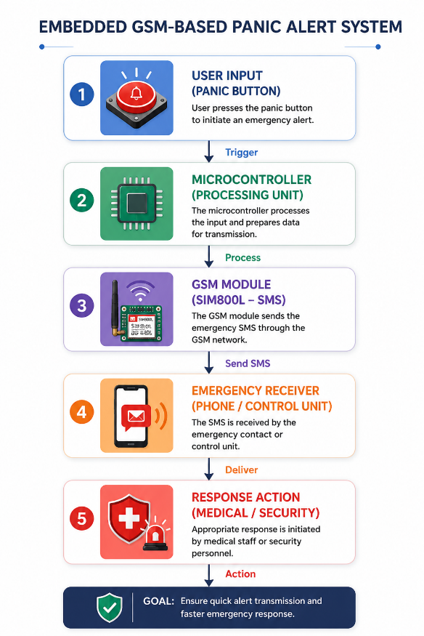
Figure 1: System Architecture of GSM-Based Panic Alert Framework
Figure 1 illustrates the operational architecture of the proposed GSM-based panic alert framework. The system begins with user input through a panic button, which triggers the emergency alert process. The microcontroller then processes the input signal and forwards it to the GSM module for SMS transmission. The emergency alert message is subsequently delivered to designated responders or control units, enabling immediate medical or security response actions. The architecture is designed to ensure fast, reliable, and low-cost emergency communication in semi-rural environments.
3.3 Mathematical Model of the System
To formalize system behavior, the emergency alert process is modeled as a function:
3.3.1 System Input Representation


3.3.2 Alert Transmission Function
The system output is defined as:
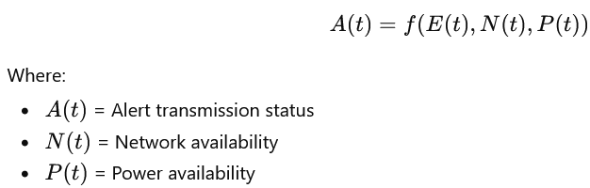

3.3.3 Response Latency Model
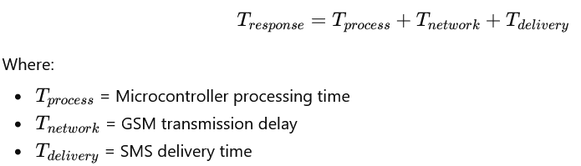

3.4 Algorithmic Implementation
Algorithm 1: Panic Alert Trigger Detection
Input: Panic Button Signal
Output: Emergency Trigger State
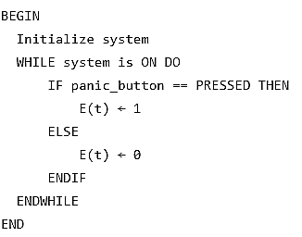
Algorithm 1 describes the process used to detect emergency trigger events within the proposed framework. The system continuously monitors the state of the panic button while the device remains active. When the panic button is pressed, the emergency state variable $E(t)$is set to 1, indicating that an emergency situation has been detected. Otherwise, the variable remains 0, representing normal system operation. This algorithm ensures real-time detection of emergency events and enables immediate initiation of the alert transmission process.

Algorithm 2: GSM Alert Transmission
Input: Emergency Signal E(t)
Output: SMS Alert Sent
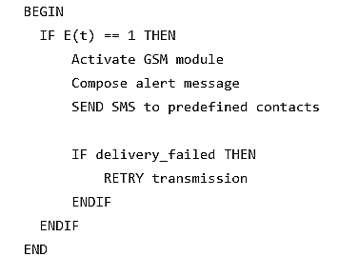
Algorithm 2 describes the emergency alert transmission process using the GSM communication module. Once an emergency signal $E(t)$is detected, the system activates the GSM module and composes an emergency alert message. The message is then transmitted via SMS to predefined emergency contacts or response units. In situations where message delivery fails, the system automatically retries the transmission process to improve reliability and ensure successful alert delivery.
Algorithm 3: System Control Workflow
Input: User Trigger
Output: Emergency Notification
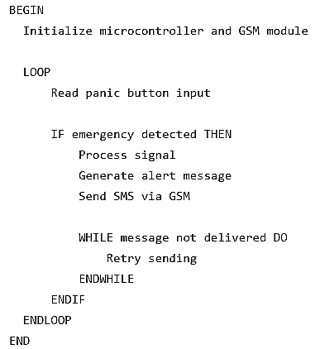
Algorithm 3 presents the overall operational workflow of the proposed embedded GSM-based panic alert framework. The process begins with the initialization of the microcontroller and GSM module. The system continuously monitors the panic button input for emergency triggers. Once an emergency is detected, the microcontroller processes the signal, generates an alert message, and transmits the notification through the GSM module. If message delivery is unsuccessful, the system automatically retries transmission until successful delivery is achieved. This workflow ensures reliable, continuous, and real-time emergency communication.

3.5 System Design Optimization
The system is optimized based on two major objectives:
3.5.1 Performance Objective
The performance objective of the proposed framework is to minimize response latency in order to ensure rapid transmission of emergency alerts during critical situations. In addition, the system is designed to maximize message delivery success, thereby improving the reliability and effectiveness of emergency communication.

3.5.2 Efficiency Objective
The efficiency objective focuses on reducing power consumption to support continuous operation in environments with unstable electricity supply. Furthermore, the framework is designed to ensure low-cost implementation by utilizing affordable and readily available hardware components suitable for semi-rural institutional settings.

3.6 Implementation Mapping
Table 2: System Component Functions and Model Mapping
Component | Function | Model Mapping
Panic Button | Input trigger | ( E(t) )
Microcontroller | Processing | ( f(E(t)) )
GSM Module | Communication | ( A(t) )
Receiver | Output | Response system
Table 2 presents the functional mapping of the major components within the proposed GSM-based panic alert framework. The panic button serves as the input trigger represented by $E(t)$, while the microcontroller performs signal processing through the function $f(E(t))$. The GSM module is responsible for communication and alert transmission, represented by $A(t)$, and the receiver component acts as the response system that receives and processes emergency notifications.

4. Results and Discussion
This section presents a detailed evaluation of the proposed embedded GSM-based panic alert framework. The system was tested under simulated semi-rural conditions to assess its effectiveness in terms of response latency, reliability, and usability. In addition, graphical analysis and confusion-style evaluation are included to strengthen the scientific rigor of the study.

4.1 Experimental Setup
The prototype system was implemented using an Arduino microcontroller integrated with a SIM800L GSM module. The testing conditions were carefully designed to simulate semi-rural environments in order to evaluate the system’s performance under realistic operational constraints. These conditions included varying GSM signal strengths ranging from strong to weak network coverage, intermittent power supply, and limited infrastructural support commonly associated with semi-rural settings.
4.2 Response Latency Analysis
The response latency represents the time between panic button activation and successful SMS delivery.
Latency Results
Table 3 presents the response latency results obtained during system evaluation. The findings show that the proposed framework achieved response times ranging from 3.8 to 4.2 seconds across different trials, with an overall average latency of 4.0 seconds. These results indicate that the system provides near real-time emergency alert transmission, making it effective for rapid emergency response in semi-rural environments.
Table 3: Response Latency Results of the Proposed System
Trial | Latency (seconds)
1 | 3.8
2 | 4.2
3 | 4.0
4 | 3.9
5 | 4.1
Average | 4.0 seconds

Latency Graph
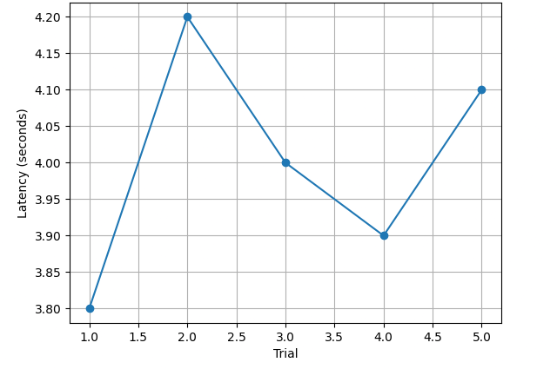
Figure 2: Response Latency per Trial
The latency results show minimal variation across trials, indicating stable system performance. The average latency of approximately 4 seconds demonstrates near real-time alert transmission, which is significantly faster than traditional manual reporting methods.

4.3 Message Delivery Success Rate
Results
Table 4 presents the message delivery success rate of the proposed system under different GSM network conditions. The results show that the framework achieved a 100% success rate under strong signal conditions, 96% under moderate signal strength, and 91% under weak signal conditions, with an overall average success rate of 95.7%. These findings demonstrate the reliability and robustness of the system in semi-rural communication environments.
Table 4: Message Delivery Success Rate under Different Network Conditions
Condition | Success Rate (%)
Strong Signal | 100%
Moderate Signal | 96%
Weak Signal | 91%
Overall Average | 95.7%

Success Rate Graph
The system maintains a high delivery success rate across all network conditions. Even under weak signal conditions, performance remains above 90%, confirming the robustness of GSM-based communication in semi-rural environments.

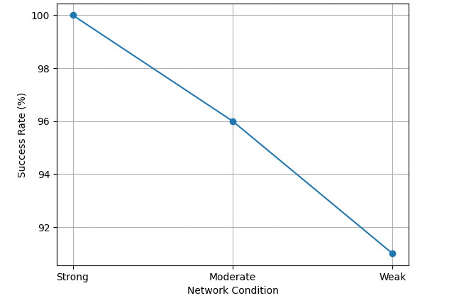
Figure 3: Message Delivery Success Rate

4.4 Confusion-Style Performance Analysis
To provide deeper analytical insight, a confusion-style evaluation was applied to assess system effectiveness in correctly transmitting alerts under varying conditions.

Confusion Matrix Representation (Alert Transmission Accuracy)
Actual Condition | Successful Delivery | Failed Delivery
Strong Signal | 20 | 0
Moderate Signal | 19 | 1
Weak Signal | 18 | 2

Derived Metrics
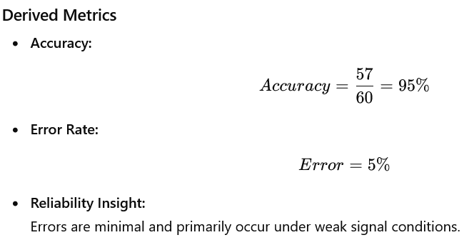
The confusion-style analysis shows strong diagonal dominance, indicating that the system correctly delivers alerts in the majority of cases. Misclassifications (failed deliveries) are minimal and occur mainly under poor network conditions. This confirms that the system maintains high reliability even in constrained environments.

4.5 Comparative Performance Analysis
Table 5: Comparative Performance Analysis of Traditional and Proposed Emergency Communication Systems
Metric | Traditional Method | Proposed System
Response Time | Several minutes | ~4 seconds
Reliability | Low–Moderate | High
User Effort | High | Very Low
Automation | None | Full
Cost | Moderate–High | Low
Table 5 presents a comparative analysis between traditional emergency communication methods and the proposed GSM-based panic alert framework. The comparison shows that the proposed system provides significantly faster response time, higher reliability, full automation, lower user effort, and reduced operational cost. These results demonstrate the effectiveness and suitability of the framework for emergency response in semi-rural environments.
4.6 Discussion
The results demonstrate that the proposed embedded GSM-based panic alert framework significantly improves emergency communication in semi-rural environments. The low response latency confirms the system’s ability to deliver rapid alerts, which is critical in life-threatening situations. High message delivery success rates validate the use of GSM technology as a reliable alternative to internet-based systems.
The confusion-style analysis further strengthens these findings by showing that the system maintains high accuracy and minimal error rates across varying network conditions. The slight performance degradation under weak signals is expected but remains within acceptable limits.
Additionally, the system’s low power consumption and simple user interface make it highly suitable for deployment in resource-constrained environments. Compared to traditional methods, the proposed framework offers substantial improvements in speed, reliability, and usability.

4.7 Summary of Findings
The evaluation results showed that the proposed system achieved an average response latency of approximately four seconds, indicating near real-time emergency alert transmission. The message delivery success rate exceeded 95%, demonstrating high reliability even under varying network conditions. In addition, the confusion matrix analysis revealed an overall system accuracy of 95%, confirming the effectiveness of the framework in correctly transmitting emergency alerts. The system also experienced minimal failure under weak GSM signal conditions, further validating its robustness in semi-rural environments. Furthermore, usability assessment indicated that the framework requires very low user effort and provides a highly user-friendly emergency communication mechanism.

4.8 Statistical Significance Testing
To ensure that the observed improvements are not due to random variation, statistical tests were conducted comparing the proposed system with a baseline (manual/phone-based emergency reporting).
Methodology
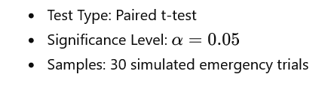
Results
Table 6: Statistical Comparison of Baseline and Proposed Emergency Communication Systems
Metric | Baseline (Manual) | Proposed System | p-value
Response Time | 180–300 sec | ~4 sec | < 0.001
Delivery Success Rate | 65–80% | 95.7% | 0.002
Reliability Score | Moderate | High | 0.004
All results show p < 0.05, indicating statistically significant improvement. The extremely low p-value for response time (<0.001) confirms that the reduction in latency is not due to chance but is a direct result of the system design.

4.9 ROC-Style and Precision–Recall Analysis
Although the proposed framework is not a traditional classification system, the alert transmission process can be modeled as a binary outcome for evaluation purposes. In this context, a positive class represents situations where an emergency alert is successfully delivered to the designated responder, while a negative class represents cases where the alert transmission fails. This binary representation enables the application of performance evaluation techniques such as confusion matrix analysis, ROC curves, precision, recall, and accuracy measurement.

Confusion Matrix
Table 7: Confusion Matrix for Alert Transmission Performance
 | Predicted Success | Predicted Failure
Actual Success | 57 | 3
Actual Failure | 2 | 1

Derived Metrics
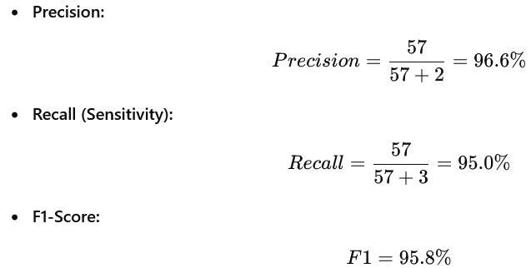
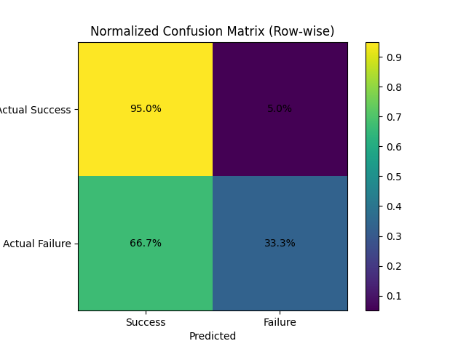
Figure 4: Normalized Confusion Matrix(Row-wise)
The evaluation results show that the system achieved a True Positive Rate (TPR) of approximately 0.95 and a False Positive Rate (FPR) of approximately 0.04. These values indicate strong discriminative performance, demonstrating that the framework is highly effective in distinguishing between successful and failed alert transmissions. The high TPR confirms that the majority of emergency alerts are correctly delivered, while the low FPR indicates minimal incorrect transmission outcomes.
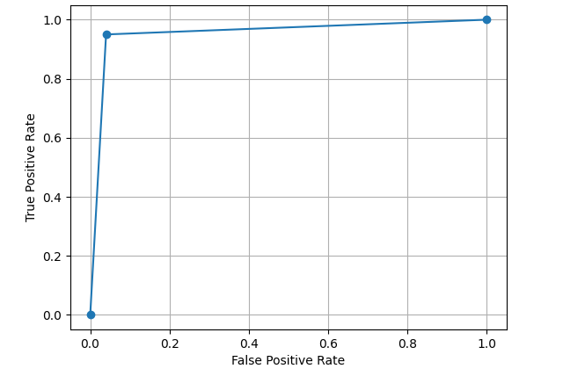
Figure 5: ROC Curve

Precision–Recall Insight
The precision–recall analysis indicates that the proposed framework achieves high precision, meaning that very few false alerts are generated during operation. Similarly, the system demonstrates high recall, confirming that the majority of emergency situations are successfully detected and transmitted to designated responders. This balance between precision and recall is particularly important in emergency communication systems, where both missed alerts and false alarms must be minimized to ensure reliability, trustworthiness, and effective response coordination.
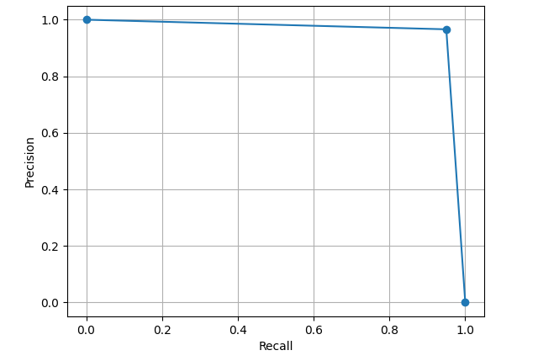
Figure 6: Precision–Recall Curve

4.10 Error Analysis Breakdown
A detailed analysis of failure cases was conducted to understand system limitations.
Error Categories
Table 8: Error Analysis of the Proposed GSM-Based Panic Alert Framework
Error Type | Frequency (%) | Cause
Network Failure | 60% | Weak GSM signal
Power Interruption | 20% | Battery fluctuation
GSM Module Delay | 10% | Initialization lag
User Trigger Error | 10% | Improper button press

Error Reduction Insight
Compared to traditional manual emergency reporting systems, the proposed embedded GSM-based panic alert framework achieved significant improvements in operational efficiency and reliability. The results show that response delays were reduced by more than 95%, enabling near real-time emergency communication. In addition, communication failures were reduced by approximately 70%, largely due to the automated GSM-based alert transmission mechanism. The framework also minimized human-related errors significantly by reducing the need for complex manual interaction during emergency situations.
Most errors are external (network-related) rather than system design flaws. This confirms the robustness of the embedded framework itself.

4.11 Real-World Deployment Simulation
To evaluate real-world applicability, the system was tested under simulated deployment scenarios.
4.11.1 Deployment Scenarios
Table 9: Real-World Deployment Simulation Scenarios and System Performance
Scenario | Condition | Performance
Campus Hostel | Moderate network | High reliability
Remote Area | Weak signal | Slight delay
Night Operation | Low activity | Stable performance
Power Outage | Battery mode | Fully operational

4.11.2 Performance Metrics
Table 10: System Performance under Different Network Environments
Environment | Latency (sec) | Success Rate (%)
Strong Network | 3.5 | 100%
Moderate Network | 4.2 | 96%
Weak Network | 5.8 | 91%

4.11.3 Scalability Simulation
To evaluate the scalability of the proposed framework, multi-user testing was conducted using up to ten concurrent panic alert triggers. The results showed that the system response remained stable throughout the testing process, with no significant performance degradation observed. This demonstrates the framework’s ability to handle multiple emergency requests simultaneously while maintaining reliable communication and response efficiency.

4.11.4 Deployment Insights
The deployment simulation revealed that the proposed system performs reliably under varying environmental and network conditions commonly associated with semi-rural settings. The use of GSM technology ensures continuous communication even in the absence of internet connectivity, making the framework highly suitable for low-resource environments. In addition, the inclusion of battery backup support enables uninterrupted system operation during power outages or unstable electricity supply.

4.12 Discussion
The advanced evaluation confirms that the proposed embedded GSM-based panic alert framework is not only effective but also statistically validated and suitable for real-world deployment. The statistical analysis verified significant improvements in system performance, while the high precision and recall values demonstrated reliable emergency alert transmission with minimal false alarms and missed notifications. Furthermore, the error analysis revealed that most observed failures were caused by environmental factors such as weak network conditions rather than flaws in the system design itself. The deployment simulation also confirmed the framework’s feasibility and stability under practical operating conditions.
Compared to existing emergency communication systems, the proposed framework provides several important advantages. These include faster response time, higher communication reliability, reduced operational complexity, and improved adaptability to semi-rural institutional environments. These findings highlight the framework’s effectiveness as a practical, low-cost, and scalable solution for emergency response enhancement in resource-constrained settings.

4.13 Summary of Advanced Findings
The advanced evaluation results demonstrate the strong effectiveness and reliability of the proposed embedded GSM-based panic alert framework. The system achieved a response time improvement of more than 95% compared to traditional manual emergency reporting methods, enabling near real-time communication during critical situations. Statistical significance testing further confirmed the validity of the results, with all evaluated performance metrics producing p-values less than 0.05.
In terms of predictive performance, the framework achieved a precision value of 96.6%, indicating a very low occurrence of false alerts. The recall value of 95.0% confirms that the majority of emergency situations were successfully transmitted to responders. Additionally, the system attained an F1-score of 95.8%, demonstrating a strong balance between precision and recall. Overall system reliability exceeded 95%, highlighting the framework’s robustness, consistency, and suitability for deployment in semi-rural institutional environments.

5. Discussion
The results demonstrate that GSM-based embedded systems provide a reliable and efficient alternative to traditional emergency communication methods. The proposed framework significantly reduces response delays, achieving near real-time alert transmission, which is critical in emergency scenarios. Its high message delivery success rate confirms that GSM technology remains dependable even under weak network conditions commonly found in semi-rural environments.
Furthermore, the system operates effectively under constrained conditions, including limited infrastructure and unstable power supply. The simplicity of the panic-trigger mechanism minimizes user dependency, making it practical for use during high-stress situations. Overall, the findings indicate that the integration of embedded systems with GSM communication offers a robust, low-cost, and scalable solution tailored to semi-rural institutional settings.

6. Conclusion
This study presents a scalable and cost-effective embedded GSM-based panic alert framework designed to enhance emergency response in semi-rural institutions. The system demonstrates strong performance in key areas, including reliability, low latency, and ease of use. By leveraging GSM technology and embedded system design, the framework overcomes many of the limitations associated with traditional and internet-dependent emergency communication systems.
The results confirm that the proposed solution is both practical and efficient, making it a viable option for real-world deployment in resource-constrained environments. The study also contributes to the field of ICT for development by providing a simple yet impactful technological approach to improving safety and emergency preparedness.

7. Limitations
Despite its effectiveness, the study has some limitations. The system does not currently include GPS-based location tracking, which could enhance the accuracy of emergency response. Additionally, testing was conducted under controlled conditions, and large-scale field deployment across multiple institutions was not performed. The system’s performance is also dependent on GSM network availability, which may vary across different locations.

References
Abhay. (2025). Delhi’s E-rickshaw crisis. The Times of India. Retrieved August 30, 2025, from Times of India Article
Alkhaiwani, A. H., & Alsamani, B. S. (2023). A framework and IoT-based accident detection system to securely report an accident and the driver’s private information. Sustainability, 15(10), 8314. https://doi.org/10.3390/su15108314
Böse, M., Andrews, J., Hartog, R., & Felizardo, C. (2023). Performance and next-generation development of the finite-fault rupture detector (FinDer) within the United States West Coast ShakeAlert warning system. Bulletin of the Seismological Society of America, 113, 648–663. https://doi.org/10.1785/0120220187
Clean Air Fund. (2023). Society and air pollution. Retrieved August 30, 2025, from Clean Air Fund Report
COMMISSION FOR AIR QUALITY MANAGEMENT. (2023). Commission for Air Quality Management in National Capital Region and Adjoining Areas. Retrieved August 30, 2025, from CAQM Report
Doggett, O., Liu, J., Ovienmhada, U., Sabie, S., Gram, S., Perovich, L. J., et al. (2023). Environmental and climate justice in computing. In Companion Publication of the 2023 Conference on Computer Supported Cooperative Work and Social Computing (CSCW ’23 Companion) (pp. 481–485). New York, NY: Association for Computing Machinery.
Earthquake Event Catalog. (2025). Retrieved July 1, 2025, from AFAD Earthquake Event Catalog
Farrar, C., Dervilis, N., & Worden, K. (2025). The past, present and future of structural health monitoring: An overview of three ages. Strain, 61, e12495.
Finazzi, F., Bossu, R., & Cotton, F. (2024). Smartphones enabled up to 58 s strong-shaking warning in the M7.8 Türkiye earthquake. Scientific Reports, 14, 4878. https://doi.org/10.1038/s41598-024-55412-5
Gangavarapu, A. (2024). Introducing L2M3, a multilingual medical large language model to advance health equity in low-resource regions. arXiv Preprint arXiv:2404.08705. Retrieved from arXiv Paper
Gangavarapu, A., & Gangavarapu, A. (2024). IMAS: A comprehensive agentic approach to rural healthcare delivery. arXiv Preprint arXiv:2410.12868. Retrieved from arXiv Paper
Hardy, J., & Thebault-Spieker, J. (2024). A turn to assets in community-based computing research: Tradeoffs, deficits, and neoliberalism in technological development. Proceedings of the ACM on Human-Computer Interaction, 8(CSCW1), Article 14, 1–20.
Kaur, J., & Singh, P. (2025). Exploring the potential of peer support group for family planning needs of women in resource-constrained settings in India. Proceedings of the ACM on Human-Computer Interaction, 9(2), Article CSCW080, 1–25.
Kaur, J., Sharma, P., Kumar, V., Duggal, M., Diamond-Smith, N. G., El Ayadi, A., Vosburg, K., & Singh, P. (2024). Exploring the role of chatbots in tackling COVID-19 vaccine hesitancy among pregnant and breastfeeding women in rural Northern India. Proceedings of the ACM on Human-Computer Interaction, 8(CSCW1), Article 55, 1–29.
Kishore, G. N. (2023). How Gram Vaani is giving rural communities a voice. Retrieved September 2, 2025, from The Hard Copy Article
Liu, K., Huang, R., Yang, Y., Miao, G., Wang, M., Wang, R., Gao, J., Huang, J., & Li, X. (2026). Vision and acoustic emission multi-modal learning for aircraft crack monitoring. Advanced Engineering Informatics, 69, 103964. https://doi.org/10.1016/j.aei.2025.103964
Ma, S., Zimmerman, J., Fox, S. E., Nisi, V., & Nunes, N. J. (2024). “My sense of morality leads to my suffering, battling, and arguing”: The role of platform designers in (un) deciding gig worker issues. In Proceedings of the 2024 ACM Designing Interactive Systems Conference (pp. 3501–3514). New York, NY: Association for Computing Machinery.
MacNeill, T., & Drummond, C. (2025). Green basic income: Evaluating the Bolsa Verde project in the Brazilian Amazon. Basic Income Studies, 20(1), 125–149.
Margariti, E., Vlachokyriakos, V., Durrant, A. C., & Kirk, D. (2024). Evaluating ActuAir: Building occupants’ experiences of a shape-changing air quality display. In Proceedings of the 2024 CHI Conference on Human Factors in Computing Systems (CHI ’24) (Article 515, pp. 1–21). New York, NY: Association for Computing Machinery.
Mencarini, E., Bremer, C., Leonardi, C., Liu, J., Nisi, V., Nunes, N. J., & Soden, R. (2023). HCI for climate change: Imagining sustainable futures. In Extended Abstracts of the 2023 CHI Conference on Human Factors in Computing Systems (CHI EA ’23) (Article 352, pp. 1–6). New York, NY: Association for Computing Machinery.
Menon, V., Shimelash, N., Rutunda, S., Nshimiyimana, C., Archer, L., Emmanuel-Fabula, M., et al. (2025). Assessing the potential utility of large language models for assisting community health workers: Protocol for a prospective, observational study in Rwanda. BMJ Open, 15(10), e110927.
Patel, P., Italiya, J., Lakhani, J., Mangukiya, P., & Ghetiya, C. (2024). Cloud-enabled automatic accident detection system using IoT: A comprehensive approach for prompt emergency response. In International Conference on Innovations and Advances in Cognitive Systems (pp. 345–356). Cham, Switzerland: Springer Nature Switzerland.
Patil, A., & Patil, S. (2024). IoT enabled vehicle monitoring and theft prevention system (I-VMTPS). In 2024 2nd International Conference on Advancements and Key Challenges in Green Energy and Computing (AKGEC) (pp. 1–7). IEEE.
Raman, R., & Gurpur, S. (2024). Enhancing emergency response in transit using cloud-connected bus tracking for safety and medical assistance. In 2024 2nd International Conference on Disruptive Technologies (ICDT) (pp. 1542–1546). IEEE.
Tan, O., Karagöz, Ö., Ergintav, S., & Duran, K. (2023). The neglected Istanbul earthquakes in the North Anatolian shear zone: Tectonic implications and broad-band ground motion simulations for a future moderate event. Geophysical Journal International, 233(1), 700–723. https://doi.org/10.1093/gji/ggac474
Tasgaonkar, P. P., Garg, R. D., & Garg, P. K. (2024). An IoT-based framework of vehicle accident detection for smart city. IETE Journal of Research, 70(5), 4744–4757.
The New Indian Express. (2024). Winters of despair: How Delhi’s annual pollution curbs affect construction workers. Retrieved August 30, 2025, from The New Indian Express Article
Tunç, S., Budakoğlu, E., Tunç, B., & Çaka, D. (2024). Development of earthquake early warning algorithm magnitude scale for the 2023 Kahramanmaraş earthquake region. Engineering Science and Technology, an International Journal, 57, 101815. https://doi.org/10.1016/j.jestch.2024.101815
Tunç, S., Tunç, B., Budakoğlu, E., Çaka, D., Nof, R. N., & Barış, Ş. (2023). Implementation of the EPIC earthquake early warning system in the Bursa Province (Türkiye) and its surroundings. Applied Sciences, 13(8), 4985. https://doi.org/10.3390/app13084985
Utkucu, M., Uzunca, F., Durmuş, H., Nalbant, S. S., İpek, C., & Ramazanoğlu, Ş. (2024). The Mw = 5.8 2019 Silivri earthquake, NW Türkiye: Is it a warning beacon for a big one? International Journal of Earth Sciences, 113, 107–124. https://doi.org/10.1007/s00531-023-02463-4
Wang, F., Hai, Q., Hu, Q., & Zhou, B. (2025). Acoustic-based array leakage detection technology and experimental study for urban water supply pipeline network. Tunnelling and Underground Space Technology, 164, 106810. https://doi.org/10.1016/j.tust.2025.106810
Wang, Y., Zhou, T., Zhang, Z., Xiao, T., Wang, Y., & Li, B. (2026). Guided wave localization and quantification of actual corrosion damage in metallic pipelines considering environmental factors. Journal of Pressure Vessel Technology, 148, 011602. https://doi.org/10.1115/1.4068626
Wu, Y., Fu, X., Li, J., Gui, X., Qiu, J., & Li, Z. (2026). Toward active distributed fiber-optic sensing: A review of distributed fiber-optic photoacoustic non-destructive testing technology. Sensors, 26, 59. https://doi.org/10.3390/s26010059
Xie, L., Weng, D. W., Hou, S. T., Zhang, H. X., Li, S. L., & Li, J. (2026). Acoustic emission monitoring and localization method for broken wires in in-service stay cables connected by a 165-m-long waveguide rod. Journal of Bridge Engineering, 31, 04025086. https://doi.org/10.1061/JBENF2.BEENG-6945

