Evaluation the Efficiency of Biosynthesized Silver Nanoparticles on some Fungal Growth and their Mycotoxin Content

Abstract
The increasing incidence of antifungal resistance and environmental hazards of synthetic fungicides create an urgent need for eco-friendly alternatives. In this regard, green nanotechnology has been developed as a promising approach for synthesis of biologically active nanomaterials. In this study, the efficiency of biosynthesized silver nanoparticles (AgNPs), using sunflower was evaluated. oil of Helianthus annuus L. as reducing and stabilizing agent with special reference to their antifungal activity and effects on mycotoxins production The synthesized nanoparticles were characterized by using UV-Vis and FTIR techniques. Their antifungal activity was evaluated against some fungal strains like Fusarium solani, Alternaria alternata and Aspergillus niger. Results showed significant inhibition of fungal growth and reduction of mycotoxin production of these fungi species. These findings underscore the promising role of plant-mediated AgNPs as eco-friendly antifungal agents for agricultural and biomedical applications.
Key words: Biosynthesis Silver nanoparticles, Fungal growth, Mycotoxine, Antifungal activity.
1. Introduction
Nanotechnology is one of the fastest growing scientific fields providing novel solutions in various disciplines such as agriculture, medicine and environmental science (Rico et al., 2011). Silver nanoparticles (AgNPs) have been extensively studied among nanomaterials because of their powerful antimicrobial activities against bacteria, and also viruses and fungi (Rai et al., 2009 ; Hassan et al., 2021 ).
The traditional chemical methods for the synthesis of nanoparticles generally involve toxic reagents and hazardous by-products, which is a matter of concern for the environmental safety and human health (Iravani, 2011). Therefore, green synthesis approaches using plant extracts have received a great deal of attention owing to their eco-friendly, low cost and sustainable nature (Shafey, 2020). Among the plant constituents important in the reduction of metal ions and stabilization of the synthesized nanoparticles are flavonoids, phenolics and terpenoids (Vivaldo-Lima et al., 2017; Bao et al., 2021).
Sunflower (Helianthus annuus L.) oil contains bioactive compounds such as tocopherols, linoleic acid and phenolic antioxidants, which contribute to its high reducing capacity and usefulness in the synthesis of nanoparticles (Akkaya, 2018; Li et al., 2024). These compounds not only help in forming the nanoparticles but also improve their biological activity through synergistic effects (Bao et al. 2021)
Fungal pathogens such as Fusarium solani, Alternaria alternata, and Aspergillus niger are among the most destructive microorganisms affecting agricultural productivity. These fungi can produce mycotoxins such as aflatoxins, fumonisins and alternariol which are serious health hazards for humans and animals (Bhat et al., 2010; Zain, 2011). These toxins are persistent and stable and difficult to get rid of using conventional methods.
Recent studies have demonstrated that AgNPs exhibit strong antifungal activity by disrupting cell membranes, generating reactive oxygen species (ROS), and interfering with cellular metabolism (Rai et al., 2009; Hassan et al., 2021). Moreover, AgNPs have been reported to reduce mycotoxin production by inhibiting key metabolic pathways involved in toxin biosynthesis (Inbaia et al., 2022).
Therefore, the present study aims to investigate the biosynthesis of silver nanoparticles using sunflower oil and evaluate their antifungal activity and their role in reducing mycotoxin production.

2. Materials and Methods
2.1 Sunflower seeds sterilization and seedlings production
Sunflower seeds (Helianthus annuus L.) were surface sterilized using 96% ethanol at 2 min. followed by 2% sodium hypochlorite at 10 min. and washed three times with distilled water (Adeleke et al., 2022). Seeds were cultured on sterilized Murashige and skoog (1962) medium at pH 5.8, incubated in the growth chamber at dark for three days, then sterilized transferred to a 16/8 light/dark cycle. After 7 days, the germination rate of the seedlings was recorded. Hypocotyl segments of this seedlings were collected from 15-days-old for the next experiments.
2.2 Sunflower seedling oil extraction
The Hypocotyl segments of the seedlings excised were oven-dried at 50–60°C for 48 hours using a Gallenkamp hot air oven (BStWo, Model 160, England) and subsequently ground into a fine powder. Oil extraction was performed using a Soxhlet apparatus (VELP Scientific, SER 148, Italy) at the Central Laboratory, College of Agriculture and Forestry, University of Mosul. The extraction was carried out using hexane as the solvent for a duration of 3 hours. Following extraction, the solvent was evaporated under reduced pressure using a rotary evaporator, and the final oil yield was calculated (Al-Hajjar, 2015) .
2.3 Biosynthesis of Silver Nanoparticles
1ml of Sunflower oil was added to 100 ml of silver nitrate AgNO₃ solution and mixed at room temperature for 30 minutes then the mixture was stirred vigorously using a magnetic stirrer. After approximately 14 min. , a visible color change was observed. The color of the clear AgNO₃ solution changed, indicating the creation of matching nanoparticles (Iravani, 2011).
2.3 Biosynthesized Ag-NPs Characterization Techniques
The synthesized silvir nanoparticles were characterized using:
- UV–Vis spectroscopy
UV–visible spectra of the aqueous colloid samples of synthesized silver nanoparticles were measured on the Visible (UV-Vis) spectrophotometer, a device (UV-Vis, Analytic Jena, Germany) found in Central laboratory, Collage of Science, University of Mosul which used to detect and diagnose silver nanoparticles prepared in a biological way and determine the maximum absorbance peaks, by placed the prepared nanoparticles solution in a quartz cell, then the absorbance was measured at the wavelength (400-440 nm) (Jagtap and Bapat 2021), the results were recorded for each sample measured.
- FT-EDAX spectroscopic technique
Fourier Transform Infrared (FTIR) spectroscopy is a potent analytical method that uses an FTIR instrument (BRUKER, American) in the Central Laboratory, College of Science, University of Mosul to detect the functional groups in a molecule and ascertain its molecular structure. The presence of plant functional groups attached to the surface of the nanoparticles was shown by unique peaks in various regions of the FTIR spectrum of Ag-NPs made using the plant extract. These peaks demonstrate that the bioactive substances in the extract had two functions during the manufacturing process: they stabilized and encapsulated the nanoparticles while also helping to reduce silver ions (Ag⁺) to metallic silver (Ag⁰) (Widatalla et al .,2022).
2.4 Fungal Isolates and Culture
The fungal species used in this study, namely Fusarium solani, Alternaria alternata, and Aspergillus niger, were selected based on their well-documented pathogenicity and their ability to produce mycotoxins (Lawrence et al., 2016).
Pure fungal cultures were maintained on Potato Dextrose Agar (PDA) medium. 39 g of PDA medium was produced according to the manufacturer’s instructions Lab M. Limited – United Kingdom and dissolved in a particular quantity of distilled water. The pH was adjusted to 5.6 ± 0.2 and the volume was increased to 1000 ml. It was then autoclaved for 15 minutes at 121 °C and 15 psi of pressure to disinfect it. The medium was then transferred into sterilized Petri dishes and allowed to harden at 25 °C in an incubator. to guarantee steady growth and repeatability of outcomes (Villarino et al., 2019).
2.5 Effect of Biosynthesized AgNPs on Studied Fungal Growth
The poisoned food approach, a commonly used method for evaluating fungal growth suppression, was used to examine the antifungal activity. Using this approach, The radial growth of fungal colonies was measured and compared to the untreated control after various treatments were added to the PDA culture media (prepared on 2.4 above) at concentrations of 10, 20, and 40% of each kind of fungus.
This method provides quantitative information on the degree of growth suppression by directly determining the inhibitory effect of biosynthesized silver nanoparticles on fungal growth. (Rico et al., 2011).
2.5 Testing the effectiveness of biosynthesis silver nanoparticle concentrations in inhibiting the growth of the fungi
Three duplicates of each treatment were used to examine the efficacy of the produced silver nanoparticle solution on the investigated fungus at doses of 10, 20, and 40 mg/ml. The plates were incubated at 25°C for 6 days with daily monitoring. The inhibition percentage was calculated using the following equation:
Percentage of inhibition = (Treatment for fungal growth rate - Control for fungal growth rate) / (Control for fungal growth rate) x 100
2.6 Determinate the Mycotion Contet
Mycotoxin levels were determined using high-performance liquid chromatography (HPLC)found in Scientific Research Authority Laboratories – Environment and Water Department, Baghdad, which is a sensitive and reliable method for detecting fungal secondary metabolites. These metabolites are produced during fungal growth and are responsible for toxic effects in contaminated food and feed (Bhat et al., 2010).
The analysis was conducted to evaluate the effect of biosynthesized silver nanoparticles on the production of mycotoxins. A reduction in toxin levels was interpreted as an indication of inhibition of fungal metabolic activity and interference with toxin biosynthesis pathways.
3. Results and Discussion
3.1 Sterilized Seedling Production
Surface sterilization produced healthy, contamination-free seedlings with 90% germination efficiency within 7 days. This result may be attributed to the effectiveness of the sterilization protocol used, particularly sodium hypochlorite (NaOCl), which efficiently eliminated surface contaminants without causing damage to the embryonic tissues. In addition, the optimized sterilization duration helped maintain seed viability and metabolic activity, leading to successful germination and the production of vigorous seedlings suitable for subsequent in vitro experiments.(Fig.1)
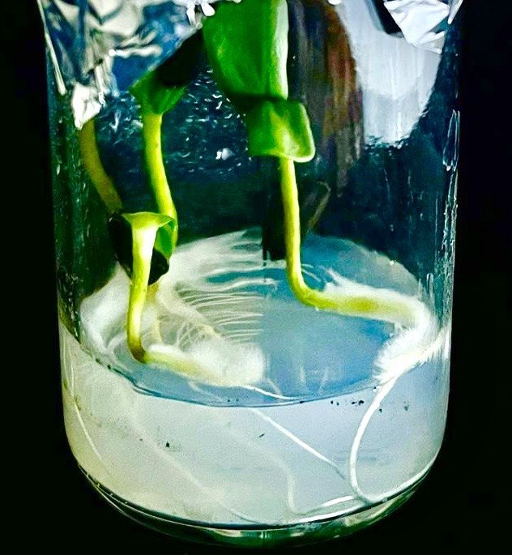
Figure1: Sunflower (Helianthus annuus L.)sterilized seedlings after 7 days of growth on MS medium
3.2 Biosynthesis of Silver Nanoparticle(AgNPs) and Characterization Techniques
3.2.1 AgNPs biosynthesis and their visual detection
The sunflower seedlings oil exhibited strong reducing capability, inducing a characteristic color transition to turbid yellowish brown within 15–20 minutes, representing the formation of AgNPs(Fig.2).
The present study confirms that sunflower oil can act as an effective reducing and stabilizing agent in the green synthesis of silver nanoparticles. The presence of antioxidants and fatty acids contributes to nanoparticle stability and enhances their biological activity (Akkaya, 2018 ; Li et al., 2024).
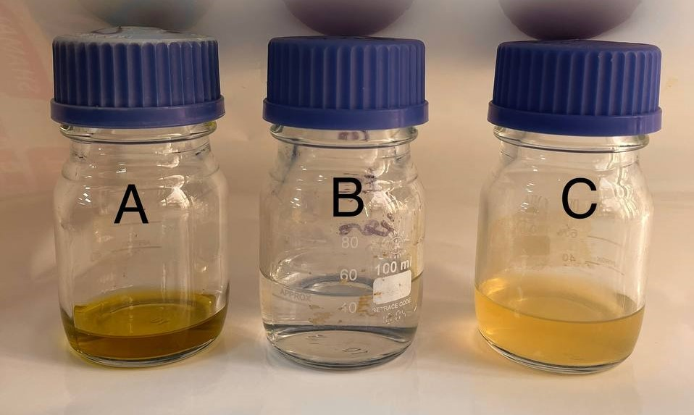
Figure 2 : Steps of AgNps formation since A: Seedling Sunflower oil , B: AgNO₃ solution and C : AgNPs produced after 15-20 min from mix A with B.
3.2.2 UV–Visible Spectroscopic Characterization of AgNPs
The formation of AgNPs was confirmed by a the above distinct color change from colorless to yellow , which is attributed to the excitation of surface plasmon vibrations (Iravani, 2011). UV–Vis spectra showed a characteristic peak in the range of 400–440 nm, consistent with previous studies (Rai et al., 2009) The absorbance values of biosynthesis AgNPs solution were measured in the electromagnetic spectrum's visible area. The UV–Vis spectrum showed a prominent absorption peak at 440 nm for silver nanoparcticles (Fig.3) .
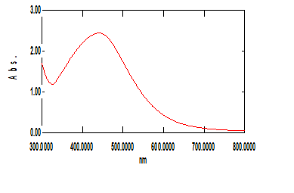
Figure 3: UV–Vis spectrum analysis of silver nanoparticle synthesis by sunflower seedlings oil compound citral at 440 nm
3.2.3 Fourier transform infrared (FTIR) spectroscopy
FTIR analysis was used to determine the potential functional groups in the biomolecules present in sunflower oil and all the reaction tubes, as well as their function in the synthesis of AgNPs as coating agents for the biosynthesis of nanoparticles, such as phenol, alcohol, carboxylic acid, alkaloids, and terpenoids, which are in charge of stabilizing and reducing nanoparticles. The following functional groups were noted in the results (Fig.4) as the following:
- In the range (3000–4000 cm⁻¹): the 3381 and 3232 cm⁻¹ to O–H vibrations (hydroxyl groups in phenols or sugars) found Indicates the role of phenolic compounds in reduction and stabilization ,3060 cm⁻¹: Aromatic C–H vibrations (from aromatic plant compounds),2933 and 2850 cm⁻¹: Aliphatic C–H vibrations (from sugars or proteins).
- In the range (1500-1800 cm⁻¹) found the 1718 cm⁻¹: C=O vibration (carbonyl in organic acids or aldehydes). Indicates the interaction of the carbonyl with the surface of the silver nanoparticles,1632 cm⁻¹: C=C vibration or amide bond (from proteins). Often indicates that plant proteins contributed to the particle encapsulation.
- In the range (1000-1400 cm⁻¹) found the 1310–1101 cm⁻¹: C–O and C–N vibrations (sugars, proteins, flavonoids). These groups act as anchoring agents for nanoparticles,1039 and 1025 cm⁻¹: C–O–C bonds (polysaccharides).
- And in Lower band (1000–400 cm⁻¹) found the 944–732 cm⁻¹: Aromatic C–H vibrations outside the C–H plane,598–462 cm⁻¹: Metal-organic bands, often associated with the interaction of silver with plant functional groups. These peaks confirm the formation of bonds between the surface of silver nanoparticles and biomolecules.
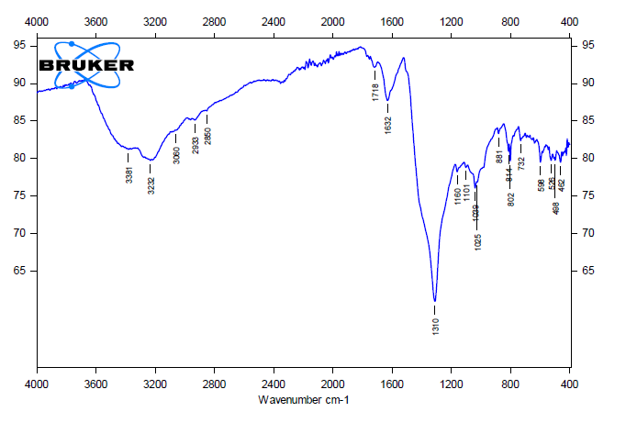
Fig.4: FTIR spectrum of AgNPs dried powder synthesized by sunflower seedlings oil
3.3 Effect of Biosynthesized AgNPs on Fungal Growth
The antifungal activity of biosynthesized silver nanoparticles (AgNPs) concentration was evaluated against Fusarium solani, Alternaria alternata, and Aspergillus niger. The results demonstrated a significant reduction in fungal growth in all treated groups compared to the control(the same fungi types grown on PDA alone non treated with the AgNPs ).
In all fungal species cultures the highest inhibition rate was observed in treatments containing AgNPs at the concentration 40%, This suggests that although sunflower oil possesses inherent bioactive compounds with antifungal properties, the incorporation of AgNPs significantly enhances the inhibitory effect.
In all tested fungal cultures, the inhibitory effect increased proportionally with increasing AgNPs concentration. In Fusarium solani, the inhibition rates reached 54%, 77%, and 100% at AgNPs concentrations of 10%, 20%, and 40%, respectively. Similarly, Aspergillus niger showed inhibition rates of 45%, 61%, and 100% when treated with the same concentrations of . Whereas the Alternaria alternata exhibited the highest sensitivity, where complete inhibition (100%) was achieved at all tested AgNPs concentrations (10%, 20%, and 40%). Meanwhile, sunflower oil alone (control treatment without nanoparticles) showed no inhibitory effect on fungal growth. These results validate the increased inhibitory capacity of silver nanoparticles made with sunflower oil by showing that the antifungal activity was highly dependent on AgNPs concentration and fungus species sensitivity. (Rai et al., 2009; Hassan et al., 2021).
Fusarium and Alternaria demonstrated the highest sensitivity to AgNP treatment among the studied fungus, which may be connected to variations in cell wall composition and metabolic activity. Aspergillus niger, on the other hand, showed comparatively less susceptibility, perhaps as a result of its robust adaptive mechanisms and greater tolerance to environmental stress.
In comparison to the control, the results showed a significant decrease in fungal growth in all treated samples (Fig. 5). AgNPs' higher antifungal activity was confirmed by their stronger inhibitory effects compared to sunflower oil alone (Hassan et al., 2021). The combination treatment showed a synergistic effect, likely due to the interaction between bioactive compounds in sunflower oil and the nanoparticles, enhancing membrane permeability and oxidative stress in fungal cells. Furthermore, the decrease in toxin levels may be associated with oxidative stress induced by AgNPs, which affects the normal functioning of fungal cells and reduces their ability to synthesize toxic compounds (Bao et al.,2025).
From the result we notic that the concentration 40% of Ag-NPs gived the highest inhibition to the growth of all the fungi studied and the inhibition rate decreas with the Ag-NPs concentration used (Table. 1) .
Table.1 Inhibition rate the growth of fungal studied types by Ag-NPs Concetration.
Inhibition rate  (%) | Colony diameter  (mm) | Ag-NPs concentrations  (%) | Type of fungi
0.0  54  77  100 | 5.6  2.6  1.3  0 | 0.0 (control)  10  20  40 | Free of fungi  Fusarium  Solian
0.0  45  61  100 | 3.8  2.1  1.5  0 | 0.0 (control)  10  20  40 | Aspergillus  Niger
0.0  100  100  100 | 4.2  0  0  0 | 0.0 (control)  10  20  40 | Alternaria  Alternata

 | Aspergillus | Fusarium | Alternaria
Control A | 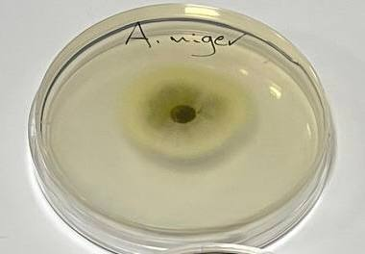 | 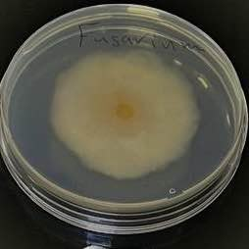 | 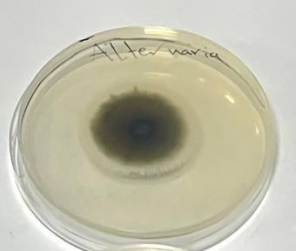
10% B | 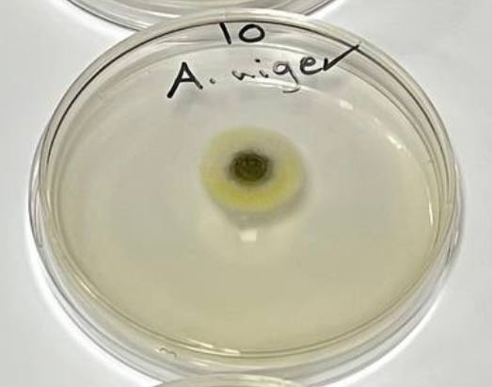 | 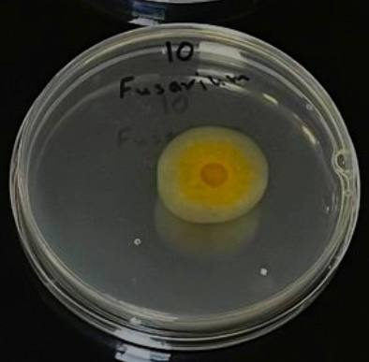 | 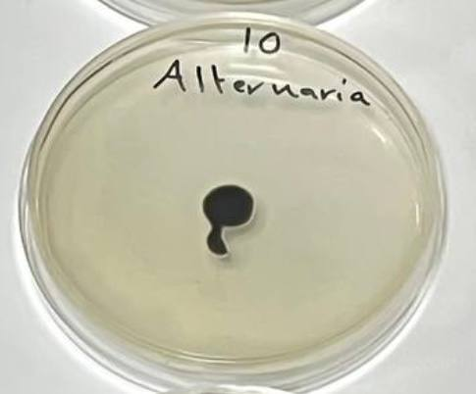
20% C | 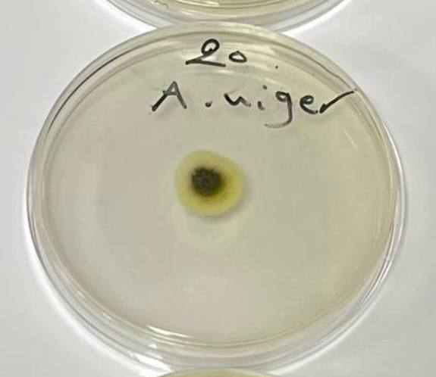 | 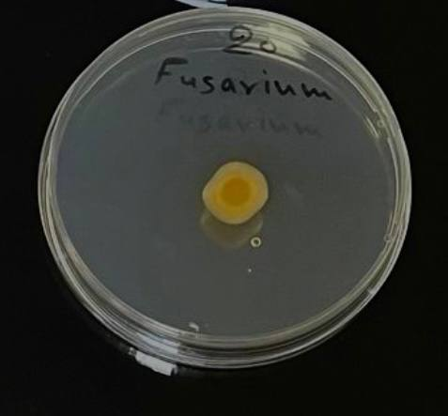 | 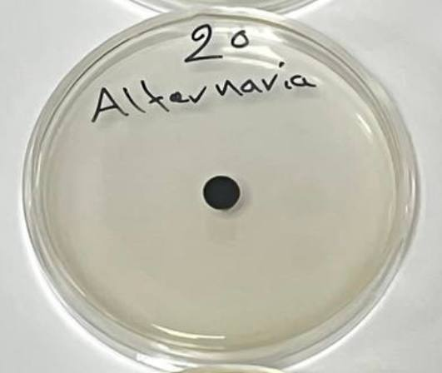
40% D | 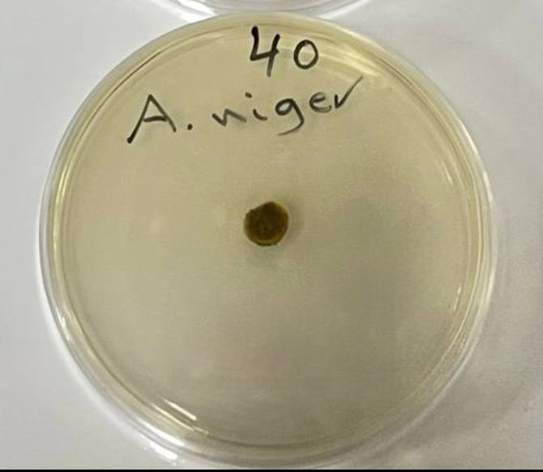 | 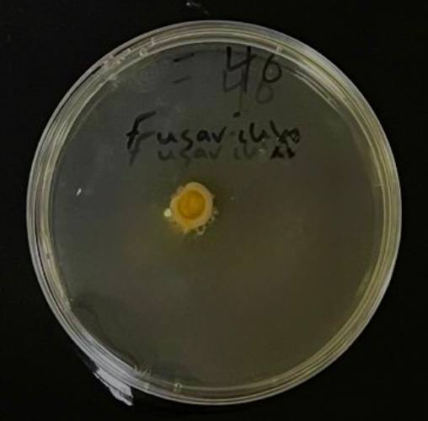 | 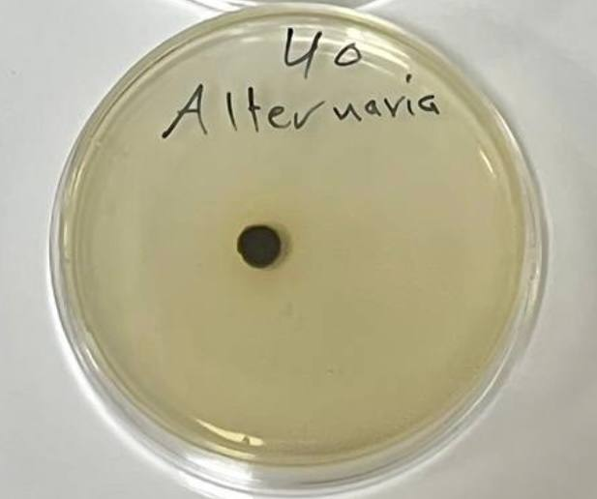

Figure (5) illustrates the effect of different concentrations of AgNPs in inhibiting the growth of studied fungi

A: Alternaria, Fusarium and Aspergillus growth on PDA alone,

B: Alternaria, Fusarium and Aspergillus growth on PDA added with 10 % AgNPs.

C:Alternaria, Fusarium and Aspergillus growth on PDA added with 20 % AgNPs.

D: Alternaria, Fusarium and Aspergillus growth on PDA added with 40 % AgNPs.
3.4 Effect of Ag-NPs on Mycotoxin Production
The antifungal mechanism of AgNPs involves multiple pathways, including membrane disruption, ROS generation, and interaction with intracellular components (Rai et al., 2009). In addition to preventing fungal development, these systems also lessen the production of toxins, which is crucial for food safety.
Because AgNPs can interfere with enzymatic pathways involved in toxin manufacture, a significant reduction in mycotoxin production was seen in all fungi treated with Ag-NPs (Inbaia et al., 2022). These results are consistent with earlier studies emphasizing the function of nanoparticles in preventing fungal secondary metabolism (Kah, et al., 2025). The relationship between the production of fungal mycotoxins and the concentration of Ag-NPs was found by using HPLC analysis to identify the production of mycotoxins from all fungal studies, compare them with their standard toxins, and compare the control of all fungal types treated with the concentration of Ag-NPs under study. Mycotoxin concentrations were highest in the control group, while AgNP treatments clearly reduced toxin generation. This decrease in mycotoxin concentration implies that AgNPs disrupt the metabolic pathways involved in toxin manufacturing in addition to inhibiting fungal growth. Prior research has demonstrated that silver nanoparticles can interfere with enzymatic systems and block important regulatory genes involved in the synthesis of secondary metabolites (Inbaia et al., 2022).
The control sample of Fusarium spp., a recognized generator of Fumonisin B1 (FB1) (Fig. 6A), showed a clear peak with a retention time of 3.83 minutes with a peak area of 169,854.08 (Fig. 6B), according to the chromatographic analysis using high-performance liquid chromatography (HPLC). This outcome is consistent with the toxin's typical generation under typical growth settings (Fried and Duffy, 1996).
The peak area of Fusarium solani treated with biosynthesized silver nanoparticles at 10% concentration, on the other hand, was significantly reduced to 20,214.65, showing a considerable drop in FB1 concentration (Fig.6C). This decrease can be explained by the way that nanoparticles suppress fungal metabolic activity, especially the biosynthetic pathways that produce mycotoxins.
The capacity of AgNPs to disrupt gene expression or inhibit important enzymes involved in fumonisin production may be indicated by variations in peak intensity, including partial or total absence. This finding is in line with earlier studies showing how well nanoparticles inhibit the generation of mycotoxins (Wang et al., 2023).
Consequently, it can be said that treatment with nanoparticles significantly decreased the production of FB1, indicating their prospective use as antifungal and anti-mycotoxigenic drugs (Ndube et al., 2009).

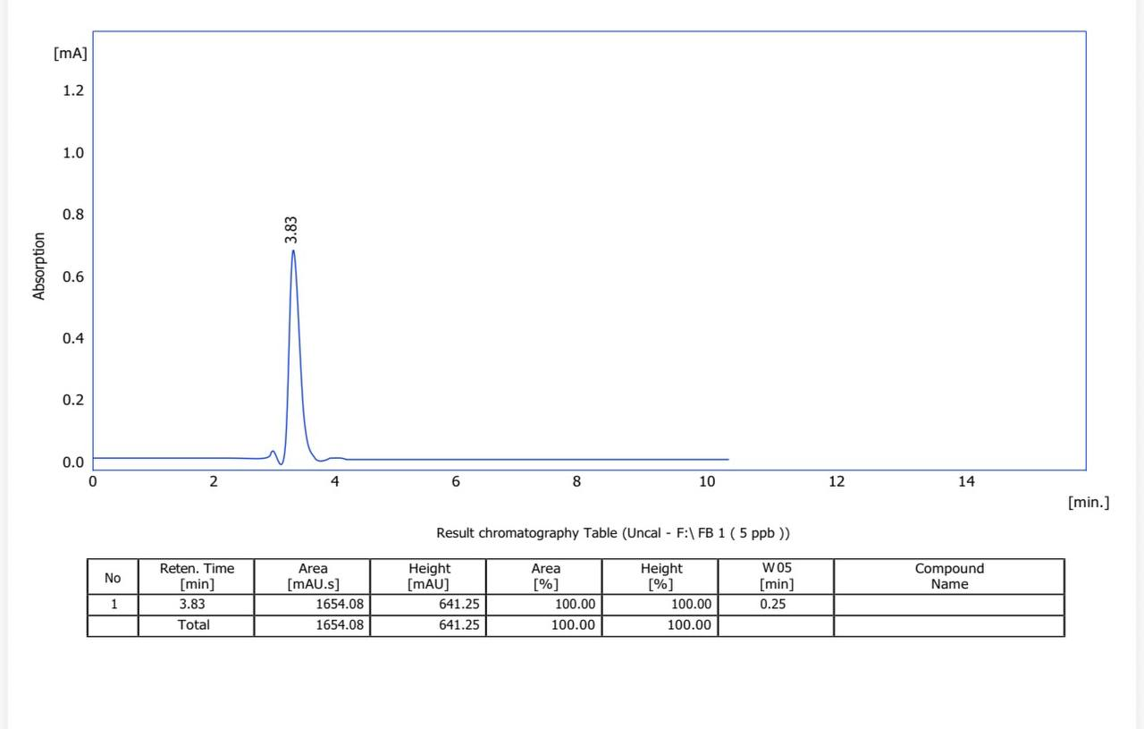
A
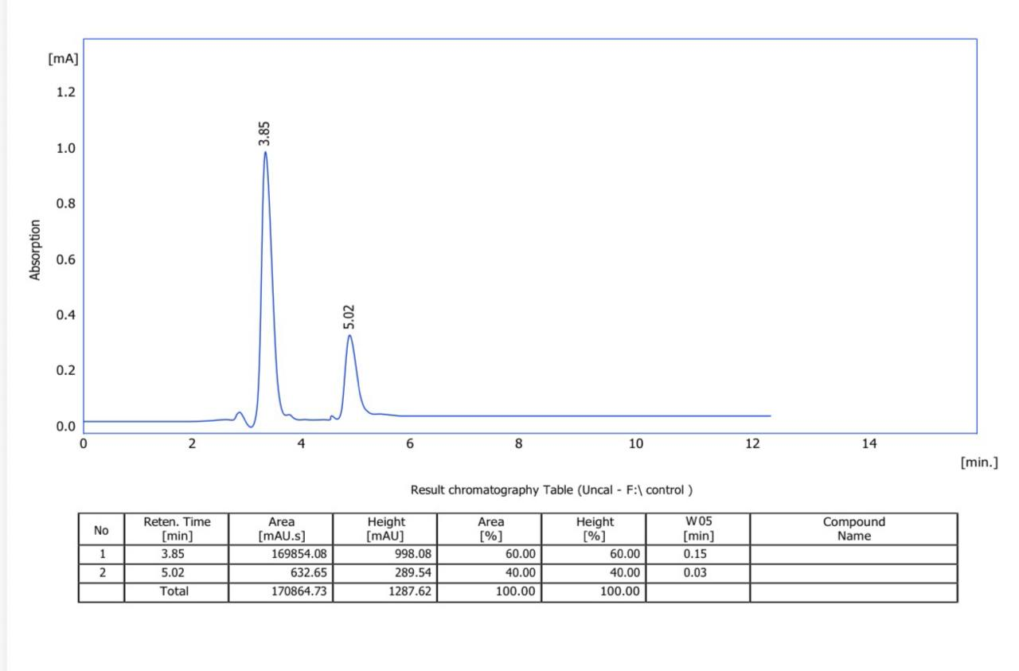
B
B
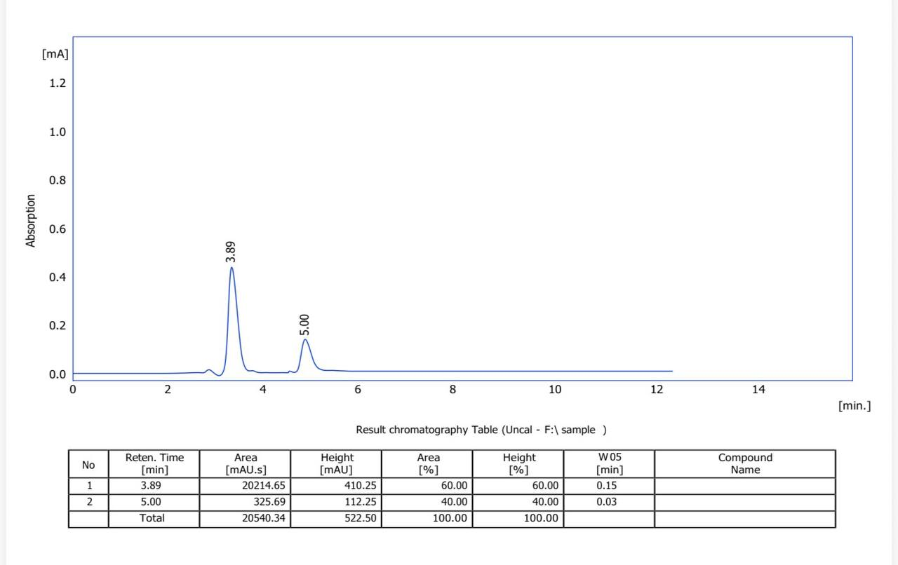
C
Fig 6 : HPLC analysis for the FB1 toxin produced by :
A : standard FB1 toxic , B : Fusarium solian on PDA alone , C : Fusarium solian on PDA and treated with 10% Ag-NPs.
High-performance liquid chromatography (HPLC) chromatographic examination of Aspergillus niger (Fig. 7A) revealed that the control sample showed a clear peak at a retention time of 7.80 minutes with a peak area of 3256.68 (Fig. 7B). This result indicates that under typical development conditions, this type of fungus produces this toxin.
The sample treated with biosynthesized silver nanoparticles, on the other hand, showed a discernible decrease in peak area to 1201.14 (Fig. 7C), suggesting a drop in aflatoxin content. This decrease can be explained by the way that nanoparticles suppress fungal metabolic activity, especially the biosynthetic pathways that produce mycotoxins.
The capacity of nanoparticles to disrupt gene expression or inhibit important enzymes involved in aflatoxin manufacture may be indicated by the observed variations in peak intensity, including partial or total reduction. This finding is in line with other research showing how well nanoparticles inhibit the generation of mycotoxins (Liu et al., 2012).
Accordingly, it can be concluded that treatment with silver nanoparticles resulted in a significant reduction in aflatoxin production, highlighting their potential application as antifungal and anti-mycotoxigenic agents.
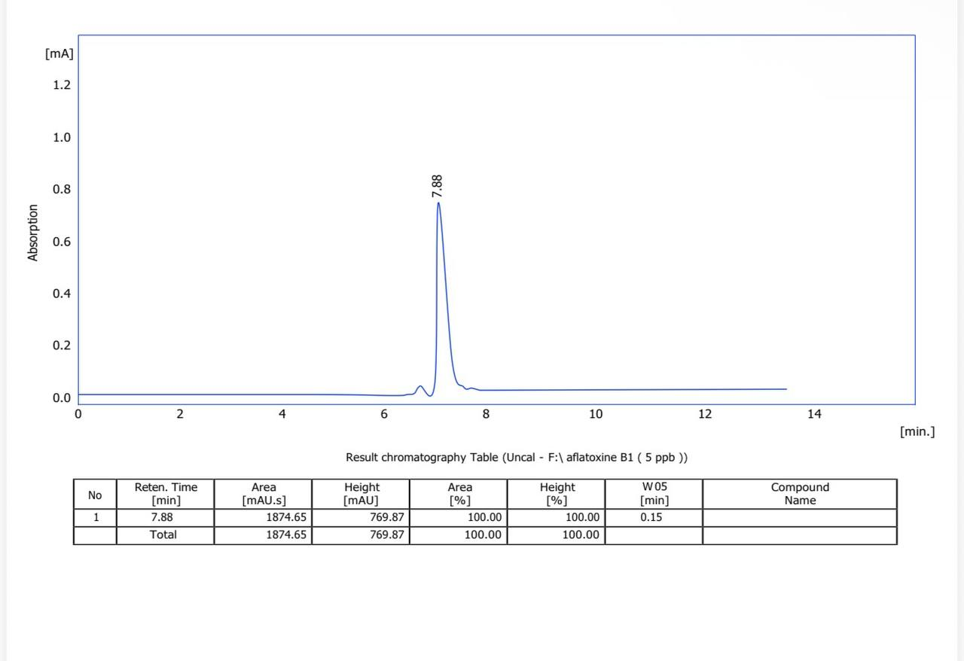
A
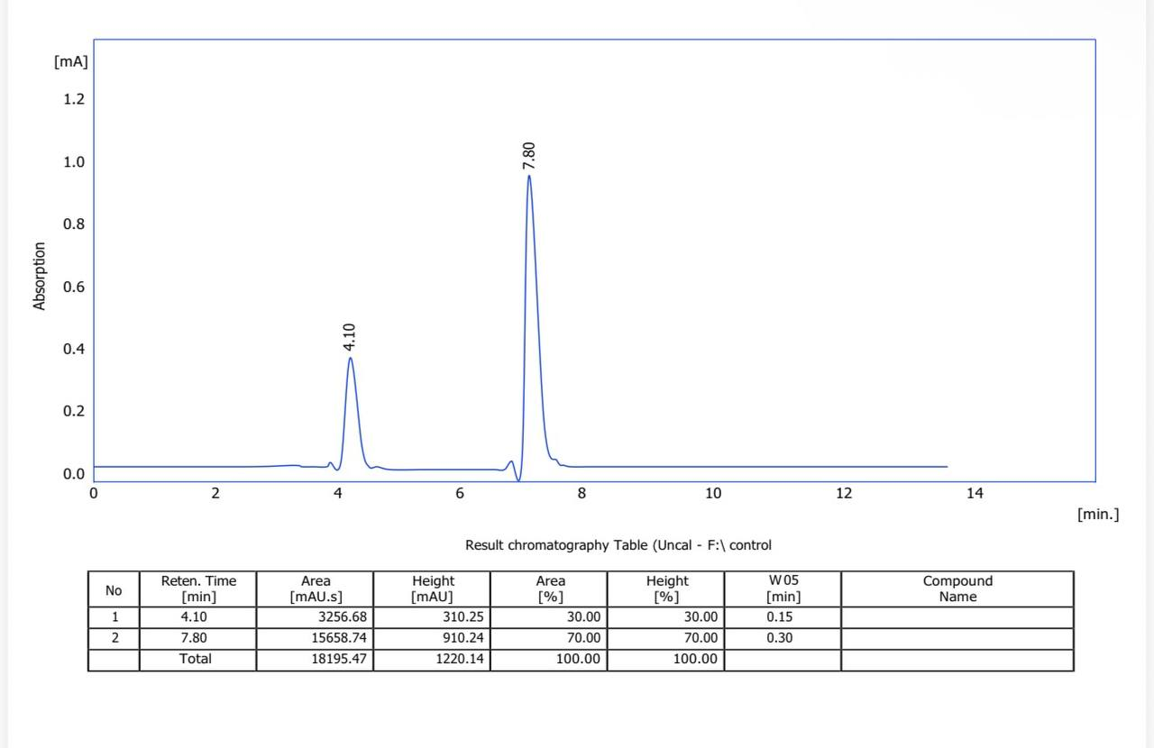
B
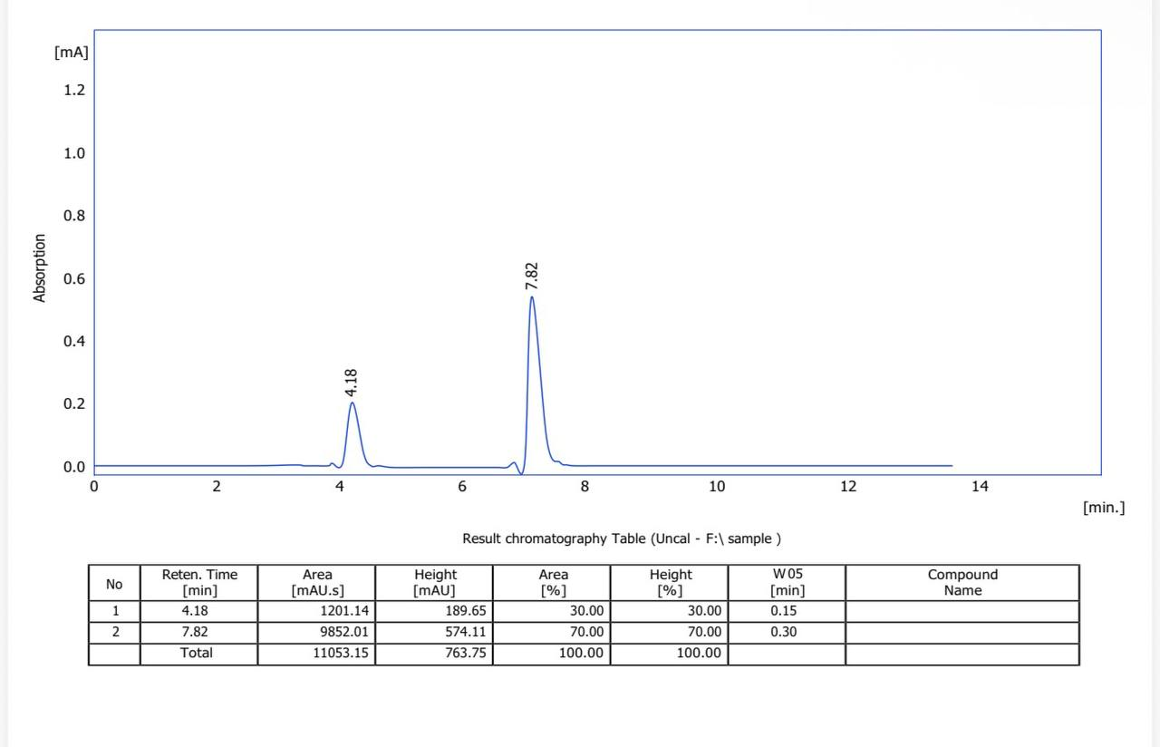
C
Fig 7 : HPLC analysis for the Aflatoxin toxin produced by :
A : Standard Aflatoxin toxic , B : Aspergillus niger on PDA alone , C : Aspergillus niger on PDA and treated with 10% Ag-NPs.
The chromatographic analysis using high performance liquid chromatography (HPLC) (Fig.8A) showed a clear peak at the retention time of 3.88 min and a peak area of 25698.08 for the control sample of Alternaria alternata a known producer of alternariol (Fig.8B) .
In contrast, the sample treated with biosynthesized silver nanoparticles showed a noticeable reduction in peak area to 9652.05, indicating a significant decrease in alternariol concentration (Fig.8C). This reduction can be attributed to the inhibitory effect of nanoparticles on fungal metabolic activity, particularly the biosynthetic pathways responsible for mycotoxin production.
The reduction in peak intensity observed in the present study (either partial or significant decrease) suggests that nanoparticles may interfere with the gene expression or inhibit the key enzymes involved in alternariol biosynthesis. This finding is consistent with previous studies emphasizing the role of nanoparticles in suppressing fungal toxin production (Wang et al., 2023).
Thus, alternariol synthesis was significantly reduced after treatment with silver nanoparticles, indicating their potential use as antifungal and anti-mycotoxigenic drugs.
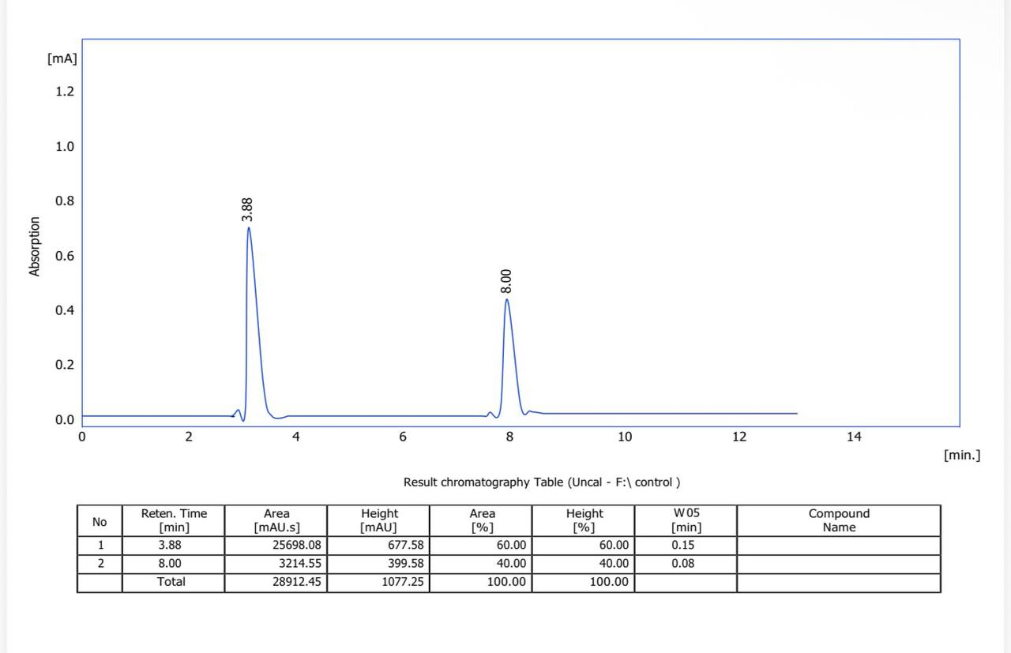
A
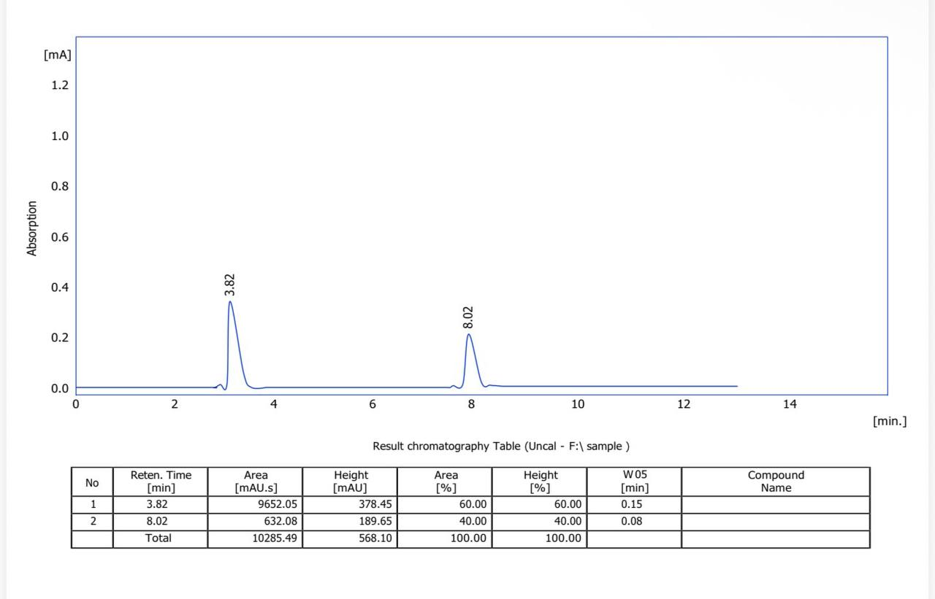
B
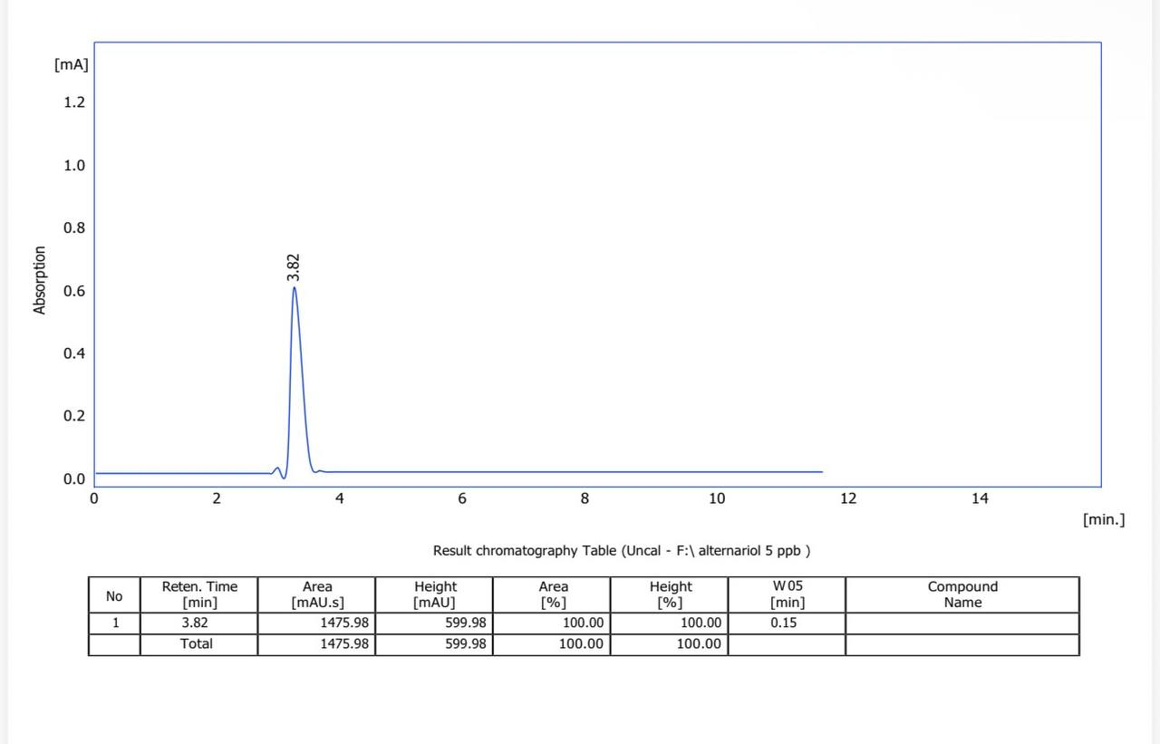
C
Fig 8 : HPLC analysis for the Aflatoxin toxin produced by :
A : standard Aflatoxin toxic , B : Alternaria alternata on PDA alone , C : Alternaria alternata on PDA and treated with 10% Ag-NPs.
5. Conclusion
Strong antifungal action and effective reduction of mycotoxin formation were demonstrated by biosynthesized silver nanoparticles made from sunflower oil. In terms of agricultural and food safety, this environmentally friendly method presents a viable substitute for chemical fungicides.

6. References
Adeleke, B. S., Ayangbenro, A. S., & Babalola, O. O. (2022). In vitro screening of sunflower associated endophytic bacteria with plant growth-promoting traits. Frontiers in Sustainable Food Systems, 6, Article 903114.
Akkaya, M. (2018). Sunflower oil composition and health effects. Journal of Food Science, 83(5), 1234–1242.
Al-Hajjar, S. (2015). Oil extraction techniques. Journal of Agricultural Chemistry, 10(2), 45–52.
Bao, X., Wang, Y., & Chen, L. (2025). Silver nanoparticles: Toxicity and inhibitory effects against Aflatoxins. Plant Science Today, 12(1).
Bao, Y., Lin, L., & Chen, L. (2021). Green synthesis of nanoparticles: Current developments and limitations. Environmental Nanotechnology, Monitoring & Management, 15, 100437. doi.org.
Bhat, R., Rai, R. V., & Karim, A. A. (2010). Mycotoxins in food and feed: Present status and future concerns. Food Control, 21(4), 443–450.
Fried, M., & Duffy, P. E. (1996). Adherence of Plasmodium falciparum to chondroitin sulfate A in the human placenta. Science, 272(5267), 1502-1504.
Hassan, S., Jalal, J., Al-Abodi, E. E., & Ahmed, K. (2021). Silver nanoparticles as antifungal agents against Aspergillus flavus and their impact on aflatoxin B1 production. Food Control, 125, 107982.
Inbaia, S. B., Al-Thani, R. F., & Al-Naimi, S. I. (2022). Antimicrobial Activity of Silver Nanoparticles against Fungi and Mycotoxins. Toxins, 14(3), 156.
Iravani, S. (2011). Green synthesis of metal nanoparticles. Green Chemistry, 13, 2638–2650.
Jagtap, U. B., & Bapat, V. A. (2021). Spectroscopic characterization of nanoparticles synthesized using plant extracts. In Nanoparticles in Medicine and Healthcare (pp. 115-135). Academic Press.
Kah, G., Adelusi, O. A., Gbashi, S., Awafong, P. M., & Njobeh, P. B. (2025). Antifungal and antimycotoxin activity of plant-synthesized silver nanoparticles (AgNPs): A novel approach to combat food contamination. Food Microbiology, 135, Article 104979.
Lawrence, D. P., Rotondo, F., & Gannibal, P. B. (2016). Biodiversity and taxonomy of the genus Alternaria. Studies in Mycology, 85, 29–60.
Li, X., Li, R., Wang, X., & Zhang, Y. (2024). Bioactive compounds, antioxidant activities and flavor profiles of sunflower oil processed by different techniques: A review. Food Chemistry, 430, 137021.
Liu, L., Jin, H., Sun, L., Ma, S., & Lin, R. (2012). Determination of aflatoxins in medicinal herbs by high-performance liquid chromatography–tandem mass spectrometry. Phytochemical Analysis, 23(5), 469–476.
Murashige, T. and Skoog, F. (1962) A Revised Medium for Rapid Growth and Bio Assays with Tobacco Tissue Cultures. Plant Physiology, 15, 473-497.
Ndube, N., van der Westhuizen, L., & Shephard, G. S. (2009). Determination of fumonisins in maize by HPLC with ultraviolet detection of o-phthaldialdehyde derivatives. Mycotoxin Research, 25(4), 225–228.
Rai, M., Yadav, A., & Gade, A. (2009). Silver nanoparticles as a new generation of antimicrobials. Biotechnology Advances, 27(1), 76–83.
Rico, C. M., Majumdar, S., Duarte-Gardea, M., Peralta-Videa, J. R., & Gardea-Torresdey, J. L. (2011). Interaction of nanoparticles with edible plants and their possible implications in the food chain. Journal of Agricultural and Food Chemistry, 59(8), 3485–3498.
Shafey, A. (2020). Green synthesis of nanoparticles. Green Chemistry Letters, 13(2), 123–140.
Villarino, M., Melgarejo, P., & De Cal, A. (2019). Characterization of Fusarium solani populations associated with wilt and root rot of strawberry plants in Spain. Phytopathology, 109(6), 1084–1095.
Vivaldo-Lima, E., Hernández-Hortelano, E., & Morales-García, C. (2017). Multiscale computational fluid dynamics–population balance model coupled system to simulate liquid–liquid suspension polymerization in a stirred vessel. Industrial & Engineering Chemistry Research. 56(16), 4668-4681.
Wang, J., Wang, Y., Zhang, X., Feng, Y., Wang, W., & Li, L. (2023).Antifungal mechanisms of silver nanoparticles on mycotoxin biosynthetic genes and secondary metabolism in filamentous fungi. iScience, 26(1), Article 105936.
Widatalla, H. A., Yassin, L. F., Alrasheid, A. A., Ahmed, S. A. R., Widdatallah, M. O., Eltilib, S. H., & Mohamed, A. A. (2022). Green synthesis of silver nanoparticles using green tea leaf extract, characterization and evaluation of antimicrobial activity. Nanoscale Advances, 4(3), 911-915.
Zain, M. (2011). Impact of mycotoxins. Comprehensive Reviews in Food Science, 10(5), 333–350.

