A Quadrature On Average Lobatto Nodes

Abstract
This paper presents a closed mixed quadrature rule constructed by averaging the Lobatto three-point rule and an anti-Lobatto four-point rule derived from the Lobatto formulation. The proposed rule is developed on the standard interval and is intended to improve the degree of precision obtained from its two constituent rules. The construction is based on combining the two lower-precision rules in such a way that the resulting averaged Lobatto rule attains precision five, whereas each of the constituent rules has precision three. The associated truncation error is examined through series expansion and comparison with the error terms of the base rules. An adaptive quadrature routine using the proposed rule as the core approximation formula is also considered. To assess the numerical behaviour of the method, five definite test integrals with known exact values are evaluated using the Lobatto rule, the anti-Lobatto rule, and the proposed averaged rule. The numerical results indicate that the averaged rule gives smaller absolute errors than the two constituent rules for the selected test cases. The adaptive implementation further reduces the required number of subintervals while maintaining high numerical accuracy for the tested examples. These results suggest that the proposed averaged Lobatto quadrature rule can provide an effective approach for the numerical approximation of definite integrals, particularly when a higher degree of precision is desired without abandoning the closed-type structure of the rule. The study remains limited to the theoretical derivation and numerical verification of the proposed rule on the selected test integrals.

Keywords:
Anti-Gaussian rule, Anti-Lobatto 4-point rule, Average Lobatto rule, Error Analysis, Adaptive quadrature routine.
AMS Subject Classification: 65D30; 65D32
- Introduction
The history of calculating area under the curve stretches back to 2000 BCE – 300 BCE. That is the ancient Greece. Greek Mathematicians defined "quadrature" as method of squaring. Geometrically to construct a square with the exact same area as a given curve (squaring). Famous examples include the quadrature of the circle (squaring the circle) and Archimedes' Quadrature of the Parabola. Around 17th century, it comes the era of calculus geometry. i.e. the age of Newton-Cotes. They have developed new formulas to calculate the integral using healthy polynomials at evenly spaced points.
Then the 19th century revolution took place i.e. the age of Carl Friedrich Gauss (1814). He invented methods that were used for optimal polynomial exactness by carefully selecting evaluation points (nodes) and multiplying by specific numerical integration weights. Those are nothing but Gaussian quadrature [1].
Down the years many mathematicians like Jacobi, Romberg etc [1] used high precision algorithms for integration process. Then the Clenshaw-Curtis quadrature, Fejer's quadrature [2] came to lime light for high accuracy formulations. Numerical analysis has become a wide range of tool in the present-day world especially in applied science and in almost its every branch. As like Mathematical Analysis, Number Theory or Algebraic Geometry, Numerical Analysis also became an independent and distinguished mathematical discipline in present day science world which started gaining momentum from late 17th century and entered its higher horizon in the realm of 20th century.
Adaptive quadrature like [7,8,9,13], for many years, is serving as a powerful tool for approximating integrals in smaller intervals where function behaves with rapid rate of change.
The numerical quadrature rules are broadly classified into two categories, namely closed type quadrature rules and open type quadrature rules. A quadrature rule is said to be of closed type if the function evaluation is needed at the end points of the interval [a,b]. A quadrature rule is said to be of open type if both the end points are omitted from the evaluation of function. Newton-Cotes quadrature rules and Lobatto quadrature rules are examples of closed type rules whereas Steffensen's quadrature rules, Gauss-Legendre quadrature rules, and anti-Gauss quadrature rules are examples of open type rules. Open type quadrature rules are more useful for evaluation of singular integrals. anti-Lobatto rules are also of closed type.
Richardson Extrapolation [1,2] is among those classical numerical algorithms and formulation which were developed to improve the precision and accuracy of quadrature rules by combining two approximations obtained with different step sizes [1,2,12]. Another important method is the Kronrod Extension technique [1,2], which extends Gaussian quadrature formulas by adding additional nodes to increase the degree of precision without discarding previously computed functional values [1,12].
R.N. Das and G. Pradhan. [3], have coined mixed quadrature technique by combining two foremost quadrature rules in a descent manner to get a new rule with higher precision and better numerical performance. Authors P. Patra et al. [13, 14,17] in recent years developed new enhanced quadrature by taking combination of two and more base rules and then developed an adaptive scheme for smaller intervals of integration within the interval and then the result were being verified by evaluating some real definite integrals. Also S. K. Mohanty and R. B. Dash [5-11] have designed a smooth, flexible and healthy Generalised Quadrature Technique, whose effectiveness were observed both in adaptive and non-adaptive routine, while developing high precision quadrature rules [5,6,10,11], found to be an outstanding technique.
In present work, we are to develop a higher precision averaged Lobatto quadrature of precision 5 from two rules of precision 3.
- Preliminaries
In this section, we present the fundamental concepts and formulations of the base quadrature rules employed in the development of the proposed quadrature scheme.
2.1 Lobatto 3-point Quadrature Rule
Lobatto 3-point Rule [1] of precision 3 is
$L_{3}(f)=\frac{1}{3}\left[f\left(-1\right)+4f\left(0\right)+f(1)\right]$ (1)
Error associated with the rule eqn (1) is
${EL}_{3}\left(f\right)=\int_{-1}^{1}{f(x)dx}-L_{q_{3}}(f)$
$=-\frac{2}{180}f^{iv}\left(0\right)+\frac{-4}{7560}f^{vi}\left(0\right)-\frac{1}{90720}f^{viii}\left(0\right)…$
$=-\frac{1}{90}f^{iv}\left(0\right)-\frac{1}{1890}f^{vi}\left(0\right)-\frac{1}{90720}f^{viii}\left(0\right)…$ (2)
2.2 Anti-Lobatto 4-point quadrature rule
Anti-Lobatto 4-point rule developed from 3-point Lobatto Rule [15,16,18] is
${aL}_{4}\left(f\right)=\frac{10}{9}\left[f\left(-\sqrt{\frac{2}{5}}\right)+f\left(\sqrt{\frac{2}{5}}\right)\right]-\frac{1}{9}\left[f\left(-1\right)+f\left(1\right)\right]$ (3)
Applying Maclaurin’s series expansion on (3), we get
$aL_{4}\left(f\right)=2f\left(0\right)+\frac{2}{3!}f^{''}\left(0\right)+\frac{2}{3×5!}f^{iv}\left(0\right)-\frac{2}{25×6!}f^{vi}\left(0\right)-\frac{93}{5^{3}}\frac{1}{9!}f^{viii}\left(0\right)$
Error associated with the rule eqn (3) is
${EaL}_{4}\left(f\right)=\int_{-1}^{1}{f(x)dx}-aL_{4}\left(f\right)$
$EaL_{4}\left(f\right)=\frac{4}{3×5!}f^{iv}\left(0\right)+\frac{64}{25×7!}f^{vi}\left(0\right)+\frac{436}{5^{3}×9!}f^{viii}\left(0\right)+\frac{7864}{5^{4}×11!}f^{x}\left(0\right)….$ (5)
Hence the anti-Lobatto 4-point rule derived from Lobatto 3-point rule is of precision 3.
3. Construction of Average quadrature by using anti-Lobatto 4-point rule with Lobatto 3-point rule
Taking the average of Lobatto 3-point rule and anti-Lobatto 4-point rule in equation (1) and (3) respectively we get the mixed quadrature rule as
${SP}_{1}\left(f\right)=\frac{1}{2}\left[L_{3}(f)+{EL}_{3}\left(f\right)+{aL}_{4}\left(f\right)+{EaL}_{4}\left(f\right)\right]$ (6)
Or, we can write this as
${SP}_{avg}\left(f\right)=\frac{1}{2}\left[L_{3}\left(f\right)+{aL}_{4}\left(f\right)+{EL}_{3}\left(f\right)+{EaL}_{4}\left(f\right)\right]$
Or ${SP}_{1}\left(f\right)=\left[{SP}_{avg}\left(f\right)+E_{avg}\left(f\right)\right]$ (7)
where,
${SP}_{1}\left(f\right)=\frac{1}{2}\left[L_{3}\left(f\right)+{aL}_{4}\left(f\right)\right]$ (8)
${ESP}_{1}\left(f\right)=\frac{1}{2}\left[{EL}_{3}\left(f\right)+{EaL}_{4}\left(f\right)\right]$ (9)
Now
${SP}_{1}\left(f\right)=\frac{1}{2}\left[L_{q_{3}}\left(f\right)+{aL}_{q_{4}}\left(f\right)\right]=\frac{1}{2}\left[\left\{\frac{1}{3}\left[f\left(-1\right)+4f\left(0\right)+f(1)\right]\right\}+\left\{\frac{10}{9}\left[f\left(-\sqrt{\frac{2}{5}}\right)+f\left(\sqrt{\frac{2}{5}}\right)\right]-\frac{1}{9}\left[f\left(-1\right)+f\left(1\right)\right]\right\}\right]$ (10)
and
$${ESP}_{1}\left(f\right)=\frac{1}{2}\left[{EL}_{3}\left(f\right)+{EL}_{q_{4}}\left(f\right)\right]=\frac{1}{2}\left[-\frac{1}{90}f^{iv}\left(0\right)-\frac{1}{1890}f^{vi}\left(0\right)-\frac{1}{90720}f^{viii}\left(0\right)…+\left\{\frac{4}{3×5!}f^{iv}\left(0\right)+\frac{64}{25×7!}f^{vi}\left(0\right)+\frac{436}{5^{3}×9!}f^{viii}\left(0\right)+…\right\}\right]$$
$=\left[\left(\frac{4}{7875}-\frac{1}{1890}\right)f^{vi}\left(0\right)+\left(\frac{436}{5^{3}×9!}-\frac{1}{90720}\right)f^{viii}\left(0\right)+…\right]$
On simplification, we get
${ESP}_{1}\left(f\right)=\frac{1}{2}\left[-\frac{1}{47250}f^{vi}\left(0\right)-\frac{1}{708750}f^{viii}\left(0\right)+…\right]$ (11)
From eq (11) it is clearly evident that, the above rule is of precision 5 as the truncation error highlights that the 5-point average Lobatto formula is exact for polynomials up to degree 5, with the first non-zero error term appearing as Peano’s Kernel[1,2,4] derivative related.
- Error Analysis
The error analysis leads to the following theorems.
Theorem 1
Assuming that $f(x)$possesses sufficiently many continuous derivatives on the interval $\left[-1,1\right]$, the truncation errors corresponding to the two base quadrature rules and the proposed constructed rule satisfy the error estimates ${EL}_{3}\left(f\right)=-\frac{2}{180}f^{iv}\left(0\right)+o(h^{5})$,
${EaL}_{4}\left(f\right)=\frac{1}{90}f^{iv}\left(0\right)+o(h^{5})$, and ${ESP}_{1}\left(f\right)=\frac{1}{90}f^{iv}\left(0\right)+o(h^{5})$, respectively.
Proof
The result obtains from (2), (5) and (11)
Theorem 2
Assuming that $f(x)$ possesses sufficiently many continuous derivatives on the interval $\left[-1,1\right]$, the absolute value of the truncation errors corresponding to formulated rule is less than the two base quadrature rules.
Proof:
From (2) and (11) $|{ESP}_{1}\left(f\right)|≤{|EL}_{3}\left(f\right)|$
From (25) and (11) |ESP1f|≤|EaL4f|
- Numerical Verification
The approximate values obtained using the proposed Quadrature Rule ${SP}_{1}\left(f\right)$ and its constituent quadrature rules are presented in Table 1. displays the corresponding absolute truncation errors for different types of listed test integrals, providing a comparative assessment of the accuracy and performance of the different quadrature. Below we provide the considered test integral with the exact value of the integrals (Closed form)
- $I_{1}\left(f\right)=\int_{-1}^{1}{e^{x}dx}$= 2.350402387287603

- $I_{2}\left(f\right)=\int_{0}^{1}{e^{{-x}^{2}}dx}$=0.746824132812427

- $I_{3}\left(f\right)=\int_{1}^{3}{\frac{\sin^{2}x}{x}}dx$=0.794825180668111

- $I_{4}\left(f\right)=\int_{0}^{1}{\sqrt{x}}logx dx$= -0.444444444444444

- $I_{5}\left(f\right)=\int_{0}^{1}{\sqrt{x}}\sin{x} dx$=0.364221932032132
Table 1: Approximate values of five test integrals computed using the constituent quadrature rules and the proposed quadrature rule ${SP}_{1}\left(f\right)$ .
Integral | Approximation value |  |  | Absolute value of error
Integral | $L_{3}(f)$ | $${aL}_{4}(f)$$ | $${SP}_{1}(f)$$ | $$EL_{3}(f)$$ | $${EaL}_{4}(f)$$ | $${ESP}_{1}(f)$$
1 | 2.362053756543496 | 2.338773621833568 | 2.350413689188532 | 1.1651369$×{10}^{-2}$ | 1.1628765$×{10}^{-2}$ | 1.13019009$×{10}^{-5}$
2 | 0.747180428909510 | 0.746470136296222 | 0.746825282602866 | 3.56296097$×{10}^{-4}$ | 3.53996516$×{10}^{-4}$ | 1.14979$×{10}^{-6}$
3 | 0.789451774898485 | 0.800247709172440 | 0.794849742035463 | 5.373405769$×{10}^{-3}$ | 5.4225285$×{10}^{-3}$ | 2.456136$×{10}^{-5}$
4 | -0.326752714489516 | -0.505376093770292 | -0.416064404129904 | 1.176917299$×{10}^{-1}$ | 6.0931649$×{10}^{-2}$ | 2.838004$×{10}^{-2}$
5 | 0.366248530415346 | 0.362454033688759 | 0.364351282052053 | 2.0265984$×{10}^{-3}$ | 1.76789834$×{10}^{-3}$ | 1.29350019$×{10}^{-4}$

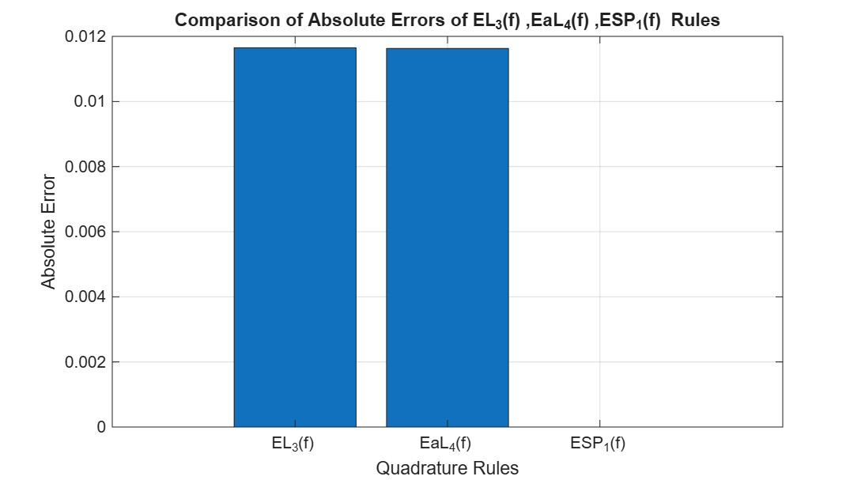
Figure 1: Absolute truncation error comparison among different quadrature rules for $I_{1}(f)$.
Remark 1: For the integral $I_{1}(f)$, the truncation errors associated with the Lobatto 3-point rule and the Anti-Lobatto 4-point rule become significant from the second decimal place onward, reflecting a moderate level of numerical accuracy. In contrast, the proposed $SP_{1}(f)$ rule exhibits a considerably smaller truncation error, which appears only from the fifth decimal place onward. This substantial reduction in error demonstrates that the proposed constructed rule achieves superior accuracy and enhanced numerical reliability compared to its constituent quadrature rules for the given integral.
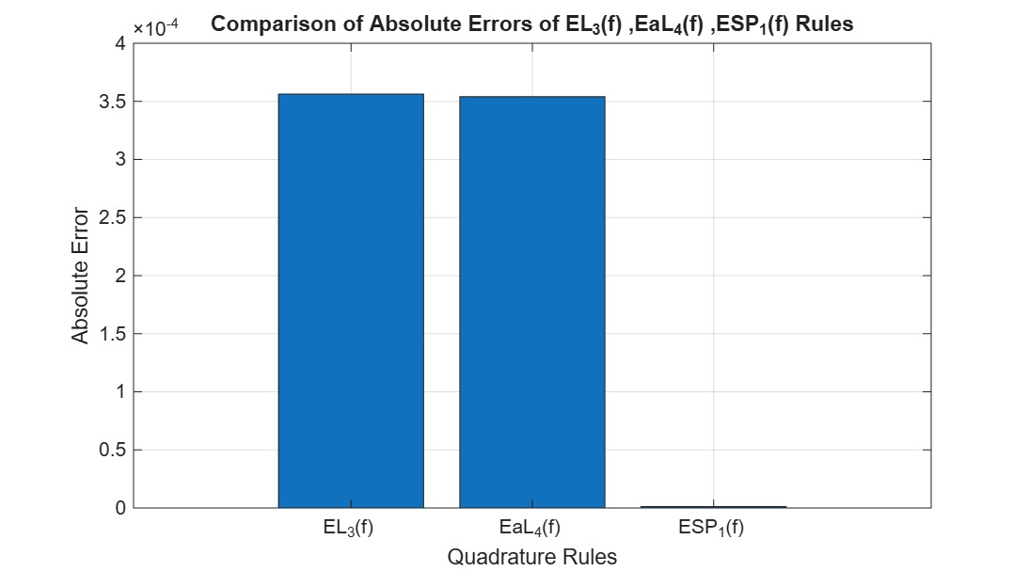
Figure 2: Absolute truncation error comparison among different quadrature rules for $I_{2}(f)$.
Remark 2: For the integral for $I_{2}(f)$, the truncation errors associated with the Lobatto 3-point rule and the Anti-Lobatto 4-point rule become significant from the fourth decimal place onward. In contrast, the proposed $SP_{1}(f)$ rule exhibits a considerably smaller truncation error, which appears only from the sixth decimal place onward. This substantial reduction in error demonstrates that the proposed constructed rule achieves superior accuracy and enhanced numerical reliability compared to its constituent quadrature rules for the given integral.
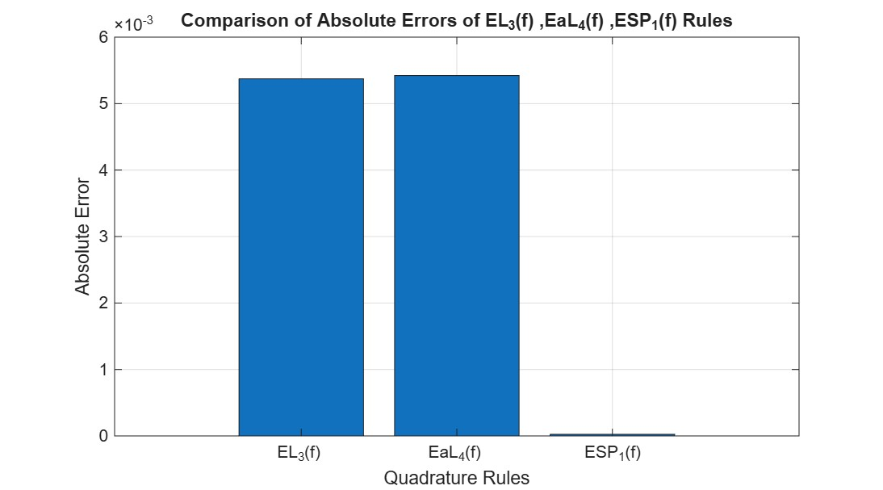
Figure 3: Absolute truncation error comparison among different quadrature rules for $I_{3}(f)$.
Remark 3: For the integral for $I_{3}(f)$, the truncation errors associated with the Lobatto 3-point rule and the Anti-Lobatto 4-point rule become significant from the 3rd decimal place onward. In contrast, the proposed $SP_{1}(f)$ rule exhibits a considerably smaller truncation error, which appears only from the fifth decimal place onward.
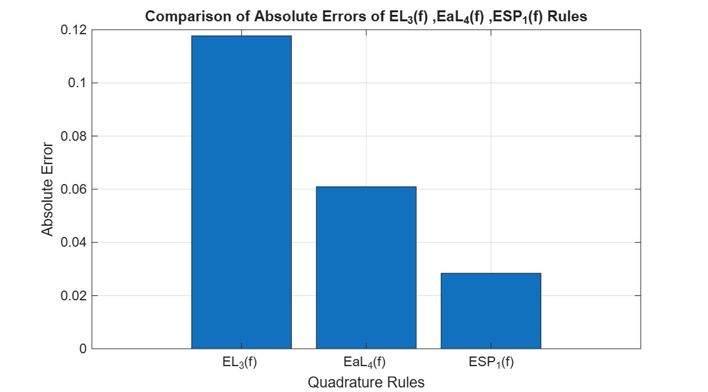
Figure 4: Absolute truncation error comparison among different quadrature rules for $I_{4}(f)$.
Remark 4: For the integral for $I_{4}(f)$, the truncation errors associated with the Lobatto 3-point rule and the Anti-Lobatto 4-point rule become significant from 1st the 2nd decimal place respectively. In contrast, the proposed $SP_{1}(f)$ rule exhibits a considerably smaller truncation error.
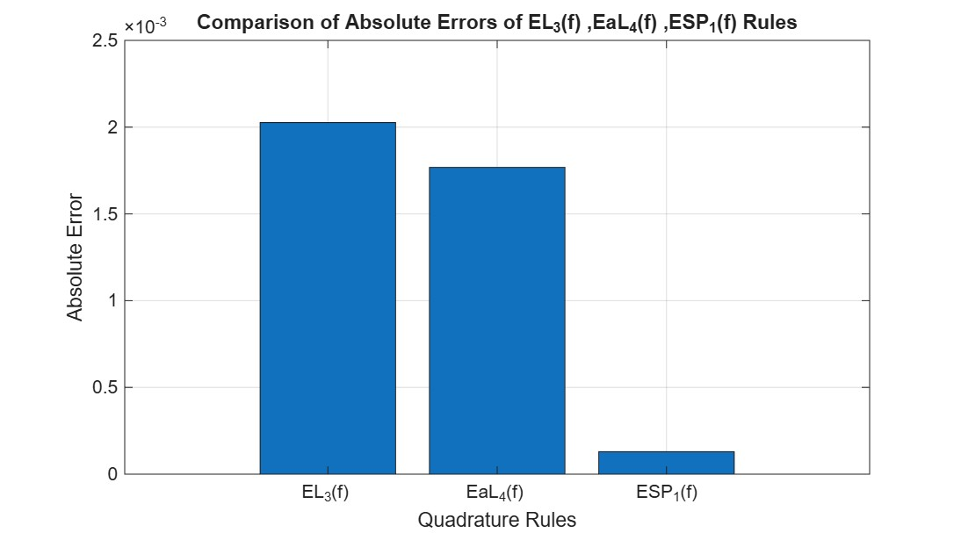
Figure 5: Absolute truncation error comparison among different quadrature rules for $I_{5}(f)$.
Remark 5: For the integral for $I_{5}(f)$, the truncation errors associated with the Lobatto 3-point rule and the Anti-Lobatto 4-point rule become significant from the 3rd decimal place onward. In contrast, the proposed $SP_{1}(f)$ rule exhibits a considerably smaller truncation error, which appears only from the fourth decimal place onward.
- Application in Adaptive quadrature routine
An adaptive quadrature algorithm has been developed [7,8,13] with a prescribed tolerance of
$1×{10}^{-8}$and applied to the five test integrals listed above. The performance of the proposed adaptive scheme is evaluated in terms of the obtained approximation values, the number of steps (subintervals) required to achieve the desired accuracy, and the corresponding absolute final errors. The numerical results are presented in Table 5.

Table 2: Approximation values, number of steps, and absolute final errors obtained using the adaptive quadrature algorithm.
Integral | For the rule $L_{3}(f)$ |  |  | For the rule ${aL}_{4}(f)$ |  |  | For the rule ${SP}_{1}(f)$
Integral | App. value | steps | Final Error | App. value | steps | Final Error | App. value | steps | Final Error
1 | 2.350402387532476 | 48 | 2.44873454846$×{10}^{-10}$ | 2.350402387042729 | 48 | 2.4487345484$×{10}^{-10}$ | 2.350402387334968 | 4 | 4.7365666944$×{10}^{-11}$
2 | 0.746824132873681 | 30 | 6.1254112893$×{10}^{-11}$ | 0.746824132751174 | 30 | 6.1253446759$×{10}^{-11}$ | 0.746824132813376 | 4 | 9.4935170835$×{10}^{-13}$
3 | 0.794825180656652 | 58 | 1.1459388993$×{10}^{-11}$ | 0.794825180679570 | 58 | 1.1459388993$×{10}^{-11}$ | 0.794825180663370 | 7 | 4.7413184489$×{10}^{-12}$
4 | -0.444444444219827 | 252 | 2.246172137$×{10}^{-10}$ | -0.444444444669060 | 250 | 2.2461521532$×{10}^{-10}$ | -0.444444444363034 | 64 | 8.141015639$×{10}^{-11}$
5 | 0.364221932325822 | 42 | 2.9369012777$×{10}^{-10}$ | 0.364221931738491 | 42 | 2.9364172205$×{10}^{-10}$ | 0.364221932096751 | 11 | 6.461886581$×{10}^{-11}$

Observations
- We have observed anti Lobatto rule is of better efficacy than of Lobatto rules.
- As we can see [16,18] gives better result in general scheme, but here we found anti Lobatto is better than Lobatto both in adaptive and non-adaptive scheme.
- But our Rule ${SP}_{1}(f)$ , which is constructed averaging Lobatto 3-point rule ($L_{3}(f)$) and anti-Lobatto 4-point rule (${aL}_{4}(f)$ {derived from Lobatto 3-point rule ($L_{3}(f)$)[16,18]} gives higher efficacy both in adaptive and non-daptive routine
- Also, our newly developed adaptive algorithm taking the mixed rule/average rule ${SP}_{1}(f)$ as the core rule gives immense accuracy when calculated in precision 5.
- The above tabulated result reflects that this rule ${SP}_{1}(f)$ can be constructed in higher order precision so as to get more and more accurte results.

Conclusions
A closed averaged Lobatto quadrature rule has been constructed by combining the Lobatto three-point rule with an anti-Lobatto four-point rule derived from it. The resulting rule preserves the closed-type nature of the constituent rules and achieves precision five, while the two base rules individually have precision three. The error analysis indicates that the leading error term of the proposed rule is of higher order than those of the constituent rules, which explains the improved accuracy observed in the numerical experiments. The evaluation of five test integrals shows that the proposed rule produces smaller absolute errors than the Lobatto and anti-Lobatto rules in the selected examples. The adaptive quadrature implementation also demonstrates that the proposed rule can achieve the required accuracy using fewer subintervals in comparison with the constituent rules. These findings support the usefulness of the averaged Lobatto rule as a numerical integration tool for definite integrals. However, the conclusions are based on the specific derivation and test cases considered in this work, and further investigation is needed for broader classes of integrands.
Limitations
The present study is limited to the construction and verification of one averaged Lobatto quadrature rule obtained from the Lobatto three-point rule and the derived anti-Lobatto four-point rule. The numerical assessment is restricted to five selected definite integrals with known exact values, and therefore the observed improvement should not be interpreted as a universal performance guarantee for all integrands. The adaptive routine is evaluated only through the reported numerical examples, without a detailed comparison against a wider range of established adaptive quadrature algorithms. The theoretical analysis depends on the assumed smoothness of the integrand and the existence of the required derivatives on the interval of integration. Singular, discontinuous, highly oscillatory, or poorly behaved functions are not examined in detail. Further work may consider broader test functions, rigorous implementation details, and comparison with standard high-order quadrature methods.

Declaration:
The authors hereby declares that the manuscript is original and has not been published or submitted elsewhere for publication. All sources of information used in the preparation of this article have been duly acknowledged.
Competing of Interest:
The authors declares that there is no conflict of interest regarding the publication of this article.

References
- K.E. Atkinson (2012)An Introduction to Numerical Analysis, Wiley Student edition, New Delhi.
- S. Conte, C.de Boor (1980) Elementary Numerical analysis, Mc-Graw Hill.
- Das, R.N. and Pradhan, G. 1996. A Mixed quadrature rule for approximate evaluation of real definite integrals, International Journal of Mathematical Education in Science and Technology .Pp. 279-283https://doi.org/10.1080/0020739960270214
- J. Ma, M. Rokhlin, S. Wandzura (1996) Generalized Gaussian quadrature rules for systems of arbitrary functions, SIAM Journal on Numerical Analysis, Vol.33, pp.971-996.
- S.K. Mohanty, R.B. Dash (2022) A Generalized Quartic Quadrature Based Adaptive Scheme, International Journal of Applied and Computational Mathematics, Vol.8, pp.1–25. https://doi.org/10.1007/s40819-022-01405-2
- S.K. Mohanty, R.B. Dash (2024) A Generalized Quadrature of Order Four for Analytic Functions, International Journal of Computing Science and Mathematics, Vol.19(3), pp.285–298. https://DOI.10.1504/IJCSM.2024.137846.
- S.K. Mohanty, R.B. Dash (2021) A quadrature rule of Lobatto-Gaussian for Numerical integration of Analytic functions, Numerical Algebra, Control and Optimization, Vol.12, pp.1–14. https://doi.10.3934/naco.2021031
- S.K. Mohanty (2021) A triple mixed quadrature rule based adaptive scheme for analytic functions, Nonlinear Func. Analysis and Applications, Vol-26, pp.935-947.
htt https://doi.org/10.22771/nfaa.2021.26.05.05
- S.K. Mohanty, R.B. Dash (2023)A Hybridized Lobatto Quadrature of Precision Eleven for Numerical Integration of Analytic Functions, Mathematical Statistician and Engineering Applications, Vol-71(4), pp.8496-8506.https://www.philstat.org/index.php/MSEA/article/view/1534
- S.K. Mohanty (2024)An Open-type generalised Quadrature rule using the anti-gaussian approach for numerical integration, Annals of Pure and Applied Mathematics, Vol-30(2), pp.121-128.DOI:https://ijistudies.com/index.php/IJIS/article/view/325
- S.K. Mohanty (2025) A Generalized Quadrature Specifically Designed for Numerical Integration of Indefinite Integrals, International journal of innovation studies, Vol-9(1), pp.1694-1703. DOI: http://dx.doi.org/10.22457/apam.v30n2a04952
- J.D. Philip, R. Philip (1984) Methods of Numerical Integration, Academic Press, Inc., Orlando, FL.
- D. Das, P. Patra , R.B. Dash (2015) An adaptive integration scheme using a mixed quadrature of three different quadrature rules, Malaya Journal of Mathematics, Vol-3, No.-3, (2015) , pp 224-232
- P. Patra, D. Das, R.B. Dash (2016) Approximation of singular integrals by mixed quadrature of anti-Gauss and Steffensen’s quadrature rules in adaptive environment, Advances in theoretical and applied mathematics, Vol-11, No.- 1 (2016), pp 79-92, Research India Publication,
http://www.ripublication.com
- Dirk P. Laurie(1996) Anti-Gaussian Quadrature formulas, Mathematics of Computation, Vol-65, pp 739-749,
- B.P. Singh, R.B. Dash, (2016 )Forming a mixed Quadrature rule using an anti-Lobatto four point Quadrature rule, Journal of Progressive Research in Mathematics (JPRM) , Vol-7, Issue-3, pp 1092-1101, , SCITECH RESEARCH ORGANISATION, ww.scitechreseach.com/journls
- P. Patra, D. Das, R.B. Dash, S.K. Ghose (2016) Using Averaged Gauss-Legendre Rules to Evaluate Some Real definite integrals in adaptive environment, International Journal of Mathematical Science & Engineering. Applications. (IJMSEA), Vol. 10, No. III, pp 183-194.
- S. Mohanty (2026) Development of a Generalised Quadrature Formula Using Anti-Gaussian Methods, Asian Journal of Mathematics and Computer Research, Vol-33, Issue-3, pp 1-13,

