An Energy-Efficient 14-T Hybrid Full Adder with High Speed in 45 nm CMOS Process

.

Abstract
This paper presents a compact 14-transistor hybrid full adder design for low-power and high-speed digital arithmetic applications using 45 nm CMOS technology. The proposed circuit combines CMOS logic and pass-transistor logic to reduce transistor count while maintaining proper logic functionality. The architecture consists of three main modules: an XOR/XNOR generation block, a SUM generation block, and a CARRY generation block. The XOR/XNOR module is used to generate complementary intermediate logic signals, which are further processed by the SUM and CARRY modules to produce the full adder outputs. The circuit was designed and simulated using Cadence Virtuoso and Spectre tools at a supply voltage of 1 V. The performance of the proposed full adder was evaluated in terms of transistor count, propagation delay, average power consumption, and power-delay product. Simulation results show that the proposed design uses 14 transistors and achieves a delay of 13.42 ps, an average power consumption of 0.0448 µW, and a power-delay product of 0.601 × 10⁻¹⁸ J. These values indicate improved performance compared with several previously reported full adder designs considered in the comparative analysis. The reduced transistor count contributes to lower circuit complexity, while the hybrid logic approach supports efficient switching behavior. The proposed design is therefore suitable for arithmetic units where compact implementation, low power dissipation, and high operating speed are important design requirements.

Keywords: Low Power, Hybrid full adder, Cadence virtuoso, CMOS 45nm, Power delay product

- INTRODUCTION
The first integrated circuit (IC) was invented in 1958. Since then, circuit designers have primarily focused on accelerating digital design and reducing its area. With advancements in Very Large-Scale Integration (VLSI) fabrication technology, manufacturing entire systems on a single chip (SoC) has become possible. This progress has enabled the development of cellular phones, laptops, handheld computers, and mobile multimedia systems capable of real-time speech recognition and video display (Aguirre and Linares, 2010). In recent years, the increase in chip density has also led to higher power consumption. Consequently, power consumption has become as important a parameter in digital design as speed and area.
Among various arithmetic components, the full adder is one of the most frequently used building blocks, as it is employed in adders, multipliers, arithmetic logic units (ALUs), and digital signal processing applications (Arul and Kathirvelu, 2024). Since full adders are extensively used in complex arithmetic structures, their power consumption and propagation delay significantly affect the overall performance of the system. Therefore, designing a full adder that provides fast operation with reduced power dissipation has become an important research objective in low-power VLSI design. Traditional CMOS full adders offer reliable operation and good noise margins; however, they generally require a larger number of transistors, resulting in increased area, power consumption, and delay.
To address these challenges, several alternative design approaches have been explored, including pass transistor logic, transmission gate logic, and hybrid logic structures. Hybrid logic has emerged as an effective solution because it combines the strengths of different logic styles within a single circuit. This approach enables designers to achieve better trade-offs between power consumption, speed, and circuit complexity. In particular, transmission gate based implementations are capable of providing full voltage swing and improved signal integrity while maintaining efficient transistor utilization.
Hybrid full adder architectures typically utilize optimized XOR/XNOR modules and efficient carry generation circuits to reduce critical path delay and switching power. The use of transmission gate based structures further improves signal integrity by providing full voltage swing operation while maintaining lower transistor count. These characteristics make hybrid full adders suitable for energy-efficient and high-speed VLSI applications. Figure 1 shows the block diagram of hybrid full adder.

MODULE 3
MODULE 2

MODULE 1

Cin SUM

A

B

Cout

Figure 1 Block diagram of hybrid full adder
The novelty of this work presents a compact 7-transistor XOR/XNOR module. The proposed XOR/XNOR circuit is designed to reduce power consumption while maintaining reliable operation. Furthermore, an efficient SUM and CARRY generation module is proposed using inverter for good signal strength and integrated with the proposed XOR/XNOR block to achieve improved speed performance. The combination of these modules provides a balanced trade-off between power dissipation and propagation delay, resulting in an enhanced Power-Delay Product (PDP).
This paper is organized into five sections. Section II provides a review of hybrid full adder architectures and related studies. Section III details the proposed full adder design and its implementation. Section IV presents the simulation results along with a comparative performance analysis. Section V concludes the paper by highlighting the major outcomes of the proposed work.
- RELATED BACKGROUND
A variety of researchers have used various technologies to implement various FA circuits. A 16-transistor hybrid full adder employing transmission gates and multiplexers was proposed to reduce power consumption and propagation delay while improving PDP performance (Bhattacharyya et al., 2014). A 22-transistor hybrid full adder incorporating a full-swing XOR-XNOR circuit was developed to achieve enhanced PDP performance and energy efficiency (Morad et al., 2015). Two 20-transistor hybrid full adder circuits were developed by modifying previously reported XOR/XNOR structures and employing multiplexer-based SUM and CARRY generation. Simulation results indicated significant improvements in PDP over conventional designs (Valashani et al., 2018). Hasan et al. (2019) proposed a high-speed adder for arithmetic applications. The design combines efficient XOR-XNOR modules with an optimized carry out section to reduce consumption of power and propagation delay. The proposed architecture achieves full-swing output operation while maintaining no. of transistor and reliable performance. A 14-transistor full adder utilizing Gate Diffusion Input (GDI) based XOR/XNOR logic was proposed to reduce energy consumption and circuit area. Post-layout analysis demonstrated notable improvements in energy efficiency and EDP (Sakthivel and Sanapala, 2019). Satyanarayana et al. (2025) proposed a modified Gate Diffusion Input (GDI) technology based full adder to improve energy efficiency in arithmetic circuits. The GDI approach was employed to switching activity, and power consumption while maintaining acceptable performance.
A family of six hybrid full adder architectures based on an optimized XOR-XNOR circuit was presented to improve speed and Power-Delay Product (PDP). Implemented in 65 nm CMOS technology, the proposed designs demonstrated superior PDP and Energy-Delay Product (EDP) performance compared to several existing full adders (Naseri and Timarchi, 2018). The proposed architecture has been enhanced by Kandpal et al. Optimized XOR-XNOR modules and four hybrid full adder architectures have been used to reduce the Power-Delay Product (PDP). The proposed hybrid full adder architectures have been analyzed in cascaded full adders that have shown better performances and scalability in implementing high-bit full adders (Kandpal et al., 2020). Two hybrid full adder architectures that used 22 and 18 transistors were designed to minimize the propagation delay of XOR and XNOR signals. In both architectures, transmission gate logic has been used in SUM and CARRY modules to improve the performance of the circuit (Mewada et al., 2019). Hybrid full adder architectures have been suggested to save the silicon area, power dissipation, and propagation delays of full adder modules. Performance analysis in single-bit and multi-bit adders has been performed to show better ADP and PDP values than several full adders' implementations (Hasan et al., 2021). An 18-transistor full adder has been proposed to save power dissipation, minimize delay, and operate in full-swing mode. The simulation results at different technology nodes prove the area efficiency and low PDP values of the hybrid full adder architecture (Kanojia et al., 2023). In their paper, Tirumalasetty & Machupalli introduced various 1-bit full adder circuits which were optimized to be highly efficient in terms of power utilization, time of propagation, and Power Delay Product. These researchers focused on the comparison of various full adder designs aimed at optimizing these parameters. As a result, it was found that a hybrid logic design could prove highly effective in terms of power efficiency and reliability (Tirumalasetty & Machupalli ,2019). In another, Jogi & Reddy introduced a high-performance full adder using a unique 9-transistor XOR-XNOR structure (Jogi and Reddy,2026).
According to the literature, there have been considerable advancements in hybrid full adders in terms of power dissipation, delay, and PDP performance. Yet, some designs continue to use a fairly large number of transistors, making them more complex in nature. In this regard, the proposed design is a compact 14-transistor hybrid full adder that ensures a perfect balance between power dissipation and delay, hence improving PDP performance.

- METHODOLOGY

  - Proposed Transmission Gate Based Prefix Cell Design

A novel 14-transistor full adder cell with enhanced power and speed performance is proposed. The circuit operates at 1 V supply voltage and is simulated using the Cadence EDA tool in CMOS 45 nm technology. A comparative analysis is conducted with previously proposed adder cells, focusing on power consumption, delay, and power-delay product (PDP). Additionally, a 6-transistor XOR-XNOR circuit is employed to simultaneously generate XOR and XNOR signals. Figure 2 illustrates the 6-transistor XOR-XNOR cell. This circuit ensures full-swing operation through the use of feedback transistors, as depicted in the figure. It features a level-restoring transistor that reduces delay and enhances the latency of the module. Simulation results confirm these improvements, demonstrating reduced energy and fewer glitches. A significant benefit of this design is that it generates both XOR and XNOR signals simultaneously, minimizing glitches. This benefit is further validated by the transient analysis of the circuit.

B A
A P₁ P₂ B
Vdd XOR

P₃
N₁
XNOR Gnd

A N₂ N₃ B

B A

Figure 2: Proposed XOR/XNOR Design

3.2 FA Circuit Module TWO and Three
The hybrid-logic full adder (FA) can be constructed by integrating three modules: Module I (the XOR-XNOR circuit), Module II (the SUM circuit), and Module III (the CARRY circuit). The previous section introduced a new design for the XOR/XNOR circuit. This section explores various methods for designing the SUM (Module II) and CARRY (Module III) circuits. The SUM and CARRY circuits can be configured in four distinct ways, along with the proposed XOR/XNOR design, are discussed in the following section.
3.2.1 Module II (Sum Generation)
Figure 3 illustrates the Sum module of the proposed hybrid full adder. The Sum Generation Module is an XOR cell that calculates the SUM by performing an XOR operation between the carry-in (Cin) and the result of the XOR operation between inputs A and B, resulting in A ⊕ B ⊕ Cin. Figure 3 illustrates the schematic of the sum generation circuit, which uses four transistors (two PMOS and two NMOS) to produce the SUM output. The circuit's reduced carry propagation path enhances its speed.
To generate the SUM signal, the design utilizes both CMOS logic and pass transistor logic (PTL). In Module II, two pass transistors are employed: one p-MOSFET (P4) and one n-MOSFET (N4). These MOSFETs are used in the pass-transistor logic configuration, where they function as switches to either pass or block the output signal based on their gate inputs. As pass gates, these MOSFETs can either transmit the input signal or block it, depending on their configuration. The output signal, which is taken from the drain of the MOSFETs, can be either the same as or the complement of the input signal.
In this setup, the gate terminal of P4 and N4 are attached to the carry – in signal (Cin). The transistor perform AND operations followed by OR operations. Additionally, an inverter is used to boost the signal strength and ensure a full voltage swing. The Sum output can be expressed by the Boolean equation shown in Equation (1).

SUM = (C’.(A XOR B)’ + (A XOR B). C (1)

C

VDD
XNOR P₄ P₅
SUM
XOR N₄
N₅
C GND
Figure 3 Sum generation using PTL and CMOS logic
In the proposed design, the input signals A, B, and Cin, while the output signal are carry and sum (S). Pass transistor logic is advantageous for its low Power consumption compared to other digital logic designs. This benefit arises because MOSFETs, when used as switches rather than amplifiers, exhibit lower static power dissipation. Additionally, pass-transistor logic allows for a more compact circuit design due to its reduced gate count relative to other logic styles.
3.2.2 Module III (Carry Generation)
Figure 4 depicts Module 3 of the proposed design, which implements the carry generation circuit .The carry (Cout) signal is generated using two CMOS logic circuits. In Module III of the proposed design, the carry (Cout) signal is generated using two separate CMOS logic circuits. The first circuit comprises P6 and N6 MOSFETs, while the second circuit includes P7 and N7 MOSFETs. The Boolean expression for the Carry output is given in Equation (2).
CARRY = (C · (A XOR B)) + (C · (A XOR B) (2)

C B
XNOR P₆ P₇ XOR

XOR N₆ N₇ XNOR

CARRY
C B
Figure 4 Module III

This design benefits from a symmetrical structure, which leads to reduced power consumption. By employing a minimal number of transistors and optimizing their sizes, the circuit achieves a compact area and minimized delay, further contributing to lower power consumption.

- RESULTS AND DISCUSSION
This section discusses the outcomes of the simulation using Cadence Electronic Design Automation on the Red Hat Linux platform. The simulations cover various full adder cell designs, including Standard CPL, TFA, TGA, Hybrid 1, Hybrid 2, and the proposed Hybrid 14-T full adder cell. The figures presented include tool-generated waveforms for different voltage levels and power consumption scenarios. Additionally, transistor waveforms showing average power consumption during state transitions are also displayed.

  - Schematic of 14-T FA

The proposed full adder architecture comprises three distinct components, each with its own advantages. These modules are cascaded to function as a standard full adder. Each module is designed to optimize the overall adder circuit in terms of power, latency, and power-delay product (PDP). Figure 5 illustrates the schematic of the proposed hybrid full adder, designed and implemented using Cadence Virtuoso in 45 nm CMOS technology. The architecture integrates the proposed XOR/XNOR, SUM, and CARRY generation modules to achieve improved performance in terms of power consumption, propagation delay, and Power-Delay Product (PDP).

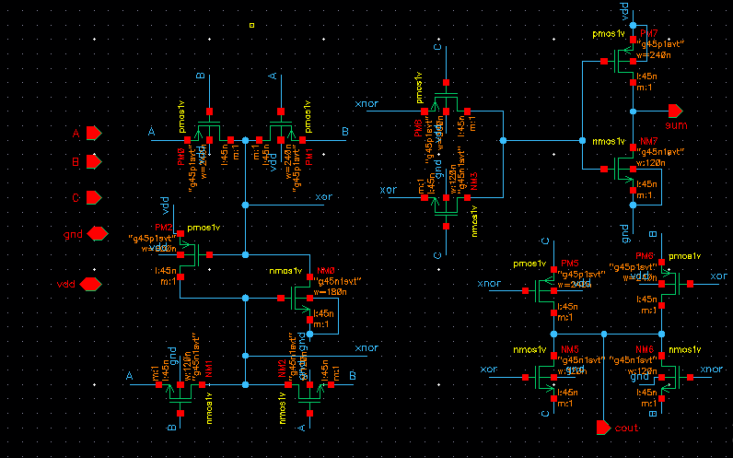

Figure 5 Schematic of 14-T Full Adder Design
  - Simulation Results
Figure 6 presents the transient analysis of the proposed XOR/XNOR module. Inputs A and B are applied to generate the XOR and XNOR outputs, while input C represents the carry-in signal used in the full adder operation. The obtained waveforms verify the correct functionality of the XOR/XNOR circuit, showing that the outputs accurately follow the expected logic behavior for each input transitions. Furthermore, both output signals are generated simultaneously with full voltage swing, ensuring reliable operation and improved signal integrity. The smooth output transitions and absence of significant glitches demonstrate the effectiveness of the proposed design. The waveform confirms full-swing output operation, with the output signals reaching both logic high (VDD) and logic low (GND) levels.

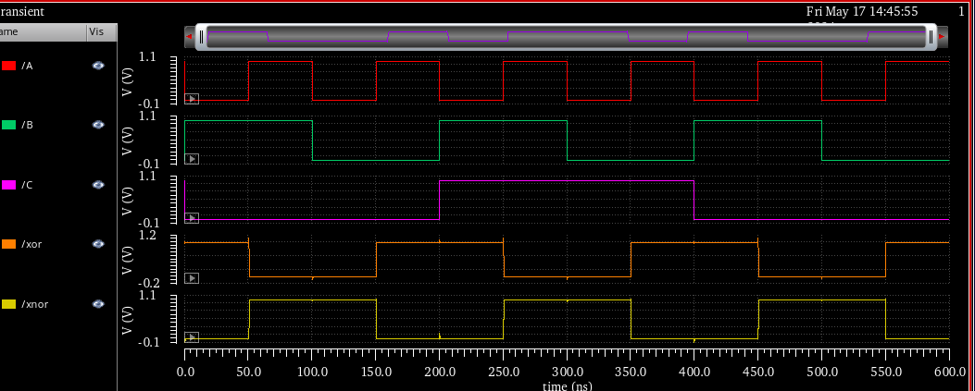

Fig. 6: Simulation waveforms for the suggested XOR-XNOR circuit

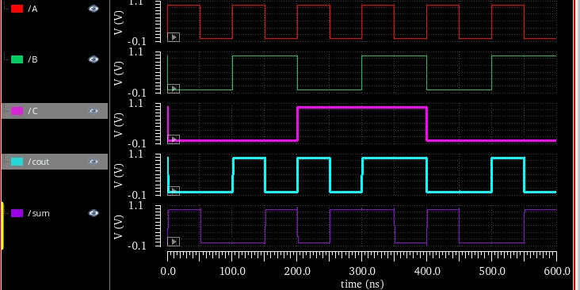

Fig. 7 Input-Output Waveform for the proposed FA design circuit
Figure 7 presents the transient response of the suggested 14-transistor hybrid full adder. The waveforms illustrate the input signals A, B, and Cin along with the corresponding SUM (S) and Cout outputs. The simulation results confirm the correct analysis of the full adder, as the generated outputs accurately follow the full adder truth table for all possible input combinations. The observed waveforms exhibit stable transitions and proper logic levels, demonstrating the effectiveness of the proposed design. Furthermore, the circuit achieves reliable output generation with reduced propagation delay, making it suitable for high-speed and low-power VLSI applications.

  - Performance Comparison
Table 1 compares the proposed circuit with previously reported designs in terms of worst-case delay, average power consumption, and Power-Delay Product (PDP). The power consumption values were obtained from the transient analysis of individual transistors. To ensure consistency and accuracy, the average power was calculated using the Spectre simulation tool.
The proposed full adder exhibits a 69.4% reduction in total power consumption compared with existing designs. The measured power consumption of the proposed circuit is 0.44 μW, whereas the corresponding values reported for Bhattacharyya’s, Kandpal’s, Valashani’s, Hasan’s, and Kanojia’s designs are 0.62 μW, 0.92 μW, 0.79 μW, 0.85 μW, and 0.63 μW, respectively. The worst-case delay was determined using the Spectre calculator and is defined as the time required for the output to reach 90% of its final steady-state value. The proposed full adder achieves a worst-case delay of 13.42 ps. In comparison, the delays reported for Bhattacharyya’s, Kandpal’s, Valashani’s, Hasan’s, and Kanojia’s designs are 9.87 ps, 54.06 ps, 74.8 ps, 38.5 ps, and 25.4 ps, respectively.
Furthermore, Table 1 presents the PDP comparison of various full adder architectures. The proposed 14-transistor full adder achieves a PDP of 6.01 aJ. In comparison, the PDP values of Bhattacharyya’s, Valashani’s, Hasan’s, and Kanojia’s designs are 49.74 aJ, 5.09 aJ, 32.73 aJ, and 16 aJ, respectively. These results demonstrate that the proposed design provides a favorable balance between power consumption and propagation delay.

Table 1: Performance Comparison of different Full Adder circuits in terms of Delay, Power Dissipation, and PDP at Power Supply of 1V.
Full Adder Circuit | No. of Transistors | Delay  (ps) | Power  (μW) | PDP  (10⁻¹⁸⁾ J
CCMOS | 28 | 60.3 | 1.28 | 77.18
Tirumalasetty’s | 16 | 83.34 | 0.65 | 54.17
Bhattacharyya’s | 16 | 98.7 | 0.62 | 61.19
Kandpal’s | 20 | 54.06 | 0.92 | 49.74
Valashani’s | 18 | 74.8 | 0.79 | 59.09
Hasan’s | 22 | 38.5 | 0.85 | 32.73
Kanojia’s | 18 | 25.4 | 0.63 | 16.00
Proposed | 14 | 13.42 | 0.0448 | 0.601

Figure 8 presents the comparison of transistor count for different full adder architectures. It can be observed that the proposed full adder requires only 14 transistors, which is the lowest among all compared designs. The reduction in transistor count is achieved through the optimized hybrid logic implementation and efficient XOR/XNOR module design. A lower transistor count not only reduces silicon area and circuit complexity but also decreases parasitic capacitances, leading to lower power consumption and improved overall performance. Therefore, the proposed full adder offers a compact and area-efficient solution for low-power VLSI applications.

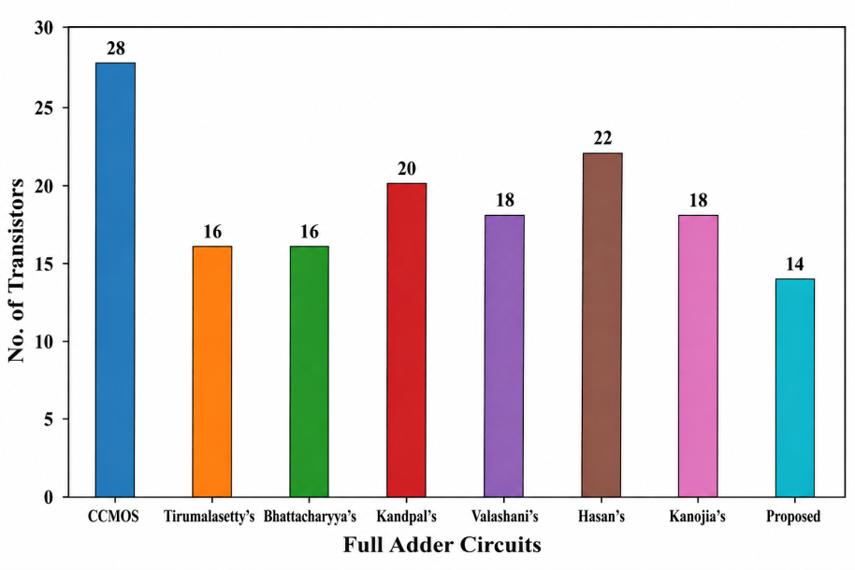
Fig. 8 Input-Output Waveform for the proposed FA design circuit

Conclusion
A 14-transistor hybrid full adder design has been presented and evaluated using 45 nm CMOS technology. The proposed architecture integrates XOR/XNOR, SUM, and CARRY generation modules to implement a compact one-bit full adder. By combining CMOS logic and pass-transistor logic, the design aims to reduce transistor count while improving power and delay performance. Simulation results obtained at a 1 V supply voltage show that the proposed circuit achieves a propagation delay of 13.42 ps, average power consumption of 0.0448 µW, and a power-delay product of 0.601 × 10⁻¹⁸ J. The comparison with existing full adder circuits indicates that the proposed design provides a favorable trade-off among transistor count, power consumption, delay, and power-delay product. The use of 14 transistors also supports a compact circuit structure, which may be useful in low-power VLSI arithmetic applications. Overall, the proposed hybrid full adder demonstrates potential for energy-efficient and high-speed digital circuit design, particularly in arithmetic blocks such as adders, multipliers, and arithmetic logic units.
Limitations
The present work is limited to simulation-based evaluation of the proposed 14-transistor full adder using 45 nm CMOS technology. The performance analysis is mainly based on delay, average power consumption, transistor count, and power-delay product. Additional validation under different process corners, supply voltages, temperatures, and load conditions is required to confirm the robustness of the design. The study does not provide detailed transistor sizing information, layout area values, parasitic extraction results, or Monte Carlo analysis. Therefore, the reported results should be interpreted as pre-layout simulation outcomes unless further layout-level verification is included. The comparison with earlier designs also depends on the simulation conditions used for each circuit; hence, a uniform test environment is necessary for a more precise performance assessment. Future work may include post-layout simulation, area estimation, noise margin analysis, and evaluation in larger arithmetic circuits.
References
Aguirre-Hernandez, M., & Linares-Aranda, M. (2010). CMOS full-adders for energy-efficient arithmetic applications. IEEE Transactions on Very Large Scale Integration (VLSI) Systems, 19(4), 718–721.Brent, R. P., & Kung, H. T. (1982). A regular layout for parallel adders. IEEE Transactions on Computers, 31(3), 260–264.
Bhattacharyya, P., Kundu, B., Ghosh, S., Kumar, V., & Dandapat, A. (2014). Performance analysis of a low-power high-speed hybrid 1-bit full adder circuit. IEEE Transactions on Very Large Scale Integration (VLSI) Systems, 23(10), 2001–2008.
Kandpal, J., Tomar, A., Agarwal, M., & Sharma, K. K. (2020). High-speed hybrid-logic full adder using high-performance 10-T XOR–XNOR cell. IEEE Transactions on Very Large Scale Integration (VLSI) Systems, 28(6), 1413–1422.
Kanojia, A., Agrawal, S., & Lorenzo, R. (2023). Comprehensive analysis of a power-efficient 1-bit hybrid full adder cell. Wireless Personal Communications, 129(2), 1097–1111.
Amini-Valashani, M., Ayat, M., & Mirzakuchaki, S. (2018). Design and analysis of a novel low-power and energy-efficient 18T hybrid full adder. Microelectronics Journal, 74, 49–59.
Hasan, M., Hossein, M. J., Hossain, M., Zaman, H. U., & Islam, S. (2019). Design of a scalable low-power 1-bit hybrid full adder for fast computation. IEEE Transactions on Circuits and Systems II: Express Briefs, 67, 1464–1468.
Hasan, M., Hussain, M. S., Hossain, M., Hasan, M., Zaman, H. U., & Islam, S. (2021). A high-speed and scalable XOR-XNOR-based hybrid full adder design. Computers & Electrical Engineering, 93, 107200.
Morad, M. J. A., Talebiyan, S. R., & Pakniyat, E. (2015). Design of new low-power high-performance full adder with new XOR-XNOR circuit. In Proceedings of the 2015 International Congress on Technology, Communication and Knowledge (ICTCK) (pp. 153–158).
Sanapala, K., & Sakthivel, R. (2019). Ultra-low-voltage GDI-based hybrid full adder design for area and energy-efficient computing systems. IET Circuits, Devices & Systems, 13(4), 465–470.
Naseri, H., & Timarchi, S. (2018). Low-power and fast full adder by exploring new XOR and XNOR gates. IEEE Transactions on Very Large Scale Integration (VLSI) Systems, 26(8), 1481–1493.
Tirumalasetty, V. R., & Machupalli, M. R. (2019). Design and analysis of low power high-speed 1-bit full adder cells for VLSI applications. International Journal of Electronics, 106(4), 521–536.
Arul, A., & Kathirvelu, M. (2024). Design a novel 1-bit full adder with hybrid logic for full-swing, area-efficiency and high-speed. Analog Integrated Circuits and Signal Processing, 119(1), 111–130.
Satyanarayana, S. V. V., Murali Krishna, B., Thamarai, M., Venkanna Babu, D., Sudheer Reddy, S., & Baboji, K. (2025). A modified GDI full adder design for enhanced energy efficiency. Iranian Journal of Science and Technology, Transactions of Electrical Engineering, 49(3), 1233–1242.
Jogi, S., & Reddy, B. N. K. (2026). Enhanced performance of full adder using advanced 9-T XOR-XNOR module. International Journal of Electronics, 113(2), 385–404.
Mewada, M., Zaveri, M., & Thakker, R. (2019). Improving the performance of transmission gate and hybrid CMOS full adders in chain and tree structure architectures. Integration, 69, 381–392.

