Virtual Laboratory Modeling; Its Impact on Learners’ Conceptual Understanding in Science

ABSTRACT
The purpose of the study was to investigate the impact of virtual laboratories on the conceptual understanding of science concept photosynthesis. The study employed a quasi-experimental pretest–posttest design with comparison groups: Experimental group received ICT-integrated instruction; virtual labs while the Control group received traditional teacher-centered instruction (textbook/lecture-based). The sample was N = 85 learners who completed both pre and post instruments, comprised of mixed gender and forms (grade levels). Welch’s t-test and descriptive statistics were used for the analysis. The Welch's t-test revealed no significant difference in pre-test knowledge between Control and Experimental groups (t = 0.04, p = 0.971, Hedges' g = 0.01), confirming baseline equivalence. However, post-test knowledge scores differed significantly, with the Experimental group outperforming the Control group (t = 3.97, p < .001, Hedges' g = 0.97). The effect size of 0.97 represents a large effect according to conventional benchmarks suggesting that virtual labs had a substantial positive impact on photosynthesis knowledge acquisition. The study therefore recommends that teachers should select ICT tools based on specific learning objectives and alignment with constructivist principles (active construction, scaffolding, feedback, visualization).
Keywords; Virtual laboratories, Modeling, Learners, Conceptual understanding, Science, Photosynthesis
INTRODUCTION
The teaching and learning of biochemistry, particularly the complex molecular processes involved in photosynthesis, represents one of the most formidable challenges in contemporary science education. Photosynthesis, as a fundamental biological process, serves as a cornerstone for understanding energy conversion in living systems and forms the basis of most life on Earth. Research consistently demonstrates that learners across various educational levels struggle with fundamental concepts related to photosynthesis. An alarming issue is that misconceptions adopted in childhood are powerful and often persist into adulthood (including teachers) according to Jančaříková and Jančařík (2022). These persistent misconceptions create a cascade effect, where inadequately prepared teachers perpetuate conceptual errors, leading to continued difficulties in student understanding and achievement in biochemistry education.
The educational challenges associated with photosynthesis stem from multiple interconnected factors. The biochemical mechanisms underlying photosynthesis involve intricate molecular interactions, electron transport chains, enzymatic reactions, and energy transformations that occur at microscopic scales, making them inherently difficult for students to visualize and comprehend. Furthermore, Jančaříková and Jančařík (2022) assert molecular life science research is becoming increasingly interdisciplinary, resulting in a steady erosion of traditional borders among chemistry, biology, physics, medicine, mathematics, and computer science. This interdisciplinary nature requires learners to integrate knowledge from multiple scientific domains simultaneously, creating cognitive overload and conceptual confusion. And one of the ways to do so is through the use of Information and Communication Technology (ICT).
The integration of Information and Communication Technology (ICT) in education has emerged as a promising approach to address these complex challenges. One of these technologies is the use of virtual laboratories.
Virtual laboratories have emerged as a significant advancement in science education, particularly in response to the challenges posed by the COVID-19 pandemic. Virtual laboratory is a powerful educational tool that enables learners to conduct experiments at the comfort of their home. An excellent opportunity to engage learners with technology and in parallel to avoid unforeseen disruptions, as happened recently due to pandemic (Vasiliadou, 2020). If virtual simulation experiments are added to the teaching process of traditional practical courses, it can continuously strengthen learners’ deeper understanding and memory of experimental theories and experimental operations and achieve better teaching results according to Sun et al. (2023). This suggests that virtual laboratories can complement rather than replace traditional instruction, creating hybrid learning environments that maximize educational effectiveness.
Purpose of study
The purpose of this study was to investigate the impact of virtual laboratories on the conceptual understanding of concept photosynthesis. This study contributes to bridging the gap between educational theory and practice by providing empirical evidence regarding the effectiveness of virtual laboratories and offering concrete recommendations for implementation in diverse educational contexts.
Objective
To evaluate the effectiveness of virtual laboratories in improving learners’ understanding of photosynthesis compared to traditional teaching methods.
Research questions
The study sought to answer the question;
How do virtual laboratories teaching compared to traditional teaching methods in terms of learners conceptual understanding of photosynthesis?
LITERATURE REVIEW
Challenges in photosynthesis
Research consistently demonstrates that photosynthesis represents one of the most challenging topics in science education. A comprehensive review of 80 systematically selected articles revealed that, misconceptions adopted in childhood are powerful and often persist into adulthood, including among teachers (Jančaříková & Jančařík, 2022). This finding is particularly alarming as it suggests a cycle of misconception perpetuation from teachers to learners across generations.
Research demonstrates that learners do not seem to realize that there are differences between photosynthesis and respiration in chemical pathways, location in the plant, and when they occur according to Parker et al. (2012). Studies have documented several persistent misconceptions about photosynthesis. Many learners’ mistake photosynthesis for plant respiration and believe that respiration takes place only in leaves where special organs such as pores are. They also believe that the plant produces oxygen over the entire day and that the most important source of food for plants is water with dissolved mineral substances (Svandova, 2014).
Schneider and Wills (2021) mentioned that elementary learners tend to believe that food must come from outside an organism. While outside sources of food are true for animals, plants produce sugars and starches through the process of photosynthesis. This misconception may be caused by students’ tendency to give plants human characteristics. The confusion is further compounded by the common reference to fertilizer as "plant food," which learners may misinterpret as the primary source of plant energy.
ICT Integration in science education
The integration of ICT in science education is strongly supported by constructivist learning theory. It has been suggested that there is a very strong link between constructivist theory and technology in education (Allsop, 2016). Constructivism emphasizes that learners actively construct knowledge through their experiences, interactions, and reflections, making ICT tools particularly well-suited for creating meaningful learning experiences.
Despite the potential benefits, ICT integration faces significant challenges. One physics teacher was keen to use information and communications technology (ICT) tools and web experiments but found himself overwhelmed by the wealth of possibilities: which tools should he use and how should he integrate them effectively into his lessons? Anderman et al. (2012) also highlights the need for systematic guidance and support for educators attempting to integrate ICT tools effectively. Teachers’ use of ICT in teaching and learning is influenced by their training, expertise, and skills in the field (Asianoa et al., 2022). This emphasizes the critical importance of teacher preparation and professional development in successful ICT integration initiatives.
While short-term benefits of ICT integration have been documented, more research is needed on the long-term retention effects of ICT-mediated learning compared to traditional approaches according to Crogman et al. (2025). This represents a significant gap in our understanding of the sustained impact of technology-enhanced instruction.
Concept of Virtual laboratories
Virtual labs are interactive, digital simulations of activities that typically take place in physical laboratory settings. Virtual labs simulate the tools, equipment, tests, and procedures used in chemistry, biochemistry, physics, biology, and other disciplines according to Badillo et al. (2020). They offer several advantages including reduced costs, increased accessibility, enhanced safety, and the ability to visualize processes that are difficult or impossible to observe in traditional laboratory settings.
Virtual laboratories have shown particular promise for photosynthesis education. Virtual laboratory activities are flexible approaches to engage undergraduate students in scientific practices. By utilizing online simulations, students can conduct virtual experiments on important biochemical reactions that occur during photosynthesis. In this virtual photosynthesis lab, students can manipulate the light intensity, light color, and distance from the light source. A plant is shown in a beaker and test tube which bubbles to indicate the rate of photosynthesis. Students can measure the rate over time according to Hardman (2019). Such interactive experiences enable students to explore cause-and-effect relationships in biochemical processes, facilitating deeper conceptual understanding.
Research on virtual laboratory effectiveness has shown positive results. Virtual experimental platforms in chemistry laboratory education have shown impact on experimental self-efficacy. Students who engage with virtual laboratories develop greater confidence in their experimental abilities and show improved understanding of complex biochemical processes.

METHOD
Design
The study employed a quasi-experimental pretest–posttest design with comparison groups: Experimental group received ICT-integrated instruction; virtual labs while the Control group received traditional teacher-centered instruction (textbook/lecture-based).
Setting, Population and sample technique
The study used learners studying photosynthesis in the science curriculum at a reputable public high school in Tema, Ghana. The sample was N = 85 learners who completed both pre and post instruments, comprised of mixed gender and forms (grade levels). Convenient sampling techniques were employed. Intact classes assigned to experimental and control groups by administrative constraints (quasi-experimental) were considered. Groups were matched as closely as possible on prior science performance, age, and technological access patterns to reduce selection threats.
Data collection Instruments
Pre-test and posttest were used as the instrument for data collection. The Pre-test was used to measure the knowledge of the learners on Photosynthesis before the Integration of virtual lab. The Post test measured their knowledge after the integration of the virtual lab and the traditional lecture method.
Reliability and validity
Internal consistency of scales was evaluated using Cronbach’s alpha (α ≥ 0.70 acceptable; Nunnally & Bernstein, 1994). Item-total correlations were used to refine scales. Content validity was ensured by aligning knowledge items to the curriculum on photosynthesis and established conceptual benchmarks.
Procedures
Phase 1: Pre-intervention.
During the first phase, a pre-test was administered to all participating classes in week 1. The purpose of the pre-test was to establish baseline information about the learners before the intervention began. Specifically, the test measured learners’ prior knowledge of the topic. This baseline data provided a reference point for comparing learners’ learning outcomes after the instructional intervention.
Phase 2: Intervention (2–3 weeks).
The second phase consisted of the instructional intervention, which lasted approximately two to three weeks. Learners in the experimental group engaged with virtual labs session designed to support their understanding of photosynthesis. These tools included virtual laboratories that modeled key processes such as the light-dependent reactions, the production of ATP and NADPH, and the stages of the Calvin cycle. In addition, visualizations were used to illustrate the ultrastructure of the chloroplast and the flow of energy and carbon during photosynthesis. The digital tools also incorporated quizzes that provided immediate feedback, allowing learners to repeat activities and practice concepts until mastery was achieved. Instructional tasks were scaffolded to support learners learning, and optional collaborative activities were included to align with constructivist learning principles.
In contrast, learners in the control group received traditional instruction. Their lessons relied on textbook readings and teacher-led lectures while covering the same curriculum content and maintaining an equivalent amount of instructional time as the experimental group.
Phase 3: Post-intervention.
The final phase occurred after the completion of the instructional period. A post-test was administered to both the experimental and control groups within one week following the instruction. This assessment measured learners’ knowledge after the intervention and allowed for comparisons with the baseline results obtained during the pre-test. In addition, learners were asked to provide reflections on their learning experiences, offering further insight into the impact of the instructional approaches used in the study.
Data analysis plan
Descriptive statistics (Normalized test) were used to determine the knowledge scores of the learners. However, Welch’s t- test were employed to find out the significant differences in knowledge.
RESULTS AND DISCUSSION
Pre-test knowledge by group (normalized)
Table 1: Descriptive Statistics for Pre-test Knowledge Scores
Group | N | M | SD
Control | 29 | 0.283 | 0.147
Experimental | 56 | 0.284 | 0.131

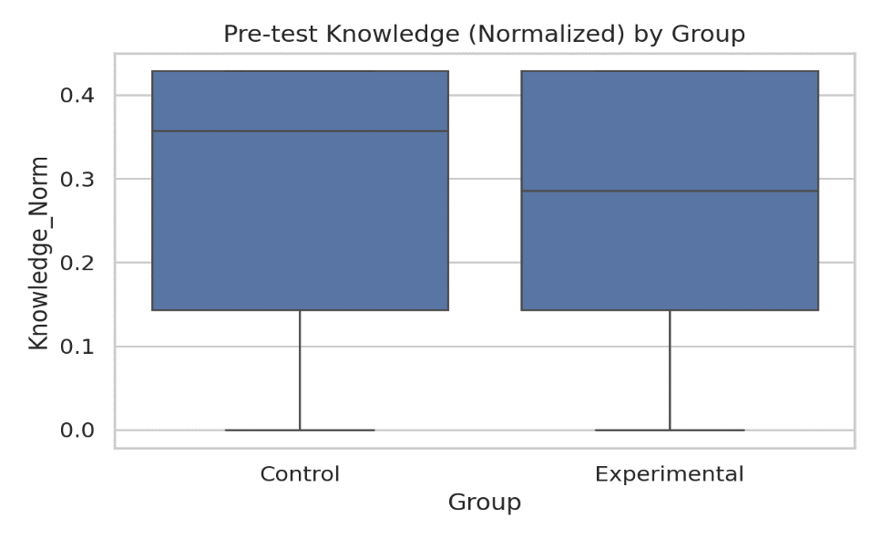

Fig. 1; Pre-test knowledge by Groups
From Table 1, Figure 1, it can be observed that the two groups demonstrated comparable baseline knowledge of photosynthesis at pre-test, with nearly identical mean scores (Control: M = 0.283, SD = 0.147; Experimental: M = 0.284, SD = 0.131). This similarity suggests that groups were equivalent before the intervention, an important prerequisite for quasi-experimental designs. Post-test knowledge favored the Experimental group with a statistically significant difference and a small-to-moderate effect size.
Post-test knowledge by group (normalized)
Table 2: Descriptive Statistics for Post-test Knowledge Scores
Group | N | M | SD
Control | 31 | 0.419 | 0.096
Experimental | 54 | 0.497 | 0.068

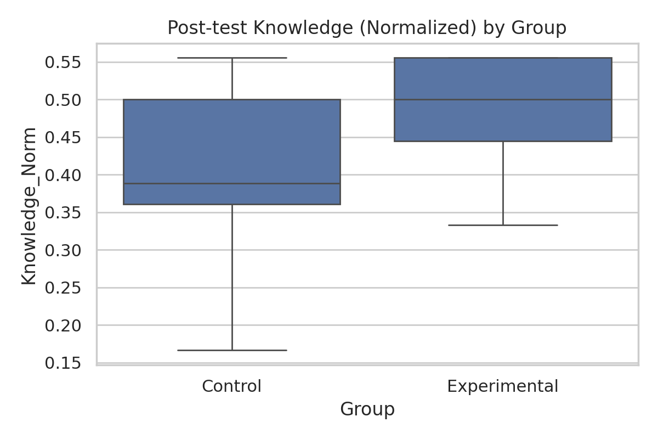

Fig. 2; Post test knowledge by Groups
From Table 2, Figure 2, it can be observed that, following the instructional intervention, both groups showed improvement from baseline, but the Experimental group demonstrated higher post-test knowledge scores (M = 0.497, SD = 0.068) compared to the Control group (M = 0.419,
SD = 0.096). The Experimental group also exhibited less variability in scores, as indicated by the smaller standard deviation. This also indicated that Post-test knowledge favored the experimental group with a statistically significant difference and a small-to-moderate effect size.
Welch's t-tests were employed to account for potential variance heterogeneity (Delacre et al., 2017). Effect sizes were calculated using Hedges' g (Hedges, 1981). p < .01. p < .001. The Welch's t-test revealed no significant difference in pre-test knowledge between Control and Experimental groups (t = 0.04, p = 0.971, Hedges' g = 0.01), confirming baseline equivalence. However, post-test knowledge scores differed significantly, with the Experimental group outperforming the Control group (t = 3.97, p < .001, Hedges' g = 0.97). The effect size of 0.97 represents a large effect according to conventional benchmarks (Cohen, 1988) suggesting that virtual labs had a substantial positive impact on photosynthesis knowledge acquisition. This finding aligns with research demonstrating that multimedia and ICT-based instruction can enhance student achievement in biology topics (Ferede et al., 2024).
Implications
The study holds significant importance across multiple dimensions, addressing critical challenges in science education while contributing to broader societal and educational goals. The study tackles one of the most persistent problems in biochemistry education, as misconceptions about photosynthesis adopted in childhood are powerful and often persist in adulthood, including among teachers themselves. The study directly addresses this fundamental issue by investigating how virtual laboratories can transform the teaching and learning of complex biochemical processes such as photosynthesis.
Limitations
The study faced several technological limitations, as access to advanced ICT tools and infrastructure varied significantly in the participating institution, and technical difficulties or equipment malfunctions affected data collection and implementation processes. The rapid pace of technological advancement rendered some tools obsolete during the study period, potentially impacting the relevance of findings. Individual learning differences and cognitive styles were not fully accounted for in the analysis, potentially overlooking important factors that influence learning outcomes. Practical limitations included time constraints, limited depth of investigation in certain areas, budget restrictions affected the scope of ICT tools that were evaluated.
CONCLUSIONS AND RECOMMENDATIONS
The experimental evidence demonstrates that carefully designed virtual laboratories can produce substantial improvements in learners’ understanding of complex science concepts such as photosynthesis, with effect size in the large range (Hedges' g = 0.97). This finding provides strong empirical support for continued investment in educational technology for complex science topics. Thus, teachers should select ICT tools based on specific learning objectives and alignment with constructivist principles (active construction, scaffolding, feedback, visualization). Technology should complement and enhance instruction, not simply replace traditional methods wholesale. Also, with learners struggling with terminologies, teachers should explicitly teach the conventions of scientific language, helping students understand why precision matters and how informal and formal terms relate. School authorities should provide reliable internet access, appropriate devices, and technical support to enable effective ICT implementation. Infrastructure deficits will undermine even the best-designed interventions.
References
Allsop, Y. (2016). Does technology improve learning–the value of constructivist approaches to technology-based learning. ICT in Practice, 16.
Anderman, E. M., Sinatra, G. M., & Gray, D. L. (2012). The challenges of teaching and learning about science in the twenty-first century: Exploring the abilities and constraints of adolescent learners. Studies in Science education, 48(1):89–117.
Asianoa, R., Kuupille, F., Segbefia, S. K., & Asenso, J. A. (2022). Examining the integration of ICT into teaching and learning: A study of colleges of education in the volta region. Integrated Journal for Research in Arts and Humanities, 2(1):15–24
Badillo, J., Londino-Smolar, G., & Savvides, P. (2020). 7 things you should know about virtual labs.
Cohen, J. (1988). Statistical power analysis for the behavioral sciences (2nd ed.). Lawrence Erlbaum Associates Ferede, T. A., Melese, W. T., & Tefera, B. A. (2024). Effect of using multimedia and dynamic classroom integrated instruction on grade 11 students' biology academic achievement. Heliyon, 10(18), Article e37306. https://doi.org/10.1016/j.heliyon.2024.e37306
Crogman, H. T., Cano, V. D., Pacheco, E., Sonawane, R. B., & Boroon, R. (2025). Virtual reality, augmented reality, and mixed reality in experiential learning: Transforming educational paradigms. Education Sciences, 15(3):303.
Delacre, M., Lakens, D., & Leys, C. (2017). Why psychologists should by default use Welch's t-test instead of Student's t-test. International Review of Social Psychology, 30(1), 92–101. https://doi.org/10.5334/irsp.82
Hardman, J. (2019). Towards a pedagogical model of teaching with ICT’s for mathematics attainment in primary school: A review of studies 2008–2018. Heliyon, 5(5).
Jančaříková, K., & Jančařík, A. (2022). How to teach photosynthesis? A review of academic research. Sustainability, 14(20), Article 13529. https://doi.org/10.3390/su142013529
Nunnally, J. C., & Bernstein, I. H. (1994). Psychometric Theory. McGraw–Hill.
Parker, J. M., Anderson, C. W., Heidemann, M., Merrill, J., Merritt, B., Richmond, G., & Urban-Lurain, M. (2012). Exploring undergraduates’ understanding of photosynthesis using diagnostic question clusters. CBE-Life Sciences Education, 11(1):47–57.
Schneider, B. A., Avivi-Reich, M., & Mozuraitis, M. (2015). A cautionary note on the use of the analysis of covariance (ANCOVA) in classification designs with and without within-subject factors. Frontiers in Psychology, 6, Article 474. https://doi.org/10.3389/fpsyg.2015.00474
Sun, L., Liu, D., Lian, J., & Yang, M. (2023). Application of flipped classroom combined with virtual simulation platform in clinical biochemistry practical course. BMC Medical Education, 23(1):771
Svandova, K. (2014). Secondary school students’ misconceptions about photosynthesis and plant respiration: Preliminary results. Eurasia Journal of Mathematics, Science and Technology Education, 10(1):59–67.
Vasiliadou, R. (2020). Virtual laboratories during coronavirus (covid-19) pandemic. Biochemistry and Molecular Biology Education, 48(5):482–483.

