Design and Comparative Evaluation of Parallel Prefix Adders using 45nm CMOS Process

.
ABSTRACT

In this work, optimized parallel prefix cells are designed using transmission gate and static CMOS logic, which are further incorporated into the Brent–Kung Adder structure. For the design and simulation of the proposed architecture, Cadence Virtuoso using 45 nm CMOS technology is employed at 1V supply voltage. The novel cells are designed in Cadence Virtuoso rather than FPGA- or synthesis-based implementations, as this approach allows precise control over device dimensions, threshold behavior, and charge distribution, thereby facilitating optimization of propagation delay and dynamic power dissipation. This work also compares conventional parallel prefix adders including the Kogge–Stone adder, Ladner–Fischer adder, Han–Carlson adder, and Brent–Kung adder with the proposed Adder architecture. The comparison results demonstrate that the proposed architecture achieves a Power–Delay Product (PDP) of 47.12 fJ for the 32-bit configuration. In addition, transistor count analysis indicates a reduction of approximately 36–50%, highlighting improvements in energy efficiency and hardware complexity.

Keywords: Parallel Prefix Adder, Transmission Gate, Power-Delay-Product, 45 nm CMOS Process, Brent Kung Adder

- INTRODUCTION

In recent years, the demand for high-speed and low-power arithmetic circuits has increased significantly because digital signal processing (DSP), microprocessors, communication systems, smart phones, multimedia devices, and portable electronic applications has advanced rapidly. Modern VLSI systems require efficient hardware architectures capable of providing faster computation, lower power consumption, and reduced silicon area. In applications such as real-time embedded systems, artificial intelligence hardware, and mobile processors, achieving high computational speed with minimum energy dissipation has become one of the major challenges for VLSI designers (Rabaey, 1996). Therefore, the development of efficient arithmetic circuits has gained considerable importance in nano-scale CMOS technology.
Among various arithmetic building blocks, adders are one of the most fundamental and extensively used circuits in digital systems. They form the core component of arithmetic logic units (ALUs), processors, DSP architectures, multipliers, and data-path units. The overall performance of these systems is strongly influenced by the speed, power consumption, and hardware complexity of the employed adder architecture. As technology scales toward nano-scale dimensions, designing adders with reduced delay and low power dissipation has become essential for high-performance semiconductor systems.
The Ripple Carry Adder (RCA) is one of the simplest and most widely used adder architectures because of its regular layout, compact structure, and low hardware complexity. However, the major drawback of RCA is its sequential carry propagation mechanism, where each stage must wait for the carry generated from the previous stage before producing the final output. As the number of bits increases, the carry propagation delay increases linearly, resulting in slower computation speed and degraded system performance. Due to this limitation, RCA becomes less suitable for modern high-speed VLSI applications that demand rapid arithmetic processing. To overcome the limitations of RCA, several advanced adder architectures have been developed for high-speed arithmetic operations. Among these, Parallel Prefix Adders (PPAs) are considered one of the most efficient architectures because they compute carry signals in parallel using generate and propagate concepts. Unlike RCA, PPAs significantly reduce carry propagation delay and improve computational speed. Owing to their logarithmic delay characteristics, PPAs provide better scalability and are widely preferred in high-performance processors, DSP units, and communication hardware.
Several PPA architectures have been proposed in the literature to achieve different trade-offs among propagation delay, power consumption, fan-out, wiring complexity, and transistor count (Reuben, 2021). Popular architectures include the Kogge–Stone Adder, Brent–Kung Adder, Han–Carlson Adder, and Ladner–Fischer Adder. The Kogge–Stone adder provides very low delay but requires large wiring complexity and area. The Brent–Kung adder offers reduced hardware complexity and lower wiring overhead at the cost of slightly higher delay. Similarly, Han–Carlson and Ladner–Fischer adders provide balanced trade-offs between speed and area efficiency. Therefore, selecting an appropriate PPA architecture depends on the target application requirements.
Parallel Prefix Adders are constructed using fundamental prefix cells (White, grey, black and sum cell) that are arranged in multiple computational stages for parallel carry generation. These prefix cells mainly perform generate and propagate operations to produce carry signals efficiently. By modifying the structure and interconnection of these prefix cells, different PPA architectures can be realized with distinct performance characteristics. Consequently, the design of optimized prefix cells plays a crucial role in enhancing PPAs' overall hardware complexity, speed, and power dissipation.
Transmission gate (TG)-based logic has attracted significant attention in VLSI circuit design because of its reduced transistor count, improved switching characteristics, and lower power dissipation compared to conventional CMOS implementations. Transmission gates provide efficient signal transfer with reduced voltage degradation and enable compact transistor-level implementations for arithmetic circuits. Integrating TG logic with static CMOS structures can therefore improve the performance and energy efficiency of nano-scale adder architectures.
From the existing literature, FPGA-based implementations, and conventional CMOS realizations of Parallel Prefix Adders (PPAs), the Brent–Kung Adder has been identified as one of the most efficient architectures in terms of power and delay trade-off. Although architectures such as the Kogge–Stone Adder provide very low propagation delay, they suffer from increased wiring complexity, larger area, and higher power consumption. In contrast, the Brent–Kung structure offers reduced interconnect complexity, lower hardware overhead, and improved energy efficiency while maintaining acceptable computational speed. Therefore, in this work, the Brent–Kung adder architecture is further optimized.
The novelty of this work lies in the design optimization of parallel prefix cells, such as white, grey, black, and sum cells, using transmission gate logic, which significantly reduces the transistor count, resulting in lower power consumption, reduced hardware complexity and improved switching performance. Furthermore, a comparative analysis of conventional CMOS-based Kogge–Stone Adder, Han–Carlson Adder, Ladner–Fischer Adder, and Brent–Kung Adder architectures with the proposed cell-based Brent–Kung adder is carried out to identify the most efficient trade-off among speed, power consumption, and hardware complexity for parallel prefix adder selection.
The remainder of this paper is organized as follows. Section II presents the background and overview of Parallel Prefix Adders (PPAs). Section III describes the proposed methodology and design implementation of the TG-based Brent–Kung Adder. Section IV discusses the simulation results and comparative performance analysis. Finally, Section V concludes the paper with major findings and future scope.

- RELATED BACKGROUND
Parallel prefix adders (PPAs) have been studied by many researchers to enhance the speed and efficiency of arithmetic operations. Various PPA architectures, such as the Kogge–Stone Adder, Brent–Kung Adder, Ladner–Fischer Adder, Han–Carlson, Ling, and Weinberger adders, have been extensively studied due to their distinct trade-offs in delay, area, and interconnect complexity (Beaumont-Smith and Lim, 2001, Gupta et al., 2025) . For instance, (Miskin et al. 2024, Miskin et al. 2025 ) performed a comprehensive comparison of different parallel prefix CMOS based adder architectures implemented in 90 and 45 nm CMOS technologies. Their study evaluated key performance metrics such as power, delay, and area to identify the architecture offering the best trade-off among different PPA designs. Similarly, Daphni and Vijula (Daphni and Grace, 2017) examined various adder architectures and concluded that the Kogge–Stone Adder provides the lowest delay, although it requires greater power consumption and larger area. Moving beyond basic comparative analyses, researchers made a number of inventive adder architectures aimed at enhancing overall efficiency. Notably, Dimitrakopoulos and Nikolos (Dimitrakopoulos and Nikolos, 2005) developed an innovative design methodology for Ling-based parallel prefix adders, achieving lower logic depth and reduced fanout than traditional implementations . Kumar and Babu (Kumar and Babu, 2023) introduced an improved hybrid adder design that combines a tailored Binary Excess-1 Converter (BEC) with a Kogge–Stone adder and Ripple Carry Adder (RCA) configuration. Jagadeeshkumar and Meganathan (Jagadeeshkumar and Meganathan, 2021) presented an energy-efficient 64-bit parallel prefix adder that incorporates a newly designed two-bit sum unit along with an optimized recurrence scheme. Their implementation using static CMOS in advanced technology nodes (45–16 nm) achieved notable reductions in energy consumption.
Moreover, several studies have explored the use of emerging and advanced technologies for designing parallel prefix adders to enhance performance. For example, (Krishna et al., 2018) evaluated the performance of the Brent–Kung adder implemented in 45 nm CMOS technology, using Cadence simulations across different bit width. In another work, Touil et al. (Touil et al., 2023) developed an optimized parallel prefix adder based on Quantum Dot Cellular Automata (QCA) to achieve low power consumption along with high-speed operation. Recent studies have presented high-performance parallel binary adders using advanced domino CMOS logic, achieving notable reductions in delay and energy consumption. In addition, hybrid parallel-prefix architectures have been introduced that combine conventional structures with improved computation techniques to reduce logic depth and achieve a better trade-off between speed and area (Das and Khatri, 2008, Rosa et al., 2023).
In this work, a novel CMOS-based full custom adder cell is implemented for the Brent–Kung Adder using 45 nm CMOS technology, in which all fundamental building blocks are designed using Transmission Gate (TG) logic and static CMOS instead of FPGA-based predefined libraries. Different Parallel Prefix Adder (PPA) architectures are discussed below.

Different Parallel Prefix Adder Architectures

Parallel prefix adders (PPAs) are considered one of the most efficient adder architectures for high-speed digital systems (Perri et al., 2014), as they enable carry signals to be generated in parallel rather than sequentially. This parallel carry computation significantly reduces propagation delay by minimizing the critical path length. Various PPA architectures have been proposed, each offering different trade-offs in terms of delay, area, and interconnect complexity.
The Brent–Kung Adder is tree-structured parallel prefix architecture introduced in 1982 by Richard P. Brent and H. T. Kung, which minimizes carry propagation delay by reducing critical path length and interconnect complexity (Brent and Kung, 1982).
The Ladner–Fischer Adder, introduced in 1980, is a parallel prefix structure. It combines features of both the Sklansky Adder and the Brent–Kung Adder, offering a flexible trade-off between logic depth and wiring complexity. Although the Ladner–Fischer prefix structure exhibits relatively high fan-out at certain nodes, it achieves a minimal number of stages along the critical path. Consequently, the overall propagation delay is approximately log2​(n)+1 (Ladner and Fischer, 1980).
The Kogge–Stone Adder, introduced by Peter M. Kogge and Harold S. Stone in 1973, is one of the fastest parallel prefix adders because it computes carry signals completely in parallel, giving a delay of about log2​(n). This makes it very suitable for high-speed applications. However, it uses a large number of nodes and interconnections, which increases area, wiring complexity, and power consumption due to higher parasitic capacitances (Kogge and Stone, 1973).
The Han–Carlson Adder is a hybrid parallel prefix structure that combines features of both the Kogge–Stone Adder and the Brent–Kung Adder. In this structure, carry-merge operations are mainly carried out for even bit positions, while generate and propagate signals are processed for odd bits (Han and Carlson, 1987).

METHODOLOGY

Proposed Transmission Gate Based Prefix Cell Design

This work adopts a circuit-level design approach to optimize the performance of a Brent–Kung Adder by focusing on transistor-level modifications. The methodology involves redesigning the fundamental prefix cells using transmission gate (TG) logic in combination with static CMOS to achieve improved energy efficiency and speed performance. The three primary phases of the Brent-Kung adder's operation are pre-computation, carry generation, and post-computation.

3.1.1 White Cell: During the initial pre-processing stage, the two signals which one is propagate (Px) and generate (Gx) signals for each of the bit is obtained with a fundamental white cell. Both signal are obtained from the operands Ax and Bx, and are expressed as follows:

Ρ_{Χ} = Α_{Χ} ⊕ Β_{Χ} (1)
G_{X =} Α_{Χ.} Β_{Χ} (2)

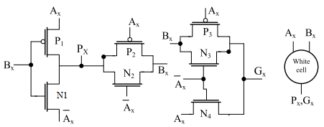
(a) | (b)
Figure 1 Proposed white cell (a) Circuit using transmission gates, (b) Symbol
Figure 1 presents the proposed white cell along with its symbolic representation. When Ax is logic 1 while Bx is logic 0, transistor P1 becomes active; causing the output becomes high because it follows Ax. When Ax is zero, P2 and N2 transistors are activated, allowing the output Bx. If both inputs combination If both input combinations are high, transistor N1 turns ON and the output Px becomes the inverted form of input Ax. For the generate output Gx, when Ax is at logic 1, transistors P3 and N3 both are turns ON and output depend on Bx logic. When Ax is low, single transistor N4 turns ON, and Ax is the output at this logic . The white cell receives inputs Ax and Bx, where x represents the bit position. In an n-bit PPA, the value of x ranges from 0 to n−1. In the proposed approach, transistor dimensions are carefully optimized to ensure nearly equal rise and fall delays (tₚLH ≈ tₚHL). The design is realized in 45 nm CMOS technology, where the minimum transistor width is 120 nm (Singh et al., 2022).
3.1.2 Carry Generation: The carry generation stage is responsible for computing carry signals in parallel to reduce propagation delay and improve addition speed. This stage consists of grey and black cells, which perform the prefix operations required for carry computation. In the proposed design, the grey and black cells are implemented using transmission gate (TG) logic to achieve improved power and delay performance. The structures of the grey and black cells are illustrated below.

3.1.2.1 Grey Cell: The grey cell generates only the carry output by combining the incoming generate and propagate signals. Unlike the black cell, the grey cell does not produce a propagate output, which helps in reducing hardware complexity and power consumption. The carry computation carried out by the grey cell is represented by Eq. (3):

C_{Χ+1} = G_{Χ} + P_{Χ} · C_{Χ} (3)

Figure 2 shows the proposed grey cell used in the carry generation network. The circuit is realized using transmission gates TG3 and TG4 along with transistors P4, P5, N5, and N6 to achieve efficient carry computation with reduced transistor complexity. The functionality of TG3 together with transistor N5 is controlled by the propagate signal Px​ and the carry input Cx. When Px ​is at logic high, TG3 is enabled, allowing the carry input Cx​ to determine the output state. Consequently, the term Px.Cx follows the value of Cx, enabling proper carry propagation. In contrast, when Px is low, the product term becomes zero and transistor N5 conducts, forcing the output to logic low. Similarly, If the intermediate term Px. Cx attains a high value, transistor P5 turns ON and transfers the corresponding logic level to the output node. Otherwise, TG4 becomes active and the final output is controlled by the generate signal Gx​. This overall switching mechanism enables accurate carry generation and propagation within the proposed grey cell architecture. In addition, transistors P4 and N6 act as an inverter stage for the output produced by TG3 and N5.
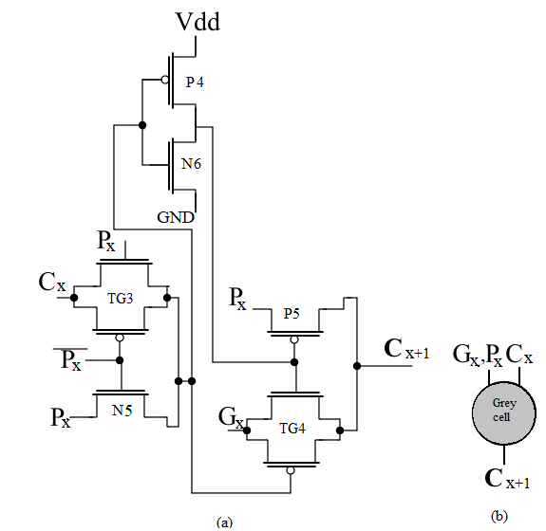
(a) | (b)
Figure 2 Proposed Grey Cell (a) Circuit using transmission Gates, (b) Symbol
3.1.2.2 Black Cell: The black cell is another of the fundamental building blocks of a Parallel Prefix Adder (PPA), responsible for performing carry merge operations between adjacent stages of the prefix network. It generates both group propagate and group generate signals, which are further utilized for parallel carry computation in subsequent stages. Figure 3 illustrates the proposed black cell, which is implemented using 13 transistors. Equations (4) and (5) represent the generate and propagate signals, respectively.
G_{OUT} = Gx + Px · G_{x−1} (4)
P_{OUT} = Px · P_{x−1} (5)

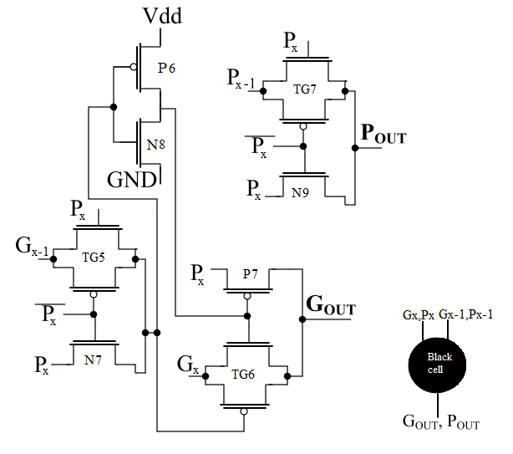
(a) | (b)
Figure 3 Proposed Black Cell (a) Circuit and (b) Symbol
The operation of TG5, N7, TG7, and N9 depends on the control signals Px​ and invert Px​​. For the Pout​ output, when Px​ is low, transistor N9 turns ON and the signal Px​ appears at the Pout​ terminal. However, when Px​ is high, the signal Px−1​ is transferred to the Pout​ node through the transmission gate path. For the Gout ​output, when Px​= 0, transistor N7 active and the inverted Px​ signal is addressed to the inverter formed by P6 and N8. Consequently, a high output is obtained at P7 and TG6, turning TG6 ON and allowing the signal Gx​ to propagate to the Gout​ terminal. On the other hand, when Px​ ​=1, TG5 becomes active and the inverted Gx−1 ​signal is applied to P6 and N8. This signal further controls TG6 and P7, causing the Gout ​output to follow the logical operation. Hence, both output equations are successfully satisfied by the proposed black cell operation.

3.1.3 Post-Processing Stage: Figure 4 illustrates the proposed sum cell, which is implemented using only 6 transistors. The sum cell is responsible for generating the final sum bit in the post-processing stage of the Parallel Prefix Adder. The SUM output is obtained by performing the XOR operation between the propagate signal and the carry signal corresponding to the same bit position. The sum expression is given as:

Sx = Px ⊕ Cx (6)
Figure 4 illustrates the proposed sum cell, which operates based on the XOR functionality of inputs Px​ and Cx​. The circuit is implemented using only one transmission gate along with static CMOS logic, resulting in reduced transistor count and lower hardware complexity. When both Px​ and Cx​ are at logic low, transistor P8 and transmission gate TG8 turn ON, causing a low logic level from Cx​ to appear at the SUM output with full swing characteristics. When Cx​ is low and Px​ is high, transistor P8 drives the SUM output to logic high. Similarly, when Cx​ is high and Px​ is low, TG8 provides a full-swing high output at the SUM node. However, when both Px​ and Cx​ are at logic high, transistor N10 turns ON and produces a full-swing low output at the SUM terminal.
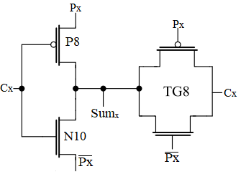

Figure 4 SUM cell using transmission gates
3.2 Brent Kung Implementation: Figure 5 illustrates the 32-bit implementation of the Brent–Kung Adder. The architecture uses basic prefix cells built one level at a time. It starts with 2-bit groups, which get combined to make 4-bit, 8-bit, 16-bit, and ultimately 32-bit prefixes. The carry generation network is split into several stages; the new 32-bit design uses eight stages to efficiently move carries along. The computation begins with white cells that generate the initial propagate and generate signals. These signals are then processed through subsequent prefix stages using grey and black cells to compute higher-order carries. In the final stage, post-processing is performed where the computed carry signals are used to generate the final sum outputs and carry-out. This hierarchical and staged setup lets the design do efficient carry computations, controlling the logic depth and reducing the interconnect complexity.
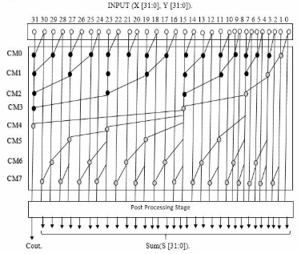
Figure 5 Architectural representation of 32-bit Brent Kung Adder

4. results and discussion

4.1 Transient Response And Implementation of Design
Cadence Virtuoso is used to implement and simulate the proposed design in 45 nm CMOS technology. All simulations are carried out at a supply voltage of 1 V, with an operating frequency of 1 GHz, and under a fan-out-of-4 (FO4) load condition to ensure realistic performance evaluation. Figures 6 show the schematic implementation in (a) part and simulation results of the 4-bit adder configuration in (b) part. The waveform S0, S1, S2 and S3 represents the sum outputs of the adder, while signals C4 is final carry output of the adder.
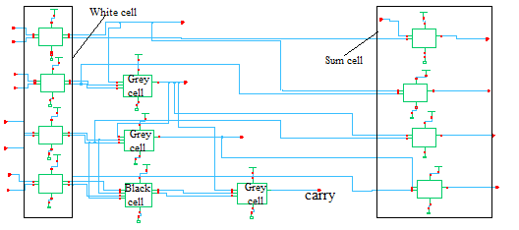
(a)

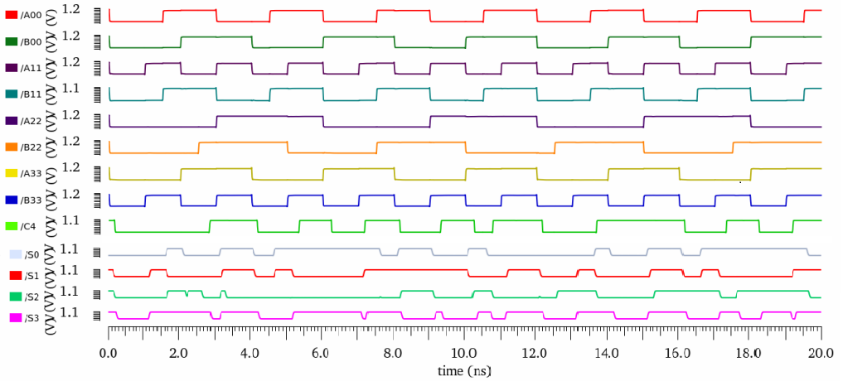
(b)

Figure 6 (a) Schematic implementation (b) Simulation results of 4-bit BKA
Figure 7 illustrates the schematic and transient analysis of the 8-bit Brent–Kung adder. The input operands provided to the adder are represented in the waveform by A0–A7 and B0–B7. The Cin​ signal denotes the input carry, which is initially maintained at logic ‘0’, whereas Cout​ represents the final carry output generated after the addition operation. The corresponding sum outputs are represented by S0​–S7​, indicating the generated result bits of the adder operation. Similarly, transient analyses are also performed for the 16-bit and 32-bit Brent–Kung adder architectures to figure out the functionality and timing analysis of the proposed design for higher bit-width implementations.
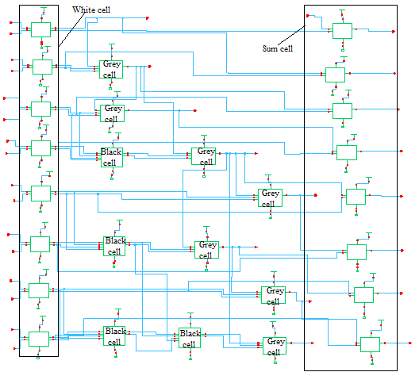
(a)
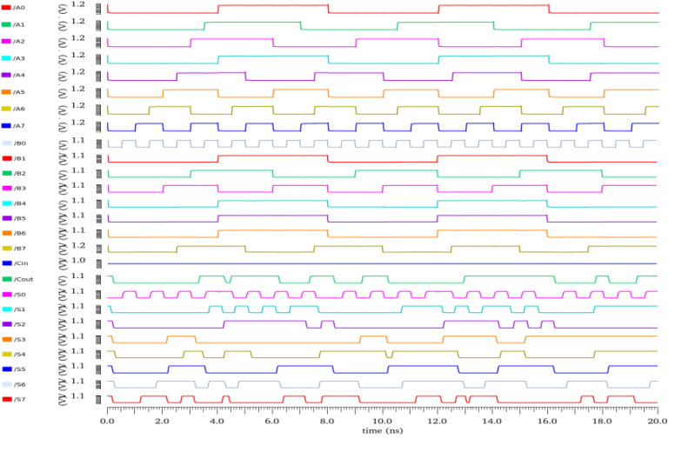
(b)

Figure 7 (a) Schematic implementation (b) Simulation results of 8-bit BKA

4.2 Performance Comparison and Discussion
Table 1 presents a comparison of delay for conventional CMOS-based various PPAs and the transmission-gate (TG) based Brent–Kung adder, with all results evaluated under an FO4 load using an input-buffered test bench. The results clearly indicate that the TG-based Brent–Kung adder provides the best trade-off between delay and power. Table 2 shows the average power consumption and table 3 present the Power-Delay Product, where the TG-based Brent–Kung adder achieves the most favorable performance.

Table 1. Delay (ns) comparison

Delay(ns)
Bit Size | Ladner– Fischer | Han–Carlson  adder | Kogge–Stone  adder | Brent Kung Adder | Proposed TG Brent Kung Adder
4-bit | 0.552 | 0.513 | 0.164 | 0.238 | 0.198
8-bit | 0.845 | 0.684 | 0.428 | 0.523 | 0.368
16-bit | 1.63 | 1.48 | 0.952 | 1.02 | 0.742
32-bit | 3.17 | 2.76 | 1.48 | 1.62 | 1.14

Table 2. Power consumption (µW)

Power(µw) comsumption
Bit Size | Kogge–Stone adder | Han–Carlson adder | Ladner– Fischer | Brent Kung Adder | Proposed TG Brent Kung Adder
4-bit | 14.46 | 11.76 | 10.48 | 10.32 | 5.16
8-bit | 21.38 | 18.58 | 16.33 | 16.58 | 7.26
16-bit | 56.84 | 49.21 | 46.85 | 56.43 | 17.43
32-bit | 146.26 | 123.83 | 112.78 | 102.67 | 41.62
Table 3. PDP(fJ) of different PPA’s

PDP (fJ)
Bit  Size | Ladner-Fischer | Han–Carlson adder | Kogge–Stone adder | Brent Kung adder | Proposed TG Brent Kung Adder
4-bit | 5.7849 | 6.0328 | 2.371 | 2.456 | 1.02168
16-bit | 76.365 | 72.83 | 54.11 | 57.55 | 12.93306
32-bit | 357.51 | 341.77 | 216.46 | 166.3 | 47.4468
32-bit | 357.51 | 341.77 | 216.46 | 166.3 | 47.4468

Table 4. Transistor count comparisons of different PPAs

Transistor Count
Bit Size | Kogge–Stone adder | Han–Carlson adder | Ladner– Fischer | Brent Kung Adder | Proposed TG Brent Kung Adder
4-bit | 252 | 184 | 174 | 174 | 103
8-bit | 582 | 426 | 414 | 396 | 244
16-bit | 1452 | 1062 | 1052 | 876 | 556
32-bit | 3330 | 2352 | 2034 | 1860 | 1202

Table 4 present a comparison of transistor count, demonstrating that the TG-based design reduces the number of transistors by approximately 35–40%, which contributes to lower power consumption clearly demonstrates that the proposed design shows approximately 35% to 41% reduction in the number of transistors across different bit sizes. Specifically, the reduction is about 40.8% for 4-bit, 37.9% for 8-bit, 35.8% for 16-bit and 34.9% for 32-bit implementations. This reduction in transistor count directly contributes to lower power consumption and improved area efficiency, highlighting the effectiveness of the proposed design.

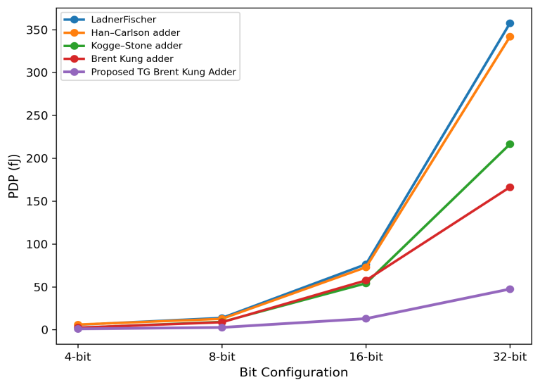

Figure 8 Power –delay –product comparison of different parallel prefix adder for different bit at 1V power supply
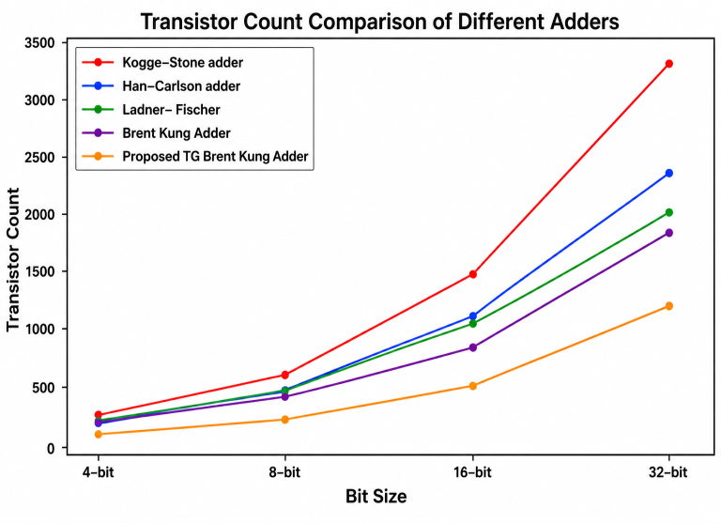

Figure 9 Transistor count comparison of different parallel prefix adder

Figure 7 illustrates the comparative graph of the Power–Delay Product (PDP) for different Parallel Prefix Adders (PPAs) evaluated at a supply voltage of 1 V and an operating frequency of 1 GHz. The graph demonstrates the overall energy efficiency of the considered PPA architectures and highlights the improved PDP performance achieved by the proposed TG-based Brent–Kung Adder.
Figure 8 presents the transistor count comparison of different PPA architectures. The comparison clearly indicates that the proposed TG-based design greatly reduces the transistor count compared to conventional CMOS implementations. This leads to less hardware complexity, reduced silicon area, and improved power efficiency.

5. Conclusion
This work designs optimized parallel prefix cells—white, grey, black, and sum cells—using TG logic and static CMOS techniques to enhance Parallel Prefix Adders' performance. The proposed cells are incorporated into the Brent–Kung Adder architecture and implemented at transistor level using Cadence Virtuoso in 45 nm CMOS technology. Using TG-based logic greatly decreases the transistor count without compromising full-swing operation or efficiency. The performance of the proposed TG-based Brent–Kung architecture is analyzed and compared with conventional CMOS-based PPA architectures, including the Kogge–Stone Adder, Han–Carlson Adder, Ladner–Fischer Adder, and conventional Brent–Kung Adder structures. The comparative study shows that the traditional Brent-Kung adder is still one of the best for balancing propagation delay and power use. The proposed architecture exhibits a significantly reduced transistor count of approximately 35–50% compared to conventional CMOS implementations, which consequently lowers overall power dissipation and hardware complexity. Additionally, the design boasts a Power–Delay Product (PDP) of 47.44 fJ, showing better energy efficiency for high-speed operations. The results prove that the proposed TG-based Brent–Kung adder is really efficient. It strikes a great balance between speed, power use, and hardware simplicity. Because of this, it's perfect for today's nano-scale VLSI systems that need both low power and high performance.
References
Beaumont-Smith, A., & Lim, C. C. (2001). Parallel prefix adder design. In Proceedings of the 15th IEEE Symposium on Computer Arithmetic (ARITH-15) (pp. 218–225).
Brent, R. P., & Kung, H. T. (1982). A regular layout for parallel adders. IEEE Transactions on Computers, 31(3), 260–264.
Daphni, S., & Grace, K. S. V. (2017). A review analysis of parallel prefix adders for better performance in VLSI applications. In Proceedings of the IEEE International Conference on Circuits and Systems (ICCS) (pp. 103–106).
Das, S., & Khatri, S. P. (2008). A novel hybrid parallel-prefix adder architecture with efficient timing-area characteristic. IEEE Transactions on Very Large Scale Integration (VLSI) Systems, 16(3), 326–331.
Dimitrakopoulos, G., & Nikolos, D. (2005). High-speed parallel-prefix VLSI Ling adders. IEEE Transactions on Computers, 54(2), 225–231.
Gupta, T., Verma, G., & Akhter, S. (2025). FPGA implementation and performance analysis of parallel prefix structures for modular adders design. Circuits, Systems, and Signal Processing, 44(2), 992–1016.
Han, T., & Carlson, D. A. (1987). Fast area-efficient VLSI adders. In Proceedings of the 8th IEEE Symposium on Computer Arithmetic (pp. 49–56).
Jagadeeshkumar, N., & Meganathan, D. (2021). A systematic design of novel energy efficient 64-bit parallel-prefix adder. International Journal of Electronics, 108(11).
Kogge, P. M., & Stone, H. S. (1973). A parallel algorithm for the efficient solution of a general class of recurrence equations. IEEE Transactions on Computers, 22(8), 786–793.
Krishna, T. V., Niveditha, S., Mamatha, G., Sunil, M., & Vamshi, K. (2018). Simulation study of Brent Kung adder using Cadence tool. International Journal of Advanced Research, Ideas and Innovations in Technology, 4(3), 564–570.
Kumar, J. R. D., & Babu, C. G. (2023). Performance investigation of a modified hybrid parallel prefix adder for speedy and lesser power computations. IETE Journal of Research, 69(5), 2310–2327.
Ladner, R. E., & Fischer, M. J. (1980). Parallel prefix computation. Journal of the ACM, 27(4), 831–838.
Miskin, V. P., Kerur, S. S., Kargar, S. Y., Joshi, S., Dhanesha, R., & Malgavi, S. (2024). Performance analysis of parallel prefix adders using 90nm technology. In Proceedings of the Global Conference on Communication and Information Technology (GCCIT) (pp. 1–8).
Miskin, V. P., Kerur, S. S., Sulakhe, O. P., Shahapur, H. V., Deshpande, A. G., & Shirasangi, A. B. (2025). Performance metrics comparison of 8-bit adder architectures in 45nm CMOS. In Proceedings of the 3rd International Conference on Networks, Multimedia and Information Technology (NMITCON) (pp. 1–8).
Perri, S., Lanuzza, M., & Corsonello, P. (2014). Design of high-speed low-power parallel-prefix adder trees in nanometer technologies. International Journal of Circuit Theory and Applications, 42(7), 731–743.
Rabaey, J. M. (1996). Digital Integrated Circuits. Englewood Cliffs, NJ, USA: Prentice-Hall.
Reuben, J. (2021). Design of in-memory parallel-prefix adders. Journal of Low Power Electronics and Applications, 11(4), 45.
Rosa, M. M. A. D., Paim, G., Costa, P. C. L. D., Costa, E. A. C. D., Soares, R. I., & Bampi, S. (2023). AxPPA: Approximate parallel prefix adders. IEEE Transactions on Very Large Scale Integration (VLSI) Systems, 31(1), 17–28.
Singh, S. N., Srivastava, G., Arshad, S. S., & Shukla, S. (2022). A low-voltage two-stage CMOS OTA with enhanced DC-gain for biomedical applications. International Journal of Circuit Theory and Applications, 98(2), 257–264.
Touil, L., Henchir, C., & Mtibaa, A. (2023). An efficient design of a parallel prefix adder based on QCA technology. IETE Journal of Research, 1–15.

