Original Research Article
Fabricated Antifungal Hydrogels Containing Silver Nanoparticles for Advanced Biomedical Applications

ABSTRACT

Fungal infections associated with wounds and biomedical devices continue to pose a serious challenge for health care, thus the development of effective antimicrobial materials is needed. Here, we have synthesised an antifungal hydrogel using silver nanoparticles (AgNPs) and explored its potential for biomedical applications. AgNPs were synthesised by green route and were loaded into a tri-polymeric hydrogel matrix containing κ-carrageenan (k-C), polyethylene glycol (PEG) and polyvinylpyrrolidone (PVP). The prepared hydrogel showed good transparency, structural stability and uniform distribution of AgNPs in the polymeric network. The antifungal activity of the AgNP loaded hydrogel was studied against Aspergillus niger in both therapeutic and prevention model. The hydrogel was found to effectively inhibit fungal growth on contaminated agar surfaces in the treatment model with a clear zone of inhibition as compared to the nanoparticle-free control. The prevention model consisted of a biphasic nutrient-rich hydrogel system, with one half consisting of AgNPs and the other half as control. The AgNP-containing area showed complete inhibition of fungal colonisation, while the control side showed extensive fungal growth. The results showed that the addition of AgNPs into the hydrogel matrix did not influence its antifungal activity. The advantages of biocompatible polymeric network and potent antifungal activity of AgNPs make this hydrogel a promising candidate for wound dressings, infection control and other biomedical applications. The present study offers the potential of AgNPs based hydrogel as advanced antimicrobial biomaterials, and a stepping stone for future studies including physicochemical characterisation, biocompatibility evaluation and in vivo wound healing investigation.

Keywords: Silver nanoparticles, Antifungal hydrogel, κ-Carrageenan, Polyethylene glycol, Polyvinylpyrrolidone, Aspergillus niger, Biomedical applications.

- INTRODUCTION
Nanotechnology has emerged as one of the most dynamic and rapidly advancing fields of research worldwide, particularly in materials science and nanoparticle synthesis. Nanoparticles (NPs) possess unique physicochemical properties, including nanoscale size, high surface area-to-volume ratio, tunable morphology, enhanced reactivity, flexibility, and component purity, which distinguish them from their bulk counterparts. (Khan et al., 2019).Various inorganic metals, including gold, zinc, titanium, palladium, and silver, have been widely utilized for nanoparticle synthesis because of their distinctive thermal, magnetic, catalytic, and biological properties(Jeevanandam et al., 2018). Among metallic nanoparticles, silver nanoparticles (AgNPs) have attracted remarkable attention because silver has been recognized for its medicinal and antimicrobial properties for more than 2000 years. Silver exhibits broad-spectrum antimicrobial activity and can inhibit microbial growth through multiple mechanisms(Iravani et al., 2014). With the increasing prevalence of antimicrobial resistance, AgNPs have emerged as promising alternatives owing to their potent bactericidal effects against numerous pathogenic microorganisms, lower cost, and reduced likelihood of inducing resistance compared to conventional antibiotics. These unique characteristics have expanded the applications of AgNPs into healthcare, food preservation, consumer products, biological systems, and industrial fields(Rai et al., 2009).
Silver nanoparticles can be synthesized through physical, chemical, and biological approaches.(Wasilewska et al., 2023). Conventional physical and chemical synthesis methods often involve toxic reagents, high energy consumption, and elevated costs, limiting their sustainability and environmental compatibility(Durán et al., 2016). In contrast, biological or green synthesis methods have gained increasing preference due to their eco-friendly nature, cost effectiveness, and reduced risks to human health(Ahmed et al., 2016). Consequently, developing novel synthesis strategies capable of controlling nanoparticle morphology, size distribution, stability, and physicochemical properties has become an important area of research(Shnoudeh et al., 2019). Nanoparticle stability is a crucial factor influencing their functionality and biomedical performance(Meran et al., 2018). Generally, nanoparticles can be stabilized through electrostatic stabilization, steric stabilization, or electrosteric stabilization (Nuss & Von Rechenberg, 2008). Various stabilizing agents such as surfactants, polymers, dendrimers, and biomacromolecules have been utilized to improve nanoparticle stability and prevent aggregation(Mourdikoudis et al., 2018;Pişkin, 1997. Among polymeric stabilizers, hydrogels represent an important class of materials that have received substantial attention, particularly for biomedical and pharmaceutical applications(Li & Mooney, 2016; Pavlovic, 2015).
Hydrogels are three-dimensional networks of hydrophilic polymers capable of absorbing large quantities of water while maintaining structural integrity through physical or chemical crosslinking(Hoffman, n.d.;Ross-Murphy & McEvoy, 1986). Owing to their biocompatibility, tunable mechanical properties, and resemblance to biological tissues, hydrogels have been extensively investigated for drug delivery systems, wound healing, tissue engineering, and regenerative medicine(E. M. Ahmed, 2015; Peppas et al., 2006). To date, numerous hydrogels derived from natural and synthetic polymers have been developed for therapeutic delivery and tissue repair applications(Dreiss, 2020). Natural hydrogels are commonly fabricated using biopolymers such as carrageenan, collagen, chitosan, gelatin, fibrin, silk fibroin, alginate, and hyaluronic acid(Zhao et al., 2023). Conversely, synthetic hydrogels are prepared from engineered polymers including polyvinyl alcohol (PVA), poly(acrylic acid) (PAA), poly(lactic acid) (PLA), poly(lactic-co-glycolic acid) (PLGA), poly(hydroxyethyl methacrylate) (PHEMA), and polyethylene glycol (PEG)(Bhatia & Bhatia, 2016;Satchanska et al., 2024). Synthetic polymers often exhibit superior mechanical strength, stability, and tunability compared with natural polymers. Among them, PEG is widely used in hydrogel formulations because of its excellent hydrophilicity, non-toxicity, and biocompatibility, particularly in drug delivery applications. PEG-based hydrogels are frequently combined with other biomaterials to optimize their physicochemical and biological properties(Wang et al., 2023).
Among naturally derived hydrogel-forming biomaterials, carrageenan has attracted considerable interest for biomedical applications. Carrageenan is a natural sulfated polysaccharide obtained from the intercellular matrix of red algae and primarily composed of galactose and its derivatives(Campo et al., 2009). It possesses multiple biological activities, including anticoagulant(Yermak et al., 2012), antiviral(Frediansyah, 2021), antibacterial, anti-inflammatory, and wound-healing properties(Pereira & Faria, 2024). Additionally, carrageenan demonstrates excellent biocompatibility, biodegradability, gel-forming capability, and moisture retention, making it highly suitable for hydrogel development. Importantly, carrageenan has been classified as “Generally Recognized As Safe” (GRAS) by the U.S. Food and Drug Administration (FDA) since 1973(Cohen & Ito, 2002).
Considering these favorable characteristics, carrageenan-based hydrogels incorporated with green synthesized AgNPs represent a promising platform for biomedical applications.(Benali et al., 2023) The integration of biocompatible hydrogels with antimicrobial nanoparticles offers opportunities to develop multifunctional materials with enhanced therapeutic efficacy and improved biological performance.
- MATERIAL AND METHODS
2.1. Materials
k-carrageenan (k-C), polyethylene glycol (PEG), KCl and AgNO3 were utilized for hydrogel synthesis. All solutions were prepared utilizing MilliQ water. Distilled water was utilized for the preparation of any solutions in antifungal study. The Fungal strains of Aspergillus niger were obtained from the Microbiology Department of Shobhit University. These strains were then cultured in nutrient broth and incubated at 32°C for 24 to 42 hours. After incubation, potato dextrose agar media were prepared and poured into petri dishes for further analysis.
2.2 Experimental Section
2.2.1 Synthesis of k-C/PEG/PVP Hydrogels
A suitable clinically relevant tri-polymeric hydrogel system (k-C/PEG/PVP) was prepared by blending k-carrageenan (k-C) and polyethylene glycol (PEG) addressing its potential biomedical applications like wound healing. Prior to the hydrogel fabrication, aqueous solutions of individual polymer were prepared using distilled water. A 1.0 % (w/v) k-carrageenan (k-C) , 7% (w/v) PVP, and 1.5%( w/v) PEG(Sigma, USA) was prepared by dissolving in 50 ml distilled water at 80 °C for 30 min with gentle stirring according to (De Silva et al., 2011). These polymeric solutions were then blended at 80 °C with vigorous stirring to ensure homogeneous mixing. The sol-gel transition occurred at temperature below 30 °C.
2.2.2 Preparation of AgNPs Impregnated-Hydrogel
To evaluate the antifungal potential of the developed hydrogel system, AgNPs at an optimized concentration of 10 ppm were incorporated into the κ-carrageenan (k-C)/polyethylene glycol (PEG)/polyvinylpyrrolidone (PVP) hydrogel matrix during formulation. Briefly, 1 mL of AgNP suspension was mixed with 10 mL of the tri-polymeric k-C/PEG/PVP solution and poured into a Petri dish. The mixture was allowed to stand under controlled conditions until a uniform hydrogel layer with an approximate thickness of 1 mm was formed. Subsequently, the hydrogel was treated with 0.2 M potassium chloride (KCl) solution to facilitate interchain crosslinking and enhance structural stability. The crosslinked hydrogel sheets were then cut into small pieces and thoroughly washed with distilled water to remove any residual KCl. The purified and stabilized AgNP-loaded hydrogel sheets were subsequently utilized to assess their antifungal activity against Aspergillus niger.

2.2.3 Antifungal Properties of AgNPs Impregnated-Hydrogel
2.3.3.1. Antifungal activities: The Treatment Approach Using an In Vitro Model simulating Contaminated Wound
A 100 µL fungal suspension of Aspergillus niger was uniformly spread onto the surface of solidified nutrient agar plates and allowed to air dry for a short period under aseptic conditions. Subsequently, AgNP-impregnated hydrogel pieces were carefully placed onto the inoculated agar surface. Hydrogel sheets without AgNP incorporation served as the control group (Figure 1C, a). The plates were then incubated at 37 °C for 24–48 h, after which fungal growth and inhibition at the interface between the agar medium and the hydrogel sheets were examined and recorded.

2.3.3.2. Antifungal activities: The Preventive Approach Using an In Vitro Model simulating Fresh Wound
A seamless biphasic hydrogel plate was fabricated in which one half of the hydrogel contained AgNPs, while the other half served as the control. Briefly, 2 mL of sterile nutrient broth medium (5%, w/v; Sigma, USA) was thoroughly mixed with 25 mL of the tri-polymeric κ-carrageenan (k-C)/polyethylene glycol (PEG)/polyvinylpyrrolidone (PVP) composite solution . The resulting solution was divided into two equal portions. AgNPs were incorporated into one portion, whereas the second portion remained nanoparticle-free and served as the control.
Both hydrogel formulations were simultaneously poured into opposite sides of a 30 mm Petri plate, allowing the two solutions to meet and form a continuous interface along the central line. The plate was then maintained at room temperature (25 °C) under laminar airflow conditions to facilitate the sol–gel transition. Following complete gelation, 100 µL of an Aspergillus niger spore suspension was uniformly spread over the hydrogel surface and incubated at 25 °C for 3–5 days to evaluate fungal growth and inhibition across the biphasic hydrogel system (Figure 1A).
All experiments described in Section 2.3 were performed in triplicate under aseptic conditions within a laminar airflow cabinet to ensure reproducibility and prevent microbial contamination.
2.3. Statistical analysis
All the experiments were performed in triplicates and results are expressed as mean ± standard deviation.

3. Results
3.1 Preparation of k-C-PEG Hydrogels
The synthesis of the κ-carrageenan (k-C)/polyethylene glycol (PEG)/ polyvinylpyrrolidone (PVP) hydrogel was carried out as illustrated in Figure 1. Briefly, the PEG chains were crosslinked within the polymeric network through ionic interactions induced by potassium chloride (KCl), resulting in the formation of a stable hydrogel matrix. The successful formation of the hydrogel was evidenced by the appearance of transparent and uniform hydrogel sheets, as shown in Figure 1.

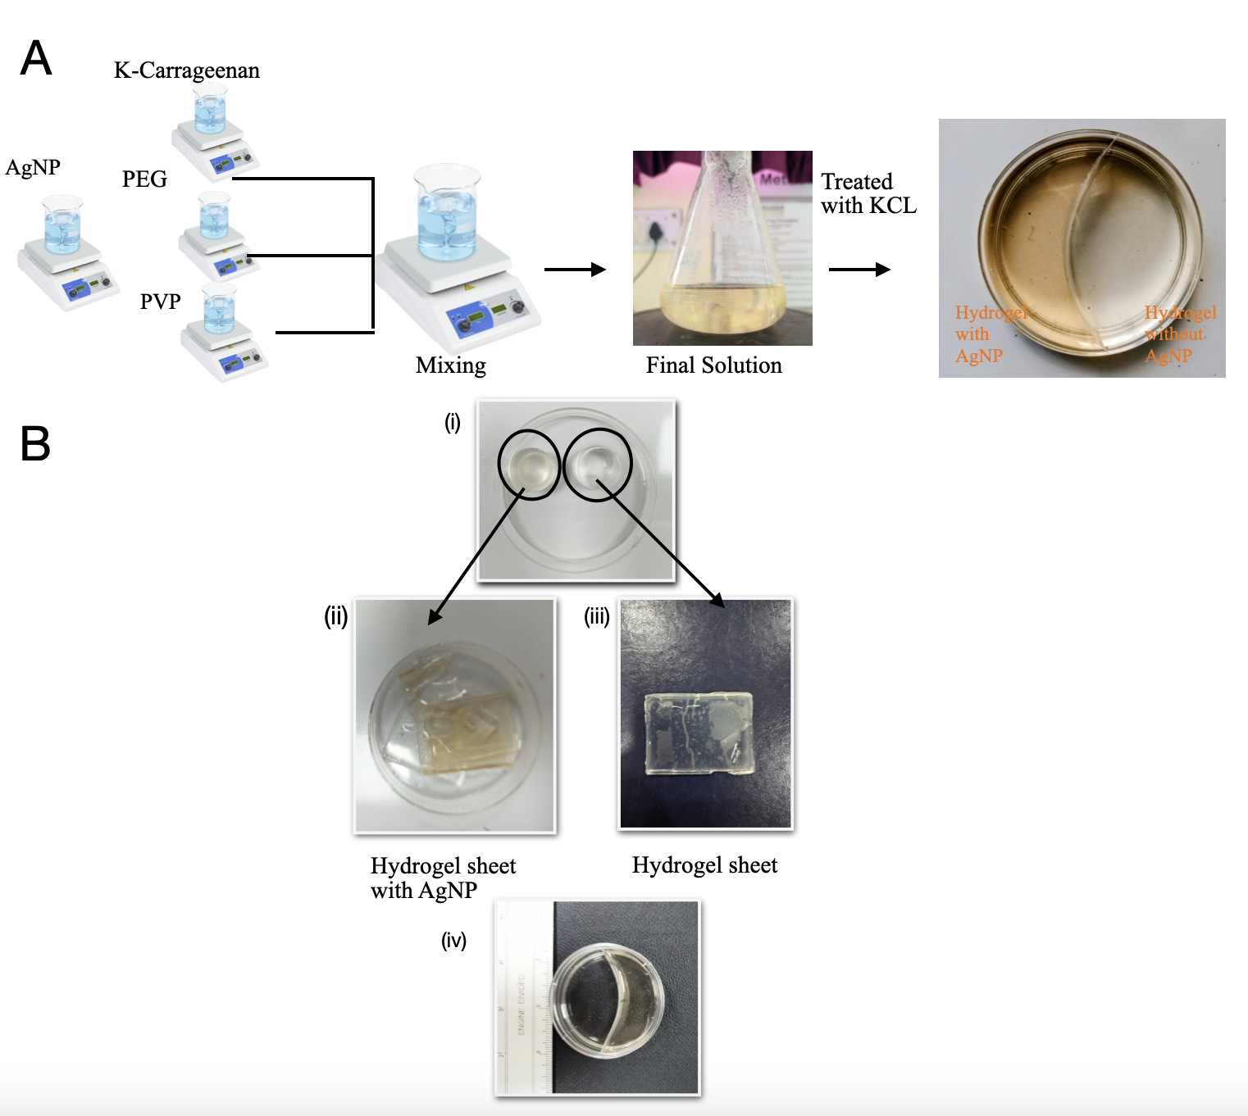

Figure 1. Antimicrobial hydrogel preparation; (A) representing the fabrication of AgNPs (10 ppm) impregnated clinically relevant tri-polymeric hydrogel composed of k-carrageenan, polyethylene glycol and polyvinylpyrrolidone (PVP) (k-C-PEG-PVP), including the cross-linking mechanism in presence of potassium chloride (KCl) and its envisioned application for the treatment of contaminated atopic chronic wounds, (B) Images representing the impregnation of AgNPs into the hydrogel system. (ii) The brown-colored hydrogel blocks or sheets indicate successful incorporation of AgNPs, (iii) whereas the transparent hydrogels serve as the control and (iv) shows biphasic hydrogel system consisting of one half Containing hydrogel and other half have AgNP incorporated hydrogel.

3.2 Preparation of AgNPs Impregnated-Hydrogel
To assess whether the antifungal activity of AgNPs was retained after incorporation into a polymeric matrix, the nanoparticles were embedded within a clinically relevant κ-carrageenan (k-C)/polyethylene glycol (PEG)/polyvinylpyrrolidone (PVP) hydrogel system with potential applications in wound healing. For this purpose, a tri-polymeric hydrogel composed of k-C, PEG, and PVP was fabricated, and AgNPs were incorporated during the hydrogel preparation process. The resulting hydrogel was transparent and exhibited a light brown coloration, indicating the successful incorporation of AgNPs into the polymeric network (Figure 1B). The AgNP-loaded hydrogel was subsequently evaluated using two different approaches to investigate its antifungal efficacy: (i) treatment of contaminated wound models and (ii) prevention of fungal colonization and growth.

3.2.1 Treatment of Contaminated Wound Approach
For this purpose, a uniform fungal lawn of Aspergillus niger was first established on the surface of solidified agar plates to simulate a contaminated wound environment. AgNP-impregnated hydrogel sheets were then carefully placed onto the inoculated agar surface. A distinct zone of inhibition was observed at the interface between the agar medium and the AgNP-loaded hydrogel sheets (left), indicating effective suppression of fungal growth. In contrast, substantial fungal growth was observed beneath and around the control hydrogel sheets lacking AgNPs (right), confirming the absence of antifungal activity in the control system (Figure 2A).
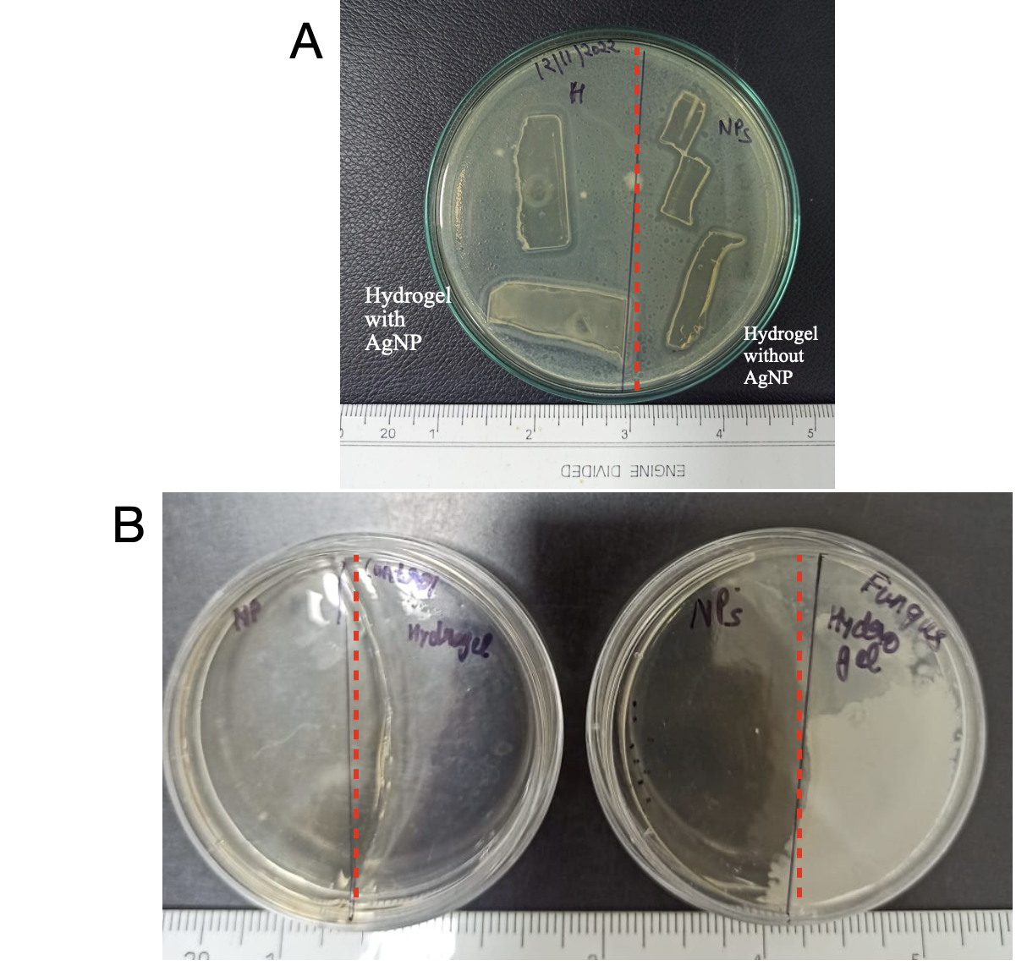

Figure 2. Evaluation of the Antifungal Activity of AgNP-Loaded Hydrogels Using Therapeutic and Preventive Models. (A) Treatment of contaminated wound approach; representation of a simulated contaminated wound, where an agar plate with bacteria spread onto its surface acts as a contaminated wound bed, and the application of AgNP-impregnated hydrogel represents the treatment, and image showing successful killing of A. Niger following the treatment with AgNPs impregnated hydrogel system. (B) The Preventive Approach; representing the preparation of a seamless biphasic hydrogel plate, where one half contains AgNPs, simulating a fresh wound bed protected by the antimicrobial hydrogel layer, and figure showing the biphasic hydrogel (a) the biphasic hydrogel plate, where the AgNP-containing region (left) exhibits a characteristic brown coloration, indicating successful nanoparticle incorporation, and (b) fungal growth occurring exclusively on the control region (right), whereas no fungal colonization is observed on the AgNP-loaded hydrogel, confirming its preventive antifungal efficacy.

3.2.2 The Preventive Approach
To simulate a freshly formed wound susceptible to microbial contamination, a seamless biphasic nutrient-rich hydrogel plate was fabricated, with one half (50%) impregnated with AgNPs and the other half serving as the control. A suspension of Aspergillus niger was then uniformly spread across the entire hydrogel surface. Following incubation, no fungal growth was observed on the AgNP-loaded region of the hydrogel, whereas the control region exhibited extensive fungal colonization and was completely covered by fungal growth (Figure 2B). These findings demonstrate the effective preventive antifungal activity of the AgNP-impregnated hydrogel against A. niger.

4. DISCUSSIONS
Antimicrobial resistance (AMR) has emerged as a major global healthcare challenge, largely driven by the excessive and inappropriate use of antibiotics. One promising strategy to mitigate this issue is the development of alternative antimicrobial agents, such as silver nanoparticles (AgNPs), which exhibit broad-spectrum antibacterial activity while reducing dependence on conventional antibiotics. Although AgNPs can be applied directly in solution form, the present study focused on their incorporation into a biopolymeric hydrogel matrix to develop an effective antimicrobial wound dressing for the management of atopic, chronic, and infected wounds.
To verify the retention of antifungal efficacy within a three-dimensional polymeric network, AgNPs were incorporated into a di-polymeric hydrogel composed of polyethylene glycol (PEG) and carrageenan. Both polymers are extensively studied, biocompatible, FDA-approved materials widely utilized in biomedical applications due to their non-toxic nature and favorable physicochemical properties. The antimicrobial performance of the AgNP-loaded hydrogel was assessed using two different approaches: treatment of contaminated wounds and prevention of wound contamination. In the treatment model, agar plates were used to simulate wound beds, while fungal growth on the agar surface represented an infected wound environment. Application of the AgNP-impregnated hydrogel resulted in significant fungal inhibition, indicating its effectiveness in treating contaminated wounds. In the preventive model, AgNPs were incorporated into a nutrient-rich hydrogel system prior to fungal inoculation, thereby simulating a wound dressing containing embedded antimicrobial agents. The complete absence of fungal growth on the AgNP-loaded hydrogel confirmed the sustained antifungal activity of the nanoparticles and highlighted the hydrogel's potential to prevent microbial colonization and infection.
Since the principal aim of this study was to develop AgNP-based antimicrobial materials, the synthesis conditions and nanoparticle concentration were optimized primarily based on antibacterial performance. Consequently, this work focused on the AgNPs successful incorporation into a clinically relevant hydrogel system intended for atopic wound-healing applications. While the current study established the antimicrobial efficacy of the developed hydrogel, comprehensive characterization of the final formulation—including rheological and mechanical properties, swelling behavior, water absorption capacity, biodegradation profile, and in vitro biocompatibility—will be the subject of future investigations to further validate its suitability for biomedical and wound-care applications.
5. CONCLUSION
A silver nanoparticle (AgNP)-loaded hydrogel system was successfully developed and evaluated for both therapeutic and preventive wound-healing applications. These findings indicate that the AgNPs retained their antifungal efficacy even after incorporation into the hydrogel matrix, highlighting the potential of such hydrogel systems as antimicrobial wound dressings. The antifungal activity observed in this study is consistent with previous reports demonstrating the broad-spectrum antimicrobial properties of AgNPs, including their effectiveness against fungal pathogens such as A. niger. Therefore, the developed AgNP-loaded hydrogel represents a promising platform for the prevention and treatment of fungal infections in wound-healing applications.

CONFLICTS OF INTEREST
There are no conflicts to declare

REFERENCES:

Ahmed, E. M. (2015). Hydrogel: Preparation, characterization, and applications: A review. Journal of Advanced Research, 6(2), 105–121. https://doi.org/10.1016/j.jare.2013.07.006

Ahmed, S., Ahmad, M., Swami, B. L., & Ikram, S. (2016). A review on plants extract mediated synthesis of silver nanoparticles for antimicrobial applications: A green expertise. Journal of Advanced Research, 7(1), 17–28. https://doi.org/10.1016/j.jare.2015.02.007

Benali, F., Boukoussa, B., Issam, I., Iqbal, J., Mokhtar, A., Hachemaoui, M., Habeche, F., Hacini, S., & Abboud, M. (2023). Zinc nanoparticles encapsulated in porous biopolymer beads for
reduction of water pollutants and antimicrobial activity. International Journal of Biological Macromolecules, 248(125832), 125832. https://doi.org/10.1016/j.ijbiomac.2023.125832

Bhatia, S., & Bhatia, S. (2016). Natural polymers vs synthetic polymer. Natural polymer drug delivery systems: nanoparticles, plants, and algae. 95–118.

Campo, V. L., Kawano, D. F., Da Silva, D. B., Jr, & Carvalho, I. (2009). Carrageenans: Biological properties, chemical modifications and structural analysis-A review. Carbohydrate polymers. 77, 167–180.

Cohen, S. M., & Ito, N. (2002). A critical review of the toxicological effects of carrageenan and processed eucheuma seaweed on the gastrointestinal tract. Critical Reviews in Toxicology, 32(5), 413–444. https://doi.org/10.1080/20024091064282

De Silva, D. A., Hettiarachchi, B. U., Nayanajith, L. D. C., Milani, M. D. Y., & Motha, J. T. S. (2011). Development of a PVP/kappa-carrageenan/PEG hydrogel dressing for wound healing applications in Sri Lanka. Journal of the National Science Foundation of Sri Lanka, 39(1), 25. https://doi.org/10.4038/jnsfsr.v39i1.2920

Dreiss, C. A. (2020). Hydrogel design strategies for drug delivery. Current Opinion in Colloid & Interface Science, 48, 1–17. https://doi.org/10.1016/j.cocis.2020.02.001

Durán, N., Durán, M., de Jesus, M. B., Seabra, A. B., Fávaro, W. J., & Nakazato, G. (2016). Silver nanoparticles: A new view on mechanistic aspects on antimicrobial activity. Nanomedicine: Nanotechnology, Biology, and Medicine, 12(3), 789–799. https://doi.org/10.1016/j.nano.2015.11.016

Frediansyah, A. (2021). The antiviral activity of iota-, kappa-, and lambda-carrageenan against COVID-19: A critical review. Clinical Epidemiology and Global Health, 12(100826), 100826. https://doi.org/10.1016/j.cegh.2021.100826
Hoffman, A. S. (n.d.). Hydrogels for biomedical applications. Advanced Drug Delivery Reviews 2012, 64, 18–23.

Iravani, S., Korbekandi, H., Mirmohammadi, S. V., & Zolfaghari, B. (2014). Synthesis of silver nanoparticles: chemical, physical and biological methods. Research in Pharmaceutical Sciences, 9(6), 385–406.

Jeevanandam, J., Barhoum, A., Chan, Y. S., Dufresne, A., & Danquah, M. K. (2018). Review on nanoparticles and nanostructured materials: history, sources, toxicity and regulations. Beilstein Journal of Nanotechnology, 9, 1050–1074. https://doi.org/10.3762/bjnano.9.98

Khan, I., Saeed, K., & Khan, I. (2019). Nanoparticles: Properties, applications and toxicities. Arabian Journal of Chemistry, 12(7), 908–931. https://doi.org/10.1016/j.arabjc.2017.05.011

Li, J., & Mooney, D. J. (2016). Designing hydrogels for controlled drug delivery. Nature Reviews. Materials, 1(12), 16071. https://doi.org/10.1038/natrevmats.2016.71

Meran, Z., Besinis, A., De Peralta, T., & Handy, R. D. (2018). Antifungal properties and biocompatibility of silver nanoparticle coatings on silicone maxillofacial prostheses in vitro. Journal of Biomedical Materials Research. Part B, Applied Biomaterials, 106(3), 1038–1051. https://doi.org/10.1002/jbm.b.33917

Mourdikoudis, S., Biophysics Group, Department of Physics and Astronomy, University College London, London, WC1E 6BT, UK. ntk. thanh@ucl. ac. uk, Pallares, R. M., & Thanh, N. T. K. (2018). Characterization techniques for nanoparticles: comparison and complementarity upon studying nanoparticle properties. Nanoscale, 10(27), 12871–12934. https://doi.org/10.1039/c8nr02278j

Nuss, K. M., & Von Rechenberg, B. (2008). Biocompatibility issues with modern implants in bone-a review for clinical orthopedics. The open orthopaedics journal. 2.

Pavlovic, M., & Pavlovic, M. (2015). What are biomaterials? Bioengineering: A Conceptual Approach. 229–244.
Peppas, N. A., Hilt, J. Z., Khademhosseini, A., & Langer, R. (2006). Hydrogels in biology and medicine: From molecular principles to bionanotechnology. Advanced Materials (Deerfield Beach, Fla.), 18(11), 1345–1360. https://doi.org/10.1002/adma.200501612

Pereira, J. S., & Faria, R. X. (2024). Molecular aspects of carrageenan in the pharmaceutical and food industries. Current Nutrition and Food Science, 20(4), 466–475. https://doi.org/10.2174/1573401319666230418123401

Pişkin, E. (1997). Biomaterials in different forms for tissue engineering: an overview, Materials science forum. Trans Tech Publ, 1–14.

Rai, M., Yadav, A., & Gade, A. (2009). Silver nanoparticles as a new generation of antimicrobials. Biotechnology Advances, 27(1), 76–83. https://doi.org/10.1016/j.biotechadv.2008.09.002

Ross-Murphy, S. B., & McEvoy, H. (1986). Fundamentals of hydrogels and gelation. British Polymer Journal, 18(1), 2–7. https://doi.org/10.1002/pi.4980180103

Satchanska, G., Davidova, S., & Petrov, P. D. (2024). Natural and synthetic polymers for biomedical and environmental applications. Polymers, 16(8), 1159. https://doi.org/10.3390/polym16081159

Shnoudeh, A. J., Hamad, I., Abdo, R. W., Qadumii, L., Jaber, A. Y., Surchi, H. S., & Alkelany, S. Z. (2019). Synthesis, characterization, and applications of metal nanoparticles. In Biomaterials and Bionanotechnology (pp. 527–612). Elsevier.

Wang, Z., Ye, Q., Yu, S., & Akhavan, B. (2023). Poly ethylene glycol (PEG)-based hydrogels for drug delivery in cancer therapy: A comprehensive review. Advanced Healthcare Materials, 12(18), e2300105. https://doi.org/10.1002/adhm.202300105

Wasilewska, A., Klekotka, U., Zambrzycka, M., Zambrowski, G., Święcicka, I., & Kalska-Szostko, B. (2023). Physico-chemical properties and antimicrobial activity of silver nanoparticles fabricated by green synthesis. Food Chemistry, 400(133960), 133960. https://doi.org/10.1016/j.foodchem.2022.133960

Yermak, I. M., Barabanova, A. O., Aminin, D. L., Davydova, V. N., Sokolova, E. V., Solov’eva, T. F., Kim, Y. H., & Shin, K. S. (2012). Effects of structural peculiarities of carrageenans on their immunomodulatory and anticoagulant activities. Carbohydrate Polymers, 87(1), 713–720. https://doi.org/10.1016/j.carbpol.2011.08.053

Zhao, L., Zhou, Y., Zhang, J., Liang, H., Chen, X., & Tan, H. (2023). Natural polymer-based hydrogels: From polymer to biomedical applications. Pharmaceutics, 15(10), 2514. https://doi.org/10.3390/pharmaceutics15102514

