Review Article
Biodegradation of Nitroaromatic Compounds by Alkaliphilic Bacteria: Mechanisms, Applications, and Future Perspectives.

ABSTRACT
Nitroaromatic compounds are extensively utilized in various industries; however, their toxic and persistent nature creates serious environmental and health concerns. Conventional treatment methods are frequently costly and may not provide complete pollutant removal. This review discusses the potential application of alkaliphilic bacteria—microorganisms that thrive in high pH environments and can degrade these pollutants. The paper summarizes the classification and characteristics of alkaliphilic bacteria, describes the enzymatic mechanisms involved in nitroaromatic reduction, and highlights recent research findings from laboratory and field studies. Key applications in environmental bioremediation are highlighted. Current challenges, such as slow degradation rates and limited genetic understanding, are also discussed. The review concludes that alkaliphilic bacteria offer a promising, eco-friendly solution for treating nitroaromatic-contaminated sites adapted to alkaline environments in which many ordinary microorganisms fail to survive.
Keywords: Nitroaromatic compounds; alkaliphilic bacteria; biodegradation; nitro reductase enzymes; environmental remediation; extremophiles.

1. INTRODUCTION
Nitroaromatic compounds are a class of man-made organic compounds containing one or more nitro functional groups (–NO₂) attached to an aromatic ring (J. C. Spain,1995). These chemicals are widely utilized in the production of pesticides, explosives, dyes, pharmaceuticals, and industrial solvents (Spain J. C, 2000). Common examples include nitrobenzene, dinitrotoluene, trinitrophenol (picric acid), and nitroanilines. While useful in industry, these substances are toxic, mutagenic, and often carcinogenic to living organisms (La & Froines, 1993; Miliukiene & Cenas, 2008).
Discharge of these compounds through industrial waste, agricultural runoff, or improper disposal practices leads to environmental contamination (J. C. Spain, 1995). Their strong electron-withdrawing nitro groups make them resistant to natural breakdown by sunlight, air, or common microbes (Crawford, 1995). As a result, they persist in ecosystems for years, posing long-term risks to human health and wildlife.
Conventional techniques used for pollutant removal include incineration, chemical oxidation, and adsorption onto activated carbon. However, such treatment methods are expensive and may generate secondary pollutants (Kulkarni & Chaudhari, 2007; Leitão, A. L. et al., 2007). In recent years, researchers have increasingly focused on bioremediation—using living organisms to clean up pollution—as a more sustainable alternative. Among the most promising candidates are alkaliphilic bacteria, which grow optimally at pH 9 or above.
This review aims to summarize the role of alkaliphilic bacteria in nitroaromatic compound degradation. The paper discusses the basic concepts, mechanisms, recent advances, practical applications, and future research needs in this emerging field.

2. LITERATURE REVIEW
2.1 Basic Concept and Classification of Nitroaromatic Compounds
Nitroaromatic compounds are considered major environmental contaminants because of their toxic and persistent properties and potential mutagenic effects. These pollutants are frequently discharged from industrial activities such as dye manufacturing, pesticides, and explosives. Nitroaromatic compounds are classified based on the number and position of nitro groups attached to the aromatic ring, (P. Ju & R. E. Parales, 2010; Maier, R. M., et al., 2009). as well as the presence of other substituents such as amino, hydroxyl, or chloro groups. Mono-nitroaromatic compounds contain a single nitro group (e.g., nitrobenzene, 4-nitroaniline), whereas dinitroaromatic compounds possess two nitro groups (e.g., 2,4-dinitrotoluene). Trinitroaromatic compounds contain three nitro groups, such as 2,4,6-trinitrotoluene (TNT).
Besides nitro substituents, these compounds may also contain additional functional groups like methyl, chloro, or amino groups, that can alter their chemical behaviour and biodegradation characteristics (Higson, 1992; Medić, A., et al., 2020). These compounds are associated with environmental pollution because of their persistence and toxic effects. They are commonly released from industries such as dye manufacturing, pesticides, and explosives.
2.2 Alkaliphilic Bacteria: Characteristics and Adaptations
Alkaliphilic bacteria are microorganisms adapted to survive and grow efficiently under alkaline pH conditionsnranging from 9 to 11 (M. T. Madigan et al., 2018). They are commonly found in alkaline environments such as soda lakes, alkaline deserts, and industrial alkaline wastewater (Tambekar et al., 2012; Birhanu & Amare, 2017). Compared to neutrophilic bacteria, alkaliphiles exhibit enhanced stability and metabolic activity under high pH conditions.
These microorganisms possess specialized physiological and cellular adaptations that enable them to survive in high pH conditions. For instance, their specialized cell membrane systems help maintain intracellular pH near neutrality despite the external alkaline environment (M. T. Madigan et al., 2018). Additionally, alkaliphilic bacteria produce a variety of extracellular enzymes, including proteases, cellulases, and lignin-degrading enzymes, which remain active and stable under alkaline conditions (Jameel & Khan, 2011; Sharma, 2016). Alkaliphilic bacteria degrade nitroaromatic compounds through enzymatic pathways involving reduction, oxidation, and aromatic ring-cleavage mechanisms. Key enzymes such as nitroreductases and dioxygenases are important in initiating and maintaining biodegradation pathways.
Several genera of Several studies have identified alkaliphilic bacterial species to degrade aromatic pollutants. These include Bacillus, Pseudomonas, Stenotrophomonas, Halomonas, and Dietzia (Yumoto et al., 2002; García et al., 2004; Urszula et al., 2009). Their ability to function efficiently under extreme which increases their suitability for bioremediation applications of industrial effluents that are both alkaline and contaminated with toxic organic compounds (B. E. Rittmann & P. L. McCarty, 2001; Halls & Alexander 1983). Therefore, alkaliphilic bacteria are regarded as effective microorganisms for the bioremediation of alkaline industrial wastewater.
2.3 Mechanisms of Nitroaromatic compound Biodegradation
The degradation of nitroaromatic compounds by bacteria involves two major strategies: reductive transformation of the nitro group followed by oxidative aromatic ring cleavage (Spain, 1995).
2.3.1 Nitroreductase Enzymes
Most alkaliphilic bacteria reduce nitroaromatics using flavin-dependent nitroreductases enzymes. These enzymes catalyze the transfer of two electrons to the nitro group, converting it to a nitroso intermediate, then to a hydroxylamine, and finally to an amine (Bryant & DeLuca, 1991; Nivinskas et al., 2001). These reactions are typically mediated by oxygen-insensitive nitroreductases under oxygen-limited or anaerobic environments (Ju & Parales, 2010). In some cases, partial reduction may result in the generation of intermediate compounds that may exhibit toxicity that require further enzymatic degradation.
The general reaction is:
R–NO₂ + 2NAD(P)H + 2H⁺ → R–NH₂ + 2NAD(P)⁺ + H₂O

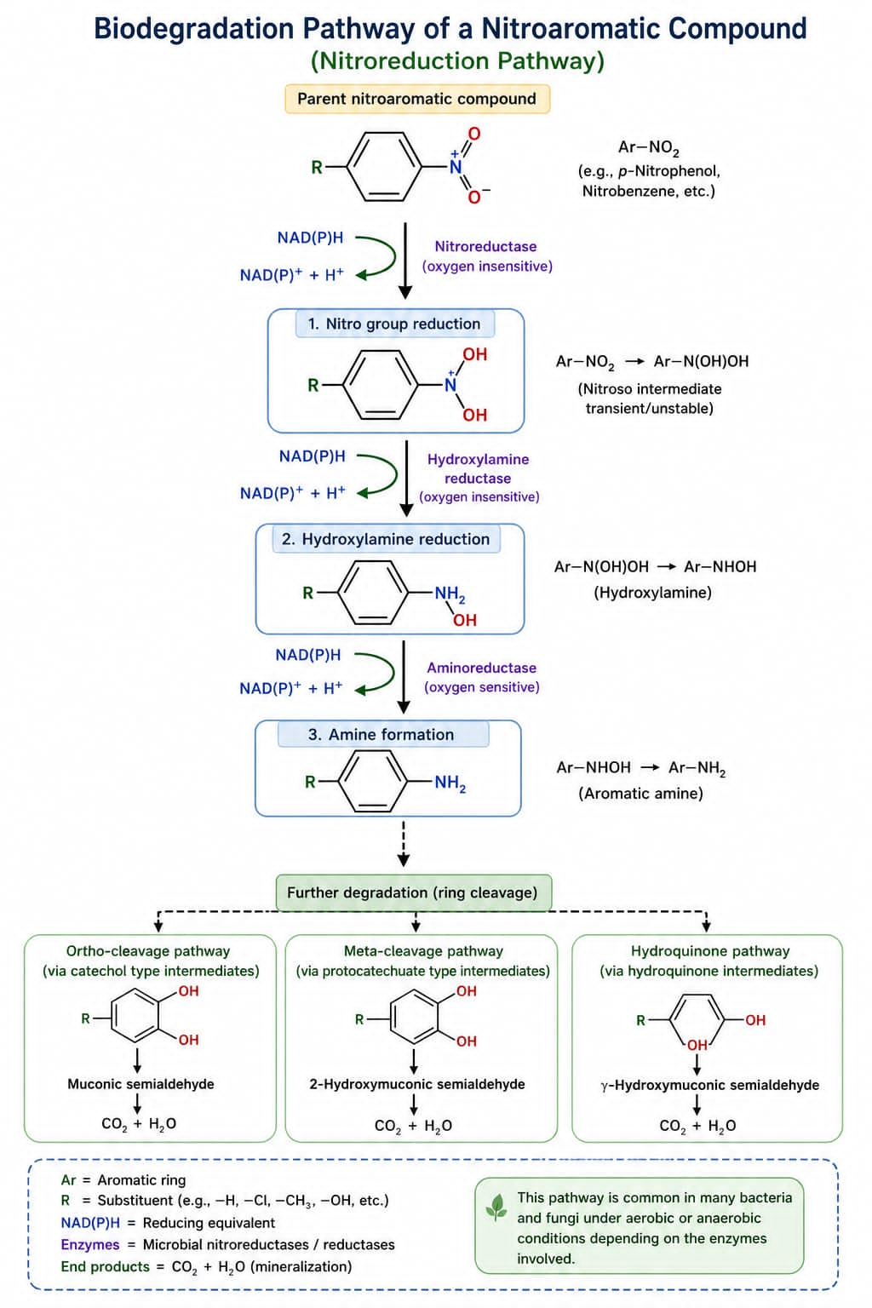
Figure 1: Enzymatic biodegradation pathway of nitroaromatic compounds showing nitroreduction (–NO₂ to –NH₂) followed by aromatic ring cleavage.
The resulting aromatic amine intermediates are comparatively less toxic and can be further degraded by microbial enzymes (Soojhawon et al., 2005). Some bacteria can use the nitro group as a nitrogen source, allowing them to grow on nitroaromatic compounds as their sole source of nitrogen (Bruhn et al., 1987; Pacheco, A. D. O et al., 2007).

2.3.2 Ring Cleavage Pathways
After nitro group reduction, the aromatic ring must be opened for complete mineralization. Two major pathways exist. In the ortho-cleavage pathway, catechol 1,2-dioxygenase breaks the ring between the two hydroxyl groups, producing cis,cis-muconic acid (Harayama & Rekik, 1989; Silva et al., 2012). In the meta-cleavage pathway, catechol 2,3-dioxygenase opens the ring next to the hydroxyl groups, yielding 2-hydroxymuconic semialdehyde (Hassan et al., 2014). Both pathways ultimately feed into central metabolism, ultimately producing carbon dioxide and water (Alexander, 1999).

2.3.3 Formation of Meisenheimer Complexes
Some bacteria degrade highly nitrated compounds like picric acid via the generation of a hydride-Meisenheimer intermediate complex During this mechanism, a hydride ion supplied by NADPH binds to the aromatic ring forming a stable intermediate that is then reduced and ring-cleaved (Rieger et al., 1999; Haigler & Spain 1991). This pathway is particularly important for the degradation of highly nitrated compounds such as trinitrophenol picric acid (Spain, 1995).

2.4 Recent Research Findings
Recent molecular and biochemical investigations have expanded current knowledge regarding nitroaromatic biodegradation mechanisms. Numerous studies conducted in recent decades have reported the capability of alkaliphilic bacteria to degrade different nitroaromatic pollutants.
Rafii et al., (1991) showed that anaerobic bacteria from the human gut could reduce nitroaromatics, but the rates were slow. Later, (Qureshi et al., 2007) isolated a Stenotrophomonas strain from contaminated soil that completely degraded 4-nitroaniline within 72 hours under aerobic conditions. Similarly, (Khan et al., 2013) reported a Pseudomonas strain that used N-methyl-4-nitroaniline as the only source of carbon and nitrogen for growth. (Iwaki and Hasegawa 2007) characterized a Burkholderia strain that degraded 2-nitrobenzoate via a novel pathway involving a nitroreductase and a mutase enzyme. This research contributed important information regarding the genetic mechanisms involved in nitroaromatic metabolism.
These observations improve current understanding of microbial pathways involved in nitroaromatic degradation (Spain, 1995).
More recently, Jadhav and Sarwade (2021) demonstrated that an alkaliphilic Pseudomonas strain could decolorize and detoxify azo dyes containing nitro groups. Medic et al., (2020) showed that extremophilic Pseudomonas aeruginosa could degrade both petroleum hydrocarbons and nitroaromatics, indicating their usefulness in the bioremediation of mixed industrial pollutants. These results demonstrate the effectiveness of alkaliphilic bacteria as effective agents for the biodegradation of nitroaromatic pollutants in diverse environmental conditions (Rittmann & McCarty, 2001).

2.5 Applications in Environmental Microbiology
The primary application of alkaliphilic bacteria in nitroaromatic degradation is the bioremediation of contaminated industrial sites. For example, textile and dyeing effluents are often highly alkaline and contain nitroanilines and nitrophenols (Grekova-Vasileva & Topalova, 2009). Alkaliphilic bacteria can be added to treatment ponds or bioreactors to to degrade and detoxify these contaminants. This method improves the overall performance of wastewater treatment processes under alkaline conditions (B. E. Rittmann & P. L. McCarty, 2001).
Another promising application is the in-situ bioremediation of explosive-contaminated soils. TNT and its transformation products are common pollutants at military training grounds and munitions factories. While earlier research mainly concentrated on neutral-pH microorganisms there is growing interest in alkaliphilic strains for treating lime-stabilized or alkaline soils (Spanggord et al., 1991; Fathepure, 2014).

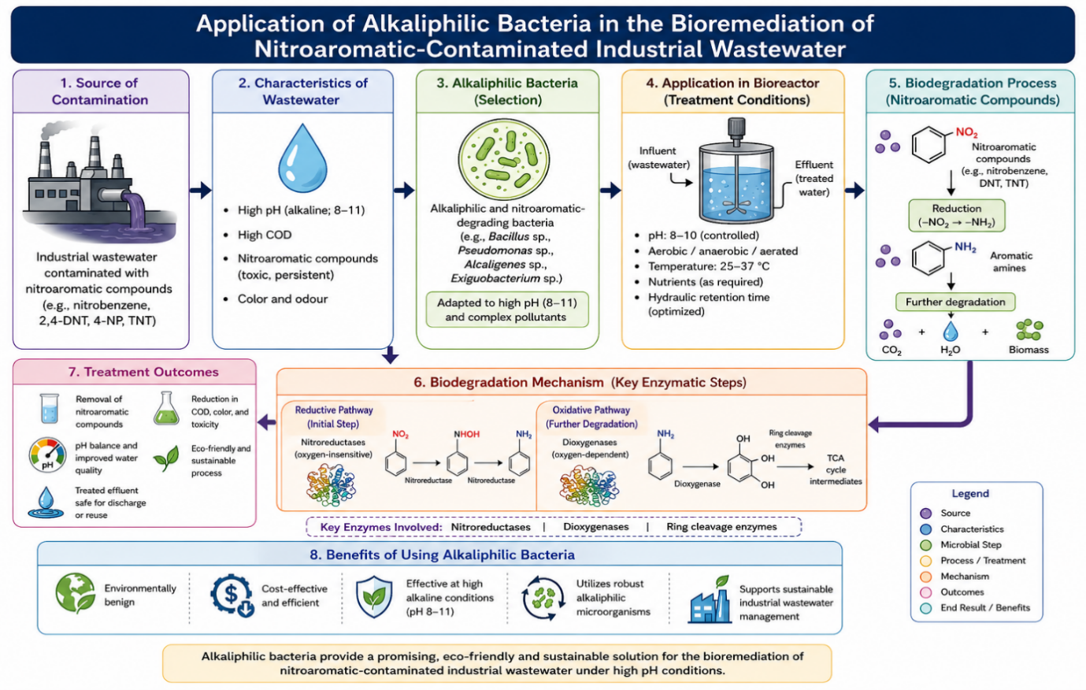
Figure 2: Application of alkaliphilic bacteria in the bioremediation of nitroaromatic-contaminated industrial wastewater.

2.6 Current Challenges and Limitations
Despite their significant potential, several challenges limit the widespread application of alkaliphilic bacteria in nitroaromatic degradation (M. J. S. Alexander, 1999).
First, degradation rates are often slow compared to chemical methods. Many bacteria require days or weeks to completely mineralize even simple nitroaromatics (Marvin-Sikkema & de Bont, 1994). Second, some nitroaromatic compounds, especially those with multiple nitro groups, are highly toxic to bacteria themselves, inhibiting growth and enzyme activity (Terada, 1981). Third, the genetic and biochemical knowledge of alkaliphilic degraders is still limited. Most research has focused on neutral-pH bacteria such as Pseudomonas and Rhodococcus, leaving a gap in our understanding of alkaliphilic systems (de Oliveira et al., 2010).
Industrial wastewater often contains complex mixtures of contaminants such as heavy metals, solvents, and salts that may negatively affect bacterial growth and biodegradation efficiency (Zhu et al., 2017; Gilcrease & Murphy 1995). These challenges indicate the necessity for advanced research and improved technologies to enhance the effectiveness and large-scale use of alkaliphilic bacteria in environmental remediation (B. E. Rittmann & P. L. McCarty, 2001).

2.7 Future Scope and Research Gaps
Further investigations are required to improve the practical application of alkaliphilic bacteria in bioremediation. First, more studies are needed to identify and characterize novel alkaliphilic strains that can degrade diverse nitroaromatic pollutants. especially those with multiple substituents. Second, genomic and proteomic studies can identify the full set of enzymes involved and reveal how they are regulated (Cao et al., 2008). Third, genetic engineering could be used to enhance degradation rates and broaden substrate specificity. For example, genes encoding nitro reductases from one organism could be transferred into faster-growing alkaliphilic hosts.
Finally, field-scale studies are urgently needed. Most research to date has been conducted in the laboratory using pure cultures and simple media. Field-scale experiments and bioreactor studies are essential to evaluate the efficiency of these microorganisms under actual environmental conditions (Alexander, 1981; Razo-Flores et al., 1997). These studies may reduce current knowledge gaps and support the commercial application of alkaliphilic bacteria in bioremediation technologies (B. E. Rittmann & P. L. McCarty, 2001).

3. DISCUSSION
Previous studies indicate that alkaliphilic bacteria contain specialized enzymatic systems capable of degrading nitroaromatic pollutants (J. C. Spain, 1995). These microorganisms utilize diverse metabolic pathways, including nitroreduction and subsequent aromatic ring cleavage, to convert toxic intermediates into comparatively safer compounds.
Comparative analysis of earlier studies reveals several significant findings regarding biodegradation mechanisms. First, the degradation pathways vary significantly among bacterial strains. While some organisms reduce the nitro group prior to ring cleavage, others may directly attack the aromatic ring. This metabolic diversity is both an advantage and a challenge, as it allows different strains to degrade a wide range of pollutants but complicates the development of universal treatment strategies.
Second, a considerable difference is often observed between laboratory efficiency and field-level performance. Many strains that show efficient degradation under controlled laboratory conditions often perform poorly in real environmental because of environmental factors such as inhibitory substances, unstable pH conditions, and mixed contaminants. This highlights the challenges in scaling up laboratory findings to real-world environmental applications (M. J. S. Alexander, 1999).
Third, the role of oxygen is critical in determining the degradation pathway. Many nitroreductases are oxygen-insensitive and can function under both aerobic and anaerobic conditions (K. S. Ju & R. E. Parales, 2010). However, ring-cleavage enzymes often require molecular oxygen, suggesting that a combination of anaerobic and aerobic stages may be optimal for complete mineralization.
Overall, alkaliphilic bacteria represent a promising and sustainable approach for the biodegradation of nitroaromatic pollutants. However, further research is required to optimize their efficiency, understand their genetic and metabolic pathways, and improve their large-scale application in environmental bioremediation (B. E. Rittmann & P. L. McCarty, 2001).

4. CONCLUSION
Nitroaromatic pollutants are persistent toxic compounds that can adversely affect environmental and human health. This review emphasizes the role of alkaliphilic bacteria in the biodegradation of nitroaromatic contaminants through various enzymatic pathways such as nitroreduction and aromatic ring cleavage (J. C. Spain, 1995).
The ability of these microorganisms to survive in alkaline environments makes them useful for treating alkaline industrial wastewater. Despite their advantages, certain limitations such as reduced degradation efficiency, toxic intermediates, and insufficient genetic information still require further investigation (M. J. S. Alexander, 1999).
Future research focusing on genetic engineering, metabolic pathway optimization, and field-scale validation will be essential to fully exploit the potential of alkaliphilic bacteria in environmental bioremediation (B. E. Rittmann & P. L. McCarty, 2001).
Overall, alkaliphilic bacteria offer an eco-friendly, efficient, and sustainable solution for the remediation of nitroaromatic-contaminated environments.

5. REFERENCES
- Alexander, M. (1981). Biodegradation of chemicals of environmental concern. Science, 211(4478), 132–138.
- Alexander, M. (1999). Biodegradation and Bioremediation (2nd ed.). Academic Press.
- Birhanu, M. K., & Amare, G. (2017). Cyanide degrading alkaliphilic bacteria from Rift Valley soda lakes and their potential for bioremediation. Ecosystems & Ecography, 7(2). https://doi.org/10.4172/2157-7625-C1-030
- Bruhn, C., Lenke, H., & Knackmuss, H. J. (1987). Nitrosubstituted aromatic compounds as nitrogen source for bacteria. Applied and Environmental Microbiology, 53(1), 208–210.
- Bryant, C., & DeLuca, M. (1991). Purification and characterization of an oxygen-insensitive NAD(P)H nitroreductase from Enterobacter cloacae. Journal of Biological Chemistry, 266(7), 4119–4125.
- Cao, B., Geng, A., & Loh, K. C. (2008). Induction of ortho- and meta-cleavage pathways in Pseudomonas in biodegradation of high benzoate concentration. Applied Microbiology and Biotechnology, 81(1), 99–107.
- Crawford, R. L. (1995). The microbiology and treatment of nitroaromatic compounds. Current Opinion in Biotechnology, 6(3), 329–336.
- De Oliveira, I. M., Bonatto, D., & Henriques, J. A. P. (2010). Nitroreductases: Enzymes with environmental, biotechnological and clinical importance. Current Research, Technology and Education Topics in Applied Microbiology and Microbial Biotechnology, 2(1), 1008–1019.
- Fathepure, B. Z. (2014). Recent studies in microbial degradation of petroleum hydrocarbons in hypersaline environments. Frontiers in Microbiology, 5, 173.
- García, M. T., Mellado, E., Ostos, J. C., & Ventosa, A. (2004). Halomonas organivorans sp. nov., a moderate halophile able to degrade aromatic compounds. International Journal of Systematic and Evolutionary Microbiology, 54(5), 1723–1728.
- Gilcrease, P. C., & Murphy, V. G. (1995). Bioconversion of 2,4-diamino-6-nitrotoluene to a novel metabolite under anoxic and aerobic conditions. Applied and Environmental Microbiology, 61(12), 4209–4214.
- Grekova-Vasileva, M., & Topalova, Y. (2009). Enzyme activities and shifts in microbial populations associated with activated sludge treatment of textile effluents. Biotechnology & Biotechnological Equipment, 23(1), 1136–1142.
- Haigler, B. E., & Spain, J. C. (1991). Biotransformation of nitrobenzene by bacteria containing toluene degradative pathways. Applied and Environmental Microbiology, 57(11), 3156–3162.
- Halls, L. E., & Alexander, M. (1983). Microbial transformation of nitroaromatic compounds in sewage effluent. Applied and Environmental Microbiology, 45(4), 1234–1241.
- Harayama, S., & Rekik, M. (1989). Bacterial aromatic ring-cleavage enzymes are classified into two different gene families. Journal of Biological Chemistry, 264(26), 15328–15333.
- Hassan, H. A., Eldein, A. B. A. Z., & Rizk, N. M. (2014). Cloning and kinetic properties of catechol 2,3-dioxygenase from novel alkaliphilic BTEX-degrading Pseudomonas sp. HB01. Life Science Journal, 11(2), 376–384.
- Higson, F. K. (1992). Microbial degradation of nitroaromatic compounds. Advances in Applied Microbiology, 37, 1–19.
- Iwaki, H., & Hasegawa, Y. (2007). Degradation of 2-nitrobenzoate by Burkholderia terrae strain KU-15. Bioscience, Biotechnology, and Biochemistry, 71(1), 145–151.
- Jadhav, B. D., & Sarwade, V. D. (2021). BIO-MINERALIZATION OF DISPERSE DYE AZO ORANGE-3 BY AN ALKALIPHILE PSEUDOMONAS DL 17. Journal of Advanced Scientific Research, 12(02 Suppl 2), 221-229.
- Jameel, A., & Khan, M. (2011). Production and characterization of alkaline protease from locally isolated alkaliphilic Bacillus species. International Journal of Engineering Science and Technology, 3(6), 4596–4603.
- Ju, K. S., & Parales, R. E. (2010). Nitroaromatic compounds, from synthesis to biodegradation. Microbiology and Molecular Biology Reviews, 74(2), 250–272.
- Khan, F., Vyas, B., Pal, D., & Cameotra, S. S. (2013). Aerobic degradation of N-methyl-4-nitroaniline (MNA) by Pseudomonas sp. strain FK357 isolated from soil. PLoS ONE, 8(10), e75046.
- Kulkarni, M., & Chaudhari, A. (2007). Microbial remediation of nitro-aromatic compounds: An overview. Journal of Environmental Management, 85(2), 496–512.
- La, D. K., & Froines, J. R. (1993). Comparison of DNA binding between the carcinogenic 2,6-dinitrotoluene and its noncarcinogenic analog 2,6-diaminotoluene. Mutation Research Letters, 301(2), 79–85.
- Leitão, A. L., Duarte, M. P., & Oliveira, J. S. (2007). Degradation of phenol by a halotolerant strain of Penicillium chrysogenum. International Biodeterioration & Biodegradation, 59(3), 220–225.
- Madigan, M. T., Bender, K. S., Buckley, D. H., Sattley, W. M., & Stahl, D. A. (2018). Brock Biology of Microorganisms (15th ed.). Pearson.
- Maier, R. M., Pepper, I. L., & Gerba, C. P. (2009). Environmental Microbiology (2nd ed.). Academic Press.
- Marvin-Sikkema, F. D., & de Bont, J. A. M. (1994). Degradation of nitroaromatic compounds by microorganisms. Applied Microbiology and Biotechnology, 42(4), 499–507.
- Medić, A., Lješević, M., Inui, H., Beškoski, V., Kojić, I., Stojanović, K., & Karadžić, I. (2020). Efficient biodegradation of petroleum n-alkanes and polycyclic aromatic hydrocarbons by extremophilic Pseudomonas aeruginosa with multidegradative capacity. RSC Advances, 10(24), 14060–14070.
- Miliukiene, V., & Cenas, N. (2008). Cytotoxicity of nitroaromatic explosives and their biodegradation products in mice splenocytes. Zeitschrift für Naturforschung C, 63(7–8), 519–525.
- Nivinskas, H., Koder, R. L., Anusevičius, Ž., Šarlauskas, J., Miller, A. F., & Narimantas, Č. (2001). Quantitative structure–activity relationships in two-electron reduction of nitroaromatic compounds. Archives of Biochemistry and Biophysics, 385(1), 170–178.
- Pacheco, A. D. O., Kagohara, E., Andrade, L. H., Comasseto, J. V., Crusius, I. H. S., Paula, C. R., & Porto, A. L. M. (2007). Biotransformations of nitro-aromatic compounds to amines and acetamides by tuberous roots. Enzyme and Microbial Technology, 42(1), 65–69.
- Qureshi, A., Verma, V., Kapley, A., & Purohit, H. J. (2007). Degradation of 4-nitroaniline by Stenotrophomonas strain HPC 135. International Biodeterioration & Biodegradation, 60(4), 215–218.
- Rafii, F., Franklin, W., & Heflich, R. H. (1991). Reduction of nitroaromatic compounds by anaerobic bacteria isolated from the human gastrointestinal tract. Applied and Environmental Microbiology, 57(4), 962–968.
- Razo-Flores, E., Donlon, B., Lettinga, G., & Field, J. A. (1997). Biotransformation and biodegradation of N-substituted aromatics in methanogenic granular sludge. FEMS Microbiology Reviews, 20(3–4), 525–538.
- Rieger, P. G., Sinnwell, V., Preuß, A., Francke, W., & Knackmuss, H. J. (1999). Hydride-Meisenheimer complex formation and protonation as key reactions of 2,4,6-trinitrophenol biodegradation by Rhodococcus erythropolis. Journal of Bacteriology, 181(4), 1189–1195.
- Rittmann, B. E., & McCarty, P. L. (2001). Environmental Biotechnology: Principles and Applications. McGraw-Hill.
- Sharma, S. (2016). Alkalophiles and industrial enzymes. International Research Journal of Engineering and Technology (IRJET), 3(4), 1260–1263.
- Silva, A. S., Camargo, F. A. O., Andreazza, R., Jacques, R. J. S., Baldoni, D. B., & Bento, F. M. (2012). Enzymatic activity of catechol 1,2-dioxygenase and catechol 2,3-dioxygenase produced by Gordonia polyisoprenivorans. Química Nova, 35, 1587–1592.
- Soojhawon, I., Lokhande, P. D., Kodam, K. M., & Gawai, K. R. (2005). Biotransformation of nitroaromatics and their effects on mixed function oxidase system. Enzyme and Microbial Technology, 37(5), 527–533.
- Spain, J. C. (1995). Biodegradation of nitroaromatic compounds. Annual Review of Microbiology, 49, 523–555.
- Spain, J. C., Hughes, J. B., & Knackmuss, H. J. (2000). Biodegradation of nitroaromatic compounds and explosives. CRC Press.
- Spanggord, R. J., Spain, J. C., Nishino, S. F., & Mortelmans, K. E. (1991). Biodegradation of 2,4-dinitrotoluene by a Pseudomonas sp. Applied and Environmental Microbiology, 57(11), 3200–3205.
- Tambekar, D. H., Dhundale, V. R., & Gulhane, S. R. (2012). Studies on alkaliphilic bacteria isolated from saline soil. Journal of Environmental Research and Development, 6(4), 933–939.
- Terada, H. (1981). The interaction of highly active uncouplers with mitochondria. Biochimica et Biophysica Acta (BBA) - Reviews on Bioenergetics, 639(3–4), 225–242.
- Urszula, G., Izabela, G., Danuta, W., & Sylwia, L. (2009). Isolation and characterization of a novel strain of Stenotrophomonas maltophilia possessing various dioxygenases. Brazilian Journal of Microbiology, 40, 285–291.
- Yumoto, I., Hirota, K., & Nakajima, K. (2002). Alkaliphilic bacteria and their industrial applications. Journal of Bioscience and Bioengineering, 94(6), 597–605
- Zhu, D., Zhang, P., Xie, C., Zhang, W., Sun, J., Qian, W. J., & Yang, B. (2017). Biodegradation of alkaline lignin by Bacillus ligniniphilus L1. Biotechnology for Biofuels, 10(1), 1–14.

