Original Research Article
Genetic transformation of purslane (Portulaca oleracea L.) plant by Ri plasmids isolated from Agrobacterium rhizogenes ATCC 15834

Abstract
This study achieved genetic transformation of purslane (Portulaca oleracea L.) plant used the direct injection technique with three concentrations of Ri (root induced) plasmids isolated from Agrobacterium rhizogenes ATCC 15834. Among the tested treatments, the concentration of 27.75 ng µl ⁻¹ was more effective than the others, giving a genetic transformation rate 92% after 10 days of inoculated of Purslane seedling stems and causing hairy roots to grow at the injection site. The inducing hairy roots were successfully excised and cultured on solid (Murashige and Skoog) MS medium, where they developed into well-established cultures characterized by rapid growth, white coloration, and extensive branching. By isolating DNA from three distinct hairy root samples and amplifying it using the polymerase chain reaction (PCR), genetic transformation was further verified at the molecular level. Electrophoresis results showed a single amplified band corresponding to the specific primer of the rolA gene, with a size of 248 bp.

Keywords: Purslane plant, Transgenesis, A.rhizogenes ATCC 15834, Ri=plasmids.
Introduction
Genetic transformation is defined as the process of introducing a piece of chromosomal or plasmid DNA into any recipient cell, integrating it with its genetic material and successfully initiating gene expression [1]. Its allows the plant to introduce genes that can be usind in agriculture especially in important crop through the production new and genetically diverse plant material [2]. one of the ways to achieve genetic transformation is through Agrobacterium rhizogenes which is a gram-negative bacteria ,rod-shaped [3].Carries Ri plasmid which is the causative agent of hairy root disease [4].This process occurred by infecting the plant cells by transferring a piece of its plasmid known as Transfer-DNA (T-DNA), into injured plant cells the incorporated with plant cell's genome followed by gene expression and the appearance of the characteristic in the infected plant [5].
Hairy roots arise from the transfer and stable integration of foreign genetic material carried by the T-DNA region of the bacterial Ri plasmid into the plant genome [6]. In plant biotechnology, hairy root cultures sever an effective system for generating high-value secondary metabolism, expressing recombinant proteins and supporting molecular breeding research [7].Genetic transformation using Agrobacterium rhizogenes is characterized by its ease of application and its wide success across various type of plants such as Brassica oleracea var. italica [8], Brassica napus L.[9] , Matricaria chamomilla L.[10] , Helianthus annuus L. [11], Raphanus sativus [12], and Daucus carota L. [13].The purslane (Portulaca oleracea L.) belongs to the family of Portulaceae, it's an annual herbaceous plant[14] . This plant has green to red- tinged stem, obovate-shaped leaves, and bears yellow flowers [15], which found in many regions around the world, due to its capability to resist drought and salinity [16]. It's highly valued for its nutritional content, including ω-3 fatty acids, vitamins, and minerals, as well as for its medicinal properties in traditional therapeutic practices [17].
This study was conducted to maximize the future of this plant and u to evaluate the effectiveness of the Ri plasmid extracted from Agrobacterium rhizogenes ATCC 15834 at three different concentrations for the genetic transformation of purslane (Portulaca oleracea L.), with molecular-level confirmation of the transformation.

Materials and Methods
Surface sterilization of Purslane (Portulaca oleracea L.) seeds
The seeds of purslane (Portulaca oleracea L.) were obtained from the local market in Mosul, Iraq, and surface-sterilized by submerging them in 70% ethanol for 45 seconds, followed by submerged in 2% sodium hypochlorite solution for 10 minutes, and finally rinsing them three times with sterile distilled water [18]. Ten to twelve sterilized seeds were put into each of 100 ml glass jars that held 30 ml of solid MS medium [19]. The samples were kept at 24 ± 2°C in a growth room with no light. The seedlings were moved to a light regime of 16 hours of light (2000 lux) and 8 hours of darkness after germination, which took three days
Isolation of Ri plasmid
A suspension of A. rhizogenes ATCC 15834 was prepared by inoculated a loopful of bacterial culture into three separate vials, each containing 10 mL of liquid YEB medium[20]. The cultures were incubated individually for 24, 48, and 72 h. DNA Plasmid Ri was isolated from 1.5 mL of each bacterial suspension using the method described by [21]. at wavelengths of 260 and 280 nm, a nanodrop (spectrophotometer Biodrop, England) was used to measure the concentration and purity of the isolated plasmid DNA [22].

Inoculation of Purslane (Portulaca oleracea L.) seedling stems with Ri plasmids derived from Agrobacterium rhizogenes ATCC 15834 using the direct injection method
Fifteen-day-old purslane seedlings were pulled out and approximately 1.5 cm stems were taken and inoculated by direct injection used a fine needle (insulin syringe) whose tip had been previously immersed in a plasmid suspension incubated for 24, 48, and 72 hours, respectively which isolated from A. rhizogenes ATCC15834 and the stem sections were pierced at the tips and sides[23]. The control samples were inoculated with sterile distilled water and then stood upright inside solid MS medium, then immersed upright in solid MS medium. All samples were incubated in a growth incubator under 400 lux light conditions and a temperature of 24 ± 2°C.
Induction of hairy roots cultures
The seedling stems' single hairy roots or tiny tufts (2–3 cm in length) were taken out and put in 9-cm-diameter Petri plates with 25 ml of solid MS media. The hairy roots were maintained by subculturing every 20 days, during which the roots were divided into several segments and transferred individually into fresh medium of the same composition [24]
Detection the genetic transformation of tissue masses and hairy roots at the molecular level by polymerase chain reaction (PCR)
Genomic DNA was extracted from tissue masses and hairy roots formed on the stem that had been genetically transformed with 27.75 ng µl⁻¹ of Ri plasmids of A.rhizogenes ATCC 15834 after 20 days of growth, as well as from roots of normal purslane seedlings grown for the same period. DNA extraction was carried out using the Add Prep Genomic DNA Extraction Kit (Korea). DNA concentration was measured using a NanoDrop spectrophotometer [25] . The quality of the extracted DNA was assessed by electrophoresis on a 1.0% agarose gel stained with Safe Red dye (Korea), using an electric current of 80 V for one hour [26] . The extracted DNA samples were subsequently analyzed using polymerase chain reaction (PCR) to verify the success of the genetic transformation. A specific primer for the rolA gene, producing an amplicon of 248 bp, was used according to [27], with the corresponding nucleotide sequence.
F=5΄-CGTTGTCGGAATGGCCCAGACC-3΄,
R=5΄-CGTAGGTCTGAATATTCCGGTCC-3΄
The PCR reaction mixture was prepared in premix tubes by adding the required components. DNA amplification was carried out using a thermal cycler (T100™ Thermal Cycler, Bio-Rad, USA). The cycling program included an initial denaturation at 95 °C for 10 minutes, followed by 35 cycles of denaturation at 95 °C for 1 minute, primer annealing at 55 °C for 1 minute, and extension at 72 °C for 1 minute. A final extension step was performed at 72 °C for 10 minutes. The amplified products were then separated on a 1.0% (w/v) agarose gel and visualized after staining with Safe Red dye.
Results
Concentration and purity of Ri plasmids isolated from the A. rhizogenes ATCC15834
The results showed differences in the concentrations of Ri plasmids isolated from the vector A. rhizogenes ATCC15834, which were correlated with the duration of bacterial incubation. The highest concentration (27.75 ng µL-¹) was recorded in isolates incubated for 48 hours, followed by two other concentrations (19.59 ng µL-¹ for 72 hours of inocubation) and (14.49 ng µL-¹ for 24 hours of inocubation), with a purity of 1.8 for all plasmids.
Induction of Hairy Roots from Purslane (Portulaca oleracea L.) Seedling Stems
The results indicated the success of the genetic transformation process in purslane seedling stems when directly injected with different concentrations of Ri plasmids isolated from A. rhizogenes ATCC15834. As evidenced by the appearance of tissue masses in varying numbers at inoculation sites, as well as the formation of hairy root protrusions from the inoculated stem sections at different locations. The concentration 27.75 ng µl ⁻¹ was most effective in stimulating tissue masses with 285 and hairy root formation percentage reached to 92%, as shown in the table (1) after 10 days. The tissue masses began to appear as small protrusions that developed into clusters surrounding the stems at specific locations, as shown in the Figure (1, B, D). In contrast, the control samples did not show any appearance of tissue masses or hairy roots, as shown in the Figure (1, A).
Table1: Hairy roots production from Purslane (Portulaca oleracea L.) seedlings stems inoculated with different concentrations of Ri plasmids isolated from A.rhizogenes ATTC 15834 after 10 days with number of tissue masses
Ri plasmid concentration of A.rhizogenes ATTC 15834  (ng µl ⁻¹) | Number of stems  inoculated/  responsive | Hairy roots induction  (%) | Hairy root rate/stem | The duration of hairy root formation | The total number of tissue masses formed in responding seedlings
14.49 | 50/20 | 40 | 1.6 | 12 | 125
27.75 | 50/46 | 92 | 3.2 | 10 | 285
19.59 | 50/32 | 64 | 2.5 | 11 | 200
(control) | 50/0 | 0 | 0 | 0 | 0

The data in the table above was taken based on the changes resulting from inoculation with with different concentrations of Ri plasmids isolated from A. rhizogenes ATCC15834 by direct injection iof plant tissues, the values mentioned represent the cumulative results obtained during the study period of the injected seedlings

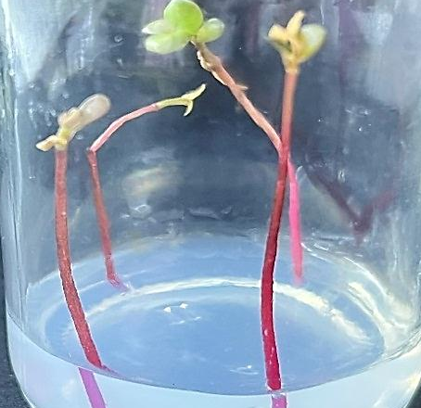
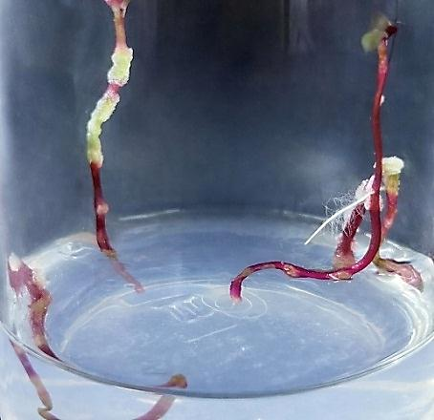
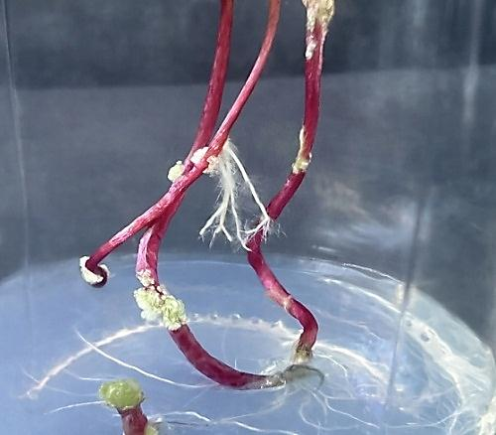
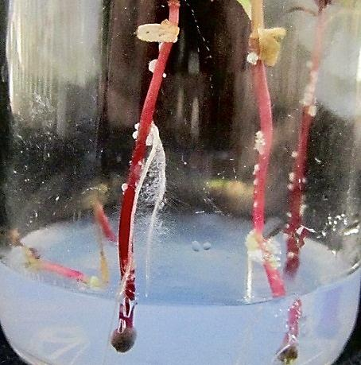
a
d
c
b

Figure (1): Tissue masses and hairy roots formation on the stems of Purslane (Portulaca oleracea L.) plants seedlings injected with different concentrations of plasmids isolated from A. rhizogenes ATCC 15834
a)Seedling stems inoculated with sterile distilled water (control sample). b) The formation of hairy roots on seedlings stems injected with14.49 ng µl ⁻¹ plasmids of A. rhizogenes ATCC15834 After 15 days of initiated (Notice the tissue masses). c) The formation of hairy roots on seedlings stems injected with 27.75 ng µl ⁻¹ plasmids of A. rhizogenes ATCC15834 After 15 days of initiated (Notice the tissue masses). d) The formation of hairy roots on seedlings stems injected with 19.59 ng µl ⁻¹ plasmids of A. rhizogenes ATCC15834 After 15 days of initiated (Notice the tissue masses)
maintenance of hairy root cultures
The results showed when excised the types of hairy roots formed in the inoculated sites in Purslane seedlings stems and placed individually on solid MSO medium in Petri dishes, only the hairy roots produced as a result inoculated the stem with 27.75 ng µl ⁻¹ plasmids of A. rhizogenes ATCC15834 continued growth and forming dense cultures with new branching when subcultured every 20 days Figure (2). While the other concentrations failed to produce cultures.

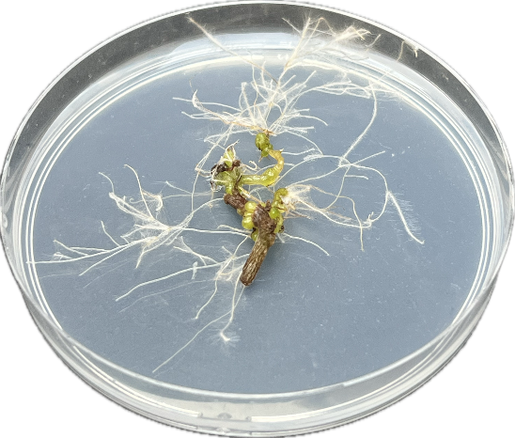

Figure (2): Culture of hairy roots induced on seedlings stems following inoculation with 27.75 ng µl ⁻¹ plasmids of A. rhizogenes ATCC15834
The extracted DNA purity and concentration
The concentration of DNA extracted from tissue masses and hairy roots formed in this study according to inoculated with 27.75 ng µl⁻¹ addition to root of control seedlings were 862, 917and 634 ng µl⁻¹ with purity 1.8 respectively
The evidence for the genetic transformation of Purslane plant at molecular biological level
The specialist rol A polymerase chain reaction tests For every type of chromosomal DNA recovered from tissue masses and hairy roots, a primer demonstrates the existence of pure bands (Figure 3). This band is not present in the DNA of the control sample; it corresponds to a molecular weight of 248 bp, which is the same as the molecular weight of the specific primer used in the study. The data show how the genetic transformation process works in purslane plants, how the T-DNA genes from the used bacterial strains are transferred and integrated into the plant cell genome, and how those genes are expressed.

4

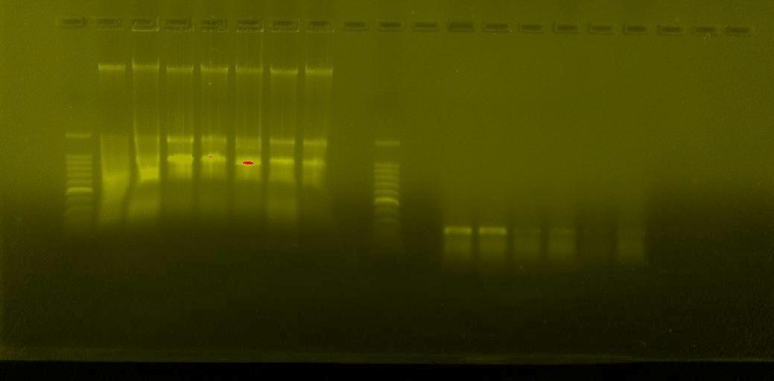
1500 bp
500 bp
248 bp
M
1
3
5
2

Figure (3): rol A genes detection in the DNA from tissue masses and hairy roots transformed with A. rhizogenes ATCC 15834 plasmids at concentration:
Lane (1): Roots of Purslane plant seedlings (control). Lane (3): Genetically transformed tissue masses with 27.75 ng µl⁻¹ of A. rhizogenes ATCC plasmid. lane (4): Genetically transformed hairy roots with 27.75 ng µl⁻¹ of A. rhizogenes ATCC plasmid

Discussion
The purslane plant (Portulaca oleracea L.) genetic transformation success is attributed to the efficiency of the direct injection method in transferring plasmids as well as the tolerance of the purslane plant tissues to the inoculation process. The formation of Hairy roots represents the first morphological evidence of successful genetic transformation, indicating effective and stable integration of the plasmid's T-DNA into the genome of the plant cell[28]. Induction wounds is a critical factor for initiating the genetic transformation process, as it facilitates the entry of foreign T-DNA into plant cells. Direct injection has been widely reported as an effective transformation technique in several plant species including sugar beet (Beta vulgaris subsp.) [29] , cabbage (Brassica oleracea var) [30] , and wormwood (Artemisia herba-alba) [31]. The success of this method may be related to the stem tissues to tolerate the injection process even at relatively high DNA concentration. According to [32], the introduction of T-DNA genes into the cell's genome caused a hormonal imbalance that resulted in the creation of these roots. The increase in DNA quantities in genetically modified samples supports the efficient transfer of T-DNA genes into the plant cell genome, which facilitated the synthesis of proteins, amino acids, and nucleic acids[33] .In conclusion, the polymerase chain reaction (PCR) results confirmed the success of the gene transformation and provided clear molecular evidence of the integration and expression of the target genes into the purslane cell genome [34,35].

Conclusion
The current study developed a protocol for transferring the rol A gene from the Ri plasmid isolated from A..rhizogenes ATCC 15834 into the cells of purslane seedlings, followd by confirmation of genetic transformation using PCR technology through molecular analysis.

References
[1] Tripathi, A.,and Shukla, S. (2024). Methods of genetic transformation: major emphasis to crop plants. Journal of microbiology, biotechnology and food sciences, 13(4), e10276-e10276
[2] Keshavareddy, G., Kumar, A.R.V. and Ramu, V.S. (2018). Methods of plant transformation-a review. Int. J. Curr. Microbiol. Appl. Sci, 7(7), pp.2656-2668.
[3] Foti, C.,and Pavli, O. I. (2020). High-efficiency Agrobacterium rhizogenes- mediated transgenic hairy root induction of Lens culinaris. Agronomy, 10(8), 1170
[4] Malarz, J., Yudina, Y. V., and Stojakowska, A. (2023). Hairy root cultures as a source of phenolic antioxidants: simple phenolics, phenolic acids, phenylethanoids, and hydroxycinnamates. International Journal of Molecular Sciences, 24(8), 6920
[5] Ying, W., Wen, G., Xu, W., Liu, H., Ding, W., Zheng, L.,and Wang, X. (2023). Agrobacterium rhizogenes: paving the road to research and breeding for woody plants. Frontiers in plant science, 14, 1196561.
[6] Urquiza-López, A., Bazaldúa, C., Cardoso-Taketa, A. T., and Villarreal, M. L. (2025). Compounds from medicinal plants produced in hairy root and transgenic hairy root cultures: a review. PeerJ, 13, e19967.
[7] Gad, K., Huu, C. N., Plaschil, S., Kappel, C.,and Lenhard, M. (2025). Genetic transformation of Primula sieboldii using Agrobacterium rhizogenes and whole-plant regeneration from transgenic hairy roots. Frontiers in Plant Science, 16, 1623387.
[8] Sultan, S. J.,and Mohammed, A. A. (2020). Genetic transformation of broccoli (Brassica oleracea Var. italica) plant by plasmids of A. rhizogenes R1601 and their molecular detection. Biochem. Cell. Arch., Accepted.
[9] Qaddawi, Z. T., Sultan, S. J.,and Mohammed, A. A. H. (2024). Efficiency of direct injection and co-cultivation methods in genetic transformation of oilseed rape (Brassica napus L.) seedlings leaves by Agrobacterium rhizogenes ATCC15834. Malaysian Journal of Microbiology, 20(5).
[10] Al-Obaidi, A.M.I.Y. (2024). Role the rol genes of Agrobacterium in Stimulating biosynthesis the Apigenin and Chamazulene compounds in Matricaria chamomilla L. plant Tissues. MSc. Department of Biology/ College of Science/ Mosul University/ Iraq.
[11] Al-sinjiri, A.M.H.S. (2022). Efficiency the Helianthus annus plant tissues which genetically transformed with Agrobacterium rhizogenes ATCC 15834 in phytoremediation. MSc. Department of Biology/ College of Science/ Mosul University/ Iraq
[12] Mohammed, A. A. (2020). Efficiency the hairy roots of radish (Raphanus Sativus) plant which genetic transformed by Agrobacterium Rhizogenes ATCC15834 for anthocyanin production. EurAsian J. Bios. 14(2): 6437-6441.
[13] Mohammed, A. and M. Al-Mallah, (2013). Determination of β-carotene in Carrot (Daucus carota L.) plants regenerated from stems callus. Rafidain Journal of Science, 24(5): 27-36.
[14] Wang, M., Li, C., Li, J., Hu, W., Yu, A., Tang, H.,and Zhang, H. (2023). Extraction, purification, structural characteristics, biological activity and application of polysaccharides from Portulaca oleracea L.(Purslane): a review. Molecules, 28(12), 4813.
[15] De Souza, P. G., Rosenthal, A., Ayres, E. M. M.,and Teodoro, A. J. (2022). Potential functional food products and molecular mechanisms of Portulaca oleracea L. on Anticancer Activity: A Review. Oxidative medicine and cellular longevity, 2022(1), 7235412.
[16] Mohamed Ahmed, I. A., AlJuhaimi, F., Özcan, M. M., Uslu, N.,and Karrar, E. (2025). Determination of the distribution of bioactive compounds, antioxidant activities, polyphenols and macro and microelement contents in different parts of wild and cultivated purslane (Portulaca oleracea L.) plants. Journal of Food Measurement and Characterization, 1-11.
[17] Xu, M., Zhao, X., Fang, J., Yang, Q., Li, P. and Yan, J., (2024). An Effective Somatic-Cell Regeneration and Genetic Transformation Method Mediated by Agrobacterium tumefaciens for Portulaca oleracea L. Plants, 13(17), p.2390.
[18] Moghadam, Y. A., Piri, K. H., Bahramnejad, B.,and Habibi, P. (2013). Methyl jasmonate and salicylic acid effects on the dopamine production in hairy cultures of Portulaca oleracea (Purslan). Bulletin of Environment, Pharmacology and Life Sciences, 2(6), 89-94.
[19] Murashige, T. and Skoog, F. (1962). A revised medium for rapid growth and bioassay with tobacco tissue culture. Physiol. Plant., 15(3): 473 -479.
[20] Vincent, J. M. (1970). A manual for the Practical Study of Root Nodule Bactria.IBP Handbook No.15. Oxford: Blackwell Scientific Publication, Oxford, PP. 113-131.
[21] Sambrook, J.; Fritschi, E.F. and Maniatis, T. (1989). Molecular cloning: A laboratory manual, Cold Spring Harbor Laboratory Press, New York, USA.
[22] Dhahi, S.J.; Al-Assie, A.H. and Omear, H.A. (2011). Application of the randomly amplified polymorphic DNA (RAPD) marker to analyze the genetic variability in species of the fungus Alternaria. Raf. J. Sci., 22: 1-16.
[23] Al-Mallah, M. K. and Mohammed, A. A. (2012). Transfer of Ri T-DNA genes of Agrobacterium rhizogenes R1601 via direct microinjection and Co_cultivation to carrot, Daucus carota L. tissue and production of transformed hairy root cultures. Iraq J. Biotech, 11, 227-239.

[24] Mohammed, A.A. and Masyab, H.M. (2020). Genetic transformation of Nigella sativa L. plants with Agrobacterium rhizogenes 35S GUS R1000 and estimation of Thymoquinone level in transformed hairy roots cultures. Plant Arch. 20 (1): 3649-3652.
[25] Dhahi, S.J. ; Al-Assie, A.H. and Omear, H.A. (2011). Application of the randomly amplified polymorphic DNA (RAPD) marker to analyze the genetic variability in species of the fungus Alternaria. Raf. J. Sci., 22: 1-16.
[26] Weigand, F.; Baum, M. and Udupa, S. (1993). DNA molecular Marker Techniques". Technical Manual. No.20. International Center for Agricultural Research in the Dry Area. Aleppo, Syria.
[27] Rahimi, K.; Haghbeen, K.; Marefatjo, J.; Jazii, F.R. and Sheikhani, R. (2008). Successful production of hairy root of Valeriana.
[28] Ma, H., Meng, X., Xu, K., Li, M., Gmitter Jr, F. G., Liu, N.,and Duan, S. (2022). Highly efficient hairy root genetic transformation and applications in citrus. Frontiers in Plant Science, 13, 1039094.
[29] Al-Mallah, M. K. and Al-Nema, Q. S. (2016),"Putative genetically modified callus derived from transformed hairy roots induced on sugarbeet (Beta vulgaris) explants by Agrobacterium rhizogenes 1601 harbouring Riplasmid", Iraqi J. Biotech., 11(2): 4.
[30] Musaib, H. M., and Al-Mallah, M. Q. (2019). Genetic manipulation for cytokinin production in genetically modified cabbage plants and compensation for its absence in the medium (Patent No. 5646). Central Agency for Standardization and Quality Control / Baghdad / Iraq
[31] Al-Jubouri, T. S. (2024). Isolation and identification of Artemisinin compound from the tissues of genetically transformed A. herba-alba plant with the Ri plasmid vector. PhD. Thesis/ Department of Biology, College of Science, Mosul University/ Iraq
[32] Mohammed, A.A. and Masyab, H.M. (2020). Genetic transformation of Nigella sativa L. plants with Agrobacterium rhizogenes 35S GUS R1000 and estimation of Thymoquinone level in transformed hairy roots cultures. Plant Arch. 20 (1): 3649-3652.
[33] Park, N.I.; Park, J.H.; Lee, C.Y.; Lee, S.Y. and Park, S.U. (2010). Agrobacterium rhizogenes-mediated transformation of β- glucuronidase reporter gene in hairy roots of Angelica gigas Nakai. Plant Omics J., 3:115-120.

[34] Balasubramanian, M.; Anbumegala, M.; Surendran. R.; Arun, M. and Shanmugam, G. (2018). Elite hairy roots of Raphanus sativus L. as a source of antioxidants and flavonoids. 3 Biotech., 8(128): 1-15.

[35] Lacroix, B. and Citovsky, V. (2019). Pathways of DNA transfer to plants from Agrobacterium tumefaciens and related bacterial species. Annu. Rev. Phytopathol., 25(57): 231–251.

