Original Research Article
Development and Characterization of Value-Added Breakfast Cereal Enriched with Banana Blossom

ABSTRACT
Banana blossom is an edible flower rich in macro and micro nutrients. It also has a good amount of dietary fibre and antioxidants hence are beneficial in managing diabetes, cardiovascular diseases, and constipation. The present study is aimed to develop a novel breakfast cereal enriched with banana blossom flour and analyze its nutritional and sensory properties. Moreover, this study provides insight into process standardization, support technological advancement for commercial-scale production. The fresh blossoms were pre-treated with natural citric acid to avoid enzymatic browning by lowering pH and inhibiting polyphenol oxidase. Four formulations of the product were made and sensory evaluation was performed. 30 untrained panellists evaluated the product through Hedonic scale. Out of which the F2 formulation which contained 3gm of banana blossom showed the best results. The sensory evaluation scores were evaluates statistically by ANOVA, which revealed that formulation F2 has the maximum acceptability when compared to all other formulations. The taste part has the highest mean score of 8.60, whereas the other attributes like appearance, texture and smell all equally have mean score of 8.57. The proximate analysis results showed it has relatively less moisture and fat of 4% & 4.9% while proves to be good source of plant protein of 17.60%. It has a rich source of carbohydrate and fibre of 71.17% and 24.76%. These promising results of proximate and nutritional analysis make it a perfect choice as incorporation in breakfast cereal. The rapid urbanization in today’s life asks for nutritionally rich ready to eat breakfast cereal. The market available variant is often highly rich in added sugars and less in dietary fibres and other essential nutrients. The banana blossom being an underutilised agricultural by product containing essential nutrients, enhances the nutritional qualities of the cereal thus making healthier food choices.
Keywords: Banana Blossom, breakfast cereal, proximate, sensory, dietary fibre

- INTRODUCTION
Banana (Musa Paradisica) is one of the most delicious and widely consumed foods all over the world(Pereira and Maraschin 2015). Bananas are predominantly cultivated in tropical countries (Tasnim, Das et al. 2020). Hence, India is the world’s largest producer of banana(Elaveniya and Jayamuthunagai 2014). What’s interesting is the distinctive morphological feature present at the tip of this banana bunches. This attractive terminal inflorescence part is characterized by compact, maroon-coloured, leafy conical structure composed of overlapping bracts(Tasnim, Das et al. 2020). This terminal inflorescence is generally termed as banana blossom or banana heart(Lau, Kong et al. 2020). It is mostly consumed in the eastern part of India. This edible flower(Komal and Kaur 2019) is a rich source of antioxidants like phenols and flavonoids(Lakshmi, Padmavathy et al. 2024) It also contains significant amount protein, dietary fibre, vitamins and minerals like- Magnesium, Iron Copper and Potassium(Kajal, Singh et al.). Due to its rich nutrient profile, it has also serves some potential health benefits. Its high antioxidant and fibre properties help manage diabetes(de Oliveira Vilhena, Fachi et al. 2018), cholesterol levels, constipation and cardiovascular diseases(Chiang, Yang et al. 2021). Being rich in iron it supports haemoglobin formation which prevents anaemia(Sheng, Ma et al. 2010). Despite being nutritionally valuable, the usage of banana blossom has been reduced due to its lengthy and labour intensive preparation procedure which involves removing of the outer bracts, separation of florets, removal of inedible part, and extensive cleaning and washing(Ambrose, Sumithra et al. 2018).
‘Breakfast’ is the first meal of the day. It is the most important and essential meal which creates a heavy impact on our health(Betts, Chowdhury et al. 2016). Starting your day with a good breakfast brings a lot of positive health and nutritional outcome(Tolfrey and Zakrzewski 2012). Hence, choosing a right breakfast cereal plays a significant role in maintaining better and nutritional lifestyle. Breakfast cereals are a minimal processed ready-to-eat or ready-to-serve dish which is gaining importance and attention in today’s busy life due to its convenience, numerous nutritional and health benefits(Kapoor and Haripriya 2020). Breakfast cereal primarily consists of whole grains like rolled oats(Welch 2011), wheat, barley, corn flakes and different kinds of seeds which make this a valuable source of antioxidants, vitamins, minerals and dietary fibres(Comerford 2026). It is usually taken with milk, yogurt or fruit juice. It is crispy in nature and sometimes additional components are added to make it more enriched with nutrients. Consumption of a healthy breakfast cereal is being associated with multiple health benefits like improving digestive health, cardiovascular health; lowering of cholesterol and blood sugar levels also prevention of lifestyle related disorders(Joye 2020). Its antioxidant rich properties play significant role in reducing oxidative stress(Ryan, Thondre et al. 2011). More significantly, its shelf stability feature acts the main role in busy lifestyle as it requires no lengthy preparation hence becomes a wholesome breakfast meal. This present study mainly focuses on the incorporation of an underutilised yet nutritionally rich banana blossom in breakfast cereal to enhance its nutritional and functional properties. The replacement of wheat flour with functional ingredient has always proven to be nutritionally enriching(Tasnim, Das et al. 2020). Enriching the breakfast cereal with banana blossom will act as great source of dietary fibres, antioxidants, bioactive compounds, vitamins and minerals(Joshi and Srivastava 2024). In this study banana blossoms were treated with natural citric acid (lime juice) to prevent enzymatic browning by lowering the pH and inhibiting polyphenol oxidase. Enzymatic browning generally causes loss of a lot of nutrients present in the food hence prevention of this was one of the very essential step of the study (Tasnim, Das et al. 2020). This study aimed to develop a novel breakfast cereal enriched with banana blossom flour and to analyze its nutritional and sensory properties. Moreover, this study provides insight into the process standardization, support technological advancement for commercial-scale production.

- MATERIALS AND METHODS

  - Locale of Study
The main study and analysis was conducted in Babasaheb Bhimrao Ambedkar University, Lucknow. Some of the ingredients were collected from Kolkata as well.
  - Period of Study
The study was conducted in systemic manner in between the period of January 2026- May 2026.
  - Materials
Fresh banana blossoms (Musa acuminata Colla) were obtained from a local vegetable market in Kolkata, West Bengal. The blossoms were selected based on their maturity, freshness, absence of any kind of microbial or visible spoilage. To prevent enzymatic browning, the blossoms were given pre-treatment by soaking in natural citric acid solution(Kaewjumpol, Srisamlee et al. 2021, Legowo, Pramono et al. 2024). Other ingredients required for the formulation of the product includes rolled oats, amaranthus, chia seeds, corn flour, cinnamon powder, cocoa powder and monk fruit sweetner which were purchased from standard grocery store of Lucknow, Uttar Pradesh. All best quality materials were chosen and stored under appropriate ambient conditions.
  - Preparation of Banana Blossom Flour(BBF)
The preparation of banana blossom flour was carried out, following a systematic processing method to ensure maximum nutrient retention and maintain good product quality. The following steps were performed in preparation of the flour: (Tasnim, Das et al. 2020)
Initially, the procured banana blossoms were washed thoroughly under potable running water to remove all the dirt and presence of extraneous matter. Then the marooned coloured bracts were removed carefully one after the other sequentially. The inner edible white florets arranged in an overlapping pattern beneath each bract were then separated manually. The separated white florets were further cleaned to remove the unwanted portions. Excess surface moisture was removed by gently spreading the florets on a sterile filter paper under ambient conditions. The blossoms were then subjected to the process of pre-treatment by soaking them in natural citric acid (lemon juice) of 2 tbsp diluted in 1 litre of water for at least an hour. This process of pre-treatment was mainly carried out to inhibit enzymatic browning caused by an enzyme polyphenol oxidase which reacts with oxygen in air. In this reaction the phenolic compounds gets converted into brown coloured pigments called melanin. This pre-treatment is also performed to minimize the nutrient degradation of the banana blossom. After completion of the soaking process, in the next step the blossoms were drained completely to remove the moisture present in the surface. The drained blossoms were then uniformly sliced to an approximately thickness of 3mm to cause proper drying Then spread uniformly in sterile trays of the dehydrator at 50º C for 18hrs to achieve adequate removal of moisture and enhance shelf life stability. Lastly, upon completion of the dehydration procedure the dried banana blossoms sliced were now allowed to cool down under room temperature then finely ground using a mixer grinder to obtain finely grounded powder. Then the resulting powder was sieved(by a 250 micrometer seiver) to ensure uniform particle size which was named as Banana Blossom Flour (BBF). Finally the BBF was stored in air tight containers at room temperature until further use.

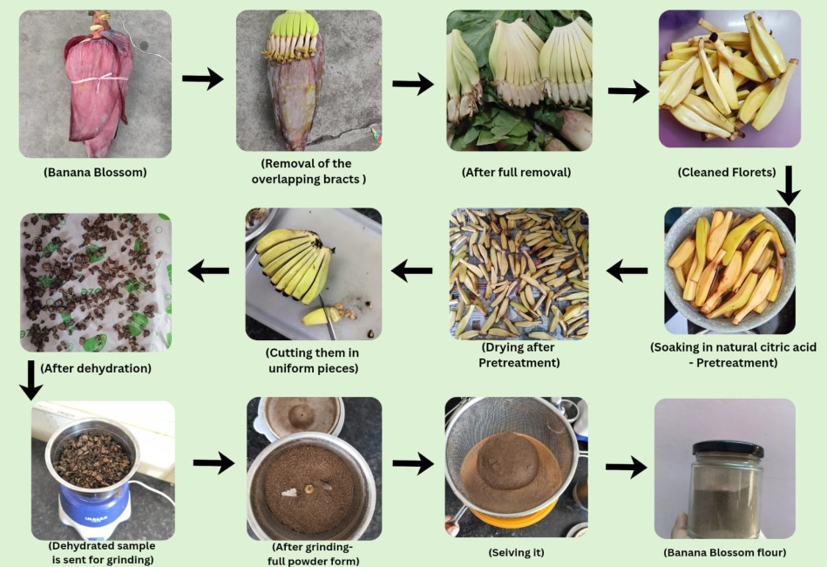

(Fig.1 Flowchart depicts the step by step procedure of making of Banana Blossom Flour)

  - Preparation of Breakfast cereal enriched with Banana Blossom Flour (BBF)
After the preparation of the banana blossom flour the next step of the study was to incorporate it as a functional ingredient in breakfast as a cereal. The base of the breakfast cereal was prepared by supplementing the regular wheat flour by corn flour, amaranthus flour, grinded oats and grinded chia seeds. Along with this, cocoa powder was added to provide a chocolaty flavour to the cereal and to make it more appetising. Sugar was substituted by a natural sweetener called ‘Monk fruit sweetener’ which is a high intensity, zero calorie sweetener. It provides sweetness 150-200 times more than regular sugar also has antioxidant properties. Monk fruit has a natural compound, mogrosides which is responsible for the sweetness. All the ingredients including the BBF were weighted separately using a weigh balance. Then were mixed according to the formulations for 4 different samples to form dough. The control sample did not contain the BBF.
Four different dough were then kneaded according to the various compositions. The dough was properly kneaded using correct proportion of water and melted butter. After this, the dough was flattened and then given appropriate shapes (here the shape of a crescent moon is given using a spoon). Then the shaped pieces were placed over a butter paper in the baking tray and put into a microwave oven to bake at 155-165⁰C for 15-20mins. After the adequate time it was taken out and place in room temperature to cool down. Lastly, after getting cooled the breakfast cereal was now ready to be served with hot/ cold milk as per consumer choice. It can even be consumed as bites for breakfast without addition of milk.
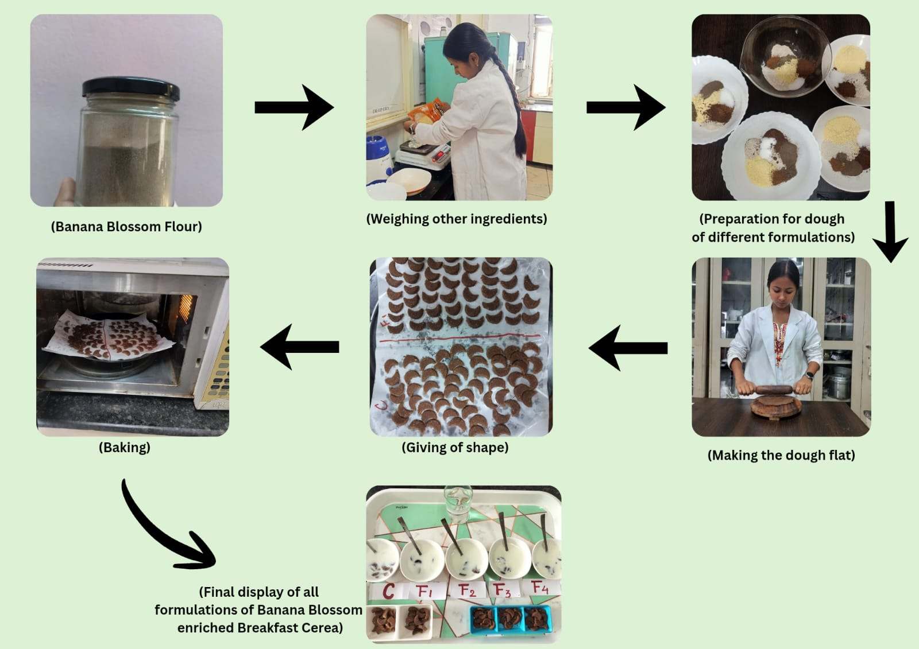

(Fig.2 Flowchart depicts the step by step procedure of the Breakfast cereal from the banana blossom flour)
(Table no. 1 Formulation table for banana blossom enriched breakfast cereal)
INGREDIENTS(gm) | CONTROL | FI | F2 | F3 | F4
Oats Flour | 25 | 20 | 15 | 10 | 5
Corn Flour | 15 | 20 | 25 | 30 | 35
Amaranthus Flour | 6 | 5 | 5 | 5 | 5
Chia Seeds (grinded) | 2 | 1 | 1 | 1 | 1
Cinnamon Powder | 2 | 1 | 1 | 1 | 1
Cocoa Powder | 2 | 2 | 2 | 2 | 2
Sweetener | 2 | 2 | 2 | 2 | 2
Banana Blossom Flour | 0 | 2 | 3 | 4 | 5

  - Proximate analysis of Banana blossom flour and Banana blossom enriched breakfast cereal
The AOAC guidelines (2019) helped in determining the moisture, ash, crude protein, crude fat, and crude fibre content of the cereal. It is very essential in determining the nutrient content of the novel product development. Carbohydrate was estimated according to the guidelines by Food and Agriculture Organisation(Beshaw, Demssie et al. 2022).
2.6.1. Estimation of Moisture Content
The moisture content of the samples was determined using the Oven Drying Method. The amount of weight loss occurred in the samples was used to determine the moisture content of the sample. Clean and dry petri dish was weighted for three times after being dried at hot air oven at 105⁰C. Then the petri dish with sample was weighted as W1 and then put in oven at 105⁰C for 4 hours after that was weighted again as W2. (Alam, Biswas et al. 2023)
%Moisture = (W₁) – (W₂) × 100
Weight of sample (W)g
2.6.2. Estimation of Fat content
Soxhlet method was used to estimate the fat content of the samples. Samples free of moisture were placed in a thimble attached to a stand and placed in pre weighted soxhlet beaker. The beaker was filled using Petroleum ether The beaker was then connected to the soxhlet apparatus and samples were extracted for 2 hours at 80⁰C in the 1st cycle and 2 hours for 120^{0C} for the last cycle. Lastly the beaker was dried in hot air oven at 105⁰C for 30mins. Crude fat percent was calculated as under: (Watkins 2023)
% Crude Fat= Wt. of ether soluble material (W2 - W1) x 100
Weight of Sample (W)g
Where,
W1=Wt. of round bottom flask
W2=Wt. of round bottom flask + fat
W=Wt. of sample
W2-W1=Wt. of ether soluble material.
2.6.3. Estimation of Protein Content
The protein concentration was determined by the Kjeldahl method consisting of digestion, distillation and titration. The digesting of approximately 0.3 g of the sample with a catalyst mixture and concentrated sulfuric acid at 440°C for five to six hours resulted in a bright greenish-blue solution. The digest was diluted to 100 ml and 10 ml of this digest was distilled with 30% sodium hydroxide. After being released, Using a mixed indicator, the ammonia was collected in boric acid and titrated against 0.1 N hydrochloric acid. A blank was prepared in a similar manner and its nitrogen value was used to calculate the protein content.
% Nitrogen= (Sample titre - Blank titre) x Normality of HCL × 14 × 100 x 100
(Wt. of sample x aliquot taken for distillation) × 1000
A conversion factor of 6.25 was used to convert nitrogen into protein content.
Protein % = Nitrogen% × 6.25
2.6.4. Estimation of Ash Content
To estimate Ash content, the dry charring method was used. Firstly the constant weight of the silica crucible was set by 3 consecutive times after drying in hot air oven at 105°C. Then in a silica crucible 2g of sample was taken and ignited on a Bunsen burner till the flumes stop coming (charring process). Then was shifted to electrical muffle Furnace until clean ash was obtained. The temperature of furnace was raised to 550°C. The residue was noted and reported as a percentage.(Ture and Bekele 2024)
% Ash = (W2-W1) x 100
W(g)
Where,
W=Wt. of sample
W1-Constant Wt. of Crucible
W2- Final Wt. of crucible+ ash
2.6.5. Estimation of Fibre Content
To determine fibre content, the moisture and fat-free sample was used. 10g of the sample was added to sulphuric acid (1.25%). Then boiling for 30 minutes, the sample was digested. This sample was filtered with filter paper and then washed with warm water, to remove some acid. The sample in an a beaker was then. 10 mL of NaOH (1.25%) was taken in beaker. Distilled water was added to the sample which was then boiled for 40 minutes. Again filter the sample and washed with hot water, now its alkali-free. A sample was put in a crucible and heated in oven at 85°C and oven temperature was set at 130°C for 2 hours. The second weighing was repeated, the sample was burned at 600°C, cooled and washed once again. For cooling kept it in a desiccator after charring and then weighed. Fibre weight in the sample is determined by the weight that was lost during charring.(Jenfa, Adelusi et al. 2024)
Fiber % = Wt of dried sample before ashing – Wt of sample after ashing × 100
Initial weight of sample

2.6.6. Estimation of Carbohydrate Content
By using the difference method the carbohydrate percent was estimated. (Amusan, Ogunbiyi et al. 2024)
% Carbohydrates = 100-(Moisture % + protein%+ fat% +Ash %)
  - Organoleptic Analysis of Banana blossom enriched breakfast cereal
Sensory evaluation or organoleptic analysis was performed by 30 untrained panellists, who were given samples to taste and evaluate which were of different formulations of banana blossom flour, these were coded randomly(Lyon, Francombe et al. 2012). Panellists were asked to rate the randomly coded samples on a 1-9 point hedonic scale (1- dislike extremely, 2- dislike very much, 3- dislike moderately, 4- dislike slightly, 5- neither dislike nor like, 6- like slightly, 7- like moderately, 8- like very much, 9- like extremely) on the basis of different sensory attributes like appearance, taste, odour, texture and overall acceptability(Wichchukit and O'Mahony 2015).
  - Microbial Analysis of Banana blossom enriched breakfast cereal
    - Total Plate Count
The Total Plate Count technique (TPC) was used to quantify the total viable aerobic microbial (TVAM) load of the food matrix. The homogenized samples were serially diluted in sterile diluent and aliquots were placed on a nutritionally complete agar medium and either poured or spread. Plates were incubated under optimal conditions with respect to both time and temperature to allow viable cells to grow into large colonies. Visual colonies were counted and each colony was considered to have a single progenitor cell or localised group and results were reported as colony forming units/gram or milliliter of the sample. High counts were used as an indicator of poor hygienic processing and poor shelf stability.
TPC (CFU/g) = (Number of Colonies ×Dilution Factor) / Amount of Sample Plated
    - Total Yeast and Mold Count
Yeast and Mold Count (YMC) is one of the microbiologic methods that measure the population of yeast and mold microorganisms in a food product. It is a significant parameter to know the microbiological quality, degree of spoilage and storage stability of food products.
The sample is plated on an appropriate selective culture media and incubated under controlled conditions to which yeasts and molds have grown. Viable cells of yeast and mold multiply and grow into colonies visible on the agar surface during the incubation period. The numbers of these colonies are counted and are expressed as colony forming units (CFU). The test is useful for assessing fungal contamination and its ability to predict the shelf life and safety of food products, as excessive growth of yeasts and moulds can cause food to spoil, produce off-flavour and reduce the quality of the food product.
Yeast and Mold (CFU/g) = (Number of Colonies ×Dilution Factor) / Amount of Sample Plated
  - Statistical Analysis of Banana blossom enriched breakfast cereal
Data of sensory and proximate were analyzed using One-Way Analysis of Variance (ANOVA) with Post-Hoc test to identify the significant difference among the means at p< 0.05. The IBM SPSS Software (Version 20.0) was used for statistical analysis of the sensory scores.
- RESULTS AND DISCUSSION
  - Nutritional Composition of Banana Blossom Flour (BBF)
The table no 1 shows that the BBF has a moderate content of moisture (8.25%) which indicates the need for proper storage and dehydration for preventing spoilage. Fat is relatively low in amount (2.12%) hence can be BBF can be considered as a low fat ingredient for breakfast meals. The (14.75%) protein content reflects that it has a impressive amount of plant based protein source. The ash content (4.38%) says that it has a little amount of minerals in it. The most highlighting part is the carbohydrate content (70.05 %.) This shows that BBF is an extremely rich source of energy, thus making it suitable for adding in staple food items for the benefit of mankind. The notably good amount of crude fibre content (15.85%) makes BBF aid digestive health, cardiovascular diseases. The nutritional composition of BBF determines, it is nutritionally rich in macro, micro nutrients, and fibre making it a valuable ingredient. (Tasnim, Das et al. 2020)
  - Nutritional Composition of Banana blossom enriched breakfast cereal
From the table no. 2 it is understood that the breakfast cereal enriched with BBF has a comparative lesser moisture (4.00%) than the BBF, thus have a longer shelf life. Fat content is a bit higher (4.95%) but contributes to make the cereal a source of energy. The protein content (17.60%) determines that the breakfast cereal is a good source of plant based protein. It has a less amount of ash thus there can be presence of very less minerals in the cereal. The impressive amount of carbohydrate 71.17% makes BBF the most suitable ingredient for breakfast cereal. It acts as a source of immense energy which is absolutely perfect as the first meal for the day. The notable high crude fibre content (24.765%) is beneficial for reducing blood sugar level, maintain digestive health and satiety.
The nutritional analysis has showed that banana blossom enriched breakfast cereal is a good source of energy, plant based protein, fibre thus making it perfect as a starting meal of the day. The developed product is nutritionally enriched and has many therapeutic qualities.
(Table 2 The Nutritional Composition of Banana Blossom Flour(BBF) and the BBF enriched Breakfast cereal)
Parameters |  | BBF |  | BBF-enriched Breakfast Cereal
Moisture (%) |  | 8.25±0.28 |  | 4.00±0.12
Fat (%) |  | 2.12±0.34 |  | 4.95±0.27
Protein (%) |  | 14.75±0.55 |  | 17.60±0.29
Ash (%) |  | 4.38±0.11 |  | 2.27±0.09
Carbohydrate (%) |  | 70.05±0.46 |  | 71.17±0.42
Crude Fibre (%) |  | 15.85±0.28 |  | 24.76±0.18

(Table 3 Statistical analysis showing F- Value and P- Value of Proximate Composition parameters of Banana Blossom Flour and Banana Blossom enriched breakfast cereal)
Parameter |  | F-Value |  |  | P- Value
Moisture (%) |  | 75.058 |  |  | 0.001
Fat (%) |  | 29.939 |  |  | 0.005
Protein (%) |  | 63.844 |  |  | 0.001
Ash (%) |  | 92.685 |  |  | 0.001
Fibre (%) |  | 289.680 |  |  | 0.000
Carbohydrate (%) |  | 96.490 |  |  | 0.001

One way ANOVA was used as the statistical test to determine the significant difference of values at p < 0.05. The results in table 3 shows that there were significant differences between the BBF and BBF enriched breakfast cereal for all the nutritional parameters
Moisture, fat, protein, ash, fibre, and carbohydrate contents among the BBF and BBF-enriched breakfast cereals were significantly different (p < 0.05) as analysed by one-way ANOVA. In general, the proximate analyses confirm that the use of banana blossom flour definitely affected and improved the nutritional composition of the breakfast food developed.

  - Organoleptic analysis of banana blossom enriched breakfast cereal

(Table 4 Overall Sensory Scored of Breakfast Cereal)
Treatment | Organoleptic Evaluation
Treatment | Appearance | Taste | Smell | Texture
C | 8.37±0.56^{be} | 8.33±0.61^{d} | 8.20±0.71^{ce} | 8.20±0.66^{c}
F1 | 7.97±0.67^{ac} | 8.20±0.76^{c} | 7.97±0.67^{c} | 7.97±0.72^{c}
F2 | 8.57±0.57^{bde} | 8.60±0.50^{bde} | 8.57±0.50^{bd} | 8.57±0.50^{bde}
F3 | 8.13±0.73^{c} | 7.97±0.76^{ac} | 7.97±0.72^{c} | 8.03±0.72^{c}
F4 | 7.87±0.73^{ac} | 8.20±0.6^{c} | 7.73±0.74^{c} | 8.00±0.64^{c}
(a= comparison with control, b= comparison with F1, c= comparison with F2, d= comparison with F3, e= comparison with F4)
The organoleptic assessment indicated notable differences (p =0.05) among the treatments regarding appearance, flavour, aroma, and texture. The analysis was performed only on F2 sample. Regarding appearance, sample F2 achieved the highest rating and ANOVA displayed significant differences when compared to F1, F3, and F4. The control (C) group also showed significant differences from all the formulation. Samples F1 and F4 received lower scores for appearance and significantly differed from most other treatments. In terms of flavour, substantial variations were noted among the samples. Sample F2 emerged as the most favoured and showed significant differences from F1, F3, and F4, whereas the control (C) was similar to F1 and F4 but differed from F3 and F2.
In terms of aroma, sample F2 again received the highest acceptability of 8.60 and was significantly different from the other samples. The control sample (C) showed significant differences from both F2 and F4 but was akin to F1 and F3. The evaluation of texture also revealed significant variations among the treatments. Sample F2 received the highest rating and was significantly different from all other samples. The control (C), F1, F3, and F4 displayed minimal variation among them and were statistically similar in texture. Overall, sample F2 emerged as the most preferred formulation across all sensory characteristics. While differences were noted among the other treatments, all samples fell within an acceptable range, demonstrating good sensory quality.
  - Microbial Analysis of banana blossom enriched breakfast cereal
    - Total Plate Count
The result of the total plate count (TPC) of banana blossom enriched breakfast cereal was found to be 5.80 x 102cfu/g (580cfu/g). The low microbial count is an indicator of good manufacturing practices and effective thermal processing. There were no elevated counts found, thus the product development process did not add any extra or undesirable microbes to the final product. This makes the food product microbiologically safe for human consumption. Overall, the total plate count result indicates the banana blossom enriched breakfast cereal is processed with all food safety protocols and made in well hygienic environment. This also increases the self-life of the developed product.
3.4.2. Total Yeast and Mold Count
The result of yeast and mold count in the banana blossom enriched breakfast cereal was found to be less than 10 cfu/g (<10 cfu/g). This shows that there is no such significant growth of yeast and mold in the cereal matrix. Thus, the matrix shows low water activity at which no fungal proliferation is possible under standard storage conditions. Hence it can be concluded that the breakfast cereal is microbiologically safe, stable and of excellent hygienic quality.
  - Statistical Analysis
Table 3 shows the results derived from one way ANOVA of the nutritional parameters like moisture(%), ash(%), fat(%), protein(%) fibre(%), carbohydrate(%) of BBF and BBF enriched breakfast cereal. The results determines that there was significant differences(p < 0.05) among the proximate compositions.
The sensory scores of the various formulations of the developed breakfast cereal are shown in Table 4. The results were obtained from the one-way ANOVA and post hoc test determines that there were significant differences (p < 0.05) in the formulations with respect to various attributes like appearance, taste and smell and texture. The table 4 clearly shows that among all formulations, F2 has recorded the highest scores for appearance (8.57 ± 0.57), taste (8.60 ± 0.50), smell (8.57 ± 0.50), and texture (8.57 ± 0.50), indicating the highest overall acceptability.
The tests were performed in IBM SPSS Software (Version 20.0)
LIMITATIONS
The study was mainly focused on nutritional, proximate and microbial analysis whereas the other bioactive components were not discussed in details. Also the sensory analysis was conducted by a limited size panellist hence it may be not be liked by all consumers. The study was done in controlled laboratory condition which was limited to the laboratory only, thus the real market acceptability, large scale processing in industries and commercial feasibility was not proven, the cost analysis was not estimates. Long term stability was also not extensively studied.
CONCLUSION
Banana Blossom or the banana heart is one of the most underutilised parts in the banana tree(Lau, Kong et al. 2020). It has a lot of nutritional values thus addition of this in a breakfast cereal makes it a perfect combination of nutritionally enriched food product(Thagunna, Kandel et al. 2023). The research was mainly carried out to study the development and characterization of the developed product through proximate and sensory analysis. It showed that it is rich in energy, potassium, calcium, phosphorus and fibre(Zou, Tan et al. 2022). The proximate analysis determines that the breakfast cereal has richer content of carbohydrates, protein and fibre of 71.17%,17.60% & 24.76% than the banana blossom flour itself thus provides a lot of energy(Edima-Nyah, Ntukidem et al. 2024).This makes it a perfect breakfast meal to start the day perfectly. It is also rich in dietary fibre and protein(Begum and Deka 2019). The cereal has a less moisture content which shows that it can be stored for a longer period of time. The organoleptic evaluation clearly states that F2 formulation has the best overall acceptability, in appearance, taste, smell and texture. The study can be continued further by using other techniques of pre-treatment, dying, structural analysis and antioxidant properties.

Declaration of AI Use
This manuscript was prepared through the combined contributions of all author(s), including contributions to the study design, data, content development, results, interpretation, and related scholarly work. The author(s) acknowledge the use of Grammarly and ChatGPT to assist with grammar checking, language refinement, reference formatting. These AI-assisted tools were not used as authors and did not replace the intellectual contributions or scholarly judgment of the author(s). All AI-assisted outputs, including content, references, and interpretations, were carefully reviewed, revised, verified, and approved by the author(s). The author(s) accept full responsibility for the accuracy, integrity, and final content of the manuscript.

REFERENCES
- Alam, M., et al. (2023). "Quality attributes of the developed banana flour: Effects of drying methods." Heliyon 9(7).

- Ambrose, D. C., et al. (2018). "Techniques to Improve the Shelf Life of Freshly Harvested Banana Blossoms." Current Agriculture Research Journal 6(2).pages

- Amusan, T. O., et al. (2024). "Evaluation of phytochemical compounds and proximate analysis of doum palm fruit (Hyphaene thebaica) blend with turmeric powder (Curcuma longa)." BMC chemistry 18(1): 140.

- Begum, Y. A. and S. C. Deka (2019). "Chemical profiling and functional properties of dietary fibre rich inner and outer bracts of culinary banana flower." Journal of food science and technology 56(12): 5298-5308.

- Beshaw, T., et al. (2022). "Determination of proximate composition, selected essential and heavy metals in sesame seeds (Sesamum indicum L.) from the Ethiopian markets and assessment of the associated health risks." Toxicology Reports 9: 1806-1812.

- Betts, J. A., et al. (2016). "Is breakfast the most important meal of the day?" Proceedings of the Nutrition Society 75(4): 464-474.

- Chiang, S.-H., et al. (2021). "Evaluation of the in vitro biological activities of Banana flower and bract extracts and their bioactive compounds." International Journal of Food Properties 24(1): 1-16.

- Comerford, K. B. (2026). "The impacts of ready-to-eat-cereals and cereal fibers on gut health, body weight, and cardiometabolic health." Frontiers in Nutrition Volume 13 - article number

- de Oliveira Vilhena, R., et al. (2018). "Antidiabetic potential of Musa spp. inflorescence: a systematic review." Journal of Pharmacy and Pharmacology 70(12): 1583-1595.

- Edima-Nyah, A. P., et al. (2024). "Chemical, Microbial, and Sensory Properties of Breakfast Cereals Made from Yellow Maize and Soybean Flour Blends with Firmly Ripe Banana Flavoring." IPS Journal of Nutrition and Food Science 3(3): 227-233.

- Elaveniya, E. and J. Jayamuthunagai (2014). "Functional, physicochemical and anti-oxidant properties of dehydrated banana blossom powder and its incorporation in biscuits." International Journal of ChemTech Research 6(9): 4446-4454.

- Jenfa, M. D., et al. (2024). "Physicochemical compositions, nutritional and functional properties, and color qualities of sorghum–orange‐fleshed sweet potato composite flour." Food Science & Nutrition 12(4): 2364-2378.

- Joshi, P. and A. Srivastava (2024). "Enhancing nutrition and value: Innovative uses of banana blossom in functional food products." Journal of Medicinal and Aromatic Plant Sciences 46(4): 143-150.

- Joye, I. J. (2020). "Dietary fibre from whole grains and their benefits on metabolic health." Nutrients 12(10): 3045.

- Kaewjumpol, G., et al. (2021). "Enzymatic browning in banana blossoms and techniques for its reduction." Horticulturae 7(10): 373.

- Kajal, A., et al. "Nutritional, mineral and polyphenolic characterisation of dried banana inflorescence powder from different Musa cultivars." Journal, DOI, Year

- Kapoor, T. and A. Haripriya (2020). "Formulation and evaluation of functional, nutritional and sensory properties of inulin incorporated ready to eat multi-grain breakfast cereal." Indian Journal of Nutrition and Dietetics 57(4): 422.

- Komal, D. and P. Kaur (2019). "Development of value added product and evaluation of banana blossom incorporated nut chocolate." Development 3(5): 1930-1931.

- Lakshmi, S., et al. (2024). "Phytochemical Analysis and Antioxidant Potential of Methanol Extract of Banana Blossom." Research Journal of Pharmacy and Technology 17(8): 3587-3592.

- Lau, B. F., et al. (2020). "Banana inflorescence: Its bio-prospects as an ingredient for functional foods." Trends in Food Science & Technology 97: 14-28.

- Legowo, A., et al. (2024). "Inhibition of maillard reaction of kepok banana flour with citric acid." Indonesian Journal of Agricultural Research 7(1): 29-37.

- Lyon, D. H., et al. (2012). Guidelines for sensory analysis in food product development and quality control, Springer Science & Business Media.

- Pereira, A. and M. Maraschin (2015). "Banana (Musa spp) from peel to pulp: ethnopharmacology, source of bioactive compounds and its relevance for human health." Journal of ethnopharmacology 160: 149-163.

- Ryan, L., et al. (2011). "Oat-based breakfast cereals are a rich source of polyphenols and high in antioxidant potential." Journal of food composition and analysis 24(7): 929-934.

- Sheng, Z.-W., et al. (2010). "Investigation of dietary fiber, protein, vitamin E and other nutritional compounds of banana flower of two cultivars grown in China." African Journal of Biotechnology 9(25): 3888-3895.

- Tasnim, T., et al. (2020). "Nutritional, textural and sensory quality of plain cake enriched with rice rinsed water treated banana blossom flour." Journal of Agriculture and Food Research 2: 100071.

- Thagunna, B., et al. (2023). "Banana blossom: nutritional value, health benefits and its utilization." Reviews in Food and Agriculture 4(2): 66-70.

- Tolfrey, K. and J. K. Zakrzewski (2012). "Breakfast, glycaemic index and health in young people." Journal of Sport and Health Science 1(3): 149-159.

- Ture, E. and M. Bekele (2024). "Optimal biscuit baking condition and characterization of the biscuit physiochemical, functional, antioxidant, anti-nutrient and textural properties." Cogent Food & Agriculture 10(1): 2412368.

- Watkins, P. (2023). "Comparing the use of chloroform to petroleum ether for Soxhlet extraction of fat in meat." Animal Production Science 63(14): 1445-1449.

- Welch, R. W. (2011). "Nutrient composition and nutritional quality of oats and comparisons with other cereals." Book title, chapter number, doi

- Wichchukit, S. and M. O'Mahony (2015). "The 9‐point hedonic scale and hedonic ranking in food science: some reappraisals and alternatives." Journal of the Science of Food and Agriculture 95(11): 2167-2178.

- Zou, F., et al. (2022). "The valorization of banana by-products: nutritional composition, bioactivities, applications, and future development." Foods 11(20): 3170.

