Comparative In Vitro Evaluation of Botanical Extracts and Chemical Fungicides Against Alternaria brassicae: Concentration-Dependent Efficacy Assessment for Sustainable Disease Management

Abstract
Alternaria brassicae causes devastating blight in Brassica crops, leading to yield losses of up to 71% across major growing regions. Traditional chemical fungicide management raises concerns about environmental persistence, resistance development, and residue accumulation. Botanical extracts offer sustainable alternatives through bioactive antifungal compounds. This study evaluated and compared the in vitro antifungal efficacy of botanical extracts and chemical fungicides against A. brassicae through concentration-dependent assessment to determine effective concentrations, characterise inhibition patterns, and identify sustainable alternatives for disease management in mustard cultivation systems. It was hypothesised that botanical extracts would demonstrate significant, concentration-dependent antifungal activity against A. brassicae, though chemical fungicides would achieve superior pathogen suppression. These findings confirm the study hypothesis. A key limitation of this study is that all experiments were conducted under controlled in vitro conditions; field validation is required before these findings can be applied to commercial disease management. Five botanical extracts (garlic, ginger, turmeric, tulsi, lantana) at 2.5%, 5%, and 10% concentrations, and five fungicides (Carbendazim+Mancozeb, Difenoconazole, Fluxapyroxad, Penflufen, Trifloxystrobin) at 0.025%, 0.05%, and 0.1% concentrations were evaluated using the poisoned food technique on PDA medium. Radial growth inhibition was calculated using Vincent’s formula, with appropriate statistical analysis. Botanical extracts showed concentration-dependent inhibition, with garlic achieving the highest efficacy (66.44% at 10%), followed by turmeric (66.00%), tulsi (64.00%), ginger (63.44%), and lantana (60.78%). Fungicides demonstrated superior inhibition, with four achieving complete suppression (100%) at 0.1%: Carbendazim + Mancozeb (98.13% at 0.025%), Trifloxystrobin (97.18%), Difenoconazole (96.83%), and Fluxapyroxad (96.56%). Penflufen showed incomplete inhibition (97.78% at 0.1%). All treatments exhibited significant dose-dependent responses. Chemical fungicides provide superior pathogen suppression, but botanical extracts, particularly garlic and turmeric, offer promising, sustainable alternatives with substantial antifungal activity. Concentration-dependent efficacy patterns support optimized dosing strategies. Integrating botanical extracts with reduced fungicide applications represents a viable, eco-friendly approach to sustainable management of Alternaria blight in mustard production systems.
Keywords: Alternaria brassicae, Botanical extracts, Fungicides, Concentration-dependent inhibition, Sustainable disease management, Antifungal efficacy

1. Introduction
Brassica juncea L. (Indian mustard) is a critical oilseed crop cultivated across 14.23 million hectares in India, contributing significantly to national food security and farmers' livelihoods. However, this economically important crop faces substantial productivity challenges due to numerous fungal pathogens, with Alternaria brassicae (Berk.) Sacc. being the most destructive causal agent of Alternaria blight, which affects all aerial plant parts throughout the growing season (Pun et al., 2020; Ahammad et al., 2024).
Alternaria blight causes devastating yield losses, with productivity losses ranging from 15 to 71% and oil content reductions of 14 to 36%, across major mustard-growing regions of Punjab, Uttar Pradesh, Rajasthan, and Haryana. The necrotrophic pathogen produces host-specific toxins and cell wall-degrading enzymes that trigger programmed cell death, resulting in characteristic concentric necrotic lesions that significantly impair photosynthetic capacity and overall plant vigour (Pandey et al., 2024; Mishra et al., 2024; Ahmed et al., 2024).
Traditional disease management relies heavily on chemical fungicides, which provide effective pathogen control but raise serious concerns about environmental persistence, the development of fungicide resistance, residue accumulation in food chains, and adverse effects on beneficial organisms. The growing global emphasis on sustainable agriculture and environmental protection has intensified research into eco-friendly alternatives, including biological control agents and plant-derived antimicrobial compounds.
Botanical extracts from medicinal and aromatic plants contain diverse bioactive compounds, including alkaloids, phenolics, terpenoids, and essential oils, which exhibit broad-spectrum antimicrobial activity against plant pathogens. Plants such as garlic (Allium sativum), turmeric (Curcuma longa), ginger (Zingiber officinale), and tulsi (Ocimum tenuiflorum) possess well-documented antifungal properties, attributed to compounds such as allicin, curcumin, gingerols, and eugenol, respectively (Guleria and Kumar 2009; Guleria et al., 2021). Recent studies have demonstrated the efficacy of essential oils from various plant sources, with Citrus sinensis essential oil showing significant antifungal and antivirulence effects against Alternaria pathogens (Samandari-Najafabadi et al., 2024).
Understanding the comparative efficacy of botanical extracts and chemical fungicides across concentrations is essential for developing integrated disease management strategies that optimise pathogen control while maintaining environmental sustainability. This study aims to systematically evaluate and compare the in vitro antifungal efficacy of selected botanical extracts and chemical fungicides against A. brassicae through concentration-dependent assessment under controlled laboratory conditions. The present study was therefore conducted with the hypothesis that botanical extracts would demonstrate significant, concentration-dependent antifungal activity against A. brassicae, though chemical fungicides would achieve superior overall pathogen suppression.

2. Materials and Methods

2.1 Pathogen Isolation and Culture Maintenance
Alternaria brassicae isolates were obtained from naturally infected mustard plants exhibiting characteristic blight symptoms, collected from the experimental fields of Chandra Shekhar Azad University of Agriculture and Technology, Kanpur. Infected leaf tissues with concentric ring lesions were surface-sterilised with 0.1% mercuric chloride for 45 seconds, followed by three successive washes with sterile distilled water to remove residual sterilant. Tissue segments (2-3 mm) were excised from lesion margins with a sterile scalpel and plated on potato dextrose agar (PDA).
Pure cultures were established using the single-spore isolation technique, which involved serial-dilution plating of conidial suspensions on fresh PDA medium. Individual colonies were examined microscopically for characteristic A. brassicae morphology, including dark greenish-black colonies with concentric growth patterns, muriform conidia with distinctive beaks, and characteristic septation patterns. Confirmed isolates were purified through successive transfers and maintained on PDA slants at 4°C under sterile mineral oil.
Working cultures were prepared by transferring isolates from stock cultures to fresh PDA plates and incubating at 27±1°C for 7-10 days to obtain actively growing cultures with abundant sporulation. Culture viability and purity were verified through periodic microscopic examination and morphological assessments to ensure consistent experimental conditions. Mycelial discs for inoculation were prepared using a sterile 5 mm cork borer from the margins of actively growing colonies.

2.2 Botanical Extract Preparation
Fresh plant materials from five locally available botanicals were collected and processed under aseptic conditions. Garlic (Allium sativum) bulbs, ginger (Zingiber officinale) rhizomes, turmeric (Curcuma longa) rhizomes, tulsi (Ocimum tenuiflorum) leaves, and lantana (Lantana camara) leaves were thoroughly washed in running water to remove surface contaminants, then surface-sterilised with 70% ethanol for 30 seconds, followed by three washes with sterile distilled water.
Plant materials were separately crushed using a sterilised mortar and pestle with sterile distilled water at a 1:1 (w/v) ratio to extract water-soluble bioactive compounds. The crude extracts were filtered through double-layered muslin cloth to remove coarse particles, then through Whatman No. 1 filter paper for fine filtration. The filtered extracts were centrifuged at 1500 rpm for 15 minutes at 4°C, and the clear supernatants were collected and used as the 100% stock.
Working concentrations of 2.5%, 5%, and 10% were prepared by diluting appropriate volumes of the stock extract with sterile distilled water immediately before use. Extract quality was assessed through preliminary phytochemical screening to confirm the presence of bioactive compounds. All botanical extracts were freshly prepared for each experiment to prevent degradation of active compounds and to maintain consistent bioactivity.

2.3 Fungicide Preparation and Treatment Setup
Five commercial fungicides representing different chemical groups and modes of action were selected for evaluation: Carbendazim 12% + Mancozeb 63% WP (benzimidazole + dithiocarbamate), Difenoconazole 25% EC (triazole), Fluxapyroxad 33.3% G/L (pyrazole carboxamide), Penflufen 240 FS (pyrazole carboxamide), and Trifloxystrobin 50% WDG (strobilurin). Stock solutions were prepared by accurately weighing the required quantities on an analytical balance and dissolving in sterile distilled water.
Working concentrations of 0.025%, 0.05%, and 0.1% were prepared based on the active ingredient content and added to molten PDA medium at approximately 50°C to prevent thermal degradation of the fungicide molecules. The amended medium was thoroughly mixed on a magnetic stirrer to ensure uniform distribution before being poured into sterile Petri plates (20 mL per plate). Control plates contained PDA medium without any amendments.
For botanical extract evaluation, required volumes of extract at the specified concentrations were incorporated into molten PDA medium and mixed thoroughly before plating. All treatments were prepared under laminar airflow conditions to maintain sterility. The pH of the amended medium was monitored and maintained at 5.5-6.0 to ensure optimal growth conditions and prevent pH-induced effects on pathogen growth.

2.4 In Vitro Antifungal Assay and Data Collection
The poisoned food technique was used to evaluate antifungal efficacy in accordance with established protocols. Each treatment plate was inoculated at the centre with a 5-mm-diameter mycelial disc obtained from 7-day-old actively growing cultures using a sterile cork borer. The mycelial discs were placed with the growing side down and gently pressed to ensure proper contact with the medium surface. Inoculated plates were sealed with Parafilm to prevent moisture loss.
All treatments were arranged in a completely randomised design (CRD) with three replicates per treatment to ensure statistical validity. Plates were incubated at 27±1°C in a temperature-controlled incubator until control plates achieved complete growth (typically 7-10 days). Radial growth measurements were recorded daily using digital callipers along two perpendicular axes, and mean values were calculated for each experimental unit.
Colony morphology, including colour, texture, pigmentation, margin characteristics, and sporulation patterns, was systematically documented using digital photography and microscopic examination. Percentage inhibition was calculated using Vincent's (1947) formula: Per cent inhibition = [(C-T)/C] × 100, where C = radial growth in control and T = radial growth in treatment. Data were subjected to analysis of variance (ANOVA) using statistical software, and treatment means were compared using Duncan's Multiple Range Test at the 5% significance level.

3. Results

3.1 Botanical Extract Efficacy Against A. brassicae
The antifungal efficacy of five botanical extracts, evaluated at three concentrations (2.5%, 5%, and 10%), exhibited significant, concentration-dependent inhibition of A. brassicae mycelial growth relative to the untreated control (Table 1). The control treatment exhibited unrestricted radial growth of 9.00 cm, with complete Petri plate colonization by the end of the incubation period. All botanical extracts significantly suppressed pathogen growth, with higher concentrations showing progressively greater inhibition.
Garlic (Allium sativum) extract demonstrated superior antifungal activity among the tested botanicals, achieving 49.33%, 60.67%, and 66.44% inhibition at concentrations of 2.5%, 5%, and 10%, respectively. Colony morphology showed progressive deterioration, from dark, transparent black colonies with moderate mycelium at 2.5% to small, transparent black, loose mycelial colonies at 10%. Turmeric (Curcuma longa) showed comparable efficacy, with inhibition of 46.56%, 52.11%, and 66.00% at increasing concentrations.
Tulsi (Ocimum tenuiflorum) showed consistent improvement with increasing concentration, with inhibition of 38.67%, 49.56%, and 64.00% at 2.5%, 5%, and 10%, respectively. Ginger (Zingiber officinale) demonstrated moderate efficacy, with 39.44%, 47.89%, and 63.44% inhibition, while lantana (Lantana camara) showed the lowest initial performance (29.44% at 2.5%) but improved substantially to 60.78% at the maximum concentration. Microscopic examination revealed concentration-dependent reductions in colony density, aerial mycelium formation, and overall vigour across all botanical treatments.
Statistical analysis revealed significant differences among treatments and concentrations, with a standard error of the mean (SEm±) of 0.07 cm and a critical difference (CD) of 0.22 cm at the 5% significance level. A clear concentration-dependent response pattern was observed across all botanical extracts, indicating dose-responsive antifungal activity, with bioactive compounds exerting inhibitory effects proportional to the applied concentrations.

Table 1: Effect of different botanicals on the mycelial growth of Alternaria brassicae in vitro conditions
Treatment | Botanical | Conc. (%) | Radial growth (cm) | Inhibition (%) | Colony appearance
T₁ | Garlic (Allium sativum) | 2.5 | 4.56 | 49.33 | Dark transparent black colony with moderate mycelium
T₁ | Garlic (Allium sativum) | 5 | 3.54 | 60.67 | Dark transparent black with dense compact center
T₁ | Garlic (Allium sativum) | 10 | 3.02 | 66.44 | Small transparent black loose mycelial colony
T₂ | Ginger (Zingiber officinale) | 2.5 | 5.45 | 39.44 | Dark olive colony with velvety texture with concentric rings and lighter peripheral margin
T₂ | Ginger (Zingiber officinale) | 5 | 4.69 | 47.89 | Dark olive-black colony with moderately dense mycelium and lighter peripheral margin
T₂ | Ginger (Zingiber officinale) | 10 | 3.29 | 63.44 | Compact dark colony with reduced margin
T₃ | Turmeric (Curcuma longa) | 2.5 | 4.81 | 46.56 | Greyish-black fluffy colony
T₃ | Turmeric (Curcuma longa) | 5 | 4.31 | 52.11 | Dense grey-black colony
T₃ | Turmeric (Curcuma longa) | 10 | 3.06 | 66.00 | Small compact grey-black colony
T₄ | Tulsi (Ocimum tenuiflorum) | 2.5 | 5.52 | 38.67 | Grey to dark fluffy colony
T₄ | Tulsi (Ocimum tenuiflorum) | 5 | 4.54 | 49.56 | Dense greyish-black colony with compact center
T₄ | Tulsi (Ocimum tenuiflorum) | 10 | 3.24 | 64.00 | Small compact grey-black colony
T₅ | Lantana (Lantana camara) | 2.5 | 6.35 | 29.44 | Large dark olive black colony covering plate
T₅ | Lantana (Lantana camara) | 5 | 5.45 | 39.44 | Dark olive black dense colony with wide spread
T₅ | Lantana (Lantana camara) | 10 | 3.53 | 60.78 | Compact dark olive black colony with reduced diameter
T₆ | Control | — | 9.00 | 0 | Large black colony
 | SEm (±) | — | 0.07 | — | —
 | CD (5%) | — | 0.22 | — | —

Fig. 1: Graph showing Effect of different botanicals on mycelial growth of Alternaria brassicae

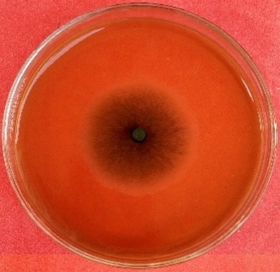 | 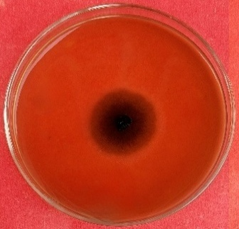 | 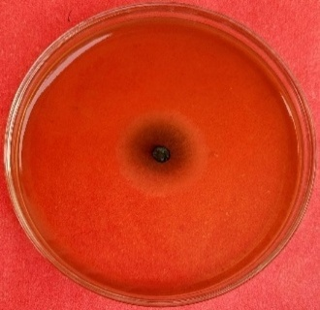
Garlic 2.5% | Garlic 5% | Garlic 10%
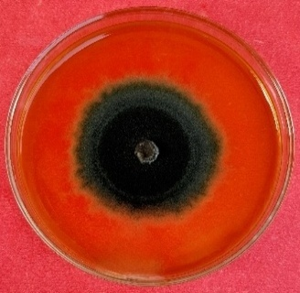 | 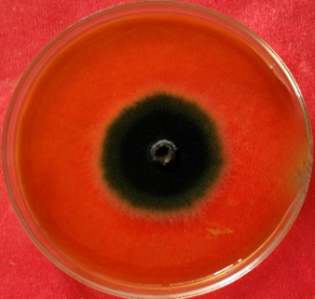  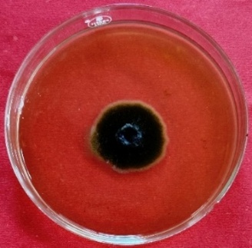
Ginger 2.5% | Ginger 5% | Ginger 10%
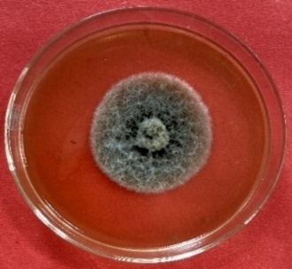 | 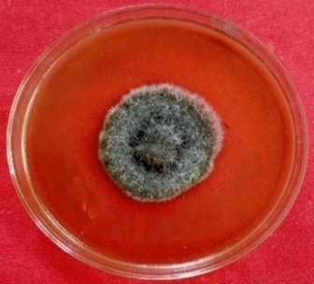  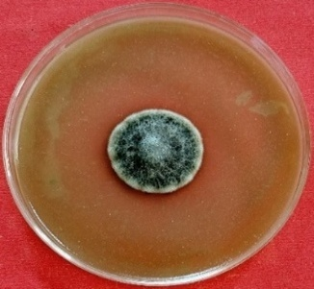
Turmeric 2.5% | Turmeric 5% | Turmeric 10%
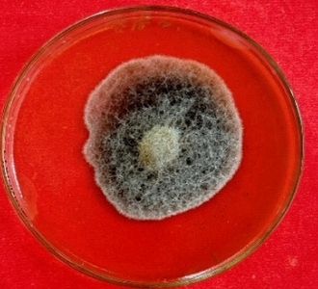  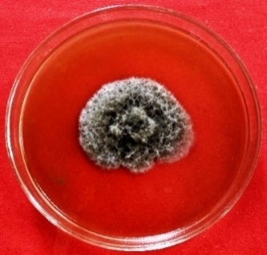 | 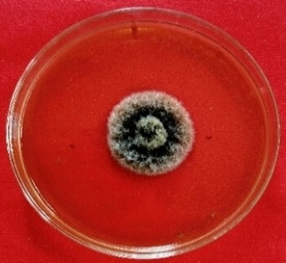
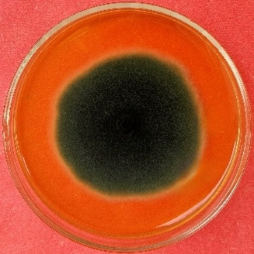  Tulsi 2.5% | Tulsi 5% | Tulsi 10%
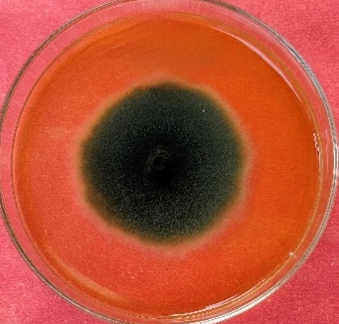
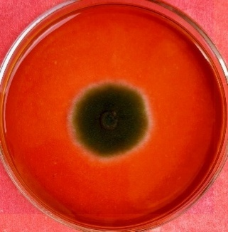

Lantana 2.5% | Lantana 5% | Lantana 10%
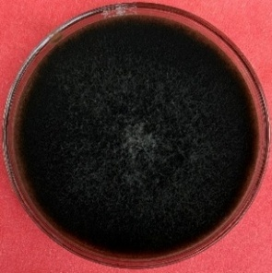

Control

Plate 1: Effect of different botanicals on the mycelial growth of Alternaria brassicae in vitro conditions

3.2 Fungicidal Efficacy Against A. brassicae
The in vitro evaluation of five fungicides at three concentrations (0.025%, 0.05%, and 0.1%) demonstrated superior antifungal efficacy compared with botanical extracts, with all fungicides showing significant, concentration-dependent pathogen suppression (Table 2). The untreated control exhibited complete radial growth of 9.00 cm, with unrestricted colony development and abundant sporulation across the Petri plate surface.
Carbendazim 12% + Mancozeb 63% WP demonstrated exceptional antifungal performance, achieving 98.13%, 98.89%, and 100.00% inhibition at 0.025%, 0.05%, and 0.1% concentrations, respectively. Complete pathogen suppression at the highest concentration indicates a potent dual-mode-of-action combining benzimidazole and dithiocarbamate chemistries. Trifloxystrobin 50% WDG showed comparable efficacy, with 97.18%, 97.93%, and 100.00% inhibition across increasing concentrations.
Difenoconazole 25% EC and Fluxapyroxad 33.3% G/L both achieved complete suppression (100%) at 0.1%, with initial inhibition rates of 96.83% and 96.56% at 0.025%, respectively. Penflufen 240 FS showed comparatively lower efficacy among the tested fungicides, recording only 97.78% inhibition at the maximum concentration, with 2.00 cm residual radial growth, indicating incomplete pathogen suppression and potential differential sensitivity.
All fungicides, except Penflufen, achieved complete suppression of mycelial growth at 0.1%, demonstrating superior antifungal potency compared to botanical extracts. Statistical analysis revealed highly significant treatment effects, with an SEm± of 0.04 cm and a CD of 0.13 cm at the 5% significance level, confirming genuine differences in antifungal efficacy among the tested fungicide formulations and concentration levels.

Table 2: Effect of different fungicides on mycelial growth of Alternaria brassicae under in vitro conditions
Treatment | Fungicide | Concentration (%) | Radial growth (cm) | Per cent inhibition (%)
T₁ | Carbendazim 12% + Mancozeb 63% WP | 0.025 | 1.68 | 98.13
T₁ | Carbendazim 12% + Mancozeb 63% WP | 0.05 | 1.00 | 98.89
T₁ | Carbendazim 12% + Mancozeb 63% WP | 0.1 | 0.00 | 100.00
T₂ | Difenoconazole 25% EC | 0.025 | 2.85 | 96.83
T₂ | Difenoconazole 25% EC | 0.05 | 1.98 | 97.80
T₂ | Difenoconazole 25% EC | 0.1 | 0.00 | 100.00
T₃ | Fluxapyroxad 33.3% G/L | 0.025 | 3.10 | 96.56
T₃ | Fluxapyroxad 33.3% G/L | 0.05 | 2.45 | 97.28
T₃ | Fluxapyroxad 33.3% G/L | 0.1 | 0.00 | 100.00
T₄ | Penflufen 240 FS | 0.025 | 3.46 | 96.16
T₄ | Penflufen 240 FS | 0.05 | 2.36 | 97.38
T₄ | Penflufen 240 FS | 0.1 | 2.00 | 97.78
T₅ | Trifloxystrobin 50% WDG | 0.025 | 2.54 | 97.18
T₅ | Trifloxystrobin 50% WDG | 0.05 | 1.86 | 97.93
T₅ | Trifloxystrobin 50% WDG | 0.1 | 0.00 | 100.00
T₆ | Control | – | 9.00 | –
 | SEm (±) | – | 0.04
 | CD (5%) | – | 0.13

Fig. 2: Graph showing Effect of different fungicides on mycelial growth of Alternaria brassicae under in vitro conditions
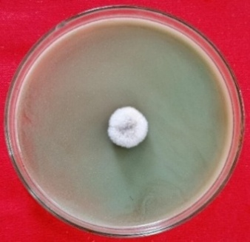 | 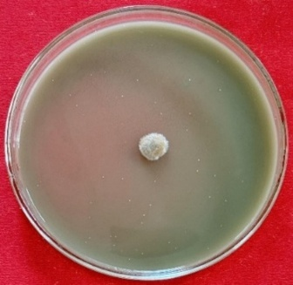 | 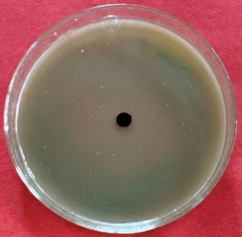
Carbendazim 12% + Mancozeb 63% WP -(0.025%) | Carbendazim 12% + Mancozeb 63% WP -  (0.05%) | Carbendazim 12% + Mancozeb 63% WP -(0.1%)
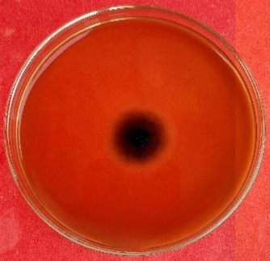 | 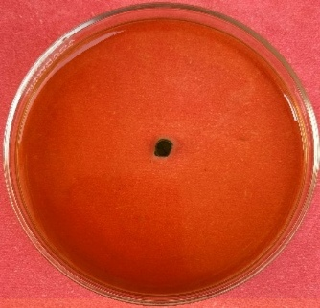  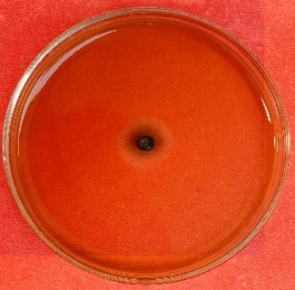
Difenoconazole 25% EC - (0.025%) | 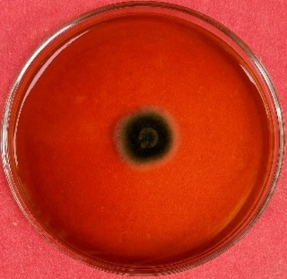  Difenoconazole 25% EC - (0.05%) | Difenoconazole 25% EC - (0.1%)
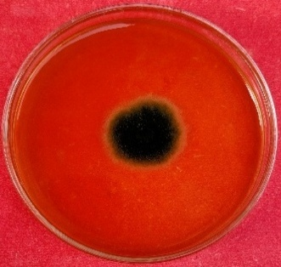 | 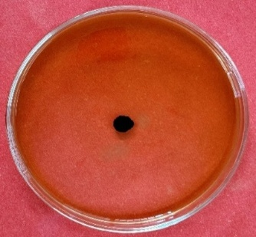
Fluxapyroxad 33.3%  G/L - (0.025%) | Fluxapyroxad 33.3% G/L - (0.05%) | Fluxapyroxad 33.3% G/L - (0.1%)
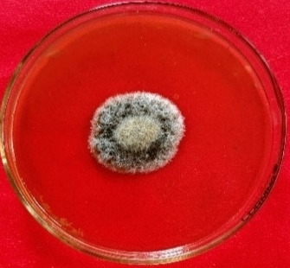 | 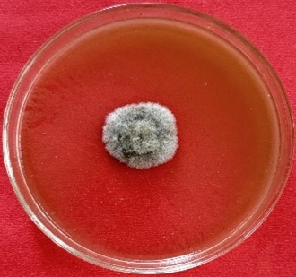  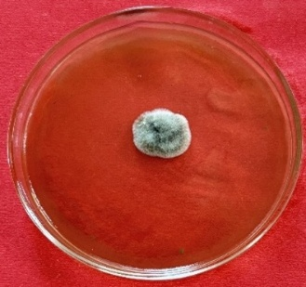
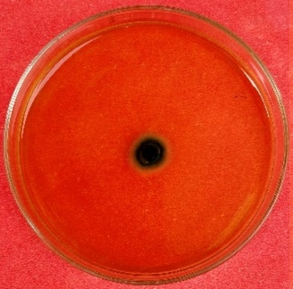  Penflufen 240 FS - (0.025%) | Penflufen 240 FS -  (0.05%) | Penflufen 240 FS -(0.1%)
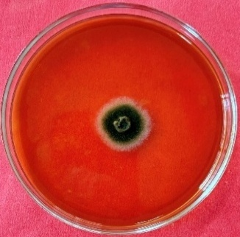 | 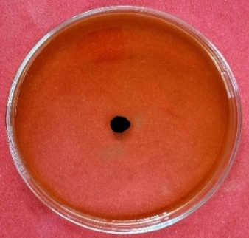
Trifloxystrobin 50% WDG - (0.025%) | Trifloxystrobin 50% WDG - (0.05%) | Trifloxystrobin 50% WDG - (0.1%)
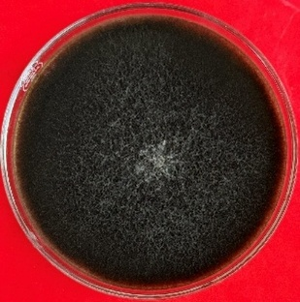

Control

Plate 2: Effect of different fungicides on mycelial growth of Alternaria brassicae under in vitro conditions

4. Discussion
The superior antifungal efficacy of garlic and turmeric extracts can be attributed to their rich content of bioactive compounds with proven antimicrobial properties. Garlic's primary bioactive compound, allicin (diallyl thiosulphinate), inhibits fungal growth by covalently binding to thiol-containing enzymes, including acetyl-CoA synthetase, alcohol dehydrogenase, and thioredoxin reductase, thereby disrupting essential metabolic pathways in the pathogen, including carbon metabolism, redox balance, and ergosterol biosynthesis.
Curcumin, the active principle in turmeric, exerts antifungal activity through multiple mechanisms, including disruption of fungal membrane integrity by inserting into lipid bilayers, increasing membrane permeability, and chelating divalent metal ions essential for enzyme cofactor function. The concentration-dependent efficacy observed across all botanical extracts indicates threshold-responsive inhibition, likely reflecting the minimum effective concentrations required for bioactive compounds to exert significant antifungal effects (Guleriaet al., 2021; Behiry et al., 2022). Recent studies have also shown that plant extracts containing alkaloids, phenolics, and terpenoids cause significant morphological disruption in Alternaria species, leading to hyphal lysis and cell death at effective concentrations (Shaikh et al., 2024).
The exceptional performance of the Carbendazim + Mancozeb combination reflects its dual mode of action, targeting multiple cellular processes simultaneously. Carbendazim disrupts microtubule assembly by binding to β-tubulin, thereby preventing nuclear division during mitosis, while Mancozeb inactivates multiple sulfhydryl-containing enzymes essential for cellular respiration and metabolism. This complementary mechanism reduces the likelihood of resistance development and provides robust pathogen control (Ishieze et al., 2023; Shaikh et al., 2024). These findings are consistent with recent reports of superior efficacy of combination fungicides over single-mode-of-action products against Alternaria species (Shaikh et al., 2024).
The incomplete inhibition observed with Penflufen, despite high concentrations, suggests potential intrinsic resistance or reduced sensitivity of the tested A. brassicae population to succinate dehydrogenase inhibitor (SDHI) chemistry. This finding underscores the importance of baseline sensitivity monitoring and resistance management strategies in fungicide stewardship programs. Integrating botanical extracts with reduced fungicide applications offers a promising approach to sustainable disease management while minimising selection pressure for resistance development.
A notable limitation of this study is that all experiments were conducted exclusively under controlled in vitro laboratory conditions, using the poisoned-food technique. Results obtained under in vitro conditions may not directly translate to field performance, where environmental variability, soil microbiome interactions, plant physiological factors, and agronomic practices substantially influence treatment efficacy. Field validation studies under diverse agroclimatic conditions and economic analysis of the proposed integrated approaches are, therefore, essential before these findings can be recommended for large-scale commercial adoption.

5. Conclusion
Chemical fungicides provide superior pathogen suppression, with four achieving complete inhibition at 0.1%. However, botanical extracts, particularly garlic (66.44%) and turmeric (66.00%), demonstrate substantial antifungal activity, offering promising eco-friendly alternatives for sustainable disease management. The clear concentration-dependent efficacy patterns observed support optimized dosing strategies for both chemical and biological interventions. Integrating botanical extracts with reduced fungicide use represents a viable approach to the environmentally sustainable management of Alternaria blight in mustard production systems, balancing effective pathogen control with environmental stewardship and resistance management objectives. Future research should focus on field validation studies and economic analysis to fully realise the potential of these sustainable approaches in commercial agriculture.
COMPETING INTERESTS:

Authors have declared that they have no known competing financial interests OR non-financial interests OR personal relationships that could have appeared to influence the work reported in this paper.
Authors’ contributions: HR conceived and designed the study, conducted the experiments, analysed the data, and drafted the manuscript. MS supervised the research and critically revised the manuscript. SS assisted with data collection and statistical analysis. All authors read and approved the final manuscript.
Acknowledgements: The authors are grateful to the Department of Plant Pathology, Chandra Shekhar Azad University of Agriculture and Technology, Kanpur, for providing laboratory and greenhouse facilities for this research.

Disclaimer (Artificial intelligence)
Author(s) hereby declare that NO generative AI technologies such as Large Language Models (ChatGPT, COPILOT, etc.) and text-to-image generators have been used during the writing or editing of this manuscript.

6. References
- Behiry, S. I., Philip, B., Salem, M. Z. M., Amer, M. A., El-Samra, I. A., Abdelkhalek, A. and Heflish, A. (2022). Urtica dioica and Dodonaea viscosa leaf extracts as eco-friendly bioagents against Alternaria alternata. Scientific Reports, 12, 16468. https://doi.org/10.1038/s41598-022-20708-4
- Guleria, S. and Kumar, A. (2009). Antifungal activity of Agave americana leaf extract against Alternaria brassicae. Archives of Phytopathology and Plant Protection, 42, 370–375. https://doi.org/10.1080/03235400601121380

- Guleria, S., Kumari, S. and Guleria, P. (2021). Management of spot disease of Indian mustard caused by Alternaria brassicae using botanical fungicide. Indian Phytopathology, 74, 783–790. https://doi.org/10.1007/s42360-021-00388-w
- Ishieze, P. U., Amuji, C. F., Ugwuoke, K. I., Baiyeri, P. K. and Eze, M. O. (2023). Comparative efficacy of systemic and combination fungicides for the control of Alternaria leaf spot of cabbage. Applied Microbiology, 3(3), 906–914. https://doi.org/10.3390/applmicrobiol3030062
- Pandey, M. K., Ahmad, M. M., Siddiqui, S., Kumar, A., Singh, S. K. and Rai, D. (2024). Survey on the disease incidence of Alternaria Blight of Mustard in Eastern and Central Parts of Uttar Pradesh. International Journal of Plant and Environment, 10, 69–75. https://doi.org/10.18811/ijpen.v10i01.09
- Samandari-Najafabadi, N., Taheri, P. and Tarighi, S. (2024). Antifungal and antivirulence effects of Citrus sinensis essential oil on Alternaria pathogens. Journal of Plant Pathology, 106, 1153–1171. https://doi.org/10.1007/s42161-024-01638-8
- Shaikh, S., Ghone, R., Urdukhe, Y. R. and Mogle, U. (2024). Efficacy of botanical extracts, biocontrol agents and fungicides against Alternaria brassicicola. International Journal of Current Microbiology and Applied Sciences, 13, 88–96. https://doi.org/10.20546/ijcmas.2024.1304.010
- Vincent, J. M. (1947). Distortion of fungal hyphae in the presence of certain inhibitors. Nature, 159, 850. https://doi.org/10.1038/159850b0.
- Ahammad, F., Mapari, P. N., Kumar, R., Datre, S., Thakur, J., Patil, P., & Zacharia, S. (2024). In vitro Evaluation of Fungicides and Plant Derived Extracts on Mycelial Growth of Alternaria brassicae. Journal of Scientific Research and Reports, 30(7), 246–251. https://doi.org/10.9734/jsrr/2024/v30i72141
- Pun, L. B., Chhetri, K., Pandey, A., & Poudel, R. (2020). In vitro evaluation of botanical extracts, chemical fungicides and Trichoderma harzianum against Alternaria brassicicola causing leafspot of cabbage. Nepalese Horticulture, 14(1), 68-76.
- Mishra, A., Khan, N. A., Jha, R. K., Murugesh, T., & Singh, A. (2024). Study of resistance mechanism of Alternaria blight (Alternaria brassicicola) by biochemical markers in Indian Mustard (Brassica juncea L. Czern. &Coss.). Frontiers in Plant Science, 15, 1420197.
- Ahmed, R., Saikia, P., Aryasree, R., & Bhorali, P. (2024). Isolation and characterization of Alternaria brassicicola from Assam (India) and screening for resistance in Sinapis alba. Tropical Plant Pathology, 49(6), 850-863.

