Evaluation of Genetic Variation for Yield and Growth Traits in Different Types of Oat (Avena sativa L.)

Abstract
The majority of the crop produced by cultivars was sown in the spring, however in places with a high elevation, genotypes are sown in the autumn, and locations with sweltering summers. This present study aimed to examine the level of genetic diversity within different genotypes of oats (Avena sativa L.) for yield and other growth characters during the rabi season (2025-26). The research trial was conducted during the rabi season of 2025-26 at the Agricultural Research Farm of Prof. Rajendra Singh (Rajju Bhaiya) University, Naini, Prayagraj, Uttar Pradesh. In the present investigation, 13 oat genotypes were evaluated in a randomized block design method having three replications. The purpose of this experiment was to determine the genetic variation, heritability, genetic advance, correlation coefficient, path coefficient and genetic diversity (D²) analysis for yield and its contributing factors. Data were collected for 18 traits. Based on analysis of variance, revealed significant differences among all genotypes for all eighteen characters, indicating the presence of considerable genetic variability. The phenotypic coefficient of variation (PCV) was more than genotypic coefficient of variation (GCV) for all traits. Correlation analysis revealed that seed yield plant⁻¹ (g) exhibited highly significant positive association with seeds per panicle, tillers count per plant, leaves count per plant, width of flag leaf (cm) and harvest index(%). Path coefficient analysis indicated that seeds per panicle and Seed yield plot⁻¹ (kg) exerted the highest positive direct effect on seed yield plant⁻¹ (g). The Mahalanobis D² and Tocher’s cluster analysis methods were used to determine divergence based on genetic diversity within different oat genotypes. The total number of genotypes were divided into five groups. Group I had the highest number of genotypes, while group IV and V had only one genotype each, which indicated high differentiation among the genotypes. The highest inter-group distance was found between group II and group V. The lowest inter-group distance was found between group I and group IV. Based on cluster mean performance, cluster II appeared to be superior for yield-related traits, whereas cluster III had high biological yield (kg) and maturity period. Therefore, it may be concluded that highly diverged clusters, such as clusters II and V.
Key Words: Genetic variability, heritability, correlation coefficient, genetic diversity, oat

- Introduction
Oat have been used as both human food and livestock feed since ancient times. While some oat varieties are cultivated as pasture or hay, the majority serve as feed grains. Oat straw has historically been a valuable source of bedding for livestock. Both oat forage and grain are rich in 9.23% fat, 3.56% protein, 30.44% fiber, 0.82% calcium and 0.27% phosphorus (Gohain et al., 2023 and Mishra et al., 2026). Globally, most oat grain is used for animal feed and in human diets. It is primarily fed to dairy cattle, horses, mules, and turkeys, with smaller amounts given to hogs, beef cattle, and sheep. Oat hulls, a by-product of food processing, are utilized as animal feed, fuel for power plants, and in the chemical industry. Oat bran, in particular, has gained significant attention from the medical community for its role in lowering blood cholesterol. Experts attribute this benefit to β-glucans – water-soluble fibers found in oat bran – which help reduce cholesterol levels and, in turn, prevent heart disease. Nutritionists also recommend increasing daily fiber intake, such as that from oat bran, as it promotes healthy digestion. Several breakfast cereals and bakery products are made from oat flour and rolled oats. Additionally, certain oat-based ingredients serve as antioxidants and stabilizers in ice cream and other dairy products. Oat are an important fodder and feed crop. They grow best in cool environments with temperatures between 15-25°C and adequate moisture. The crop is tolerant of cold weather and remains unaffected by late frosts or snow. Globally, oats rank sixth among cereal crops, following wheat, maize, rice, barley, and sorghum. Botanically, oat (Avena sativa L., 2n = 6x = 42) is a self-pollinated species belonging to the grass family Poaceae (FAOSTAT, 2022).
Oat belong to the genus Avena within the family Poaceae and rank sixth among cereal crops globally. In India, 1.0 million hectares of oat are grown, producing 1.7 to 2.5 tonnes of grain per hectare and 35 to 50 tonnes of 7-9 tonnes of dry matter and green fodder per acre, respectively (Anonymous-ICAR, 2019). The majority of the crop produced by cultivars was sown in the spring, however in places with a high elevation, genotypes are sown in the autumn, and locations with sweltering summers. In colder climates, spring-style oats can be sown in the fall to avoid the summertime heat and drought, In India, oats occupy around 1.0 million hectares, with the largest cultivated area in Uttar Pradesh, followed by Punjab, Bihar, Haryana, and Madhya Pradesh. Oat grown in these regions show wide adaptability due to their excellent growing habits, rapid regeneration, and superior nutritional value (Misri, 2004).
In India, oat are widely cultivated in Uttar Pradesh, Madhya Pradesh, Haryana, Punjab, Himachal Pradesh, Rajasthan, Bihar, Gujarat, Andhra Pradesh, and the hilly regions of the southern plateau. The crop is predominantly grown during the Rabi season, mainly for fodder purposes. In recent years, however, oat grains have also been increasingly used for preparing baby food, breakfast cereals, and animal feed. Farmers have readily adopted oat cultivation because of its multi-cut nature and high yield of nutritious, palatable fodder. Among rabi fodder crops, oats are noted for their higher dry matter content, protein levels ranging from 7–10%, and resistance to various diseases. The crop is particularly well-suited for silage production. It provides the highest green fodder yield per unit area and time, even with minimal irrigation. Moreover, due to its multi-cut system and rapid growth habit, oat ensure a consistent supply of green fodder over an extended period (Devi et al., 2025).
This research work was carried out with an objective to examine the level of genetic diversity within different genotypes of oats (Avena sativa L.) for yield and other growth characters during the rabi season 2025-26. The objectives were to (i)) To estimate the genetic variation for yield and growth traits in oat genotypes using heritability, and genetic advance. (ii) To study about trait associations through correlation and path coefficient analysis to identify key traits influencing grain yield and growth in oat (Avena sativa L.). (iii) To assess the genetic diversity among oat genotypes for agronomic and yield characters using D²-statistics.
2. Materials and Methods
2.1 Experimental Location, Design and Materials
The current experiment was conducted during rabi season 2025-26 at the Agricultural Research Farm of Prof. Rajendra Singh (Rajju Bhaiya) University, Naini, Prayagraj, Uttar Pradesh, with 13 oat genotypes (Table 1), viz., NDO - 1, JHO - 822, Kent, NDO - 724, NDO - 1802, NDO - 02, NDO - 03, NDO - 1101, OS - 6, UPO - 212, NDO - 711, NDO - 1102 and NDO – 952 (check variety). The plants were grown in a 3×2.5 m² plot with 30×10 cm² (R×P) with three replicates in a randomized block design (RBD).

Table 1. List of oat genotypes.
S. No. | Genotypes Name | Sourced By
1. | NDO - 1 | ANDUAT, Ayodhya, U.P.
2. | JHO - 822 | ANDUAT, Ayodhya, U.P.
3. | Kent | ANDUAT, Ayodhya, U.P.
4. | NDO - 724 | ANDUAT, Ayodhya, U.P.
5. | NDO - 1802 | ANDUAT, Ayodhya, U.P.
6. | NDO - 02 | ANDUAT, Ayodhya, U.P.
7. | NDO - 03 | ANDUAT, Ayodhya, U.P.
8. | NDO - 1101 | ANDUAT, Ayodhya, U.P.
9. | OS - 6 | ANDUAT, Ayodhya, U.P.
10. | UPO - 212 | ANDUAT, Ayodhya, U.P.
11. | NDO - 711 | ANDUAT, Ayodhya, U.P.
12. | NDO - 1102 | ANDUAT, Ayodhya, U.P.
13. | NDO - 952 | ANDUAT, Ayodhya, U.P.

2.2 Observations Recording
The data on various characters viz., days to 50% flowering, plant height at 30, 60, 90 DAS (cm), tillers count per plant, leaves count per plant, length of flag leaf (cm), width of flag leaf (cm), length of panicle (cm), length of pedicle (cm), days after sowing to maturity, biological yield (g), harvest index (%), 1000 seed weight (Test weight), spikelets per panicle, seeds per panicle, Seed yield plot⁻¹ (kg), seed yield plant⁻¹ (g) was recorded.
2.3 Statistical Evaluation
Mean values of the characters from each replication in respect to every genotype were calculated. Later, analysis of variance was conducted through the procedure recommended by Panse and Sukhatme (1967). Phenotypic Coefficient of Variation (PCV) and Genotypic Coefficient of Variation (GCV) were calculated in accordance with the procedure outlined by Burton (1952). Heritability estimates were made on the basis of Broad-sense heritability through the procedure recommended by Burton and Devane (1953). The genetic advance (GA) and Genetic Advance as Percent of Mean (GAM%) were calculated on the basis of the equations provided by Johnson et al. (1955). Correlation estimates were calculated based on the genotypic (rg) and phenotypic (rp) correlation coefficients, as recommended by Robinson et al. (1955). Path coefficient analysis, considering the effect estimates both directly and indirectly, was conducted as per the procedure of Dewey and Lu (1959). Diversity among the oat genotypes was measured through Mahalanobis D² statistics (1928). The clustering process of the genotypes was conducted using Tocher’s method.
3. Results and Discussion
3.1 ANOVA (Analysis of Variance)
Analysis of variance showed significant differences among the 13 oat genotypes for the 18 traits studied. Analysis of variance showed significant differences among the genotypes at 1% and 5% level of significance. The mean sum squares are given in table 2 for different traits. The highly significant mean sum of squares was recorded for the traits viz., days to 50% flowering, plant height at 30 DAS, plant height at 60 DAS, plant height at 90 DAS, tillers count per plant, leaves count per plant, length of flag leaf (cm), width of flag leaf (cm), length of panicle (cm), length of pedicle (cm), days after sowing to maturity, biological yield (kg), harvest index (%), 1000 seed weight, spikelets per panicle, seeds per panicle, seed yield plot⁻¹ (kg), seed yield plant⁻¹ (g). Mayuri and Rashmi (2022), Sahu et al. (2023), Parameshwaran et al. (2024), Devi et al. (2025) and Arya et al. (2026) also recorded highly significant differences among the oat genotypes with respect most of the characters under their studies.
Table 2: Analysis of variance (ANOVA) for 18 traits of oat genotypes.
Traits | Mean sum of squares
Traits | Replications | Genotypes | Error
Traits | (d. f=2) | (d. f=12) | (d. f=24)
Days to 50% flowering | 3.41 | 19.085 ** | 1.021
Plant Height at 30 DAS | 5.394 | 7.341 ** | 2.299
Plant Height at 60 DAS | 9.386 | 6.766 ** | 1.565
Plant Height at 90 DAS | 19.934 | 19.136 ** | 4.086
Tillers count per plant | 0.095 | 1.973 ** | 0.161
Leaves count per plant | 9.998 | 20.372 ** | 1.445
Length of flag leaf (cm) | 7.333 | 51.073 ** | 7.781
Width of flag leaf (cm) | 0.048 | 0.321 ** | 0.031
Length of panicle (cm) | 0.09 | 41.939 ** | 2.607
Length of pedicle (cm) | 0.003 | 10.232 ** | 0.405
DAS to maturity | 15.487 | 18.38 ** | 1.432
Biological yield (kg) | 0.025 | 1.793 ** | 0.013
Harvest index (%) | 4.528 | 251.983 ** | 5.399
1000 seed weight | 4.333 | 14.368 ** | 4.278
Spikelets per panicle | 2.752 | 160.406 ** | 5.324
Seeds per panicle | 1.918 | 583.064 ** | 3.476
Seed yield plot⁻¹ (kg) | 0.024 | 0.337 ** | 0.008
Seed yield plant⁻¹ (g) | 0.22 | 4.171 ** | 0.039
* indicates significance at 5% level, ** indicates significance at 1% level
3.2 Evaluation of oat genotypes based on mean performance
The days to 50% flowering ranged from 75.33 days to 83.67 days with a mean of 79.79 days. The maximum days to 50% flowering was observed in UPO–212 (83.67 days) followed by NDO–1102 (83.00 days) and OS–6 (82.00 days). Whereas, the minimum was recorded in JHO–822 (75.33 days) followed by NDO–1 (75.67 days). Plant height at 30 DAS ranged from 28.80 cm to 33.43 cm with a mean of 31.13 cm. The maximum height of the plant was found for the variety NDO–1802 (33.43 cm), followed by NDO–02 (33.30 cm) and NDO–1102 (32.30 cm), whereas the minimum plant height was recorded in JHO–822 (28.80 cm). Plant heights at 60 DAS ranged from 98.90 cm to 103.27 cm, with the mean plant height of 101.20 cm. The maximum heights of plants at 60 DAS were recorded in the varieties NDO–711 (103.27 cm), NDO–1 (103.07 cm) and NDO–1101 (102.97 cm). Whereas, the minimum was recorded in NDO–952 (98.90 cm). Plant height at 90 DAS ranged from 161.33 cm to 169.53 cm with a mean of 165.71 cm. The maximum plant height was observed in Kent (169.53 cm) followed by NDO–711 (169.37 cm) and OS–6 (168.00 cm). Whereas, the minimum data were collected from NDO–1102 (161.33 cm). Tiller numbers per plant were found between 5.30 and 7.87, with an average value of 6.72. Maximum tiller number data were obtained from NDO–1101 (7.87), followed by NDO–1802 (7.73) and NDO–952 (7.23), but the minimum data was acquired from NDO–724 (5.30). Leaves per plant were found between 21.47 and 31.80, with a mean value of 27.97. The highest number of leaves per plant was noted in NDO–1101 (31.80) followed by NDO–1802 (31.07). Whereas, the minimum was recorded in NDO–724 (21.47). Length of flag leaf ranged from 33.70 cm to 46.33 cm with a mean of 39.27 cm. The maximum length of flag leaf was recorded in NDO–952 (46.33 cm) followed by NDO–1 (45.67 cm). Whereas, the minimum was recorded in NDO–1802 (33.70 cm). Width of flag leaf ranged from 1.47 cm to 2.40 cm with a mean of 1.92 cm. The maximum width of flag leaf was recorded in NDO–952 (2.40 cm) followed by UPO–212 (2.30 cm). Whereas, the minimum was recorded in OS–6 (1.47 cm). Length of panicle ranged from 24.10 cm to 33.50 cm with a mean of 28.72 cm. The maximum length of panicle was recorded in NDO–03 and NDO–952 (33.50 cm) followed by NDO–724 (32.73 cm). Whereas, the minimum was recorded in Kent (24.10 cm). Pedicel length ranged from 8.30 cm to 13.40 cm with a mean of 11.05 cm. The maximum pedicel length was recorded in NDO–1101 (13.40 cm) followed by NDO–02 (13.07 cm). Whereas, the minimum was recorded in NDO–03 (8.30 cm). days after sowing to maturity ranged from 111.33 days to 118.67 days with a mean of 114.95 days. The maximum maturity duration was observed in UPO–212 and NDO–952 (118.67 days) followed by NDO–1101 (117.00 days). Whereas, the minimum was recorded in JHO–822 (111.33 days). Biological yield ranged from 3.30 kg to 5.60 kg with a mean of 4.65 kg. The maximum biological yield was recorded in NDO–952 (5.60 kg) followed by NDO–1802 (5.37 kg) and NDO–03 (5.37 kg). Whereas, the minimum was recorded in NDO–724 (3.30 kg). Harvest index ranged from 30.80% to 59.70% with a mean of 43.20%. The maximum harvest index was recorded in JHO–822 (59.70%) followed by NDO–1101 (58.10%). Whereas, the minimum was recorded in UPO–212 (30.80%). 1000 seed weight ranged from 36.30 g to 43.70 g with a mean of 39.80 g. The maximum seed weight was recorded in NDO–03 (43.70 g) followed by NDO–724 (41.30 g). Whereas, the minimum was recorded in NDO–711 (36.30 g). Spikelets per panicle ranged from 64.40 to 85.70 with a mean of 76.78. The maximum number of spikelets was recorded in NDO–952 (85.70) followed by NDO–1101 (85.30). Whereas, the minimum was recorded in NDO–03 (64.40). Seeds per panicle ranged from 132.10 to 177.90 with a mean of 161.14. The maximum number of seeds was recorded in NDO–952 (177.90) followed by NDO–1101 (177.20). Whereas, the minimum was recorded in NDO–724 (132.10). Seed yield plot⁻¹ ranged from 1.40 kg to 2.40 kg with a mean of 1.95 kg. The maximum seed yield was recorded in NDO–952 (2.40 kg) followed by JHO–822 and NDO–1802 (2.30 kg). Whereas, the minimum was recorded in NDO–724 (1.40 kg). Seed yield plant⁻¹ ranged from 5.60 g to 9.30 g with a mean of 7.65 g. The maximum seed yield plant⁻¹ was recorded in NDO–952 (9.30 g) followed by NDO–1802 (9.10 g) and JHO–822 (8.90 g). Whereas, the minimum was recorded in NDO–724 (5.60 g). The present investigation revealed a considerable amount of variability among the 13 oat genotypes for all the 18 characters studied. Early flowering genotypes such as JHO–822 and NDO–1 may be useful in breeding programmes aimed at developing short-duration varieties, whereas late maturing genotypes like UPO–212 and NDO–952 could be beneficial for higher biological yield accumulation under favourable conditions. Growth-related traits such as plant height at different stages (30, 60, and 90 DAS) showed moderate variation, indicating stable growth performance among genotypes. However, genotypes like Kent and NDO–711 exhibited higher plant height at later stages, which may contribute to higher biological yield. Yield contributing traits such as tillers count per plant, leaves count per plant, length of panicle, and flag leaf characteristics showed noticeable variability. Genotypes like NDO–1101 and NDO–1802 exhibited superior performance in terms of tiller number and leaf production, which are important for enhancing photosynthetic efficiency and ultimately yield. Among yield traits, biological yield and seed yield plot⁻¹ and per plant showed wide variation, reflecting the combined effect of all contributing traits. The genotype NDO–952 consistently performed superior for biological yield, number of spikelets, seeds per panicle, and seed yield, indicating its potential as a high-yielding genotype. Similarly, genotypes JHO–822 and NDO–1802 also showed promising performance for yield and related traits. Harvest index, which reflects the efficiency of conversion of biological yield into economic yield, varied significantly among genotypes. Higher harvest index observed in JHO–822 and NDO–1101 suggested better partitioning of assimilates towards grain yield. Genotypes with higher seed weight such as NDO–03 may contribute positively to overall grain yield. Overall, the results indicated that genotypes NDO–952, NDO–1802, NDO–1101, and JHO–822 were superior for most of the yield and yield contributing traits. Similar finding were also reported by Chauhan and Singh (2019), Gupta and Mehta (2020), Nechu et al. (2021), Mayuri and Rashmi (2022) and Ravi Raj et al. (2025).

Table 3. Evaluation of 13 oat genotypes based on mean performance.
Genotypes | Days to 50% flowering | Plant Height at 30 DAS | Plant Height at 60 DAS | Plant Height at 90 DAS | Tillers count per plant | Leaves count per plant | Length of flag leaf (cm) | Width of flag leaf (cm) | Length of panicle (cm) | Length of pedicle (cm) | DAS to maturity | Biological yield (kg) | Harvest index (%) | 1000 seed weight | Spikelets per panicle | Seeds per panicle | Seed yield plot⁻¹ (kg) | Seed yield plant⁻¹ (g)
NDO - 1 | 75.67 | 29.53 | 103.07 | 163.40 | 7.20 | 29.13 | 45.67 | 2.00 | 26.67 | 11.17 | 111.67 | 5.27 | 34.8 | 42.0 | 84.4 | 156.5 | 1.8 | 7.4
JHO - 822 | 75.33 | 28.80 | 100.27 | 166.73 | 5.70 | 26.67 | 37.87 | 1.60 | 30.93 | 8.40 | 111.33 | 3.80 | 59.7 | 38.3 | 74.5 | 174.1 | 2.3 | 8.9
Kent | 78.00 | 31.73 | 101.40 | 169.53 | 6.73 | 26.73 | 39.60 | 2.13 | 24.10 | 12.93 | 113.33 | 5.20 | 42.6 | 38.3 | 67.7 | 163.8 | 2.2 | 8.1
NDO - 724 | 78.33 | 29.33 | 101.90 | 162.53 | 5.30 | 21.47 | 36.73 | 1.53 | 32.73 | 9.27 | 111.67 | 3.30 | 43.1 | 41.3 | 75.9 | 132.1 | 1.4 | 5.6
NDO - 1802 | 79.00 | 33.43 | 99.57 | 165.07 | 7.73 | 31.07 | 33.70 | 2.27 | 25.97 | 11.50 | 115.00 | 5.37 | 43.5 | 37.0 | 84.9 | 176.5 | 2.3 | 9.1
NDO - 02 | 80.00 | 33.30 | 101.77 | 166.77 | 7.07 | 26.73 | 43.93 | 1.57 | 27.97 | 13.07 | 114.00 | 4.33 | 51.6 | 41.0 | 76 | 164.7 | 2.2 | 8.2
NDO - 03 | 80.33 | 30.03 | 102.10 | 165.33 | 6.93 | 27.60 | 37.03 | 1.70 | 33.50 | 8.30 | 116.00 | 5.37 | 34.2 | 43.7 | 64.4 | 154.8 | 1.8 | 7
NDO - 1101 | 80.00 | 32.27 | 102.97 | 163.53 | 7.87 | 31.80 | 39.27 | 2.17 | 25.40 | 13.40 | 117.00 | 3.83 | 58.1 | 37.7 | 85.3 | 177.2 | 2.2 | 8.8
OS - 6 | 82.00 | 30.03 | 101.13 | 168.00 | 7.20 | 26.73 | 42.00 | 1.47 | 29.77 | 9.27 | 115.67 | 4.80 | 36.8 | 40.0 | 73.5 | 151.8 | 1.8 | 7.1
UPO - 212 | 83.67 | 31.83 | 99.03 | 166.83 | 6.67 | 29.73 | 33.90 | 2.30 | 25.13 | 12.27 | 118.67 | 5.33 | 30.8 | 41.7 | 82.9 | 165.4 | 1.6 | 6.5
NDO - 711 | 81.00 | 32.10 | 103.27 | 169.37 | 6.20 | 27.60 | 38.47 | 1.73 | 33.47 | 11.67 | 116.33 | 4.47 | 34.9 | 36.3 | 74.5 | 142.6 | 1.6 | 6.1
NDO - 1102 | 83.00 | 32.30 | 100.20 | 161.33 | 5.57 | 28.53 | 36.07 | 2.03 | 24.27 | 9.70 | 115.00 | 3.80 | 48.5 | 41.0 | 68.5 | 157.4 | 1.8 | 7.3
NDO – 952 (check variety) | 81.00 | 30.00 | 98.90 | 165.80 | 7.23 | 29.87 | 46.33 | 2.40 | 33.50 | 12.77 | 118.67 | 5.60 | 43.2 | 39.3 | 85.7 | 177.9 | 2.4 | 9.3
Mean | 79.79 | 31.13 | 101.2 | 165.71 | 6.72 | 27.97 | 39.27 | 1.92 | 28.72 | 11.05 | 114.95 | 4.65 | 43.2 | 39.8 | 76.78 | 161.14 | 1.95 | 7.65
SEd (±) | 0.83 | 1.24 | 1.02 | 1.65 | 0.33 | 0.98 | 2.28 | 0.14 | 1.32 | 0.52 | 0.98 | 0.09 | 1.9 | 1.69 | 1.88 | 1.52 | 0.07 | 0.16
CD (5%) | 1.7 | 2.56 | 2.11 | 3.41 | 0.68 | 2.03 | 4.70 | 0.3 | 2.72 | 1.07 | 2.02 | 0.19 | 3.9 | 3.49 | 3.89 | 3.14 | 0.15 | 0.33
CV | 1.27 | 4.87 | 1.24 | 1.22 | 5.97 | 4.3 | 7.10 | 9.15 | 5.62 | 5.76 | 1.04 | 2.47 | 5.4 | 5.19 | 3 | 1.16 | 4.61 | 2.6
Max | 83.67 | 33.43 | 103.27 | 169.53 | 7.87 | 31.8 | 46.33 | 2.4 | 33.5 | 13.4 | 118.67 | 5.6 | 59.7 | 43.7 | 85.7 | 177.9 | 2.4 | 9.3
Min | 75.33 | 28.8 | 98.9 | 161.33 | 5.3 | 21.47 | 33.70 | 1.47 | 24.1 | 8.3 | 111.33 | 3.3 | 30.8 | 36.3 | 64.4 | 132.1 | 1.4 | 5.6

3.3 Genetic variation
Genotypic coefficient of variation (GCV) and phenotypic coefficient of variation (PCV) have been tabulated in Table 4 and Figure 1, respectively. The maximum value of GCV was recorded for harvest index (20.97%), biological yield (16.55%), seed yield plot⁻¹ (16.74%), width of flag leaf (16.25%), length of pedicle (16.37%), and seed yield plant⁻¹ (15.33%), implying the presence of significant genetic variability for these traits. The GCV had moderate values for length of panicle (12.60%), tillers per plant (11.56%), length of flag leaf (9.67%), spikelets per panicle (9.36%), leaves per plant (8.97%), and seeds per panicle (8.62%), showing moderate genetic variability for these traits. The low values of GCV were found for days to 50% flowering (3.07%), days to maturity (2.06%), plant height at 30 DAS (4.16%), plant height at 60 DAS (1.30%), plant height at 90 DAS (1.35%), and 1000 seed weight (4.60%), indicating limited genetic variability for these traits. The PCVs were observed to be marginally higher as compared to their corresponding GCVs for all these characteristics, which is an indication of the influence of environment on the manifestation of these traits. The highest PCV was found in case of harvest index (21.65%), while other PCVs included biological yield (16.74%), seed yield plot⁻¹ (17.36%), width of flag leaf (18.65%), and length of pedicle (17.35%).
3.4 Estimation of heritability and genetic advance
Table 4 and Figure 2 represent estimates of heritability and genetic advance. Heritability estimates varied between 42.22% and 98.23%. Highest heritability estimates were recorded for seeds per panicle (98.23%), biological yield (97.82%), seed yield per plant (97.21%), seed yield per plot (92.96%), harvest index (93.83%), and spikelets per panicle (90.66%). This shows that these traits were less influenced by environmental conditions, and hence phenotypic selection based on these traits would prove to be very efficient. High heritability estimates were observed for length of flag leaf (64.96%), width of flag leaf (75.95%), number of tillers per plant (78.96%), days to maturity (79.78%), and days to 50% flowering (85.49%). Conversely, low heritability estimates were recorded for plant height at 30 DAS (42.22%), plant height at 60 DAS (52.55%), plant height at 90 DAS (55.11%), and 1000 seed weight (44.01%), suggesting greater environmental influence. The highest genetic advance as a percentage of mean value was seen in harvest index (41.86%), followed by biological yield (33.73%), seed yield plot⁻¹ (33.25%), length of pedicle (31.81%), and seed yield plant⁻¹ (31.15%). These results reveal that additive genes play a dominant role, and therefore, the chances of successful selection on such traits are high. Moderate genetic advance was found for length of panicle (23.71%), tillers count per plant (21.16%), spikelets per panicle (18.36%), seeds per panicle (17.61%), leaves count per plant (16.68%), and length of flag leaf (16.06%). In contrast, low genetic advance was recorded for days to 50% flowering (5.85%), days to maturity (3.80%), plant height traits, and 1000 seed weight (6.29%), indicating limited potential for improvement through direct selection. It is evident from the current study that there is substantial genetic variability for almost all characters considered among the different oat genotypes. The PCV was always higher compared to GCV for all the characters, which denotes the impact of the environment on these traits. It is observed that there was high variability for attributes like harvest index, biological yield, and seed yield, which gives a lot of room for proper selection. Seed yield, biological yield, harvest index, and the traits associated with them were found to have very high heritability along with high genetic advance, which is an indication of preponderance of additive gene action and suitability for selection. In contrast, traits like days to flowering and plant height showed lower genetic advance, suggesting limited improvement through simple selection. Similar finding were also reported by Singh et al. (2017), Wagh et al. (2018), Chaudhary et al. (2020), Vanjare et al. (2021), Pankaj et al. (2022), Parameshwaran et al. (2024), Devi et al. (2025) and Arya et al. (2026).

Table 4: Assessment of components of variance and genetic parameters for different quantitative characters in oat.
Genotypes | Vg | Vp | GCV (%) | PCV (%) | HERTI (%) | GA | GA AS %
Days to 50% flowering | 6.70 | 7.72 | 3.07 | 3.32 | 85.49 | 4.67 | 5.85
Plant Height at 30 DAS | 3.21 | 5.51 | 4.16 | 6.40 | 42.22 | 1.73 | 5.57
Plant Height at 60 DAS | 2.77 | 4.34 | 1.30 | 1.79 | 52.55 | 1.96 | 1.94
Plant Height at 90 DAS | 7.74 | 11.83 | 1.35 | 1.82 | 55.11 | 3.42 | 2.06
Tillers count per plant | 0.71 | 0.87 | 11.56 | 13.00 | 78.96 | 1.42 | 21.16
Leaves count per plant | 7.27 | 8.72 | 8.97 | 9.95 | 81.36 | 4.66 | 16.68
Length of flag leaf (cm) | 19.61 | 27.40 | 9.67 | 12.00 | 64.96 | 6.30 | 16.06
Width of flag leaf (cm) | 0.12 | 0.15 | 16.25 | 18.65 | 75.95 | 0.55 | 29.18
Length of panicle (cm) | 14.85 | 17.46 | 12.60 | 13.80 | 83.41 | 6.81 | 23.71
Length of pedicle (cm) | 3.55 | 3.95 | 16.37 | 17.35 | 88.98 | 3.51 | 31.81
DAS to maturity | 6.60 | 8.04 | 2.06 | 2.31 | 79.78 | 4.37 | 3.80
Biological yield (kg) | 0.60 | 0.62 | 16.55 | 16.74 | 97.82 | 1.56 | 33.73
Harvest index (%) | 85.79 | 91.19 | 20.97 | 21.65 | 93.83 | 18.09 | 41.86
1000 seed weight | 6.22 | 10.49 | 4.60 | 6.94 | 44.01 | 2.50 | 6.29
Spikelets per panicle | 55.24 | 60.57 | 9.36 | 9.83 | 90.66 | 14.10 | 18.36
Seeds per panicle | 195.51 | 198.99 | 8.62 | 8.70 | 98.23 | 28.37 | 17.61
Seed yield plot⁻¹ (kg) | 0.11 | 0.12 | 16.74 | 17.36 | 92.96 | 0.65 | 33.25
Seed yield plant⁻¹ (g) | 1.40 | 1.44 | 15.33 | 15.55 | 97.21 | 2.38 | 31.15

Fig. 1 Genotypic coefficient of variation (GCV) and phenotypic coefficient of variation (PCV).

Fig. 2 Heritability and genetic advance.
3.5 Genotypic and phenotypic correlation analysis
The genotypic and phenotypic correlation coefficients have been shown in Table 5 and 6, respectively, and graphically in Figure 3 and 4. Genotypic Correlation Coefficients: Seed yield plant⁻¹ (g) had very highly significant positive association with tillers count per plant (0.565**), leaves count per plant (0.601**), width of flag leaf (cm) (0.465**), length of pedicle (cm) (0.402**), harvest index (%) (0.615**), spikelets per panicle (0.373*), seeds per panicle (0.923**) and seed yield plot⁻¹ (kg) (1.002**). But plant height at 60 days after sowing (DAS) (cm) (-0.430**) and 1000 seed weight (g) (-0.464**) had significant negative association with seed yield plant⁻¹ (g). Phenotypic Correlation Coefficients: Seed yield plant⁻¹ (g) had highly significant positive association with tillers count per plant (0.485**), leaves count per plant (0.536**), width of flag leaf (cm) (0.409**), length of pedicle (cm) (0.335*), harvest index (%) (0.582**), spikelets per panicle (0.341*) and seeds per panicle (0.908**). Whereas 1000 seed weight (g) (-0.325*). The results of the correlation analysis suggested that the strength of the genotypic correlation coefficients was comparatively greater than those of the phenotypic correlation coefficients, implying that the relationships among the traits under study were primarily governed by genetic parameters with little effect from the environment. Both at the genotypic and phenotypic level, seed yield plant⁻¹ correlated positively and significantly with the number of seeds per panicle, number of tillers per plant, number of leaves per plant, flag leaf width, and harvest index, revealing that these traits have great importance in determining yield potential. Out of all the traits under consideration, seeds per panicle had the maximum and most consistent positive correlation with seed yield plant⁻¹. The positive association of tillers and leaves per plant with yield reflects the importance of source capacity, while the significant association of harvest index indicates the role of efficient partitioning of assimilates towards economic yield. Similarly, width of flag leaf contributes to photosynthetic efficiency and ultimately enhances yield. On the other hand, 1000 seed weight showed negative association with seed yield at both levels, indicating a compensatory relationship between seed size and seed number. This suggests that increasing seed size alone may not improve yield unless balanced with seed number. Phenological traits such as days to 50% flowering and days after sowing to maturity showed weak or negative association with yield, indicating that early flowering and maturity may be advantageous for better yield performance. Similar finding were also reported by Chaudhary et al. (2020), Nechu et al. (2021), Bichewar et al. (2022), Kebede et al. (2023), Jani et al. (2024), Yaduvanshi et al. (2025) and Arya et al. (2026).
Table 5 Assessment of genotypic correlation coefficient for different quantitative characters in oat.
Traits | Days to 50% flowering | Plant Height at 30 DAS | Plant Height at 60 DAS | Plant Height at 90 DAS | Tillers count per plant | Leaves count per plant | Length of flag leaf (cm) | Width of flag leaf (cm) | Length of panicle (cm) | Length of pedicle (cm) | DAS to maturity | Biological yield (kg) | Harvest index (%) | 1000 seed weight | Spikelets per panicle | Seeds per panicle | Seed yield plot⁻¹ (kg) | Seed yield plant⁻¹ (g)
Days to 50% flowering | 1.00 | 0.524** | -0.377* | 0.007 | 0.063 | 0.246 | -0.261 | 0.249 | -0.098 | 0.176 | 0.853** | 0.134 | -0.359* | 0.113 | -0.083 | -0.075 | -0.332* | -0.292
Plant Height at 30 DAS |  | 1.00 | -0.220 | 0.14 | 0.410** | 0.617** | -0.389* | 0.410** | -0.672** | 0.751** | 0.497** | 0.083 | 0.142 | -0.447** | 0.147 | 0.311* | 0.282 | 0.206
Plant Height at 60 DAS |  |  | 1.00 | 0.102 | 0.072 | -0.268 | 0.349* | -0.594** | 0.204 | -0.006 | -0.415** | -0.357* | 0.007 | -0.002 | -0.220 | -0.577** | -0.350* | -0.430**
Plant Height at 90 DAS |  |  |  | 1.00 | 0.17 | -0.063 | 0.189 | -0.121 | 0.169 | 0.330* | 0.263 | 0.432** | -0.296 | -0.444** | -0.258 | 0.059 | 0.118 | 0.016
Tillers count per plant |  |  |  |  | 1.00 | 0.788** | 0.310* | 0.476** | -0.269 | 0.569** | 0.452** | 0.624** | -0.065 | -0.239 | 0.509** | 0.598** | 0.525** | 0.565**
Leaves count per plant |  |  |  |  |  | 1.00 | 0.027 | 0.835** | -0.462** | 0.535** | 0.637** | 0.496** | 0.049 | -0.314* | 0.561** | 0.784** | 0.507** | 0.601**
Length of flag leaf (cm) |  |  |  |  |  |  | 1.00 | -0.082 | 0.267 | 0.318* | -0.096 | 0.222 | 0.063 | 0.129 | 0.249 | 0.114 | 0.336* | 0.293
Width of flag leaf (cm) |  |  |  |  |  |  |  | 1.00 | -0.523** | 0.645** | 0.577** | 0.532** | -0.076 | -0.288 | 0.586** | 0.641** | 0.424** | 0.465**
Length of panicle (cm) |  |  |  |  |  |  |  |  | 1.00 | -0.446** | 0.039 | -0.044 | -0.182 | 0.056 | -0.161 | -0.391* | -0.221 | -0.264
Length of pedicle (cm) |  |  |  |  |  |  |  |  |  | 1.00 | 0.416** | 0.29 | 0.084 | -0.499** | 0.555** | 0.446** | 0.402** | 0.402**
DAS to maturity |  |  |  |  |  |  |  |  |  |  | 1.00 | 0.456** | -0.313* | -0.180 | 0.277 | 0.332* | 0.036 | 0.089
Biological yield (kg) |  |  |  |  |  |  |  |  |  |  |  | 1.00 | -0.623** | 0.125 | 0.191 | 0.335* | 0.236 | 0.232
Harvest index (%) |  |  |  |  |  |  |  |  |  |  |  |  | 1.00 | -0.443** | 0.071 | 0.482** | 0.607** | 0.615**
1000 seed weight |  |  |  |  |  |  |  |  |  |  |  |  |  | 1.00 | -0.348* | -0.375* | -0.499** | -0.464**
Spikelets per panicle |  |  |  |  |  |  |  |  |  |  |  |  |  |  | 1.00 | 0.464** | 0.265 | 0.373*
Seeds per panicle |  |  |  |  |  |  |  |  |  |  |  |  |  |  |  | 1.00 | 0.900** | 0.923**
Seed yield plot⁻¹ (kg) |  |  |  |  |  |  |  |  |  |  |  |  |  |  |  |  | 1.00 | 1.002**
Seed yield plant⁻¹ (g) |  |  |  |  |  |  |  |  |  |  |  |  |  |  |  |  |  | 1.00
* indicates significance at 5% level, ** indicates significance at 1% level
Table. 6 Assessment of phenotypic correlation coefficient for different quantitative characters in oat.
Traits | Days to 50% flowering | Plant Height at 30 DAS | Plant Height at 60 DAS | Plant Height at 90 DAS | Tillers count per plant | Leaves count per plant | Length of flag leaf (cm) | Width of flag leaf (cm) | Length of panicle (cm) | Length of pedicle (cm) | DAS to maturity | Biological yield (kg) | Harvest index (%) | 1000 seed weight | Spikelets per panicle | Seeds per panicle | Seed yield plot⁻¹ (kg) | Seed yield plant⁻¹ (g)
Days to 50% flowering | 1.00 | 0.345* | -0.256 | 0.076 | 0.046 | 0.211 | -0.217 | 0.139 | -0.058 | 0.13 | 0.730** | 0.117 | -0.295 | 0.16 | -0.066 | -0.071 | -0.264 | -0.255
Plant Height at 30 DAS |  | 1.00 | 0.106 | 0.059 | 0.29 | 0.27 | -0.171 | 0.296 | -0.421** | 0.472** | 0.217 | 0.066 | 0.049 | -0.275 | 0.077 | 0.235 | 0.108 | 0.182
Plant Height at 60 DAS |  |  | 1.00 | -0.115 | 0.001 | -0.152 | 0.118 | -0.292 | 0.058 | 0.012 | -0.253 | -0.238 | -0.067 | -0.005 | -0.170 | -0.375* | -0.328* | -0.281
Plant Height at 90 DAS |  |  |  | 1.00 | 0.133 | -0.037 | 0.027 | -0.137 | 0.16 | 0.11 | 0.063 | 0.329* | -0.178 | -0.348* | -0.119 | 0.039 | 0.131 | 0.024
Tillers count per plant |  |  |  |  | 1.00 | 0.580** | 0.341* | 0.348* | -0.215 | 0.502** | 0.391* | 0.562** | -0.092 | -0.082 | 0.488** | 0.527** | 0.422** | 0.485**
Leaves count per plant |  |  |  |  |  | 1.00 | 0.003 | 0.591** | -0.384* | 0.418** | 0.501** | 0.448** | 0.038 | -0.252 | 0.465** | 0.687** | 0.425** | 0.536**
Length of flag leaf (cm) |  |  |  |  |  |  | 1.00 | -0.059 | 0.135 | 0.268 | -0.025 | 0.19 | 0.015 | 0.063 | 0.174 | 0.076 | 0.229 | 0.242
Width of flag leaf (cm) |  |  |  |  |  |  |  | 1.00 | -0.387* | 0.545** | 0.434** | 0.473** | -0.091 | -0.136 | 0.445** | 0.573** | 0.330* | 0.409**
Length of panicle (cm) |  |  |  |  |  |  |  |  | 1.00 | -0.374* | 0.016 | -0.045 | -0.142 | 0.093 | -0.128 | -0.352* | -0.182 | -0.213
Length of pedicle (cm) |  |  |  |  |  |  |  |  |  | 1.00 | 0.398** | 0.26 | 0.06 | -0.247 | 0.489** | 0.425** | 0.350* | 0.335*
DAS to maturity |  |  |  |  |  |  |  |  |  |  | 1.00 | 0.388* | -0.258 | 0.025 | 0.234 | 0.274 | 0.047 | 0.061
Biological yield (kg) |  |  |  |  |  |  |  |  |  |  |  | 1.00 | -0.621** | 0.107 | 0.181 | 0.329* | 0.213 | 0.233
Harvest index (%) |  |  |  |  |  |  |  |  |  |  |  |  | 1.00 | -0.286 | 0.075 | 0.455** | 0.623** | 0.582**
1000 seed weight |  |  |  |  |  |  |  |  |  |  |  |  |  | 1.00 | -0.195 | -0.264 | -0.280 | -0.325*
Spikelets per panicle |  |  |  |  |  |  |  |  |  |  |  |  |  |  | 1.00 | 0.434** | 0.256 | 0.341*
Seeds per panicle |  |  |  |  |  |  |  |  |  |  |  |  |  |  |  | 1.00 | 0.849** | 0.908**
Seed yield plot⁻¹ (kg) |  |  |  |  |  |  |  |  |  |  |  |  |  |  |  |  | 1.00 | 0.947
Seed yield plant⁻¹ (g) |  |  |  |  |  |  |  |  |  |  |  |  |  |  |  |  |  | 1.00
* indicates significance at 5% level, ** indicates significance at 1% level
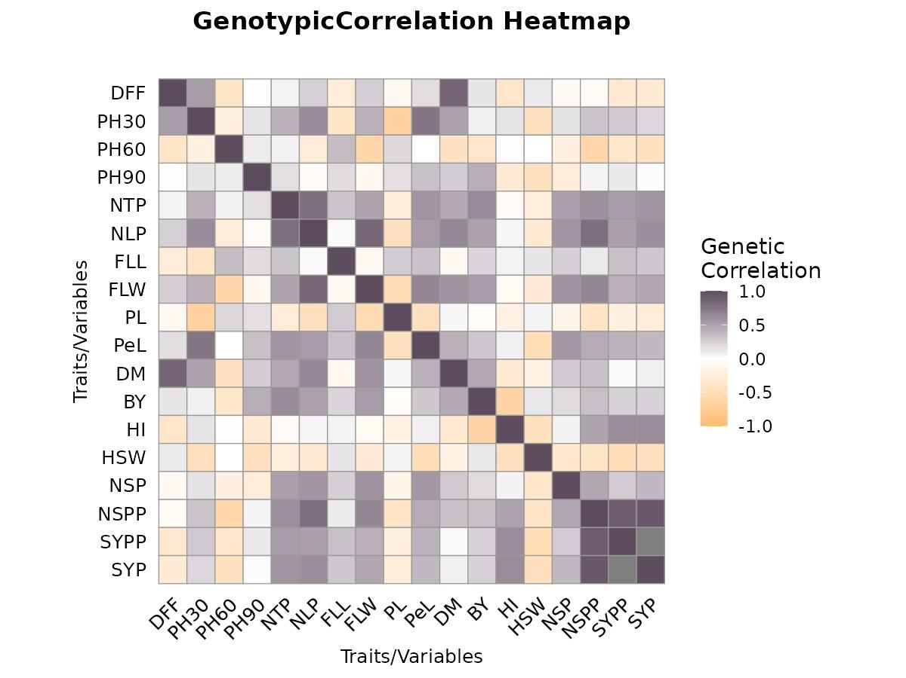

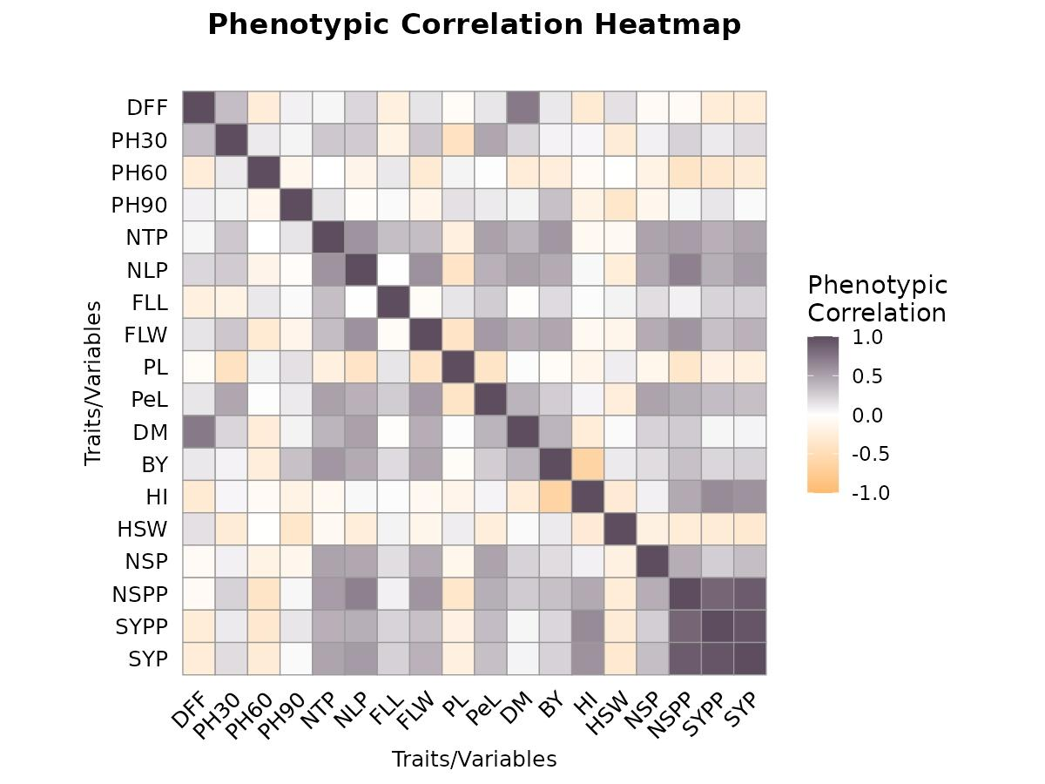
Fig. 3 Shaded genotypic correlation matrix diagram among yield and its components in oat. DFF - days to 50% flowering, PH30 - plant height at 30 DAS, PH60 - plant height at 60 DAS, PH90 - plant height at 90 DAS (cm), NTP - tillers count per plant, NLP - leaves count per plant, FLL - length of flag leaf (cm), FLW - width of flag leaf (cm), PL - length of panicle (cm), PeL - length of pedicle (cm), DM - days after sowing to maturity, BY - biological yield (g), HI - harvest index (%), HSW - 1000 seed weight (Test weight), NSP - spikelets per panicle, NSPP - seeds per panicle, SYPP - seed yield plot⁻¹ (kg), SYP - seed yield plant⁻¹ (g).
Fig. 4 Shaded phenotypic correlation matrix diagram among yield and its components in oat. DFF - days to 50% flowering, PH30 - plant height at 30 DAS, PH60 - plant height at 60 DAS, PH90 - plant height at 90 DAS (cm), NTP - tillers count per plant, NLP - leaves count per plant, FLL - length of flag leaf (cm), FLW - width of flag leaf (cm), PL - length of panicle (cm), PeL - length of pedicle (cm), DM - days after sowing to maturity, BY - biological yield (g), HI - harvest index (%), HSW - 1000 seed weight (Test weight), NSP - spikelets per panicle, NSPP - seeds per panicle, SYPP - seed yield plot⁻¹ (kg), SYP - seed yield plant⁻¹ (g).
.3.6 Genotypic and phenotypic path analysis
The genotypic and phenotypic path coefficient values for the above-said traits are shown in Tables 7 and 8, and represented graphically in Fig. 5 and 6, respectively. Genotypically, out of total 18 characteristics, nine characteristics showed a positive direct effect on the seed yield plant⁻¹ which includes days to 50% flowering (0.226), plant height at 60 DAS (0.037), tillers count per plant (0.206), length of flag leaf (0.103), width of flag leaf (0.116), length of panicle (0.093), spikelets per panicle (0.01), seeds per panicle (0.529) and seed yield plot⁻¹ (1.161). Whereas the traits viz. plant height at 30 DAS (-0.059), plant height at 90 DAS (-0.087), leaves count per plant (-0.146), length of panicle (-0.039), length of pedicle (-0.21), days after sowing to maturity (-0.2), biological yield (-0.659), harvest index (-0.79) and 1000 seed weight (-0.156) exhibit negative and direct effect on the seed yield plant⁻¹. Phenotypically, from among 18 characters, ten characters had significant direct effects on the seed yield plant⁻¹, which are days to 50% flowering (0.052), plant height at 30 DAS (0.083), plant height at 60 DAS (0.033), tillers count per plant (0.053), leaves count per plant (0.056), length of flag leaf (0.114), width of flag leaf (0.044), length of panicle (0.093), seeds per panicle (0.51) and seed yield plot⁻¹ (0.84). Whereas the traits viz. plant height at 90 DAS (-0.097), length of pedicle (-0.121), days after sowing to maturity (-0.15), biological yield (-0.342), harvest index (-0.425), 1000 seed weight (-0.079) and spikelets per panicle (-0.011) exhibit negative and direct effect on the seed yield plant⁻¹. Results from the path coefficient analyses at genotypic and phenotypic levels revealed that seeds per panicle, harvest index and seed yield plot⁻¹ were the primary attributes contributing directly towards seed yield. However, in terms of relative importance, it was noticed that the contribution made by these variables was comparatively greater at genotypic level than at phenotypic level, thereby pointing out the dominant role of genetic factors in these associations rather than that of environment. At genotypic level, tillers count per plant, length of flag leaf and width of flag leaf were some of those traits which were having moderate indirect effect towards seed yield through various yield related traits. In contrast, there were several traits which had shown negative effects, but contributed indirectly through other attributes, e.g., biological yield and days after sowing to maturity. Similarly, when the path coefficients were determined at phenotypic level, then it was observed that leaves count per plant and tillers count per plant had shown moderate indirect effects, while biological yield and 1000 seed weight had shown negative direct effects. Similar finding were also reported by Chaudhary et al. (2020), Nechu et al. (2021), Bichewar et al. (2022), Kebede et al. (2023), Jani et al. (2024), Yaduvanshi et al. (2025) and Arya et al. (2026).

Table 7: Direct and indirect effects of component characters attributing to seed yield plant⁻¹ in oat at genotypic level.
Traits | Days to 50% flowering | Plant Height at 30 DAS | Plant Height at 60 DAS | Plant Height at 90 DAS | Tillers count per plant | Leaves count per plant | Length of flag leaf (cm) | Width of flag leaf (cm) | Length of panicle (cm) | Length of pedicle (cm) | DAS to maturity | Biological yield (kg) | Harvest index (%) | 1000 seed weight | Spikelets per panicle | Seeds per panicle | Seed yield plot⁻¹ (kg) | GC with Seed yield plant⁻¹
Days to 50% flowering | 0.226 | -0.031 | -0.014 | -0.001 | 0.013 | -0.036 | -0.027 | 0.029 | 0.004 | -0.037 | -0.17 | -0.088 | 0.284 | -0.018 | -0.001 | -0.04 | -0.385 | -0.292
Plant Height at 30 DAS | 0.119 | -0.059 | -0.008 | -0.012 | 0.085 | -0.09 | -0.04 | 0.048 | 0.026 | -0.158 | -0.099 | -0.055 | -0.112 | 0.07 | 0.001 | 0.164 | 0.327 | 0.206
Plant Height at 60 DAS | -0.085 | 0.013 | 0.037 | -0.009 | 0.015 | 0.039 | 0.036 | -0.069 | -0.008 | 0.001 | 0.083 | 0.235 | -0.006 | 0.000 | -0.002 | -0.305 | -0.406 | -0.43
Plant Height at 90 DAS | 0.002 | -0.008 | 0.004 | -0.087 | 0.035 | 0.009 | 0.02 | -0.014 | -0.007 | -0.069 | -0.053 | -0.285 | 0.234 | 0.069 | -0.003 | 0.031 | 0.137 | 0.016
Tillers count per plant | 0.014 | -0.024 | 0.003 | -0.015 | 0.206 | -0.115 | 0.032 | 0.055 | 0.01 | -0.12 | -0.09 | -0.411 | 0.051 | 0.037 | 0.005 | 0.316 | 0.61 | 0.565
Leaves count per plant | 0.056 | -0.036 | -0.01 | 0.005 | 0.163 | -0.146 | 0.003 | 0.097 | 0.018 | -0.112 | -0.127 | -0.327 | -0.039 | 0.049 | 0.006 | 0.414 | 0.589 | 0.601
Length of flag leaf (cm) | -0.059 | 0.023 | 0.013 | -0.016 | 0.064 | -0.004 | 0.103 | -0.01 | -0.01 | -0.067 | 0.019 | -0.146 | -0.05 | -0.02 | 0.002 | 0.06 | 0.39 | 0.293
Width of flag leaf (cm) | 0.056 | -0.024 | -0.022 | 0.01 | 0.098 | -0.122 | -0.008 | 0.116 | 0.02 | -0.136 | -0.115 | -0.351 | 0.06 | 0.045 | 0.006 | 0.339 | 0.492 | 0.465
Length of panicle (cm) | -0.022 | 0.04 | 0.008 | -0.015 | -0.055 | 0.068 | 0.028 | -0.061 | -0.039 | 0.094 | -0.008 | 0.029 | 0.144 | -0.009 | -0.002 | -0.207 | -0.257 | -0.264
Length of pedicle (cm) | 0.04 | -0.044 | 0.000 | -0.029 | 0.117 | -0.078 | 0.033 | 0.075 | 0.017 | -0.21 | -0.083 | -0.191 | -0.066 | 0.078 | 0.006 | 0.236 | 0.467 | 0.366
DAS to maturity | 0.193 | -0.029 | -0.015 | -0.023 | 0.093 | -0.093 | -0.01 | 0.067 | -0.002 | -0.087 | -0.2 | -0.301 | 0.247 | 0.028 | 0.003 | 0.175 | 0.042 | 0.089
Biological yield (kg) | 0.03 | -0.005 | -0.013 | -0.037 | 0.129 | -0.072 | 0.023 | 0.062 | 0.002 | -0.061 | -0.091 | -0.659 | 0.492 | -0.02 | 0.002 | 0.177 | 0.274 | 0.232
Harvest index (%) | -0.081 | -0.008 | 0.000 | 0.026 | -0.013 | -0.007 | 0.007 | -0.009 | 0.007 | -0.018 | 0.063 | 0.411 | -0.79 | 0.069 | 0.001 | 0.255 | 0.705 | 0.615
1000 seed weight | 0.026 | 0.026 | 0.000 | 0.039 | -0.049 | 0.046 | 0.013 | -0.033 | -0.002 | 0.105 | 0.036 | -0.082 | 0.35 | -0.156 | -0.003 | -0.198 | -0.579 | -0.464
Spikelets per panicle | -0.019 | -0.009 | -0.008 | 0.022 | 0.105 | -0.082 | 0.026 | 0.068 | 0.006 | -0.117 | -0.055 | -0.126 | -0.056 | 0.054 | 0.01 | 0.245 | 0.308 | 0.373
Number of Seeds/panicle | -0.017 | -0.018 | -0.021 | -0.005 | 0.123 | -0.115 | 0.012 | 0.074 | 0.015 | -0.094 | -0.066 | -0.221 | -0.381 | 0.059 | 0.005 | 0.529 | 1.045 | 0.923
Seed yield plot⁻¹ (kg) | -0.075 | -0.017 | -0.013 | -0.01 | 0.108 | -0.074 | 0.035 | 0.049 | 0.009 | -0.084 | -0.007 | -0.156 | -0.48 | 0.078 | 0.003 | 0.476 | 1.161 | 1.002
GC: Genotypic Correlations, Residual are -0.02114

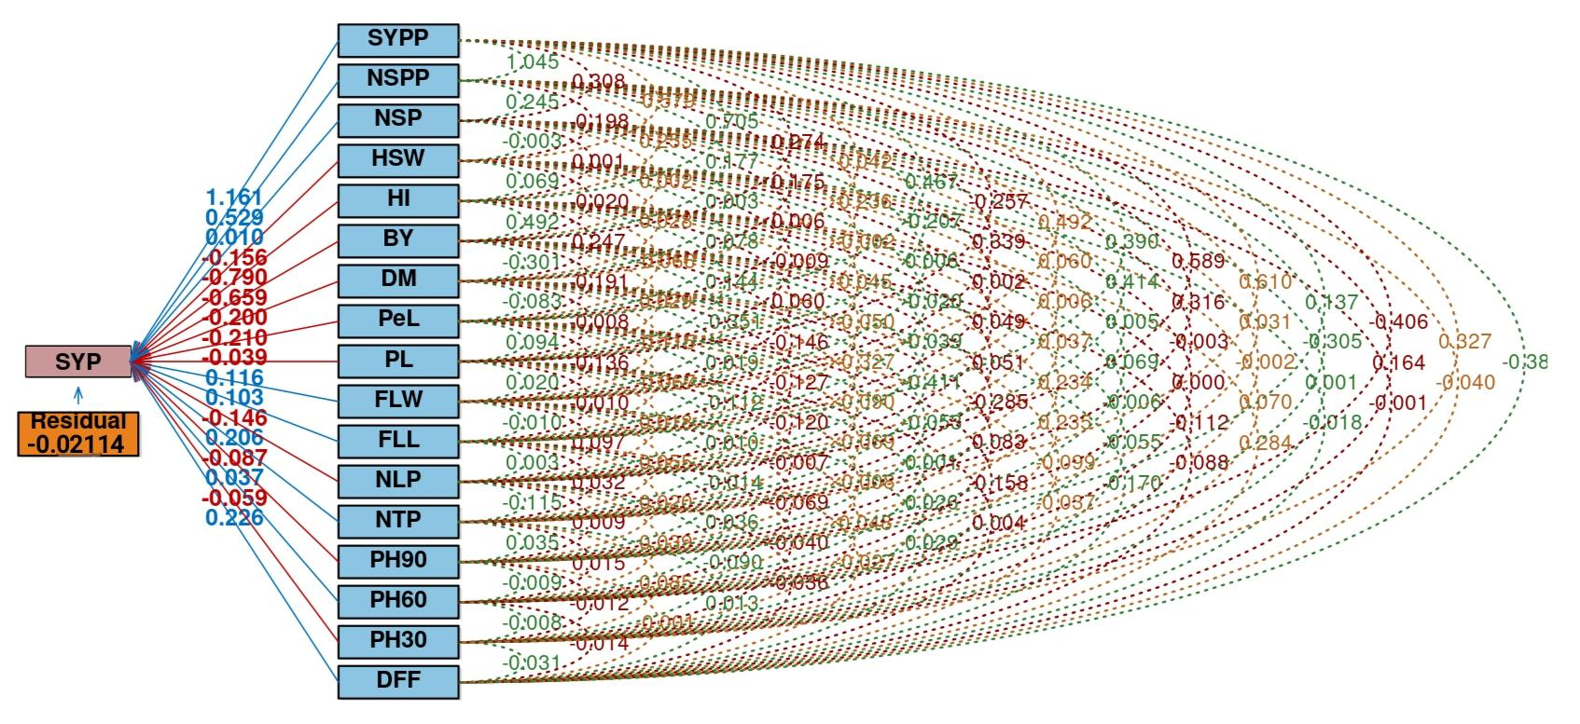
Fig. 5 Genotypic path diagram representing direct and indirect effects for seed yield plant⁻¹. DFF - days to 50% flowering, PH30 - plant height at 30 DAS, PH60 - plant height at 60 DAS, PH90 - plant height at 90 DAS (cm), NTP - tillers count per plant, NLP - leaves count per plant, FLL - length of flag leaf (cm), FLW - width of flag leaf (cm), PL - length of panicle (cm), PeL - length of pedicle (cm), DM - days after sowing to maturity, BY - biological yield (g), HI - harvest index (%), HSW - 1000 seed weight (Test weight), NSP - spikelets per panicle, NSPP - seeds per panicle, SYPP - seed yield plot⁻¹ (kg), SYP - seed yield plant⁻¹ (g).

Table 8: Direct and indirect effects of component characters attributing to seed yield plant⁻¹ in oat at phenotypic level.
Traits | Days to 50% flowering | Plant Height at 30 DAS | Plant Height at 60 DAS | Plant Height at 90 DAS | Tillers count per plant | Leaves count per plant | Length of flag leaf (cm) | Width of flag leaf (cm) | Length of panicle (cm) | Length of pedicle (cm) | DAS to maturity | Biological yield (kg) | Harvest index (%) | 1000 seed weight | Spikelets per panicle | Seeds per panicle | Seed yield plot⁻¹ (kg) | PC with Seed yield plant⁻¹
Days to 50% flowering | 0.052 | 0.029 | -0.008 | -0.007 | 0.002 | 0.012 | -0.025 | 0.006 | -0.005 | -0.016 | -0.11 | -0.04 | 0.125 | -0.013 | 0.001 | -0.036 | -0.222 | -0.255
Plant Height at 30 DAS | 0.018 | 0.083 | 0.003 | -0.006 | 0.015 | 0.015 | -0.019 | 0.013 | -0.039 | -0.057 | -0.033 | -0.023 | -0.021 | 0.022 | -0.001 | 0.12 | 0.091 | 0.182
Plant Height at 60 DAS | -0.013 | 0.009 | 0.033 | 0.011 | 0.000 | -0.008 | 0.013 | -0.013 | 0.005 | -0.001 | 0.038 | 0.082 | 0.028 | 0.000 | 0.002 | -0.191 | -0.276 | -0.281
Plant Height at 90 DAS | 0.004 | 0.005 | -0.004 | -0.097 | 0.007 | -0.002 | 0.003 | -0.006 | 0.015 | -0.013 | -0.009 | -0.113 | 0.076 | 0.027 | 0.001 | 0.02 | 0.11 | 0.024
Tillers count per plant | 0.002 | 0.024 | 0.000 | -0.013 | 0.053 | 0.032 | 0.039 | 0.015 | -0.02 | -0.061 | -0.059 | -0.192 | 0.039 | 0.006 | -0.005 | 0.269 | 0.355 | 0.485
Leaves count per plant | 0.011 | 0.022 | -0.005 | 0.004 | 0.031 | 0.056 | 0.000 | 0.026 | -0.036 | -0.051 | -0.075 | -0.153 | -0.016 | 0.02 | -0.005 | 0.35 | 0.357 | 0.536
Length of flag leaf (cm) | -0.011 | -0.014 | 0.004 | -0.003 | 0.018 | 0.000 | 0.114 | -0.003 | 0.013 | -0.032 | 0.004 | -0.065 | -0.006 | -0.005 | -0.002 | 0.039 | 0.192 | 0.242
Width of flag leaf (cm) | 0.007 | 0.025 | -0.01 | 0.013 | 0.019 | 0.033 | -0.007 | 0.044 | -0.036 | -0.066 | -0.065 | -0.162 | 0.039 | 0.011 | -0.005 | 0.292 | 0.277 | 0.409
Length of panicle (cm) | -0.003 | -0.035 | 0.002 | -0.015 | -0.011 | -0.021 | 0.015 | -0.017 | 0.093 | 0.045 | -0.002 | 0.015 | 0.06 | -0.007 | 0.001 | -0.179 | -0.153 | -0.213
Length of pedicle (cm) | 0.007 | 0.039 | 0.000 | -0.011 | 0.027 | 0.023 | 0.03 | 0.024 | -0.035 | -0.121 | -0.06 | -0.089 | -0.025 | 0.019 | -0.005 | 0.217 | 0.294 | 0.335
DAS to maturity | 0.038 | 0.018 | -0.008 | -0.006 | 0.021 | 0.028 | -0.003 | 0.019 | 0.001 | -0.048 | -0.15 | -0.133 | 0.11 | -0.002 | -0.003 | 0.14 | 0.04 | 0.061
Biological yield (kg) | 0.006 | 0.005 | -0.008 | -0.032 | 0.03 | 0.025 | 0.022 | 0.021 | -0.004 | -0.031 | -0.058 | -0.342 | 0.264 | -0.008 | -0.002 | 0.168 | 0.179 | 0.233
Harvest index (%) | -0.015 | 0.004 | -0.002 | 0.017 | -0.005 | 0.002 | 0.002 | -0.004 | -0.013 | -0.007 | 0.039 | 0.213 | -0.425 | 0.022 | -0.001 | 0.232 | 0.524 | 0.582
1000 seed weight | 0.008 | -0.023 | 0.000 | 0.034 | -0.004 | -0.014 | 0.007 | -0.006 | 0.009 | 0.03 | -0.004 | -0.037 | 0.122 | -0.079 | 0.002 | -0.135 | -0.235 | -0.325
Spikelets per panicle | -0.003 | 0.006 | -0.006 | 0.012 | 0.026 | 0.026 | 0.02 | 0.019 | -0.012 | -0.059 | -0.035 | -0.062 | -0.032 | 0.015 | -0.011 | 0.221 | 0.215 | 0.341
Seeds per panicle | -0.004 | 0.02 | -0.012 | -0.004 | 0.028 | 0.038 | 0.009 | 0.025 | -0.033 | -0.051 | -0.041 | -0.113 | -0.193 | 0.021 | -0.005 | 0.51 | 0.714 | 0.908
Seed yield plot⁻¹ (kg) | -0.014 | 0.009 | -0.011 | -0.013 | 0.022 | 0.024 | 0.026 | 0.014 | -0.017 | -0.042 | -0.007 | -0.073 | -0.265 | 0.022 | -0.003 | 0.433 | 0.84 | 0.947
PC: Phenotypic Correlations, Residual are = 0.155

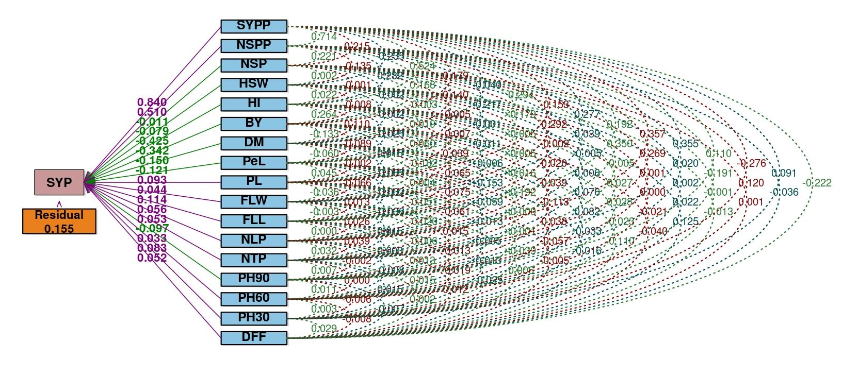
Fig. 6 Phenotypic path diagram representing direct and indirect effects for seed yield plant⁻¹. DFF – days to 50% flowering, PH30 – plant height at 30 DAS, PH60 – plant height at 60 DAS, PH90 – plant height at 90 DAS (cm), NTP – tillers count per plant, NLP – leaves count per plant, FLL – length of flag leaf (cm), FLW – width of flag leaf (cm), PL – length of panicle (cm), PeL – length of pedicle (cm), DM - days after sowing to maturity, BY – biological yield (g), HI – harvest index (%), HSW – 1000 seed weight (Test weight), NSP - spikelets per panicle, NSPP - seeds per panicle, SYPP - seed yield plot⁻¹ (kg), SYP – seed yield plant⁻¹ (g).
3.7 Assessment of genetic diversity
The analysis of percentage contribution of different traits towards total genetic divergence indicated that all eighteen characters contributed variably. The highest contribution was recorded by biological yield (23.48%), indicating its major role in divergence, followed by harvest index (16.62%), seed yield plant⁻¹ (11.31%), seeds per panicle (13.29%), and seed yield plot⁻¹ (8.99%).
3.7.1 Analysis of mean values among clusters
Cluster means for various traits were calculated and displayed in Table 9. Cluster III recorded the late days to 50% flowering (83.67 days), while cluster V showed the earliest (78.33 days). The rest of the clusters had an intermediate average value of the attributes studied. The tallest plant height was seen in cluster II (31.90 cm), while the shortest plant height was noted in cluster V (29.33 cm) at 30 DAS. At 60 DAS, the tallest plant height was recorded in cluster I (102.12 cm), while the shortest was noted in cluster III (99.03 cm). Again, at 90 DAS, the tallest plant height was recorded in cluster I (167.07 cm), while the shortest plant height was noted in cluster V (162.53 cm). In terms of the number of tillers per plant, the highest number of tillers was recorded in cluster II (7.61), while the lowest number of tillers was noted in cluster V (5.30). In addition, in regard to the number of leaves per plant, the highest number of leaves was noted in cluster II (30.91), while the least number of leaves was recorded in cluster V (21.47). Furthermore, the longest length of flag leaf was recorded in cluster I (41.12 cm), while the shortest flag leaf length was observed in cluster III (33.90 cm). Cluster III showed the highest width of flag leaf (2.30 cm), whereas cluster V recorded the lowest (1.53 cm). Cluster V recorded the maximum length of panicle (32.73 cm), while cluster III showed the minimum (25.13 cm). Cluster II showed the highest pedicel length (12.56 cm), whereas cluster IV recorded the lowest (9.05 cm). Cluster III exhibited the late maturity duration (118.67 days), while cluster V had the earliest (111.67 days)..The highest biological yield was recorded in cluster III (5.33 kg), whereas cluster V showed the lowest (3.30 kg). Cluster IV recorded the highest harvest index (54.12%), while cluster III showed the lowest (30.80%). Cluster III exhibited the highest 1000 seed weight (41.67 g), while cluster II recorded the lowest (38.00 g). Cluster II showed the maximum spikelets per panicle (85.33), whereas cluster IV recorded the minimum (71.50). The highest number of seeds per panicle was seen in Cluster II (177.22), while the lowest number was seen in Cluster V (132.10). Also, the highest seed yield per plot (2.33 kg) was found in Cluster II, while the lowest was found in Cluster V (1.43 kg). In addition, the highest seed yield per plant (9.06 g) was observed in Cluster II, while the lowest was found in Cluster V (5.63 g).
Table 9: Table of Cluster means : Tocher method
Trait | Cluster I | Cluster II | Cluster III | Cluster IV | Cluster V
Days to 50% flowering | 79.50 | 80.00 | 83.67 | 79.17 | 78.33
Plant Height at 30 DAS | 31.12 | 31.90 | 31.83 | 30.55 | 29.33
Plant Height at 60 DAS | 102.12 | 100.48 | 99.03 | 100.23 | 101.90
Plant Height at 90 DAS | 167.07 | 164.80 | 166.83 | 164.03 | 162.53
Tillers count per plant | 6.89 | 7.61 | 6.67 | 5.63 | 5.30
Leaves count per plant | 27.42 | 30.91 | 29.73 | 27.60 | 21.47
Length of flag leaf (cm) | 41.12 | 39.77 | 33.90 | 36.97 | 36.73
Width of flag leaf (cm) | 1.77 | 2.28 | 2.30 | 1.82 | 1.53
Length of panicle (cm) | 29.24 | 28.29 | 25.13 | 27.60 | 32.73
Length of pedicle (cm) | 11.07 | 12.56 | 12.27 | 9.05 | 9.27
DAS to maturity | 114.50 | 116.89 | 118.67 | 113.17 | 111.67
Biological yield (kg) | 4.91 | 4.93 | 5.33 | 3.80 | 3.30
Harvest index (%) | 39.16 | 48.24 | 30.80 | 54.12 | 43.10
1000 seed weight | 40.22 | 38.00 | 41.67 | 39.67 | 41.33
Spikelets per panicle | 73.42 | 85.33 | 82.93 | 71.50 | 75.93
Seeds per panicle | 155.71 | 177.22 | 165.43 | 165.77 | 132.10
Seed yield plot⁻¹ (kg) | 1.91 | 2.33 | 1.63 | 2.08 | 1.43
Seed yield plant⁻¹ (g) | 7.32 | 9.06 | 6.53 | 8.10 | 5.63
3.7.2 Cluster distance evaluation
From the table 10 interpretation for the intra as well as inter cluster distances are considered. Further fig 7 represents those distances as the Tocher diagram. The intra-cluster distance was highest in cluster III (690.066), followed by cluster II (595.615) and cluster I (474.539), indicating the presence of considerable variability among genotypes within these clusters. Clusters IV and V showed zero intra-cluster distance due to the presence of a single genotype in each cluster. The inter-cluster distance analysis revealed significant genetic divergence among clusters. The maximum distance between any two clusters was recorded between cluster II and cluster V (3821.374), cluster IV and cluster V (2755.099), and cluster III and cluster IV (1623.220). These distances denote that there was extensive genetic variation within these clusters. On the other hand, the minimum distance was calculated between cluster I and cluster IV (854.278). This distance indicated the close genetic relationship among genotypes of these clusters.
Table 10: Inter-cluster and intra-cluster distances D² values on oat genotypes.
Cluster Number | Cluster.I | Cluster.II | Cluster.III | Cluster.IV | Cluster.V
Cluster I | 474.539 | 1466.747 | 1221.847 | 854.278 | 1462.572
Cluster II |  | 595.615 | 1141.701 | 1012.673 | 3821.374
Cluster III |  |  | 690.066 | 1623.220 | 1814.763
Cluster IV |  |  |  | 0 | 2755.099
Cluster V |  |  |  |  | 0
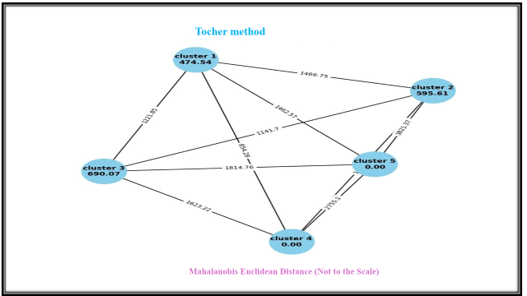
Fig. 7 Cluster distances by Tocher method.
3.7.3 Analysis of genetic clustering among genotypes
The 13 oat genotypes were categorized into 5 clusters using hierarchical cluster analysis. The distribution of genotypes in each cluster and a pictorial representation of dendrogram is also obtained represented in Fig 8. The clustering pattern indicated a wide range of genetic diversity among the genotypes studied. Cluster I included: NDO-1, UPO-212, NDO-711, NDO-952, Kent, and NDO-03. Cluster II included: NDO-1102, NDO-1802, and OS-6. Cluster III included: NDO-724 and NDO-02. Cluster IV contained: JHO-822. Cluster V contained: NDO-1101.
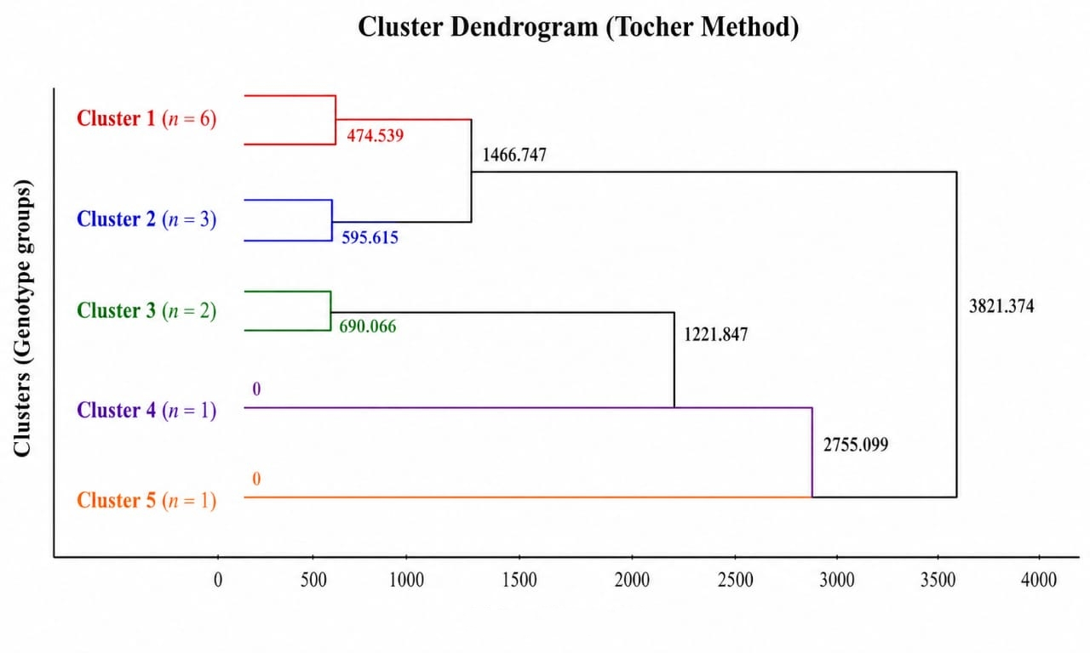
The results of the D² analysis revealed the presence of considerable genetic diversity among the oat genotypes, as indicated by their distribution into five distinct clusters. The formation of solitary clusters (IV and V) suggests the existence of highly divergent genotypes, which can be valuable in breeding programs. The trait contribution analysis showed that biological yield, harvest index, and seed yield traits contributed the most towards total divergence. This indicates that yield-related characters played a major role in differentiating the genotypes and should be given priority during selection. The cluster mean values highlighted that cluster II possessed superior performance for important yield traits such as seed yield plot⁻¹, seed yield plant⁻¹, and seeds per panicle, while cluster III showed higher biological yield and maturity duration. In contrast, cluster V generally recorded lower values for most traits. The inter-cluster distance analysis revealed maximum divergence between cluster II and cluster V, followed by cluster IV and cluster V, suggesting that crosses between these clusters may produce high heterosis and desirable recombinants. Similar finding were also reported by Kumari et al. (2019), Ihsan et al. (2021), Ihsan et al. (2022), Kebede et al. (2023), Tiruneh et al. (2024), Zhao et al. (2025) and Hasan et al. (2026).
Fig. 8 Dendrogram representing clustering by Tocher method.

Conclusion
In this experiment JHO–822 (75.33 days) and NDO–1 (75.67 days) were identified as early days to 50% flowering genotypes, while UPO–212 (83.67 days) and NDO–952 (118.67 days) showed late days to 50% flowering and days after sowing to maturity, respectively. Analysis of variance revealed highly significant differences among all genotypes for the traits studied. The highest GCV and PCV were observed for harvest index (20.97%) and (21.65%), respectively, indicating high variability. Maximum heritability in broad sense was recorded for seeds per panicle (98.23%), followed by biological yield (97.82%) and seed yield plant⁻¹ (97.21%). The highest genetic advance as percent of mean was observed for harvest index (41.86%), followed by biological yield (33.73%) and seed yield plot⁻¹ (33.25%). From correlation analysis, it is evident that seed yield plant⁻¹ is strongly correlated positively with seeds per panicle, tillers count per plant, leaves count per plant, width of flag leaf, harvest index, and seed yield plot⁻¹. According to path coefficient analysis, seeds per panicle, tillers count per plant, width of flag leaf, and seed yield plot⁻¹ exhibited a very high positive direct effect on seed yield, which implies that these characters deserve due consideration while selecting parents. From the genetic diversity analysis, it was clear that there existed a wide diversity amongst the genotypes, thus confirming that there is scope for using varied parental lines in the hybridization program in the future. Genotypes NDO–952, NDO–1802, NDO–1101 and JHO–822 were identified as superior and are recommended for cultivation and future breeding programmes based on their performance in seed yield, biological yield, seeds per panicle and related yield contributing traits.
Conflict of Interest Statement
We have no conflicts of interest to disclose. Authors declare that they have no conflicts of interest. The research was fully done in independently; there was not any financial support involved.
Disclaimer (Artificial intelligence)
Author(s) hereby declare that NO generative AI technologies such as Large Language Models (ChatGPT, COPILOT, etc.) and text-to-image generators have been used during the writing or editing of this manuscript.

References
Mishra, S. N., Pandey, U., Dubey, P. and Pandey, M. (2026). Oat (Avena sativa L.) as a Functional Food: A Review of Nutritional Composition and Health Benefits. European Journal of Nutrition & Food Safety, 18(4), 212–224. https://doi.org/10.9734/ejnfs/2026/v18i42011
Food and Agriculture Organization of the United Nations. (2022). FAOSTAT statistical database [Data set]. https://www.fao.org/faostat/en/
Anonymous. (2019). Forage crops and grasses. In Handbook of Agriculture (pp. 1355–1366). Indian Council of Agricultural Research.
Ravi Raj, Mishra, S. N., Singh, S., Shubham, Kumar, D. and Pandey, M. (2025). Investigation of various quantitative traits interaction and genetic variability in oats (Avena sativa L.). Journal of Advances in Biology & Biotechnology, 28(9): 382–393. https://doi.org/10.9734/jabb/2025/v28i92890
Panse, V. G. and Sukhatme, P. V. (1967). Statistical methods for agricultural workers (2nd Ed.). Indian Council of Agricultural Research.
Mahalanobis, P.C. (1928). A statistical study of Chinese head measurement. Journal Asiatic Society of Bengal, 25(2): 31-307.
Misri, B. (2004). Fodder oats in the Indian Himalaya. In J. M. Suttie & S. G. Reynolds (Eds.), Fodder oats: A world overview (pp. 98–101). FAO.
Gohain, T., Lenmem, Y. and Tzudir, L. (2023). Production and productivity of oat (Avena sativa L.) cultivars as fodder crop on hilly terraces of Nagaland under rainfed condition. Agricultural Science Digest, 45(special issue). https://doi.org/10.18805/ag.D-5737
Devi, R., Sood, V. K., Anuradha, Rana, A., Katoch, A., Kamal, S. and Kumar, A. (2025). Comprehensive assessment of genetic variability and selection strategies in oat germplasm for improved fodder and seed yield in N-W Himalayan mid-hill environments. Indian Journal of Agricultural Research, 59(7), 1022–1030. https://doi.org/10.18805/IJARe.A-6206
Burton, G.W. (1952). Quantitative inheritance in grasses. Proceedings of 6th International Grassland Congress. 1(2): 227-283.
Burton, G.W. and Devane, E.M. (1953). Estimating heritability in tall fescue from replicated Cloned material. Journal of Agronomy, 45(3): 474-481.
Robinson, H.F., Comstick, R.E. and Harvey, P.H. (1955). Genotypic and Phenotypic correlation in Wheat and their implication in selection. Agronomy Journal, 43(5): 282-287.
Johnson, H. W., Robinson, H. F. and Comstock, R. E. (1955). Genotypic and phenotypic Correlations in field peas and their implications in selection. Agronomy Journal, 47(5): 477-483.
Arya, S., Dahiya, A., Panchta, R., Nagpal, S. and Gusaiwal, H. K. (2026). Genetic Variability and Multivariate Analysis of Yield and Quality Traits in Single-Cut Fodder Oat (Avena sativa L.). Journal of Experimental Agriculture International, 48(1), 199–210. https://doi.org/10.9734/jeai/2026/v48i13994
Sahu, M., Belsariya, N., Kak, A. and Sujit. (2023). Variability pattern and its distribution among germplasm accession of oat (Avena sp. L.). Forage Research, 49(1), 54–63.
Mayuri, S. and Rashmi T. (2022). Frequency distribution and genetic variability for forage yield attributing traits in oats (Avena sativa L.). Electronic Journal of Plant Breeding, 13(1), 92–97.
Parameshwaran, M., Goswami, P. K., Neog, S. B. and Baruah, A. R. (2024). Assessment of genetic variability in oat (Avena sativa L.) germplasm using agro-morphological traits and microsatellite markers. Electronic Journal of Plant Breeding, 15(4), 820–831. https://doi.org/10.37992/2024.1504.097
Gupta, K. and Mehta A. K. (2020). Genetic variability studies of advanced generation mutant Oat (Avena sativa L.) lines for yield, fodder traits and proline content. Range Management and Agroforestry, 41(1), 52–59.
Nechu, R. K., Bilaiya S. K., Singhal, P. and Singh, M. (2021). Studies of genetic variability parameters for forage yield and its contributing traits in single cut oat (Avena sativa L.). Frontiers in Crop Improvement, 9, 3173–3176.
Vanjare, D. C., Shinde, G. C., Shinde, S. D. and Pawar, V. S. (2021). Genetic variability, heritability and genetic advance studies for green forage yield and associated traits in forage oat (Avena sativa L.). International Journal of Current Microbiology and Applied Sciences, 10(3), 488–493. https://doi.org/10.20546/ijcmas.2021.1003.064
Wagh, V. R., Sonone, A. H. and Damame, S. V. (2018). Assessment of genetic variability, correlation and path coefficient analysis in forage oat (Avena sativa L.). Forage Research, 44, 172–175.
Chaudhary, M., Singh S. K., Kumar, M., Chand, P. and Kumar, M. (2020). Genetic Variability, heritability and character association among yield and yield attributing traits in oats (Avena sativa L.). International Journal of Chemical Studies, 8(5), 1295–1301.
Pankaj, Chawla, R., Phogat, D. S. and Poonia, A. (2022). Estimation of genetic variability, Heritability, genetic advance and character association in oat (Avena sativa L.) genotypes for fodder and seed yield attributing traits. Journal of Agriculture Research and Technology, 47(2), 226–232. https://doi.org/10.56228/JART.2022.47219
Singh, A. K., Wali, P. and Sharma M. (2017). Estimates of genetic variability, heritability, genetic advance and character association of oat genotypes for green fodder yield. Annals of Agricultural Research, 38(3), 337–341.
Yaduvanshi, N., Shweta, Yadav, R. K., Maurya, C. L. and Kant, S. (2025). Correlation and Path coefficient analyses for grain and fodder yield in F1 and F2 generations of oats (Avena Sativa L.). International Journal of Advanced Biochemistry Research, 9(2S), 69–79. https://doi.org/10.33545/26174693.2025.v9.i2Sb.3691
Jani, B. K., Gohil, D. P., Sakure, A. A., Patel, M. P. and Parmar, D. J. (2024). Appraisal of Character association in fodder oat (Avena sativa L.). Plant Archives, 24(2), 2367–2372. https://doi.org/10.51470/PLANTARCHIVES.2024.v24.no.2.338
Kebede, G., Worku, W., Feyissa, F. and Jifar, H. (2023). Agro-morphological traits-based Genetic diversity assessment on oat (Avena sativa L.) genotypes in the central highlands of Ethiopia. All Life, 16(1). https://doi.org/10.1080/26895293.2023.2236313
Bichewar, N., Mehta, A. K., Bhargava, K. and Ramakrishana, S. (2022). Variability, Correlation and path coefficient studies in interspecific crosses (Avena sativa × Avena sterilis) Of oat. Electronic Journal of Plant Breeding, 13(4). https://doi.org/10.37992/2022.1304.153
Ihsan, M., Nazir, N., Ghafoor, A., Khalil, A. A. K., Zahoor, M., Nisar, M., Khames, A., Ullah, R. and Shah, A. B. (2021). Genetic Diversity in Local and Exotic Avena sativa L. (Oat) Germplasm Using Multivariate Analysis. Agronomy, 11(9), 1713. https://doi.org/10.3390/agronomy11091713
Ihsan, M., Nisar, M., Nazir, N., Zahoor, M., Khalil, A. A. K., Ghafoor, A., Khan, A., Mothana, R. A. M., Ullah, R. and Ahmad, N. (2022). Genetic diversity in nutritional Composition of oat (Avena sativa L.) germplasm reported from Pakistan. Saudi Journal of Biological Sciences, 29(3), 1487–1500. https://doi.org/10.1016/j.sjbs.2021.11.023
Kumari, T. and Jindal, Y. (2019). Genetic diversity and variability analysis in oats (Avena Sp.) genotypes. Electronic Journal of Plant Breeding, 10(1), 1–8. https://doi.10.5958/0975-928X.2019.00001.2
Tiruneh, A. A., Geletu, K. T., Yao, N. K. and Weldegiorgis, K. D. (2024). The genetic diversity and population structure of wild and cultivated Avena species in Ethiopia using SSR markers. Heliyon, 10(21), e38942. https://doi.org/10.1016/j.heliyon.2024.e38942
Hasan, S. A., Abdullah, R. M., Jaber, H. A. and Al-Mafarji, T. R. (2026). Genetic diversity of oat (Avena sativa L.) genotypes under different concentrations of potassium. SABRAO Journal of Breeding and Genetics, 58(1), 285–293. https://doi.org/10.54910/sabrao2026.58.1.26
Zhao, Y., Fang, J., Gislum, R., Zhao, B., Zhong, Z., Lei, Y., Yan, D., He, R., Chen, Y., Zhou, Q. and Wang, H. (2025). Genetic diversity analysis of phenotypic and agronomic traits in oat germplasm resources. Frontiers in plant science, 16, 1670684. https://doi.org/10.3389/fpls.2025.1670684

