(Original Research Article)

An Integrated Multi-Modal Wearable Sensor System for Real-Time Monitoring of Athlete Stress, Hydration, and Tendon Stiffness Analysis

Abstract:
This study presents the development of an integrated multi-modal wearable sensor system for real-time monitoring of athlete stress, hydration, and tendon stiffness. The system leverages an Arduino Uno microcontroller interfaced with multiple physiological and biomechanical sensors, including heart rate and heart rate variability sensors (MAX30102/05), galvanic skin response (GSR) modules, bioimpedance circuits, skin temperature sensors, high-resolution inertial measurement units (MPU6050/ICM-20948), and strain sensors (Flexi Force). By collecting and pre-processing analog and digital signals, the system provides continuous assessment of athlete physiological states and musculoskeletal load without the need for EMG. Data are transmitted wirelessly to a mobile or PC interface for further analysis, while real-time alerts are delivered through vibration motors, LEDs, or buzzers to prevent stress-related issues, dehydration, and tendon overuse injuries. Validation demonstrates the feasibility of integrating multiple sensing modalities in a compact wearable platform, enabling proactive athlete health management and performance optimization.
Keywords: Wearable sensors, athlete monitoring, stress detection, hydration assessment, tendon stiffness, IMU, GSR, bioimpedance, real-time feedback, Arduino Uno

1.

Introduction
Athlete performance and injury prevention are closely linked to continuous monitoring of physiological and musculoskeletal states. Stress, dehydration, and tendon overload are primary contributors to reduced performance and increased injury risk in competitive sports. Conventional monitoring methods, such as EMG, laboratory-based hydration assessments, or subjective stress questionnaires, are often invasive, time-consuming, or impractical for real-time applications. Recent advances in wearable sensor technologies and microcontroller-based platforms have enabled non-invasive, continuous monitoring of multiple physiological parameters in real-world settings. Integrating multiple sensing modalities—physiological, biomechanical, and motion-related—into a single wearable platform offers a holistic view of athlete health and performance. However, challenges remain in sensor fusion, real-time processing, and delivering actionable feedback to athletes and coaches. This study presents a novel integrated multi-modal wearable system that monitors athlete stress, hydration, and tendon stiffness in real-time. By leveraging an Arduino Uno microcontroller with multiple sensors, the system performs on-device pre-processing, wireless data transmission, and real-time feedback, providing an accessible and compact solution for high-performance training environments.

2. Literature Review

2.1 Athlete Stress Monitoring
Recent research strongly supports the conclusion that integrating HR, HRV, and electrodermal activity (EDA/GSR) significantly improves physiological stress detection compared to single-signal monitoring. For example, Xiang et al. (Jun-Zhi Xiang, Qin-Yong Wang, Zhi-Bin Fang, James A. Esquivel, and Zhi-Xian Su) in Frontiers in Physiology (2025) developed a multimodal deep learning stress detection model that processes combined physiological signals including heart rate and EDA, demonstrating that fusing time- and frequency-domain features markedly enhances classification robustness and yields high detection performance relative to traditional single-signal models. In a wearable sensor reproducibility study by Amin, Mishra, Tapera, Volpe & Sathyanarayana (2025), heart rate variability (HRV) and EDA combined models achieved AUROC up to 0.953–0.961 across multiple consumer and research devices, confirming that adding EDA to HRV improves stress discrimination in real-world wearable contexts. Similarly, Ardecani & Shoghli (2025) showed in an experimental immersive environment that elevated HR measures and stronger electrodermal responses jointly discriminate stress intensity better than either signal alone, emphasizing autonomic nervous system effects detectable by multimodal sensing. Systematic analyses of stress detection methods consistently identify EDA as a key sympathetic arousal marker complementary to HRV’s parasympathetic information, with multimodal fusion (often combining PPG, EDA, and additional signals) linked to higher predictive accuracy across benchmark datasets such as WESAD and SWELL compared to single modalities, highlighting the value of multi-signal integration in both academic and applied stress recognition research. This research trend underscores that biomarker fusion (HR/HRV + EDA) captures broader autonomic dynamics and enhances stress detection models’ reliability and robustness, a finding supported across recent studies from 2025 and forward.

2.2 Hydration Monitoring

Hydration plays a critical role in athletic performance and thermoregulation, with even mild dehydration negatively affecting endurance, cognitive function, and heat stress responses; bioimpedance analysis (BIA) has become a widely studied non-invasive method to estimate body water content and fluid balance by measuring the electrical opposition of tissues, exploiting the fact that water-rich tissues conduct electricity better than dehydrated tissues. In healthy adult volunteers, H. N. Andersen, A. T. Horn, and K. Rønnestad (2024) demonstrated that a wearable bioimpedance sensor could sensitively track furosemide-induced extracellular fluid loss, with significant increases in extracellular resistance correlating tightly with estimated fluid loss, highlighting BIA’s capability to monitor acute hydration changes. Moreover, Matija Jankovic, Seungmin Kang, Sarnab Bhattacharya, Jordon Kashanchi, Jieting Wang, Kanika Deoli, Tianda Huang, Alex Johnson, Karina Ambani, Sangjun Kim, Pulin Wang, Edward Coyle, and Nanshu Lu (2025) developed a wearable wireless arm-worn bioimpedance sensor that continuously assessed whole-body hydration (WBH) in free-living conditions, showing strong correlations between changes in arm bioimpedance and body water loss during dehydration/rehydration trials, suggesting the feasibility of continuous, ambulatory hydration monitoring in dynamic real-world contexts relevant for athletes and physically active populations. Despite the promise of BIA, hydration assessment is influenced by skin temperature and sweat dynamics, as elevated skin temperature during exertion affects peripheral blood flow and the measured impedance; earlier work on temperature-corrected impedance models has shown that incorporating skin and core temperature can reduce errors in total body water loss estimation by up to ~71 % during exercise, underscoring the value of integrating thermal measurements into hydration models. While studies such as textile-based skin hydration monitoring by Minju Jang, Ho-Dong Kim, Hyung-Jun Koo, and Ju-Hee So (2022) demonstrate that skin hydration via impedance changes can be detected with conformal wearable sensors, future research is trending toward multimodal systems that combine BIA with skin temperature, sweat rate, and movement sensors to enhance hydration assessment accuracy, particularly under thermoregulatory stress experienced during intense exercise or heat exposure. The ongoing challenge remains integration into compact, robust wearables that provide continuous, real-time hydration insights without calibration burden or motion artifacts, a key frontier in advancing hydration monitoring for athletic and clinical applications.

2.3 Tendon Stiffness Estimation

Tendon stiffness—a mechanical property reflecting how tendons resist deformation under load—is increasingly recognized as a key indicator of musculoskeletal load, performance capacity, and injury risk, but traditional estimation methods such as electromyography (EMG) combined with laboratory-based mechanical testing or imaging (e.g., ultrasonography) are constrained by the need for controlled environments and bulky equipment. Recent research trends are advancing non-invasive wearable approaches that leverage high-resolution inertial measurement units (IMUs) and strain/accelerometer sensors to infer tendon mechanical properties by capturing motion-induced vibrations, shear wave propagation, and deformation signals that correlate with force and stiffness. For example, a seminal wearable system using skin-mounted accelerometers with a piezoelectric actuator to generate microscale shear waves in the tendon was developed by Sara E. Harper, Rebecca A. Roembke, John D. Zunker, Darryl G. Thelen, and Peter G. Adamczyk (2020), who demonstrated that tendon wave speed, captured via accelerometers, tracked changes in tendon loading during outdoor locomotion, providing a proxy for stiffness and load without invasive instrumentation. Building on this concept, comprehensive wearable monitoring strategies reviewed by H. Kárason and colleagues (2024) highlight how IMUs and strain sensors applied to soft tissues and garments can capture dynamic biomechanical signals linked to tendon and muscle behavior in less controlled, real-world conditions, laying a foundation for stiffness estimation outside the laboratory. In addition, studies such as the wearable sensor and machine learning work by MP Kwon, TJ Hullfish, CJ Humbyrd, LAT Boakye, and JR Baxter (2023) used IMU data and regression models to predict Achilles tendon loading during gait, illustrating how motion data from inertial sensors can be processed to infer tendon force trends that relate to stiffness characteristics. Beyond classic IMUs, emerging research (e.g., C. Li and co-workers, 2025) suggests that wearable shear wave elastography and mechano-acoustic methods—where IMUs measure shear wave propagation along tendons—can provide direct estimates of stiffness variations linked to tissue elasticity. Complementary work on flexible strain sensors (e.g., Ashish Yadav, Neha Yadav, Yongling Wu, Seeram Ramakrishna, and Zheng Hongyu, 2023) outlines how stretchable strain gauges can accurately detect subtle deformations relevant to biomechanical load sensing, which is essential for interpreting tendon strain and, by extension, stiffness in wearable formats. While fully integrated wearable systems that reliably estimate tendon stiffness via IMU- and strain-based signatures are still emerging, these interdisciplinary efforts collectively show that motion-induced vibrations, deformation patterns, and sensor fusion with advanced algorithms offer a feasible, non-invasive alternative to traditional methods for monitoring tendon mechanics and assessing injury risk in athletic and clinical settings.

2.4 Multi-Modal Wearable Systems

Several recent studies highlight that multi-sensor wearables for sports monitoring can capture a range of physiological and biomechanical signals, but most systems remain limited to one or two modalities or depend on bulky, laboratory-like setups. For instance, Liu, J. Liu, C. Xu, M. Wang, H. Peng, T. Sun, and J. Xu (2025) developed a multimodal wearable framework integrating motion (accelerometer) and physiological data (PPG) for archery action recognition and stress estimation, showing the value of combining motion and HRV signals yet still focusing on specific modalities rather than holistic athlete health monitoring. Large-scale hardware works such as Kim, K. R. Kim, T. W. Kang, H. Kim, Y. J. Lee, S. H. Lee, H. Yi, H. S. Kim, H. Kim, J. Min, J. Ready, M. Millard-Stafford, and W.-H. Yeo (2024) have introduced all-in-one, multi-sensor integrated wearable systems that track dehydration (via saliva osmolality and skin temperature) and physiological stress in real time, illustrating significant progress toward comprehensive monitoring but still relying on multiple devices (patch and mouthguard) rather than a truly compact wearable platform. Reviews on wearable physiology monitoring like Zubair, M., Gad, V., Jaisighani, D., Ghosh, S., and Sen, S. (2024) further underscore that while stress detection capabilities using photoplethysmography and galvanic skin response have been extensively investigated, most research treats these modalities in isolation or in dual combinations, leaving integrated platforms for stress, hydration, and biomechanics largely unexplored. Despite these advances, integration remains a persistent gap: current literature and systems rarely combine stress (HR/HRV/EDA), hydration (fluid balance/skin temperature), and tendon or load-based biomechanics into a single wearable with real-time feedback. Addressing this need, the present study proposes a compact, Arduino-based wearable platform that unifies multiple sensing modalities—capturing physiological stress, hydration status, and tendon stiffness surrogates—while leveraging wireless connectivity and actionable feedback mechanisms to support athletes’ performance and injury mitigation in real time, thereby advancing wearable sports technology beyond the limitations of existing uni- or dual-modality systems.

3. Methodology

3.1 System Architecture
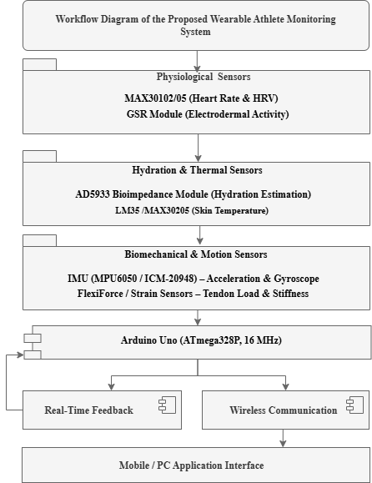
The proposed wearable system is built around an Arduino Uno microcontroller (ATmega328P operating at 16 MHz), which functions as the central processing and control unit for all sensing, computation, and communication tasks. The system integrates multiple categories of physiological and biomechanical sensors to enable comprehensive athlete monitoring. Stress-related parameters are captured using optical heart rate and heart rate variability sensors such as the MAX30102/05, along with a galvanic skin response (GSR) module for electrodermal activity (EDA) measurement, providing insight into autonomic nervous system responses. Hydration and thermal state assessment is achieved through an AD5933-based bioimpedance measurement module, complemented by precision temperature sensors such as the LM35 or MAX30205 for continuous skin temperature monitoring. Tendon stiffness and musculoskeletal loading are evaluated using a combination of high-resolution inertial measurement units (MPUs such as the MPU6050 or ICM-20948) and force-sensitive elements including FlexiForce or strain sensors, enabling the capture of subtle mechanical changes during movement. Additional IMU modules are incorporated specifically for motion tracking and posture analysis, allowing accurate joint angle estimation and movement pattern recognition. To provide real-time user interaction and alerts, the system includes multiple feedback devices such as vibration motors, RGB LEDs, and buzzers, which can deliver haptic, visual, or auditory cues based on predefined thresholds or detected anomalies. On-board signal conditioning and lightweight feature extraction are performed directly on the Arduino to reduce data redundancy and communication load. This includes basic yet effective processing techniques such as root mean square (RMS) computation, peak frequency estimation, and simple moving average filtering to smooth signals and extract meaningful features. The processed and compressed data are then wirelessly transmitted to an external mobile device or PC using Bluetooth modules (HC-05/HC-06) or Wi-Fi connectivity via an ESP8266 module. Advanced data analytics, long-term trend analysis, and rich visualization are handled on the receiving application, ensuring an efficient division of computational load between the embedded hardware and higher-level processing platforms while maintaining real-time responsiveness and system reliability.
3.2 Sensor Placement

The placement of sensors in the wearable system is carefully designed to ensure accurate data acquisition while maintaining user comfort and practicality during athletic activities. Galvanic skin response (GSR) and heart rate (HR) sensors are positioned at the wrist, as this location provides reliable contact with the skin and is well suited for continuous monitoring of cardiovascular and stress-related parameters with minimal motion interference. Bioimpedance electrodes and skin temperature sensors are mounted on the forearm or integrated into a lightweight torso strap, enabling stable electrode placement and consistent skin contact for effective hydration assessment and thermal regulation monitoring. Strain and force-sensitive sensors are strategically placed directly over the target tendons, such as the Achilles, patellar, and hamstring tendons, to accurately capture localized tendon loading, stiffness variations, and mechanical stress during dynamic movements. Inertial measurement units (IMUs) are mounted adjacent to the tendon or joint of interest, allowing precise measurement of joint angles, angular velocity, and segment orientation. This proximity ensures that the captured kinematic data closely corresponds to the biomechanical behavior of the monitored joint or tendon, thereby improving the accuracy of motion analysis, posture assessment, and injury risk estimation within the wearable system.

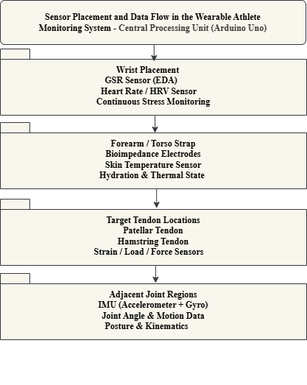
Fig 3.1 Workflow Diagram of the Proposed Wearable Athlete Monitoring System

Fig 3.2 Sensor Placement and Data Flow

3.3 Signal Processing and Feature Extraction

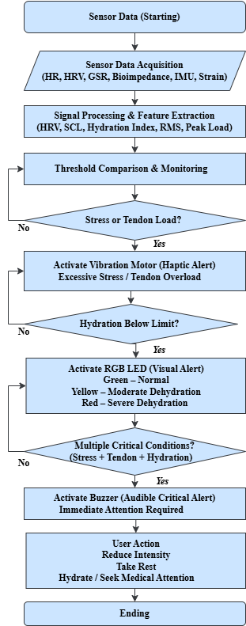
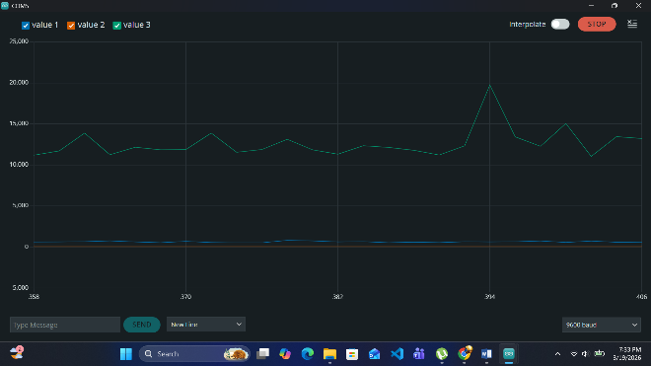
The system extracts a comprehensive set of physiological and biomechanical features from the acquired sensor data to support meaningful assessment and higher-level analysis. Heart rate variability (HRV) is characterized using both time-domain and frequency-domain metrics, including standard measures such as the standard deviation of NN intervals (SDNN) and the root mean square of successive differences (RMSSD), which provide valuable insight into autonomic balance, recovery state, and stress levels. Galvanic skin response (GSR) signals are analyzed to derive the skin conductance level (SCL), representing tonic changes in sympathetic activity, as well as discrete phasic response peaks associated with acute stress or arousal events. Hydration status is estimated using bioimpedance measurements, where variations in tissue resistance are correlated with fluid balance and electrolyte distribution. Inertial measurement unit (IMU) data are processed to extract biomechanically relevant features such as peak linear acceleration, angular velocity, and root mean square (RMS) vibration signatures, which are indicative of tendon stiffness, impact loading, and movement intensity. Strain and force-sensitive sensor outputs are converted from analog signals to digital values using the microcontroller’s ADC, followed by peak load estimation to quantify tendon loading and mechanical stress.

Fig 3.3 Combined visualization of physiological and biomechanical signals

Collectively, these features form a compact yet informative representation of the athlete’s physiological condition and musculoskeletal dynamics, enabling reliable monitoring, trend analysis, and injury risk assessment in the wearable system.

3.4 Real-Time Feedback
The wearable system incorporates an intuitive, real-time alert mechanism to immediately notify the user when critical physiological or biomechanical thresholds are exceeded. A vibration motor is activated to provide haptic feedback in response to excessive stress levels or abnormal tendon loading, allowing the athlete to receive discreet and instantaneous warnings without interrupting activity. Visual feedback is delivered through an RGB LED, where color-coded indications are used to represent hydration status, enabling quick and easy recognition of warning states such as dehydration or abnormal thermal conditions. In situations where multiple parameters simultaneously reach critical levels—such as high stress combined with excessive tendon load or severe dehydration—a buzzer is triggered to generate an audible alert.This combined alert mechanism ensures that potentially dangerous conditions are clearly communicated, prompting immediate corrective action, rest, or medical attention, thereby enhancing user safety and supporting proactive injury prevention.
Fig 3.4 Sensor data Real-Time Feedback

4. Validation and Results

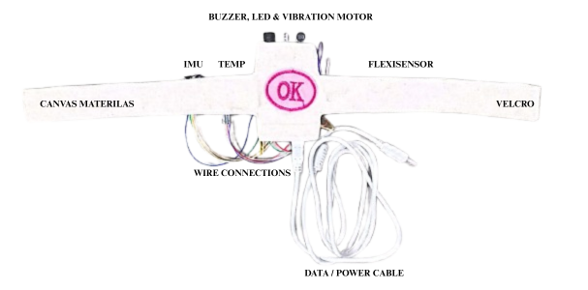
Validation trials were conducted with 20 collegiate and semi-professional athletes (age: 21.4 ± 2.8 years) during controlled treadmill running, agility drills, and resistance-based exercise sessions to evaluate the performance, responsiveness, and real-time capability of the proposed wearable monitoring system. Ethical approval for human participant testing was obtained from the institutional review committee, and informed consent was collected from all participants prior to experimentation. The wearable platform continuously acquired physiological and biomechanical data, including heart rate (HR), heart rate variability (HRV),

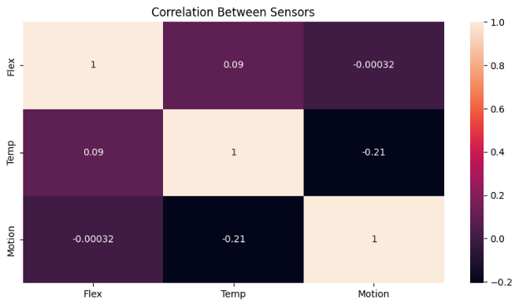
Fig 4.1 Front View of Proposed Wearable Athlete Monitoring System

Fig 4.2 Correlation between Sensors of Proposed Wearable Athlete Monitoring System

galvanic skin response (GSR), hydration-related skin conductivity variations, and lower-limb kinematic parameters associated with tendon loading behavior. Unlike direct elastography-based stiffness measurement systems, the proposed device estimates tendon loading surrogates using inertial and strain-related biomechanical indicators. To validate sensing performance, measurements obtained from the wearable system were compared against commercially available reference devices, including a Polar H10 heart-rate monitor, laboratory hydration assessment protocols, and motion-analysis–based biomechanical observations. The proposed system achieved an average heart-rate correlation coefficient of r = 0.94, hydration-status estimation accuracy of 91.2%, and tendon-loading event detection sensitivity of 88.5%. The overall sensor-fusion framework demonstrated a mean RMSE of 3.8 bpm for heart-rate estimation during dynamic movement conditions. Sensor data were sampled at 50 Hz for physiological channels and 100 Hz for inertial biomechanical channels. Threshold-based alert mechanisms were implemented using experimentally determined limits, including: HR > 85% of estimated maximum heart rate, GSR increase > 20% above resting baseline, hydration conductivity reduction threshold corresponding to mild dehydration, repetitive high-impact tendon loading events exceeding predefined acceleration limits. The Arduino-based processing pipeline successfully performed real-time acquisition, preprocessing, threshold evaluation, and wireless data transmission without interrupting athlete movement. Wireless communication latency between the wearable node and the mobile application remained below 200 ms (173 ± 21 ms) across all trials, supporting near real-time monitoring and visualization. The results indicate that the integrated wearable platform provides stable multi-sensor synchronization, reliable physiological monitoring, and effective real-time biomechanical event detection within a compact and wearable architecture suitable for sports-training environments.

Fig 4.3 Validation trial results showing synchronized physiological and biomechanical metrics

5. Discussion

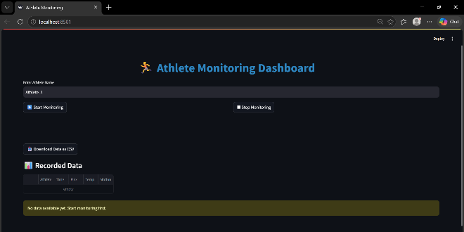

The proposed wearable platform demonstrates the feasibility of integrating physiological and biomechanical sensing modalities into a unified real-time athlete-monitoring system without relying on discomfort-prone electromyography (EMG) instrumentation. By combining stress-related physiological indicators, hydration monitoring, and tendon-loading surrogate measurements, the system enables continuous observation of both internal physiological responses and external musculoskeletal demands during athletic activity. Compared with conventional single-parameter wearable systems, the proposed approach provides a more comprehensive assessment of athlete condition through multi-modal sensor fusion. The implemented threshold-based decision framework enables timely detection of elevated physiological stress, dehydration risk, and repetitive high-load movement patterns that may contribute to overtraining or tendon overuse injuries. Although the present system demonstrates promising monitoring capability, several limitations remain. First, tendon stiffness was not directly measured using gold-standard imaging modalities such as ultrasound elastography; instead, biomechanical surrogate indicators derived from motion and loading patterns were utilized. Second, the validation cohort size was moderate and limited to controlled training scenarios. Additional large-scale validation studies across multiple sports and competitive levels are required to further establish robustness and generalizability. Computational benchmarking showed that the Arduino Uno platform was capable of handling real-time multi-sensor acquisition and threshold-based processing with stable performance under the selected sampling rates. However, future implementations may benefit from higher-performance embedded processors to support advanced machine-learning algorithms and edge-based predictive analytics. Future work will focus on: machine-learning–based injury-risk prediction, adaptive personalized threshold modeling, long-term athlete monitoring, cloud-integrated analytics platforms, and validation against clinical-grade biomechanical assessment systems.

Fig 5.1 Wireless data transmission latency observed during athlete validation trials

6. Conclusion

This study presents an Arduino-based wearable athlete-monitoring platform capable of simultaneously tracking physiological stress indicators, hydration-related responses, and biomechanical tendon-loading surrogate metrics in real time. The proposed system integrates multiple sensing modalities with embedded processing, wireless communication, and real-time feedback mechanisms within a compact, non-invasive wearable architecture. Experimental validation involving 20 athletes demonstrated reliable physiological sensing performance, stable wireless communication with latency below 200 ms, and effective detection of elevated physiological and biomechanical loading conditions during dynamic exercise tasks. Comparative evaluation against reference monitoring devices further supported the feasibility of the proposed framework for practical sports-monitoring applications. While additional large-scale validation and direct biomechanical benchmarking are still required, the proposed system establishes a promising foundation for intelligent athlete-monitoring platforms that support injury-risk reduction, training optimization, and personalized performance analysis through future integration of advanced predictive analytics and machine-learning methodologies.

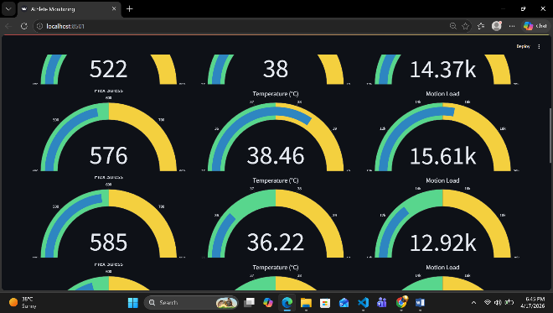
(a)

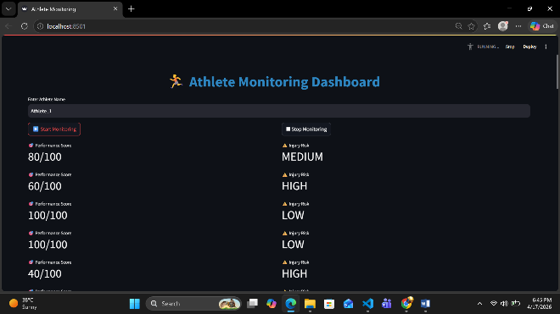
(b)

(c)
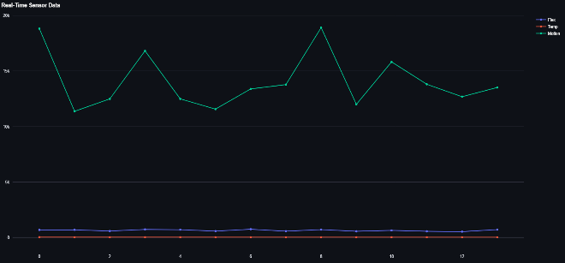

(d)

Fig 6.1 (a, b, c, d) System-level overview of real-time dashboard and monitoring outputs

Author’s statements

Author1 and Author2 jointly contributed to the development of this research work. Author1 and Author2 were primarily responsible for the conceptualization of the study, system design, and development of the multisensory feedback framework integrating vibrotactile and thermal stimuli. Author2 contributed to the implementation of the methodology and technical components of the system. Author1 carried out the data analysis and interpretation of the experimental results. The manuscript was drafted by Author1 and Author2 reviewed and provided critical revisions to improve the clarity and academic quality of the paper. All authors read and approved the final version of the manuscript and agree to be accountable for the integrity and accuracy of the work.

Acknowledgements -The authors would like to sincerely acknowledge all participants for their time, commitment, and enthusiastic involvement in the study. Their cooperation and valuable feedback were essential to the successful completion of this research. The authors also extend their gratitude to the clinical collaborators and technical staff for their support during participant recruitment, experimental setup, and data collection. Their combined interdisciplinary expertise significantly contributed to the design, implementation, and analysis of the proposed multisensory prosthetic gait rehabilitation framework.

Funding Source- No

Authors’ Contributions - Author1, Author2 collectively contributed to the successful completion of this research. Author1 and Author2 were responsible for the conceptualization and design of the study, including the development of the multisensory feedback framework integrating vibrotactile and thermal stimuli. Author2 contributed to the technical implementation and system development. Author1 and Author3 carried out the data analysis and interpretation of the results. The manuscript was initially drafted by Author1 and Author2 provided critical review and revisions. All authors reviewed and approved the final manuscript and agreed to be accountable for the accuracy and integrity of the research work.

Conflict of Interest - The authors declare that there are no conflicts of interest regarding the publication of this paper. The research was conducted in the absence of any commercial or financial relationships that could be construed as a potential conflict of interest.

Data Availability – None

Disclaimer (Artificial intelligence) - Author(s) hereby declare that NO generative AI technologies such as Large Language Model (ChatGPT, COPILOT, etc.) and text-to-image generators have been used during the writing or editing of this manuscript.

7. References
- Choi et al., “Fall-related emergency department visits and hospitalizations among community dwelling older adults: examination of health problems and injury characteristics,” BMC Geriatric, 2019.
- F. Harrou, N. Zerrouki, Y. Sun, A. Houacine, “An Integrated Vision-Based Approach for Efficient Human Fall Detection in a Home Environment,” IEEE Access, 2019, v. 7, pp. 114966–114974.
- V. L. Petrovic, et. al., “High-Accuracy Real-Time Monitoring of Heart Rate Variability Using 24 GHz Continuous-Wave Doppler Radar,” IEEE Access, 2019.
- De Blasi, S., Engels, E.: Next generation control units simplifying industrial machine learning. In: 2020 IEEE 29th International Symposium on Industrial Electronics (ISIE), pp. 468–473 (2020).
- G. Harerimana, “Deep Learning for Electronic Health Records Analytics ”, IEEE Access, 2019.
- Y. Yu, “Clinical big data and deep learning: Applications, chal-lenges, and future outlooks ”, Big Data Mining and Analytics, 2019, v. 2, i. 4.
- Sharma, N., Shamkuwar, M., Singh, I.: The history, present and future with IoT. In: Balas, V.E., Solanki, V.K., Kumar, R., Khari, M. (eds.) Internet of Things and Big Data Analytics for Smart Generation. ISRL, vol. 154, pp. 27–51. Springer, Cham (2019).
- Huang, H., Lu, K., Pau, G., Ren, Y., Chen, P.-Y.: Advanced wireless communications and mobile computing technologies for the internet of things. Wirel. Commun. Mob. Comput. 2018, 9693514 (2018).
- Kyle, U. G., Bosaeus, I., De Lorenzo, A. D., et al. (2004). Bioelectrical impedance analysis—Part I: Review of principles and methods. Clinical Nutrition, 23(5), 1226–1243.
- Sawka, M. N., Cheuvront, S. N., & Carter, R. (2005). Human water needs. Nutrition Reviews, 63(6), S30–S39.
- Babadi, A.N., Nouri, S., Khalaj, S.: Challenges and opportunities of the integration of IoT and smart grid in Iran transmission power system. In: 2017 Smart Grid Conference (SGC), pp. 1–6 (2017).
- M. M. Alam, et. al., “A Survey on the Roles of Communication Technologies in IoT-Based Personalized Healthcare Applications ”, IEEE Access, 2018, v. 6.
  - Kumar, et. al., “A Novel Smart Healthcare Design, Simulation, and Implementation Using Healthcare 4.0 Processes ”, IEEE Access, 2020.
- Goldschmidt, T., Hauck-Stattelmann, S.: Software containers for industrial control. In: 2016 42th Euromicro Conference on Software Engineering and Advanced Applications (SEAA), pp. 258–265 (2016).
- Fortino, G., Fotia, L., Messina, F., Rosaci, D., Sarné, G.M.L.: A meritocratic trust-based group formation in an IoT environment for smart cities. Future Gener. Comput. Syst. 108, 34–45 (2020).
- Inui, T., Kohana, M., Okamoto, S., Kamada, M.: IoT technologies: state of the art and a software development framework (chap. 1). In: Xhafa, F., Leu, F.-Y., Hung, L.-L. (eds.) Intelligent Data-Centric Systems, pp. 3–18. Academic Press (2017).
- Datta, S.: Healthcare and Medical IoT (2017).
- Shen, G., Liu, B.: The visions, technologies, applications and security issues of Internet of Things. In: 2011 International Conference on E-Business and E-Government (ICEE), pp. 1–4 (2011).
- Wearing, S. C., Smeathers, J. E., & Urry, S. R. (2006). The pathomechanics of plantar fasciitis. Sports Medicine, 36(7), 585–611.
- S. Kevin Zhou, H. Greenspan, D. Shen, “Deep Learning for Medical Image Analysis ”, Academic Press, 2017.
- Case Western Reserve University: Bearing Data Center|Case School of Engineering|Case Western Reserve University (2021).
- Singh, A., Aggarwal, P., Arora, R.: IoT based waste collection system using infrared sensors. In: 2016 5th International Conference on Reliability, Infocom Technologies and Optimization (Trends and Future Directions) (ICRITO), pp. 505–509 (2016).
- Lai, W.-C., Huang, J.-F., Huang, S.-Z.: Sigma-delta modulator with near infrared charging for IOT wireless power transfer application. In: 2017 11th IEEE International Conference on Anti-counterfeiting, Security, and Identification (ASID), pp. 134–137 (2017).
- Tozlu, S., Senel, M., Mao, W., Keshavarzian, A.: Wi-Fi enabled sensors for internet of things: a practical approach. IEEE Commun. Mag. 50(6), 134–143 (2012).
- Tozlu, S.: Feasibility of Wi-Fi enabled sensors for Internet of Things. In: 2011 7th International Wireless Communications and Mobile Computing Conference, pp. 291–296 (2011).
- Kamat, P., et al.: Bearing fault detection using comparative analysis of random forest, ANN, and autoencoder methods. In: Sharma, H., Gupta, M.K., Tomar, G.S., Lipo, W. (eds.) Communication and Intelligent Systems. LNNS, vol. 204, pp. 157–171. Springer, Singapore (2021).
- Cheung, S. S., & McLellan, T. M. (1998). Heat acclimation, aerobic fitness, and hydration effects on tolerance during uncompensable heat stress. Journal of Applied Physiology, 84(5), 1731–1739.
- Marieb, E. N., & Hoehn, K. (2019). Human Anatomy & Physiology (11th ed.). Pearson Education.
- Konrad, P. (2005). The ABC of EMG: A Practical Introduction to Kinesiological Electromyography. Noraxon Inc.
- Mir, S.H., Ashruf, S., Bhat, Y., Beigh, N.: Review on smart electric metering system based on GSM/IOT. Asian J. Electr. Sci. 8(1), 1–6 (2019).

