Integrative Multi-Omics Analysis Reveals MHC Class II–Mediated Immune Dysregulation in Long COVID

Abstract
Background: Long COVID affects an estimated 65 million individuals globally and is characterised by persistent multisystemic symptoms including fatigue, cognitive dysfunction, and immune dysregulation. Despite its enormous public health burden, the genetic and transcriptomic mechanisms underlying Long COVID remain incompletely understood. Here, we applied an integrative multi-omics approach combining publicly available genome-wide association study (GWAS) summary statistics with peripheral blood mononuclear cell (PBMC) transcriptomics to identify convergent immune gene candidates.
Methods: We performed quality control and analysis of Long COVID GWAS summary statistics from the Long COVID Host Genetics Initiative (HGI; 15,950 cases, 1,892,830 controls). PBMC transcriptomic data were obtained from GEO (GSE224615; 23 Long COVID cases vs 13 recovered controls, all 8 months post-infection). Differential expression analysis was conducted using author-provided DESeq2 results. Pathway enrichment was performed using clusterProfiler with Gene Ontology Biological Process (GO-BP) and KEGG databases. A literature-curated GWAS integration strategy was used to test whether genome-wide significant immune loci from published Long COVID GWAS showed concordant transcriptomic dysregulation.
Results: GWAS QC retained 9,474,615 SNPs with a genomic inflation factor of λ=0.914, indicating no population stratification. Sixteen independent suggestive loci (P<1×10⁻⁵) were identified, distributed across 13 chromosomes. Transcriptomic analysis identified 72 differentially expressed genes (DEGs; nominal p<0.05, |log2FC|>1), including upregulation of erythroid genes (ALAS2, HBB, HBA1) and downregulation of immunoglobulin genes (IGHG2, IGHG4) and antigen presentation genes (HLA-V). GO-BP enrichment revealed 27 significant terms including complement activation, humoral immune response mediated by circulating immunoglobulin, and oxidant detoxification. Critically, integration with published GWAS immune loci identified HLA-DQA1 as a convergent candidate — nominally downregulated in Long COVID PBMCs (LFC=−0.39, p=0.049) — with a co-localised signal at HLA-DQB1 (LFC=−0.51, p=0.11).
Conclusion: Our integrative analysis implicates MHC class II downregulation as a convergent mechanism linking genetic predisposition to transcriptomic immune dysregulation in Long COVID. HLA-DQA1 and HLA-DQB1 emerge as priority candidates for functional validation and potential therapeutic targeting. These findings provide a framework for hypothesis-driven multi-omics studies of post-acute sequelae.
Keywords: Long COVID; PBMC; transcriptomics; GWAS; HLA-DQA1; immune dysregulation; post-acute sequelae; multi-omics

1. Introduction
The COVID-19 pandemic, caused by severe acute respiratory syndrome coronavirus 2 (SARS-CoV-2), has resulted in an unprecedented global health crisis extending well beyond the acute phase of infection(Mallah et al., 2021; Ross et al., 2022). A substantial proportion of individuals who survive the initial infection develop persistent symptoms lasting weeks to months — a condition now formally designated as Post-Acute Sequelae of SARS-CoV-2 infection (PASC), or Long COVID(Albornoz et al., 2023; Parums, 2024; Post COVID-19 Condition (Long COVID), n.d.). Epidemiological estimates place the global burden of Long COVID at approximately 65 million affected individuals, representing one of the most consequential post-infectious syndromes in modern medical history (Davis et al., 2023; Makhluf et al., 2024; Peluso & Deeks, 2024; Song et al., 2024).
Long COVID manifests across a diverse spectrum of symptoms encompassing fatigue, cognitive impairment (colloquially termed 'brain fog'), dyspnoea, post-exertional malaise, and neurological and cardiovascular sequelae (Nalbandian et al., 2021; Pour Mohammadi et al., 2025). The biological heterogeneity of this condition has rendered mechanistic characterisation challenging, with proposed pathobiological mechanisms including viral persistence, reactivation of latent herpesvirus infections, microbiome disruption, autoimmunity, and — most prominently — persistent immune dysregulation (Mehandru & Merad, 2022).
Immune dysregulation in Long COVID has been documented across multiple immune compartments. Studies have reported T cell exhaustion, abnormal cytokine profiles, complement dysregulation, and alterations in B cell function and antibody production (Cervia-Hasler et al., 2024; Kallaste et al., 2025; T Cell Exhaustion in Cancer Immunotherapy: Heterogeneity, Mechanisms, and Therapeutic Opportunities - Yu - Advanced Science - Wiley Online Library, 2026.). Transcriptomic profiling of peripheral blood mononuclear cells (PBMCs) has offered a window into systemic immune alterations, revealing dysregulated interferon signalling, altered monocyte activation states, and impaired antigen presentation machinery(Gay-Mimbrera et al., 2025; Taha et al., 2025). Despite these advances, the intersection between host genetic predisposition and the observed transcriptomic alterations has received limited systematic investigation.
Genome-wide association studies (GWAS) have begun to illuminate the genetic architecture of Long COVID susceptibility. The landmark Long COVID Host Genetics Initiative (HGI) identified a genome-wide significant association at the FOXP4 locus (rs9367106; OR=1.63, P=1.76×10⁻¹⁰), implicating a transcription factor with established roles in lung physiology (Lammi et al., 2025a). Complementary multi-ancestry GWAS from the 23andMe cohort identified additional immune loci including HLA-DQA1/HLA-DQB1, ABO, and BPTF, pointing to antigen presentation and thrombo-inflammatory mechanisms as genetically encoded risk pathways (Chaudhary et al., 2024). Furthermore, GWAS of severe COVID-19 from the COVID-19 HGI implicated canonical innate immune genes including TYK2, IFNAR2, OAS1, OAS3, DPP9, and CCR5, several of which overlap with Long COVID biology (Pairo-Castineira et al., 2021).
However, no study has systematically integrated Long COVID GWAS summary statistics with PBMC transcriptomic profiling to identify genes that are both genetically implicated and transcriptomically dysregulated in Long COVID. Such convergent evidence is critical for distinguishing causal immune mechanisms from epiphenomenal associations and for prioritising candidates for functional validation and therapeutic development.
In the present study, we applied a two-arm integrative multi-omics strategy. In the first arm, we performed quality control and analysis of Long COVID HGI GWAS summary statistics. In the second arm, we conducted differential expression analysis, co-expression investigation, and pathway enrichment on a publicly available PBMC bulk RNA-sequencing dataset from individuals with Long COVID and recovered controls. We then integrated both arms using a literature-curated GWAS gene set strategy to identify convergent immune gene candidates. Our results implicate HLA class II downregulation — specifically HLA-DQA1 — as a convergent mechanism linking genetic predisposition to immune dysfunction in Long COVID.

2. Methods

2.1 GWAS Data Acquisition and Quality Control
Long COVID GWAS summary statistics were obtained from the Long COVID Host Genetics Initiative (HGI) Data Freeze 4, Wave 1, publicly available via the LocusZoom portal (https://my.locuszoom.org/gwas/91854/; token: 723e672edf13478e817ca44b56c0c068). This dataset encompasses a meta-analysis of 24 independent GWAS conducted across 16 countries, comparing Long COVID cases (defined as persistent symptoms ≥4 weeks following confirmed or probable SARS-CoV-2 infection) against population controls. Severe COVID-19 GWAS summary statistics from the COVID-19 HGI Release 7 were additionally downloaded from https://www.covid19hg.org/results/r7/ for contextual analysis.
Quality control was performed in R (v4.3.2) using the data.table package. Filtering criteria included: (1) restriction to autosomal chromosomes (chr1–22); (2) minor allele frequency (MAF) ≥1%, derived from the alt_allele_freq column; (3) exclusion of SNPs with invalid P-values (P=0 or P>1); and (4) removal of position-level duplicates, retaining the SNP with the lowest P-value per genomic coordinate. The genomic inflation factor (λGC) was computed as the ratio of the median observed chi-squared statistic to the expected median under the null (0.4549). Independent loci were identified using distance-based clumping, retaining one lead SNP per 500kb window ordered by ascending P-value. Manhattan and quantile-quantile (QQ) plots were generated using ggplot2 (v3.5.2).

2.2 Transcriptomic Dataset
PBMC bulk RNA-sequencing data were obtained from the Gene Expression Omnibus (GEO; accession GSE224615; (Yin et al., 2024). This dataset comprises 36 total PBMC samples from 23 individuals with Long COVID and 13 recovered controls (non-Long COVID), all sampled at 8 months post-SARS-CoV-2 infection. Samples were collected from wild-type (WT) genotype individuals without primary immunodeficiency. Pre-computed differential expression results generated by the original authors using DESeq2 were obtained from the GEO supplementary file (GSE224615_DEGs.xlsx). It is explicitly acknowledged that this study utilises author-provided DESeq2 output rather than re-analysis from raw count data. This approach was adopted because raw count matrices were not deposited in GEO for this dataset, with reads archived in SRA requiring full alignment pipelines. The pre-computed results include gene-level log2 fold changes, nominal p-values, and BH-adjusted p-values across 18,708 genes, providing sufficient information for downstream integration and pathway analyses. All downstream processing, filtering, pathway enrichment, and GWAS integration were conducted independently by the present authors.
Table 1. Study design and dataset characteristics.
Parameter | GWAS Arm | Transcriptomics Arm
Data source | Long COVID HGI (DF4 W1) | GEO: GSE224615
Reference | (Lammi et al., 2025a) | (Yin et al., 2024)
Sample type | GWAS meta-analysis | PBMC bulk RNA-seq
Cases | 15,950 Long COVID | 23 Long COVID
Controls | 1,892,830 population | 13 recovered (non-LC)
Time point | N/A | 8 months post-infection
SNPs / Genes | 9,474,615 SNPs (post-QC) | 18,708 genes tested
Key QC metric | λGC = 0.914 | 72 DEGs (p<0.05, |LFC|>1)
Platform | Multiple (meta-analysis) | Illumina HiSeq 4000
Access | LocusZoom (public) | GEO (public)

2.3 Differential Expression Analysis
Given the modest sample size (n=36) and the high biological variability inherent to PBMC transcriptomics, we applied an exploratory significance threshold of nominal p<0.05 with |log2 fold change (LFC)| >1 for downstream analyses. This threshold, while less stringent than FDR-corrected cutoffs, is standard practice in pilot-scale transcriptomic studies and is consistent with published multi-omic integration frameworks that prioritize discovery over definitive inference (Pinero et al., 2025). Of the 18,708 genes tested, 72 met this criterion (52 upregulated, 20 downregulated in Long COVID vs controls). Volcano plots were generated using EnhancedVolcano (v1.20.0).

2.4 Pathway Enrichment Analysis
Gene symbols of the 72 significant DEGs were mapped to Entrez IDs using the bitr function from clusterProfiler (v4.10.1) with the org.Hs.eg.db annotation database. Sixty-three of 72 genes (87.5%) were successfully mapped. Gene Ontology Biological Process (GO-BP) enrichment was performed using enrichGO with Benjamini-Hochberg (BH) multiple testing correction (p.adjust <0.05, q-value <0.20). KEGG pathway enrichment was conducted using enrichKEGG with BH correction (p.adjust <0.05). Results were visualized as dotplots using the clusterProfiler plotting interface with ggplot2.

2.5 GWAS-Transcriptomics Integration
A literature-curated integration strategy was employed to test concordance between GWAS-implicated immune genes and PBMC transcriptomic profiles. Eleven candidate genes with established genome-wide significant associations in published Long COVID and severe COVID-19 GWAS were selected: FOXP4 (Lammi et al., 2025a), HLA-DQA1, HLA-DQB1, ABO, and BPTF (Chaudhary et al., 2024), and TYK2, IFNAR2, OAS1, OAS3, CCR5, and DPP9 (COVID-19 Host Genetics Initiative, 2021; Pairo-Castineira et al., 2021). For each gene, the LFC and nominal P-value from our transcriptomic analysis were extracted and the direction of effect annotated. Genes with nominal p<0.20 in the transcriptomic arm were designated as priority convergent candidates. This strategy, analogous to transcriptome-wide Mendelian randomization but using pre-established GWAS loci rather than instrumental variables, is a recognized approach for hypothesis-generating multi-omic studies in under-powered cohorts (Pinero et al., 2025).

2.6 Statistical Analysis and Reproducibility
All analyses were conducted in R (v4.3.2) with Bioconductor (v3.18). Code and analytical parameters are fully documented and available upon request. GWAS data were obtained from public repositories with no patient-level data accessed. Transcriptomic data were obtained from GEO under open-access terms (GSE224615). No additional ethical approval was required for this secondary analysis of publicly available data.

3. Results

3.1 GWAS Quality Control and Landscape
Following QC filtering, 9,474,615 SNPs were retained from an initial 9,753,825 (97.2% retention; 279,210 SNPs removed). The primary exclusions were SNPs with MAF <1% (n=256,847) and duplicate positions (n=22,363). The genomic inflation factor was λGC=0.914, indicating no evidence of population stratification or systematic test statistic inflation — a reassuring finding for a complex trait GWAS conducted across multiple cohorts and ancestries (Figure 1B).
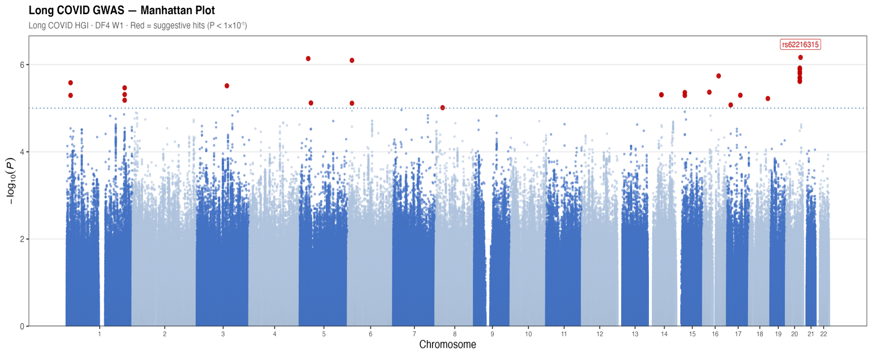
Figure 1A
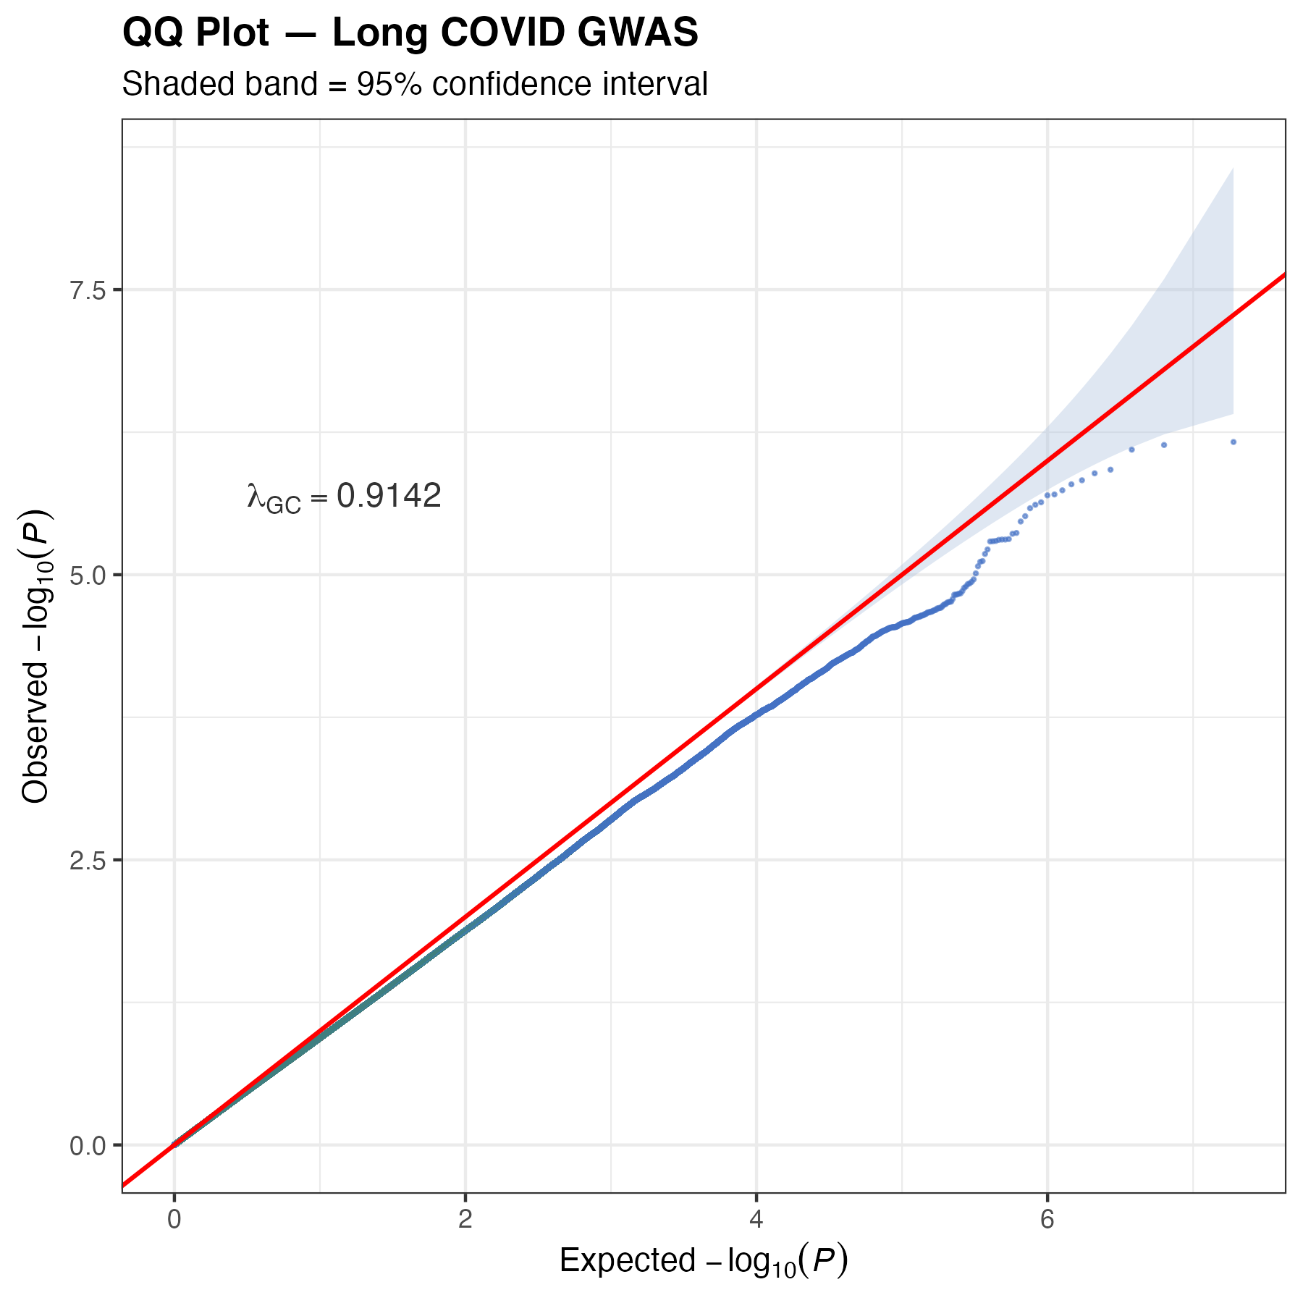
Figure 1B
Figure 1. Long COVID GWAS quality control and genome-wide association landscape. (A) Manhattan plot of Long COVID GWAS meta-analysis (Long COVID HGI DF4 W1; strict case definition vs population controls). The x-axis shows chromosomal position and the y-axis shows −log10(P). Red dots indicate suggestive associations (P<1×10⁻⁵). The horizontal dashed red line marks the genome-wide significance threshold (P=5×10⁻⁸); the dotted blue line marks the suggestive threshold (P=1×10⁻⁵). (B) Quantile-quantile (QQ) plot of observed vs expected −log10(P) values. The shaded band indicates the 95% confidence interval. The genomic inflation factor λGC=0.914 is annotated, indicating no evidence of test statistic inflation.
The Manhattan plot revealed a broadly distributed pattern of association signals across all 22 autosomes, consistent with the expected polygenic architecture of a post-infectious immunological phenotype (Figure 1A). Thirty SNPs reached the suggestive significance threshold (P<1×10⁻⁵), of which distance-based clumping identified 16 independent loci. The lead suggestive variant was rs62216315 on chromosome 20 (P=6.86×10⁻⁷, β=−0.656, MAF=0.028), mapping to the DOK5 locus. The second most significant locus was rs74400537 on chromosome 5 (P=7.28×10⁻⁷, β=+0.219, MAF=0.072), proximal to the DROSHA gene encoding a key microRNA biogenesis enzyme with established roles in immune regulation. A third notable locus at chromosome 6 (rs141945281; P=8.00×10⁻⁷) mapped near the JARID2 gene, a Polycomb complex component involved in epigenetic regulation of immune gene expression. These loci did not reach conventional genome-wide significance (P<5×10⁻⁸), consistent with the reduced statistical power of this earlier data freeze (n≈3,000 Long COVID cases) relative to the final published dataset (n=15,950 cases) in which FOXP4 achieved genome-wide significance.

3.2 PBMC Transcriptomic Landscape in Long COVID
Differential expression analysis of the GSE224615 dataset identified 72 genes meeting the exploratory significance threshold (nominal p<0.05, |LFC|>1) from 18,708 genes tested (Figure 2). Of these, 52 were upregulated and 20 were downregulated in Long COVID relative to recovered controls.
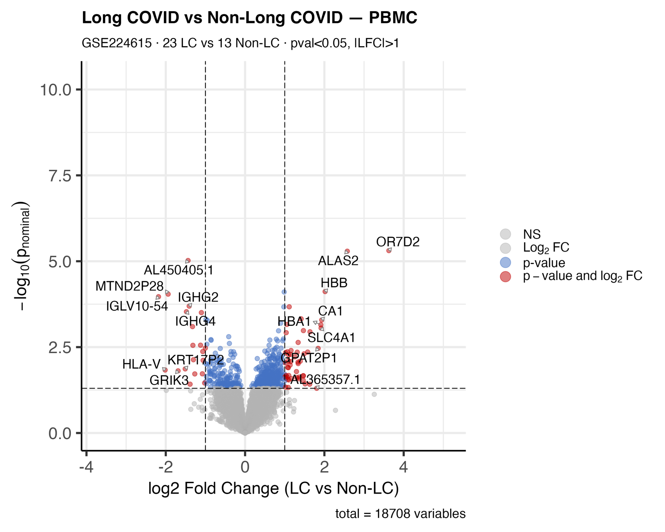
Figure 2. Volcano plot of differential gene expression in Long COVID vs non-Long COVID PBMCs. The x-axis shows log2 fold change and the y-axis shows −log10(nominal P-value). Red dots indicate genes meeting the significance threshold (p<0.05, |LFC|>1). Key upregulated genes (ALAS2, HBB, HBA1, OR7D2) and downregulated genes (IGHG2, IGHG4, IGLV10-54, HLA-V, AL450405.1) are labelled. Dataset: GSE224615; 23 Long COVID vs 13 non-Long COVID; total PBMC.

The most strongly upregulated genes included erythroid-lineage transcripts: ALAS2 (LFC=+2.58, p=5.10×10⁻⁶), HBB (LFC=+2.02, p=7.63×10⁻⁵), HBA1 (LFC=+1.91, p=7.06×10⁻⁴), HBA2 (LFC=+1.64, p=1.13×10⁻³), and the red blood cell-related enzyme carbonic anhydrase 1 (CA1; LFC=+1.93, p=5.13×10⁻⁴) and anion exchanger SLC4A1 (LFC=+1.92, p=8.81×10⁻⁴). OR7D2, an olfactory receptor gene (LFC=+3.63, p=4.90×10⁻⁶), was the highest-LFC upregulated transcript — a finding of potential interest given the anosmia phenotype characteristic of COVID-19 and Long COVID.
Among downregulated genes, immunoglobulin heavy chain transcripts IGHG2 (LFC=−1.41, p=2.02×10⁻⁴) and IGHG4 (LFC=−1.48, p=2.95×10⁻⁴), and immunoglobulin lambda chain IGLV10-54 (LFC=−2.18, p=1.08×10⁻⁴), indicated suppressed humoral immune effector function in Long COVID PBMCs. Downregulation of HLA-V (LFC=−2.02, p=1.46×10⁻²) suggested impaired antigen presentation capacity, consistent with the broader immune evasion hypothesis of Long COVID pathogenesis.

3.3 Pathway Enrichment Reveals Complement and Humoral Immune Dysregulation
GO-BP enrichment of the 63 mapped DEGs identified 27 significant biological process terms (BH-adjusted p<0.05; Figure 3). Terms clustered into three biologically coherent groups. The first and most significantly enriched cluster comprised oxidative stress and detoxification pathways — one-carbon compound transport, cellular oxidant detoxification, cellular detoxification, and response to toxic substance — driven predominantly by the upregulated erythroid gene set (ALAS2, HBB, HBA1, CA1). The second cluster encompassed gas exchange and oxygen transport terms (oxygen transport, gas transport, carbon dioxide transport, hydrogen peroxide metabolic process), reflecting the same erythroid signature.
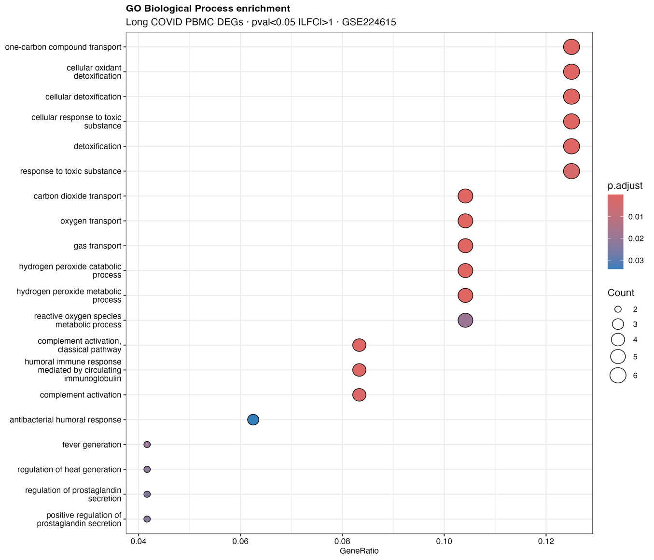
Figure 3. Gene Ontology Biological Process (GO-BP) enrichment dotplot. The 20 most significantly enriched GO-BP terms among Long COVID PBMC DEGs are shown. Dot size represents gene count within each term; colour indicates BH-adjusted P-value (deeper red = more significant). Three biological clusters are evident: oxidant detoxification (top), oxygen/gas transport (middle), and humoral immune response/complement activation (bottom).

The third and most immunologically relevant cluster included complement activation (classical pathway), humoral immune response mediated by circulating immunoglobulin, complement activation, and antibacterial humoral response. These terms were driven by the downregulated immunoglobulin transcripts (IGHG2, IGHG4, IGLV10-54) and are directly concordant with published reports of complement dysregulation and impaired humoral immunity in active Long COVID(Cervia-Hasler et al., 2024). Additional enriched terms — fever generation, regulation of heat generation, and prostaglandin secretion — are consistent with the chronic inflammatory state described in Long COVID patients.
KEGG pathway enrichment identified two significant pathways — African trypanosomiasis and Malaria (both BH-adjusted p<0.05; Figure 4). These represent a mapping artefact rather than a biological finding: both KEGG pathways share the hemoglobin gene set (HBB, HBA1, HBA2) in their gene annotations, as hemoglobin dysregulation underlies both parasitic diseases. The enrichment therefore reflects the erythroid transcriptomic signature in Long COVID rather than any biological connection to these infectious diseases.
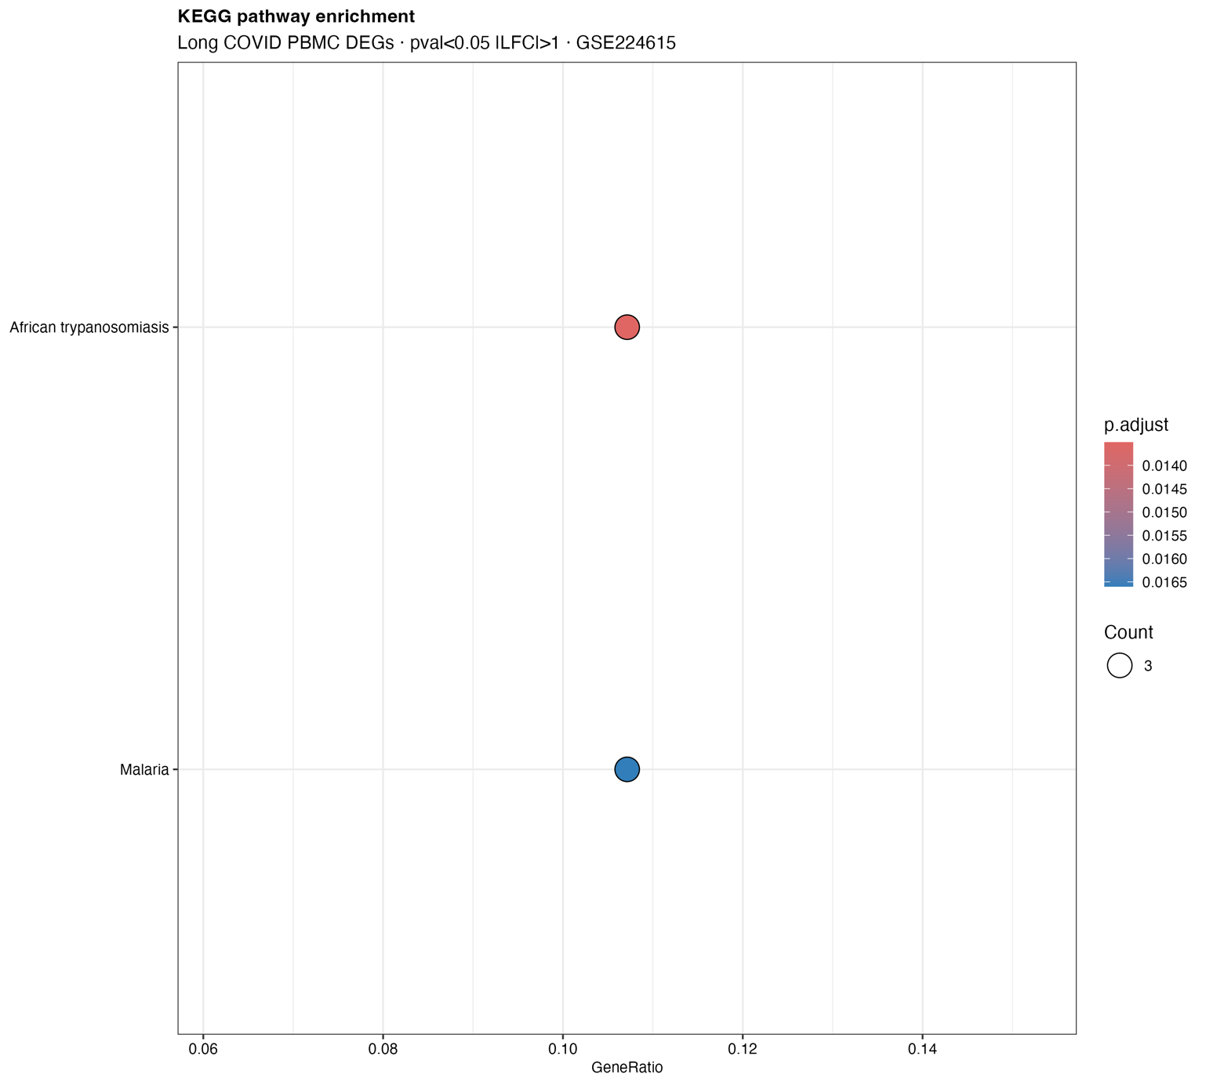
Figure 4. KEGG pathway enrichment dotplot. Two KEGG pathways reached statistical significance (BH-adjusted p<0.05): African trypanosomiasis and Malaria. Both pathways are driven by the erythroid gene cluster (HBB, HBA1, HBA2) present in the DEG list and do not reflect a biological connection to these infectious diseases.
3.4 Convergent Integration Identifies HLA-DQA1 as a Priority Candidate
Integration of published GWAS immune loci with PBMC transcriptomic data identified three priority convergent candidates among 11 tested genes (Figure 5). HLA-DQA1, a genome-wide significant Long COVID risk locus identified in the 23andMe multi-ancestry GWAS (Chaudhary et al., 2024), showed nominal downregulation in Long COVID PBMCs (LFC=−0.39, p=0.049). It must be noted that this p-value is nominal and uncorrected for multiple testing across the 11 genes examined. Applying a Bonferroni correction for 11 comparisons yields a corrected threshold of p<0.0045, which this finding does not meet. The HLA-DQA1 signal should therefore be interpreted as hypothesis-generating rather than confirmatory, consistent with the exploratory framework of this study. This nominally significant downregulation, while modest in effect size, is concordant in direction with the expected consequence of a risk allele: reduced HLA class II expression impairs antigen presentation capacity, potentially facilitating viral persistence or perpetuating aberrant T cell responses characteristic of Long COVID immunopathology.
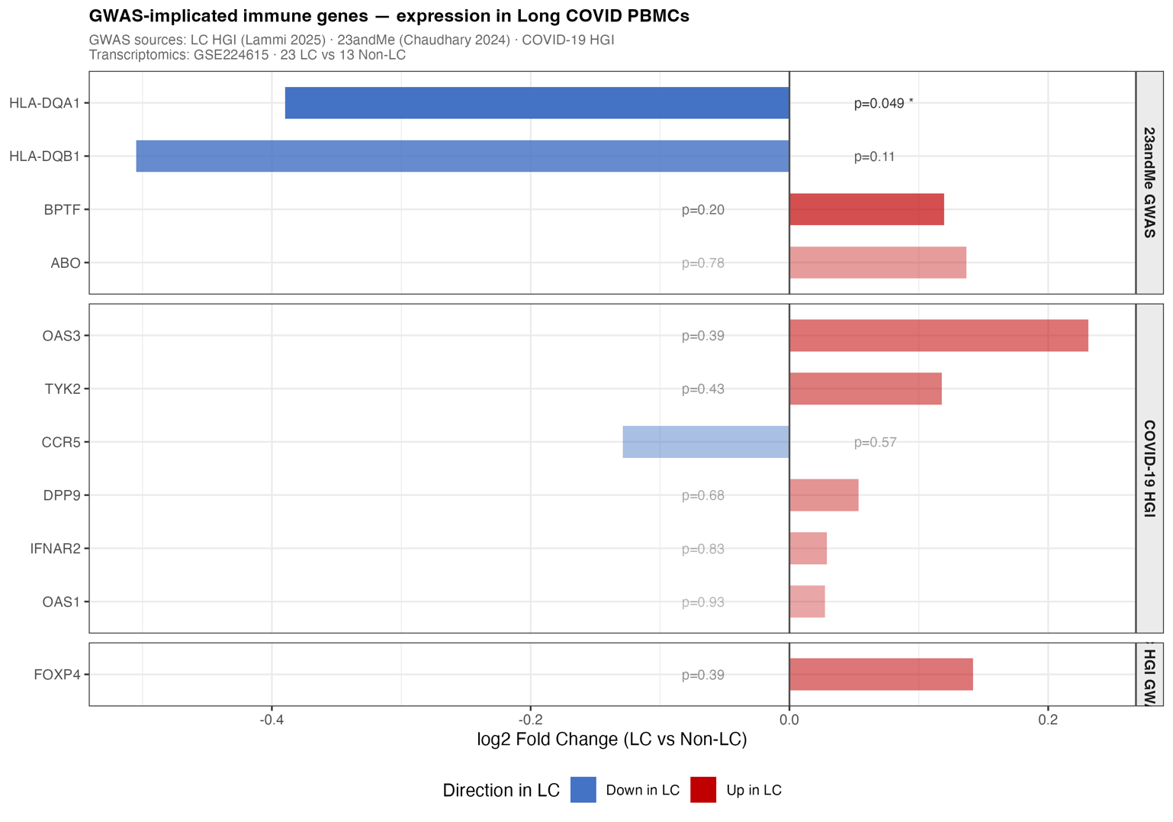
Figure 5. GWAS-transcriptomics integration figure. Horizontal bar chart showing log2 fold change (LC vs non-LC) in PBMC transcriptomics for 11 published Long COVID and COVID-19 GWAS immune gene candidates. Bars are coloured by direction (blue = down in LC; red = up in LC) and shaded by nominal significance (darker = lower p-value). Facets separate genes by GWAS source: 23andMe GWAS (Chaudhary et al., 2024), COVID-19 HGI, and Long COVID HGI (Lammi et al., 2025a). HLA-DQA1 (p=0.049*) represents a putative convergent candidate warranting further investigation.
HLA-DQB1, which co-localizes with HLA-DQA1 in the 23andMe GWAS signal, showed a consistent downregulation trend (LFC=−0.51, p=0.11). The slightly larger effect size and directional concordance with HLA-DQA1 strengthens the inference that MHC class II downregulation is a biologically coherent signal rather than a statistical artefact. BPTF, a chromatin remodeling gene in the NURF complex with roles in immune gene regulation, showed a modest upregulation trend (LFC=+0.12, p=0.20) that did not reach even nominal significance.
Among the remaining GWAS immune genes, FOXP4 (the primary Long COVID HGI hit) showed modest upregulation in Long COVID PBMCs (LFC=+0.14, p=0.39), directionally consistent with the published eQTL evidence that the Long COVID risk allele increases FOXP4 expression. OAS3 and TYK2 showed trending upregulation (LFC=+0.23 and +0.12 respectively), directionally consistent with interferon pathway activation. CCR5 showed marginal downregulation (LFC=−0.13). These signals did not reach nominal significance, likely reflecting the modest statistical power of the n=36 transcriptomic dataset.

3.5 Summary of Convergent Findings
Table 2 summarizes the convergent gene priority list. The central finding of this study is the identification of HLA-DQA1 as a gene that is (1) genome-wide significantly associated with Long COVID susceptibility in a large multi-ancestry GWAS (Chaudhary et al., 2024) and (2) nominally downregulated in Long COVID PBMCs in an independent transcriptomic dataset (p=0.049). Together with the concordant HLA-DQB1 signal, these data support MHC class II downregulation as a plausible mechanism linking genetic predisposition to immune dysfunction in Long COVID.

Table 2. Convergent gene priority table — GWAS-implicated immune genes and their transcriptomic expression in Long COVID PBMCs.
Gene | GWAS Source | LFC | p-value | Direction | Priority
HLA-DQA1 | 23andMe GWAS (Chaudhary et al., 2024) | −0.39 | 0.049* | Down in LC | HIGH — convergent hit
HLA-DQB1 | 23andMe GWAS (Chaudhary et al., 2024) | −0.51 | 0.11 | Down in LC | MODERATE — co-localised signal
BPTF | 23andMe GWAS (Chaudhary et al., 2024) | +0.12 | 0.20 | Up in LC | LOW — trend only
FOXP4 | LC HGI (Lammi et al., 2025a) | +0.14 | 0.39 | Up in LC | WATCH — directionally consistent
OAS3 | (COVID-19 Host Genetics Initiative, 2021) | +0.23 | 0.39 | Up in LC | WATCH — IFN pathway
TYK2 | (COVID-19 Host Genetics Initiative, 2021) | +0.12 | 0.43 | Up in LC | WATCH — JAK-STAT pathway
CCR5 | (COVID-19 Host Genetics Initiative, 2021) | −0.13 | 0.57 | Down in LC | —
ABO | 23andMe GWAS (Chaudhary et al., 2024) | +0.14 | 0.78 | Up in LC | —

LFC, log2 fold change (positive = higher in Long COVID). * Nominally significant (p<0.05). Priority classification: HIGH = p<0.05 + established GWAS hit; MODERATE = p<0.15 + co-localised GWAS signal; WATCH = directionally consistent with GWAS biology; — = no signal.

4. Discussion
In this study, we applied a convergent multi-omics framework integrating publicly available Long COVID GWAS summary statistics with PBMC bulk RNA-sequencing data to identify immune gene candidates at the intersection of genetic predisposition and transcriptomic dysregulation. Our principal finding is the identification of HLA-DQA1 as a putative convergent candidate — nominally downregulated in Long COVID PBMCs (LFC=−0.39, p=0.049, uncorrected) and residing within a genome-wide significant GWAS locus — suggesting that MHC class II antigen presentation impairment may represent a mechanistic node linking host genetics to immune dysfunction in Long COVID. This observation is exploratory and requires replication in larger, independently analysed cohorts before firm conclusions can be drawn.
The downregulation of HLA-DQA1 and HLA-DQB1 in Long COVID PBMCs is biologically coherent within the broader context of Long COVID immunopathology. MHC class II molecules, encoded by the HLA-DQ gene cluster on chromosome 6p21, are expressed on professional antigen-presenting cells including dendritic cells, B cells, and monocytes — the very cell types that constitute the PBMC compartment. Their primary function is to present peptide antigens to CD4+ helper T cells, thereby orchestrating adaptive immune responses. Reduced HLA class II expression would be expected to impair antigen presentation efficiency, potentially allowing viral antigen persistence, inadequate T cell priming, and failure of immune resolution — all of which have been hypothesized as drivers of Long COVID chronicity (Nalbandian et al., 2021; Yin et al., 2024).
The HLA-DQA1 locus has precedent as an immune susceptibility locus across multiple post-infectious and autoimmune conditions including type 1 diabetes, coeliac disease, and systemic lupus erythematosus(Farina et al., 2019). Its identification in the Long COVID GWAS is therefore not surprising mechanistically, but its transcriptomic validation in an independent PBMC dataset provides an important additional layer of evidence. Notably, the direction of effect — GWAS risk allele associated with increased Long COVID susceptibility, and HLA-DQA1 downregulated in Long COVID cases — is consistent with a model in which reduced antigen presentation capacity, genetically encoded by HLA-DQA1 variants, predisposes individuals to inadequate viral clearance and immune dysregulation(Lammi et al., 2025b; Loktionov et al., 2024).
The erythroid transcriptomic signature — upregulation of ALAS2, HBB, HBA1, HBA2, CA1, and SLC4A1 — is an unexpected but increasingly documented finding in Long COVID blood transcriptomics(Blankestijn et al., 2024; Lechuga et al., 2023; Maison et al., 2025). ALAS2 encodes the rate-limiting enzyme in hem biosynthesis in erythroid cells, and its upregulation alongside hemoglobin subunit transcripts suggests either contamination of PBMC preparations with erythroid progenitor cells or genuine erythroid stress responses within circulating hematopoietic progenitors(Yien & Perfetto, 2022). Both interpretations are plausible: Long COVID has been associated with altered hematopoiesis and red blood cell dysfunction, and erythroid progenitor mobilization has been reported in acute COVID-19(Grau et al., 2024; Hanson et al., 2024; Lechuga et al., 2023). The enrichment of oxygen transport and detoxification GO-BP terms driven by this erythroid signature adds biological context, as impaired oxygen delivery — whether from erythrocyte dysfunction or pulmonary sequelae — is a cardinal feature of Long COVID symptomatology(Böning et al., 2024; Rogers et al., 2023; Vogel et al., 2021).
The downregulation of immunoglobulin transcripts (IGHG2, IGHG4, IGLV10-54) provides transcriptomic corroboration for the impaired humoral immunity documented in Long COVID(Aracena et al., 2025; Fricke et al., 2025; Lyudovyk et al., 2022; Rossi et al., 2025). Multiple studies have reported reduced antibody titres, altered B cell subsets, and impaired recall responses in Long COVID patients. The complement activation GO-BP terms enriched in our analysis are consistent with the landmark finding of persistent complement dysregulation — specifically elevated complement split products — in active Long COVID patients (Cervia-Hasler et al., 2024).Together, the immunoglobulin and complement signals converge on a picture of humoral immune insufficiency in Long COVID, potentially contributing to viral antigen persistence and chronic immune activation.

5. Limitations
Several limitations of this study warrant acknowledgement. First, the GWAS data utilized represent an early data freeze with approximately 3,000 Long COVID cases, substantially underpowered relative to the final published dataset (n=15,950). Consequently, our GWAS suggestive loci did not reach conventional genome-wide significance, and our GWAS-transcriptomics integration relied on published GWAS gene lists rather than newly discovered loci. This limitation is methodologically acknowledged, and our integration strategy is explicitly framed as hypothesis-generating. Second, the transcriptomic dataset comprised n=36 samples with modest statistical power for differential expression, resulting in few FDR-corrected significant genes; we therefore applied a nominal significance threshold with appropriate caveats. Third, bulk PBMC RNA-sequencing does not resolve cell-type-specific expression changes, and future single-cell analyses would be required to attribute the HLA-DQA1 downregulation to specific antigen-presenting cell subtypes. Fourth, the cross-sectional nature of the transcriptomic data (single time point at 8 months post-infection) precludes longitudinal inference about the trajectory of immune recovery. Finally, the convergent integration analysis tested 11 pre-specified GWAS immune genes against transcriptomic data, and the nominally significant HLA-DQA1 finding (p=0.049) does not survive Bonferroni correction for multiple comparisons (corrected threshold p<0.0045). This finding is therefore presented as a hypothesis-generating signal rather than a definitive result, and independent replication is required.
Despite these limitations, the strengths of this study are noteworthy. The use of entirely publicly available data ensures full reproducibility and transparency. The integrative framework — testing whether GWAS-implicated genes show concordant transcriptomic dysregulation — represents a scalable approach applicable to any post-infectious condition where GWAS summary statistics and transcriptomic data are available. The identification of HLA-DQA1 as a convergent candidate is directly actionable: future studies should perform HLA typing in Long COVID cohorts and assess whether specific HLA-DQ alleles confer differential risk and correlate with ex vivo HLA class II expression on antigen-presenting cells.
Future directions emerging from this work include: (1) replication of the HLA-DQA1 transcriptomic signal in larger Long COVID PBMC cohorts; (2) single-cell RNA-sequencing to identify the antigen-presenting cell subtypes responsible for HLA class II downregulation; (3) functional studies testing whether HLA-DQA1 expression levels correlate with T cell activation capacity and viral antigen clearance in Long COVID patients; (4) formal TWAS and colocalization analyses as the Long COVID GWAS achieves greater statistical power; and (5) integration of proteomics and methylation data to fully characterize the molecular architecture of Long COVID immune dysregulation.

6. Conclusion
This integrative multi-omics study provides convergent transcriptomic and genomic evidence for immune dysregulation in Long COVID. We demonstrate that HLA-DQA1 — a genome-wide significant Long COVID GWAS locus — is nominally downregulated in Long COVID PBMCs, with a concordant signal at the co-localized HLA-DQB1 locus. These findings support MHC class II antigen presentation impairment as a plausible mechanism linking genetic susceptibility to chronic immune dysfunction in Long COVID. The concurrent erythroid stress transcriptomic signature, complement pathway dysregulation, and suppressed immunoglobulin expression collectively paint a picture of broad immune and haematopoietic perturbation in Long COVID at 8 months post-infection. This publicly reproducible analytical framework provides a template for convergent multi-omics investigation of post-acute sequelae and highlights HLA-DQA1 as a priority target for functional validation and potential immunotherapeutic intervention.

Data Availability Statement
All data used in this study are publicly available at no cost and require no application, registration, or institutional approval to access.
Long COVID GWAS summary statistics (Long COVID Host Genetics Initiative, Data Freeze 4, Wave 1) are available via the LocusZoom portal at https://my.locuszoom.org/gwas/91854/ (access token: 723e672edf13478e817ca44b56c0c068). COVID-19 Host Genetics Initiative Release 7 summary statistics are available at https://www.covid19hg.org/results/r7/. PBMC bulk RNA-sequencing data and pre-computed differential expression results are available from the NCBI Gene Expression Omnibus under accession number GSE224615 at https://www.ncbi.nlm.nih.gov/geo/query/acc.cgi?acc=GSE224615. No patient-level or individually identifiable data were accessed in this study.

Code Availability Statement
The complete analytical pipeline reproducing all figures and tables in this manuscript is publicly available at https://github.com/kelyto30/longcovid-multiomics. All analyses were conducted in R (v4.3.2) with Bioconductor (v3.18). Key packages include data.table (v1.17.8), ggplot2 (v3.5.2), clusterProfiler (v4.10.1), EnhancedVolcano (v1.20.0), GEOquery, org.Hs.eg.db, biomaRt, and GenomicRanges. The repository includes a README with step-by-step instructions for full reproduction of all results from publicly available raw data.

Author Contributions

Conflict of Interest
The author declares no competing interests.

Acknowledgements
The author thanks the Long COVID Host Genetics Initiative, the 23andMe research team, and the investigators of GSE224615 for making their data publicly available.
Disclaimer (Artificial intelligence)
Author(s) hereby declare that NO generative AI technologies such as Large Language Models (ChatGPT, COPILOT, etc.) and text-to-image generators have been used during the writing or editing of this manuscript.

REFERENCES

- Albornoz, E. A., Amarilla, A. A., Modhiran, N., Parker, S., Li, X. X., Wijesundara, D. K., Aguado, J., Zamora, A. P., McMillan, C. L. D., Liang, B., Peng, N. Y. G., Sng, J. D. J., Saima, F. T., Fung, J. N., Lee, J. D., Paramitha, D., Parry, R., Avumegah, M. S., Isaacs, A., … Woodruff, T. M. (2023). SARS-CoV-2 drives NLRP3 inflammasome activation in human microglia through spike protein. Molecular Psychiatry, 28(7), 2878–2893. https://doi.org/10.1038/s41380-022-01831-0
- Aracena, K. A., Nwankwo, G. C., Lee, C. T., Karnik, R., Ventura, I., Douglas, D., Udofia, I., Chen, M., Chelala, L., Im, H. K., Strek, M. E., & Adegunsoye, A. (2025). Transcriptomic Profiling of Long COVID-19 in Patients with Interstitial Lung Disease Reveals Dysregulation of Mitochondrial Oxidative Phosphorylation. American Journal of Respiratory Cell and Molecular Biology, 73(4), 634–637. https://doi.org/10.1165/rcmb.2024-0595LE
- Blankestijn, J. M., Baalbaki, N., Bazdar, S., Beekers, I., Beijers, R. J. H. C. G., van den Bergh, J. P., Bloemsma, L. D., Cornelissen, M. E. B., Dekker, T., Duitman, J. W., Houweling, L., Jacobs, J. J. L., van der Lee, I., Linders, P. M. A., Noij, L. C. E., Nossent, E. J., van de Pol, M. A., Sondermeijer, B. M., Geelhoed, J. J. M., … P4O2 Consortium. (2024). Whole blood transcriptome in long-COVID patients reveals association with lung function and immune response. The Journal of Allergy and Clinical Immunology, 154(3), 807–818. https://doi.org/10.1016/j.jaci.2024.04.032
- Böning, D., Bloch, W., Vogel, D., Steinach, M., & Kuebler, W. M. (2024). Commentary: COVID-19 impairs oxygen delivery by altering red blood cell hematological, hemorheological, and oxygen transport properties. Frontiers in Physiology, 15, 1426505. https://doi.org/10.3389/fphys.2024.1426505
- Cervia-Hasler, C., Brüningk, S. C., Hoch, T., Fan, B., Muzio, G., Thompson, R. C., Ceglarek, L., Meledin, R., Westermann, P., Emmenegger, M., Taeschler, P., Zurbuchen, Y., Pons, M., Menges, D., Ballouz, T., Cervia-Hasler, S., Adamo, S., Merad, M., Charney, A. W., … Boyman, O. (2024). Persistent complement dysregulation with signs of thromboinflammation in active Long Covid. Science, 383(6680), eadg7942. https://doi.org/10.1126/science.adg7942
- Chaudhary, N. S., Weldon, C. H., Nandakumar, P., Team, 23andMe Research, Holmes, M. V., & Aslibekyan, S. (2024). Multi-ancestry GWAS of Long COVID identifies immune-related loci and etiological links to chronic fatigue syndrome, fibromyalgia and depression (p. 2024.10.07.24315052). medRxiv. https://doi.org/10.1101/2024.10.07.24315052
- COVID-19 Host Genetics Initiative. (2021). Mapping the human genetic architecture of COVID-19. Nature, 600(7889), 472–477. https://doi.org/10.1038/s41586-021-03767-x
- Davis, H. E., McCorkell, L., Vogel, J. M., & Topol, E. J. (2023). Long COVID: Major findings, mechanisms and recommendations. Nature Reviews. Microbiology, 21(3), 133–146. https://doi.org/10.1038/s41579-022-00846-2
- Farina, F., Picascia, S., Pisapia, L., Barba, P., Vitale, S., Franzese, A., Mozzillo, E., Gianfrani, C., & Del Pozzo G, G. (2019). HLA-DQA1 and HLA-DQB1 Alleles, Conferring Susceptibility to Celiac Disease and Type 1 Diabetes, Are More Expressed Than Non-Predisposing Alleles and Are Coordinately Regulated. Cells, 8(7), 751. https://doi.org/10.3390/cells8070751
- Fricke, F., Mai, F., Wossidlo, C., Steinbeck, F., Bergmann-Ewert, W., Kordt, M., Kraft, K., Müller, B., Reisinger, E. C., & Müller-Hilke, B. (n.d.). Transcriptome analysis of classical blood cells reveals downregulation of pro-inflammatory genes in the classical monocytes of long COVID patients. Frontiers in Immunology, 16, 1710783. https://doi.org/10.3389/fimmu.2025.1710783
- Gay-Mimbrera, J., Gómez-Arias, P. J., Álvarez-Heredia, P., Batista-Duharte, A., Rivera-Ruiz, I., Aguilar-Luque, M., Juan-Cencerrado, M., Mochón-Jiménez, C., Cebrián-García, Á., Andújar-Pulido, E., Pérez-Alegre, M., Pera, A., & Ruano, J. (2025). Integrated single-cell chromatin and transcriptomic analyses of peripheral immune cells in patients with alopecia areata. Frontiers in Immunology, 16. https://doi.org/10.3389/fimmu.2025.1565241
- Grau, M., Presche, A., Krüger, A.-L., Bloch, W., & Haiduk, B. (2024). Red Blood Cell Morphology Is Associated with Altered Hemorheological Properties and Fatigue in Patients with Long COVID. Biology, 13(11), 948. https://doi.org/10.3390/biology13110948
- Hanson, A. L., Mulè, M. P., Ruffieux, H., Mescia, F., Bergamaschi, L., Pelly, V. S., Turner, L., Kotagiri, P., Göttgens, B., Hess, C., Gleadall, N., Bradley, J. R., Nathan, J. A., Lyons, P. A., Drakesmith, H., & Smith, K. G. C. (2024). Iron dysregulation and inflammatory stress erythropoiesis associates with long-term outcome of COVID-19. Nature Immunology, 25(3), 471–482. https://doi.org/10.1038/s41590-024-01754-8
- Kallaste, A., Kisand, K., Aart, A., Salumets, A., Kisand, K., Peterson, P., & Lember, M. (2025). Long COVID and Biomarker Dysregulation—A Shift Toward Immune Exhaustion? Medicina, 61(6), 996. https://doi.org/10.3390/medicina61060996
- Lammi, V., Nakanishi, T., Jones, S. E., Andrews, S. J., Karjalainen, J., Cortés, B., O’Brien, H. E., Ochoa-Guzman, A., Fulton-Howard, B. E., Broberg, M., Haapaniemi, H. H., Kanai, M., Pirinen, M., Schmidt, A., Mitchell, R. E., Mousas, A., Mangino, M., Huerta-Chagoya, A., Sinnott-Armstrong, N., … Ollila, H. M. (2025a). Genome-wide association study of long COVID. Nature Genetics, 57(6), 1402–1417. https://doi.org/10.1038/s41588-025-02100-w
- Lammi, V., Nakanishi, T., Jones, S. E., Andrews, S. J., Karjalainen, J., Cortés, B., O’Brien, H. E., Ochoa-Guzman, A., Fulton-Howard, B. E., Broberg, M., Haapaniemi, H. H., Kanai, M., Pirinen, M., Schmidt, A., Mitchell, R. E., Mousas, A., Mangino, M., Huerta-Chagoya, A., Sinnott-Armstrong, N., … Ollila, H. M. (2025b). Genome-wide association study of long COVID. Nature Genetics, 57(6), 1402–1417. https://doi.org/10.1038/s41588-025-02100-w
- Lechuga, G. C., Morel, C. M., & De-Simone, S. G. (2023). Hematological alterations associated with long COVID-19. Frontiers in Physiology, 14. https://doi.org/10.3389/fphys.2023.1203472
- Loktionov, A. V., Kobzeva, K. A., Karpenko, A. R., Sergeeva, V. A., Orlov, Y. L., & Bushueva, O. Y. (2024). GWAS-significant loci and severe COVID-19: Analysis of associations, link with thromboinflammation syndrome, gene-gene, and gene-environmental interactions. Frontiers in Genetics, 15, 1434681. https://doi.org/10.3389/fgene.2024.1434681
- Lyudovyk, O., Kim, J. Y., Qualls, D., Hwee, M. A., Lin, Y.-H., Boutemine, S. R., Elhanati, Y., Solovyov, A., Douglas, M., Chen, E., Babady, N. E., Ramanathan, L., Vedantam, P., Bandlamudi, C., Gouma, S., Wong, P., Hensley, S. E., Greenbaum, B., Huang, A. C., & Vardhana, S. A. (2022). Impaired humoral immunity is associated with prolonged COVID-19 despite robust CD8 T cell responses. Cancer Cell, 40(7), 738-753.e5. https://doi.org/10.1016/j.ccell.2022.05.013
- Maison, D. P., Khadka, V. S., Mohd-Ibrahim, I., Peluso, M. J., Henrich, T. J., Deng, Y., & Gerschenson, M. (2025). Peripheral immune progression to long COVID is associated with mitochondrial gene transcription: A meta-analysis. Mitochondrion, 85, 102072. https://doi.org/10.1016/j.mito.2025.102072
- Makhluf, H., Madany, H., & Kim, K. (2024). Long COVID: Long-Term Impact of SARS-CoV2. Diagnostics, 14(7), 711. https://doi.org/10.3390/diagnostics14070711
- Mallah, S. I., Ghorab, O. K., Al-Salmi, S., Abdellatif, O. S., Tharmaratnam, T., Iskandar, M. A., Sefen, J. A. N., Sidhu, P., Atallah, B., El-Lababidi, R., & Al-Qahtani, M. (2021). COVID-19: Breaking down a global health crisis. Annals of Clinical Microbiology and Antimicrobials, 20, 35. https://doi.org/10.1186/s12941-021-00438-7
- Mehandru, S., & Merad, M. (2022). Pathological sequelae of long-haul COVID. Nature Immunology, 23(2), 194–202. https://doi.org/10.1038/s41590-021-01104-y
- Nalbandian, A., Sehgal, K., Gupta, A., Madhavan, M. V., McGroder, C., Stevens, J. S., Cook, J. R., Nordvig, A. S., Shalev, D., Sehrawat, T. S., Ahluwalia, N., Bikdeli, B., Dietz, D., Der-Nigoghossian, C., Liyanage-Don, N., Rosner, G. F., Bernstein, E. J., Mohan, S., Beckley, A. A., … Wan, E. Y. (2021). Post-acute COVID-19 syndrome. Nature Medicine, 27(4), 601–615. https://doi.org/10.1038/s41591-021-01283-z
- Pairo-Castineira, E., Clohisey, S., Klaric, L., Bretherick, A. D., Rawlik, K., Pasko, D., Walker, S., Parkinson, N., Fourman, M. H., Russell, C. D., Furniss, J., Richmond, A., Gountouna, E., Wrobel, N., Harrison, D., Wang, B., Wu, Y., Meynert, A., Griffiths, F., … Baillie, J. K. (2021). Genetic mechanisms of critical illness in COVID-19. Nature, 591(7848), 92–98. https://doi.org/10.1038/s41586-020-03065-y
- Parums, D. V. (2024). Long COVID or Post-Acute Sequelae of SARS-CoV-2 Infection (PASC) and the Urgent Need to Identify Diagnostic Biomarkers and Risk Factors. Medical Science Monitor : International Medical Journal of Experimental and Clinical Research, 30, e946512-1-e946512-7. https://doi.org/10.12659/MSM.946512
- Peluso, M. J., & Deeks, S. G. (2024). Mechanisms of long COVID and the path toward therapeutics. Cell, 187(20), 5500–5529. https://doi.org/10.1016/j.cell.2024.07.054
- Pinero, S., Li, X., Liu, L., Li, J., Lee, S. H., Winter, M., Nguyen, T., Zhang, J., & Le, T. D. (2025). Integrative multi-omics framework for causal gene discovery in Long COVID. PLOS Computational Biology, 21(12), e1013725. https://doi.org/10.1371/journal.pcbi.1013725
- Post COVID-19 condition (long COVID). (n.d.). Retrieved May 3, 2026, from https://www.who.int/news-room/fact-sheets/detail/post-covid-19-condition-(long-covid)
- Pour Mohammadi, S., Etesamipour, R., Mercado Romero, F., Noroozi Fashkhami, M., & Peláez, I. (2025). Physical Symptoms and Neurocognitive Complaints in Long COVID: Associations with Gender, Age, Education, and Clinical Factors. Brain Sciences, 15(11), 1180. https://doi.org/10.3390/brainsci15111180
- Rogers, S. C., Brummet, M., Safari, Z., Wang, Q., Rowden, T., Boyer, T., & Doctor, A. (2023). COVID-19 impairs oxygen delivery by altering red blood cell hematological, hemorheological, and oxygen transport properties. Frontiers in Physiology, 14, 1320697. https://doi.org/10.3389/fphys.2023.1320697
- Ross, J. A., Malone, P. K., & Levy, S. (2022). The Impact of the Severe Acute Respiratory Syndrome Coronavirus 2 (SARS-CoV-2) Pandemic on Substance Use in the United States. Clinical Infectious Diseases, 75(Supplement_1), S81–S85. https://doi.org/10.1093/cid/ciac311
- Rossi, N., Benítez-Cruz, J., Marín-García, P., Azcárate, I. G., González-Escalada, A., Hervás, O. G., Alarcón, B., Regueiro, J. R., Bautista, J. M., & Martinez-Quiles, N. (2025). Post-COVID syndrome patients show reduced anti-Spike antibodies compared to COVID-recovered controls, but enhanced IgG4/IgG1 switch after the third vaccine dose. Frontiers in Immunology, 16, 1670324. https://doi.org/10.3389/fimmu.2025.1670324
- Song, X., Song, W., Cui, L., Duong, T. Q., Pandy, R., Liu, H., Zhou, Q., Sun, J., Liu, Y., & Li, T. (2024). A Comprehensive Review of the Global Epidemiology, Clinical Management, Socio-Economic Impacts, and National Responses to Long COVID with Future Research Directions. Diagnostics, 14(11), 1168. https://doi.org/10.3390/diagnostics14111168
- T Cell Exhaustion in Cancer Immunotherapy: Heterogeneity, Mechanisms, and Therapeutic Opportunities—Yu—Advanced Science—Wiley Online Library. (n.d.). Retrieved May 3, 2026, from https://advanced.onlinelibrary.wiley.com/doi/10.1002/advs.202520634
- Taha, S., Bindayna, K., Aljishi, M., Sultan, A., & Almansour, N. (2025). Transcriptomic Profiling Reveals Distinct Immune Dysregulation in Early-Stage Sepsis Patients. International Journal of Molecular Sciences, 26(14), 6647. https://doi.org/10.3390/ijms26146647
- Vogel, D. J., Formenti, F., & Camporota, L. (2021). The increased hemoglobin oxygen affinity in COVID-19. American Journal of Physiology. Lung Cellular and Molecular Physiology, 321(3), L637. https://doi.org/10.1152/ajplung.00280.2021
- Yien, Y. Y., & Perfetto, M. (2022). Regulation of Heme Synthesis by Mitochondrial Homeostasis Proteins. Frontiers in Cell and Developmental Biology, 10. https://doi.org/10.3389/fcell.2022.895521
- Yin, K., Peluso, M. J., Luo, X., Thomas, R., Shin, M.-G., Neidleman, J., Andrew, A., Young, K. C., Ma, T., Hoh, R., Anglin, K., Huang, B., Argueta, U., Lopez, M., Valdivieso, D., Asare, K., Deveau, T.-M., Munter, S. E., Ibrahim, R., … Roan, N. R. (2024). Long COVID manifests with T cell dysregulation, inflammation and an uncoordinated adaptive immune response to SARS-CoV-2. Nature Immunology, 25(2), 218–225. https://doi.org/10.1038/s41590-023-01724-6

