Environmental Implications of Plastic-Degrading Bacterial Enzymes in Polyethylene Terephthalate Bioremediation
Abstract
Polyethylene terephthalate (PET) is one of the most persistent synthetic polymers found in terrestrial and aquatic environments, and is responsible for long-term plastic accumulation and the formation of microplastic. Traditional mechanical and chemical recycling methods are still limited by contamination, degradation of polymer quality, energy consumption, and only suitable for concentrated waste streams. This review discusses and summarizes the available peer-reviewed data regarding the bacterial enzymes that degrade polyethylene terephthalate (PETase, MHETase, cutinases, and engineered variants of hydrolases). The literature was searched for the polyethyleneterephthalate biodegradation, bacterial enzymes, PETase, MHETase, plastisphere microorganisms, enzymatic recycling, environmental risk and bioremediation using major scientific databases such as PubMed, Scopus, Web of Science, ScienceDirect and Google Scholar. Only studies that focused on bacterial sources and isolation, enzymatic mechanisms, protein engineering, environmental effects, or scalability of polyethylene terephthalate degradation were included. Overall, there were 34 articles included in the final synthesis. The results indicate that bacterial enzymes can depolymerise PET to recoverable intermediates and monomers, although the practical use of these enzymes requires consideration of the crystallinity of the substrate, their catalytic efficiency under ambient conditions, enzyme instability and lack of knowledge of intermediates involved in natural ecosystems. There is current evidence that contained industrial enzymatic recycling is the most advanced near-term application, whereas open-environment bioremediation needs a more robust ecological risk assessment, standardised tests, and regulation. The production of environmentally robust enzyme variants, microbial consortia, life-cycle assessment, and safety frameworks for responsible deployment are promising areas for future research.
Keywords: Polyethylene terephthalate biodegradation; PETase; MHETase; bacterial hydrolases; enzymatic bioremediation; plastisphere; enzyme engineering; microbial plastic degradation; environmental risk assessment; circular economy.

1. Introduction
One of the hallmarks of the 21st century is plastic pollution. One such is polyethylene terephthalate (PET) which is widely used in consumer packaging, manufacturing of textile products and one-use applications. World production of PET has continued to rise over the last few decades to approximately 70 million metric tonnes per year, and is projected to rise further because of the demand from developing markets (Geyer et al., 2017). While helpful, PET is very resistant to abiotic degradation, being too slow to degrade under ambient environmental conditions to prevent long-term accumulation in terrestrial and aquatic environments (Urbanek et al., 2018).
PET persistence has been well documented in terms of its consequences. PET is also able to break down into microplastics (particles < 5 mm) and nanoplastics (particles < 1 micrometer) upon dislodgment, by physical weathering and ultraviolet irradiation, which enter food webs, sediment matrices, and drinking water systems (Eerkes-Medrano et al., 2015; Barboza et al., 2018). It has been suggested that these particle fractions are able to bind persistent organic contaminants and heavy metals, which they transport and contaminate secondarily (Koelmans et al., 2016; Hartmann et al., 2017). Furthermore, ingestion-related effects of microplastics have been linked to physical damage, inflammation and endocrine disruption in a variety of animal taxa, but dose–response relationships in natural environments remain underdetermined (Wright & Kelly, 2017; Besseling et al., 2019).
PET recycling is limited by traditional technologies like mechanical, thermal or chemical recycling, due to economic and technical constraints. Mechanically recycled polymer chain length will decrease with each recycling operation and the quality of the polymer will diminish over time, which restricts the number of end-use applications. The chemical recycling (glycolysis or methanolysis) process needs high temperatures, concentrated materials and significant amounts of energy input, which becomes non-economical at small scale and for heterogeneous streams of plastics (Ragaert et al., 2017; Schyns & Shaver, 2021). All of these constraints highlight the need for other remediation methods to be used alongside, or in place of, these remediation technologies.
The remarkable discovery of Ideonella sakaiensis 201-F6, a bacterium that can grow on PET as its sole carbon source, was a turning point in environmental biotechnology (Yoshida et al., 2016). The enzymatic machinery which was responsible for this, mainly PETase (a serine hydrolase) and MHETase (a lactonase), demonstrated proof of concept for achieving selective depolymerization of PET using near-ambient conditions. Engineered variants with significantly increased catalytic rates have been obtained in subsequent structural characterization and directed evolution studies. Thus, enzymatic bioremediation is now a realistic part of the future plastic management strategies (Bornscheuer, 2016; Joo et al., 2018; Qiu et al., 2024).
This review collates existing mechanistic, biochemical and environmental information on bacterial enzymes that degrade PET. It reviews the body of evidence for environmental use, critically assesses risks and limitations, and outlines priority research areas to help move the field beyond the proof of concept to the environmental rollout, scale and adoption.

2. Review Methodology
This narrative review was conducted through a structured search of peer-reviewed literature on polyethylene terephthalate-degrading microorganisms and bacterial enzymes. Searches were performed in PubMed, Scopus, Web of Science, ScienceDirect, and Google Scholar using combinations of the following terms: polyethylene terephthalate biodegradation, PET biodegradation, PETase, MHETase, bacterial hydrolases, plastic-degrading bacteria, bacterial source and isolation, plastisphere, enzymatic recycling, enzyme engineering, microplastic bioremediation, ecological risk, and environmental implications. Articles were considered eligible if they focused on polyethylene terephthalate biodegradation, bacterial sources and isolation, enzymatic mechanisms, protein engineering, microbial metabolism of degradation products, environmental risk, scalability, or circular economy applications. Foundational studies from 2015 onward were retained where essential to the historical development of the field, while recent studies from 2020 to 2025 were prioritised to strengthen the novelty and current relevance of the review. Articles were excluded if they focused only on non-polyethylene terephthalate polymers without transferable enzymatic or ecological relevance, lacked peer-reviewed publication status, or did not directly address microbial or enzymatic biodegradation. After screening titles, abstracts, and full texts for relevance, 34 articles were included in the final synthesis. The selected literature was analysed thematically under enzyme discovery, degradation mechanism, environmental distribution, applications, limitations, ecological risks, and future research directions.

3. Literature Review
The scientific literature on PET biodegradation spans environmental microbiology, structural biochemistry, protein engineering, and environmental impact assessment. An understanding of its trajectory is essential for situating current advances and identifying where critical evidence gaps remain.

3.1 Historical Discovery of PET-Degrading Organisms

Until 2016, the degradation of PET under ambient conditions was thought to be negligible by enzymatic degradation. Thermophilic cutinases from Thermobifida cellulosilytica and other actinobacteria were shown to be active at high temperatures (50-70°C), but with low activity in environmentally relevant conditions (Ribitsch et al., 2017). The pioneering work of Yoshida and colleagues (2016) led to a reorientation of the field because they were able to describe I. sakaiensis, a bacterium found in sediment contaminated with PET in Japan. This organism was able to concurrently express two enzymes, IsPETase and IsMHETase, which sequentially break PET down to its constituent monomers TPA and EG at 30°C, the first report of mesophilic enzymatic catabolism of PET.

Comparative sequence analysis of IsPETase revealed similarities in structure with cutinases, but with different active site properties, such as a wider cleft for the substrate binding and the different configurations of the active site loops, which gave higher activity against solid phase PET substrates (Han et al., 2017). This finding confirmed that degradation of PET could be accomplished by naturally evolved microbial enzymes, and was not an intrinsically intractable biochemical problem. Later environmental studies found similar enzymatic sequences in a variety of microbial communities, indicating that this ability to degrade plastics might have evolved as a response to the increased pollution of polymers created by humans (Zrimec et al., 2021).

3.2 Structural and Biochemical Characterization

X-ray crystallography studies of IsPETase showed the presence of a canonical serine hydrolase catalytic triad (Ser160-His237-Asp206) enclosed in a substrate binding groove which indeed is able to accommodate the rigid aromatic rings of PET.The X-ray crystallography studies of IsPETase showed that the canonical serine hydrolase catalytic triad (Ser160-His237-Asp206) is enclosed in a substrate binding groove that can indeed accommodate the rigid aromatic rings of PET. PETase stands out from its closest structural relatives by the presence of two disulfide bonds and a peculiar beta-sheet insertion in the vicinity of the active site. Biochemical studies show that PETase is selective for amorphous PET, which polymer chain mobility allows PETase to come into contact with the polymer substrate, and that it has very little activity towards crystalline PET, due to the lower accessibility of ester bonds in crystalline PET (Austin et al., 2018). Additionally, structural analysis showed a conformational change in the active site loops upon substrate binding, a flexible feature that was exploited in the following engineering efforts (Palm et al., 2019).

A series of variants of PETase has been obtained by directed evolution and rational protein engineering that are all more thermostable and catalytically efficient. Lu et al., 2022 created the FAST-PETase variant using a machine learning-guided mutagenesis strategy which fully degraded the post-consumer PET samples within days at 50 °C. Likewise, the Leaf-Branch compost cutinase from LCC (cutinase from the fungus Coprinopsis cibarius) efficiently depolymerized PET at industrial scale, under specific reactor conditions, with yield of monomers sufficient for their repolymerization (Tournier et al., 2020). More recently, DuraPETase and other thermostabilized variants have been found to have longer operational stability, which is important for industrial process applications (Cui et al., 2021).

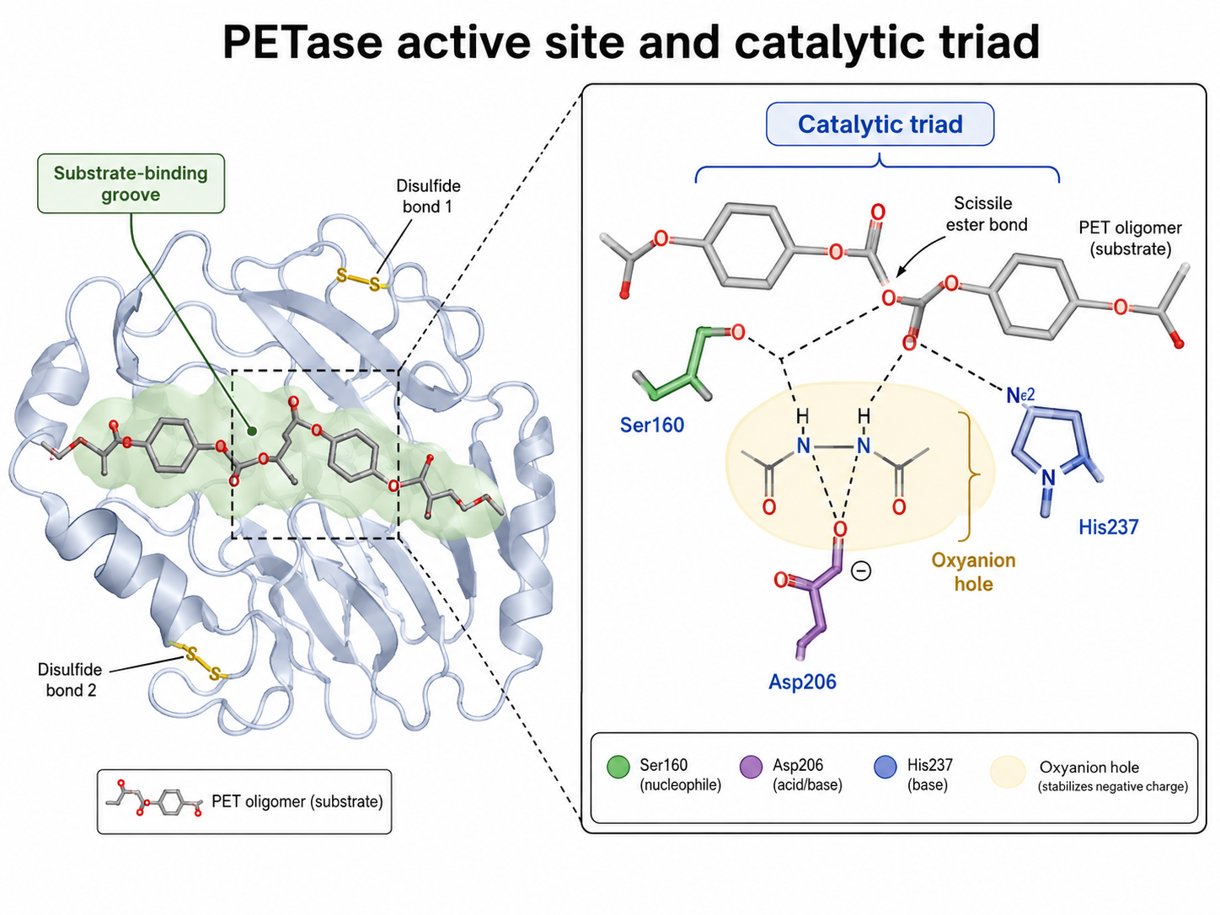
Figure 1. PETase active site and catalytic triad showing the substrate-binding groove, PET oligomer positioning, and the Ser160-His237-Asp206 catalytic residues involved in ester bond hydrolysis.

Table 1. Major PET-Degrading Enzymes and Engineered Variants Relevant to PET Bioremediation
Enzyme or variant | Source or development approach | Main function | Key strength | Main limitation | Relevance to PET bioremediation
IsPETase | Naturally produced by Ideonella sakaiensis 201-F6 | Hydrolyses ester bonds in PET to generate soluble intermediates, mainly MHET, with smaller amounts of BHET, TPA, and EG | Active under near-ambient conditions compared with earlier thermophilic cutinases | Limited catalytic efficiency against highly crystalline PET | Provides the foundational proof that bacterial enzymes can depolymerise PET under mild conditions
IsMHETase | Naturally produced by Ideonella sakaiensis 201-F6 | Hydrolyses MHET into TPA and EG | Completes the PETase-MHETase cascade by removing MHET accumulation | Does not act directly on PET polymer | Essential for improving overall depolymerisation efficiency and reducing product inhibition
Thermophilic cutinases | Derived from organisms such as Thermobifida species | Hydrolyse PET and related polyester substrates, especially at elevated temperatures | Better activity near or above PET glass transition conditions | Poor activity under ambient environmental conditions | Useful for controlled reactor systems, but less suited for direct environmental deployment
LCC-ICCG | Engineered variant of leaf-branch compost cutinase | Rapidly depolymerises PET under industrial reactor conditions | Demonstrated high monomer yield from post-consumer PET under controlled thermophilic conditions | Requires elevated temperature and controlled processing conditions | Strong candidate for contained industrial enzymatic recycling
FAST-PETase | Machine-learning-guided engineered PETase variant | Accelerates PET depolymerisation across selected post-consumer PET samples | Improved activity and practical degradation speed compared with wild-type PETase | Performance still depends on substrate properties and controlled conditions | Shows the value of machine learning and protein engineering for improving PETase function
DuraPETase and related thermostabilised variants | Computationally redesigned or engineered PETase variants | Improve PETase stability and catalytic performance | Greater thermal and operational stability than wild-type PETase | Environmental performance under complex field conditions remains uncertain | Relevant to future development of more robust enzymes for industrial or environmental use
PETase-MHETase fusion systems | Engineered multi-enzyme or fusion-protein constructs | Combine PET hydrolysis and MHET conversion within a linked enzymatic system | Reduces MHET accumulation and improves cascade efficiency | Design, stability, and scale-up remain technically challenging | Useful model for enzyme-cocktail and synthetic-biology approaches to PET degradation

3.3 Environmental Distribution of PET-Degrading Microorganisms
The enzymes that degrade PET have been identified in various environmental samples, such as marine sediments, soils, and freshwater environments, indicating that they might be more widespread in the taxonomic realm than previously thought (Zrimec et al., 2021; Gambarini et al., 2022). The ecological relevance of such sequences is, however, still unproven: It is not always possible to extrapolate from gene presence to in situ functional enzyme expression and/or relevant catalytic activity. Little is known about the population and abundance of metabolically active organisms that degrade PET in natural environments, or about the spatial distribution of these organisms.
In studies on biofilm growth on PET surfaces certain microbial species have been found to be enriched that have a higher ability to degrade enzymes when compared to their non-enriched counterparts (Oberbeckmann & Labrenz, 2020). The plastisphere appears to form its own niche, and the compositional characteristics of the plastisphere depend on the type of plastic, the geographic location and surface weathering (but the role of plastisphere-associated microbiota in bulk plastic degradation in situ hasn't been quantified yet) (Wright et al., 2021).
In recent years, the diversity of microorganisms capable of degrading plastics has been broadened to include the use of non-culture based discovery methods. Previous methods were mainly based on enrichment culture, clear-zone assays, colonisation assays on surfaces and microscopy to search for microorganisms that are able to adhere to or modify plastic substrates. The detection of putative polyethylene terephthalate hydrolases in complex environmental samples has been enhanced by more recent culture-independent methods such as metagenomics, metatranscriptomics, metaproteomics, and computational enzyme prediction (Viljakainen & Hug, 2021; Jahanshahi et al., 2025). These methods are especially helpful since polymer-depolymerising microbial communities are not always correlated with measurable depolymerisation of plastic. Hence, future research should involve culture based isolation, multi-omics and functional screening, and enzyme validation to differentiate true degradation of PE from surface colonization.

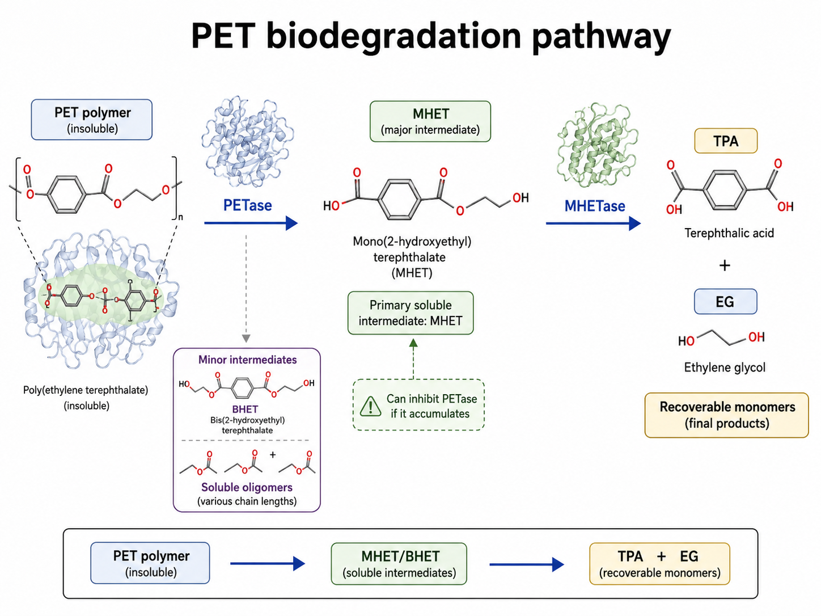
Figure 2. PET biodegradation pathway showing PETase-mediated hydrolysis of PET into soluble intermediates, mainly MHET, followed by MHETase-mediated conversion of MHET into terephthalic acid and ethylene glycol.

4. Mechanism of PET Biodegradation
PET biodegradation by bacterial enzymes follows a specific biochemical pathway with sequential enzymatic reactions and formation of intermediate metabolites. This is followed by the release of the terminal monomer. Mechanistic knowledge of this pathway is very useful to assess both the potential and the limitations of enzymatic bioremediation.

4.1 Enzymatic Hydrolysis by PETase
PETase hydrolyzes PET polymer chain by nucleophilic attack on ester bonds by a serine-dependent mechanism. The catalytic cycle begins with a nucleophilic attack of the carbonyl carbon of an ester bond in the PET substrate by the active site serine residue (Ser160) to produce a tetrahedral intermediate, which is followed by the loss of a molecule of alcohol. A conserved, structural feature of serine hydrolases, the oxyanion hole, is responsible for stabilizing this intermediate. The collapse of the tetrahedral intermediate gives rise to the release of the alcohol and formation of an acyl-enzyme ester intermediate. The activated water molecule, which is bound by the histidine-aspartate dyad of the catalytic triad, then attacks the acyl-enzym complex, to regenerate the free enzyme and release the acid component (Austin et al., 2018; Fecker et al., 2018).
PETase breaks PET in two modes of action; the first breaks the polymer by cleaving at the ester bonds in the main chain, and the second breaks the polymer by cleaving at the side chain ester bonds. The intermediate oligomers, mono(2-hydroxyethyl) terephthalate (MHET) and bis(2-hydroxyethyl) terephthalate (BHET), as well as TPA and EG, are produced in the process of endolytic cleavage of internal ester bonds. Under standard assay conditions, kinetic analysis suggests that MHET is the main initial soluble reaction product, and that product inhibition is a mechanistic constraint that can significantly affect the efficiency of the reaction (Knott et al., 2020).

4.2 Secondary Hydrolysis by MHETase
MHETase is a hydrolase belonging to the tannase family which specifically breaks down the main soluble intermediate product of PETase activity, MHET. The enzyme has a structured active site in which the terephthalic acid part of MHET is positioned for aromatic stacking interactions with the enzyme, while the ester bond is positioned for nucleophilic attack by the catalytic serine. Hydrolysis of MHET by MHETase yields one molecule of TPA and one molecule of EG, which is the depolymerization of the PET repeat unit to its constituent monomers (Yoshida et al., 2016; Knott et al., 2020).
Research shows that co-expression or close physical association of PETase and MHETase greatly improves overall depolymerization rate compared to each enzyme separately. Kim et al., 2019 reported bifunctional fusion enzyme with PETase and MHETase domains which showed synergistic activity in reducing MHET accumulation and product inhibition of PETase. The discovery has relevance for designing enzymatic cocktails and fusion protein constructs for applied bioremediation, and has spurred efforts to generate multi-enzyme cascades that incorporate additional hydrolases to combat oligomer accumulation (Sagong et al., 2020).
The metabolism and assimilation of nutrients downstream will occur. Downstream metabolism and assimilation of nutrients will take place.
In I. sakaiensis, TPA and EG are imported into the cytoplasmic compartment of the bacterial cell by specific import systems, and are catabolized by separate pathways. A TPA dioxygenase system (TphA and TphB) is involved in the conversion of TPA to protocatechuate which is then funneled into the beta-ketoadipate pathway of the tricarboxylic acid cycle. EG is metabolized via glycolaldehyde and glyoxylate intermediates to produce biosynthetic intermediates and energy-yielding metabolites. The near-completeness suggests that PET is a true growth substrate for I. sakaiensis rather than just a substrate for enzymatic surface modification (Yoshida et al., 2016).
It is known that defined catabolic routes exist for TPA and EG and this has enabled engineering of heterologous hosts for monomer recovery. By metabolic engineering strategies in Pseudomonas putida and Corynebacterium glutamicum, the flux of TPA has been redirected towards the extracellular accumulation or production of value added metabolites instead of degradation in the cells, which facilitated high purity recovery of monomers or bio-based chemicals for subsequent applications (Werner et al., 2021; Tiso et al., 2021).

4.3 Downstream Metabolism and Cellular Assimilation
In I. sakaiensis, TPA and EG generated by the enzymatic cascade are transported into the bacterial cell via dedicated uptake systems and metabolized through distinct catabolic pathways. TPA is converted to protocatechuate by a TPA dioxygenase system (TphA and TphB), which is subsequently channeled into the tricarboxylic acid cycle via the beta-ketoadipate pathway. EG is metabolized through glycolaldehyde and glyoxylate intermediates to generate biosynthetic precursors and energy-yielding metabolites. The completeness of this metabolic pathway indicates that PET serves as a genuine growth substrate for I. sakaiensis, not merely as a target for enzymatic surface modification (Yoshida et al., 2016).
The identification of defined catabolic routes for TPA and EG has facilitated the engineering of heterologous hosts for monomer recovery. Metabolic engineering approaches in Pseudomonas putida and Corynebacterium glutamicum have directed TPA flux toward extracellular accumulation or toward value-added metabolite production rather than intracellular catabolism, enabling the recovery of high-purity monomers or bio-based chemicals for downstream applications (Werner et al., 2021; Tiso et al., 2021).

5. Environmental Implications
The deployment of PET-degrading enzymes in environmental contexts carries a complex portfolio of potential benefits and risks. A rigorous assessment of these implications is essential for responsible technology development and regulatory evaluation.

5.1 Reduction of PET Persistence and Microplastic Generation
The most direct environmental benefit of enzymatic PET degradation is the acceleration of polymer breakdown in contaminated environments, thereby reducing the long-term accumulation of intact PET and limiting the physical fragmentation processes that generate microplastics and nanoplastics. Mathematical modeling of PET fragmentation kinetics indicates that even a modest increase in surface erosion rates through enzymatic activity could substantially reduce the steady-state mass of microplastics in affected ecosystems, given the exponential relationship between particle number and surface area during fragmentation (Shen et al., 2020). However, empirical field data validating these models are presently lacking, and the practical contribution of enzymatic activity to bulk microplastic reduction under environmental conditions has not been directly measured.
It is important to note that enzymatic degradation does not intrinsically prevent intermediate product accumulation. If MHET and BHET generated by PETase activity are not efficiently further metabolized or removed, these soluble aromatic compounds may themselves exert ecological effects, including inhibition of aquatic organisms and accumulation in sediments. The environmental fate of PET degradation intermediates in open systems remains an understudied and critical knowledge gap (Danso et al., 2019).

5.2 Ecosystem Impacts of Enzymatic Activity
The introduction of PET-degrading enzymes or enzyme-producing microorganisms into natural ecosystems raises substantive ecological concerns that must be evaluated prior to large-scale deployment. Engineered microbial strains with enhanced PETase activity could displace native microbial communities if they confer competitive advantages in PET-colonized environments, potentially altering plastisphere dynamics and associated food web interactions. Studies on introduced biocontrol organisms in other environmental contexts demonstrate that displacement of native taxa can have cascading ecological consequences that are difficult to predict or reverse (Oberbeckmann & Labrenz, 2020).
The specificity of PETase for PET ester bonds provides some degree of biochemical selectivity; however, the potential for off-target hydrolysis of structurally related natural polyesters, including suberin in plant tissues and cutin on leaf surfaces, has not been comprehensively evaluated. Evidence from in vitro substrate profiling studies indicates that PETase and related cutinases possess measurable activity against model cutin monomers, suggesting that ecological risk assessment must include evaluation of potential impacts on plant physiology and soil organic matter dynamics (Ribitsch et al., 2017; Palm et al., 2019).
Aquatic environments merit particular attention. TPA, one of the terminal products of PET enzymatic degradation, is relatively recalcitrant in anaerobic conditions and has been detected at elevated concentrations in industrial effluents. The controlled degradation of PET in aerobic surface waters would generate TPA concentrations likely well below acute toxicity thresholds; however, chronic low-level exposure effects on aquatic biota remain inadequately characterized (Wierckx et al., 2015; Hartmann et al., 2017).

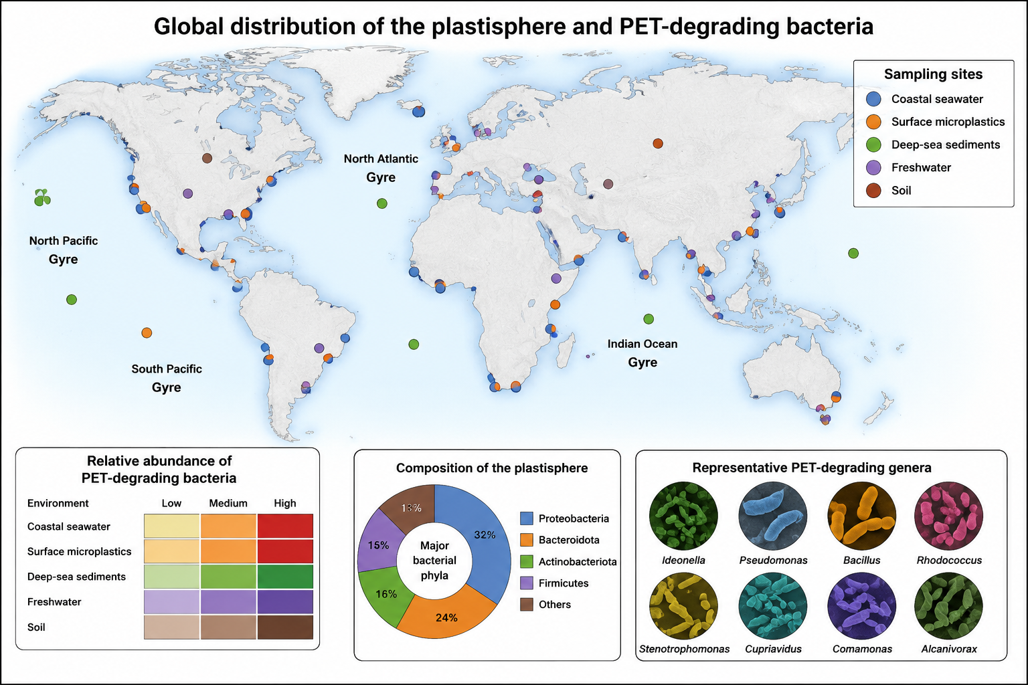
Figure 3. Global distribution of plastisphere-associated environments and PET-degrading microbial communities

5.3 Comparison with Conventional Recycling Approaches
Enzymatic depolymerization offers mechanistic advantages over conventional PET recycling that are relevant from an environmental life cycle perspective. Mechanical recycling of PET is limited to materials with low contamination levels and specific color profiles, excludes composite or multilayer packaging, and yields downcycled polymer with degraded mechanical properties. In contrast, enzymatic depolymerization to TPA and EG produces virgin-equivalent monomers from diverse, contaminated, and colored PET streams, enabling true closed-loop recycling without quality deterioration (Ragaert et al., 2017; Schyns & Shaver, 2021).
Life cycle assessment (LCA) studies of enzymatic PET recycling indicate significantly lower greenhouse gas emissions and energy consumption compared with conventional virgin PET production and thermal recycling routes, provided that the enzyme production process is itself optimized and the energy requirements of reactor heating are addressed (Tournier et al., 2020; Rosenboom et al., 2022). Evidence suggests that when enzymatic processes operate at or near ambient temperatures, as is the objective for in situ bioremediation applications, the carbon footprint advantage over chemical recycling is maximized. However, comparative LCA data for environmental release scenarios are essentially absent from the current literature.

5.4 Potential Contribution to Circular Economy Frameworks
Enzymatic PET depolymerization aligns conceptually with circular economy principles by enabling material recovery from waste streams that are currently directed to landfill or incineration. The recovery of chemically pure TPA and EG monomers from enzymatic processes supports their reintegration into PET polymer production, closing the material loop in a manner that is not achievable through mechanical recycling of degraded or heterogeneous feedstocks (Tournier et al., 2020; Tiso et al., 2021). Studies demonstrate proof-of-concept for re-polymerization of enzymatically recovered TPA to produce PET with properties equivalent to virgin-grade material, though the economic viability of this pathway at commercial scale remains to be established (Rosenboom et al., 2022).

6. Applications
PET-degrading enzymatic systems have been evaluated in a range of applied contexts, spanning controlled industrial processes to exploratory environmental deployment strategies.

6.1 Industrial Enzymatic Recycling
The most advanced and evidence-supported application of PET-degrading enzymes is contained industrial biorecycling. Carbios demonstrated pilot-scale enzymatic depolymerization of post-consumer PET waste using the engineered LCC-ICCG cutinase under thermophilic conditions (72 degrees Celsius), achieving greater than 90 percent monomer yield from colored, opaque PET within 10 hours (Tournier et al., 2020). This process has been validated at demonstration plant scale and represents the most proximate pathway to commercial deployment. The recovered TPA has been used to produce food-grade PET bottles, providing direct evidence for circular economy applicability. Cell-factory approaches integrating complete metabolic pathways for PET monomer assimilation offer additional routes to material valorization (Liu et al., 2025). Techno-economic analyses indicate that industrial biorecycling can be economically competitive with virgin PET production under favorable market conditions, particularly when carbon pricing mechanisms are considered (Rosenboom et al., 2022).

6.2 In Situ Bioremediation
The direct application of PET-degrading enzymes or microbial consortia to contaminated environmental compartments, including marine systems, freshwater bodies, and contaminated soils, represents a longer-term and substantially more uncertain application pathway. Laboratory-scale studies have demonstrated PETase activity in marine water chemistry simulations and soil microcosm experiments, but extrapolation to field conditions is constrained by multiple variables, including enzyme stability, mass transfer limitations, competitive inhibition by dissolved organic matter, and the heterogeneous physical state of environmental PET (Danso et al., 2019; Gambarini et al., 2022).
Immobilization strategies, in which PETase is conjugated to carriers such as silica nanoparticles, magnetic beads, or biodegradable polymers, have been explored as mechanisms to extend enzyme half-life in environmental matrices and facilitate recovery after treatment. Studies demonstrate that immobilized PETase retains functional activity through multiple use cycles, and that carrier materials can be engineered to provide targeted delivery to plastic-rich microenvironments (Cui et al., 2021). However, the ecological implications of introducing nanoparticle carriers into natural ecosystems introduce an additional layer of environmental risk assessment complexity.

6.3 Textile and Fiber Applications
Enzymatic surface modification of PET textiles, using PETase at sub-degrading concentrations, has been proposed as a means to improve dyeability, moisture management, and the end-of-life biodegradability of polyester fabrics without compromising structural integrity. Controlled surface etching by PETase generates carboxyl and hydroxyl functionalities on PET fiber surfaces, potentially reducing the finishing chemical burden of textile processing. This application domain remains in early-stage research, with limited data on the long-term consequences of enzymatically modified fibers during mechanical washing, a primary route of microplastic emission from synthetic textiles (Shen et al., 2020; Wright et al., 2021).

7. Challenges and Limitations
Despite considerable progress in understanding and engineering PET-degrading enzymes, substantial scientific, technical, and regulatory challenges constrain the translation of laboratory findings to environmental practice.

7.1 Catalytic Efficiency and Substrate Accessibility
Even the most advanced engineered PETase variants exhibit catalytic efficiencies far below those of hydrolytic enzymes acting on soluble substrates, largely because degradation of solid-phase PET is constrained by interfacial enzyme–substrate interactions rather than intrinsic catalytic activity. This limitation is further compounded by the higher crystallinity of environmental PET compared to the amorphous substrates commonly used in laboratory studies. Evidence indicates that environmental PET often exhibits surface crystallinity exceeding 30 percent, which reduces effective enzyme binding site availability and significantly slows degradation relative to model systems (Knott et al., 2020; Lu et al., 2022).
Pretreatment strategies such as thermal annealing below the glass transition temperature to reduce crystallinity, mechanical milling to increase surface area, and ultraviolet irradiation to induce surface oxidation have been shown to enhance enzymatic degradation under controlled conditions. However, the energy and resource demands associated with these processes partially offset the environmental advantages of enzymatic approaches over conventional recycling methods, and their applicability to dispersed environmental contamination remains limited (Urbanek et al., 2018; Fecker et al., 2018).

7.2 Environmental Stability of Enzymes
Protein stability under diverse environmental conditions presents a fundamental challenge for in situ applications. Free PETase in aquatic or soil environments is subject to proteolytic degradation, pH extremes, ultraviolet irradiation, adsorption to particulate matter, and competitive inhibition by humic acids and other dissolved organic compounds. Half-lives of free PETase in natural water samples have not been systematically reported, representing a critical data gap. Thermostabilizing mutations that improve reactor performance may not confer equivalent benefits under the fluctuating, low-temperature, and chemically complex conditions characteristic of contaminated natural environments (Bornscheuer, 2016; Palm et al., 2019).

7.3 Scalability and Economic Viability
The production cost of recombinant PETase at scale remains a significant economic barrier to broad deployment. Current enzyme production relies predominantly on laboratory fermentation systems, with production costs that are incompatible with application to diffuse environmental contamination. While industrial biorecycling in contained facilities can achieve cost recovery through the value of recovered monomers, environmental remediation applications do not generate product revenue streams and must be justified on the basis of avoided environmental damage costs (Schyns & Shaver, 2021; Rosenboom et al., 2022).
Regulatory frameworks for the deliberate release of engineered enzymes or genetically modified microorganisms into natural environments are nascent in most jurisdictions, and the approval process for field trials is expected to be lengthy and require extensive environmental safety data that are not currently available (Wierckx et al., 2015; Danso et al., 2019).

7.4 Ecological Risk Assessment Gaps
Limited data exist on the ecological consequences of enzymatic PET degradation at the community and ecosystem level. The fate of TPA and EG in diverse environmental matrices, particularly under anaerobic conditions prevalent in sediments and waterlogged soils, is inadequately characterized. The potential for horizontal gene transfer of PETase-encoding sequences from engineered strains to native microbial populations, and the ecological consequences of such transfer, has not been evaluated (Oberbeckmann & Labrenz, 2020; Wright et al., 2021). Furthermore, the interactions between enzymatic degradation products and existing microplastic-associated contaminant complexes remain an open research question (Besseling et al., 2019; Hartmann et al., 2017).
7.5 Review Limitations
This review is limited by the heterogeneity of experimental methods used across polyethylene terephthalate biodegradation studies. Many published studies use different substrate forms, crystallinity levels, pretreatment methods, enzyme concentrations, incubation temperatures, and analytical endpoints, which limits direct quantitative comparison among reported degradation efficiencies. In addition, most evidence on bacterial enzymes derives from laboratory assays or controlled reactor systems rather than long-term field trials in natural ecosystems. The review also did not perform a formal meta-analysis, and non-English or unpublished studies may not have been captured. Finally, ecological data on the fate, persistence, and toxicity of polyethylene terephthalate degradation intermediates such as MHET, BHET, terephthalic acid, and ethylene glycol remain limited, so conclusions about open-environment deployment should be interpreted cautiously.

8. Future Research Directions
The current state of evidence identifies several high-priority research domains that are essential for the responsible advancement of PET enzymatic bioremediation.

8.1 Protein Engineering for Environmental Robustness
Future protein engineering should focus explicitly on stability and activity in environmentally relevant conditions (low temperatures (5 – 20° C), variable pH, high ionic strength, aqueous matrices), not just optimized for the conditions of a laboratory buffer or controlled reactor. The machine-learning strategies that have successfully been applied to the evolution of thermostable PETase variants should be applied to modeling the fitness landscape of cold-active and contaminant-tolerant variants (Lu et al., 2022; Cui et al., 2021). Furthermore, the development of proteolytic degradation and surface adsorption resistance will be crucial in the case of open environmental systems to enhance the functional enzyme half-life.

8.2 Synthetic Ecology and Consortium Design
Rather than relying on single-organism or single-enzyme systems, future research should evaluate the potential of rationally designed microbial consortia. In such systems, different microorganisms perform complementary roles in PET degradation, intermediate metabolism, and biomass growth.Evidence from synthetic ecology demonstrates that microbial consortia frequently outperform monocultures in complex substrate utilization through metabolic division of labor and cross-feeding interactions (Tiso et al., 2021; Sagong et al., 2020). The design of consortia incorporating PETase-expressing organisms alongside efficient TPA and EG metabolizers could overcome the product inhibition constraints that limit single-enzyme systems.

8.3 Environmental Fate and Risk Assessment
An immediate research priority is the systematic characterization of the environmental fate of PET degradation intermediates in a variety of environmental matrices under various redox conditions. These intermediates include MHET, BHET, TPA, and EG.Laboratory ecotoxicological assays using environmentally relevant exposure concentrations, complemented by field mesocosm experiments, are needed to establish safety thresholds and inform regulatory frameworks (Barboza et al., 2018; Besseling et al., 2019). Standardized protocols for assessing the ecological impact of enzymatic bioremediation interventions, analogous to those developed for petroleum hydrocarbon bioremediation, have yet to be developed for the plastic degradation context.

8.4 Life Cycle and Techno-Economic Assessment
Comprehensive life cycle assessments of enzymatic PET bioremediation across its full application spectrum are needed to quantify net environmental benefits relative to alternative waste management strategies. These assessments should incorporate uncertainty analysis reflecting the current state of process development and should be updated as engineering performance data accumulates (Rosenboom et al., 2022; Gambarini et al., 2022). Techno-economic modeling that accounts for enzyme production costs, process infrastructure, and market dynamics for recovered monomers will be essential for identifying conditions under which enzymatic approaches become economically competitive.

9. Conclusion
A scientifically sound and environmentally sound solution to plastic waste is the bacterial enzymatic degradation of polyethylene terephthalate, in which enzymes like PETase, MHETase and engineered cutinases can depolymerize polyethylene terephthalate into recoverable monomers. Based on current evidence, the best short-term use of the technology is in the area of contained industrial enzymatic recycling, where the process can be controlled, degradation products can be recovered and ecological exposure can be minimised. The application of free enzymes or engineered microorganisms in the open field is still an immature technology, however, due to the issues of enzyme stability, polymer crystallinity, mass transfer, intermediate degradation fate and ecological safety. The manuscript thus suggests that further research should focus on the development of enzyme variants that are environmentally robust, microbial consortia with complete intermediate metabolism, standardisation of ecotoxicological testing, and life-cycle assessment. Policy making should also be done in parallel with scientific advancement in order to ensure that enzymatic bioremediation can play a responsible role in the management of plastics in a circular manner without generating any unanticipated ecological risks.

Disclaimer (Artificial Intelligence)
Author(s) hereby declare that NO generative AI technologies such as Large Language Models (ChatGPT, COPILOT, etc.) and text-to-image generators have been used during the writing or editing of this manuscript.

References
1. Geyer, R., Jambeck, J. R., & Law, K. L. (2017). Production, use, and fate of all plastics ever made. Science Advances, 3(7), e1700782. https://doi.org/10.1126/sciadv.1700782
2. Urbanek, A. K., Rymowicz, W., & Mironczuk, A. M. (2018). Degradation of plastics and plastic-degrading bacteria in cold marine habitats. Applied Microbiology and Biotechnology, 102(18), 7669–7678. https://doi.org/10.1007/s00253-018-9195-y
3. Eerkes-Medrano, D., Thompson, R. C., & Aldridge, D. C. (2015). Microplastics in freshwater systems: a review of the emerging threats, identification of knowledge gaps and prioritisation of research needs. Water Research, 75, 63–82. https://doi.org/10.1016/j.watres.2015.02.012
4. Barboza, L. G. A., Dick Vethaak, A., Lavorante, B. R. B. O., Lundebye, A. K., & Guilhermino, L. (2018). Marine microplastic debris: An emerging issue for food security, food safety and human health. Marine Pollution Bulletin, 133, 336–348. https://doi.org/10.1016/j.marpolbul.2018.05.047
5. Koelmans, A. A., Bakir, A., Burton, G. A., & Janssen, C. R. (2016). Microplastic as a vector for chemicals in the aquatic environment: critical review and model-supported reinterpretation of empirical studies. Environmental Science & Technology, 50(7), 3315–3326. https://doi.org/10.1021/acs.est.5b06069
6. Hartmann, N. B., Rist, S., Bodin, J., Jensen, L. H. S., Schmidt, S. N., Mayer, P., et al. (2017). Microplastics as vectors for environmental contaminants: exploring sorption, desorption, and transfer to biota. Integrated Environmental Assessment and Management, 13(3), 488–493. https://doi.org/10.1002/ieam.1904
7. Wright, S. L., & Kelly, F. J. (2017). Plastic and human health: a micro issue? Environmental Science & Technology, 51(12), 6634–6647. https://doi.org/10.1021/acs.est.7b00423
8. Besseling, E., Redondo-Hasselerharm, P., Foekema, E. M., & Koelmans, A. A. (2019). Quantifying ecological risks of aquatic micro- and nanoplastic. Critical Reviews in Environmental Science and Technology, 49(1), 32–80. https://doi.org/10.1080/10643389.2018.1531688
9. Ragaert, K., Delva, L., & Van Geem, K. (2017). Mechanical and chemical recycling of solid plastic waste. Waste Management, 69, 24–58. https://doi.org/10.1016/j.wasman.2017.07.044
10. Schyns, Z. O. G., & Shaver, M. P. (2021). Mechanical recycling of packaging plastics: a design-for-recycling guide. Macromolecular Rapid Communications, 42(3), 2000415. https://doi.org/10.1002/marc.202000415
11. Yoshida, S., Hiraga, K., Takehana, T., Taniguchi, I., Yamaji, H., Maeda, Y., et al. (2016). A bacterium that degrades and assimilates poly(ethylene terephthalate). Science, 351(6278), 1196–1199. https://doi.org/10.1126/science.aad6359
12. Bornscheuer, U. T. (2016). Feeding on plastic. Science, 351(6278), 1154–1155. https://doi.org/10.1126/science.aaf2853
13. Joo, S., Cho, I. J., Seo, H., Son, H. F., Sagong, H. Y., Shin, T. J., et al. (2018). Structural insight into molecular mechanism of poly(ethylene terephthalate) degradation. Nature Communications, 9, 382. https://doi.org/10.1038/s41467-018-02881-1
14. Qiu, J., Chen, Y., Zhang, L., Wu, J., Zeng, X., Shi, X., et al. (2024). A comprehensive review on enzymatic biodegradation of polyethylene terephthalate. Environmental Research, 240(Part 2), 117427. https://doi.org/10.1016/j.envres.2023.117427
15. Ribitsch, D., Hromic, A., Zitzenbacher, S., Zartl, B., Gamerith, C., Pellis, A., et al. (2017). Small cause, large effect: structural characterization of cutinases from Thermobifida cellulosilytica. Biotechnology and Bioengineering, 114(10), 2397–2406. https://doi.org/10.1002/bit.26372
16. Han, X., Liu, W., Huang, J. W., Ma, J., Zheng, Y., Ko, T. P., et al. (2017). Structural insight into catalytic mechanism of PET hydrolase. Nature Communications, 8, 2106. https://doi.org/10.1038/s41467-017-02255-z
17. Zrimec, J., Buric, F., Al-Subhi, A., Wahlstrom, R., Chen, J., Sjoling, A., et al. (2021). Plastic-degrading potential across the global microbiome correlates with recent pollution trends. mBio, 12(5), e02155-21. https://doi.org/10.1128/mBio.02155-21
18. Austin, H. P., Allen, M. D., Donohoe, B. S., Rorrer, N. A., Kearns, F. L., Silveira, R. L., et al. (2018). Characterization and engineering of a plastic-degrading aromatic polyesterase. Proceedings of the National Academy of Sciences, 115(19), E4350–E4357. https://doi.org/10.1073/pnas.1718804115
19. Palm, G. J., Reisky, L., Bottcher, D., Muller, H., Michels, E. A. P., Walczak, M. C., et al. (2019). Structure of the plastic-degrading Ideonella sakaiensis MHETase bound to a substrate. Nature Communications, 10, 1717. https://doi.org/10.1038/s41467-019-09326-3
20. Lu, H., Diaz, D. J., Czarnecki, N. J., Zhu, C., Kim, W., Shroff, R., et al. (2022). Machine learning-aided engineering of hydrolases for PET depolymerization. Nature, 604(7907), 662–667. https://doi.org/10.1038/s41586-022-04599-z
21. Tournier, V., Topham, C. M., Gilles, A., David, B., Folgoas, C., Moya-Leclair, E., et al. (2020). An engineered PET depolymerase to break down and recycle plastic bottles. Nature, 580(7802), 216–219. https://doi.org/10.1038/s41586-020-2149-4
22. Cui, Y., Chen, Y., Liu, X., Dong, S., Tian, Y., Qiao, Y., et al. (2021). Computational redesign of a PETase for plastic biodegradation under ambient condition by the GRAPE strategy. ACS Catalysis, 11(3), 1340–1350. https://doi.org/10.1021/acscatal.0c05126
23. Gambarini, V., Pantos, O., Kingsbury, J. M., Weaver, L., Handley, K. M., & Lear, G. (2022). Phylogenetic distribution of plastic-degrading microorganisms. mSystems, 7(1), e01112-21. https://doi.org/10.1128/msystems.01112-21
24. Oberbeckmann, S., & Labrenz, M. (2020). Marine microbial assemblages on microplastics: diversity, adaptation, and role in degradation. Annual Review of Marine Science, 12, 209–232. https://doi.org/10.1146/annurev-marine-010419-010633
25. Wright, R. J., Langille, M. G. I., & Walker, T. R. (2021). Food or just a free ride? A meta-analysis reveals the global diversity of the plastisphere. ISME Journal, 15(3), 789–806. https://doi.org/10.1038/s41396-020-00814-9
26. Viljakainen, V. R., & Hug, L. A. (2021). New approaches for the characterization of plastic-associated microbial communities and the discovery of plastic-degrading microorganisms and enzymes. Computational and Structural Biotechnology Journal, 19, 6191–6200. https://doi.org/10.1016/j.csbj.2021.11.023
27. Jahanshahi, D. A., Barzani, M. R. R., Bahram, M., Ariaeenejad, S., & Kavousi, K. (2025). Metagenomic exploration and computational prediction of novel enzymes for polyethylene terephthalate degradation. Ecotoxicology and Environmental Safety, 289, 117640. https://doi.org/10.1016/j.ecoenv.2024.117640
28. Fecker, T., Galaz-Davison, P., Engelberger, F., Narui, Y., Sotomayor, M., Parra, L. P., et al. (2018). Active site flexibility as a hallmark for efficient PET degradation by I. sakaiensis PETase. Biophysical Journal, 114(6), 1302–1312. https://doi.org/10.1016/j.bpj.2018.02.005
29. Knott, B. C., Erickson, E., Allen, M. D., Gado, J. E., Graham, R., Kearns, F. L., et al. (2020). Characterization and engineering of a two-enzyme system for plastics depolymerization. Proceedings of the National Academy of Sciences, 117(41), 25476–25485. https://doi.org/10.1073/pnas.2006753117
30. Kim, H. T., Kim, J. K., Cha, H. G., Kang, M. J., Lee, H. S., Khang, T. U., et al. (2019). Biological valorization of poly(ethylene terephthalate) monomers for upcycling waste PET. ACS Sustainable Chemistry & Engineering, 7(24), 19396–19406. https://doi.org/10.1021/acssuschemeng.9b03908
31. Sagong, H. Y., Son, H. F., Joo, S., Lee, S. H., Kim, I. K., Park, S. Y., et al. (2020). Structural basis of polyethylene terephthalate (PET) or polyethylene furanoate (PEF) recognition by the depolymerizing enzyme LCC. FEBS Letters, 594(2), 264–275. https://doi.org/10.1002/1873-3468.13660
32. Werner, A. Z., Clare, R., Mand, T. D., Haugen, S., Ramirez, K. J., Shea, T. M., et al. (2021). Tandem chemical deconstruction and biological upcycling of poly(ethylene terephthalate) to beta-ketoadipic acid by Pseudomonas putida KT2440. Metabolic Engineering, 67, 250–261. https://doi.org/10.1016/j.ymben.2021.07.005
33. Tiso, T., Narancic, T., Wei, R., Pollet, E., Beagan, N., Schroeder, K., et al. (2021). Towards bio-upcycling of polyethylene terephthalate. Metabolic Engineering, 66, 167–178. https://doi.org/10.1016/j.ymben.2021.03.011
34. Shen, M., Ye, S., Zeng, G., Zhang, Y., Xing, L., Tang, W., et al. (2020). Can microplastics pose a threat to ocean carbon sequestration? Marine Pollution Bulletin, 150, 110712. https://doi.org/10.1016/j.marpolbul.2019.110712
35. Danso, D., Chow, J., & Streit, W. R. (2019). Plastics: environmental and biotechnological perspectives on microbial degradation. Applied and Environmental Microbiology, 85(19), e01095-19. https://doi.org/10.1128/AEM.01095-19
36. Wierckx, N., Prieto, M. A., Pomposiello, P., de Lorenzo, V., O'Connor, K., & Blank, L. M. (2015). Plastic waste as a novel substrate for industrial biotechnology. Microbial Biotechnology, 8(6), 900–903. https://doi.org/10.1111/1751-7915.12312
37. Rosenboom, J. G., Langer, R., & Traverso, G. (2022). Bioplastics for a circular economy. Nature Reviews Materials, 7(2), 117–137. https://doi.org/10.1038/s41578-021-00407-8
38. Liu, F., Wang, T., Liu, X., Xu, N., & Pan, X. (2025). Efficient biodegradation and upcycling of polyethylene terephthalate mediated by cell-factories. Frontiers in Microbiology, 16, 1599470. https://doi.org/10.3389/fmicb.2025.1599470

