MORPHOLOGICAL AND ANATOMICAL STUDIES ON Ipomoea aquatica

ABSTRACT
This study revealed morphological and anatomical analysis on Ipomoea aquatica. The study aimed comprehensively elucidating the morphological characteristics of Ipomoea aquatica. Result, established a foundation for botanical classification providing insights into the plant's ecological niche. The result also showed that Ipomoea aquatica, classified as a herbaceous plant, exhibits non-woody stems, indicative of succulence and flexibility. The trailing growth habit emphasizes its spatial interactions, highlighting potential adaptations for efficient resource capture. The fibrous root system contributes to stability and efficient nutrient absorption. The cambium tissue in the stem, with a greenish-brown colour is indicative of chlorophyll presence and plays multifaceted roles in buoyancy, nutrient transport, and overall structural integrity. The variation in flower colour adds aesthetic diversity, potentially influencing pollinator interactions. The green colour of petioles and leaves signifies chlorophyll presence, essential for photosynthesis and indicative of the plant's health and growth potential. The result also showed leaf morphology, revealing the alternate arrangement, and petiolated leaves of Ipomoea aquatica. The lanceolate shape, acute apex, entire margin, truncate base, and glabrous surface collectively contribute to the plant's adaptability and resistance to herbivory. The elongated leaves with a length of 13.5 cm and width of 7.0 cm provide a substantial surface area for sunlight absorption, enhancing gas exchange and transpiration. The petiole length of 9.4 cm strategically positions the leaves for optimal sunlight exposure while the Stem parameters, including a moderate height of 9.5 cm and a slender girth of 0.5 cm, contribute to the overall plant architecture, influencing leaf arrangement and mechanical support. Based on the result, Ipomoea aquatica interacts with its environment. Physiological investigations to explore the physiological processes within Ipomoea aquatica, including photosynthesis, nutrient transport, and responses to environmental stressors should be conducted. This can provide a deeper understanding of the plant's resilience and adaptive mechanisms and Genetic Diversity Analysis into the genetic diversity within Ipomoea aquatica populations to uncover variations in morphological traits and adaptability should be conducted. This knowledge can be valuable for conservation efforts and breeding programs aimed at enhancing desirable characteristics.
Keywords: Ipomoea aquatic, Morphological characterization, Anatomical studies, Leaf epidermal anatomy, Convolvulaceae

INTRODUCTION
“Ipomoea is the largest species in the family Convolvulaceae which comprises of over 600 to 1000 species in the recent phylogenetic conceptions of the group” (Austin and Huáman, 2015; Manos et al., 2011; Miller et al., 2012). “Most Ipomoea spp. occur in tropical and subtropical climates throughout the world, but representative elements of the genus are in all known biomes” (McDonald, 2013).
“The genus comprises about five hundred species in the tropical and sub-tropical zones of the world. Thirty-eight species have been reported in West Africa and of these, thirty species are reported in Nigeria” (Hutchinson, 2010). “They are mostly herbaceous to woody, scrambler, climber, trailer, twinning, shrubs or small tree. The presence of milky latex exudates and bicollateral vascular bundles is highly diagnostic” (Shukla, 2014). “Flowers are campanulate, generally bisexual, actinomorphic with variable petal colours ranging from purple to blue, red, pink, scarlet or white” (Olorode, 2009). “Stamens are five situated alternately with the corolla lobes; ovary is superior with one style, stigma capitate” (Austin, 2011). “Fruits are capsular, thin walled, globose or ovoid in shape and bearing 4 or rarely 6 seeds per fruit. Ipomoea are good flagship species and possible good environmental indicators” (Gill, 2013).
Ipomoea species are generally of vital economic importance ranging from ornamental, medicinal to culinary value. Ipomoea species are highly variable in nature and this has led to the description of intraspecific species.
“Ipomoea aquatica which is commonly called water convolvulus or water spinach is highly invasive, forming dense mats over the surface of water bodies such as lakes, ponds, canals and ditches. Ipomoea aquatica has green/white stem, green leaves with green/white petioles and white flowers” (Siemonsma and Kasem, 2010). “It is prolific in growth and can invade most cultivated areas such as rice and sugarcane fields and other areas with varying water levels” (Schardt and Schmidt, 2009). The young shoot (tender) and/or the whole plant (stem and leaves) are cooked or lightly fried in oil and eaten in a variety of dishes. The vines are used as fodder for cattle and pigs. In the south-eastern part of Nigeria, it is eaten, cooked with oil and spices are added to enhance the relatively bland flavour. It is also used as a sauce for tuber crops such as yam and potatoes or as leaf vegetable component of farm food. It is known to be a potent agent in the treatment of gastro-intestinal disorders as well as anaemia.
Under reasonable growing conditions Ipomoea aquatica is a fast growing, vine-like plant that spreads along the ground or water surface, and is reluctant to climb. It is a close relative to sweet potato but is grown for its succulent growing tips and not roots or tubers. The plant can be propagated from cuttings or the use of the seed. Plants grown from seed are usually slower to establish; the quality is also less reliable compared to plants derived from cuttings. The seeds is first soaked for one day before sowing. Cuttings from 200 to 600 mm long preferably taken a day or two after harvesting the tip, are the most suitable for propagation.
“Since 200 B.C., Ipomea aquatica plant has been recognized as an edible medicinal plant in South-eastern Asia and probably it was carried to the western world by the Europeans during 1400 AD and is most frequently consumed as a boiled or fried vegetable or even as salad” (Austin, 2013). According to Austin, (2013). “I. aquatica offers high nutritive values with significant quantities of essential amino acids (threonine, methionine, leucine, tyrosine, phenylalanine, lysine, histidine), non-essential amino acids (aspartic acid, serine, glutamic acid, glycine, arginine, proline), macro-salts (potassium, calcium, magnesium, sodium, phosphorus), micro-salts (zinc, iron, manganese, copper, cobalt), crude fibers, carbohydrates, fatty acids, organic acids and polyphenols” (Doka et al., 2014).
“Studies have revealed that, the leaves of this plant is enriched with important vitamins, namely b-carotene, thiamine, riboflavin, niacin, pyridoxin, cyanocobalamin, ascorbic acid, a-tocopherol, and phylloquinone” (Misra and Misra, 2014). “However, chemical polymorphisms were recorded in the quantitative abundance of the aforementioned nutrients and phytochemicals in plants like Ipomoea asarifolia and Ipomoae aquatic” (Doka et al., 2014). “The US recommended dietary allowances revealed that I. aquatica leaves is a good source of K, Mg, Mn, and Fe” (Umar et al., 2016). In Indian Ipomoea aquatica and Ipomoea asarifolia leaves have been reported to possess significantly acceptable gross energy value of ~110 kJ/g of fresh weight (Gupta and Yadav, 2016), however, the energy value largely depends upon geo-climatic distributions of the plant (Doka et al., 2014). Munger (2011) compared the nutritional value of I. aquatica with other commercial crops and I. aquatica was been found to possess all the necessary qualities to be regarded as a good nutritional supplement (Prasad et al., 2010).
“Studies reported that in addition to essential nutrients, the plant also contains significant quantities of dietary anti-oxidants and other important secondary metabolites helpful for health promotions” (Dua et al., 2015). The plant have been used in the Indian folk medicine against different ailments including diabetes (Malalavidhane et al., 2013), hepatotoxicity (Alkiyumi et al., 2012), constipation (Samuelsson et al., 2009), and in the treatment of arsenic and heavy metal-mediated toxicities (Dua et al., 2015). “Beside its potential health benefits, the plant is still an under-utilized vegetable due to lack of knowledge and recommendation” (Prasad et al., 2008). Therefore, more scientific studies are required regarding Ipomoae aquatica and its nutraceutical features. This therefore necessitated this study into investigating the morphological and anatomical features of Ipomoae aquatica.

MATERIALS AND METHODS
Area of study
The study was conducted at the Botany Laboratory, Nnamdi Azikiwe University, Awka, Anambra State, Nigeria. Nnamdi Azikiwe University’s main campus in Awka is located at approximately 6.2486° N latitude and 7.1155° E longitude, corresponding to about 6°14′55″ N, 7°6′56″ E.
Collection and identification of plants
The species Ipomoea aquatica used in this work were collected from Okpuno Awka Anambra state in the month of October 2023 and were identified by a plant taxonomist in the Department of Botany, Nnamdi Azikiwe University, (UNIZIK) Awka, using standard taxonomic keys and descriptions from authoritative floras, including Flora of West Tropical Africa (Hutchinson & Dalziel, 1954), Useful Plants of West Tropical Africa (Burkill, 1985), and other relevant taxonomic literature.
Morphological Analysis
Morphological assessment was done by physical observation and measurement of physiognomic features of the leaf, stem and the root. The materials used include metre rule, cardboard sheet and a camera. Photographs of the salient morphological features were taken.
Anatomical studies
Foliar Epidermal study
“Impression technique was used to study the foliar epidermis of adaxial (upper) and the abaxial (lower) surface of the leaf. The leaf samples were washed with water and allowed to dry. Nail polish was applied using camel brush on a small portion on both the adaxial and abaxial surface of the leaf samples and left for about 10-15 minutes to dry. A second coating was applied and allowed to dry for the same length of time after which the third coating was applied and allowed to stay up to 25, minutes. The samples were then passed through an air current for 30 minutes to ensure maximum dryness. Then the epidermal strips of the leaves were peeled gently with the aid of a pair of forceps and slightly stained with safranin red. And was placed on clean slide and covered with a cover slip. The slide was viewed under a binocular microscope at different magnification but the photomicrograph was taken at x 400 magnification” (Malalavidhane et al., 2013).
Sectioning
Transverse sections of the leaf, stem, and root of the I. aquatica species were immersed in water for subsequent anatomical analysis. A sharp, wet, single-edged razor blade was used to trim the specimen's surface and ensure accurate orientation. Several sections were prepared and transferred to a watch glass once being cut. Transverse and thinner sections were prepared to facilitate the passage of light through the specimen and to enable precise focussing on a single layer of cells. Staining
About 3- 4 sections were transferred to different slides, the sections were stained with alcian blue for 5 minutes and counter stained with safranin red. After 5 minutes, safranin was allowed to drain off and then the sections were washed three times in distilled water. 97% alcohol was used to wash the sections twice for proper dehydration. Mounted sections were examined using a binocular light microscope following the method described by Atkinson and Wells (2017). Photomicrograph were taken using a digital camera.
Preparation of Plant Material
The leaves and the stems of I. aquatica were harvested fresh, washed with clean cold tap water, and was cut into tiny pieces for easy drying and grinding.

RESULTS
Morphological Studies
Table 1. provides an overview of the morphology of Ipomoea aquatica species, highlighting key features. Each of these features plays a significant role in characterizing and understanding the botanical characteristics of Ipomoea aquatica. The plant has a herbaceous nature with a trailing and fibrous growth habit and root structure, respectively. The stem is tubular and exhibits a greenish-brown hue. The pink flower accompanied by green leaves and a petiole.
Table 1: Morphology of Ipomoea aquatica Species
Features | Ipomoae aquatic
Plant type | Herbaceous
Growth habit | Trailing
Root type | Fibrous
Stem shape | Hollow
Stem colour | Greenish brown
Flower colour | Pink, white
Petiole colour | Green
Leaf colour | Green

Leaf morphology of Ipomoea aquatica species
Table 2. delineates the leaf morphology of Ipomoea aquatica, encompassing various characteristics. Each of these features plays a crucial role in characterizing the plant's leaves and contributes to its adaptability, ecological niche, and overall physiological functions. The leaf type, arrangement and attachment to stem were simple, alternate and petiolate respectively. While the leaf shape, apex and margin were lanceolate, acute and entire. The leaf base and leaf texture were truncate and glabrous respectively.
Table 2: Leaf morphology of Ipomoea aquatica species.
Leaf features | Ipomoae aquatica
Leaf type | Simple
Leaf arrangement | Alternate
Leaf attachment to the stem | Petiolate
Leaf shape | Lanceolate
Leaf apex | Acute
Leaf margin | Entire
Leaf base | Truncate
Leaf texture | Glabrous

Measurements of some parts of the Ipomoea aquatica species.
The provided measurements in Table 3. offer a quantitative depiction of the morphological characteristics of the Ipomoea aquatica species. These figures provide valuable insights into the plant's adaptive strategies and ecological roles. The leaf dimensions are particularly noteworthy. With a leaf length of 13.5 cm, these plants exhibit elongated leaves, indicating a substantial surface area for sunlight absorption. This elongation is complemented by a leaf width of 7.0 cm, contributing to a broader leaf architecture that enhances gas exchange and transpiration. The resulting leaf area of 94.5 cm² consolidates these dimensions, representing the total surface available for crucial physiological processes such as photosynthesis. These figures collectively suggest a robust potential for light capture and resource utilization in Ipomoea aquatica. The petiole, stem height and stem girth were 9.4, 9.5 and 0.5 cm respectively.
Table 3: Measurements of some parts of the Ipomoea aquatica species.
Plant parts | Parameters | Ipomoea aquatica
Leaf | Leaf length | 13.5cm
 | Leaf width | 7.0cm
 | Leaf area | 94.5cm2
Petiole | Petiole length | 9.4cm
Stem | Stem height | 9.5cm
 | Stem girth | 0.5cm
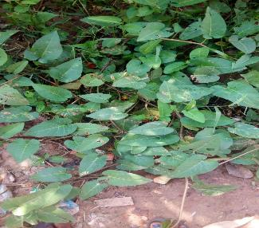
Plate 1: Photograph of Ipomoea aquatica in its Natural Environment

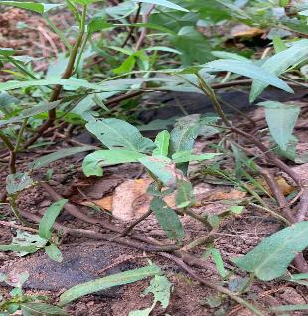
Plate 2: Root system of Ipomoea aquatica

Anatomical studies of Ipomoea aquatica

Leaf epidermal study of the two Ipomoea species.

Epidermal cell

Subsidiary Cell
Guard Cell

Stoma

Plate 3: Abaxial surface of the leaf of Ipomoea aquatica (×400).

Stoma

Subsidiary Cell
Guard Cell
Epidermis

Plate 4: Adaxial surface of the leaf of Ipomoae aquatica (×400).

Anatomy of the petioles of the I. aquatica.
The transverse section of the petioles as shown in plate 5 revealed the internal structures of the petioles. Here there is a single layer of epidermal tissues covering the internal structures and prevent excessive loss of water.
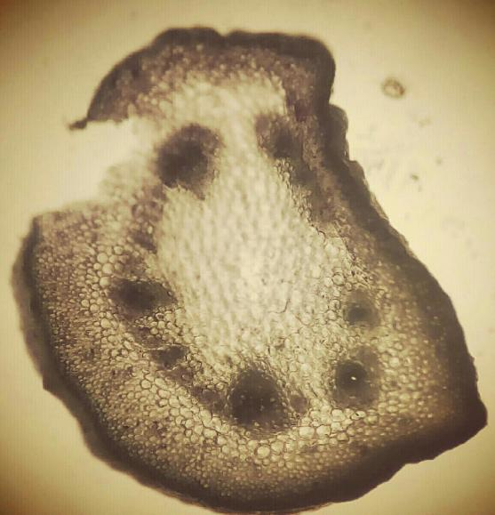
Vascular Bundle
Parenchyma
Collenchyma
Epidermis

Plate 5: Transverse section of the petiole of Ipomoea aquatica.(×100)

Anatomy of the stem of I. aquatica.
The transverse section of the stem of I. aquatica as shown in plate 6 has internal tissues protected by epidermal tissues which is later replaced by periderm in the matured stage as a sign of secondary growth. vascular bundles are arranged in rings. It is differentiated into cortex, endodermis, pericycle, medullary rays & pith.
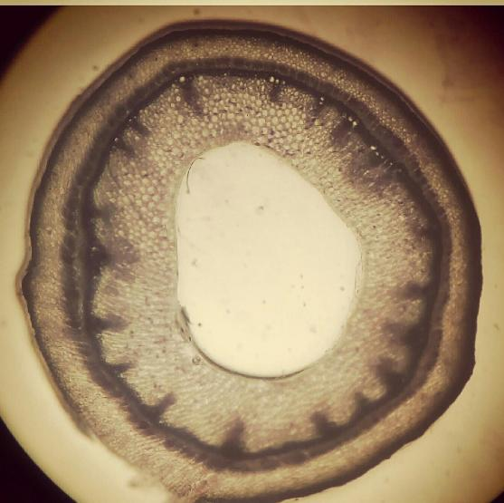
.
Vascular Bundle
Pith
sclernchyma
parenchyma
Epidermis
hypodermis
Plate 6: Transverse section of the stem of I.aquatica

Anatomy of the root of Ipomoea aquatica.
The transverse section of the root of the Ipomoea aquatica species as shown in plate 7 revealed vessel types as in the stem. They bear thin walled root hairs. They are differentiated into cortex, pith, pericycle.
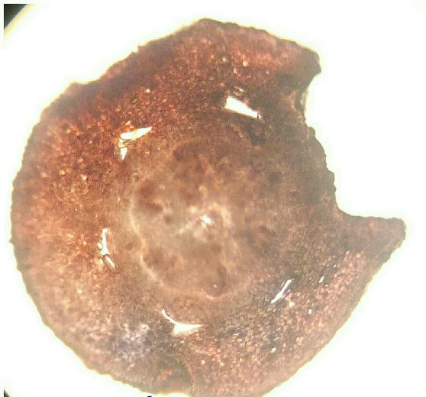
Pericycle
Pith
Epidermis
Vascular Bundle
Cortex

Plate 7: Transverse section of the root of I. aquatica

DISCUSSION
Findings showed that Ipomoea aquatica, is a herbaceous plant with non-woody stems, completing its life cycle within a single growing season. This herbaceous nature suggests a higher degree of succulence and flexibility compared to woody plants, enhancing its adaptability to changing environmental conditions. The trailing growth habit of Ipomoea aquatica is a significant adaptation for efficient light and nutrient capture. This trailing or spreading nature allows the plant to occupy space effectively and interact with its environment, maximizing exposure to sunlight for photosynthesis and optimizing nutrient absorption.
The fibrous root system of Ipomoea aquatica, characterized by numerous small roots emerging from the stem base, plays a vital role in stabilizing the plant and facilitating efficient water and nutrient absorption. This root system is well-suited for plants growing in aquatic or marshy environments, providing stability in variable soil conditions. The hollow (cambium tissue) stem of Ipomoea aquatica serves multiple functions, potentially contributing to buoyancy, enabling the plant to float in water. Additionally, the hollow (cambium tissue) structure aids in nutrient transport within the plant and influences overall structural integrity. This adaptation allows the plant to thrive in aquatic habitats. This observation corroborates the results of Fabiano et al. (2011). In his study, it was said that certain epidermal cells of Ipomoea aquatica are rather diminutive, while others had convex outer periclinal walls.
The greenish-brown color of the stem indicates the presence of chlorophyll, the pigment responsible for photosynthesis. Stem color is essential as it reflects the plant's ability to produce its food through photosynthesis, contributing to its overall health and vigor. This pigmentation is a key adaptation for efficient energy production.
The variation in flower color, with shades of pink and white, adds aesthetic diversity to Ipomoea aquatica. Flower color plays a role in attracting pollinators, and the presence of multiple colors suggests adaptation to a range of pollinators or environmental conditions, enhancing the plant's reproductive success.
The green color of the petiole, the stalk attaching the leaf to the stem, is indicative of chlorophyll presence. The petiole serves as a conduit for nutrient transport between the leaf and the stem, playing a crucial role in overall plant health and coordination of physiological processes.
The green color of the leaves, associated with the presence of chlorophyll, is fundamental for photosynthesis. Green leaves are crucial for capturing sunlight and converting it into energy, highlighting the plant's vitality and growth potential. This adaptation allows Ipomoea aquatica to thrive in various light conditions.
Findings also further showed that the leaf morphology of Ipomoea aquatica, feature characteristics such as leaf type, arrangement, attachment to the stem, shape, apex, margin, base, and surface. These features collectively contribute to the adaptability, ecological niche, and overall physiological functions of the plant's leaves. The classification of leaves as simple indicates a single, undivided structure, aiding in easy identification and botanical classification. The alternate leaf arrangement facilitates efficient exposure to sunlight, minimizing shading effects among adjacent leaves and maximizing individual leaf efficiency.
“The petiolate attachment of leaves to the stem, with the presence of a slender stalk or petiole, is crucial for nutrient transport, mechanical support, and optimal leaf positioning for light capture. This adaptation enhances the plant's ability to thrive in various environmental conditions. The lanceolate shape of the leaves, characterized by a long, narrow structure with a pointed tip, is adaptive for maximizing light interception, particularly in dense vegetation. The acute apex further enhances the leaf's ability to penetrate through surrounding vegetation, aiding in light capture and adaptation to specific ecological niches” (Fabiano et al., 2011).
The entire leaf margin, indicate a smooth and unbroken edge, is significant for herbivory resistance and nutrient conservation. The truncate leaf base contributes to stability and efficient attachment to the stem, optimizing exposure to environmental factors such as light and wind.
A glabrous leaf surface, signifying a smooth, hairless texture, influences the leaf's interactions with environmental factors, including water retention, resistance to pathogens, and adaptability to specific climatic conditions. This trait enhances the leaf's ability to maintain optimal function in diverse environments. These findings agree with the finding of Fabiano, et al., (2011) who in their study repot that “epidermis of Ipomoea aquatica is uniseriate with isodiametric cells, a thin cuticle and stomata on both surfaces. On the adaxial epidermis of the petiole there are projections that look similar to extrafloral nectaries; however, close observation of the anatomy of these structures reveals that they consist only of parenchymatous tissue and are devoid of stomata and vascular tissue. In the proximal region of the leaf lamina there are two opposing nectaries. These occur as crypts on the surface, with a system of internal channels and an epidermis covered by trichomes. Trichomes on the epidermis, consist of a single cell at the base and up to five secreting cells”.
Quantitative measurements of the morphological characteristics of Ipomoea aquatica species, offers insights into their adaptive strategies and ecological roles. The elongated leaves, substantial leaf area, and strategic petiole length suggest a robust potential for light capture and resource utilization. The stem parameters, including height and girth, indicate moderate vertical growth and a slender yet sturdy stem. These measurements contribute to the overall architectural structure of the plant, influencing leaf arrangement and stability in various environmental conditions. The findings of the study agree to the finding of Fabiano et al., (2011) who said that chlorenchyma of Ipomoea species consists of up to three cell layers and the angular collenchyma of 5 layers.
Conclusion
In conclusion, the comprehensive exploration of Ipomoea aquatic morphological characteristics, provides valuable insights into the plant's adaptive strategies, ecological niche, and physiological functions. The herbaceous nature of Ipomoea aquatica, marked by non-woody stems and a single growing season life cycle, underscores its flexibility and succulence, setting it apart from woody plants. The trailing growth habit of Ipomoea aquatica is a crucial adaptation for efficient light and nutrient capture, allowing the plant to spread and interact effectively with its environment. The fibrous root system enhances stability and nutrient absorption, particularly advantageous in variable soil conditions.
In essence, the morphological features collectively showcase Ipomoea aquatica's ability to thrive in various habitats, balancing efficient resource acquisition with structural stability. These botanical characteristics contribute to the plant's ecological success and underscore its vital role in ecosystems. The study of Ipomoea aquatica's morphology provides a foundation for further research on its ecological interactions, physiological processes, and potential applications in agriculture or environmental management.
Disclaimer (Artificial intelligence)

Author(s) hereby declare that NO generative AI technologies such as Large Language Models (ChatGPT, COPILOT, etc.) and text-to-image generators have been used during the writing or editing of this manuscript.

REFERENCES
Atkinson, J. A. and Wells, D. M. (2017). An updated protocol for high throughput plant tissue sectioning. Frontiers in Plant Science, 8,
Austin and Huáman, (2015). The chemistry of resin glycosides of the Convolvulaceae family, in: Bendz G, Santesson Journals (eds.), Medicinal and Natural Sciences, Chemistry in Botanical Classification, Academic Press, New York, Pp 235 - 240.
Austin (2013). Effect of Ipomoea batatas leaf extract on the thyroid gonadal axis of Male wistar rats. Science Citation Index, 7; 78 – 84.
Austin (2011). The names of the morning glories cultivated and naturalized in East Africa. Taxon, 6; 231 - 233.
Burkill, H. M. (1985). The Useful Plants of West Tropical Africa (Vol. 1). Royal Botanic Gardens, Kew
Doka, Schmidt, John, Igwe, and Misra (2014). Sweet potato: A review of its past, present, and future role in human nutrition. Advance Food Nutrition Resources, 52; 41-46.
Dua, Malala, David, Benedict, and Malvin (2015). Method of analysis, 17th Edition. AOAC (2000) Official Methods of Analysis. 17th Edition, the Association of Official Analytical Chemists, Gaithersburg, MD, USA. Methods 925.10, 65.17, 974.24, 992.16.

Fabiano, Martins, Jamile, Lima, Ana, Angélica, and Macedo (2011). Chemical composition of Cola acuminata and Garcinia kola seeds grown in Nigeria. International Journal of Food Science and Nutrition, 45; 223-230.
Gill (2013). Study on flavonoids from leaf of Ipomoea batatas. Journal of Nutrition, 30; 516 - 518.
Gupta and Yadav (2016). The Practical Evaluation of Phytopharmaceuticals. Bristol: Wright Sccintecnica, 5; 81 - 82.
Hutchinson and Dalziel (2010). Lipid, fatty acid, amino acid and mineral composition five edible plant leaves. Journal of Agricultural and Food Chemistry, 38; 2137-2139.
Hutchinson, J. and Dalziel, J. M. (1954). Flora of West Tropical Africa (Vol. 2). Crown Agents, London.
Malalavidhane, Prasad, Frill, Leon, and Samson (2013). Nutritional and potentially medicinal values of the leaves of Senna siamea. Global Journal of Pure and Applied Science, 18; 12-14.
McDonald (2013). Isolation of a free radical-scavenging antioxidant from water spinach (Ipomoea aquatic Forsk). Journal of Science Food Agriculture, 85; 1461-1468.
Miller, Luke, John, Ben and Donald (2012). Characterization and immunostimulatory activity of (1-6)-a-D-glucan from the root of Ipomoea batatas. International Journal of Immunopharmacology, 5; 1436 - 1445.
Misra and Misra (2014). General Methods of Analysis Pharmacopoeia. Analytical techniques in pharmaceutical analysis: A review, 2(1); 121-208.
Olorode (2009). Biodynamic constituents in the Mexican morning glory of Diodiascandens SW in Nigeria. Archives of Applied Science Research. Pp 9.
Prasad, Dike, Danjuma, Daniel, Samuel and Samson (2010). Handbook of basic food beverage analysis. Etovin Publishers AKS. Nigeria. Pp 53 -70.
Prasad, Luke, Benedict Luios and Leon (2008). The useful plant of West Africa, Families S-Z. Addenda Royal Botanic Gardens, Kew, Richmond. United Kingdom, 2(4); Pp 532.
Shukla, M. (2014). Efficacy of Ipomoea batatas (Caiapo) on diabetes control in type 2 diabetic subjects treated with diet. Diabetes Care, 25; 239 - 240.
Siemonsma and Kasem (2010). Screening of plants acting against Heterometrus laoticus Corpion venom activity on fibroblast cell lysis. Journal of Ethnopharmacology, 103; 201 – 207.
Umar, Siemonsma, Austin, Husman and Mike (2016). British Pharmacopoeia. Ash value, Acid insoluble, water soluble extractive and Alcohol extractive. American Journal of Food and Nutrition, 2(4); 71-76.

