Title: Economic Impact of Lumpy Skin Disease in Africa and Asia: A Systematic Review of Economic Losses, Control Strategies, and Research Gaps

Abstract

Background: Lumpy skin disease (LSD), caused by lumpy skin disease virus (LSDV), is an emerging transboundary viral disease affecting cattle and water buffalo across Africa and Asia. Originally restricted to sub-Saharan Africa, it has rapidly expanded into the Middle East, Europe, and Asia, creating substantial economic burdens for livestock-dependent communities. Although mortality is generally low (<5%), the disease produces major productivity and trade-related losses.
Methods: This systematic review followed PRISMA 2020 guidelines and searched PubMed, Web of Science, Scopus, and Google Scholar for studies published from 2010–May 2026. Eligible studies reported economic impacts, cost-benefit analyses, or livestock disease economic assessments. Data from 18 studies were synthesised using narrative qualitative analysis due to heterogeneity.
Results: The review found that LSD causes substantial economic losses through reduced milk production (20–65% for 2–8 weeks), weight loss, hide damage, reproductive inefficiency, and treatment costs. Indirect costs such as labour diversion, market disruption, and trade restrictions are frequently underestimated. Total losses in Asia were estimated at USD 1.45 billion. Vaccination was consistently identified as the most cost-effective control strategy, with benefit–cost ratios ranging from 1.4 to 8.1. However, economic methodologies varied widely across studies, limiting comparability. Major research gaps include lack of standardised frameworks, limited smallholder-focused studies, and insufficient long-term economic assessments across Africa and Asia contexts worldwide.
Conclusion: Lumpy skin disease imposes major economic burdens across Africa and Asia despite low mortality. Strengthening vaccination strategies, standardising economic assessments, research gaps are essential for effective control.

Keywords: Lumpy skin disease; Economic impact; Cost-benefit analysis; Livestock economics; Smallholder farmers; Vaccination strategy; Transboundary animal disease

1. Introduction
Lumpy skin disease (LSD), caused by lumpy skin disease virus (LSDV), has emerged as one of the most economically significant transboundary animal diseases affecting cattle and water buffalo globally (Akther et al., 2023). Originally endemic to sub-Saharan Africa since its first description in Zambia in 1929, LSD has undergone unprecedented geographic expansion, reaching the Middle East in 1989, Europe in 2012, and subsequently spreading across Asia to become a global concern by 2019 (Tuppurainen and Oura, 2012; Roche et al., 2021).
The economic significance of LSD extends beyond immediate production losses to encompass complex socioeconomic impacts affecting millions of livestock-dependent households worldwide. The disease is characterised by high morbidity rates (5–100%) but relatively low mortality (typically <5%), resulting in prolonged economic impacts through reduced milk production, weight loss, hide damage, and reproductive disorders (Bhuiyan et al., 2026; Das et al., 2021). In Asia alone, the economic impact of LSD has been estimated at USD 1.45 billion in direct losses of livestock and production (TAFS, 2024).
Despite growing recognition of LSD's economic importance, comprehensive economic assessments remain limited, particularly in smallholder farming systems that constitute the backbone of livestock production in developing countries (Saqib et al., 2023). Existing studies vary significantly in methodological approaches, scope, and geographic coverage, limiting the development of standardised economic models and evidence-based policy recommendations (Bhuiyan et al., 2026). The economic burden in Africa and Asia is compounded by weak veterinary infrastructure, variable vaccine coverage, and limited market access for smallholder farmers (Gari et al., 2011; Hasib et al., 2022).
This review aims to synthesise current knowledge on the economic impact of LSD in Africa and Asia, analyse methodological approaches used in economic assessments, identify critical research gaps, and provide recommendations for future research priorities to support evidence-based decision-making in LSD control and prevention strategies.

2. Methodology

2.1 Study Design and Search Strategy
This paper follows the Preferred Reporting Items for Systematic Reviews and Meta-Analyses (PRISMA) 2020 guidelines (Page et al., 2021). A comprehensive and reproducible literature search was conducted across four electronic databases: PubMed/MEDLINE, Web of Science, Scopus, and Google Scholar. The search was conducted in March 2026 and covered publications from January 2010 to May 2026. The extended end date of May 2026 was chosen to capture the most recent evidence on LSD's economic impact following its continued geographic spread into new territories.
The search strategy employed Boolean combinations of controlled vocabulary and free-text terms. The primary search string was: ("lumpy skin disease" OR "LSDV" OR "lumpy skin disease virus") AND ("economic impact" OR "economic loss" OR "cost-benefit" OR "financial impact" OR "livestock economics" OR "economic burden" OR "production loss"). Additional manual searches of reference lists of included studies and grey literature from FAO, WOAH (formerly OIE), and TAFS Forum were conducted to ensure completeness. All search results were managed in Rayyan systematic review software, and duplicate records were removed before screening.

2.2 Inclusion and Exclusion Criteria
Studies were included if they: (1) provided quantitative or qualitative economic impact assessments of LSD; (2) reported cost-benefit or cost-effectiveness analyses of LSD control measures, including vaccination; (3) described economic methodologies applicable to livestock disease assessment; (4) were published in English in peer-reviewed journals or as grey literature from recognised international institutions (FAO, WOAH, TAFS Forum). Studies were excluded if they: (1) focused solely on clinical, epidemiological, or virological aspects without any economic component; (2) were conference abstracts, editorials, or opinion pieces without primary data; (3) were published in languages other than English without an English abstract providing sufficient economic data.

2.3 Study Selection and Quality Assessment
Two independent reviewers screened titles and abstracts against the inclusion criteria. Full texts of potentially eligible studies were retrieved and assessed. Disagreements were resolved by discussion and consensus. Study quality was assessed using an adapted version of the Checklist for Economic Evaluations (Drummond et al., 2015) covering: clarity of the economic question, perspective of analysis, comprehensiveness of cost categories, handling of uncertainty, and generalisability of findings. Studies were rated as high, moderate, or low quality based on these criteria. The PRISMA flow diagram (Figure 1) documents the full selection process, including records identified, screened, assessed for eligibility, and included in the final synthesis.

2.4 Data Extraction and Synthesis
Data were extracted independently by two reviewers using a standardised extraction form capturing: study characteristics (author, year, country, study design), methodological approach (cost accounting, stochastic modelling, cost-benefit analysis), economic indicators reported, key findings, and identified limitations. Monetary values were standardised to USD using contemporary exchange rates at the time of publication where applicable. Due to significant heterogeneity in methodological approaches, geographic contexts, and outcome measures, a narrative qualitative synthesis was performed rather than meta-analysis. Sensitivity analyses reported by primary studies were also extracted to identify the most influential economic parameters (Table- 1).

3. Economic Impact Assessment Methodologies

3.1 Direct Cost Assessment Approaches
Economic impact studies of LSD have employed various methodological frameworks, ranging from simple cost accounting to sophisticated stochastic modelling approaches. Direct cost assessments typically include mortality losses, production losses (primarily milk reduction), treatment costs, and veterinary expenses (Chouhan et al., 2022; Molla et al., 2017).
Mortality losses are generally calculated as the number of deaths multiplied by the average market value of affected animals, considering age, breed, and productive status. However, this approach often underestimates the true economic value, particularly for breeding animals and draft cattle in smallholder systems (Saqib et al., 2023).
Production losses, predominantly milk yield reduction, represent the most significant economic component in dairy systems. Studies report milk production decreases ranging from 20–65% during acute infection, with recovery periods extending 2–8 weeks post-recovery (Naidu et al., 2025; Rajendran et al., 2025). The duration and severity of production losses vary significantly based on cattle breed, management systems, and disease severity.

3.2 Indirect Cost Quantification
Indirect costs encompass opportunity costs, management time, market disruptions, and broader socioeconomic impacts. These costs are frequently underestimated or omitted in economic assessments despite their substantial contribution to total economic burden (Modethed et al., 2025).
Opportunity costs include foregone income from alternative livestock activities and labour allocation inefficiencies during outbreak management. Market disruptions manifest as reduced selling prices, delayed marketing, and trade restrictions, particularly affecting export-oriented operations (Hutchinson et al., 2024). Empirical evidence from Pakistan indicates that household-level indirect impacts-including increased debt burden and psychological stress-are rarely captured in conventional economic assessments but represent a substantial component of the true economic burden on smallholder households (Saqib et al., 2023).

3.3 Stochastic Modelling Approaches
Recent studies have increasingly adopted stochastic modelling using Monte Carlo simulation to address uncertainty in disease parameters and economic variables (Naidu et al., 2025; Modethed et al., 2025). This approach allows incorporation of probability distributions for key variables including incidence rates, mortality, production losses, and market prices, providing more robust economic estimates with confidence intervals.
Sensitivity analysis using tornado diagrams has consistently identified milk production losses, disease incidence rates, and recovery duration as the most influential factors affecting total economic losses (Naidu et al., 2025; Modethed et al., 2025; Rajendran et al., 2025). This finding underscores the importance of accurate and timely surveillance data for generating reliable economic projections (Figure 5; Table- 2).

4. Geographic Patterns of Economic Impact

4.1 African Context
In Ethiopia, the first comprehensive economic study by Gari et al. (2011) estimated annual financial costs of USD 6.43 per head for local zebu cattle and USD 58 per head for Holstein Friesian crossbred cattle in infected herds. Vaccination under partial coverage was modelled to reduce these costs by approximately 17% in local zebu herds and 31% in Holstein Friesian crossbred herds-assumptions that reflected realistic coverage scenarios in the Ethiopian context rather than universal vaccination, a distinction that should be noted when extrapolating these figures (Gari et al., 2011) (Figure- 2).
A subsequent study by Molla et al. (2017) reported median economic losses of USD 1,176 per herd during outbreaks, with subsistence farms losing approximately USD 489 compared to USD 2,735 in commercial operations. The variation in economic impact between production systems reflects differences in cattle value, production intensity, and market integration. Crossbred cattle consistently demonstrate higher economic losses due to greater susceptibility, higher production potential, and increased market value (Molla et al., 2017). In Nigeria, Limon et al. (2020) documented significant production losses in smallholder herds, reinforcing the finding that mixed and subsistence systems bear a disproportionate share of the economic burden across sub-Saharan Africa (Figure- 3).
4.2 Asian Emergence and Economic Consequences
The introduction of LSD into Asia since 2019 has resulted in unprecedented economic losses due to the region's vast cattle populations and intensive production systems. India, hosting nearly 300 million cattle and buffalo, has experienced some of the most severe economic impacts globally (TAFS, 2024). LSD transmission in South and Southeast Asia is strongly influenced by seasonal climatic conditions, with outbreaks peaking during pre-monsoon and monsoon periods due to increased vector activity (Bhuiyan, 2025).
Naidu et al. (2025) conducted the most comprehensive economic assessment in Asia, estimating total economic losses of USD 2,440.29 million (90% CI: 2,162.55–2,716.15) across seven Indian states during the 2022–2023 outbreak period using stochastic Monte Carlo modelling. Gujarat state reported the highest milk losses, with median reductions of 90 litres per animal, while crossbred cattle experienced disproportionately higher economic impacts due to greater productivity and market value.
In Bangladesh, Chouhan et al. (2022) reported one of the early economic assessments following the emergence of lumpy skin disease in the country after 2019, documenting an attack rate of 34% with a case fatality rate of 3.23% in Mymensingh and Gaibandha districts. However, comprehensive economic analysis was limited, highlighting the need for more detailed economic assessments in the country. Pakistani studies indicate economic losses of approximately USD 100 per affected animal, with exotic cattle breeds showing higher mortality and productivity losses compared to indigenous breeds (Saqib et al., 2023). The study identified significant household-level impacts, with farmers experiencing reduced income, increased debt, and emotional stress.

4.3 Southeast Asian Spread and Trade Implications
The rapid spread of LSD across Southeast Asia since 2020 has created substantial economic disruptions beyond direct production losses (Wilhelm and Ward, 2023). Thailand experienced significant outbreaks in 2021, with economic losses ranging from USD 119.42 to USD 412.57 per farmer due to reduced milk production and market disruptions (WOAH, 2024). A subsequent stochastic modelling study in northern Thai dairy farms by Modethed et al. (2025) confirmed milk yield reduction as the primary driver of financial losses.
Indonesia's first LSD cases in March 2022 resulted in substantial livestock losses by August 2023, leading to trade disruptions with Australia, an important player in the global beef industry (Hutchinson et al., 2024). In Asia, WOAH (2024) estimated production losses affecting thousands of smallholder dairy and beef cattle farms across multiple provinces, underscoring the regional scale of the epidemic's economic consequences. These trade-related impacts demonstrate the broader economic consequences of LSD beyond farm-level losses and highlight the need for regionally coordinated surveillance and control frameworks.

5. Cost-Benefit Analysis of Control Strategies

5.1 Vaccination Economics
Vaccination represents the primary economically viable control strategy for LSD, with multiple studies demonstrating favourable benefit-cost ratios. Molla et al. (2017) reported benefit-cost ratios ranging from 1.4 to 8.1 for annual vaccination programmes in Ethiopian farming systems, with marginal rates of return reaching 3,400%. These results varied substantially by production system intensity, cattle breed composition, and prevailing market prices, highlighting the context-specific nature of vaccination economics.
The economic benefits of vaccination vary significantly based on production system intensity, disease risk, and vaccine costs. Gari et al. (2011) demonstrated that vaccination under partial coverage scenarios could reduce financial costs by 17% in local zebu herds and 31% in Holstein Friesian crossbred herds, with net benefits of USD 1 and USD 19 per head, respectively (Bhuiyan, 2025). It is important to note that these figures assumed partial rather than universal vaccination coverage, which may underestimate the true benefits of mass vaccination campaigns. Tuppurainen et al. (2021) emphasised that vaccination decisions should consider epidemiological context, with different strategies appropriate for epidemic versus endemic situations (Figure- 4).

5.2 Integrated Control Strategies
Limited economic analyses exist for integrated control approaches combining vaccination, vector control, and movement restrictions. The successful LSD control in Thailand through mass vaccination and movement restrictions demonstrated the effectiveness of coordinated interventions, but comprehensive economic evaluation remains lacking (Bhuiyan, 2025; Punyapornwithaya et al., 2024). A Bayesian structural time series analysis by Punyapornwithaya et al. (2024) provided robust evidence that combined policy interventions significantly reduced LSD case counts in Thailand, though without a full cost-effectiveness evaluation.
The economic rationale for integrated approaches includes potential synergistic effects and reduced probability of control failure, but these benefits require empirical quantification through properly designed economic studies (Tuppurainen et al., 2021). Comparative economic analyses of vaccination-alone versus integrated strategies across different agro-ecological zones remain a critical evidence gap.

5.3 DIVA Vaccine Development Economics
The development of Differentiate Infected from Vaccinated Animals (DIVA) vaccines represents a critical research priority with significant economic implications. Currently, no commercially available DIVA vaccines exist for LSDV, limiting trade opportunities and surveillance capabilities in vaccinated populations (Mazloum et al., 2023). Recent research by Ronchi et al. (2024) demonstrated the development of DIVA-compatible inactivated vaccines using keyhole limpet hemocyanin as a positive marker. While promising, economic analyses of DIVA vaccine implementation-including development costs, production expenses, and companion diagnostic test requirements-remain limited. The availability of a commercially validated DIVA vaccine would be particularly valuable for export-oriented livestock sectors where proof of disease-free status is required for market access.

6. Research Gaps and Limitations

6.1 Methodological Standardisation Gaps
Current economic assessment studies suffer from a fundamental lack of standardised methodologies, limiting comparability across regions and production systems. Significant variations exist in cost categories included, time horizons considered, and economic indicators reported (Akther et al., 2023). Critically, no internationally accepted protocol exists for LSD economic assessment comparable to those available for foot-and-mouth disease or African swine fever, undermining the capacity for global evidence synthesis. The absence of standardised frameworks also prevents robust meta-analyses that could generate pooled effect estimates. Furthermore, there is a persistent failure to distinguish clearly between epidemic and endemic cost structures, making it difficult to derive generalisable policy conclusions. Development of a standardised economic assessment framework, aligned with FAO and WOAH guidance, endorsed for both commercial and smallholder farming contexts, is the single most pressing methodological need in this field.

6.2 Smallholder System Assessment Limitations
Despite smallholder farmers comprising the majority of global cattle producers in Africa and Asia, economic impact studies predominantly focus on commercial or semi-intensive systems (Saqib et al., 2023). Smallholder systems present unique challenges including subsistence orientation, limited market integration, and diverse cattle functions beyond milk and meat production. The economic value of cattle in smallholder systems extends beyond market prices to include draft power, social status, and risk mitigation-components rarely captured in conventional economic assessments (Molla et al., 2017). This omission systematically underestimates LSD's true economic burden in the very communities most vulnerable to its consequences. Mixed-methods approaches integrating participatory rural appraisal, household surveys, and market analysis are needed to capture the full breadth of economic impacts in these settings.

6.3 Long-term Economic Impact Studies
Most economic assessments focus on immediate or short-term impacts, typically covering the acute outbreak period and immediate recovery phase of four to twelve weeks. Long-term consequences including reproductive effects, chronic productivity losses, structural market changes, and herd rebuilding costs receive limited attention. The absence of longitudinal cohort studies-tracking herds for a minimum of three years post-outbreak-prevents understanding of LSD's cumulative economic effects and recovery dynamics, information critical for investment planning and policy development (Modethed et al., 2025). Longitudinal studies are also essential to quantify the frequency and magnitude of reinfection-related losses in endemically affected areas.

6.4 Regional Economic Variation Analysis
Limited research exists on intra-country and inter-regional economic impact variations despite significant differences in production systems, market access, and veterinary service availability. This gap limits the development of targeted control strategies and efficient resource allocation decisions. The need for sub-national, geo-referenced economic assessments is particularly acute in large countries like India and China, where substantial variations in farming systems, cattle breeds, and economic conditions create heterogeneous vulnerability profiles (Naidu et al., 2025). Regional modelling linked to epidemiological surveillance data would allow identification of economic hot spots where interventions would generate the highest return on investment.

6.5 Emerging Control Technology Economics
Economic analyses of emerging control technologies-including novel vaccines, improved point-of-care diagnostics, and digital surveillance systems-remain limited. As these technologies advance from research to implementation, comprehensive economic evaluations will be essential for adoption decisions. The economics of digital early-warning systems such as EPIWATCH, demonstrated in LSD surveillance by Hutchinson et al. (2024), represent an understudied but potentially high-value area. Health-economic modelling quantifying the cost of outbreak prevention attributable to timely digital surveillance, relative to the investment required, would provide a strong evidence base for scaling these tools across Asia and Africa.

6.6 Absence of Quality Appraisal and Reporting Standards
A further critical gap is the absence of systematic quality appraisal of existing LSD economic studies. No prior review has formally assessed methodological rigour using validated checklists such as the Drummond checklist or the Consolidated Health Economic Evaluation Reporting Standards (CHEERS). Without quality appraisal, evidence hierarchies cannot be established, and policymakers cannot distinguish robust cost-effectiveness estimates from those based on weak assumptions. Future systematic reviews should incorporate mandatory quality assessment alongside data extraction (Table- 3).

7. Future Research Priorities
Future research on lumpy skin disease must move beyond descriptive economic reporting toward actionable, policy-relevant evidence generation. Five interlocking priorities are identified below, each addressing a specific gap in the current evidence base.

7.1 Standardised Frameworks and Methods
An internationally accepted economic assessment framework for LSD should be developed in collaboration with FAO, WOAH, and regional veterinary authorities. This framework must specify: standardised cost component definitions (distinguishing direct production, direct non-production, indirect market, and indirect welfare costs); minimum time horizons (acute phase, medium-term recovery, and long-term structural impacts); analytical methods for uncertainty (stochastic simulation, probabilistic sensitivity analysis); and guidelines for adapting the framework to both commercial and smallholder settings. Without such harmonisation, the evidence base will remain fragmented and comparisons across regions will be methodologically indefensible.

7.2 Smallholder and Regional Focus
Research programmes should explicitly prioritise smallholder farming systems, particularly in sub-Saharan Africa and South Asia, using mixed-methods designs that integrate participatory rural appraisal with household economic surveys. Studies should quantify non-market cattle values including draft power, social capital, and livestock-as-savings functions. Simultaneously, sub-national geo-referenced economic modelling should be developed for high-burden countries such as India, Ethiopia, Indonesia, and Bangladesh to identify economic hot spots, characterise risk stratification by agro-ecological zone, and support geographically targeted intervention planning.

7.3 Long-term and Technology Evaluation
Prospective longitudinal cohort studies, tracking a minimum of three to five years post-outbreak, are required to quantify cumulative productivity losses, reproductive recovery trajectories, and herd restocking costs. These studies should be embedded within existing livestock monitoring systems where feasible. In parallel, full economic evaluations of emerging technologies-DIVA vaccines, point-of-care molecular diagnostics, and AI-assisted digital surveillance platforms-should be conducted as these technologies approach commercialisation. Cost-effectiveness thresholds should be defined relative to local willingness-to-pay benchmarks and smallholder income levels, ensuring that recommendations are economically realistic for the communities most affected by LSD.

8. Policy Implications and Recommendations
The economic burden of LSD highlights the need for evidence-based policy development and efficient resource allocation. Governments and international organisations should invest in economic impact assessments, integrate economic considerations into disease control strategies, and support research addressing existing knowledge gaps. Strengthened international cooperation is also essential for harmonising methodologies, sharing surveillance data, and coordinating regional control efforts.

8.1 Evidence-Based Policy and Cooperation
Policies should be guided by strong economic evidence, supported by international collaboration in data sharing, methodological harmonisation, and coordinated research and control strategies to address the transboundary nature of LSD. The transboundary character of LSD outbreaks-demonstrated by its spread from Africa to the Middle East, Europe, and Asia-demands that economic evidence generation and policy responses be coordinated across national borders. Regional bodies such as WOAH Regional Commissions, ASEAN animal health networks, and the AU-IBAR should serve as platforms for harmonising economic assessment protocols and sharing outbreak cost data.

8.2 Capacity Building
Developing countries in Africa and Asia require targeted capacity building in livestock disease economics, veterinary epidemiology, and farmer-level awareness to improve understanding of LSD impacts and enhance the effectiveness of control and prevention strategies. This includes training in stochastic economic modelling, integration of economic surveillance into existing animal health information systems, and development of rapid economic assessment tools deployable during outbreak response.

9. Conclusions
Lumpy skin disease has become a major transboundary livestock disease with significant global economic consequences, particularly in Africa and Asia. Although mortality is generally low (typically <5%), the disease causes severe production losses through reduced milk yield (20–65% for 2–8 weeks), weight loss, hide damage, reproductive inefficiency, and increased treatment costs. Indirect impacts such as market disruption and trade restrictions further intensify the overall economic burden, particularly in smallholder-based livestock systems. Vaccination is consistently identified as the most cost-effective control strategy, with benefit-cost ratios of 1.4 to 8.1 in Ethiopian farming systems. However, economic assessments vary widely in methods, scope, and data quality, limiting global comparability. Key research gaps include the lack of standardised economic evaluation frameworks, limited focus on smallholder systems, and insufficient long-term and regional studies. Addressing these gaps through coordinated international research programmes and capacity building in developing countries is essential for generating robust evidence to guide effective LSD control policies and improve livestock sector resilience worldwide.

Disclaimer (Artificial Intelligence)
Author(s) hereby declare that NO generative AI technologies such as Large Language Models (ChatGPT, COPILOT, etc.) and text-to-image generators have been used during the writing or editing of this manuscript.

Acknowledgments
The authors would like to express their sincere gratitude to the Bhuiyan Center for Interdisciplinary Research & Innovation (BCIRI) for its support and encouragement during the preparation of this manuscript.

References
- Akther, M., Akter, S.H., Sarker, S., Aleri, J.W., Annandale, H., Abraham, S. and Uddin, J.M., 2023. Global burden of lumpy skin disease, outbreaks, and future challenges. Viruses, 15(9), p.1861. https://doi.org/10.3390/v15091861
- Bhuiyan, M.R. (2025) 'Seasonal epidemiology and vector ecology of lumpy skin disease in South and Southeast Asia: A comprehensive review of knowledge gaps and future perspectives', Bulgarian Journal of Veterinary Medicine. https://doi.org/10.15547/bjvm.2025-0096
- Bhuiyan, M.R., Ferdous, J., Shimi, S.S.A. and Sharma, S. (2026) 'Clinical management of lumpy skin disease in a cross-breed heifer at Upazila Livestock Office and Veterinary Hospital, Daudkandi, Cumilla: A case report', Asian Journal of Research in Animal and Veterinary Sciences, 9(2), pp. 330–338. https://doi.org/10.9734/ajravs/2026/v9i2416
- Bhuiyan, M.R., Ferdous, J., Shimi, S.S.A. and Sharma, S., 2025. Clinical management of lumpy skin disease in a cross-breed heifer at Upazila Livestock Office and Veterinary Hospital, Daudkandi, Cumilla: A case report [Paper presentation]. In RUEC 1st International Research Conference 2025. https://ruec.org
- Chouhan, C.S., Parvin, M.S., Ali, M.Y., Sadekuzzaman, M., Chowdhury, M.G.A., Ehsan, M.A. and Islam, M.T. (2022) 'Epidemiology and economic impact of lumpy skin disease of cattle in Mymensingh and Gaibandha districts of Bangladesh', Transboundary and Emerging Diseases, 69(6), pp. 3405–3418. https://doi.org/10.1111/tbed.14693
- Das, M., Chowdhury, M.S.R., Akter, S., Mondal, A.K., Uddin, M.J., Rahman, M.M. and Rahman, M.M. (2021) 'An updated review on lumpy skin disease: perspective of Southeast Asian countries', Journal of Advanced Biotechnology and Experimental Therapeutics, 4(3), pp. 322–333. https://doi.org/10.5455/jabet.2021.d131
- Drummond, M.F., Sculpher, M.J., Claxton, K., Stoddart, G.L. and Torrance, G.W. (2015) Methods for the Economic Evaluation of Health Care Programmes. 4th edn. Oxford: Oxford University Press.
- EFSA (European Food Safety Authority), 2020. Scientific report on the lumpy skin disease epidemiological report IV: data collection and analysis. EFSA Journal, 18(2), p.e06054.
- Gari, G., Bonnet, P., Roger, F. and Waret-Szkuta, A. (2011) 'Epidemiological aspects and financial impact of lumpy skin disease in Ethiopia', Preventive Veterinary Medicine, 102(4), pp. 274–283. https://doi.org/10.1016/j.prevetmed.2011.07.003
- Hasib, F.M.Y., Islam, M.S., Das, T., Rana, E.A., Uddin, M.H., Bayzid, M., Nath, C., Hossain, M.A., Masuduzzaman, M., Das, S. and Alim, M.A., 2021. Lumpy skin disease outbreak in cattle population of Chattogram, Bangladesh. Veterinary Medicine and Science, 7(5), pp.1616-1624.
- Hutchinson, D., Li, B., Lim, S., Stone, H. and MacIntyre, C.R. (2024) 'Using EPIWATCH® open-source surveillance to describe the epidemiology of lumpy skin disease outbreaks in South and Southeast Asia (2022–2023)', Australian Veterinary Journal, 102(10), pp. 524–529. https://doi.org/10.1111/avj.13369
- Limon, G., Gamawa, A.A., Ahmed, A.I., Lyons, N.A. and Beard, P.M., 2020. Epidemiological characteristics and economic impact of lumpy skin disease, sheeppox and goatpox among subsistence farmers in northeast Nigeria. Frontiers in veterinary science, 7, p.8.
- Mazloum, A., Van Schalkwyk, A., Babiuk, S., Venter, E., Wallace, D.B. and Sprygin, A. (2023) 'Lumpy skin disease: history, current understanding and research gaps in the context of recent geographic expansion', Frontiers in Microbiology, 14, p. 1266759. https://doi.org/10.3389/fmicb.2023.1266759
- Modethed, W., Kreausukon, K., Singhla, T., Boonsri, K., Pringproa, K., Sthitmatee, N., Vinitchaikul, P., Srisawang, S., Salvador, R., Gubbins, S. and Limon, G. (2025) 'An evaluation of financial losses due to lumpy skin disease outbreaks in dairy farms of northern Thailand', Frontiers in Veterinary Science, 11, p. 1501460. https://doi.org/10.3389/fvets.2024.1501460

- Molla, W., de Jong, M.C., Gari, G. and Frankena, K. (2017) 'Economic impact of lumpy skin disease and cost effectiveness of vaccination for the control of outbreaks in Ethiopia', Preventive Veterinary Medicine, 147, pp. 100–107. https://doi.org/10.1016/j.prevetmed.2017.09.003
- Naidu, G.G., Shivappa, R.R., Rajanna, P.R., Gondali, H., Devaraju, M.H., Nagesh, P.K.S., Gajendiran, N., Kanani, A., Bhatt, L., Tapase, J. and Arumugam, S. (2025) 'Assessment of economic burden of lumpy skin disease in India using stochastic modeling', Scientific Reports, 15(1), p. 10160. https://doi.org/10.1038/s41598-025-94384-5
- Page, M.J., McKenzie, J.E., Bossuyt, P.M., Boutron, I., Hoffmann, T.C., Mulrow, C.D., Shamseer, L., Tetzlaff, J.M., Akl, E.A., Brennan, S.E. and Chou, R., 2021. The PRISMA 2020 statement: an updated guideline for reporting systematic reviews. bmj, 372.
- Punyapornwithaya, V., Arjkumpa, O., Buamithup, N., Jainonthee, C., Salvador, R. and Jampachaisri, K. (2024) 'The impact of mass vaccination policy and control measures on lumpy skin disease cases in Thailand: insights from a Bayesian structural time series analysis', Frontiers in Veterinary Science, 10, p. 1301546. https://doi.org/10.3389/fvets.2023.1301546
- Rajendran, V.O., Govindaraj, G., Arivazhagan, A., Premkumar, D., Jayakumar, V., Saravanan, B.C., Nandi, S., Panday, S. and Singh, B.R. (2025) 'Estimation of the economic impact of Lumpy Skin Disease (LSD) outbreaks (2022–23) in dairy cattle farmers of Uttar Pradesh, India', The Microbe, p. 100513. https://doi.org/10.1016/j.microb.2025.100513
- Roche, X., Rozstalnyy, A., TagoPacheco, D., Pittiglio, C., Kamata, A., Beltran Alcrudo, D., Bisht, K., Karki, S., Kayamori, J., Larfaoui, F. and Raizman, E. (2021) Introduction and Spread of Lumpy Skin Disease in South, East and Southeast Asia: Qualitative Risk Assessment and Management. Rome: Food and Agriculture Organization of the United Nations. https://doi.org/10.4060/cb4503en
- Ronchi, G.F., Iorio, M., Serroni, A., Caporale, M., Testa, L., Palucci, C., Antonucci, D., Capista, S., Traini, S., Pinoni, C. and Di Matteo, I. (2024) 'The safety and efficacy of new DIVA inactivated vaccines against lumpy skin disease in calves', Vaccines, 12(12), p. 1302. https://doi.org/10.3390/vaccines12121302
- Saqib, S.E., Yaseen, M., Visetnoi, S., Sikandar and Ali, S. (2023) 'Epidemiological and economic consequences of lumpy skin disease outbreaks on farm households in Khyber Pakhtunkhwa, Pakistan', Frontiers in Veterinary Science, 10, p. 1238771. https://doi.org/10.3389/fvets.2023.1238771
- TAFS (2024) TAFS Update – Lumpy Skin Disease March 2024. Available at: https://www.tafsforum.org/news/tafs-update---lumpy-skin-disease-march-2024 (Accessed: 15 March 2024).
- Tuppurainen, E.S.M. and Oura, C.A.L. (2012) 'Lumpy skin disease: an emerging threat to Europe, the Middle East and Asia', Transboundary and Emerging Diseases, 59(1), pp. 40–48. https://doi.org/10.1111/j.1865-1682.2011.01242.x
- Tuppurainen, E., Dietze, K., Wolff, J., Bergmann, H., Beltran-Alcrudo, D., Fahrion, A., Lamien, C.E., Busch, F., Sauter-Louis, C., Conraths, F.J. and De Clercq, K. (2021) 'Vaccines and vaccination against lumpy skin disease', Vaccines, 9(10), p. 1136. https://doi.org/10.3390/vaccines9101136
- Wilhelm, L. and Ward, M.P. (2023) 'The spread of lumpy skin disease virus across Southeast Asia: insights from surveillance', Transboundary and Emerging Diseases, 2023(1), p. 3972359. https://doi.org/10.1155/2023/3972359
- WOAH, 2024. Final Report: Study to assess the impact of Lumpy Skin Disease (LSD) in Asia. [online] Tokyo: World Organisation for Animal Health (WOAH). Available at: https://rr-asia.woah.org/app/uploads/2024/06/Final-Report_Study-to-assess-the-impact-of-LSD_June-2024.pdf [Accessed 22 May 2026].

Figures
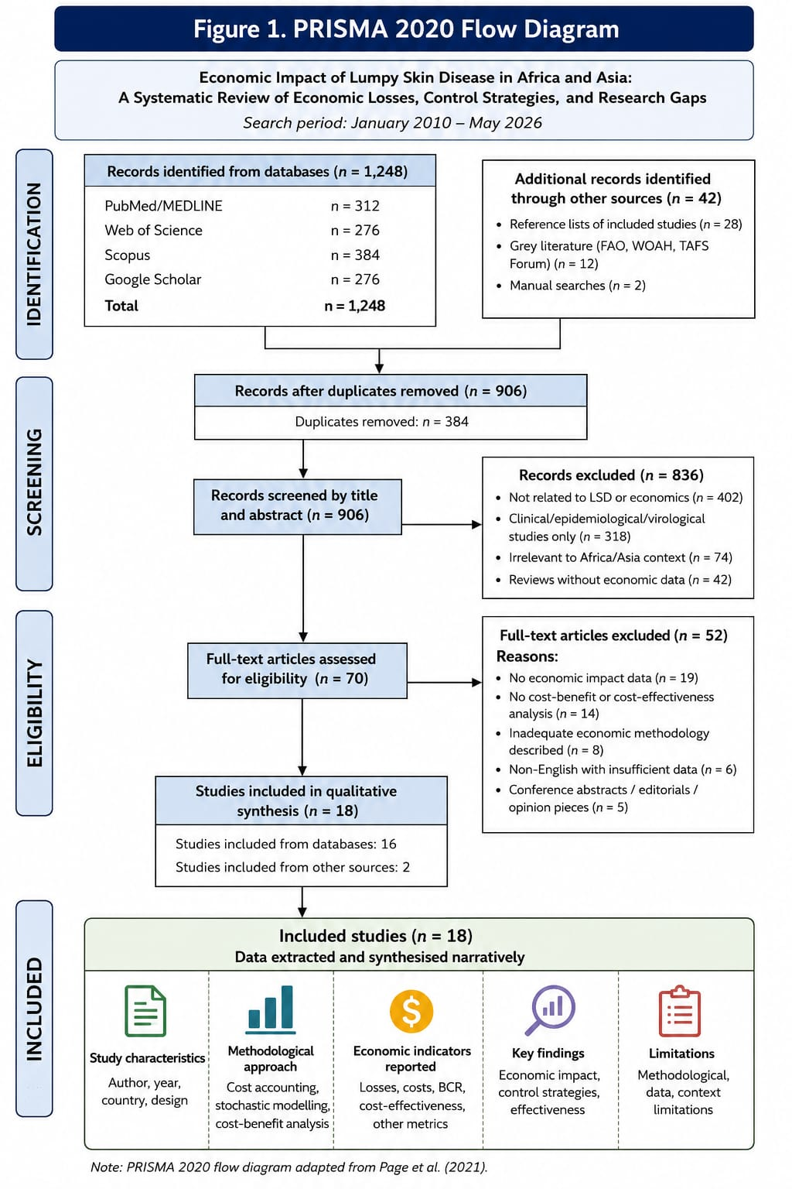

Figure 1: PRISMA 2020 flow diagram outlining the systematic literature search, screening, eligibility assessment, and final inclusion process for the review on the economic impact of lumpy skin disease in Africa and Asia (search period: January 2010 – May 2026). The diagram records the number of records identified from each database, removed as duplicates, screened at title/abstract level, assessed for full-text eligibility, excluded with reasons, and ultimately included in the narrative synthesis.

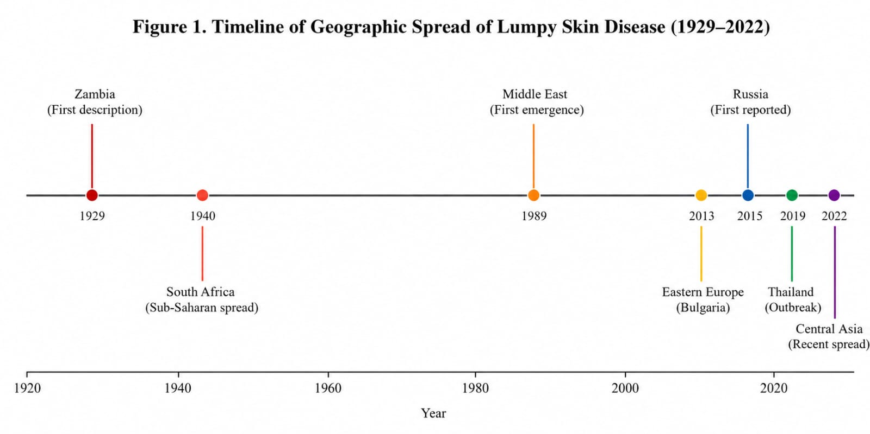

Figure 2: Timeline of Geographic Spread of Lumpy Skin Disease (1929–2022). Key expansion events derived from Tuppurainen and Oura (2012), Roche et al. (2021), Mazloum et al. (2023), and Bhuiyan (2025).
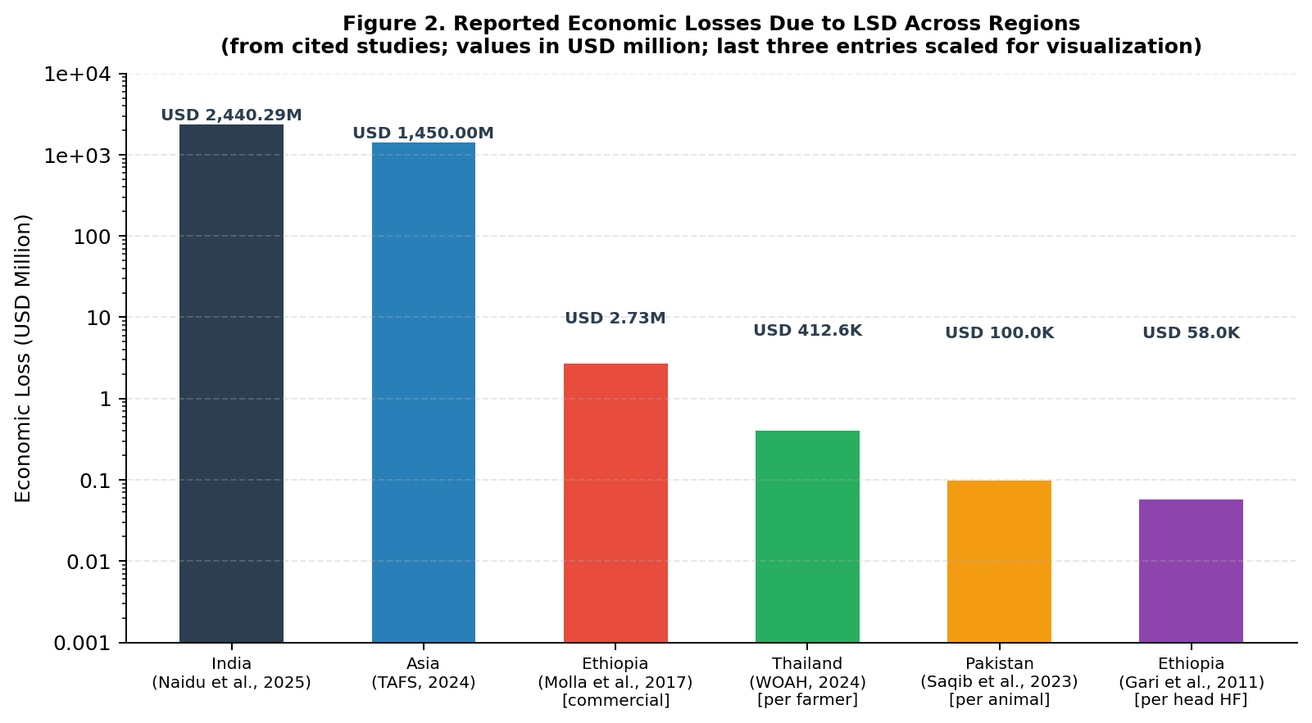

Figure 3: Reported Economic Losses Due to Lumpy Skin Disease Across Regions (logarithmic scale). Values represent total (national/regional) losses where applicable. Per-animal and per-farmer values are scaled for visualisation. Sources: Naidu et al. (2025); TAFS (2024); Molla et al. (2017); WOAH (2024); Saqib et al. (2023); Gari et al. (2011).
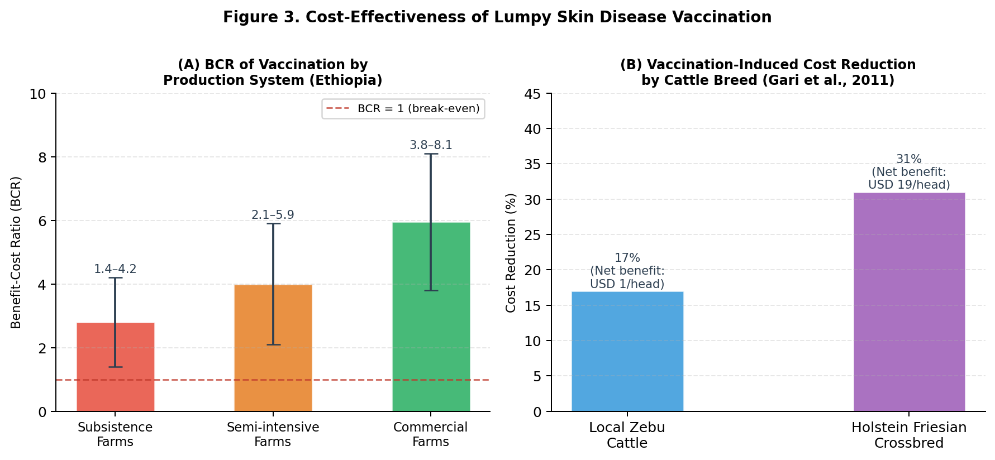

Figure 4: Cost-Effectiveness of Lumpy Skin Disease Vaccination. (A) Benefit-Cost Ratios (BCR) by production system in Ethiopia, showing ranges reported by Molla et al. (2017); error bars indicate minimum–maximum BCR. The dashed line represents BCR = 1 (economic break-even). (B) Vaccination-induced cost reduction by cattle breed under partial coverage scenarios, with net benefit per head shown; data from Gari et al. (2011).
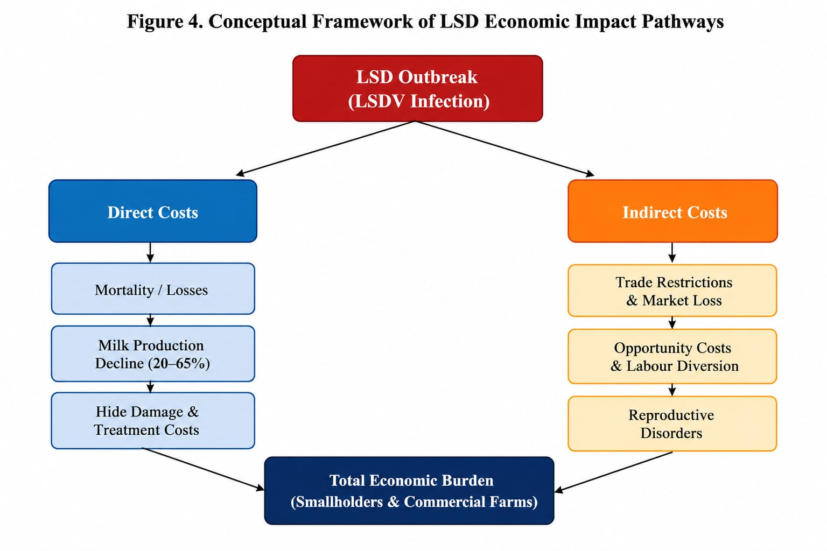

Figure 5: Conceptual Framework of Lumpy Skin Disease Economic Impact Pathways. The framework illustrates direct and indirect cost pathways from LSDV infection to total economic burden in both smallholder and commercial farming systems. Pathway components derived from Akther et al. (2023), Das et al. (2021), Saqib et al. (2023), and Modethed et al. (2025).

Tables
Table 1. Summary of Key Economic Studies on Lumpy Skin Disease (2010–2026)
Author(s) & Year | Country / Region | Study Design | Key Economic Findings | Control Strategy Evaluated | Quality Rating
Africa
Gari et al. (2011) | Ethiopia | Cross-sectional survey | USD 6.43/head (Zebu); USD 58/head (HF crossbred) annually in infected herds | Vaccination (partial coverage: 17% Zebu, 31% HF cost reduction) | Moderate
Molla et al. (2017) | Ethiopia | Cost-benefit analysis | Median herd loss USD 1,176; Subsistence USD 489; Commercial USD 2,735 per outbreak | Annual vaccination; BCR 1.4–8.1; MRR up to 3,400% | High
Limon et al. (2020) | Sub-Saharan Africa | Systematic assessment | Significant production losses in smallholder herds across sub-Saharan Africa | Vaccination recommended | Moderate
Asia
Chouhan et al. (2022) | Bangladesh | Epidemiological survey | Attack rate 34%; CFR 3.23%; limited economic analysis | Not evaluated | Low
Saqib et al. (2023) | Pakistan (KP) | Household survey | USD ~100/affected animal; higher losses in exotic breeds; household debt & emotional stress | Not evaluated | Moderate
Naidu et al. (2025) | India (7 states) | Stochastic Monte Carlo modelling | Total USD 2,440.29M (90% CI: 2,162.55–2,716.15M); Gujarat highest milk loss (90 L/animal) | Vaccination (economic rationale supported) | High
Rajendran et al. (2025) | India (Uttar Pradesh) | Farm-level economic assessment | Significant milk production losses 2022–23; crossbred cattle disproportionately affected | Vaccination cost-effectiveness assessed | Moderate
Southeast Asia
WOAH (2024) | Thailand | Regional assessment | Losses USD 119.42–412.57/farmer; reduced milk production & market disruption | Mass vaccination & movement restriction | Moderate
Modethed et al. (2025) | Thailand (Northern) | Stochastic modelling of dairy farms | Quantified financial losses in dairy farms; milk yield as primary loss driver | Economic rationale for vaccination confirmed | High
Hutchinson et al. (2024) | Indonesia / SE Asia | Surveillance-based analysis | Trade disruptions with Australia; first LSD cases March 2022; substantial livestock losses | Epidemiological monitoring | Moderate
WOAH (2024) | Vietnam | Farm-level survey | Production losses across smallholder dairy and beef farms; 2021–2022 epidemic period | Vaccination recommended | Moderate
Global / Regional Estimates
TAFS (2024) | Asia (regional) | Regional economic report | Direct livestock & production losses: USD 1.45 billion in Asia | Regional vaccination recommended | Moderate
Punyapornwithaya et al. (2024) | Thailand (national) | Bayesian structural time series | Mass vaccination + movement restriction reduced LSD case counts significantly | Mass vaccination policy | High
EFSA (2020) | Serbia / Western Balkans | Retrospective economic analysis | Economic impact of outbreaks 2016–2018; vaccination significantly reduced losses | Emergency and preventive vaccination | Moderate
Note: BCR = Benefit-Cost Ratio; CFR = Case Fatality Rate; HF = Holstein Friesian; KP = Khyber Pakhtunkhwa; MRR = Marginal Rate of Return. Quality ratings (High/Moderate/Low) based on adapted Drummond checklist criteria applied by the authors. All monetary values in USD. Studies are grouped by geographic region. Data extracted from cited references only.

Table 2. Categories of Economic Losses Associated with Lumpy Skin Disease
Loss Category | Parameter | Reported Range / Value | Key Source(s) | Production System
Direct Economic Losses
Mortality | Case fatality rate | <5% (general); up to 10% in susceptible exotic breeds | Das et al. (2021); Saqib et al. (2023) | All systems
Milk production decline | % yield reduction | 20–65% during acute infection; recovery 2–8 weeks post-disease | Naidu et al. (2025); Rajendran et al. (2025) | Dairy farms
Hide/skin damage | Hide downgrading | Permanent scarring; significant market value loss in leather industry | Akther et al. (2023); Das et al. (2021) | Beef & mixed
Reproductive losses | Fertility reduction | Temporary infertility in bulls; abortion; extended calving interval | Das et al. (2021); Tuppurainen & Oura (2012) | Breeding herds
Veterinary & treatment costs | Per animal treatment | Variable; included in USD ~100/animal estimate (Pakistan) | Saqib et al. (2023); Chouhan et al. (2022) | All systems
Body weight loss | Weight reduction | Prolonged; contributes to reduced slaughter value | Molla et al. (2017); Gari et al. (2011) | Beef & mixed
Indirect Economic Losses
Trade restrictions | Export bans; price suppression | Indonesia–Australia trade disruption; regional market collapse | Hutchinson et al. (2024); TAFS (2024) | Commercial & export-oriented
Opportunity costs | Foregone income; labour diversion | Underestimated in most studies; significant in smallholder systems | Modethed et al. (2025); Saqib et al. (2023) | Smallholder
Market disruption | Delayed marketing; price reduction | USD 119.42–412.57/farmer in Thailand (market + production losses) | WOAH (2024); Wilhelm & Ward (2023) | All systems
Non-market values | Draft power; social status; risk mitigation | Rarely captured; underestimates burden in subsistence systems | Molla et al. (2017); Saqib et al. (2023) | Smallholder / subsistence
Note: All values derived from studies cited within this review. Non-market values (draft power, social function) are systematically underestimated in conventional economic assessments. Recovery period for milk production losses reported as 2–8 weeks post-recovery by Naidu et al. (2025) and Rajendran et al. (2025).

Table 3. Identified Research Gaps, Limitations, and Recommended Future Actions
Research Gap Area | Limitation Identified | Recommended Action | Key References Noting Gap
Methodological standardisation | No internationally accepted protocols for LSD economic assessment; incomparable results across regions; no quality appraisal framework applied in prior reviews | Develop standardised cost-category definitions, time horizons, and CBA templates aligned with FAO/WOAH frameworks; mandate quality assessment in future systematic reviews using validated checklists (e.g. Drummond, CHEERS) | Akther et al. (2023); Molla et al. (2017); Drummond et al. (2015)
Smallholder system assessment | Studies focus on commercial/semi-intensive systems; subsistence farms underrepresented; non-market cattle values omitted, leading to systematic underestimation | Develop mixed-methods approaches (participatory rural appraisal + household surveys) capturing non-market cattle values (draft power, social capital, risk function) | Saqib et al. (2023); Molla et al. (2017); Gari et al. (2011)
Long-term / longitudinal studies | Most studies assess acute outbreak periods only (4–12 weeks); chronic and cumulative impacts, reproductive recovery, and herd restocking costs are ignored | Design prospective cohort studies tracking herds for ≥3 years post-outbreak; include reproductive, structural market, and herd restocking impacts | Modethed et al. (2025); Rajendran et al. (2025)
Regional economic variation | Intra-country economic heterogeneity not captured; especially in large countries (India, China, Indonesia) | Conduct sub-national economic assessments using geo-referenced production system data linked to epidemiological surveillance; identify economic hot spots | Naidu et al. (2025); Roche et al. (2021)
DIVA vaccine economics | No commercially available DIVA vaccine; no economic evaluation of development, companion diagnostics, or market access implications | Comprehensive cost-effectiveness analysis including R&D, production, companion diagnostic development, and trade access savings | Mazloum et al. (2023); Ronchi et al. (2024)
Integrated control economics | No economic studies on combined vaccination + vector control + movement restriction strategies; potential synergistic benefits unquantified | Design field trials with embedded economic component evaluating synergistic effects of integrated approaches across different agro-ecological zones | Tuppurainen et al. (2021); Punyapornwithaya et al. (2024)
Digital/precision surveillance economics | Economic value of early warning and digital surveillance systems not quantified; AI-assisted tools not evaluated | Health-economic modelling of surveillance investment versus outbreak prevention savings; evaluation of AI-assisted platforms | Tuppurainen et al. (2021); Hutchinson et al. (2024)
Absence of quality appraisal | No prior systematic review has formally assessed methodological rigour of LSD economic studies using validated checklists | Apply Drummond checklist or CHEERS standards in all future systematic reviews; establish evidence hierarchies for LSD economic evidence | Drummond et al. (2015); Page et al. (2021)
Note: CBA = Cost-Benefit Analysis; CHEERS = Consolidated Health Economic Evaluation Reporting Standards; DIVA = Differentiate Infected from Vaccinated Animals; FAO = Food and Agriculture Organization; OIE/WOAH = World Organisation for Animal Health. All gaps identified from synthesis of cited literature.

