Combined ethanol extract of Piper guineense leaf and Zingiber officinale rhizome attenuates aluminium chloride-induced Dementia in Wistar rats by inhibiting NADPH oxidase-driven oxidative stress and neuroinflammation

Abstract
Background: Alzheimer's disease (AD) is a progressive neurodegenerative disorder with limited treatment options. Neuroinflammation and oxidative stress, driven by nicotinamide adenine dinucleotide phosphate (NADPH) oxidase activation, play central roles in AD pathogenesis. This study evaluated the safety profile and neuroprotective efficacy of a combined ethanol extract of Piper guineense leaf and Zingiber officinale rhizome in an aluminium chloride (AlCl₃)-induced dementia model in Wistar rats. Methods: Acute toxicity was assessed using a modified Lorke's method. Thirty male Wistar rats were divided into six groups (n=5): normal control, AlCl₃ control (120 mg/kg), extract control (800 mg/kg), low-dose extract (400 mg/kg + AlCl₃), high-dose extract (800 mg/kg + AlCl₃), and donepezil (5 mg/kg + AlCl₃). The extract doses (400 and 800 mg/kg) were selected based on neuroprotective doses reported in previous studies on the individual plants, and the LD₅₀ was determined to confirm safety. After 21 days, brain homogenates were analysed for NADPH oxidase, nitric oxide metabolites (NOx), nitrate, malondialdehyde (MDA), antioxidant enzymes (SOD, CAT, GPx), and cytokines (TNF-α, IL-6, IL-1β). Results: The LD₅₀ was 7745.97 mg/kg, indicating a wide safety margin. AlCl₃ administration significantly upregulated NADPH oxidase (73.66±1.17 vs. 47.96±0.99 pg/mg in control), elevated total NOx, depleted nitrate levels, reduced SOD (from 26.84±0.90 to 12.58±0.26 u/g), CAT (from 11.67±0.29 to 5.71±0.12 u/g), and GPx (from 38.96±0.97 to 20.17±0.75 u/g), and increased MDA three-fold (0.60±0.03 vs. 0.20±0.01 mmol/g). Pro-inflammatory cytokines were markedly elevated. High-dose extract (800 mg/kg) significantly inhibited NADPH oxidase (50.00±0.26 pg/mg), restored nitrate levels (3.48±0.14 µmol/g), normalized antioxidant enzymes (SOD: 24.48±0.40 u/g; CAT: 10.24±0.24 u/g; GPx: 34.31±0.66 u/g), reduced MDA (0.28±0.01 mmol/g), and suppressed cytokine levels, with efficacy comparable to donepezil. Conclusion: The combined extract demonstrates a favourable safety profile and exerts neuroprotective effects by inhibiting NADPH oxidase, restoring redox homeostasis, and suppressing neuroinflammation, supporting its potential as a multi-target therapeutic agent for neurodegenerative conditions.
Keywords: Piper guineense, Zingiber officinale, NADPH oxidase, neuroinflammation, oxidative stress, Alzheimer's disease, aluminium chloride, donepezil
INTRODUCTION
Alzheimer's disease (AD) is a progressive and fatal neurodegenerative disorder, representing the leading cause of dementia globally (Vaja et al., 2025). The global disease burden is substantial; between 1991 and 2021, the prevalence of Alzheimer's disease and other dementias (ADRD) among adults aged ≥65 years increased by 160%, rising from 18.7 million to 49 million cases (Xiaopeng et al., 2025). While some projections suggest the global burden may stabilize or decrease in certain regions, the growth in low- and middle-income countries (LMICs) is expected to continue, with sub-Saharan Africa experiencing a significant rise in dementia cases (Zhang et al., 2025; Wu et al., 2025). In Nigeria, the most populous country in Africa, AD accounts for approximately 60% of dementia cases, and the burden has risen substantially, with an over 400% increase in cases over a twenty-year period to an estimated 318,011 in 2015 among the elderly (Adeloye et al., 2019; Wakawa et al., 2025).
Despite the high burden, the pathogenesis of AD remains incompletely understood. Pathological hallmarks include the accumulation of amyloid-beta (Aβ) plaques and hyperphosphorylated tau protein, alongside complex interplay of oxidative stress and neuroinflammation (Firdous et al., 2024; Pavlov et al., 2025). Chronic oxidative damage and the secretion of pro-inflammatory cytokines can disrupt neuronal function, ultimately leading to cognitive decline and the manifestation of dementia symptoms (Firdous et al., 2024; de Araújo et al., 2026). A key enzymatic source of reactive oxygen species (ROS) in the brain is nicotinamide adenine dinucleotide phosphate (NADPH) oxidase, particularly the Nox2 and Nox4 isoforms, which are upregulated in Alzheimer's disease and contribute to neuronal damage through excessive superoxide production (Ma et al., 2017; Tarafdar & Pula, 2018). With current conventional therapies offering only modest symptomatic relief and often being associated with adverse effects, there is a pressing global need for novel, multi-targeted therapeutic strategies (Talebi et al., 2021; Priyadarshini et al., 2025).
Plant-derived medicinal compounds have gained significant attention as promising candidates for treating neurodegenerative diseases (Chen & Sun, 2025). Standardized extracts with multi-target mechanisms can simultaneously address oxidative stress, neuroinflammation, and cholinergic dysfunction, representing a more holistic approach than single-target drugs (Pavlov et al., 2025). Notably, Piper guineense (black pepper) contains the alkaloid piperine, which possesses antioxidant and neuroprotective properties; studies have shown it can reduce lipid oxidation and inhibit tangle formation in brain tissues (Ademuyiwa et al., 2023). Similarly, Zingiber officinale (ginger) and its bioactive compounds, including gingerols and shogaols, have demonstrated potential to improve memory and abrogate cognitive impairments through anti-inflammatory and anti-oxidative mechanisms (Talebi et al., 2021; Priyadarshini et al., 2025).
A valuable tool for investigating potential neuroprotective agents is the aluminum chloride (AlCl₃)-induced neurotoxicity model. Chronic exposure to AlCl₃ and the resultant accumulation of aluminum in brain tissue has been shown to induce cholinergic dysfunction, elevate oxidative stress, and promote neuroinflammation, all of which are central features of AD-like pathology (Dey & Singh, 2022). Preclinical studies have successfully used oral AlCl₃ administration to replicate key biochemical and behavioural hallmarks of AD, making it a widely accepted in vivo model for screening potential therapeutics.
To date, the neuroprotective potential of a combined ethanol leaf extract of P. guineense and Z. officinale against AlCl₃-induced neurotoxicity has not been fully investigated. This study, therefore, aimed to evaluate the neuroprotective effect of a 1:1 combination of extracts from both plants on oxidative stress, neuroinflammation, and neurobehavioral deficits in an AlCl₃-exposed Wistar rat model. To provide preliminary evidence for the possible synergistic neuroprotective activity of these two medicinal plants, this study assessed NADPH oxidase activity, inflammatory cytokines, and antioxidant enzyme levels in brain tissue from an AlCl₃-exposed Wistar rat model.
MATERIAL AND METHOD
Drugs and reagents
Aluminum chloride (AlCl3, St. Louis MO, USA) and Donepezil hydrochloride (5 mg, Bafna Pharmaceuticals LTD, India) were utilized in this study¹. The Donepezil was marketed by Sunmed Pharmacy Australia (Batch No: T7640; NAFDAC Reg No: A4–0035HP/DRUGS/MIS/04/87) and purchased in Port Harcourt, Rivers State. All other chemicals and reagents were of analytical grade and sourced from commercial suppliers.
Plant Collection and Authentication
Fresh leaves of Piper guineense (Voucher No: RSUpb0115) and rhizomes of Zingiber officinale (Voucher No: RSUpb0116) were obtained from the Oil Mill and Mile 3 markets in Rivers State, Nigeria, respectively. Authentication was performed by Prof. M. G. Ajuru, a senior taxonomist at the Department of Plant Science and Biotechnology, Rivers State University.
Preparation of Plant Materials and Extraction
Fresh leaves of P. guineense and rhizomes of Z. officinale were thoroughly washed with distilled water to remove debris and air-dried at room temperature for fourteen (14) days. The dried P. guineense leaves were pulverized into a fine powder using an electronic blender, while the Z. officinale rhizomes were chopped into smaller pieces and similarly processed into powdery form using a mechanical grinder.
For the extraction process, 200 g of the finely powdered P. guineense leaf was macerated in 1.5 liters of ethanol for 48 hours with periodic agitation. The resulting mixture was filtered through a clean muslin cloth followed by Whatman No. 1 filter paper. The filtrate was concentrated to dryness in a hot air oven at 40ºC, yielding a pasty dark green extract weighing 13.92 g.
The same standardized procedure was applied to the Z. officinale powder, resulting in an oily dark brown extract weighing 8.72 g. Both extracts were stored in sterile, airtight reagent bottles and preserved in a refrigerator at 4ºC until further use. For the experimental treatments, the two extracts were combined in a 1:1 (w/w) ratio to form the combined ethanol leaf extract.
Acute Toxicity Study
Acute toxicity was assessed using a modified Lorke’s method. Twenty-one Wistar rats (120–150 g) were utilized in a three-phase study. In the first phase, nine rats were divided into three groups receiving 10, 100, and 1000 mg/kg of the extract, respectively. Following 24 hours of observation with no mortality, a second phase was conducted using doses of 1600, 2900, and 5000 mg/kg. A final confirmation was performed by administering 5000 mg/kg to three rats, which were monitored for 7 days. No clinical signs of toxicity or mortality were observed, leading to the conclusion that the LD₅₀ exceeds 5000 mg/kg
Experimental Animals and Ethical Considerations
Thirty (30) adult male Wistar rats (120-150 g) were sourced from the Animal House Facility of the Faculty of Basic Clinical Sciences, Rivers State University. The animals were housed in well-ventilated cages and subjected to a 14-day acclimatization period under standardized environmental conditions, including a room temperature of 25ºC ± 5ºC relative humidity of 46% ± %, and a natural 12-hour light-dark cycle. During this period and throughout the study, the rats were provided with a standard pelletized diet and water ad libitum.
Following acclimatization, the rats were randomly assigned to six (6) experimental groups (n=5 per group). All experimental procedures were conducted in strict accordance with the internationally accepted principles for laboratory animal use and care, as outlined in the Guide for the Care and Use of Laboratory Animals (NIH Publications No. 85-23, revised 1985).
Experimental Design and Induction of Dementia
Adult male Wistar rats were randomly allocated into six experimental groups (n = 5 per group) as follows:
Table 1. Experimental Design
Group | Identification | No. of Rats (n) | Treatment/Exposure
G1 | Normal Control | 5 | Distilled water only
G2 | AlCl₃ Control | 5 | AlCl₃ (120 mg/kg bwt)
G3 | Extract Control | 5 | Combined extract (800 mg/kg bwt)
G4 | Low-Dose Treatment | 5 | Combined extract (400 mg/kg bwt) + AlCl₃ (120 mg/kg bwt)
G5 | High-Dose Treatment | 5 | Combined extract (800 mg/kg bwt) + AlCl₃ (120 mg/kg bwt)
G6 | Standard Drug | 5 | Donepezil (5 mg/kg bwt) + AlCl₃ (120 mg/kg bwt)
Neurotoxicity was induced using AlCl₃, administered orally at a dose of 120 mg/kg body weight once daily for 21 consecutive days. The selected AlCl₃ dose and duration fall within the neurotoxic range reported to induce reproducible neuronal dysfunction and biochemical disturbances following repeated exposure in Wistar rats.
The doses of the combined extract (400 mg/kg and 800 mg/kg) were chosen based on previously published pharmacological studies that demonstrated neuroprotective activity of the individual plant extracts. Specifically, Piper guineense (black pepper) extracts or its active alkaloid piperine have shown antioxidant and neuroprotective effects in rodent models at doses ranging from 200 mg/kg to 800 mg/kg (Ademuyiwa et al., 2023). Similarly, Zingiber officinale (ginger) extracts and its bioactive compounds (gingerols, shogaols) have been reported to improve memory and attenuate cognitive impairments at doses between 200 mg/kg and 800 mg/kg in various preclinical studies (Talebi et al., 2021; Priyadarshini et al., 2025). To explore potential synergy and maintain a balance between efficacy and safety, we selected 400 mg/kg (low dose) and 800 mg/kg (high dose) for the combined extract. The acute toxicity study (LD₅₀ = 7745.97 mg/kg) confirmed that both doses are well within the safe range (approximately 5-10% of the LD₅₀), thereby ensuring that any observed neuroprotective effects are due to pharmacological activity rather than toxicity.
Tissue Preparation and Homogenization
Following the treatment period, rats were euthanized, and the whole brain was rapidly excised. Brain tissues were rinsed in ice-cold phosphate-buffered saline (PBS, pH 7.4) and homogenized (10% w/v) in a cold 0.1 M phosphate buffer. The homogenates were centrifuged at 10,000 rpm for 15 minutes at 4ºC, and the resulting supernatants were collected for enzymatic and biochemical evaluations.
Biochemical Assays
- Assay of Nicotinamide Adenine Dinucleotide Phosphate Oxidase (NADPH Oxidase) Activity: The activity of NADPH oxidase in brain homogenates was quantified using a rat-specific Enzyme-Linked Immunosorbent Assay (ELISA) kit focused on the Nox2/Nox4 enzyme complex, with results expressed in pg/mg protein (Li et al., 2012).
- Determination of Nitrosative Stress Markers: Total Nitric Oxide Metabolites (NOx) and specific Nitrate levels were determined using the Griess reagent system after the enzymatic reduction of nitrate to nitrite via nitrate reductase (Abdel-Salam et al., 2023).
- Assessment of Oxidative Stress Markers: The markers of oxidative damage and the enzymatic antioxidant defense system were assayed using established protocols. The activities of Superoxide Dismutase (SOD), Catalase (CAT), and Glutathione Peroxidase (GPx) were determined using standard kinetic spectrophotometric methods (Misra & Fridovich, 1972; Aebi, 1984). As a marker of lipid peroxidation, MDA levels were estimated using the Thiobarbituric Acid Reactive Substances (TBARS) assay. The reaction between MDA and thiobarbituric acid (TBA) produced a pink-colored complex measured at 532 nm.
- Determination of Inflammatory Markers: The concentrations of pro-inflammatory cytokines (Tumor Necrosis Factor-alpha (TNF-alpha), Interleukin-6 (IL-6) and Interleukin-1beta (IL-1β), were quantified using high-sensitivity Enzyme-Linked Immunosorbent Assay (ELISA) kits. The assays were performed in accordance with the manufacturer's instructions (Khan et al., 2019).
- Protein Determination: Total protein concentration in the brain homogenates was determined using the Biuret method or Lowry’s assay, using bovine serum albumin (BSA) as the standard, to normalize all biochemical parameters.
Statistical Analysis
All data obtained from the biochemical assays and memory assessments were expressed as Mean ± Standard Error of the Mean (SEM). Statistical evaluations were performed using GraphPad Prism (version 9.0). To determine the significance of differences between the six experimental groups, a one-way Analysis of Variance (ANOVA) was employed. This was followed by Tukey’s Multiple Comparison Test to identify specific differences between the control, AlCl₃-only, extract-treated, and standard drug (Donepezil) groups. A value of p < 0.05 was considered statistically significant. All graphical representations were generated to highlight the variance between the diseased group (AlCl₃-only, Group 2) and the treated groups (Groups 4, 5, and 6).
RESULTS
Result of acute toxicity evaluation of Piper guinenses leaves and Zingiber officinalis combined extract
Graded doses up to 6000 mg/kg of the combined extract produced no mortality in rats. The rats administered up to this dose remained active and physically stable throughout the 24-hour period of observation. However, 33.33percent mortality was observed in the third phase and group administered 7000 mg/kg body weight while all rats administered 10,000 mg/kg of the combined extract died. The application of Lorke’s formular therefore yielded an LD₅₀ value of 7745.97 mg/kg body weight for the 50:50 combined extracts of Piper guinenses leaves and Zingiber officinalis. Summary of results are presented in Table 2.
Table 2: Summary of Acute Toxicity Stages
Stage | Group | Dose (mg/kg) | Mortality | Observations
I | 1–3 | 10, 100, 1000 | 0/3 (0%) | Active and physically stable.
II | 1–2 | 1600, 2900 | 0/3 (0%) | Active and physically stable.
II | 3 | 5000 | 0/3 (0%) | Initially calm; regained activity within 1 hr.
III | 1 | 6000 | 0/3 (0%) | Initially calm; regained activity within 24 hrs.
III | 2 | 7000 | 1/3 (33.33%) | Weak, depressed, and calm; partial recovery.
III | 3 | 10000 | 3/3 (100%) | Calm, depressed; 100% mortality within 24 hrs.
Note: LD₅₀ = (D₀ x D₁₀₀)^{1/2}; Where: D₀: Highest dose that gave no mortality, D₁₀₀: Lowest dose that produced mortality, LD₅₀ = (6000 x 10000)^{1/2}, LD₅₀ = 7745.97 mg/kg body weight

Effect of combined ethanol leaf extract of P. guineese leaf and Z. officinale on brain NADPH Oxidase activities
The effect of combined ethanol leaf extract of Piper guineese and Zingiber officinale on brain nicotinamide adenine dinucleotide phosphate (NADPH Oxidase) activity in AlCl₃-induced dementia in adult male Wistar rats was shown in Table 3. The result shows that control is 47.96 ± 0.99. Aluminum Chloride administered 120mg/kg bwt gave 73.66 ± 1.17 then Combined extract alone administered 800mg/kg bwt gave 47.96 ± 0.99 while combined extract 400 mg/kg + Aluminum Chloride 120mg/kg bwt administered gave 53.08 ± 0.12. then combined extract 800mg/kg bwt + AlCl₃120 mg/kg bwt administered gave 50.00 ± 0.26 while Standard drug + AlCl₃120 mg/kg bwt administered gave 51.62 ± 0.65

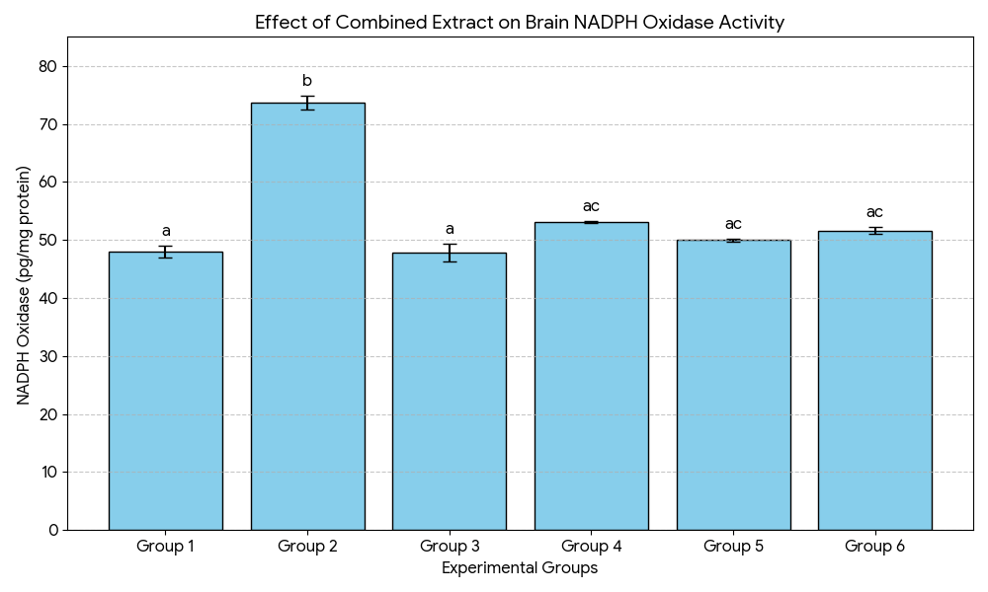
Figure 1: Effect of combined ethanol leaf extract of P. guineese and Z. officinale on brain NADPH Oxidase activity in AlCl₃-induced dementia in adult male Wistar rats.

Effect of combined ethanol leaf extract of P. guineese leaf and Z. officinale on brain Nitric Oxide Metabolites (NOx)
Significant differences were observed across groups (p<0.001). AlCl3​ (G2) caused the most significant increase in Nox levels (Nitric Oxide Metabolites). Treatment with the extract (G4 and G5) significantly reduced Nox levels compared to the AlCl3​ group, with the 800 mg/kg dose (G5) being more effective and similar to Donepezil (G6).

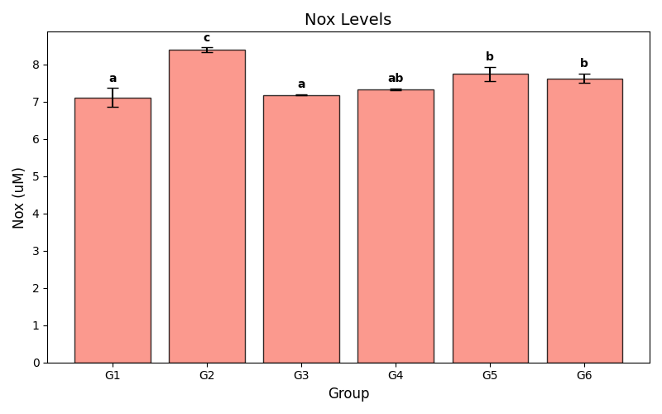
Figure 2: Effect of combined ethanol leaf extract of P. guineese and Z. officinale on brain Nitric Oxide Metabolites (NOx) content in AlCl₃-induced dementia in adult male Wistar rats
Effect of combined ethanol leaf extract of P. guineese leaf and Z. officinale on brain Nitrate level
There was a highly significant variation in Nitrate levels (p<0.001). AlCl₃-only​ (Group 2) reduced Nitrate levels compared to control. Interestingly, the low-dose treatment (G4) resulted in the highest levels of Nitrate, significantly exceeding the control and standard drug groups. However, both treatments significantly increased nitrate levels compared to the AlCl₃-only group.

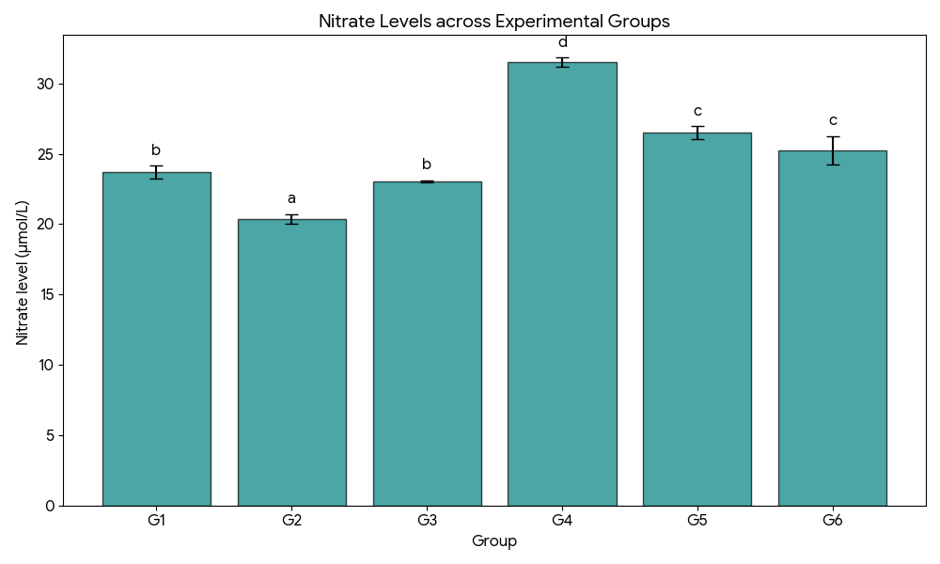
Figure 3: Effect of combined ethanol leaf extract of Piper guineese and Zingiber officinale on brain nitrate level in AlCl₃-induced dementia in adult male Wistar rats

Effect of combined ethanol leaf extract of P. guineese leaf and Z. officinale on brain homogenate antioxidant parameters
The effect of combined ethanol leaf extract of Piper guineese and Zingiber officinale on brain homogenate antioxidant parameters in AlCl₃-induced dementia in adult male Wistar rats is shown in table 2 The result shows that exposure to AlCl₃ only (Group 2) significantly (p ≤ 0.05) reduced glutathione (GSH) by approximately 27% (from 6.29 ± 0.20 to 4.61 ± 0.04 mg/g tissue), while the activities of glutathione peroxidase (GPx), superoxide dismutase (SOD) and catalase (CAT) significantly(p ≤ 0.05) decreased by 22%, 19% and 29%, respectively. In contrast, malondialdehyde (MDA), an index of lipid peroxidation, increased threefold from 0.20 ± 0.02 to 0.60 ± 0.03 mmol/g tissue. However, co-administration of the combined extract produced significant (p ≤ 0.05) and dose-dependent neuroprotection. Group 4 (400 mg/kg + AlCl₃) exhibited partial restoration of antioxidant enzymes and significant (p ≤ 0.05) suppression of MDA compared with the AlCl₃-only (group 2). More pronounced recovery was observed in Group 5 (800 mg/kg + AlCl₃), whose antioxidant indices approached control values. The standard drug-treated group (Group 6) demonstrated a comparable restorative pattern.
Table 3: Effect of combined ethanol leaf extract of Piper guineese and Zingiber officinale rhizome on brain homogenate antioxidant parameters in AlCl₃-induced dementia in adult male Wistar rats
Groups | Oxidative stress markers
Groups | GSH  (mg/g tissue) | GPx  (u/g tissue) | SOD  (u/g tissue) | CAT  (u/g tissue) | MDA  (mmol/g tissue)
G1 | 6.29 ± 0.20ª | 25.97 ± 0.64ª | 37.63 ± 1.32^{ac} | 8.09 ± 0.18ª | 0.20 ± 0.02ª
G2 | 4.61 ± 0.04^{b} | 20.17 ± 0.75^{b} | 30.63 ± 1.07^{b} | 5.71 ± 0.12^{b} | 0.60 ± 0.03^{b}
G3 | 7.37 ± 0.23^{c} | 28.20 ± 0.21ª | 41.17 ± 2.70^{c} | 8.50 ± 0.42ª | 0.17 ± 0.02ª
G4 | 5.25 ± 0.17^{bd} | 22.40 ± 0.72^{bc} | 33.03 ± 1.26^{ab} | 6.15 ± 0.10^{bc} | 0.40 ± 0.03^{c}
G5 | 5.83 ± 0.10^{ad} | 22.87 ± 0.29^{bc} | 34.23 ± 0.52ª | 6.84 ± 0.05^{c} | 0.38 ± 0.04^{c}
G6 | 5.60 ± 0.14^{ad} | 23.00 ± 0.62^{c} | 35.53 ± 0.20^{ac} | 7.04 ± 0.05^{c} | 0.34 ± 0.03^{c}
Data are represented as mean ± standard error of triplicate values, values in a column bearing different alphabetical superscript differ significantly from each other at 95% confidence level (p≤0.05).
Effect of combined ethanol extract of P. guineese leaf and Z. officinale rhizome on brain inflammatory biomarkers
Aluminum chloride intoxication significantly (p ≤ 0.05). elevated pro-inflammatory cytokines IL-6, IL-1β, and TNF-α in the AICI3- only group (group 2) relative to control (group 1). IL-6 increased by approximately 74%, IL-1β by over 340%, and TNF-α by 89%. In aluminum-exposed animals, combined extract administration produced dose-dependent mitigation of neuroinflammation. The 400 mg/kg dose (group 4) significantly (p ≤ 0.05) lowered cytokine levels relative to the AICI3-only (group 2), while the 800 mg/kg dose (group 5) produced greater suppression, approaching values obtained with the group 6 animals treated with the standard drug (Donepezil).

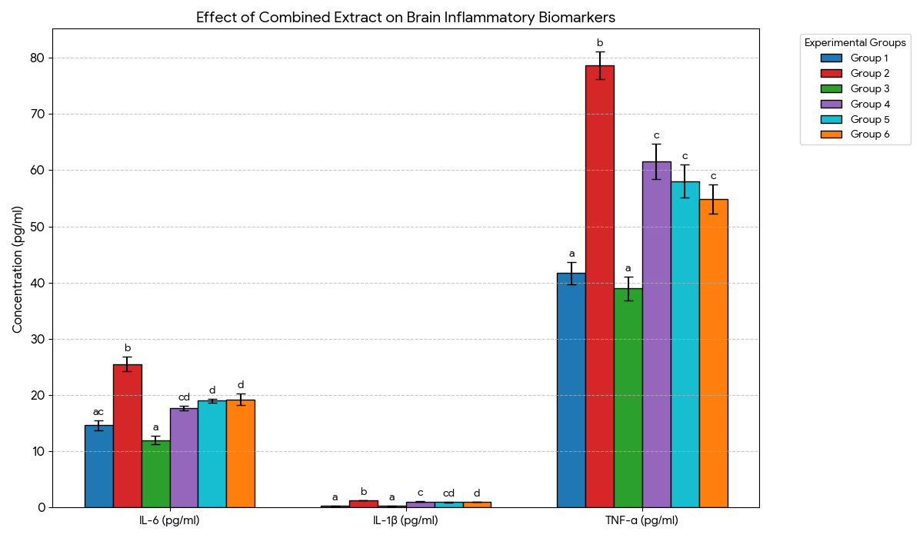
Figure 4: Effect of combined ethanol extract of P. guineese leaf and Z. officinale rhizome on brain inflammatory biomarkers in AlCl₃-induced dementia in adult male Wistar rats

DISCUSSION
The findings of this study demonstrate that aluminium chloride (AlCl₃) induces dementia through a complex interplay of oxidative stress, nitrosative damage, and neuroinflammation, which is significantly mitigated by the combined ethanol leaf extract of P. guineense and Z. officinale. Importantly, this therapeutic efficacy is supported by a wide margin of safety established through acute toxicity evaluation.
The determination of the LD₅₀ is a critical preliminary step in evaluating the therapeutic index of any herbal intervention. Our findings indicate that the combined extract of P. guineense and Z. officinale is relatively non-toxic. According to the Globally Harmonized System (GHS) of classification, substances with an LD₅₀ greater than 5000 mg/kg are generally considered to be of low acute toxicity (Category 5) or practically non-toxic. The calculated value of 7745.97 mg/kg places this polyherbal combination well within the safety margin for oral administration in experimental models. Importantly, the selected experimental doses of 400 and 800 mg/kg represent only 5–10% of the LD₅₀, confirming that the observed neuroprotective effects are not confounded by systemic toxicity.
A key point of discussion is whether the combined extract produces synergistic effects beyond the sum of the individual plant extracts. Previous studies on Piper guineense (or its active principle piperine) have reported neuroprotective activity in the dose range of 200–800 mg/kg, with significant reductions in oxidative stress and amyloid pathology (Ademuyiwa et al., 2023). Similarly, Zingiber officinale extracts have shown memory-enhancing and anti-inflammatory effects at doses of 200–800 mg/kg (Talebi et al., 2021; Priyadarshini et al., 2025). In the present study, the high-dose combined extract (800 mg/kg) produced neuroprotective effects comparable to donepezil, whereas the low dose (400 mg/kg) showed partial but significant restoration. Given that individual extracts at equivalent doses (e.g., 400 mg/kg of each alone) would be expected to produce modest effects based on the literature, the efficacy observed with the combination at the same total dose suggests at least an additive effect. This is consistent with the pivotal role of NADPH oxidase-driven oxidative stress in aluminum-induced neurodegeneration, as previously established by Kumar and Gill (2014), who demonstrated that aluminum exposure promotes free radical production and disrupts mitochondrial function. The nearly complete normalization of NADPH oxidase activity and antioxidant enzymes by the combination (800 mg/kg) indicates that the two plants may act on complementary pathways – for instance, piperine may enhance bioavailability of gingerols, or the two may jointly suppress NF-κB activation. While our study was not designed to formally test synergy using isobolographic analysis, the results provide strong evidence that the combination is at least as effective as the sum of its parts. Future studies should employ factorial designs to definitively establish synergy.
Simultaneously, the AlCl₃ group exhibited a significant rise in nitric oxide metabolites (NOx). This surge in NOx often reflects the activation of inducible nitric oxide synthase (iNOS). Similar elevations in nitric oxide metabolites following AlCl₃ exposure have been reported in studies with ononin and rosiridin (Chen et al., 2021; Alqarni et al., 2024). However, our result also shows that AlCl₃ administration (Group II) resulted in a significant depletion of nitrate levels in the whole brain homogenate. This discrepancy may be attributed to the different tissue sampling protocols employed. While other investigators utilized cerebral cortex homogenates, our study analyzed whole brain homogenates. Aluminium-induced neurotoxicity is characterized by regional heterogeneity (Abubakar, 2004); the cerebral cortex is highly susceptible to neuroinflammation, which triggers up-regulation of iNOS, leading to a localized surge in nitric oxide (Chen et al., 2021). In whole-brain analysis, this localized increase may be masked by the global depletion of physiological nitric oxide, reflecting a state of oxidative exhaustion and loss of NO homeostasis across the entire central nervous system.
The significant rise in NADPH oxidase activity observed in Group 2 provides the mechanistic explanation for the downstream nitrosative stress. The excess superoxide radicals produced by NOX reacts rapidly with nitric oxide (NO) derived from concurrently up-regulated iNOS to form the highly reactive oxidant peroxynitrite (ONOO⁻). This non-enzymatic scavenging of NO by NADPH oxidase-derived superoxide explains the “nitrate paradox” in our findings, the significant depletion of nitrate levels despite high total NOx. In essence, the high catalytic flux of NADPH oxidase effectively removes available nitric oxide before it can be processed into stable, physiological nitrates in the brain. The reduction in NO levels has been linked to the progression of Alzheimer’s-like neurodegeneration and cognitive decline (Alqarni et al., 2024).
However, the combined extract of P. guineense and Z. officinale (Groups 4 and 5) demonstrated a restorative effect, particularly at 800 mg/kg, where it normalized NADPH oxidase activity and NOx levels. The 400 mg/kg dose showed a substantial increase in nitrate levels, even exceeding the control, likely by reducing the scavenging pressure via inhibition of NADPH oxidase. The efficacy of the combined extract was comparable to donepezil, supporting its potential as a therapeutic agent in the management of aluminium-induced dementia. Similar results have been reported by Okwakpam et al. (2023), who found that apocynin and curcumin, both NOX2 inhibitors, effectively suppressed NADPH oxidase activity and alleviated oxidative stress in a diclofenac-induced cardiotoxicity model, further validating the therapeutic value of natural NOX inhibitors.
The results of the present study also demonstrate that chronic administration of AlCl3 induces significant disruption of the brain’s redox homeostasis. We observed a marked reduction in the activities of superoxide dismutase (SOD), catalase (CAT), and glutathione peroxidase (GPx), coupled with a three-fold elevation in malondialdehyde (MDA) levels in Group 2. Aluminium exposure has been shown to cause an increase in lipid peroxidation while depleting antioxidants such as SOD, CAT and GPx in the cerebellum and hippocampus (Bandi et al., 2023). The sustained activity of NOX in the AlCl3-only group appears to have overwhelmed the brain’s primary enzymatic defence, SOD. The significant reduction of SOD activity indicates a kinetic failure of the brain to dismute the superoxide surge, allowing for the initiation of lipid peroxidation (measured as high MDA). Similarly, the lowered activity of CAT and GPx allowed for the accumulation of H₂O₂ and lipid hydroperoxides. Multiple studies have confirmed that AlCl₃ consistently suppresses antioxidant enzymes while accelerating membrane damage (Chen et al., 2021; Inwang et al., 2023). However, the combined extract of P. guineense and Z. officinale acted as a potent antioxidant inducer, restoring these enzymes to levels statistically comparable to the standard drug, donepezil.
The results of this study elucidate a critical “cross-talk” between enzymatic oxidative stress and the neuroinflammatory cascade in the AlCl₃-induced model of dementia. A primary finding was the significant elevation of pro-inflammatory cytokines (TNF-α, IL-6, and IL-1β) in the AlCl₃-only group (Group 2). This sharp inflammatory surge is a hallmark of aluminium-induced neurodegeneration and is corroborated by recent studies (Wang et al., 2023; Chen et al., 2021). This cytokine surge is likely downstream of the pathologically up-regulated NADPH oxidase activity observed in our data. NOX-derived superoxide radicals (O₂⁻) act as potent secondary messengers that activate the nuclear factor-kappa B (NF-κB) signalling pathway. Once activated, NF-κB translocates to the nucleus to induce the transcription of pro-inflammatory genes, including iNOS and the measured cytokines (Wang et al., 2023). This mechanism is further supported by studies demonstrating that NF-κB shows an increasing trend with Al accumulation in the brain (Wang et al., 2023). Finally, the suppression of TNF-α, IL-6, and IL-1β by the extract indicates an attenuation of the NF-κB pathway, which is often triggered by the oxidative products of the NADPH oxidase enzyme. The high-dose extract (Group 5) successfully quenched the neuroinflammatory surge, demonstrating its potential as a multi-target therapeutic agent.
Despite the robust findings, this study has limitations, including the use of a single rodent species and sex (male Wistar rats), which may limit generalizability, as well as the relatively short duration of AlCl₃ exposure and extract administration. Future studies should explore chronic neurotoxicity models, include both sexes, conduct histopathological examinations of specific brain regions (cortex and hippocampus), and isolate the active compounds responsible for the observed synergistic neuroprotective effects.
CONCLUSION
The present study provides compelling evidence that the combined ethanol extract of Piper guineense and Zingiber officinale confers significant neuroprotection in aluminum-induced neurotoxicity through targeted modulation of key enzymatic pathways governing oxidative and inflammatory homeostasis. Central to this protective effect is the suppression of NADPH oxidase, a primary upstream source of pathological reactive oxygen species, whose overactivation in aluminum exposure precipitates antioxidant enzyme collapse, lipid peroxidation, nitrosative imbalance, and neuroinflammatory amplification. By inhibiting NADPH oxidase activity, the combined extract effectively restored the functional integrity of endogenous antioxidant enzymes, superoxide dismutase, catalase, and glutathione peroxidase, while replenishing reduced glutathione levels and suppressing lipid peroxidation. This enzymatic re-equilibration stabilized redox signaling, normalized nitric oxide metabolism, and curtailed the activation of inflammatory mediators, including TNF-α, IL-6, and IL-1β, thereby interrupting the vicious cycle linking oxidative stress to neuroinflammation.
Importantly, the high-dose extract demonstrated therapeutic efficacy comparable to the standard anti-dementia drug, Donepezil, underscoring the translational relevance of this polyherbal formulation. These findings position the combined extract as a potent multi-target enzyme modulator capable of intervening at the biochemical origin of neurodegenerative progression rather than merely attenuating downstream symptoms. Collectively, this work establishes an enzyme-based mechanistic foundation for the neuroprotective action of P. guineense and Z. officinale and supports their development as adjunct or alternative therapeutic agents for managing neurodegenerative disorders driven by redox and inflammatory dysregulation. Future investigations should focus on isolating the active phytochemical constituents responsible for NADPH oxidase inhibition and validating these effects in clinical models of dementia.
Ethical approval
The study protocol was reviewed and approved by the Institutional Animal Ethics Committee of Rivers State University (Protocol No. 17100668; 2019) and complied with the Animal Research: Reporting of In Vivo Experiments (ARRIVE) guidelines.
Disclaimer (Artificial intelligence)
Authors hereby declare that NO generative AI technologies such as Large Language Models (ChatGPT, COPILOT, etc.) and text-to-image generators have been used during the writing or editing of this manuscript.
REFERENCE
- Abdel-Salam, O. M. E., El-Sayed El-Shamarka, M., Youness, E. R., & Shaffie, N. (2023). Protective effect of hot peppers against amyloid β peptide and brain injury in AlCl₃-induced Alzheimer's disease in rats. Iranian journal of basic medical sciences, 26(3), 335–342. https://doi.org/10.22038/IJBMS.2022.67871.14845
- Abubakar, M. G., Taylor, A., & Ferns, G. A. (2004). Regional accumulation of aluminium in the rat brain is affected by dietary vitamin E. Journal of trace elements in medicine and biology : organ of the Society for Minerals and Trace Elements (GMS), 18(1), 53–59. https://doi.org/10.1016/j.jtemb.2004.02.001
- Adeloye, D., Auta, A., Ezejimofor, M., Oyedokun, A., Harhay, M. O., Rudan, I., & Chan, K. Y. (2019). Prevalence of dementia in Nigeria: a systematic review of the evidence. Journal of global health reports, 3, e2019014. https://doi.org/10.29392/joghr.3.e2019014
- Ademuyiwa, O. H., Fasogbon, B. M., & Adebo, O. A. (2023). The potential role of Piper guineense (black pepper) in managing geriatric brain aging: a review. Critical reviews in food science and nutrition, 63(16), 2840–2850. https://doi.org/10.1080/10408398.2021.1980764
- Ademuyiwa, O. H., Fasogbon, B. M., & Adebo, O. A. (2023). The potential role of Piper guineense (black pepper) in managing geriatric brain aging: a review. Critical Reviews in Food Science and Nutrition, 63(16), 2840-2850. https://doi.org/10.1080/10408398.2021.1980764
- Aebi, H. (1984) Catalase in Vitro. Methods Enzymology, 105, 121-126.
http://dx.doi.org/10.1016/S0076-6879(84)05016-3
- Alqarni, S. S., Afzal, M., Alharbi, K. S., Alenezi, S. K., Alsahli, T. G., Zaidi, S., Altyar, A. E., Ghaboura, N., Kazmi, I., Mantargi, M. J. S., & Imam, F. (2024). Rosiridin Protects Against Aluminum Chloride-Induced Memory Impairment via Modulation of BDNF/NFκB/PI3K/Akt Pathway in Rats. Medicina (Kaunas, Lithuania), 60(11), 1812. https://doi.org/10.3390/medicina60111812
- Bandi, S. K., Nayak, P., Mallipeddi, K., & Rajagopalan, A. (2023). Pro-Oxidant and Antioxidant Activity in Female Rat Cerebellum and Hippocampus on Exposure to Aluminium. International Journal of Pharmaceutical Investigation, 13(4), 793-797. https://doi.org/10.5530/ijpi.13.4.099
- Chen, D., & Sun, Y. (2025). Current Status of Plant-Based Bioactive Compounds as Therapeutics in Alzheimer's Diseases. Journal of integrative neuroscience, 24(1), 23090. https://doi.org/10.31083/JIN23090
- Chen, X., Zhang, M., Ahmed, M., Surapaneni, K. M., Veeraraghavan, V. P., & Arulselvan, P. (2021). Neuroprotective effects of ononin against the aluminium chloride-induced Alzheimer's disease in rats. Saudi journal of biological sciences, 28(8), 4232–4239. https://doi.org/10.1016/j.sjbs.2021.06.031
- de Araújo, A. B., S Azul, F. V. C., Carneiro, Y. C., de Sousa, C. N. S., de Vasconcelos, S. M. M., Rios, F. J., & Leal, L. K. A. M. (2026). Neuroinflammation and Oxidative Stress in Parkinson's Disease, Alzheimer's Disease, and COVID-19: Microglia-Neutrophil Interaction. ACS omega, 11(5), 6922–6938. https://doi.org/10.1021/acsomega.5c10397
- Dey, M., & Singh, R. K. (2022). Chronic oral exposure of aluminum chloride in rat modulates molecular and functional neurotoxic markers relevant to Alzheimer's disease. Toxicology mechanisms and methods, 32(8), 616–627. https://doi.org/10.1080/15376516.2022.2058898
- Firdous, S. M., Khan, S. A., & Maity, A. (2024). Oxidative stress-mediated neuroinflammation in Alzheimer's disease. Naunyn-Schmiedeberg's archives of pharmacology, 397(11), 8189–8209. https://doi.org/10.1007/s00210-024-03188-3
- Inwang, U. A., Davies, K. G., Ekong, M. B., Obasi, C. P., Onyebuenyi, M., & Nwaji, A. R. (2023). The anti-oxidative and cognitive properties of Zingiber officinale rhizome ethanol extract and its dichloromethane and n-hexane fractions against aluminium chloride-induced neurotoxicity in Swiss mice. International Journal of Pharmaceutical Sciences and Research, 14(8), 3921–3930. https://doi.org/10.13040/IJPSR.0975-8232.14(3).1196-01
- Khan, A., Ikram, M., Muhammad, T., Park, J., & Kim, M. O. (2019). Caffeine Modulates Cadmium-Induced Oxidative Stress, Neuroinflammation, and Cognitive Impairments by Regulating Nrf-2/HO-1 In Vivo and In Vitro. Journal of clinical medicine, 8(5), 680. https://doi.org/10.3390/jcm8050680
- Kumar, V., & Gill, K. D. (2014). Oxidative stress and mitochondrial dysfunction in aluminium neurotoxicity and its amelioration: a review. Neurotoxicology, 41, 154–166. https://doi.org/10.1016/j.neuro.2014.02.004
- Li, M., Dou, L., Jiao, J., Lu, Y., Guo, H. B., Man, Y., Wang, S., & Li, J. (2012). NADPH oxidase 2-derived reactive oxygen species are involved in dysfunction and apoptosis of pancreatic β-cells induced by low density lipoprotein. Cellular physiology and biochemistry : international journal of experimental cellular physiology, biochemistry, and pharmacology, 30(2), 439–449. https://doi.org/10.1159/000339037
- Ma, M. W., Wang, J., Zhang, Q., Wang, R., Dhandapani, K. M., Vadlamudi, R. K., & Brann, D. W. (2017). NADPH oxidase in brain injury and neurodegenerative disorders. Molecular neurodegeneration, 12(1), 7. https://doi.org/10.1186/s13024-017-0150-7
- Misra, H. P., & Fridovich, I. (1972). The role of superoxide anion in the autoxidation of epinephrine and a simple assay for superoxide dismutase. The Journal of biological chemistry, 247(10), 3170–3175.
- Okwakpam, F. N., Dokubo, A., Monanu, M. O., & Uahomo, P. O. (2023). Cardioprotective effects of apocynin and curcumin against diclofenac-induced cardiotoxicity in male Wistar rats via inhibition of oxidative stress. Scholars International Journal of Biochemistry, 6(7), 86–98. https://doi.org/10.36348/sijb.2023.v06i07.001
- Pavlov, S., Prajapati, S. K., Yadav, D., Marcano-Rodriguez, A., Yadav, H., & Jain, S. (2025). Advances in Bioactive Compounds from Plants and Their Applications in Alzheimer's Disease. Biomolecules, 16(1), 7. https://doi.org/10.3390/biom16010007
- Priyadarshini, S., Goyal, K., R, R., Gupta, S., Roy, A., Biswas, R., Patra, S., Chauhan, P., Wadhwa, K., Singh, G., Kamal, M., Iqbal, D., Alsaweed, M., Nuli, M. V., Abomughaid, M. M., Almutary, A. G., Sinha, J. K., Bansal, P., Rani, B., Walia, C., … Jha, N. K. (2025). Polypharmacology and Neuroprotective Effects of Gingerol in Alzheimer's Disease. Molecular neurobiology, 62(7), 8166–8186. https://doi.org/10.1007/s12035-024-04484-y
- Talebi, M., İlgün, S., Ebrahimi, V., Talebi, M., Farkhondeh, T., Ebrahimi, H., & Samarghandian, S. (2021). Zingiber officinale ameliorates Alzheimer's disease and Cognitive Impairments: Lessons from preclinical studies. Biomedicine & pharmacotherapy = Biomedecine & pharmacotherapie, 133, 111088. https://doi.org/10.1016/j.biopha.2020.111088
- Tarafdar, A., & Pula, G. (2018). The Role of NADPH Oxidases and Oxidative Stress in Neurodegenerative Disorders. International journal of molecular sciences, 19(12), 3824. https://doi.org/10.3390/ijms19123824
- Vaja, R., Vohra, M., Ramachandran, A. V., & Baxi, D. (2025). Development of a Novel Aluminium Chloride-Induced Zebrafish Model of Alzheimer's Disease: Involvement of Oxidative Stress, Cholinergic Dysfunction, and Gut Pathophysiology. Neurotoxicity research, 43(6), 46. https://doi.org/10.1007/s12640-025-00769-9
- Wakawa, I. A., Musami, U. B., Kwairanga, S. H., Ogualili, P. N., Mahmood, M. Y., Fugu, M. A., Gimba, M. M., Allamin, M. M., Abbas, Z. U., Sunkani, M. K., Yaganami, Z. B., Kadau, F. M., Sani, N. M., Danmallam, P., Nanjul, L., Babazau, L., Muhammad, Z., Goni, B. W., Machina, B. K., Karch, C. M., … Maina, M. B. (2025). Dementia in a resource-constrained sub-Saharan African setting: A comprehensive retrospective analysis of prevalence, risk factors, and management at the only neuropsychiatric facility in Northeastern Nigeria. Alzheimer's & dementia : the journal of the Alzheimer's Association, 21(3), e14538. https://doi.org/10.1002/alz.14538
- Wang, L., Zhang, J., Zhao, Y., Li, J., Lu, X., Song, J., Zhang, L., & Niu, Q. (2023). Nuclear factor kappa B (NF-κB) participates in the aluminum-induced down-regulation of miR29a/b1. Journal of trace elements in medicine and biology : organ of the Society for Minerals and Trace Elements (GMS), 80, 127309. https://doi.org/10.1016/j.jtemb.2023.127309
- Wu, M., Gao, L., Su, Q., Wang, H., Zhao, Q., & Wang, H. (2025). Global burden, spatiotemporal disparities, and sex-specific trends of early- and late-onset Alzheimer's disease and other dementias: a comparative analysis and projections to 2035. BMC neurology, 26(1), 1. https://doi.org/10.1186/s12883-025-04530-9
- Xiaopeng, Z., Jing, Y., Xia, L., Xingsheng, W., Juan, D., Yan, L., & Baoshan, L. (2025). Global Burden of Alzheimer's disease and other dementias in adults aged 65 years and older, 1991-2021: population-based study. Frontiers in public health, 13, 1585711. https://doi.org/10.3389/fpubh.2025.1585711
- Zhang, N., Chai, S., & Wang, J. (2025). Assessing and projecting the global impacts of Alzheimer's disease. Frontiers in public health, 12, 1453489. https://doi.org/10.3389/fpubh.2024.1453489

