Strategic Roadmap for Exploring Phytochemical Profiles of Ixora Nigricans L. Flowers and Leaves Extract: The X-ray Diffraction Overview Insight

ABSTRACT

This study investigates the phytochemical landscape of Ixora Nigricans L., a medicinal plant species, through a comparative analysis of its foliar and floral tissues. Qualitative phytochemical screening was performed across a polarity gradient using n-hexane, ethyl acetate, and ethanol to evaluate the distribution of secondary metabolites, while X-ray diffraction (XRD) analysis was used to evaluate crystallinity and structural properties of the extracts. Results revealed a diverse metabolic profile significantly influenced by both solvent polarity and tissue type. Alkaloids demonstrated a ubiquitous presence across all solvent systems and tissues, suggesting a chemically diverse nitrogenous profile with potential pharmacological breadth. In contrast, steroids were identified exclusively in the ethanolic leaf extracts, indicating their presence as polar glycosides and highlighting a tissue-specific biosynthetic downregulation in reproductive organs. Terpenoids were consistently sequestered in the lipophilic n-hexane fractions of both tissues, confirming their role as non-polar defense agents. Furthermore, tannins exhibited a more consistent distribution across the floral fractions compared to the leaves, suggesting an enrichment of phenolics in reproductive structures for protection against oxidative stress and pathogens. These findings establish I. Nigricans are a rich source of bioactive constituents, particularly alkaloids and tannins. The distinct partitioning of metabolites suggests that while leaves are optimal for steroidal recovery, the flowers offer a specialized phenolic profile, providing a strategic roadmap for bioactivity-guided fractionation and the biogenic synthesis of nanoparticles using these tissues as natural reducing agents. The XRD analysis further revealed predominantly amorphous to semi-crystalline structures, with variations in crystallite size and structural ordering between leaf and flower extracts. These findings highlight I. nigricans as a promising source of bioactive compounds and provide a basis for targeted phytochemical extraction and potential applications in green nanotechnology and drug development.

Keywords: Ixora Nigricans L., pharmacological breadth, Bioactive constituents, Bioactivity, Phytochemical screening, Solvent polarity, Secondary metabolites, Medicinal plants.

1. Introduction
Ixora Nigricans, commonly known as black Ixora or black jungle family [1]. It is native to Southeast Asia, particularly found in countries like Malaysia, Indonesia, and Thailand [2]. Ixora Nigricans is an evergreen shrub characterized by its dark green foliage and striking clusters of small, tubular flowers [3]. In traditional medicine, Ixora Nigricans has been used for various medicinal purposes by indigenous communities [4]. The increasing interest in natural products and traditional medicine has sparked scientific investigations into the phytochemical composition and potential health benefits of Ixora Nigricans [5]. Understanding the phytochemical composition of Ixora Nigricans is essential for unravelling its medicinal potential and validating its traditional uses [6]. This information can contribute to expanding our knowledge of Ixora Nigricans as a valuable medicinal plant and may pave the way for further research on its pharmacological activities, mechanisms of action, and potential applications in healthcare [7]. Phytochemicals such as alkaloids, tannins, flavonoids, and phenolic compounds are widely present in different parts of medicinal plants and are commonly used in herbal medicine to treat various diseases, including cough, malaria, wounds, toothache, rheumatic disorders, inflammation, and ROS-related conditions [8]. These compounds exhibit a range of pharmacological activities, including antimicrobial, anti-inflammatory, and antidiarrheal properties. The Alkaloids have antimicrobial and anti-inflammatory properties, helping to reduce gastrointestinal distress [9]. For example, different indigenous communities use Ixora Nigricans for various medicinal purposes, like the Chakma use root extract for diarrhea and ear infections, the Tanchangya prepare leaf-based pills for dysentery, and the Marma use root extract for treating unconsciousness in children, as well as vomiting and bleeding. Scientific studies on its leaves have confirmed significant pharmacological activities, including anti-inflammatory, antioxidant, antiviral, cytotoxic, antispasmodic, anti-arthritic, and CNS depressant effects [10].

Micronutrients, though required in small quantities, are essential for optimal growth and development of the plant, besides playing a critical role in enhancing the quality and yield of blooms. Elements such as boron (B), copper (Cu), iron (Fe), manganese (Mn), and zinc (Zn) play significant roles in plant health and flower production [11]. For example, calcium (Ca) facilitates flower opening and delays senescence, while zinc aids in stem elongation and pollen production. Iron is indispensable for photosynthesis, and boron supports cell division and hormone transport [12]. Although traditional flowers like Ixora are increasingly in demand, India’s floriculture sector largely prioritizes cut flowers such as roses, lilies, and orchids, resulting in minimal governmental support for loose-flower cultivation [13]. Fertilizers are applied every six (6.0) months to ensure balanced growth, improved flower color, and higher yield in Ixora, with nitrogen playing a key role in boosting vegetative growth and productivity. Phosphorus supports essential plant processes, while potassium regulates stomatal function, water balance, energy metabolism, and enzyme activity [14]. The plant has glossy, leathery, oblong leaves (sessile to short-petiolate, arranged oppositely or in whorls with basal stipules) and small tubular flowers in dense clusters, which can also be used for cotton fabric coloration [15].
Medicinal plants are rich sources of secondary metabolites such as alkaloids, tannins, terpenoids, and flavonoids, which are known to exhibit diverse biological activities, including antimicrobial, antioxidant, and anti-inflammatory effects. Previous studies on Ixora species have reported a range of pharmacological properties; however, detailed investigations into the comparative distribution of phytochemicals across different plant tissues remain limited [16]. In particular, the influence of solvent polarity on metabolite extraction and tissue-specific variation has not been extensively explored for I. nigricans [17]. Another study on Ixora species has reported significant pharmacological activities, including antioxidant, antiviral, cytotoxic, and central nervous system effects [18]. However, comprehensive comparative studies focusing on tissue-specific phytochemical distribution remain limited.
In this study, we assessed the impact of Ixora Nigricans on medicinal activity and micronutrient-related growth, aiming to determine whether the combined extracts are more effective than individual ones and to provide recommendations on their use [19]. Diversity studies have been conducted, and the genotypes have been clustered based on morphological and molecular data [20]. This primary research may seem beneficial to a large number of people interested in collecting or researching Ixora. Photographs of each species were included in the paper for better identification [21]. Promoting Ixora cultivation through sustainable practices could provide substantial economic benefits to small and marginal farming communities [22]. The plant has been taken into consideration with a keen interest to investigate and carry out the complete study and to get information for consumption and utilization, as well as industrial application of the plant and its product, and quantification of various phytochemical content of dry powder.

2.0 Materials and Methods
2.1. Plant Material Collection
Fresh, fully matured leaves and flowers of Ixora Nigricans were collected from the premises of the Department of Applied Chemistry and Chemical Engineering, Islamic University, Kushtia-7003, Bangladesh. The collection was carried out during the daytime at an approximate ambient temperature of 32.0 °C. The plant samples were authenticated based on morphological characteristics, and only healthy, uncontaminated specimens were selected for analysis.

2.2. Preparation of Plant Materials
The collected plant materials were thoroughly washed with clean water to remove adhering dust and impurities. The leaves were shade-dried at temperatures below 30.0 °C to minimize degradation of thermolabile constituents. The stems were washed, shade-dried, and subsequently oven-dried at a controlled temperature below 40.0 °C using a laboratory oven (WHL-25A, Huanghua Faithful Instrument Co., Ltd., China). The dried plant materials (leaves and flower) were ground into a fine powder using a mechanical blender. Further size reduction was achieved using a mortar and pestle, followed by grinding with a mechanical mortar grinder (Fritsch, Germany) to ensure uniformity. The powdered material was sieved through a 20 mesh sieve and stored in airtight containers, properly labeled, and kept in a cool, dry, and dark environment until extraction.

2.3. Extraction Procedure
2.3.1. General Considerations
Extraction was performed to isolate bioactive phytoconstituents from the plant materials. All procedures were conducted carefully to prevent degradation, loss, or contamination of the active compounds.

2.3.2. Cold Extraction (Solvent Maceration)
The powdered plant materials were subjected to cold extraction using solvents of increasing polarity, namely n-hexane, ethyl acetate, and methanol. Each sample was soaked in the respective solvent in airtight containers and maintained at room temperature for five (5.0) days with intermittent shaking and stirring to enhance extraction efficiency.

2.3.3. Filtration and Concentration of Extracts
Following the extraction period, the mixtures were filtered using appropriate filtration techniques. The filtrates were collected separately and concentrated by evaporating the solvents under reduced pressure or at room temperature until semi-solid residues were obtained.
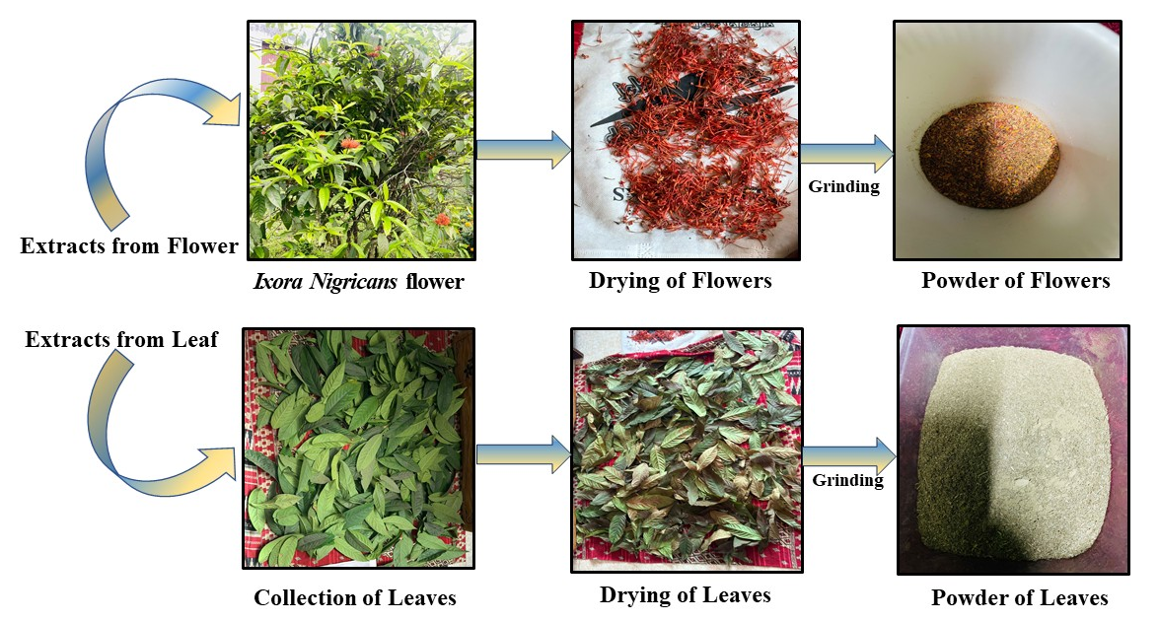
Fig 1: Preparation of Plant Extracts from Ixora Nigricans L. (flowers and leaves).

The resulting extracts were stored in labeled vials and preserved under suitable conditions for further analysis.

2.4. Phytochemical Screening
Preliminary phytochemical screening of the extracts was conducted to identify the presence of major secondary metabolites. Standard qualitative methods were employed to detect compounds such as alkaloids, flavonoids, tannins, saponins, and glycosides. These assays provided a rapid and cost-effective means of assessing the chemical composition of the plant extracts.

2.4.1 Mayer’s Reagent
It is used for the detection of alkaloids. Solution (A) was made to dissolve 0.68 g mercuric chloride in 30.0 ml of distilled water. Solution (B) was made to dissolve 2.5 g of potassium iodide (KI) in 10.0 ml of distilled water. Solutions A and B were mixed, and the volume was adjusted to 100.0 ml with distilled water.

2.4.2 Salkowski Test
The Salkowski test was performed for the presence of terpenoids. Each extract was mixed with 2.0 ml of chloroform, and then concentrated H₂SO₄ (3.0 ml) was carefully added to form a layer. A reddish-brown coloration in the interface indicated a positive result for the presence.

2.4.3 Test for Phytochemicals
The extracts of leaves and flowers of Ixora Nigricans (20 mg) were subjected to qualitative analysis to detect the presence of different classes of chemical constituents in the plant.

2.4.4 Test for Alkaloids
Ethyl acetate, n-hexane, and methanol extracts of each part of Ixora Nigricans were warmed separately with 2.0 % H₂SO₄ for two (2.0) minutes. It was filtered, and a few drops of the following reagents were added, indicating the presence of alkaloids. Mayer’s reagent shows a creamy white color, indicating a positive. Mayer’s reagent is a chemical reagent mainly used for the detection of alkaloids in qualitative analysis.

2.4.5 Test for Steroids
2.0 ml of acetic anhydride and 2.0 ml of H₂SO₄ were added to the extracts. The color changed from violet to blue or green, indicating the presence of 22 steroids.
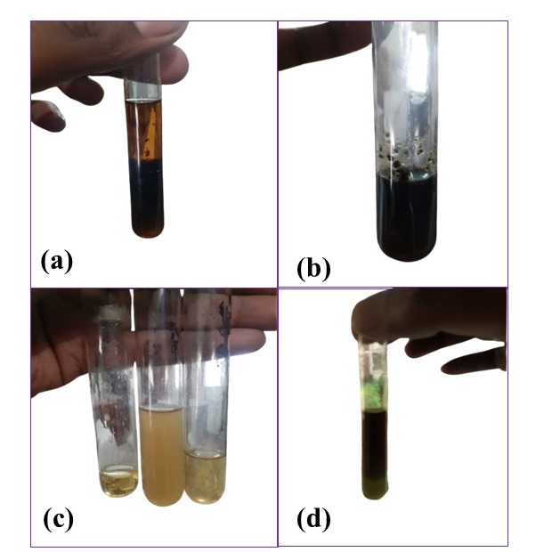
Fig 2: The resulting picture of (a) alkaloid, (b) steroid, (c) terpenoid and (d) tanin.

2.4.6 Test for Terpenoids
The test is based on the reaction of cholesterol (a sterol) with concentrated sulfuric acid (H₂SO₄), producing a color change due to the formation of conjugated compounds. The Salkowski test was performed for the presence of terpenoids. Each extract was mixed with 2.0 mL of chloroform, and then concentrated H₂SO₄ (3.0 mL) was carefully added to form a layer. A reddish-brown coloration in the interface indicated a positive result for the presence of terpenoids.

2.4.7 Test for Tanins
About 0.50 g of the extract was boiled in 10.0 ml of water in a test tube and then filtered. A few drops of 0.1 % (v/v) Ferric chloride (FeCl₃) were added and observed for brownish green or a blue-black coloration.

3. Characterization
3.1. X-ray diffraction (XRD)
Powder XRD was used to describe the crystallinity and crystallographic characteristics of the Rongon flower and leaves extract [31-33]. This non-destructive analytical method looks at how X-rays [34-36] interact with a crystalline material's regular atomic arrangement [23], [24]. A monochromatic X-ray beam was directed at the extracted samples to collect XRD data [37-39]. The crystallographic shape, structure, size, lattice parameters, d-spacing, and dislocation density can all be ascertained with the aid of XRD [25]. The copper tube's X-ray generator, supplied by Smart Lab SE [Rigaku, Japan], runs at 40.0 kV and 50.0 mA (2.0 kW) [40-42]. Using Bragg-Brentano (BB) optics [43-45], the main X-ray travels through a K_{β} [46-48] filter 1D for Cu and a Beryllium (Be) window standard incident primary beam (K¹=1.5406° for Cu) [49-50]. The standard operation mode was utilized. A 1D scan mode with a step width of 0.01° and a rate of 30.0°/minute was used for the experiment [51-53]. The length-limiting slit was set at 10.0 mm, the incidence slit box was set at 0.5°, and the scan range (2θ) was between 5.0 ° and 70.0 ° [54-56]. With both receiving slit boxes 1 and 2 open in the theta-theta goniometer geometry, the Hypix-400 horizontal HPAD [57-59] (hybrid pixel array detector), was utilized for detection [60-62]. The crystallite size of synthetic nanoparticles was determined using the Scherrer equation [26], [27], and [28], as explored by equation 1.
D =$\frac{Kλ}{βCosθ}$ (1)

4.0 Result and Discussion
4.1 X-ray Diffraction Analysis
To assess the structural properties of Rongon (Ixora Nigricans L.) flower and leaf extracts, X-ray diffraction patterns were acquired over a 2θ range of 5.0 ° to 70.0 °. Instead of crisp Bragg reflections, both samples exhibited large diffraction halos, suggesting an amorphous-to-semicrystalline structure. These patterns are common in organic matrices derived from plants, which are composed of complex phytochemicals lacking long-range periodic order. The XRD features of the flower and leaf extract-mediated samples are primarily amorphous to weakly crystalline, suggesting minimal long-range structural order controlled by phytochemical-mediated nucleation and growth processes. Previous research indicates that XRD can distinguish between the amorphous and crystalline nature of plant-based materials, which is critical for understanding the stability and solubility of bioactive compounds [79]. Significant changes in their phytochemical makeup and their impact on nanostructure development, however, are reflected in peak position, intensity, and broadening [29].
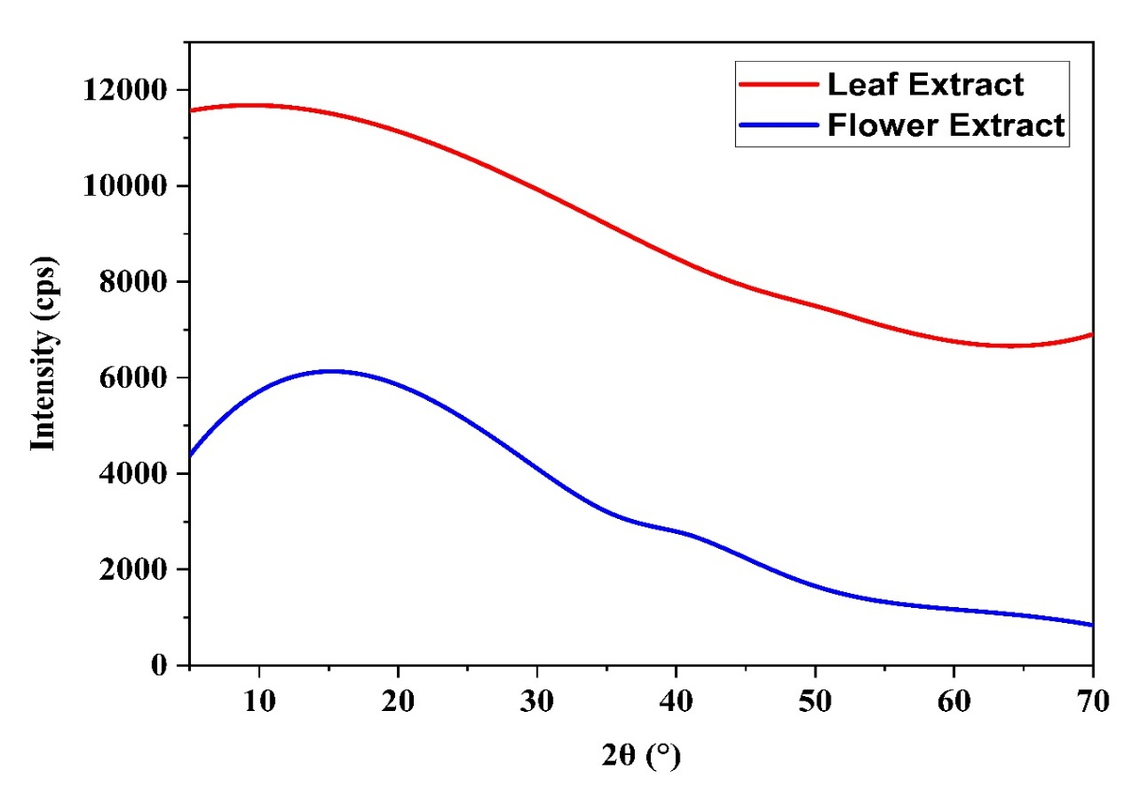
Fig 3: X-ray diffraction patterns of Ixora Nigricans L. (Rongon) flower and leaf extracts.

Table 1. Grain size calculation of Ixora Nigricans (Rongon) flower and leaves extracts.
Sample | 2θ  (°) | (θ)  (°) | FWHM  (radians) | Intensity, I  (CPS°) | Crystallite size  (D) (nm) | d-spacing  (nm)
Flower Extract | 41.8 | 20.9 | 0.19984 | 5184 | 0.78 | 0.0216
Leaf extract | 52.3 | 26.15 | 0.308923 | 4346 | 0.52 | 0.175
The floral extract exhibits a diffraction peak at 2θ = 41.8° with a considerably lower FWHM (0.19984 rad), indicating a bigger crystallite size (0.78 nm) and better-ordered crystalline domains. The presence of active phytochemicals like flavonoids and phenolics that enable controlled nucleation and efficient capping, encouraging more uniform crystal growth and tighter lattice arrangement (d = 0.0216 nm), is responsible for the higher intensity (5184 CPS), which further indicates enhanced structural ordering [30].
The leaf extract, on the other hand, shows a diffraction peak at 2θ = 52.3° with a larger FWHM (0.308923 rad), suggesting a lower crystallite size (0.52 nm) and decreased crystallinity. Due to a greater percentage of condensed polyphenols, lignin-related chemicals, and lignocellulosic residues, the lower intensity (4346 CPS) represents comparatively less organized structural domains [63-64]. Faster nucleation, restricted crystal development, and relatively larger lattice spacing (d = 0.175 nm) result from these components' contributions to a more complex and heterogeneous phytochemical matrix. Overall, the findings show that while stem extract promotes smaller, less crystalline structures due to a denser but more heterogeneous phytochemical environment influencing rapid nucleation and growth kinetics, flower extract favors more ordered and relatively larger crystalline nanostructures due to effective phytochemical capping and controlled growth.

4.2 Phytochemical screening of the leaves and flowers of Ixora Nigricans L.
Table 2. Chart for phytochemical screening of the leaves of Ixora Nigricans L.
Solvent | Tested group
Solvent | Alkaloids | Steroids | Terpenoids | Tanin
N-hexane | + | _ | + | +
Ethyl acetate | + | _ | _ | +
Ethanol | + | + | _ | _

In the phytochemical 2 and table 3, the symbols used "+" for presence, "_" for absence of these constituents.
The qualitative phytochemical screening of Ixora nigricans L. leaf extracts (Table 2) revealed a diverse distribution of secondary metabolites influenced by solvent polarity. Alkaloids were identified across all solvent systems, suggesting a broad range of alkaloidal structures with varying polarities. In contrast, steroids were selectively extracted by ethanol, indicating the presence of polar derivatives such as glycosides.
Terpenoids and tannins were predominantly localized in the n-hexane and ethyl acetate fractions. The presence of terpenoids in the n-hexane extract confirms their lipophilic nature [65], while the detection of tannins in less polar solvents suggests a specific chemical profile-likely condensed tannins-that warrants further quantitative study. These results highlight the necessity of a multi-solvent approach for the comprehensive isolation of the plant's bioactive constituents.
Table 3. Chart for phytochemical screening of the flowers of Ixora nigricans L.
Solvent | Tested group
Solvent | Alkaloids | Steroids | Terpenoids | Tanin
N-hexane | + | _ | + | +
Ethyl acetate | + | _ | _ | +
Ethanol | + | _ | _ | +

The qualitative screening of Ixora Nigricans L. flower extracts (Table 3) revealed a high prevalence of alkaloids and tannins, which were consistently detected across all solvent systems regardless of polarity. This ubiquity suggests a diverse chemical profile of these metabolites, likely contributing to the flowers' pharmacological potential. Literature established that the use of a polarity gradient—moving from non-polar solvents like n-hexane to polar solvents like ethanol—is essential for the comprehensive extraction of secondary metabolites [80]. Earlier investigations have demonstrated that this sequential approach successfully isolates distinct groups, such as lipophilic terpenoids in n-hexane and polar glycosides or tannins in ethanolic fractions, allowing for a targeted evaluation of a plant’s specific pharmacological potential, such as antimicrobial or antioxidant activities [81].
Conversely, terpenoids were uniquely localized in the n-hexane fraction, confirming their lipophilic nature and the need for nonpolar solvents for their extraction. Notably, steroids were absent from all tested extracts, indicating a tissue-specific metabolic profile distinct from that of the leaves [66]. These findings characterize the floral extracts as a rich source of nitrogenous and phenolic compounds, providing a basis for targeted bioactivity studies.

4.3 Comparative analysis of plant extract (Leaf and Flower)
Comparative profiling of Ixora nigricans L. leaf and floral tissues reveals significant metabolic partitioning, reflecting specialised physiological roles. While alkaloids were ubiquitous, suggesting a conserved nitrogen-based defence strategy, other metabolites showed clear tissue-dependent sequestration. Steroids were identified exclusively in leaf extracts, likely as polar glycosides, reflecting the leaf's role as a primary metabolic hub for the biosynthesis of structural and signalling molecules. By contrast, the absence of steroids in flowers suggests strategic downregulation in reproductive tissues to prioritise other pathways [67]. Conversely, tannins were more consistent in floral extracts, likely serving as chemical barriers to protect the germline from UV stress and pathogens [68]. Furthermore, the localisation of terpenoids in n-hexane fractions across both tissues confirms their conserved role as lipophilic defence agents. These findings characterise the leaves as a superior source for steroidal isolation, while the floral profile is more specialised for concentrated phenolic applications.

5.0 Functional Application and Activity
The functional Applications of Ixora Coccinea extract were explored in Fig. 1, and the exponential uses and activity were described below.

1. Antioxidant Activity
Ixora coccinea exhibits potent antioxidant activity due to its high content of flavonoids (quercetin, rutin), phenolic acids, and triterpenoids (ursolic acid, oleanolic acid). These compounds donate hydrogen atoms or electrons to neutralize reactive oxygen species (ROS) such as superoxide radicals, hydroxyl radicals, and peroxides. Additionally, the extract enhances endogenous antioxidant defense systems by increasing reducing power and total antioxidant capacity. This activity plays a crucial role in preventing oxidative stress-mediated diseases, including neurodegeneration, diabetes, and cancer [69].

2. Antimicrobial Activity
The antimicrobial effect of I. coccinea is attributed to bioactive compounds like flavonoids, tannins, and terpenoids. These compounds disrupt microbial cell walls, alter membrane permeability, and inhibit essential enzymes, leading to microbial death. Extracts show broad-spectrum activity against Gram-positive (Staphylococcus aureus) and Gram-negative (Escherichia coli, Pseudomonas aeruginosa) bacteria, as well as fungi (Candida albicans). The presence of phenolic compounds also interferes with microbial protein synthesis, making the plant a promising candidate against antibiotic-resistant strains [71].

3. Anti-Inflammatory Activity
The anti-inflammatory activity involves inhibition of key inflammatory mediators such as prostaglandins, leukotrienes, histamines, and cytokines. The plant extracts may inhibit cyclooxygenase (COX) and lipoxygenase (LOX) pathways, thereby reducing the production of inflammatory prostaglandins. Additionally, its antioxidant property reduces oxidative stress-induced inflammation. This dual mechanism makes it effective in treating inflammatory disorders such as arthritis, skin inflammation, and tissue injury [70].

4. Antidiarrheal Activity
The antidiarrheal effect is mediated through multiple mechanisms, including inhibition of gastrointestinal motility and reduction of intestinal secretion. The extract reduces the propulsion of intestinal contents (as observed in charcoal meal tests) and decreases enteropooling induced by castor oil. Tannins present in the plant may also form protein-tannate complexes, reducing intestinal irritation and fluid loss. These mechanisms collectively validate its traditional use in treating diarrhea and dysentery [72].

5. Anthelmintic Activity
The anthelmintic activity is primarily due to phytochemicals such as tannins and alkaloids, which interfere with the energy metabolism of parasites. These compounds cause paralysis by affecting neuromuscular coordination and eventually lead to the death of the worms. Experimental studies using earthworms demonstrate that chloroform extracts show faster paralysis and death compared to other extracts, indicating strong antiparasitic potential [73].

6. Anticancer (antitumor) Activity
Its anticancer potential is mainly due to the presence of camptothecin, a well-known topoisomerase I inhibitor. This compound prevents DNA replication in rapidly dividing cells, leading to apoptosis (programmed cell death). Additionally, flavonoids and triterpenoids contribute to anticancer effects by inducing oxidative stress in cancer cells and inhibiting angiogenesis. Experimental studies also show cytotoxic effects against melanoma and other tumor cell lines, highlighting its pharmaceutical importance [74].
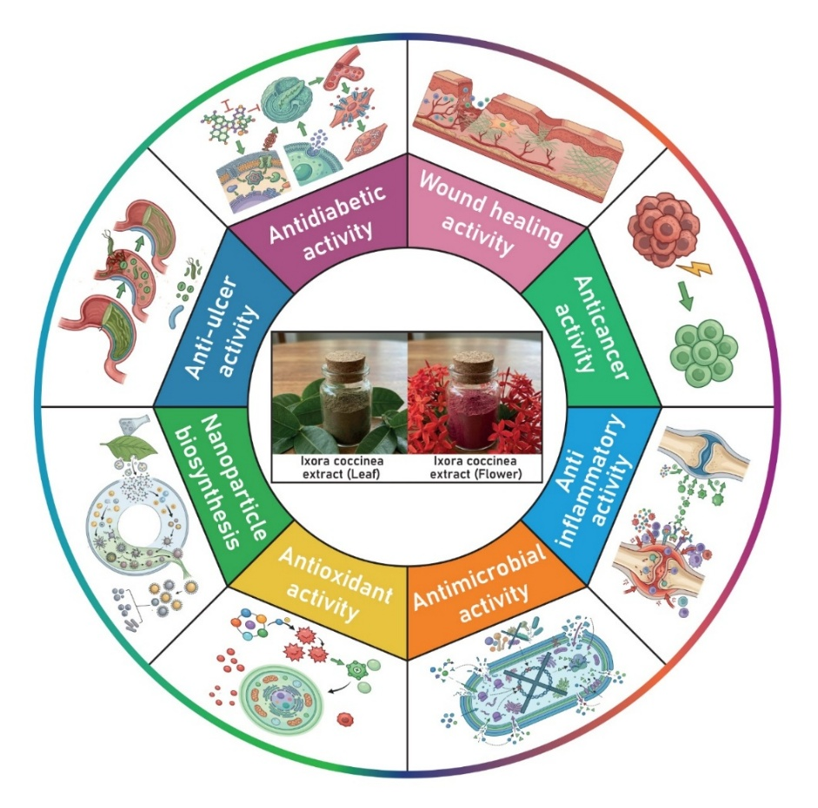
Fig 4: The functional Applications of Ixora Coccinea extract.

7. Antileishmanial Activity
The plant exhibits significant inhibitory effects against Leishmania donovani promastigotes. The mechanism is likely related to the disruption of parasite mitochondrial function and induction of oxidative stress within the parasite cells. Methanolic extracts show higher activity, suggesting the involvement of polar bioactive compounds. This activity is particularly important for developing low-cost treatments for kala-azar in endemic regions [75].

8. Wound healing Activity
The wound healing potential of Ixora coccinea is associated with enhanced collagen synthesis, increased hydroxyproline content, and improved cross-linking of collagen fibers. These changes lead to increased tensile strength and faster wound contraction. The plant also promotes angiogenesis and epithelialization, which are essential steps in tissue regeneration. Its antimicrobial action further prevents infection, making it effective in both acute and chronic wounds [76].

9. Antidiabetic and hypolipidemic Activity
The hypoglycemic effect may be due to stimulation of insulin secretion, increased glucose uptake by peripheral tissues, or inhibition of carbohydrate metabolism enzymes. The plant also improves lipid metabolism by reducing serum cholesterol, triglycerides, and LDL levels while increasing HDL. These combined effects make it beneficial in managing diabetes and preventing associated cardiovascular complications [69, 77].

10. Analgesic (antinociceptive) Activity
The analgesic activity is mediated through the inhibition of pain mediators such as prostaglandins and substance P. The plant may act on both central and peripheral pain pathways, reducing pain perception. This effect is supported by experimental models showing decreased response to painful stimuli, indicating its potential as a natural pain reliever [70].

11. Hepatoprotective Activity
The hepatoprotective effect is attributed to antioxidant and membrane-stabilizing properties. The plant reduces liver enzyme levels (AST, ALT) and prevents lipid peroxidation in liver tissues. It protects hepatocytes from toxin-induced damage and supports the regeneration of liver cells, making it useful in liver disorders such as hepatitis and drug-induced toxicity [70].

12. Gastroprotective Activity
The plant protects the gastric mucosa by enhancing mucus secretion, reducing acid production, and neutralizing free radicals. It also inhibits ulcer formation by strengthening the stomach lining and promoting healing of existing ulcers. These effects are closely linked to its antioxidant and anti-inflammatory properties [70].

13. Antimutagenic Activity
The antimutagenic property involves the protection of genetic material from damage caused by mutagens such as chemicals and radiation. Flavonoids and phenolic compounds stabilize DNA structure and reduce mutation rates, thereby lowering the risk of cancer and genetic disorders [70].

14. Chemoprotective Activity
The plant protects normal cells from the toxic effects of chemotherapeutic agents and environmental toxins. It enhances cellular defense mechanisms, reduces oxidative damage, and improves the survival of healthy cells during exposure to harmful substances [70].

15. Dermatological Applications
Due to its antimicrobial, anti-inflammatory, and antioxidant properties, Ixora coccinea is widely used in treating skin conditions such as eczema, boils, ulcers, and infections. It promotes skin regeneration and reduces irritation and redness, making it valuable in dermatological treatments [70].

16. Gastrointestinal Applications
Traditionally, the plant is used for treating digestive disorders such as diarrhea, dysentery, nausea, and anorexia. Root decoctions act as stomachic agents, improving digestion and appetite, while tannins help reduce intestinal inflammation [72].

17. Respiratory Applications
Ixora coccinea is traditionally used in respiratory conditions such as catarrhal bronchitis and related disorders. The flowers and roots are specifically mentioned in the treatment of bronchial problems. This use is supported by its anti-inflammatory activity, which helps reduce irritation and swelling in the respiratory tract. Since inflammation is a major factor in bronchitis, this property contributes to symptom relief [72].

18. Reproductive Health Applications
Ixora coccinea is used in traditional medicine for treating menstrual disorders such as dysmenorrhea and conditions like leucorrhoea. Its astringent and anti-inflammatory properties help regulate reproductive health [72].

19. Sedative Activity
The plant exhibits mild sedative properties, helping to relieve hiccups, nausea, and restlessness. It may act on the central nervous system to produce calming effects, improving comfort and relaxation [72].

20. Anti-asthmatic Activity
Ixora coccinea shows potential in managing asthma due to its combined anti-inflammatory, antioxidant, and anti-allergic properties. Asthma is mainly characterized by airway inflammation, bronchoconstriction, and hypersensitivity. The plant helps reduce inflammation in bronchial tissues by suppressing mediators such as histamine and prostaglandins. Its antioxidant compounds protect lung tissues from oxidative damage, which is a major factor in chronic asthma. Additionally, it may relax bronchial smooth muscles, improving airflow and reducing breathing difficulty [78]

21. Analgesic (pain-relieving) Activity
The analgesic effect of Ixora coccinea is associated with its ability to inhibit pain-inducing mediators such as prostaglandins and bradykinins. These compounds are released during tissue injury and inflammation. By reducing their production, the plant decreases the sensation of pain. It may act through both peripheral pathways (at the site of injury) and central pathways (within the nervous system), making it useful in managing inflammatory pain conditions [69, 70].

22. Antipyretic Activity
Although not extensively studied experimentally, Ixora coccinea is traditionally used in conditions involving fever. Its antipyretic potential is likely linked to its anti-inflammatory action, as fever is regulated by inflammatory mediators acting on the hypothalamus. By reducing these mediators, the plant may help normalize body temperature and reduce fever symptoms [70].

23. Cytotoxic Activity
Ixora Nigricans contains compounds such as camptothecin and flavonoids that interfere with cellular replication and metabolic processes. These compounds can induce apoptosis (programmed cell death) in cancer cells and inhibit their proliferation. This makes the plant valuable in screening for anticancer drugs and understanding mechanisms of cell death. [69, 71, 78].

24. Anti-tumour Activity
In addition to cytotoxic effects, Ixora coccinea has been shown to suppress tumor growth in experimental models. It works by inhibiting uncontrolled cell division, reducing tumor size, and preventing metastasis. The plant may also block angiogenesis (formation of new blood vessels), which tumors need for growth and survival. These properties highlight its potential role in cancer therapy [74].

24. Cardioprotective Activity
The cardioprotective effect of Ixora Nigricans is mainly due to its antioxidant and lipid-lowering properties. It protects heart tissues from oxidative stress and prevents damage caused by toxic agents such as drugs or free radicals. By improving lipid profiles and reducing cholesterol levels, the plant may also help prevent cardiovascular diseases like atherosclerosis and heart failure [69].

25. Anti-ulcer Activity
Ixora Nigricans plays an important role in protecting the stomach lining against ulcer formation. It reduces gastric acid secretion while increasing mucus production, which acts as a protective barrier. Its antioxidant activity also helps neutralize free radicals that damage gastric tissues. As a result, it not only prevents ulcer formation but also promotes the healing of existing ulcers [69, 78].

26. Nanoparticle biosynthesis Application
The plant has a modern application in green nanotechnology. Its phytochemicals act as natural reducing and stabilizing agents in the synthesis of metal nanoparticles, such as gold nanoparticles. These biomolecules convert metal ions into nanoscale particles and prevent their aggregation. The resulting nanoparticles show enhanced antimicrobial and biomedical properties, making them useful in drug delivery, diagnostics, and therapeutic applications [69, 78].

27. Neuroprotective Activity
Ixora Nigricans protects neurons from damage caused by oxidative stress, toxins, and neurodegenerative processes. Its antioxidant compounds prevent neuronal cell death and maintain cellular integrity in the brain. This activity suggests potential applications in conditions such as Alzheimer’s disease, Parkinson’s disease, and other neurodegenerative disorders [69].

28. Anxiolytic Activity
The plant exhibits anxiolytic (anti-anxiety) effects by influencing neurotransmitter activity in the brain. It may enhance inhibitory neurotransmitters such as GABA, leading to a calming effect. This helps reduce stress, anxiety, and nervous tension, making it useful in managing psychological conditions [69].

29. Antityrosinase Activity (antiresinase)
Ixora coccinea inhibits tyrosinase, an enzyme responsible for melanin production in the skin. By reducing melanin synthesis, the plant can be used in cosmetic applications such as skin lightening and treatment of hyperpigmentation disorders. This activity is also important in preventing enzymatic browning in biological systems [66].

30. Antineoplastic Activity
Antineoplastic activity refers to the overall ability to prevent, inhibit, or treat cancer. Ixora coccinea demonstrates this through multiple mechanisms, including antioxidant protection, inhibition of tumor cell growth, induction of apoptosis, and prevention of metastasis. This broad-spectrum anticancer potential makes it a promising candidate for future drug development [69, 70, 71].

5.0 Conclusion
This study establishes Ixora Nigricans L. as a rich source of bioactive metabolites, characterized by significant partitioning between foliar and floral tissues. The ubiquitous presence of alkaloids suggests broad pharmacological potential, while the exclusive localization of steroids in the leaves and the consistent tannin profile in the flowers highlight organ-specific biosynthetic strategies. The XRD analysis revealed predominantly amorphous to semi-crystalline structures, suggesting variations in phytochemical-mediated structural organization. However, these findings are based on qualitative screening and preliminary structural analysis, which may limit the depth of interpretation. Therefore, the results should be interpreted with caution. These findings provide a strategic roadmap for targeted drug discovery and the green synthesis of nanoparticles, identifying leaves as optimal for steroidal recovery and flowers for phenolic applications. Future research should focus on the quantitative characterization and bioactivity evaluation of these identified constituents to fully realize their therapeutic and industrial utility.

Conflicts of Interest
The authors declared that there are no known conflicts or financial interests that could influence this manuscript.

Data Availability
Data will be available on request.

Disclaimer (Artificial intelligence)
Author(s) hereby declare that NO generative AI technologies such as Large Language Models (ChatGPT, COPILOT, etc.) and text-to-image generators have been used during the writing or editing of this manuscript.

Reference

[1]. Baliga, M. S., & Kurian, P. J. (2012). Ixora coccinea Linn.: Traditional uses, phytochemistry and pharmacology. Chinese journal of integrative medicine, 18(1), 72-79.
[2]. Von Rintelen, K., Arida, E., & Häuser, C. (2017). A review of biodiversity-related issues and challenges in megadiverse Indonesia and other Southeast Asian countries. Research Ideas and Outcomes, 3, e20860.
[3]. Maraia, h. E. O. (2017). Investigating aspects of niche partitioning in ixora l.(rubiaceae), its spatial and morphological diversity in papuasia (Doctoral dissertation, University of Technology).
[4]. Baliga, M. S., & Kurian, P. J. (2012). Ixora coccinea Linn.: Traditional uses, phytochemistry and pharmacology. Chinese journal of integrative medicine, 18(1), 72-79.
[5]. Rahman, M., Chowdhury, U., & Humaira, T. (2025). Phytochemical composition and bioactivity assessment of Ixora nigricans R. Br. ex Wight & Arn. leaf extract. Chittagong University Journal of Biological Sciences, 1-6.
[6]. Nadeem, R., Imran, M., Saeed, Z., Pervaiz, M., & Younas, U. (2025). Exploring the therapeutic potential of Ixora extract: a comprehensive review of mediated studies. Advances in Traditional Medicine, 25(1), 107-144.
[7]. Bharathy, P., Thanikachalam, P. V., Shoban, A. N., Himayavendhan, H. V., Shoban, A., & Himayavendhan, H. (2024). Floral Fusion: Unravelling the Potent Blend of Ixora coccinea and Rhododendron arboreum for Health and Safety Benefits. Cureus, 16(9).
[8]. Ansari, P., Shofiul, A. J., Sarker, S. M., Kallol, K. M., Zareen, T., Tasnim, T., ... & Sarmin, B. (2015). Potential investigation of anti-inflammatory and anti-oxidative properties of ethanolic extract of Ixora nigricans leaves. IJPR, 5(4), 104.
[9]. Stark, T. D., Mtui, D. J., & Balemba, O. B. (2013). Ethnopharmacological survey of plants used in the traditional treatment of gastrointestinal pain, inflammation and diarrhea in Africa: future perspectives for integration into modern medicine. Animals, 3(1), 158-227.
[10]. Rahman, M., Chowdhury, U., & Humaira, T. (2025). Phytochemical composition and bioactivity assessment of Ixora nigricans R. Br. ex Wight & Arn. leaf extract. Chittagong University Journal of Biological Sciences, 1-6.
[11]. Karthik, K., Ganga, M., Reshma, R., & Visalakshi, M. (2025). Optimizing micronutrient use for enhanced flowering and yield in ixora. Plant archives (09725210), 25(1).
[12]. Karthik, K., Ganga, M., Sumera, S., & Venkata Sai Chakradhar Reddy, D. (2025, November). Role of Micronutrients in Enhancing Floral Quality and Postharvest Shelf Life in Ixora. In Biology and Life Sciences Forum (Vol. 47, No. 1, p. 6). MDPI.
[13]. Karthik, K., Ganga, M., & Visalakshi, M. (2025). Impact of Micronutrients on Floral Quality, Plant Physiology and Shelf life of Ixora coccinea. Journal of Experimental Agriculture International, 47(8), 377-385.
[14]. Alam, M. N., Biozid, M. S., Chowdhury, A. I., Mazumdar, M. M. U., Chowdhury, S., & Chowdury, M. I. A. (2015). Anti-arthritic and cytotoxic effects of methanolic extract of Ixora nigricans leaf. Journal of Medicinal Plants Research, 9(25), 719-723.
[15]. Indu, C. R., Neelavathi, R., & Masilamani, P. (2025). Studies on optimization of spacing and nutrient levels on growth and flower yield of Ixora (Ixora coccinea L.).
[16]. Nadeem, R., Imran, M., Saeed, Z., Pervaiz, M., & Younas, U. (2025). Exploring the therapeutic potential of Ixora extract: a comprehensive review of mediated studies. Advances in Traditional Medicine, 25(1), 107-144.
[17]. Katiyar, D., Ghosh, D., Singh, R., Dixit, S., Chopra, S., Tripathi, S., & Saini, T. (2025). Medicinal Mushrooms: Bioactive Components, Pharmacological, Immunological and Toxicological Insights. ChemistrySelect, 10(37), e01956.
[18]. Shafi, S. (2016). Pharmacological Investigation of CNS Depressant and Analgesic Activity of Methanolic Extract of Ixora coccinea (Doctoral dissertation, East West University).
[19]. Karthik, K., Ganga, M., Visalakshi, M., & Chitdeshwari, T. (2022). Response of Ixora (Ixora spp.) varieties to foliar application of micronutrients. The Pharma Innovafion Journal, 11(7), 2741-2745.
[20]. Akilan, P., Visalakshi, M., Manikanda Boopathi, N., Sathiyamurthy, V. A., & Vanitha, K. (2024). Assessment of genetic diversity among Ixora genotypes through morphological and RAPD molecular marker analysis. PLANT SCIENCE.
[21]. Nadeem, R., Imran, M., Saeed, Z., Pervaiz, M., & Younas, U. (2025). Exploring the therapeutic potential of Ixora extract: a comprehensive review of mediated studies. Advances in Traditional Medicine, 25(1), 107-144.
[22]. Karthik, K., Ganga, M., Sumera, S., & Venkata Sai Chakradhar Reddy, D. (2025, November). Role of Micronutrients in Enhancing Floral Quality and Postharvest Shelf Life in Ixora. In Biology and Life Sciences Forum (Vol. 47, No. 1, p. 6). MDPI.
[23]. C. Giannini, M. Ladisa, D. Altamura, D. Siliqi, T. Sibillano, and L. De Caro, X-ray Diffraction: A powerful technique for the multiple-length-scale structural analysis of nanomaterials, Aug. 01, 2016, MDPI AG. doi: 10.3390/cryst6080087.
[24]. S.I. Sadia, et al.Green synthesis of crystalline silver nanoparticle by bio-mediated plant extract: A critical perspective analysis, Elsevier B.V (2024), 10.1016/j.nanoso.2024.101272

[25] M. Alam, S. Ahmed, R. Bishwas, … S. M.-S. A. J. of, and undefined 2024, X-ray Crystallographic Diffraction Study by Whole Powder Pattern Fitting (WPPF) Method: Refinement of Crystalline Nanostructure Polymorphs TiO2, Elsevier. M. Alam, S Ahmed, RK Bishwas, S Mostofa, S. A. Jahan. South African Journal of Chemical Engineering, 2024•Elsevier, Accessed: Nov. 06, 2024. [Online]. Available: 〈https://www.sciencedirect.com/science/article/pii/S1026918524001252〉.
[26]. M. Umalas, et al. Electron beam induced growth of silver nanowhiskers J. Cryst. Growth, 410 (2015), pp. 63-68, 10.1016/J.JCRYSGRO.2014.10.021
[27]. M. Tabassum, M.A. Alam, S. Mostofa, R.K. Bishwas, D. Sarkar, S.A. Jahan Synthesis and crystallinity integration of copper nanoparticles by reaction medium J. Cryst. Growth, 626 (2024), Article 127486, 10.1016/J.JCRYSGRO.2023.127486
[28]. U. Holzwarth and N. Gibson, The Scherrer equation versus the ‘Debye-Scherrer equation,’ Nature Nanotechnology 2011 6:9, vol. 6, no. 9, pp. 534–534, Aug. 2011, doi: 10.1038/nnano.2011.145.
[29]. Kaur, H., Kumar, S. and Bouzid, G., 2024. Exploring the role of different phytochemicals on the morphological variations of metal and metal oxide nanomaterials for biomedical application. Interactions, 245(1), p.234.
[30]. Yadav, S., Nadar, T., Lakkakula, J. and Wagh, N.S., 2024. Biogenic synthesis of nanomaterials: bioactive compounds as reducing, and capping agents. In Biogenic nanomaterials for environmental sustainability: principles, practices, and opportunities (pp. 147-188). Cham: Springer International Publishing.
[31]. Lu, Y.C., Lu, Y. and Fan, X., 2020. Structure and characteristics of lignin. In Lignin: biosynthesis and transformation for industrial applications (pp. 17-75). Cham: Springer International Publishing.
[32]. Anik, F. K., Alam, M. A., Bishwas, R. K., Sachchu, M. M. H., Mohsin, M., & Jahan, S. A. (2025). Effect of Hydrolysis Catalyst and Photo-catalysis Performance Exploration of Rutile Nanocrystal Derived from Screen Printing Waste: A Waste to Wealth Approach. Chemistry of Inorganic Materials, 100131.
[33]Alam, M. A., Shishir, M. K. H., Podder, U., Hasan, M. R., Rahaman, M. A., Islam, M. T., & Rahman, A. (2026). Crystallographic bibliography of Co-precipitate derived (311) Guite (Co3O4) crystalline materials. Next Nanotechnology, 9, 100392.
[34]. Sachchu, M. M. H., Anik, F. K., Ahmed, S., Aman, S., Podder, U., Sayeem, N. R., ... & Alam, M. A. (2025). Crystallographic investigation of PVA@ PLA nanocomposite film by X-ray diffraction: insight from high resolution TEM. Journal of Engineering Research and Reports, 27(3), 310-327.
[35]. Hossain, J., Sachchu, M. M. H., Ahmed, S., Sadia, S. I., Shishir, M. K. H., Sayeem, N. R., ... & Alam, M. A. (2025). Reinforcement of Biodegradable PLA-PVA Composite Films with Carbon Nanotubes: Mechanical and Thermal Property Analysis. Journal of Materials Science Research and Reviews, 8(1), 110-123.
[36]. Tabassum, S., Hossain, M. S., Sachchu, M. M. H., Uddin, M. N., & Ahmed, S. (2025). Green synthesis of nano-Ag2O using Moringa oleifera leaves for efficient photocatalytic and antimicrobial applications. New Journal of Chemistry, 49(4), 1301-1313.
[37]. Sachchu, M. M. H., Hasan, M., Hossain, M. K., Ahmed, S., Eva, T. N., Lima, M. N. J., ... & Alam, M. A. (2025). Heavy metal contamination in Pangas Catfish of farm ponds aquaculture in different locations in Bangladesh: A risk assessment study. Food Chemistry Advances, 8, 101044.
[38]. Sachchu, M. M. H., Tama, R. T., Hossain, M. S., Hoque, N. S., Hossain, M. K., Lima, N. J., ... & Alam, M. A. (2025). Physicochemical and Microbiological Assessment of Low Rainfall and Extreme Weather Conditions: A Case Study on Tropic of Cancer in Bangladesh. Asian Journal of Research in Biochemistry, 15(2), 174-193.
[39]. Sachchu, M. M. H., Hossain, A., Kobir, M. M., Hoda, M. D., Ahamed, M. R., Lima, M. N. J., ... & Alam, M. A. (2024). Heavy metal intake by fishes of different river locations in Bangladesh: A comparative statistical review. Asian Journal of Fisheries and Aquatic Research, 26(6), 43-67.
[40]. Al-Mahmud, M. R., Shishir, M. K. H., Ahmed, S., Tabassum, S., Sadia, S. I., Sachchu, M. M. H., ... & Alam, M. A. (2024). Stoichiometry crystallographic phase analysis and crystallinity integration of silver nanoparticles: A Rietveld refinement study. Journal of Crystal Growth, 643, 127815.
[41]. Ahmed, S., Shishir, M. K. H., Sadia, S. I., Al-Reza, S. M., Sachchu, M. M. H., Aidid, A. R., ... & Alam, M. A. (2024). Crystallographic phase biographs of copper nanocrystalline material: A statistical perspective review. Nano-Structures & Nano-Objects, 39, 101275.
[42]. Shishir, M. K. H., Afrin, S., Sachchu, M. M. H., Eva, T. N., Tabassum, S., Ahmed, S., ... & Alam, M. A. (2024). Crystalline copper nanomaterials for advanced ceramic: a comprehensive review for functional ceramic coating approaches. Asian Journal of Advanced Research and Reports, 18(8), 13-34.
[43]. Alam, M. A., Bishwas, R. K., Mostofa, S., & Jahan, S. A. (2024). Impact on preferred orientation and crystal strain behavior of nanocrystal anatase-TiO2 by X-ray diffraction technique. South African Journal of Chemical Engineering, 49, 348-352.
[44]. Alam, M. A., Tabassum, M., Mostofa, S., Bishwas, R. K., Sarkar, D., & Jahan, S. A. (2023). The effect of precursor concentration on the crystallinity synchronization of synthesized copper nanoparticles. Journal of Crystal Growth, 621, 127386.
[45]. Alam, M. A., Ahmed, S., Bishwas, R. K., Mostofa, S., & Jahan, S. A. (2025). X-ray crystallographic diffraction study by whole powder pattern fitting (WPPF) method: Refinement of crystalline nanostructure polymorphs TiO2. South African Journal of Chemical Engineering, 51, 68-77.
[46]. Sayeem, N. R., Podder, U., Alam, M. A., Shishir, M. K. H., Miah, M. A. R., Anik, F. K., ... & Jahan, S. A. (2026). Critical perspective review on green synthesis of zinc oxide nanoparticles: Explored wurtzite phase, characterization and real world applications. Next Nanotechnology, 9, 100412.
[47]. Alam, M. A., Bishwas, R. K., Zannat, F., & Jahan, S. A. (2026). Crystallographic Exploration of Copper Nanocrystal by X-ray and Selected Area Electron Diffraction Pattern: High Resolution Transmission Electron Microscopy Insight. Physics Letters A, 131391.
[48]. Alam, M. A., Bishwas, R. K., Mostofa, S., Ahmed, S., Zannat, F., & Jahan, S. A. (2026). Study of Sol-Gel Derived Silver Nanoparticle (AgNPs): X-ray Computed Crystal Growth Mechanism and Thermal Analysis. South African Journal of Chemical Engineering, 100839.
[49]. Anik, F. K., Alam, M. A., Bishwas, R. K., Sachchu, M. M. H., Mohsin, M., & Jahan, S. A. (2025). Effect of Hydrolysis Catalyst and Photo-catalysis Performance Exploration of Rutile Nanocrystal Derived from Screen Printing Waste: A Waste to Wealth Approach. Chemistry of Inorganic Materials, 100131.
[50]. Alam, M. A., Bishwas, R. K., Ahashan, S. M., Miah, M. A. R., Rahaman, M. A., Islam, M. T., ... & Jahan, S. A. (2026). Crystallography Phase Analysis of Copper Oxide Nanocrystal by X-ray Diffraction and Selected Area Electron Diffraction: A Comprehensive Exploration. Materials Today Communications, 115057.
[51]. Das, G., Hossain Shishir, M. K., Bayzid, T., Mustak, M. H., Alam, M. A., Uddin, M. H., & Khan, G. M. A. (2026). Valorization of Silk Waste Sericin Through Zinc Oxide Nanoparticles Biosynthesis for Toxic Dye Degradation. ChemistrySelect, 11(9), e04728.
[52]. Alam, M. A., Shishir, M. K. H., Podder, U., Hasan, M. R., Rahaman, M. A., Islam, M. T., & Rahman, A. (2026). Crystallographic bibliography of Co-precipitate derived (311) Guite (Co3O4) crystalline materials. Next Nanotechnology, 9, 100392.
[53]. Zannat, F., Alam, M. A., Bishwas, R. K., & Jahan, S. A. (2025). Crystallographic integration of highly preferred orientated peptization derived nano anatase TiO2. Journal of Crystal Growth, 128462.
[54]. Rahaman, M. M., Saha, S., Shaha, C. K., Alam, M. A., Akhtar, U. S., Karmaker, S., & Saha, T. K. (2026). A Comprehensive Study on the Adsorption of Ciprofloxacin Using Chitosan: Spectroscopic, DFT, Kinetic, Isotherm, Thermodynamic, and Reusability Insights. Desalination and Water Treatment, 101631.
[55]. Shishir, M. K. H., Alam, M. A., Bishwas, R. K., Karim, M. M., Alam, S. N., & Khan, G. M. A. (2025). Crystallographic insights into copper oxide nanoparticles synthesized via a unique sol-gel method: antibacterial activity and photocatalytic evaluation. South African Journal of Chemical Engineering.
[56]. Mohshin, J. N., Ahmed, S. T., Aidid, A. R., Sayeem, N. R., Yasmin, H., Alam, M. A., ... & Chakraborty, A. K. (2025). Powder X-ray peak diffraction pattern of iron (II) tungstate (FeWO4): Crystallite size and strain analysis, and adsorption of methylene blue. Nano-Structures & Nano-Objects, 44, 101574.
[57]. Shishir, M. K. H., Islam, M., Sayeem, N. R., Anam, N. S., Shipon, M. R. I., Rifat, M., ... & Alam, M. A. (2025). Comprehensive synthesis route of crystalline copper oxide nanoparticles: a crystallographic analysis with functional application. Chemistry of Inorganic Materials, 100123.
[58]. Ghosh, P., Bishwas, R. K., Alam, M. A., Zannat, F., Mohsin, M., & Jahan, S. A. (2025). Effect of Reaction Medium on Crystallinity and Morphological Properties of Precipitation-Derived α-Alumina Nanocrystals. Chemistry of Inorganic Materials, 100124.
[59]. Kawsar, M., Hossain, M. S., Bahadur, N. M., & Ahmed, S. (2024). Synthesis of nano-crystallite hydroxyapatites in different media and a comparative study for estimation of crystallite size using Scherrer method, Halder-Wagner method size-strain plot, and Williamson-Hall model. Heliyon, 10(3).
[60]. Hossain, M. S., & Ahmed, S. (2023). Sustainable synthesis of nano CuO from electronic waste (E-waste) cable: evaluation of crystallite size via Scherrer equation, Williamson-Hall plot, Halder-Wagner model, Monshi-Scherrer model, size-strain plot. Results in Engineering, 20, 101630.
[61]. Shishir, M. K. H., Alam, M. A., Rahaman, M. A., Islam, M. T., Rahman, A., Hasan, M. R., ... & Jahan, S. A. (2025). Crystallinity integration of Co-precipitate derived cubic bunsenite (NiO) phase crystalline nanomaterials. Results in Materials, 100763.
[62]. Alam, M. A., Ahmed, S., Sarkar, D., Bishwas, R. K., & Jahan, S. A. (2025). Preferred crystallographic design of monoclinic tenorite (CuO) nanocrystals by powder X-ray line diffraction. Chemistry of Inorganic Materials, 100119.
[63]. Bishwas, R. K., Alam, M. A., & Jahan, S. A. (2025). Crystallographic and morphological characterization of high-crystalline α-alumina nanoparticles: A comprehensive X-ray diffraction and transmission electron microscopy study. Chemical Physics Letters, 878, 142245.
[6]. Zannat, F., Alam, M. A., Ghosh, P., Bishwas, R. K., & Jahan, S. A. (2025). Sustainable synthesis of α-alumina nanoparticles: a comparative study of base-mediated crystallization via co-precipitation. Materials Advances, 6(22), 8431-8447.
[65]. Nkwocha, C.C., Felix, J.O., Michael, L.O. and Ale, B.A., 2024. Phytochemical screening and GC-FID identification of bioactive compounds in n-hexane, ethylacetate and methanol fractions of methanolic leaves extract of Azanza garckeana. Food Chemistry Advances, 4, p.100712.
[66]. Flores-Valverde, A.M. and Hill, E.M., 2008. Methodology for profiling the steroid metabolome in animal tissues using ultraperformance liquid chromatography− electrospray-time-of-flight mass spectrometry. Analytical chemistry, 80(22), pp.8771-8779.
[67]. Jing, D., Chen, W., Hu, R., Zhang, Y., Xia, Y., Wang, S., He, Q., Guo, Q. and Liang, G., 2020. An integrative analysis of transcriptome, proteome and hormones reveals key differentially expressed genes and metabolic pathways involved in flower development in loquat. International Journal of Molecular Sciences, 21(14), p.5107.
[68]. Huang, J., Zaynab, M., Sharif, Y., Khan, J., Al-Yahyai, R., Sadder, M., Ali, M., Alarab, S.R. and Li, S., 2024. Tannins as antimicrobial agents: Understanding toxic effects on pathogens. Toxicon, 247, p.107812.
[69]. Sunitha Dontha, S. D., Hemalatha Kamurthy, H. K., & Bhagavanraju Mantripragada, B. M. (2015). Phytochemical and pharmacological profile of Ixora: a review.
[70]. Baliga, M. S., & Kurian, P. J. (2012). Ixora coccinea Linn.: Traditional uses, phytochemistry and pharmacology. Chinese journal of integrative medicine, 18(1), 72-79.
[71]. Rajayan, J. S., Chandrasekar, V., Duraipandian, C., & Rajendran, K. (2024). In vitro evaluation of extracts from Ixora Species for a potential phytosomal formulation. Cureus, 16(3).
[72]. Maniyar, Y., Bhixavatimath, P., & Agashikar, N. V. (2010). Antidiarrheal activity of flowers of Ixora Coccinea Linn. in rats. Journal of Ayurveda and Integrative Medicine, 1(4), 287.
[73]. Surana, A. R., Aher, A. N., Pal, S. C., & Deore, U. V. (2011). Evaluation of anthelmintic activity of Ixora coccinea. Int. J. Pharm. Lif. Sci, 6, 813-81
[74]. Saravanan, P., & Boopalan, E. (2011). Occurrence of camptothecin an anticancer drug from Ixora coccinea Linn. Int J Appl Biol, 2(2), 30-34.
[75]. Naskar, M., Bhattacharya, S., & Biswas, M. (2013). Antileishmanial effect of Ixora coccinea leaf extracts on the in vitro growth of Leishmania donovani promastigotes. J Adv Pharm Educ Res, 3(4), 471-474.
[76]. Nayak, B. S., Udupa, A. L., & Udupa, S. L. (1999). Effect of Ixora coccinea flowers on dead space wound healing in rats. Fitoterapia, 70(3), 233-236.
[77]. Maniyar, Y., & Bhixavatimath, P. (2011). Evaluation of the hypoglycaemic and hypolipidaemic activities of the aqueous extract of the leaves of Ixora coccinea Linn in diabetic rats. Journal of Clinical and Diagnostic Research, 5(7), 1381-1384.
[78]. Elumalai, A., Eswaraiah, C., Venkatesh, Y., & Narendar, C. (2012). Phytochemical and pharmacological profile Of Ixora coccinea Linn. International Journal of Pharmacy & Life Sciences, 3(3).
[79]. Abedelmaksoud, T. G., Younis, M. I., Altemimi, A. B., Tlay, R. H., & Ali Hassan, N. (2025). Bioactive Compounds of Plant‐Based Food: Extraction, Isolation, Identification, Characteristics, and Emerging Applications. Food Science & Nutrition, 13(6), e70351.

[80]. Adeyinka, O. A., Yusuf, M. E., Bankole, I. A. S., Balogun, S. O., Oyebimpe, K., & Soyombo, K. O. (2025). Comparative study on the effects of solvent polarity on the phytochemical profile of Momordica charantia LEAVES. Journal of Chemical Society of Nigeria, 50(4).
[81]. Rajabiyan, A., Bakhshi, D., & Hosseini, S. A. (2025). A methodological review of extraction, purification, and identification techniques for natural bioactive compounds. Organic Process Research & Development, 29(8), 1885-1915.

