Original Research Article
Phytochemical and Cytotoxicity of Acetone Extract of Rosmarinus officinalis L. (Rosemary) Via BSLT

.
ABSTRACT

Background: Since ancient times, medicinal plants have been extensively utilized for the treatment of various diseases and the promotion of overall health and well-being. The application of herbal plants in traditional and modern medicine continues to gain widespread attention due to their therapeutic potential. One such plant is Rosmarinus officinalis L., an aromatic herb native to the Mediterranean region that has recently begun to be cultivated in Indonesia. This plant is known to contain a wide range of secondary metabolites with diverse biological activities, attracting considerable interest among researchers. However, studies focusing on the semi-polar extracts of rosemary remain limited. Therefore, preliminary investigations on the semi-polar extracts of rosemary are necessary to further explore their potential biological properties and applications.
Aims: The objective of this study is to evaluate the phytochemical constituents and assess the cytotoxicity level of the acetone extract of Rosmarinus officinalis L. (rosemary) via BSLT.
Methodology: The stages of working on this research include extraction, evaporation, and approval. Reserve composition analysis includes phytochemical tests, FTIR, and GCMS analysis.
Results: The compounds rosemary acetone extract are alkaloids, flavonoids, phenols, steroids, and terpenoids. The Value of the cytotoxic test with probit analysis showed LC₅₀ 0.061 µg/mL. The major components are sakuretin and isocornasol based on GCMS data.
Conclusion: Cytotoxic test results on rosemary acetone extract are toxic, so that potentially as an anticancer, these have a positive assessment of the analysis of collections that contain secondary metabolites.

Keywords: Acetone Extract, BSLT, Cytotoxicity, Phytochemical, Rosemary

1. INTRODUCTION

Aromatic herbs have long been utilized as natural flavoring agents in a wide variety of foods, while also attracting considerable scientific interest due to their numerous health-promoting properties. These herbs may be applied in fresh or dried forms, as well as through extracts, essential oils, and isolated bioactive metabolites. Among them, members of the Lamiaceae family are especially recognized for their rich phytochemical composition, including phenolic acids, flavones, phenolic diterpenes, and flavanones, which are associated with diverse biological activities and therapeutic benefits (Grigore-Gurgu, et al., 2025). The chemical composition and bioactivity of herbal products are strongly influenced by the extraction techniques employed, particularly in the preparation of extracts and essential oils. Variations in extraction methods can significantly affect the recovery of bioactive compounds and the overall functional properties of the final products. Owing to their potent antioxidant, antimicrobial, and sensory characteristics, aromatic herbs and their derivatives have gained extensive applications across multiple industries, including food, animal feed, pharmaceuticals, cosmetics, biopesticides, and textiles. These multifunctional properties highlight the growing importance of aromatic herbs as valuable natural resources for the development of health-related and industrial applications. Among the various medicinal plants, spices have attracted considerable scientific interest because of their diverse pharmacological properties. One notable species is Rosemary, formerly known as Rosmarinus officinalis L., a perennial herb belonging to the Lamiaceae family that has gained increasing attention for its therapeutic potential. Rosemary is valued as both an ornamental and medicinal plant with evergreen leaves. It consists of various varieties and can be utilized as a fresh spice, dried herb, or essential oil (Shankar, et al., 2024). Rosemary has traditionally been used to relieve muscle pain, stimulate hair growth, improve memory, strengthen the immune system, and support circulatory and anti-inflammatory functions (Hashim, et al., 2025). Clinical evidence supporting the use of rosemary as a traditional medicine is still insufficient to establish a standard dosage. Some studies have reported the use of low oral doses and aromatherapy, with low doses potentially benefiting cognitive function, while higher doses may actually have a negative impact on memory performance (Fotedar, 2024). In recent years, numerous studies have demonstrated that rosemary possesses significant biological activities, including antioxidant, antibacterial, antidiabetic, antifungal, and anticancer effects, while exhibiting relatively low toxicity (Akhsata, et al., 2025). The versatility of rosemary in traditional and modern medicine is reflected in its use as essential oils, extracts, and herbal teas. Its health benefits are attributed to the synergistic activity of its bioactive compounds, highlighting rosemary’s growing importance as a natural therapeutic and antioxidant agent in modern healthcare (Alwadkar, et al., 2024). These pharmacological activities are mainly attributed to its rich content of bioactive secondary metabolites such as flavonoids, ursolic acid, oleanolic acid, carnosic acid, and rosmarinic acid, which also contribute to its applications in the food, cosmetic, and skincare industries (Wasnik, et al., 2025). However, further investigations are still required to better understand the mechanisms underlying these biological activities.
In addition, rosemary has demonstrated promising anticancer potential through various mechanisms, including inhibition of cancer cell proliferation, induction of apoptosis, suppression of tumor angiogenesis, and reduction of inflammation associated with tumor progression (Meziane, et al., 2025). Previous studies have also highlighted its anti-obesity, neuroprotective, and gastrointestinal protective effects, particularly through the reduction of oxidative stress and inflammatory responses (Singletary, 2016; Veenstra and Johnson, 2021). Owing to these diverse therapeutic properties, rosemary has become a globally important aromatic and medicinal plant with increasing demand for its leaves, extracts, essential oils, and other derivative products (Banjaw, et al., 2024). Despite the extensive studies on rosemary, the cytotoxic potential and specific bioactive compounds of the Acetone extract of rosemary have not yet been thoroughly investigated. Therefore, this study aims to evaluate the toxicity of rosemary acetone extract using the Brine Shrimp Lethality Test (BSLT) method. Furthermore, this research also seeks to identify the phytochemical groups and dominant compounds present in the extract.
2. EXPERIMENTAL

2.1 Tools and Materials

The tools used were blenders, digital scales, Buchner funnels, rotary evaporators, glassware, dropper containers, microplates, and vials. The analysis spectroscopies used were FTIR variant 8501 Shimadzu JEOL JMN A 5000, which worked at 500 MHz, and GCMS variant qp-2010 Shimadzu. The materials used were Rosmarinus officinalis L. (rosemary) powder, several organic solvents such as methanol, Acetone, ethyl acetate, chloroform, n-hexane, seawater, DMSO 1%, and Artemia salina Leach eggs.
2.2 Preparation of Plant Extract

Dried powder of rosemary of 500 g macerated with acetone solvent 1.500 mL (1:3) for 1 x 24 hours one times, then filtered to produce acetone extract (macerated), the extract obtained is then evaporated, air dried. Phytochemical testing of the extract was carried out, and then the extract was analyzed using spectroscopy, FTIR, and GC-MS. The extract was tested for toxicity with the BSLT (Brine Shrimp Lethal Test) method.

2.3 Phytochemical Test

Alkaloids, flavonoids, phenols, steroids, terpenoids analyzed by phytochemicals using various specific reagents (Boreddy, et al., 2025).
2.3.1 Detection of Alkaloids
2.3.1.1 Mayer’s Test. The Appearance of white creamy precipitate confirms that the acetone extract contains positive alkaloids. Identification is carried out by means of the extract added with two drops of Mayer’s reagent (potassium mercuric iodide solution).
2.3.1.2 Wagner’s Test. The appearance of reddish-brown precipitate indicates the presence of alkaloids in the acetone extract. Identification is carried out by means of the extract added with two drops of Wagner’s reagent (iodine solution in potassium iodide)
2.3.2 Detection of Flavonoids
2.3.2.1 Shinoda’s Test. Acetone extract added with 0,5 mL of HCl and magnesium metal, the appearance of reddish/orange colour confirms that the extract contains positive flavonoid.
2.3.3 Detection of Phenols
2.3.3.1 Ferric Chloride Test. Acetone extract added with 3-4 drops of ferric chloride solution, the appearance of a bluish black colour confirms that the extract contains positive phenols.

2.3.4 Detection of Steroids

2.3.4.1 Libermann Burchard’s Test. The green colour indicates the presence of steroids in the acetone extract. Identification is carried out by means of the extract added with a few drops of asetic anhydride and H2SO4.

2.3.4 Detection of Terpenoids

2.3.4.1 Salkowski Test. Acetone extract is added with a few drops of H2SO4 stir slowly. The appearance of reddish brown colour confirms that the extract contains positive terpenoids.
2.4 Cytotoxicity Test

This method used BSLT (Brine Shrimp Lethality Test). The cytotoxicity test was assessed by determining the value of LC50 values through a probit analysis based on the results of 50% larvae deaths and calculated using a linear regression equation y = a + bx (Meyer, et al., 1982).

2.4.1 Preparation of the Tested Samples. The stock solution was prepared by balancing 30 mg of the extract dissolved with 200 µL DMSO 1% and 1.500 µL seawater to produce 2000 ppm, further diluted to concentrations 1000 ppm, 100 ppm, 10 ppm, 1 ppm, and 0,1 ppm. Each concentration has 3 replications. The control solution was prepared 200 µL DMSO 1% puted into the vials, and 1.500 µL seawater was added. The variation of concentrations was made the same as the stock solution, but there was no addition of the sample.

2.4.2 Preparation of Artemia Salina Larvae. Artificial seawater is made by adding 38 g of salt to 2 L of Aquadest, then the eggs of artemia salina L. are put into a dropper container, aerated, and given a 40- 60 Watt lighting lamp. The larvae with 48 hours life span were used in the toxicity test.

2.4.3 BSLT methods. 10 larvae of Artemia salina L. were put into the test solution 1000 ppm, 100 ppm, 10 ppm, 1 ppm, and 0,1 ppm. Furthermore, seawater added to reach 5 mL, stored for 24 hours under a light. Observations were made by counting the number of dead and living larvae. The toxicity level of an extract is classified according to Clarkson, et al., (2004), LC50 1000 µg/mL is defined as non toxic, LC50 in range 500-100 µg/mL is defined low toxic, range 100-500 is classified as medium toxic, and range 0-100 µg/mL is classified as highly toxic.
% mortality = Number of death larvae/Total number of larvae x 100%

3. results and discussion

Maceration is the simplest extraction method where the solvent will penetrate plant cell walls and will enter the cell cavity, thus forcing active substances in plants out of cells. Macerate obtained as much as 68.2 g, with a weight of 13.36% (w/w). Based on the phytochemical test results, it was found that the class of compounds contained in the extract included alkaloids, flavonoids, phenols, steroids, and terpenoids (Table 1). This is supported by the color change in the extract after the addition of the test reagent (Figure 1). According to Boreddy et al., (2025), phytochemical screening of rosemary revealed the presence of phenols, saponins, flavonoids, terpenoids, and steroids.
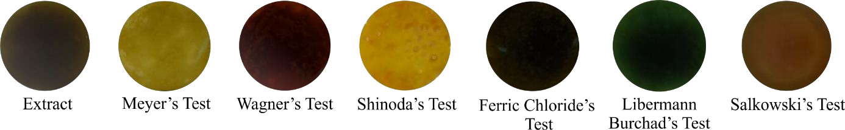
Table 1. Phytochemical Test of Rosmarinus officinalis L.
Class of Compounds | Likeness | Information
Alkaloids (Mayer’s) | white creamy precipitate | +
(Wagner’s) | reddish-brown precipitate | +
Flavonoids | orange colour | +
Phenols | bluish black | +
Steroids | green colour | +
Terpenoids | reddish brown colour | +

Figure 1. Phytochemical Test of Rosmarinus officinalis L.
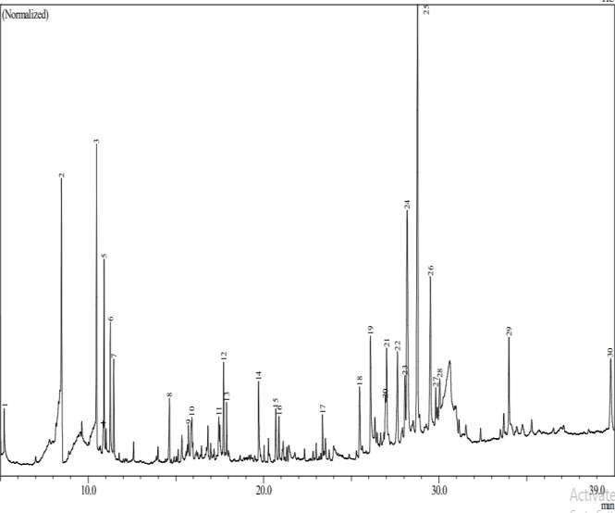
Rosemary is rich in a wide range of bioactive phytochemical compounds, particularly polyphenols, which are known for their beneficial functional properties. The results of GC MS analysis (Figure 2) showed a positive correlation with the results of phytochemicals that have been carried out, where there are flavonoid compounds as the main component in the extract, namely sakuranetin (19.42%), in addition, there are several dominant terpenoid compounds namely isocarnosol (12.70%). alkaloid compounds contained in benzotript extract (2.29%), steroid compounds mely Trimethyl-silylestrone (1.58%), and

Figure 2. GC-MS chromatogram of Acetone extract of rosemary
the extract also contained a variety of essential oils which are generally produced by each aromatic plant. These findings are in agreement with previous studies demonstrating that concentrations of 16.5% polyphenols, 26% flavonoids, and 0.96% sterols in rosemary (Boreddy et al., 2025). Among its most significant active constituents are the lipophilic diterpenes, especially carnosic acid and carnosol, which contribute greatly to its biological activity. Furthermore, rosemary extracts contain various volatile compounds that are responsible for their characteristic flavor, appealing aroma, and distinctive color, making rosemary widely valued in food, pharmaceutical, and nutraceutical applications (Aziz, et al., 2022). Rosemary essential oil (REO) consists of a complex blend of volatile organic compounds (VOCs), primarily oxygenated monoterpenes such as 1,8-cineole, camphor, and borneol. These bioactive constituents are known to possess strong antioxidant and antimicrobial properties (Simić and Ulrih, 2026). In addition, REO has also been identified in rosemary acetone extracts (Table 2), indicating that acetone extraction is capable of recovering not only phenolic compounds but also certain volatile components that contribute to the characteristic biological activity, aroma, and flavor of rosemary.
Table 2. Phytocomponents Identified in Acetone Extract of Rosemary by GC-MS
Peak | IUPAC name | Retention Time | Area  % | Formula | Molecular weight | Chemical structure
2 | eucalyptol | 8.483 | 5.51 | C₁₀H₁₈O | 154 | 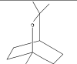
3 | camphor | 10.476 | 6.58 | C₁₀H₁₆O | 152 | 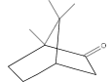
5 | borneol | 10.909 | 4.44 | C₁₀H₁₈O | 154 | 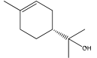
6 | α-terpineol | 11.258 | 3.33 | C₁₀H₁₈O | 154 | 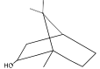
7 | Bicyclo [3.1.1] hept- 3-en-2-one, 4,6,6-  Trimethyl-(1S)- | 11.458 | 2.24 | C₁₀H₁₄O | 150 | 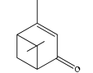
8 | trans-β- caryophllene | 14.633 | 1.28 | C₁₀H₁₄O | 150 | 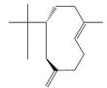
9 | Phenol, 3,5- bis(1,1- dimethylethyl) | 15.722 | 0.62 | C14H22O | 206 | 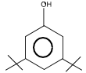
10 | d-Cadinene | 15.910 | 1.20 | C15H24 | 204 | 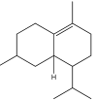
11 | Methyl jasmonate | 17.452 | 0.84 | C13H20O3 | 224 | 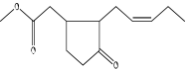
12 | 3-methyl-5-(2,6,6- trimethyl-1- cyclohexen-1-yl)-  1-pentyn-3-ol | 17.718 | 2.20 | C15H24O | 220 | 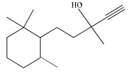
13 | Caryophyllene oxide | 17.894 | 1.25 | C15H24O | 220 | 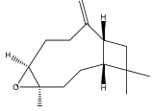
14 | neophytadien | 19.717 | 2.19 | C20H38 | 278 | 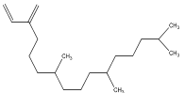
15 | Clovane diol | 20.695 | 1.77 | C15H26O2 | 238 | 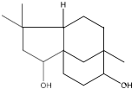
16 | Palmitic acid | 20.878 | 1.08 | C17H34O2 | 270 | 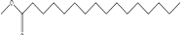
17 | Oleic acid ester | 23.363 | 1.27 | C19H36O2 | 296 | 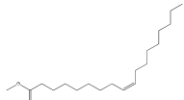
18 | benzotript | 25.474 | 2.29 | C18H15ClN2O3 | 342 | 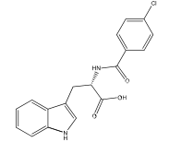
19 | S-(tert-butyl) 3-  {[tert-butyl(diphe nyl)silyl]oxy}-4- hexenethioate | 26.099 | 4.08 | C26H36O2SSi | 440 | 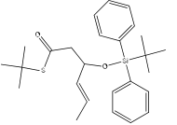
20 | Trimethyl- silylestrone | 26.933 | 1.58 | C21H30O2Si | 342 | 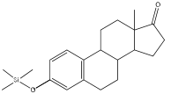
21 | Abieta-9(11),8(14),  12-trien-12-ol | 27.017 | 3.31 | C20H30O | 286 | 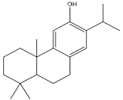
22 | Hinokione | 27.635 | 2.64 | C20H28O2 | 300 | 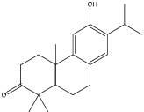
24 | Isocarnosol | 28.187 | 12.70 | C20H26O4 | 330 | 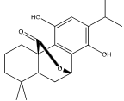
25 | Sakuranetin | 28.774 | 19.42 | C16H14O5 | 286 | 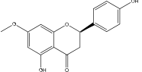
26 | Carnosol | 29.511 | 5.78 | C20H26O4 | 330 | 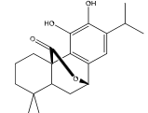
27 | p-Benzoquinone, 2,5-bis(1,1,3,3-  tetramethylbutyl)- | 29.814 | 1.10 | C22H36O2 | 332 | 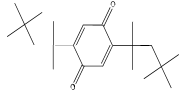
28 | Totarol | 30.038 | 1.07 | C20H30O | 286 | 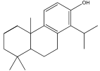
29 | Squalene | 33.987 | 2.86 | C30H50 | 410 | 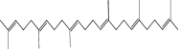
30 | α-tocopherol | 39.787 | 3.63 | C29H50O2 | 430 | 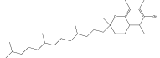

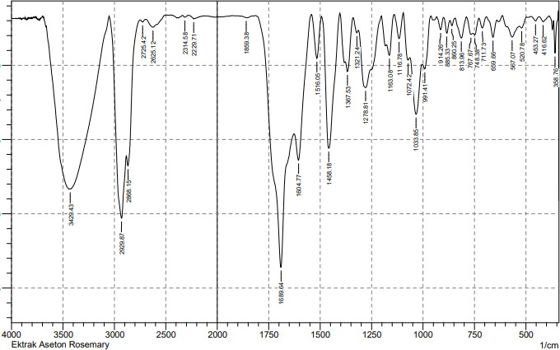
FTIR analysis is very instrumental in identifying the functional groups of compounds contained in the extract, as the reading of the functional groups is based on the peak absorption of the generated wave numbers. The functional groups contained in the acetone rosemary extract (Figure 3) include N-H (3429 cm⁻¹), C=Caromatik (1606 cm⁻¹), C=O (1689 cm⁻¹), C=Colefin (1516 cm⁻¹), C-O (1033 cm⁻¹), CH3 (1458 cm⁻¹), and CH2 (1367 cm⁻¹). According to Meyer, et al., (1982), the toxicity test is one of the

Figure 3. FTIR analysis of Rosmarinus officinalis L.
preliminary tests of anticancer activity, so this test is very necessary. Based on probit analysis of mortality (Table 3), an LC₅₀ value of 0.061 μg/mL was classified as very toxic. This result is due to sakuranetin which is the dominant compound of this extract, reported to be very active in inhibiting HCT-116 cancer cells (Park, et al., 2013). Besides, it is positively correlated with studies reported by Bourhia, et al., (2019) where rosemary extracts show antiproliferative activity against prostate cancer cells (LNCaP) with IC₅₀ 14.14-15.04 μg/mL. Carnosol was identified as one of the major compounds present in the acetone extract of Rosemary. This compound is well recognized for its anticancer activity and has been reported to exhibit significant chemopreventive and cytotoxic properties. Generally, the natural abundance of carnosol in rosemary ranges from approximately 0.5–2% (Wasnik, et al., 2025); however, the acetone extract analyzed in this study demonstrated a considerably higher carnosol content of 5.78%, indicating the potential effectiveness of acetone as a solvent for enriching bioactive anticancer constituents from rosemary. The anti-cancer activity of Rosemary works through various mechanisms, such as promoting DNA fragmentation, triggering apoptosis, suppressing astrocyte-upregulated gene-1 expression, and blocking cell cycle progression at the G1 phase (Farhadi, et al., 2022). The ethnopharmacological effects of rosemary are believed to include anticancer activity, particularly the inhibitory effects of its active compounds on the proliferation of endothelial cells and cancer cells (Shimira, el al., 2022). Carnosol exhibits significant antitumor activity through multiple mechanisms of action, including the induction of apoptosis, generation of reactive oxygen species (ROS), suppression of the AKT/mTOR and STAT3 signaling pathways, inhibition of angiogenesis, and modulation of epigenetic processes. Its anticancer potential has been supported by various experimental studies involving cancer cell lines such as breast, liver, and colon cancers, as well as mouse xenograft models and molecular docking analyses (Arajyan, et al., 2025). In addition, compounds isolated from rosemary extract such as carnosic acid, carnosol, rosmanol, rosmarinic acid, and ursolic acid have anticancer activity (Lešnik, et al., 2021).
Table 3. Result of Cytotoxicity Test Rosemary Using BSLT Method
 |  |  | Replica 1 |  | Replica 2 |  | Replica 3
Sample | Concentration (µg/mL) | Log Cons | Life | Death | Life | Death | Life | Death | %Mortality | Probit | LC₅₀
 | 1000 | -1 | 0 | 10 | 0 | 10 | 0 | 10 | 97 | 6.88 | 0.061
Acetone Extract | 100 | 0 | 0 | 10 | 0 | 10 | 1 | 9 | 93 | 6,48 | 0.061
Acetone Extract | 10 | 1 | 0 | 10 | 0 | 10 | 1 | 9 | 93 | 6,48 | 0.061
Acetone Extract | 1 | 2 | 0 | 10 | 2 | 8 | 1 | 9 | 87 | 6,13 | 0.061
Acetone Extract | 0,1 | 3 | 7 | 3 | 6 | 4 | 6 | 4 | 33 | 4,56 | 0.061

This study has several limitations that should be considered. The findings obtained are still preliminary and require further comprehensive investigation to validate the biological potential of the semi-polar acetone extract. In particular, additional analyses, such as in vitro assays against various targeted cancer cell lines, are necessary to better evaluate its anticancer activity and underlying mechanisms of action. Furthermore, a deeper exploration of the semi-polar acetone extract is needed to identify and characterize its active compounds, as well as to determine their efficacy, selectivity, and potential therapeutic applications.

4. Conclusion

The results of the toxicity test on the acetone extract of Rosmarinus officinalis L. (rosemary) were classified as highly active, with an LC₅₀ value of 0.061 μg/mL; the compounds believed to be responsible for this activity are phenolics, flavonoids, terpenoids, and essential oils, based on the results of phytochemical and FTIR analyses. GCMS results indicate that the compounds sakuretin and isocornasol are the dominant compounds present in the rosemary acetone extract.

Disclaimer (Artificial intelligence)

Author(s) hereby declare that NO generative AI technologies such as Large Language Models (ChatGPT, COPILOT, etc.) and text-to-image generators have been used during the writing or editing of this manuscript.

References

- Alwadkar, F., Salmani, A., Deshmukh, A., Farhat, P., Salmani, T. & Yerunkar, R. (2024). The Alchemy of Rosemary from Herb Garden to Apothecary: A. Comprehensive Pharmaceutical Review. International Journal of Pharmaceutical Sciences, 2(2), 3382-3394.
- Arajyan, G., Sargsyan, S., Hovsepyan, V., Pahutyan, N., Navoyah, Q., Shahinyan, M., Melyan, G. & Gabrielyan, I. (2025). Functional food applications of Rosmarinus officinalis: Antioxidant, anti-inflammatory, and metabolic kealth perspectives. Fuctional Food Science, 5(10), 496-512.
- Aziz, E., Batool, R., Akhtar, W., Shahzad, T., Malik, A., Shah, M. A., Iqbal, S., Rauf, A., Zengin, G., Bouyahya, A., Rebezov, M., Dutta, N., Khan, M. U., Khayrullin, M., Babaeva, M., Goncharov, A., Shariati, M. A. & Thiruvengadam. (2022). Rosemary species: a review of phytochemicals, bioactivities and industrial applications. South African Journal of Botany, 151: 3-18.
- Banjaw, D, T., Megersa, H. G., Abewoy, D., Lema, D. T. (2024). Rosemary Recent Classification, Plant Characteristics, Economi Parts, Marketing, Uses, Chemical Composition and Cultivation. International Journal of Scientific Research and Engineering Development, 7(1), 157-165.
- Boreddy, A., Bhuvaneshwari, J. & Srinivas, DR. U. (2025). Physico-Chemical Screening of Rosmarinus officinalis L. International Journal for Research Trend and Innovation, 10(10), 421-438.
- Bourhia, M., Laasri, F. E., Aourik, H., Boukhris, A., Ullah, R., Bari, A., Ali, S. S., El-Mzibri, M., Benbacer, L. & Gmouh, S. (2019). Antioxidant and Antiproliferative Activities of Bioactive Compounds Contained in Rosmarinus officinalis Used in the Mediterranean Diet Evidence-Based Complementary and Alternative Medicine, 1:1–7
- Clarkson, C., Maharaj, V. J., Crouch, N. R., Grace, O. M., Pillay, P., Matsabisa, M. G., Bhagwandin, N., Smith, P. J. & Folb, P. I. (2004). In vitro antiplasmodial activity of medicinal plants native to or naturalised in South Africa. Journal of Ethnopharmacology, 92:177–91.
- Farhadi, F., Rahimi, V. B., Mohamadi, N. & Askari, V. R. A. (2022). Effects of rosmarinic acid, carnosic acid, rosmanol, carnosol, and ursolic acid on the pathogenesis of respiratory diseases. IUBMB Journals, 39(3), 478-501.
- Fotedar, S. (2024). A systematic Review on Therapeutic & Cosmetic Uses of Rosemary. International Journal of Research Culture Society, 8(2):85-90.
- Grigore-Gurgu, L., Dumitraşcu, L. & Aprodu, I. (2025). Aromatic Herbs as a Source of Bioactive Compounds: An Overview of Their Antioxidant Capacity, Antimicrobial Activity, and Major Applications. Molecules, 30:1304.
- Hashim, A., Fatima, F. & Malave, P. (2025). Therapeutic Potential of Rosemary: Bridging Traditional Uses and Modern Applications. Biotechnology Journal International, 29(4), 1-13.
- Lešnik S, Furlan V, Bren U (2021) Rosemary (Rosmarinus officinalis L.): extraction techniques, analytical methods and health-promoting biological effects. Phytochem Rev, 20:1273–1328
- Meyer, B., Ferrigni, N., Putnam, J., Jacobsen, L., Nichols, D. & McLaughlin, J. (1982). Brine Shrimp: A Convenient General Bioassay for Active Plant Constituents. Planta Med, 45:31-4.
- Meziane, H., Zraibi, L., Albusayr, R., Bitari, A., Oussaid, A., Hammouti, B. &Touzani, R. (2025). Rosmarinus officinalis Linn: Unveiling its Multifaceted Nature in Nutrition, Diverse Applications, and Advanced Extraction Methods. Journal of Umm Al-Qura University for Applied Sciences, 11:9-37.
- Park, J. H., Fu, Y. Y., Chung, I. S., Hahn, T. R. & Cho, M. H. (2013). Cytotoxic property of ultraviolet- induced rice phytoalexins to human colon carcinoma HCT-116 cells. J Korean Soc Appl Biol Chem, 56:237–41.
- Shankar, A., Ali, A., Abdulla, H. M., Balaji, J., Kaur, J., Saeed, F., Wasiq, M., Imran, A., Jibraeel, H., Raheem, M. S., Aslam, A., Afzaal, M., Ahmed, A., Raza, A. & Islam, F. (2024). Nutritional C composition, phytochemical profile, therapeutic potentials, and food applications of rosemary: A comprehensive review. Journal of Food Composition and Analysis, 135:106688.
- Shimira, F., Zahid, G. & Nyirahabimana, F. (2022). An Overview and Renewed Emphasis on Ethnopharmacology of Rosemary (Salvia Rosmarinus). Curr. Pers. MAPs, 5(1), 74-85.
- Simić, P. & Ulrih, N. P. (2026). Rosemary Essential Oil as a Natural Additive in Food Industry: Recent Developments in Encapsulation Techniques. Foods, 15:893.
- Singletary, K. (2016). Rosemary An Overview of Potential Health Benefits. Nutrition Today, 51(2),102-112.
- Veenstra, J. P. & Johnson, J. J. (2021). Rosemary (Salvia rosmarinus): Health-Promoting Benefits and Food Preservative Properties. International Journal of Nutrition, 6(4), 1-10.
- Wasnik, A., Mayekar, C., Nangude, M., Yadav, S. & Thange, A. (2025). Unveilling The Therapeutic Potential of Rosmarinus officinalis (Rosemary)- A review on Pharmacological Spectrum. International Journal of Pharmaceutical Sciences, 3(1), 80-93.

