Review Article
3D Printing Technologies for Cosmetic Delivery Systems: A Review of Skin Patches and Microneedles
Abstract
The skin acts as a protective barrier that significantly limits the penetration of active ingredients from topical formulations, resulting in low bioavailability. Conventional cosmetic delivery systems often fail to efficiently deliver actives across the stratum corneum, highlighting the need for advanced approaches. In recent years, 3D printing (additive manufacturing) has emerged as a promising strategy for developing personalized and efficient skin delivery platforms.
This review summarizes recent advancements in 3D printing technologies, including fused deposition modeling (FDM), stereolithography (SLA), and inkjet printing, for the fabrication of cosmetic delivery systems such as skin patches and microneedles. Evidence from recent studies indicates that these technologies enable precise control over formulation design, customizable drug loading, and improved penetration of both hydrophilic and lipophilic actives. Microneedle-based systems, in particular, enhance delivery by bypassing the stratum corneum, while 3D printed patches provide controlled and sustained release.
Despite these advantages, challenges such as material limitations, scalability, and regulatory considerations persist. Overall, 3D printing offers significant potential to transform cosmetic product development by enabling personalized and effective delivery systems, although further research is required to support its widespread application.
Keywords: Personalized skin care, additive manufacturing, stereolithography, fused deposition model, microneedle, and skin patch.

Introduction
The skin is the largest part of the body, covering an extensive expanse of approximately 1.7 square meters. It represents about 16% of an average person's total body mass. It primarily act as a protective barrier against microbes, UV rays, chemicals, allergen, and water loss. It has three main layers: the epidermis(outer layer with stratum corneum), the dermis (middle supportive layer), and the hypodermis (inner fatty layer for insulation)(Herskovitz et al., 2016; Richardson, 2003) These three layers work in coordination to maintain the structural integrity and physiological functions of the skin, enabling it to effectively interact with and protect against the external environment.
Among these layers, the outermost region of the epidermis, known as the stratum corneum (SC), plays a crucial role in regulating the penetration of substances into the skin. It functions as a highly effective barrier, preventing the penetration of physical, chemical, and microbial substances into the skin(Bouwstra et al., 2023). While this barrier is essential for protection, it significantly restricts the penetration of cosmetic active ingredients (actives) into the deeper layers of the skin. As a result, the penetration of actives from conventional topical formulations is generally inefficient, leading to low bioavailability, often reported to be less than 2% of the applied dose. The stratum corneum acts as a formidable barrier, compromises the dermal delivery of these actives. This limits the effectiveness of topical formulations in delivering these ingredients to their intended targets. This low bioavailability is primarily due to the skin’s inherent protective mechanisms, which are designed to minimize the entry of foreign substances. (Mian et al., 2019)
Caffeine is a well-researched active ingredient in both cosmetic and pharmaceutical application and is commonly used as a representative hydrophilic compound in skin toxicology studies. For example, a review of topical caffeine formulations reported that conventional ointments achieved a maximum skin penetration of only 0.0062%, further emphasizing the limitations of traditional delivery systems.(Luo & Lane, 2015)
It is important to distinguish between cosmetic and pharmaceutical applications in the context of skin delivery systems. Cosmetics are primarily intended for topical application to cleanse, beautify, or enhance appearance without exerting therapeutic effects, whereas pharmaceutical products are designed to diagnose, treat, or prevent diseases through a defined pharmacological action(Pandey et al., 2026). However, with the advancement of active ingredient–based formulations, the boundary between cosmetics and drugs has become increasingly blurred, particularly in products claiming functional benefits such as anti-aging or anti-acne effects. Therefore, careful consideration is required when discussing delivery systems to avoid overgeneralization and to ensure appropriate classification based on intended use and mechanism of action.
Therefore, optimizing the dermal delivery of active ingredients has become a key area of research. To overcome the skin barrier, researchers have developed multiple strategies, ranging from passive techniques like chemical enhancers and supersaturation to to sophisticated systems like liposomes, niosomes, transferosomes and lipid nanoparticle(Bakhrushina et al., 2025). In addition, physical enhancement techniques such as microneedle arrays have gained attention for their ability to bypass the stratum corneum.
In this context, emerging technologies like 3D printing (additive manufacturing) have attracted significant interest as innovative platforms for developing advanced and personalized skin delivery systems. These technologies enable precise control over formulation design, geometry, and drug distribution, offering improved delivery efficiency and customization potential. Recently, the use of 3D printed platforms as carriers has been explored as a promising, patient-centric approach for enhancing dermal delivery(Lunter et al., 2024)
This review aims to critically evaluate recent advancements in 3D printing technologies for cosmetic API delivery, with a focus on skin patches and microneedle systems. It also highlights current challenges, research gaps, and future directions in personalized cosmetic formulations.
The development of Additive Manufacturing (AM), or 3D printing, has streamlined the production of microneedles by allowing the entire fabrication process to be carried out in a single step Figure No. 1. Designing the desired dimensions and shape is done using Computer-Aided Design (CAD) software, followed by fabrication. 3D printing offers not only simplicity but also pliability, allowing for easy modifications to designs using computer software. It has the power to transform personalized treatment by enabling the production of pharmaceutical formulations tailored to individual patient characteristics, including customized drug doses. 3D printed arrays have the capability to deliver multiple active ingredients simultaneously, with dosages specific to each individual. While various 3D printing techniques are used in pharmaceutics, stereolithography (SLA) shows promise for its precision. However, further research is needed to fully explore SLA for fabricating 3D printed microneedles.(Jiao et al., 2022)

Digital –to- physical cosmetic mapping
Figure 1: Digital –to- physical cosmetic mapping
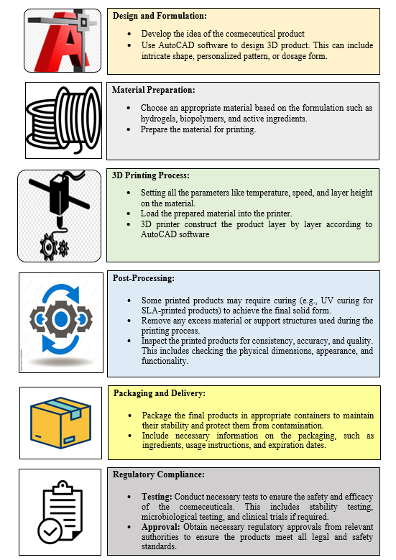

Types of 3D printing technology with their application in cosmetics
For printing skin delivery platforms, there are two dominant 3D printing technologies: FDM and SLA. Recent studies has also inspect the application of Digital Light Processing (DLP) and Two Photon Polymerization (TPP) techniques. Additionally, Inkjet Printing is utilized during post-platform fabrication processes to incorporate active ingredients into the platforms.(Lakkala et al., 2023)
Ink jet printing
Inkjet printing technique to personalized medicine comes from the same technique of computer – operated inkjet printing. It is also a form of additive manufacturing where ink is replaced with pharmaceutical solutions containing drugs. Small drops are sprayed in a level- by – level manner on a suitable substrate that finally solidifies into the solid dosage form. Inkjet printing methods primarily categorized into two techniques as shown in Figure No. 2– Continuous inkjet printing (CIJ) and Drop on demand (DOD).(Carou‐Senra et al., 2024)
Figure 2: Classification of inkjet printing

Continuous inkjet printing
As the term suggests, continuous inkjet printers operate by emitting a nonstop stream of ink droplets onto the printing surface at high speed, regardless of whether all the droplets are required. In the flow of ink, the pressure wave is initiated which results in the breakup of the ink into uniformly sized droplets, and then with the help of nozzles, these droplets are ejected out.
Uncharged drops are sent out again and liquid reutilized. Charged drops pass through an electric field between deflector plates on the substrates. It features rapid, uninterrupted formation of ink droplets, which helps prevent the nozzle from getting clogged.
As a continuous flow of ink is used at high speed, this technology causes a high degree of wastage of inks. In Continuous inkjet systems, any excess ink that isn’t used during printing is captured and sent back to the reservoir for reuse, whereas in drop-on- demand printing, the print head releases ink only at the exact moments it is required.
Drop on demand inkjet printing
Drop on demand divides into two technologies, one that utilizing heat (Thermal drop on demand) and those utilizing piezoelectricity (Piezoelectric drop on demand). In drop on demand, the ink comes out of the nozzle if there is a requirement of ink.
Thermal drop on demand printing
Thermal inkjet printing uses a heating element and this heating element produces heat to vaporize the ink and this vaporization creates a bubble. When the bubble expands it forces the ink out of the nozzle.
Piezoelectric drop on demand printing
Piezoelectric inkjet printing utilizes a small crystal situated at the rear of the ink reservoir in nozzle. Electrical current is applied to the crystal that makes the crystal vibrate. When the crystal vibrates it expands and pushes the ink through the nozzle and when the crystal shrinks, it drags more ink from the reservoir.(Varghese et al., 2022)
Application
Polymeric microneedle patches for transdermal insulin delivery were fabricated in this study using stereolithography, a 3D printing technique. The process involved using a biocompatible resin to construct microneedle designs in the shape of pyramids and cones, followed by the application of insulin formulations using inkjet printing. Trehalose, mannitol, and xylitol were employed as carrier agents to help preserve insulin’s structure and stability, while also supporting its quick release. Assessment using circular dichroism and Raman spectroscopy showed that each carrier maintained insulin in its native state, with xylitol exhibiting the best overall performance. In vitro Franz cell release studies conducted on porcine skin demonstrated rapid release of insulin within a span of 30 minutes, regardless of the specific microneedle design. This research underscores the effectiveness of 3D printing as a scalable and biocompatible approach for producing microneedle patches.(Pere et al., 2018)
Fused Deposition Modelling-
Fused deposition modeling, also known as fused filament fabrication (FFF) or filament freeform fabrication works on an “additive” principle by putting down material in layers. It produces a part by using a continuous filament of a thermoplastic material. In this beads of heated plastic are used instead of ink, and these beads are released from the print head and build the object.
It contains a printer platform, a printer head (nozzle), and the raw material in the form of the filament.
Printer platform- The print platform is a bed that is made up of metal, ceramic or hard plastic, and each continuous layer is set down on this platform.
Nozzle / Print Head – An extruder is made up of two main sections: a cold end and a hot end. The cold end draws filament from the spool, with its movement regulated by a stepper motor that controls the feed rate. This material is then guided into the hot end, which contains a heating zone and a nozzle. Inside the heating zone, the material is melted into a flowable state. It is then forced through the nozzle, where it is deposited as a fine, semi-molten strand that sticks to the surface beneath it. The printing resolution in fused filament fabrication (FFF) is largely determined by the nozzle size and the layer height. Various nozzle types are available, and the choice depends on the specific material being used for printing.
The raw material- Any thermoplastic material can be used as raw material for FDM printer. When exposed to heat, the thermoplastic material can melt again and again and be resolidified when the heat is withdrawn. A large variety of filament materials are extruded.(Dhinakaran et al., 2020)
Working process-
Figure 3: Workflow of Fused Deposition Model
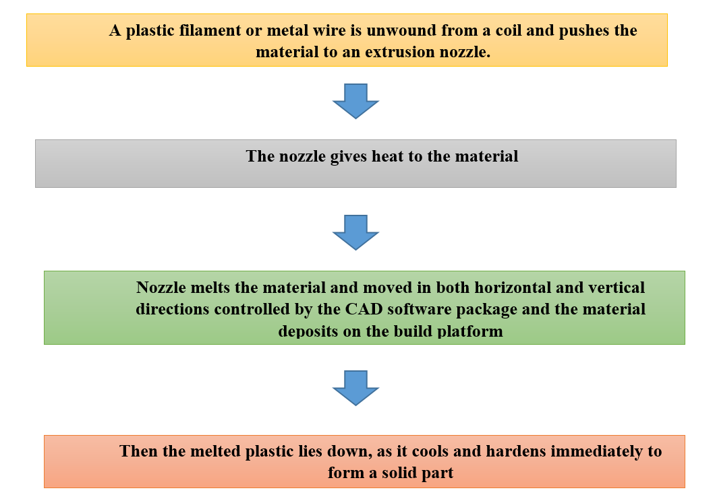

Application
- Stevic et al studied about the application of 3D printing (3DP) technology for the development of customized lipstick products. The study explored to assess the viability of using commercially available 3D scanning and printing equipment to devise personalized lipstick applicators. To capture accurate lip data, a lip scan was performed, generating digital profiles of the lips. These profiles were then utilized to create a digital representation of the lips was designed using Autodesk 3ds Max, a software tool for 3D computer graphics. For the production of personalized lipstick applicators, three essential elements were considered: a lipstick mould, base, and cap. To determine the most appropraite 3D printing technique for manufacturing personalized lipsticks, the three applicator components were created using both stereolithography (SLA) and fused deposition modeling (FDM) printers.(Stevic, 2017)
- Goyanes et al studied about acne, a common inflammatory skin condition, is known for its multifactorial nature. This study investigated the use of 3D printing to create personalized, adaptable anti-acne drug devices incorporating salicylic acid. Two different 3D printing technologies, Fused Deposition Modeling (FDM) and Stereolithography (SLA), were used to evaulate their potential in creating such devices. The process involved utilizing 3D scanning technology to capture the individual's nose morphology and generate a personalized 3D model.(Goyanes et al., 2016)
- Wang et al This study presents a pioneering approach in the field of acne treatment through the development of a customized 3D printed niosomal hydrogel (NH) loaded with CPT (a drug for acne). Unlike conventional acne treatment products like facemasks, which lack personalization and tailored medication dosing, 3D-printed drug delivery systems offer individualized solutions. Employing 3D Printed hydrogels for acne therapy provides unique benefits that are rarely highlighted in conventional studies: (i) the ability to tailor drug doses according to individual needs; (ii) customization of hydrogel size, thickness, or area to target specific acne symptoms; and (iii) a simplified drug loading process. This innovative approach highlights unique features that set it apart from existing literature.(Wang et al., 2020)
- In research conducted by Wu et al., a novel method was utilized to create a microneedle patch system designed for minimally invasive, glucose-responsive insulin delivery in the management of diabetes. The technique combined material extrusion 3D printing with post-stretching processes. The produced microneedle patch featured a 6 × 6 array of microneedles, where insulin release occurred exclusively from the microneedles in response to glucose. Importantly, the microneedles showed adequate mechanical strength to pierce the skin of mice and successfully delivered insulin in a glucose-dependent manner, both in glucose solutions and in type 1 diabetic mice. This study introduces a promising fabrication method for microneedle patch systems that hold potential for transdermal systems applications in the future.(M. Wu et al., 2020)
Stereolithography (SLA)
SLA is the most extensively researched photopolymerisation technology for creating skin delivery platforms. Stereolithography is the technique in which the liquid polymer or resin solidifies by a CNC laser or automated laser systems. There is a surface of the photopolymer vat where the UV laser will draw a pre-programmed design or shape. It is not a quick process because it takes 6 to 12 hours or for a large object, it takes several days. This technique fabricates nearly any design so it can be of big-budget.(Huang et al., 2020)

Working process-
Figure 4: Workflow of Stereolithography
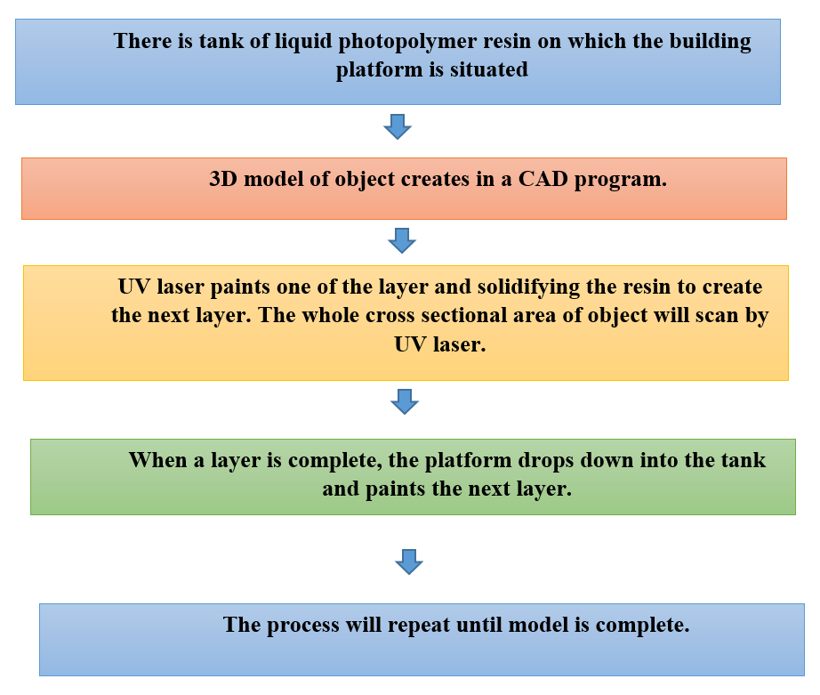

Application
Microneedle arrays for transdermal insulin administration were effectively produced using a biocompatible resin through stereolithography (SLA), with design optimization carried out to improve their ability to penetrate the skin. The microneedles were constructed by polymerizing successive layers of a light sensitive polymer resin. To facilitate insulin delivery, thin layers of insulin and carriers such as sugar alcohols or disaccharides were selectively deposited on the microneedle surface using inkjet printing. By refining the printing parameters, the fabricated microneedles showed improved ability to penetrate the skin compared to conventional metal arrays, requiring only low insertion forces in the range of 2–5 N. Additionally, micro-CT imaging verified that the coated films remained firmly attached to the microneedle surface even after insertion into the skin. In vivo animal trials demonstrated rapid insulin action, effective hypoglycemia control, and lower glucose levels achieved within 60 minutes. Additionally, steady-state plasma glucose levels were maintained over a 4-hour period compared to subcutaneous injections. These findings underscore the significant potential of 3D printed microneedle arrays in enabling efficient and precise transdermal insulin delivery, leading to improved therapeutic outcomes in diabetes management.(Economidou et al., 2019)
Published Research on 3D Printing for Cosmetic API Delivery System
Recent research in 3D printing technology have widened new chances in the cosmetic field, mostly for delivering APIs. Advancements in this area aim to make cosmetic products customizable and effective using 3D printing technology. Table 1 shows about some skin treatment, API used and their 3D printing method.
Table 1: Skin treatment, API used and their 3D printing method
Skin Treatment Effects | API | 3D Printing Method | Reference
Skin Rejuvenation | Retinol | Stereolithography | (Islam et al., 2023)
Anti-acne | Salicylic acid | Fused Deposition Model (FDM) | (Goyanes et al., 2016)
Anti-aging | Acetyl-hexapeptide 3 (AHP-3) | Digital Light Processing (DLP) | (Lim et al., 2021)
Skin hydration and firming | Hyaluronic acid | Fused Deposition Model (FDM) | (Antezana et al., 2022)
Skin whitening | Hydroquinone | Stereolithography | (Jiao et al., 2022)

Advanced 3D Printed Delivery Platforms
Skin patches and microneedles- based delivery system, both 3D printed platforms, have gained attention for their potential in delivering cosmetic and pharmaceutical products to the skin. They aim to make skin delivery more effective and convenient. In this section, we'll explore developments in both skin patches and microneedles.(Nazary Abrbekoh et al., 2022)
Skin Patches
Skin patches are a common and well-researched method for delivering active substances to the skin. They have been utilized for many years to address skin issues and enable transdermal delivery. Recent investigations have primarily concentrated on conventional skin patches, examining elements such as their active components, materials, methods to improve delivery, ways to analyze them, and their outcomes.
Figure 5: Skin Patch
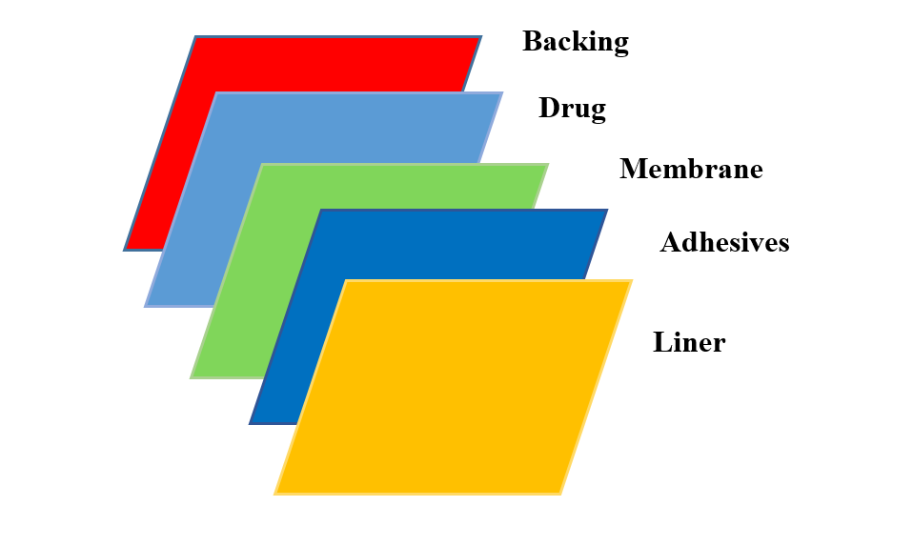

Common techniques for making skin patches include using solvents, hydrogels, and hot melt processes. These patches as shown in Figure No. 5 securely to the skin and may be designed either with or without additional adhesive support. The adhesive qualities of these patches have a significant impact on how effectively they deliver active ingredients. They create a continuous seal, which helps active ingredients penetrate the skin more effectively by assisting their diffusion.
Overall, skin patches have attracted widespread attention thanks to their ability to effectively and flexibly deliver active ingredients. By forming a continuous seal on the skin, they enhance the penetration of these ingredients, ultimately improving their effectiveness in addressing various skin conditions and facilitating transdermal delivery.
Cosmetic patches seem promising for dealing with common beauty issues like wrinkles, pigmentation problems, and signs of aging on your skin. However, regular patches have a problem: they can't hold and release enough of the good stuff that helps your skin. When we use patch-like things to put medicine on our skin, the medicine has to get out of the patch, go through the top skin layer, and sometimes it gets stuck there like tiny crystals, which can slow things down. Skin patches face a challenge because the way active ingredients spread can be inconsistent. It varies from person to person based on factors like how hydrated your skin is, your age, and your ethnicity. The skin’s outermost layer, known as stratum corneum, serves as a protective shield that can hinder the rate at which substances spread. Additionally, the effectiveness of delivering active ingredients depends on the unique characteristics of each specific ingredient. Material used in skin patch are shown in table 2.
Traditional adhesive patches usually have multiple layers and are classified based on where the drug or active ingredient is placed within these layers. This requires a multi-step manufacturing process. On the other hand, 3D printed patches are often made from a single layer and a single material, although it's possible to print them with multiple layers. Scientists have been investigating the application of 3D printed mesh or grid patches that contain drugs, either for inserting into tissues or offering support for organs.(Mohammed et al., 2021; Wong et al., 2023)
\Materials used in 3D Printed Skin Patch
Table 2: Material used in skin patch
Skin Patch
Material used | Method | Finding
Polycaprolactone (PCL), thermoplastic polyurethane and polylactic acid | FDM and SLA | Development of anti-acne cosmetic patch formulated with salicylic acid. FDM was not suitable as it cause degradation of salicylic acid. SLA method was adaptable
Lignin and PLA | Modified Hot melt extrusion FDM | Fabrication of hydrogel-based patches intended for wound care appliaction. This was adaptable and has the potential to carry high drug loading.
Chitosan-modifies nano-silica particle. | Direct Ink Writing (DIW) | Production of emulsion-based cosmetic patch.
Polylactic acid/phycocyanin-alginate | Casting | Production of spirulina extract was used for cosmetic patch with excellent adaptability.

Advancements in 3D printed patch platforms are an exciting and evolving area of study, with the potential to enhance current designs and transform the world of skin delivery systems.
Microneedles
Microneedles (MNs) combine aspects of both skin based drug delivery (patches) and hypodermic needles. They bring several advantages, including easy application, very little interfering, and effective delivery of active ingredients. A tiny needle-like structures integrated into a patch, known as a microneedle patch (MNP), which makes them easy to use. Compare to conventional patches and topical formulation, MNs offer greater versatility and deliver active ingredients more effectively deeper into the skin.(Waghule et al., 2019)
Instead of relying on passive diffusion, microneedles work by actively creating tiny opening in the skin’s outer layer (epidermis) and, when designed appropriately, can reach the deeper layer (dermis), forming tiny channels. These micro-punctures successfully bypass the skin's natural barrier, offering a painless and minimally invasive method to enhance the delivery of drugs or cosmetic products. Some advanced microneedles also double as wearable therapeutic devices for monitoring in real-time.(Tuan-Mahmood et al., 2013) Classification of 3D printed microneedles are shown in table 3.
Table3: Classification of 3D Printed Microneedles.
Types of Microneedle | Definition | Material used in Microneedle
Solid MNs | These are meant to applied drug topically. These are utilized to make microchannels in the skin. They solidly built, painless and simple in design. | Polylactic acid (PLA), Polycaprolactone (PCL), Polyglycolic acid (PGA)
Coated MNs | These have a coating of drug on MNs surface. Coatings are designed to dissolve once inserted into the skin, allowing the drug to be released. | poly(lactic-co-glycolic acid) (PLGA), polyvinyl alcohol (PVA), and polyethylene glycol, stainless steel
Dissolving MNs | These MNs are made up of biodegradable polymers that contains drug and dissolve thoroughly in the skin, delivering the drug they carry. | Gelatin, polylactico-glycolic acid (PLGA), Polyvinylpyrrolidone (PVA)
Hollow MNs | These MNs feature hollow channels that enable the direct delivery of liquid drugs into the skin. | Silicon, Glass
Swellable MNs | When these MNs comes in contact with skin moisture, they swell up and permits controlled and sustained drug release. | Polyethylene glycol, carboxymethyl cellulose (CMC), hyaluronic acid.

In a recent inclusive review, researchers have investigated the ability of microneedles (MNs) in cosmetic area. They have grouped these studies based on the distinct skin issues they aim to address. Additionally, the review delves into the use of 3D printing technology in the production of MN platforms.
The use of 3D printing in MN production can be categorized into three primary methods:
- Development of Master Molds: 3D printing allow for the precise fabrication of master molds. These molds serve as templates for producing MNs using different manufacturing methods.
- Coating Active Ingredients onto Prepared MNs: 3D printing can be employed to coat active ingredients onto MNs that are pre-fabricated. This enhances the functionality of the MNs.
- Printing Complete MN Structures: It is also possible to 3D print the entire MN structures, integrating active ingredients directly during the printing process.
While the domain of 3D printed cosmetic microneedles is relatively new, published research papers and patents have already shown effective delivery of hydrophilic and lipophilic active ingredients using alternative techniques. These findings provide compelling evidence that the use of 3D printing for microneedles in cosmetic applications holds great promise and feasibility.(Park et al., 2022)
Methods of MNs Production
Conventional methods of fabricating microneedles include moulding method, lithography, and centrifugal lithography. Moulding use PLA or PCL into a mould to create microneedles. Lithography fabricate patterns by using light on a photosensitive substrate. Centrifugal lithography uses spinning to create microneedles without UV light. However these conventional methods have some drawbacks like lack of precision required for high quality microneedles, complex method and costly. To address these drawbacks, novel 3D printed technologies have been developed like FDM, SLA, and DLP as shown in table 4. These novel methods permits for more precise, versatile and efficient microneedle that improves drug delivery systems.(Lyu et al., 2023)
Table 4: Difference between conventional and 3D printed method
Conventional MNs Fabrication Method | Moulding Method | Lithography | Centrifugal Lithography
Conventional MNs Fabrication Method | This method creates a shape of MNs using a mould. Materials like drug are incorporated or injected into the mould and permits to knuckle down. | This technique fabricate patterns by using light on a photosensitive substrate. | Centrifugal force is used on viscous polymer dispensed between rotating plates to design MNs.
3D Printed MNs Fabrication Method | FDM | SLA | DLP
3D Printed MNs Fabrication Method | FDM fabricates objects layer by layer by extruding melted thermplastic filament. it is the most widely used because of its feasibility. | A UV laser is employed to solidify liquid resin, constructing the final product layer by layer. | Digital light projector is used to cure on entire layer at once, this speeding in the process.

A study conducted to assess wrinkle reduction compared dissolving MNs (DMNs) to a standard hyaluronic acid formulation. The results showed that over an eight-week treatment period, MNs were significantly more effective. In addition to enhancing skin delivery through microchannels, MNs have the potential to stimulate the production and deposition of elastin and collagen, thereby encouraging natural skin healing and metabolic activity(Ju et al., 2025).
Although a few studies have explored the production of DMNs through 3D printing, none of them have specifically investigated the utilization of sugar-based biopolymers. The challenge of ensuring these dissolvable polymers are suitable for printing poses significant hurdles, limiting the application of 3D printing techniques for DMN manufacturing, except for micro-molding approaches.(Qureshi & Saleem, 2024)
Quality assessment of 3D Printed Skin Patch and Microneedle
A structured overview of the various features of 3D printed platforms characterization, method and their description is shown in table 5.(Olowe et al., 2022)
Table 5: Quality assessment of 3D Printed Skin Patch and Microneedle
Features | Methods | Description
Morphology and Geometry | Optical Microscopy and SEM | Examine surface morphology and dimensional accuracy, high resolution imaging to inspect surface features.
In vivo imaging techniques | In vivo imaging techniques | Examine practical application and uniformity of microneele arrays on biological surfaces.
Mechanical properties | Mechanical Tester | Measure parameters like puncture force and deformation.
Rheological Properties | Rheometers | Assess flow characteristics and viscoelastic behaviour of printing ink and form stable structure during printing.
pH Evaluation | pH Meter | Evaluate compatability with the pH of human skin to avoid irritation and ensure efficacy of cosmetics product
Filament Polymer | Differential Scanning Calorimetry (DSC) | Measure heat flow associated with phase transitions in polymer.
Degradation and Stability | SEM | Observe changes in microneedle structure over time or analyse porosity and surface defects.
Degradation and Stability | DSC/ X-ray Diffraction | Track material degradation and dissolution pattern.
Degradation and Stability | Transepidermal Water Loss (TEWL) | Evaluate effects of MNs penetration on skin barrier.

Critical Analysis of 3D Printing Technologies in Cosmetic Delivery
While 3D printing has introduced significant advancements in cosmetic and dermatological delivery systems, a critical evaluation of different technologies highlights both their potential and existing limitations.
Among the commonly used techniques, fused deposition modeling (FDM) and stereolithography (SLA) represent two contrasting approaches. FDM is widely preferred due to its cost-effectiveness, ease of operation, and compatibility with a range of thermoplastic polymers. However, its major limitation lies in the high processing temperature required for filament extrusion, which can lead to the degradation of thermosensitive cosmetic actives such as retinoids and certain peptides. In contrast, SLA operates at relatively lower temperatures and offers superior resolution and surface finish, making it more suitable for fabricating intricate structures like microneedles. Nevertheless, SLA is constrained by limited availability of biocompatible resins, potential cytotoxicity concerns, and higher operational costs. Therefore, while FDM may be more suitable for bulk fabrication and simple designs, SLA demonstrates greater applicability in precision-based and sensitive formulations(Chan et al., 2025).
A similar comparison can be drawn between microneedle systems and conventional skin patches. Microneedles provide a minimally invasive approach that actively enhances the delivery of active ingredients by creating microchannels across the stratum corneum. This allows for improved penetration of both hydrophilic and high-molecular-weight compounds, which are otherwise difficult to deliver through passive diffusion. However, challenges such as mechanical strength, reproducibility, patient acceptability, and large-scale manufacturing remain concerns. On the other hand, skin patches offer a non-invasive, user-friendly, and well-established method for topical and transdermal delivery. They are particularly advantageous for sustained release applications but are often limited by poor penetration efficiency and variability in drug diffusion due to differences in skin properties(C. Wu et al., 2024).
From a suitability perspective, the choice of technology depends on the nature of the active ingredient and the intended application. For instance, microneedle-based systems are more appropriate for delivering actives requiring deeper skin penetration or rapid onset of action, whereas patches are better suited for prolonged and controlled release of cosmetic ingredients. Similarly, SLA-based printing is more advantageous for high-precision applications, while FDM remains a practical option for cost-effective and scalable production (Vijayakumar et al., 2026).
Overall, although 3D printing technologies provide innovative solutions for cosmetic delivery, their translation into widespread application requires further optimization in terms of material selection, process standardization, scalability, and regulatory acceptance. A balanced consideration of these factors is essential for selecting the most appropriate technology for specific cosmetic applications (Kazemi & Maralbashi, 2025).
Limitations of 3D Printing in Cosmetic Delivery Systems
Despite its promising potential, 3D printing in cosmetic delivery systems is associated with several limitations. The availability of biocompatible and cosmetically acceptable printable materials remains limited, particularly for sensitive active ingredients. Techniques such as fused deposition modeling involve high processing temperatures, which may lead to degradation of thermolabile compounds. Additionally, many 3D printing methods are time-consuming and face challenges in large-scale production, limiting their industrial applicability. High equipment and material costs, particularly for advanced techniques like stereolithography and digital light processing, further restrict widespread adoption. Variability in printing parameters can affect reproducibility and product consistency, while certain techniques may lack the resolution required for intricate structures such as microneedles. Moreover, the absence of well-established regulatory guidelines and the need for additional post-processing steps add to the complexity of developing and commercializing 3D printed cosmetic products.(Yaneva et al., 2023).
Growth in 3D Bioprinting for Skin and Cosmetics
The future of 3D printing in cosmetics is assured to transform the industry with a new research and applications. Personalization of cosmetic products is one big area of advancement. 3D printing permits the fabrication of tailored skin care and other cosmetics according to an individual skin type, tone to increase the product efficacy and satisfaction by delivery drug. Research in new biocompatible and biodegradable materials will also play an important role in the production of cosmetic product such as microneedle and skin patch.
3D bioprinting has received significant attention from the cosmetic industry for new product testing. Olejnik et al 2022 studied about 3D bioprinting applications for skin, showing its ability for more exact and social testing method(Olejnik et al., 2022). Fossil based fibres are often used in conventional cosmetic facial mask which are not environment friendly. Recently, a biodegradable cosmetic patch was fabricated using environment friendly alternative blend poly (hydroxyalkoanates) and starch by 3D printing technology.
Zhang et al 2021 introduced the idea of “all-purpose ice microneedle” ability of delivering active ingredients and macromolecules to the skin which is difficult to make from conventional method. The micro-molding method was used to fabricate these microneedles. This technique involves freezing water in MN gel formulation. This research overcame the drawbacks of standard 3D printable material, ability to lead to next generation of MNs(Zhang et al., 2021).
Moreover, 3D printing can combine smart technology to print devices that can observe skin conditions in real-time and alter the release of active ingredients. Personalized treatment can be provided by these smart devices. Research and development in this field are likely to continue expanding the possibilities of 3D printing in cosmetics. We can expect more sophisticated and multifunctional cosmetic products that not only enhance beauty but also promote skin health.(Jiao et al., 2022)
Research Gaps and Future Directions
Despite recent advancements, several gaps remain in the application of 3D printing for cosmetic delivery systems. There is limited research specifically focused on cosmetic applications, with most studies derived from pharmaceutical fields. Clinical validation is also lacking, as the majority of studies are based on in vitro or preclinical models. Additionally, issues related to material selection, lack of standardization, and unclear regulatory guidelines continue to hinder progress.
Future research should focus on developing biocompatible printable materials, improving process standardization, and conducting clinical studies to validate safety and efficacy. The integration of advanced technologies such as artificial intelligence and nanotechnology may further enhance the performance and personalization of 3D printed cosmetic systems(Kapoor et al., 2025).
Conclusion
In conclusion, the application of 3D printing technology in the cosmetic industry represents a significant advancement with the potential to transform traditional methods of product development, testing, and delivery. This review critically evaluated recent advancements in 3D printing technologies for cosmetic API delivery, with a particular focus on skin patches and microneedle-based systems, in line with the stated objectives.
The findings indicate that technologies such as fused deposition modeling (FDM), stereolithography (SLA), and inkjet printing enable precise control over formulation design, customizable drug loading, and improved penetration of active ingredients. Among these, microneedle-based systems demonstrate enhanced delivery efficiency by bypassing the stratum corneum, while 3D printed patches provide sustained and targeted release of cosmetic actives. However, challenges related to material limitations, scalability, and regulatory considerations remain critical barriers to their widespread application.
3D printing offers the potential for personalized solutions, addressing several limitations of conventional skin delivery systems. 3D bioprinting also presents new opportunities for ethical and accurate product testing, while the development of eco-friendly materials can help address environmental concerns associated with traditional cosmetic products.
Looking forward, the integration of advanced technologies such as nanotechnology, artificial intelligence, and bioengineering is expected to further enhance the functionality and precision of 3D printed cosmetic delivery systems. Continued research focusing on material innovation, process optimization, and clinical validation will be essential to translate these technologies from experimental stages to real-world applications.
Overall, 3D printing holds strong potential to revolutionize cosmetic delivery by enabling more effective, personalized, and targeted treatment strategies, thereby shaping the future of the cosmetic and dermatological industry.
Disclaimer (Artificial Intelligence)
ChatGPT was used solely for grammar and language correction, and not for data analysis, interpretation, content generation, or development of scientific ideas
Abbreviations:
3D: 3 Dimensional
CAD: Computer- Aided Drug
SC: Stratum Corneum
AM: Additive Manufacturing
SLA: Stereolithography
FFF: fused filament fabrication
FDM: Fused Deposition Model
API: Active Pharmaceutical Ingredients
DLP: Digital Light Processing
AHP-3: Acetyl-hexapeptide 3
PCL: Polycaprolactone
PLA: Polylactic Acid
DIW: Direct Ink Writing
MNP: Microneedle Patch
PCL: Polycaprolactone), Polyglycolic acid (PGA)
PLGA: poly(lactic-co-glycolic acid)
PVA: Polyvinyl alcohol
CMC: Carboxymethyl cellulose
CIJ: Continuous inkjet printing
DOD: Drop on demand
TEWL: Transepidermal Water Loss
SEM: Scanning electron microscope
References
- Antezana, P. E., Municoy, S., Álvarez-Echazú, M. I., Santo-Orihuela, P. L., Catalano, P. N., Al-Tel, T. H., Kadumudi, F. B., Dolatshahi-Pirouz, A., Orive, G., & Desimone, M. F. (2022). The 3D Bioprinted Scaffolds for Wound Healing. Pharmaceutics, 14(2), 464. https://doi.org/10.3390/pharmaceutics14020464
- Bakhrushina, E. O., Shumkova, M. M., Avdonina, Y. V., Ananian, A. A., Babazadeh, M., Pouya, G., Grikh, V. V., Zubareva, I. M., Kosenkova, S. I., Krasnyuk, I. I., & Krasnyuk, I. I. (2025). Transdermal Drug Delivery Systems: Methods for Enhancing Skin Permeability and Their Evaluation. Pharmaceutics, 17(7), 936. https://doi.org/10.3390/pharmaceutics17070936
- Bouwstra, J. A., Nădăban, A., Bras, W., McCabe, C., Bunge, A., & Gooris, G. S. (2023). The skin barrier: An extraordinary interface with an exceptional lipid organization. Progress in Lipid Research, 92, 101252. https://doi.org/10.1016/j.plipres.2023.101252
- Carou‐Senra, P., Rodríguez‐Pombo, L., Awad, A., Basit, A. W., Alvarez‐Lorenzo, C., & Goyanes, A. (2024). Inkjet Printing of Pharmaceuticals. Advanced Materials, 36(11), 2309164. https://doi.org/10.1002/adma.202309164
- Chan, Y. L., Widodo, R. T., Ming, L. C., Khan, A., Abbas, S. A., Ping, N. Y., Sofian, Z. M., & Kanakal, M. M. (2025). Review on 3D Printing Filaments Used in Fused Deposition Modeling Method for Dermatological Preparations. Molecules, 30(11), 2411. https://doi.org/10.3390/molecules30112411
- Dhinakaran, V., Manoj Kumar, K. P., Bupathi Ram, P. M., Ravichandran, M., & Vinayagamoorthy, M. (2020). A review on recent advancements in fused deposition modeling. Materials Today: Proceedings, 27, 752–756. https://doi.org/10.1016/j.matpr.2019.12.036
- Economidou, S. N., Pere, C. P. P., Reid, A., Uddin, Md. J., Windmill, J. F. C., Lamprou, D. A., & Douroumis, D. (2019). 3D printed microneedle patches using stereolithography (SLA) for intradermal insulin delivery. Materials Science and Engineering: C, 102, 743–755. https://doi.org/10.1016/j.msec.2019.04.063
- Goyanes, A., Det-Amornrat, U., Wang, J., Basit, A. W., & Gaisford, S. (2016). 3D scanning and 3D printing as innovative technologies for fabricating personalized topical drug delivery systems. Journal of Controlled Release, 234, 41–48. https://doi.org/10.1016/j.jconrel.2016.05.034
- Herskovitz, I., Macquhae, F., Fox, J. D., & Kirsner, R. S. (2016). Skin movement, wound repair and development of engineered skin. Experimental Dermatology, 25(2), 99–100. https://doi.org/10.1111/exd.12916
- Huang, J., Qin, Q., & Wang, J. (2020). A Review of Stereolithography: Processes and Systems. Processes, 8(9), 1138. https://doi.org/10.3390/pr8091138
- Islam, H., Poly, T. S., Tisha, Z. T., Rahman, S., Naveed, A. I. J., Ahmed, A., Ahmed, S. N., Hassan, J., Uddin, Md. J., & Das, D. B. (2023). 3D Printed Hollow Microneedles for Treating Skin Wrinkles Using Different Anti-Wrinkle Agents: A Possible Futuristic Approach. Cosmetics, 10(2), 41. https://doi.org/10.3390/cosmetics10020041
- Jiao, Y., Stevic, M., Buanz, A., Uddin, M. J., & Tamburic, S. (2022). Current and Prospective Applications of 3D Printing in Cosmetics: A Literature Review. Cosmetics, 9(6), 115. https://doi.org/10.3390/cosmetics9060115
- Ju, H. J., Kim, J. Y., Jeong, D. H., Lee, M.-S., Kim, G. M., Bae, J. M., & Lee, J. H. (2025). Additional Use of Hyaluronic Acid-Based Dissolving Microneedle Patches to Treat Psoriatic Plaques: A Randomized Controlled Trial. Annals of Dermatology, 37(2), 105. https://doi.org/10.5021/ad.24.024
- Kapoor, D. U., Pareek, A., Uniyal, P., Prajapati, B. G., Thanawuth, K., & Sriamornsak, P. (2025). Innovative applications of 3D printing in personalized medicine and complex drug delivery systems. iScience, 28(10), 113505.
- Kazemi, M., & Maralbashi, S. (2025). Advances in 3D bioprinting for medical application: Opportunities and challenges. BioMedical Engineering OnLine, 25(1), 11. https://doi.org/10.1186/s12938-025-01498-y
- Lakkala, P., Munnangi, S. R., Bandari, S., & Repka, M. (2023). Additive manufacturing technologies with emphasis on stereolithography 3D printing in pharmaceutical and medical applications: A review. International Journal of Pharmaceutics: X, 5, 100159. https://doi.org/10.1016/j.ijpx.2023.100159
- Lim, S. H., Kathuria, H., Amir, M. H. B., Zhang, X., Duong, H. T. T., Ho, P. C.-L., & Kang, L. (2021). High resolution photopolymer for 3D printing of personalised microneedle for transdermal delivery of anti-wrinkle small peptide. Journal of Controlled Release, 329, 907–918. https://doi.org/10.1016/j.jconrel.2020.10.021
- Lunter, D., Klang, V., Eichner, A., Savic, S. M., Savic, S., Lian, G., & Erdő, F. (2024). Progress in Topical and Transdermal Drug Delivery Research—Focus on Nanoformulations. Pharmaceutics, 16(6), 817.
- Luo, L., & Lane, M. E. (2015). Topical and transdermal delivery of caffeine. International Journal of Pharmaceutics, 490(1–2), 155–164.
- Lyu, S., Dong, Z., Xu, X., Bei, H.-P., Yuen, H.-Y., James Cheung, C.-W., Wong, M.-S., He, Y., & Zhao, X. (2023). Going below and beyond the surface: Microneedle structure, materials, drugs, fabrication, and applications for wound healing and tissue regeneration. Bioactive Materials, 27, 303–326.
- Mian, M., Silfvast-Kaiser, A. S., Paek, S. Y., Kivelevitch, D., & Menter, A. (2019). A Review of the Most Common Dermatologic Conditions and their Debilitating Psychosocial Impacts. International Archives of Internal Medicine, 3(2). https://doi.org/10.23937/2643-4466/1710018
- Mohammed, A. A., Algahtani, M. S., Ahmad, M. Z., Ahmad, J., & Kotta, S. (2021). 3D Printing in medicine: Technology overview and drug delivery applications. Annals of 3D Printed Medicine, 4, 100037. https://doi.org/10.1016/j.stlm.2021.100037
- Nazary Abrbekoh, F., Salimi, L., Saghati, S., Amini, H., Fathi Karkan, S., Moharamzadeh, K., Sokullu, E., & Rahbarghazi, R. (2022). Application of microneedle patches for drug delivery; doorstep to novel therapies. Journal of Tissue Engineering, 13, 204173142210853. https://doi.org/10.1177/20417314221085390
- Olejnik, A., Semba, J. A., Kulpa, A., Dańczak-Pazdrowska, A., Rybka, J. D., & Gornowicz-Porowska, J. (2022). 3D Bioprinting in Skin Related Research: Recent Achievements and Application Perspectives. ACS Synthetic Biology, 11(1), 26–38. https://doi.org/10.1021/acssynbio.1c00547
- Olowe, M., Parupelli, S. K., & Desai, S. (2022). A Review of 3D-Printing of Microneedles. Pharmaceutics, 14(12), 2693. https://doi.org/10.3390/pharmaceutics14122693
- Pandey, A., Jatana, G. K., & Sonthalia, S. (2026). Cosmeceuticals. In StatPearls. StatPearls Publishing. http://www.ncbi.nlm.nih.gov/books/NBK544223/
- Park, S., Lee, K., & Ryu, W. (2022). Research progress on detachable microneedles for advanced applications. Expert Opinion on Drug Delivery, 19(9), 1115–1131. https://doi.org/10.1080/17425247.2022.2121388
- Pere, C. P. P., Economidou, S. N., Lall, G., Ziraud, C., Boateng, J. S., Alexander, B. D., Lamprou, D. A., & Douroumis, D. (2018). 3D printed microneedles for insulin skin delivery. International Journal of Pharmaceutics, 544(2), 425–432. https://doi.org/10.1016/j.ijpharm.2018.03.031
- Qureshi, F., & Saleem, K. (2024). Towards Greener Manufacturing: Exploring Biodegradable Polymers for Sustainable 3D Printing. Unpublished. https://doi.org/10.13140/RG.2.2.10441.56168
- Richardson, M. (2003). Understanding the structure and function of the skin. Nursing Times, 99(31), 46–48.
- Stevic, M. C. (2017). Exploring the use of 3D Printing Technology in the Fabrication of Personalised Lipstick Applicators. Journal of Dermatology & Cosmetology, 1(4). https://doi.org/10.15406/jdc.2017.01.00024
- Tuan-Mahmood, T.-M., McCrudden, M. T. C., Torrisi, B. M., McAlister, E., Garland, M. J., Singh, T. R. R., & Donnelly, R. F. (2013). Microneedles for intradermal and transdermal drug delivery. European Journal of Pharmaceutical Sciences: Official Journal of the European Federation for Pharmaceutical Sciences, 50(5), 623–637. https://doi.org/10.1016/j.ejps.2013.05.005
- Varghese, R., Salvi, S., Sood, P., Karsiya, J., & Kumar, D. (2022). Recent advancements in additive manufacturing techniques employed in the pharmaceutical industry: A bird’s eye view. Annals of 3D Printed Medicine, 8, 100081. https://doi.org/10.1016/j.stlm.2022.100081
- Vijayakumar, K., Jayaprakash, N., & Edwin, E. (2026). Microneedle-Based Cosmetic Delivery Systems: Advances, Applications, and Future Perspectives in Skin Care and Aesthetic Dermatology. Journal of Dermatologic Science and Cosmetic Technology, 100166. https://doi.org/10.1016/j.jdsct.2026.100166
- Waghule, T., Singhvi, G., Dubey, S. K., Pandey, M. M., Gupta, G., Singh, M., & Dua, K. (2019). Microneedles: A smart approach and increasing potential for transdermal drug delivery system. Biomedicine & Pharmacotherapy, 109, 1249–1258. https://doi.org/10.1016/j.biopha.2018.10.078
- Wang, Z., Liu, L., Xiang, S., Jiang, C., Wu, W., Ruan, S., Du, Q., Chen, T., Xue, Y., Chen, H., Weng, L., Zhu, H., Shen, Q., & Liu, Q. (2020). Formulation and Characterization of a 3D-Printed Cryptotanshinone-Loaded Niosomal Hydrogel for Topical Therapy of Acne. AAPS PharmSciTech, 21(5), 159. https://doi.org/10.1208/s12249-020-01677-1
- Wong, W. F., Ang, K. P., Sethi, G., & Looi, C. Y. (2023). Recent Advancement of Medical Patch for Transdermal Drug Delivery. Medicina, 59(4), 778. https://doi.org/10.3390/medicina59040778
- Wu, C., Yu, Q., Huang, C., Li, F., Zhang, L., & Zhu, D. (2024). Microneedles as transdermal drug delivery system for enhancing skin disease treatment. Acta Pharmaceutica Sinica B, 14(12), 5161–5180.
- Wu, M., Zhang, Y., Huang, H., Li, J., Liu, H., Guo, Z., Xue, L., Liu, S., & Lei, Y. (2020). Assisted 3D printing of microneedle patches for minimally invasive glucose control in diabetes. Materials Science and Engineering: C, 117, 111299. https://doi.org/10.1016/j.msec.2020.111299
- Yaneva, A., Shopova, D., Bakova, D., Mihaylova, A., Kasnakova, P., Hristozova, M., & Semerdjieva, M. (2023). The Progress in Bioprinting and Its Potential Impact on Health-Related Quality of Life. Bioengineering, 10(8), 910. https://doi.org/10.3390/bioengineering10080910
- Zhang, X., Fu, X., Chen, G., Wang, Y., & Zhao, Y. (2021). Versatile Ice Microneedles for Transdermal Delivery of Diverse Actives. Advanced Science, 8(17), 2101210. https://doi.org/10.1002/advs.202101210

