Evaluating the Trade-Growth Nexus in India Using Hybrid Econometrics and Explainable Machine Learning

Original Research Article

Abstract
This paper examines the relationship between trade openness and economic growth in India using annual data from 1975 to 2024. ARDL and NARDL models estimate long-run equilibrium and test for asymmetric adjustment; Random Forest and XGBoost models provide predictive benchmarks, with SHAP values used to interpret feature contributions. The ARDL results confirm a stable cointegrating relationship. World GDP growth has a positive and significant effect on domestic output (β = 0.657, p < 0.05), and gross capital formation contributes positively at a weaker level (β = 0.130, p < 0.10). The error correction term (ECT = −1.197, p < 0.01) indicates fairly rapid reversion toward equilibrium following a shock. NARDL estimates show sign differences between the effects of positive and negative trade shocks, but a Wald test fails to reject symmetry (p = 0.522). The asymmetry, in other words, is apparent rather than statistically meaningful. Trade openness also does not register as a significant short-run growth driver. Among the models tested, NARDL edges out ARDL on prediction error (RMSE = 2.59 vs. 2.74), while both machine learning models perform worse (XGBoost: 3.77; Random Forest: 3.89). SHAP analysis identifies lagged trade openness, global growth, and capital formation as the dominant contributors. Trade openness is associated with growth in India, but the relationship is conditional. Global economic conditions and domestic investment drive outcomes more consistently - a finding that argues for stable trade policy and attention to underlying macroeconomic fundamentals.

Key Words: Trade openness; Economic growth; Asymmetric effects; Nonlinear ARDL (NARDL); Machine learning; Explainable artificial intelligence (SHAP).

1.Introduction
Global evidence on the trade–growth relationship is mixed. Results vary across developed and developing economies, shaped by institutional quality, trade structure, and macroeconomic conditions. In developing economies, trade openness generally tracks with growth, but the relationship is uneven, and external shocks or weak domestic fundamentals can easily disrupt it. India is a useful place to examine the trade-growth relationship, partly because the 1991 liberalization was abrupt enough to study and consequential enough to matter. Production structure, labor markets, and trade flows all shifted in ways that made the external sector difficult to exclude from any serious growth analysis. The theoretical logic behind openness is well worn: global market access reallocates resources toward more productive uses, speeds technology transfer, and raises total factor productivity (Sachs et al., 1995; Frankel & Romer, 1999; Edwards, 1998)[1] [2], [3] Early Indian time-series work found exactly this: a stable long-run link between openness and output (Hye & Lau, 2015; Sehrawat & Giri, 2017)[4][5]
The trouble is that trade expansions and contractions do not appear to produce symmetric growth responses. Standard linear models estimate one coefficient for both directions of movement, which is an average of effects that may differ in sign. The ARDL bounds testing framework (Pesaran et al., 2001) [6]and its nonlinear extension, NARDL (Shin et al., 2014)[7], allow asymmetric adjustment within a cointegrating structure without forcing symmetry by construction. Machine learning adds a different capability: detecting interaction effects and nonlinear patterns that regression specifications cannot recover (Mullainathan & Spiess, 2017)[8].
There is a well-known cost to using machine learning in applied research: predictions arrive without explanation. SHAP decomposition (Lundberg & Lee, 2017)[9] addresses this directly, attributing each prediction to specific inputs using an approach grounded in cooperative game theory. Studies combining econometric structure with machine learning have shown that the two methods reinforce rather than undermine each other (Chejarla et al., 2026a; Rajana et al., 2026)[10], [11]. This paper takes that approach to India: NARDL for asymmetric dynamics, machine learning for predictive accuracy, SHAP to make the predictions legible.

2. Review of Literature
The early cross-country literature on trade and growth reached a broadly positive verdict, that open economies tended to grow faster, but the estimated effects varied enough across samples that the verdict never felt settled. Harrison (1996)[12] found positive effects for developing economies, contingent on stable macroeconomic policy. Yanikkaya (2003)[13] found cases where restrictions coexisted with above-average growth, which the standard model had no good answer for.
The 2000s literature stopped asking whether openness helps and started asking when. Lee et al. (2004)[14] found that income level and institutional quality shape the growth response; the same degree of openness produces different outcomes in different institutional contexts. Greenaway et al. (2002)[15] argued liberalization needs accompanying macroeconomic reform to pay off. Vamvakidis (2002)[16] used historical data to show timing matters: early and late liberalizers had meaningfully different trajectories. By the mid-2000s, openness was understood as a conditional rather than universal growth factor.
Subsequent work added more conditions. Wacziarg and Welch (2008)[17] found that sustained liberalization, unlike partial or reversed reform, raises investment and growth. Chang et al. (2009)[18] showed that without financial development and human capital, trade gains are limited; these are complements, not substitutes. Herzer (2013)[19], using heterogeneous panel estimators, found that long-run trade effects vary enough across countries to make aggregate estimates nearly useless for individual cases. Howitt et al. (2005)[20] traced the openness-to-growth mechanism through innovation, which depends on financial infrastructure to operate.
For India, ARDL-based analyses consistently find cointegration between openness and GDP growth (Sengupta, 2020; Raghuramapatruni & Chaitanya, 2020)[21], [22]. Capital accumulation amplifies the trade effect (Wani, 2022)[23]. Governance quality does the same (Wani et al., 2023)[24]. Exchange rate dynamics mediate how trade flows translate into output changes (Roy Chowdhury, 2025)[25]. Each of these studies adds a piece; none assembles them into a single framework.
On global linkages: Banday et al. (2021)[26] found that trade and FDI jointly explain BRICS growth variation better than either does alone. Kumar and Neogi (2025)[27] argued, at the G20 level, that the macroeconomic conditions countries maintain around trade determine how much they actually gain from it.
The assumption underlying nearly all of this work is symmetry: a one-unit increase in openness is modeled identically to a one-unit decrease. Mallick and Behera (2020)[28] tested this for India and found it wrong: positive and negative shocks produce statistically distinct growth responses. Forcing symmetry when the data reject it biases the estimates. The same problem surfaces in related macroeconomic literatures (Ghazouani et al., 2020; Usman, 2023; Ganie & Ahmad, 2025)[29], [30][31].
Machine learning entered empirical macroeconomics because standard regression handles nonlinear high-dimensional interactions poorly (Mullainathan & Spiess, 2017)[8]. The interpretability problem, that outputs predict well but explain nothing, is addressed by SHAP, which decomposes predictions into feature-level contributions in a theoretically consistent way (Lundberg & Lee, 2017)[9]. Banking stability, financial market forecasting, and commodity price modeling have all shown that econometric identification and machine learning estimation can coexist productively (Chejarla et al., 2026a; Chejarla et al., 2026b; Rajana et al., 2026)[10], [11], [32].The picture that emerges is not tidy. Openness matters, but by how much, in which direction, and through which channel depends on conditions the linear symmetric model is not built to distinguish.
2.1 Research Gap
The symmetry assumption is the most consequential problem. Mallick and Behera (2020)[28] showed it fails for India: positive and negative trade shocks produce different growth outcomes, but it persists throughout the literature by default. Symmetric estimation produces a pooled coefficient that is accurate for neither direction of movement. No existing India-specific framework tests long-run and short-run asymmetry jointly while controlling for the macroeconomic and institutional factors that condition the trade effect.
Those conditioning factors are scattered. Capital accumulation, governance, exchange rates, FDI, financial development: each appears in a separate paper with a separate sample and specification. They have never been brought into a single nonlinear model for India. The practical consequence is that the literature cannot say how these variables interact in determining the growth response to trade shocks. Machine learning has been used to study trade and growth in other settings, but rarely for emerging economies and almost never for India.
The methods are well suited to detecting the nonlinear structure the econometric literature keeps finding evidence of; their absence here is not a theoretical objection but a gap in application. Interpretability is what keeps machine learning out of policy discussions. A model that improves predictive accuracy without explaining what it is responding to is of limited use to anyone making trade or macroeconomic policy decisions. SHAP makes this tractable by producing feature-level attribution that is both rigorous and readable. Hybrid econometric–machine learning frameworks are now routine in banking and financial market research. They have not been applied to the Indian trade–growth relationship. This is where the present study sits. NARDL handles the asymmetry. Machine learning handles the nonlinear interactions and improves out-of-sample fit. SHAP makes the predictions interpretable. Neither the econometric model nor the machine learning model alone does all three, which is the point. Recent studies have started combining machine learning with econometric models to improve prediction and interpretability. For India, this kind of hybrid work is sparse and studies pairing NARDL with SHAP-based interpretation are rarer still.
2.2 Research Objectives and Hypothesis
H1: Trade openness affects growth in long run
H2: Trade effects are asymmetric
H3: Macro variables matter
H4: ML supports econometric findings

3. METHODOLOGY

3.1 Research Design and Analytical Framework

This study examines whether trade openness drives economic growth in India and whether that relationship looks the same when trade is expanding as when it is contracting. To answer both questions, the analysis combines conventional econometrics with machine learning and Explainable AI (XAI).
The work proceeds in five stages: descriptive and exploratory analysis; stationarity and structural break testing; cointegration and asymmetric modeling using ARDL and NARDL; machine learning prediction and forecasting; and SHAP-based interpretability analysis. ARDL is used to estimate the symmetric long-run relationship, while NARDL extends the framework to test for potential asymmetry by decomposing trade openness into positive and negative changes.
Econometrics handles the long-run equilibrium structure and causal inference. Machine learning handles nonlinear interactions and predictive patterns that parametric models are not built to detect. The two approaches are doing different things, which is why running both is worth the effort.

3.2 Data Sources and Variable Description

The study uses annual time-series data for India from 1975 to 2024, sourced primarily from the World Development Indicators (WDI) database published by the World Bank. Table 1 lists the nine variables. India’s GDP growth rate is the dependent variable; the rest serve as explanatory indicators covering trade, investment, global conditions, and macroeconomic stability.

Table 1. Variables Used in the Study
Variable | Symbol | Measurement
India GDP Growth | GDPG | Annual GDP growth rate (%)
Trade Openness | TO | ((Exports + Imports)/GDP) × 100
Foreign Direct Investment | FDI | Net FDI inflows (% of GDP)
Gross Capital Formation | GCF | Gross capital formation (% of GDP)
World GDP Growth | WGDP | World annual GDP growth (%)
Inflation | INF | Consumer price inflation (%)
Exchange Rate | EXR | Official exchange rate (₹ per US$)
Exports | EXP | Exports of goods and services (% of GDP)
Imports | IMP | Imports of goods and services (% of GDP)

3.3 Econometric Specification

The baseline economic growth model is specified as:
$$GDPG_{t}=β_{0}+β_{1}TO_{t}+β_{2}FDI_{t}+β_{3}GCF_{t}+β_{4}WGDP_{t}+β_{5}INF_{t}+β_{6}EXR_{t}+ε_{t} (1)$$Where:
- $GDPG_{t}$= India GDP growth at time $t$
- $TO_{t}$= Trade openness
- $FDI_{t}$= Foreign direct investment inflows
- $GCF_{t}$= Gross capital formation
- $WGDP_{t}$= World GDP growth
- $INF_{t}$= Inflation rate
- $EXR_{t}$= Exchange rate
- $ε_{t}$= Error term

3.4 Descriptive Statistics and Exploratory Analysis

Four distributional measures were computed for each variable: mean, standard deviation, skewness, and kurtosis. Skewness captures the direction and degree of asymmetry in each distribution; kurtosis measures tail weight relative to a normal distribution. Both are relevant here given the structural breaks and crisis periods in the sample.
Correlation matrices and rolling averages were computed alongside the summary statistics, the former to map relationships between variables, the latter to surface medium-term trends that year-to-year data tends to obscure.

3.5 Stationarity Testing

Non-stationary variables in a time-series regression can produce spurious results, coefficients that look significant but reflect shared trends rather than genuine relationships. Three unit root tests were run to check integration order before estimation.

3.5.1 Augmented Dickey-Fuller (ADF) Test
The ADF test checks for a unit root in the series.
$$ΔY_{t}=α+βt+γY_{t-1}+\sum_{i=1}^{p}{δ_{i}}ΔY_{t-i}+ε_{t} (2)$$Hypotheses:
- $H_{0}:γ=0$→ Unit root exists
- $H_{1}:γ<0$→ Stationary series

3.5.2 Phillips-Perron (PP) Test
The PP test follows the same logic as ADF but corrects for serial correlation and heteroskedasticity non-parametrically, making it more reliable when residuals are not well-behaved.
$$Y_{t}=α+βY_{t-1}+ε_{t} (3)$$
3.5.3 KPSS Test
The KPSS test flips the null, it assumes stationarity by default and tests against a random walk alternative.
$$Y_{t}=μ_{t}+r_{t}+ε_{t} (4)$$
Where:
- $r_{t}$is a random walk component
- H₀: Series is stationary
Running ADF and PP alongside KPSS is useful precisely because their nulls run in opposite directions. Agreement across all three gives stronger grounds for a conclusion than any single test alone. The ARDL and NARDL frameworks require variables to be I(0) or I(1) and none can be integrated at I(2).

3.6 Structural Break Analysis

Standard unit root tests assume a stable data-generating process. When structural breaks are present as they plausibly are in India’s case given the 1991 reforms, the 2008 financial crisis, and the COVID-19 shock. ADF and PP tests can fail to reject a unit root even when none exists. The Zivot-Andrews test addresses this by determining break dates endogenously rather than imposing them.
The Zivot-Andrews model is expressed as:
$$Y_{t}=μ+βt+θDU_{t}+γDT_{t}+αY_{t-1}+\sum_{i=1}^{k}{c_{i}}ΔY_{t-i}+ε_{t} (5)$$Where:
- $DU_{t}$captures intercept shifts
- $DT_{t}$captures trend shifts
- Break dates are determined from the data rather than specified in advance
A series that appears non-stationary under ADF or PP may turn out to be stationary once the break is accounted for which matters for how the variable enters the model.

3.7 ARDL Cointegration Model

Long-run and short-run dynamics were estimated using the Autoregressive Distributed Lag (ARDL) framework developed by Pesaran et al. (2001)[6]. ARDL is well-suited here for three reasons: it handles mixed integration orders, variables can be I(0) or I(1) without issue; it performs reliably with small samples; and it estimates short-run and long-run coefficients within a single specification rather than requiring separate models.
The general ARDL model is:
$$ΔY_{t}=α_{0}+\sum_{i=1}^{p}{ϕ_{i}}ΔY_{t-i}+\sum_{j=0}^{q}{β_{j}}ΔX_{t-j}+λ_{1}Y_{t-1}+λ_{2}X_{t-1}+ε_{t} (6)$$
3.7.1 Bounds Cointegration Test
Whether a long-run equilibrium relationship exists among the variables is determined using the bounds test. The null hypothesis is no cointegration; the alternative is that cointegration holds.
Decision rule:
- F-statistic above the upper bound → cointegration exists
- F-statistic below the lower bound → no cointegration
- F-statistic between bounds → inconclusive

3.8 Error Correction Model (ECM)

Where the bounds test confirms cointegration, an Error Correction Model is estimated to capture how the system adjusts back toward equilibrium following a short-run shock.
$$ΔGDPG_{t}=α+∑β_{i}ΔX_{t}+θECT_{t-1}+ε_{t} (7)$$Where:
- $ECT_{t-1}$is the lagged error correction term
- $θ$measures the speed of adjustment toward equilibrium
A negative and statistically significant ECM confirms that deviations from long-run equilibrium are corrected over time rather than persisting indefinitely.

3.9 Nonlinear ARDL (NARDL) Model

The standard ARDL model imposes symmetry, it assumes positive and negative changes in trade openness affect growth by the same magnitude in opposite directions. The NARDL framework, following Shin et al. (2014)[7], relaxes that assumption by decomposing trade openness into separate positive and negative partial sums.
Positive shocks:
$$TO_{t}^{+}=\sum_{j=1}^{t}{max⁡(ΔT}O_{j},0) (8)$$Negative shocks:
$$TO_{t}^{-}=\sum_{j=1}^{t}{min⁡(ΔT}O_{j},0) (9)$$The NARDL specification becomes:
$$GDPG_{t}=α+β_{1}TO_{t}^{+}+β_{2}TO_{t}^{-}+ε_{t} (10)$$
If the coefficients on the positive and negative partial sums differ significantly, the growth response to trade expansions is not a mirror image of the response to trade contractions, which is precisely what the asymmetry hypothesis predicts. A Wald test is employed to test the null hypothesis of symmetry (i.e., equality of positive and negative trade shock effects).

3.10 Diagnostic and Stability Tests

Four diagnostic tests were run to check model validity before drawing inference from the results.
Breusch-Godfrey Serial Correlation Test
Checks for autocorrelation in the residuals. Serial correlation in an ARDL model can bias standard errors and distort significance tests.
White Heteroskedasticity Test
Checks whether residual variance is constant across observations. Non-constant variance does not bias coefficients but affects their reliability.
Jarque-Bera Normality Test
Tests residual normality.
Tests whether residuals follow a normal distribution. Departures from normality is common in macroeconomic data with crisis periods are noted but do not invalidate the model.
$$JB=\frac{n}{6}\left(S^{2} + \frac{{\left(K-3\right)}^{2}}{4}\right) (11)$$
CUSUM Stability Test
Plots cumulative recursive residuals against critical bounds over time. If the series stays within bounds, parameter estimates are stable across the sample. Departures signal potential structural instability in the estimated coefficients.

3.11 Granger and Toda-Yamamoto Causality

Granger Causality
The Granger test asks whether lagged values of one variable have predictive content for another, after controlling for the variable’s own lags. If the coefficients ($γ_{j})$ on the lagged terms are jointly significant, X is said to Granger-cause Y, not causality in a deep structural sense, but evidence of predictive precedence.
$$Y_{t}=α+∑β_{i}Y_{t-i}+∑γ_{j}X_{t-j}+ε_{t} (12)$$
Toda-Yamamoto Causality
Standard Granger tests can produce unreliable results when variables have different integration orders or when cointegration status is uncertain. The Toda-Yamamoto approach sidesteps this by augmenting the VAR with extra lags equal to the maximum integration order, then applying Wald statistics to the original lag structure only.
The augmented VAR model is estimated as:
$$VAR(k+d_{max}) (13)$$Where:
- $k$= optimal lag length
- $d_{max}$= maximum integration order
This means the causality test does not depend on getting the unit root or cointegration tests exactly right- a practical advantage given the mixed integration orders in this dataset.

3.12 Machine Learning Models

Two nonlinear algorithms were used alongside the econometric models: Random Forest and XGBoost.
Random Forest
Random Forest builds a large number of decision trees on random subsets of the data and averages their predictions. The averaging reduces overfitting and individual trees are noisy, but the ensemble is not.
Prediction function:
$$\hat{Y}=\frac{1}{B}\sum_{b=1}^{B}{T_{b}}(X) (13)$$Where:
- $T_{b}$= individual decision tree
- $B$= total number of trees
XGBoost
XGBoost takes a different approach. Rather than averaging independent trees, it builds them sequentially and each tree corrects the residual errors left by the previous one. A regularization term is included in the objective function to penalize complexity and prevent overfitting.
Objective function:
$$Obj=∑l(y_{i},\hat{y_{i}})+∑Ω(f_{k}) (14)$$
Where:
- $l$= loss function
- $Ω$= regularization term
Both models were chosen for their ability to capture nonlinear relationships and variable interactions without requiring distributional assumptions and properties that complement the parametric structure of the ARDL and NARDL specifications.

3.13 Model Evaluation Metrics
Three metrics were used to evaluate predictive accuracy across models.
Root Mean Square Error (RMSE)
Penalizes large errors more heavily than small ones due to the squaring. Lower values indicate better fit; the metric is in the same units as GDP growth, which makes it directly interpretable.
$$RMSE=\sqrt{\frac{1}{n}∑(Y_{i}-\hat{Y_{i}})^{2}} (15)$$Mean Absolute Error (MAE)
Measures average prediction error without squaring, so large and small errors are weighted equally. Less sensitive to outliers than RMSE and useful here given the crisis periods in the sample.
$$MAE=\frac{1}{n}∑∣Y_{i}-\hat{Y_{i}}∣ (16)$$Coefficient of Determination (R²)
Measures the share of variance in GDP growth explained by the model. Values closer to 1 indicate better explanatory power, though R² alone can be misleading when the series is volatile or when comparing parametric and nonlinear models directly.
$$R^{2}=1-\frac{∑(Y_{i}-\hat{Y_{i}})^{2}}{∑(Y_{i}-\overset{ˉ}{Y})^{2}} (17)$$RMSE is the primary comparison metric across the ARDL, NARDL, Random Forest, and XGBoost models.

3.14 Explainable Artificial Intelligence (XAI)

Machine learning models are accurate but opaque- they do not naturally explain which variables drive their predictions or by how much. SHAP (Shapley Additive exPlanations) addresses this by estimating each feature’s marginal contribution to individual predictions, averaged across all possible feature combinations.
The SHAP framework estimates the contribution of each feature to model predictions.
$$ϕ_{i}=\sum_{S⊆F∖\{i\}}{\frac{∣S∣!(∣F∣-∣S∣-1)!}{∣F∣!}}[f(S∪\{i\})-f(S)] (18)$$Where:
- $ϕ_{i}$= SHAP value for feature I
- $F$= full feature set
- $S$= subset of features excluding I
SHAP operates at two levels. Globally, it ranks variables by their average contribution across all predictions that are equivalent to feature importance. Locally, it shows how each variable pushed a specific prediction above or below the baseline, which is useful for understanding model behavior during particular periods such as crisis years.
In this study, SHAP is applied to the Random Forest and XGBoost models to identify which macroeconomic variables most consistently drive GDP growth predictions and whether that pattern aligns with what the ARDL and NARDL models found.

3.15 Software and Computational Environment

All analysis was carried out in Python via Google Colab. The core libraries used were: Pandas and NumPy for data handling; Statsmodels for econometric estimation; Scikit-learn for machine learning; XGBoost for gradient boosting; SHAP for explainability analysis; and Matplotlib and Seaborn for visualization.

4. RESULTS AND DISCUSSION

This section reports findings from a hybrid framework that pairs conventional time-series econometrics with machine learning to examine trade openness and economic growth in India- specifically, whether positive and negative trade shocks produce different growth outcomes.
The analysis starts with descriptive and diagnostic checks on the variables. Unit root and cointegration tests follow, establishing whether a stable long-run relationship exists among the selected macroeconomic indicators. Asymmetric effects are then tested using the Nonlinear Autoregressive Distributed Lag (NARDL) model, which distinguishes the growth impact of trade expansions from that of trade contractions. Machine learning models are layered on to assess predictive accuracy, and Explainable AI (XAI) methods are applied to interpret which variables drive the predictions and by how much.
The two methodologies are doing different jobs. Econometrics handles formal long-run inference and policy interpretation, machine learning surfaces nonlinear patterns and interaction effects that linear models tend to flatten. Together, they allow for a closer reading of how India’s trade conditions have shaped growth across different economic periods, not just in aggregate, and not symmetrically.

4.1. Descriptive Statistics and Exploratory Data Analysis

The initial phase of the analysis examines the distributional properties and temporal dynamics of the macroeconomic variables from 1975 to 2024. Table 2 reports descriptive statistics for the variables over the study period. The series vary considerably in their distributional properties, a feature worth noting before any modeling, since it shapes which methods are appropriate. GDP growth averaged 5.79% but carries strong negative skewness (-2.06), meaning contractions were sharper than expansions of comparable size. Trade openness averaged 29.73% of GDP, with high dispersion across the sample - India’s trade exposure shifted substantially over this period, most clearly after the 1991 reforms. FDI inflows showed the highest volatility relative to their mean, with positive skewness (0.92) driven by episodic surges during liberalization. The exchange rate depreciated steadily over the period. Gross capital formation was comparatively stable, with moderate fluctuations around a gradual upward trend. World GDP growth and inflation both show leptokurtic distributions - heavy tails consistent with the 2008 financial crisis and the COVID-19 contraction hitting harder than typical years. Exports and imports trended upward across the sample, tracking India’s growing trade exposure.
Across the series, non-normality, asymmetric distributions, and structural breaks are the rule rather than the exception. Linear models are poorly suited to data with these properties, which is why the analysis uses NARDL and machine learning.
Table 2. Descriptive Statistics of Key Economic Variables
Variable | Mean | Std Dev | Min | Max | Skewness | Kurtosis
India GDP Growth (%) | 5.79 | 3.07 | -5.78 | 9.69 | -2.06 | 5.88
Official Exchange Rate ($ to ₹) | 38.47 | 23.42 | 7.86 | 83.67 | 0.21 | -1.08
Trade Openness | 29.73 | 14.95 | 12.22 | 55.79 | 0.29 | -1.50
FDI Inflows (% of GDP) | 0.87 | 0.88 | -0.03 | 3.62 | 0.92 | 0.36
Gross Capital Formation (% of GDP) | 29.31 | 5.96 | 19.42 | 41.95 | 0.31 | -0.72
World GDP Growth (%) | 3.03 | 1.55 | -2.90 | 6.41 | -1.48 | 4.38
Inflation (%) | 7.10 | 3.63 | -7.63 | 13.87 | -1.02 | 4.22
Exports (% of GDP) | 13.81 | 6.91 | 5.20 | 25.43 | 0.19 | -1.58
Imports (% of GDP) | 15.92 | 8.08 | 6.11 | 31.26 | 0.38 | -1.37

Figures 1 plot the main series across four periods: Pre-1991 Reforms, Post-1991 Reforms, Post-2008 GFC, and Post-2020 COVID-19. The structural breaks are visible. Trade openness rose sharply after 1991, and GDP growth - while more volatile was generally higher in the post-reform decades than before.
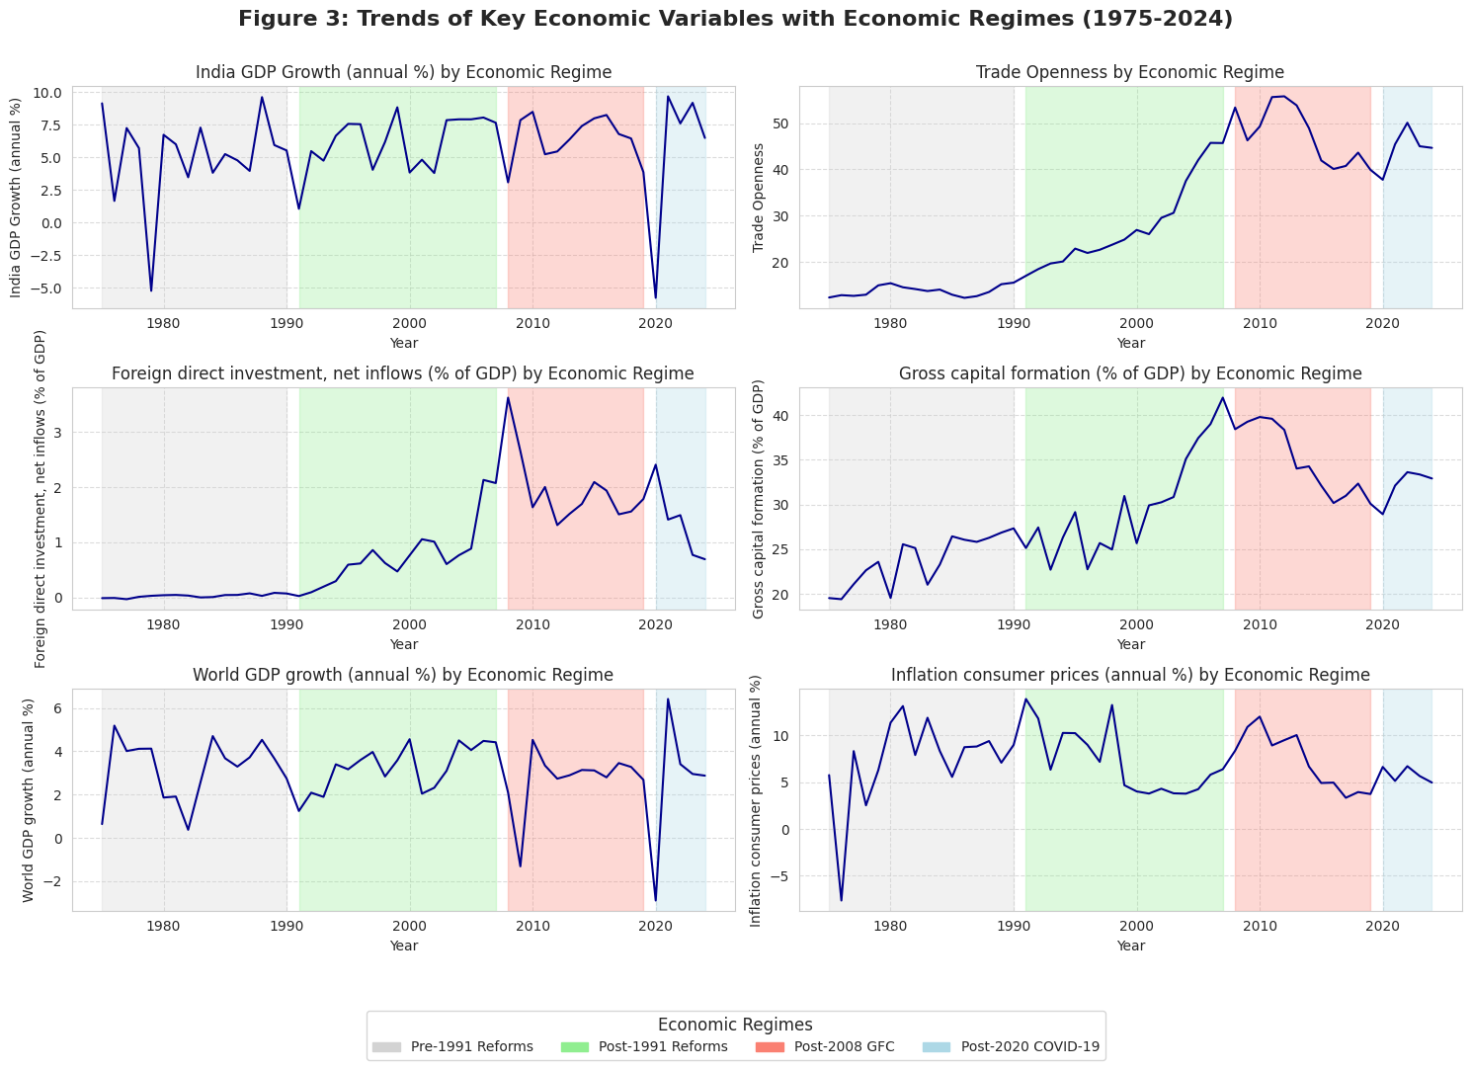
Figure 1. Trends of Key Economic Variables with Economic Regimes (1975-2024)

Figure 2 present the correlation matrix. Trade openness and GDP growth are positively correlated (0.22), offering early support for the trade-led growth hypothesis, though the relationship is modest. GDP growth correlates more strongly with gross capital formation (0.27) and world GDP growth (0.34), suggesting domestic investment and global conditions both matters. Trade openness correlates strongly with exports, imports, FDI, and the exchange rate, which makes sense given how tightly India's external sector variables move together after liberalization.
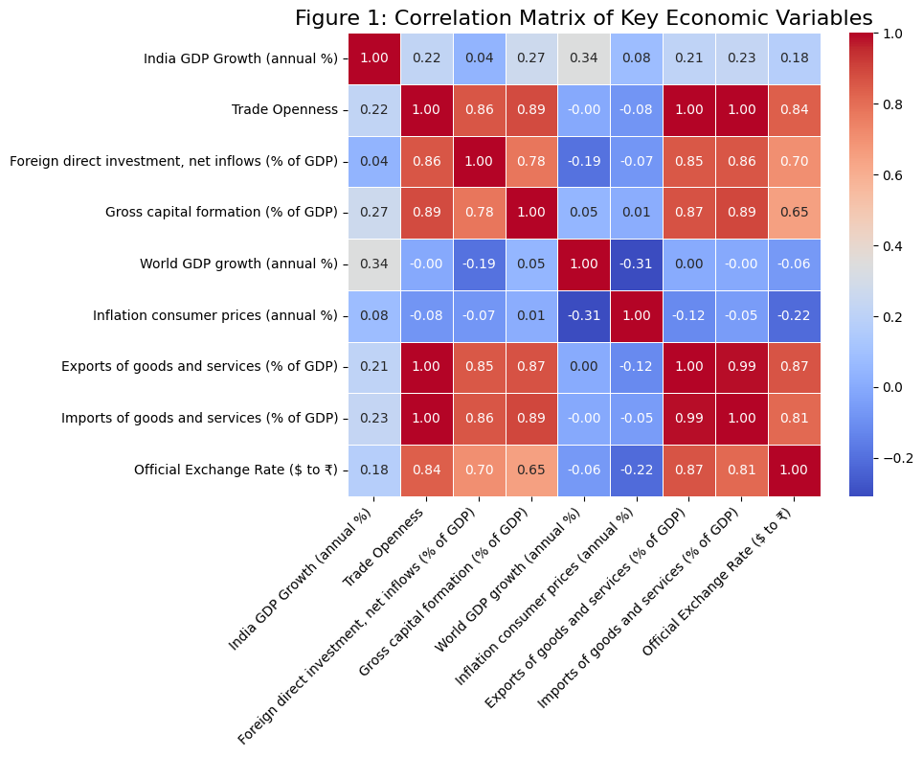
Figure 2. Correlation Matrix of Key Economic Variables

Table 3 reports Variance Inflation Factor (VIF) values used to check for multicollinearity among the explanatory variables. As a rule, VIF values above 5 or 10 signal potential concerns. The higher values for trade openness, exports, and imports are unsurprising, these series move closely together and all measure facets of the same external trade activity. The association between FDI inflows and gross capital formation is similarly expected, since foreign investment feeds directly into capital accumulation. That said, none of the values cross thresholds that would seriously distort the regression estimates, so multicollinearity is not a material problem here.

Table 3. Variance Inflation Factor (VIF) of Key Economic Variables (Adjusted for Multicollinearity)
Variable | VIF
const | 69.59
Trade Openness | 14.26
Gross capital formation (% of GDP) | 5.74
Foreign direct investment, net inflows (% of GDP) | 4.85
Official Exchange Rate ($ to ₹) | 4.50
World GDP growth (annual %) | 1.59
Inflation consumer prices (annual %) | 1.37
India GDP Growth (annual %) | 1.35

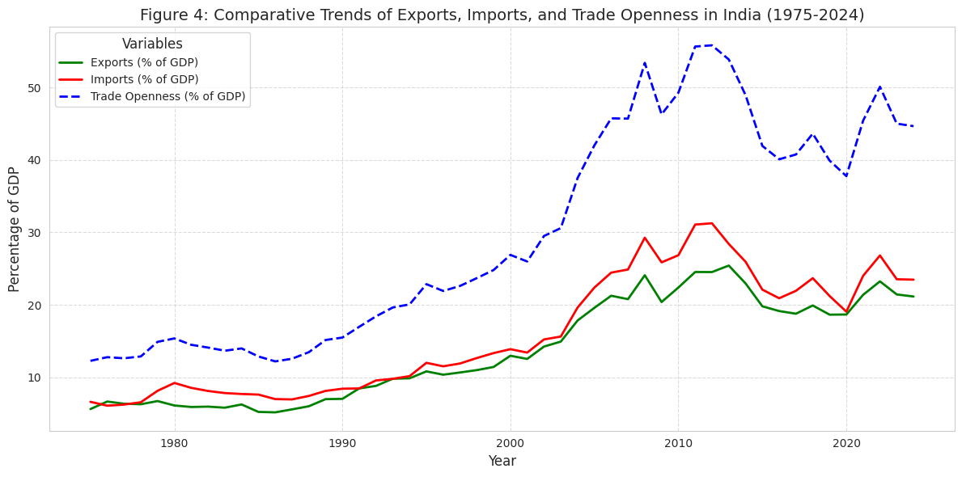
Figure 3. Comparative Trends of Exports, Imports and Trade Openness in India (1975-2024)

Figure 3 plots exports, imports, and trade openness together. All three move in the same direction over time, with a clear acceleration after 1991. Exports and imports rose together, and trade openness tracked both - the three series are, unsurprisingly, telling the same story about India’s external sector from different angles.
Figures 4 and 5 plot rolling mean and rolling volatility estimates for the major macroeconomic variables, using a 3-year moving average to smooth short-run noise and surface medium-term trends. Figure 4 shows trade openness climbing steadily after 1991, with GDP growth cycling through expansion and slowdown phases across the same period. Gross capital formation and FDI inflows both picked up during the post-liberalization decades, though neither as consistently as trade openness.
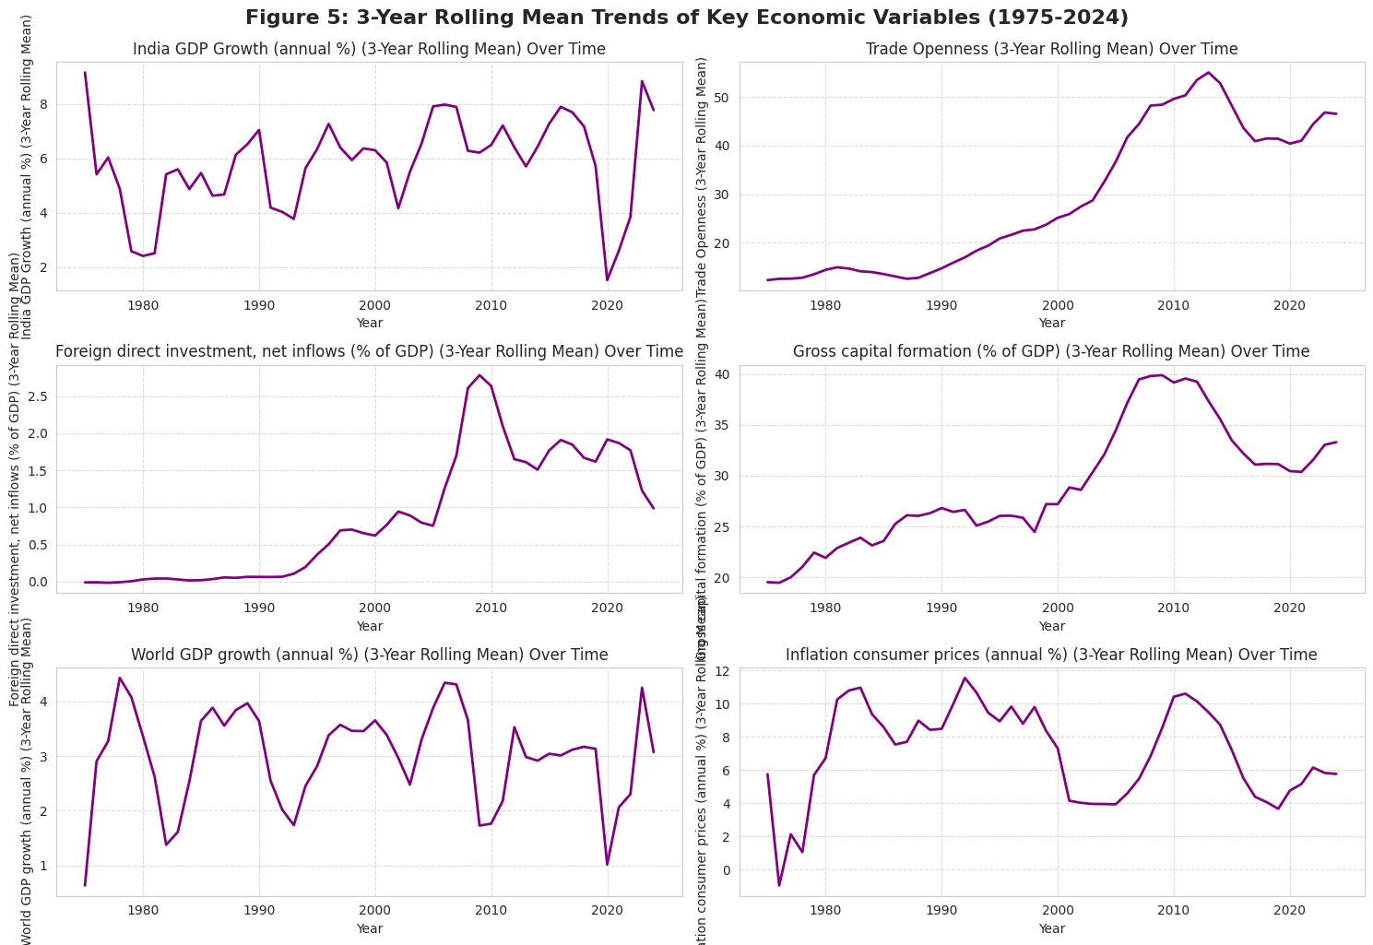
Figure 4. : 3- Year Rolling Mean Trends of Key Economic Variables (1975-2024)

Figure 5 tracks GDP growth volatility using a 5-year rolling standard deviation. Volatility spikes around the 1991 adjustment period, the 2008 Global Financial Crisis, and the COVID-19 shock, the three biggest external disruptions in the sample.
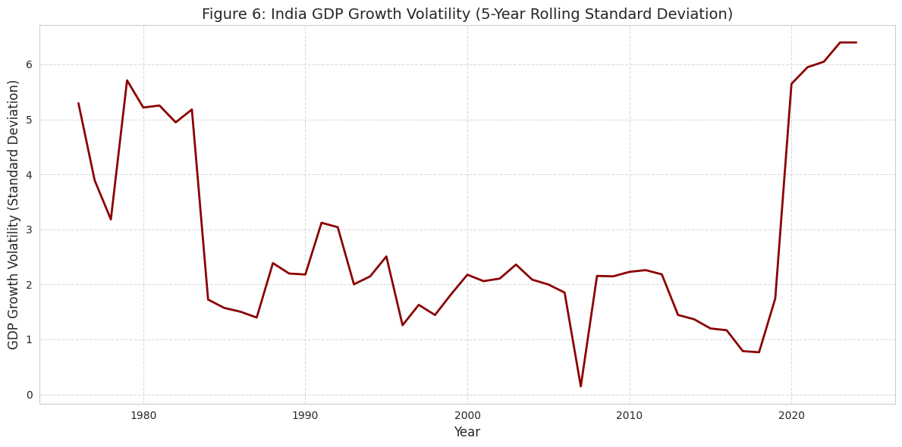
Figure 5. India GDP Growth Volatility (5- Year Rolling Standard Deviation)

The two plots together separate short-run noise from longer-term structural movement. Sustained volatility tends to weigh on investment confidence; stable medium-term trends do the opposite. Both matter for how policymakers read the growth trajectory.

4.2 Stationarity and Structural Break Analysis

Three-unit root tests were run such as ADF, Phillips-Perron, and KPSS. GDP growth and inflation are stationary at level; trade openness, exchange rate, FDI inflows, and gross capital formation are not, but become stationary after differencing. The results reported in Table 4. No variable integrates at I(2), so ARDL and NARDL remain valid for the analysis.

Table 4. Summary of Unit Root Test Results
Variable | ADF | PP | KPSS | Order of Integration
GDP Growth | Stationary | Stationary | Stationary | I(0)
Trade Openness | Non-Stationary | Non-Stationary | Non-Stationary | I(1)
Exchange Rate | Non-Stationary | Non-Stationary | Non-Stationary | I(1)
FDI Inflows | Non-Stationary | Non-Stationary | Non-Stationary | I(1)
Gross Capital Formation | Non-Stationary | Non-Stationary | Non-Stationary | I(1)
World GDP Growth | Mixed | Stationary | Stationary | I(0)/I(1)
Inflation | Stationary | Stationary | Stationary | I(0)

Standard unit root tests can produce misleading results when structural breaks are present, so the Zivot-Andrews test was run alongside them. The identified break points correspond to the 1991 reforms, the 2008 Global Financial Crisis, and the COVID-19 period- all plausible candidates given the scale of disruption each caused.
Table 5 reports the results of Zivot-Andrews test. The identified break points line up with recognizable events: the 1991 reforms, the 2008 Global Financial Crisis, and periods of domestic inflationary pressure.

Table 5. Zivot-Andrews Structural Break Test Results
Variable | Break Year | ZA Statistic | p-value | Inference
India GDP Growth (%) | 1991 | -8.161 | 0.000 | Break-Stationary
Trade Openness | 2015 | -2.897 | 0.936 | Unit Root with Break
FDI Inflows (% of GDP) | 1997 | -3.198 | 0.841 | Unit Root with Break
Gross Capital Formation (% of GDP) | 2013 | -4.047 | 0.324 | Unit Root with Break
World GDP Growth (%) | 1991 | -7.594 | 0.000 | Break-Stationary
Inflation (%) | 1989 | -5.462 | 0.005 | Break-Stationary

GDP growth shows a sharp structural break in 1991 (ZA statistic = -8.161, p < 0.01), consistent with the scale of the liberalization shock that year. World GDP growth and inflation are stationary around their own break points, reflecting the imprint of major global and domestic disruptions. Trade openness, FDI inflows, and gross capital formation, on the other hand, carry unit roots even after accounting for breaks, they trend persistently rather than mean-revert.
The combination of structural breaks and likely asymmetric adjustment is what makes NARDL the natural choice. A linear model would treat positive and negative shocks as mirror images; the data suggest they are not

4.3 Linear and Nonlinear Cointegration Dynamics (ARDL and NARDL)

The ARDL framework examines the long-run and short-run relationship between trade openness and economic growth. Based on the Bayesian Information Criterion, the optimal specification is ARDL (0,0,0), with gross capital formation and world GDP growth as the significant explanatory variables.
In the long run, world GDP growth has a positive and statistically significant effect on India's GDP growth (β = 0.657, p < 0.05). Gross capital formation also contributes positively, though only at the 10% level. Global conditions, in other words, matter more for India’s growth than domestic investment, at least within this specification.
The Error Correction Model puts the ECT at -1.197 (p < 0.01), negative and significant, which confirms a stable long-run relationship among the variables. The magnitude above one suggests rapid adjustment toward equilibrium, though with some degree of short-run overshooting before stabilization. That is fast, and suggests the economy overshoots somewhat before settling back toward equilibrium.
Short-run dynamics tell a different story. World GDP growth drives India’s growth in the short run as well, but trade openness and FDI both show weak or negative short-run coefficients. This is not unusual: greater external integration can initially increase import dependence and exposure to external shocks, with growth benefits arriving later if at all.
To test for asymmetry, trade openness was decomposed into positive and negative partial sums and re-estimated as a NARDL model. To formally assess asymmetry, a Wald test was conducted under the null hypothesis that the cumulative effects of positive and negative trade shocks are equal. The test statistic (χ² = 0.417, p = 0.522) fails to reject the null at conventional significance levels. So even though the estimated coefficients differ in sign and magnitude, the short-run effects of positive and negative trade openness shocks on GDP growth are not statistically distinguishable. The results are reported in Table 7. Positive trade shocks increase in openness and produce weak positive effects on growth. Negative shocks produce stronger adverse effects. Although the coefficients of positive and negative trade shocks differ in sign and magnitude, they are not statistically significant. A reduction in trade openness, in other words, does more damage than an equivalent expansion does good. Table 6 reports the full ARDL and ECM estimates.

Table 6. ARDL and ECM Estimation Results
Component | Variable | Coefficient | p-value
Long-run | Gross Capital Formation | 0.1302 | 0.061
Long-run | World GDP Growth | 0.6574 | 0.015
ECM | Error Correction Term (ECT) | −1.1972 | 0.000
Short-run | Δ Trade Openness | −0.2012 | 0.146
Short-run | Δ FDI | −1.5519 | 0.129
Short-run | Δ World GDP Growth | 0.8146 | 0.001
Short-run | Δ Inflation | 0.1329 | 0.182
Short-run | Δ Exchange Rate | −0.0920 | 0.642

Figure 6 plots actual against fitted GDP growth from the ARDL model. The fitted series tracks the overall trajectory well, but visibly struggles around major crisis periods - the gaps are largest precisely where shocks were sharpest. That pattern points to nonlinear and asymmetric dynamics that a linear model cannot fully absorb, which is the practical case for moving to NARDL.

Table 7. NARDL Estimation Results: Asymmetric Effects of Trade Openness on GDP Growth
Variable | Coefficient | Std. Error | t-Statistic | p-value
Constant | 2.3711 | 5.762 | 0.412 | 0.683
GDP Growth (-1) | -0.0468 | 0.167 | -0.281 | 0.780
Positive Trade Shock (TO⁺) | 0.2230 | 0.284 | 0.786 | 0.436
Positive Trade Shock (TO⁺(-1)) | -0.1179 | 0.276 | -0.427 | 0.672
Negative Trade Shock (TO⁻) | -0.1980 | 0.344 | -0.576 | 0.568
Negative Trade Shock (TO⁻(-1)) | 0.3440 | 0.336 | 1.024 | 0.312
FDI Inflows (% of GDP) | -3.1239 | 1.197 | -2.610 | 0.013**
FDI Inflows (% of GDP)(-1) | 1.2911 | 1.289 | 1.001 | 0.323
Gross Capital Formation | 0.2061 | 0.202 | 1.021 | 0.314
Gross Capital Formation (-1) | -0.0902 | 0.206 | -0.439 | 0.663

Asymmetry Wald Test
Test | Null Hypothesis | Test Statistic | p-value | Conclusion
Wald Test (Short-run Asymmetry) | TO⁺ + TO⁺(-1) = TO⁻ + TO⁻(-1) | 0.4170 | 0.5223 | Fail to reject H₀

TO⁺ represents positive changes in trade openness, while TO⁻ represents negative changes.
** indicates significance at 5% level.
The Wald test result (p = 0.522) indicates that the null hypothesis of symmetry cannot be rejected, suggesting no statistically significant asymmetry.

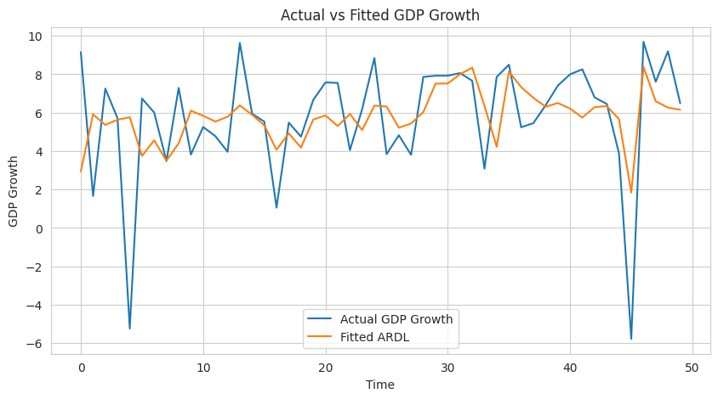
Figure 6. Actual vs Fitted GDP Growth from ARDL Model

Figure 7 plots the CUSUM stability test for the estimated ARDL model. The cumulative residuals stay within the critical bounds across the sample, meaning the long-run coefficients hold up despite the 1991 reforms, the Global Financial Crisis, and the COVID-19 shock passing through the data.
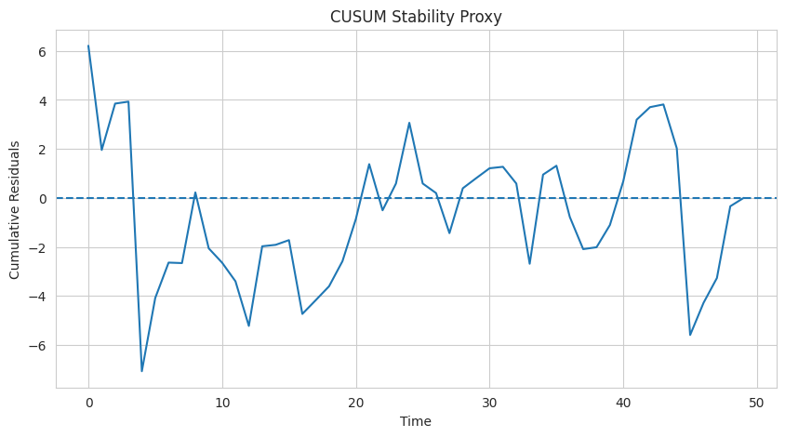
Figure 7. CUSUM Stability Test for ARDL Model

Diagnostic tests return clean results on most fronts. The White test finds no heteroskedasticity, and the Durbin-Watson statistic sits close to 2, indicating limited serial correlation. The Jarque-Bera test is the exception - residuals are non-normal, which is unsurprising given the extreme shocks and crisis periods in the sample. That non-normality is part of what motivates the NARDL and machine learning extensions. The ARDL and NARDL models establish the long-run relationship and asymmetric adjustment, but both are parametric and impose structure on the data. The next step applies machine learning models and Explainable AI techniques to pick up nonlinear interactions the econometric framework cannot flex to accommodate.

4.4 Direction of Causality Between Trade Openness and Economic Growth

Cointegration establishes that the variables move together over the long run and it does not say which drives which. Granger causality and Toda-Yamamoto tests were run to examine that question. The Granger test rejects the null that trade openness does not cause GDP growth at the 5% level (p = 0.047). Growth does not Granger-cause trade openness, so the relationship runs one way: trade to output, not the reverse. GDP growth shows no evidence of causing trade openness in either direction.
The Toda–Yamamoto test, better suited to variables with mixed integration orders, does not confirm this. The Wald statistic (χ² = 4.166, p = 0.125) fails to reject the same null - the Granger result does not hold under a more demanding method. The causality evidence is therefore limited and sensitive to methodology. Neither test supports bidirectional causality. Detailed results appear in Table 8.

Table 8. Granger and Toda-Yamamoto Causality Results
Test | Null Hypothesis | Test Statistic | p-value | Conclusion
Granger Causality (Lag 1) | Trade Openness does not cause GDP Growth | 3.937 | 0.047 | Weak evidence of causality
Granger Causality (Lag 2) | Trade Openness does not cause GDP Growth | 4.650 | 0.098 | Not significant at 5%
Toda-Yamamoto Wald Test | Trade Openness does not cause GDP Growth | 4.166 | 0.125 | Fail to reject null

The findings suggest trade openness is not a reliable short-run growth driver on its own. Whatever effect it has likely works through investment, productivity, or global demand rather than directly. That sits comfortably with the earlier NARDL finding- the trade-growth relationship in India is asymmetric and regime-dependent, not a stable linear mechanism that causality tests would be expected to pick up cleanly.

4.5 Machine Learning Prediction, Model Comparison, and Explainable AI Analysis

To complement the econometric analysis, machine learning models were employed to assess predictive performance and capture potential nonlinear interactions that ARDL and NARDL specifications may not fully represent. While econometric models focus on long-run relationships and adjustment dynamics, machine learning models prioritize predictive accuracy and flexible modeling of complex interactions.

The predictive framework uses lagged values of trade openness, gross capital formation, inflation, FDI inflows, exports, imports, exchange rate, and world GDP growth to forecast India’s GDP growth. Two nonlinear algorithms, namely Random Forest and XGBoost, were estimated and compared with ARDL and NARDL models.

Table 9. Final Integrated Model Comparison
Model | Method | RMSE | Economic Interpretation
ARDL | Linear long-run and short-run econometric model | 2.7449 | Captures equilibrium trade-growth relationship
NARDL | Asymmetric nonlinear distributed lag model | 2.5900 | Captures asymmetric effects of positive and negative trade shocks
Random Forest | Nonlinear ensemble tree-based machine learning | 3.8875 | Captures nonlinear macroeconomic interactions
XGBoost | Gradient boosting machine learning model | 3.7690 | Provides nonlinear forecasting and interaction effects

Table 9 shows that NARDL slightly outperforms ARDL in terms of predictive accuracy (RMSE 2.59 vs. 2.74). This suggests that allowing for nonlinear decomposition of trade openness improves model fit, although earlier Wald test results indicate that these differences are not statistically significant in terms of asymmetry. The machine learning models exhibit higher prediction errors in this dataset, with Random Forest reporting RMSE of 3.89 (R² = 0.16) and XGBoost reporting RMSE of 3.77 (R² = 0.21). These results suggest that, despite their flexibility, machine learning models do not outperform econometric approaches in small-sample macroeconomic settings. Walk-forward validation was used to assess out-of-sample forecasting performance. The dataset was split into training and testing subsets using an expanding-window approach, where the model is iteratively re-estimated as new observations are added. This approach preserves temporal ordering and avoids look-ahead bias. The resulting walk-forward RMSE of 2.8918 indicates that the models maintain reasonable predictive stability over time.

Table 10. Machine Learning Predictive Performance
Model | RMSE | MAE | R²
Random Forest | 3.8875 | 2.4047 | 0.1593
XGBoost | 3.7690 | 2.3176 | 0.2097

While NARDL demonstrates a modest predictive advantage over ARDL, the absence of statistically significant asymmetry suggests that this improvement reflects flexible model structure rather than confirmed asymmetric effects. The machine learning models, despite higher error metrics, provide additional insights into nonlinear relationships and interaction effects among macroeconomic variables.
To enhance interpretability, SHAP analysis was applied to the XGBoost model. The results indicate that lagged trade openness, global GDP growth, and gross capital formation are among the most influential predictors of economic growth. These findings are broadly consistent with the econometric results, reinforcing the robustness of the identified growth drivers across different methodological approaches.

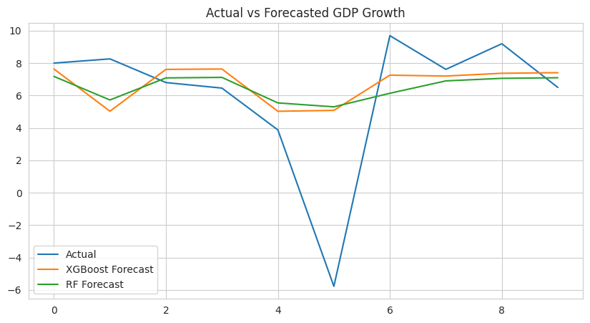
Figure 8. Actual vs Predicted GDP Growth Using Machine Learning Models

Figure 8 plots actual GDP growth against machine learning predictions. The models track medium-term movements reasonably well, but errors widen sharply during the Global Financial Crisis and the COVID-19 contraction. Abrupt, large-scale disruptions are where data-driven methods struggle most - there simply is not enough historical precedent to learn from.
SHAP (SHapley Additive exPlanations) was applied to get inside the machine learning models and move past black-box predictions. Figure 9 shows the summary plot. Variables are ranked by overall contribution on the vertical axis; the horizontal axis shows direction and magnitude. Blue points correspond to low variable values, red to high.

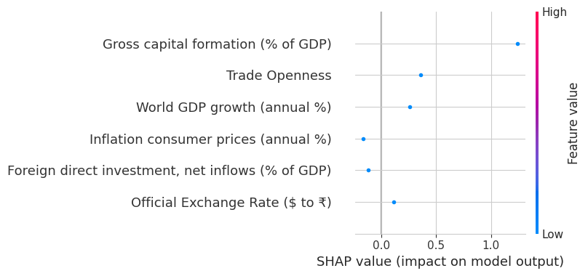
Figure 9. SHAP Analysis of XGBoost Model

Lagged trade openness ranks first. Higher prior-period openness consistently produces positive SHAP values; lower openness does the opposite. That result sits squarely with the ARDL and NARDL evidence for trade-led growth.
Gross capital formation ranks second with high investment activity pushes predictions upward, consistent with the long-run ARDL coefficient. World GDP growth follows the same pattern, reflecting how tightly India's growth tracks the global cycle.
Inflation runs the other way. High inflation values cluster on the negative side of the distribution, consistent with price instability weighing on growth. Exports contribute positively but less strongly than aggregate trade openness. FDI and imports sit close to zero and their marginal predictive contribution is small within this specification.
The SHAP results and the econometric findings are pointing in the same direction. Trade integration supports growth during stable periods; contractions in openness and adverse external shocks hit harder than equivalent expansions help. Two methods, same asymmetry.
The ARDL, NARDL, and machine learning models are telling a consistent story. Econometrics provides the interpretable long-run structure; machine learning surfaces the nonlinear interactions. Trade openness contributes positively to India’s growth, but how much and in which direction depends on global conditions, investment behavior, inflation, and whether trade is expanding or contracting.

5. Conclusion, Limitations and Policy Implications
This study examines the trade–growth relationship in India using ARDL and NARDL models alongside Random Forest, XGBoost, and SHAP-based interpretation. A stable long-run cointegrating relationship between trade openness and economic growth holds up but it is conditional and sensitive to macroeconomic context, not strongly asymmetric in any statistical sense. NARDL estimates show differences in how positive and negative trade shocks affect output, but the Wald test does not confirm significant asymmetry. The coefficients differ; that difference is not robust enough to call structural. The trade–growth relationship in India reads better as context-dependent than as asymmetric.

World GDP growth is the strongest predictor of India's output across all model specifications by some distance. Domestic investment contributes positively but with a smaller effect. Trade openness does not drive short-run growth on its own; it works through investment, productivity, and external demand rather than directly. The causality evidence is split. The standard Granger test finds short-run causality running from trade to growth; the Toda–Yamamoto approach does not. The causal link does not survive a more demanding method. Trade openness appears to be one of several interacting factors, not a dominant driver. The machine learning results land in the same place as the econometrics. Random Forest and XGBoost produce higher prediction errors than ARDL and NARDL, but SHAP analysis identifies lagged trade openness, global growth, and capital formation as the most influential predictors, the same variables the econometric models highlight. The agreement across methods adds confidence, and it shows what machine learning brings to this kind of analysis: a way to surface nonlinear interactions that standard models are not built to catch.

For policy, the case for stable and predictable trade regimes rests not on confirmed asymmetric effects but on the sensitivity of growth outcomes to external shocks and domestic policy conditions. India's dependence on global cycles is a vulnerability. Export diversification, stronger domestic demand, and adequate foreign exchange buffers are reasonable responses to it. Domestic investment quality matters more than volume, particularly the extent to which capital inflows translate into productivity gains.
Exchange rate management and inflation control are not optional extras and they are conditions for trade openness to convert into sustained growth at all. And since the data do not support strong asymmetry, there is little basis for treating expansions and contractions differently in policy terms. Consistency matters more than calibration.

The study has real limits. Annual data over fifty years is not a large sample for detecting subtle nonlinear effects. Structural breaks from the 1991 liberalization, the financial crisis, and COVID-19 are not explicitly modelled. Institutional quality, financial development, and policy uncertainty are excluded, and their absence likely shows. Machine learning performance is bounded by dataset size, and SHAP values measure importance not causality.
Trade openness can support growth in India. Whether it does depend on what else is happening globally, domestically, and in the policy environment more than on how open the economy is.

Disclaimer (Artificial intelligence)

Author(s) hereby declare that NO generative AI technologies such as Large Language Models (ChatGPT, COPILOT, etc.) and text-to-image generators have been used during the writing or editing of this manuscript.

References:
[1] J. Sachs, A. Warner, A. Åslund, and S. Fischer, “Economic Reform and the Process of Global Integration,” Brookings Pap. Econ. Act., vol. 1995, pp. 1–118, Jan. 1995, doi: 10.2307/2534573.
[2] J. A. Frankel and D. H. Romer, “Does Trade Cause Growth?,” American Economic Review, vol. 89, no. 3, pp. 379–399, Jun. 1999, doi: 10.1257/aer.89.3.379.
[3] S. Edwards, “Openness, Productivity and Growth: What Do We Really Know?,” Economic Journal, vol. 108, no. 447, pp. 383–398, Mar. 1998, doi: None.
[4] Q. M. A. Hye and W.-Y. Lau, “Trade openness and economic growth: empirical evidence from India,” Journal of Business Economics and Management, vol. 16, no. 1, pp. 188–205, Feb. 2015, doi: 10.3846/16111699.2012.720587.
[5] M. Sehrawat and A. K. Giri, “Financial Structure, Interest Rate, Trade Openness and Growth: Time Series Analysis of Indian Economy,” Global Business Review, vol. 18, no. 5, pp. 1278–1290, Oct. 2017, doi: 10.1177/0972150917710150.
[6] M. H. Pesaran, Y. Shin, and R. J. Smith, “Bounds testing approaches to the analysis of level relationships,” Journal of Applied Econometrics, vol. 16, no. 3, pp. 289–326, May 2001, doi: https://doi.org/10.1002/jae.616.
[7] Y. Shin, B. Yu, and M. Greenwood-Nimmo, “Modelling Asymmetric Cointegration and Dynamic Multipliers in a Nonlinear ARDL Framework,” in Festschrift in Honor of Peter Schmidt: Econometric Methods and Applications, R. C. Sickles and W. C. Horrace, Eds., New York, NY: Springer New York, 2014, pp. 281–314. doi: 10.1007/978-1-4899-8008-3_9.
[8] S. Mullainathan and J. Spiess, “Machine Learning: An Applied Econometric Approach,” Journal of Economic Perspectives, vol. 31, no. 2, pp. 87–106, May 2017, doi: 10.1257/jep.31.2.87.
[9] S. Lundberg and S.-I. Lee, A Unified Approach to Interpreting Model Predictions. 2017. doi: 10.48550/arXiv.1705.07874.
[10] S. K. Chejarla, S. K. Duvvuri, B. Rajana, P. T. Dakey, K. R. Rao, and M. R. Goutham, “Forecasting and Explaining Non-Performing Assets in Indian Banking Groups Using Panel Econometrics and Explainable Machine Learning Models,” Journal of Global Economics, Management and Business Research, vol. 18, no. 2, pp. 58–78, 2026, doi: 10.56557/jgembr/2026/v18i210427.
[11] B. Rajana, S. K. Duvvuri, S. K. Chejarla, P. T. Dakey, K. Ramachandra Rao, and T. R. Gandam, “Hybrid Econometric and Deep Learning Framework for Forecasting Global Commodity Price Dynamics: Evidence from Multi-Commodity Time Series (2000-2026),” Global Academic Journal of Economics and Business, vol. 8, no. 2, pp. 166–182, 2026, doi: 10.36348/gajeb.2026.v08i02.010.
[12] A. Harrison, “Openness and growth: A time-series, cross-country analysis for developing countries,” J. Dev. Econ., vol. 48, no. 2, pp. 419–447, 1996, doi: https://doi.org/10.1016/0304-3878(95)00042-9.
[13] H. Yanikkaya, “Trade openness and economic growth: a cross-country empirical investigation,” J. Dev. Econ., vol. 72, no. 1, pp. 57–89, 2003, doi: https://doi.org/10.1016/S0304-3878(03)00068-3.
[14] H. Y. Lee, L. A. Ricci, and R. Rigobon, “Once again, is openness good for growth?,” J. Dev. Econ., vol. 75, no. 2, pp. 451–472, 2004, doi: https://doi.org/10.1016/j.jdeveco.2004.06.006.
[15] D. Greenaway, W. Morgan, and P. Wright, “Trade liberalisation and growth in developing countries,” J. Dev. Econ., vol. 67, no. 1, pp. 229–244, 2002, doi: https://doi.org/10.1016/S0304-3878(01)00185-7.
[16] A. Vamvakidis, “How Robust is the Growth-Openness Connection? Historical Evidence,” Journal of Economic Growth, vol. 7, no. 1, pp. 57–80, 2002, doi: 10.1023/A:1013418610712.
[17] R. Wacziarg and K. H. Welch, “Trade Liberalization and Growth: New Evidence,” World Bank Econ. Rev., vol. 22, no. 2, pp. 187–231, 2008, [Online]. Available: https://EconPapers.repec.org/RePEc:oup:wbecrv:v:22:y:2008:i:2:p:187-231
[18] R. Chang, L. Kaltani, and N. V Loayza, “Openness can be good for growth: The role of policy complementarities,” J. Dev. Econ., vol. 90, no. 1, pp. 33–49, 2009, doi: https://doi.org/10.1016/j.jdeveco.2008.06.011.
[19] D. Herzer, “Cross-Country Heterogeneity and the Trade-Income Relationship,” FIW, FIW Working Paper series, vol. 44, Apr. 2013, doi: 10.1016/j.worlddev.2012.09.014.
[20] P. Howitt, P. Aghion, and D. Mayer-Foulkes, “The Effect of Financial Development on Convergence: Theory and Evidence,” Q. J. Econ., vol. 120, pp. 173–222, Feb. 2005, doi: 10.1162/qjec.2005.120.1.173.
[21] S. Sengupta, “How trade openness influenced economic growth in India: An empirical investigation,” Indian J. Econ. Dev., pp. 1–14, Sep. 2020, doi: 10.17485/IJED/v8.21.
[22] R. Raghuramapatruni and V. S. C. Reddy, “An Appraisal of the Impact of International Trade on Economic Growth of India- through the ARDL Approach,” International Journal of Economics and Business Administration, vol. VIII, no. 2, pp. 376–387, 2020.
[23] S. Wani, “Trade Openness, Capital Formation, and Economic Growth: Empirical Evidence from India,” Eurasian Journal of Business and Economics, vol. 15, pp. 36–49, May 2022, doi: 10.17015/ejbe.2022.029.03.
[24] S. Wani, E. Yasmin, and M. A. Soudager, “Role of Institutional Quality in Trade Openness and Economic Growth Nexus: Empirical Evidence from India,” Statistika: Statistics and Economy Journal, vol. 103, pp. 180–197, Jun. 2023, doi: 10.54694/stat.2023.2.
[25] P. Roy Chowdhury, “Relationship Of Gdp Growth Rate, Trade Openness And Real Exchange Rate In India: An Analysis Through Auto Regressive Distributor Lag (Ardl) Model,” Journal of Informatics Education and Research, vol. 5, Jul. 2025, doi: 10.52783/jier.v5i2.3101.
[26] U. J. Banday, S. Murugan, and J. Maryam, “Foreign direct investment, trade openness and economic growth in BRICS countries: evidences from panel data,” Transnational Corporations Review, vol. 13, no. 2, pp. 211–221, 2021, doi: https://doi.org/10.1080/19186444.2020.1851162.
[27] R. Kumar and D. Neogi, “Strategic Economic Management : ARDL Analysis of Trade, FDI, and Growth in G20 Nations,” Prabandhan: Indian Journal of Management, vol. 18, no. 7, pp. 8–25, Jul. 2025, doi: 10.17010/pijom/2025/v18i7/174562.
[28] L. Mallick and S. R. Behera, “Does trade openness affect economic growth in India? Evidence from threshold cointegration with asymmetric adjustment,” Cogent Economics & Finance, vol. 8, no. 1, p. 1782659, 2020, doi: 10.1080/23322039.2020.1782659.
[29] T. Ghazouani, J. Boukhatem, and C. Yan Sam, “Causal interactions between trade openness, renewable electricity consumption, and economic growth in Asia-Pacific countries: Fresh evidence from a bootstrap ARDL approach,” Renewable and Sustainable Energy Reviews, vol. 133, p. 110094, 2020, doi: https://doi.org/10.1016/j.rser.2020.110094.
[30] K. Usman, “The linkages between trade, financial openness, and economic growth in China: an ARDL-bound test approach,” J. Appl. Econ., vol. 26, no. 1, p. 2258616, Dec. 2023, doi: 10.1080/15140326.2023.2258616.
[31] A. U. H. Ganie and M. Ahmad, “Reassessing the energy – finance – growth triangle in India: evidence from asymmetric and non-linear modelling,” Journal of Financial Economic Policy, pp. 1–27, Dec. 2025, doi: 10.1108/JFEP-07-2025-0279.
[32] S. K. Chejarla, S. K. Duvvuri, B. Rajana, P. T. Dakey, R. K. Rao, and M. R. Goutham, “Geopolitical shocks and financial contagion in the Indian equity market during the Iran-Israel conflict using advanced econometric and machine learning methods,” International Journal of Finance and Management Economics, vol. 9, no. 3, pp. 184–197, 2026, doi: 10.33545/26179210.2026.v9.i3.785.

