Green Approach to Ampicillin Removal: Modified Rice Husk as a Sustainable Adsorbent
.
ABSTRACT
Widespread occurrence of the antibiotic ampicillin in water bodies, due to incomplete removal by conventional treatments, contributes to antimicrobial resistance and environmental risks. This study evaluated the adsorption performance of acid-treated rice husk (ARH) for the removal of ampicillin from industrial wash off, incorporating kinetic, thermodynamic, and statistical optimization frameworks.
Rice husk was treated with tetraoxosulphate (VI) acid (H₂SO₄), noted as ARH and then characterized for surface functional groups and morphology. Experiments were carried out by varying three adsorption factors: adsorbent dosage (1 to 5g), contact time (29.3 to 180min) and ampicillin concentration (1 to 5mg/mL). Adsorption experiment was designed using the central composite design (CCD) of the response surface methodology (RSM). Experiments were carried out for optimization, equilibrium isotherm, kinetics and thermodynamic studies.
The adsorption kinetics aligned closely with the pseudo-second-order model (R² = 0.9964). Thermodynamic analysis confirmed the process to be both spontaneous and exothermic, characterized by a negative enthalpy change (ΔH° = –21.17 kJ/mol) and consistently negative Gibbs free energy values suggesting favourable adsorption. Ampicillin concentration and ARH dosage were identified as the most statistically significant parameters influencing removal efficiency. The developed quadratic model exhibited high predictive reliability (R² = 0.9660, P < 0.001) with low significant lack-of-fit, supporting its robustness. Optimization analysis predicted a maximum removal efficiency of 94.99% under the conditions of 181 minutes contact time, 1.0 g/L ARH dosage, and 4.47 mg/L initial concentration, achieving a desirability score of 1.000.
These findings underscore the efficacy of ARH as a sustainable, low-cost biosorbent for the treatment of pharmaceutical-laden wastewater, demonstrating high performance under carefully optimized conditions and strong potential for scalable environmental applications.

Graphical Abstract

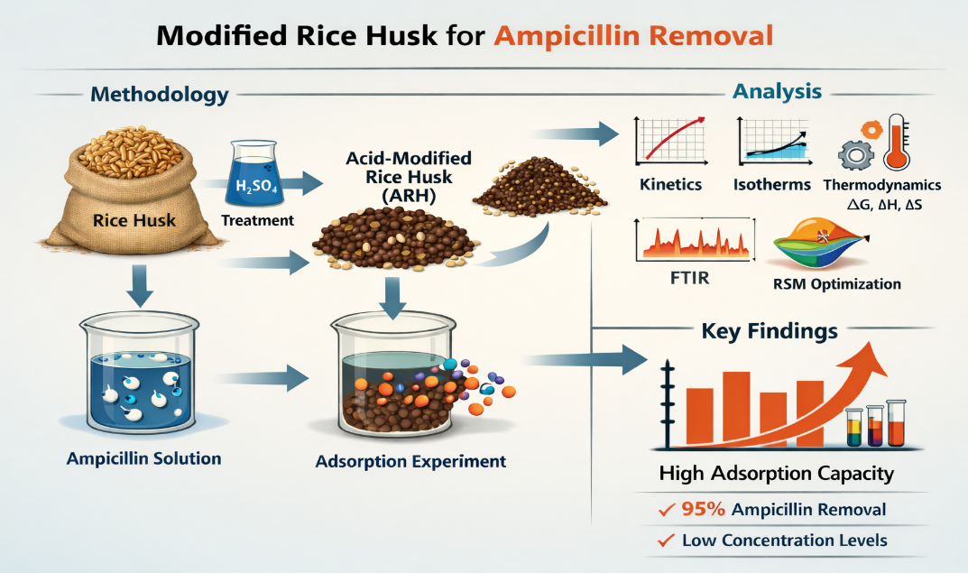

Keywords: Sustainability, Green chemistry, Biomass, Adsorption, pharmaceutical effluent, Optimization

1. INTRODUCTION

Pharmaceutical contaminants, particularly antibiotics, have emerged as persistent micropollutants in aquatic systems due to their extensive use in human health care, veterinary practice, and agriculture (Rahman and Varshneya, 2020). Antibiotic consumption at high levels in both human and veterinary populations poses a risk and adversely affects the health of living organisms (Míguez-Gonzalez, 2023). Ampicillin, a widely administered β-lactam antibiotic, is commonly detected in surface water, wastewater, and even drinking water, primarily because of its incomplete metabolism and the limited removal efficiency of conventional treatment processes (Kümmerer, 2009; Michael et al., 2013). The presence of trace-level antibiotics in aquatic environments contributes to the global escalation of antimicrobial resistance (AMR), posing serious ecological and public health challenges (Martinez, 2009; WHO, 2016).
Various treatment technologies, including membrane filtration, advanced oxidation processes (AOPs), and biodegradation, have been employed to mitigate antibiotic contamination (Ahmed et al., 2017).
Recent studies have demonstrated that AOPs such as Fenton, photo-Fenton, ozonation, photocatalysis, and UV/H₂O₂ systems are highly efficient for the degradation and mineralization of pharmaceutical contaminants in water systems (Shulin, et. al., 2026). However, despite their effectiveness, these approaches especially are often associated with limitations such as high operational costs, energy demand, and the possible formation of intermediate by-products that may exhibit residual toxicity and reduced scalability (Shulin, et. al., 2026). In contrast, adsorption has gained prominence as a versatile, cost-effective, and environmentally benign alternative for the removal of pharmaceutical pollutants from water systems (Crini & Lichtfouse, 2019).
Among the array of low-cost adsorbents, agricultural biomass residues offer benefits due to their availability, biodegradability, and potential for chemical modification to enhance adsorption performance (Yu, et.al 2016; Zhang, et.al 2023; Ajala, et.al 2023; Alawa, et.al 2025). Rice husk, a major agro-industrial by-product in rice-producing regions, is rich in silica, lignin, and cellulose—components that provide functional groups needed to adsorption.
Several studies have demonstrated that mineral acids are particularly effective for modifying lignocellulosic materials due to their strong oxidizing nature. Emdadi et al., (2017) used nitric acid to prepare chemically modified rice husk for desiccant applications. This showed increased porosity and functionalization compared to untreated samples. Similarly, Asim et al., (2015) emphasized the benefits of strong oxidizers like HNO₃ in improving the surface characteristics of biomass-based adsorbents for environmental applications. Through acid modification, the surface properties of rice husk can be significantly improved, yielding acid-modified rice husk (ARH) with enhanced affinity for polar organic contaminants such as ampicillin (Bhattacharyya & Sharma, 2004). In this work a similar acid H₂SO₄ is chosen because it acts as an oxidizing agent, enabling selective removal of lignin and hemicellulose while preserving the cellulose framework.
Response Surface Methodology (RSM) is a powerful statistical tool for developing predictive models and optimizing complex processes with multiple variables (Myers et al., 2016, Bezerra et al., 2008). The Central Composite Design (CCD) stands out among RSM's experimental designs. It efficiently estimates linear, interaction, and quadratic effects with fewer experimental runs. CCD has proven successful in environmental engineering, especially for optimizing the removal of pharmaceutical contaminants like tetracycline, ciprofloxacin, and sulfamethoxazole using low-cost adsorbents (Crini & Lichtfouse, 2019). For instance, Rahman and Varshney (2020), assessed the optimized removal efficiency of ampicillin from aqueous solution by polydopamine/zirconium(iv) iodate using response surface methodology.
Despite these advances, the specific application of CCD-RSM for ampicillin removal using acid-modified rice husk (ARH) is still largely unexplored.
This study presents a novel application of acid-modified rice husk (ARH) as a sustainable adsorbent for the removal of ampicillin from aqueous solution. Unlike many previous studies that focus on heavy metals or dyes, this work targets a pharmaceutical contaminant of emerging environmental concern at environmentally relevant concentrations. This further provides a more statistically reliable and predictive optimization framework.
Furthermore, the combined use of kinetic, isotherm, and thermodynamic models, supported by FTIR analysis, offers a comprehensive understanding of the adsorption mechanism. The utilization of locally sourced agricultural waste also highlights the potential for low-cost, sustainable water treatment solutions, particularly in developing regions.

2. material and methods
2.1 Materials
2.1.1 Collection of Materials
The rice husk used as the adsorbent precursor was obtained from a local mill in Aguleri, Otuocha, Anambra East Local Government Area, Anambra State, Nigeria. Ampicillin (fig. 1) reference standard was supplied by Quality Pharmaceuticals PVT Ltd. (India). The ampicillin wash-off was obtained from the pharmaceutical plant strictly and immediately after the production of only ampicillin. This was tested for ampicillin content only. The wash-off was collected from Gauze Pharmaceuticals Awka, Anambra State, Nigeria. All chemicals used were of analytical grade and were used without further purification. Distilled water was used throughout all experimental procedures.
2.2 Methods
2.2.1 Preparation and characterization of Rice Husk Adsorbent
The rice husk sample was acid-modified according to the process described by Nwadibia, et al., 2025. The dried rice husk was soaked in 500 mL of 1 M H₂SO₄ in a 1 L beaker stirred for 20 min and left for 24 h.
After the 24-hour treatment, sample was filtered and washed repeatedly with distilled water until the wash off water reached neutral pH (pH ≈ 7). The treated rice husk was then oven-dried at 110 °C for 4 hours and labelled as ARH (acid-modified rice husk). The ARH was characterized for surface functional groups using FTIR spectrophotometer (Buck M530-IR). To analyze for surface morphology, Scanning Electron Microscope (SEM) (Phenom ProX Q150R) was used.
To prevent secondary environmental pollution arising from acid modification, the residual acid effluent was properly treated prior to disposal. The acidic waste was neutralized using sodium hydroxide to achieve a near-neutral pH (6.5–8.5), converting the acid into harmless salts and water.
2.2.2 Standard Solution and Calibration Curve
A stock solution of ampicillin (500 mg/L) was prepared by dissolving 0.5 g of reference standard in distilled water and making up to 1000 mL. The solution was freshly prepared prior to use to avoid degradation. Serial dilutions were performed to obtain various concentrations. Absorbance readings were taken at 269 nm (Lin and Cen, 2022), and a calibration curve of (absorbance vs. concentration) was plotted.

2.2.3 Pharmaceutical Wash-Off Solution
A 50 mg sample of solid ampicillin wash-off was weighed and added to 80 mL of distilled water, heated for 5 minutes in a water bath, and then diluted to 1000 mL. The solution was filtered and used for adsorption studies. The absorbances of each solution were taken before and after adsorption.
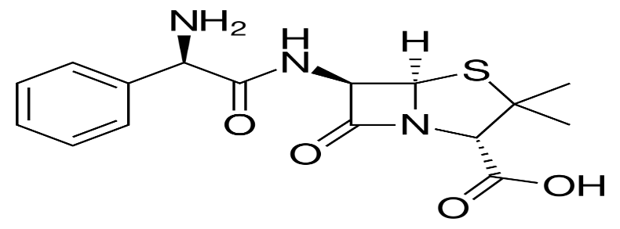
Figure 1. Chemical structure of Ampicillin.

2.3 Experimental Design and Optimization
A statistical optimization of adsorption conditions was carried out using Response Surface Methodology based on a Central Composite Design (CCD) of Minitab 17. Factors evaluated included: contact time (min), A, adsorbent dosage (g) B, and initial concentration of ampicillin (mg/mL) C. Each factor was varied at five coded levels and experimental responses were modelled to determine effects and optimal conditions for maximum adsorption efficiency. The adequacy of the fitted model was validated through analysis of variance (ANOVA). (Atta et. al. 2022). Regression plots were generated to visualize the relationship between variables. The 2nd order polynomial regression equation is given as:
Y = P₀ + P₁A + P₂B + P₃C + P₁₁A² + P₂₂B² + P₃₃C² + P₁P₂AB + P₁P₃AC + P₂P₃BC 1
where Y is the dependent variable or response (% removal); P₀ is the overall mean response or intercept constant; P₁, P₂ and P₃ are the regression model coefficients. Experimental range and levels of the independent variables are shown in table 1.

Table 1: Experimental range and levels of the independent variables
Variables | Code | Units | Coded variable Levels
Variables | Code | Units | -α | -1 | 0 | +1 | +α
Contact time | A | (min) | 29.3 | 60 | 105 | 150 | 180
Adsorbent dosage | B | (g) | 1 | 2 | 3 | 4 | 5
Initial concentration | C | (mg/mL) | 1 | 2 | 3 | 4 | 5

2.4 Batch Adsorption Experiments for Kinetics, Isotherm and Thermodynamics Models
Batch adsorption experiments were carried out to assess the efficiency of ampicillin removal using acid-modified rice husk (ARH) under varying conditions. Experiments were conducted in 250 mL Erlenmeyer flasks containing 100 mL of ampicillin solution and 1 g of ARH. The mixtures were stirred using a mechanical shaker at 200 rpm for the required contact time. Key operational variables include: initial ampicillin concentration (1–5 mg/mL), contact time (30–180 minutes) and temperature (25–105 °C). After each run, samples were filtered, and residual ampicillin absorbance was determined via UV–Vis spectrophotometry at the drug’s λₘₐₓ of 269 nm (Lin and Cen, 2022). Corresponding concentrations were determined using standard ampicillin calibration curve. Experiments were performed in triplicates, and mean values were reported to ensure reproducibility.

2.4.4 Adsorption Performance Evaluation
The removal percentage (R%) and the adsorption capacity qe (mg/g) of the ampicillin were determined using eqn (1) and (2), respectively ( Darweesh, 2026)
Percentage removal $=\frac{\left(C_{0-}C_{e}\right)}{C_{o}} x 100$ 1
The adsorption capacity $q_{e}=v\frac{{(C}_{o}-C_{e})}{m}$ 2

where C₀ and C_{e} are the initial and final ampicillin concentrations (mg/L), respectively, V is the volume (l),and M is the mass of the adsorbent (g)

2.4.1 Kinetics Studies.
Adsorption kinetics enables one to better understand sorption mechanism and rate-limiting steps (Abdu, et. al 2021; Al-Musawi, et. al. 2017; Ibrahim et. al 2022; Obradovic, 2020; Yeo, et. al. 2024).
Data obtained from time variation were analyzed using pseudo first-order (eq. 3) and pseudo second-order (eq. 4), (Ho 2006) kinetics models:
$ln \left(q_{e}-q_{t}\right)= lnq_{e}-k_{1^{t}}$ 3
$\frac{t}{q_{t}}=\frac{1}{k{q_{e}}^{2}}+\frac{t}{q_{e}}$ 4
Where k₁ (min⁻¹) and k₂ (L/mg/min) are the pseudo first-order and pseudo second-order adsorption rate constants, q_{e} amount of ampicillin deposited on the adsorbent’s surface at equilibrium, and q_{t} is the quantity deposited at any given moment (t). k₁ is calculated from the slope of the plot of log (q_{e}-q_{t}) vs t while k₂ is calculated by finding the slope and intercept from the plot of t/q_{t} vs t.
2.4.2. Diffusion Modelling Analysis
Diffusion models help determine whether the adsorption process is controlled by film diffusion (mass transfer from the bulk solution to the external surface of the adsorbent), intraparticle diffusion (mass transfer within the pores of the adsorbent), or a combination of both (Zhao, et. al 2024). To better understand the mass transfer dynamics governing ampicillin adsorption, intraparticle diffusion (eqn 5) and Boyd (eqn 6), diffusion models were applied. The intraparticle diffusion model (often described by Weber–Morris) predicts a linear relationship between adsorption quantity and the square root of time if diffusion inside the pores is solely the rate-limiting step. It is expressed as:
$q_{t}={k_{id}}^{0.5}+ C$ 5
Where k_{id} is intra-particle diffusion rate constant (g/mg min) and the intercept of the plot, C, reflects the boundary layer effect or surface adsorption. The larger the intercept, the greater the contribution of the surface adsorption in the rate-determining step (Weber and Morris 1963)
On the other hand, Boyd diffusion model is used to distinguish between film diffusion and pore (intra-particle) diffusion mechanisms in adsorption processes (Boyd et al.,1947). It is based on Fick’s second law of diffusion and applies to spherical particles under constant diffusivity assumptions. The equation is given as:
B_{t} = $-0.4977l_{n}\left(1-F\right)$ 6
B_{t} is the Boyd function at time t, F is the fraction of solute adsorbed at time t, defined as:
$F=\frac{q_{t}}{q_{e}}$, 7
q_{t} is the amount of solute in (mg/g) adsorbed at time t and q_{e} is the amount of solute in (mg/g) adsorbed at equilibrium. If a linear plot of B_{t} versus time (t) is obtained, the rate-controlling step is likely to be pore diffusion. Non-linearity of the plot indicates that film diffusion (boundary layer diffusion) may control the overall adsorption rate, especially in the early stages.
2.4.2 Isotherm Studies:
To evaluate the equilibrium interaction between ampicillin and acid-modified rice husk (ARH), adsorption capacities at equilibrium under varying concentration conditions, room temperature and time 60 mins were determined. The obtained data were fitted into three isotherm models: Langmuir (eq 8), Freundlich (eqn 9) and Dubinin–Radushkevich (D–R) (eqn 9). The Langmuir model assumes monolayer adsorption on homogeneous surface and high correlation suggests chemisorption. The Freundlich isotherm is empirical and is suitable for heterogeneous surfaces. Dubinin–Radushkevich model is empirical for estimating porosity and adsorption energy. It tells the nature of adsorption by distinguishing between physical and chemical adsorptions ( Al-Ghouti and; Yeo , 2023, Darweesh, et. al., 2026).
$\frac{C_{e}}{q_{e}}=\frac{1}{q_{m}K_{L}}+\frac{C_{e}}{q_{m}}$ 8
Where $C_{o}$ and $C_{e}$ are the initial and equilibrium ampicillin concentrations (mg/mL), respectively; q_{max} is maximum adsorption capacity (mg/g) and K_{L} Langmuir constant (L/mg).
The Freundlich isotherm shows an empirical relationship describing the adsorption of solutes from a liquid to a solid surface and it assumes that different sites with several adsorption energies are involved. It is expressed as:.
${log q}_{e}=log K_{F}+\frac{1}{n}log C_{e}$ 9
Where K_{F} is Freundlich constant indicating adsorption capacity. 1/n is adsorption intensity (dimensionless). Adsorption process is linear when n = 1, the chemical adsorption occurs when n < 1, and the adsorption is a physical process when n > 1. When the 1/n is <1, it implies favourable adsorption.
The Dubinin–Radushkevich isotherm has the following form:
$l_{n}q_{e}=l_{n}q_{D}-{βε}^{2}$ 10
$Ɛ=RT l_{n}{(1+}_{Ce}^{1})$ 11
$E =\sqrt{\frac{1}{2β}}$ 12
q_{D} is saturation capacity (mg/g), β adsorption energy constant related to adsorption energy and E is mean adsorption energy (kJ/mol). E< 8kJ/mol indicates physisorption, 8<E<16 indicates ion exchange while E > 16kJ/mol points to chemisorption (Akin, 2023).
2.4.3 Thermodynamics Studies
Thermodynamics analysis assesses the spontaneity and temperature dependence of the adsorption process (Balarak et al., 2015; Demirtaş et al., 2022). Experiments were conducted across a temperature range of 25 °C to 105 °C, maintaining an initial ampicillin concentration of 4 mg/mL, a 1 g dosage, and a 180-minute contact time. Gibbs free energy (ΔG), enthalpy (ΔH), and entropy (ΔS) were calculated using the following equations:
$\left.∆G\right.$= $\left.∆H\right.$– $T∆S$ 13
$lnK_{c}$= -$\frac{∆H}{RT}$ + $\frac{∆S}{R}$ 14
$\left.∆G\right.$ = $-RTlnK_{c}$ 15
Where R is the universal gas constant (8.314 J/mol/K), T is the absolute temperature (K), and K_{c}​ is the dimensionless equilibrium constant, calculated as:
$K_{c}=\frac{{1-C}_{e}}{C_{e}}$ 16
A Van't Hoff plot (lnK_{c}​ vs. 1/T) was employed to graphically determine ΔH and ΔS. ΔG values were then computed for each temperature.

3. results and discussion

3.1 Characterization of Adsorbent
3.1.1 The FTIR Analysis
The FTIR spectra of raw rice husk (RH), acid-modified rice husk (ARH), and ARH after ampicillin adsorption (ARH–AMP) are presented in Figure 2a-c, while the corresponding peak assignments are summarized in Table 2. The spectrum of RH exhibits characteristic bands associated with lignocellulosic biomass and silica. The absorption peaks at 3144.44, 3410.43, 3576.36 cm⁻¹. observed in the region 3600–3200 cm⁻¹ are attributed to O–H stretching vibrations of hydroxyl groups present in cellulose, hemicellulose, and lignin, as well as physically adsorbed water (Abugu et. al., 2023; Abugu et. al., 2023; Esmail and Mohammed, 2012; Nandiyanto et. al, 2024).). The peak 2939.77, cm⁻¹ corresponds to aliphatic C–H stretching vibrations, confirming the presence of organic constituents (Nwadibia, et al., 2025, Khalil, et al., 2020).
The peaks around 1621.25 and 1820.19, correspond to C=O stretching of carbonyl groups, mainly from hemicellulose (Álvarez-Torrellas, et al., 2016), while the peak around 1500 cm⁻¹ is associated with aromatic C=C vibrations of lignin. Additionally, a strong band peak at 784.32 cm⁻¹ is attributed to Si–O–Si stretching, confirming the siliceous nature of rice husk.
Following acid modification, significant changes were observed in the FTIR spectrum of ARH. The intensity of peaks associated with lignin and hemicellulose (1319–1621 cm⁻¹) decreased markedly, indicating the removal of organic components due to acid hydrolysis. The reduction of the carbonyl peak (~1820 cm⁻¹) further suggests cleavage of ester linkages and structural reorganization. In contrast, the silica-related peaks (~1100–1000 and ~784 cm⁻¹) became sharper and more pronounced, confirming increased exposure of the silica framework. This observation agrees with previous studies reporting that acid treatment enhances surface purity and adsorption capacity of biomass-derived adsorbents (Kaur et al., 2021; Abugu et al., 2023a; Nwadibia et al., 2025). After adsorption of ampicillin, additional changes were observed in the ARH–AMP spectrum. Notably, shifts in the O–H stretching region (3600–3200 cm⁻¹) indicate the formation of hydrogen bonds between hydroxyl groups on ARH and functional groups (–NH₂, –COOH) of ampicillin. The shifts in carbonyl peaks (~1621 and ~1820 cm⁻¹) suggest interaction between the β-lactam ring and carboxyl groups of ampicillin with the adsorbent surface. Furthermore, slight shifts in the aromatic C=C band (~1436 cm⁻¹) suggests possible π–π interactions between the aromatic structures of ampicillin and residual lignin components (Iwuozor, et. al., 2021, Wu, et al., 2021). The silica-related peaks also exhibited minor shifts after adsorption, suggesting that silanol (Si–OH) groups participate in surface interactions. These combined spectral changes suggest that adsorption of ampicillin onto ARH occurs possibly through multiple mechanisms, including: hydrogen bonding between –OH (ARH) and –NH₂/–COOH (ampicillin), electrostatic interactions between charged surface sites and ionized ampicillin species, π–π interactions between aromatic rings and, surface complexation involving silica groups. These findings strongly support the enhanced adsorption performance of ARH compared to RH, as acid treatment increases the availability of active sites and facilitates stronger adsorbate–adsorbent interactions.

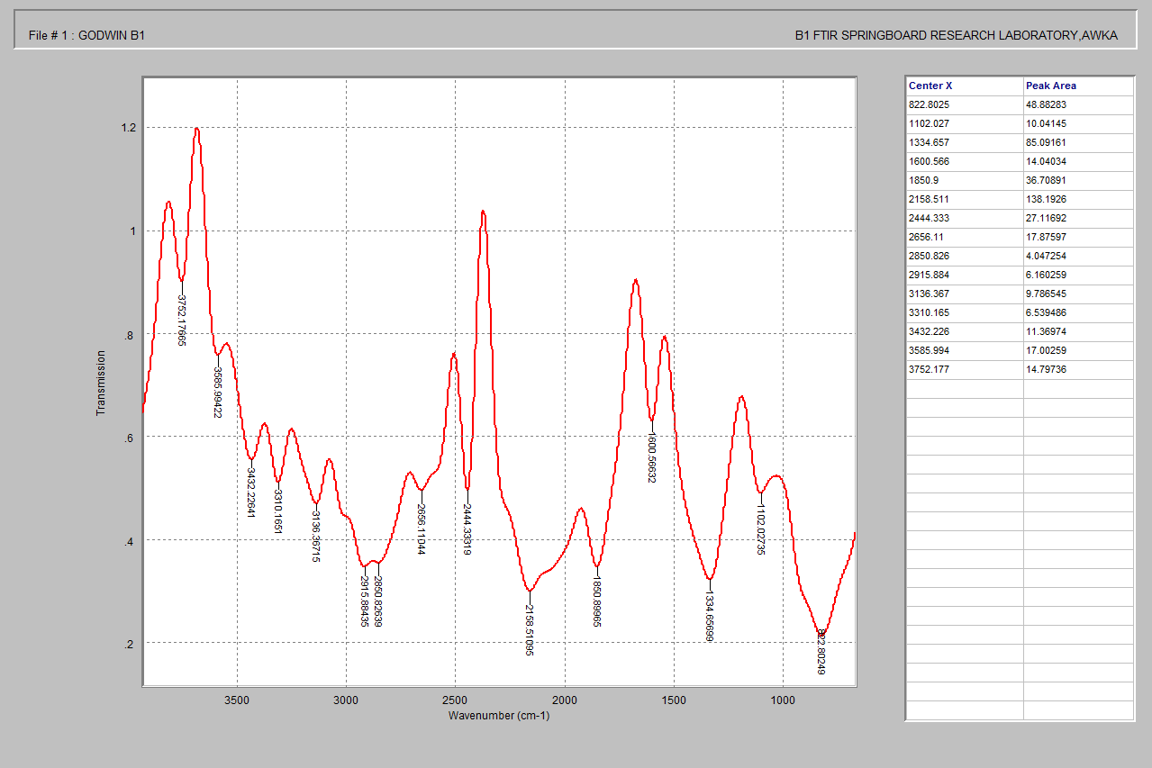
Fig. 2a: FTIR spectra of Raw Rice Husk

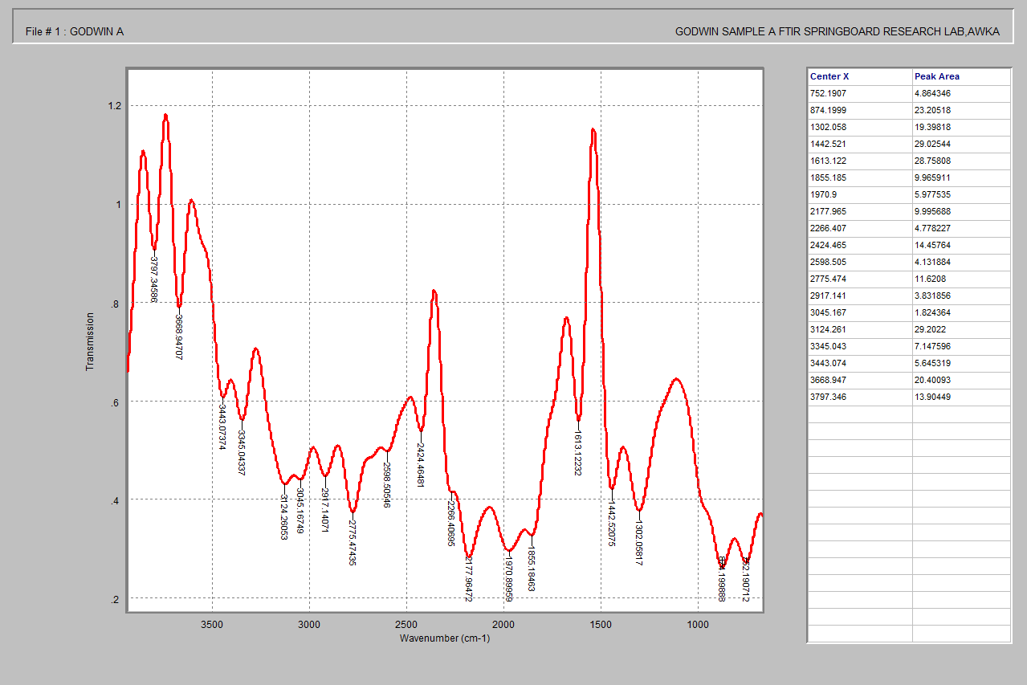
Fig. 2b: FTIR spectra of ARH before adsorption

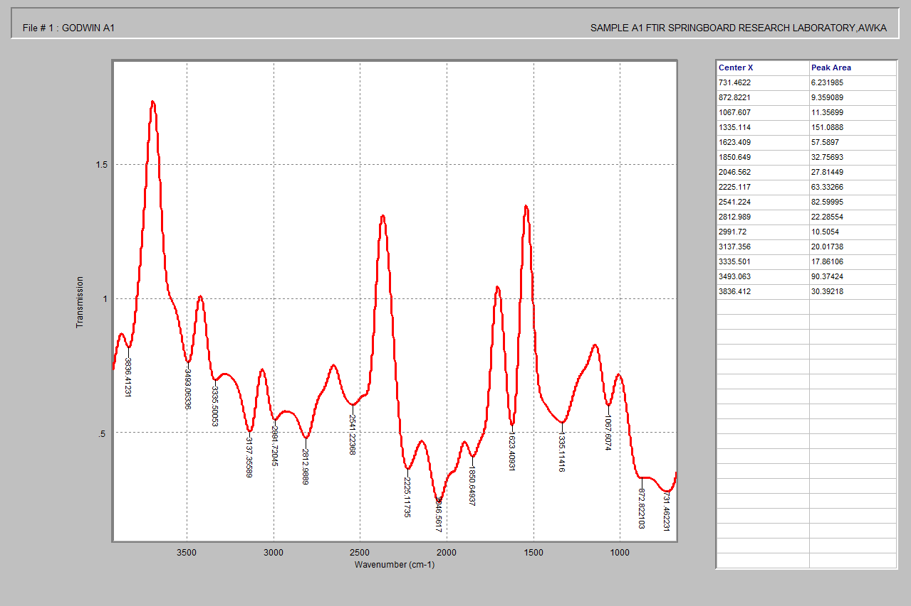
Fig. c2: FTIR spectra of ARH after adsorption

.
Table 2: FTIR Peak Assignments for RH, ARH, and ARH–AMP
Wavenumber (cm⁻¹) | Functional Group | Assignment | Observation |  |  | Interpretation
Wavenumber (cm⁻¹) | Functional Group | Assignment | RH | ARH | ARH–AMP | Interpretation
3600–3200 | –OH stretching | Hydroxyl (cellulose, lignin, water) | Broad, intense | Reduced/shifted | Further shifted | H-bonding with ampicillin
2920–2850 | C–H stretching | Aliphatic groups | Present | Reduced | Slight shift | Organic removal + interaction
~1820 | C=O (ester) | Ester/anhydride | Present | Reduced | Shifted | Interaction with β-lactam/COOH
~1621 | C=O / H–O–H | Carbonyl / adsorbed water | Moderate | Reduced | Shifted | Adsorbate binding
~1436 | Aromatic C=C | Aromatic (lignin) | Strong | Reduced | Shifted | π–π interaction with ampicillin ring
~1319 | C–H bending | Phenolic/lignin | Present | Reduced | Slight shift | Structural modification
1100–1000 | Si–O–Si | Silica network | Strong | Stronger/sharper | Slight shift | Surface interaction
~784 | Si–O | Silica symmetric vibration | Moderate | Enhanced | Slight shift | Silica involvement

3.1.2 SEM analysis
The SEM image of untreated rice husk (fig. 3) exhibits a relatively smooth and compact structure with limited porosity. Only sparse, shallow surface features such as faint ridges and minimal depressions were visible. The matrix appears consolidated, suggesting the presence of unaltered structural components including cellulose, hemicellulose, lignin, and mineral inclusions. This morphology reflects the inherent integrity of the raw biomass and indicates minimal accessibility for surface-mediated processes such as adsorption or catalytic interaction. In contrast, the acid-modified rice husk reveals a highly irregular and porous surface. The micrograph shows an extensive network of interconnected pores, ranging from micrometer to sub-micrometer scale, uniformly distributed across the sample. The surface is significantly roughened, featuring fragmented edges, deep valleys, and intricate protrusions—hallmarks of acid-induced etching and dissolution.
The change in morphology in SEM images could indicate a significant alteration in the material's composition or arrangement (Sivakumar, 2025). These morphological changes are attributed to the degradation and removal of amorphous constituents like hemicellulose, lignin, and soluble inorganic materials, thereby exposing a more resilient carbonaceous or silica-rich framework.
The acid treatment induced dramatic structural reconfiguration of the rice husk, transitioning from a compact, low-porosity surface to one with high surface roughness and extensive pore formation. The transformation from a minimally porous material to one with high surface heterogeneity significantly enhances the functional attributes of the rice husk. The modified surface offers increased accessibility to target molecules, making it well-suited for applications that demand high specific surface area, such as pollutant adsorption, heterogeneous catalysis, and composite reinforcement. The successful surface activation suggests promising potential for environmental remediation and advanced material engineering (Kumar et. al, 2025).

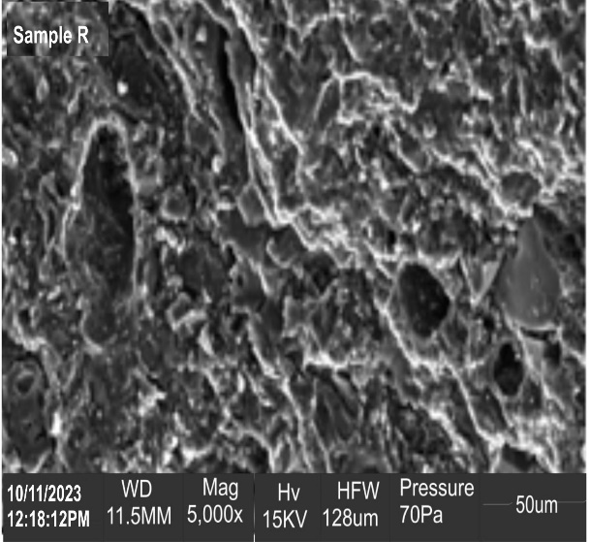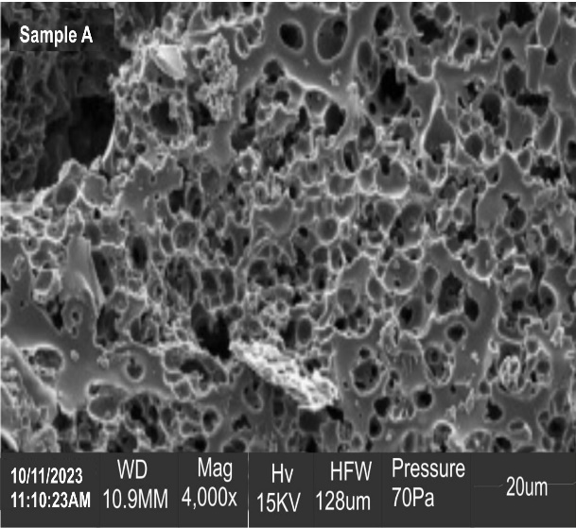
a b
Fig 3: SEM microgram of (a)Raw and (b) acid-modified Rice Husk

3.1.3 PROPOSED MECHANISM FOR ACID MODIFICATION
The acid modification transformed rice husk from a dense, mineral-containing biomass into a clean, porous, functionalized adsorbent with abundant active sites, enhanced surface area, and improved affinity for antibiotic molecules like ampicillin. The mechanism can be described in stages:
i. Removal of Inorganic Impurities (Demineralization)
Raw rice husk contains minerals such as K⁺, Ca²⁺, Mg²⁺, and Fe³⁺ embedded within the lignocellulosic–silica matrix. Acid treatment protonates and dissolves these impurities; this cleans the pore structure and exposes previously blocked adsorption sites.
$M^{n+}+{SO}_{4}^{2-}→{M{SO}_{4}}_{\left(soluble\right)}$ 17ii. Hydrolysis of Lignocellulosic Components
Rice husk is majorly composed of cellulose, hemicellulose, and lignin. H₂SO₄ hydrolyses glycosidic bonds in hemicellulose and partially disrupts cellulose, leading to the breakdown of rigid biomass structure, formation of micro- and mesopores and increased surface area
$C-O-C+H^{+}→Fragmented chains$ 18
ii. Dehydration Effects
As a dehydrating agent, H₂SO₄ removes water molecules from the biomass matrix, promoting partial carbonization. This increases structural stability and produces a more porous carbon-rich framework.
$C-CH-OH → -C-C- + H_{2}O$ 19
iii. Introduction of Surface Functional Groups
Acid modification introduces oxygen-containing functional groups: hydroxyl (–OH) and Sulfonic groups (–SO₃H, in this case). These groups arise from oxidation and sulfonation reactions and increase surface polarity and active binding sites for ampicillin
$R-H + H_{2}SO_{4}→R-SO_{3}H+H_{2}O$ 20
iv. Surface Charge Modification
Acid treatment protonates the surface:
$-OH+H^{+}→-{OH_{2}}^{+}$ 21
At acidic to neutral pH, the surface becomes positively charged, which promotes electrostatic attraction with negatively charged ampicillin species
v. Resulting Adsorption Mechanisms for Ampicillin
The modified rice husk (ARH) would therefore adsorb ampicillin via multiple interactions:
- Electrostatic attraction (between charged surface and ionized ampicillin)
- Hydrogen bonding (–OH / –COOH with ampicillin functional groups)
- π–π interactions (between aromatic structures in carbonized matrix and ampicillin rings)
- Surface complexation/chemisorption (consistent with pseudo-second-order kinetics)

3.2 Effect of Adsorption Parameters
3.2.1 Effect of Contact Time
Figure 4 illustrates the influence of contact time on the adsorption of ampicillin onto ARH. The results reveal that adsorption efficiency was strongly time-dependent, particularly during the initial stage. Removal efficiency rose sharply from 0% at 0 s to ~60% within 5 mins, then increased further to ~72% at 10 min and ~80% at 15 min. This rapid uptake is attributed to the abundance of vacant active sites on the ARH surface and the steep concentration gradient between the solution and adsorbent, which enhanced mass transfer and adsorption kinetics.
Adsorption continued to rise gradually, reaching a maximum of ~82% at 30 min. The slower increase beyond the initial stage reflects progressive site occupation, reduced availability of active sites, and increased diffusion resistance. Such behaviour is typical of adsorption systems, where rapid uptake occurs initially, followed by a slower approach to equilibrium as sites become saturated (Al-Joubory et. al, 2023, Ali et. al, 2021).
Beyond 30 min, adsorption efficiency slightly declined and stabilized between ~75–80% from 60 to 180 min, indicating equilibrium was achieved at ~30 min. At equilibrium, adsorption and desorption rates balance, resulting in no net change in capacity—a hallmark of adsorption processes (Kaur et. al, 2021).
The rapid equilibrium observed here highlights the enhanced adsorption properties conferred by acid modification, which increases surface area, pore accessibility, and the density of functional groups, thereby improving affinity for pharmaceutical molecules. Similar findings have been reported for rice husk-based adsorbents, where equilibrium is reached quickly due to improved textural and reactive properties (Romero-Hernandez et. al, 2024; Adamu et. al, 2025)
From a practical standpoint, the fast adsorption rate is advantageous for wastewater treatment, as it minimizes treatment time and enhances efficiency. Based on these results, the optimum contact time for ampicillin adsorption onto ARH is 30 min, corresponding to the maximum removal efficiency observed.

Fig 4: Effects of time on the mean percentage removal of ampicillin

3.2.2 Effect of ARH dosage
Fig. 5 illustrates the effect of ARH dosage on ampicillin removal. The adsorbent dosage demonstrates a pronounced negative influence on ampicillin removal efficiency, with the removal rate declining sharply from over 85% to approximately 72% as the dosage increases from 1.0 to 5.0 g/L. This trend is typically attributed to the phenomenon of adsorbent oversupply, which can promote particle aggregation and subsequently reduce the effective surface area available for adsorption. Such aggregation may hinder mass transfer between the solute molecules and active binding sites, thereby diminishing overall adsorption performance. These findings suggest that lower dosages of acid-modified rice husk (ARH) are more effective (Nausheen et. al, 2020), likely due to enhanced utilization of surface sites and improved solute–adsorbent interactions (Kuppusamy et. al, 2026).

Fig 5: Effects of ARH dosage on the mean percentage removal of ampicillin

3.2.3 Effect of Initial Ampicillin Concentration
The influence of initial ampicillin concentration on its removal is presented in fig. 6. The percentage removal of ampicillin showed a clear positive correlation with increasing initial ampicillin concentration up to a certain point (approximately 4.3 mg/L), after which it began to slightly decline. Initially, as the concentration of ampicillin increased, the driving force for mass transfer from the solution to the adsorbent surface also increased, leading to a higher percentage of removal. This suggests that at lower concentrations, active sites on the adsorbent are readily available and utilized effectively. The subsequent slight decrease in removal efficiency at very high concentrations might be attributed to the saturation of available adsorption sites on the acid-modified rice husk, where the adsorbent capacity becomes limiting relative to the number of ampicillin molecules in solution (Gupta et. al, S., 2025). This indicates an optimal initial concentration range where the adsorbent is most effective in removing ampicillin.

Fig 6: Effects of concentration on the mean percentage removal of ampicillin

3.3. Response Surface Optimization and Model Validation

Table 3 presents the design matrix together with the experimentally determined percentage removal efficiencies and the corresponding values predicted by the developed quadratic model. The predicted values ranged from 55.78% and 90.10% closely aligning with the experimental percentage removal efficiencies that varied between 52.91% to 89.93%. This close agreement between predicted and observed values robustly affirms the adequacy and predictive capability of the quadratic model in describing the complex behaviour of the ampicillin adsorption process. The highest removal efficiency observed was 89.93% (Run 1: A = 105 min, B = 1 g, C = 3 mg/L), with the model predicting a very similar value of 90.10%. This high removal, achieved at a lower contact time and moderate initial concentration with an optimized dosage, suggests an efficient initial diffusion gradient and sufficient availability of active adsorption sites. Conversely, the minimum removal efficiency of 52.91% was recorded in Run 6 (A = 105 min, B = 3 g, C = 5mg/L). This outcome is likely attributable to an insufficient quantity of adsorbent at high concentration levels, leading to incomplete ampicillin uptake and saturation of available sites. The consistent removal efficiencies observed across the centre point runs (Runs 8, 9, 10, 12, 14, 16), ranging from 77.6% to 79.3%, underscore the good reproducibility of the experimental methodology and the inherent precision of the adsorption measurements.

This comparison between the experimental and RSM-predicted responses shows good agreement, with most deviations within ±5%, indicating high predictive accuracy of the model. The average percentage error was approximately 2.4%, confirming the adequacy of the regression model in describing the adsorption process. However, a higher deviation was observed for one experimental run (Run 3), where the error reached 14.47%. This discrepancy may be attributed to experimental variability or stronger interaction effects at extreme factor levels, which are not fully captured by the quadratic model. Despite this, the overall consistency between predicted and experimental values demonstrates that the model is reliable for optimization within the studied range. The predictive power of the RSM model was further demonstrated by the plot of the predicted percentage removal efficiency against the experimental percentage removal efficiency (fig 7a), which yielded high coefficient of determination R² of 0.9669
To assess the robustness of the regression model describing ampicillin removal by acid-modified rice husk (ARH), a residual plot analysis was performed. As shown in Figure 7b, the residuals are minimal and are randomly dispersed around the zero line, indicating a strong agreement between the model’s predictions and the observed experimental data. This random distribution suggests that key regression assumptions—linearity, independence, and homoscedasticity—are reasonably upheld. Notably, the plot reveals no discernible patterns such as curvature or funnel-shaped spread, which would typically signal model misspecification due to non-linearity or heteroscedasticity. The even spread of residuals implies that the model does not systematically overpredict or underpredict ampicillin removal efficiency across the range of fitted values.). Consequently, the established model can be confidently employed to predict ampicillin adsorption across a wide range of operational conditions and to guide subsequent process optimization efforts.

Table 3: Design matrix for ampicillin removal
SN | A | B | C | EXP | RSM
1 | 0 | - α | 0 | 89.93 | 90.10
2 | +1 | -1 | +1 | 84.31 | 86.88
3 | +1 | +1 | -1 | 54.39 | 62.26
4 | +α | 0 | 0 | 75.74 | 75.50
5 | +1 | -1 | -1 | 74.59 | 72.19
6 | 0 | 0 | + α | 52.91 | 55.78
7 | - α | 0 | 0 | 78.18 | 80.56
8 | 0 | 0 | 0 | 77.63 | 77.83
9 | 0 | 0 | 0 | 76.28 | 77.83
10 | 0 | 0 | 0 | 77.63 | 77.83
11 | -1 | +1 | +1 | 80.59 | 81.46
12 | 0 | 0 | 0 | 77.63 | 77.83
13 | +1 | +1 | +1 | 81.67 | 80.78
14 | 0 | 0 | 0 | 79.28 | 77.83
15 | -1 | +1 | -1 | 75.39 | 71.29
16 | 0 | 0 | 0 | 77.63 | 77.83
17 | -1 | -1 | -1 | 78.14 | 77.50
18 | 0 | 0 | +α | 81.99 | 80.65
19 | 0 | +α | 0 | 76.43 | 77.79
20 | -1 | -1 | +1 | 85.25 | 83.85
Fig. 7a: Plot of Residual versus predicted response versus Experimental response

Fig. 7b: Plot of Residual versus predicted values

3.4 Analysis of Variance (ANOVA)
The statistical significance and predictive power of the RSM model were further corroborated by the comprehensive ANOVA, with results summarized in Table 4. The analysis yielded high coefficient of determination (R²) and adjusted R² values of 0.966 and 0.9354 respectively. The final empirical model's equation for percentage removal of ampicillin Y response is given as equations17. The synergetic and antagonistic effects of the respective variables were informed by the positive and negative signs before the terms (Garba and Afidah, 2014)
% removal = 68.8 + 21.44A - 0.113B - 0.840C - 3.295A² + 0.000164B² + 0.00325C² + 0.0232A*B + 0.0672A*C + 0.000068 B*C 17
The model was highly significant (p < 0.001), explaining 96.60% of the total variation in ampicillin removal. Moreover, the lack-of-fit test was not significant (p = 0.180), indicating that the model adequately fits the experimental data and is predictive within the studied range.
Among the linear terms, the initial concentration of ampicillin (C) was the most influential factor (p < 0.001), contributing 52.96% to the total variation, underscoring its dominant role in determining removal efficiency. Adsorbent dosage also showed a strong linear effect (p < 0.001; 14.84% contribution), likely due to the increased availability of active binding sites at higher doses. Contact time had a statistically significant but smaller linear effect (p = 0.044), contributing only 1.81%, suggesting that its impact is less substantial compared to concentration and dosage.
The quadratic terms were collectively significant (p < 0.001), revealing non-linear relationships between the variables and removal efficiency. In particular, the quadratic effects of concentration (C²) and dosage (B²) were highly significant (p < 0.001 and p = 0.002, respectively), contributing 11.66% and 10.02% of the variation. These results indicate that increases in concentration or dosage beyond certain thresholds may not proportionally improve removal, pointing to the existence of optimal operating ranges. In contrast, the quadratic effect of time (A²) was not significant (p = 0.827), reinforcing its primarily linear influence.
Two-way interaction effects were also significant overall (p = 0.021). Notably, the interaction between time and concentration was statistically significant (p = 0.007; 3.91% contribution), suggesting that the optimal contact time is dependent on the initial ampicillin concentration. This interaction highlights the importance of co-optimizing these two parameters. Conversely, interactions between time and dosage (p = 0.103) and dosage and concentration (p = 0.442) were not significant, implying that their effects are largely independent.

Table 4: Analysis of Variance for the % removal of ampicillin using ARH

Source | DF | Seq SS | % Contribution | Adj SS | Adj MS | F-Value | P-Value
Model | 9 | 1197.05 | 96.69 | 1197.05 | 133.005 | 31.54 | 0
Linear | 3 | 862.62 | 69.61 | 862.62 | 287.541 | 68.2 | 0
A | 1 | 22.43 | 1.81 | 22.43 | 22.425 | 5.32 | 0.044
B | 1 | 183.94 | 14.84 | 183.94 | 183.941 | 43.63 | 0
C | 1 | 656.26 | 52.96 | 656.26 | 656.256 | 155.64 | 0
Square | 3 | 269.66 | 21.76 | 269.66 | 89.887 | 21.32 | 0
A² | 1 | 1.02 | 0.08 | 0.21 | 0.211 | 0.05 | 0.827
B² | 1 | 124.14 | 10.02 | 71.84 | 71.841 | 17.04 | 0.002
C² | 1 | 144.5 | 11.66 | 144.5 | 144.496 | 34.27 | 0
2-Way Interaction | 3 | 64.76 | 5.23 | 64.76 | 21.588 | 5.12 | 0.021
A*B | 1 | 13.6 | 1.10 | 13.6 | 13.598 | 3.23 | 0.103
A*C | 1 | 48.46 | 3.91 | 48.46 | 48.462 | 11.49 | 0.007
B*C | 1 | 2.7 | 0.22 | 2.7 | 2.703 | 0.64 | 0.442
Error | 10 | 42.16 | 3.31 | 42.16 | 4.216
Lack-of-Fit | 5 | 37.63 | 3.04 | 37.63 | 7.527 | 0.831 | 0.18
Pure Error | 5 | 4.53 | 0.27 | 4.53 | 0.906
Total | 19 | 1239.2 | 100

3.5 Response surface plots and desirability function results
To comprehensively understand the interactive effects of the process parameters—contact time, adsorbent dosage and initial ampicillin concentration—on the removal efficiency of ampicillin using acid-modified rice husk (ARH), three-dimensional (3D) response surface plots were generated. These plots visually represent the relationships between paired variables while holding the third constant at its specified hold value (time = 105, dosage = 3, conc = 3), thereby aiding in the identification of optimal operating conditions for maximizing ampicillin removal.
The plot in fig 8, shows how % removal varies with changes in time and dosage, while initial concentration is held constant at 3. The surface slopes upward with increasing contact time, indicating that longer exposure enhances removal efficiency—likely due to more time for solute–adsorbent interactions to occur. In contrast, the surface slopes downward as dosage increases, confirming the earlier finding that higher adsorbent dosages reduce removal efficiency. The curvature of the surface suggests a nonlinear relationship, especially with dosage. This supports the residual analysis, which hinted at some nonlinear effects. The plot does not show a flat plane, which means both variables have interactive and dynamic effects on the response. For example, at low dosage, increasing time significantly boosts removal. At high dosage, even long contact times fail to achieve high removal, likely due to adsorbent oversaturation or aggregation. The optimal region appears to be at low dosage (around 1–2 g/L) and high contact time (150–200 min), where removal efficiency peaks. This suggests that maximizing time while minimizing dosage yields the best performance—an important insight for cost-effective process design. The surface plot illustrating the interaction between contact time and initial ampicillin concentration (fig. 9) reveals a clear synergistic effect on removal efficiency. As the initial ampicillin concentration increases, the removal efficiency generally rises, with this effect becoming particularly pronounced when coupled with sufficiently long contact times. This visual observation directly supports the significant two-way interaction identified in the ANOVA between time and concentration (P=0.007). The plot suggests that while contact time alone might not be the sole dominant factor, its impact on ampicillin removal becomes critical in the presence of higher initial concentrations, reflecting a kinetic dependency where a greater number of ampicillin molecules requires a longer duration to achieve equilibrium adsorption. The interaction between adsorbent dosage and initial ampicillin concentration (fig 10) is characterized by a pronounced curvature on the response surface, indicating a clear non-linear behaviour. At lower adsorbent dosages, the removal efficiency exhibits higher sensitivity to changes in initial ampicillin concentration. However, increasing the adsorbent dosage effectively mitigates this sensitivity by providing a greater number of active binding sites, thereby enhancing the overall removal capacity. This observed behaviour corresponds well with the significant quadratic effects of both initial concentration (A², P<0.001, 11.66% contribution) and adsorbent dosage (C², P=0.002, 10.02% contribution) as identified in the ANOVA. These non-linearities underscore the existence of optimal ranges for each parameter, where excessively high initial concentrations may overwhelm the system's adsorption capacity unless adequately balanced with a correspondingly increased adsorbent dosage.

Fig 8: Surface Plot of % removal vs time and ARH dosage

Fig 9: Surface Plot of % removal vs time and Concentration

Fig 10: Surface Plot of % removal vs ARH dosage and Concentration

3.6 Optimal conditions for maximum removal efficiency
The RSM optimization plots (fig. 11), identified a time of 181 min, the lowest tested dosage of 1.000 g and an initial ampicillin concentration of 4.4747 mg/L as the optimal conditions, under which a maximum predicted removal efficiency of 94.9894% was achieved. The associated desirability score of 1.0000 indicates perfect agreement between the model's prediction and the defined optimization target. The attainment of such high removal efficiency at the minimum dosage highlights the superior adsorptive capacity of ARH, underscoring its economic and environmental viability for large-scale applications. Notably, the efficiency profile demonstrated a marked decline at higher dosages, indicative of active site saturation and resource inefficiency beyond the optimal range. Likewise, the concentration-response trend exhibited a typical plateau behaviour at elevated levels, suggesting limited enhancement in removal performance beyond approximately 4.47 mg/L due to surface saturation constraints. In contrast, contact time exhibited a more gradual influence, with model projections suggesting an optimal value near 180 minutes, consistent with fixed-time assumptions used in constant-condition experiments. These results collectively affirm the effectiveness of ARH as a low-cost, sustainable adsorbent for the remediation of pharmaceutical-contaminated wastewater. The consistency of the optimization outcome across multiple variable interactions further supports the robustness of the RSM model, demonstrating its practical utility in fine-tuning process parameters for maximal adsorption performance.

Fig. 11: The response surface optimization plots

3.7 Adsorption Isotherms
To understand the interaction between ampicillin and the acid-modified rice husk (ARH) at equilibrium, experimental adsorption data were fitted to three common isotherm models (fig 12): Langmuir, Freundlich, and Dubinin-Radushkevich (D-R). The parameters obtained from these models, along with their respective coefficients of determination (R²), are summarized in Table 5.
The Langmuir isotherm model describes monolayer adsorption onto a homogeneous surface with a finite number of identical adsorption sites, assuming no interaction between adsorbed molecules. For the ARH, the Langmuir model yielded an R² value of 0.8792. The maximum monolayer adsorption capacity (q_{m}​) was found to be 0.0445 mg/L. The Langmuir constant (K_{L}​), related to the adsorption energy and affinity of the binding sites, was 2.502. The dimensionless separation factor (R_{L}​) was calculated as 0.2855. Since 0<R_{L}​<1, this indicates that the adsorption of ampicillin onto the acid-modified rice husk is a favourable process under the experimental conditions. However, the relatively lower R² value compared to the Freundlich and D-R models suggests that the Langmuir model may not fully capture the complexity of the adsorption mechanism.
The Freundlich isotherm is an empirical model that describes heterogeneous adsorption on surfaces with non-uniform adsorption energies, allowing for multilayer adsorption. This model provided the best fit to the experimental data, with an R² value of 0.9356. The Freundlich constant (K_{F}​), indicative of adsorption capacity, was 5.83. The heterogeneity factor (n) was determined to be 0.3275. A value of n between 0 and 1 (or 1/n greater than 1) indicates a heterogeneous surface, which is consistent with the SEM observations showing an irregular and porous morphology of the acid-modified rice husk. Furthermore, for favourable adsorption, the value of n should be greater than 1, or 1/n should be less than 1. In this case, n=0.327531, meaning 1/n≈3.05. This suggests that the adsorption is not highly favourable in terms of intensity across all sites, or perhaps indicates a strong binding at initial stages followed by weaker binding. The higher R² for the Freundlich model implies that the adsorption of ampicillin onto ARH is more accurately described as occurring on a heterogeneous surface with varying adsorption energies, rather than a uniform monolayer.
The Dubinin-Radushkevich (D-R) isotherm is generally applied to express the adsorption mechanism following a pore-filling process, applicable to both homogeneous and heterogeneous surfaces. It is particularly useful for distinguishing between physical and chemical adsorption (Yeo et. al. 2023). The D-R model exhibited a good fit with an R² value of 0.9268. The saturation adsorption capacity (q_{m}) from this model was 1.957mg/L, which differs significantly from the q_{m}​ obtained from the Langmuir model, reflecting the different assumptions of each model regarding the adsorption mechanism. The mean free energy of adsorption (E) was calculated to be 605.65 J/mol (or 0.606kJ/mol). The magnitude of E provides insight into the nature of the adsorption process: If E<8 kJ/mol, the adsorption is typically considered physical adsorption (physisorption); if 8≤E≤16 kJ/mol, it suggests ion exchange; if E>16 kJ/mol, it indicates chemical adsorption (chemisorption). Given that the calculated E value (0.606 kJ/mol) is significantly less than 8 kJ/mol, the adsorption of ampicillin onto the acid-modified rice husk is predominantly a physical adsorption process. This implies that weak forces, such as an der Waals forces, dipole-dipole interactions, or hydrogen bonding, are primarily responsible for the uptake of ampicillin by the ARH.
Based on the R² values, the Freundlich isotherm model provides the best description of the ampicillin adsorption equilibrium onto acid-modified rice husk (R²=0.9356), followed closely by the Dubinin-Radushkevich model (R²=0.9268), and then the Langmuir model (R²=0.8792). The superior fit of the Freundlich model suggests that the ARH surface is heterogeneous, consistent with the complex and irregular porous structure observed in the SEM analysis. The D-R model further supports a physical adsorption mechanism, indicating that ampicillin molecules are primarily bound to the ARH surface through weak intermolecular forces rather than strong chemical bonds. The favourable R_{L}​ value from the Langmuir model, despite its lower R², still confirms the viability of ARH as an adsorbent for ampicillin.

Table 5: Isotherm parameters for adsorption of ampicillin
Model | Langmuir |  |  |  | Freundlich |  |  | DR
Parameters | q_{m}(mg/L) | K_{L} | R_{L} | R² | n | K_{F} | R² | q_{m} (mg/L) | E (J) | R²
Parameters | 0.0445 | 2.5025 | 0.2855 | 0.8792 | 0.3275 | 5.8292 | 0.9356 | 1.9571 | 605.65 | 0.9268

a

b

c
Fig 12: Isotherm plots for adsorption on (a) Langmuir (b) Freundlich and (c) D-R

3.8 Kinetic Studies
The kinetic parameters—calculated adsorption capacity q_{e}, rate constants k, and correlation coefficients R²—are summarized in Table 6. The pseudo first-order model (fig 13a) yielded a lower coefficient of determination (R² = 0.724), indicating poor descriptive power and significant deviation from experimental data. The pseudo second-order model (fig 13b), however provided an exceptionally good fit to the experimental data, with an (R²) value of 0.9964, indicating near-perfect agreement between observed and predicted values.
The pseudo-second-order model assumes that the adsorption rate is proportional to the square of the number of unoccupied sites (Ho & McKay, 1999; Sangoremi, 2025). However, despite its widespread use, the model is fundamentally empirical and does not inherently imply chemisorption, as it can successfully describe systems governed by diffusion and other physical processes (Hubbe, et al., 2019; Plazinski et al., 2009; Simonin, 2016). Furthermore, adsorption kinetics in heterogeneous systems are often influenced by intraparticle diffusion and surface heterogeneity, which can lead to pseudo-second-order behavior even in physisorption-dominated systems (Boyd et al., 1947; Foo & Hameed, 2010).

This finding is consistent with earlier research where pseudo-second-order kinetics well described ampicillin removal efficiency from aqueous solution by polydopamine/zirconium(iv) iodate: optimization by response surface methodology (Rahman and Varshneya, 2020). Although the numerical values of rate constants are not directly comparable due to different units and formulations, the relatively high value of k in the pseudo-second-order model generally implies faster adsorption kinetics under this model. The pseudo-second-order model predicts a much higher equilibrium adsorption capacity compared to the pseudo-first-order. This suggests that the pseudo-second-order model better accounts for the actual adsorption behaviour of ampicillin onto ARH.
Although the data fits the Pseudo-Second-Order kinetic model—frequently associated with chemisorption—the low free energy of adsorption (0.6 kJ/mol) and the fit to the Freundlich isotherm suggest that the rate is limited by the availability of surface sites or a complex diffusion-reaction mechanism, rather than a true chemical reaction. It is therefore a physically-driven process controlled by surface site heterogeneity, as suggested by Plazinski et al., 2009.
These findings align well with prior SEM characterization of the acid-modified rice husk, which revealed a highly porous and rough surface. The acid treatment substantially increased the number of reactive adsorption sites, removed amorphous lignocellulosic content, and exposed silica-rich frameworks. The kinetic behaviour observed validates ARH as a viable, low-cost, and efficient biosorbent for ampicillin removal in wastewater treatment applications. Its fast equilibrium attainment and high adsorption capacity support scalable implementation in pharmaceutical effluent management, especially in regions affected by antimicrobial contamination.

Table 6. Kinetic parameters for ampicillin adsorption onto ARH

Parameters | Pseudo first order | Pseudo Second order
q_{e (calc)} (mg/g) | 0.0022 | 0.1872
k | 0.005min⁻¹ | 10.293 (l/mg/min)
R² | 0.7057 | 1

A

b
Fig 13: (a) Pseudo-first order, (b) Pseudo-second order plot for adsorption of ampicillin onto ARH

3.9. Diffusion Modelling Analysis
To better understand the mass transfer dynamics governing ampicillin adsorption, diffusion-based models were applied: Intraparticle diffusion and Ritchie–Boyd–Ruckenstein (Richenberg) diffusion. Diffusion models help determine whether the adsorption process is controlled by film diffusion (mass transfer from the bulk solution to the external surface of the adsorbent), intraparticle diffusion (mass transfer within the pores of the adsorbent), or a combination of both.The intraparticle diffusion model (often described by Weber–Morris) predicts a linear relationship between adsorption quantity and the square root of time if diffusion inside the pores is sole the rate-limiting step. The plot is shown in fig. 14a, with an R² value of 0.6373. This suggests moderate contribution of intraparticle diffusion to the overall rate. However, this is not close enough to unity to be considered the dominant mechanism. The constant 'C' in the intraparticle diffusion model provides an indication of the boundary layer thickness. The intercept (C = 0.131) is a non-zero intercept signifying that boundary layer (film) diffusion also plays a role, meaning the process doesn’t occur entirely within the adsorbent particles. Since C is not zero, it further supports that intraparticle diffusion is not the only controlling step. The coefficient of determination R² for Richenberg's model is 0.8628. This value is significantly higher than that for the intraparticle diffusion model, indicating a better fit of the experimental data to Richenberg's model. The better fit of the Richenberg model implies that film diffusion (boundary layer resistance) plays a significant role in the adsorption of ampicillin onto acid-modified rice husk. The diffusion modelling results suggest that the adsorption process involves multiple diffusion mechanisms (fig. 14), with film diffusion being more dominant than intra-particle diffusion. Acid-modified rice husk's surface properties may favour fast adsorption at the boundary layer, with limited diffusion into pores. These observations align with prior studies on antibiotic adsorption using biomass-derived adsorbents (Aymar et al., 2019; Wang et al., 2021). Comparable results were also reported for ampicillin removal with modified clays and functionalized carbon materials, where both surface interactions and pore diffusion played significant roles in governing the adsorption process (Haciosmanoğlu et al., 2022). Diffusion models complement kinetic models by breaking down the physical transport steps. Even if chemisorption is the rate-limiting reaction step, the overall rate can still be influenced by how quickly the adsorbate reaches the active sites via diffusion. The present diffusion analysis suggests that while chemisorption governs the reaction rate, the transport of ampicillin to the adsorbent surface and into its pores are also significant factors affecting the overall adsorption speed. The acid-modified rice husk possesses favourable diffusion pathways, thanks to its porous architecture. While external film diffusion initiates the adsorption process, internal diffusion dominates the rate over time, making this biosorbent effective for capturing ampicillin in real-world water treatment scenarios.

a b
Fig 14: (a) Intra particle diffusion plot and (b) Richenberg model for adsorption of ampicillin onto ARH

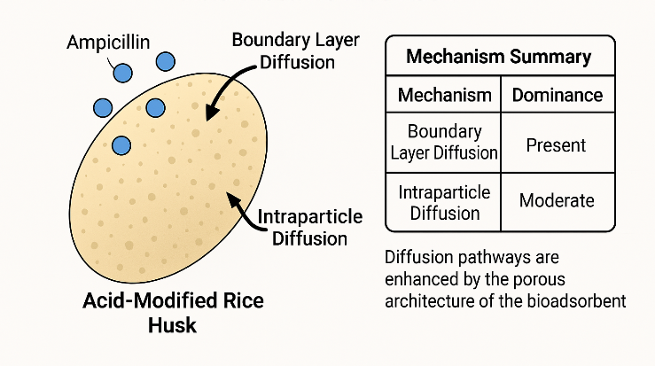
Fig. 15: Diffusion modelling of Ampicillin removal using ARH

3.10 Thermodynamics Analysis
Thermodynamic parameters—namely Gibbs free energy change (ΔG°), enthalpy change (ΔH°), and entropy change (ΔS°) were calculated to assess the spontaneity, energy change, and degree of disorder involved in the adsorption of ampicillin onto acid-modified rice husk (ARH). These values, summarized in Table 7 , provide crucial insights into the feasibility and mechanism of the adsorption process. The Van’t Hoff plot (Figure 16 ), which illustrates the relationship between ln Kc and 1/T, displays a linear trend, indicating that the assumptions of the Van’t Hoff equation hold true over the studied temperature range. The derived linearity suggests that ΔH° and ΔS° can be regarded as constant within this range. The correlation coefficient (R² = 0.8964) signifies a strong fit, meaning that approximately 89.64% of the variation in ln Kc is explained by its linear relationship with 1/T. This reinforces the suitability of the Van’t Hoff model for describing the temperature dependence of the adsorption process. All calculated ΔG° values are negative, confirming that the adsorption of ampicillin onto ARH is spontaneous at all tested temperatures. However, the values become progressively less negative as temperature increases, indicating that spontaneity decreases with rising temperature. This trend is characteristic of exothermic adsorption, where the process becomes less favourable at higher temperatures. The negative ΔH° further supports the exothermic nature of the process, implying that heat is released as ampicillin binds to the rice husk surface. Accordingly, as the temperature rises (i.e., 1/T decreases), the equilibrium constant (Kc) declines, leading to a reduction in adsorption capacity.
Enthalpy ΔH° in the range of 0 to −20 kJ/mol indicates typically physisorption (physical adsorption), which involves weak van der Waals forces or hydrogen bonding; from −20 to −80 kJ/mol indicates stronger physisorption or weak chemisorption, depending on the system and values above −80 kJ/mol show characteristic of chemisorption, involving chemical bond formation. The magnitude of ΔH° –21 kJ/mol, suggests that stronger physisorption is the dominant mechanism, potentially involving weak interactions such as hydrogen bonding or van der Waals forces. Zhu et al., 2010, reported ΔH° values between −10 and −30 kJ/mol for antibiotic adsorption onto activated carbon, classifying it as physical but strong adsorption while Mei et.al, Wang & Li (2007) found similar ΔH° values (~−25 kJ/mol) for adsorption of tetracycline on mesoporous silica, attributed to H-bonding and electrostatic interactions.
Additionally, the negative entropy change (ΔS° = –0.05 kJ/mol·K) indicates a decrease in randomness at the solid–liquid interface during adsorption. This reduction in disorder suggests that the adsorbed ampicillin molecules become more structured on the ARH surface, likely due to hydrogen bonding, electrostatic interactions, or confinement within pores. While some water molecules may be displaced (increasing the entropy of the surrounding water), the net system entropy decreases as a result of molecular ordering on the adsorbent surface—a typical feature of adsorption processes. In summary, the thermodynamic analysis confirms that the adsorption of ampicillin onto acid-modified rice husk is a spontaneous, exothermic, and physically driven process, governed by weak intermolecular interactions and influenced by temperature.

Table 7: Thermodynamic parameters for adsorption of ampicillin
ΔH  (kJ/mol) | ΔS (kJ/mol/K) | T (K) | ΔG (kJ/mol)
-21.17 | -0.05 | 298 | -6.02
-21.17 | -0.05 | 313 | -5.26
-21.17 | -0.05 | 338 | -3.99
-21.17 | -0.05 | 363 | -2.72
-21.17 | -0.05 | 378 | -1.96

Fig 16: Thermodynamics plot for adsorption of ampicillin

3.3.1. Comparison of Adsorption Performance with Related Studies
The adsorption performance of acid-modified rice husk (ARH) obtained in this study compares favorably with previously reported adsorbents derived from agricultural wastes. The maximum removal efficiency of approximately 94.99% observed for ampicillin is within the upper range of values reported for similar biomass-based adsorbents. For instance, rice husk ash has been reported to achieve high removal efficiency for ofloxacin under optimized conditions, while NaOH-treated rice husk activated carbons have demonstrated removal efficiencies of up to 95% for pharmaceutical contaminants.

Table 8: Comparison of Adsorption Performance with Related Studies
Adsorbent | Target Pollutant | Adsorption Capacity | Key Conditions | Model/Mechanism | Reference
Acid-modified rice husk (ARH) | Ampicillin | 94.99% | Dose ≈ 1.0 g/L; Conc ≈ 4.47 mg/L; time ≈ 180 min | Pseudo-second-order; chemisorption; multilayer interactions | This study
Rice husk ash | Ofloxacin | >85% | pH-dependent; moderate dosage | Pseudo-second-order; diffusion-controlled | Kaur et al., 2021
NaOH-treated rice husk activated carbon | Pharmaceuticals | ~80–95% removal | Alkaline activation; high surface area | Langmuir, pseudo-second-order | Romero-Hernandez et al., 2024
Activated carbon from rice husk | Azo dye (methyl orange) | >90% | Acid/thermal activation | Langmuir isotherm | Nwadibia et al., 2025
Natural nano-mineral adsorbent | Methyl orange | Efficient adsorption | Morphology-controlled | Surface adsorption + electrostatic | Wu et al. 2021
Modified agricultural waste adsorbents | Antibiotics | 70–95% removal (varies) | Surface modification improves efficiency | Chemisorption dominant | Iwuozor et al., 2021

3.1.2 Research Highlights
- Acid-modified rice husk (ARH) demonstrated high efficiency for ampicillin removal, achieving an optimized removal of ≈ 94.99% under RSM-predicted conditions, confirming its potential as a low-cost and sustainable adsorbent for real wastewater treatment applications.
- The optimized process conditions obtained through RSM provide practical design parameters for industrial and field-scale implementation.
- “The adsorbent achieved high removal efficiency (≈95%) under optimized conditions; however, the maximum adsorption capacity (qₘ = 0.0445 mg g⁻¹) is relatively low compared to many reported biosorbents. This indicates that the material is more suitable for treating low-concentration pharmaceutical contaminants rather than high-load applications.
- Adsorption kinetics followed the pseudo-second-order model (R² ≈ 0.996), indicating that the rate-limiting step is primarily governed by chemisorption involving surface functional groups.
- Equilibrium data showed favourable adsorption behaviour, best described by isotherm models (e.g., Langmuir/Freundlich), with separation factor (Rₗ < 1) confirming strong affinity between ARH and ampicillin molecules.

- Thermodynamic analysis revealed a spontaneous and exothermic process (ΔG° < 0, ΔH° ≈ −21.17 kJ/mol), with decreased randomness at the solid–solution interface (ΔS° < 0), indicating stable adsorption interactions.

3.1.3 Practical Applications
The findings of this study demonstrate that acid-modified rice husk (ARH) is an effective, low-cost, and sustainable adsorbent for the removal of ampicillin from aqueous systems. This presents several practical applications:
(a) Wastewater treatment involving pharmaceutical effluents from drug manufacturing industries, hospital wastewater containing antibiotic residues and municipal wastewater, where emerging contaminants such as antibiotics are increasingly detected. Its high adsorption efficiency makes it suitable for tertiary treatment processes aimed at polishing effluents before discharge.
(b) Rural and Decentralized Water Treatment: Due to its low cost, abundance, and simple preparation, ARH can be utilized in small-scale water purification systems in rural or low-income communities. This aligns with sustainable development goals related to clean water and environmental protection.
c) ARH-based adsorption systems can also be integrated into industrial processes for water recycling and reuse, reduction of environmental discharge loads
(d) The material can also be extended to the removal of other pharmaceutical compounds, dyes and organic pollutants and potentially heavy metals, due to functional surface groups

4. Conclusion

This study systematically investigated and confirmed acid-modified rice husk (ARH) as an effective and low-cost adsorbent for removing ampicillin from water. FTIR analysis showed that functional groups like hydroxyl, carbonyl and silicates in adsorption. The process followed pseudo-second-order kinetics (R² ≈ 0.996) and was spontaneous, exothermic, and more ordered at the solid–solution interface. Response Surface Methodology (RSM) revealed significant effects of dosage, concentration, and time, with an optimal removal efficiency of 94.99% at minimal ARH usage. These results establish ARH as a sustainable and efficient adsorbent for pharmaceutical wastewater treatment.
While the acid-modified rice husk (ARH) demonstrates significant potential for the adsorptive removal of ampicillin, several constraints warrant consideration for future research. The observed adsorption capacity remains relatively modest. Furthermore, the absence of systematic regeneration and desorptive cycles limits the assessment of the adsorbent's long-term stability and economic viability for large-scale applications. A comprehensive cost-benefit analysis and reusability study should be conducted to establish the material's industrial feasibility. Future work should explore acid recovery and reuse strategies to further enhance process sustainability. The RSM model predicted an optimum removal of ~95%; however, experimental validation of this optimum was not performed in the present study. Future work will focus on confirmation experiments to verify model predictions and assess reproducibility.

Disclaimer (Artificial intelligence)
Author(s) hereby declare that NO generative AI technologies such as Large Language Models (ChatGPT, COPILOT, etc.) and text-to-image generators have been used during the writing or editing of this manuscript.

References

- Abdu, N., Abdullahi, M., & Yusuf, A. (2021). Kinetics and thermodynamics of nitrate adsorption by biochar derived from maize stalk. EQA - International Journal of Environmental Quality, 41, 17–32.
- Abugu, H. O., Alum, O. L., Ihedioha, J. N., Ezugwu, A. L., Ucheana, I. A., Ali, I. J., & Eze, S. I. (2023). Sequestration of Pb²⁺ from aqueous solution using bio-based alkaline modified sorbent from waste Irvingia gabonensis seed husk. Water Practice and Technology, 18(11), 2495–2513. https://doi.org/10.2166/wpt.2023.170
- Abugu, H. O., Eze, S. I., Ezugwu, A. L., Ali, I. J., & Ihedioha, J. N. (2023). Chemical pretreatment of Lagenaria breviflora seeds used as biosorbents for the removal of aqueous-bound Ni²⁺. Water Practice and Technology, 18(11), 2514–2535. https://doi.org/10.2166/wpt.2023.192
- Adamu, H.I., Faruruwa, M.D., Adeyemi, M.M., & Tomori, W.B. (2025). Green Synthesized Iron Oxide Nanoparticles from Rice Husk for Ciprofloxacin and Ibuprofen Adsorption. African Journal of Advances in Science and Technology Research.
- Ahmed, M. B., Zhou, J.L., Ngo, H. H., Guo, W., & Thomaidis, N. S. (2017). Progress in the biological and chemical treatment technologies for emerging contaminant removal from wastewater: A critical review. Journal of Hazardous Materials, 323, 274–298.
- Ajala, O. A., Akinnawo, S. O., Bamisaye, A., Adedipe, D. T., Adesina, M. O., Okon-Akan, O. A., Adebusuyi, T. A., Ojedokun, A. T., Adegoke, K. A., & Bello, O. S. (2023). Adsorptive removal of antibiotic pollutants from wastewater using biomass/biochar-based adsorbents. RSC Advances, 13(7), 4678–4712.
- Akin Sahbaz, D. (2023). Enhanced Adsorption Performance Cross-Linked Chitosan/Citrus reticulata Peel Waste Composites as Low-Cost and Green Bio-Adsorbents: Kinetic, Equilibrium Isotherm, and Thermodynamic Studies. Polymers, 15(15), 3246. https://doi.org/10.3390/polym15153246
- Alawa, B., Singh, S., Chakma, S., Kishor, R., Stålsby Lundborg, C., & Diwan, V. (2025). Development of novel biochar adsorbent using agricultural waste biomass for enhanced removal of ciprofloxacin from water: Insights into the isotherm, kinetics, and thermodynamic analysis. Chemosphere, 375, 144252. https://doi.org/10.1016/j.chemosphere.2024.144252
- Al-Ghouti M.A. & Da'ana D.A.( 2020). Guidelines for the use and interpretation of adsorption isotherm models: A review. J Hazard Mater. 2020 Jul 5;393:122383. doi: 10.1016/j.jhazmat.2020.122383. Epub 2020 Feb 29. PMID: 32369889.
- Al-Joubory, T. G. H., Al-Hyali, E. A. S., & Al-Hadeethi, M. R. (2023). Study of the factors affecting the adsorption efficiency of some chemical pesticides using activated carbon at the nanoscale. International Journal of Advanced Chemistry Research, 5(1), 89–98.
- Al-Musawi, T. J., Mahdi, Z. M., & Al-Sammarraie, A. M. (2017). Kinetic modelling of antibiotics adsorption from aqueous solution using Brouers–Sotolongo fractal equation. Environmental Science and Pollution Research, 24(4), 4048–4057. https://doi.org/10.1007/s11356-016-8182-z
- Álvarez-Torrellas, S., Rodríguez, A., Ovejero, G., García, J. (2016). Comparative adsorption performance of ibuprofen and tetracycline from aqueous solution by carbonaceous materials. Chemical Engineering Journal, 283. 936-947
- Asim, N., Z. Emdadi, M. Mohammad, M. A. Yarmo, & K. Sopian. (2015). “Agricultural Solid Wastes for Green Desiccant Applications: An Overview of Research Achievements, Opportunities and Perspectives.” Journal of Cleaner Production 91:26–35. https://doi.org/10.1016/j.jclepro.2014.12.015.
- Atta, H. A., Hummadi, K. K., & M-Ridha, M. J. (2022). The application of response surface methodology and Design-Expert® for analysis of ciprofloxacin removal from aqueous solution using raw rice husk: kinetic and isotherm studies. Desalination and Water Treatment, 248, 203–216. https://www.deswater.com/DWT_articles/vol_248_papers/248_2022_203.pdf
- Balarak D, Jaafari J, Hassani G, Mahdavi Y, Tyagi I, Agarwal S, Gupta VK (2015). The use of low-cost adsorbent (Canola Residues) for the adsorption of methylene blue from aqueous solution: isotherm, kinetic and thermodynamic studies. Colloids Interface Sci Commun 7:16–19.
- Bezerra, M. A., Santelli, R. E., Oliveira, E. P., Villar, L. S., Ebling, M. C., & de M. L. G. A. L. (2008). Response surface methodology (RSM) as a tool for optimization in analytical chemistry. Talanta, 76(5), 965-976. https://doi.org/10.1016/j.talanta.2008.05.019
- Bhattacharyya, K.G. & Sharma, A. (2004). Azadirachta indica leaf powder as an effective biosorbent for dyes: a case study with aqueous Congo Red solutions, Journal of Environmental Management,71(3), 217-229
- Boyd, G. E., Adamson, A. W., & Myers, L. S. (1947). The exchange adsorption of ions from aqueous solutions by organic zeolites. II. Kinetics. Journal of the American Chemical Society, 69(11), 2836-2840.
- Crini, G. & Lichtfouse, E. (2019). Advantages and disadvantages of techniques used for wastewater treatment. Environmental Chemistry Letters, 17, 145–155.
- Darweesh, R. F. H., Zaki, R. M., Mahdy, A. & Ahmed, A. S. A., (2026). Enhanced adsorption of methylene blue (MB) dye by the MoS2/ZIF-8 composite: isotherm and kinetics studies,Mater. Adv.,7(1),338-350
- Demirtaş H, Taşar Ş, Kaya F. & Özer A (2022). Sorption of BB41 dye molecules using chitosan-based particles from aqueous solutions: A kinetic and thermodynamic evaluation. J Environ Chem Eng 10(4):108062.
- Emdadi, Z., N. Asim, M. Ambar Yarmo, M. Ebadi, M. Mohammad, & K. Sopian. (2017). “Chemically Treated Rice Husk Blends as Green Desiccant Materials for Industrial Application.” Chemical Engineering & Technology 40 (9): 1619–1629. https://doi.org/10.1002/ceat.201600105.
- Esmail, S., & S. Y.,Mohammed.(2012). Removal of Cadmium Ions from Simulated Wastewater Using Rice Husk Biosorbent” Journal of Engineering, 18(07), pp. 868–875. doi:10.31026/j.eng.2012.07.09.
- Gupta, S., Prajapati, A., & Kumar, A. (2025). Removal of anionic dyes by magnetic modified Aloe barbadensis Miller residue leaves as a bio-adsorbent using biosorption process. Green Technologies and Sustainability, 3, 100196. https://doi.org/10.1016/j.grets.2025.100196
- Hacıosmanoğlu,G. G., Martín,C. M. J., Santos,J. L., Aparicio, I. & Alonso, E. (2022), Antibiotic adsorption by natural and modified clay minerals as designer adsorbents for wastewater treatment: A comprehensive review, Journal of Environmental Management,317,
- Ho, Y. S. (2006). Review of second-order models for adsorption systems. Journal of Hazardous Materials, 136(3), 681-689.
- Hubbe, M. A., Azizian, S., and Douven, S. (2019). "Implications of apparent pseudo-second-order adsorption kinetics onto cellulosic materials: A review," BioRes. 14(3), 7582-7626.
- Ibrahim, M. M., Abubakar, M. A., & Yusuf, A. (2022). Adsorption kinetics and isotherm models: A review. Caliphate Journal of Science and Technology, 4(1), 1–10. https://www.ajol.info/index.php/cajost/article/view/221289
- Iwuozor, K. O., Ighalo, J. O., Emenike, E. C., Ogunfowora, L. A., & Igwegbe, C. A. (2021). Adsorption of methyl orange: A review on adsorbent performance. Current Research in Green and Sustainable Chemistry, Article 100179. https://doi.org/10.1016/j.crgsc.2021.100179
- Kaur, G., Singh, N., & Rajor, A. (2021). Ofloxacin adsorptive interaction with rice husk ash: Parametric and exhausted adsorbent disposability study. Journal of Contaminant Hydrology, 236, 103737.
- Khalil, U., M.,Bilal Shakoor, S., Ali, M., Rizwan, M., Nasser Alyemeni, & Wijaya, L..(2020). Adsorption-reduction performance of tea waste and rice husk biochars for Cr(VI) elimination from wastewater. Journal of Saudi Chemical Society, 24(11), 799–810
- Kumar, A., Nidheesh, P., Wang, C., Bhattacharya, T., & Zhang, X. (2023). Straw-derived biochar for the removal of antibiotics from water: Adsorption and degradation mechanisms, recent advancements and challenges. Environmental Research, 237(P2), 116998. https://doi.org/10.1016/j.envres.2023.116998
- Kumar, S., Kaur, P., Hsu, C.-Y., Mustafa, M. A., Rani, J., Kaur, J., & Kaushal, S. (2025). Advances in surface modification of biomass and its nanostructuring for enhanced environmental remediation applications. Materials Advances, 6, 8774–8815. https://doi.org/10.1039/D5MA00494B
- Kümmerer, K. (2009) – Antibiotics in the aquatic environment – A review – Part I. Chemosphere, 75(4), 417–434.
- Kuppusamy, B., Mohamed Ismail, F. R., Balakrishnan, P., Kim, S. C., Asrafali, S. P., & Periyasamy, T. (2026). From Biomass to Adsorbent: A Comprehensive Review on Bio-Derived Carbons for Dye Removal. Polymers, 18(2), 180. https://doi.org/10.3390/polym18020180
- Lin, Y., & Cen, S. (2022). Content determination of ampicillin by Ni(II)-mediated UV–Vis spectrophotometry. RSC Advances, 12(16), 9786–9792. https://doi.org/10.1039/d2ra00116k
- Martinez, J.L. (2009) – Environmental pollution by antibiotics and by antibiotic resistance determinants. Environmental Pollution, 157(11), 2893–2902.
- Mei, Y., Zhuang, S., & Wang, J. (2024). Biochar: A potential and green adsorbent for antibiotics removal from aqueous solution. Reviews in Environmental Science and Bio/Technology, 23, 1065–1103.
- Michael, I., Rizzo, L., McArdell, C. S., Manaia, C. M., Merlin, C., Schwartz, T., Dagot, C., & Fatta-Kassinos, D. (2013) – Urban wastewater treatment plants as hotspots for antibiotic resistant bacteria and genes spread into the environment: A review. Science of the Total Environment, 447, 345–360.
- Míguez-González, A., Cela-Dablanca, R., Barreiro, A., Rodríguez-López, L., Rodríguez-Seijo, A., Arias-Estévez, M., Núñez-Delgado, A., Fernández-Sanjurjo, M. J., Castillo-Ramos, V., & Álvarez-Rodríguez, E. (2023). Adsorption of antibiotics on bio-adsorbents derived from the forestry and agro-food industries. Environmental Research, 233, 116360. https://doi.org/10.1016/j.envres.2023.116360
- Myers, R. H., Montgomery, D. C., & Anderson-Cook, C. M. (2016). Response Surface Methodology: Process and Product Optimization Using Designed Experiments (4th ed.). John Wiley & Sons.
- Nandiyanto , A. B. D., Nugraha , W. C., Yustia , I., Ragadhita , R., Fiandini , M., Meirinawati , H., & Wulan , D. R. (2024). Isotherm and kinetic adsorption of rice husk particles as a model adsorbent for solving issues in the sustainable gold mining environment from mercury leaching. Journal of Mining Institute, 265, 104-120. Retrieved from https://pmi.spmi.ru/pmi/article/view/16281
- Nausheen S., Bhatti H.N., Arif K., Nisar J., Iqbal M. Native clay, MnFe₂O₄/clay composite and bio-composite efficiency for the removal of synthetic dye from synthetic solution: Column versus batch adsorption studies. Desalination Water Treat. 2020;187:219–231. doi: 10.5004/dwt.2020.25349. [DOI]
- Nwadibia, P. C., Eze, J. C., Anyaogu, D. I., Abugu, H. O., & Ejikeme, P. M. (2025). Adsorptive capacity of activated carbon derived from rice husks for azo dye removal from solution. Discover Chemistry, 2, 152. https://doi.org/10.1007/s44371-025-00233-9
- Obradovic, B. M. (2020). Guidelines for general adsorption kinetics modelling. Hemijska Industrija, 74(1), 65–70. DOI:10.2298/HEMIND200201006O
- Plazinski, W., Rudzinski, W., & Plazinska, A. (2009). Theoretical models of sorption kinetics including a surface reaction mechanism: A review. Advances in Colloid and Interface Science, 152(1–2), 2–13. https://doi.org/10.1016/j.cis.2009.07.009
- Rahman, N., & Varshneya, P. (2020). Assessment of ampicillin removal efficiency from aqueous solution by polydopamine/zirconium(IV) iodate: Optimization by response surface methodology. RSC Advances, 10(34), 20261–20273. https://doi.org/10.1039/D0RA02061C
- Romero-Hernandez, J. J., Paredes-Laverde, M., Silva-Agredo, J., Mercado, D. F., Ávila-Torres, Y., & Torres-Palma, R. A. (2024). Pharmaceutical adsorption on NaOH-treated rice husk-based activated carbons: Kinetics, thermodynamics, and mechanisms. Journal of Cleaner Production, 434, 139935.
- Sangoremi, A. A. (2025). Adsorption kinetic models and their applications: A critical review. International Journal of Research and Scientific Innovation (IJRSI). https://doi.org/10.51244/IJRSI.2025.120500019
- Shulin P, Tahri W, Khaskhoussi A & El-Sappah A. H (2026) Enhanced water treatment via combined oxidation and adsorption: a synergistic approach. Front. Chem. 13:1747407. doi: 10.3389/fchem.2025.1747407
- Simonin, J.-P. (2016). On the comparison of pseudo-first order and pseudo-second order rate laws in the modelling of adsorption kinetics. Chemical Engineering Journal, 300, 254–263. https://doi.org/10.1016/j.cej.2016.04.079
- Sivakumar, P., Srikanth, S., Sangaiya, P., & Solai Selvi, R. (2025). Optimizing high-impact UV and visible light-induced biodegradable mulch films from particle size and morphology-controlled synthesis of coat button plant (Tridax procumbens) leaves extract capped iron oxide nano films. Journal of Hunan University Natural Sciences, 62(5). https://doi.org/10.5281/zenodo.15378073
- Weber, W. J., & Morris, J. C. (1963). Kinetics of adsorption on carbon from solution. Journal of the Sanitary Engineering Division, 89(SA2), 31-59.
- World Health Organization. (2016). Global action plan on antimicrobial resistance. https://www.who.int/publications/i/item/9789241509763
- Wu, L., Liu, X., Lv, G. (2021). Study on the adsorption properties of methyl orange by natural one-dimensional nano-mineral materials with different structures. Scientific Reports, 11, 10640. https://doi.org/10.1038/s41598-021-90235-1
- Yeo, J. Y. J., Khaerudini, D. S., Soetaredjo, F. E., Waworuntu, G. L., Ismadji, S., Sunarso, J., & Liu, S. (2023). Isotherm data for adsorption of amoxicillin, ampicillin, and doripenem onto bentonite. Data in Brief, 48, 109159. https://doi.org/10.1016/j.dib.2023.109159
- Yeo, J. Y. J., Aqsha, A., Ismadji, S., & Sunarso, J. (2024). Adsorption kinetics of amoxicillin, ampicillin, and doripenem on organobentonite. AIP Conference Proceedings, 3073(1), 070013. https://doi.org/10.1063/5.0194120
- Yu, F., Li, Y., Han, S., & Ma, J. (2016). Adsorptive removal of antibiotics from aqueous solution using carbon materials. Chemosphere, 153, 365–385.
- Zhao, Y., Wang, L., & Zhang, X. (2024). Modified intraparticle diffusion model for biochar adsorption of chlorobenzene pollutants. Journal of Soils and Sediments, 24, 3626–3640.

