Characterization and Efficiency of Abura Tree (Hallea ciliata) Sawdust in the Removal of Lead ion From Aqueous Solution

ABSTRACT
Water pollution from industrial activities has led to the accumulation of toxic heavy metals like lead in aquatic systems, posing serious environmental and health risks. Adsorption using low-cost biomaterials such as sawdust, particularly from Hallea ciliata (Abura tree), has emerged as an effective and sustainable method for removing these contaminants from aqueous solutions. The study characterized and evaluated the efficiency of Abura tree (Hallea ciliata) sawdust collected from sawmill as absorbent for the removal of lead ion from aqueous solution. Method such as sieving, washing, drying was use to prepare the sawdust while Fourier Transformed Infrared Spectroscopy (FTIR) and Scanning Electron Microscope (SEM) were used for characterization and Flame Atomic Absorption Spectrophotometer by Buck Scientific VGP 210 was used for the detection of lead concentration. Batch adsorption method under varying pH, dosage, contact time, and varied concentration were adopted. Results revealed FTIR spectra bands at 3339.7 cm⁻¹ for O-H and N-H stretching vibration due to alcohol, carboxylic acid in lignin and aliphatic primary amine; 1729.5cm⁻¹ for C=O bending vibration due to ester in hemicellulose. SEM result revealed irregular distinctive smooth surfaced-like and rough-shaped surface-liked structure. Adsorption results showed that at pH 8.0, dosage of 2g and contact time of 90 min and initial concentration of 100mg/L; 45.44 %, 75.89 %, 75.86 % and 75 % removal efficiency were recorded. It was concluded that sawdust of Abura tree (Hallea ciliata) was an efficient adsorbent for the removal of metal ion from aqueous solution and therefore recommended as it is easily available.

Keywords: Adsorption, Hallea ciliata Sawdust, Characterization, Efficiency

INTRODUCTION
Life on Earth would be nearly impossible without water, which is why it is regarded as a vital substance. In addition to drinking, it is used for everyday household tasks and needs to be in extremely pure form. However, industrialization-induced population growth has contaminated potable water supplies worldwide, making it nearly impossible to obtain clean water for domestic use these days (Mittal et al., 2009). Industrial effluent, which contains a wide variety of pollutants, enters clean water sources directly and makes them unfit for human consumption (Kalavathy et al., 2009).

Heavy metal ions are among the most prevalent contaminants in these wastewaters. The production of automobiles, metal purification, electroplating, galvanizing, electronics, pharmaceuticals, chemicals, battery manufacturing, and even erosion from natural sources are additional sources, according to research (Duruibe et al., 2007). After exposure, heavy metal ions can build up and become toxic, even at low contact levels (Gebrehawaria, 2016). These metal ions are persistent and can harm both biotic and abiotic components in the ecosystem if they are allowed to enter food chains. Heavy metal ions in water have been demonstrated to be detrimental to both the environment and living organisms (Mukherjee and Bordoloi, 2011).

Researchers have frequently employed methods like membrane processes, ion exchange, chemical precipitation, reverse osmosis, biological processes, and electrochemical treatment to lower the concentrations of metal ions in water (Kadirvel et al., 2002). However, because of the materials' accessibility, affordability, biocompatibility, and reduced non-toxic nature, the adsorption process has been deemed the best. According to Renu et al. (2017) and Maciver et al. (2020), materials like zeolite, clay, cassava waste, maize cob and husk, activated carbon, and cocoa husk have demonstrated good qualities as adsorbents.

One biowaste that works well as an adsorbent is sawdust. It is created by sawmills as a byproduct of cutting wood. Sawdust is the term for the fine powdered wood residue. According to Giwa et al. (2015), sawdust is used as a minor fuel to warm homes. Because sawdust is naturally composed of cellulose fibers in an amorphous matrix of hemicellulose and lignin, it has a better tendency to be used widely (Kataria and Garg, 2018). The primary component of wood's cell wall is cellulose, which contains numerous hydroxyl groups that are highly hydrophilic and showed a lot of potential as an adsorbent (Chen et al., 2018). Numerous studies have shown how to prepare and use sawdust from various tree species to remove metal ions from aqueous solutions. As an example, sawdust from chattim trees, devil trees, or Altonia scholaris (Saha et al., 2012), beech trees, teakwoods, or pinewoods (Witek-Krowiak, 2013; Mane et al., 2016; Brehan et al., 2017) have been reported. Particularly, aqueous Pb (II) biosorption on native Alstonia macrophylla sawdust by Sewwandi et al. (2012) showed that the adsorption capacity recorded 204.2 mg/g. However, the kinetic result (R² = 1.000) indicated that the data fit the pseudo-second-order model. Elsewhere, the removal of lead ions from synthetic effluents using Algerian pine, beech, and fir sawdust as investigated by Nordine et al. (2014) recorded 15.5 mg/g of lead adsorption at ideal temperatures of 23⁰C, pH 5.45, 100 mg/L of initial Pb (II) concentration, and doses of 10 g. The findings from Populus sp. sawdust's capacity to extract Pb (II) from wastewater was evaluated by Jadidi and Motavassel (2016) also showed that lead ion removal was 45–55% when the contact time was 90 minutes, 50–65% removal when pH was at its ideal level of 5, 50% removal when concentration was 200 mg/L. Semerjian, (2018) also showed that the removal of lead (Pb) from aqueous solutions using pine (Pinus halepensis) sawdust under optimum conditions of pH of 5, recorded 99% removal efficiency, 99.8% removal efficiency under optimum condition of 30 min contact time, 99% removal efficiency for dose of 10 g/L, and 97% removal efficiency of lead ion at 50 mg/L of initial concentration. However, to remove lead ions from aqueous solution, the current study aims to prepare, characterize and use sawdust collected from the Abura tree (Hallea ciliata).

MATERIALS AND METHOD
Preparation of sawdust
Sawdust was collected from a saw-mill at Ilaobuchi, Port Harcourt after prior recognizance visits was made and then sieved to 250 µm size. It was washed several times to remove dust and then dried at 110 ⁰C for 24hrs in drying oven and stored for use.
Preparation of Aqueous Solution (Adsorbate)
Lead nitrate - Pb (NO₃)₂, 1.599 g was weighed, dissolved in distilled water in a standard 1000 ml volumetric flask, and made up to the required mark to prepare the lead ion stock solution. The serial dilution formula in equation (1) was used to prepare additional lower concentrations of the aqueous solutions (100 ppm, 200 ppm, 300 ppm, 400 ppm, and 500 ppm) from the stock solution.

$C_{1}V_{1}= C_{2}V_{2}$ (1)
Where; C₁ = Concentration of stock solution, V₁ = Volume of stock solution needed to make new solution, C₂ = Concentration of new solution, V₂ = Final volume of new solution
Batch Adsorption studies using Abura Tree Sawdust
Adsorption was done in 250 ml conical flasks with 0.5 g of adsorbent and 30 ml of a lead ion solution of known concentration. Using a rotary vibrator, the contents of each flask were incubated independently at room temperature while being constantly stirred at a rate of 200 rpm. pH (2.5, 4.5, 6.5, 8.5, and 10.5), dosage (0.5, 1.0, 1.5, 2.0, and 2.5g), contact time (30, 60, 90, 120, and 150 mins), and different lead ion solution concentrations (100, 200, 300, 400, and 500 ppm) were all examined. Whatman no. 1 filter paper was used to filter the mixtures and the filtrate was used to measure the concentration of lead ions using a Flame Atomic Absorption Spectrophotometer by Buck Scientific VGP 210.

Data Analysis
The amount of lead ion removed (Removal Efficiency) was calculated as percent of initial concentration as in equation (2)
$\%E=\frac{C_{i}-C_{f}}{C_{i}} x 100$ (2)

where C_{i} and C_{f} are initial and final concentrations of lead ion

Amount of metal ion bound by the adsorbent:
The amount of lead ion bound by the adsorbent was calculated by the expression in equation (3).

$qe=\frac{V\left[ C_{i}-C_{f}\right]}{M}$ (3)

Where; qe = metal ion uptake, V = Volume of solution containing metal, C_{i} = Initial concentration of metal in solution, C_{f} = Final concentration of metal in filtrate, M = Amount of added adsorbent on dry basis

RESULTS AND DISCUSSION
Characterization of Abura Tree (Hallea ciliata) Sawdust
Fourier transform infrared spectroscopy (FTIR) was used to characterize the sawdust and determine its functional groups and scanning electron microscopy was used to show the morphology of the sawdust.
FTIR Analysis
The FTIR peaks for Abura Tree (Hallea ciliata) Sawdust is presented in figure 1. The spectra 3339.7 cm⁻¹ was recorded for O-H and N-H stretching vibration due to alcohol, carboxylic acid in lignin and aliphatic primary amine, 2885.0 cm⁻¹ correspond to O-H and N-H stretching due to alcohol and amine salt, 2109.7cm⁻¹ for C≡C bending vibration due to alkyne, 1729.5cm⁻¹ for C=O bending vibration due to ester in hemicellulose, 1595.3 cm⁻¹ for C=C vibration due to cyclic alkene, 1505.8 cm⁻¹ for N-O due to nitro compound, 1423.8 cm⁻¹ for O-H stretching vibration due to carboxylic acid, 1319.5 cm⁻¹ for O-H bending vibration due to phenol, 1230.0 cm⁻¹ for C-O bending vibration due to alkyl ester, 1028.7 cm⁻¹ for C-O bending vibration due to primary alcohol and 857.3 cm⁻¹ for C=C bending due to alkene (Gebrehawaria, 2016). The data from this study was in agreement with the adsorption peaks that Sirusbakht et al. (2018) and Tsamo et al. (2019) produced from pinewood sawdust. Similar wavelength bands to the current study were also observed by Nordine et al. (2014) in a study that used sawdust from Algerian pine, beech, and fir trees.

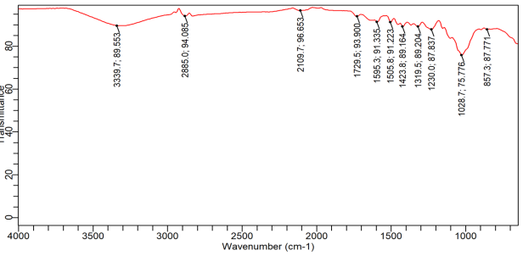
Fig 1: FTIR Analysis of Abura tree (Hallea ciliata) sawdust
SEM Analysis
In figure 2, the irregular distinctive smooth surfaced-like and rough-shaped surface-like structure clearly indicated the presence of pores that enhance adsorption (Ahmad et al., 2009). The structure and look observed by Tsamo et al. (2019) and Afzaal et al. (2022) in raw sawdust and unmodified sawdust was consistent with the structure recorded in the present study.

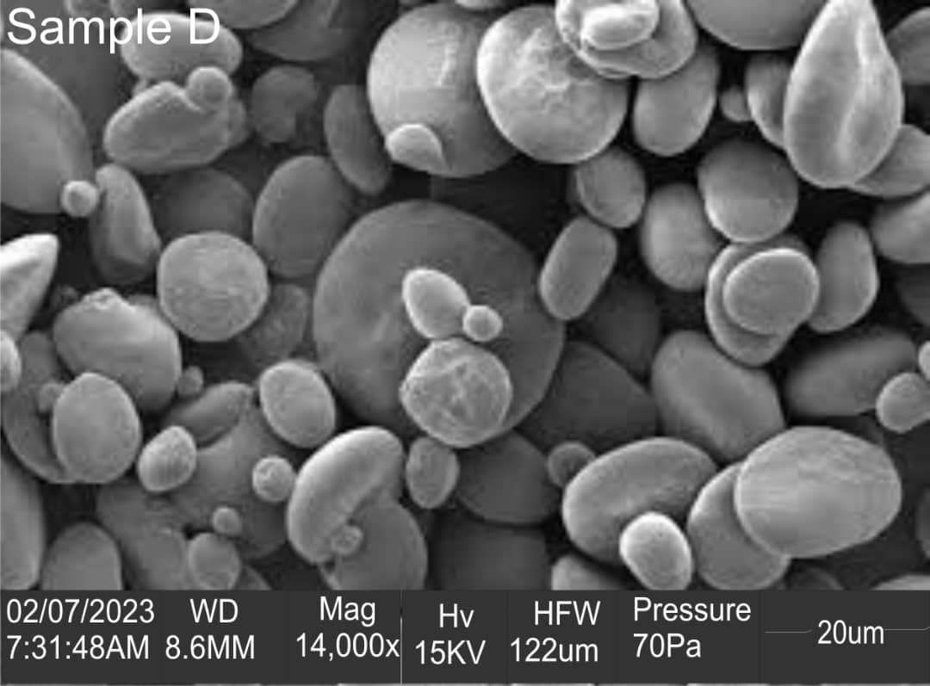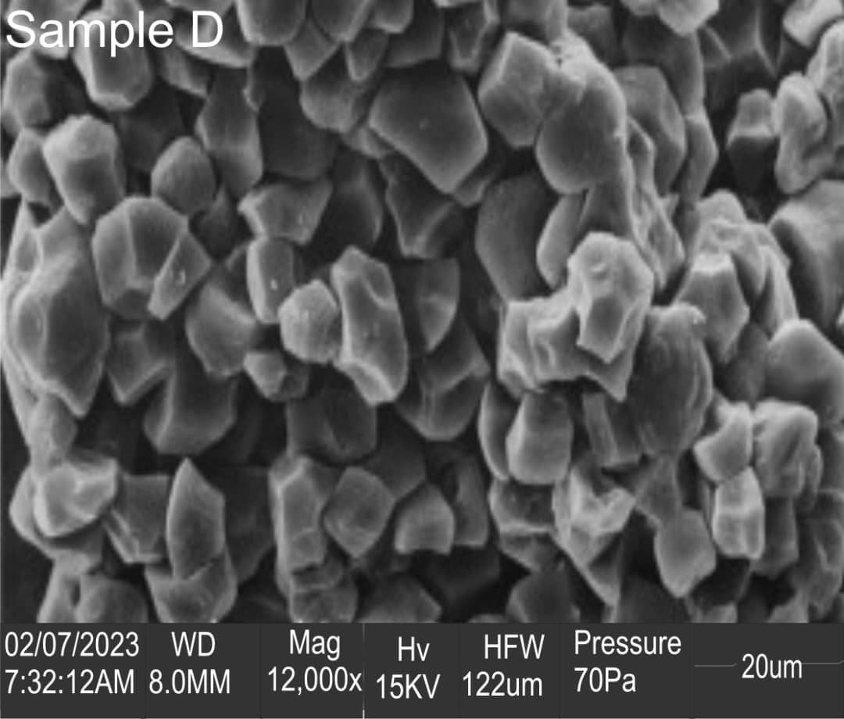
Fig. 2: SEM of Sawdust Collected from Abura Tree (Hallea ciliata)

Adsorption Studies and Effect of variables on removal efficiency
pH: As the pH increased from 2.5 to an optimum value of 8.5, the lead ion removal efficiency onto sawdust adsorbent, as shown in Figure 3, increased from 17.05 percent to 45.44 percent. From 1.023 mg/g to 2.276 mg/g, the adsorption capacity, or qe, also increased as the pH rose. At low pH, the sawdust surface's hydroxyl, carboxylic acid, and phenolic groups become protonated. This results in a positive charge on the sawdust surface. The ion of lead has a positive charge. Adsorption is decreased as a result of the electrostatic attraction between the positively charged lead ion and the positively charged sawdust surface being in competition (Lim et al., 2008). The hydroxyl groups on the sawdust surface deprotonate as the pH rises. As a result, the sawdust surface's positive charge is decreased. The adsorption capacity of sawdust is improved by the increased electrostatic attraction between the lead ion and the sawdust surface (Ahmad et al., 2009). In contrast to the results of the current study, a study by Jadidi and Motavassel (2016) on the capacity of Populus sp. sawdust to remove Pb (II) from wastewater found that removal efficiency increased from 50% to 65% at an ideal pH of 5.

Fig. 3: Effect of varied pH on lead ion removal (lead ion conc. = 100mg/L; dosage = 0.5g; contact time = 60min)
Dosage: The result showed as shown in Figure 4 indicated that the removal efficiency of lead ion from aqueous solution increased from 20.35 % to 75.89 % when dosage of adsorbent was increased from 0.5 g to an optimum value of 2 g. The adsorptive capacity decreased from 1.221 mg/g at a dose of 0.5 g to 0.9108 mg/g when the dose was increased to 2.5 g. The increase in removal efficiency according to Jadidi and Motavassel (2016) may be as a result of more available active sites on the sawdust adsorbent as the dosage increases. However, at a point, it showed no further adsorption after a certain dose of adsorbent was added. This suggests that after a certain dose of adsorbent, the maximum adsorption sets in and hence the amount of metal ions bound to the adsorbent and the number of free ions remain constant even with further addition of adsorbent dose (Božić et al., 2021). The adsorption capacity of sawdust for lead ion on the other hand decreased with increasing dosage. This is as a result of the constant adsorbate concentration used during the experiment which may not supply enough metal ions as the adsorbent increases (Long et al., 2021). Comparing with other studies, Semerjian, (2018) studying the removal of lead (Pb) from aqueous solutions using pine (Pinus halepensis) sawdust reported that, for a dose of 10 g/L, 99 % removal efficiency was recorded. The finding was in disagreement the result recorded in the present study.
Fig. 4: Effect of varied dosage on lead ion removal (lead ion conc. = 100mg/L; pH = 8.5; contact time = 60min)
Contact time: Result revealed as seen in Figure 5 indicated that the removal efficiency of lead ion by the adsorbent increased from 30.65 % to 75.86 % as the contact time increased from 30 min to an optimum value of 90 min. Result further showed that adsorption capacity also increased from 1.839 mg/g as the contact time increases with the highest value (4.5516 mg/g) recorded at 90 min. The increased in removal efficiency and adsorption capacity with increasing contact time is due to the increased diffusion of the metal ion onto the surface of the sawdust adsorbent (Nordine et al., 2014). At longer contact times, the metal ions have more time to diffuse onto the surface of the sawdust adsorbent and to interact with the active sites. Removal efficiency of 85 % was recorded at 60 min contact time by Mahmood-ul-Hassan et al., (2018) in the kinetics and isotherms study of lead ion removal using bio-adsorption from aqueous solution onto Picea smithiana sawdust was higher and inconsistent with data generated from the present study.

Fig. 5: Effect of varied contact time on lead ion removal (lead ion conc. = 100mg/L; pH = 8.5; dosage = 2g)
Initial concentration: When the initial concentration of the lead nitrate aqueous solution was increased from 100 ppm to 500 ppm, the removal efficiency of lead ions onto the sawdust, as shown in Figure 6, decreased from 75% to 18.968% under optimal conditions of pH 8.5, dosage of 2 g, and contact time of 90 minutes. However, at 100 and 300 ppm, respectively, the adsorption capacity rose from 4.5 mg/g to 6.114 mg/g, according to the results. The sawdust adsorbent's active sites becoming saturated is the cause of the reduction in removal efficiency as the initial concentration rises (Božić et al., 2021). At higher concentrations, there are more lead metal ions in the solution than there are active sites on the sawdust adsorbent. The ratio of the initial number of lead ions to the surface area of the sawdust adsorbent decreases with increasing concentration, which could explain the increase in adsorption capacity with increasing initial concentration (Semerjian, 2018). The results of this investigation are in line with earlier studies on the methylene blue adsorption onto sawdust. According to a study by Jadidi and Motavassel (2016) on the effectiveness of Populus sp. sawdust in removing lead (II) from wastewater, the removal efficiency was 50% for lead ions at a concentration of 200 mg/L. Nevertheless, the lead ion removal efficiency was lower than the efficiency found in the current investigation.

Fig. 6: Effect of varied concentration on lead ion removal (pH = 8.5; dosage = 2g; contact time = 90 min)

CONCLUSION
The characterization results obtained using FTIR and SEM showed that the sawdust of Abura tree (Hallea ciliata) possess functional groups and structures that support adsorption of heavy metal ions from aqueous solution. Further results obtained from this study indicated that under optimum conditions of pH (8.0), dose (2g), contact time (90min) and 100mg/L concentration of lead ion, 75 % removal and 6.114 mg/g adsorption capacity for lead ion was recorded. It is therefore suggested that sawdust obtained from Abura tree showed better adsorption removal efficiency hence better for adsorption studies.

Disclaimer (Artificial intelligence)

Author(s) hereby declare that NO generative AI technologies such as Large Language Models (ChatGPT, COPILOT, etc.) and text-to-image generators have been used during the writing or editing of this manuscript.

REFERENCES

Afzaal M., Hameed M., Abbasi N.A, Liaqat I., Rasheed R., Khand A.A & Manan H.A (2022). Removal of Cr (III) from wastewater by using raw and chemically modified sawdust and corn husk. Water Practice & Technology, 17(9), 1938 – 1958
Ahmad, A., Rafatullah, M., Sulaiman, O., Ibrahim, M. H., Chii, Y. Y., & Siddique, B. M. (2009). Removal of Cu (II) and Pb (II) ions from aqueous solutions by adsorption on sawdust of Meranti wood. Desalination, 247(1-3), 636–646.
Božić, D., Gorgievski, M., Stanković, V., Cakić, M., Dimitrijević, S., & Conić, V. (2021). Biosorption of Lead Ions from Aqueous Solutions by Beech Sawdust and Wheat Straw. Chemical Industry & Chemical Engineering Quarterly, 27(1), 21–34.
Brehan A.G, Dibaba E.T, Agonafir H.B, Cheru M.S, Dessie S.T & Chemere E.B (2017). Removal of Hexavalent Chromium (Cr (VI)) from Aqueous Solution Using Corncob and Pine Sawdust Biosorbents. International Journal of Advanced Scientific Research and Management, 2(3), 1 – 6
Chen, X., Xu, R., Xu, Y., Hu, H., Pan, S., & Pan, H. (2018). Natural adsorbent based on sawdust for removing impurities in waste lubricants. Journal of Hazardous Materials, 350, 38-45.
Duruibe, J. O., Ogwuegbu, M. O. C. & Egwurugwu, J. N. (2007). Heavy metal pollution and human biotoxic effects. International Journal of Physical Sciences, 2 (5), 112-118
Gebrehawaria G. (2016). Removal of Chromium (VI) Ions from Aqueous Solution Using Leaves of Cordia Africana and Sawdust of Acacia Albida. International Journal of Modern Chemistry and Applied Science, 3(2), 369-377
Giwa, A.A.; Oladipo, M.A. & Salam, K.A.A. (2015). Adsorption of Rhodamine B from single, binary and ternary dye systems using Sawdust of Parkia biglobosa as adsorbent: Isotterm kinetic and thermodynamics studies. J. Chem. Pharm. Res., 7, 454–475.
Jadidi N. & Motavassel M. (2016). Assessing the Ability of Populus sp. Sawdust in Removal of Heavy Metals Pb (II), Ni (II) and Cr (III) from Wastewaters. Nature Environment and Pollution Technology, 15(4), 1369-1372
Kadirvelu K., Senthilkumar P., Thamaraiselvi K. & Subburam V (2002). Activated carbon prepared from biomass as adsorbent: elimination of Ni (II) from aqueous solution. Bioresource Technology; 81, 87–90.
Kalavathy H., Regupathi I., Pillai M. G., & Miranda L. R (2009). Modelling, analysis and optimization of adsorption parameters for H3PO4 activated rubber wood sawdust using response surface methodology (RSM), Colloids and Surfaces. Biointerfaces, 70(1), 35–45
Kataria, N., & Garg, V. K. (2018). Green synthesis of Fe3O4 nanoparticles loaded sawdust carbon for cadmium (II) removal from water: regeneration and mechanism. Chemosphere, 208, 818-828
Lim J., Kang H., Kim L. & Ko S. (2008). Removal of Heavy Metals by Sawdust Adsorption: Equilibrium and Kinetic Studies. Journal of Korean Society of Environmental Engineers, 13(2), 79-84
Long, M., Jiang, H., & Li, X. (2021). Biosorption of Cu2+, Pb2+, Cd2+ and their mixture from aqueous solutions by Michelia figo sawdust. Scientific Reports, 11(1), 1 - 13
Maciver V.P, Dagde K.K, Konne J.L (2020). Synthesis of Zeolite X from Locally Sourced
Kaolin Clay from Kono-Boue and Chokocho, Rivers State, Nigeria. Advances in Chemical Engineering and Science, (10), 399-407
Mahmood-ul-Hassan, M., Yasin, M., Yousra, M., Ahmad, R., & Sarwar, S. (2018). Kinetics, isotherms, and thermodynamic studies of lead, chromium, and cadmium bio-adsorption from aqueous solution onto Picea smithiana sawdust. Environmental Science and Pollution Research, 25(13), 12570–12578.
Mane V.B, Suryawanshi M.A, Kumbhar G.B, Sahu P.L & Gajbhiye P.S (2016). Adsorption for the Removal of Chromium Using Natural Adsorbents. International Research Journal of Engineering and Technology, 3(8), 1951 – 1955
Mittal, A., Kaur, D., Malviya, A., Mittal, J., & Gupta, V. K. (2009). Adsorption studies on the removal of coloring agent phenol red from wastewater using waste materials as adsorbents. Journal of Colloid and Interface Science, 337(2), 345-354.
Mukherjee A.K & Bordoloi N.K (2011). Bioremediation and reclamation of soil contaminated with petroleum oil hydrocarbons by exogenously seeded bacterial consortium: a pilot scale study. Environmental Science and Pollution Research, 18(3), 471-478.
Nordine, N., El Bahri, Z., Sehil, H., Fertout, R. I., Rais, Z., & Bengharez, Z. (2014). Lead removal kinetics from synthetic effluents using Algerian pine, beech and fir sawdust’s: optimization and adsorption mechanism. Applied Water Science, 6(4), 349–358.
Renu, Agarwal M & Singh K (2017). Heavy metal removal from wastewater using various adsorbents: a review. Journal of Water Reuse and Desalination, 387-419
Saha R., Saha I., Nandi R., Ghosh A., Basu A., Ghosh S.K & Bidyut Saha (2012). Application of Chattim Tree (Devil Tree, Alstonia Scholaris) Saw Dust as a Biosorbent for Removal of Hexavalent Chromium from Contaminated Water. Canadian Society for Chemical Engineering, 9999, 11-21
Semerjian, L. (2018). Removal of heavy metals (Cu, Pb) from aqueous solutions using pine (Pinus halepensis) sawdust: Equilibrium, kinetic, and thermodynamic studies. Environmental Technology & Innovation, 12, 91–103
Sirusbakht S., Vafajoo L., Soltani S. & Habibi S., (2018). Sawdust bio sorption of chromium (vi) ions from aqueous solutions. Chemical Engineering Transactions, 70, 1147-1152
Tsamo C., Bachirou I., Samomssa I. & Fouogoung T.B (2019). Removal of Hexavalent Chromium from Aqueous Solution Using Unmodified Saw Dust: Batch and Column Studies. Current Journal of Applied Science and Technology, 32(3), 1-16
Witek-Krowiak A. (2013). Application of beech sawdust for removal of heavy metals from water: biosorption and desorption studies. European Journal of Wood Production, (71), 227–236
Sewwandi, B. G. N., Vithanage, M., Wijesekara, S. S. R. M. D. H. R., Rajapaksha, A. U., Jayarathna, D. G. L. M., & Mowjood, M. I. M. (2012). Characterization of Aqueous Pb(II) and Cd(II) Biosorption on Native and Chemically ModifiedAlstonia macrophyllaSaw Dust. Bioremediation Journal, 16(2), 113–124.

