Design and Development of Smart Waste Bin for Trash Collection Efficiency and Optimization

Abstract
Design and Development of Smart Waste Bin for Trash Collection Efficiency and Optimization was carried out. The design outlined decision-making process of the smart bin and presented a comprehensive and user-centered approach to dustbin management. Several component such as the Arduino UNO, DC servo motor, Ultrasonic sensors, lithium ion battery, Micro Controller and battery were used to develop the prototype. The smart bin was built such that it requires low input power to function. The purpose of the study was to develop a smart waste bin using a microcontroller-based platform like Arduino Uno board that is interfaced with a GSM modern and an Ultrasonic sensor that may inform the municipal authority about the waste contained in the waste bin. The smart bin comprises of the body and the lifting system. Through these integrated functionalities, the robot's decision-making mechanism established a sophisticated and practical solution that streamlines dustbin usage and maintenance while prioritizing user convenience and satisfaction. Analysis performed show that using weight to determine if a dustbin is filled up was not efficient, as a heavy object above 20kg can be placed and the bin is still not filled up.

.
Keywords: Arduino, Waste management, Smart waste bin, recycling.

1.0 Introduction
Noticeable changes in the environment over the last 2 years has shown that the number of waste incidents has increased since the 80s. The desire for intelligent and eco-friendly cities, along with population growth and increased human engagement, has led to the creation of a substantial amount of waste. It is therefore important to appropriately handle, treat, and manage the waste in order to maintain a sustainable environment for the growing population [30].
The fight for a sustainable future is won or lost in the city, crucially, our success relays on how we handle the collection, disposal, treatment, and management of generated waste [31]. Additionally, it is imperative to maintain a clean and healthy environment as it is a global issue of utmost importance [32]. With the rise in population, waste generation has increased, posing a significant challenge for waste management. Effectively addressing these challenges necessitates making informed decisions and adopting appropriate approaches to waste management in today's world has become crucial [33]. Waste bin in this present day surroundings often overflow due to the significant increase in daily waste generation, Thereby creating an unsanitary environment for residents and emits unpleasant odors in those areas, contributing to the spread of diseases and human illness [34-35]. Furthermore, the absence of waste monitoring by waste collectors has resulted in overflowing waste from the bins, leading to the formation of make shift dump sites on the streets. This not only prolongs the time required for emptying the bins but also makes it challenging to determine when they are full. Traditional waste management approaches, such as burying, open-air burning, and open dumping, have been proven to be ineffective and harmful to public health and the environment. Therefore, the objective of the study is to develop a smart waste bin using a microcontroller-based platform like Arduino which will aim at monitoring the trash level of the waste bin and minimize the management costs associated with street bins.
2.0 literature review
2.1 Smart waste bin system
The introduction of Smart bins serve as an improved waste collection containers that are useful in large cities, allowing strategic management of waste by workers. It promotes efficient waste collection in the sense that it can be used without having to touch the instrument with your bare hands. This in turn make the community safer and healthier by reducing the spread of germs and infections [26]. Smart bins provides an innovative waste monitoring and rubbish compacting abilities that reduces labor costs, pollution and saves energy. Furthermore several researchers has reported a significant improvement in the development of waste management. Islam et al [8] developed strategies for selecting containers to dispose off recyclable waste. They introduced a paradigm that utilizes the Ontology Web Language (OWL) to filter and reuse smart waste. OWL dynamics was used to indicate the presence of recyclable materials in each garbage. These initiatives were aimed at transforming waste management practices and promoting a more sustainable future. Their methods achieved 63% and 22% accuracy with SVM and CNN training, respectively.
Robot and artificial intelligence inclusion in design and operation of urban waste treatment plants is aim at revolutionizing how solid waste is managed, increasing the operational efficiency and creating better sustainable waste management practices [27-28].

2.2 Waste management systems for smart cities
Waste management in general encompasses various activities, including planning, collection, transportation, treatment, recycling, and disposal, all of which require monitoring and regulation. One important aspect of waste management is ensuring that open-space waste bins are adequately filled before the next cleaning cycle begins. Failure to do so can result in hazards such as dirt accumulation and unpleasant odors, which can contribute to the spread of diseases. Improper collection of urban waste can lead to several problems that impact the environment, nations, and citizens. In recent times, effective waste management has become a crucial concern in urban areas. Therefore, the implementation of smart waste bin will help minimize, if not eliminate, this challenge (1).
Effective waste management is beneficial for environmental development. It helps increase recycling efforts and reduces the environmental impact. [2] This is particularly important in developing nations, where waste management poses a significant challenge to economic progress. Functional testing and proper waste management play a crucial role in advancing a sustainable global environment. Recycling waste is essential for society to minimize waste accumulation [6].

Since the past two decade researchers have been working on smart trash cans. The term "Smart Trash Bin" was first mentioned in a study that conducted an academic Google search in 2013. Since then, an increasing number of papers have been published on this topic, with a notable surge in 2017. In that year, a total of 82 articles were discovered, marking a fourfold increase compared to the previous year. Table 1 provides an overview of the number of academic publications retrieved using the search terms "Smart Trash Bin" and "Smart Trash Bin" in Google Scholar. These search terms were used to identify publications that specifically discussed smart trash bins and to gather comprehensive research on the subject.

Table 1 The Number of Papers with the Keywords Smart Trash Bin and “Smart Trash Bin”.
Year | Smart Trash Bin | “Smart Trash Bin”
2013 | 998 | 4
2014 | 1080 | 2
2015 | 1070 | 6
2016 | 1140 | 5
2017 | 1250 | 20
2018 | 1280 | 32
2019 | 1460 | 45
2020 | 1334 | 82
Source: (Huh & Choi, 2021)

A study conducted by Fauziah et al. [9] examined research on smart trash cans between 2015 and 2019, utilizing resources from Google Scholar and Science Direct articles. Through their analysis of literature and surveys related to the implementation of smart trash bin projects, Chandra et al. [10] concluded that these projects have the potential to influence people's attitudes towards proper garbage disposal and the community's approach to waste management. In a separate study by Henita et al [11], utilized smart trash cans as an educational tool in schools to help students understand different types of waste. Haribabu et al. [12] focused on examining mobile applications associated with intelligent garbage cans, with the goal of achieving Smart City objectives and optimizing human resources. Another study by Ujwala et al [13] further explored the potential benefits and implications of smart trash cans in waste management systems. Oscar et al. [14] developed a dependable approach to effectively categorize waste. Their system transports the waste to appropriate facilities for biodegradation or recycling, depending on the type of garbage. In order to achieve both proper garbage disposal and waste reduction objectives, they introduced a system that incorporates smart bins and trash disposal trackers. In a related study, [15] presented an information technology-based trash management system that tackles the challenges associated with garbage management. They also created a prototype of a solid waste trash management system that specifically focuses on waste separation and collection stages.
Several other research studies have focused on the development of smart waste containers that incorporate automatic garbage sorting and monitoring capabilities. For instance, Chattopadhyay et al. [20] utilized an Arduino board, Wi-Fi module, ultrasonic sensor, and other components to create a smart sensing system for each bin within a campus area. The sensor is positioned towards the opening of the trash can and detects when the empty space inside the bin is less than 5 cm, indicating that it is full. The bin status is then reported through a dedicated website. In another study, Singh et al. [16] designed a smart garbage container that segregates trash into biodegradable and non-biodegradable materials. The sensor in this system identifies and separates the garbage as biodegradable or not whenever a person approaches the bin with rubbish in hand. Subsequently, when the bin is full, message will be sent to the person in charge to empty the waste bin. Cheap smart waste system was implemented to automatically separate wet and dry waste via moisture sensor and then sent for further processing [17]
The proposed approach by Kesthara et al. [18] involves the categorization of waste into three groups: dry waste, wet waste, and metal trash, which facilitates optimization of the waste collection schedule. Each category was equipped with a mechanism for acceptance or rejection of waste based on specific criteria.
Prakash and Jayalakshmi [19] implemented a smart waste system as an outdoor test bed. This system incorporated mesh networking and cycle characteristics to enable bin suppliers to assess whether a particular location required additional bins or if the existing bins needed to be removed or relocated. This information helped the cleaning staff in planning their activities more effectively. However, it should be noted that the current usage of this system is limited to its application as an outdoor test bed.
Sumit Rathi et al. [21] developed a smart trash can utilizing a pair of stereoscopic cameras to assess the trash filling level. The design incorporated deep modeling and daily image processing techniques. Furthermore, an open-source technology was utilized to construct a 3D model of the captured image, enabling the estimation of depth. In contrast to the commonly used Arduino microcontroller, the Raspberry Pi model 3B was employed in this system.
Rajathi et al. [22] developed a robotic dustbin with a planned trajectory that utilizes two forward-facing IR sensors located at the base of the robot. These sensors enable the dustbin to navigate along a predetermined path. The robot is equipped with an obstacle sensor on its side, which detects dark objects and triggers a buzzer to temporarily halt the depositing of trash. Moreover, an ultrasonic sensor is positioned near the rim of the bin to measure the level of garbage present.
According to the proposal by Prasanna [23], the implementation of smart bins involves their deployment at the sub-terrestrial level, along with the integration of a smart microcontroller, load cell, compactor, and IR system. Each smart container is assigned a unique identification tag. The excess waste accumulated in the bin is compacted using the compactor. The main objective of this system is to activate the sensor and send a message to the control unit, including the bin's identification and location, when the bin is nearing its full capacity. Prasanna (2017) emphasizes the importance of managing biomedical waste, agricultural waste, and industrial waste using this approach
According to the proposal by Prasanna [23], the implementation of smart bins involves their deployment at the sub-terrestrial level, along with the integration of a smart microcontroller, load cell, compactor, and IR system. Each smart container is assigned a unique identification tag. The excess waste accumulated in the bin is compacted using the compactor. The main objective of this system is to activate the sensor and send a message to the control unit, including the bin's identification and location, when the bin is nearing its full capacity. Prasanna (2017) emphasizes the importance of managing biomedical waste, agricultural waste, and industrial waste using this approach. Rajathi et al. [22] designed a robot garbage bin with two sensors installed at the bottom, which moves along a straight line. An obstacle sensor is embedded on one side of it, which can sense black and emit a buzzer sound to indicate that the garbage has stopped storing for some time. In addition, an ultrasonic sensor can be placed at the bin’s edge to detect the waste level [25].
In their research, Rajathi et al. [22] developed a robotic garbage bin equipped with two bottom sensors, enabling it to move in a straight line. The bin also features an obstacle sensor embedded on one side, capable of detecting black objects and emitting a buzzer sound to indicate a temporary pause in garbage collection. Additionally, the bin can be equipped with an ultrasonic sensor at its edge to accurately measure the level of waste it contains [25].

3.0 Methodology
The materials used for the design of the project were subdivided into the electronics and mechanical components. The selection process was based on parameters that suit the purpose and use of the design in consideration. The mechanical part comprises of the body and the lifting system. The Lifting system houses the servo motor which controls lid for lifting the dustbin. The electrical component of the system controls the sensitivity and decision making path of the smart waste bin.
The Hardware use include, Arduino UNO, DC servo motor, Ultrasonic sensors, lithium ion battery, Micro Controller and battery. The ultrasonic sensor HC-SR04 used consists of two ultrasonic transducers, a transmitter that converts the electrical signal into 40 KHz ultrasonic sound pulses, with a receiver that listens for the transmitted pulses. The receiver produces an output pulse whose width is proportional to the distance of the object in front. The distance is measured when the microcontroller sends a trigger signal to the ultrasonic sensor. The battery supplies the required voltage that is needed for the electrification and adequate control of the circuit. The inputs from the Ultrasonic sensor goes into the arduino which controls the servo motor. The ultrasonic sensors on the top of the dustbin lid, checks to see if the dustbin is filled up. The waste bin keeps making a buzzing sound as it displays that the bin is full on the LCD screen. The buzzing will only stop when the user has left the dustbin. The waste bin has a 20kg load cell limit sensor which measures the weight of the waste bin.
The circuit is designed to open the dustbin whenever an object comes close to it using the HC-SR04 ultrasonic sensor at the front of the dustbin. Figure 1 show the Schematic diagram of the smart sensing system. At the turn of the power switch. The robot closes the dustbin. Then it measures the distance of the front ultrasonic sensor, if the distance is less than or equal to the proximity distance (50cm). If it is true, it checks if the bin is full by measuring the distances of top right and left ultrasonic sensors, then checks if they are less than or equal to the full proximity (10cm). If both of the sensors are less than the full proximity, it will activate the buzzer and display “Bin full”, then it goes back to the top of the flowchart. Else it will measure the weight of the bin. If the weight of the bin is greater than or equal to 20, it will open the dustbin. It then measures the distance of the front ultrasonic sensor to check if the user is still using the bin. It activates the while loop as long as the front distance is less than or equal to 30cm. This is to ensure the bin is always open as long as the user is still using the dustbin. If the front ultrasonic distance is greater than 30cm it breaks out of the loop and goes back to the top of the flowchart.

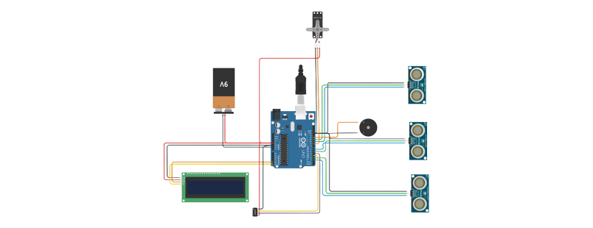
Figure 1 Schematic diagram of the smart sensing system.
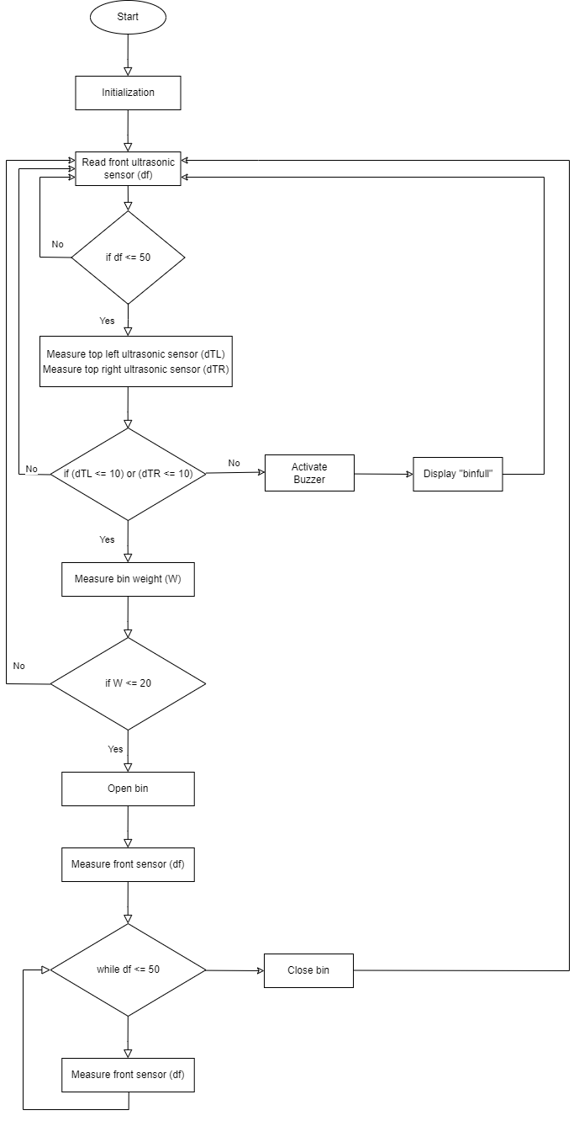

Figure 2 Algorithm flowchart for decision making
3.2 Algorithm of System
The flowchart in Figure 2 shows the decision making process of the robot. First of all, the robot will not start the movement after turning on the power. The first thing it does is to close the dustbin. Then it measures the distance of the front ultrasonic sensor, if the distance is less than or equal to the proximity distance (50cm). If that condition is true, it checks if the bin is full by measuring the distances of top right and left ultrasonic sensors, then checks if they are less than or equal to the full proximity (10cm). If both of the sensors are less than the full proximity, it will activate the buzzer and display “Bin full”, then go back to the top of the flowchart. Else it will measure the weight of the bin. If the weight of the bin is greater than or equal to 20, it will open the dustbin. It then measures the distance of the front ultrasonic sensor to check if the user is still using the bin. It activates the while loop as long as the front distance is less than or equal to 30cm. This is to ensure the bin is always open as long as the user is still using the dustbin. If the front ultrasonic distance is greater than 30cm it breaks out of the loop and goes back to the top of the flowchart. The design of smart is shown in Figure 3

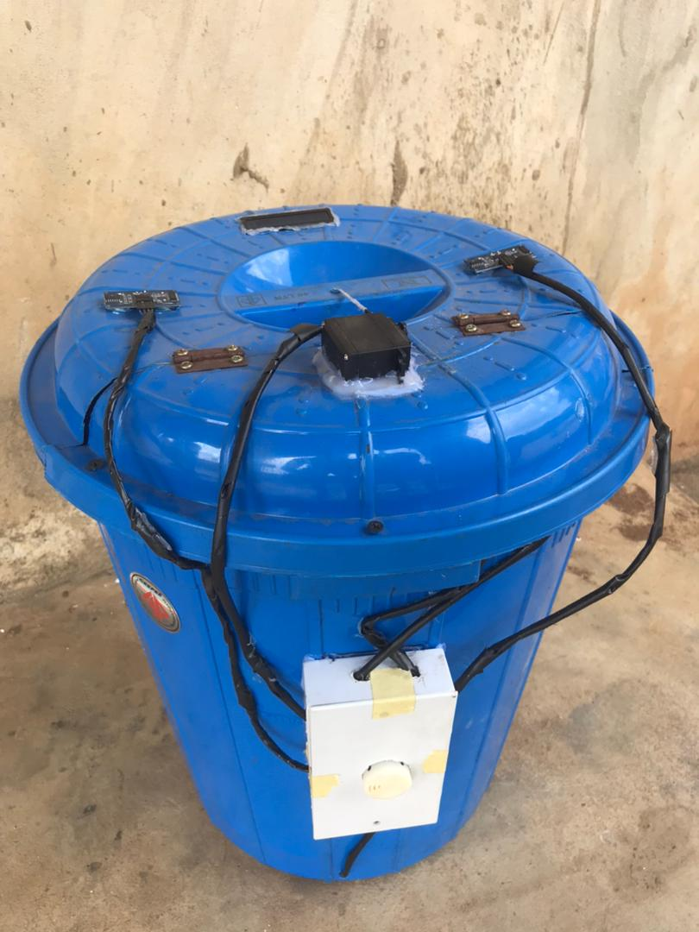
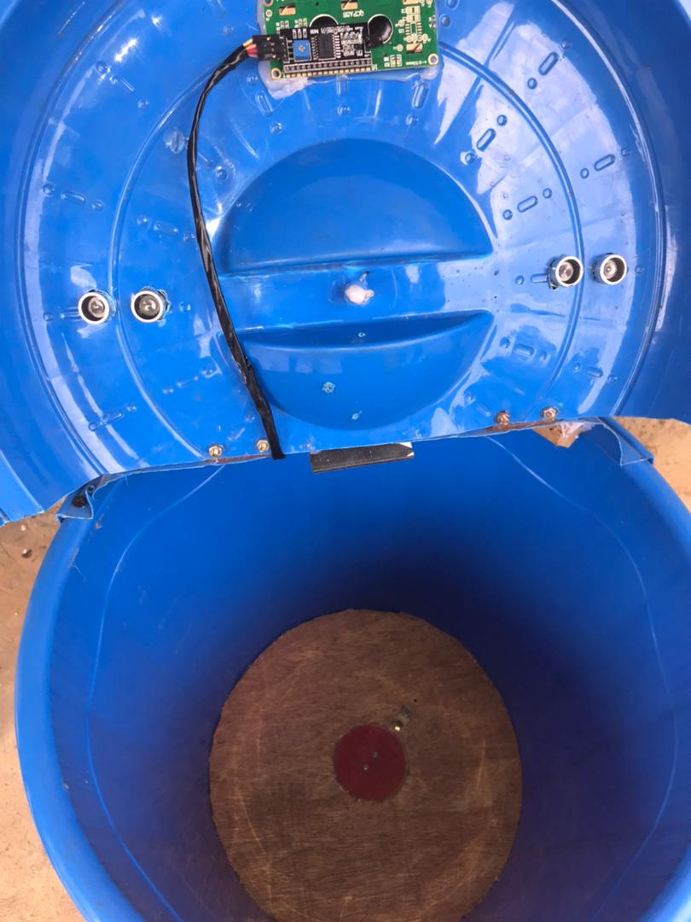

Figure 3 Design of smart bin

4.0 Results and discussion
Table 2 show the Lifting Situation of the robot. The dustbin’s movement varies with different conditions or situations. Its decision depends on the feedback or states of the ultrasonic sensors (front and top) and the weight readings from the load cell.
4.1.1 Data Analysis

Table 2. Lifting situations
Front Sensor  (Cm) | Top Left Sensor  (Cm) | Top Right Sensor  (Cm) | Weight Sensor  (Kg) | Dustbin  Movement
>= 30 | >= 10 | >= 10 | <= 20 | Closed
>= 30 | >= 10 | >= 10 | >= 20 | Closed
<= 30 | <= 10 | <= 10 | <= 20 | Closed
<= 30 | <= 10 | <= 10 | >= 20 | Closed
<= 30 | <= 10 | <= 10 | <= 20 | Open
<= 30 | >= 10 | <= 10 | <= 20 | Open
<= 30 | <= 10 | >= 10 | <= 20 | Open
<= 30 | >= 10 | >= 10 | >= 20 | Open

The different lifting situations of the dustbin was tested to reveal the accuracy of the prototype in responding appropriately in relation to the conditions presented. From (Table 2) it was evident that the ability of the servo motor to lift the dustbin lid was efficient. It can also be gathered that using weight to determine if a dustbin is filled up is not an efficient method, as a heavy object above 20kg can be placed and the bin is still not filled up. As illustrated easier the robot subsequently evaluates the distance measured by the front ultrasonic sensor. If this distance is 50cm or less, the robot proceeds to examine the distances measured by the top right and left ultrasonic sensors. Should both readings be within the range of the full proximity (10cm), indicating a full bin, the robot triggers an alert through the activation of a buzzer and a visual display reading "Bin full." The robot then loops back to the beginning of the flowchart.
However, if the top ultrasonic sensors' readings do not indicate a full bin, the robot shifts its focus to assessing the weight of the bin.

5.1 Conclusions
Design and development of smart waste bin for trash collection efficiency and optimization has been successfully carried out. The idea was to efficiently manage waste in a unique manner. Several component comprising of the Arduino UNO, DC servo motor, Ultrasonic sensors, lithium ion battery, Micro Controller and battery were used to develop the prototype. The smart bin comprises of the body and the lifting system. The goal was to build a smart waste bin based on a microcontroller-based platform Arduino Uno board that is interfaced with a GSM modern and an Ultrasonic sensor that may inform the municipal authority about the waste contained in the waste bin. The waste bin can efficiently handles tasks such as assessing proximity, fullness, and user presence. The inclusion of a user-responsive while loop guarantees continuous accessibility to the waste bin, enhancing the overall user experience. Through these integrated functionalities, the waste bin decision-making mechanism establishes a sophisticated and practical solution that streamlines waste bin usage and maintenance while prioritizing user convenience and satisfaction. The analysis performed show that using weight to determine if a dustbin is filled up is not an efficient method, as a heavy object above 20kg can be placed and the bin is still not filled up. . In summary the outlined decision-making process of the waste bin presents a comprehensive and user-centered approach to waste bin management.

References
[1] Sundarakumar M. R., (2017) “SMART DUSTBIN-GARBAGE MONITORING SYSTEM BY EFFICIENT ARDUINO BASED,”, pp. 165–167,
[Online]. Available: https://dx.doi.org/10.2139/ssrn.3126098.

[2] Donepudi P. K., (2015) “Crossing Point of Artificial Intelligence in Cybersecurity,” Am. J. Trade Policy, vol. 3, no. 2, pp. 121–128, [Online]. Available: https://doi.org/10.18034/ajtp.v2i3.493.

[3] National Framework for Advancing the U.S. Recycling System (2019). U.S. EPA: Washington, DC, USA.

[4] STREETSBLOG NYC. Will NYC Finally Get Garbage Out of Pedestrians’ Way? Available online: https://nyc.streetsblog.org/2019/06/04/will-nyc-finally-get-garbage-out-of-pedestrians-way/ (accessed on 12 May 2021).

[5] WTTW. Ask Geoffrey: A Brief History of Chicago’s Trash. Available online: https://news.wttw.com/2020/05/28/ask-geoffreybrief- history-chicago-trash (accessed on 12 May 2021)

[6] P. K. Donepudi, (2015) “Crossing Point of Artificial Intelligence in Cybersecurity,” Am. J. Trade Policy, vol. 3, no. 2, pp. 121–128, [Online]. Available: https://doi.org/10.18034/ajtp.v2i3.493.

[7] V. M. Thomas, “Environmental implications of RFID. In Electronics and the Environment.,” in ISEE 2008. IEEE International Symposium on Electronics and the Environment, 2008, pp. 1–5., doi: 10.1109/SEE.2008.4562916.

[8] M. S. Islam, M. Arebey, M. Hannan, and H. Basri, (2012) “Overview for solid waste bin monitoring and collection system.,” J. Appl. Sci. Res., vol. 8, no. 2, pp. 879–886.

[9] I. B. Fauziah, (2020) “Esthetic, integrated, smart and green trash bin for public space: A review,” in IOP Conf. Ser. Earth Environ. Sci. pp. 575, doi: 10.1088/1755-1315/575/1/012240. [CrossRef]

[10]. R.P. Chandra, T. Tawami, (2020) “Design of Smart Trash Bin”, IOP Conf. Ser. Mater. Sci. Eng. 879, pp. 1–6. [CrossRef].

[11] H. Rahmayanti,.; V. Oktaviani, Y. Syani, (2018) “The implementation of smart trash as smart environment concept”. E3S Web Conf.74, pp. 1–5. [CrossRef]

[12] P. Haribabu, S.R. Kassa, , J. Nagaraju, R. Karthik, , N. Shirisha, M .Anila. (2017) “ Implementation of a Smart Waste Management System using IoT”. In Proceedings of the International Conference on Intelligent Sustainable Systems (ICISS), Palladam, India, , vol. 7–8; pp. 1155–1156.

[13]. U. Ravale, A. Khade, N. Patel, S. Chaure, “Smart Trash: An Efficient Way for Monitoring SolidWaste Management”. In Proceedings of the International Conference on Current Trends in Computer, Electrical, Electronics, and Communication (CTCEEC), Mysore, India, 2021, vol 8–9; pp. 1135–1137. Appl. Sci., 11, 4810 19 of 20

[14]. O. Karnalim, O. Wongso,V.E. Budiman, F.C. Jonathan, B.A. Manuel, M.A. Marlina, (2020) “Persuasive Technology for Managing Waste Disposal through Smart Trash Bin and Waste Disposal Tracker”. Int. J. Inf. Commun. Technol. (IJOICT) 6, 41–51. [CrossRef]

[15]. F.R. Maulana, T.A.S. Widyanto, Y. Pratama, K. Mutijarsa, (2018) “Design and Development of Smart Trash Bin Prototype for Municipal Solid Waste Management”. In Proceedings of the International Conference on ICT for Smart Society (ICISS), Semarang, Indonesia, 10–11.

[16] S. K . Singh, A. Khamparia, U. Mittal, and P. Rana (2019)“Intelligent Remote Monitoring Waste”, Think India J., vol. 67, no. 7, , pp. 521–533.

[17] J. Sakshi, L. Hardika, A. Ishika, and G. M. Lodha, (2019) “Survey Paper on Smart Dustbin Management System” vol. 2, no. 2, pp. 1–4,.

[18] V. Kesthara, N. Khan, S.P. Praveen, C. Mahesha, and N. Murali, (2018) “Sensor-Based Smart Dustbin for Waste Segregation and Status Alert”, Int. J. Latest Technol. Eng. Manag. Appl. Sci., vol. VII, no. Iv, pp. 171–173.

[19] S. Prakash and V. Jayalakshmi, (2018) “An Efficient Smart Garbage Dustbin Monitoring System Enhanced with WI-FI Technology”, Int. J. Pure Appl. Math., vol. 119, no. 12, , pp. 6789–6795.

[20] P. Chattopadhyay, R. Chaudhuri, S. Dasgupta, and G. Priya, (2017) “Smart Garbage Monitoring System School of Computer Science and Engineering”, Int. J. Eng. Res. Technol., vol. 6, no. 05, pp. 705–710,

[21] Rathi S., Pande S., and Lokhande H., (2017) Smart Garbage Collection System,‖ vol. 5, no. Iv, pp. 758–764.

[22] G.I. Rajathi., R. Vedhapriyavadhana, and L. R. Priya, (2019) “Robotic Dustbin on Wheels”, Int. J. Innov. Technol. Explor. Eng., vol. 9, no. 1, , pp. 1990–1993, doi: 10.35940/ijitee.L3021.119119.

[23] V. S. Prasanna, (2017) “Sub-Terrestrial Smart Bin Technology to Enhance Krishnagiri District.,” in IEEE 2017 International Conference on Telecommunication, Power Analysis, and Computing Techniques (ICTPACT), pp. 1–5.

[24] G.I. Rajathi, V. Rajamani, L. Priya (2020) “Robotic dustbin on wheels”. International Journal of Innovative Technology and Exploring Engineering 9, pp. 1990–1993. Available at: https:// www. ijitee. org/wp-content/upload ds/ papers/ v9i1/ L3021 10812 19. Pdf

[25] H Mbom, A. Raji, A. Omiyale (2022) “Design and implementation of an IoT based smart waste bin for fill level and biodegradability monitoring”. J Eng Res, 25:84–95. https://ir.unilag.edu.ng/ handle/123456789/10910"

[26] M. Abdallah, M. Abu Talib,S. Feroz, Q. Nasir, H. Abdalla, B. Mahfood (2020)“Artificial intelligence applications in solid waste management: a systematic research review. Waste Manag 109, , 231–246 https:// doi. org/ 10. 1016/j. wasman. 2020. 04. 057

[27] M. . Goutam et al., “A review on modern and smart technologies for efficient waste disposal and management,” J. Environmental Manag., vol. 297, p. 113347, 2021, doi: 10.1016/j.jenvm an.2021.113347.

[28] T. Yigitcanlar F. Cugurullo “The sustainability of artificial intelligence: an urbanistic viewpoint from the lens of smart and sustainable cities. Sustainability”, 2020, 12:8548. https:// doi. org/ 10. 3390/su122 08548

[29] Ukaogo P.O., Ewuzie U, Onwuka CV (2020) “Environmental pollution: causes, effects, and the remedies”. In: Chowdhary P, Raj A, Verma D, Akhter Y (eds) Microorganisms for sustainable environment and health. Elsevier, Amsterdam, pp 419–429. https://doi. org/ 10. 1016/ B978-0- 12- 819001- 2. 00021-8

[30] Likotiko, E., Petrov, D., Mwangoka, J., & Hilleringmann, U. (2018) Real time solid waste monitoring using cloud and sensors technologies. The Online Journal of Science and Technology, January 8(1),.

[31] Zhongming, Z., Linong, L., Xiaona, Y., Wangqiang, Z., & Wei, L. (2019) The future is now: Science for achieving sustainable development, Independent group of scientists appointed by the Secretary-General Sustainable Development Report,

[32] Sarkis, J. Zhu. Q. (2017) Environmental sustainability and production: taking the road less traveled. International Journal of Production Research.

[33] Kumar, S., Smith, S. R., Fowler, G., Velis, C., Kumar, S. J., Arya, S. & Cheeseman, C. (2017) Challenges and opportunities associated with waste management in India. Royal Society Open Science, 4(3), 160764.

[34] Noiki, A., Afolalu, S. A., Abioye, A. A., Bolu, C. A., & Emetere, M. E. (2021) Smart waste bin system: a review. In IOP Conference Series: Earth and Environmental Science, IOP Publishing, Vol. 655, No. 1, p. 012036.

[35] Pargaien, S., Pargaien, A. V., Verma, D., Sah, V., Pandey, N., & Tripathi, N. (2021) Smart Waste Collection Monitoring System using IoT. In 2021 Third International Conference on Inventive Research in Computing Applications (ICIRCA) (pp.11-16). IEEE.

