Original Research Article
Lumpy skin disease in Kangayam and Bargur cattle breeds of Tamil Nadu, India

Abstract
Lumpy skin disease (LSD) is a notifiable and transboundary pox virus disease of cattle and buffalo in India. It is caused by LSD virus that shares the genetic relatedness with sheeppox and goatpox viruses in the genus Capripox virus. The current investigation deals with diagnosis of LSD in Kangayam and Bargur cattle breeds of Tamil Nadu, a southern state of India during the period from October 2020 to November 2025. These affected native cattle showed generalized nodular skin lesions and other clinical signs suggestive of LSD. A total of 32 samples including 23 skin scabs and 9 whole blood samples collected from these indigenous cattle breeds were subjected to PCR targeting both p32 and F genes of Capripoxviruses. Of which, all 23 skin scabs and only one whole blood sample were found positive by PCR. The current report confirms the circulation of LSD infection in Kangayam and Bargur breeds of cattle based on clinical outcome and by molecular PCR to differentiate the same from similar clinical conditions in cattle.

Keywords: Lumpy skin disease – Zebu Cattle – Kangayam - Bargur breed - PCR

1. Introduction
Lumpy skin disease (LSD) is a WOAH notifiable, economically important transboundary poxviral disease of cattle and Asian water buffalo. LSD affects the cattle of all ages and breeds (Saegerman et al., 2018), and was also reported from other animals such as Yak and Mithun (Reddy et al., 2023 and 2024). It is caused by LSD virus of the genus capripoxvirus, belonging to subfamily Chordopoxvirniae of the family Poxviridae (Buller et al., 2005) and genetically is more closely related to sheeppoxvirus (SPPV) and goatpoxvirus (GTPV).
The disease is transmitted predominantly by arthropod vectors and to lesser extent by direct or indirect modes. Though morbidity is relatively high (upto 100%), the mortality is less (<1-5%) (Abutarbush et al., 2013). The severity of the clinical LSD infection also varies from mild local skin infection to severe systemic infections and depends upon the circulating LSDV strain, vector prevalence, age and immune status of the host (Tuppurainen et al., 2017). The affected cattle exhibit clinical signs such as initial pyrexia for 1–3 days, followed by rhinitis, lachrymation, enlarged lymph nodes, anorexia, reduced milk yield, depression and disinclination to move (Tasioudi et al., 2016). The nodules on the body skin (0.5–5.0 cm size) appear within 1-2 days and gradually become harder, necrotic thus inducing severe pain, discomfort, and lameness (Tageldin et al., 2014). They may either regress in 2-3 weeks, or may results in hard, raised necrotic ‘sit-fasts’ lesions. If unnoticed, this becomes liable to myiasis or secondary bacterial infection.
The disease is economically significant and results in tangible losses such as decreased milk yield and meat quality, abortion, infertility, damaged skin and hide, culling of affected animals (Tuppurainen and Oura, 2012) and intangible losses are due to restricted cattle movement and trade restriction. The disease can be diagnosed based on clinical signs; however the clinical signs and lesions must be differentiated from similar clinical conditions (Tuppurainen et al., 2017). The similar confounding skin lesions in cattle warrants diagnosis of LSD by molecular techniques such as conventional PCR and real-time PCR (Ireland and Binepal, 1998; Tuppurainen et al., 2005). Further, sequencing analysis can be done for the differentiation of LSDV from closely related SPPV or GTPV.
Though, historically was restricted to African countries, after 1988-89, it has spread outside sub-Saharan Africa and subsequently reported from many countries. LSD has further expanded to other continents and the first report from India was recorded from the state of Odisha in 2019 (Sudhakar et al., 2020) followed by dissemination to other states of India (Kumar et al., 2021) including Tamil Nadu (Prabhu et al., 2022). Further, reports suggest varied severity of the clinical disease between breeds and strains of cattle (Davies, 1991). Though reported to be more common and severe in cross bred cattle, the present study describes LSD infection in Kangayam and Bargur cattle breeds native to Tamil Nadu state of India by molecular confirmation.
2. Materials and Methods
2.1. Clinical appraisal and Sample collection
The samples such as skin scabs and whole blood were collected during the period from October 2020 to November 2025 from Kangayam and Bargur cattle with nodular skin lesions suggestive of LSD. Apart from generalized skin lesions the animals were reported to be presented with clinical symptoms such as pyrexia, deceased milk yield, anorexia, edema in dependent parts and difficulty in walking. Severe cases also revealed pneumonia, purulent nasal discharge and recumbency in terminally ill cases. A total of 54 animals (23 kangayam animals and 31 bargur cattle) have been examined and representative samples have been subjected to laboratory diagnosis. Animals at various stages of infections were presented for clinical examination. Hence, blood samples have been collected from animals with initial pyrexia and eruption of skin nodules at the time of examination. Whereas, at the advanced stages of infections, scabs have been collected from the ruptured skin nodules. A total of 23 scab samples and 09 whole blood samples were collected (Table. 1) according to established guidelines after obtaining due consent from the farmers. The unclotted blood (4 ml EDTA vials) and scabs were transported on ice and stored at 4ºC until use.
2.2. Processing of clinical samples and viral genomic DNA extraction
Skin scabs were cut into small pieces, finely triturated and made as 10% (w/v) homogenized suspension in sterile Phosphate Buffer Saline (pH 7.4). These tissue homogenates were freeze-thawed thrice and clarified by centrifuging at 3000 rpm for 10 min at 4ºC to remove gross debris. The clear supernatant containing virus was used for DNA extraction and if needed, was stored at -20ºC until use. The viral DNA was extracted from unclotted blood and supernatant from skin scabs using DNeasy® Blood & Tissue Kit (Catalogue No. 69504; M/s Qiagen, Germany), according to the manufacturer’s protocol with minor modifications. In brief, 100 μl of whole blood or scab homogenates were taken as starting material with 3 h to overnight lysis at 56ºC and eluted in 30 μl elution buffer and stored at -20°C for use in molecular PCR.
2.3. Polymerase Chain Reaction
The DNA extracted were subjected to Capripoxvirus specific attachment gene (p32) based diagnostic PCR and fusion protein (F) based PCRs as described earlier. The oligoprimers, thermal cycling conditions and size of the target amplicons are mentioned in Table 1. The PCR reactions were performed in a total volume of 25 μl consisting of 12.5 μl of Taq DNA polymerase 2x Master Mix RED with 1.5mM MgCl₂ (Ampliqon, Denmark), 10 pmol of each forward and reverse primers, 8.5 μl of nuclease-free water and 2μl of extracted template DNA. The PCR amplification was carried out in a thermal cycler (Eppendorf Mastercycler® nexus GX2, Hamburg, Germany) and the final PCR products were analyzed by agarose (1.5%) gel electrophoresis in 1x TAE buffer.
Table 1. Details of Oligoprimers and PCR thermal cycling conditions used in the study
Gene Target | Orien  tation | Primer Sequence (5’-…………-3’) | Cycling conditions | Amplicon Size | Reference
P32 viral attachment protein | For | TCCGAGCTCTTTCCTGATTTTTCTTACTAT | 95ºC, 3m; 34 cycles of 95ºC for 45s, 50ºC for 50s, 72ºC for 1m; followed by 72ºC, for 10m | 192 bp | Ireland and Binepal, 1998
P32 viral attachment protein | Rev | TATGGTACCTAAATTATATACGTAAATAAC |  | 192 bp | Ireland and Binepal, 1998
F Fusion protein | For | ACTAGTGGATCCATGGACAGAGCTTTATCA | 94°C, 5m, 35 cycles of 94°C for 1m, 50°C for 30s, 72°C for 1m;  followed by 72°C, 5m | 472 bp | Ireland and Binepal, 1998; Sudhakar et al., 2020
F Fusion protein | Rev | GCTGCAGGAATTCTCATAGTGTTGTACTTCGTG |  | 472 bp | Ireland and Binepal, 1998; Sudhakar et al., 2020

3. Results and Discussion
Lumpy skin disease is an emerging, economically important disease of cattle and buffaloes and notifiable according to World Organisation for Animal Health (WOAH). Though, initially thought to be restricted to Sub-Saharan Africa, the transboundary spread started after 1988-89 (House et al., 1990) to other countries. Recently, the disease has been reported as emerging disease in many Asian countries including India (Sudhakar et al., 2020). Hence, the importance of LSD also increases as the way of control and eradication of this transboundary disease is very difficult. In India, the outbreaks were reported from many states including Tamil Nadu (Kumar et al., 2021; Prabhu et al., 2022) and posed a huge economic impact on cattle husbandry.
The clinical disease was reported both in indigenous cattle (Bos indicus) as well as cross-bred (Bos taurus) cattle, of which the cross-bred is reported to be the most affected (Lakshmikavitha et al., 2021). Further, the severity of LSD varies significantly between cattle breeds and strains (Davies, 1991). However, in the present study, the affected indigenous cattle breeds of Tamil Nadu showed fever for an initial period of 1-4 days with reduced milk production. This is in agreement with the previous study conducted by Pandey et al. (2021), that revealed 30-55% drop in milk production in Bos indicus cattle of central India. The affected cattle showed generalized skin lesions in various parts of the body such as head, neck, fore and hind quarters, perineum and udder. These skin nodules (Fig. 1) were ~1-5 cm in size, round, hard, painful to touch and later some of these nodules open to bleed and resulted in a deep seated wounds (n=23). In some cases, the opened lesions, if unattended, resulted in secondary bacterial complications. In few cattle, these nodules resulted in necrosed, hard, raised area, referred as the “sit fasts” (Fig. 2) and the scars of the lesions remained visible for more than 2 years (Fig. 3). Further, lymphadenopathy and edema in the limbs and dependent parts was also observed in some animals (n=13) that resulted in movement restriction. Severe lesions extending up to the underlying subcutaneous region and muscles were also noticed in many poorly maintained cases. The animals severely affected also exhibited anorexia, ocular discharge, purulent nasal discharge and pneumonia (n=5). These clinical signs were in agreement with reports suggestive of LSD in cross bred cattle (Salib and Osman, 2011; Kumar et al., 2021; Prabhu et al., 2024). The affected calves showed severe extensive lesions with systemic involvement compared to the adults. The number of cattle affected with mild and severe clinical disease have been mentioned in Table. 1.
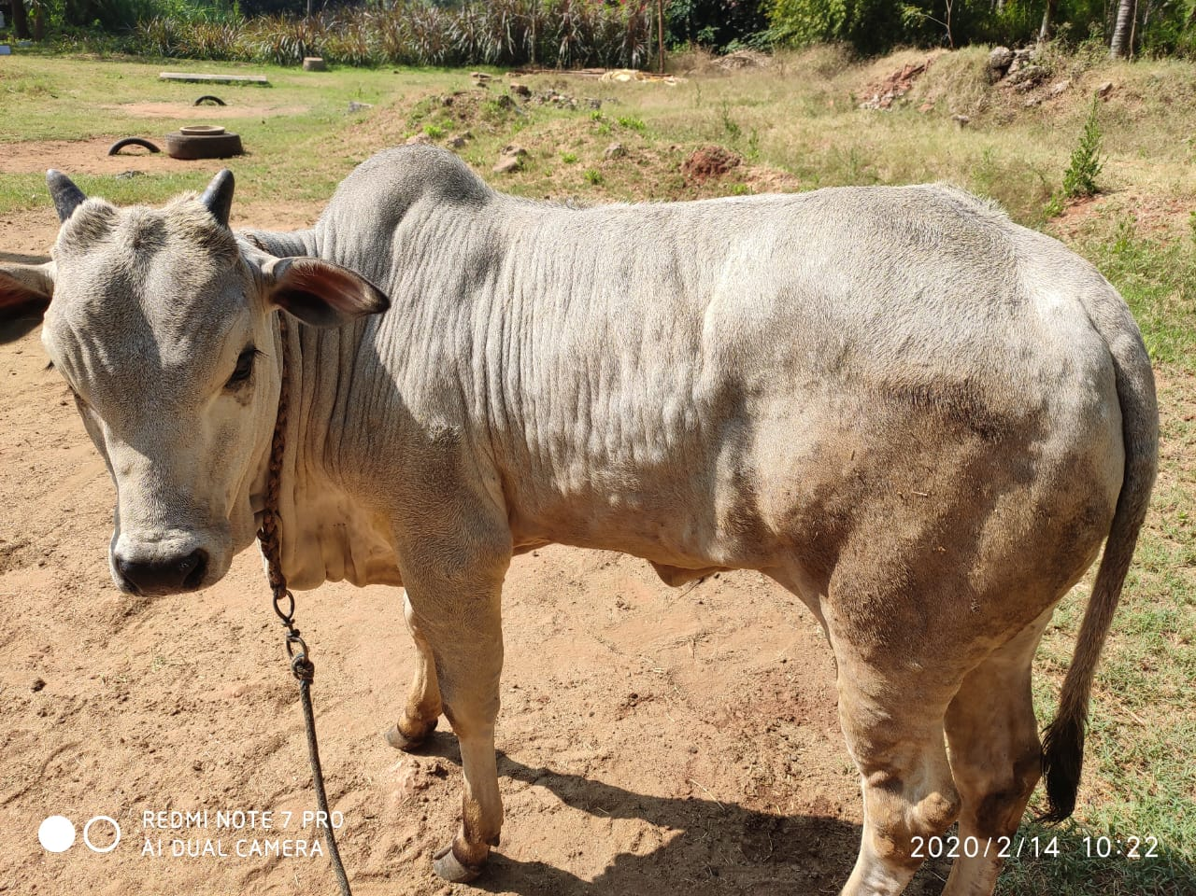
Fig. 1. Round, circumscribed skin nodules (1-5cm) seen all over the body of Kangayam heifer
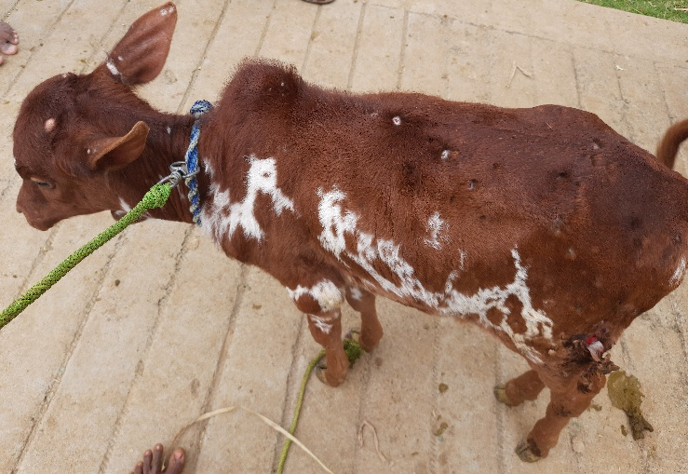
Fig. 2. Raised, hard “sit-fasts” lesions and skin ulcers observed on Bargur calf
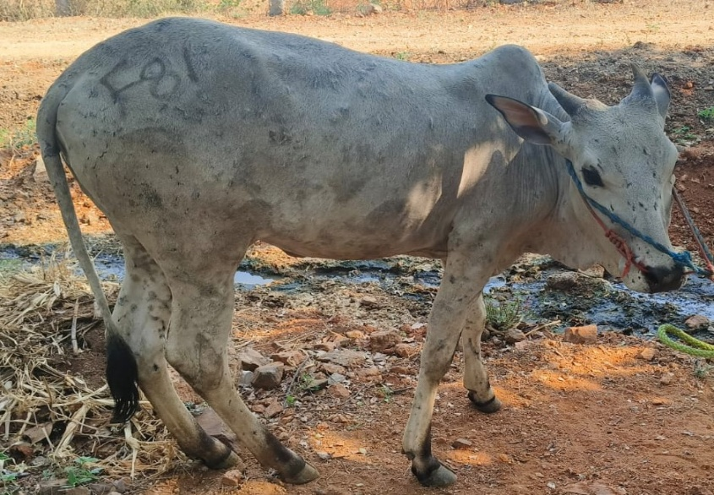
Fig. 3. Long lasting skin scars visible after 2 years in Kangayam heifer
Though LSD can be diagnosed based on clinical manifestations, the clinical disease and lesions must be differentiated from similar confounding conditions including pseudo lumpy skin disease, cowpox, pseudocowpox, dermatophytosis, dermatophilosis, allergic reaction, photosensitisation, insect bites etc. (Tuppurainen et al., 2017). These similar clinical conditions necessitate confirmation of the disease by molecular diagnostic techniques such (Ireland and Binepal, 1998; Tuppurainen et al., 2005). Therefore, in the current study the molecular confirmation of the disease was done by using conventional PCR targeting both p32 gene based as well as F genes, that yielded ~192 bp (Fig. 4A) and ~472 bp (Fig. 4B) amplicons, respectively. Out of 32 samples subjected to PCR, 23 skin scabs (100%) and one unclotted blood samples (11.11%) were found positive. Further, 2 representative PCR products were further confirmed as LSDV by sequencing (Unpublished data; GenBank Accession Numbers: OM506237.1 and OM506241.1). The predilection of virus to the skin epithelium (Zeynalova et al., 2016) and collection of blood from cattle in non-viraemic state could have resulted in reduced number of positive cases in blood samples as reported earlier (Prabhu et al., 2022) when compared to skin scabs. The limitation for the physician to collect samples is, the animals were reported to be clinically ill only when they exhibit skin lesions, during which state the animals might have become non-viraemic. If blood is collected within the initial 2-5 days of pyrexia, the positivity of LSDV in the blood samples might increase. The current finding also supports the previous reports that also corroborated the disadvantage of using whole blood samples as they were found to be positive for a short period of 4 -11 days post infection (Babiuk et al., 2008; and Tuppurainen et al., 2005).
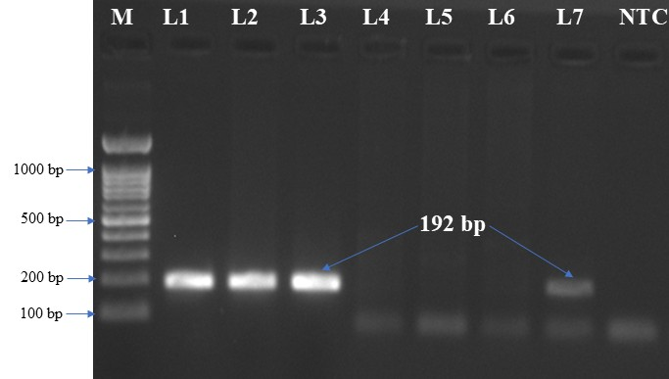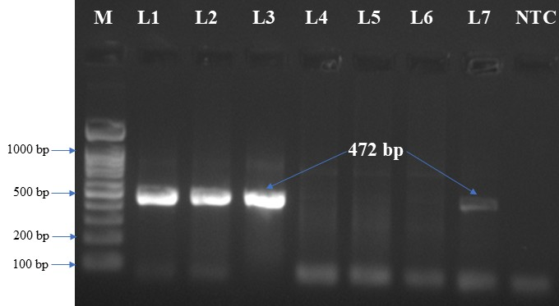
Fig. 4A: P32 gene based PCR Fig. 4B: F gene based PCR
M: 100 bp DNA Marker; L1-L3: Positive skin scabs; L4-L6: Negative whole blood samples; L7: Positive whole blood sample; NTC: Non template control
Table. 2. Details of Zebu cattle clinically examined, samples collected and positive by PCR
Cattle Breed | No. of animal clinically examined (n) | Severity of the infection in affected native cattle *(n) |  |  |  | Samples collected (n) |  | PCR positive (n)
Cattle Breed | No. of animal clinically examined (n) | + | ++ | +++ | ++++ | Whole blood | Skin scabs | Whole blood | Skin scabs
Kangayam | 23 | 4 | 11 | 6 | 2 | 3 | 11 | 0 | 11
Bargur | 31 | 9 | 12 | 7 | 3 | 6 | 12 | 1 | 12
Total | 54 | 13 | 23 | 13 | 5 | 9 | 23 | 1 | 23

* +: Mild skin lesions; ++: Extensive skin lesions; +++: Severe systemic infection with lymphadenopathy; ++++: More severe systemic infection with complications and pneumonia
4. Conclusion
The present study confirms the circulation of LSD viral infection in Kangayam and Bargur indigenous cattle of Tamil Nadu based on clinical manifestations and by PCR. Though, earlier reports support that, cross bred cattle are found to be more severely affected than the Zebu cattle, the present findings confirm severe infections even in native cattle. These clinical findings in indigenous cattle warrants the need for increased awareness about the clinical LSD infection; better biosecurity measures across the boundaries of the non-endemic disease free countries; best research efforts for improved surveillance, and preventive measures to control this economically important transboundary disease.

Competing Interest
The authors have declared that no competing interest exists.
Disclaimer (Artificial Intelligence)
The author(s) hereby declare that NO generative AI technologies such as Large Language Models (ChatGPT, COPILOT, etc.) and text-to-image generators have been used during the writing or editing of this manuscript

References
- Abutarbush, S.M., Ababneh, M.M., Al Zoubi, I.G., Al Sheyab, O.M., Al Zoubi, M.G., Alekish, M.O. & Al Gharabat, R.J. (2013). Lumpy skin disease in Jordan: disease emergence, clinical signs, complications and preliminary-associated economic losses. Transbound Emerg Dis, 62(5), 549-554
- Babiuk, S., Bowden, T.R., Parkyn, G., Dalman, B., Manning, L., Neufeld, J., Embury-Hyatt, C., Copps, J. & Boyle, D.B. (2008). Quantification of lumpy skin disease virus following experimental infection in cattle. Trans bound Emerg Dis, 55, 299–307
- Buller, R.M., Arif, B.M., Black, D.N., Dumbell, R., Esposito, J.J., Lefkowitz, E.J, et al. (2005). Virus taxonomy: eight report of the international committee on the taxonomy of viruses. Elsevier Academic Press, Oxford, 117–133.
- Davies, F.G. (1991). Lumpy skin disease, an African capripox virus disease of cattle. British Veterinary Journal, 147(6), 489-503.
- House, A.J., Wilson, T.M., El-Nakashly, S., Karim, I.A., El-Danaf, N., Mousa, A.N. & Ayoub, N.N. (1990). The isolation of lumpy skin disease virus and bovine herpesvirus from cattle in Egypt. J. Vet. Diagn. Invest, 2, 111-115.
- Ireland, D.C. & Binepal, Y.S. (1998). Improved detection of capripoxvirus in biopsy samples by PCR. J Virol Methods, 74, 1–7
- Kumar, N., Chander, Y., Kumar, R., Khandelwal, N., Riyesh, T., Chaudhary, K. Shanmugasundaram, K., Kumar, S., Kumar, A., Gupta, M.K, Pal, Y., Barua, S. & Tripathi, B.N. (2021). Isolation and characterization of lumpy skin disease virus from cattle in India. PLoS ONE, 16(1), e0241022.
- Lakshmikavitha, K., Sreedevei, B. & Rajesh. K. (2021). Clinico-molecular diagnosis and characterization of bovine lumpy skin disease virus in Andhra Pradesh, India. Tropical Animal Health and Production, 53, 424-424.
- Pandey, N., Hopker, A., Prajapati, G., Rahangdale, N., Gore, K. & Sargison, N. (2022). Observations on presumptive lumpy skin disease in native cattle and Asian water buffaloes around the tiger reserves of the central Indian highlands. New Zealand Veterinary Journal, 70(2), 101–108.
- Prabhu, M., Malmarugan, S., Rajagunalan, S., Balakrishnan, G., Lakshmi Prasanth, T. & Ganapathi, P. (2022). Molecular detection of lumpy skin disease virus from Tamil Nadu, India. Pharma. Innov. J, 11, 75-78.
- Prabhu, M., Malmarugan, S., Rajagunalan, S., Govindan, B., Thangavelu, L.P., Palanisamy, G., Yogisharadhya, R. & Karthik, K. (2024). Isolation and molecular characterization of lumpy skin disease virus from Tamil Nadu, India during the outbreaks from 2020 to 2022. Virus Genes, 60(2), 159-172.
- Reddy, G.B.M., Mounica, P.S., Sudeep, N., Vikram, R., Garam, G.B., Lalzampuia, H., Ragulraj, S., Pal, S., Khate, K., Bijalwan, S., Girish, P.S. & Gulati, B.R. (2024). First evidence of lumpy skin disease in mithun (Bos frontalis) in India. Arch Virol, 169(3), 65
- Reddy, G.B.M., Pabbineedi, S.M., Nagaraj, S., Bijalwan, S., Tadakod, S., Bhutia, Z., Palmu, D., Rai, S., Bhutia, P.D., Bhutia, P.T., Shenga, E. & Gulati, B.R. (2023). Lumpy Skin Disease (LSD) in Yak (Bos grunniens): An Evidence of Species Spillover from Cattle in India. Microorganisms, 11(12), 2823.
- Saegerman, C., Bertagnoli, S., Meyer, G., Ganière, J.P., Caufour, P., De Clercq, K. & Casal, J. (2018). Risk of introduction of lumpy skin disease in France by the import of vectors in animal trucks. PLoS ONE, 13(6), e0198506
- Salib, F.A. & Osman, A.H. (2011). Incidence of lumpy skin disease among Egyptian cattle in Giza Governorate. Egypt Vet World, 4(4), 162–167
- Sudhakar, S.B., Mishra, N., Kalaiyarasu, S., Jhade, S.K., Hemadri, D., Sood, R., Bal, G.C., Nayak, M.K., Pradhan, S.K. & Singh, V.P. (2020). Lumpy skin disease (LSD) outbreaks in cattle in Odisha state, India in August 2019: Epidemiological features and molecular studies. Transbound Emerg Dis, 67(6), 2408-2422
- Tageldin, M.H., Wallace, D.B., Gerdes, G.H., Putterill, J.F., Greyling, R.R., Phosiwa, M.N., Al Busaidy, R.M. & Al Ismaaily, S.I. (2014). Lumpy skin disease of cattle: an emerging problem in Sultanate of Oman. Trop Anim Health Prod, 46(1), 241-246
- Tasioudi, K.E., Antoniou, S.E., Iliadou, P., Sachpatzidis, A., Plevraki, E., Agianniotaki, E.I., Fouki, C., Mangana-Vougiouka, O., Chondrokouki, E. & Dile, C. (2016). Emergence of Lumpy Skin Disease in Greece, 2015. Transbound Emerg Dis, 63, 260–265
- Tuppurainen, E.S., Venter, E.H. & Coetzer, J.A. (2005). The detection of lumpy skin disease virus in samples of experimentally infected cattle using different diagnostic techniques. Onderstepoort J Vet Res, 72, 153–164
- Tuppurainen, E.S.M. & Oura, C.A.L. (2012). Review: Lumpy skin disease: An emerging threat to Europe, the Middle East and Asia. Transbound Emerg Dis, 6, 243–255.
- Tuppurainen, E.S.M., Venter, E.H., Shisler, J.L., Gari, G., Mekonnen, G.A., Juleff, N., Lyons, N.A., De Clercq, K., Upton, C., Bowden, T.R., Babiuk, S. & Babiuk, L.A. (2017). Review: Capripoxvirus diseases: current status and opportunities for control. Transbound Emerg Dis, 64, 729–745.
- Zeynalova, S., Asadov, K., Guliyev, F., Vatani, M. & Aliyev, V. (2016). Epizootology and Molecular Diagnosis of Lumpy Skin Disease among Livestock in Azerbaijan. Front. Microbiol, 7, 1022.

