EFFECTIVENESS OF USING POPSICLE STICKS IN IMPROVING
THE SUBTRACTION SKILLS OF 1st GRADE PUPILS IN BOBOLOSAN ELEMENTARY SCHOOL

.

ABSTRACT

Mathematics provides an effective way of building mental discipline and encourages logical reasoning and mental rigor. It is widely recognized as a foundational subject that supports the understanding of other disciplines such as science, social studies, music, and art. Developing mathematical skills at an early age is crucial, particularly in basic operations like subtraction, which serve as building blocks for more advanced concepts. The present study aims to improve the subtraction skills of Grade 1 pupils in Bobolosan Elementary School through the use of Popsicle Sticks as manipulatives. Conducted during the academic year 2024–2025 in Laoang, Northern Samar, the study employed a quasi-experimental design using pre-test and post-test methods to measure learning outcomes. The researchers selected 27 Grade 1 pupils as respondents, focusing on those identified as non-proficient in numeracy. Subtraction problems were administered before and after the intervention, and a t-test was used to analyze the mean difference between the pre-test and post-test scores. Findings revealed that the pre-test results of the pupils were moderate, indicating initial challenges in performing subtraction. However, the post-test scores showed significant improvement, demonstrating that the use of Popsicle Sticks provided effective visual representation and hands-on experiences that enhanced comprehension. The statistical analysis confirmed a significant difference between the pre-test and post-test results, with higher scores obtained after the intervention. This study concludes that manipulatives such as Popsicle Sticks are valuable tools in teaching mathematical concepts, particularly subtraction, to young learners. Their use fosters engagement, supports active learning, and helps pupils develop a deeper understanding of abstract ideas through concrete experiences. For educators, adopting a hands-on approach with manipulatives offers a practical advantage in improving numeracy skills and promoting meaningful learning in mathematics.

Keywords: Mathematics; Subtraction skills; Grade 1 pupils; Popsicle sticks; Quasi-experimental design; Pre-test and post-test; Manipulatives; t-test analysis

1. INTRODUCTION

Mathematics is a cornerstone of human thought, logic, and daily life. It develops discipline, strengthens reasoning, and supports learning in other subjects such as science, social studies, music, and art. In basic elementary education, mathematics is especially important because it lays the foundation for lifelong skills. Pupils use math not only in school but also in everyday activities—computing grades, estimating travel time, or calculating profits. Among the four basic operations, subtraction is often the most difficult for young learners, as it requires counting backward and regrouping.
Local studies in the Philippines highlight the importance of innovative strategies in addressing learning gaps. Casane & Giray (2026) found that pre-service teachers were strongest in budgeting and saving but needed more support in debt management and investing, while Casane (2026) showed that financial literacy directly influenced academic performance. Baluyot et al. (2026) demonstrated that the Picture-to-Words Strategy improved Grade 4 pupils’ vocabulary and writing, and Casane (2024) revealed that multigrade teachers managed challenges more effectively when maintaining positive attitudes. Jagonoy et al. (2026) confirmed that the Think-Pair-Share strategy enhanced Grade 5 pupils’ reading comprehension, while Casane (2025) identified perceptual gaps between teachers and school heads that required professional development and collaboration. These findings collectively emphasize that interactive strategies, positive attitudes, and structured support are crucial for improving learning outcomes, especially in basic education.
International research echoes similar concerns. Grade 1 pupils in China, Indonesia, and Ghana struggle with sequencing, counting, and subtraction due to limited resources and abstract teaching methods (Li, 2021; Torres, 2021; Mohammed et al., 2025). In the Philippines, international assessments like PISA reveal that only 16% of students reach minimum proficiency in mathematics, far below the OECD (2023) average of 69%. Local data from Bobolosan Elementary School also highlight gaps in numeracy, with several Grade 1 pupils performing at low proficiency levels.

Educational experts emphasize the use of manipulatives—concrete objects that make abstract concepts more tangible (Ghazali, Mohamed, & Mustafa, 2020; Ramilo et al., 2022). In line with the Department of Education’s National Learning Recovery Plan (DepEd Order No. 13, s. 2023), this study introduces Popsicle sticks as a hands-on intervention to improve subtraction skills among Grade 1 pupils. By modeling subtraction with tangible objects, learners can visualize and practice operations more effectively.

For higher education, particularly in the preparation of BEEd pre-service teachers, these activities are highly significant. They provide future educators with practical, child-centered methods that can be applied in classrooms to address diverse learning needs. Moreover, they cultivate professional readiness by equipping pre-service teachers with innovative strategies, resilience, and the ability to adapt instruction to real-world challenges.
Ultimately, education at all levels benefits when effective strategies are consistently integrated into teaching. In basic education, they ensure mastery of foundational skills, while in higher education, they prepare teachers to become facilitators of meaningful learning. By bridging these two levels, schools can build a strong continuum of educational practice that nurtures both learners and educators, ensuring academic success and lifelong skills.
2. MATERIALS AND METHODS

1.Research Design: This study employed a quasi-experimental one-group pretest-posttest design to evaluate the effectiveness of using Popsicle sticks in enhancing subtraction skills among Grade 1 pupils. This design was chosen because it allows researchers to measure the improvement of the same group before and after the intervention, thereby identifying the direct effects of the strategy.

2. Respondents: The respondents of the study were 27 Grade 1 pupils officially enrolled at Bobolosan Elementary School, Laoang, Northern Samar during the School Year 2024–2025. These pupils were selected as they represented the actual classroom context where subtraction difficulties were observed.

3. Sampling Technique: The study used complete enumeration, meaning all available and willing participants from the defined group were included. This ensured that the intervention was applied to the entire Grade 1 class for consistency and fairness.
4. Research Instruments: A researcher-made test was used to assess subtraction skills. The instrument consisted of items aligned with the Grade 1 mathematics curriculum and was validated by experts in mathematics education to ensure clarity, relevance, and reliability. Pre-test and post-test scores served as the primary data for analysis.

5. Data Analysis: The statistical tools used in the study included frequency counts, percentages, mean scores, and t-test analysis. These methods were employed to measure pupils’ performance before and after the intervention, determine the level of improvement, and establish the significance of the results.
6. Limitations of the Study: The study was limited by its use of a one-group pretest-posttest design, which did not include a control group for comparison. This restricts the ability to generalize findings beyond the specific class studied. Additionally, the same instrument was used for both the pre-test and post-test, which may have introduced testing effects. The small sample size, confined to a single school, also limits the broader applicability of the results. Despite these limitations, the study provides valuable insights into the effectiveness of manipulatives in improving subtraction skills among young learners.
7. Intervention Procedure
BEFORE

- The researchers will give printed copies of pre-test to the pupils before the implementation of the intervention.
- Prepare the popsicle sticks.
- Give one set of popsicle with counting dots in every pupil. Each popsicle stick depends on the counting of dots with different colors.

DURING

- The researchers introduce
- subtracting numbers by the use of popsicle sticks.

- The researchers prepare a popsicle with counting dots accommodate subtraction problems written on the manila paper.
- The researchers pick inside the box a problem to solve and the researchers will read the problem in front clearly.
- Every pupil answers the problem given by the researcher.
- The researchers conduct a short review about adding numbers.

- The pupils will demonstrate the subtraction by group using the popsicle sticks.
- The researchers give printed copies of the post-test to the pupils with the same questionnaire in the pre-test.

AFTER

Fig 1: Intervention Procedures before, during, and after the intervention
9. Data Gathering Procedure
DOTTY POPS GAME COMPONENTS:
Popsicle Sticks
Little objects (These could be dots using colored paper, paste)
DOTTY POPS MATH GAME
The steps in using Popsicle Sticks are as follows:
Step 1. Preparing of the Popsicle Sticks.

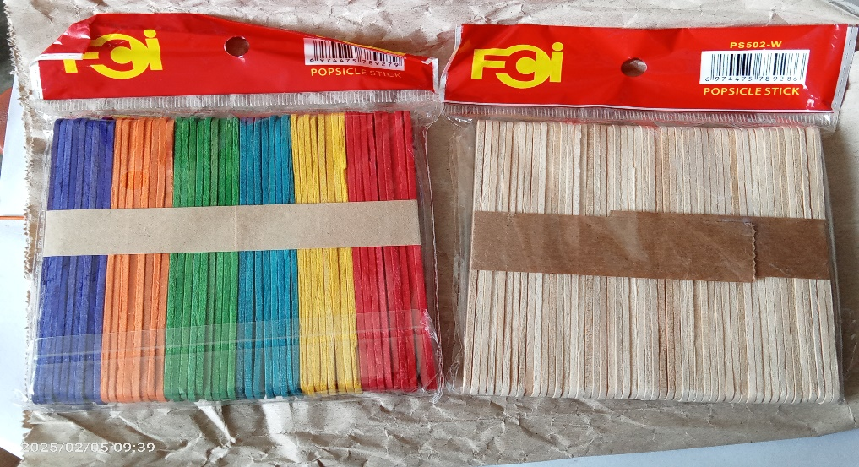

Step 2. Give one set of popsicle sticks to every pupil. Each set consists of 10 dots of colored paper with the different colors and the same sizes.

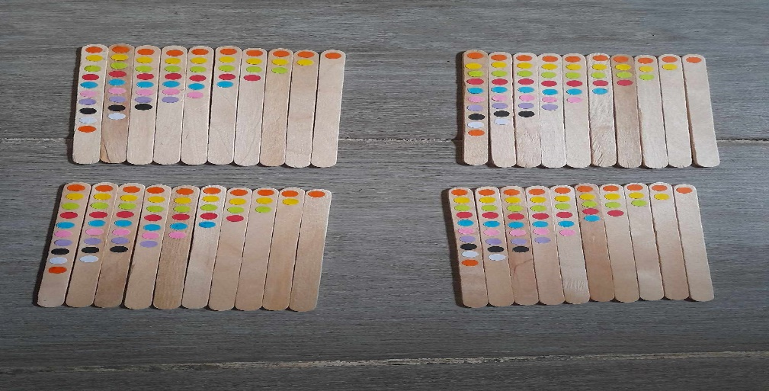

Step 3. The researchers will explain first that every piece of popsicle sticks is counted depends of the number of dots.
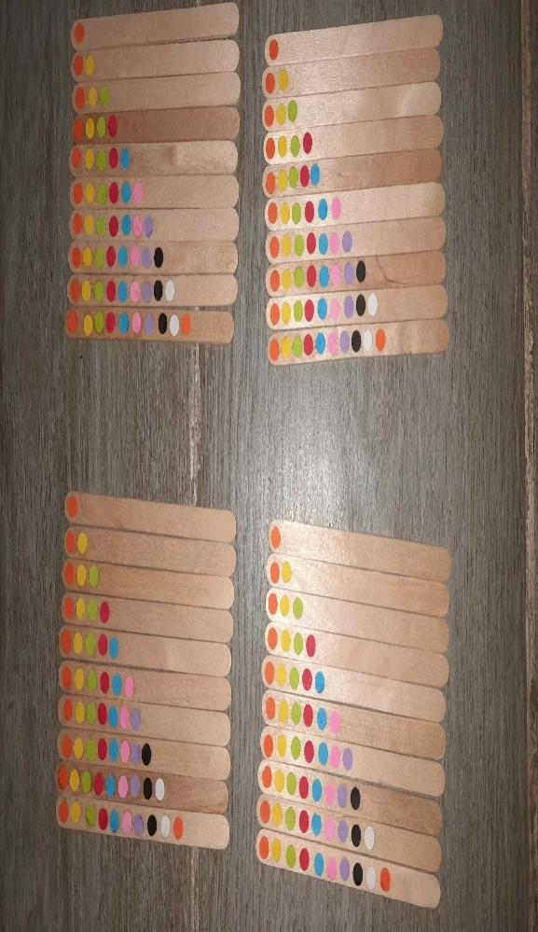

Step 4. The researcher will introduce to pupils the subtraction of numbers using the popsicle sticks.
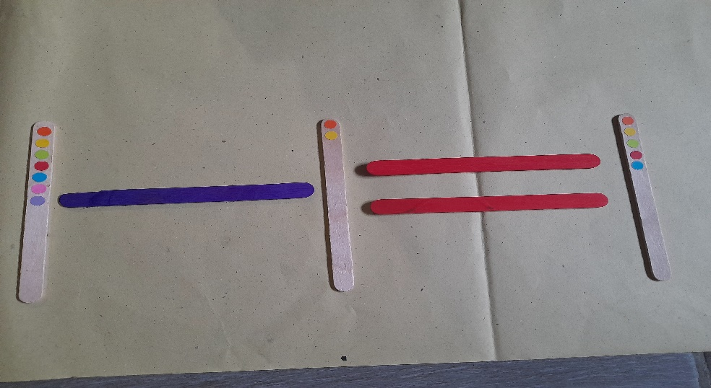

Step 5. The pupils will individually demonstrate the subtraction using popsicle sticks.

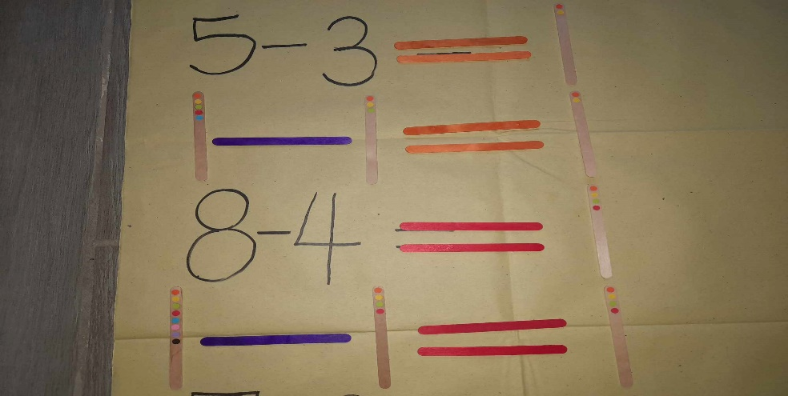

10. Statistical Treatment of Data: The gathered data were carefully collated, tallied, and summarized by the researchers. Results from the pre-test and post-test were subjected to appropriate statistical treatment to ensure the accuracy and reliability of findings. Frequency counts, percentages, mean scores, and t-test analysis were employed to measure pupils’ performance, determine the level of improvement, and establish the significance of the intervention. This systematic approach provided objective evidence of the effectiveness of using Popsicle sticks in enhancing subtraction skills among Grade 1 pupils.

3. RESULTS AND DISCUSSIONS
Pre-Test
The findings revealed that out of 27 participants, 11 or 40.7% obtained the highest score of 10, while 1 or 3.7% scored 9, and 2 or 7.4% scored 8. Meanwhile, 1 or 3.7% of the pupils got the lowest score of 2, 4 or 14.8% scored 3, and another 4 or 14.8% scored 4. The pre-test produced a grand mean of 6.93, which was interpreted as Good. This indicates that the majority of the pupils already had sufficient knowledge of subtraction even before the intervention, suggesting that a significant portion of the class possessed a foundational understanding of the concept.
This result supports the findings Vendicacion (2025), who noted that while many pupils demonstrate basic number sense, challenges often arise in sequencing and counting backward, which are essential for subtraction. Similarly, Mohammed et al. (2025) emphasized that subtraction remains abstract for young learners, particularly in contexts with limited teaching aids. The pre-test results in Bobolosan Elementary School reflect these observations: although a number of pupils showed proficiency, others struggled with lower scores, highlighting the uneven distribution of subtraction skills.
The implication is that pupils who scored lower may not yet have fully transitioned from concrete, object-based experiences to abstract, symbolic understanding. This underscores the importance of using manipulatives such as Popsicle sticks to support the development of mathematical concepts.
Thus, the pre-test results confirm that while some Grade 1 pupils already demonstrate competence in subtraction, others require targeted interventions. This aligns with Ramilo et al. (2022), who found that manipulatives significantly enhance learning outcomes by bridging abstract concepts with tangible experiences. The intervention using Popsicle sticks is therefore justified, as it provides a practical tool to support learners who struggle with subtraction and ensures more equitable numeracy development across the class.

Table 1. Pre-Test

PARTICIPANTS | SCORE | Percentage
- Student 1 | 6 | 60%
- Student 2 | 3 | 30%
- Student 3 | 3 | 30%
- Student 4 | 10 | 100%
- Student 5 | 9 | 90%
- Student 6 | 10 | 100%
- Student 7 | 10 | 100%
- Student 8 | 10 | 100%
- Student 9 | 10 | 100%
- Student 10 | 3 | 30%
- Student 11 | 4 | 40%
- Student 12 | 10 | 100%
- Student 13 | 5 | 50%
- Student 14 | 4 | 40%
- Student 15 | 10 | 100%
- Student 16 | 4 | 40%
- Student 17 | 8 | 80%
- Student 18 | 4 | 40%
- Student 19 | 8 | 80%
- Student 20 | 2 | 20%
- Student 21 | 10 | 100%
- Student 22 | 10 | 100%
- Student 23 | 10 | 100%
- Student 24 | 3 | 30%
- Student 25 | 5 | 50%
- Student 26 | 6 | 60%
- Student 27 | 10 | 100%
 | Mean = 6.93 | 6.93%

Post-Test
During the post-test, 20 pupils (70.07%) scored the highest mark of 10, 4 pupils (14.8%) scored 9, and 1 pupil (3.7%) scored 8. On the lower end, only 2 pupils (7.4%) scored 7. The post-test produced a grand mean of 9.56, interpreted as Very Good. This shows a clear improvement compared to the pre-test mean of 6.93, confirming that the Dotty Pops math game using Popsicle sticks was effective in enhancing subtraction skills.
These results support Ramilo et al. (2022), who found that manipulatives significantly improve learning outcomes by making abstract concepts tangible. The improvement highlights the importance of concrete, hands-on experiences in helping learners transition toward abstract understanding. Pupils engaged in multisensory and interactive activities, which strengthened their conceptual grasp of subtraction and promoted deeper mathematical comprehension.
Furthermore, the findings echo Ghazali, Mohamed, & Mustafa (2020), who highlighted that manipulatives foster active participation and deeper comprehension. By using Popsicle sticks in a game format, pupils were able to count, group, and visualize subtraction, making the process less abstract and more meaningful.
Overall, the post-test results demonstrate that the Dotty Pops math game not only improved pupils’ subtraction skills but also provided a fun, engaging, and effective learning experience. This validates the intervention as a practical strategy for Grade 1 mathematics and supports the broader literature on the value of manipulatives in basic education.

Table 2. Post-Test

PARTICIPANTS | SCORE | Percentage
Student 1 | 10 | 100%
Student 2 | 10 | 100%
Student 3 | 10 | 100%
Student 4 | 10 | 100%
Student 5 | 10 | 100%
Student 6 | 10 | 100%
Student 7 | 10 | 100%
Student 8 | 10 | 100%
Student 9 | 10 | 100%
Student 10 | 8 | 80%
Student 11 | 9 | 90%
Student 12 | 10 | 100%
Student 13 | 10 | 100%
Student 14 | 10 | 100%
Student 15 | 10 | 100%
Student 16 | 10 | 100%
Student 17 | 10 | 100%
Student 18 | 10 | 100%
Student 19 | 9 | 90%
Student 20 | 7 | 70%
Student 21 | 10 | 100%
Student 22 | 10 | 100%
Student 23 | 10 | 100%
Student 24 | 7 | 70%
Student 25 | 9 | 90%
Student 26 | 9 | 90%
Student 27 | 10 | 100%
 | Mean = 9.56 | 95.6 %

Test of Significant Difference between the Pre-test and Post-Test
Table 3 compares the pre-test and post-test scores of the respondents. The pre-test had a mean of 6.93 (SD = 3.04), while the post-test mean rose to 9.56 (SD = 0.89). The computed t-value of -5.160 at 26 degrees of freedom yielded a p-value of .000, which is below the 0.05 level of significance. Thus, the null hypothesis (H₀) was rejected, indicating a significant difference between the pre-test and post-test scores.
This improvement validates the effectiveness of the Dotty Pops math game using Popsicle sticks in enhancing subtraction skills among Grade 1 pupils. The findings are consistent with local studies such as Jagonoy et al. (2026), who showed that interactive strategies like Think-Pair-Share improved reading comprehension, and Baluyot et al. (2026), who demonstrated that the Picture-to-Words Strategy enhanced vocabulary and writing. Similarly, Casane (2024, 2025, 2026) highlighted that positive teacher attitudes, structured support, and financial literacy interventions directly influence academic performance. These studies collectively emphasize that innovative, interactive strategies—whether in literacy, numeracy, or broader educational contexts—lead to measurable improvements in learning outcomes.
The results also align with international research. Li (2021), Torres (2021), and Mohammed et al. (2025) documented that Grade 1 pupils in China, Indonesia, and Ghana struggle with sequencing and subtraction due to abstract teaching methods. The significant gain in post-test scores at Bobolosan Elementary School demonstrates how concrete tools like Popsicle sticks can overcome these challenges.
Findings from Vendecacion et al. (2025) highlight the importance of concrete experiences in helping learners transition toward abstract understanding. Pupils who initially struggled were able to grasp subtraction more effectively when provided with tangible objects to manipulate. In line with this, Ghazali, Mohamed, and Mustafa (2020) as well as Ramilo et al. (2022) emphasized that manipulatives foster active participation and deeper comprehension, which explains the marked improvement in post-test performance.
Overall, the statistical evidence demonstrates that the Dotty Pops math game is an effective, child-centered strategy for teaching subtraction. It bridges abstract concepts with real-world experiences, supports mastery of foundational skills in basic education, and provides future BEEd pre-service teachers with practical methods they can apply in their classrooms.

Table 3
Test of Significant Difference Between the Pretest and Posttest Score
of the Respondents
Test | Mean | SD | t-value | df | p-value | Decision | Interpretation
Pre-Test | 6.93 | 3.04 | -5.160 | 26 | .000 | Reject H₀ | Significant
Post-Test | 9.56 | .89

4. Conclusion

This study was undertaken to determine the effectiveness of the Dotty Pops math game using Popsicle sticks in improving subtraction skills among Grade 1 pupils at Bobolosan Elementary School, Laoang, Northern Samar. Utilizing a one-group pretest-posttest design with twenty-seven participants, the results revealed that the pre-test mean score of 6.93, interpreted as Good, increased to a post-test mean score of 9.56, interpreted as Very Good. Statistical analysis confirmed a significant difference between the two sets of scores, thereby establishing that the intervention had a positive impact on pupils’ performance.

Based on these findings, the researcher therefore concludes that the Dotty Pops math game is an effective, child-centered strategy for teaching subtraction. The activity provided pupils with a multisensory and interactive learning experience that bridged abstract mathematical concepts with tangible practice. This approach not only strengthened their conceptual understanding and problem-solving skills but also made learning more engaging and meaningful, demonstrating that manipulatives can play a vital role in enhancing numeracy among young learners.
In light of the results, the researcher recommends that teachers integrate manipulatives and interactive games into mathematics instruction to make abstract concepts more concrete and accessible to pupils. School administrators are encouraged to support such innovations by providing resources and training for teachers to adopt child-centered approaches. Pre-service teachers should be exposed to and practice these strategies during their training to build professional readiness and ensure effective classroom application. Future researchers are advised to replicate the study in other grade levels, subjects, or schools to further validate the effectiveness of manipulatives and explore their broader impact on learning outcomes.

Ethical approval and Consent: Ethical approval was secured from school authorities. Parental consent was obtained, and pupils participated voluntarily. Confidentiality of results was maintained, and the intervention was designed to benefit all learners without causing harm or undue pressure.

Disclaimer (Artificial intelligence)

Author(s) hereby declare that NO generative AI technologies such as Large Language Models (ChatGPT, COPILOT, etc.) and text-to-image generators have been used during the writing or editing of this manuscript.

References

Baluyot, D. M. L., Ponce, R. S., Tejano, A. C., Verano, R. L., & Casane, L. L. (2026). Enhancing vocabulary and writing skills through Picture-to-Words Strategy among Grade 4 pupils of Pangpang Integrated School. Asian Journal of Arts, Humanities and Social Studies, 9(1), 129–136. https://doi.org/10.56557/ajahss/2026/v9i1104

Casane, L. L. (2024). Teacher’s attitude and challenges in teaching multi-grade classes. International Journal of Advanced Research in Education and Society, 6(5), 219–230. https://doi.org/10.55057/ijares.2024.6.5.21
Casane, L. L. (2025). Instructional competence, professional and personal characteristics of teachers in multigrade classes. Asian Journal of Education and Social Studies, 51(5), 817–829. https://doi.org/10.9734/ajess/2025/v51i51962
Casane, L. L. (2026). Academic performance in edukasyong pantahanan at pangkabuhayan and financial literacy among students in bachelor of elementary education. Asian Journal of Arts, Humanities and Social Studies, 9(1), 102–112. https://doi.org/10.56557/ajahss/2026/v9i1101
Casane, L. L., & Giray, A. L., Jr. (2026). Financial literacy of pre-service teachers of UEP Laoang campus: Basis for crafting financial literacy program. Journal of Economics and Trade, 11(1), 384–393. https://doi.org/10.56557/jet/2026/v11i110459
Department of Education. (2023). DepEd Order No. 13, s. 2023: Adoption of the National Learning Recovery Plan (NLRP). Department of Education.
Ghazali, M., Mohamed, R., & Mustafa, Z. (2021). A systematic review on the definition of children’s number sense in the primary school years. Eurasia Journal of Mathematics, Science and Technology Education, 17(6), em1968. https://doi.org/10.29333/ejmste/10871
Jagonoy, S. T., Pepito, G. N., Ponce, R. F., Sua, H. A. G., & Casane, L. L. (2026). Enhancing reading comprehension through Think-Pair-Share in the Grade 5 pupils of Catigbian Elementary School. Asian Journal of Arts, Humanities and Social Studies, 9(1), 121–128. https://doi.org/10.56557/ajahss/2026/v9i1103
Li, J. (2021). Challenges in early mathematical education in rural China: Addressing the gap in number recognition and basic arithmetic. Journal of Early Childhood Education, 45(3), 112–125.
Mohammed, A. A., Iman, A., Abdul-Mumin, A.-H., & Anass, A. A. (2025). Enhancing subtraction skills among kindergarten learners: A hands-on approach using bundle of stick. American Journal of Arts and Human Science, 4(1), 15–24. https://doi.org/10.54536/ajahs.v4i1.3965
OECD. (2023). PISA 2022 results (Volume I and II): Country notes: Philippines – What students know and can do in mathematics. OECD Publishing. Retrieved May 4, 2025, from https://www.oecd.org/pisa/publications/pisa-2022-results.htm
Ramilo, R., Cruz, M., Geanga, J. P., & Faustino, J. B. (2022). Teachers’ perspectives on optimizing manipulatives in teaching 21st century skills in kindergarten. Journal of Childhood, Education & Society.
Torres, R. C. (2021). Addressing the learning gaps in the distance learning modalities. ResearchGate, 1–4. https://www.researchgate.net/publication/352551820_Addressing_the_Learning_Gaps_in_the_Distance_Learning_Modalities
Vendicacion, E. G., Huevos, C. G. & Espiritu Jr., M. L. (2025). Arithmetic Counting Techniques through Manipulatives: Effect on the Numeracy Skills of Grade 1 Pupils. International Journal of Multidisciplinary: Applied Business and Education Research, 6(4), 1635-1642. http://dx.doi.org/10.11594/ijmaber.06.04.06. File retrieved April 20, 2026.

