EFFECTIVENESS OF USING POPSICLE STICKS IN IMPROVING
THE SUBTRACTION SKILLS OF 1st GRADE PUPILS IN BOBOLOSAN ELEMENTARY SCHOOL

.
ABSTRACT

This study aims to improve the subtraction skills of 1st Grade pupils in Bobolosan Elementary School through the use of Popsicle Sticks. This study was conducted in Bobolosan Elementary School, Laoang, Northern Samar, during the academic year 2024-2025. The researchers used quasi-experimental, pre-test, and post-test designs for the intervention. Specifically, this study seeks to answer the following: 1) What are the pre-test results in subtraction of the respondents? 2) What are the post-test results in subtraction of the respondents, and 3) is there a significant difference between the pre-test and post-test results in subtraction of the respondents? The researchers chose Grade 1 pupils as respondents because there was a greater number of pupils who were non-proficient in numeracy. The respondents were the 27 pupils from Bobolosan Elementary School who answered the pre-test and post-test subtraction problems. A t-test was employed for the analysis of data to get the mean difference between the pre-test and post-test.
Findings revealed that the pre-test results of the grade 1 pupils were moderate.
The findings of the post-test were showed significant improvement.
There is a significant difference between the pre-test and the post-test of pupils in Bobolosan Elementary School.
In conclusion, higher scores were obtained in the post-test compared to the pre-test in subtracting numbers. The use of manipulatives like Popsicle Sticks is an effective tool that provides a visual representation and hands-on experiences to the pupils in subtracting numbers. It is an advantage for the educators to use manipulatives and a hands-on approach, especially in teaching mathematical concepts to the pupils.

Keywords:
Popsicle Sticks, Subtractions, Pupils, Skills, Effectiveness, Improvement,

1. INTRODUCTION

Mathematics is a fundamental part of human thought and logic, and integral to attempts at understanding the world and ourselves. The fundamentals of mathematics begin with arithmetic operations such as addition, subtraction, multiplication and division. It is one of the most important subjects in the school. Mathematics provides an effective way of building mental discipline and encourages logical reasoning and mental rigor. Moreover, mathematical knowledge plays a crucial role in understanding the contents of other school subjects such as science, social studies, and even music and art (Rhyddings). It is also used when a person buys goods in the store. Even teachers use mathematics in computing the grades of the pupils. Businessmen also use mathematics to calculate how many monthly profits or sales they earn. Even drivers need mathematics to estimate how many kilometers and hours to reach the destination of the passengers. It is important to apply mathematics in every aspect of life and in dealing with daily life problems.
Subtraction is the foundational concept in Mathematics. Unfortunately, pupils with learning difficulties often find it challenging as it entails counting backward. However, many Grade 1 learners face challenges in mastering counting, often struggling with number sequencing and understanding quantity. These difficulties can create gaps in learning that persist as students’ progress through their education (Brown & Clark, 2020).
In primary education, Grade 1 students in China, Indonesia, and Ghana face common challenges in mastering foundational math skills like counting and basic arithmetic. In China, issues such as improper number formation and sequencing difficulties hinder students’ math progress, especially in rural areas with limited resources (Li, 2021). Similarly, in Indonesia, students struggle with basic counting and addition, and lack of interactive tools like counting sticks makes learning difficult.
The situation has led to a decline in math learning, as students may need more remediation to progress to new lessons, leading to learning gaps (Torres, 2021). Use Popsicle Sticks at any point in the lesson to increase engagement of all students and to show you value each person in the classroom.
Similarly, in Indonesia, students struggle with basic counting and addition, and lack of interactive tools like counting sticks makes learning difficult. However, research shows that such hands-on methods significantly improve performance, particularly in areas with fewer resources (Masrukahtin, Siswanto, & Susilo, 2022). In Ghana, Kindergarten learners face difficulties with subtraction due to its abstract nature and limited teaching aids, leading to challenges in numeracy development, especially in rural schools (Mohammed et al., 2025).
Based on the Programme for International Student Assessment (PISA), In the Philippines, 16% of students attained at least Level 2 proficiency in mathematics, significantly less than on average across OECD countries (OECD average: 69%). At a minimum, these students can interpret and recognize, without direct instructions, how a simple situation can be represented mathematically (e.g. comparing the total distance across two alternative routes, or converting prices into a different currency). Almost no students in the Philippines were top performers in mathematics, meaning that they attained Level 5 or 6 in the PISA mathematics test (OECD average: 9%). This is evident that not only in some areas in the Philippines but throughout the country many pupils have difficulty in learning mathematics (ANC DIGITAL NEWS, December 2023).
Based on the Mean Percentage Score (MPS) results in the Second Quarter, the Bobolosan Elementary School got the average MPS in Mathematics in the Laoang II District which is 86.25. The result revealed that the MPS of Grade 1 pupils in the First Quarter is 86.25 and 82 in the Second Quarter. Based also on the Summary of 27 Student’s Numeracy Profile of Grade 1 pupils in Quarter 2, 8 pupils are highly proficient, 8 pupils proficient, 8 nearly proficient, and 3 low proficient, pupils in numeracy. This data shows that there are a greater number of pupils who are proficient in numeracy. (MPS, 1st and 2nd quarter school year 2024-2025, Bobolosan Elementary School)
Subtraction is one of the four basic arithmetic operations in mathematics. We can observe the applications of subtraction in our everyday life in different situations. Subtraction is the foundational concept in Mathematics. Unfortunately, pupils with learning difficulties often find it challenging as it entails counting backward. Going gets tough for these pupils when the number gets bigger and involves regrouping.
According to cognitive psychologist Jerome Bruner, there are three stages of representation through which students demonstrate their understanding: enactive (use of concrete objects), iconic, and symbolic (1960, 1986).
As Ghazali, Mohamed, and Mustafa (2020) highlighted the necessity of a well-defined understanding of number sense in primary mathematics education to facilitate reproducible research and informed teaching. Their detailed analysis of number sense indicators offers a practical guide for educators and researchers to develop and implement evidence-based instructional strategies.
More so, using manipulatives, also called maneuverable objects, initially designed for teaching Mathematics, has made profound progress in teaching (Ramilo et al., 2022). As facilitators of knowledge, teachers should do their best to offer learners the best resources and materials to enhance their cognitive skills.
Despite the numerous challenges in the education sector, heightened by the pandemic driven school disruptions, the Department of Education (DepEd) remained committed and dedicated to addressing learning loss as well as the low performance of Filipino learners in international large-scale assessments through the adoption of the National Learning Recovery Plan (NLRP) enshrined in the DepEd Order No.13, s. 2023. This is anchored on the MATATAG agenda, with improving numeracy and literacy as one of its significant highlights. Adopting to the local context, DepEd Region III conducts various assessments among public schools in Central Luzon to gain accurate results and findings that will serve as baseline data in improving the teaching-learning process and developing intervention and remediation programs.
Thus, the researchers will introduce Popsicles Sticks as an intervention to improve the addition skills of the pupils because it is a tangible object that the pupils can manipulate to practice subtracting numbers. It is an effective and interactive tool to engage the pupils in hands-on experiences. Moreover, it helps also the pupils to learn the different concepts in mathematics like addition, subtraction, multiplication, and division.
Since mathematical concepts are interconnected, it is very important to improve the subtraction skills of Grade 1 pupils. This can be achieved through modeling how to use Popsicles Sticks so that the pupils will learn how to subtract numbers. For example, 7 - 2 = 5, so 7 dots in popsicle minus 2 dots in popsicles equal to 5 dots in popsicles sticks. The pupils can try different numbers by subtracting the pieces of the popsicles sticks with subtract up to 10. Hence, learning how to subtract using the Popsicles sticks could result in the improvement of the pupils' performance in mathematics.

2. MATERIALS AND METHODS

- Participants and Other Sources of Data and Information
This study was conducted in Bobolosan Elementary School, Laoang, Northern Samar during the academic year 2024 – 2025. The participants of the study were the 27 pupils who were enrolled in Grade 1 in Bobolosan Elementary School. The data was taken from the pre-test and post-test results.
- Research Instrument
The researcher used quasi-experimental type of research were employed in this study, which focuses on a one-group pretest-posttest design, as behavioral researchers often use this to identify the effects of an intervention on a given study.

- Intervention Procedure
BEFORE

- The researchers will give printed copies of pre-test to the pupils before the implementation of the intervention.
- Prepare the popsicle sticks.
- Give one set of popsicle with counting dots in every pupil. Each popsicle stick depends on the counting of dots with different colors.

DURING

- The researchers introduce
- subtracting numbers by the use of popsicle sticks.

- The researchers prepare a popsicle with counting dots accommodate subtraction problems written on the manila paper.
- The researchers pick inside the box a problem to solve and the researchers will read the problem in front clearly.
- Every pupil answers the problem given by the researcher.
- The researchers conduct a short review about adding numbers.

- The pupils will demonstrate the subtraction by group using the popsicle sticks.
- The researchers give printed copies of the post-test to the pupils with the same questionnaire in the pre-test.

AFTER

Fig 1: Intervention Procedure

- Data Gathering Procedure
DOTTY POPS GAME COMPONENTS:
Popsicle Sticks
Little objects (These could be dots using colored paper, paste)
DOTTY POPS MATH GAME
The steps in using Popsicle Sticks are as follows:
Step 1. Preparing of the Popsicle Sticks.
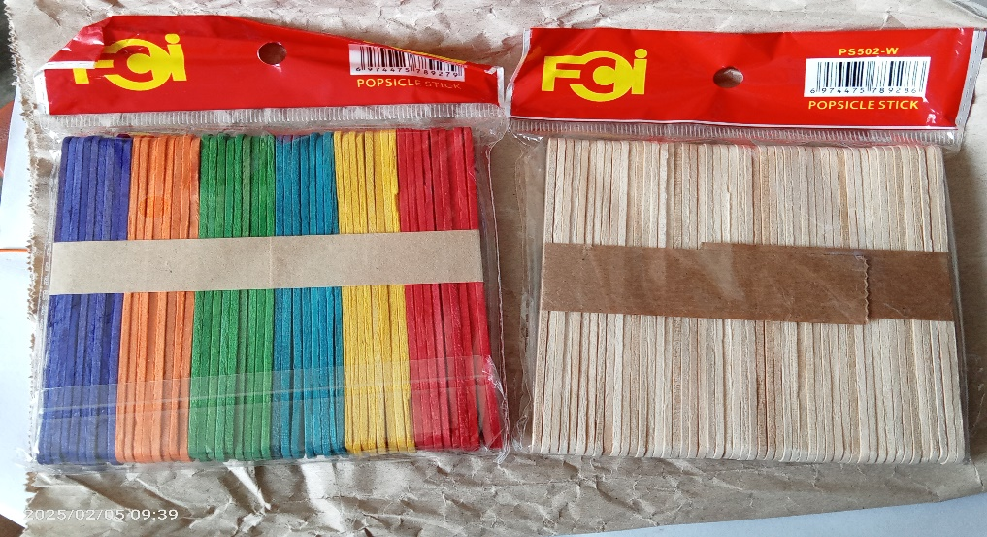

Fig. 2. Popsicle Sticks preparation

Step 2. Give one set of popsicle sticks to every pupil. Each set consists of 10 dots of colored paper with the different colors and the same sizes.
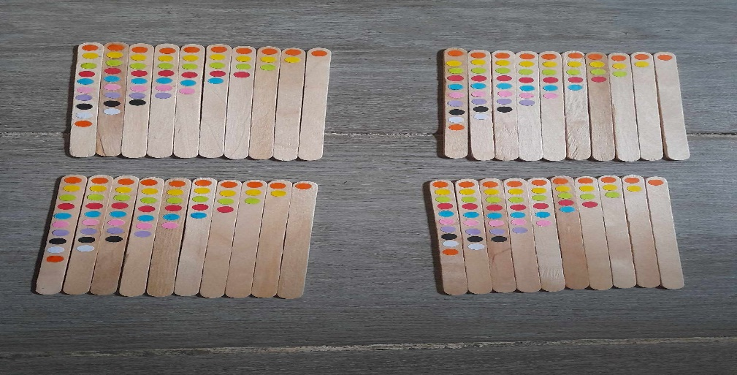

Fig. 3. One set of popsicle sticks to every pupil

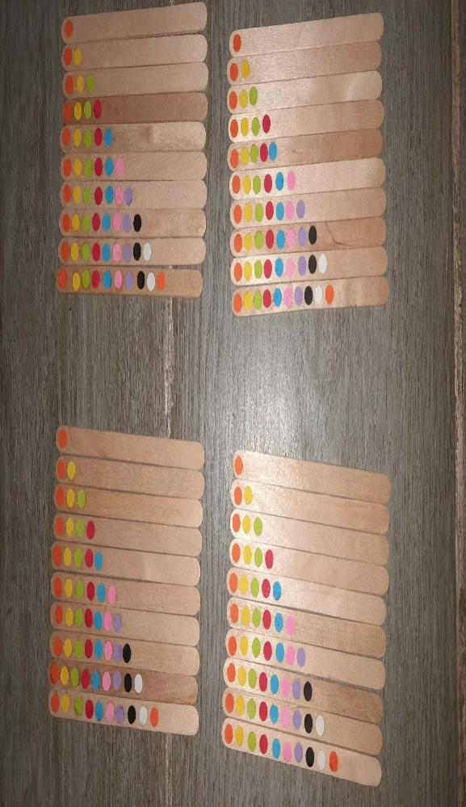
Step 3. The researchers will explain first that every piece of popsicle sticks is counted depends of the number of dots.

Fig. 4. Popsicle sticks counted depends of the number of dots

Step 4. The researcher will introduce to pupils the subtraction of numbers using the popsicle sticks.
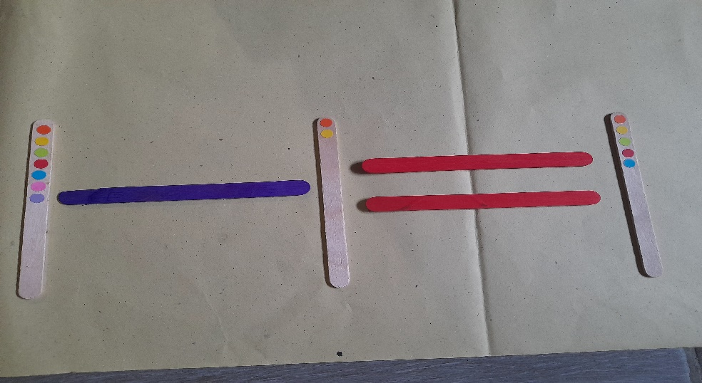

Fig. 5. Subtraction of numbers using the popsicle sticks

Step 5. The pupils will individually demonstrate the subtraction using popsicle sticks.

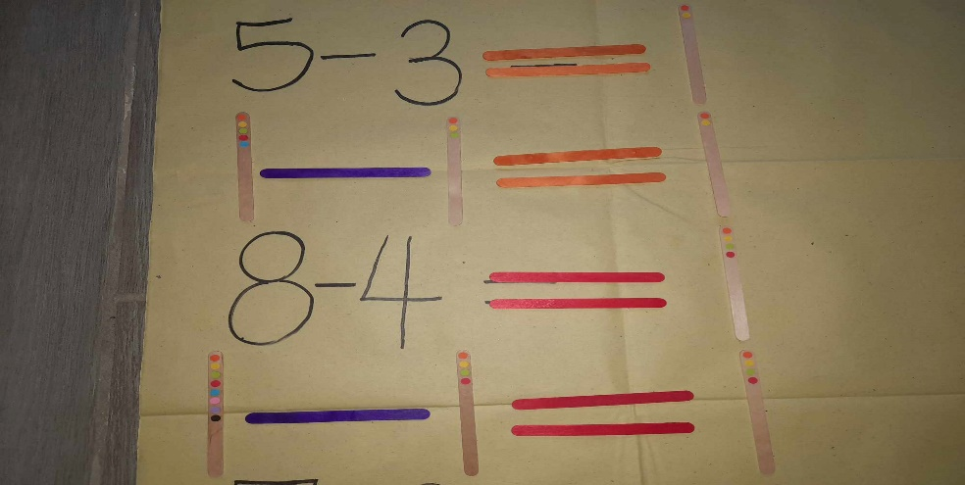

Fig. 6. Subtraction using popsicle sticks
- Statistical Treatment of Data
The gathered data was collated tallied, and correspondingly summarized by the researchers. The data, which gathered by the pretest and posttest intervention was objective by the statistical treatment in order to ensure the reliability of results.
3. RESULTS AND DISCUSSIONS
Pre-Test
The finding revealed that out of 27 participants 11 or 40.7 percent got the highest score of 10, while, 1 or 3.7 percent participant got the second highest score of 9, and 2 or 7.4 percent got the third highest score of 8. Meanwhile, out of 27 participants, 1 or 3.7 percent participant got the lowest score of 2, while 4 or 14.8 percent got the second lowest score of 3, and 4 or 14.8 percent got the third lowest score of 4. The pre-test got a grand mean of 6.93 and interpreted as good. This means that majority of the pupils has enough knowledge on how to subtract. This implies that a significant portion of the class already possesses a strong understanding even before given an instruction of the subject matter.

Table 1.
Pre-Test

PARTICIPANTS | SCORE | Percentage
- Student 1 | 6 | 60%
- Student 2 | 3 | 30%
- Student 3 | 3 | 30%
- Student 4 | 10 | 100%
- Student 5 | 9 | 90%
- Student 6 | 10 | 100%
- Student 7 | 10 | 100%
- Student 8 | 10 | 100%
- Student 9 | 10 | 100%
- Student 10 | 3 | 30%
- Student 11 | 4 | 40%
- Student 12 | 10 | 100%
- Student 13 | 5 | 50%
- Student 14 | 4 | 40%
- Student 15 | 10 | 100%
- Student 16 | 4 | 40%
- Student 17 | 8 | 80%
- Student 18 | 4 | 40%
- Student 19 | 8 | 80%
- Student 20 | 2 | 20%
- Student 21 | 10 | 100%
- Student 22 | 10 | 100%
- Student 23 | 10 | 100%
- Student 24 | 3 | 30%
- Student 25 | 5 | 50%
- Student 26 | 6 | 60%
- Student 27 | 10 | 100%
 | Mean = 6.93 | 6.93%

Post-Test
The finding revealed during the post-test, out of 27 participants 20 or 70.07 percent got the highest score of 10, while, 4 or 14.8 percent participant got the second highest score of 9, and 1 or 3.7 percent got the third highest score of 8. Meanwhile, out of 27 participants, 2 or 7.40 percent participant got the lowest score of 7, The post-test got a mean of 6.92. The got a grand mean of 9.56 interpreted as very good. This means that the popsicle sticks is effective and has improved their subtraction skills through Dotty pops math game. It can help them improve their subtraction skills because it is used in some schools which greatly help the elementary pupils to learn subtraction easily by participating in the game. This implies that the Dotty pops math game is one of many objects considered as manipulative that can allow children to interpret, represent and comprehend a variety of math concepts while using real word examples, in which students are able to touch and feel. Dotty pops math game are great for counting, grouping, patterning, measurement, and sorting activities. The use of dotty pops math game demonstrated a high impact on students’ subtraction skills as displayed on the MPS result of post-test over pre-test. Therefore, it is concluded that implementing dotty pops math game in teaching Subtraction to 1st Graders improved their solving skills. Overall, the Dotty pops math game engages Pupils in a multisensory and interactive learning experience that strengthens their conceptual understanding of subtraction, and develops problem solving skills.

Table 2
POST – TEST

PARTICIPANTS | SCORE | Percentage
Student 1 | 10 | 100%
Student 2 | 10 | 100%
Student 3 | 10 | 100%
Student 4 | 10 | 100%
Student 5 | 10 | 100%
Student 6 | 10 | 100%
Student 7 | 10 | 100%
Student 8 | 10 | 100%
Student 9 | 10 | 100%
Student 10 | 8 | 80%
Student 11 | 9 | 90%
Student 12 | 10 | 100%
Student 13 | 10 | 100%
Student 14 | 10 | 100%
Student 15 | 10 | 100%
Student 16 | 10 | 100%
Student 17 | 10 | 100%
Student 18 | 10 | 100%
Student 19 | 9 | 90%
Student 20 | 7 | 70%
Student 21 | 10 | 100%
Student 22 | 10 | 100%
Student 23 | 10 | 100%
Student 24 | 7 | 70%
Student 25 | 9 | 90%
Student 26 | 9 | 90%
Student 27 | 10 | 100%
 | Mean = 9.56 | 95.6 %

Test of Significant Difference between the Pre-test and Post-Test
Based on the findings table 3 shows that there is a significant difference between the pretest (M= 6.93, SD= 3.04) and post-test (M= 9.56, SD=.89) results of the respondents. The test of difference between the pre-test and the post-test got a t-value of -5.160, degree of freedom of 26, p-value of .000, reject the hypothesis and interpreted as significant. This means that there is an improvement in the subtraction skills with the use of Dotty Pops Math Game of Grade 1 pupils because most of them got the highest scores in the post-test. This implies that majority of the grade 1 pupils improved their knowledge in subtraction using the Dotty Pops Math Game even though for only a short period of time.

Table 3
Test of Significant Difference Between the Pretest and Posttest Score
of the Respondents
Test | Mean | SD | t-value | df | p-value | Decision | Interpretation
Pre-Test | 6.93 | 3.04 | -5.160 | 26 | .000 | Reject H₀ | Significant
Post-Test | 9.56 | .89

- Data Gathering Method
To gather the needed data, the researchers asked first permission from the research adviser, research professor, and Chairperson of Department of Teacher Education through letter. Upon approval, the researchers asked permission through a letter to the Principal Teacher of Bobolosan Elementary School, Laoang, Northern Samar that Grade 1 pupils was the participants for the research study; afterwards, the researchers approached the adviser of grade 1 pupils in Bobolosan Elementary School that the researchers can conduct a research study to his/her class.
Before the conduct of the intervention, the researchers administered first the pretest to determine if the pupils had an idea of subtraction, the pre-test was collected and checked by the researchers. Afterwards, the researchers came to the school again to teach the participants on how to subtract using dotty pops math game using popsicle sticks for them to better improve their subtraction skill. After two days, the researchers came back to school again to administer post-test to determine if the performance of the 1st Grade pupils in subtraction had improved. The researchers had taught 5 times in 1 week. Data was tallied, analyzed, and interpreted.
- Trustworthiness of Quantitate Results
The result of pre-test and post-test of Grade 1 pupils in Bobolosan Elementary School was tallied, analyzed, and interpreted through using frequency counts and percentage. Specifically, the difference in the mean scores between the pre-test and post-test was computed as a measure of change in the grade one pupils’ subtraction ability. Meanwhile, inferential analysis involves pair sample t-test was used to identify the significant difference between the pre-test and post- test.
- Ethical Consideration
The researchers followed a set of principles that guide these research design and practices. A written permission to the Principal Teacher II of Bobolosan Elementary School, to the Grade 1 class adviser for the approval of the research purposed and to the parent consent, we wrote a letter as a permission that we utilized their children as our respondents in our research. Lastly, the proper citation and referencing of all the ideas taken from various studies was followed.
This study was conducted in Bobolosan Elementary School, Laoang, Northern Samar during the academic year 2024 – 2025. The participants of the study were the Grade 1 pupils in Bobolosan Elementary School. This study was conducted to improve the subtraction skills of 1st graders of Bobolosan Elementary School through the use of dotty pops math game. The data was taken from the pre-test and post-test results.

4. Conclusion

The higher post-test scores of the grade 1 students following the Dotty Pops Math Game is a testament to the effectiveness of interactive and hands-in learning experiences. This outcome reflects not only improved math skills but also the benefits of engaging, playful educational activities.
The Dotty Pops Math Game, in particular, seems to have created a positive impact on these young learners. Engagement and Motivation, the success of this game in raising post-test scores indicates that it engaged the students and piqued their interest. Hands-on activities can be far more motivating for children than traditional teaching methods. Practical Application, the game likely allowed the students to apply math concepts in a practical way. This bridges the gap between theoretical knowledge and real-world application, enhancing their understanding. Interactive Learning, interactive games encourage students to actively participate and collaborate, fostering a sense of excitement and camaraderie among peers. This can lead to a more conducive learning environment. Problem-Solving Skills, the Dotty Pops Math Game likely promoted problem-solving skills, critical thinking, and mathematical reasoning. These skills are crucial not only for math but for various aspects of a child’s development.
In summary, the higher post-test scores from the Dotty Pops Math Game are a promising indication of the positive impact of interactive and hands-on learning experiences in a classroom. Such activities not only improve subject-learning experiences but also foster skills like problem-solving, critical thinking, and collaboration, which are valuable throughout a student’s educational journey. The success of this game underlines the importance of diversifying teaching methods to cater to various learning styles and interests.

Disclaimer (Artificial intelligence)

Author(s) hereby declare that NO generative AI technologies such as Large Language Models (ChatGPT, COPILOT, etc.) and text-to-image generators have been used during the writing or editing of this manuscript.

References

- Blachowicz, c. L. Z., & fisher, p. J. L. (2020). Teaching vocabulary in all classrooms (5th ed.). Pearson. File retrieved April 20, 2026.
- BYJU’S, https://byjus.com/maths/subtraction/. File retrieved, January 31, 2025.

- DepEd Order No. 13, s. 2023. Adoption of the National Learning Recovery Plan (NLRP). File retrieved April 20, 2026.

- Ghazali, M., Mohamed, R., & Mustafa, Z. (2021). A systematic review on the definition of children’s number sense in the primary school years. Eurasia Journal of Mathematics, Science and Technology Education, 17(6), em1968. https://doi.org/10.29333/ejmste/10871. File retrieved April 20, 2026.

- Josielyn C. Comay-AO; Paulina O. Mintac; Maricel A. Turalba (2019-2020) Improving the basic mathematics operation skills of primary grade learners through remediation, reinforcement, and enhancement model workbookhttps://depedro1.com/wcontent/uploads/2019/02/Josielyn- Comay-ao.pdf. File retrieved, January 31, 2025.
- Li, J. (2021). Challenges in early mathematical education in rural China: Addressing the gap in number recognition and basic arithmetic. Journal of Early Childhood Education, 45(3),
  - 112-125. File retrieved April 20, 2026.

- Masrukahtin, S., Siswanto, M. B. E., & Susilo, C. Z. (2022). The use of counting media sticks on addition materials to improve Grade 1 students’ learning outcomes. Indonesian Journal of Primary Science Education, 1(2). File retrieved April 20, 2026.

- Mohammed, A. A., Iman, A., Abdul-Mumin, A.-H., & Anass, A. A. (2025). Enhancing subtraction skills among Kindergarten learners: A hands-on approach using bundle of stick. American Journal of Arts and Human Science, 4(1), 15–24. https://doi.org/10.54536/ajahs.v4i1.3965. File retrieved April 20, 2026.

- OECD, (December 5, 2023), PISA 2022 Results (Volume I and II) – Country Notes: Philippines, https://www.oecd.org/en/publications/pisa-2022- results-volume-iand-ii-country-notes_ed6fbcc5 en/philippines_a0882a2d-en.html. File retrieved, January 31, 2025.

- Philstar (April 12, 2025), Philippine participates a new in PISA; better results seen. File retrieved, May 5, 2025.

PISA 2022, (December 5, 2023), Results (Volume I and II) - Country Notes: Philippines, What students know and can do in mathematics. File retrieved, May 4, 2025.

- Ramilo, R., Cruz, M., D. Geanga, J.P., & Faustino, J.B. (2022). Teachers' perspectives on optimizing manipulatives in teaching 21st century skills in kindergarten. Journal of Childhood, Education & Society. File retrieved April 20, 2026.

- Rhyddings (2022) https://www.rhyddings.co.uk/maths-2/, File retrieved, January 31,2025.

- Torres, R. C. (2021). Addressing the learning gaps in the distance learning modalities. ResearchGate, 1-4. https://www.researchgate.net/publication/352551820_Addressing_the_ Learning_Gaps _in_the_Distance_Learning_Modalities

- Vendicacion, E. G., Huevos, C. G. & Espiritu Jr., M. L. (2025). Arithmetic Counting Techniques through Manipulatives: Effect on the Numeracy Skills of Grade 1 Pupils. International Journal of Multidisciplinary: Applied Business and Education Research, 6(4), 1635-1642. http://dx.doi.org/10.11594/ijmaber.06.04.06. File retrieved April 20, 2026.

