Genetic Diversity and Multivariate Analysis of Yield-Attributing Traits in Groundnut (Arachis hypogea L.)

Abstract
This study evaluated genetic variability, trait associations and selection efficiency in twenty-three groundnut genotypes. Significant differences among genotypes indicated substantial genetic diversity. Kernel traits varied widely, with 100-kernel weight (25-38 g), sound mature kernel (SMK) weight (23-35 g) and SMK percentage (86-95%). Pod yield (3314-4970 kg ha⁻¹) and kernel yield (2156-2967 kg ha⁻¹) also showed considerable variability. Kernel yield exhibited a strong positive association and high direct effect on pod yield, indicating its usefulness as a selection criterion, although negative correlations with quality traits suggested a trade-off. Principal component analysis showed that the first three components explained 80.83% of total variation. Cluster analysis grouped genotypes into four clusters, with Cluster IV superior for yield and Cluster III for quality traits. Genotypes K 2672, K 2667, K 2661, K 2662, and K 2675 were identified as promising for yield, while K-9, K 2658, K 2660, and K 2659 were suitable for quality improvement.
Keywords: Diversity, selection index, PCA-biplot, clustering, yield
Introduction
Groundnut (Arachis hypogaea L.) is an essential oilseed and food legume crop that is widely grown in tropic and subtropics areas around the globe. It serves as a major source of edible oil, protein and vital nutrients, thus plays a crucial role in nutritional security and aiding the livelihood of small and marginal farmers (Parmar et al., 2022). In India, groundnut is a leading oilseed crop, however its productivity remains relatively low and inconsistent due to various biotic and abiotic challenges, as well as the intricate genetic structure of yield. Yield is a quantitative character controlled by many genes and is significantly affected by environmental factors, making direct selection least significant. Therefore, a comprehensive breeding strategy that incorporates association studies, variability, selection indices and genetic diversity analysis is necessary for sustainable yield enhancement. The success of any crop improvement program largely depends on the level of genetic variability present in the germplasm. Variability parameters such as phenotypic and genotypic coefficients of variation (PCV and GCV), heritability and genetic advance offers insights into the nature of gene action and help identify traits suitable for selection. High heritability combined with high genetic advance suggests additive gene effects and the effectiveness of selection. Numerous studies have reported significant variability for yield and its component traits in groundnut, indicating ample potential for improvement through selection (Rupa et al., 2025; Yadav et al., 2023; Attia et al., 2022). However, yield improvement cannot rely solely on variability estimates, as it is a complex trait influenced by numerous interacting genetic factors. Association studies, such as correlation and path coefficient analysis, helps in understanding the relationship among the traits. Correlation measures the degree and direction of association, while path analysis breaks down these correlations into direct and indirect effects, thereby identifying traits with true causal influence on yield (Kannappan et al., 2022). Genetic diversity studies complement these approaches by identifying genetically diverse genotypes for hybridization. Multivariate techniques such as principal component analysis (PCA) and cluster analysis group genotypes into distinct categories based on multiple traits. Considerable diversity has been reported among groundnut genotypes, indicating the potential for selecting diverse parents to exploit heterosis and generate superior recombinants (Kumari et al., 2023; Hariharan et al., 2026). Crossing genotypes from distant clusters increases the likelihood of obtaining transgressive segregants. Thus, integrating variability, association, selection index and diversity analysis offers a comprehensive approach for identifying superior genotypes and enhancing breeding efficiency. Hence, the present study was conducted to assess genetic variability, analyse trait associations and evaluate genetic diversity among groundnut genotypes for yield improvement.
Material and methods
In this experiment, twenty-three genotypes, along with the check variety, Kadiri-9 were evaluated during Kharif 2024 at the Agricultural Research Station, Kadiri, using a Randomized Complete Block Design with three replications. The crop was sown at a spacing of 30 cm x 10 cm. Standard agronomic practices recommended for groundnut cultivation were followed to ensure optimal crop growth and development. Observations were recorded on days to first flowering, days to 50% flowering, initial and final plant stands, shelling percentage, 100 kernel weight, sound mature kernel (SMK) percentage, SMK weight, dry pod yield and kernel yield by following the standard procedure. The data generated were subjected to statistical analyses to estimate genetic variability, trait associations, and genetic diversity using R software (version 4.5.2).
Results and Discussion
Analysis of variance (Table 1) revealed significant differences among genotypes for most traits, indicating the presence of substantial genetic variability. Days to first flowering ranged from 26 to 29 days, while the days to 50% flowering ranged between 28 and 34 days. This variation in flowering traits suggests moderate genetic diversity among the genotypes. The limited range for days to first flowering implies restricted variability for earliness, whereas the broad range for 50% flowering indicates differences in flowering duration, potentially influencing adaptation across diverse environments. The 100-kernel weight varied between 25 and 38 g, sound mature kernel (SMK) percentage ranged from 86 to 95% while SMK weight from 23 to 35 g. Kernel related traits exhibited considerable variability, suggesting strong genetic control and potential scope for selection. Higher SMK% reflects better shelling efficiency and improved quality, while variation in kernel weight indicates the presence of bold-seeded genotypes preferred for both yield and market value (Harika et al., 2023; Rupa et al., 2025). The dry pod yield ranged from 3314 to 4970 kg ha⁻¹ and kernel yield ranged between 2156 and 2967 kg ha⁻¹. Both yield traits, dry pod yield and kernel yield exhibited substantial differences among genotypes and considerable variability in yield performance (Table 1). Boxplot analysis (Figure 1) further conformed substantial variation among genotypes across all studied traits, highlighting the presence of exploitable genetic diversity. This variability reflects the existence of high-yielding genotypes and emphasizes the potential scope for genetic improvement, consistent with earlier findings from Kannappa et al. (2022) and Attia et al. (2022). The observed differences are likely attributable to variation in yield components and their interaction with environmental factors, offering valuable opportunities for effective selection in groundnut breeding programs.
The scatter plot (Figure 2) depicting the relationship between kernel yield and the Smith-Hazel Selection Index (SHSI) revealed a strong positive correlation, suggesting that an increase in kernel yield correspond to higher index values. The positive slope of the regression line highlights the effectiveness of SHSI in identifying high-performing genotypes. Genotypes positioned in the upper-right quadrant, such as K 2667, K 2672, K 2675, K 2663, K 2662 and K 2661, were identified as superior due to their high kernel yield and selection index values. Among these, K 2667 and K 2672 were particularly notable for their exceptional performance, making them promising candidates for further breeding efforts. In contrast, genotypes like K 2659, K 2660 and K 2664 were found in the lower-left quadrant, reflecting relatively poor performance. The check variety Kadiri 9 showed a moderate yield but had a relatively lower SHSI values.
Correlation (Table 2) and path analysis (Table 3) revealed that yield and its component traits are predominantly genetically linked, as evidenced by higher genotypic coefficients compared to phenotypic coefficients. This highlights the genetic regulation of these traits and enhances the reliability of selection based on these traits. Kernel yield (KY) exhibited a strong and significant positive correlation with dry pod yield (0.68 at genotypic and 0.82 at phenotypic levels). Path analysis further revealed that dry pod yield (DPY) exerted the highest positive direct effects (1.0986, 1.0197), followed by shelling percentage (0.8074, 0.5970). This pronounced direct effect, along with its significant positive correlation with KY, suggests that selecting for DPY would be highly effective in boosting overall kernel productivity (Shoba et al., 2023; Kumari and Sasidharan 2020). Conversely, shelling percentage showed inconsistent association with KY, being significant only at the phenotypic level, suggesting environmental influence its expression, making it less reliable as a sole selection criterion. A significant and positive correlation of kernel yield with days to 1st flowering (0.51) and days to 50% flowering (0.45) was observed at the genotypic level, indicating that genotypes with relatively longer durations tend to accumulate more assimilates, ultimately leading to higher yields.
At the genotypic level, dry pod yield (DPY) showed highly significant and positive correlations with days to first flowering (0.95), days to 50% flowering (0.75), initial plant stand (0.62) and final plant stand (0.48). A similar trend was observed at the phenotypic level, although the positive correlations for initial and final plant stand were non-significant. Path analysis further clarified these relationships, revealing that DPY contributed substantial positive indirect effects on kernel yield through days to first flowering (0.3075, 0.4775), days to 50% flowering (0.8340, 0.4578), initial plant stand (0.6858, 0.066) and final plant stand (0.5282, 0.0313). Among these, days to 50% flowering exerted the highest indirect effect and maintained a significant positive correlation with kernel yield at both genotypic and phenotypic levels, highlighting its reliability as a selection criterion. The positive indirect effects through days to first flowering and plant stand traits suggest that optimal crop duration and improved establishment enhance assimilate accumulation, thereby boosting yield. However, weaker phenotypic associations for plant stand suggest environmental influence (Mahmoud et al., 2025). Conversely, DPY exhibited significant negative correlations with shelling percent (-0.50), 100 kernel weight (-0.80) and SMK weight (-0.79), suggesting a physiological or genetic trade-off between yield and quality attributes. This implies that practicing selection solely for higher pod yield might inadvertently reduce kernel quality parameters. Among the quality traits, 100-kernel weight showed strong positive genotypic correlations with sound mature kernel (SMK) weight (0.94) and SMK percentage (0.53), indicating that bold-seeded genotypes significantly enhance kernel quality. However, their negative association with flowering traits and yield suggests complex trait interactions, likely due to resource allocation constraints or genetic linkage. Furthermore, shelling percentage exhibited negative indirect effects on kernel yield through most traits, except for 100-kernel weight and SMK weight, indicating its limited and complex role in influencing overall yield.
The principal component analysis (PCA) of ten agronomic traits revealed that the first seven principal components (PC) collectively accounted for over 98% of the total variation. Notably, the first three principal components (PC1 to PC3), with eigenvalues >1, together explained 80.83% of the variability, with PC1 (eigenvalue of 4.64) alone contributed 46.41% (Table 4). PC1 was mainly influenced by days to 1st flowering (0.93), days to 50% flowering (0.81), dry pod yield (0.83) and kernel yield (0.50), with smaller contributions from initial (0.14) and final plant stand (0.22). Genotypes K 2667, K 2662, K 2677, K 2661, K 2673, K 2666 and K 2675 were represented in PC1, with K 2667 and K 2662 identified as significant contributors due to their positioning further from the origin along the yield vectors, suggesting their potential for yield enhancement (Figure 3). PC1 and PC2 together explained 67.39% of the total variation, with PC2 contributing 20.98%. The main contributors to PC2 were shelling percentage (0.40), days to 50% flowering (0.26), kernel yield (0.24) and 100 kernel weight (0.02). Genotypes K 2664, K 2657 and K 2656 were located in Quadrant II, which was mainly influenced by shelling percentage. Quadrant III included genotypes Kadiri 9, K 2658, K 2660 and K 2659, associated with quality traits like 100-kernel weight, SMK weight and SMK%. These results align with the findings of Vishnuprabha et al. (2024) and Sukrutha et al. (2023), who emphasized pod and kernel traits as key contributors in groundnut diversity studies, as well as Mubai et al. (2020) and Danalakoti et al. (2024), who highlighted yield and quality traits as primary contributors. These traits exhibited a negative correlation with yield components, indicating a trade-off between yield and quality. Quadrant IV (Q-4) comprised genotypes K 2665, K 2670, K 2671, K 2676, K 2668, K 2672, and K 2674, which were linked to initial and final plant stand. These traits were closely related and moderately contributed to overall variability, underscoring their importance in crop establishment and stability.
Cluster analysis using Ward’s method grouped the accessions into four distinct clusters (Figure 4). Clusters III and IV each contained eight genotypes, while Clusters I and II contained three and four genotypes, respectively. Similarly, Hamdi et al. (2024), classified 16 genotypes into four clusters, and Umadevi et al., 2025, grouped 55 genotypes into five clusters. he highest intra-cluster distance was observed in Cluster II (3.10), followed by Cluster I (2.38), indicating significant variability among the accessions within these groups. The largest inter-cluster distance was observed between Clusters I and III (6.13), followed by Clusters I and IV (6.02), suggesting notable genetic divergence among these clusters (Table 5). Cluster IV showed the highest mean dry pod yield (4474.81 kg ha⁻¹), followed by Cluster I (4233.69 kg ha⁻¹), indicating that genotypes within these clusters excel in yield performance (Table 6). Additionally, Cluster IV demonstrated relatively higher values for days to first (28.19) and 50% flowering (32.89), implying that increased yield is associated with a slightly longer crop duration. Conversely, Cluster III recorded the highest values for shelling percentage (70.22%), SMK weight (33.49 g), and 100-kernel weight (35.53 g), along with a high SMK percentage (92.11%). This suggests that genotypes in this cluster excel in quality traits; however, their lower yield (3682.14 kg ha⁻¹) indicates a trade-off between yield and quality. Cluster II exhibited moderate yield (3703.04 kg ha⁻¹) and the highest sound mature kernel percentage (92.33%), along with good kernel weight and relatively earlier flowering (26.92 and 31.33 days), making it suitable for developing early-maturing genotypes with acceptable quality.
Conclusion
In the current study, significant variation among twenty-three groundnut genotypes was observed for most traits, indicating substantial genetic variability. Kernel-related traits, including 100-kernel weight, sound mature kernel (SMK) weight and SMK percentage, exhibited wide variability. Similarly, dry pod yield and kernel yield also showed considerable differences, reflecting variation in yield potential. Correlation and path coefficient analyses revealed a strong positive association between kernel yield and dry pod yield, with the latter exhibiting the highest direct effect, thereby establishing it as a key selection criterion. However, dry pod yield showed negative correlations with quality traits such as shelling percentage and kernel weight, indicating a trade-off between yield and quality. Principal component analysis indicated that the first three components, with eigenvalues greater than one, accounted for 80.83% of the total variation, with the first principal component alone contributing 46.41%. Based on PCA and the Smith-Hazel Selection Index, genotypes K 2672, K 2667, K 2662, K 2661 and K 2675 were identified as superior for dry pod yield. Cluster analysis supported these findings by grouping these genotypes in Cluster IV, known for a high mean dry pod yield. For quality traits, genotypes K-9, K 2658, K 2660, and K 2659 were identified as promising and grouped in Cluster II, which combined moderate yield with high SMK percentage, desirable kernel weight and relatively early flowering. Therefore, Cluster II genotypes may serve as valuable resources for developing early-maturing varieties with improved quality attributes.

References
Attia, M.A., Ahmed, A.A. and Noman, H.M. (2022). Genetic variation, correlation coefficient and pathway analysis for yield and its components in peanut (Arachis hypogaea L.). SVU-International Journal of Agricultural Sciences, 4(3), 178-186.
Danalakoti, K., Dubey, N., Darvhankar, M., Avinashe, H., Kumar, D.M., Sharadhi, G.P. and Ghosh, S. (2024). Assessment of groundnut (Arachis hypogaea L.) cultivars on yield and yield contributing traits using principal component analysis. Agricultural Science Digest, 1-9.
Hamdi, M.F.F.A., Ilyas, S.A.T.R.I.Y.A.S., Qadir, A.B.D.U.L. and Mayes, S.E.A.N. (2024). Morphological variability and cluster analysis of 16 bambara groundnut (Vigna subterranea) genotypes. Biodiversitas Journal of Biological Diversity, 25(1), 97-106.
Hariharan, K., Satheeskumar, K. and Mahendran, R. (2026). Multivariate analysis in groundnut (Arachis hypogaea L.) germplasm accessions for yield traits by principle component analysis. Indian Journal of Agricultural Research, 1, 5.
Harika, P., Reddy, B., Gayathri, N. and Fareeda, G. (2025). Genetic variability and breeding potential for yield and quality enhancement in groundnut (Arachis hypogaea L.). Journal of Advances in Biology & Biotechnology, 28(2), 647-653.
Kannappan, P.A., Viswanathan, P.L., Manivannan, N. and Rajendran, L. (2022). Variability, correlation and path analyse in segregating population of groundnut (Arachis hypogaeae L.). Electronic Journal of Plant Breeding, 13(3), 1099-1104.
Kumari, B. Meena, S. Sridevi, N. Manivannan, and Ravichandran, V. (2023). "Genetic diversity studies in groundnut genotypes (Arachis hypogaea L.). Electronic Journal of Plant Breeding, 14(2) : 747 - 751.
Kumari, K. and Sasidharan, N. (2020). Studies on genetic variability, correlation and path coefficient analysis for morphological and yield traits in different Arachis spp. International Journal of Current Microbiology and Applied Sciences, 9(11), 1030-1039.
Mahmoud, M.W., Hussein, E. and Ashour, K. (2020). Sequential path analysis for determining the interrelationships between yield and its components in peanut. Egyptian Journal of Agronomy, 42(1), 79-91.
Mubai, N., Sibiya, J., Mwololo, J., Musvosvi, C., Charlie, H., Munthali, W., Kachulu, L. and Okori, P. (2020). Phenotypic correlation, path coefficient and multivariate analysis for yield and yield-associated traits in groundnut accessions. Cogent Food & Agriculture, 6(1), 1823591
Parmar, S., Sharma, V., Bomireddy, D., Soni, P., Joshi, P., Gangurde, S.S., Wang, J., Bera, S.K., Bhat, R.S., Desmae, H. and Shirasawa, K. (2022). Recent advances in genetics, genomics, and breeding for nutritional quality in groundnut. Accelerated Plant Breeding, 4, 111-137.
Rupa, A., Reddy, B.R.K., Narasimhulu, R. and Pradeep, M. (2025). Genetic Variability in Groundnut: Decoding Effects on Yield, Disease Resistance and Nut Quality. Journal of Advances in Biology & Biotechnology, 28(12), 1214-1225.
Shoba, D., Manivannan, N. and Vindhiyavarman, P. (2023). Correlation and Path Coefficient Analysis in Groundnut (Arachis hypogaea L.). Madras Agricultural Journal, 99, 1.
Sukrutha, B., Reddy, C.K.K., Madhuri, K.V.N., Reddy, C.B.R., Kumar, A.R.N., Vemireddy, L.N. and Akkareddy, S. (2023). Principal component analysis and path coefficient analysis for groundnut yield and seed quality attributes (Arachis hypogaea L.). Legume Research, 48(7), 1096-1102.
Umadevi, M., Vanitha, K., Mythili, S.R., Shanthi, P., Kavithamani, D. and Arulselvi, S. (2025). Genetic analysis of groundnut (Arachis hypogaea L.) genotypes for yield and oil quality parameters. Plant Science Today.
Vishnuprabha, R.S., Viswanathan, P.L., Manonmani, S., Rajendran, L. and Selvakumar, T. (2024). Development of early maturing varieties in groundnut (Arachis hypogaea L.). Legume Research. An International Journal, 47(11), 1870-1874.
Yadav, G.L., Rajput, S.S., Gothwal, D.K. and Jakhar, M.L. (2023). Genetic Variability, Character Association and Path Analysis for Pod Yield and its Component Characters in Groundnut [Arachis hypogaea (L.)]. Legume Research: An International Journal, 46(6), 678.

Table 1. Analysis of Variance for yield and kernel quality traits in Groundnut
 | RSS | TSS | EMSS | Range | CV
Days to 1st flowering | 0.57 | 2.50** | 0.23 | 26-29 | 1.74
Days to 50% flowering | 0.28 | 5.23** | 0.15 | 28-34 | 1.22
Initial plant stand | 871.48 | 96.08 | 80.71 | 120-140 | 6.71
Final plant stand | 319.87 | 79.99 | 51.73 | 109-130 | 5.81
Shelling % | 18.30 | 51.32** | 6.23 | 56-73 | 3.97
100 Kernel weight | 2.55 | 29.44** | 0.85 | 25-38 | 3.15
SMK% | 200.18** | 13.73* | 6.54 | 86-95 | 2.81
SMK weight | 4.22 | 28.69** | 1.67 | 23-35 | 4.72
Dry pod yield | 408645.4 | 435665.09** | 131655.7 | 3314-4970 | 8.71
Kernel yield | 174788.8 | 155370.16** | 57549.4 | 2156-2967 | 9.19
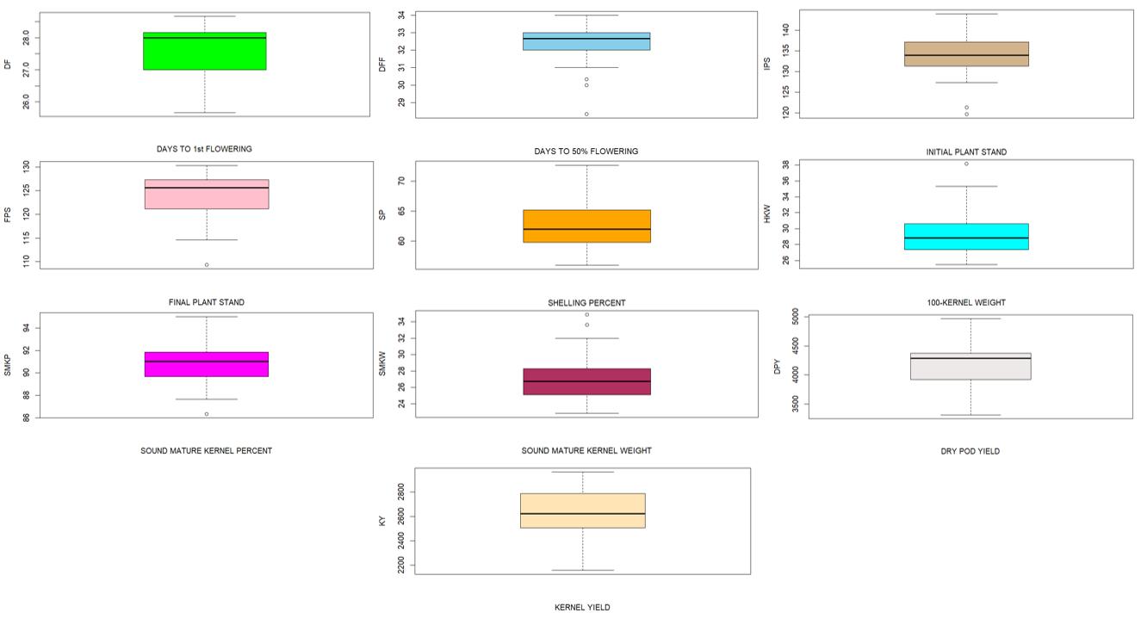

Figure 1. Trait variability for yield and kernel quality traits among the groundnut genotypes

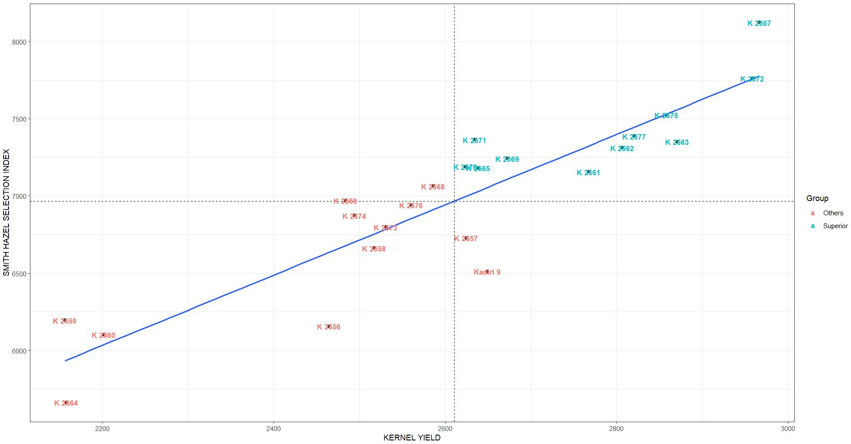
Figure 2. Scatter plot showing the relationship between kernel yield and smith hazel selection index
Table 2: Genotypic (lower diagonal) and phenotypic (upper diagonal) correlation of studied traits in groundnut
Traits |  | DF | DFF | IPS | FPS | SP | 100 KW | SMK% | SMK weight | DPY | KY
DF |  | 1 | 0.74 ** | 0.07 | 0.11 | -0.44** | -0.71** | -0.15 | -0.64 ** | 0.46 ** | 0.21
DFF |  | 0.87** | 1 | -0.06 | -0.05 | -0.34 ** | -0.59 ** | -0.27 * | -0.63 ** | 0.44 ** | 0.26 * | -0.2
IPS |  | 0.73 ** | -0.33 | 1 | 0.78 ** | -0.14 | -0.05 | 0.07 | 0.06 | 0.06 | -0.02 | -0.4
FPS |  | 0.51 * | -0.24 | 0.56 ** | 1 | -0.19 | -0.14 | 0.04 | -0.08 | 0.03 | -0.08 | -0.6
SP |  | -0.65 ** | -0.49 * | -0.51 * | -0.44 * | 1 | 0.46 ** | -0.01 | 0.38 ** | -0.33 ** | 0.25 * | -0.8
100 KW |  | -0.89 ** | -0.62 ** | -0.33 | -0.33 | 0.55 ** | 1 | 0.31 ** | 0.87 ** | -0.45 ** | -0.18 | 1
SMK% |  | -0.38 | -0.47 * | 0.67 ** | 0.17 | -0.18 | 0.53 ** | 1 | 0.42 ** | -0.16 | -0.19 | 0.8
SMK weight |  | -0.81 ** | -0.69 ** | 0.21 | -0.09 | 0.44 * | 0.94 ** | 0.80 ** | 1 | -0.38 ** | -0.17 | 0.6
DPY |  | 0.95 ** | 0.75 ** | 0.62 ** | 0.48 * | -0.50 * | -0.80 ** | -0.16 | -0.79 ** | 1 | 0.82 ** | 0.4
KY |  | 0.51 * | 0.45 * | 0.25 | 0.18 | 0.27 | -0.43 * | -0.37 | -0.52 ** | 0.68 ** | 1 | 0.2
 | , DF=Days to 1st flowering, DFF=Days to 50% flowering, IPS=Initial plant stand, SP=Shelling percentage, 100 KW=100 Kernel weight, SMK=Sound mature kernel, DPY=Dry pod yield, KY=Kernel yield

Table 3: Genotypic and phenotypic path coefficients of yield and related traits in groundnut
 |  | Days to 1st flowering | Days to 50% flowering | Initial plant stand | Final plant stand | Shelling percent | 100 Kernel weight | SMK% | SMK weight | Dry pod yield
Days to 1st flowering | G | 0.1076 | -0.0435 | 0.0099 | -0.0090 | -0.5320 | -0.1249 | 0.0252 | 0.0396 | 1.0465
Days to 1st flowering | P | 0.0303 | -0.0081 | 0.0002 | 0.0001 | -0.2684 | -0.0424 | 0.0021 | 0.0282 | 0.4775
Days to 50% flowering | G | 0.0939 | -0.0498 | -0.0045 | 0.0042 | -0.3997 | -0.0879 | 0.0315 | 0.0337 | 0.8340
Days to 50% flowering | P | 0.0225 | -0.0110 | -0.0002 | 0.0000 | -0.2053 | -0.0352 | 0.0037 | 0.0280 | 0.4578
Initial plant stand | G | 0.0789 | 0.0165 | 0.0136 | -0.0203 | -0.4196 | -0.0464 | -0.044 | -0.0106 | 0.6858
Initial plant stand | P | 0.0022 | 0.0007 | 0.0034 | 0.0005 | -0.0875 | -0.0032 | -0.001 | -0.0030 | 0.0666
Final plant stand | G | 0.0552 | 0.0120 | 0.0158 | -0.0175 | -0.3566 | -0.0474 | -0.0117 | 0.0045 | 0.5282
Final plant stand | P | 0.0035 | 0.0006 | 0.0027 | 0.0007 | -0.1148 | -0.0089 | -0.0006 | 0.0036 | 0.0313
Shelling percent | G | -0.0709 | 0.0247 | -0.0071 | 0.0077 | 0.8074 | 0.0781 | 0.0122 | -0.0219 | -0.5596
Shelling percent | P | -0.0136 | 0.0038 | -0.0005 | -0.0001 | 0.5970 | 0.0277 | 0.0003 | -0.0168 | -0.3390
100 Kernel weight | G | -0.0958 | 0.0312 | -0.0045 | 0.0059 | 0.4494 | 0.1403 | -0.0353 | -0.0460 | -0.8832
100 Kernel weight | P | -0.0217 | 0.0065 | -0.0002 | -0.0001 | 0.2796 | 0.0592 | -0.0043 | -0.0384 | -0.4644
SMK% | G | -0.0411 | 0.0238 | 0.0091 | -0.0031 | -0.1495 | 0.0749 | -0.0660 | -0.0391 | -0.1820
SMK% | P | -0.0047 | 0.0030 | 0.0003 | 0.0000 | -0.0118 | 0.0189 | -0.0133 | -0.0187 | -0.1717
SMK weight | G | -0.0874 | 0.0344 | 0.0029 | 0.0016 | 0.3622 | 0.1323 | -0.0529 | -0.0488 | -0.8735
SMK weight | P | -0.0195 | 0.0070 | 0.0002 | -0.0001 | 0.2285 | 0.0518 | -0.0057 | -0.0439 | -0.3886
Dry pod yield | G | 0.1025 | -0.0378 | 0.0085 | -0.0084 | -0.4113 | -0.1128 | 0.0109 | 0.0388 | 1.0986
Dry pod yield | P | 0.0142 | -0.0049 | 0.0002 | 0.0000 | -0.1984 | -0.0270 | 0.0022 | 0.0167 | 1.0197

Table 4: Eigen values, variance percentage and factor loadings for studied traits in groundnut
 | PC1 | PC2 | PC3
Days to 1st flowering | 0.93 | -0.13 | -0.10
Days to 50% flowering | 0.81 | 0.26 | -0.17
Initial plant stand | 0.14 | -0.89 | 0.28
Final plant stand | 0.22 | -0.86 | 0.20
shelling % | -0.55 | 0.40 | 0.63
100 Kernel weight | -0.91 | 0.02 | 0.14
SMK% | -0.44 | -0.46 | -0.12
SMK weight | -0.89 | -0.21 | 0.13
Dry pod yield | 0.83 | -0.05 | 0.33
Kernel yield | 0.50 | 0.24 | 0.80
Eigen value | 4.64 | 2.10 | 1.34
Variance percent | 46.41 | 20.98 | 13.44
Cumulative variance percent | 46.41 | 67.39 | 80.83

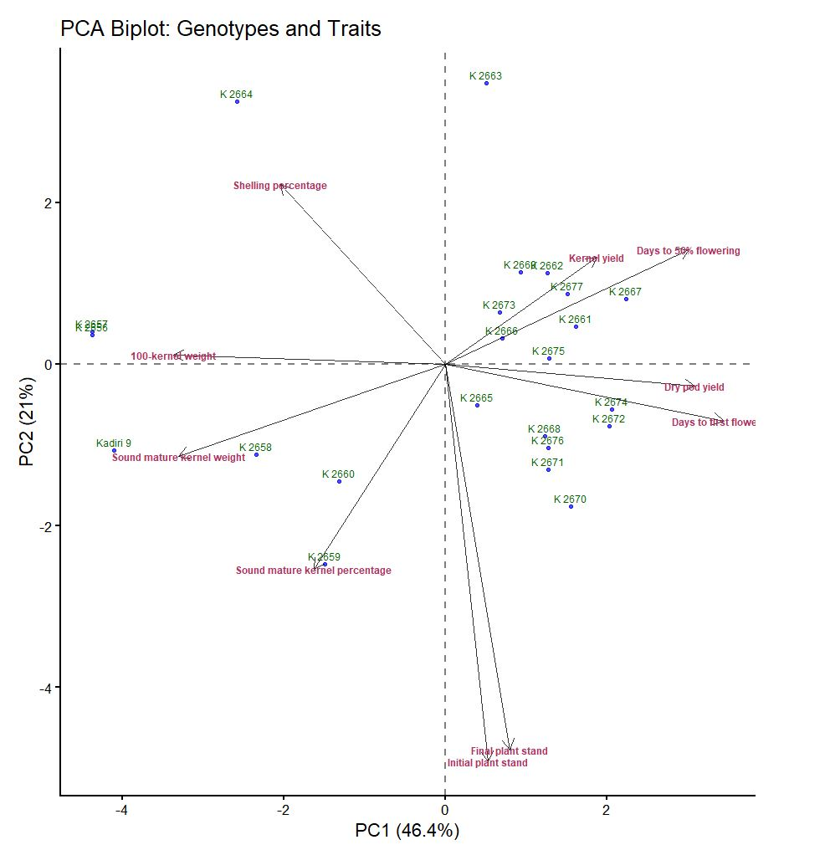
Figure 3. PCA biplot of traits studied in groundnut

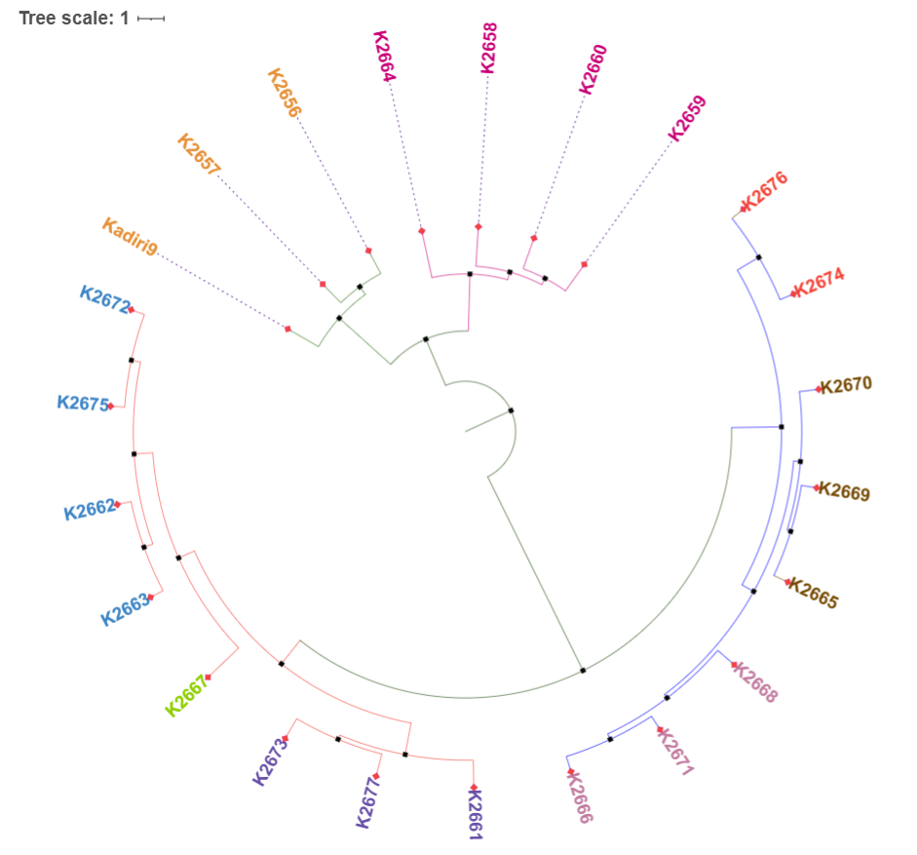
Cluster III
Cluster IV
Cluster I
Cluster II

Figure 4. Clustering patter of twenty-three evaluated groundnut genotypes

Table 5. Inter and Intra cluster distances of the four clusters identified
 | Cluster-Ⅰ | Cluster-Ⅱ | Cluster-Ⅲ | Cluster-Ⅳ
Cluster-Ⅰ | 2.38 | 4.32 | 6.13 | 6.02
Cluster-Ⅱ | 4.32 | 3.10 | 4.86 | 3.89
Cluster-Ⅲ | 6.13 | 4.86 | 2.27 | 2.60
Cluster-Ⅳ | 6.02 | 3.89 | 2.60 | 1.69

Table 6. Cluster wise average performance of yield and yield related traits in groundnut
Clusters | Dry pod yield | Shelling percentage | Sound mature kernel percent | Sound mature kernel weight | 100-kernel weight | Days to first flowering | Days to 50% flowering
Cluster-Ⅰ | 4233.69 | 63.57 | 88.33 | 24.73 | 27.50 | 28.00 | 32.71
Cluster-Ⅱ | 3703.04 | 61.17 | 92.33 | 29.23 | 30.93 | 26.92 | 31.33
Cluster-Ⅲ | 3682.14 | 70.22 | 92.11 | 33.49 | 35.53 | 25.89 | 29.67
Cluster-Ⅳ | 4474.81 | 60.63 | 91.37 | 26.58 | 27.96 | 28.19 | 32.89

