Original Research Article
Geometer Moths (Lepidoptera: Geometroidea) Species diversity from Gangau Wildlife Sanctuary, Madhya Pradesh

Abstract
The current study is the first to provide information on the Geometridae moth species of Gangau Wildlife Sanctuary of Madhya Pradesh. Thus, our goal was xxxxxxxxxxxxxxxxThe survey was conducted in order to explore the species diversity of Geometer moths during two surveys in September and December 2022. Moths were collected by light traps, light sheets, and insect nets in different forest ranges of the sanctuary. A total of 29 species, belonging to 21 genera across 3 subfamilies of Geometridae moths, were recorded. The subfamily Ennominae (13 and 19) had the highest number of genera and species, followed by Geometrinae (5 and 5), Sterrhinae (3 and 5), and had the lowest. As such, we bring new knowledge about xxxxxxx This observation provides a confirmed record of the species diversity across the different forest ranges of Gangau Wildlife Sanctuary, contributing to regional faunal documentation of the wildlife sanctuaries and other conservation areas of Madhya Pradesh.

Keywords: Lepidoptera, Moths, Geometridae, Species diversity, Gangau Wildlife Sanctuary, Madhya Pradesh
1.Introduction
Moths are a significant component of terrestrial ecosystems as herbivores and pollinators, as phytophagous pests, and as players in nutrient cycling (Barlow, 1982; Kendrick, 2002; Lee and Zilie, 2019). Gangau Wildlife Sanctuary (24⁰ .699751’ N, 80⁰. 0967927’ E) is a protected area situated on the banks of the Ken River in Chhatarpur District of Madhya Pradesh, India. A large area of Gangau WLS has been included in the Panna Biosphere Reserve, covering only 78.539 km2. This area is scattered and adjoins Panna National Park and Ken-Gharial WLS is about 30 km from the Panna Biosphere Reserve and includes the river and forests, with one-half km on either side. The predominant forest type in Gangau Wildlife Sanctuary is tropical dry deciduous forest. These forests shed their leaves during certain seasons, and the trees here have adapted to the region's dry, arid climate. Teak and Sal (Tectona grandis and Shorea robusta) are prominent tree species. Mahua (Madhuca longifolia) and Bamboo (Bambusa arundinacea) are other common tree species found in the area. They produce edible flowers and seeds that are essential food sources for several wildlife species. This Sanctuary has grasslands that provide crucial feeding and breeding grounds for various herbivores and supports the park's ecosystem. The sanctuary's water bodies and riverbanks host diverse riparian vegetation, including aquatic plants and shrubs that thrive in wetter areas. The Sanctuary is home to a diverse range of fauna and other wildlife.
Moths are a significant component of terrestrial ecosystems as herbivores and pollinators, as phytophagous pests, and as players in nutrient cycling (Barlow, 1982; Kendrick, 2002; Lee and Zilie, 2019). Geometridae moths belong to the superfamily Geometroidea, with approximately 23,002 described species (Nieukerken et al., 2011), and are the second-most-diverse family of Lepidoptera, occurring worldwide except in the Polar Regions (Heppner, 1991; Enkhtur et al., 2020). Geometridae is a moth family; its species are nocturnal and tend to be more specific to certain habitats, particularly at high altitudes (Axmacher and Fiedler, 2008; Sanyal et al., 2017; Lotani and Negi, 2026).
The geometer moths have slender abdomens and broad wings. The hindwings are visible, as the forewings are usually held flat, giving the appearance of a butterfly. Most of the moths are moderate in size, with a wingspan of 3 cm. A distinctive pair of tympanal organs at the base of the abdomen is possessed by these moths; they are lacking in flightless females (Cook and Scoble, 1992; Scoble,1999; Hepner, 2008). Geometrid moths (Inchworms or loppers) are mostly the forest pests of woody plants, agricultural crops, fruit-berry crops, and feed mainly on the leaves of a wide range of plants, particularly trees and shrubs (Walia 2005; Sharma, 2011; Paunikar et al., 2023, 2026). Geometrids are abundant and diverse components of most forest ecosystems. This, along with their weak flight ability and low propensity to migrate (Brehm et al., 2003; DeWaard et al., 2011), makes them excellent indicators of environmental quality (Kitching et al., 2000).
There are 2043 species of geometrid moths reported from India (Sondhi et al., 2020; Dey et al., 2021), and the family comprises nine subfamilies, out of which seven subfamilies, i.e., Ennominae, Geometrinae, Sterrhinae, Larentiinae, Desmobathrinae, Oenochrominae, and Orthostixinae, represent the Indian fauna of Geometridae. The subfamilies Ennominae has maximum species number of 858, followed by Larentiinae with 565 species, Geometrinae with 294 species, Sterrhinae with 282 species, Desmobathrinae with 29 species, Oenochrominae with nine species, and Orthostixinae with four species (Kirti et al., 2019).
However, their extensive study has not been carried out in different regions of India as it is diverse country in terms of climatic conditions. Some Geometrid moths have been reported from other parts of India (CITATION). Mathew and Rahamathulla (1995) listed 77 species from Silent Valley National Park, Kerala. Walia (2005) published a list of 184 species of the family Geometridae from Chandigarh and Himachal Pradesh, and out of these, 86 species are under subfamily Ennominae, 46 species under subfamily Sterrhinae, 38 species under subfamily Geometrinae, 13 species belonging to 11 genera of subfamily Larentiinae, and a single species under subfamily Desmobathrinae. Elenchezhian et al. (2014) reported 28 species from Maruthamalai hills, Thakur and Kumar (2015) studied the biodiversity of geometrid moths and reported 35 species belonging to 26 genera from the conifer forest of Himachal Pradesh. Sondhi et al. (2018) recorded 47 species from Shendurney and Ponmudi in Agastyamalai Biosphere Reserve, Kerala. Kumar et al. (2018), who conducted the study on biodiversity and recorded 27 genera and three subfamilies, Ennominae, Geometrinae, and Sterrhinae, found that the subfamily Ennominae was represented with the maximum species, followed by the subfamily Geometrinae and the subfamily Sterrhinae. geometrid moths in Himachal Pradesh, India. Iyer et al. (2021) reported 98 genera and 108 species from the Kalakad- Mundanthurai Tiger Reserve, Tamil Nadu, in India. Amin and Khan (2022) studied moth diversity and recorded 39 species across 29 genera, 17 tribes, and 4 subfamilies in the Kashmir Valley, India.
In Madhya Pradesh and Chhattisgarh, Central India, Chandra and Nema (2007) listed 313 moth species, including 34 in the family Geometridae. Chandra and Sambath (2016) recorded 8 species of Geometridae from Veerangana Durgawati Wildlife Sanctuary.
After that, several species of Geometridae moths have been reported from various wildlife sanctuaries of Madhya Pradesh (Paunikar et al., 2025ab), except the Gangau Wildlife Sanctuary. Hence, work on the species diversity of the Geometridae moth was initiated.

Despite the considerable diversity of Geometridae moths reported across different regions of India, studies remain geographically uneven, with several protected areas still lacking baseline inventories (e.g., Konal et al., 2021; Paunikar et al., 2025ab), . In Central India, particularly in Madhya Pradesh, available records are limited and fragmented, and no comprehensive assessment has been conducted in Gangau Wildlife Sanctuary. Given the ecological importance of geometrid moths as herbivores and bioindicators, documenting their diversity in understudied regions is essential. Therefore, the present study aims to assess the species diversity and composition of Geometridae moths in Gangau Wildlife Sanctuary and to provide baseline data to support future ecological and conservation studies in the region.
2. Materials and Methods
2.1 Study area
The study was conducted in Gangau Wildlife Sanctuary (24.699751° N, 80.0967927° E), a protected area located along the Ken River in the Chhatarpur District of Madhya Pradesh, India (Figure 1).

2.2 Collection and identification of moths
To collect Geometrid moths across the sanctuary's different forest ranges, intensive and extensive tours were conducted in 2022. Adult geometrid moths were trapped using light traps installed at different locations during the night. A light trap was set during the 7-10 pm time period using a mercury vapor lamp over a 3×3m (square) white cloth sheet, which was hung between two vertical poles. Sometimes, moths were naturally attracted to the light bulb on the wall, sitting around it for whole nights, so observation became easy without any artificial traps. Some diurnal flying adult moths, or those found in the morning, were photographed in a sitting position, or an insect net was used to catch them. After collection, the samples were preserved in the collection boxes of the Central Zone Regional Center of the Zoological Survey of India, Jabalpur, Madhya Pradesh, India. Moths were photographed using cell phones and Nikon DSLR camera.. Moths were identified using available literature and a standard field guide to Indian moths. The identification of moths was confirmed using various literature sources, including the fauna of British India (Hampson, 1895), the moths of Borneo (Holloway, 1993-97), Kirti et al. (2019), Shubhalaxmi (2018), and other publications. Web resources dedicated to lepidopteran diversity were also used to confirm or verify species names (Scoble and Hausmann 2007).
3. Result and Discussion
A total of 29 species of Geometridae, belonging to 21 genera and 3 subfamilies, were recorded (Table 1 and Appendix 1).Geometer moth represented 3 subfamilies: Geometrinae (5 genera, 5 species), Ennominae (13 genera, 19 species), and Sterrhinae (3 genera, 5 species). The Ennominae subfamily is the highest contributor in species and genera (61% and 65%), followed by Geometrinae (17% and 23.80%), and the lowest in Sterrhinae (14% and 17.24%), respectively. The present investigation showed the highest species richness in the subfamily Ennominae. Similarly, Walia (2005) and Kumar et al. (2018) also reported the dominance of this subfamily in Himachal Pradesh.
Chiasmia species was most dominant, with 5 species, Chiasmia emersaria, Chiasmia fidoniata, Chiasmia nora, Chiasmia eleonora, and Chiasmia hebestata in the subfamily Ennominae, followed by Scopula species Scopula emissaria, Scopula pulchellata and Scopula minorata in the subfamily Sterrhinae. Some species of Geometer moths, Pelagodes falsaria, Thalasodes quadraria, Ascotis selenaria Biston suppressaria, Cloera injectaria, Chiasmia fidoniata, Hyperythra lutea, Hyposidra talaca and Scopula pulchellata were abundantly found in the different forest ranges of the study area.
In recent years, a variety of Geometridae moth species have been reported from different wildlife sanctuaries in Madhya Pradesh. Paunikar et al. (2024) recorded 16 genera and 19 species across 3 subfamilies of Geometridae moths from Ratapani Wildlife Sanctuary in Raisen and Sehore districts of Madhya Pradesh. Paunikar and Nair (2025a) reported 23 species and 17 genera across 3 subfamilies in the Gandhi Sagar Wildlife Sanctuary. Further, Paunikar and Nair (2025b) reported 13 species and 12 genera from three subfamilies of Geometridae moths in the Ken-Gharial Wildlife Sanctuary, Madhya Pradesh.

Table 1: List of species of Geometridae Moths in Gangau Wildlife Sanctuary, Madhya Pradesh

Sr. No. | Superfamily/  Family | Subfamilies | Species
1 | Geometroidea /Geometridae Leach, 1815 | Geometrinae Leach, 1815 | Aporandria specularia (Guenee, 1858)
2 | Geometroidea /Geometridae Leach, 1815 | Geometrinae Leach, 1815 | Comibaena cassidara Guenee, (1858)
3 | Geometroidea /Geometridae Leach, 1815 | Geometrinae Leach, 1815 | Maxates goniaria ssp. acutissima Walker, 1861
4 | Geometroidea /Geometridae Leach, 1815 | Geometrinae Leach, 1815 | Pelagodes falsaria Prout,1912
5 | Geometroidea /Geometridae Leach, 1815 | Geometrinae Leach, 1815 | Thalassodes quadraria Guenée, [1858]
6 | Geometroidea /Geometridae Leach, 1815 | Ennominae Duponchel, 1845 | Ascotis selenaria (Denis & Schiffermuller, 1775)
7 | Geometroidea /Geometridae Leach, 1815 | Ennominae Duponchel, 1845 | Astygisa albopunctata (Swinhoe, 1891)
8 | Geometroidea /Geometridae Leach, 1815 | Ennominae Duponchel, 1845 | Biston suppressaria (Guenee, 1858)
9 | Geometroidea /Geometridae Leach, 1815 | Ennominae Duponchel, 1845 | Chiasmia emersaria Walker, 1861
10 | Geometroidea /Geometridae Leach, 1815 | Ennominae Duponchel, 1845 | Chiasmia fidoniata Walker, (1863)
11 | Geometroidea /Geometridae Leach, 1815 | Ennominae Duponchel, 1845 | Chiasma cf. nora Walker, 1861
12 | Geometroidea /Geometridae Leach, 1815 | Ennominae Duponchel, 1845 | Chiasmia eleonora (Cramer,1780)
13 | Geometroidea /Geometridae Leach, 1815 | Ennominae Duponchel, 1845 | Chiasmia hebesata Walker, 1861
14 | Geometroidea /Geometridae Leach, 1815 | Ennominae Duponchel, 1845 | Cleora acaciaria Boisduval, 1833
15 | Geometroidea /Geometridae Leach, 1815 | Ennominae Duponchel, 1845 | Cloera injectaria (Walker, 1860)
16 | Geometroidea /Geometridae Leach, 1815 | Ennominae Duponchel, 1845 | Ectropidia shoreae Prout, 1934
17 | Geometroidea /Geometridae Leach, 1815 | Ennominae Duponchel, 1845 | Heterostegane tritocampsis Prout, 1934
18 | Geometroidea /Geometridae Leach, 1815 | Ennominae Duponchel, 1845 | Hyperythra lutea Stoll, 1781
19 | Geometroidea /Geometridae Leach, 1815 | Ennominae Duponchel, 1845 | Hyposidra talaca Walker, 1860
20 | Geometroidea /Geometridae Leach, 1815 | Ennominae Duponchel, 1845 | Hypomecis infixaria Walker, 1860
21 | Geometroidea /Geometridae Leach, 1815 | Ennominae Duponchel, 1845 | Hypomecis transcissa (Walker, 1860)
22 | Geometroidea /Geometridae Leach, 1815 | Ennominae Duponchel, 1845 | Isturgia disputaria Guenee, (1858)
23 | Geometroidea /Geometridae Leach, 1815 | Ennominae Duponchel, 1845 | Petalia medardaria Herrich-Schaffer, (1856)
24 | Geometroidea /Geometridae Leach, 1815 | Ennominae Duponchel, 1845 | Zamarada excisa Hampson, 1891
25 | Geometroidea /Geometridae Leach, 1815 | Sterrhinae Meyrick, 1892 | Antitrygodes cuneilinea (Walker, 1862)
26 | Geometroidea /Geometridae Leach, 1815 | Sterrhinae Meyrick, 1892 | Scopula emissaria Walker, 1861
27 | Geometroidea /Geometridae Leach, 1815 | Sterrhinae Meyrick, 1892 | Scopula pulchellata Fabricius, 1794
28 | Geometroidea /Geometridae Leach, 1815 | Sterrhinae Meyrick, 1892 | Scopula minorata (Boisduval, 1833)
29 | Geometroidea /Geometridae Leach, 1815 | Sterrhinae Meyrick, 1892 | Timandra mundissima (Walker, 1861)

Add a paragraph…..
Add a paragraph ;
In the present investigation, it was only a preliminary study, and the species collected were from only two surveys. Given the area under a variety of forest tree cover in the sanctuary, the sampling period and sites appeared insufficient. A detailed, exhaustive survey with higher sampling intensity and different collection methods may yield sufficient data to prepare a checklist of moths in the Gangau Wildlife Sanctuary of Panna district, Madhya Pradesh.

4. Conclusion
This study represents the first comprehensive inventory of Geometer moths from the Gangau Wildlife Sanctuary in Panna district, Madhya Pradesh, documenting 21 genera and 29 species belonging to the subfamilies Ennominae, Geometrinae, and Sterrhinae. The assemblage is dominated by the Ennominae (13 genera and 19 species), Geometrinae (5 genera and 5 species), and Sterrhinae (3 genera and 5 species). The forest habitats of the sanctuary, where host-plant diversity and microclimatic conditions favor different species of Geometridae moths.

Disclaimer (Artificial Intelligence)
Author(s) hereby declare that NO generative AI technologies such as Large Language Models (ChatGPT, COPILOT, etc.) and text-to-image generators have been used during the writing or editing of this manuscript.
Competing Interests
Authors have declared that no competing interests exist.
References

Amine, D., & Khan, Z.H. (2022). Diversity of Geometrid moths (Geometridae: Lepidoptera) in Kashmir valley, India. Environment Conservation Journal, 23 (1&2), 154-163.
Axmacher, J., & Konrad, F. (2008). Habitat type modifies geometry of elevational diversity gradients in geometrid moths (Lepidoptera; Geometridae) on Mt. Kilimanjaro, Tanzania. Tropical Zoology, 21, 243-251.
Barlow, H.S. (1982). An introduction to the moths of S.E. Asia. Malayan Nature Society, Kuala Lumpur, 305 pp., 51 pls.
Brehm, G., Homeier, J. & Fiedler, K. (2003). Beta diversity of geometrid moths (Lepidoptera, Geometridae) in an Andean montane rainforest. Diversity and Distributions, 9(5), 351–366.
Chandra, K. & Nema, D.K. (2007) Fauna of Madhya Pradesh (including Chhattisgarh), State Fauna Series, Rec. Zool. Surv. India, 15(1), 347-418.
Chandra, K. & Sambath, S. (2016) Faunal Diversity of Veerangana Durgawati Wildlife Sanctuary, District Damoh, Madhya Pradesh, (Published: Director, Zool. Surv. India, Kolkata) 56, 173-213.
Cook, M.A. and Scoble, M.J. (1992). Tympanal organs of Geometrid moths: a review of their morphology, function and systematic importance. Systematic Entomology, 17: 219-232.
DeWaard, J. R., Hebert, P. D. & Humble, L. M. (2011). A comprehensive DNA barcode library for the looper moths (Lepidoptera: Geometridae) of British Columbia,Canada. PloS one, 6(3), e18290.
Dey, P., V.P. Uniyal, A. Hausmann & D. Stüning (2021). Revision of the genus Prometopidia Hampson, 1902, with description of the new species P. joshimathensis sp. nov. from West-Himalaya and its subspecies P. j. yazakii ssp. nov. from Nepal (Lepidoptera: Geometridae, Ennominae). Zootaxa, 4980(1): 28–44.
Elanchezhian, M., Gunasekaran, C., & Deepa, A.A. (2014). A study on moth diversity in three different habitats of Maruthamalai Hill, Western Ghats, South India. Global Journal for Research Analysis, 3(12), 136–138.
Enkhtur, K., Boldgiv, B. & Pfeiffer, M. (2020). Diversity and distribution patterns of geometrid moths (Geometridae, Lepidoptera) in Mongolia.Diversity 12, 186.
Hampson G.F. (1895). The Fauna of British India, including Ceylon and Burma. Moths – Vol. 3, Noctuidae (cont.) to Geometridae. Taylor and Francis, London, 546p.
Heppner, J.B. (1991). Faunal regions and the diversity of Lepidoptera. Tropical Lepidoptera, 2 (Suppl. 1), 1–85.
Heppner, J.B. (2008). Geometer Moths (Lepidoptera: Geometridae). In: Capinera J.L. (eds) Encyclopedia of Entomology. Springer, Dordrecht.
Holloway, J.D. (1993). The moths of Borneo (Part 11), Family Geometridae: Subfamilies Ennominae. Malayan Nature Journal, 47(1), 1–309.
Holloway, J.D. (1996). The moths of Borneo (Part 9), Family Geometridae: Subfamilies Oenochrominae, Desmobathrinae, Geometrinae. Malayan Nature Journal, 49(2–3), 147–326.
Holloway, J.D. (1997). The moths of Borneo (Part 10), Family Geometridae: Subfamilies Sterrhinae, Larentiinae, Addenda to other subfamilies. Malayan Nature Journal, 51(1), 1–242. https:// doi.org/10.1007/978-3-540-73526-7_15.
Iyer, G., Stüning, D. & Sondhi, S. (2021). An inventory of geometrid moths (Lepidoptera: Geometroidea: Geometridae) of Kalakad-Mundanthurai Tiger Reserve, India. Journal of Threatened Taxa, 13(13), 19887–19920. https://doi.org/10.11609/jott.7105.13.13.19887-19920.
Kendrick, R.C. (2002). Moths (Insecta: Lepidoptera) of Hong Kong. PhD Thesis. Department of Ecology and Biodiversity, Hong Kong, University of Hong Kong. 623 pp., 9 pls. http://hdl.handle. net/10722/31688. Last accessed on 4 December 2020.
Kirti, J. S., Chandra, K., Saxena, A., & Singh, N. (2019). Geometrid Moths of India. Nature Books India.
Kitching, R. L., Orr, A. G., Thalib, L., Mitchell, H., Hopkins, M. S., & Graham, A. W. (2000). Moth assemblages as indicators of environmental quality in remnants of upland Australian rain forest. Journal of Applied Ecology 37: 284-297.
Kumar, M., Kumar, P., & Kumar, A. (2018). Taxonomic Study on Geometrid Moths (Lepidoptera: Geometridae) Diversity in Chirpine Forest of Himachal Pradesh. Asian Journal of Advances Basic Science, 6(1), 49-53.
Lees, D.C., & Zilli, A. (2019) Moths: Their biology, diversity and evolution. Natural History Museum, London, 208.
Lotani, N.S., & Negi, C.S. (2026). Diversity and distribution pattern of geometrid moths (Insecta: Lepidoptera: Geometridae) along the altitudinal gradient, Kumaun Himalaya, India. Journal of Threatened Taxa, 18(3), 28495–28509.
Mathew, G., & Rahamathulla, V.K. (1995). Biodiversity in the Western Ghats – A study with reference to moths (Lepidoptera: Heterocera) in the Silent Valley National Park, India. Entomon, 20(2), 25–33.
Paunikar, S., Kulkarni, N., & Barve S. (2023). Moth diversity (Lepidoptera: Heterocera) in the forest ecosystem of Tropical Forest Research Institute (TFRI), campus, Jabalpur, Madhya Pradesh. International Journal of Entomological Research, 8(9),25-32.
Paunikar, S., Ramakrisnan, Sharma, A. K., Nair, A., & Das, B. K. (2026). Diversity of Moth (Lepidoptera: Insecta) in the agricultural crop Chickpea (Cicer arietinum L.) of Jabalpur district of Madhya Pradesh, Uttar Pradesh Journal of Zoology,47(5),31-41.
Paunikar, S., & Nair, A. (2025a). Studies on Moth Distribution (Insecta: Lepidoptera: Heterocera) in Gandhisagar Wildlife Sanctuary, Mandsaur and Neemach Districts of Madhya Pradesh, Central India. Biological Forum –An International Journal, 17(2), 42-5.
Paunikar, S. & Nair, A. (2025b). Moth Fauna (Lepidoptera: Glossata) of Ken-Gharial Wildlife Sanctuary of Panna and Chhatarpur district of Madhya Pradesh. International Journal of Global Science Research, 12(1),2558-2567.
Paunikar, S., Nair, A. & Sambath, S. (2024). Study on diversity of Moths (Lepidoptera: Heterocera) of Ratapani Wildlife Sanctuary and Tiger Reserve, Raisen and Sehore districts of Madhya Pradesh. Indian Journal of Tropical Biodiversity, 32(1), 22-32.
Sanyal, A., Dey, P. Uniyal, V., Chandra, K., & Raha, A. (2017). Geometridae stephens, 1829 (Lepidoptera: Geometridae) from different altitudes in Western Himalayan protected areas of Uttarakhand, India. SHILAP Revista de Lepidopterología, 45(177), 143-163.
Scoble, M.J. (1999). Geometrid Moths of the World - A catalogue (Lepidoptera: Geometridae). CSIRO Publishing, Collingwood, 1, 5-482.
Scoble, M.J. & Hausmann, A. (2007). Online list of valid and available names of the Geometridae of the world. Geometroidea Archive. https://geometroidea.smns-bw.org/archive/48. Accessed on 18.v.2023.
Sharma, G. (2011). Studies on lepidopterous insects associated with vegetables in Aravali Range, Rajasthan, India. Biological Forum: An International Journal, 3(1), 21-26.
Shubhalaxmi, V. (2018). Field guide to Indian Moths. Ed.2, pp (VI+461), Birdwing Publishers, India.
Sondhi, S., Nath, D. Sondhi, Y., & Kunte, K. (2020). A new species of Metallolophia Warren, 1895 (Lepidoptera: Geometridae: Geometrinae) and notes on M. opalina (Warren, 1893) from eastern Himalaya, India. Zootaxa, 4838(2), 289–297.
Sondhi, Y., Sondhi, S., Pathour, S.R& Kunte, K. (2018). Moth diversity (Lepidoptera: Heterocera) of Shendurney and Ponmudi in Agastyamalai Biosphere Reserve, Kerala, India, with notes on new records. Tropical Lepidoptera Research, 28(2), 66–89. https://doi. org/10.5281/zenodo.2027709.
Thakur, V. & Kumar, P. (2015). Biodiversity of Geometrid Moths (Lepidoptera) of Conifer forests of Saraj Valley of Himachal Pradesh, India. International Journal of Current Research, (1),11426-11429.
Van Nieukerken, E.J., L. Kaila, I.J. Kitching, N.P. Kristensen, D.C. Lees, J. Minet, C. Mitter,M. Mutanen, J.C. Regier and T.J. Simonsen, (2011). Order Lepidoptera Linnaeus,1758. In: Zhang, z.-q.(ed.) animal biodiversity: An outline of higher-levelclassification and survey of taxonomic richness. Zootaxa, 3148(1), 212-221.
Walia, V. K. (2005). Insecta: Lepidoptera: Geometridae (Moths). Zoological Survey of India, Fauna West Himalayas, 2, 181-190.

Appendix 1 :Geometer Moth Diversity of Gangau Wildlife Sanctuary, Madhya Pradesh.
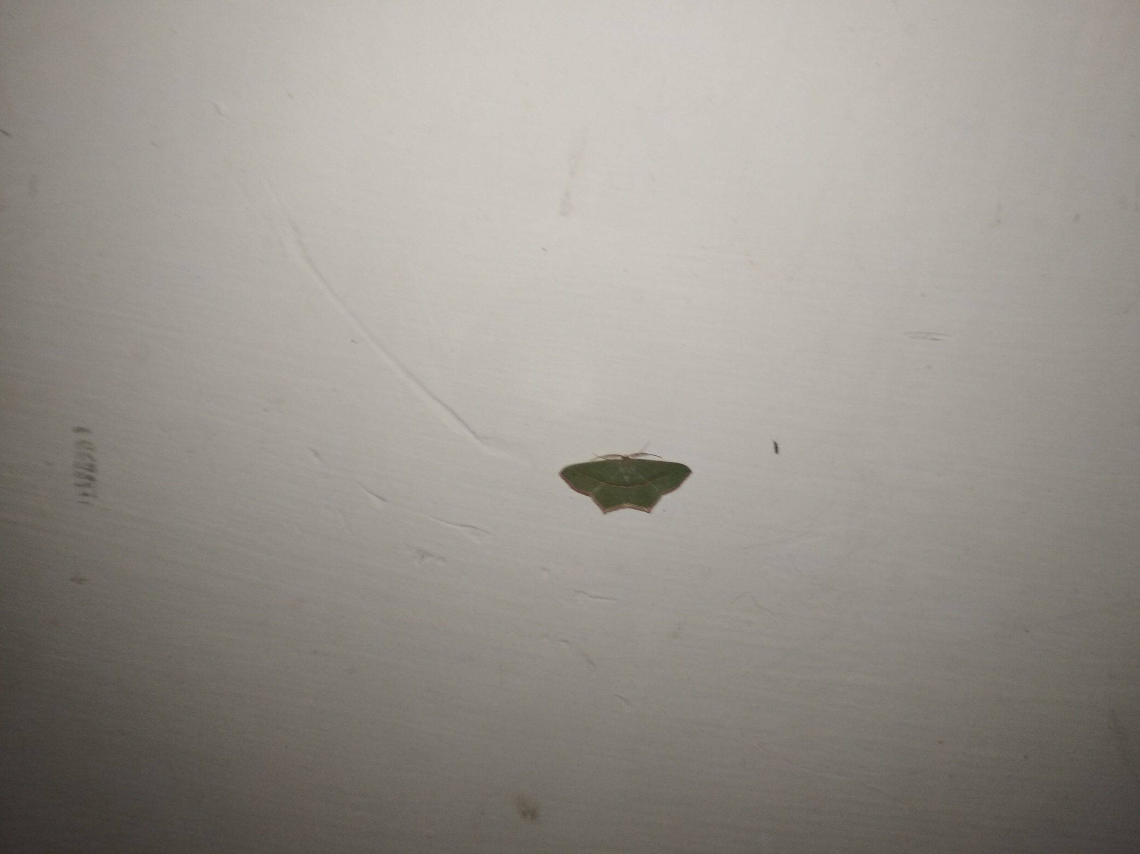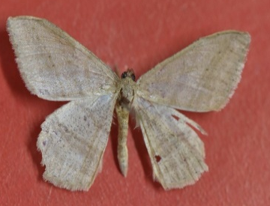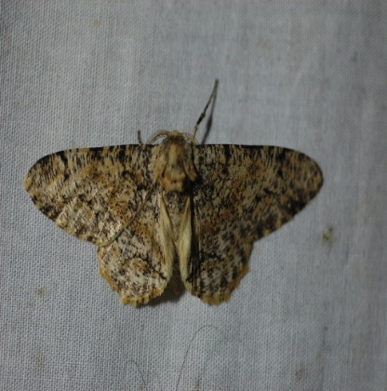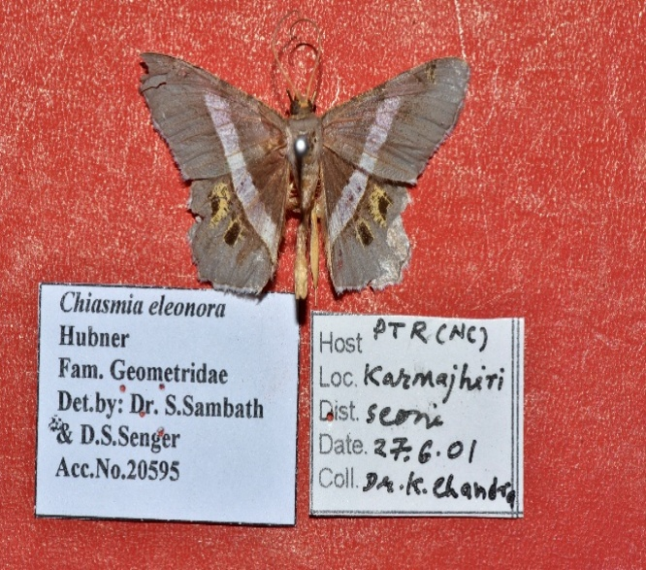Timandra mundissima Chiasmia fidoniata Biston suppressaria Chiasmia eleonora
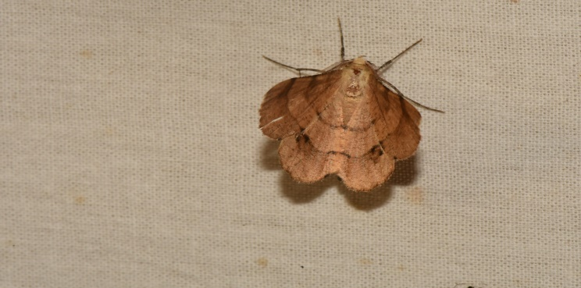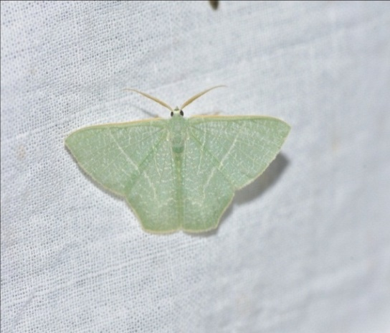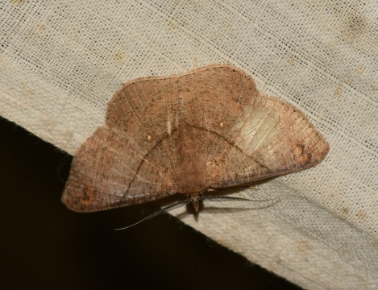Hyperythra lutea Thalassodes quadraria Petalia medardaria Chiasmia emersaria
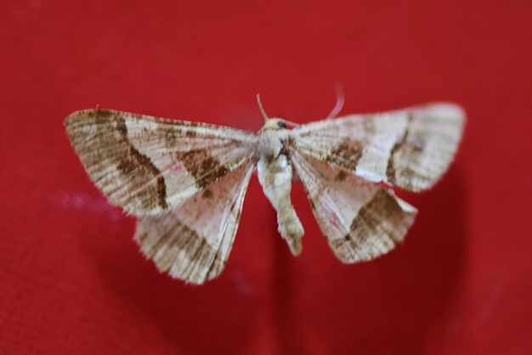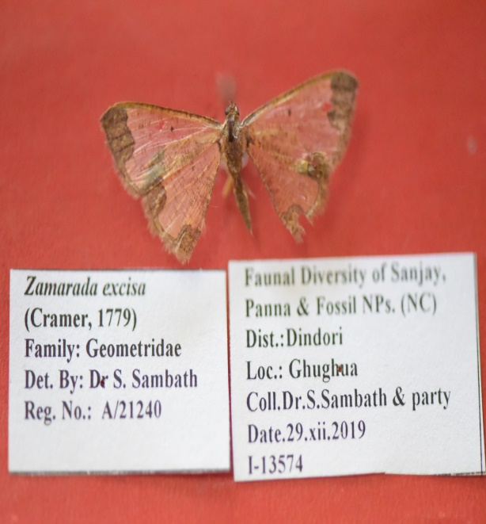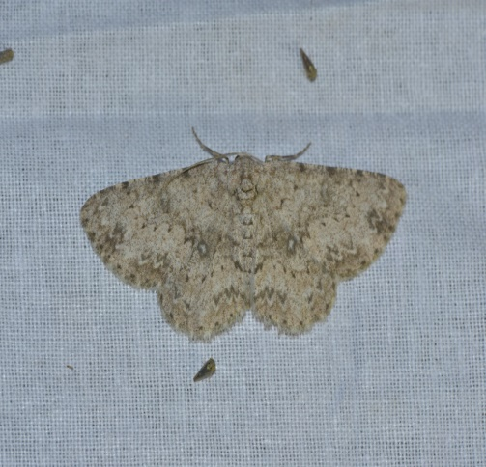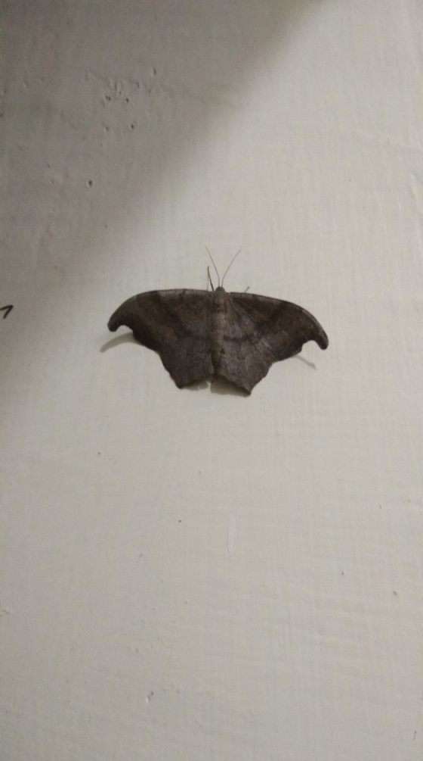Isturgia disputaria Zamarada excisa Ascotis selenaria Hypocidra talaca
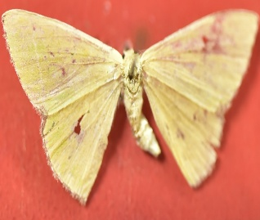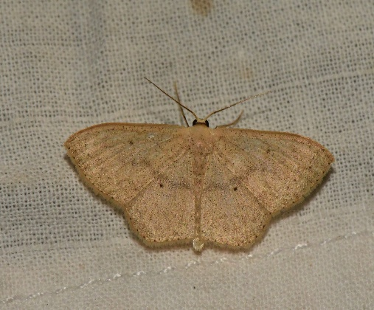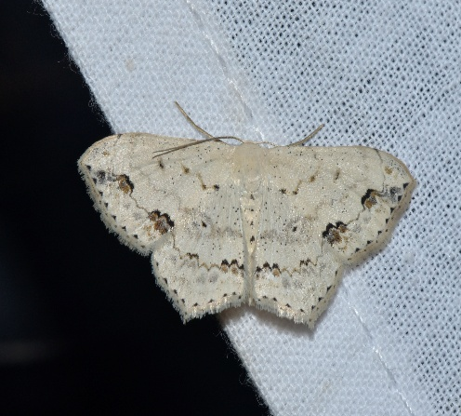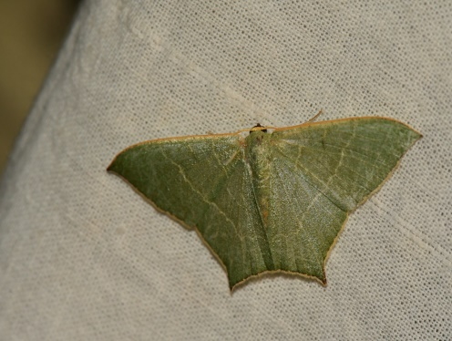Comibaena cassidara Scopula minorata Scopula pulchellata Maxates veninotata
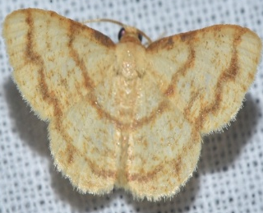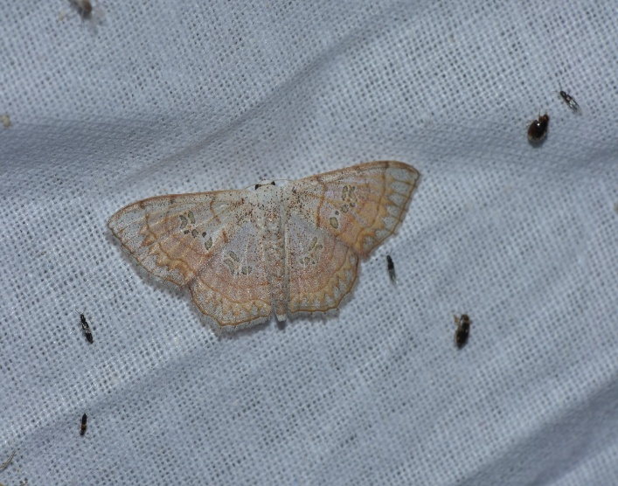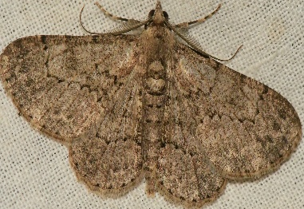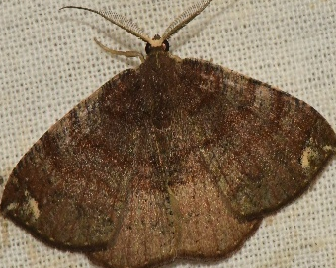Heterostegane tritocampsis Antitrygodes cuneilinea Cleora injectaria Astygisa albopunctata

Example the presentation board using Inkscape...
