Original Research Article
Histopathological and physiological effects of Carbofuran (Furadan) on the freshwater teleost fish, Tilapia mossambica

Abstract: Teleost fish, such as Tilapia mossambica, are widely recognized as important models in ecotoxicological research due to their evolutionary and ecological relevance. This study evaluates the physiological and histopathological effects of the carbamate pesticide carbofuran (Furadan) on T. mossambica. Fish were exposed to sub-lethal concentrations of carbofuran (1.5 ppm and 2.5 ppm) for 24 and 48 hours. The median lethal concentration (LC₅₀) for 24-hour exposure was determined to be 3 ppm. Significant reductions in oxygen consumption were observed, indicating metabolic disruption. Histopathological examination of the gills, liver, and intestine revealed pronounced tissue alterations, including necrosis, hyperplasia, vacuolization, and epithelial damage. These findings demonstrate that even sub-lethal concentrations of carbofuran can cause severe physiological and structural impairments in fish, underscoring the pesticide’s potential risk to aquatic organisms and the broader aquatic environment.
Key words: Carbofuran, Tilapia mossambica, Histopathology, Necrosis, Hyperplasia.

1. INTRODUCTION
Pesticides are synthetic chemical compounds widely employed in intensive agricultural practices and aquaculture to control pests and manage vector-borne diseases. These pesticides can enter natural water bodies through surface runoff, leaching from treated soils, or direct application to target organisms in aquatic environments (Yonar et al. 2012). In addition to their intended effect on target pests, pesticides adversely impact a broad spectrum of non-target aquatic organisms, including invertebrates and fish species (Peter et al. 2013). Among the different classes of pesticides, the carbamate insecticide Furadan, the commercial name of carbofuran is extensively applied in agricultural practices, particularly in the cultivation of field crops and vegetables (Begum and Mithra 2015). Carbofuran (2,3-dihydro-2,2-dimethyl-7-benzofuranyl methyl carbamate) is a highly toxic carbamate pesticide commonly employed for the control of a variety of agricultural pests, including insects, mites, and nematodes (Otieno et al. 2010). Owing to factors such as agricultural overspray, household usage, high water solubility, and significant soil mobility, these pesticides can readily migrate from treated areas into adjacent aquatic systems, including rivers, ponds, and lakes (Sharma et al. 2015).
Carbofuran is highly toxic to non-target organisms, and due to its pronounced acute toxicity, its application has been restricted or banned in numerous countries to mitigate environmental and ecological risks (Otieno et al. 2010). It interferes with the nervous system by inhibiting acetylcholinesterase, an enzyme critical for normal neural function (Mandal and Mandal 2023). At elevated concentrations, pesticides have been shown to adversely affect the survival, growth, and reproductive capacity of aquatic organisms while also inducing significant histopathological alterations in vital organs such as the gonads, gills, liver, stomach, kidneys, brain, and muscle tissues (Mckim et al. 1975). A review of existing literature on fish and environmental pollutants reveals that sublethal concentrations of various pesticides induce histopathological alterations in multiple organs of fish. The severity of these lesions is typically influenced by the pesticide type, exposure concentration, and duration of exposure (Pacheco and Santos 2002). Fish, being the ultimate indicators of aquatic pollution, reflect the impact of toxicants through physiological and histopathological changes (Fanta et al. 2003). Through these backgrounds, the present study has been conducted to investigate the histopathological and physiological effects of carbofuran on T. mossambica, with a focus on oxygen consumption rates and tissue damage in vital organs. Understanding these impacts is crucial to evaluating the risks posed by carbofuran in freshwater habitats.
2. MATERIALS AND METHODS
2.1 Experimental species and treatment
Healthy adult T. mossambica, were collected from freshwater ponds and brought to the laboratory. The length and weight of the fish ranged from 12-16 cm and 50-60 g respectively. The fish were thoroughly cleaned and then rinsed in a 0.1% KMnO₄ solution to prevent any possible dermal infections. The fish were maintained in glass aquaria containing continuously aerated, dechlorinated water at a temperature of 26 ± 2 °C and a pH of 7.5 ± 0.5. The fish were provided with a commercial diet two times a day and were kept for a duration of ten days to ensure proper acclimatization. After the acclimatization process, the sample fish were allocated into two groups: a control group and a treated group (subjected to pesticide treatment). A carbamate pesticide carbofuran (Furadan 3G) was selected as the test chemical for this study. A preliminary range-finding experiment was conducted to determine an appropriate concentration range for subsequent definitive testing. Fishes were exposed to varying concentrations of Carbofuran, and mortality was monitored to identify the highest concentration with no observed effect and the lowest concentration causing mortality.
2.2 Estimation of Oxygen
The respiratory assessment of the fish was performed with the use of a respirometer. In this procedure, the experimental fish was kept in a sealed conical flask filled with water of known oxygen content. After one hour, the oxygen level in the water was estimated, and the reduction in oxygen concentration was calculated, which corresponds to the oxygen consumed by the fish during that time. The standard Winkler's method was employed to estimate the oxygen content of the water.
2.3 Definitive Test and LC50 Determination
For the definitive tests, a stock solution of carbofuran (1000 ppm) was prepared by dissolving 100 mg of the pesticide in 0.5 mL of acetone and subsequently diluting it with distilled water to a final volume of 100 mL. Serial dilutions of this stock solution were used to obtain the desired test concentrations. Experimental exposures were conducted in 7-liter glass troughs, each containing four fish. Mortality rates were documented after 24 hours, with the LC50 value (the concentration that results in 50% mortality) determined to be 3 ppm. The concentration that caused 100% mortality was recorded as the lethal concentration.

2.4 Histopathological Studies
For histological investigations fishes were exposed to varying concentrations (1.5 ppm, and 2.5 ppm) of carbofuran with three replications for each group. Throughout 24 and 48 hours of experiment, both control and carbofuran treated fishes were dissected to obtain gills, liver, and intestine tissue samples for histological study. The tissue specimens were kept in 10% formaldehyde. After 24 hours, the sections of tissue were dehydrated by ethyl alcohol and the embedded using paraffin. The paraffin embedded tissue blocks were sectioned using a microtome. The thin sections were mounted on individual microscope slides and stained with hematoxylin and eosin. For gills Mallory’s triple stain was used.
2.5 Statistical Analysis
Carbofuran exposure in T. mossambica was analyzed using one-way analysis of variance (ANOVA), followed by Tukey’s post hoc test for pairwise comparison of means. Additionally, a chi-square test was performed to evaluate the association between Carbofuran exposure and the incidence of specific histopathological alterations in the gills, liver, and intestines. All statistical analyses were conducted using SPSS software (version 27.0).
3. RESULTS
The acute toxicity of Carbofuran (Furadan) to T. mossambica was evaluated, with the 24-hour LC₅₀ value determined to be 3 ppm. This value was calculated based on the survival percentages of fish exposed to varying concentrations of the pesticide. Carbofuran exposure significantly influenced the oxygen consumption of Tilapia mossambica across all treatment groups when compared to the control (Table 1).
Table 1. Effect of carbofuran concentration on oxygen consumption in T. mossambica.
Sl. No. | Concentration (ppm) | Oxygen Consumption (mg O₂/L/hr)
1 | Control | 0.75 ± 0.02
2 | 1.5 ppm (24 hours) | 1.03 ± 0.04
3 | 2.5 ppm (24 hours) | 0.55 ± 0.03
4 | 1.5 ppm (48 hours) | 0.86 ± 0.05
5 | 2.5 ppm (48 hours) | 0.40 ± 0.02

Fish exposed to the lower concentration of Carbofuran (1.5 ppm) showed an elevated rate of oxygen consumption compared to the control group. The highest rate was recorded at 1.5 ppm after 24 hours of exposure, indicating an initial physiological response to the pesticide. However, oxygen consumption declined markedly at the higher concentration (2.5 ppm) and with extended exposure duration (48 hours), reflecting potential respiratory distress and metabolic suppression. One-way ANOVA results (Table 2) revealed a statistically significant difference in oxygen consumption among the various treatment groups (F (4, 15) = 29.34, p < 0.001). Subsequent post hoc analysis using Tukey’s HSD test (Table 3) confirmed significant differences between the control group and fish exposed to both 1.5 ppm and 2.5 ppm of carbofuran. Notably, oxygen consumption declined significantly after 48 hours of exposure at the higher concentration, indicating a dose- and time-dependent effect.

Table 2. One-way ANOVA for oxygen consumption at different concentrations and exposure durations of carbofuran.
Sl.No. | Source of Variation | Sum of Squares | df | Mean Square | F-Value | p-Value
1 | Between Groups | 0.187 | 4 | 0.04675 | 29.34 | < 0.001
2 | Within Groups | 0.025 | 15 | 0.00167
3 | Total | 0.212 | 19

Table 3. Tukey’s HSD Post Hoc comparison of oxygen consumption in T. mossambica.

Sl. No. | Comparison | Mean Difference | p-Value
1 | Control vs 1.5 ppm (24 hours) | -0.28 | < 0.01
2 | Control vs 2.5 ppm (24 hours) | +0.20 | < 0.001
3 | Control vs 1.5 ppm (48 hours) | -0.11 | < 0.05
4 | Control vs 2.5 ppm (48hours) | -0.35 | < 0.001

The chi-square test for organ damage confirmed that there was a significant association between the concentration of Carbofuran and the extent of tissue damage (Table 4). The gills showed the highest association (χ² = 14.36, p < 0.001), indicating they are particularly sensitive to Carbofuran toxicity. Significant changes were also observed in the liver (p< 0.005) and intestines (p< 0.001), highlighting the systemic impact of the pesticide.
Table 4. Chi-Square test for association between Carbofuran exposure and histopathological changes in Tilapia mossambica
Organ | χ² | df | p-Value
Gills | 14.36 | 2 | < 0.001
Liver | 10.28 | 2 | < 0.005
Intestines | 11.58 | 2 | < 0.001

Histopathological examination of the gill, liver, and intestinal tissues revealed extensive tissue damage in T. mossambica following exposure to carbofuran. The gill tissues of T. mossambica exposed to carbofuran exhibited significant structural changes (Figure 1). At 24 hours, minimal changes were observed, but at 48 hours, minor degenerative changes, such as the fusion of the epithelial layer of secondary lamellae and initial stages of hyperplasia, were noted. In fish exposed to 2.5 ppm (Figures 1D and 1E) illustrate more severe damage, including detachment of the epithelial layer, fusion of primary and secondary lamellae, and necrosis of the gill arch. By 48 hours, the gill structure was significantly compromised, with intense hyperplasia and degeneration of skeletal muscle fibers.

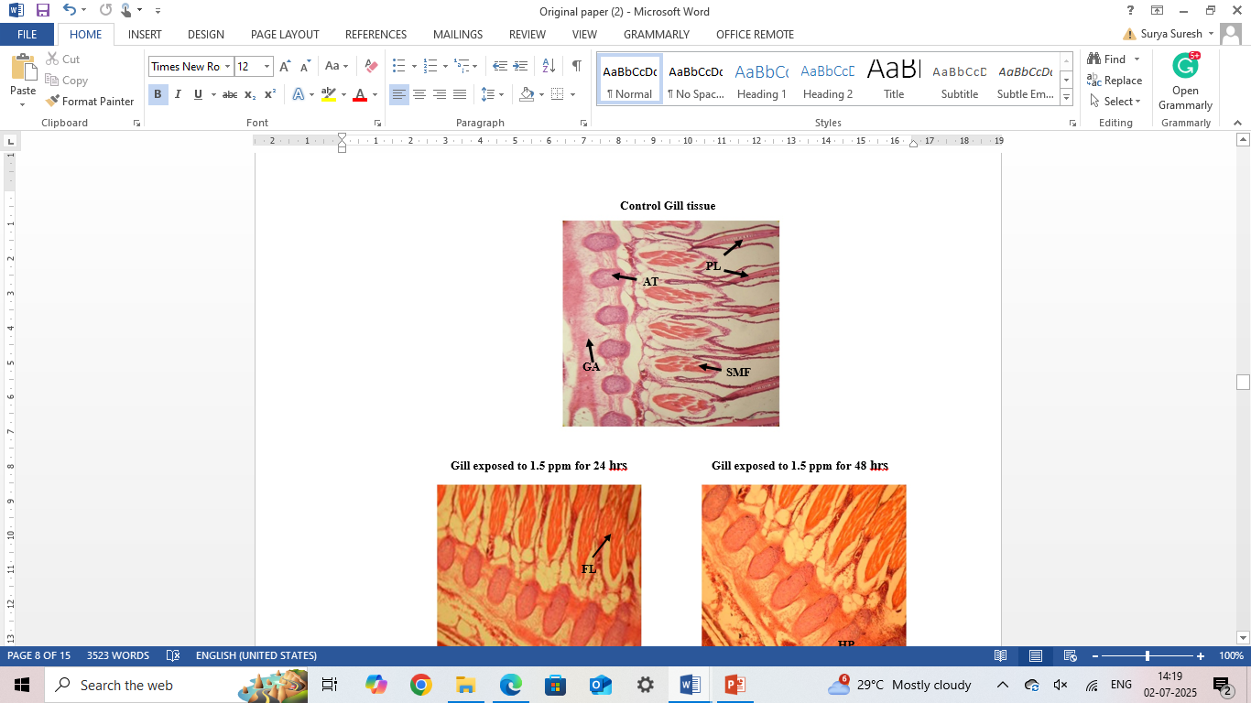
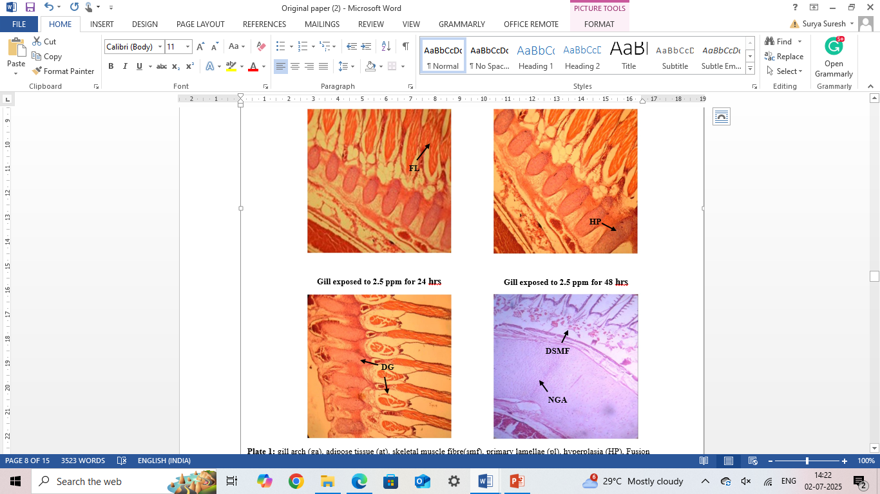
A
B
C
D
E

Figure 1. Histological analysis of Gill tissues of Tilapia mossambica exposed to carbofuran. (A) Control, (B) Gill exposed to 1.5 ppm for 24 hrs, (C) Gill exposed to 1.5 ppm for 48 hrs, (D) Gill exposed to 2.5 ppm for 24 hrs, (E) Gill exposed to 2.5 ppm for 48 hrs.
.

Abbreviations used: Gill Arch (GA), Adipose Tissue (AT), Skeletal Muscle Fibre (SMF), Primary Lamellae (PL), Hyperplasia (HP), Fusion of gill Lamellae (FL), Degeneration of Skeletal Muscle Fibre (DSMF), Necrosis of Gill Arch (NGA), Degenerative cell (DG).

The results of the present study revealed that carbofuran strictly affected the liver tissues of T. mossambica and observed significant damage at both concentrations (Figure 2). The liver tissues of fish exposed to 1.5 ppm for 24 and 48 hours, highlighting changes such as pycnotic nuclei, necrotic areas, and vacuolization. After 24 hours of exposure to 1.5 ppm, hepatocytes appeared shrunken, with pycnotic nuclei and vacuolization. After 48 hours, hepatocyte degeneration and necrotic areas became more prominent. Fish exposed to 2.5 ppm (Figures 2D and 2E) exhibited extensive vacuolization, destruction of sinusoidal structures, and necrosis after 24 hours, which worsened with prolonged exposure, leading to complete loss of hepatic architecture. These changes became more pronounced with increased exposure time.

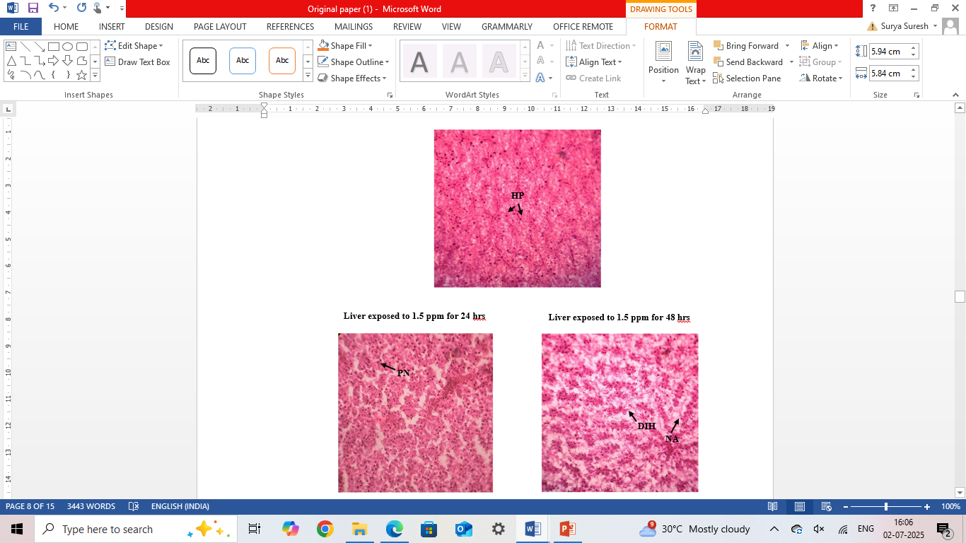
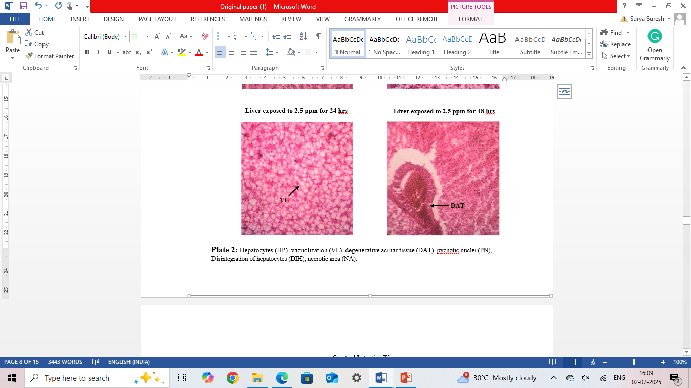
A
B
C
D
E

Figure 2. Histological analysis of Liver tissues of Tilapia mossambica exposed to carbofuran. (A) Control, (B) Liver exposed to 1.5 ppm for 24 hrs, (C) Liver exposed to 1.5 ppm for 48 hrs, (D) Liver exposed to 2.5 ppm for 24 hrs, (E) Liver exposed to 2.5 ppm for 48 hrs.

Abbreviations used: Hepatocytes (HP), Vacuolization (VL), Degenerative Acinar Tissue (DAT), Pycnotic Nuclei (PN), Disintegration of Hepatocytes (DIH), Necrotic Area (NA).

The intestinal tissue (Figure 3) exhibited several abnormalities in response to pesticide exposure. At 1.5 ppm for 24 hours, degradation of the muscularis mucosa and epithelial layer was evident. Prolonged exposure resulted in disintegration of the villi and complete loss of intestinal structure at 2.5 ppm for 48 hours. Excess mucous secretion and the destruction of capillaries and connective tissues were observed, leading to severe damage to the intestinal wall.

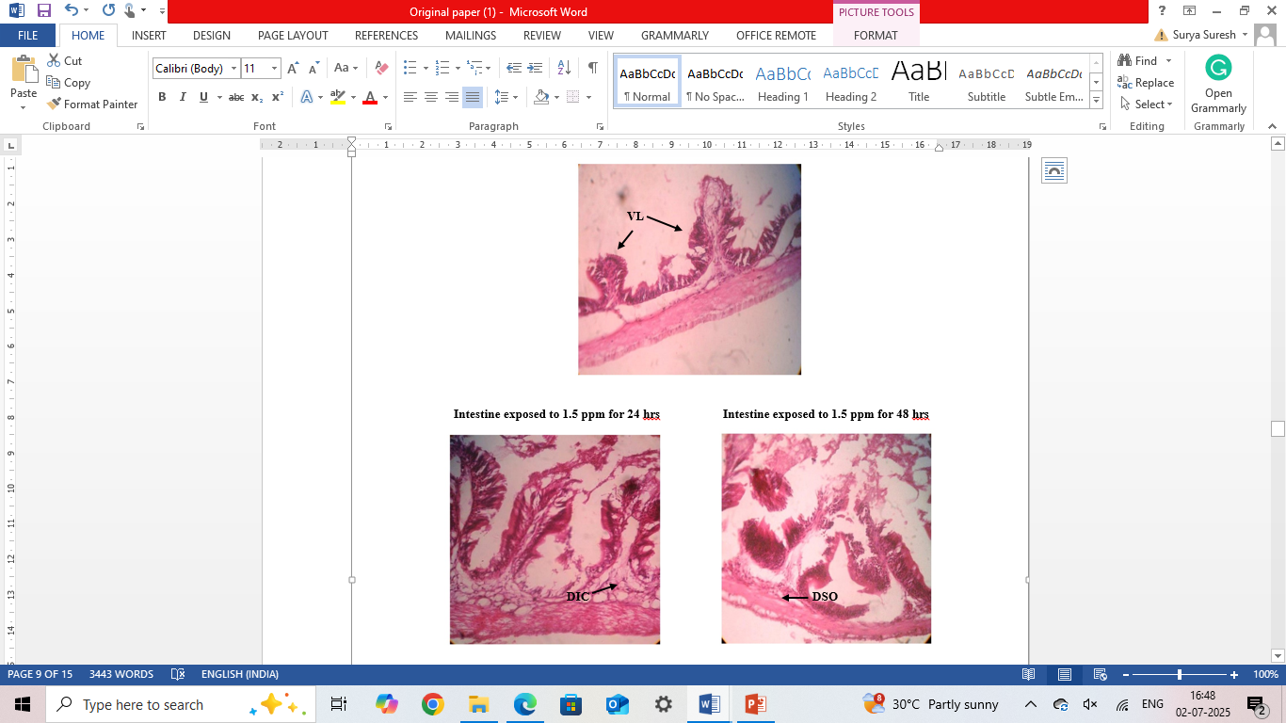
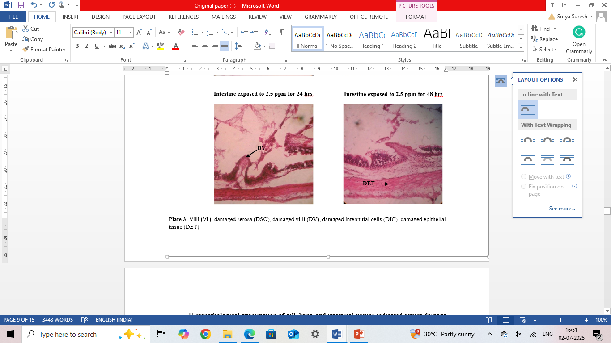
B
A
C
D
E

Figure 3. Histological analysis of Intestine tissues of Tilapia mossambica exposed to carbofuran. (A) Control, (B) Intestine exposed to 1.5 ppm for 24 hrs, (C) Intestine exposed to 1.5 ppm for 48 hrs, (D) Intestine exposed to 2.5 ppm for 24 hrs, (E) Intestine exposed to 2.5 ppm for 48 hrs.

Abbreviations used: Villi (VL), Damaged Serosa (DSO), Damaged Villi (DV), Damaged Interstitial Cells (DIC), Damaged Epithelial Tissue (DET)

4. DISCUSSION
Histological analysis of tissue samples from various organs of exposed fish represents a sensitive and reliable approach for toxicological evaluation and for monitoring the health and water quality of aquatic ecosystems. The findings of this study demonstrate that carbofuran significantly affects both oxygen consumption and tissue integrity in T. mossambica. An initial increase in oxygen consumption was observed at lower concentrations of exposure, likely reflecting a compensatory physiological response to pesticide-induced stress. However, at higher concentrations, oxygen consumption declined markedly, indicating respiratory distress associated with structural damage to the gill tissues (Pandey et al. 1993, Soucek et al. 2021). Similar findings were reported in Cyprinus carpio exposed to Cypermethrin, where oxygen consumption decreased progressively with increasing toxicant exposure (Neelima et al. 2016). Histopathological analysis revealed severe damage to the gills, liver, and intestinal tissues of T. mossambica following Carbofuran exposure. The gills, serving as the primary site for respiration and ion regulation, were particularly vulnerable, exhibiting pronounced hyperplasia, epithelial detachment, and lamellar fusion. These structural alterations are known to impair respiratory efficiency and contribute to hypoxic conditions in affected fish. The liver, a key organ involved in detoxification, exhibited marked histopathological alterations, including extensive necrosis, cytoplasmic vacuolization, and loss of sinusoidal architecture, aligning with the findings of Abirami et al. (2017). These hepatic changes appeared to be both dose-dependent and time-sensitive. Likewise, the intestinal tissues showed significant pathological changes, such as disintegration of villi and excessive mucus secretion, suggesting impaired nutrient absorption and an increased susceptibility to secondary infections (Braunbeck & Appelbaum 1999, Das & Gupta 2013). The findings of this study underscore the detrimental impact of pesticide exposure on aquatic organisms, particularly evidenced by significant histopathological alterations and disruptions in key physiological functions (Fanta et al. 2003). These findings emphasize the critical need for stringent regulation of pesticide use to mitigate its adverse effects on aquatic ecosystems. The present study highlights the significant and harmful impact of Carbofuran on fish health and survival. Notably, physiological parameters such as oxygen consumption were markedly altered, indicating the toxicant's profound effect on metabolic processes and energy utilization in T. mossambica. (Mishra et al. 2020).
The statistically significant results obtained from ANOVA and subsequent post hoc analyses confirm that Carbofuran exposure leads to notable alterations in oxygen consumption in T. mossambica at both 24- and 48-hour time points. The observed decline in oxygen consumption at higher concentrations likely reflects respiratory distress, which corresponds with histopathological findings of gill damage, including lamellar fusion and necrosis. These findings are consistent with previous studies (Pandey et al. 1993) that have reported comparable patterns of physiological disruption in fish following pesticide exposure. The present findings are in accordance with the observations reported by Loganathan et al. (2024). Chi-square analysis of histopathological alterations further substantiates the conclusion that Carbofuran exposure induces significant tissue damage in vital organs, including the gills, liver, and intestines. These findings underscore the sub-lethal toxicity of carbofuran and indicate a clear dose-dependent relationship between pesticide concentration and the extent of organ damage.
5. CONCLUSION
Despite being banned in various regions due to their biomagnification within the food chain, persistent agrochemicals are still found in water, soil, and ecosystems, particularly in developing countries, leading to serious harm to humans and the environment. The current study revealed that exposure to carbofuran induced significant histopathological changes in the gills, liver, and intestines of T. mossambica, along with pronounced changes in oxygen consumption. These findings emphasize the toxic effects associated with sub-lethal concentrations of pesticides, which pose a grave threat to fish health and freshwater ecosystems. Further investigation is essential to understand the long-term effects and evaluate the potential risks posed by carbofuran in natural habitats.

REFERENCES

Abirami T, Alen GRJ, Bavani G, and Karthikeyan J. 2017. “Ecotoxicology of green-synthesized silver nanoparticles on freshwater fish, Mystus gulio.” International Journal of Pharmacy and Pharmaceutical Sciences 9(11): 192-198. https://doi.org/10.22159/ijpps.2017v9i11.21627
Bancroft JD, Gamble M. 2008. Theory and Practice of Histological Techniques. New York: Churchill-Livingstone.
Begum BH, Mithra D. 2015. “Effects of an Oraganophosphate Pesticide, Malathion (50% EC) on the Liver of air breathing fish, Heteropneustes fossilis.” International Research Journal of Environment Sciences 4(9): 21-24.
Braunbeck T, Appelbaum S. 1999. “Ultrastructural alterations in the liver and intestine of carp Cyprinus carpio induced orally by ultra-low doses of endosulfan.” Diseases of Aquatic Organisms 36(3): 183–200. https://doi.org/10.3354/dao036183.
Das S, Gupta A. 2013. “Histopathological changes in the intestine of Indian Flying Barb (Esomus danricus) exposed to organochlorine pesticide, endosulfan (EC 35).” International Journal of Scientific Research 2(7): 206-208. https://www.doi.org/10.36106/ijsr.
Fanta E, Rios FSA, Romao S, Vianna ACC, and Freiberger S. 2003. “Histopathology of the fish Corydoras paleatus contaminated with sublethal levels of organophosphorus in water and food.” Ecotoxicology and Environmental Safety 54 (2): 119-130. https://doi.org/10.1016/s0147-6513(02)00044-1.
Loganathan K, Tennyson S, and Arivoli S. 2024. “Triazophos toxicity induced histological abnormalities in Heteropneustes fossilis Bloch 1794 (Siluriformes: Heteropneustidae) organs and assessment of recovery response.” The Journal of Basic and Applied Zoology 85(1): 1-25. http://dx.doi.org/10.1186/s41936-024-00373-x.
Luna LG. 1968. Manual of Histologic Staining Methods of the Armed Forces Institute of Pathology. McGraw-Hill, New York.
Mandal S, Mandal B. 2023. “A Review on the impact of pesticide toxicity on the physiological and behavioral condition of fish.” Toxicology International 30(4): 429–439. https://doi.org/10.18311/ti/2023/v30i4/34317.
McKim JM, Benoit DA, Biesinger KE, Brungs WA, and Siefert RE. 1975. “Effects of pollution on freshwater fish.” Journal (Water Pollution Control Federation): 1711-1768. https://www.jstor.org/stable/25038890.
Mishra S, Zhang W, Lin Z, Pang S, Huang Y, Bhatt P, and Chen S. 2020. “Carbofuran toxicity and its microbial degradation in contaminated environments.” Chemosphere 259: 127419. https://doi.org/10.1016/j.chemosphere.2020.127419.
Neelima P, Gopala Rao N, Srinivasa Rao G, and Chandra Sekhara Rao J. 2016. “A study on oxygen consumption in a freshwater fish Cyprinus carpio exposed to lethal and sublethal concentrations of cypermethrin (25%Ec).” International Journal of Current Microbiology and Applied Sciences 5(4): 338-346. https://dx.doi.org/10.20546/ijcmas.2016.504.040.
Otieno PO, Lalah JO, Virani M, Jondiko IO, and Schramm KW. 2010. “Soil and water contamination with carbofuran residues in agricultural farmlands in Kenya following the application of the technical formulation Furadan.” Journal of Environmental Science and Health Part B 45(2): 137-144. https://doi.org/10.1080/03601230903472058.
Pacheco M, Santos MA. 2002. “Biotransformation, genotoxic, and histopathological effects of environmental contaminants in European eel (Anguilla anguilla L.).” Ecotoxicology and environmental safety 53(3): 331-347. https://doi.org/10.1016/s0147-6513(02)00017-9.
Pandey S, Mishra A, and Sharma P. 1993. Histopathological changes in the gills of Channa punctatus exposed to Carbofuran. Journal of Environmental Biology 14 (3): 207-212.
Peter VS, Babitha GS, Bonga SW, and Peter MCS. 2013. “Carbaryl exposure and recovery modify the interrenal and thyroidal activities and the mitochondria-rich cell function in the climbing perch Anabas testudineus Bloch.” Aquatic Toxicology 126: 306-313. https://doi.org/10.1016/j.aquatox.2012.09.014.
Sharma R, Peshin R, Shankar U, Kaul V, and Sharma S. 2015. “Impact evaluation indicators of an Integrated Pest Management program in vegetable crops in the subtropical region of Jammu and Kashmir, India.” Crop Protection 67, 191-199. https://doi.org/10.1016/j.cropro.2014.10.014.
Soucek DJ, Dickinson A. and Harbaugh T. 2021. “Pesticide toxicity in freshwater systems: Mechanisms and impacts.” Ecotoxicology 28(4): 548-556.
Yonar ME, Yonar SM, Ural MS, Silici S, and Düşükcan M. 2012. “Protective role of propolis in chlorpyrifos-induced changes in the haematological parameters and the oxidative/antioxidative status of Cyprinus carpio carpio.” Food and Chemical Toxicology 50(8): 2703-2708. https://doi.org/10.1016/j.fct.2012.05.032.

