STRATEGIC MANAGEMENT OF FASCIOLOSIS IN A SHEEP FLOCK

ABSTRACT
Two male Muzaffarnagari sheep were presented at RVP, ICAR-IVRI, Bareilly with clinical signs including anorexia, depression, painful bleating, pyrexia, serous nasal discharge, conjunctival pallor and edema. Fecal examination revealed Fasciola hepatica eggs. Hematological evaluation revealed anemia and leukocytosis. Serum biochemical analysis indicated hepatic dysfunction and severe hypoproteinemia. One sheep succumbed to infection, and post-mortem demonstrated multiple greyish necrotic lesions with hemorrhages and cavities containing numerous Fasciola spp. within bile ducts. Therapeutic management included Triclabendazole bolus @10 mg/kg administered twice at a 3-day interval along with supportive therapy. Deworming of the remaining flock using Triclabendazole @10 mg/kg was advised. Post-treatment fecal examination was negative for fasciolosis, and no further mortality occurred within the flock.
Keywords: Fasciolosis, Liver fluke, Triclabendazole, Hepatic injury, Hypoproteinemia
- INTRODUCTION
Fasciolosis is a major parasitic disease of domestic ruminants predominantly caused by Fasciola hepatica which significantly affects livestock health and productivity across the globe (Lan et al., 2024). The parasitic infection leads to substantial economic losses, decreased weight gain, reduced wool and meat production, mortality and condemnation of affected livers at slaughter (Mazeri et al., 2021). The disease remains an important constraint in sheep farming systems relying on pasture grazing particularly in temperate and tropical agro-climatic regions (Beesley et al., 2018). Sheep remains highly susceptible to infection and frequently develop acute or subacute fasciolosis following ingestion of infective metacercaria present on contaminated pasture and water sources (Hodžić et al., 2022). The life cycle of F. hepatica involves freshwater snails of the genus Lymnaea acting as intermediate hosts, thereby making swampy grazing lands, irrigation fields, and poorly drained pastures important epidemiological risk factors for disease transmission (Cwiklinski et al., 2021). Migration of immature flukes through hepatic parenchyma results in extensive tissue destruction, hemorrhage, and inflammatory reactions, whereas adult parasites inhabiting the bile ducts induce cholangitis, fibrosis, and progressive hepatic dysfunction (Kronenberg et al., 2022). Clinical manifestations vary according to the parasitic burden ranging from sudden death in acute outbreaks to chronic anemia, weight loss, hypoproteinemia, and reduced productivity in long-standing infections (Khan et al., 2020). Furthermore, fasciolosis predisposes infected sheep to clostridial diseases such as black disease caused by Clostridium novyi, due to hepatic necrosis providing anaerobic conditions favorable for bacterial proliferation (Taylor et al., 2021). This case report describes strategic management of fasciolosis in a sheep flock
- MATERIAL AND METHODS
Affected sheep (Fig-1) were presented to RVP, IVRI, Bareilly, Uttar Pradesh with a history of reduced feed intake, weakness, progressive weight loss and mortality of few animals in that flock. History revealed that the animals were maintained under semi-intensive management and allowed to graze in low lying pasture suspected to be infested with snails. A detailed clinical examination of affected sheep was performed to evaluate general health status and disease severity. Clinical examination revealed pain on percussion, Pyrexia (104.3℉) since 5 days, painful bleating, serous nasal discharge, heart rate 65 bpm, respiratory rate 30-32/min, conjunctival pallor and edema. Fresh fecal samples were collected directly from the rectum of suspected sheep and subjected to sedimentation technique for qualitative detection of parasitic eggs. Microscopic examination revealed eggs of Fasciola hepatica. About 3-5 ml of blood was collected in EDTA vial and clot activator vial for haematological estimation and serum biochemistry. From the two sheep presented one of the sheep succumbed to infection, and necropsy was conducted following standard post-mortem procedures. Tissue samples were collected in 10% neutral buffered formalin for histopathological examination following which the samples were stained with hematoxylin and eosin to assess pathological alterations associated with fluke migration. The sheep was treated with Triclabendazole bolus @10 mg/kg administered twice at a 3-day interval along with supportive therapy comprising Inj. Enrofloxacin @5mg/kg IM for 5 days, Inj. Meloxicam @1mg/kg IM for 5 days, Inj. Chlorpheniramine maleate @0.5mg/kg IM for 5 days, Inj. Vitamin B-complex (3 ml IM) for 1 week, and oral hematinics (5–10 ml) for five days.
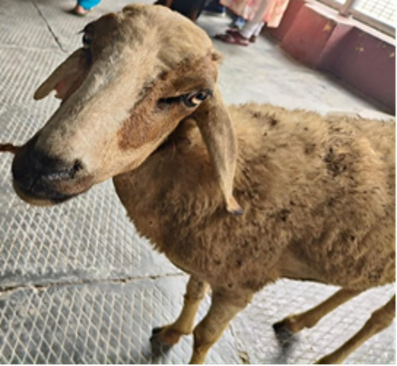
Fig-1 (Affected sheep)
- RESULTS AND DISCUSSION
The severity of clinical signs like edematous swelling in the submandibular region (bottle jaw) indicative of hypoproteinemia associated with chronic liver dysfunction. Clinical pathology parameters are depicted in Table 1. Hematological analysis demonstrated marked anemia with hemoglobin at 6.7 g/dL and PCV at 20.3% and leukocytosis (40.8 × 10³/cumm). Serum biochemistry revealed elevated SGOT level (251.9 IU/L), hypoproteinemia (3.68 g/dL), and hypoalbuminemia (1.6 g/dL), indicating hepatic injury and compromised protein metabolism. The necropsy of the ovine specimen revealed that the peritoneal cavity contained approximately 200–300 ml of blood-tinged fluid, and extensive hemorrhages were observed in the omentum. The liver exhibited multifocal hemorrhages extending deep into the parenchyma, along with small blood-filled cavities. On sectioning, numerous elongated trematodes (Fasciola spp.) were found within bile ducts and hemorrhagic cavities (Fig-2). Histopathological examination of the affected sheep revealed extensive hepatic lesions consistent with chronic fasciolosis. The liver parenchyma showed multifocal areas of coagulative necrosis interspersed with hemorrhages, accompanied by dilated bile ducts containing cross-sections of Fasciola spp. Parasites (Fig-3). The bile duct epithelium exhibited marked hyperplasia, with periductal fibrosis and infiltration of inflammatory cells, predominantly lymphocytes, plasma cells, eosinophils, and macrophages. Hemosiderin-laden macrophages were frequently observed, reflecting ongoing hemorrhage and erythrocyte breakdown. Surrounding hepatic tissue demonstrated degenerative changes, including hepatocellular vacuolation and loss of normal architecture (Fig-4). An incidental detection of Sarcocystis cysts was noted in cardiac muscle during examination, indicating concurrent exposure to multiple parasitic infections under similar grazing conditions (Fig-5). The therapeutic regimen of ovine fasciolosis in this case included administration of triclabendazole at 10 mg/kg body weight, given as two doses at three-day interval, targeting the elimination of Fasciola spp. from the bile ducts. Supportive therapy comprised enrofloxacin at 5 mg/kg for five consecutive days to prevent secondary bacterial infections, and meloxicam at 1 mg/kg intramuscularly to reduce inflammation and provide analgesia. Chlorpheniramine maleate was administered intramuscularly at 0.5 mg/kg for five days to counteract allergic or hypersensitivity reactions. Additionally, vitamin B-complex injections (3 ml IM daily for one week) and oral haematinics (5–10 ml daily for five days) were provided to support haematopoiesis and improve overall systemic condition. The entire flock was administered triclabendazole and ivermectin oral suspension at 3 ml per sheep, repeated at 15-day intervals, particularly targeting younger animals to prevent reinfection. Follow-up faecal examinations revealed negative results for Fasciola eggs, and importantly, no further mortality was recorded in the flock. Preventive management advice included restricted grazing in snail-populated or swampy areas, thereby reducing exposure to the intermediate host and minimizing the risk of recurrence.
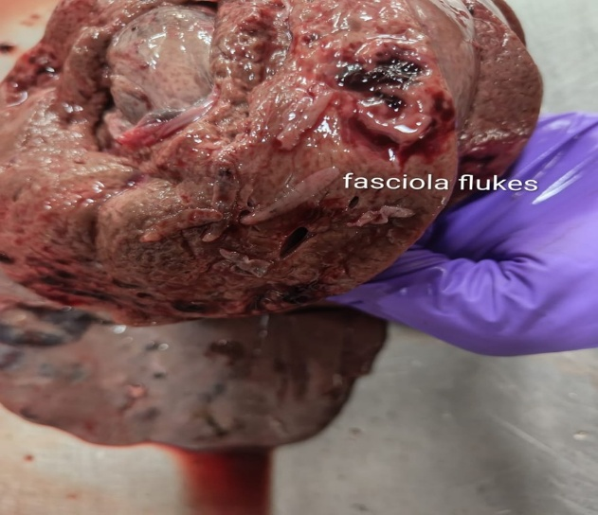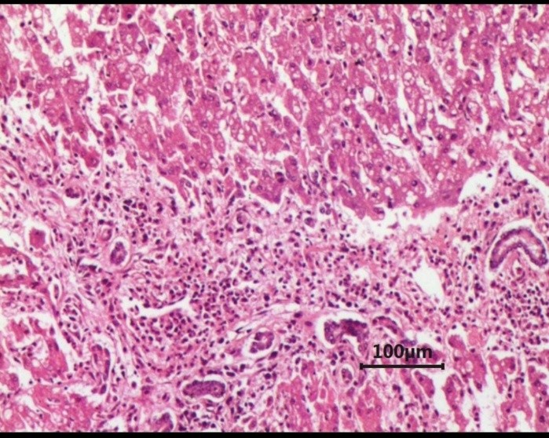
Fig-2 (Fasciola flukes in bile duct) Fig-3 (Histopathology sections of liver)

Table 1: Pre and Post Treatment Changes in Hematobiochemical Parameters
BLOOD PARAMETERS | OBSERVED VALUE | REFERENCE RANGE
CBC EXAMINATION
Hemoglobin (g/dL) | 6.7 | 9-15
PCV (%) | 20.3 | 27-45
TLC (10³/cumm) | 40.8 | 4.1
TEC(10⁶/cumm) | 6.45 | 8.6
Platelets (10³/mcl) | 250 | 800-1100
Neutrophil (%) | 77 | 10-50
SGOT(IU/L) | 251.9 | 158
Total Protein(g/dl) | 3.68 | 6-7.9
SGPT(IU/L) | 19.27 | 26-34
Albumin | 1.6 | 2-4.3
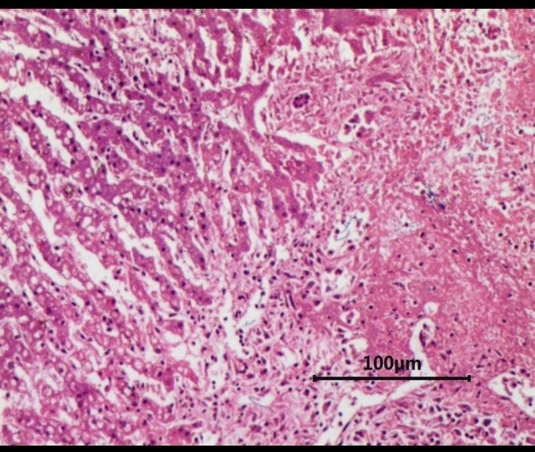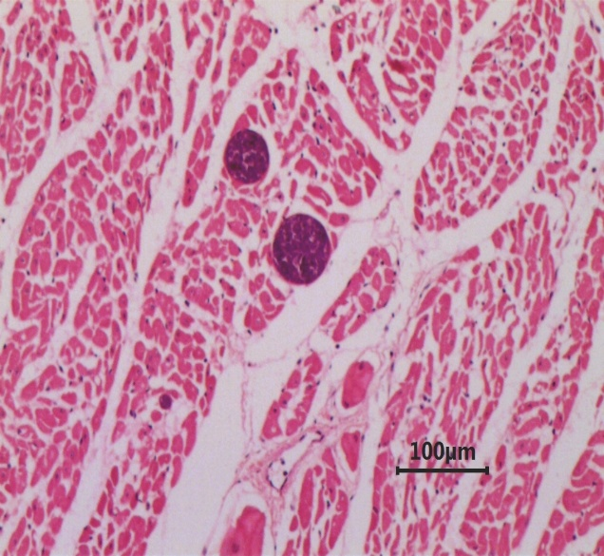
Fig-4( Degenerative changes of hepatic tissue) Fig-5(Sarcocystis sp in cardiac muscle)
Fasciolosis caused by trematodes of the genus Fasciola (F. hepatica and F. gigantica) remains one of the most important parasitic diseases of ruminants worldwide with substantial economic loss, reduced productivity, mortality and treatment costs. The impact of fasciolosis differs between small and large ruminants. In sheep and goats, the disease often presents as acute, severe clinical disease due to higher susceptibility and lower acquired immunity, anemia, and reduced fertility (Mas-Coma et al., 2020;Khan et al., 2022). In contrast cattle and buffaloes tends to develop chronic and often subclinical infections with decreased milk yield, poor weight gain, and liver condemnation at slaughterhouses due to partial resistance and adaptive immune response (Selemetas et al., 2021). The severe clinical outcome observed in the present study suggests that sheep are highly vulnerable to acute fasciolosis under conditions of heavy parasitic exposure (Mehmood et al., 2023). The severity of fasciolosis is strongly influenced by parasite burden with heavy infections causing hepatic destructions due to mass migration of flukes (Khan et al., 2020; Andrews et al., 2020). Acute fasciolosis is typically associated with high metacercarial intake, leading to hemorrhagic hepatitis and mortality (Nyindo and Lukambagire, 2021). The epidemiology of fasciolosis is closely linked to environmental conditions like high moisture, poorly drained pastures and presence of suitable snail habitats that facilitate the proliferation of intermediate hosts and increase transmission risk (Alasaad et al., 2021). Fasciolosis progresses through distinct clinical phases: an incubation phase with minimal symptoms, an acute invasive phase characterized by fever, abdominal pain, and hepatomegaly, and a chronic phase marked by anaemia, cachexia, and biliary obstruction due to adult flukes in bile ducts. Most common complication of fasciolosis is its association with infectious necrotic hepatitis, commonly known as Black Disease, caused by Clostridium novyi type B. Migrating flukes create necrotic foci in the liver that provide anaerobic conditions for clostridial spores to germinate, resulting in sudden toxaemia and death in sheep (Uzal et al., 2016). Fecal examinations, although widely used, has limitations including low sensitivity during early infection and inability to detect prepatent stages (Nyindo and Lukambagire, 2021). Advanced diagnostic techniques sucha as ELISA and PCR offer higher sensitivity and specificity (Mehmood et al., 2023). Triclabendazole, a benzimidazole derivative is uniquely effective against both immature and adult stages of F. hepatica and F. gigantica exerts it’s activity by binding to parasite ß-tubulin, disrupting microtubule formation and impairing essential cellular processes such as nutrient absorption and intracellular transport and ultimately parasite’s death (Fairweather, 2011). The growing occurrence of resistance to triclabendazole has become a major concern in the global control of fasciolosis (Fairweather and Boray, 2020; Kelley et al., 2021). This resistance is largely linked to the repeated and unregulated use of anthelminthitic drugs (Charlier et al., 2022). Integrated parasite management strategies including targeted selective treatment, drug rotation, and pasture management are essential to sustain drug efficacy (Sánchez-Andrade and Paz-Silva, 2022) Control measures focus on environmental management like restricted grazing in snail infested or swampy pastures (Kumari and Srivastava, 2025). Chemical control like synthetic molluscicides such as copper sulphate and niclosamide reduce intermediate host density and interrupt parasite transmission (Singh et al., 2021).
- CONCLUSION
The present study documented clinical, haematological, biochemical and pathological findings of hepatic fasciolosis of sheep grazing in snail infested pasture. Affected animals showed anaemia, pyrexia, oedema, and hepatic dysfunction confirmed through faecal and laboratory examinations. Post-mortem findings revealed severe liver damage with Fasciola hepatica infestation. Treatment with triclabendazole and supportive therapy resulted in recovery and prevented further mortality in the flock.

DISCLAIMER (ARTIFICIAL INTELLIGENCE)
Author(s) hereby declare that NO generative AI technologies such as Large Language Models (ChatGPT, COPILOT, etc) and text-to-image generators have been used during writing or editing of this manuscript.
COMPETING INTERESTS
Authors have declared that no competing interests exist.
REFERENCES
Alasaad, S., Soriguer, R. C., and Abu-Madi, M. (2021). Climate change and fasciolosis distribution: Predictive modeling approaches. Science of the Total Environment, 754, 142232.
Andrews, S. J. (2020). The life cycle of Fasciola hepatica revisited. International Journal for Parasitology, 50(6–7), 485–497.
Beesley, N.J., Caminade, C. and Charlier, J. 2018. Fasciola and fasciolosis in ruminants in Europe. Advances in Parasitology 103: 148-173.
Charlier, J., Kelley, J., Skuce, P. (2022). Fasciola hepatica control: Recent advances and future challenges. Trends in Parasitology, 38(4), 298–310.
Cwiklinski, K., Dalton, J.P. and Dufresne, P.J. 2021. The Fasciola hepatica genome and host–parasite interactions. International Journal for Parasitology 51: 877–893.
Fairweather, I. 2011. Triclabendazole: New skills to unravel an old(ish) enigma. Journal of Helminthology 85(3): 227–234.
Fairweather, I., and Boray, J. C. (2020). Mechanisms of triclabendazole resistance in Fasciola hepatica. Parasitology, 147(5), 453–463.
Hodžić, A., Zuko, A. and Avdić, R. 2022. Prevalence and risk factors of fasciolosis in sheep. Veterinary Medicine and Science 8: 2156–2164.
Kelley, J. M., Elliott, T. P., and Beddoe, T. (2021). Current threat of triclabendazole resistance in Fasciola hepatica. Veterinary Parasitology, 290, 109360.
Khan, M.K., Sajid, M.S. and Iqbal, Z. 2020. Epidemiology and control prospects of fasciolosis in ruminants. Veterinary Parasitology 283: 109178.
Khan, M.K., Sajid, M.S. and Khan, M.N. 2020. Pathology and clinical manifestations of fasciolosis in small ruminants. Pakistan Veterinary Journal 40: 1–6.
Kronenberg, P.A., Peña-Espinoza, M. and Thamsborg, S.M. 2022. Host immune response against Fasciola hepatica. Parasite Immunology 44: e12922.
Kumari, A. and Srivastava, S. 2025. Integrated control strategies for fasciolosis in livestock: Emphasis on grazing management. Veterinary Parasitology Research Journal 12(2): 145–152.
Lan, Z., Zhang, X.H., Xing, J.L. and Wang, H.R. 2024. Global prevalence of liver disease caused by Fasciola: A systematic review and meta-analysis. Journal of Global Health 14: 04223.
Mas-Coma, S., Bargues, M. D., and Valero, M. A. (2020). Human and animal fascioliasis: Epidemiological and control perspectives. Advances in Parasitology, 109, 1–70.
Mazeri, S., Rydevik, G. and Handel, I. 2021. Epidemiological modelling of Fasciola hepatica infection. Preventive Veterinary Medicine 188: 105261.
Mehmood, K., Zhang, H., Sabir, A. J. (2023). A comprehensive review on epidemiology, pathogenesis and control of Fasciola hepatica. Veterinary Research Communications, 47(2), 345–362.
Nyindo, M., & Lukambagire, A. H. (2021). Fascioliasis: An ongoing zoonotic trematode infection. BioMed Research International, 2021, 1–15.
Sánchez-Andrade, R., and Paz-Silva, A. (2022). Sustainable control of fasciolosis in grazing systems. Veterinary Parasitology, 305, 109690.
Selemetas, N., Phelan, P., and O’Kiely, P. (2021). The effects of fasciolosis on production in ruminants: A review. Irish Veterinary Journal, 74(1), 1–9.
Singh, D.K., Singh, V.K., Singh, R.N. and Kumar, P. 2021. Fasciolosis: Causes, challenges and controls. Springer Nature Singapore.
Taylor, M.A., Coop, R.L. and Wall, R.L. 2021. Veterinary Parasitology. 5th edn. Wiley-Blackwell.
Uzal, F.A., Songer, J.G. and Prescott, J.F. 2016. Clostridial Diseases of Animals. Wiley Blackwell.

