Original Research Article
Phytochemical and Cytotoxicity of Acetone Extract of Rosmarinus officinalis L. (Rosemary) Via BSLT

.
ABSTRACT

Background: Rosmarinus officinalis L. is an aromatic plant from the Mediterranean origin which was started to be cultivated in Indonesia. Polar extract from rosemary has various bioactivity sothat it attracts researchers.
Aims: The objective of this study is to evaluate the phytochemical constituents and assess the cytotoxicity level of the acetone extract of Rosmarinus officinalis L. (rosemary) via BSLT.
Methodology: The stages of working on this research include extraction, evaporation, and approval. Reserve composition analysis includes phytochemical tests, FTIR, and GCMS analysis.
Results: The compounds rosemary acetone extract are alkaloid, flanonoid, phenols, steroids and terpenoids. The Value of cytotoxic test with probit analysis showed LC₅₀ 0.061 µg/mL.
Conclusion: Cytotoxic test results on rosemary acetone extract is toxic so thatpotentially as anticancer these have a positive assessment of the analysis of collections that contain secondary metabolite.

Keywords: Acetone Extract, BSLT, Cytotoxicity, Phytochemical, Rosemary

1. INTRODUCTION

Medicinal plants have long been utilized as alternative therapeutic agents due to their accessibility, affordability, and relatively simple cultivation processes. Approximately 80% of the population in Asian countries relies on medicinal plants for primary healthcare and natural remedies (Handa, et al., 2016). Among the various medicinal plants, spices have attracted considerable scientific interest because of their diverse pharmacological properties. One notable species is Rosemary, formerly known as Rosmarinus officinalis L., a perennial herb belonging to the Lamiaceae family that has gained increasing attention for its therapeutic potential. Rosemary has traditionally been used to relieve muscle pain, stimulate hair growth, improve memory, strengthen the immune system, and support circulatory and anti-inflammatory functions (Hashim, et al., 2025). In recent years, numerous studies have demonstrated that rosemary possesses significant biological activities, including antioxidant, antibacterial, antidiabetic, antifungal, and anticancer effects, while exhibiting relatively low toxicity (Akhsata, et al., 2025). The versatility of Rosemary in traditional and modern medicine is reflected in its use as essential oils, extracts, and herbal teas. Its health benefits are attributed to the synergistic activity of its bioactive compounds, highlighting rosemary’s growing importance as a natural therapeutic and antioxidant agent in modern healthcare (Alwadkar, et al., 2024).These pharmacological activities are mainly attributed to its rich content of bioactive secondary metabolites such as flavonoids, ursolic acid, oleanolic acid, carnosic acid, and rosmarinic acid, which also contribute to its applications in the food, cosmetic, and skincare industries (Wasnik, et al., 2025). However, further investigations are still required to better understand the mechanisms underlying these biological activities.
In addition, rosemary has demonstrated promising anticancer potential through various mechanisms, including inhibition of cancer cell proliferation, induction of apoptosis, suppression of tumor angiogenesis, and reduction of inflammation associated with tumor progression (Maziane, et al., 2025). Previous studies have also highlighted its anti-obesity, neuroprotective, and gastrointestinal protective effects, particularly through the reduction of oxidative stress and inflammatory responses (Singletary, 2016; Veenstra and Johnson, 2021). Owing to these diverse therapeutic properties, rosemary has become a globally important aromatic and medicinal plant with increasing demand for its leaves, extracts, essential oils, and other derivative products (Banjaw, et al., 2024).Despite the extensive studies on rosemary, the cytotoxic potential and specific bioactive compounds of the acetone extract of rosemary have not yet been thoroughly investigated. Therefore, this study aims to evaluate the toxicity of rosemary acetone extract using the Brine Shrimp Lethality Test (BSLT) method. Furthermore, this research also seeks to identify the phytochemical groups and dominant compounds present in the extract.
2. EXPERIMENTAL

2.1 Tools and Materials

The tools used were blenders, digital scales, buchner funnels, rotary evaporators, glassware, dropper containers, microplates, and vials. The analysis spectroscopis used were FTIR variant 8501 Shimadzu JEOL JMN A 5000 which worked at 500 MHz and GCMS variant qp-2010 Shimadzu. The materials used were Rosmarinus officinalis L. (rosemary) powder, several organic solvents such as methanol, acetone, ethyl acetate, chloroform, n-hexan, seawater, DMSO 1%, and Artemia salina Leach eggs.
2.2 Preparation of Plant Extract

Driedpowder of rosemary of 500 g macerated with acetone solvent 1.500 mL (1:3) for 1 x 24 hours one times, then filtered to produce acetone extract (macerated), the extract obtained is then evaporated, air dried. Phytochemical tested of the extract was carried out, then the extract was analyzed using spectroscopis FTIR and GC-MS. The extract was tested for toxicity with BSLT (Brine Shrimp Lethal Test) method.

2.3 Phytochemical Test

Alkaloids, flavonoids, phenols, steroids, terpenoids analyzed by phytochemicals using various specific reagents (Boreddy, et al., 2025).
2.3.1 Detection of Alkaloids
2.3.1.1 Mayer’s Test. The Appearance of white creamy precipitate confirms that acetone extract positive alkaloids. Identification is carried out by means of the extract added with two drops of Mayer’s reagent ( potassium mercuric iodide solution).
2.3.1.2 Wagner’s Test. The appearance ofreddish-brown precipitate indicates the presence of alkaloids in acetone extract. Identification is carried outby means of the extract added with two drops of Wagner’s reagent (iodine solution in potassium iodide)
2.3.2 Detectionof Flavonoids
2.3.2.1 Shinoda’sTest. Acetonextract addedwith0,5mL of HCl andmagnisium metal, appearanceof reddish/orange colour confirms that the extract positive flavonoid
2.3.3 DetectionofPhenols
2.3.3.1 Ferric Chloride Test. Aceton extract added with 3-4 drops of ferric chloride solution, appearance of bluish black colour confirms that the extract positive phenols.

2.3.4 Detectionof Steroids

2.3.4.1 Libermann Burchard’s Test. The appearance green colour indicates the presence of steroids in acetone extract. Identification is carried out by means of the extract added with a few drops of aseticanhydride and H2SO4.

2.3.4 Detectionof Terpenoids

2.3.4.1Salkowski Test.Acetonextraxt added with a few drops H2SO4 stir slowly, appearance of reddish brown colour confirms that the extract positive terpenoids.

2.4 Cytotoxicity Test

This method used BSLT (Brine Shrimp Lethality Test), The cytotoxicity test was assessed by determining the value of LC50values through a pobit analysis based on theresults of 50% larvae deaths and calculated using a linear regression equation y = a + bx(Meyer, et al., 1982).

2.4.1 Preparation of the Tested Samples. The stok solution was prepared by balancing 30 mg of the extract dissolved with200 µL DMSO 1%and1.500 µL seawater toproduce2000 ppm, further diluted until the concentrations 1000 ppm, 100 ppm, 10 ppm, 1 ppm, and 0,1 ppm. Each concentration has 3 replications.Thecontrolsolutionwasprepared200µLDMSO1%putedintothevialsandadded 1.500 µL seawater, the variantion of concentrations made same as the stok solution but there is no addition of the sample.

2.4.2Preparation of Artemia Salina Larvae. Artificial seawater is made by adding 38 g of salt to 2 L of aquadest, then the eggs of artemia salina L. puted into a droper container, aerated, and given a 40- 60 Watt lighting lamp. The larvae with 48 hours life span were used in toxicity test.

2.4.3 BSLT methods. 10 larvae of Artemia salina L. puted into test solution 1000 ppm, 100 ppm, 10 ppm, 1 ppm, and 0,1 ppm. Furthermore seawater added to reach 5 mL, stored for 24 hours under a light. Observations weremadebycountingthenumber of deadandlivinglarvae. Toxicity level of aextract is classification according to Clarkson,et al., (2004), LC501000 µg/mL is definedas nontoxic, LC50inrange500-100 µg/mL is defined lowtoxic, range100-500 is classified as medium toxic, and in range0-100 µg/mL is classified as highly toxic.
%mortality=Numberof deathlarvae/Totalnumberoflarvaex100%

3. results and discussion

Maceration is the simplest extraction method where solvent will penetrate plant cell walls and will enter the cell cavity, thus forcing active substances in plants out of cells. Macerate obtained as muchas 68.2 g, witha weight of 13.36% (w/w). Based onthephytochemical test results, it was found that the class of compounds contained in the extract included alkaloids, flavonoids, phenols, steroids, and terpenoids (Table 1). This is supported by the color change in the extract after the addition of the test reagent (Figure 1).According to Boreddy et al., (2025), phytochemical screening of rosemary revealed the presence of phenols, saponins, flavonoids, terpenoids, and steroids.
Table1. PhytochemicalTestofRosmarinusofficinalisL.
ClassofCoumpounds | Likeness | Information
Alkaloids(Mayer’s) | whitecreamyprecipitate | +
(Wagner’s) | reddish-brownprecipitate | +
Flavonoids | orangecolour | +
Phenols | bluishblack | +
Steroids | greencolour | +
Terpenoids | reddishbrowncolour | +
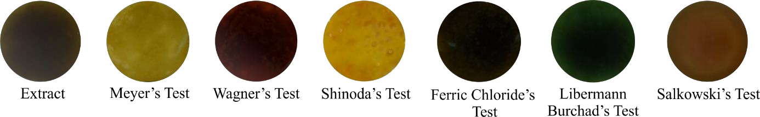
Figure1. PhytochemicalTestofRosmarinusofficinalisL.
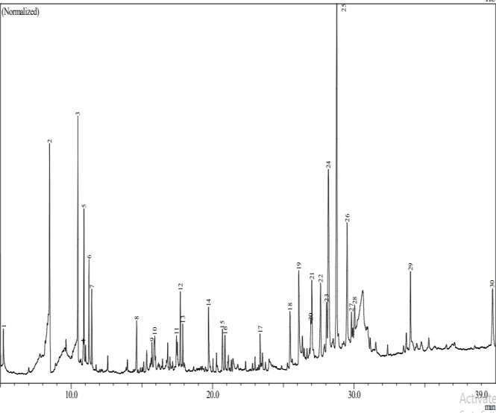

Figure2. GC-MSchromatogramofacetoneextract of rosemary
The results of GC MS analysis showed a positive correlation with the results of phytochemicalsthat havebeencarriedout, where there are flavonoids compounds as themaincomponent intheextract, namely sakuranetin (19.42%), in addition, thereare several dominant terpenoids compounds namely isocarnosol (12.70%). alkaloids compounds contained in benzotript extract (2.29%), steroids compounds namely Trimethyl-silylestrone (1.58%), and the extract also contained a variety of essential oils which aregenerally produced by each aromaticplant.
These findings are in agreement with previous studies demonstrating that concentrations of 16.5% polyphenols, 26% flavonoids, and 0.96% sterols in rosemary (Boreddy et al., 2025).
Table2. PhytocomponentsIdentified in Acetone Extract of Rosemary by GC-MS
Peak | IUPAC name | RT | Area  % | Formula | Molecular weight | Chemical structure
2 | eucalyptol | 8.483 | 5.51 | C₁₀H₁₈O | 154 | 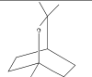
3 | camphor | 10.476 | 6.58 | C₁₀H₁₆O | 152 | 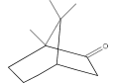
5 | borneol | 10.909 | 4.44 | C₁₀H₁₈O | 154 | 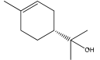
6 | α-terpineol | 11.258 | 3.33 | C₁₀H₁₈O | 154 | 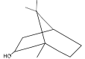
7 | Bicyclo[3.1.1]hept- 3-en-2-one, 4,6,6-  Trimethyl-(1S)- | 11.458 | 2.24 | C₁₀H₁₄O | 150 | 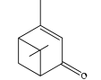
8 | trans-β- caryophllene | 14.633 | 1.28 | C₁₀H₁₄O | 150 | 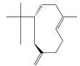
9 | Phenol, 3,5- bis(1,1- dimethylethyl) | 15.722 | 0.62 | C14H22O | 206 | 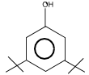
10 | d-Cadinene | 15.910 | 1.20 | C15H24 | 204 | 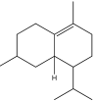
11 | Methyljasmonate | 17.452 | 0.84 | C13H20O3 | 224 | 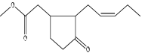
12 | 3-methyl-5-(2,6,6- trimethyl-1- cyclohexen-1-yl)-  1-pentyn-3-ol | 17.718 | 2.20 | C15H24O | 220 | 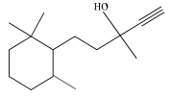
13 | Caryophyllene oxide | 17.894 | 1.25 | C15H24O | 220 | 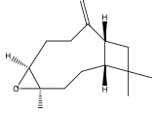
14 | neophytadien | 19.717 | 2.19 | C20H38 | 278 | 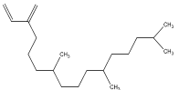
15 | Clovane diol | 20.695 | 1.77 | C15H26O2 | 238 | 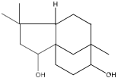
16 | Palmiticacid | 20.878 | 1.08 | C17H34O2 | 270 | 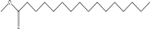
17 | Oleicacid ester | 23.363 | 1.27 | C19H36O2 | 296 | 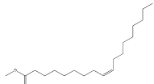
18 | benzotript | 25.474 | 2.29 | C18H15ClN2O3 | 342 | 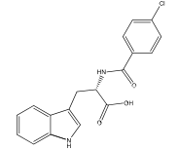
19 | S-(tert-butyl)3-  {[tert-butyl(diphenyl)silyl]oxy}-4- hexenethioate | 26.099 | 4.08 | C26H36O2SSi | 440 | 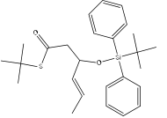
20 | Trimethyl- silylestrone | 26.933 | 1.58 | C21H30O2Si | 342 | 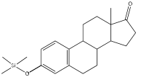
21 | Abieta-9(11),8(14),  12-trien-12-ol | 27.017 | 3.31 | C20H30O | 286 | 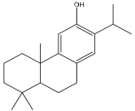
22 | Hinokione | 27.635 | 2.64 | C20H28O2 | 300 | 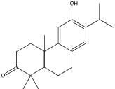
24 | Isocarnosol | 28.187 | 12.70 | C20H26O4 | 330 | 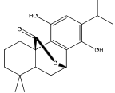
25 | Sakuranetin | 28.774 | 19.42 | C16H14O5 | 286 | 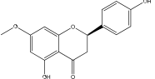
26 | Carnosol | 29.511 | 5.78 | C20H26O4 | 330 | 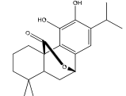
27 | p-Benzoquinone, 2,5-bis(1,1,3,3-  tetramethylbutyl)- | 29.814 | 1.10 | C22H36O2 | 332 | 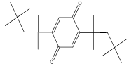
28 | Totarol | 30.038 | 1.07 | C20H30O | 286 | 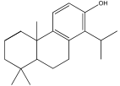
29 | Squalene | 33.987 | 2.86 | C30H50 | 410 | 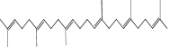
30 | α-tocopherol | 39.787 | 3.63 | C29H50O2 | 430 | 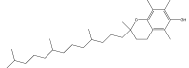
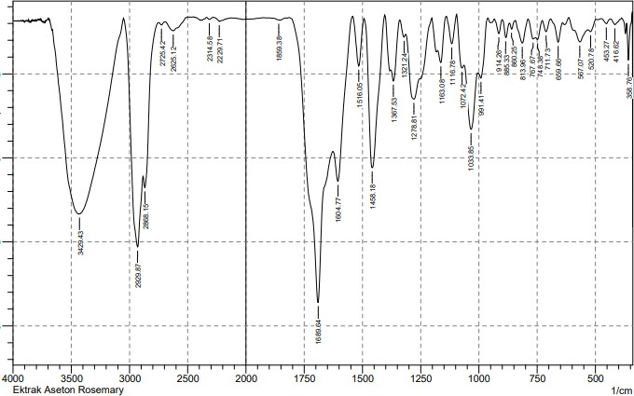FTIR analysis is very instrumental in identifying the functional groups of compounds contained in the extract, the way the reading of the functional groupsis based on the peak absorption of the generated wave numbers[15]. The functional groups contained in theacetone rosemary extract include N-H (3429cm⁻¹),C=Caromatik(1606cm⁻¹),C=O(1689 cm⁻¹), C=Colefin (1516 cm⁻¹), C-O (1033 cm⁻¹), CH3(1458 cm⁻¹), and CH2(1367 cm⁻¹).

Figure3.FTIRanalysisofRosmarinusofficinalis L.
AccordingtoMeyer, et al., (1982)toxicitytest is one of thepreliminarytests of anticancer activity, so this test is very necessary. Based on probit analysis of mortality, an LC₅₀value of 0.061 μg/mL was classified as very toxic. This result is due to sakuranetin which is the dominant compound of this extract reported to be very active in inhibiting HCT-116 cancer cells (Park, et al., 2013). Besides, it is positively correlated with studies reported by Bourhia, et al., (2019) where rosemary extracts showantiproliferative activity against prostate cancer cells (LNCaP) with IC₅₀ 14.14-15.04 μg/mL.Carnosol was identified as one of the major compounds present in the acetone extract of Rosemary. This compound is well recognized for its anticancer activity and has been reported to exhibit significant chemopreventive and cytotoxic properties. Generally, the natural abundance of carnosol in rosemary ranges from approximately 0.5–2% (Wasnik, et al., 2025); however, the acetone extract analyzed in this study demonstrated a considerably higher carnosol content of 5.78%, indicating the potential effectiveness of acetone as a solvent for enriching bioactive anticancer constituents from rosemary.
Table3. Result of Cytotoxicity Test Rosemary Using BSLT Method
 |  |  | Replica 1 |  | Replica 2 |  | Replica 3s
Sample | Consentration (µg/mL) | Log Cons | Life | Death | Life | Death | Life | Death | %Mortality | Probit | LC₅₀
 | 1000 | -1 | 0 | 10 | 0 | 10 | 0 | 10 | 97 | 6.88 | 0.061
Acetone Extract | 100 | 0 | 0 | 10 | 0 | 10 | 1 | 9 | 93 | 6,48 | 0.061
Acetone Extract | 10 | 1 | 0 | 10 | 0 | 10 | 1 | 9 | 93 | 6,48 | 0.061
Acetone Extract | 1 | 2 | 0 | 10 | 2 | 8 | 1 | 9 | 87 | 6,13 | 0.061
Acetone Extract | 0,1 | 3 | 7 | 3 | 6 | 4 | 6 | 4 | 33 | 4,56 | 0.061

4. Conclusion

Theresults of thetoxicitytest of Rosmarinus offincinalis L. (rosemary) acetoneextract wereclassified as very active with LC50values of 0.061 μg/mL, the compounds believed to play a role were flavonoids, terpenoids, and essential oils which were the dominant compounds.

References

Alwadkar, F., Salmani, A., Deshmukh, A., Farhat, P., Salmani, T. & Yerunkar, R. (2024). The Alchemy of Rosemary from Herb Garden to Apothecary: A. Comprehensive Pharmaceutical Review. International Journal OF Pharmaceutical Sciences, 2(2),3382-3394.
Banjaw, D. T., Megersa, H. G., Abewoy, D., Lema, D. T. (2024). Rosemary Recent Classification, Plant Characteristics, Economi Parts, Marketing, Uses, Chemical Composition and Cultivation. International Journal of Scientific Research and Engineering Development, 7(1), 157-165.
Boreddy, A., Bhuvaneshwari, J. & Srinivas, DR. U. (2025).Physico-Chemical Screening of Rosmarinus officinalis L. International Journal for Research Trend and Innovation, 10(10): 421-438.
Bourhia, M., Laasri, F. E., Aourik,H., Boukhris, A., Ullah, R., Bari, A., Ali, S. S., El-Mzibri, M., Benbacer, L. &Gmouh, S. (2019). Antioxidant and Antiproliferative Activities of Bioactive Compounds Contained in Rosmarinus officinalis Used in the Mediterranean Diet Evidence-Based Complementary and Alternative Medicine,2019:1–7
Clarkson, C., Maharaj, V. J., Crouch, N. R., Grace, O. M., Pillay, P., Matsabisa, M. G., Bhagwandin, N., Smith, P. J. &Folb, P. I. (2004). In vitro antiplasmodial activity of medicinal plants native to or naturalised in South Africa. Journal of Ethnopharmacology, 92,177–91.
Handa, S. S., Rakesh, D. D. & Vasisht, K. (2016). Compendium of Medicinal and Aromatic Plants Volume II. ICS-UNIDO.
Hashim, A., Fatima, F. & Malave, P. (2025). Therapeutic Potential of Rosemary: Bridging Traditional Uses and Modern Applications. Biotechnology Journal International, 29(4), 1-13.
Meyer, B., Ferrigni, N., Putnam, J., Jacobsen, L., Nichols, D. & McLaughlin, J. (1982). BrineShrimp: A Convenient General Bioassay for Active Plant Constituents. Planta Med, 45:31-4
Meziane, H., Zraibi, L., Albusayr, R., Bitari, A., Oussaid, A., Hammouti, B.&Touzani, R. (2025). Rosmarinus officinalis Linn: Unveiling its Multifaceted Nature in Nutrition, Diverse Applications, and Advanced Extraction Methods. Journal of Umm Al-Qura University for Applied Sciences. 11:9-37.
Park, J. H., Fu, Y. Y., Chung, I. S., Hahn, T. R. & Cho, M. H. (2013). Cytotoxic property of ultraviolet- induced rice phytoalexins to human colon carcinoma HCT-116 cells. J Korean Soc Appl Biol Chem,56: 237–41.
Singletary, K. (2016). Rosemary An Overview of Potential Health Benefits. Nutrition Today, 51(2),102-112.
Veenstra, J. P. & Johnson, J. J. Rosemary (Salvia rosmarinus): Health-Promoting Benefits and Food Preservative Properties. International Journal of Nutrition. 6(4):1-10.
Wasnik, A., Mayekar, C., Nangude, M., Yadav, S. & Thange, A. (2025). Unveilling The Therapeutic Potential of Rosmarinus officinalis (Rosemary)- A review on Pharmacological Spectrum. International Journal of Pharmaceutical Sciences, 3(1), 80-93.

