Review Article
Rising CO₂ and Hidden Hunger: Impacts of Climate Change on Micronutrient Density in Staple Crops.

ABSTRACT
Rising atmospheric carbon dioxide (CO₂) is increasingly recognized as a determinant of crop nutritional quality, with implications that extend beyond yield alone. This review brings together mechanistic, experimental, and epidemiological evidence to examine how elevated CO₂ alters the micronutrient composition of staple crops and what this means for population health. Drawing on plant physiology, field-based enrichment studies, controlled experiments, and dietary modeling, it outlines the pathways through which atmospheric change influences food quality. Elevated CO₂ enhances carbon assimilation and promotes the accumulation of carbohydrates, leading to a relative dilution of other nutrients. At the same time, reduced transpiration and changes in nitrogen metabolism constrain the uptake and incorporation of key nutrients, including iron, zinc, protein, and selected vitamins, particularly in major crops such as rice and wheat. Across different study designs, a consistent pattern emerges, with declines in nutrient density shaped by crop type, genotype, and environmental conditions. For populations that rely heavily on staple foods, these changes translate into lower dietary intake of essential micronutrients. Model-based projections suggest that continued increases in CO₂ could substantially increase the global burden of iron and zinc deficiencies by mid-century. Taken together, the evidence points to a widening gap between food quantity and food quality. Addressing this challenge will require coordinated approaches that link crop improvement, soil and agronomic management, dietary diversification, and nutrition-sensitive policy within broader climate and food system strategies.

Keywords:
Elevated CO₂; Nutrient dilution; Micronutrient density; Iron and zinc deficiency; C₃ crops; Crop composition; Climate–nutrition nexus; Food system vulnerability; Dietary modeling; Biofortification
- Introduction
Micronutrient deficiency, commonly termed hidden hunger, remains a major and underrecognized global health challenge, affecting more than two billion people and contributing to anemia, impaired immune function, adverse pregnancy outcomes, and deficits in cognitive development(Elegbeleye et al., 2025) . Unlike overt caloric insufficiency, hidden hunger persists despite adequate energy intake, reflecting a fundamental deficit in diet quality. The burden is concentrated in low- and middle-income countries, where diets rely heavily on a limited number of staple crops, including rice, wheat, and maize, that provide energy but insufficient micronutrient diversity(Yilmaz & Yilmaz, 2025)
Food security strategies have historically emphasized caloric availability and yield maximization. While these approaches have reduced extreme hunger, they have not addressed the quality of diets, leaving large populations vulnerable to micronutrient inadequacy. This persistent gap highlights the limitations of a calorie-centered framework, particularly in the context of accelerating environmental change (Costlow et al., 2025)
Rising atmospheric carbon dioxide (CO₂), a defining feature of contemporary climate change, is increasingly recognized as a determinant of crop nutritional composition in addition to yield. In C₃ crops, elevated CO₂ enhances photosynthetic carbon assimilation, often increasing carbohydrate accumulation and, in some cases, yield. However, these gains are consistently accompanied by reductions in essential nutrients, including iron, zinc, protein, and selected vitamins, through processes described as nutrient dilution. These shifts reflect underlying changes in plant physiology affecting mineral uptake, nitrogen metabolism, and internal nutrient allocation (Ainsworth et al., n.d.)
Accumulating evidence indicates that CO₂-induced changes in crop composition translate into measurable declines in dietary micronutrient intake. Populations dependent on staple-based diets are particularly vulnerable, especially where dietary diversity is limited and access to nutrient-dense foods is constrained(Ebi et al., 2021). In this context, elevated CO₂ functions as a systemic driver of micronutrient deficiency, directly linking environmental change to human nutritional outcomes.
Despite increasing recognition of these dynamics, the integration of crop nutritional quality into climate and food security frameworks remains limited. This gap constrains the effectiveness of existing policy responses in addressing the full scope of climate-related nutritional risks. This review synthesizes current evidence on the impact of rising CO₂ on micronutrient density in staple crops, integrating insights from plant physiology, experimental studies, and population-level modeling. By situating these findings within broader food and nutrition systems, it advances a reframing of climate change as a determinant of nutritional adequacy and supports the development of more comprehensive, nutrition-sensitive policy strategies.
2. Methodology
2.1 Review Design
This study employs a narrative review to integrate evidence across disciplines and characterize the effects of elevated atmospheric carbon dioxide on micronutrient density in staple crops. The approach is theory-informed and interpretive, enabling the synthesis of mechanistic, experimental, and population-level evidence within a unified analytical framework.
2.2 Data Sources
The review draws on peer-reviewed literature, with emphasis on studies published within the past five years across plant physiology, agronomy, nutrition science, and climate–health research. Selection prioritized methodologically robust studies that reflect current advances and consensus in the field.
2.3 Evidence Base
Three categories of evidence were included. Free-Air CO₂ Enrichment experiments provide field-based observations under realistic environmental conditions. Controlled environment studies offer mechanistic insight into plant physiological responses. Meta-analyses and modeling studies contribute aggregated evidence and projections of population-level nutritional impacts.
2.4 Search Strategy
A structured literature search was conducted across major scientific databases using predefined combinations of keywords related to elevated CO₂, crop nutrient composition, micronutrient deficiency, and food systems. The strategy was designed to capture both foundational research and recent developments at the intersection of climate change and nutrition.
2.5 Inclusion Criteria
Studies were included based on direct relevance to the effects of elevated CO₂ on crop nutritional quality and associated human health implications. Priority was given to studies with rigorous methodological design, clearly defined nutrient outcomes, and a focus on staple crops central to global diets.
2.6 Analytical Approach
A thematic synthesis was used to organize and interpret the evidence. The analysis focused on three domains: mechanistic pathways linking CO₂ exposure to changes in nutrient composition, consistency and variability across studies and environmental contexts, and implications for population health and policy.
2.7 Rationale
A narrative synthesis was selected to enable integration across heterogeneous evidence types and disciplinary perspectives. This approach supports systematic interpretation of causal pathways and facilitates translation of findings into policy-relevant insights, consistent with standards for interdisciplinary research.

3. Conceptual Framework: Linking Atmospheric CO₂ to Human Nutrition
The relationship between rising atmospheric carbon dioxide (CO₂) and human nutrition is best conceptualized within a multi-scale systems framework that links environmental change to population health outcomes. Elevated CO₂ initiates a sequence of processes that originate in plant physiology and extend through food systems to shape nutritional status, reinforcing the broader divergence between caloric sufficiency and nutritional adequacy.
At the plant level, elevated CO₂ enhances photosynthetic carbon assimilation in C₃ crops, leading to increased carbohydrate accumulation. This response is accompanied by reduced transpiration and perturbed nitrogen metabolism, which constrain the uptake and allocation of essential micronutrients, including iron and zinc, and limit protein synthesis. These processes collectively alter crop nutritional composition (Ekele et al., 2025).
These physiological changes translate into consistent compositional shifts in staple crops. Crops cultivated under elevated CO₂ conditions exhibit measurable declines in key nutrients, a phenomenon widely described as nutrient dilution. Evidence from experimental and meta-analytic studies demonstrates reductions in iron, zinc, and protein across major staples such as rice and wheat, with variability in magnitude driven by crop type, genotype, and environmental context (Ziska, 2022)
At the dietary level, these compositional changes have direct implications for nutrient intake. In many low- and middle-income settings, staple crops constitute a primary source of daily energy. Declines in nutrient density therefore reduce overall dietary quality, particularly where access to diverse and nutrient-dense foods remains limited (Kidane et al., 2025).
These dietary shifts translate into measurable health consequences. Reduced intake of essential micronutrients increases the risk of iron deficiency anemia, impairs immune function associated with zinc deficiency, and contributes to broader forms of malnutrition. Model-based projections indicate that these effects may substantially increase the burden of micronutrient deficiencies in vulnerable populations over coming decades (Tam et al., 2020).
Within this framework, elevated atmospheric CO₂ functions as a systemic determinant of nutritional status. Its effects are indirect yet far-reaching, operating through interconnected biological and socioeconomic pathways that link climate change to human health outcomes. This conceptualization underscores the need to integrate nutritional quality into climate and food system assessments, to capture the full spectrum of risk associated with rising CO₂.

Figure 1.(A,B,C,D,E) Multi-Scale Pathway from Elevated CO₂ to Hidden Hunger
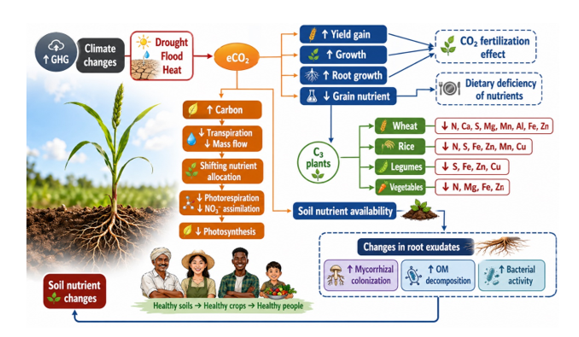
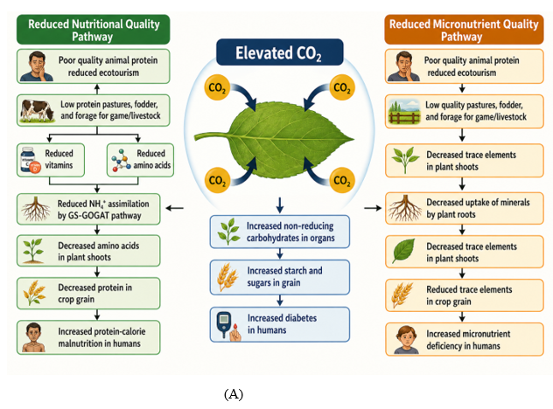
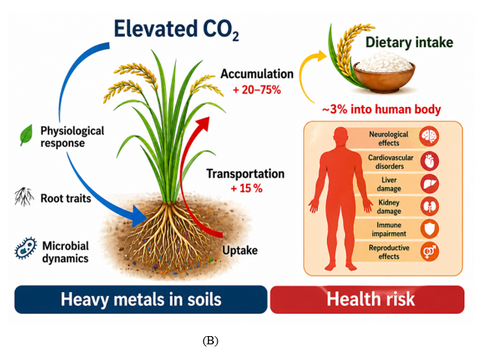
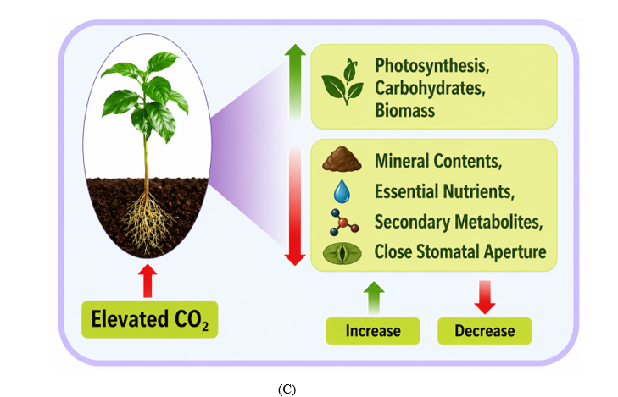

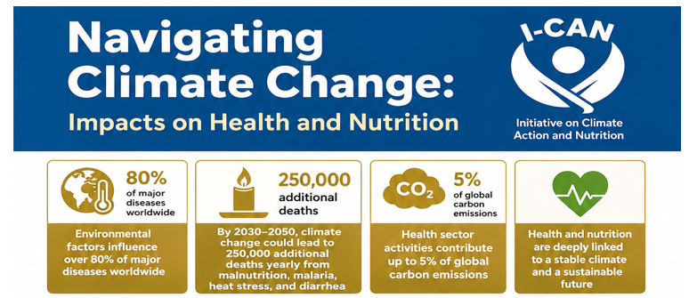
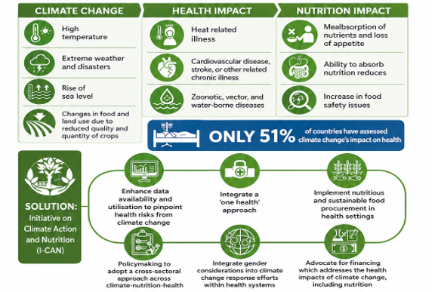
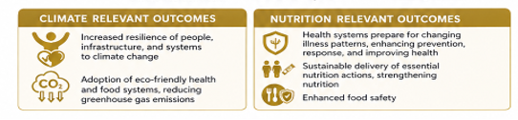
(D)
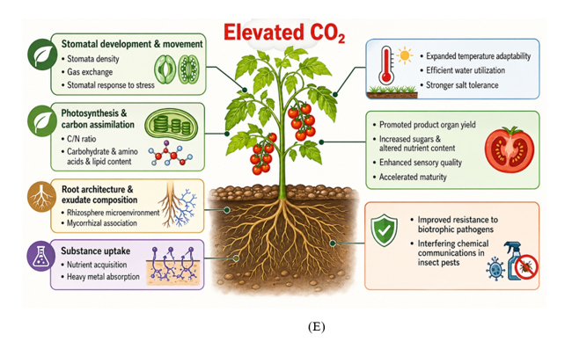
Conceptual Framework: From Atmospheric CO₂ to Nutritional Risk
Rising atmospheric CO₂ initiates a cascade of plant physiological responses, including changes in photosynthetic activity, stomatal conductance, and nitrogen assimilation, which collectively alter crop composition. These responses are consistently associated with reductions in the concentration of essential micronutrients in staple crops. As a result, populations dependent on these foods experience diminished dietary micronutrient intake, increasing the risk of deficiency.
At the population level, these shifts contribute to adverse health outcomes, particularly in settings where dietary diversity is limited. This framework integrates plant physiological processes with downstream nutritional and epidemiological consequences, providing a structured pathway linking atmospheric change to human health risk (Lee et al., 2022)
4. Atmospheric CO₂ Trends and Agricultural Exposure
Atmospheric carbon dioxide concentrations have risen from approximately 280 ppm in the pre-industrial era to levels exceeding 420 ppm today, with further increases expected under most emissions trajectories (Carbon Dioxide Now More than 50% Higher than Pre-Industrial Levels | National Oceanic and Atmospheric Administration, 2022). Projections indicate that concentrations approaching 550 ppm by mid-century are plausible, a range already associated with measurable changes in crop composition in both experimental and field settings(Smith et al., 2018). While these trends are often considered in terms of temperature effects and crop yields, the direct influence of CO₂ on plant physiology introduces a less apparent, but equally important, dimension of food system vulnerability.
The consequences of these changes are not evenly distributed. Regions with a high burden of micronutrient deficiency frequently coincide with those where diets depend heavily on a narrow range of staple crops. In much of Sub-Saharan Africa, cereals and tubers constitute the primary dietary base, with limited access to more diverse or nutrient-rich foods. Under such conditions, even modest reductions in the micronutrient content of staple crops can have meaningful implications for nutritional status at the population level (Africa Regional Overview of Food Security and Nutrition 2020, 2021)
Agricultural context further shapes the degree of exposure. In many low-income settings, production systems are predominantly smallholder and rainfed, operating under constraints related to soil fertility, input availability, and climate variability. These factors can intensify the nutritional consequences of CO₂-induced changes in crop composition. Although more intensive systems may mitigate some effects through fertilization and improved management, available evidence suggests that declines in nutrient density are not fully offset across production environments(Bhardwaj et al., 2024)
It is also important to consider that elevated CO₂ does not act in isolation. Its effects interact with other environmental stressors, including rising temperatures, water limitations, and atmospheric pollutants, leading to variability in crop responses across regions and species (Rezaei et al., 2023). Taken together, these dynamics highlight rising atmospheric CO₂ as a global driver of nutritional risk, with impacts that are shaped by local agricultural and dietary contexts.
5. Mechanistic Basis of Nutrient Dilution
Declines in micronutrient density under elevated atmospheric CO₂ reflect coordinated shifts in plant physiology rather than a single dilution process. Alterations in carbon assimilation, mineral acquisition, and nitrogen metabolism act in concert, and their effects are further shaped by concurrent environmental stressors. Together, these processes define the pathway through which atmospheric change modifies the nutritional quality of crops.
5.1 Carbon Assimilation and the Dilution Effect
Elevated CO₂ stimulates photosynthetic carbon fixation in C₃ species, leading to increased accumulation of carbohydrates, including starch and soluble sugars. Although this response can enhance biomass production, it disrupts the balance between carbon-rich compounds and other essential nutrients. Carbon is incorporated at a faster rate than minerals and proteins, resulting in a relative decline in micronutrient concentration, commonly described as the dilution effect(Kidane et al., 2025) Changes in source–sink relationships reinforce this pattern, with greater allocation toward storage compounds at the expense of nutrient-dense fractions. Consequently, edible plant tissues may provide more energy per unit mass but reduced micronutrient content, a trend consistently observed in staple crops such as rice and wheat (Bhardwaj et al., 2024)
5.2 Mineral Uptake and Transport Constraints
Elevated CO₂ also influences the uptake and internal transport of mineral nutrients. Reduced stomatal conductance lowers transpiration rates, thereby diminishing the mass flow of nutrients such as iron and zinc from the soil to the root surface. This constrains both uptake and subsequent translocation to edible tissues (Ekele et al., 2025). The extent of this limitation depends on soil fertility and management practices. In nutrient-poor systems, limited capacity for compensation amplifies declines in tissue micronutrient levels. Interactions among root physiology, soil chemistry, and microbial activity further contribute to variability across environments(M. Han et al., 2025)
5.3 Nitrogen Metabolism and Protein Decline
Nitrogen assimilation is particularly sensitive to elevated CO₂. Increased concentration is associated with reduced activity of key enzymes involved in nitrate assimilation, limiting the incorporation of nitrogen into amino acids and proteins. This leads to consistent reductions in protein content across major crops (Taub et al., 2008). At the same time, shifts in carbon–nitrogen balance favor carbohydrate accumulation, reinforcing the decline in protein concentration. These changes may also affect amino acid profiles, with implications for dietary protein quality in populations that depend heavily on plant-based sources (Dakora et al., 2025a).
5.4 Interaction with Climate Co-stressors
The effects of elevated CO₂ are modified by interactions with other environmental stressors, including temperature, water availability, and ozone exposure. These interactions are context-dependent and can produce non-linear responses. Elevated temperatures may accelerate phenological development, reducing the duration available for nutrient accumulation. Water limitation restricts nutrient uptake through reduced soil moisture, while ozone exposure impairs photosynthetic function and increases oxidative stress. The combined influence of these factors contributes to variability in crop responses across species, genotypes, and agroecological settings(Bhatia et al., 2021)
Taken together, these processes indicate that nutrient dilution under elevated CO₂ arises from interconnected physiological adjustments rather than a single mechanism. Understanding these interactions is essential for linking atmospheric change to shifts in crop composition and for informing strategies to preserve nutritional quality under evolving climatic conditions.
6. Empirical Evidence: Experimental and Meta-Analytic Synthesis
A substantial body of evidence indicates that elevated atmospheric CO₂ is associated with measurable declines in the nutritional quality of staple crops. Results from field experiments, controlled studies, and meta-analyses converge on a consistent pattern of reduced micronutrient and protein concentrations. While the magnitude of these effects varies with species, genotype, and environmental context, the direction of change is broadly uniform.
6.1 Free-Air CO₂ Enrichment Studies
Free-Air CO₂ Enrichment (FACE) experiments offer the most ecologically relevant assessment of crop responses under elevated CO₂, as they are conducted under open-field conditions that retain natural interactions with soil, climate, and biotic factors. Across multiple sites, these studies report consistent reductions in iron, zinc, and protein concentrations in major C₃ crops, including rice and wheat(Hu et al., 2024). Although yield responses differ across environments, the decline in nutrient density is consistently observed, indicating a generalized physiological response rather than a location-specific phenomenon.
6.2 Controlled Environment Studies
Experiments conducted under controlled conditions provide mechanistic insight by isolating the direct effects of elevated CO₂ on plant processes. These studies demonstrate that increased CO₂ alters carbon–nutrient balance, leading to reduced mineral accumulation and constrained nitrogen assimilation. The resulting decreases in micronutrient and protein content mirror patterns observed in field settings(Ofiti et al., 2023). While such systems do not capture the full complexity of agricultural environments, they establish a causal link between CO₂ exposure and changes in crop composition.
6.3 Meta-Analytic Evidence
Syntheses of data across experimental platforms further substantiate these findings. Meta-analyses report reductions in iron, zinc, and protein concentrations typically ranging from 3% to 13% under elevated CO₂, with more pronounced effects in C₃ crops compared with C₄ species(Myers et al., 2014) Observed variability reflects differences in crop genotype, soil nutrient availability, and production systems. Declines tend to be greater in nutrient-limited soils and low-input systems, while genetic variation among cultivars contributes to differential sensitivity. These analyses also identify areas of limited evidence, particularly with respect to vitamin content and underrepresented crop species, indicating priorities for further investigation.
Table 1. Changes in Micronutrient and Protein Concentrations in Staple Crops Under Elevated CO₂
Crop | CO₂ (ppm) | Iron (%) |  | Zinc (%) |  | Protein (%) | Vitamin Changes | Study Type | Region
Rice | 550–600 | ↓ 5–10 |  | ↓ 3–8 |  | ↓ 7–10 | ↓ Folate, B1 | FACE | Asia
Wheat | 550–600 | ↓ 5–9 |  | ↓ 4–7 |  | ↓ 6–13 | ↓ B vitamins | FACE | Global
Maize | 550–600 | Minimal |  | Minimal |  | ↓ slight | Limited data | Mixed | Africa/US
Soybean | 550–600 | ↓ 4–6 |  | ↓ 3–5 |  | ↓ 2–5 | Variable | FACE | US/Brazil

Taken together, the available evidence supports a consistent association between elevated atmospheric CO₂ and reductions in crop nutrient density. The convergence of findings from field-based experiments, controlled studies, and meta-analyses strengthens confidence that these changes reflect underlying physiological responses rather than context-specific anomalies. This coherence across methodological approaches underscores the relevance of CO₂-driven compositional shifts for global nutritional outcomes.
7. Crop-Specific and Regional Heterogeneity
The nutritional consequences of elevated atmospheric CO₂ are not uniform across crops or regions. Variation arises from differences in photosynthetic physiology, soil nutrient status, and patterns of dietary reliance, and these factors jointly determine where compositional changes are most likely to translate into population-level risk.
7.1 Differential Responses of C₃ and C₄ Crops
Plant physiological pathways play a central role in shaping response patterns. C₃ crops, including rice and wheat, exhibit pronounced sensitivity to elevated CO₂, as current atmospheric concentrations constrain their photosynthetic efficiency. Increased CO₂ availability enhances carbon assimilation, leading to greater carbohydrate accumulation and a corresponding dilution of mineral and protein fractions. Reductions in iron, zinc, and protein have therefore been reported consistently across major C₃ staples(Leavitt et al., 2022). C₄ crops, such as maize and sorghum, respond differently. Their intrinsic carbon-concentrating mechanism reduces responsiveness to rising CO₂, resulting in smaller and less consistent changes in nutrient composition. Although modest declines in protein have been documented, micronutrient responses are generally less pronounced(Khan et al., 2025). This contrast highlights the role of photosynthetic strategy in determining nutritional outcomes under changing atmospheric conditions.
7.2 Influence of Soil Micronutrient Availability
Soil nutrient status substantially modifies plant responses to elevated CO₂. Where micronutrients such as iron and zinc are abundant, partial compensation may occur through continued uptake. In many regions, however, soil is already nutrient-depleted, limiting this capacity. Under such conditions, CO₂-related constraints on nutrient acquisition can intensify declines in tissue micronutrient concentrations(Wang et al., 2025) . The extent of these effects is further shaped by interactions among root architecture, soil chemistry, and microbial processes. These factors contribute to variability across agroecological systems and underscore the importance of soil health in sustaining crop nutritional quality.
7.3 Regional Patterns of Dependency and Vulnerability
The public health implications of CO₂-driven changes depend on regional dietary structure. In Sub-Saharan Africa, food systems rely heavily on staples such as maize and cassava, often produced under low-input conditions. Limited dietary diversity increases sensitivity to reductions in nutrient density, particularly where access to fortified or nutrient-rich foods is constrained(Kidane et al., 2025)
In South Asia, rice and wheat dominate dietary intake and provide a substantial share of daily energy. Given the sensitivity of these C₃ crops to elevated CO₂, populations in this region are especially vulnerable to reductions in iron and zinc intake(Myers et al., 2015). These patterns reflect the convergence of biological susceptibility and structural constraints within food systems.
7.4 Potential of Indigenous and Underutilized Crops
Indigenous and underutilized crops present an opportunity to enhance nutritional resilience. Many possess higher intrinsic micronutrient content and are well adapted to local environmental conditions, including marginal soils and climatic stress. Incorporating these species into production systems and diets can improve diversity and reduce reliance on a limited number of staples.
Evidence regarding their response to elevated CO₂ remains limited, yet their nutritional attributes and ecological adaptability indicate potential value in mitigating nutrient dilution. Expanding research and targeted investment in these crops will be important for developing context-specific strategies that align agricultural adaptation with nutritional objectives.
Overall, the effects of elevated CO₂ on crop nutrition reflect the interaction of physiological, environmental, and socioeconomic factors. Recognizing this heterogeneity is essential for designing interventions that are responsive to both global trends and regional conditions.

8. Translating Crop Composition to Human Nutrition
The relevance of CO₂-induced changes in crop composition becomes evident when these shifts are considered in relation to dietary patterns and health outcomes. Small reductions in nutrient density at the crop level can translate into substantial deficits at the population level, particularly in settings where diets are dominated by staple foods.
8.1 Dietary Exposure
In many low- and middle-income regions, a limited number of staple crops provide the majority of daily energy intake. Where dietary diversity is constrained, changes in the nutrient content of crops such as rice, wheat, and maize have a direct impact on total nutrient intake. Limited access to animal-source foods or fortified products further restricts the capacity to offset these changes (Chiaka et al., 2022). As a result, compositional shifts in staple crops are effectively transmitted through the food system, shaping population-level exposure.
8.2 Modeled Nutrient Intake Changes
Dietary modeling studies consistently project reductions in iron, zinc, and protein intake under elevated CO₂ scenarios. Although the magnitude of these changes varies by dietary structure and regional context, the overall direction remains consistent. Even modest percentage declines in nutrient density can produce substantial absolute reductions in intake when applied across populations with high reliance on staple crops(Smith et al., n.d.). These projected impacts are most pronounced in South Asia and Sub-Saharan Africa, where both exposure and underlying vulnerability are elevated.
8.3 Health Outcomes
Reduced intake of essential nutrients has well-established consequences for human health. Declining iron intake increases the prevalence of iron deficiency anemia, with implications for maternal health, cognitive development, and productivity. Inadequate zinc intake impairs immune function and heightens susceptibility to infectious disease, particularly among children. Reductions in dietary protein contribute to protein-energy malnutrition, affecting growth and physiological resilience(Soni et al., 2025).
These effects are not evenly distributed. Children, pregnant women, and economically disadvantaged populations bear a disproportionate burden, as existing nutritional vulnerabilities are compounded by declines in food quality.
Taken together, the pathway from crop composition to health outcomes is direct and consequential. Changes in plant physiology driven by elevated CO₂ propagate through dietary systems to influence disease risk, highlighting the need for coordinated responses across agriculture, nutrition, and climate policy.

9. Population-Level Burden and Future Projections
Current projections indicate that elevated atmospheric CO₂ will contribute to a measurable increase in global nutritional risk by mid-century. Models that integrate changes in crop composition with prevailing dietary patterns suggest that hundreds of millions of additional individuals may experience inadequate iron and zinc intake by 2050 under plausible emissions scenarios(Beach et al., 2019). These estimates arise not from large shifts in crop composition alone, but from the cumulative effect of modest nutrient declines across populations that rely heavily on staple foods.
The distribution of this burden is uneven. Sub-Saharan Africa and South Asia are projected to experience the greatest increases in risk, reflecting the intersection of high dependence on C₃ staples, limited dietary diversity, and a pre-existing burden of micronutrient deficiency. In such contexts, relatively small reductions in nutrient density can scale into substantial population-level deficits(X. Han et al., 2022). Southeast Asia and parts of Latin America are also expected to be affected, although outcomes vary according to dietary composition and agricultural systems.
Socioeconomic conditions play a critical role in shaping exposure and resilience. Poverty, restricted access to nutrient-rich foods, and limited coverage of fortification or supplementation programs constrain the capacity to offset dietary shortfalls. Where health systems lack capacity, the consequences of micronutrient deficiency are more likely to persist and intensify. In this sense, elevated CO₂ functions as a risk multiplier, reinforcing existing structural inequalities.
An important implication is the growing disconnect between food quantity and food quality. Increases in crop yield under elevated CO₂ do not necessarily translate into improved nutritional adequacy. Without deliberate intervention, gains in caloric supply may coincide with declining micronutrient intake, with implications for growth, immune function, productivity, and long-term human development.

Table 2. Projected Population at Risk of Micronutrient Deficiency Under Elevated CO₂
Region | Additional Population at Risk (Millions) | Primary Deficiency | Staple Dependency | Vulnerability Level
Sub-Saharan Africa | ≥100 | Iron, Zinc | Maize, Cassava | Very High
South Asia | ≥150 | Iron, Protein | Rice, Wheat | Very High
Southeast Asia | Moderate | Zinc | Rice | High
Latin America | Moderate | Protein | Maize | Moderate

These projections define the scale and distribution of risk and point to the need for nutrition-sensitive climate policy that addresses both environmental change and structural determinants of vulnerability.
10. Policy Translation: From Evidence to Action
Addressing declines in crop nutrient density associated with elevated atmospheric CO₂ requires coordinated action across agriculture, food systems, and public health. The current evidence base supports the integration of nutrition-sensitive approaches into climate and agricultural policy, with emphasis on both mitigation of nutrient losses and protection of population health.
10.1 Agricultural Innovation
Crop improvement is central to this response. Biofortification, aimed at increasing intrinsic concentrations of iron, zinc, and protein in staple crops, offers a direct means of counteracting nutrient dilution. Advances in genomic selection and gene-editing technologies expand the capacity to develop cultivars that maintain nutritional quality under elevated CO₂ conditions(Azeem et al., 2025). Incorporating nutritional traits into breeding priorities is essential to ensure that gains in productivity are not achieved at the expense of dietary quality.
10.2 Agronomic Strategies
Field-level interventions can moderate nutrient losses. Targeted management of soil micronutrients, particularly iron and zinc, improves plant uptake in depleted systems. Practices that enhance soil structure and biological activity, including the use of organic amendments and diversified cropping systems, support nutrient availability and system resilience. Approaches that optimize water use and reduce environmental stress further contribute to maintaining crop nutritional quality under changing conditions(Kundu & Biswas, 2025)
10.3 Food System Interventions
Reducing reliance on a narrow range of staples requires structural adjustments within food systems. Greater dietary diversity, with increased inclusion of legumes, fruits, vegetables, and animal-source foods where feasible, strengthens nutrient intake and reduces vulnerability to compositional changes in staple crops. Improving food access and reinforcing local value chains are critical for enabling such shifts, particularly in resource-constrained settings(Kidane & Urugo, 2024)
10.4 Public Health Strategies
Public health interventions remain essential for addressing existing and emerging deficiencies. Large-scale fortification programs provide an efficient mechanism for delivering key micronutrients, while targeted supplementation supports high-risk groups, including children and pregnant women. Coordinating these measures with agricultural and climate strategies enhances their effectiveness and sustainability over time(Espinosa-Salas & Gonzalez-Arias, 2026)

Figure 2. Integrated Climate–Nutrition Response Framework
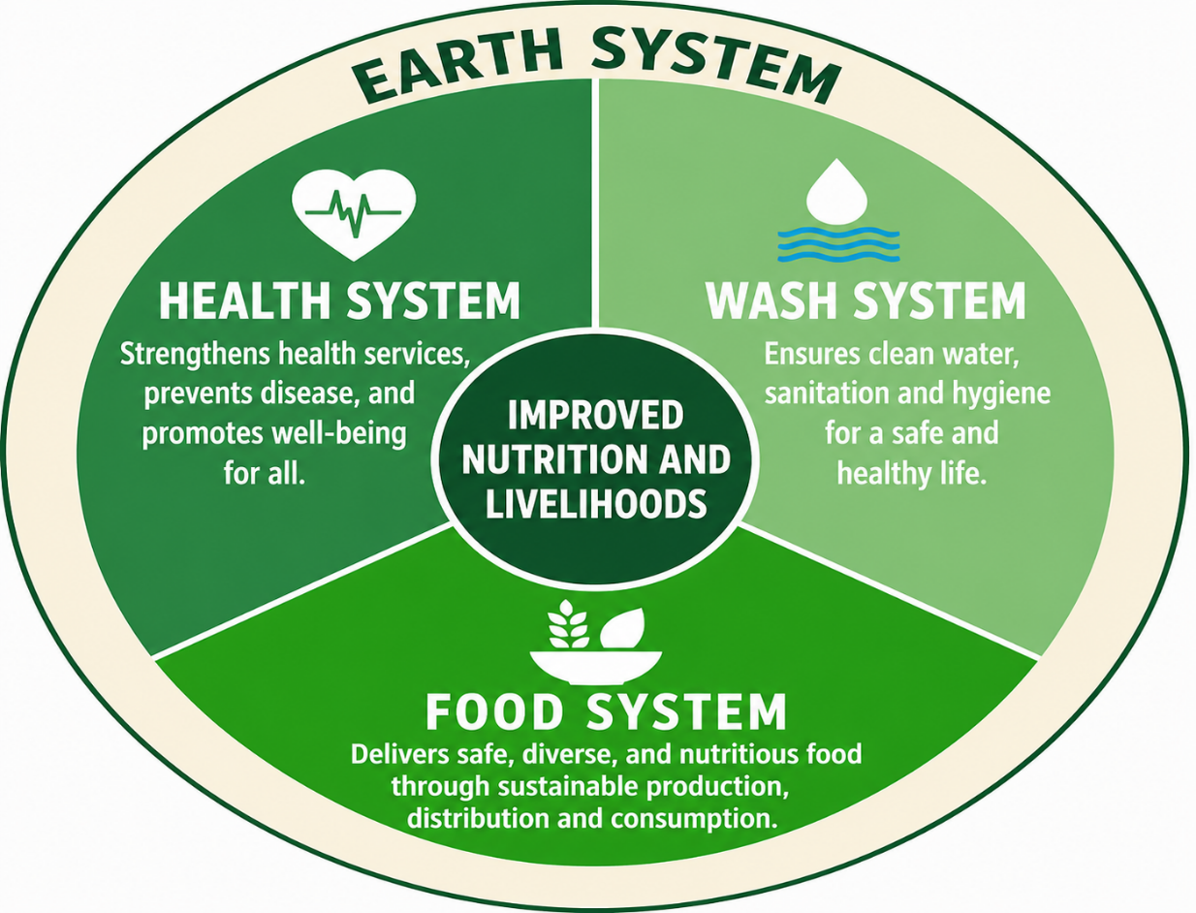

Fig 3: External Drivers impacting Food Systems
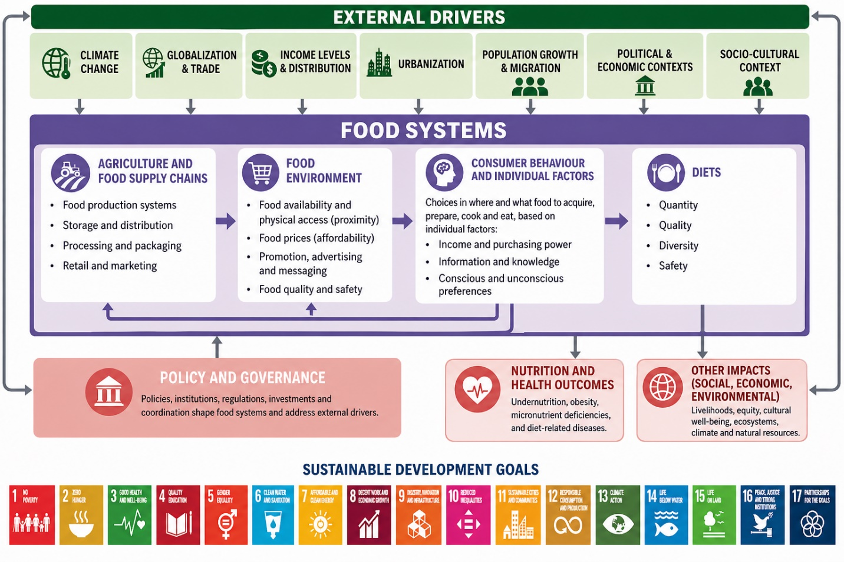
Fig 4: Integration of Climate-Smart Agriculture
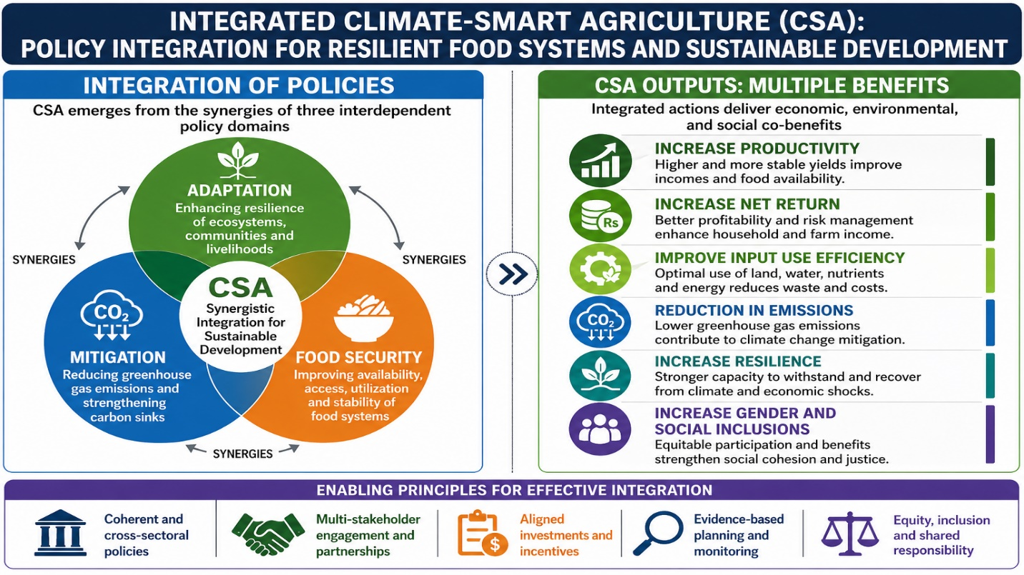
Fig 5: Intervention of Climate-Smart Agriculture in different fields

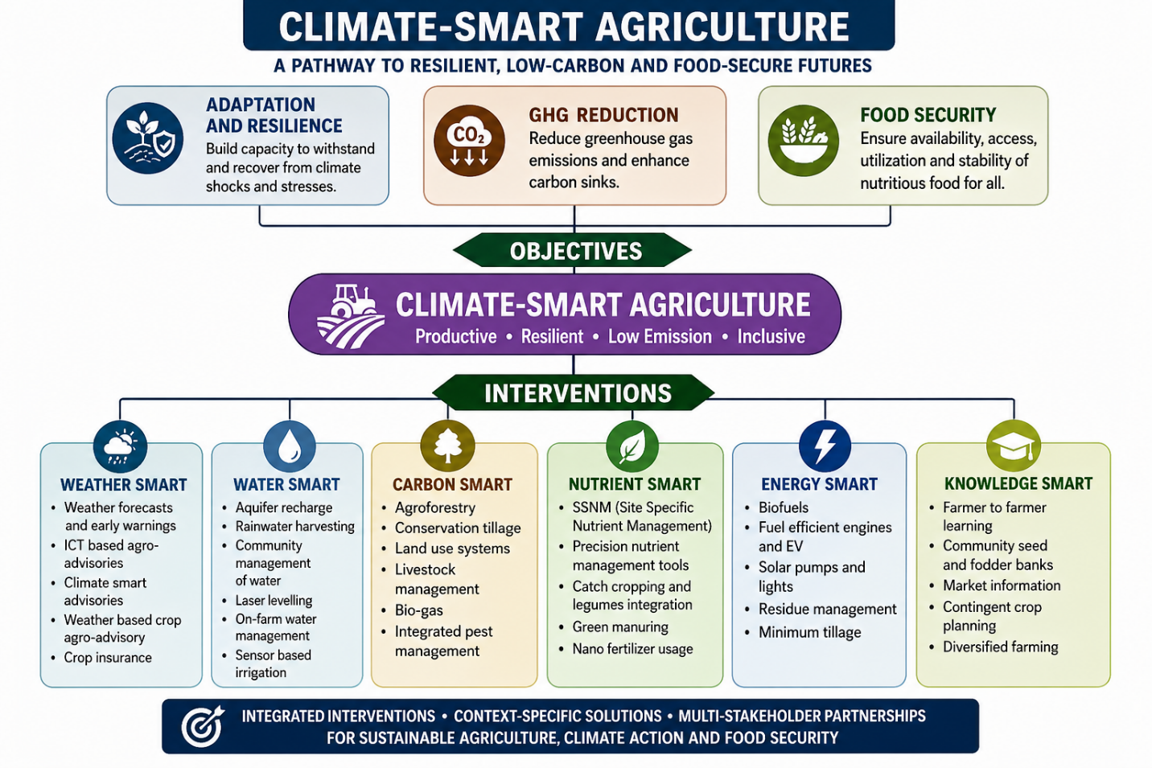
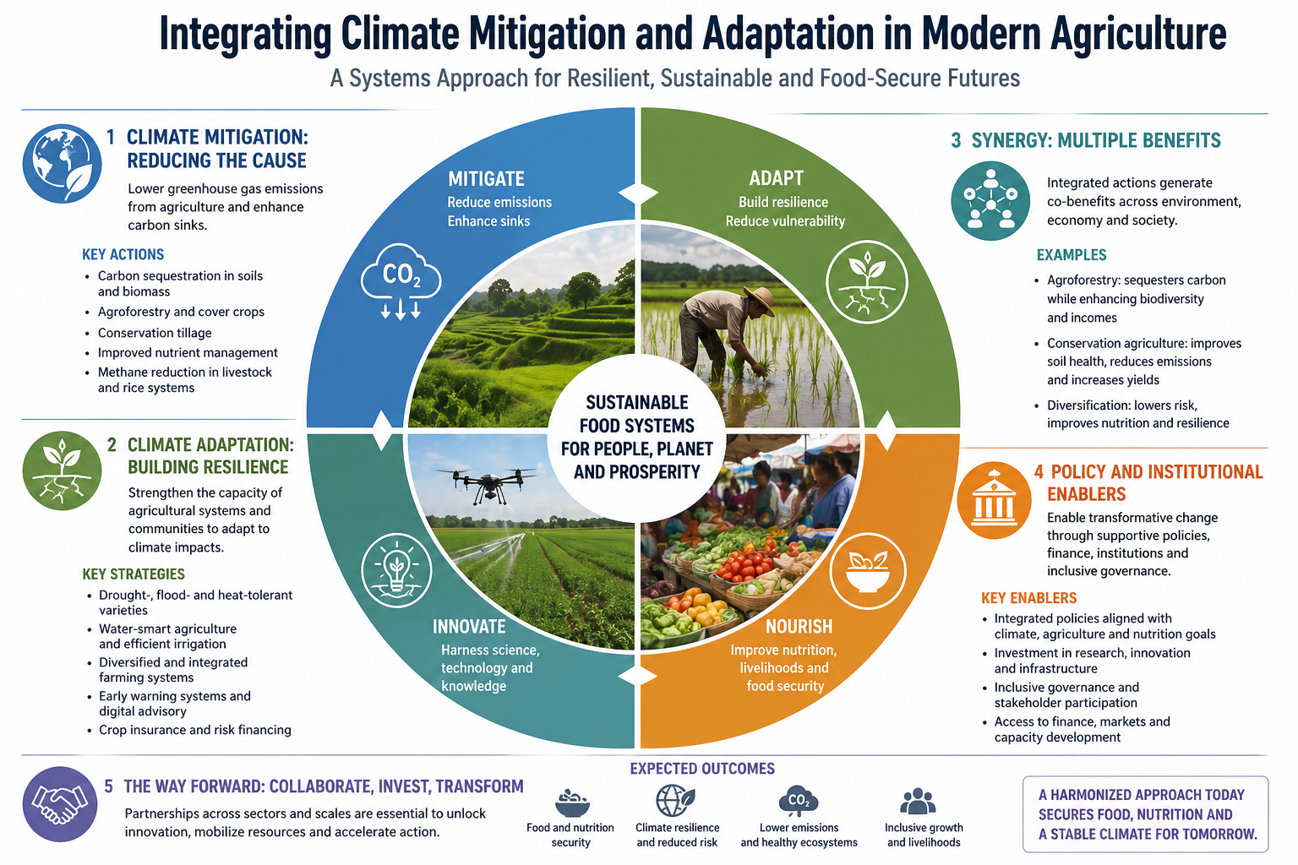
Fig 6: Climate Mitigation Adaptation in Modern Agriculture

Integrated Framework for Response
Climate mitigation, agricultural innovation, targeted nutrition interventions, and coherent policy integration constitute the core components of an effective response to CO₂-driven changes in crop quality. No single measure is sufficient in isolation. Preserving nutritional adequacy under rising atmospheric CO₂ requires coordinated action across climate policy, agricultural systems, and public health. Such alignment is essential to ensure that food systems sustain not only caloric supply but also the nutrient composition necessary for population health.
11. Governance and Policy Alignment
Addressing declines in crop nutritional quality associated with elevated atmospheric CO₂ requires governance frameworks that integrate climate, agriculture, and nutrition within a unified policy structure. The challenge extends beyond technical solutions to institutional coordination. In the absence of alignment across sectors, advances in productivity or climate resilience may not translate into improved nutritional outcomes.
11.1 Integrating Nutrition into Climate and Agricultural Policy
Nutrition should be treated as a core objective within climate and agricultural strategies. This entails incorporating nutrient density into crop breeding priorities, agricultural investment decisions, and adaptation planning. Policies that prioritize yield alone risk reinforcing the divergence between caloric availability and nutritional adequacy. A nutrition-sensitive approach to agriculture aligns production goals with health outcomes and supports resilience without compromising dietary quality(Di Prima et al., 2022).
11.2 Alignment with Global Development Agendas
Coherence is strengthened when national policies are aligned with broader development frameworks. The Sustainable Development Goals provide an integrated platform linking food security, health, climate action, and equity. Efforts to address CO₂-related declines in nutrient density contribute directly to targets on hunger reduction, improved health, and climate resilience. Alignment with these agendas enhances coordination, strengthens accountability, and facilitates access to international financing and technical support(Dakora et al., 2025).
11.3 Institutional Roles and Financing Mechanisms
Effective implementation depends on coordinated action across institutions. Ministries responsible for agriculture, health, environment, and finance must operate within shared planning frameworks that support joint prioritization and resource allocation. Research and extension systems play a critical role in translating evidence into practice, while private sector actors influence input supply, processing, and market access.
Financing structures should reflect this integrated approach. Climate finance, nutrition-sensitive agricultural investments, and blended funding mechanisms can support interventions that generate benefits across sectors. Strategic investment in soil health, crop improvement, and food system diversification remains central to sustaining nutrient quality under rising(Havemann et al., 2020). Ultimately, governance determines whether scientific evidence informs practice. Aligning policy, institutions, and financing around nutrition-sensitive climate action is essential to safeguard food quality and support population health under changing atmospheric conditions.
12. Knowledge gaps, research priorities
Although significant advances have been made in understanding the link between increased atmospheric CO₂ and crop nutritional quality, there are still important uncertainties at mechanistic, empirical, and translational levels. The educational, scientific, and policy dimensions of these gaps are hardly academic; they limit the precision of risk projections, and hinder designing targeted interventions as well as the inclusion of nutritional quality in climate and agricultural policy. Therefore, a systematic approach to addressing these is crucial to making current evidence actionable for public health and food systems responses.
12.2 Training and capacity building for CLTS+ implementation and monitoring
Public health importance and the availability of standard laboratory testing procedures have led the literature to focus mainly on iron, zinc and protein. This has been at the expense of a wider appreciation for CO₂-induced compositional modification, however. Initial results indicate that some B vitamins, such as folate and thiamine, might be reduced under high CO₂, but there is limited and inconsistent data available and it is mostly limited to only a few crop species (Brown et al., 2025). Impacts of such deficiencies do not only apply to the single micronutrient, but the B vitamins also have important roles in energy metabolism, neurological function, and erythropoiesis, which means that they have an impact on metabolic interactions as well. The effects of iron and zinc deficiency are worsened by deficiencies in these nutrients, leading to compounded nutritional risk, which is not well represented in existing models.
In addition to vitamins, the impacts of high CO₂ on calcium, magnesium, selenium, and iodine are not well understood, as these elements are important for bone function, immune function, thyroid regulation, and antioxidant defense, respectively. Future experimental and field research must take a more comprehensive view of the micronutrient makeup of food to create a full picture of how atmospheric change is altering the nutritional makeup of food. With this augmented evidence base, CO₂-related nutritional change projections will not be as large as they truly should be, and interventions will be more narrowly focused on a subset of deficiencies.
12.2 Extending Crop and Regional Coverage
The current evidence base is largely dominated by a small number of C₃ crops, mainly rice and wheat, which are produced under high-input or temperate conditions, and traded globally. These crops are a major part of food security but are not representative of the total diversity of agricultural systems or food consumption patterns, especially in the most vulnerable areas, where CO₂-induced malnutrition is a growing issue. Most staple food crops of Sub-Saharan Africa and South Asia, such as sorghum, millet, cassava, cowpea and various traditional legumes, have been relatively neglected in the experimental literature (Ndlovu et al., 2024). It is not just a scientific gap, but a structural inequity in the evidence base that hampers the meaningfulness of existing evidence for populations most affected by micronutrient deficiencies.
Furthermore, the generalizability of the results obtained in well-resourced experimental contexts is further constrained by regional differences in soil fertility, climate conditions and agronomic practice. The findings from FACE experiments in temperate, high input systems may not be readily applicable to smallholder rainfed systems where nutrient availability is likely to be highest under CO₂ increases. More research is needed, therefore, with experimental designs that reflect agroecological diversity in vulnerable areas and the use of local cultivars, representative soil conditions and production systems relevant to smallholder agriculture. The evidence base can only provide the context-specific insights needed to support equitable and effective policy responses if it is diversified both in terms of the coverage of different crops and in terms of different regional representation.
12.3 Advancing Methodological Integration
Advancements in the extent and impacts of CO₂-driven nutritional change will require an increase in the number of studies, but also the depth of the methodology and the integration of multiple disciplines. The following three areas are worthy of special note.
Longitudinal Human Studies
There is little empirical evidence about the status of population health impacts, and it is largely dependent on model-based projections. Dietary modelling can give estimates of expected changes in intake under various CO₂ scenarios but does not account for the complexity of dietary adaptation, compensatory behaviours or cumulative effects of long-term exposure to declining nutrient density. To enhance causal inference and to anchor projections on observed human experience, the design of studies examining the effect of evolving food environments on diet, nutritional indicators and health outcomes should include prospective follow-up (longitudinal) tracking of these measures (Shim et al., 2014). These would also shed light on the importance of dietary diversity, socioeconomic factors and food system access in dampening or exacerbating the impact of compositional change in staple crops, which are poorly captured by aggregate models.
Integrated Crop–Nutrition–Health Models
One of the most important methodological limitations is the lack of common analytical models that integrate plant physiology, agronomic situation, feeding patterns and health effects in a common modeling architecture. At present these fields are served by mainly separate research communities with various tools, assumptions and outcome measures. Therefore, the evidence is piecemeal, with links among atmospheric change, crop composition, dietary intake, and disease burden needing to be inferable across separate models and not derived from integrated analysis. Creating a framework to integrate crop growth and composition models with dietary intake models and epidemiological health outcome projections would greatly improve the accuracy, consistency, and policy-relevance of future evaluations (Quan et al., 2025). This integration would also help to facilitate scenario analysis on several levers at once, such as emissions scenarios, agricultural adaptation measures, and public health interventions, to better assess response options with more nuanced and realistic scenarios.
Omics-based and precision approaches.
New discoveries in the fields of genomics, metabolomics, transcriptomics and ionomics provide tools which have the potential to help elucidate the molecular and cellular mechanisms of how different nutrients respond to high CO₂. These strategies can be used to uncover the underlying mechanisms involved in nutrient retention and accumulation in response to varying atmospheric conditions, thereby offering mechanistic insights that aid in basic understanding and crop development (Ekele et al., 2025). Variability between cultivars can be characterized genomically and ionomically to identify traits linked to nutrient retention under higher CO₂, which can then be used to create breeding objectives for developing cultivars with the ability to retain or improve nutrient quality, while producing yield. CO₂-induced changes in the composition of primary nutrients can impact bioavailability, but changes in the composition of secondary metabolites (and anti-nutritional factors) are rarely studied and can interact with primary nutrient composition. Combining these high-resolution methods within situ experiments and population-level analysis is a new research frontier that has a direct impact on nutritionally resilient crop systems, as well as a relationship to molecular biology and public health.
12.4 Fostering Evidence–Policy Interface
In addition to discipline and methodological gaps, there is also a challenge to distill the scientific evidence into insight relevant to policy. The literature has shown that the trend of CO₂-induced nutritional shifts is real and consistent, but this evidence has not been cogently translated into national or global strategies for climate change adaptation, agricultural planning, nutrition policy, etc. Some of these disconnects are due to the interdisciplinary nature of the problem, which does not fit into the scope of the individual ministries, funding bodies or research institutions. This requires intentional efforts to invest in research that is clearly focused on the translation of results to policy, ensuring the availability of indicators that can be used to monitor nutritional quality of agricultural systems, embedding the outcomes of crop composition research into national food and nutrition monitoring systems, and creating evidence synthesis platforms to deliver information from the science to the policy arena in an easy to use and implement format.
Finally, these identified gaps in knowledge are manageable. They do need scientific creativity and multi-disciplinary, multi-institutional, multi-geo coordination. The need to prioritize this agenda, focusing on underrepresented crops, vulnerable regions, integrated modelling, and policy-relevant translation is necessary to keep the science of CO₂-driven nutritional risk in step with the urgency of the challenge it aims to address.
13. Conclusion
Increased levels of carbon dioxide (CO₂) have become a systemic and increasingly important factor for decreasing food quality in staple food crops. Across all of this evidence from the plant physiological mechanisms to free-air enrichment experiments, controlled environment studies, meta-analyses and population level dietary modeling, a consistent and troubling pattern emerges. Increased photosynthetic carbon assimilation under elevated CO₂ comes at a cost: measurable declines in concentrations of iron, zinc, protein, and some vitamins in major C₃ crops, rice and wheat. These changes are not simply local or context-specific irregularities, but are basic, metabolic changes which occur across species, geographies, and production systems. This coherence in evidence, despite its methodological differences, provides a significant increase in confidence that there is a real, generalized and continuous phenomenon of nutrient dilution associated with CO₂ instead of an artefact of the experimental conditions.
The health impacts from these compositional variations are immediate and significant, especially for communities that rely on a limited number of staple foods. Small percentage losses in nutrient density are a significant absolute loss of micronutrients in areas where rice, wheat or maize is the staple food, a study in India found. The sum total of all these changes, impacting hundreds of millions of people who do not have access to dietary alternatives, is a significant contribution to hidden hunger, and largely unrecognized. This is further supported by model-based projections, which predict that if likely mid-century CO₂ emission pathways are realized, hundreds of millions more people could be at risk of not getting enough iron and zinc, especially in Sub-Saharan Africa and South Asia, where most of the global micronutrient deficiency burden is currently borne. These are not hypothetical threats in the distant future. The weather patterns contributing to these changes are already in place and the nutritional impacts are being felt in real time in food systems which are only partially ready to deal with the situation.
One of the significant and neglected outcomes of these trends is the widening gap between the availability of food and how good it is. Global food security has always been told in terms of the need for yield: enough calories to feed an expanding population. Contrary to popular belief, higher CO₂ can also lead to higher yields in certain situations, while reducing the nutritional quality of the yield. This disconnect between caloric sufficiency, and nutritional adequacy serves as a reminder of the crucial role that nutrition has in both food security and food security policy, a part of which is energy. Gains in food productivity that do not take into consideration the nutrient content of the food do not constitute real food security if there is an increase in the vulnerability of the population that consumes this food. This is not just a scientific disparity, but a policy one, a shift in the way people think about food security that must take place if we are to define, measure, and achieve food security.
An effective response to this challenge will call for a strategic reorientation of both the science and policy bases, from the emphasis on ensuring adequate calories to the emphasis on ensuring nutrient adequacy and dietary quality. This is no easy transition. It requires two-way action in several domains at once: crop improvement and biofortification, to ensure that high CO₂ levels do not affect the nutritional quality of crops; soil and agronomic management, to ensure the availability of minerals necessary for the uptake of nutrients by plants; dietary diversification strategies, reducing the reliance on a narrow range of staple crops; and public health interventions, such as fortification and targeted supplementation, to safeguard high-risk populations during the transition phase. None of these measures are enough alone and effectiveness of any one measure is contingent on the extent to which it is integrated with action at a system level. If the full range of CO₂-induced risks is to be mitigated, then a coordinated approach to climate policy, agricultural investment, nutrition programming and health system strengthening is required, with a shared nutrient goal.
Governance and institutional mechanisms need to adapt. Currently, climate, agriculture and nutrition policies are largely siloed and coordination between mandates, planning cycles and financing mechanisms is still limited. These boundaries are crossed by the dilemma of the nutritional change brought about by CO₂. It is rooted in atmospheric science, acts through plant science and food systems, and is at the human population health level, and thus needs cross-sectoral governance responses. Incorporating nutrition as a central goal of climate adaptation policies, national agricultural policies and food system investments is crucial to prevent the unintended consequences of policies and actions to meet environmental challenges from exacerbating the nutrition gap.
CO₂ levels need to be considered not only as an environmental factor or an agricultural factor but as a key factor influencing the nutritional status and human health and development. It has systemic effects that are measurable and progressive, building as the number of emissions continues and the impacts grow as the concentration in the atmosphere increases. They are also unfair and disproportionately affect people and food systems that have the least to do with the emissions that cause them and the least ability to withstand their impact. This disparity puts a special moral and policy burden on the international community to consider nutritional risk associated with CO₂ as a global problem with coordinated, well-funded and timely solutions.
The course is obvious. The amount of nutrients in staple food crops is decreasing and CO₂ is increasing in the atmosphere, but the populations most relying on these crops for survival are the least able to adapt. This is not a potential threat that needs to be confirmed, it's a nutritional crisis that's unfolding below the radar of policy attention, as part of the climate crisis. There is adequate scientific evidence to act. What is left is a political question, one of commitment, coordination and where, specifically, the challenge to health and the food system is coming from. The costs of inaction will not be borne equally. It will be evaluated based on the cognitive development of children, the health of pregnant women, the productivity of rural communities and the resilience of food systems in the regions that are least responsible for the emissions that are causing this change. One of the implications of this increase in CO₂ is for human nutrition and it requires a response commensurate to its magnitude.

REFERENCES
- Elegbeleye, J. A., Fayemi, O. E., Agbemavor, W. S. K., Krishnamoorthy, S., Adebowale, O. J., Adeyanju, A. A., et al. (2025). Beyond calories: Addressing micronutrient deficiencies in the world's most vulnerable communities—A review. Nutrients, 17(24), 3960. https://doi.org/10.3390/nu17243960
- Yilmaz, H., & Yilmaz, A. (2025). Hidden hunger in the age of abundance: The nutritional pitfalls of modern staple crops. Food Science & Nutrition, 13(2), e4610. https://doi.org/10.1002/fsn3.4610
- Costlow, L., Herforth, A., Sulser, T. B., Cenacchi, N., & Masters, W. A. (2025). Global analysis reveals persistent shortfalls and regional differences in availability of foods needed for health. Global Food Security, 44, 100825. https://doi.org/10.1016/j.gfs.2024.100825
- Ainsworth, E. A., Sanz-Saez, A., & Leisner, C. P. (2025). Crops and rising atmospheric CO2: Friends or foes? Philosophical Transactions of the Royal Society B: Biological Sciences, 380(1927), 20240230. https://doi.org/10.1098/rstb.2024.0230
- Ebi, K. L., Anderson, C. L., Hess, J. J., Kim, S.-H., Loladze, I., Neumann, R. B., et al. (2021). Nutritional quality of crops in a high CO2 world: An agenda for research and technology development. Environmental Research Letters, 16(6), 064045. https://doi.org/10.1088/1748-9326/abfcfa
- Ekele, J. U., Webster, R., Perez de Heredia, F., Lane, K. E., Fadel, A., & Symonds, R. C. (2025). Current impacts of elevated CO2 on crop nutritional quality: A review using wheat as a case study. Stress Biology, 5(1), 34. https://doi.org/10.1007/s44154-025-00217-w
- Ziska, L. H. (2022). Rising carbon dioxide and global nutrition: Evidence and action needed. Plants, 11(7), 1000. https://doi.org/10.3390/plants11071000
- Kidane, B., Urugo, M. M., Hirpha, H. H., Paulos, T., Hundea, W., & Tessema, F. (2025). Nutritional challenges of staple crops due to increasing atmospheric carbon dioxide levels: Case of Sub-Saharan Africa. Journal of Agriculture and Food Research, 19, 101592. https://doi.org/10.1016/j.jafr.2024.101592
- Tam, E., Keats, E. C., Rind, F., Das, J. K., & Bhutta, Z. A. (2020). Micronutrient supplementation and fortification interventions on health and development outcomes among children under-five in low- and middle-income countries: A systematic review and meta-analysis. Nutrients, 12(2), 289. https://doi.org/10.3390/nu12020289
- Lee, B. Y., Ordovás, J. M., Parks, E. J., Anderson, C. A. M., Barabási, A.-L., Clinton, S. K., et al. (2022). Research gaps and opportunities in precision nutrition: An NIH workshop report. The American Journal of Clinical Nutrition, 116(6), 1877–1900. https://doi.org/10.1093/ajcn/nqac237
- Carbon dioxide now more than 50% higher than pre-industrial levels. (2022, June 3). National Oceanic and Atmospheric Administration. https://www.noaa.gov/news-release/carbon-dioxide-now-more-than-50-higher-than-pre-industrial-levels
- Smith, M. R., Thornton, P. K., & Myers, S. S. (2018). The impact of rising carbon dioxide levels on crop nutrients and human health. https://hdl.handle.net/10568/145924
- Africa regional overview of food security and nutrition 2020. (2021). FAO. https://doi.org/10.4060/cb4831en
- Bhardwaj, R. L., Parashar, A., Parewa, H. P., & Vyas, L. (2024). An alarming decline in the nutritional quality of foods: The biggest challenge for future generations' health. Foods, 13(6), 877. https://doi.org/10.3390/foods13060877
- Rezaei, E. E., Webber, H., Asseng, S., Boote, K., Durand, J. L., Ewert, F., et al. (2023). Climate change impacts on crop yields. Nature Reviews Earth & Environment, 4(12), 831–846. https://doi.org/10.1038/s43017-023-00491-0
- Dakora, F. D., Li, H., & Zhao, J. (2025). Exploring the impacts of elevated CO2 on food security: Nutrient assimilation, plant growth, and crop quality. Engineering, 44, 234–244. https://doi.org/10.1016/j.eng.2024.12.018
- Taub, D. R., Miller, B., & Allen, H. (2008). Effects of elevated CO2 on the protein concentration of food crops: A meta-analysis. Global Change Biology, 14(3), 565–575. https://doi.org/10.1111/j.1365-2486.2007.01511.x
- Bhatia, A., Mina, U., Kumar, V., Tomer, R., Kumar, A., Chakrabarti, B., et al. (2021). Effect of elevated ozone and carbon dioxide interaction on growth, yield, nutrient content and wilt disease severity in chickpea grown in Northern India. Heliyon, 7(1), e06049. https://doi.org/10.1016/j.heliyon.2021.e06049
- Hu, S., Li, T., Wang, Y., Gao, B., Jing, L., Zhu, J., et al. (2024). Effects of free air CO2 enrichment (FACE) on grain yield and quality of hybrid rice. Field Crops Research, 306, 109237. https://doi.org/10.1016/j.fcr.2023.109237
- Ofiti, N. O. E., Altermatt, M., Petibon, F., Warren, J. M., Malhotra, A., Hanson, P. J., et al. (2023). Warming and elevated CO2 induced shifts in carbon partitioning and lipid composition within an ombrotrophic bog plant community. Environmental and Experimental Botany, 206, 105182. https://doi.org/10.1016/j.envexpbot.2022.105182
- Myers, S. S., Zanobetti, A., Kloog, I., Huybers, P., Leakey, A. D. B., Bloom, A., et al. (2014). Rising CO2 threatens human nutrition. Nature, 510(7503), 139–142. https://doi.org/10.1038/nature13179
- Han, M., Han, Y., Liu, X., Li, G., & Li, P. (2025). Rhizosphere microbiomes altered by environmental stresses and agronomic practices: Implications for plant adaptation and soil biogeochemical processes. Plant Stress, 18, 101062. https://doi.org/10.1016/j.stress.2025.101062
- Wang, X., Zhang, S., Li, H., Du Laing, G., Odlare, M., & Skvaril, J. (2025). Elevated CO2 decreases micronutrient Zn but not Fe in vegetables – evidence from a meta-analysis. Frontiers in Plant Science, 16. https://doi.org/10.3389/fpls.2025.1509102
- Leavitt, S. W., Cheng, L., Williams, D. G., Brooks, T., Kimball, B. A., Pinter, P. J., et al. (2022). Soil organic carbon isotope tracing in sorghum under ambient CO2 and free-air CO2 enrichment (FACE). Land, 11(2), 309. https://doi.org/10.3390/land11020309
- Khan, P., Aziz, T., Jan, R., & Kim, K.-M. (2025). Effects of elevated CO2 on maize physiological and biochemical processes. Agronomy, 15(1), 202. https://doi.org/10.3390/agronomy15010202
- Myers, S. S., Wessells, K. R., Kloog, I., Zanobetti, A., & Schwartz, J. (2015). Effect of increased concentrations of atmospheric carbon dioxide on the global threat of zinc deficiency: A modelling study. The Lancet Global Health, 3(10), e639–e645. https://doi.org/10.1016/S2214-109X(15)00093-5
- Ndlovu, M., Scheelbeek, P., Ngidi, M., & Mabhaudhi, T. (2024). Underutilized crops for diverse, resilient and healthy agri-food systems: A systematic review of sub-Saharan Africa. Frontiers in Sustainable Food Systems, 8, 1498402. https://doi.org/10.3389/fsufs.2024.1498402
- Chiaka, J. C., Zhen, L., & Xiao, Y. (2022). Changing food consumption patterns and land requirements for food in the six geopolitical zones in Nigeria. Foods, 11(2), 150. https://doi.org/10.3390/foods11020150
- Soni, R., Verma, D., Chopra, R., Singh, V., & Goswami, D. (2025). Demystifying intricate factors of nutritional anemia beyond iron deficiency – A narrative review. Clinical Nutrition ESPEN, 69, 745–764. https://doi.org/10.1016/j.clnesp.2025.08.034
- Beach, R. H., Sulser, T. B., Crimmins, A., Cenacchi, N., Cole, J., Fukagawa, N. K., et al. (2019). Combining the effects of increased atmospheric carbon dioxide on protein, iron, and zinc availability and projected climate change on global diets: A modelling study. The Lancet Planetary Health, 3(7), e307–e317. https://doi.org/10.1016/S2542-5196(19)30094-4
- Han, X., Ding, S., Lu, J., & Li, Y. (2022). Global, regional, and national burdens of common micronutrient deficiencies from 1990 to 2019: A secondary trend analysis based on the Global Burden of Disease 2019 study. EClinicalMedicine, 44, 101299. https://doi.org/10.1016/j.eclinm.2022.101299
- Azeem, A., Khan, S., Zia Ul Haq, M., Shafiq, S., Aslam, M. T., Munir, S., et al. (2025). Biofortification strategies for enhancing crop nutritional value: A review of methods, challenges, and future directions. Discover Plants, 2(1), 185. https://doi.org/10.1007/s44372-025-00276-3
- Kundu, P., & Biswas, S. (2025). Securing soil health as the foundation for strengthening planetary health. Soil Security, 21, 100205. https://doi.org/10.1016/j.soisec.2025.100205
- Kidane, B., & Urugo, M. (2024). Nutritional challenges of staple crops due to increasing atmospheric carbon dioxide levels: Case of Sub-Saharan Africa. Journal of Agriculture and Food Research. https://doi.org/10.1016/j.jafr.2024.101592
- Di Prima, S., Wright, E. P., Sharma, I. K., Syurina, E., & Broerse, J. E. W. (2022). Implementation and scale-up of nutrition-sensitive agriculture in low- and middle-income countries: A systematic review of what works, what doesn't work and why. Global Food Security, 32, 100595. https://doi.org/10.1016/j.gfs.2021.100595
- Espinosa-Salas, S., & Gonzalez-Arias, M. (2026). Nutrition: Micronutrient intake, imbalances, and interventions. In StatPearls. StatPearls Publishing. http://www.ncbi.nlm.nih.gov/books/NBK597352/
- Havemann, T., Negra, C., & Werneck, F. (2020). Blended finance for agriculture: Exploring the constraints and possibilities of combining financial instruments for sustainable transitions. Agriculture and Human Values, 37(4), 1281–1292. https://doi.org/10.1007/s10460-020-10131-8
- Brown, K. H., Hess, S. Y., Moore, S. E., Combs, G. F., Cashman, K. D., McNulty, H., et al. (2025). Neglected micronutrients—considering a broader set of vitamins and minerals in public health nutrition programs worldwide: A narrative review. The American Journal of Clinical Nutrition, 122(3), 680–694. https://doi.org/10.1016/j.ajcnut.2025.06.030
- Shim, J.-S., Oh, K., & Kim, H. C. (2014). Dietary assessment methods in epidemiologic studies. Epidemiology and Health, 36, e2014009. https://doi.org/10.4178/epih/e2014009
- Quan, W., Zhou, J., Wang, J., Huang, J., & Du, L. (2025). Machine learning-driven precision nutrition: A paradigm evolution in dietary assessment and intervention. Nutrients, 18(1), 45. https://doi.org/10.3390/nu18010045

