Original Research Article
Comparative Assessment of Polycyclic Aromatic Hydrocarbon Concentrations in Groundwater from Deken and Looyoo Communities in Rivers State Nigeria

ABSTRACT
This study assessed the concentrations and spatial distribution of polycyclic aromatic hydrocarbons (PAHs) in groundwater sources from Deken and Looyoo communities in Rivers State, Nigeria, with a view to evaluating water quality and potential health risks. Groundwater samples were collected from selected boreholes and wells across both communities and analyzed using Gas Chromatography–Mass Spectrometry (GC-MS) following standard procedures. A wide range of PAHs was detected, including naphthalene, acenaphthylene, acenaphthene, fluorene, phenanthrene, anthracene, fluoranthene, pyrene, benzo(a)anthracene, chrysene, benzo(b)fluoranthene, benzo(k)fluoranthene, indeno(1,2,3-cd)pyrene, and dibenzo(a,h)anthracene.The results showed that PAH concentrations ranged from approximately 0.00002 to 0.00090 mg/L. Looyoo recorded higher contamination levels, with notable concentrations such as pyrene (0.00070 mg/L), benzo(a)anthracene (0.00038 mg/L), and dibenzo(a,h)anthracene (0.00090 mg/L), compared to Deken where most values ranged between 0.00000 and 0.00010 mg/L. However, naphthalene showed a higher concentration in Deken (0.00050 mg/L) than in Looyoo (0.00024 mg/L), indicating localized pollution sources. Total PAH concentration was also higher in Looyoo (4.05 × 10⁻³ mg/L), confirming greater contamination intensity. The presence of both low and high molecular weight PAHs suggests mixed sources such as petroleum-related activities, combustion processes, and anthropogenic inputs. Although the levels observed are lower than those reported in heavily polluted regions of Nigeria, exceedances of permissible limits for some compounds indicate potential health risks due to the toxic, mutagenic, and carcinogenic nature of PAHs.In conclusion, groundwater in both communities is contaminated and may not be safe for direct consumption without treatment. Continuous monitoring, improved environmental management and provision of safe drinking water were recommended.
Keywords: Polycyclic Aromatic Hydrocarbon, Groundwater, Deken, Looyoo, Rivers State,

INTRODUCTION
Potable water is the water that has sufficient quality to serve as drinking water. It is an essential ingredient for good health and the socio-economic development of man. (Udom et al., 2002).
Over large parts of the world, humans have inadequate access to potable water and used sources contaminated with disease vector, pathogens or unacceptable levels of toxins or suspended solids (Sobsey, 1990).
In the developing world, 80% of all diseases are directly related to poor drinking water and unsanitary conditions (Olajire and Imeokparia, 2001) As a result, reduction of water borne diseases is a major public health goal in many developing countries.
The natural causes of water pollution are gases, soil minerals, humic material, waste created by animals and other living organisms present in water. Contamination of water bodies has become an issue of serious environmental concern (Hodges, 1980; Akaninwor et al, 2007).
Water consumed by humans must be potable, colourless and odourless. Apart from being fit for the purpose, it must also be fit to be used for washing i.e. must form leather with soap. Every water is usually seen as normal water but they contain varying amount of materials in concentrations ranging from a few milligrams to 3 5,000mg/l.
Water makes up more than two thirds of human body weight, it is important for good health and human survival depends on it and if the body loses more than 2%water supply, it could trigger signals of dehydration, fuzzy and short term memory, water aids in the transportation of vital blood plasma (92% water) within the body, water regulates the body’s temperature and provides the basis for the fluids and metabolism, water serves as lubricant in digestion; it also lubricates the joints and cartilages and makes them move freely (Adewoye et al., 2013).
Major sources of groundwater pollution arise from anthropogenic activities largely caused by the poor and uncultured living habit of people as well as the unhealthy practice of factories, industries and corporate bodies; resulting in the discharge of untreated effluents and waste. (Alabaster et al., 1980).
Olutona et al., (2012) reported that forty percent (40%) of deaths in developing nations occur due to infections from water related diseases. Diseases contacted through drinking water kill about 5 million children annually and an estimated 500 million cases of diarrhea occur every year in children below 5 years in parts of Asia, Africa and Latin America (WHO, 2011).
Heavy metals normally occurring in nature are not harmful to our environment because they are only in small amounts (Sanayei et al., 2009) but changes to a negative dimension if the levels of these metals are higher than the recommended limits. Human beings can be exposed to heavy metal ions through direct and indirect sources such as food, drinking water and exposure to industries (Ghaedi et al., 2005).
Polycyclic Aromatic Hydrocarbons (PAHs) are a group of xenobiotic chemicals which are• made up of carbon and hydrogen. They represent a group of contaminants with high melting and boiling points, low vapor pressure and very low water solubility. In the environment, they are mostly derived from anthropogenic activities. However, they can also be released into the environmentthrough natural and incomplete combustion. PAHs are ubiquitous in the environment, which can be frequently found in food, air, soil, and sediments. Additionally, they can be detected in street dust, ram water and urban runoffs. PAHs can reach water bodies mainly through dry and wet deposition, road runoff and industrial wastewater, leaching from creosote-impregnated wood, petroleum spills and fossil fuel combustion. They are generally teratogenic, carcinogenic and mutagenic and may induce lung, bladder as well as skin cancer. In addition, exposure to high levels of PAHs has been shown to produce immunosuppressive effects and is capable of causing oxidative stress during its metabolism.

MATERIALS AND METHODS
The Study Areas
The study areas are located in Tai Eleme in Ogoni, Rivers State. Geographically, Tai Eleme stretch from about 4° 42′ 0″ N to 7° 18′ 0″ E and its original name is Deken (Fig. 1. and 2). The Gokana people are mostly fishermen and farmers. Gokana is located within the South East Senatorial zone of Nigeria and has both riverine and upland communities. It is also one of the major oil-producing areas in Rivers State. It shares boundaries with Tai in the North, Khana in the East, Ogu/Bolo in the West and Bonny in the South. The LGA is situated about 50km south of Port Harcourt and 30km from Onne industrial area.
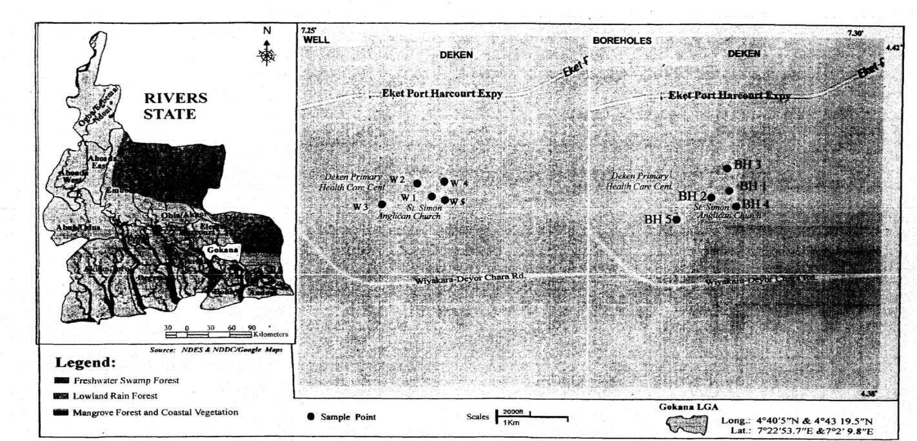
Fig 1 : Map of Rivers State showing the study area

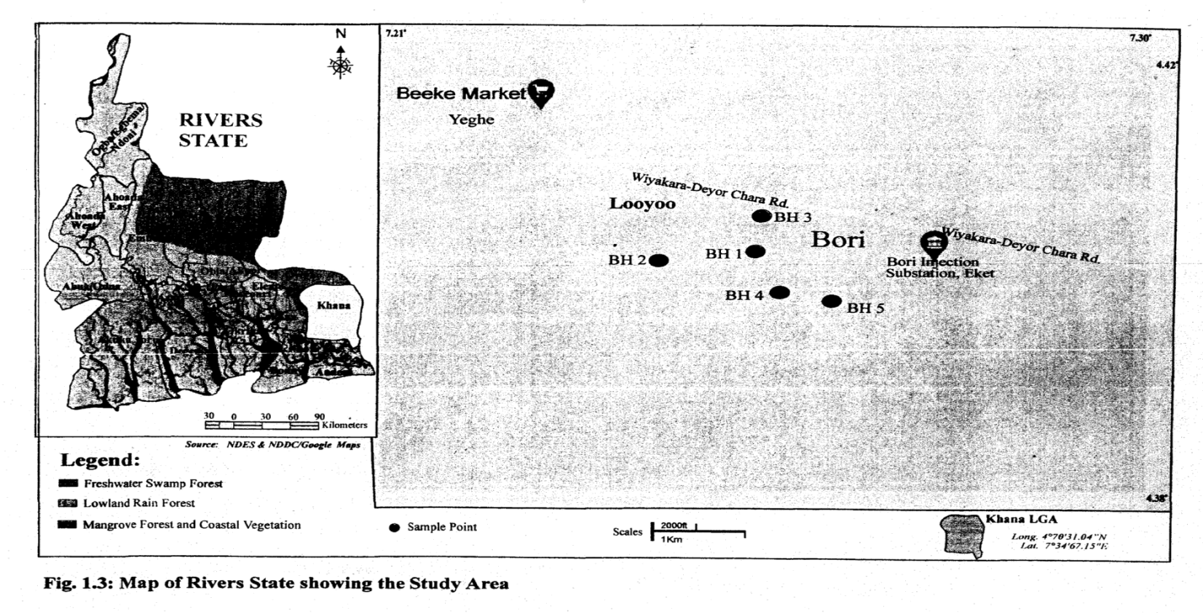
Fig 2 : Map of Rivers State showing the study area
Sampling Site Selection and Location
The sampling site was selected based on representative of most used groundwater. Groundwater samples were collected from 5 stations in two study areas (Deken and Looyoo).
Collection of Water Samples
Groundwater samples were collected using Glass bottles with aluminum cover for the determination of Polycyclic Aromatic Hydrocarbons (PAHs) concentrations; sterile plastic vials were used to collect samples for the determination of heavy metals concentrations.
Analytical Methods
Polycyclic Aromatic Hydrocarbons (PAHs)
The extract was raised into the micro vial (100 micro liters) and preserved in the refrigerator ‘until being injected into the GC-MS instrument. The PAHs extracts were analyzed by using a 3800 Varian Gas chromatography coupled to a VarianSaturn 2200 mass spectrometer, equipped with a 30m x 0.25 mm i.d. WCOT CP-Sil 8 CB column. The GC-MS operated under the following conditions: the initial column temperature was 70° C. After an initial holding time of 1 min, the temperature was programmed to rise to 300°C at a rate of 10°C/min for 30 min. The injector and detector temperatures were 250°C and 300°C, respectively. Helium was used as the carrier gas at a flow rate of 2 mi/nun This method was according to the established procedure by the EPA method 8270D. PAHs concentrations were identified based on their retention times and confirmed by comparing their mass spectra with the reference library.

RESULTS AND DISCUSSION
The results of the levels of the parameters measured in the areas are presented in Tables1and 2.
Polycyclic Aromatic Hydrocarbons
Naphthalene
The study shows that Deken BH 2 and Well 1 had the highest mean Concentration of naphthalene, 7.36x 10⁻⁶and 5.01x10⁻⁴ respectively. While Looyoo boreholes have low ranges. The concentration of the water samples are below the permissible limit of 4x10⁻² set by USEPA (1996) except for Deken BH 2 and Well 1 whose values were higher and thus be monitored because it has been indicated polluted.
Acenaphthylene
The concentrations of acenaphthylene in the study areas indicates that values fir all stations are below permissible limit recommended by USEPA except for Looyoo BH 3(2.24x10⁴) and Deken well 1(3.296x10⁻⁶) that is slightly above. At such the water is not polluted with respect to acenaphthylene but Looyoo BH 2 and Deken well I should be monitored.
Acenaphthene
The result from the study area shows that mean value for Concentration of acenaphthene appears to be lower than the standard effect for Deken Bi-l 2 and Looyoo BH 2 with values of 3.13x10³ and 4.68x10⁴ respectively. With respect to acenaphthene, Deken BH 2 and Looyoo BH 2 is polluted and thus requires adequate attention.
Fluorene
The highest mean Concentration of fluorene, 4.37x10⁻⁶ and 4.95x10⁻⁴ for Deken well I and Looyoo BH 2 respectively were above the standards set up by US EPA (2014) while the other stations appeared lower than the standards. Fluorenc, therefore, does have adverse effect on human as it concerns Deken welt I and Looyoo BH 2.
Phenanthrene
The phenanthrene mean Concentrations for all the stations were high except Deken BH 1 (1.93 x l0⁻³) that is within the permissible standard given by USEPA. The water for various stations with higher values are polluted and requires urgent attention as the health of the consumers are at risk.
Anthracene
The mean Concentrations of anthracene in the water were above the limit set up my USEPA (2014), thus, pose concern for human an itd aquatic lives in the area.
Fluoranthene
The mean Concentrations of fluoranthene in the study areas shows high values in Deken BH 2 (6.4 x 10⁻⁴) and Looyoo BH 3 (3.76 x 10⁻⁴) while the other values are lower than the standard given by USEPA. It is imperative to stop whateveractivity on the study areas with higher valued so as to annul the cause of the increment.
Pyrene
The level of pyrene in the study area shows extremely high amount except for Deken BH 1 (1.45 x l0) that is within the limit Stated by USEPA (2014). The water for the stations with higher values are polluted.
Benzo(a) anthracene
In this study, the mean concentrations of Benz (a) anthracene showed extremely high values in Deken BH 2 (8.4 x 10⁻⁴) and Looyoo BH 2 (6.77 x l0⁻⁴) and 3 (6.74x 10⁻⁴) but other stations indicate lower amount or within permissible limit set up by USEPA. This elucidates that Deken BH 2 and Looyoo BH 2 and 3 arc polluted with Benzo(a) anthracene and hence can adversely affect human health in the area.
Chrysene
The mean concentrations of chrysene showed high values for DekenBH1 [ (2.8 x 10⁻³) and Well 1 (6.0 x 10⁻⁶) and Looyoo BH 2 (2.91 x 10⁻⁴). Other stations appeared to be within the permissible limit. This indicated risk on health of human who use the water for consumption purposes.
Benzo(b) fluoranthene
The mean Concentrations for Benz(b) fluoranthene have a higher mean concentration in Deken BH 1 (5.92 x 10⁻³) and well 1(9.44 x 10.6⁻⁶) and Looyoo BH 1 (4.17 x 10⁻⁴) and 2 (2.37 x 10⁻⁴). The water is adversely polluted.

Benzo(k) fluoranthene
Benzo (k) fluoranthene has a higher mean Concentration in Deken BH 1 (7.70 x 10⁻³) and Looyoo BH 2 (3.49 x 10⁻⁴) and 3 (2.31 x 10⁻⁴). The water is polluted and could be as a result of human activity carried out in the study areas.
Indeno (1, 2, 3-cd) pyrene
The mean Concentration of the Indeno (1,2,3-cd) pyrene in the study areas were within the permissible limit of 2x10-4 set by USEPA (2014) except for Looyoo BFI 3 (4.96 x 10⁻⁴) that is higher. This indicates that the water is unpolluted for the other stations except Looyoo BH 3.
Dibenez(a,h)anthracene
Deken BH 1(6 x 10⁻⁵), well 1(8 x 10⁻⁵) and Looyoo BH 3 (9.03 x 10⁻⁴)showedconcentrations that exceeded the permissible limit, while Deken BH2 (1.0 x 10⁻⁴) and Looyoo BH 2 <0.001 is within the permissible limit stated by IJSEPA. Deken BH 1, well I and Looyoo BH 3 are polluted and needs regular monitoring.
Table 1. Concentrations of Polycyclic Aromatic Hydrocarbon from Deken Community
No. | Parameters | BH1 April 1 | BH1 Oct. | Mean | BH3 April | BH3 Oct. | Mean | Well 1 April | Well 1 Oct. | Mean
1 | Naphthalene | 3.65x10⁻⁵ | 3.38x 10⁻⁴ | 0.0002 + 0.00021 | 1.51 x 10⁻⁶ | 1.32 x 10⁻⁵ | 7.36ε06+8.27 ε-06 | 1.11 x 10⁻⁶ | <0.001 | 0.000501 + 0.0007
2 | Acenaphthylene | 4.92 x 10⁻⁵ | 3.15 x 10⁻³ | 0.0016 + 0.0022 | 3.12 x 10⁻⁶ | 2.86 x 10⁻⁴ | 0.00014 + 0.00020 | 4.72 x 10⁻⁷ | 6.12 x 10⁻⁶ | 3.296 + 37ε-06
3 | Acenaphthene | 1.72 x 10⁻⁵ | 3.27 x 10⁻³ | 0.0016 + 0.0023 | 5.81 x 10⁻⁵ | 6.2 x 10⁻³ | 0.0031 + 0.0043 | 2.86 x 10⁻⁶ | 3.03 x 10⁻⁵ | 0.000017 + 1.9403ε-5
4 | Fluorene | 6.29 x 10⁻⁵ | 3.20 x 10⁻³ | 0.0016 + 0.0022 | 1.33 x 10⁻⁵ | 2.33 x 10⁻³ | 0.0012 + 0.0016 | 4.75 x 10⁻⁶ | 4.99 x 10⁻⁶ | 0.000004 + 1.697ε-7
5 | Phenanthrene | 5.77 x 10⁻⁵ | 3.80 x 10⁻³ | 0.00193 + 0.00264 | 249 x 10⁻⁵ | 1.68 x 10⁻³ | 0.00085 + 0.00117 | 2.05 x 10⁻⁶ | 1.57 x 10⁻⁴ | 0.000080 + 0.000195
6 | Anthracene | 1.39 x 10⁻⁵ | 1.63 x 10⁻³ | 0.0082 + 0.00114 | 4.01 x 10⁻⁶ | 4.28 x 10⁻⁵ | 0.000023 + 2.742 | 1.37 x 10⁶ | 1.16 x 10⁻⁴ | 0.000058 + 8.105ε-7
7 | Fluoranthene | 6.22 x 10⁻⁵ | 2,73 x 10⁻³ | 0.00139 + 0.00188 | 7.59 x 10⁻⁶ | 1.28 x 10⁻³ | 0.00064 + 0.00089 | 5.51 x 10⁻⁷ | 2.53 x 10⁻⁴ | 0.000126 + 0.000178
8 | Pyrene | 4.32 x 10⁶ | 2.90 x10⁻³ | 0.00145 + 0.0020 | 1.79 x 10⁻⁶ | 1.28 x 10⁻³ | 0.00064 + 0.00090 | 2.27 x 10⁻⁷ | 9.51 x 10⁻⁵ | 4.77ε5 + 6.71ε-5
9 | Benzo(a)anthracene | 5.07 x 10⁵ | 1.84 x 10⁻³ | 0.0094 + 0.00126 | 1.86 x 10⁻⁶ | 1.69 x 10⁻³ | 0.00084 + 0.0012 | 1.37 x 10⁻⁷ | 7.01 x 10⁻⁴ | 0.00010 + 0.000142
10 | Chrysene | 5.08 x 10⁻⁴ | 5.02 x 10⁻³ | 0.0028 + 0.0031 | 8.08 x 10⁻⁶ | 8.02 x 10⁻⁵ | 0.00142 + 0.010 ε-5 | 6.17 x 10⁻⁶ | 8.15 x 10⁻⁴ | 0.000006 + 1.4142ε-8
11 | Benzo(B)Fluoranthene | 3.33 x 10⁻⁴ | 3.33 x 10⁻² | 0.00592 + 0.0078 | 4.60 x 10⁻⁶ | 2.83 x 10⁻³ | 0.00141 + 0.0020 | 1.24 x 10⁻⁵ | 6.48 x 10⁻⁶ | 9.44ε6 + 4.186ε-6
12 | Benzo(k)fluoranthene | 8.04 x 10⁻⁵ | 1.46 x 10⁻² | 0.00770 + 0.00976 | 3.43 x 10⁻⁶ | 2.24 x 10⁻³ | 0.00112 + 0.00158 | 2.81 x 10⁻⁵ | 5.42 x 10⁻⁶ | 0.00001 + 0.604ε-5
13 | Indeno (1,2,3cd) pyrene | <0.0001 | <0.0001 | 0.0001 + 0 | 8.68 x 10⁻⁴ | 8.36 x 10⁻³ | 0.0046 + 0.0053 | 9.37 x 10⁻⁴ | 5.33 x 10⁻⁵ | 0.00050 + 0.00062
14 | Dibenez (a,h) anthracene | <0.0001 | <0.0001 | 0.00006 + 0.00064 | <0.0001 | <0.0001 | 0.0001 + 0 | <0.0001 | 6.48 x 10⁻⁵ | 0.00008 + 2.49ε-5
15 | Total | 1.99 x 10⁻³ | 1.99 x 10⁻³ |  | 1.00 x 10⁻³ |  |  | 9.99 x 10⁻⁴ | 9.99 x 10⁻⁴

Table 2.Concentrations of Polycyclic Aromatic Hydrocarbons from Loo-Yoo Community
No. | PAH₅ | BH1 Oct. | BH2Oct. | BH3 Oct. | BH4 Oct. | BH5 Oct. | USEPA
1 | Naphthalene | ND | 1.79 x 10⁻⁴ | 2.92 x 10⁻⁴ | ND | ND | 4.0 x 10⁻⁴
2 | Acenaphthylene | ND | 1.55 x 10⁻⁴ | 2.24 x 10⁻⁴ | ND | ND | 2.0 x 10⁻¹
3 | Acenaphthene | ND | 4.68 x 10⁻⁴ | 1.52 x 10⁻⁴ | ND | ND | 2.0 x 10⁻¹
4 | Fluorene | ND | 4.95 x 10⁻⁴ | 1.89 x 10⁻⁴ | ND | ND | 2.0 x 10⁻¹
5 | Phenanthrene | ND | 3.48 x 10⁻⁴ | 3.39 x 10⁻⁴ | ND | ND | 2.0 x 10⁻¹
6 | Anthracene | ND | 7.64 x 10⁻⁵ | 2.92 x 10⁻⁴ | ND | ND | 2.0 x 10⁻¹
7 | Fluoranthene | ND | 1.11 x 10⁻⁴ | 3.76 x 10⁻⁴ | ND | ND | 2.0 x 10⁻¹
8 | Pyrene | ND | 4.32 x 10⁻⁴ | 9.66 x 10⁻⁴ | ND | ND | 2.0 x 10⁻¹
9 | Benzo(a)anthracene | ND | 6.77 x 10⁻⁴ | 6.74 x 10⁻⁵ | ND | ND | 2.0 x 10⁻⁴
10 | Chrysene | ND | 2.91 x 10⁻⁴ | 1.10 x 10⁻⁴ | ND | ND | 2.0 x 10⁻⁴
11 | Benzo(B)Fluoranthene | ND | 4.17 x 10⁻⁴ | 2.31 x 10⁻⁴ | ND | ND | 2.0 x 10⁻⁴
12 | Benzo(k)fluoranthene | ND | 3.49 x 10⁻⁴ | 2.31 x 10⁻⁴ | ND | ND | 2.0 x 10⁻⁴
13 | Indeno (1,2,3cd) pyrene | ND | <0.001 | 4.96 x 10⁻⁴ | ND | ND | 2.0 x 10⁻⁴
14 | Dibenez (a,h) anthracene | ND | <0.001 | 9.03 x 10⁻⁴ | ND | ND | 4.0 x 10⁻⁴
15 | Total | ND | 4.05 x 10⁻³ | 3.99 x 10⁻³ | ND | ND | 3.0 x 10⁻⁴

Fig 3
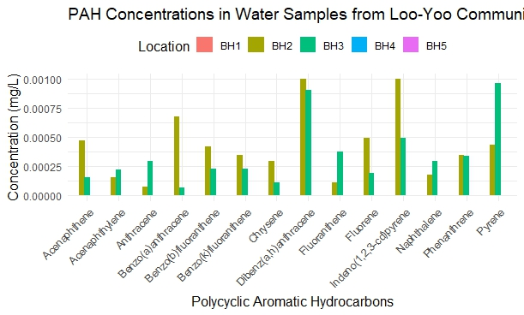

Fig 4 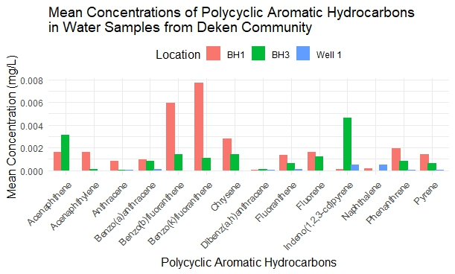

Fig 5

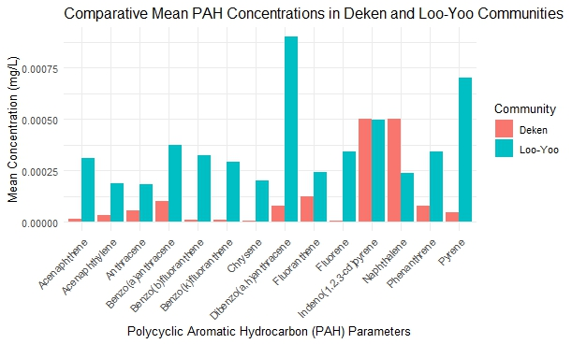

Mean concentrations of all measured PAHs were generally higher in Loo-Yoo water samples than in Deken, indicating a stronger overall PAH contamination in Loo-Yoo. Low-molecular-weight PAHs such as acenaphthene (0.00031 mg/L), acenaphthylene (0.00020 mg/L), anthracene (0.00019 mg/L), fluorene (0.00035 mg/L), phenanthrene (0.00035 mg/L), and fluoranthene (0.00025 mg/L) were consistently elevated in Loo-Yoo compared to Deken, where corresponding values ranged from 0.00000 to 0.00008 mg/L. Among medium- to high-molecular-weight PAHs, benzo(a)anthracene (0.00038 mg/L), benzo(b)fluoranthene (0.00033 mg/L), benzo(k)fluoranthene (0.00030 mg/L), chrysene (0.00021 mg/L), and pyrene (0.00070 mg/L) showed pronounced enrichment in Loo-Yoo relative to Deken concentrations of 0.00000–0.00010 mg/L. Dibenzo(a,h)anthracene exhibited the largest disparity between communities, with a mean value of 0.00090 mg/L in Loo-Yoo compared to 0.00013 mg/L in Deken. Indeno(1,2,3-cd)pyrene was the only compound showing equal mean concentrations in both communities (0.00050 mg/L), suggesting a common regional source or similar exposure pathway. Conversely, naphthalene showed higher levels in Deken (0.00050 mg/L) than in Loo-Yoo (0.00024 mg/L), indicating localized input patterns distinct from the generally elevated PAH profile observed in Loo-Yoo.

The present study demonstrates a clear spatial contrast in polycyclic aromatic hydrocarbon (PAH) contamination between Deken and Loo-Yoo communities, with Loo-Yoo consistently exhibiting higher mean concentrations across nearly all measured compounds. This pattern of site-to-site variability aligns well with observations reported in several Nigerian and international studies, where localized anthropogenic pressures create uneven PAH distributions within relatively small geographic areas. In the present study, individual PAH concentrations generally ranged from approximately 0.00002 to 0.00090 mg/L, placing both communities within the lower to moderate end of the global concentration spectrum. However, the dominance of higher values in Loo-Yoo compared to Deken suggests stronger or more persistent PAH inputs at that location, a phenomenon frequently attributed in the literature to differences in urbanization, waste disposal practices, fuel combustion intensity, or proximity to hydrocarbon-related activities.
When compared with Nigerian coastal and urban waters, the concentrations observed in Deken and Loo-Yoo are substantially lower than those reported for heavily polluted sites such as Atlas Cove, Lagos, where surface water PAH levels ranged from 0.046 to 0.507 mg/L and were dominated by low-molecular-weight (LMW) PAHs (Olayinka et al., 2018). Similarly, Woji Creek in the Niger Delta recorded extremely elevated ΣPAHs between 6.03 and 29.26 mg/L, with LMW compounds prevailing in the water column (Ihunwo et al., 2019). In contrast, the present study’s maximum individual concentration of 0.00090 mg/L for dibenzo(a,h)anthracene in Loo-Yoo is several orders of magnitude lower, indicating that although contamination is evident, both Deken and Loo-Yoo are not exposed to the intense hydrocarbon loading characteristic of major industrial hot spots in Nigeria.
Groundwater and well-water studies from the Niger Delta and other Nigerian regions further contextualize the present findings. Borehole waters around dumpsites in Rivers and Bayelsa States exhibited PAH concentrations ranging from 0.106 to 3.009 mg/L, with LMW PAHs dominating (Okechukwu et al., 2021), far exceeding levels measured in Deken and Loo-Yoo. Conversely, wells in Ekpeyeland, Rivers State, recorded total PAHs below 0.002 mg/L despite the detection of all 16 priority PAHs, with a dominance of high-molecular-weight (HMW) compounds (A. et al., 2024). This latter observation is more comparable to the present study in terms of absolute concentration range, particularly for Deken, although Loo-Yoo shows relatively stronger enrichment of both LMW and selected HMW PAHs. Borehole waters from the Awka dumpsite also reported ΣPAHs between 0.004 and 0.014 mg/L, dominated by four- to five-ring compounds (Aralu et al., 2023), which remain higher than values observed in both communities under study.
The mixed LMW and HMW PAH profile observed in Deken and Loo-Yoo mirrors patterns reported for surface waters in the Niger–Benue confluence, where naphthalene ranged from non-detectable to 0.543 mg/L and benzo(a)pyrene reached up to 0.113 mg/L, resulting in site-specific ΣPAHs of approximately 0.08–0.9 mg/L (Ekere et al., 2019). Although the absolute concentrations in the present study are generally lower, the coexistence of LMW compounds such as naphthalene and phenanthrene with HMW species like pyrene, indeno(1,2,3-cd)pyrene, and dibenzo(a,h)anthracene indicates similar mixed source characteristics. The reversed trend for naphthalene, which was higher in Deken than Loo-Yoo, further supports the notion of localized inputs, consistent with findings from Igbokoda, Irele, and Okitipupa, where PAH levels varied widely between wells and boreholes depending on site-specific conditions (Akinnifesi et al., 2024).
Globally, the concentration range reported in the present study fits comfortably within values documented for moderately contaminated freshwater systems. Data from the AQUA-GAPS global monitoring program showed Σ28 PAHs ranging from 0.000061 to 0.045 mg/L across marine and freshwater environments, with phenanthrene often dominating (Lohmann et al., 2024). Lakes in China recorded ΣPAHs between 0.000004 and 0.01297 mg/L, with naphthalene and indeno(1,2,3-cd)pyrene frequently among the most abundant compounds (Meng et al., 2019), a pattern that partially aligns with the prominence of these compounds in the present study. Similarly, surface waters in Hanoi, Vietnam, exhibited median PAH concentrations of 0.000246 mg/L in canals, 0.000072 mg/L in lakes, and 0.000033 mg/L in rivers, dominated by naphthalene, phenanthrene, pyrene, and fluoranthene (Hoang et al., 2025), closely matching both the concentration scale and compound distribution observed in Deken and Loo-Yoo.
Studies from South and Southeast Asia further reinforce this alignment. Rivers in Bangladesh recorded ΣPAHs between 0.00198 and 0.00962 mg/L, with three-ring PAHs dominating water samples (Nahar et al., 2023), while the Damodar River in India showed individual PAHs ranging from non-detectable to 0.036 mg/L, with three- to four-ring compounds prevailing (Ambade et al., 2021). Drinking water sources in southern Jharkhand, India, reported even lower ΣPAHs of 0.000009–0.000022 mg/L (Ambade et al., 2020), values comparable to or slightly below those observed in Deken but lower than several Loo-Yoo measurements. These comparisons suggest that while Deken and Loo-Yoo do not approach the contamination severity of major Nigerian hot spots, Loo-Yoo in particular exhibits PAH levels consistent with moderately impacted freshwater systems globally.

CONCLUSION
The results of the chemical analysis of the groundwater show that the water from the various boreholes are generally acidic. All PAHs content showed higher values compared with permissible limit and Pyrene, Chrysene, Benzo(a) anthracene showed very high values.
From the findings of this study, it was recommended that the water in the areas should be treated before use to avoid serious hazards. Government should as a matter of urgency create awareness in the communities of the PAHs content of the water.

REFERENCES
Adewoye, S. O., Adewoye, A. O., Opasola, 0. A. &Elegbede, .1. A. (2013).Physicochemical parameters and iteary metal levels in water samples from hand dug wells in Gambari, Ogbomoso, Oyo State. IOSR Journal of Environmental Science Taxicology of Food Technology. 5(l):22-30.
Akaninwor, B. O. &Wewgwe, M. O. &Nwaichi, E. O. (2007). Levels of some heavy metals and physicochemical properties of effluent from a Beverage company in Rivers State, Nigeria Journal of Applied Studies for Environmental Management. 11:27-30.
Alabaster, J. S. & Lloyd, R. (1980). Water quality criteria for fresh water. Butter worths, London 1-283.
Andrade-Eiroa, & A. Leroy V. &Dagaut, P. &Bedjanian, Y. (2010). Determination of polycyclic Aromatic Hydrocarbons in kerosene and biokerosene 800t. Chemosphere 78:1342-1349.
APHA, (1995). Standard methods for the examination of water and waste water, 18th ed. APHA-AWWA-WPCF. Washington DC.
ATSDR (Agency for Toxic Substances and Diseases Registry (1995). Department of Human and Health Service and International Agency for Research on Cancer-Geneva.
Bakarji, E. H. &Krajo. J. (1999): Determination of heavy metals in Damascus drinking water using total reflection X-ray fluorescence quality research. Water Journal Canada. 34, 304.
Bhaskar, C. V., Kumar, K &Nagendrappa, G. (2010). Assessment of heavy metals in water samples of certain locations situated around Tumkur, Karmataka, India. http://www.Indian environment portal .org.in/assessment_to_the_metals_in_water_samples.pdf.
Census, (2006). National Population Commission Rivers State.
Cam, D., Gagni, B, Meldolesi, L. Gallera, G. (2002). Determination of Polycyclic Aromatic Hydrocarbons in Sediments using Spectrometry. Journal of Chromatography Studies. 38:55-60.
Department of National Health and Welfare, (1969). Canadian Drinking water standard and objectives.
Ehirim, C. N. &Ebeniro, J. O. (2013). 2-D Electrical Resistivity Monitoring of a municipal solid waste dumpsite in Port Harcourt, Nigeria 1OSR. Journal Environmental Science Toxicology Food Technology. 2(5): 29-34.
Ellah, J. (1995). Ali-Ogba: A History www.africabookscollective.com of Ogba People”
Erah, P. O. &Akujieze, C. N., Oteze, G. E. (2002). The Quality of Groundwater on Benin City: A baseline study on inorganic chemicals and microbial contaminant of health importance in borehole and open wells, Tropical International Pharmaceutical Resources, 1(2): 75-82.
European Union, (20l4). European and National Drinking water quality standards. Northern Ireland Environmental Agency. Periplex. 3-10.
Ghaedi, M., Fathia. & M. R., Marahel, F. & Ahmadi, F. (2005). Simultaneous Preconcentration and Determination of copper cobalt and lead ions Fresher Environment 14, 1158-1165.
Hodges, L. (1980). Environmental pollution 2nd edition Hold Rincheart and Winston Publications, New York, 98-109.
Ideriah, T. J. K. & David-Omiema, S. &Ogbonna, D. N. (2012): Distribution of heavy metals in water and sediment along Abonnema shorelines, Nigeria. Resources and Environment 2(1), 3 3-40.
Ideriah, T. J. K. &Nwinaa-ie, J. (2015). Levels of polycyclic Aromatic Hydrocarbons in Water at Betem Rivers State., International Journal of Advance Innovation Resource. 4(10), 2278-2844.
Ideriah, T. 3. K. (2015). Assessment of Groundwater Quality for Multipurpose use imparts of Andoni Rivers State. Indian Journal Resource Periapex. 4(10):34-41.
Jalali, M. (2007). Hydrochemical identification of groundwater resources and their changes under the impacts of human activity in the Chad Basin in Western Iran. Environmental Monitoring and Assessment. 130:347-364.
Kiafa, A. A. (2012). Environmental impacts of oil exploration and exploitation in the Niger Delta of Nigeria. Global International Studies Front-Resource Environmental. Earth Science. 12(3): 0975-5 896.
Karyab, H. &Yunesian, M. &Nassari, S. &Nabizabeh, R. (2013). Polycyclic Aromatic Hydrocarbons in Drinking Water or gas chromatography for the monitoring of polycyclic aromatic hydrocarbons in urban waste water and sewage sludge used for soil amendment. Journal Chromatography. A. 859,29-39.
McNeely, R. N. &Neimanis V. P., & Dwyer, L. (1979). Water Quality sourcebook, A Guide to Water Quality Parameter, Inland Water Directorate, Water Quality Branch, Ohawa, Canada.
Moja, S. T. &Mtunti, F. &Madlanga V. (2013). Determination of polycyclic aromatic hydrocarbons in Rivers water sample from part A Toxicon. Hazard Substance Emergency England. 48(8), 847-854.
NAFDAC (2001). National Agency for Food and Drug Administration and Control in Nigeria. Drinking Water Regulations. NAFDAC consumer bulletin Oct-Dec. No. 1:9.
Nwidu, L. L. &Ebong, O. O.&Wasiro, B. A. (2006). The health implication ofunderground water used for domestic consumption in oil producing area,Port Harcourt City, Nigeria. Medical and Pharmaceutical Studies. 2(1): 39-45.
Nwidu, L. L. &Ojeh, B. Okoriye T. &Vaikosen, N. A. (2008). Assessment of the water quality and prevalence of water borne diseases in Amassoma, Niger Delta, Nigeria. Africa International Biotechnology. 2993-2997.
Obiefuna, G.I & Sheriff, A. (2011): Assessment of Shallow groundwater Quality of PindigaGombe Area, Yola Area, NE, Nigeria for Irrigation and Domestic purposes. Research journal of Environmental Earth Science. 3(2): 132-142.
Oladeji, O. S. (2002). Preliminary Assessment of the Environmental impacts of land use patterns on Groundwater Quality, AJOL. Global Journal of Environmental Science. pg. 1(1).
Olajire, A. A. &Imeokparia, F. E. (2001). ‘Water quality assessment of OsunRiver: Studies on inorganic nutrients, Environmental Monitoring and Assessment. 69(1): 17-28.
Olutona, O.G. & Emmanuel, A. A., John, A. O. &Seum, A. A. (2012). Physiochemical Quality Assessment of Shallow well waters in Imo State, South Western Nigeria. Journal of Environmental Studies Water Resource. 1(6): 127-132.
Oyeku, O. T. &Eludoyin, A. 0. (2012). Heavy metal contamination of groundwater resources in a Nigerian urban settlement. Africa International Environmental Science and Technology. 4(4): 201-214.
Sanayei, Y & Ismail N. &Talebi, S. M. (2009). Determination of heavy metals in Zayyandeh hood, Isfahan-Iran. World of Applied Studies Journal. 1209- 1214.
Sobsey, M. D. (1990). Inactivation of health-related microorganism in water by disinfection processes. Water Science Technology. 21:179-195.
SON, (2007): Nigeria standards for drinking water quality. Nigeria industrial standard NIS:554.//www.unicef.org/Nigeria/ng-Publications-Nigeria-standard-for-Drinking-water-quality.pdf.
Stuermer, D. H., Ng. D. B. & Morris, C. J. (1982). Organic contaminants in ground water near underground coal gasoline site in North Eastern Wyoming. International Environmental Studies Technology. 16:582-587.
Raghunath, I.M (1987): Groundwater 2nd Edition; Wiley Eastern Ltd; New Delhi, India.
Rajappa, B., Manjappa, S. &Puttaiah, E. T. (2010). Monitoring of heavy metal concentration in groundwater of HakinakaTaluk, India. Contemporary Engineering Sciences, 3(4): 183-190.
Udom, G. J., Ushie, F. A &Esu. E. 0. (2002). A geochemical survey ofgroundwater in Khana and Gokana Local Government Area of Rivers State,Nigeria. Journal of Applied Science and Environmental Management. 6:53-59.
United Nations Environment Programme (UNEP, 2001), Environmental Assessment of Ogoni Land Pg. 30-50.
USEPA (2013). Polycyclic aromatic hydrocarbons (PAHs) what are the standards and regulations for PAHs exposure. United State Environmental Protection Agency (USEPA) 1-4.
Van-Me, P. C. B. J., Mahier, M. & Hamilton, S. P. A. (2005). Parking lots seal coat: a major source of PAHs in urban & Sub-urban environments, US Geological survey fact sheet; 31476.
Williamson, K & Petty, B & Huskins, J & Kaiser, K. (2002). Determination of priority pollutants in water, sediment superable membrane device. Chemosphere 49, 703-7 15.
WHO,(World Health Organization) (2011). Guidelines for drinking water quality. 4th Edition WHO Presses, 2011, Periplex. 564. Journal of Science and Engineer Resource. (4). pg. 2229-5518

