Original Research Article
ECONOMIC AND ZOONOTIC POTENTIAL OF HELMINTHIC PARASITES IN PIGS SLAUGHTERED AT DEONAR ABATTOIR, MUMBAI: A CROSS-SECTIONAL STUDY WITH META-ANALYTICAL INSIGHTS

ABSTRACT
A cross-sectional abattoir-based investigation was conducted to determine the prevalence, zoonotic significance, and economic impact of helminthic metacestodes in pigs slaughtered at Deonar abattoir, Mumbai, over a period of 11 months (March 2025 to January 2026). A total of 3,129 pig carcasses were systematically examined during routine meat inspection. The overall prevalence of metacestode infections was 3.55%, with 111 pigs affected. Single infections (3.36%) predominated over mixed infections (0.19%). The most prevalent parasite was suspected Cysticercus viscerotropica (1.37%), followed by Cysticercus tenuicollis (1.09%), Hydatid cysts (0.73%), and Cysticercus cellulosae (0.35%). No evidence of Trichinella spp. or Opisthorchiid flukes was detected. Seasonal variation showed higher prevalence during the monsoon (5.68%) compared to winter (2.59%) and summer (2.54%), although the differences were statistically non-significant. Organ-wise distribution revealed that hydatid cysts were predominantly detected in the lungs (0.54%), followed by the spleen (0.16%) and liver (0.03%), and all cysts were sterile. Cysticercus tenuicollis was mainly localized in the omentum and mesentery, whereas Cysticercus cellulosae was predominantly found in skeletal musculature with occasional cardiac involvement. Molecular analysis of suspected C. viscerotropica lesions did not confirm Taenia asiatica. Economic analysis revealed total losses of ₹4,04,516.8 due to organ and carcass condemnation, with cysticercosis contributing the highest loss. Meta-analysis of human infections further suggests that cysticercosis and hydatidosis remain significant zoonotic parasitic diseases in India, whereas Trichinella spp. and Taenia asiatica occur only sporadically. Despite the relatively low prevalence observed, the detection of metacestodes indicates persistent environmental contamination and ongoing transmission cycles.
The study highlights the need for strengthened meat inspection, improved sanitation, and integrated One Health–based surveillance, proper disposal of infected offal, and enhanced control strategies to minimize zoonotic transmission and safeguard public health as well as the sustainability of pig production systems.
Keywords: Porcine helminths, Abattoir study, Mumbai, Economic loss, Zoonosis, Taenia asiatica, Metacestodes
INTRODUCTION
Pig production contributes approximately 7% of total animal protein supply in India, with an estimated population of 13.5 million pigs accounting for about 10% of national meat production. Pig rearing is predominantly practised in the eastern and north-eastern states under backyard systems characterised by low bio security and minimal veterinary inputs. Approximately 84% of pigs are slaughtered annually for meat or value addition (Agricultural Research Data Book, 2007), and India ranked 46th among global pork exporters in 2022 (Thomas et al., 2025).
Parasitic diseases remain among the most neglected health constraints in pig production, consistently rated by farmers as the foremost health concern. Their chronic and subclinical nature leads to systematic underreporting, despite causing significant productivity losses through impaired feed conversion, stunted growth, organ condemnations, and increased susceptibility to secondary infections.
Several porcine helminths also pose serious zoonotic risks. Taenia solium infection, the etiological agent of human taeniasis and porcine cysticercosis, is a major cause of adult-onset epilepsy in tropical regions due to neurocysticercosis (Rajshekhar, 2016). Notably, this parasite is unique in that humans can serve as both definitive and intermediate hosts, thereby facilitating its transmission cycle (Jeri et al., 2004). Taenia asiatica, historically overlooked due to its close morphological resemblance to T. saginata, has gained recognition as a distinct zoonotic species, with molecular and serological diagnostic advances playing a pivotal role in clarifying its epidemiology and distribution (Parija and Ponnambath, 2013). Echinococcus granulosus causes hydatidosis in scavenging pigs, resulting in widespread organ condemnations and economic losses (Gatne, 2001). Cysticercus tenuicollis similarly causes carcass condemnation, with diagnosis largely limited to post-mortem inspection due to the histozoic nature of the metacestodes. Trichinellosis poses a growing food-borne risk as pork consumption rises across several Indian states (Singh et al., 2013).
Globally, food-borne zoonoses affect approximately 10% of the population annually, and the FAO projects an 18.5% rise in global pork production over the next decade, further underscoring the need to address pork-borne parasitic diseases. In this context, the present study was undertaken to: (1) determine the prevalence of zoonotic helminths in pigs slaughtered at Deonar abattoir, and (2) assess their economic and zoonotic impact.
MATERIALS AND METHODS
The present study was conducted at Deonar abattoir, Mumbai, over a period of eleven months from March 2025 to January 2026. A total of 3,129 pig carcasses were examined during routine post-mortem inspection. All pigs presented for slaughter during the study period were included and subjected to systematic post-mortem examination. Carcasses and organs (liver, lungs, heart, spleen, and musculature) were examined by visual inspection, palpation, and incision as per standard meat inspection procedures (OIE, 2008). Parasitic lesions such as cysts were recorded based on location, number and size. Suspected parasitic materials were collected and identified morphologically using standard parasitological keys based on structural features and predilection sites (Soulsby, 1982; Taylor et al., 2016). Histopathological evaluation of miliary fibrotic hepatic lesions was undertaken, and specimens with equivocal morphology were subsequently subjected to molecular confirmation. Prevalence was calculated as per the formula described by Thrusfield (2005), while economic loss was calculated as described by Vaidya et al. (2018). Data were analyzed using descriptive statistics and expressed as percentages to evaluate infection prevalence and organ-wise distribution. A systematic literature review was conducted to compile published data on the prevalence of porcine helminths. Relevant studies were retrieved from PubMed, Scopus, and Google Scholar using predefined keywords. Studies reporting prevalence with clear sample size and infection data were included, while those lacking quantitative information were excluded (Moher et al., 2009). Extracted data included author, year, location, sample size, and number of positives. Where applicable, pooled prevalence estimates were derived using a random-effects model and heterogeneity was assessed using the I² statistic (Higgins et al., 2004).
RESULTS
Overall prevalence of porcine metacestodes
A total of 3,129 pig carcasses were systematically examined at Deonar abattoir, Mumbai, over 11 months (March 2025 to January 2026). Out of these, 111 animals were positive for one or more metacestodes, yielding an overall prevalence of 3.55% (Table 1). Single infections predominated (105 pigs; 3.36%) over mixed infections (6 pigs; 0.19%). Among individual parasites, Cysticercus viscerotropica (suspected) recorded the highest prevalence (1.37%), followed by C. tenuicollis (1.09%), hydatidosis (0.73%), and C. cellulosae (0.35%). No Trichinella larvae were detected in any diaphragm or intercostal muscle samples examined throughout the study period. Similarly, no trematode infections attributable to Opisthorchis or Clonorchis spp. were detected in any of the carcasses.
Seasonal prevalence of porcine metacestodes
The highest overall prevalence was recorded during the monsoon season (5.68%), followed by post-monsoon/winter (2.59%) and summer (2.54%). All four metacestode species followed this consistent pattern. C. tenuicollis showed the most pronounced monsoon peak (1.92%), followed by suspected C. viscerotropica (1.82%), C. cellulosae (0.81%), and hydatidosis (1.12%). Seasonal variation was statistically non-significant (χ² = 5.99, df = 6, p > 0.05).
Porcine Hydatidosis
Hydatidosis was recorded in 23 pigs (0.73%) (Fig 1 & 2). Single-organ involvement was observed in 20 pigs (86.95%) and multiple-organ involvement in 3 pigs (13.04%). The lungs were the most frequently affected organ (17 cases; 0.54%), followed by the spleen (5 cases; 0.16%) and liver (1 case; 0.03%). All hydatid cysts detected were sterile.
Suspected Cysticercus viscerotropica: Gross and Histopathological findings
Multiple small, miliary white nodular lesions were observed on the hepatic surface and parenchyma in 43 pigs (1.37%) (Fig 5). No cysticerci were detected in skeletal musculature in any of these cases. Direct microscopic compression of tissue preparations failed to reveal intact scolex, laminated cyst wall, or other definitive metacestode structures. Histopathological examination of 24 selected samples revealed focal granulomatous reactions with central necrosis, dense eosinophilic and mononuclear inflammatory infiltration, occasional multinucleated giant cells, peripheral fibrosis, and focal calcification (Fig 6). Additional hepatic changes included hydropic degeneration, sinusoidal congestion, mild bile duct proliferation, and lymphoid follicle formation adjacent to granulomatous foci. No intact or definitive parasitic structures were consistently demonstrable across sections.
Molecular characterisation of suspected Cysticercus viscerotropica
Twenty-four liver specimens with histopathologically suspicious lesions were processed for PCR-based molecular confirmation using the protocol of Wang et al. (2016), with annealing temperature optimised from 52°C to 58°C. Gradient PCR with varied annealing temperatures and modifications in template DNA volume and primer concentrations were attempted. None of the samples yielded the expected amplification band on 1.5% agarose gel electrophoresis, indicating the absence of detectable Taenia mitochondrial DNA in all examined specimens.
Economic Losses incurred due to porcine helminths
The total direct economic loss due to helminthic infections during the study period was ₹4,04,516.8. (Table. 2) C. cellulosae contributed the greatest proportion (₹3,74,220; 92.5%) through condemnation of 693 kg of skeletal musculature, with a projected annual loss of ₹4,08,240. Suspected C. viscerotropica accounted for ₹25,155 (55.9 kg liver condemned; projected annual loss ₹27,441.8), hydatidosis for ₹4,234.8 (8.84 kg lungs, 0.3 kg liver, 0.9 kg spleen; projected annual ₹4,619.8), and C. tenuicollis for ₹907 (0.9 kg spleen, 2.6 kg omentum and mesentery; projected annual ₹979.74).
Meta-analysis of Zoonotic significance of porcine parasites based on reported human Infections: (Table 3 & 4)
Human cysticercosis: Meta-analysis of 15 studies (2000–2023; n = 15,087) yielded a pooled prevalence of 20.8% (95% CI: 11.4–34.9%; I² = 96.7%, p < 0.0001). MRI-based studies reported the highest pooled prevalence (35.8%), followed by serological methods (21.7%) and PCR (13.6%). Year of publication was a significant predictor of prevalence (p = 0.0029). Higher prevalence was observed in western India, moderate in northern regions, and comparatively lower in southern India.
Human hydatidosis: Meta-analysis of 14 studies (2007–2025; n = 16,009) yielded a pooled prevalence of 18.0% (95% CI: 7.8–36.3%; I² = 99.1%, p < 0.0001). Serological studies yielded pooled estimates of 18–19%, a PCR-based study reported 93.7%, and MRI-based estimates were 2.9%. Diagnostic method was a significant contributor to heterogeneity (p = 0.0051). Higher prevalence was observed in northern and southern India.
Trichinellosis and Taenia asiatica: Human trichinellosis was documented sporadically through case reports and small outbreaks in northern India, with a serological positivity of 5.74% (7/122) in one investigation. Human T. asiatica infection was identified in isolated reports through ELISA serology in Pondicherry and molecular detection in pigs from Haryana.
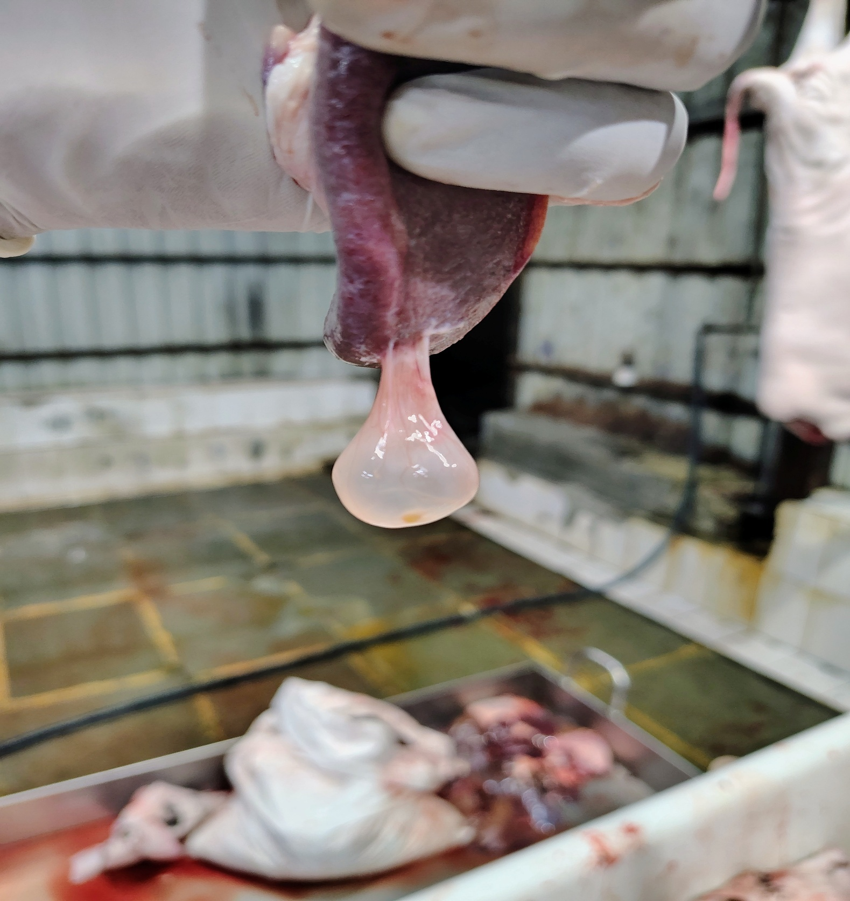
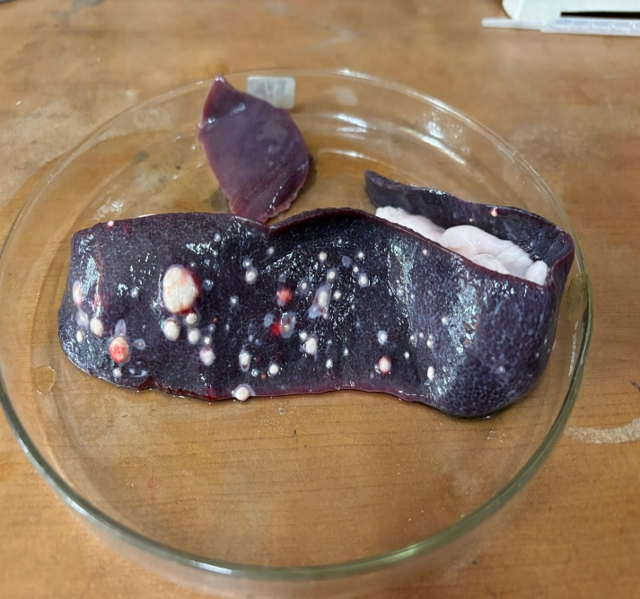

Fig. 1. Multiple hydatid cysts on the spleen

Fig. 2. Cysticercus tenuicollis attached to the spleen
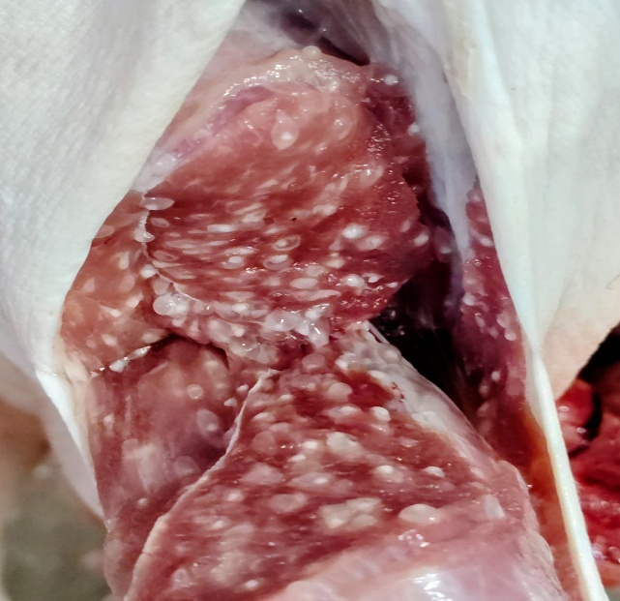
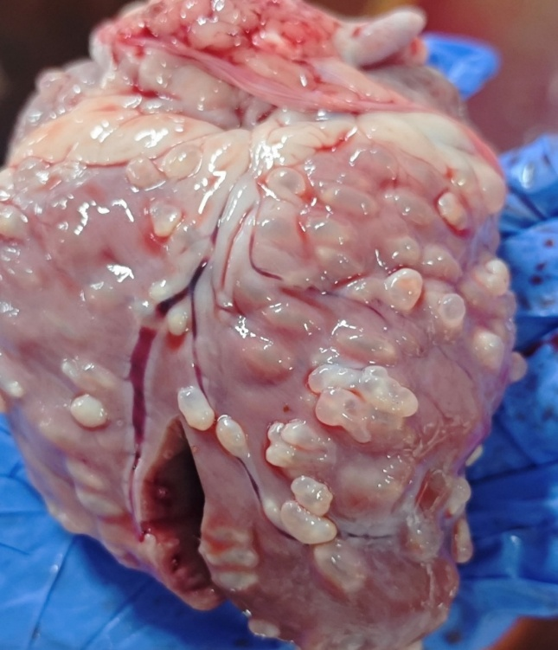

Fig. 4. Cysticercus cellulosae on the shoulder muscle with Heavy Intensity
Fig. 3. Cysticercus cellulosae on the Heart muscle with Heavy Intensity

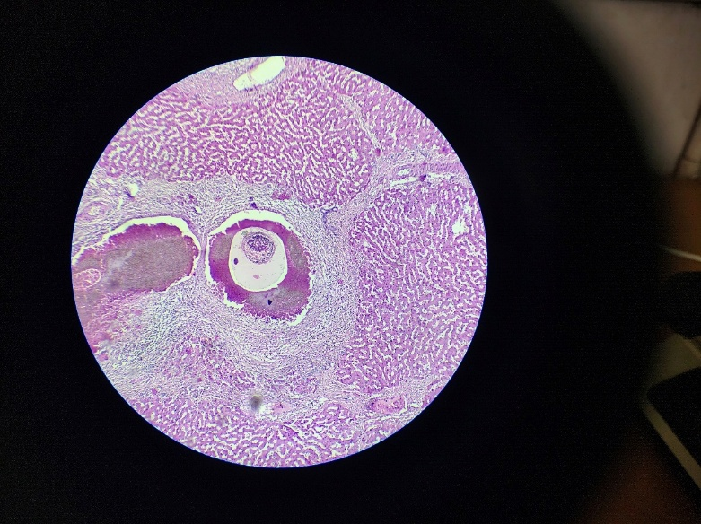
Fig. 6. Histopathological section of liver showing a cyst-like lesion surrounded by eosinophils, inflammatory cells and fibroplasia. H&E. X40.
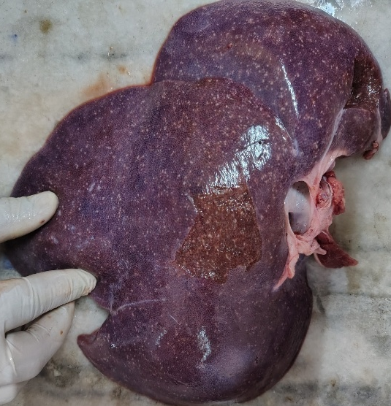

Fig. 5. Liver suspected for Cysticercus viscerotropica in pigs

Bladder worm | Single infection | Mixed infection |  |  |  |  | Total
Bladder worm | Single infection | Hydatidosis | C.viscerotropica (Suspected) | C.tenuicollis | C. cellulosae | All Four | Total
Hydatidosis | 20  (0.64%) | - | 2 | 1 | - | - | 23  (0.73%)
Cysticercus viscerotropica (Suspected) | 41  (1.31%) | 2 | - | - | - | - | 43  (1.37%)
Cysticercus tenuicollis | 33  (1.05%) | 1 | - | - | - | - | 34  (1.09%)
Cysticercus cellulosae | 11  (0.35%) | - | - | - | - | - | 11 (0.35%)
Total | 105(3.36%) | 6  (0.19%) |  |  |  | - | 111 (3.55%)

Table 2. Economic losses due to helminthic parasites in pigs

Table 1. Overall prevalence of metacestodes in slaughtered pigs

Sr. No. | Metacestode | Total number of positive animals | Approximate Wt. of rejected organs |  |  |  | Complete carcass | Total economic losses (₹) | Projected annual economic loss (₹)
Sr. No. | Metacestode | Total number of positive animals | Liver  (450/kg) | Lungs  (420/kg) | Spleen  (430/kg) | Omentum& mesentery  (200/kg) | Pork  (540/kg) | Total economic losses (₹) | Projected annual economic loss (₹)
1 | Cysticercus viscerotropica | 43 | 55.9  kgs | 0 | 0 | 0 | 0 | 25,155 | 27,441.8
2 | Hydatidosis | 23 | 0.3  kg  (₹135) | 8.84  kgs  (₹3,712.8) | 0.9  kg  (₹387) | 0 | 0 | 4,234.8 | 4,619.8
3 | Cysticercus cellulosae | 11 | 0 | 0 | 0 | 0 | 693 kgs | 3,74,220 | 4,08,240
4 | Cysticercus tenuicollis | 34 | 0 | 0 | 0.9 kg  (₹387) | 2.6 kgs  (₹520) | 0 | 907 | 989.45
 | Total | 111 | 56.2 kgs | 8.84 kgs | 1.8 kgs | 1.9 kgs | 693 kgs | 4,045,16.8 | 4,41,129.05

Table. 3. Meta-regression results of cysticercosis in humans of India
Moderator Variable | Coefficient (β) | SE | z value | p value | 95% CI (Lower) | 95% CI (Upper) | Significance
Intercept | -321.6804 | 55.5341 | -5.7925 | <0.0001 | -430.5252 | -212.8356 | ***
Sample size | -0.0001 | 0.0001 | -2.1332 | 0.0329 | -0.0003 | -0.0000 | *
Diagnostic method (PCR) | -2.2558 | 0.6302 | -3.5792 | 0.0003 | -3.4910 | -1.0205 | ***
Diagnostic method (Serology) | 0.0144 | 0.4031 | 0.0356 | 0.9716 | -0.7757 | 0.8044 | NS
Diagnostic method (Serology-2) | -0.0819 | 0.6991 | -0.1171 | 0.9068 | -1.4521 | 1.2884 | NS
Diagnostic method (USG) | -0.1250 | 0.6196 | -0.2017 | 0.8401 | -1.3393 | 1.0893 | NS
Year of study | 0.1594 | 0.0276 | 5.7809 | <0.0001 | 0.1053 | 0.2134 | ***

Table. 4. Multivariable meta-regression analysis of factors associated with human Hydatid disease prevalence

Moderator Variable | Coefficient (β) | SE | z value | p value | 95% CI (Lower) | 95% CI (Upper) | Significance
Intercept | -136.1896 | 171.6750 | -0.7933 | 0.4276 | -472.6664 | 200.2872 | NS
Sample size | -0.0001 | 0.0004 | -0.3789 | 0.7047 | -0.0009 | 0.0006 | NS
Diagnostic method (PCR) | 6.7415 | 2.4094 | 2.7980 | 0.0051 | 2.0193 | 11.4638 | **
Diagnostic method (Serology) | 2.1817 | 1.6254 | 1.3423 | 0.1795 | -1.0040 | 5.3674 | NS
Diagnostic method (Serology-2) | 2.5333 | 1.6780 | 1.5097 | 0.1311 | -0.7555 | 5.8221 | NS
Year of study | 0.0657 | 0.0847 | 0.7751 | 0.4383 | -0.1004 | 0.2317 | NS

DISCUSSION
The present investigation demonstrated an overall prevalence of 3.55% of zoonotic metacestodes in pigs slaughtered at Deonar abattoir, Mumbai, indicating a relatively low to moderate level of infection. Comparable prevalence rates have been reported in abattoir-based studies from Maharashtra (Gaurat and Gatne, 2005; Jawalagatti et al., 2017), suggesting a gradual decline in helminthic infections. This trend may be attributed to improved hygiene, better offal disposal practices, and increased awareness of zoonotic transmission (Singh et al., 2013).
The predominance of single infections over mixed infections observed in the present study reflects limited concurrent exposure to multiple parasite species or biological interactions influencing co-infection establishment (Macpherson, 2005). Similar findings have been reported in earlier abattoir surveys, where single infections were more frequently encountered (Mkupasi et al., 2011). Among the detected metacestodes, the higher occurrence of suspected Cysticercus viscerotropica, followed by Cysticercus tenuicollis and hydatidosis, indicates continued circulation of taeniid parasites in pigs (Nguyen et al., 2016). In contrast, the relatively low prevalence of Cysticercus cellulosae suggests improved sanitation and reduced exposure to human faecal contamination, a critical factor in the transmission of Taenia solium (Wardrop et al., 2015; Rajshekhar, 2016). Seasonal variation with higher prevalence during monsoon may be attributed to favourable environmental conditions such as increased humidity and optimal temperature that enhance the survival of infective stages (Thrusfield, 2005). Although similar seasonal trends have been reported (Kalai et al., 2012), the lack of statistical significance indicates that additional factors, including management practices and animal sourcing, may also influence infection dynamics. The organ-wise distribution observed in this study aligns with known biological behaviour of these parasites. Hydatid cysts were predominantly located in lungs due to filtration of oncospheres via pulmonary circulation (Eckert and Deplazes, 2004). Cysticercus tenuicollis showed predilection for the omentum and mesentery, consistent with its migratory larval stage (Soulsby, 1982). The localization of Cysticercus cellulosae in skeletal muscles and cardiac tissue corresponds with classical descriptions and has direct implications for meat inspection (Taylor et al., 2016). Hepatic miliary lesions initially suspected to represent Cysticercus viscerotropica were not confirmed by PCR, thereby highlighting the limitations of gross diagnosis during routine meat inspection. Histopathological findings characterized by granulomatous inflammation suggest chronic degenerative changes, possibly associated with parasite migration or non-taeniid etiologies (Satyaprakash et al., 2018). These findings further underscore the importance of integrating molecular diagnostics with conventional meat inspection methods to improve diagnostic accuracy (Sambrook and Russell, 2001).
From an economic perspective, helminth infections resulted in measurable losses due to the condemnation of affected organs and carcasses. Although the prevalence of Cysticercus cellulosae was low, it accounted for the highest economic loss due to whole carcass condemnation, consistent with previous reports (Mandakhalikar et al., 2009; Singh et al., 2017). In contrast, hydatidosis and C. tenuicollis contributed comparatively lower losses as they primarily affected viscera of lower market value (Torgerson et al., 2000).
The meta-analysis of zoonotic infections provides important epidemiological context to these findings. The pooled prevalence of human cysticercosis (20.8%) and hydatidosis (18.0%) was substantially higher than that observed in pigs, indicating that even low-level infection in livestock can sustain significant zoonotic transmission in endemic settings (Bizhani et al., 2020; Fomda et al., 2015).The high heterogeneity (I² > 95%) observed in the meta-analysis reflects variability in diagnostic approaches, geographical regions, and study populations. Notably, higher prevalence estimates from imaging and serological studies compared to molecular methods suggest potential overestimation due to the detection of past or subclinical infections (Balduzzi et al., 2019). In contrast, zoonotic infections such as Trichinellosis and Taenia asiatica were sporadic in both the present study and meta-analysis, suggesting limited but potential public health relevance (Gottstein et al., 2009; Ale et al., 2014). The absence of Trichinella infection in the present study may be attributed to improved feeding practices and reduced exposure to infected carcasses.
Overall, the findings indicate that zoonotic helminths persist in pig populations under existing production systems. Despite relatively low prevalence, the associated economic losses and strong zoonotic linkage emphasize the need for sustained surveillance, improved sanitation, proper disposal of infected offal, and strengthening of meat inspection systems (WOAH, 2023). Adoption of an integrated One Health approach remains essential for effective control and prevention of these infections (Macpherson and Bidaisee, 2015).
CONCLUSION
The present study demonstrates the continued occurrence of zoonotic metacestodes in pigs slaughtered at Deonar abattoir, Mumbai, thereby posing a potential risk to public health and resulting in notable economic losses. Although the overall prevalence was found to be low to moderate, the persistence of environmental contamination and active transmission cycles remains a concern. Meta-analytical findings indicate a higher prevalence of cysticercosis and hydatidosis in humans, suggesting that even low-level infection in pigs can sustain significant zoonotic transmission. Effective control of these parasitic infections requires the implementation of rigorous meat inspection practices, proper disposal of infected offal, and improvement in sanitation measures. In addition, the adoption of a One Health approach integrating animal, human, and environmental health sectors is critical for the sustainable prevention and control of zoonotic helminth infections.
REFERENCES
Ale, A., Victor, B., Praet, N., Gabriël, S., Speybroeck, N., Dorny, P., & Devleesschauwer, B. (2014). Epidemiology and genetic diversity of Taenia asiatica: A systematic review. Parasites & Vectors, 7(1), 45.
Balduzzi, S., Rücker, G., & Schwarzer, G. (2019). How to perform a meta-analysis with R: A practical tutorial. BMJ Mental Health, 22(4).
Bizhani, N., Hashemi Hafshejani, S., Mohammadi, N., Rezae, M., & Rokni, M. B. (2020). Human cysticercosis in Asia: A systematic review and meta-analysis. Iranian Journal of Public Health, 49(10), 1839–1847.
Eckert, J., & Deplazes, P. (2004). Biological, epidemiological, and clinical aspects of echinococcosis. Clinical Microbiology Reviews, 17(1), 107–135.
Fomda, B. A., Khan, A., Thokar, M. A., Malik, A. A., Fazili, A., Dar, R. A., & Malla, N. (2015). Sero-epidemiological survey of human cystic echinococcosis. PLoS ONE, 10(4), e0124813.
Gatne, M. L. (2001). Studies on the antigenic profiles of hydatidosis in farm animals with particular emphasis on specific immunodiagnostics (Doctoral dissertation, Ph. D. Thesis. Dr. Balasaheb Sawant Konkan Krishi Vidyapeeth, Dapoli, Maharashtra).
Gottstein, B., Pozio, E., & Nöckler, K. (2009). Epidemiology, diagnosis, treatment, and control of trichinellosis. Clinical Microbiology Reviews, 22(1), 127–145.
Gaurat, R. P., & Gatne, M. L. (2005). Prevalence of helminth parasites in domestic pigs in Mumbai: An abattoir survey. Journal of the Bombay Veterinary College, 13, 100–102.
Higgins, J. P., & Thompson, S. G. (2004). Controlling the risk of spurious findings from meta-regression. Statistics in medicine, 23(11), 1663-1682.
Indian Council of Agricultural Research. (2007). Agricultural research data book. ICAR, New Delhi, India.
Jawalagatti, V., Mishra, S., Pednekar, R. P., & Gatne, M. L. (2017). Porcine metacestodiasis: A prevalence study. Indian Journal of Veterinary Research, 26(2), 52–54.
Jeri, C., Gilman, R. H., Lescano, A. G., Mayta, H., Ramirez, M. E., Gonzalez, A. E., Nazerali, N & Garcia, H. H. (2004). Species identification after treatment for human taeniasis. The Lancet, 363(9413), 949-950.
Kalai, K., Nehete, R. S., Ganguly, S., Ganguli, M., Dhanalakshmi, S., & Mukhopadhayay, S. K. (2012). Investigation of parasitic and bacterial diseases in pigs. Journal of Parasitic Diseases, 36(1), 129–134.
Macpherson, C. N. L. (2005). Human behaviour and epidemiology of parasitic zoonoses. International Journal for Parasitology, 35(11–12), 1319–1331.
Macpherson, C. N. L., & Bidaisee, S. (2015). Role of society and culture in foodborne parasites. In Foodborne Parasites in the Food Supply Web (pp. 49–73). Woodhead Publishing.
Mandakhalikar, K. D., Jangir, D., & Waskar, V. S. (2009). Prevalence of cysticercosis in pigs and economic losses due to condemnation of pork.
Mkupasi, E. M., Ngowi, H. A., & Nonga, H. E. (2011). Prevalence of extra-intestinal porcine helminth infections. Tropical Animal Health and Production, 43(2), 417–423.
Moher D, Liberati A, Tetzlaff Jand Altman D G. Preferred reporting items for systematic reviews and meta-analyses: the PRISMA statement BMJ 2009; 339 :b2535 doi:10.1136/bmj.b2535
Nguyen, M. T. T., Dermauw, V., Noh, J., Chien, N. H., Dao, T. T. H., Nguyen, T. G. T., & Dorny, P. (2016). Occurrence of Taenia species in pigs. Journal of Helminthology, 94, e201.
OIE Terrestrial Animal Health Code & Manual (2008): Provided standards for meat inspection, veterinary public health, and guidelines on identifying T. spiralis in pigs.
Parija, S. C., & D. K. Ponnambath, (2013). Laboratory diagnosis of Taenia asiatica in humans and animals. Tropical parasitology, 3(2), 120-124.
Rajshekhar, V. (2016). Neurocysticercosis: Diagnostic problems & therapeutic strategies. Indian Journal of Medical Research, 144(3), 319–326.
Sambrook, J., & Russell, D. W. (2001). Molecular cloning: A laboratory manual (3rd ed.). Cold Spring Harbor Laboratory Press.
Satyaprakash, K., Khan, W. A., Chaudhari, S. P., Shinde, S. V., Kurkure, N. V., & Kolte, S. W. (2018). Pathological and molecular identification of porcine cysticercosis in Maharashtra, India. Acta Parasitologica, 63(4), 784-790.
Singh, B. B., Ghatak, S., Banga, H. S., Gill, J. P. S., & Singh, B. (2013). Veterinary urban hygiene—challenge for India. Revue Scientifique et Technique, 32(3), 645–656.
Singh, B. B., Khatkar, M. S., Gill, J. P. S., & Dhand, N. K. (2017). Economic burden of neurocysticercosis in India. Acta Tropica, 165, 161–169.
Soulsby, E. J. L. (1982). Helminths, arthropods and protozoa of domesticated animals (7th ed.). Baillière Tindall.
Taylor, M. A., Coop, R. L., & Wall, R. (2016). Veterinary Parasitology (4th ed.). Wiley-Blackwell.
Thomas R, Gupta VK, Vidyarthi VK, Somvanshi R, Attupuram NM, Kumar S, Singh RK. (2025). Historical and cultural perspectives of pigs in ancient India and prospects of natural pig farming in contemporary India. Indian Journalof Animal Science 95(3):179–187.
Thrusfield, M. (2005). Veterinary Epidemiology (3rd ed.). Blackwell Science.
Torgerson, P. R., Carmona, C., & Bonifacino, R. (2000). Estimating economic effects of cystic echinococcosis. Annals of Tropical Medicine & Parasitology, 94(7), 703–713.
Vaidya, V. M., Zende, R. J., Paturkar, A. M., et al. (2018). Cystic echinococcosis in animals and humans of Maharashtra. Acta Parasitologica, 63(2), 232–243.
Wang, L., Luo, X., Hou, J., Guo, A., Zhang, S., Li, H., & Cai, X. (2016). Infection of Taenia asiatica in a Bai Person in Dali, China. The Korean Journal of Parasitology, 54(1), 67.
Wardrop, N. A., Thomas, L. F., Atkinson, P. M., De Glanville, W. A., Cook, E. A., Wamae, C. N., Gabriel, S& Fèvre, E. M. (2015). The influence of socio-economic, behavioral and environmental factors on Taenia spp. transmission in Western Kenya: evidence from a cross-sectional survey in humans and pigs. PLoS neglected tropical diseases, 9(12), e0004223.
World Organization for Animal Health (WOAH). (2023). Criteria for the inclusion of diseases, infections and infestations in the WOAH list. In Terrestrial animal health code. https://www.woah.org/en/what-we-do/standards/codes-and-manuals/terrestrial-code-online-access/?id=169&L=1&htmfile=chapitre_criteria_diseases.htm

