Review Article
Haplotype-Resolved Genomics for Complex Crop Genomes: Technologies, Insights, and Breeding Applications

Abstract:
The significance of haplotype-resolved genome assemblies, which enable the reconstruction of individual chromosomal copies while preserving allele-specific variation, has been brought to light by recent advances in plant genomics. The techniques provide a better representation of genetic variation as opposed to the traditional genome assemblies, which recombine the homologous sequences into one consensus, especially in heterozygous and polyploid crops. This review explains the role of assemblies resolved using haplotype in enhancing our understanding of genome evolution, conducting research on allele-specific expression, and improving the accuracy of genomes. Important technologies are also discussed, including triple binning and phasing techniques, long-read sequencing (PacBio HiFi and Nanopore), and Hi-C scaffolding. They have been used to detect key characteristics and support the breeding process of crops like potatoes, wheat, grapevine, and cassava. All things considered, these methods have a great deal of potential to generate high-yielding, stress-tolerant cultivars and speed up crop output.
Keywords: Pangenome, Heterozygosity and Polyploidy, Allele-specific variation, Genome sequencing, and Haplotype-resolved genome assembly.

1. Introduction

The development of genome sequencing has significantly altered the research of plant genetics and crop improvement. Over the past 20 years, whole-genome sequencing has enabled researchers to study genomic structure, identify genes that regulate key agronomic traits, and elucidate the molecular pathways involved in plant growth and stress tolerance. Plant genomes can, however, be highly complex due to large genome sizes, long repetitive sequences, and the occurrence of heterozygosity and polyploidy. All these factors complicate the assembly of accurate genomes using conventional sequencing techniques. According to Pucker et al. (2022), repetitive sequences and gene families are common components of plant genomes, which complicate the assembly when using short-read sequencing technologies. Kong et al. (2023) state that sophisticated sequencing techniques are required to obtain high-quality assemblies of complex plant genomes.
The heterozygosity is a typically common characteristic of most plant specimens, particularly outcrossing plants and perennial crops. The heterozygous genomes are homologous with the alleles in most genetic loci being opposite to each other. These allelic variations have the potential to affect key characteristics like resistance to disease, tolerance to stress, and productivity.
The homologous chromosomes in polyploid genomes have a copy of DNA that is very similar in sequence. Owing to this resemblance, the traditional methods of genome assembly can often not distinguish between different copies of chromosomes. Because of this, genome assemblies can have incorrectly fused sequences in potentially different subgenomes, and thus, there might not be complete or accurate genome populations. According to Zhao and Shi (2025), assemblies of genomes unearthed by haplotype are crucial to separate homoeologous chromosomes and recreate polyploid genomes. Without a haplotype resolution application, it is challenging to determine the variation in copies of the genes, structural rearrangement, and allele-specific variation in the phenotype of the plant.
Traditional genome assemblies cannot capture this variation, since the homologous sequences are contracted into one consensus genome. Qi et al. (2022) showed that the genome assembly of cassava using a haplotype in the study provided insights into the presence of allele-specific transcriptomic features that were unobservable before. According to Zhang et al. (2022), traditional genome assembly procedures often break down homologous areas into one sequence and result in the yield of valuable genetic data. This has resulted in the fact that a number of the genetic variations that affect plant traits are still going on undetected. This observation underscores the importance of haplotype-level genome analysis in the context of gene regulation in heterozygous crops.
It can be anticipated that the combination of haplotype-resolving genomes and pangenome analysis will improve crop improvement research. A pangenome is a collection of all genes in a species, including both the essential genes, which are found in every individual, and dispensable genes that add to the genetic diversity. Li et al. (2025) explain that the pangenome analysis allows researchers to discover new genes and structural variations that are not available in one genome reference. In Figure 1, the idea of plant pangenomes is demonstrated through the distribution of both core and unique genes in several genomes.
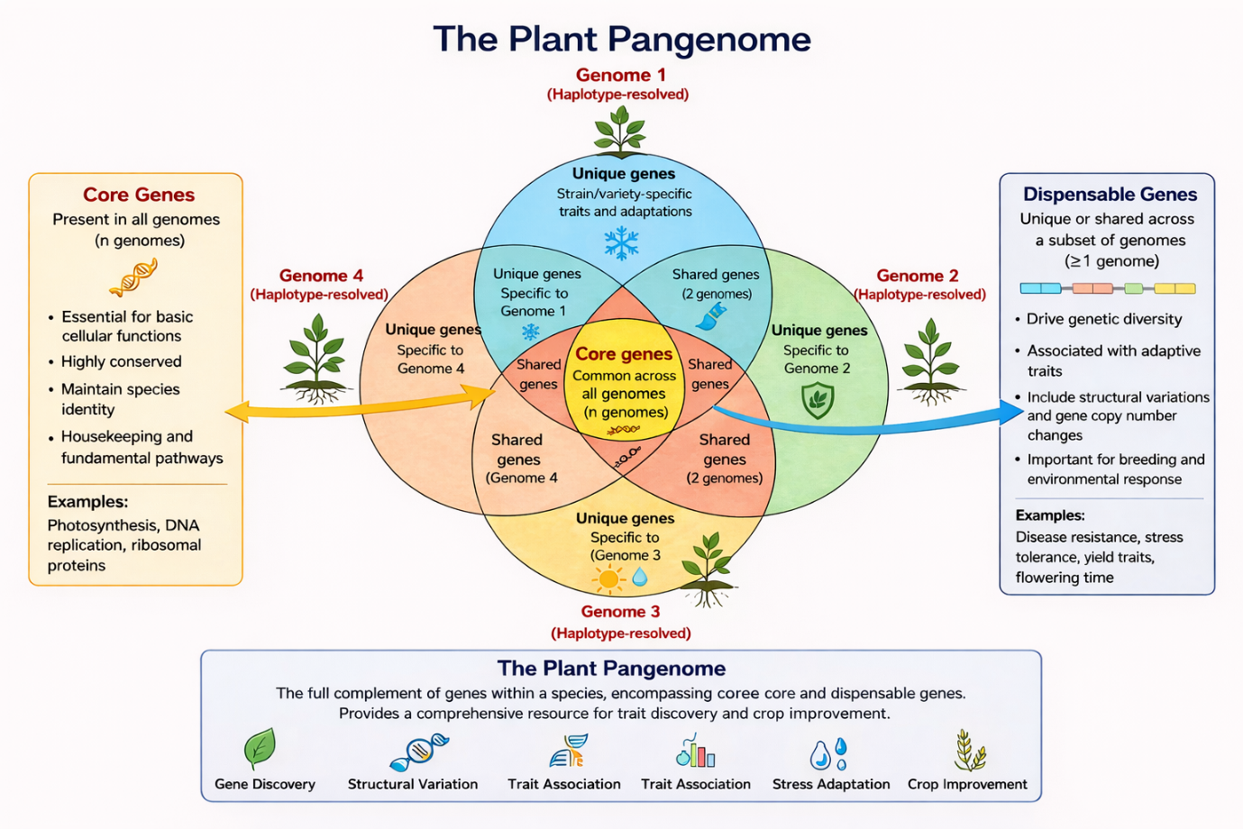
Figure 1: The plant pangenome, showing core and dispensable genes that contribute to essential functions and genetic diversity.
Sequencing technologies and computational tools are likely to enhance the quality of assemblies of genomes with better haplotype resolution. According to Gladman et al. (2023), the research in plant genomics is quickly evolving with the innovation in long-read sequencing and genome block assembly algorithms. With the ever-decreasing cost of sequencing and ever-improving bioinformatics, haplotype-resolved genome assemblies will become increasingly readily available to crop improvement programmes across the globe.
The combination of haplotype-solved genomes with pan genomics and artificial intelligence breeding strategies will be important in generating crop varieties with high yields and resistant to climate change in the future.
2. Tools used in haplotype-resolved genome assemblies
This section provides an overview of the key tools and approaches commonly employed in haplotype-resolved genome assembly workflows. The major tools discussed include trio binning, Hi-C scaffolding, Oxford Nanopore sequencing, PacBio HiFi sequencing, Long Phase, and gamete/sperm sequencing, which collectively enable accurate haplotype separation, long-read assembly, and chromosome-scale genome reconstruction.
The relevance of haplotype-resolved genome assemblies is especially strong with crops with complicated genome organization. Cassava, grapevine, potato, and strawberry are many economically important crops that have strongly heterozygous or polyploid genomes. According to Qi et al. (2022), the haplotype-resolved genome assembly in cassava showed that there was a wealth of allele-specific gene expression patterns and structural variation that was not evident in collapsed genome assemblies. On the same note, Song et al. (2024) reveal that the step-by-step genome assembly of an octoploid strawberry revealed the diversity of genetic changes between subgenomes, which offers new explanations about genome evolution.
High-resolution genome assemblies based on haplotype have become an effective answer to this shortcoming. Haplotype-resolved assemblies recombine chromosome copies one at a time, instead of collapsing homologs into one consensus sequence. Guk et al. (2022) show that the use of haplotype-resolved genome assembly can currently effectively separate parental haplotypes and maintain allele-specific information throughout the entire genome. This would enable scientists to examine how genes vary in detail.
Genome assembly based on haplotype could be realised with increasing approval because of recent technological advances. Long-read sequencing systems like the PacBio HiFi sequencing offer longer and more precise reads of the sequence, which have access to repetitive regions of plant genomes. According to Gladman et al. (2023), these new sequencing technologies are transforming plant genomics because they allow creating gapless assemblies of genomes. Besides this, chromosome conformation capture methods like Hi-C can give data on the spatial organisation of chromosomes, useful to assemble genome sequences on a chromosome scale. Hou et al. (2023) compare a number of Hi-C scaffolding tools and show their relevance in assembling plant genomes more accurately. According to Li et al. (2025), the pangenomes consist of universal and non-essential genes that cause phenotypic variations in all people.
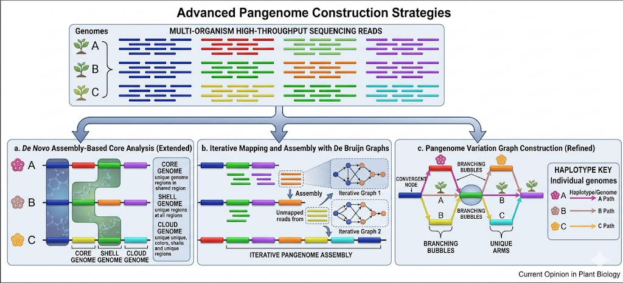
Figure 2: Schematic diagram illustrating three primary approaches for pangenome construction
Understanding haplotype diversity within crop genomes, therefore, provides a stronger foundation for studying plant evolution and improving crop breeding strategies.
Genome assembly based on a haplotype resolved usually follows a number of steps. To begin with, data on a platform like PacBio HiFi or Oxford Nanopore sequencing are obtained as high-quality long-read sequencing. According to Gladman et al. (2023), long-read technologies generate sufficiently long sequencing reads that allow continuous assembly of genomes that contain repeats. The reads are sequenced, and bioinformatics algorithms are applied to identify variations in genomes and phase out the sequences based on their haplotype ancestry.
The last step is the preparation of phased reads into contigs and scaffolds of a haplotype. Lin et al. (2022) proposed the algorithm Long Phase that allows phasing genomic variants on a chromosome scale much faster. These are computing tools that are necessary in the reconstruction of haplotype-resolved genomes in an efficient manner.

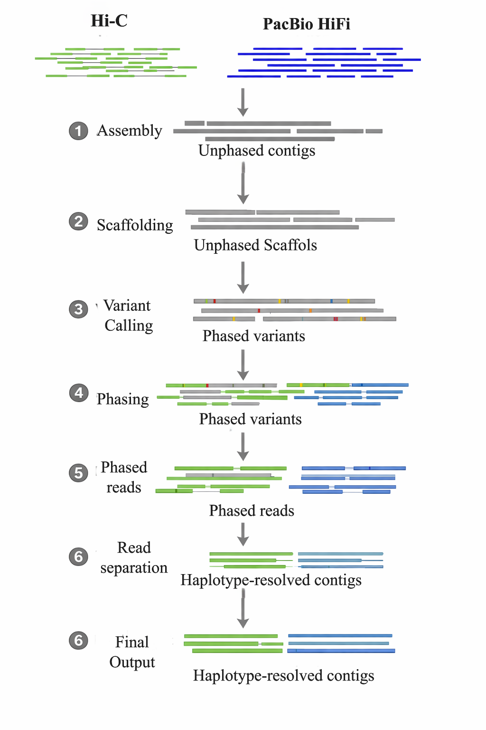

Figure 3: Workflow of haplotype-resolved genome assembly using HI-C and PacBio HiFi data, from assembly and scaffolding to variant calling, phasing, and generation of haplotype-resolved contigs.
By preserving allele-specific sequence information, haplotype-resolved assemblies provide a more accurate representation of genome structure and genetic diversity.
Table 1. Comparison of experimental and computational approaches for haplotype-resolved genome assembly, emphasizing haplotype phasing accuracy, assembly continuity, and structural variation detection.
Tool / Method | Principle | Key Advantage | Reference
Trio binning | Uses parental sequencing data to separate haplotypes before assembly. | Highly accurate phasing in heterozygous genomes | (Delorean et al., 2023)
Hi-C scaffolding | Uses chromosome conformation capture to organise sequences at the chromosome level. | Improves assembly continuity and chromosome-scale accuracy. | (Hou et al., 2023)
Oxford Nanopore sequencing | Generates ultra-long sequencing reads. | Resolves repetitive regions and structural variations | (Foster et al., 2026).
PacBio HiFi sequencing | Produces long, high-accuracy reads | High-quality assemblies with fewer errors | (Gladman et al., 2023)
Long Phase | Computational phasing of genomic variants | Fast and efficient chromosome-scale haplotype phasing | (Lin et al., 2022)
Gamete/sperm sequencing | Direct sequencing of haploid cells | Accurate haplotype reconstruction and recombination mapping | (Zhang et al., 2025)

3. Haplotype-resolved genome assembly analysis
3.1 In heterozygotes and polyploids
A haplotype is a cluster of alleles that are inherited together as a unit along a chromosome by one parent. In diploid organisms, there are two haplotypes on each pair of chromosomes; one is a haplont inherited by the maternal parent and the second haplont inherited by the paternal parent. The traditional approaches of genome assembly usually combine these haplotypes into one consensus sequence. It has also been shown that this process causes the loss of the potential to identify allele-specific variation and no analogous chromosomal structural variations (Kong et al., 2023).
Genome assembly using haplotype-resolved genome assembly solves this problem by solving each haplotype separately. Guk et al. (2022) explain that using de novo phasing methods enables a researcher to differentiate between maternal and paternal populations in their DNA sequences during genome assemblies. The process maintains valuable genetic diversity that has an effect on the phenotype of plants.
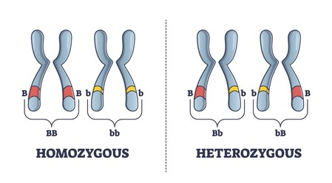
Figure 4: Comparative illustration of a homozygous vs a heterozygous pair of chromosomes
It is on these differences in alleles that researchers can be able to establish a useful genetic diversity which can be used in breeding programmes.
Polyploidy is the presence of more than two sets of whole chromosomes in an organism. Polyploids are quite common in plants, and they have been instrumental in the evolution and diversification of several crop species. Several staple foods, such as wheat, potato, cotton, strawberry, sugarcane, and banana, are polyploid. Such genomes are typically accomplished through hybridisation of species, and then, whole-genome duplication, and provide multivalent homologous chromosomes known as subgenomes. Although polyploidy can result in storing genetic diversity and adaptability, it can result in high complications during genome sequencing and assembly.
Bread wheat ( Triticum aestivum ) is one of the most notorious instances of a polyploid genome. Modern bread wheat is the hexaploid one with three kinds of sub-genomes, i.e., A, B, and D. These sub-genomes were created due to the occurrence of hybridisation between the obsolete species that existed as diploids and then the duplication of the chromosomes. It is this process that evolved to produce the sophisticated structure of the genome that is present in modern wheat. The only fact that represents the evolutionary basis of the polyploidization process of wheat is reflected in Figure 5, where the genomes of the diploids were combined to create the current hexaploid wheat genome.
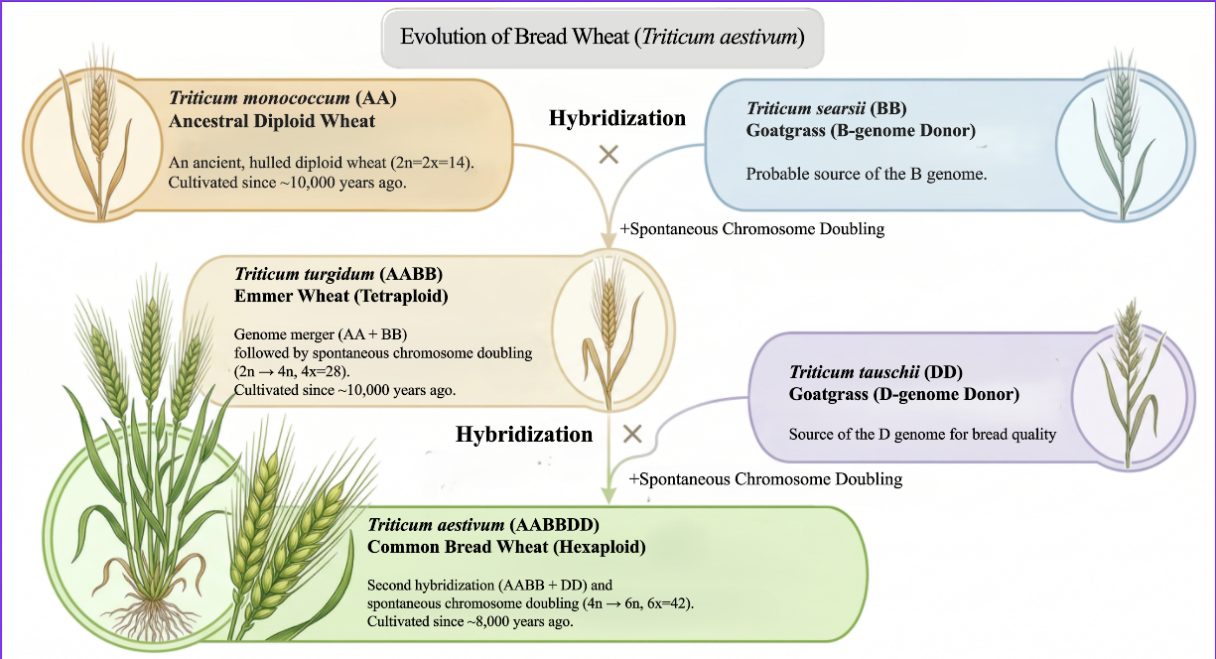
Figure 5: Evolution of bread wheat (Triticum aestivum) through hybridisation and chromosome doubling from diploid(AA, BB, DD) to tetraploid (AABB) and hexaploid (AABBDD) forms.
Other important crops also have a polyploid complexity of their genome. An example of such a crop is cultivated cotton, an allotetraploid Gossypium hirsutum, that developed as a result of hybridisation of two ancestral diploid cotton species. This has seen cotton have two very different subgenomes that go into the formation of fibre and other agronomic characteristics. Equally, sugarcane ( Saccharum spp.) also has one of the most intricate polyploid genomes of any crop plant, with numerous chromosome sets in it, based on inter-specific hybridisation. This polyploidy is especially problematic in genome assembly because more traditional sequencing methods would be used.
The genomic studies conducted recently have proven the relevance of this method in some polyploid crops. Song et al. (2024) produced an assembly of the genome of the octoploid cultured strawberry ( Fragaria ananassa) with no final gaps, where genetic and epigenetic analysis of subgenomes showed a significant difference. These variations determine the pattern of gene expression and lead to diversity in the development of the fruit and environmental adaptation. On the same note, Godec et al. (2025) generated a haplotype-resolved genome assembly of the tetraploid potato cultivar Désiré that identified structural variations and gene duplications linked to significant agronomic traits such as tuber development and disease resistance.
Besides these illustrations, other polyploid crops have been given good insights through haplotype-resolved genome analysis. Haplotype-resolved assemblies in cotton have assisted in establishing subgenome-specific gene expression patterns regulating fibre formation and quality. Genome-level haplotype analysis in sugarcane has allowed scientists to isolate highly repetitive regions and also provide genes that relate to sugar accumulation. Banana (Musa spp.), frequently present in triploid form, is also a genome where haplotype-resolved genome analysis is useful, enabling the researcher to study genome evolution and also identify genes involved in fruit development and disease resistance.
Likewise, genome assembly with haplotype resolution has also been used on grapevine to enhance the identification of disease resistance loci. Zou et al. (2023) created a multitiered approach of haplotype strategy, which improved the gradual assembly of resistance genes linked to downy mildew. Their findings indicate that resolved haplotype genomes have better genetic information than breeding programmes do. Djari et al. (2024) extended this study by creating a genome assembly of grapevine with haplotype resolution by producing a genome and creating an interactive transcriptome analysis platform. They reported that the haplotype data are beneficial in explaining the process of gene regulation and the growth of plants.
3.2 Structural variation and functional genomics
Identification of structural variations is another useful strategy for haplotype-resolved genome assemblies. The underlying changes may include structural variations that may affect the expression of genes and the adaptation of plants through insertions, deletions, inversions, and copy number changes. According to Wang et al. (2025), such changes in structures tend to be significant in the identification of crop characters, especially in stressful environmental conditions. Since haplotype-resolved assemblies maintain the sequence of each chromosome, researchers can precisely identify such variations and examine their mechanism of action.

4. Applications in crop improvement
Haplotype-resolved genome assemblies play an important role in crop improvement by identifying allele-specific variations linked to key traits. Their applications have been demonstrated in crops such as cassava, grapevine, wheat, potato, strawberry, cotton, sugarcane, and banana, aiding in better breeding strategies and trait selection.
Genome assemblies and haplotype-resolved assemblies are also useful in crop improvement and contemporary plant breeding. These assemblies enable the identification of the beneficial alleles that regulate important agronomic characteristics, including yield, resistance to disease, and environmental stress, using allele-specific genetic variation. Haplotype diversity analysis can provide plant breeders with valuable information that can subsequently be used to develop more effective breeding strategies.
Table 2: Overview of haplotype-resolved genome assembly studies in crop species, highlighting the use of long-read sequencing and Hi-C for resolving complex genomes and genomic variation.
Crop | Genome Type | Tools Used | Key Findings / Outcomes | Reference
Cassava (Manihot esculenta) | Diploid, highly heterozygous. | PacBio HiFi, Hi-C. | Revealed allele-specific gene expression and structural variation linked to stress tolerance and yield | (Qi et al., 2022)
Grapevine (Vitis vinifera) | Highly heterozygous. | Long-read sequencing, haplotype phasing. | Improved identification of disease resistance loci (downy mildew) and gene mapping accuracy. | (Liu, Z. et al. 2024)
Wheat (Triticum aestivum) | Hexaploidy (A, B, D genomes) | Hi-C, long-read sequencing. | Enabled subgenomes separation and identification of genes related to yield and stress tolerance | (Sun et al., 2023; Zhao & Shi, 2025).
Potato (Solanum tuberosum) | Tetraploid | PacBio HiFi, Hi-C. | Identified structural variation and gene duplication influencing tuber development and disease resistance. | (Godec, T., et al. 2025)
Strawberry (Fragaria × ananassa) | Octoploid | Long-read sequencing, phased assembly. | Revealed subgenomes divergence and epigenetic variation affecting fruit quality. | (Patrick P. Edger et al., 2019)
Cotton (Gossypium hirsutum) | Allotetraploid | Long-read sequencing, haplotype phasing. | Identified subgenomes-specific gene expression regulating fibre development. | (Maojun Wang et al., 2019)
Sugarcane (Saccharum spp.) | Highly polyploid | Long-read sequencing, genome phasing | Detected complex structural variation and genes controlling sugar accumulation. | (Zhao & Shi 2025)
Banana (Musa spp.) | Triploid | Long-read sequencing, haplotype assembly. | Provided insights into genome evolution, fruit. development and disease resistance. | (Nathalie D'Hont et al., 2012)

4.1 Haplotype-based breeding strategy and future prospects
A new application area for haplotype-resolved genome assemblies is the formation of haplotype-regulated breeding strategies. The conventional breeding approaches usually utilise phenotypic selection, which does not necessarily entail total representation of the underlying genetic variation that results in trait expression. Meena et al. (2025) proposed the idea of haplotype breeding, which entails establishing the desirable haplotype combinations with desirable traits and choosing these haplotypes when breeding programmes are involved. This would enable breeders to rapidly gain genetic enhancement by targeting particular allele combinations that lead to excellence in crop performance.
Another crop improvement has been achieved through genomics-assisted breeding. As Sun et al. (2023) note, genomic technologies are revolutionising the breeding of wheat since they allow searching and identifying genes related to the ability to withstand stress and diseases, as well as to the stability of yield. The superiority of genomic selection models lies in the haplotype-resolved genomes because they incorporate more information on allele-specific variation.

Genome assemblies that have been resolved to a haplotype will likely emerge as a focal point of plant genomics in the next few years. With the future (and ever-improving) of sequencing technology, including long-read sequencing and, more recently, Hi-C technologies, producing high-quality, chromosome-scale assemblies will no longer be exclusive to a small number of model crops. Instead, they are likely to be extended to a broader selection of economically and ecologically significant and understudied plant species.
One of the most promising avenues is the increasingly close relationship between haplotype-resolved assemblies and pangenome studies. A reference genome can enable researchers to more fully represent all the genetic diversity of a species. This will facilitate the recognition of crucial changes, particularly those that are associated with yield, stress resistance, and resistance to diseases, which go unnoticed when using conventional methods.
Meanwhile, the combination of artificial intelligence and machine learning is likely to transform the use of genomic data. Through integrating information on haplotype levels with predictive models, breeders and researchers will have the opportunity to make the most appropriate judgments about the complex traits of inheritance and make breeding decisions much faster and more accurately. This is especially crucial to polyploid crops, in whose genetic intricacy a history of progress has been difficult to maintain.
The other successes that need to be developed upon include integrating genomes that have been resolved through the haplotype with other biological data layers, including transcriptomics and epigenomics. This multi-omics method will assist in discovering the pattern of expression and regulation of various alleles during different environmental settings, and will provide more details on how plants adapt and perform.
Practically, the breeding mechanism will also change in terms of its strategies. Future programs are likely to target the combinations of haplotype benefits of the individual genetic markers, rather than taking a one-dimensional genetic approach. The change can enhance breeding performance and provide superior breeds with enhanced crop behaviour within a reduced period of time.
Though these are promising developments, certain challenges should still be tackled. These are enhancing computational requirements to work with very complex genomes, particularly in polyploid organisms, and to establish standardized workflows in assembly and analysis of genomes. Moreover, it will continue to be a significant consideration to manage and share large-scale genomic data.
On the whole, genome assemblies resolved using haplotype will be major in the future of crop improvement. A combination of these factors will lead to their role in coming up with resilient and high-yielding crops adapted to the changing environmental conditions as they become more and more integrated with emerging technologies and more approachable genomic methods.
5. Conclusion
Genome assemblies that have been resolved using a haplotype are an enormous breakthrough in plant genomics and crop enhancement studies. In contrast to traditional assemblies, which collapse homologous chromosomal sequences to a single consensus genome, Haplotype-resolved assemblies preserve allele-specific variation and structural variations between chromosome copies. These assemblies have proven particularly helpful in the assembling of the heterozygous and polyploid crops, whose complexity of the genome alone is inconvenient to the traditional methodologies of genome assembly. Haplotype-resolved genome assemblies can give more information about the genome organisation and evolution of plants by distinguishing haplotypes and detecting sub-genomic variation.
The synthesis of resolved genomes based on haplotype analysis and pangenome analysis, combined with genomic breeding, established new possibilities to enhance crop yield and resistance. As the sequencing technologies keep evolving, haplotype-solved genome assemblies become an even more significant part of the development of the next-generation crop varieties.
Conflict of Interest: The authors declare that they do not have any conflict of interest

References

- Bayer PE, Golicz AA, Scheben A, Batley J, & Edwards D (2020)
Plant pan-genomes are the new reference. Nature Plants, 6(8), 914–920.
https://doi.org/10.1038/s41477-020-0733-0
- Chen ZJ & Birchler JA (2013) Polyploid and hybrid genomics. Wiley-Blackwell.
https://doi.org/10.1002/9781118552872
- Crossa J, Pérez-Rodríguez P, Cuevas J, et al (2017) Genomic selection in plant breeding: Methods, models, and perspectives. Trends in Plant Science, 22(11), 961–975.
https://doi.org/10.1016/j.tplants.2017.08.011
- D’Hont A, Denoeud F, et al. (2012). The banana (Musa acuminata) genome and the evolution of monocotyledonous plants. Nature, 488(7410), 213–217. https://doi.org/10.1038/nature11241
- Delorean EE, Youngblood R C, et al (2023). Representing true plant genomes: haplotype-resolved hybrid pepper genome with trio-binning. Frontiers in Plant Science, 14, 1184112. https://doi.org/10.3389/fpls.2023.1184112
- Djari A, Madignier G, Di Valentin, et al (2024). Haplotype-resolved genome assembly and implementation of VitExpress, an open interactive transcriptomic platform for grapevine. Proceedings of the National Academy of Sciences, 121(23), e2403750121. https://doi.org/10.1073/pnas.2403750121
- Edger P P, Poorten T J, VanBuren R, et al. (2019). Origin and evolution of the octoploid strawberry genome. Nature Genetics, 51(3), 541–547. https://doi.org/10.1038/s41588-019-0356-4
- Garg S, Fungtammasan A, et al (2021).
Chromosome-scale, haplotype-resolved assembly of human genomes. Nature Biotechnology, 39(3), 309–312.
https://doi.org/10.1038/s41587-020-0711-0
- Gladman N, Goodwin S, et al (2023). Era of gapless plant genomes: innovations in sequencing and mapping technologies revolutionize genomics and breeding. Current Opinion in Biotechnology, 79, 102886. https://doi.org/10.1016/j.copbio.2022.102886
- Godec T, Beier S, et al. (2025). Haplotype-resolved genome assembly of the tetraploid potato cultivar Désirée. Scientific data, 12(1), 1044. https://doi.org/10.1038/s41597-025-05372-3
- Godec T, et al. (2025). Haplotype-resolved genome assembly of the tetraploid potato cultivar Désirée using PacBio HiFi and Hi-C. Horticulture Research. https://doi.org/10.1093/hr/uhaf075
- Golicz AA, Bayer PE, et al (2020).
Pangenomics comes of age: From bacteria to plant and animal applications. Trends in Genetics, 36(2), 132–145.
https://doi.org/10.1016/j.tig.2019.11.006
- Guk J Y Jang, M J Choi JW, et al. (2022). De novo phasing resolves haplotype sequences in complex plant genomes. Plant Biotechnology Journal, 20(6), 1031-1041. https://doi.org/10.1111/pbi.13815
- Hou Y Wang, L. et al. (2023). Comparison of hi-c-based scaffolding tools on plant genomes. Genes, 14(12), 2147. https://doi.org/10.3390/genes14122147
- Jang M J Cho, H J Park, et al. (2024). Haplotype-resolved genome assembly and resequencing analysis provide insights into genome evolution and allelic imbalance in Pinus densiflora. Nature Genetics, 56(11), 2551-2561. https://doi.org/10.1038/s41588-024-01944-y
- Kong W, Wang Y, et al. (2023). Recent advances in the assembly of complex plant genomes. Genomics, Proteomics & Bioinformatics, 21(3), 427-439. https://doi.org/10.1016/j.gpb.2023.04.004
- Kremling K A G, Diepenbrock C H, et al. (2019). Transcriptome-wide association supplements genome-wide association in maize. G3: Genes, Genomes, Genetics, 9(9), 3023–3033.
https://doi.org/10.1534/g3.119.400549
- Li T, Mohamedikbal S, et al. (2025). Pan genomics combined with artificial intelligence and precision breeding can accelerate crop improvement. Current Opinion in Plant Biology, 88, 102825. https://doi.org/10.1016/j.pbi.2025.102825
- Lin J H, Chen L C,et al. (2022). Long Phase: an ultra-fast chromosome-scale phasing algorithm for small and large variants. Bioinformatics, 38(7), 1816-1822. https://doi.org/10.1093/bioinformatics/btac058
- Liu Z, et al. (2024). Grapevine pangenome facilitates trait genetics and genomic breeding. Nature Genetics. https://doi.org/10.1038/s41588-024-01967-5
- Luo J, Wang Y, et al.(2024). Haplotype-resolved genome assembly of poplar line NL895 provides a valuable tree genomic resource. Forestry Research, 4, e015. https://doi.org/10.48130/forres-0024-0013
- Meena V K, Thribhuvan R, et al. (2025). Haplotype breeding: fast-track the crop improvements. Planta, 261(3), 51. https://doi.org/10.1007/s00425-025-04622-3
- Michael T P, & Van Buren R. (2020).
Building near-complete plant genomes. Current Opinion in Plant Biology, 54, 26–33.
https://doi.org/10.1016/j.pbi.2019.12.009
- Pucker B, Irisarri I, et al. (2022). Plant genome sequence assembly in the era of long reads: Progress, challenges, and future directions. Quantitative Plant Biology, 3, e5. https://doi.org/10.1017/qpb.2021.18
- Qi W, Lim YW, et al. (2022). The haplotype-resolved chromosome pairs of a heterozygous diploid African cassava cultivar reveal novel pan-genome and allele-specific transcriptome features. Gigascience, 11, giac028. https://doi.org/10.1093/gigascience/giac028
- Rhie A, McCarthy S A, et al. (2021).
Towards complete and error-free genome assemblies of all vertebrate species. Nature, 592(7856), 737–746.
https://doi.org/10.1038/s41586-021-03451-0
- Song Y, Peng Y, et al. (2024). Phased gap-free genome assembly of octoploid cultivated strawberry illustrates the genetic and epigenetic divergence among subgenomes. Horticulture research, 11(1), uhad252. https://doi.org/10.1093/hr/uhad252
- Sun C, Hu H, et al. (2023). Genomics‐assisted breeding: The next‐generation wheat breeding era. Plant Breeding, 142(3), 259-268. https://doi.org/10.1111/pbr.13094
- Sun S, Zhou Y, et al. (2018).
Extensive intraspecific gene order and gene structural variations between Mo17 and other maize genomes. Nature Genetics, 50(9), 1289–1295.
https://doi.org/10.1038/s41588-018-0182-0
- Varshney R K, Sinha P, et al. (2021). 5Gs for crop genetic improvement. Current Opinion in Plant Biology, 60, 101965.https://doi.org/10.1016/j.pbi.2020.101965
- Wang M, Tu L, et al. (2019). Reference genome sequences of two cultivated allotetraploid cottons (Gossypium hirsutum and Gossypium barbadense). Nature Genetics, 51(2), 224–229. https://doi.org/10.1038/s41588-018-0282-x
- Wang X, Liu C, et al. 2025. How structural variations influence crop improvement. International Journal of Molecular Sciences, 26(14), p.6635. https://doi.org/10.3390/ijms26146635
- Yi L, Sa R, et al. (2022). Chromosome-scale, haplotype-resolved genome assembly of Suaeda glauca. Frontiers in Genetics, 13, 884081. https://doi.org/10.3389/fgene.2022.884081
- Zhang H, Lang Z, et al. (2018).
Dynamics and function of DNA methylation in plants. Nature Reviews Molecular Cell Biology, 19(8), 489–506.
https://doi.org/10.1038/s41580-018-0016-z
- Zhang T, Zhou , et al. (2022). Complex genome assembly based on long-read sequencing. Briefings in Bioinformatics, 23(5), bbac305. https://doi.org/10.1093/bib/bbac305
- Zhang W, Tariq A, et al. (2025). Plant sperm cell sequencing for genome phasing and determination of meiotic crossover points. Nature Protocols, 20(3), 690-708. https://doi.org/10.1038/s41596-024-01063-2
- Zhang X, Li D, et al. (2024). Haplotype-resolved assembly of auto-polyploid genomes via combining Hi-C and gametic data. Scientific Reports, 14(1), 7892. https://doi.org/10.1038/s41598-024-58623-5
- Zhao Z, & Shi T. (2025). Haplotype-Resolved Assembly in Polyploid Plants: Methods, Challenges, and Implications for Evolutionary and Breeding Research. Genes, 16(6), 636. https://doi.org/10.3390/genes16060636
- Zhou Y, Chebotarov D, et al. (2020).
A platinum standard pan-genome resource that represents the population structure of Asian rice. Scientific Data, 7, 113.
https://doi.org/10.1038/s41597-020-0438-2
- Zou C, Sapkota S, et al. (2023). A multitiered haplotype strategy to enhance phased assembly and fine mapping of a disease resistance locus. Plant Physiology, 193(4), 2321-2336. https://doi.org/10.1093/plphys/kiad494

