Review Article
Integrated multi-omics approach for the enhancement of secondary physiological traits to develop abiotic stress tolerance in cereal breeding.

Abstract:
Salinity, drought, and heat are abiotic stresses that significantly impact the yield of major cereals. Strong genotype × environment interactions make traditional yield-based selection unreliable under stress. Secondary traits like osmotic adjustment, stomatal conductance, and chlorophyll fluorescence have emerged as reliable indicators of stress resistance. Rice genotypes with good stomatal conductance and sodium exclusion mechanisms exhibit high salinity tolerance. Wheat genotypes with low canopy temperature and high stomatal conductance are associated with high drought tolerance and yield stability. Sorghum stay-green lines maintain photosynthesis under water stress, while shorter anthesis-silking intervals and improved stay-green phenotypes aid maize drought resistance.

Multi-omics techniques offer deeper insights into molecular and metabolic stress adaptation. Examples include metabolomic analyses of wheat and rice during drought, which reveal the accumulation of soluble sugars and osmoprotectants, and genomic studies, such as genome-wide association studies (GWAS) and quantitative trait locus (QTL) mapping, that identify loci associated with stress-responsive phenotypes. Utilising secondary physiological traits in conjunction with multi-omics and high-throughput phenotyping (HTP) platforms provides a robust foundation for developing climate-resilient grain varieties and accelerating genetic improvements. This approach holds immense potential for ensuring global food security by developing crop varieties that can withstand changing climate conditions, thereby stabilising yields and reducing vulnerability to environmental stresses.

Keywords: Secondary Physiological traits, abiotic stress, multi-omics technology, cereal breeding.

- Introduction:
Global food systems are run on cereal crops. However, abiotic stresses such as drought, salinity, heat, cold, and soil toxicity are reducing the productivity of these crops. These environmental constraints interfere with physiological processes, such as photosynthesis, nutrient absorption, and metabolic activities, eventually reduce crop production and stability (Roychowdhury et al., 2023). The increased climatic variability has also led to an amplification of stressors in agricultural systems across the world (Koshariya, 2022). Food and Agriculture Organisation (FAO) 2025 estimates indicate that 40% of the land is already degraded, affecting 3.2 billion people and posing challenges for biodiversity and global food security.
Abiotic stresses cause both acute and sub-acute responses; the former is a case where cell death is a direct effect (ROS accumulation), and the latter is a case where the crop prepares to respond to the stress by epigenetic memory (Atta et al., 2023; Ganie et al., 2024). Sub-acute stress, i.e. DNA methylation, histone changes, and chromatin rearrangements that do not change the main sequence of the DNA but have a strong impact on the transcriptional plasticity of the plant (Singh et al., 2021).
One such case of sub-acute responses where salinity stress causes RNA-directed DNA methylation (RdDM) in Zea mays, which has been dispersed through the germline and is mediated by the KTF1 protein (Wang et al., 2025). Unlike the progeny of naive parents, this gives produces off-springs with a pre-stressed epigenetic configuration, which is defined by enhanced salt rejection, and increased biomass growth in saline habitats (Wang et al., 2025; Atta et al., 2023). These findings indicate the significance of sub-acute stress as a signal to resilience and phenotypic response in unpredictable ecosystems.
Recent studies in both legumes and cereals have revealed that heat and drought stress break the sink-source relationship, as the plant is no longer able to produce enough sucrose for the growing grain, resulting in lower grain weight and number (Sukumaran et al., 2021; Jha et al., 2021). Abiotic stresses often co-exist in a natural environment due to the interdependent nature of their pathways, influencing crops' physiological, metabolic, and cellular processes (Sachdev et al., 2021) because of the interdependency of their pathways.
Conventionally, breeding programs have been based on grain yield-based selection. Nevertheless, yield is a multifaceted quantitative trait that strongly depends on environmental variability, so it cannot be considered an important selection criterion during stress periods (Raffo and Jensen, 2023). To address these limitations, plant breeders are using secondary physiological traits that provide indirect evidence of stress tolerance.
Recent developments in molecular biology have improved crop enhancement through integration with multi-omics technologies. Such methods enable the discovery of genetic variation, gene expression patterns, protein-protein interactions, and stress-related metabolic pathways. Such datasets can be integrated to elucidate the regulation of complex networks underlying plant adaptation to abiotic stress and to produce climate-resilient cereal crops (Roychowdhury et al., 2023; Satrio et al., 2024). A new era of omics-assisted breeding, combining multi-omics approaches for specific abiotic stress tolerance with genome-assisted breeding (GAB) to improve crop yield, quality, and related agronomic traits (Roychowdhury et al., 2023). A successful approach for recognising the biochemical basis of stress adaptation is metabolite profiling across species and cultivars with different levels of stress tolerance (Raza, 2020). Variations in metabolite composition can be used as markers for stress tolerance and represent the physiological state (Carrera et al., 2021). Therefore, these metabolite profiles can be employed as predictive biomarkers in crop development and screening, especially for identifying genotypes that are resistant to stress (Mashabela et al., 2023). Additionally, this method makes it possible to identify qualitative and quantitative variations in metabolites linked to phenotypes that are stress-tolerant (Salam et al., 2023). For example, comparative metabolomic analysis of drought-tolerant and sensitive genotypes of rice (Oryza sativa L.) has revealed that the tolerant genotypes accumulate more osmo-protectants, such as proline, soluble sugars, and amino acids, which aid in osmotic adjustment and cellular protection under stress (Głuchowska et al., 2025).
- Theoretical Framework of Secondary Traits
The secondary physiological characteristics are rather significant in enhancing the effectiveness of selection in breeding crops. These characteristics are not directly related to yield, but they offer desirable data on plant adaptation to environmental stress. The trait should be of breeding value since it should have a medium to high level of heritability and should positively correlate with grain yield in a stress environment, stable and non-destructive (Wang et al., 2022), . Characteristics like canopy temperature depression and stomatal conductance are common since they exhibit high correlations with plant water status and water transpiration efficiency (Lepekhov, 2022).
Physiological breeding, theoretically based concept of ideotype. Under this concept, breeders construct an ideal plant type that has a given set of characteristics that result in productivity under given environmental conditions. As an example, ideotypes of drought-resistant cereals often have a deep root system, water efficiency, and late leaf senescence (Djanaguiraman et al., 2024). The other factor of significance is the economic viability of the measurement of physiological characteristics. Some of the traits may demand advanced technology, but others are measurable with relatively basic methods, hence making them appropriate in a large-scale breeding program (Raffo and Jensen, 2023).
Through the integration of omics technology, breeders can target the underlying molecular drivers of resilience, such as reduced silking intervals (ASI) in maize, osmotic adjustment in wheat, and sodium exclusion in rice, rather than just measuring surface-level traits like yield (Langridge & Reynolds 2021). In order to compute Genomic Estimated Breeding Values (GEBVs), this multi-layered data is combined using strong predictive frameworks such as GBLUP and Bayesian Alphabet models, which take into consideration the high-dimensional nature of omics data (Varshney et al., 2021).

2.1. Water-Relations and Cooling Traits
Water-related physiological traits provide critical information about plant adaptation to drought and heat stress conditions.

Canopy Temperature Depression
Canopy temperature depression (CTD) is the variation between ambient air temperature and plant canopy temperature. Plants with the ability to keep the canopy cooler usually are more efficient in transpiration and access water more easily through the soil (Lepekhov, 2022). This attribute has been a popular tool in wheat breeding programs to select drought-tolerant genotypes. Radiation, wind speed, and soil moisture availability are some of the environmental conditions that impact CTD. Research has indicated that wheat genotypes that have low heat stress canopy temperatures tend to give better grain yields than relatively vulnerable genotypes (Wang et al., 2022). CTD values exhibited a significant correlation with yield under drought and heat stress in a large scale of experiments (Sohail et al., 2020). A simple linear regression is revealed through (Kaur et al., 2018), wherein if CTD decreases by 1 °C, the yield declines by 1.5 and 1.7 q/ha. Wheat research has also demonstrated a strong correlation between increased grain counts and yield stability and a cooler canopy during the reproductive stage (Yildirim, M. et al. 2008). In rice systems, through the evidential work of (Tian et al. 2024), the heat-tolerant varieties maintained lower canopy temperature and higher stomatal conductance, which reveals that canopy temperature is likely the most reliable indicator for rice crop to withstand heat.

Stomatal Conductance
Stomatal conductance controls the exchange of gases between the atmosphere and the plant leaves. The stomata are controlled in an efficient manner, so plants can photosynthesise and lose little water (Zhang et al., 2023). Stomatal reactions vary between leaves and reproductive structures in rice crop during drought, which emphasises the complexity of the physiological traits under the stress condition (Zhang et al., 2023). Genotypes of wheat that experience drought stress at low canopy temperature exhibit enhanced yield because of an efficient process of transpiration, whereas rice genotypes that experience water shortage have regulated stomatal conductance (Lepekhov, 2022; Zhang et al., 2023). Through studies conducted by (El Sabagh et al., 2017) under drought stress, it was concluded that stomatal conductance is closely connected with grain yield, indicating better grain output and can be used as a selection criterion to identify the drought stress genotypes in maize under Mediterranean conditions. A study conducted by the US Department of Energy to investigate the transcriptome approach for drought on Sorghum, findings state that nearly 44% of the genome is responsive to drought, and the increased level of photosynthetic gene up-regulation and chlorophyll maintenance during recovery distinguish pre-flowering tolerant lines (Varoquaux et al., 2019).

Through the Nested Near Isogenic Lines, an integrative approach of Genome Wide Association Studies (GWAS) and Transcription Wide Association Studies (TWAS) in maize demonstrated an association between cuticle conductance and ISTL1 (Increased Salt Tolerance-Like1) and proved that wax chemistry (fatty acids, aldehydes) drives cuticular water permeability rather than just cuticle thickness or stomatal structure, providing insights into future cereal breeding (Lin et al., 2022). Studies by (Ouyang et al. 2017) on rice and wheat explains that transpiration efficiency is governed by the balance of stomatal conductance (gs) and mesophyll conductance (gm). To measure the gas exchange, a fluorescence chamber head (Li-Cor 6400XT; USA) and chlorophyll fluorescence were used at three levels of moisture content, suggesting that for improved water use efficiency, in rice, the ratio of gm/gs should be made to higher levels under drought conditions.

2.2 Photosynthetic Stability and Pigment Traits
Photosynthesis is highly sensitive to environmental stress. Therefore, maintaining photosynthetic stability under adverse conditions is essential for crop productivity.

Chlorophyll Fluorescence
A non-destructive method to examine the operation of photosystem II (PSII), a key component of the light-dependent reactions in photosynthesis, is chlorophyll fluorescence analysis, which is performed on leaf samples. In stressful environments, the photosynthetic apparatus can lower the efficiency of PSII, leading to lower values of fluorescence. Abiotic stresses, especially salinity, cause changes in the composition and the functioning of chloroplasts, which in turn affect the photosynthetic activity. Research carried out on barley genotypes revealed that salt-tolerant genotypes exhibit higher chlorophyll fluorescence levels than sensitive genotypes, suggesting that the photosynthetic system is more stable under salinity stress (Hammami et al., 2024).
Another work on barley of (Makhtoum et al., 2023) explained the importance of chlorophyll inflorescence for the study of drought and salinity, where under stress, higher photosynthetic capacity genotypes can be used in Marker Assisted Selection (MAS) programs, and it is identified that upon multiple or combined stress, i.e., salinity, heat and drought, the photochemical, PS II efficiency and quantum yield decreases, increasing non-photochemical quenching (photo-protective mechanism). The work on the Recombinant Inbred Lines (RIL) population of (Makhtoum et al. 2022), which covers the genes controlling stomata length, leaf number, leaf weight, and genetic score, identifies the significance of chromosomes 1, 4, 5, and 7 under salt stress. QTLs (8, 9, and 26) for normal, drought, and salinity have been identified using Composite Interval Mapping (CIM). Additionally, novel alleles (qLWS-4a, qSLS-4, qLNS-7b, qSCS-7, and qLNS-7a) have been identified, promoting innovative strategies to enhance barley's ability to tolerate salinity.

Stay-Green Trait
The stay-green (SG) trait is the early delay in the onset of senescence of the leaves during grain filling. Plants with this property live longer in terms of chlorophyll content and photosynthetic activity. Stay-green genotypes of sorghum can maintain active photosynthesis during drought times, which also leads to enhanced grain filling and sustained yield in the face of water scarcity (Djanaguiraman et al., 2024). On a comparative genomic study on rice, three potential candidate genes (GRMZM2G359974, GRMZM2G301884, and GRMZM2G083894) were identified through Mega QTL analysis which are related to kernel weight and size in maize (Chen et al., 2017; Kamal et al., 2022) and QTL mapping of RIL population using Simple Sequence Repeats (SSR), 23 QTLs have been identified for chlorophyll content, PS II, photochemical efficiency, stay green at maturity and confirmed that stay green QTL’s are significantly correlated to plant yield (Yang et al., 2017; Kamal et al., 2022) and the importance of transcriptional factor NAC 7 to improve SG in maize laid out by (Zhang et al., 2019; Kamal et al., 2022).

Vegetation Indices

Remote sensing technology has been utilised to rapidly evaluate plant health using vegetation indices such as the Normalised Difference Vegetation Index (NDVI). These indices contain novel information on canopy structure, biomass growth, chlorophyll content, and crop vigour can be used to monitor the reaction of plants to environmental stress in the case of large breeding populations (Skendžić et al., 2023). Barley genotypes that retain chlorophyll fluorescence are more salinity-tolerant, and sorghum stay-green genotypes continue photosynthesis and grain filling during drought (Hammami et al., 2024; Djanaguiraman et al., 2024). Changes in ionic balance, stomatal conductance, and transpiration that contribute to maize tolerance to drought and high temperatures can be measured by ultraviolet spectrum (UV) (Huang et al., 2016). Infrared Thermography (IRT) has been used to measure temperature differences between leaves, air, and canopies under heat and drought stress (Boote et al. 2016). Spectroscopy to track the rate of photosynthetic activities of leaves and canopies in response to the initial stages of drought (Boote et al. 2016; Farooqi et al., 2022), supporting efficient selection in cereal breeding.

2.3. Biochemical and Osmotic Traits
Abiotic stresses like drought and salinity on plants result in various biochemical and physiological adaptive changes that allow plants to sustain cellular homeostasis and survive in harsh environmental conditions. These biochemical reactions are important in the defence of the cellular structures, stabilising the metabolic activities, and maintaining the growth of plants under stress exposure.
Osmotic adjustment involves the build-up of osmolytes in plant cells to balance water in water-depriving conditions. Such osmolytes are made of proline, glycine betaine, soluble sugars, and organic acids, which are necessary to preserve the turgor pressure and prevent damage to cellular membranes and proteins caused by dehydration. These compounds reduce the osmotic potential of the cell and thus help the plants to retain water and maintain the metabolic activities in case of drought stress (Bhutto et al., 2023). Proline is one of these osmolytes, which has received a lot of attention because of its various protective properties, such as osmotic control, antioxidant and stabilisation of the macromolecules. It has been extensively reported that increased proline accumulation is a major physiological memory that is linked with enhanced drought resistance in various cereal plants, such as maize and wheat (Khan et al., 2025).
Besides osmotic adjustment, crops exposed to salinity stress perform ionic movement to prevent sodium ions (Na+) from being accumulated in sensitive tissues that are toxic. Salt-tolerant plants attain this through selective ion uptake, root exclusion of sodium, and decompartmentalization of sodium ions into vacuoles, which maintain cellular potassium (K+) homeostasis (Shahzad et al., 2022). Figure 1 shows the physiological processes and critical pathways that make plants salinity-tolerant. Genetic research has also found vital genomic areas governing sodium rejection, a Saltol locus in rice, which is significant in the regulation of Na+ transport and the tolerance of salinity in rice varieties (Lokeshkumar et al., 2023).
Numerous reactive oxygen species (ROS), especially hydrogen peroxide, are essential for the detection of both biotic and abiotic stress, the integration of various external signals, and the activation of stress-response networks, all of which support the development of defence mechanisms and plant resilience (Mittler et al., 2022).
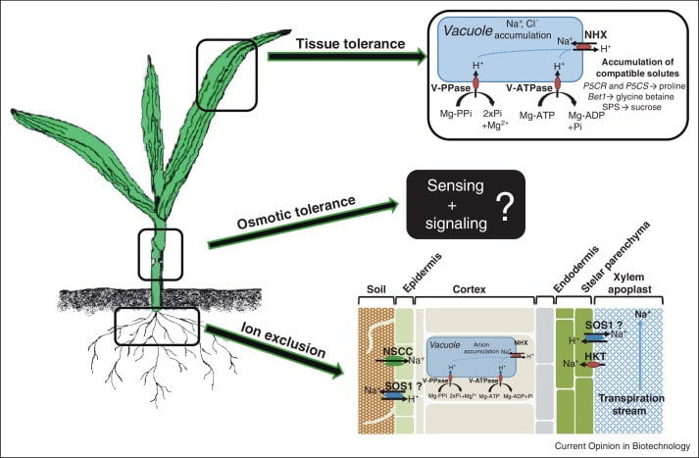
Figure 1: Mechanisms of salinity tolerance, including ion exclusion and osmotic adjustment in plants (Shahzad et al., 2022
- High-Throughput Phenotyping Technologies
The current developments in high-throughput phenotyping (HTP) systems have assisted plant breeders greatly in testing large breeding populations in field and controlled environmental conditions. Conventional phenotyping methods are often manual, time-consuming, labour-intensive, and not scalable. Conversely, a recent generation of high-throughput phenotyping systems is based on innovative imaging technology, sensor-based monitoring systems, and automated data analysis software to provide efficient, low-cost, and rapid measurement of plant phenotypes. Such technologies allow breeders to record large phenotypic data in response to different stresses, which enhances the effectiveness of the selection process in breeding programs (Sheikh et al., 2024).
The most commonly used HTP applications include unmanned aerial vehicles (UAVs), drones with multispectral, hyperspectral, and thermal sensors. Large experimental fields are rapidly covered by these aerial platforms, generating high-resolution images containing much information about the structure of the canopy and plant vigour and physiological status of crops. Vegetation indices commonly calculated by multispectral sensors include the Normalised Difference Vegetation Index (NDVI), which is used in determining plant biomass and chlorophyll content. In a similar way, thermal sensors can be used to measure the canopy temperature, a critical parameter for the water status of vegetation and its ability to transpire efficiently during drought (Gono et al., 2024). The overall process of the UAV-based phenotyping systems can be visualised as shown in Figure 2. With the combination of remote sensing technologies and image-processing algorithms in conjunction with machine learning methods. This has made high-throughput phenotyping technologies necessary mechanisms to expedite genetic gain and enhance the selection of stress-tolerant genotypes in present-day crop breeding programs (Sheikh et al., 2024).

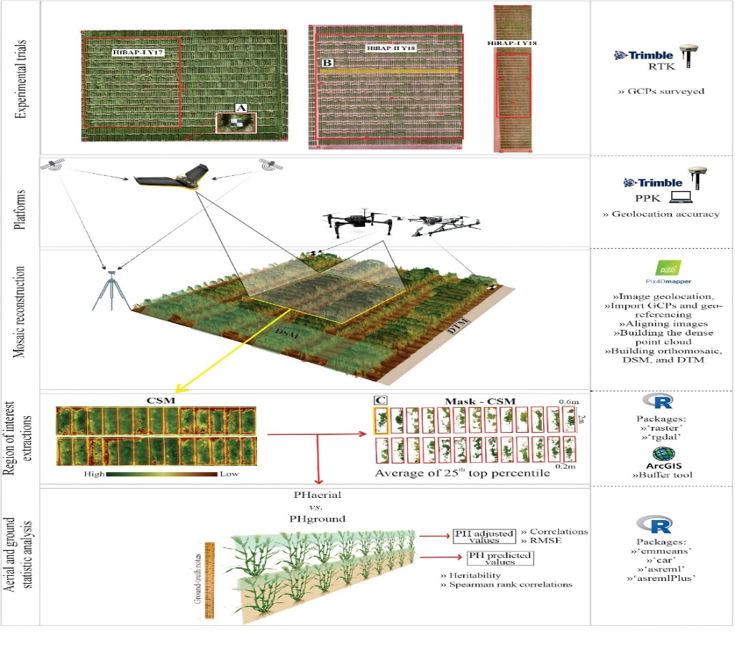
Figure 2: Illustrates how aerial images are gathered, processed, and analysed to obtain suitable plant features.

Crop | Abiotic stress | Trait Phenotyped | HTP Technology | Key Findings | References
Wheat, barley | Drought, nitrogen stress | Evapotranspiration, respiration, and spectral traits | Hyper spectral + IR imaging | Identified physiological responses across growth stages for stress tolerance | (Paul et al., 2025)
Cereals & crops | Drought, heat, salinity | Root/shoot traits, chlorophyll content, canopy temperature | AI-integrated imaging, multispectral sensors | Enabled non-destructive, continuous monitoring | (Angidi et al., 2025)
Maize, wheat | Multiple stresses | Spectral indices, canopy traits | Remote sensing + machine learning | Integration of ML improved stress detection accuracy and selection efficiency | (Gill et al., 2022)
Wheat | Heat, drought | Growth rate, biomass accumulation | Controlled-environment phenotyping chambers | Developed a precise environmental simulation for stress screening | (Ren et al., 2022)
Wheat, rice, maize | Drought, heat, salinity | Canopy temperature, NDVI, chlorophyll fluorescence | UAVs, thermal imaging, multispectral sensors | Enabled rapid screening of large germplasm for stress-adaptive physiological traits | (Islam et al., 2021)
Cereals | Drought | Root architecture, stomatal conductance, biomass | Imaging platforms, automated phenomics systems | Identified key drought-adaptive traits for breeding programs | (Kim et al., 2021)

Table 1: HTP tools and targets for the abiotic stresses in cereal breeding.
- Genomic Basis of Secondary Traits
The genomic technology has made a lot of progress in understanding the genetic mechanisms of secondary physiological traits related to abiotic stress tolerance in cereals. Numerous of them, such as root structure, canopy temperature, and water-use efficiency, are numerically inherited and are regulated by several genes. This has resulted in genomic methods like GWAS, QTL mapping and genomic selection have gained prime importance in identifying genetic determinants that can lead to stress adaptation. Genome-wide association studies allow scientists to describe the associations between genetic markers and phenotypic characters among samples of a diverse germplasm. GWAS can identify genomic regions in association with significant agronomic traits by studying the occurrence of SNP variants in the genome. GWAS in wheat has identified multiple genomic regions that are linked to both drought tolerance and micronutrient accumulation, which is insightful information about the genetic mechanism of adaptation to stress conditions (Devate et al., 2022).
On the same note, genetic loci of root system architecture and water-use efficiency, essential characteristics of drought resistance in wheat, have been identified using QTL mapping techniques (Sallam et al., 2022). Moreover, genomic selection also aims at using genome-wide molecular markers to predict the breeding value of individuals before conducting extensive phenotypic screening. This method allows breeders to reduce the generation duration and obtain a higher genetic profit in crop development programs (Ma and Li, 2024).
The functions of Transcription Factors (TFs) in maize responses to abiotic stressors have been emphasised in several studies. Genes encoding antioxidant enzymes, synthase, and molecular chaperones linked to the endoplasmic reticulum stress response were expressed more when this TF was overexpressed. Therefore, during the vegetative and reproductive stages, lines maintained increased photosynthesis, enhanced dehydration, and drought stress tolerance, which increased maize grain yield under drought-stressed circumstances (Farooqi et al., 2022).
- Multi-Omics Integration in Crop Improvement
Multi-omics integration has now become an effective tool for investigating the complex metabolomic reactions in plants in response to abiotic stress and accelerating crop improvement. Multi-omics is the collective study of multi-layers of biological data, such as genomics, transcriptomics, proteomics and metabolomics. These omics platforms offer their own perspectives across various fields of plant biology. Genomics represents those genetic variations linked with stress tolerance, transcriptomics represents the examination of gene expression connections, proteomics represents the amount and interaction of proteins, and metabolomics represents the examination of the biochemicals implicated in plant metabolism. Combining these datasets, scientists will be capable of deriving a full picture of the molecular networks involved in regulating the plant responses to environmental stresses (Roychowdhury et al., 2023). Recent developments in high-throughput technology and bioinformatics software have made tremendous improvements to the creation and analysis of vast volumes of molecular data. With the current technological advances, researchers can associate genetic variation and physiological characteristics and metabolic throughputs of stress adaptation (Satrio et al., 2024). According to transcriptome studies (RNA-seq) conducted by (Schmidt et al., 2018) the findings exhibit that the salinity-tolerant rice cultivars respond to salinity more quickly than sensitive ones, and they also induce H₂O₂ and signal transduction earlier. By restricting salt to roots and old leaves and turning on photosynthesis-related genes in new leaves, salinity-tolerant plants build up an adaptation program. According to functional genomics studies, the transcription factors encoded by the ZmWRKY40 and ZmNF-YB2 genes give maize improved resistance to drought (Gangola and Ramadoss 2020). Moreover, artificial intelligence and machine learning algorithms have been applied, which have improved the analysis of large omics data. Such computational methods make it possible to identify important candidate genes and regulatory mechanisms related to stress tolerance and contribute to creating climate-resistant varieties of crops (Syeda, 2025). The application of metabolomics in studying the plant stress response is critically important in the analysis of small molecules of metabolic processes.
- Poor fatty acid composition in wheat has been identified in metabolomic analysis as a result of drought stress and recovery (Ullah et al., 2022).
- The compatible solutes, including proline, have the role of stabilising proteins and cell membranes in times of stress exposure (Khan et al., 2025).
- Such sophisticated analytical methods, such as gas chromatography-mass spectrometry and liquid chromatography-mass spectrometry, enable researchers to identify hundreds of metabolites simultaneously (Raza, 2022).
- The need to make metabolic adaptations to enhance the resilience of plants in response to environmental stress conditions has been emphasised recently (Głuchowska et al., 2025).

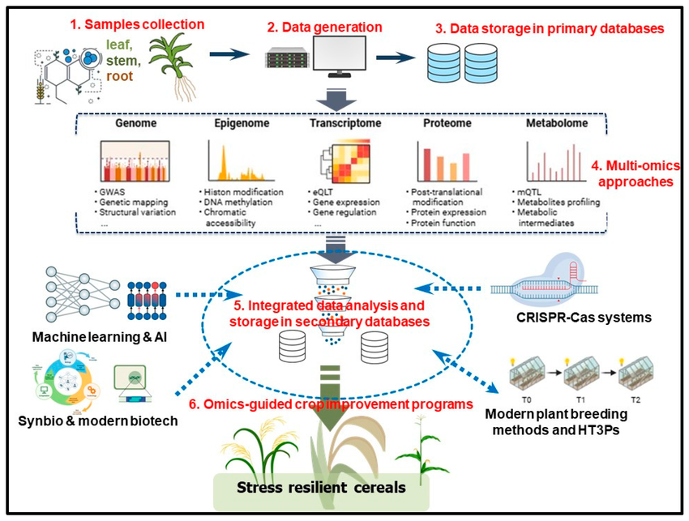

Figure 3: Multi-omics integration framework for developing stress-resilient cereal crops (Syeda, 2025).

- Challenges and Future Perspectives
Although improved technologies aid in crop improvement, there are still several challenges in breeding stress-resistant cereal crops. The genotype × environment interactions have a significant impact on the phenotype of stress-related traits, and it may be challenging to forecast the plant performance in the diverse environments (Raffo and Jensen, 2023). Multi-omics technologies have sophisticated laboratory facilities and computing tools, which might restrict their use in certain breeding programs (Satrio et al., 2024). In the future, this is likely to be made more accessible by the constant technological advances and the falling costs of sequencing.

- Conclusion
Abiotic stress remains as a major problem in global cereal production, threatening food security and the sustainability of agriculture. Enhancing the resistance of crops to such environmental limitations has thus emerged as a bigger goal in contemporary breeding schemes. Secondary physiological traits are useful indicators of plant responses to stress and are more useful for breeders to distinguish the tolerant genotypes. These characteristics are usually more heritable than the yield of grain in stressful conditions and, as such, increase the precision for selection in breeding populations. The recent developments in molecular biology and biotechnology have also boosted the crop improvement strategies by combining the genomic, metabolomic, and phenotypic data. The high-throughput phenotyping technologies and multi-omics applications enable a researcher to examine plant responses to stressors under various levels of biology. Climate-resilient breeding programs involving the combination of physiological screening, complex phenotyping platforms, and multi-omics technologies will be essential towards coming up with varieties of climate-resilient cereals that can sustain the same productivity across varying climatic environments. Despite these challenges, such as high costs, technical complexity, and genotype × environment interactions, ongoing advancements in sequencing technologies, artificial intelligence, and data analytics are making these approaches increasingly accessible. Therefore, combining physiological trait-based selection with multi-omics and modern phenotyping platforms represents a promising strategy to accelerate breeding programs and develop climate-resilient cereal varieties.

Conflict of Interest:
The authors have no conflict of interest declared.

References:
- Angidi, S., Madankar, K., Tehseen, M. M., & Bhatla, A. (2025). Advanced high-throughput phenotyping techniques for managing abiotic stress in crops—A comprehensive review. Crops, 5(2), 8. https://doi.org/10.3390/crops5020008
- Atta, K., Mondal, S., Gorai, S., Singh, A. P., Kumari, A., Ghosh, T., Roy, A., Hembram, S., Gaikwad, D. J., Mondal, S., Bhattacharya, S., Jha, U. C., & Jespersen, D. (2023). Impacts of salinity stress on crop plants: Improving salt tolerance through genetic and molecular dissection. Frontiers in Plant Science, 14, Article 1241736. https://doi.org/10.3389/fpls.2023.1241736
- Bhutto, L. A., Osborne, C. P., & Quick, W. P. (2023). Osmotic adjustment and metabolic changes under drought stress conditions in wheat (Triticum aestivum L.) genotypes. Pakistan Journal of Botany, 55(3), 915–923. http://dx.doi.org/10.30848/PJB2023-3(22
- Carrera, A., Echenique, V., Zhang, W., Helguera, M., Manthey, F., Schrager, A., & Dubcovsky, J. (2021). Metabolomics in crop improvement: Applications for abiotic stress tolerance. Agronomy, 11(5), 824. https://doi.org/10.3390/agronomy11050824
- Chen, L., An, Y., Li, Y. X., Li, C., Shi, Y., Song, Y., Zhang, D., Wang, T., & Li, Y. (2017). Candidate loci for yield-related traits in maize revealed by a combination of metaQTL analysis and regional association mapping. Frontiers in Plant Science, 8, 2190. https://doi.org/10.3389/fpls.2017.02190
- Devate, N. B., Krishna, H., Sunilkumar, V. P., Manjunath, K. K., Mishra, C. N., Jain, N., ... & Singh, P. K. (2022). Identification of genomic regions of wheat associated with grain Fe and Zn content under drought and heat stress using a genome-wide association study. Frontiers in Genetics, 13, 1034947. https://doi.org/10.3389/fgene.2022.1034947
- Djanaguiraman, M., Gowsiga, S., Govindaraj, M., Habyarimana, E., Senthil, A., Thavaprakaash, N., & Chellammal, C. (2024). Impact of root architecture and transpiration rate on drought tolerance in stay-green sorghum. Crop Science, 64(5), 2612–2629. https://doi.org/10.1002/csc2.21108
- Dłuchowska, K., Bielach, A., & Zmienko, A. (2025). Advances in plant metabolomics for stress tolerance and crop improvement. Metabolites, 15(6), 384. https://doi.org/10.3390/metabo15060384
- El Sabagh, A., Barutçular, C., & Islam, M. S. (2017). Relationships between stomatal conductance and yield under deficit irrigation in maize (Zea mays L.). Journal of Experimental Biology and Agricultural Sciences, 5(1), 14–21. https://doi.org/10.18006/2017.5(1).014.021
- Farooqi, M. Q. U., Nawaz, G., Wani, S. H., Choudhary, J. R., Rana, M., Sah, R. P., Afzal, M., Zahra, Z., Ganie, S. A., Razzaq, A., Reyes, V. P., Mahmoud, E. A., Elansary, H. O., El-Abedin, T. K. Z., & Siddique, K. H. M. (2022). Recent developments in multi-omics and breeding strategies for abiotic stress tolerance in maize (Zea mays L.). Frontiers in Plant Science, 13, 965878. https://doi.org/10.3389/fpls.2022.965878
- Gangola, M. P., & Ramadoss, B. R. (2020). WRKY transcription factors for biotic and abiotic stress tolerance in plants. In S. H. Wani (Ed.), Transcription factors for abiotic stress tolerance in plants (pp. 15–28). Academic Press. https://doi.org/10.1016/B978-0-12-819334-1.00002-2
- Ganie, S. A., Wani, S. H., & Vishwakarma, H. (2024). The plant mind: Unraveling abiotic stress priming, memory, and adaptation. Plant, Cell & Environment, 47(10), 3821–3841. https://doi.org/10.1111/pce.14922
- Gill, T., Gill, S. K., Saini, D. K., Chopra, Y., de Koff, J. P., & Sandhu, K. S. (2022). A comprehensive review of high-throughput phenotyping and machine learning for plant stress phenotyping. Phenomics, 2, 156–183. https://doi.org/10.1007/s43657-022-00048-z
- Hammami, Z., Tounsi-Hammami, S., Nhamo, N., Rezgui, S., & Trifa, Y. (2024). The efficiency of chlorophyll fluorescence as a selection criterion for salinity and climate aridity tolerance in barley genotypes. Frontiers in Plant Science, 15, 1324388. https://doi.org/10.3389/fpls.2024.1324388
- Islam, N. U., Wani, S. H., Ali, G., Dar, Z. A., Wani, A., & Lone, A. (2021). High-throughput phenotyping for abiotic stress resilience in cereals. Journal of Cereal Research, 13(1). https://doi.org/10.25174/2582-2675/2021/111256
- Kamal, N. M., Gorafi, Y. S. A., Abdelrahman, M., Abdellatef, E., & Tsujimoto, H. (2022). Stay-green trait: A prospective approach for yield potential and drought and heat stress adaptation in globally important cereals. International Journal of Molecular Sciences, 23(9), 4967. https://doi.org/10.3390/ijms23094967
- Kaur, S., Singh, S. P., & Kingra, P. K. (2018). Canopy temperature as indicator of thermal and nutrient stresses in wheat crop. MAUSAM, 69(2), 309–314. https://doi.org/10.54302/mausam.v69i2.355
- Khan, P., Abdelbacki, A. M., Albaqami, M., Jan, R., & Kim, K. M. (2025). Proline promotes drought tolerance in maize. Biology, 14(1), 41. https://doi.org/10.3390/biology14010041
- Kim, M., Lee, C., Hong, S., Kim, S. L., Baek, J.-H., & Kim, K.-H. (2021). High-throughput phenotyping methods for breeding drought-tolerant crops. International Journal of Molecular Sciences, 22(15), 8266. https://doi.org/10.3390/ijms22158266
- Kosakivska, I. V., Vedenicheva, N. P., Babenko, L. M., Voytenko, L. V., Romanenko, K. O., & Vasyuk, V. A. (2022). Exogenous phytohormones in the regulation of growth and development of cereals under abiotic stresses. Molecular Biology Reports, 49(1), 617–628. https://doi.org/10.1007/s11033-021-06802-2
- Koshariya, A. K. (2022). Climate-resilient crops: Breeding strategies for extreme weather conditions. Plant Science Archives, 1(03). https://doi.org/10.51470/PSA.2022.7.2.01
- Langridge, P., & Reynolds, M. P. (2021). Breeding for climate resilience in plants. Current Opinion in Plant Biology, 61, 102007. https://doi.org/10.1016/j.pbi.2021.102007
- Lepekhov, S. B. (2022). Canopy temperature depression for drought-and heat stress tolerance in wheat breeding. Vavilov Journal of Genetics and Breeding, 26(2), 196. https://doi.org/10.18699/VJGB-22-24
- Lokeshkumar, B. M., Krishnamurthy, S. L., Rathor, S., Warriach, A. S., Vinaykumar, N. M., Dushyanthakumar, B. M., & Sharma, P. C. (2023). Morphophysiological diversity and haplotype analysis of saltol QTL region in diverse rice landraces for salinity tolerance. Rice Science, 30(4), 306–320. https://doi.org/10.1016/j.rsci.2023.02.001
- Ma, Y., & Li, Y. (2024). The research progress on genomic selection and breeding for drought resistance in wheat: From genetic analysis to smart breeding applications. Geographical Research Bulletin, 3, 625–646. https://doi.org/10.50908/grb.3.0_625
- Makhtoum, S., Mohammadi, V., Mirwaisi, S., & Shariati, J. V. (2023). Genomics and physiology of chlorophyll fluorescence parameters in Hordeum vulgare L. under drought and salt stresses. Plants, 12(11), 2135. https://doi.org/10.3390/plants12112135
- Makhtoum, S., Sabouri, H., Gholizadeh, A., Ahangar, L., & Katouzi, M. (2022). QTLs controlling physiological and morphological traits of barley (Hordeum vulgare L.) seedlings under salinity, drought, and normal conditions. BioTech, 11(3), 26. https://doi.org/10.3390/biotech11030026
- Mashabela, M. D., Piater, L. A., Dubery, I. A., & Tugizimana, F. (2023). Metabolomics in plant stress response: Insights into biochemical pathways and tolerance mechanisms. Plants, 12(2), 269. https://doi.org/10.3390/plants12020269
- Mittler, R., Zandalinas, S. I., Fichman, Y., & Van Breusegem, F. (2022). Reactive oxygen species signalling in plant stress responses. Nature Reviews Molecular Cell Biology, 23(10), 663–679. https://doi.org/10.1038/s41580-022-00499-2
- Paul, K., Rischbeck, P., & Kaul, H.-P. (2025). High-throughput phenotyping of cereal crops under stress: Unveiling evapotranspiration and respiration patterns. Agronomy, 15(10), 2442. https://doi.org/10.3390/agronomy15102442
- Raffo, M. A., & Jensen, J. (2023). Gene × gene and genotype × environment interactions in wheat. Crop Science, 63(4), 1779–1793. https://doi.org/10.1002/csc2.20986
- Raza, A. (2020). Metabolomics: A systems biology approach for enhancing heat stress tolerance in plants. Plant Cell Reports, 39(12), 1705–1717. https://doi.org/10.1007/s00299-020-02563-8
- Raza, A. (2022). Metabolomics: A systems biology approach for enhancing heat stress tolerance in plants. Plant Cell Reports, 41(3), 741–763. https://doi.org/10.1007/s00299-020-02635-8
- Ren, A., Jiang, D., Kang, M., et al. (2022). Evaluation of an intelligent artificial climate chamber for high-throughput crop phenotyping in wheat. Plant Methods, 18, 77. https://doi.org/10.1186/s13007-022-00916-9
- Roychowdhury, R., Das, S. P., Gupta, A., Parihar, P., Chandrasekhar, K., Sarker, U., & Sudhakar, C. (2023). Multi-omics pipeline and omics-integration approach to decipher plant’s abiotic stress tolerance responses. Genes, 14(6), 1281. https://doi.org/10.3390/genes14061281
- Sachdev, S., Ansari, S. A., Ansari, M. I., Fujita, M., & Hasanuzzaman, M. (2021). Abiotic stress and reactive oxygen species: Generation, signaling, and defence mechanisms. Antioxidants, 10(2), 277. https://doi.org/10.3390/antiox10020277
- Salam, M. A., Jamshaid, S., & Zeng, J. (2023). Metabolomics and its role in plant abiotic stress tolerance. International Journal of Molecular Sciences, 24(7), 6234. https://doi.org/10.3390/ijms24076234
- Sallam, A., Eltaher, S., Alqudah, A. M., Belamkar, V., & Baenziger, P. S. (2022). Combined GWAS and QTL mapping revealed candidate genes and SNP network controlling recovery and tolerance traits associated with drought tolerance in seedling winter wheat. Genomics, 114(3), 110358. https://doi.org/10.1016/j.ygeno.2022.110358
- Satrio, R. D., Fendiyanto, M. H., & Miftahudin, M. (2024). Tools and techniques used at global scale through genomics, transcriptomics, proteomics, and metabolomics to investigate plant stress responses at the molecular level. In Molecular dynamics of plant stress and its management (pp. 555–607). Springer Nature Singapore. https://doi.org/10.1007/978-981-97-1699-9_25
- Schmidt, G. W., Delaney, S. P., Khoo, K. H., & Richardson, A. E. (2018). Transcriptome and cell physiological analyses in different rice cultivars provide new insights into adaptive and salinity stress responses. Frontiers in Plant Science, 9, 204. https://doi.org/10.3389/fpls.2018.00204
- Shahzad, B., Shabala, L., Zhou, M., Venkataraman, G., Solis, C. A., Page, D., ... & Shabala, S. (2022). Comparing essentiality of SOS1-mediated Na+ exclusion in salinity tolerance between cultivated and wild rice species. International Journal of Molecular Sciences, 23(17), 9900. https://doi.org/10.3390/ijms23179900
- Sheikh, M., Iqra, F., Ambreen, H., Pravin, K. A., Ikra, M., & Chung, Y. S. (2024). Integrating artificial intelligence and high-throughput phenotyping for crop improvement. Journal of Integrative Agriculture, 23(6), 1787–1802. https://doi.org/10.1016/j.jia.2023.10.019
- Singh, A., Kanwar, P., Yadav, A. K., Mishra, M., Jha, S. K., Baranwal, V., Pandey, A., & Kapoor, S. (2021). Constitutive photomorphogenesis 5A (CSN5A) regulates heat stress memory by increasing H3K4me3 in memory genes. Plant Physiology, 186(3), 1671–1687. https://doi.org/10.1093/plphys/kiab163
- Skendžić, S., Zovko, M., Lešić, V., Pajač Živković, I., & Lemić, D. (2023). Detection and evaluation of environmental stress in winter wheat using remote and proximal sensing methods and vegetation indices—A review. Diversity, 15(4), 481. https://doi.org/10.3390/d15040481
- Sohail, M., Hussain, I., Qamar, M., Tanveer, S. K., Abbas, S. H., Ali, Z., & Imtiaz, M. (2020). Evaluation of spring wheat genotypes for climatic adaptability using canopy temperature as a physiological indicator. Pakistan Journal of Agricultural Research, 33(1), 89–96. https://doi.org/10.17582/journal.pjar/2020/33.1.89.96
- Syeda, A. (2025). Harnessing multi-omics and genome-editing technologies for climate-resilient agriculture: Bridging AI-driven insights with sustainable crop improvement. Plant Molecular Biology, 115(6), 1–24. https://doi.org/10.1007/s11103-025-01650-1
- Tian, W., Mu, Q., Gao, Y., Zhang, Y., Wang, Y., Ding, S., Aloryi, K. D., Okpala, N. E., & Tian, X. (2024). Micrometeorological monitoring reveals that canopy temperature is a reliable trait for the screening of heat tolerance in rice. Frontiers in Plant Science, 15, 1326606. https://doi.org/10.3389/fpls.2024.1326606
- Ullah, S., Khan, M. N., Lodhi, S. S., Ahmed, I., Tayyab, M., Mehmood, T., ... & Akram, M. (2022). Targeted metabolomics reveals fatty acid abundance adjustments as playing a crucial role in drought-stress response and post-drought recovery in wheat. Frontiers in Genetics, 13, 972696. https://doi.org/10.3389/fgene.2022.972696
- Varoquaux, N., Cole, B., Gao, C., Pierroz, G., Baker, C. R., Nightingale, M., Coleman-Derr, D., Ladygina, N., Singh, S., Beilsmith, K., Owens, S. N., Deshpande, S., Daum, C., Yen, G., Yoshinaga, Y., Zane, M., Singan, V., Grigoriev, I. V., Detter, J. C., ... Vogel, J. P. (2019). Transcriptomic analysis of field-droughted sorghum from seedling to maturity reveals biotic and metabolic responses. Proceedings of the National Academy of Sciences, 116(52), 27393–27401. https://doi.org/10.1073/pnas.1907500116
- Varshney, R. K., Bohra, A., Yu, J., Graner, A., Zhang, Q., & Sorrells, M. E. (2021). Designing future crops: Genomics-assisted breeding comes of age. Trends in Plant Science, 26(6), 631–649. https://doi.org/10.1016/j.tplants.2021.03.010
- Wang, J., Zhang, X., Han, Z., Feng, H., Wang, Y., Kang, J., ... & Ma, G. (2022). Analysis of physiological indicators associated with drought tolerance in wheat under drought and re-watering conditions. Antioxidants, 11(11), 2266. https://doi.org/10.3390/antiox11112266
- Wang, L., Zhou, W., Wang, M., Liu, Y., Tian, Z., Xie, L., & Wang, Y. (2025). RNA-directed DNA methylation (RdDM) mediated by KTF1 improves salt resistance and biomass in Zea mays. Nature Plants. (In Press). https://doi.org/10.1038/s41477-024-01821-w
- Zhang, J., Fengler, K. A., Van Hemert, J. L., Gupta, R., Mongar, N., Sun, J., Allen, W. B., Wang, Y., Weers, B., Mo, H., Lafitte, R., Hou, Z., Bryant, A., Ibraheem, F., Arp, J., Swaminathan, K., Moose, S. P., Li, B., & Shen, B. (2019). Identification and characterization of a novel stay-green QTL that increases yield in maize. Plant Biotechnology Journal, 17(12), 2272–2285. https://doi.org/10.1111/pbi.13139
- Zhang, Q., Tang, W., Xiong, Z., Peng, S., & Li, Y. (2023). Stomatal conductance in rice leaves and panicles responds differently to abscisic acid and soil drought. Journal of Experimental Botany, 74(5), 1551–1563. https://doi.org/10.1093/jxb/erac496

