Original Research Article
The Study of Diversity and Quantitative Ethnobotanical Assessment of Tree Species in Damoh District, Madhya Pradesh

.
ABSTRACT

This study provides a comprehensive ethnobotanical assessment of floristic diversity and traditional medicinal knowledge within a forest-dependent community. A socio-demographic survey of 130 participants (56.92% male, 43.08% female) revealed a population deeply integrated with natural resources, dominated by married individuals (62.31%) and those in the 40–59 age bracket (48.47%). Occupations were primarily centered on farming (40.00%) and labor (30.77%), with a significant reliance on traditional health practitioners (4.62%). The floristic inventory documented 110 plant species belonging to 36 families. The family Mimosaceae emerged as the most diverse (9 species), followed by Fabaceae and Moraceae (8 species each). Quantitative ethnobotanical indices, including Frequency of Citation (FC), Relative Frequency of Citation (RFC), and Use Value (UV), were employed to determine species importance. Diospyros melanoxylon Roxb. exhibited the highest cultural significance, recording the maximum values across all indices (FC = 188, RFC = 0.794, and UV = 2.67). Analysis of plant part utilization indicated that stems (35%) and fruits (21%) are the most frequently exploited components, followed by bark (13%) and leaves (12%). These findings highlight a sophisticated local knowledge system that prioritizes woody tissues and reproductive parts for therapeutic applications. The high RFC and UV for specific taxa provide a robust baseline for future pharmacological screening and emphasize the need for sustainable harvesting strategies to preserve both biodiversity and indigenous heritage.

Keywords: Ethnobotany, Floristic Diversity, Use Value, Medicinal Plants.

1. INTRODUCTION

The full interaction between humans and plants is explained by the word "ethnobotany," which also examines the depth of local people's traditional botanical knowledge and how they use it to exploit plants for a range of reasons (Amjad and Arshad 2014; Arshad et al. 2014). This kind of information is still available and trustworthy when it comes to vegetation dynamics, which gives important details about the species and serves as the foundation for local resource management (Wezel and Lykke 2006). The Convention on Biological Diversity has acknowledged the importance of ethnobotany in the preservation of biological diversity, and ethnobotany is getting the most attention in natural resource management studies globally (Sop et al. 2012; Maurya, D., Adhikari, C., Kumar, A., Malasiya, D., & Bishwas, A. J.,2025).
The cultural practices determine how plants are used (Teixidor-Toneu et al., 2018). Medicinal plants are one of the most diverse groups of plants used traditionally in different cultures worldwide (Uprety et al., 2010; Uprety et al., 2012; Abera, 2014; Aziz et al., 2018; da Costa Lin et al., 2021; Kunwar et al., 2022; Turpin et al., 2022). The development of modern medicine has replaced the traditional usage of medicinal plants as a means of managing and treating a variety of illnesses (Khakurel, Dhruba, et al., 2022).
Ethnobotanical research is typically carried out with local communities and indigenous peoples, where traditional knowledge is mostly unrecorded (Adhikari et al., 2021). However, such knowledge is decreasing rapidly around the globe mainly due to globalization, modernization, and market integration resulting in an asymmetrical pattern of knowledge loss (Aswani et al., 2018; Adhikari, C., Maurya, D., & Bishwas, A. J., 2023). Indigenous and local groups' knowledge of medicinal plants vary significantly throughout the nation. For everyday necessities including fuel, fodder, fiber, agricultural implements, and medicine, the rural residents of the area rely significantly on forest resources. The majority of this information about plants' potential uses is qualitatively explained using the locals' traditional knowledge. Nevertheless, only a small number of IHR studies have taken into account the quantitative use value of forest resources. Consequently, the majority of management recommendations continue to be subjective (Khakurel, Dhruba, et al., 2022).
Through centuries of trial and error, indigenous groups have developed sophisticated systems of knowledge, demonstrating the long-standing link between human societies and the vegetal world (Verma, 2016). India, one of the twelve mega-biodiversity nations in the world, has an extensive collection of traditional medical knowledge spread over its varied landscapes (Verma, 2016). Within this landscape, the state of Madhya Pradesh stands out as a "veritable niche" for healing herbs and woody species used in Ayurveda, Unani, and Siddha systems of medicine (Bisen et al., 2021).
Damoh district is situated within the Bundelkhand region of Central India, a semi-arid plateau characterized by a unique terrain of Bhamder plateaus and Kaimur hills (Singh & Varaprasad, 2011; Maurya, D., Adhikari, C., & Bishwas, A. J.,2025). The region serves as an ecological gateway between North and South India, featuring a mix of undulating topography and forestlands that support significant genetic diversity (Singh & Varaprasad, 2011). In these areas, tribal communities like the Gond and Sahariya remain largely dependent on forest produce for their primary healthcare and livelihoods (Verma, 2016; FAO, n.d.).
The most prevalent and culturally important element of the ethnomedical environment is frequently tree species, despite the widespread recognition of medicinal herbs. According to numerous evaluations conducted throughout Madhya Pradesh, trees are the most commonly used plant habit for medical purposes (Verma, 2014, 2016). Key species such as Acacia nilotica (Babul), Aegle marmelos (Bel), and Azadirachta indica (Neem) are integral to local pharmacopeia, providing bark, gums, and leaves for treating conditions ranging from digestive disorders to respiratory infections (FAO, n.d.; Sulaiman et al., 2020; Maurya, D., Adhikari, C., Kumar, T., & Bishwas, A. J., 2021).
Because traditional knowledge is frequently transmitted orally, modernization and changing socioeconomic objectives can erode it. Quantitative ethnobotanical evaluations are used to close the gap between qualitative indigenous reports and scientific validation. These approaches assess a species' cultural and medical significance using statistical indices (Sulaiman et al., 2020; Faruque et al., 2018). In order to protect this "treasure-trove" of biodiversity for coming generations, researchers can prioritize species for conservation and pharmacological screening by using these quantitative approaches on the medicinal trees of Damoh (Patil, 2009; Verma, 2014; Maurya, D., Kumar, T., Adhikari, C., Kumar, A., & Bishwas, A. J., 2022).
In the present study, a quantitative assessment of the ethnobotanical resources has been made to establish the high priority species of ethnobotanical and ethnomedicinal importance and the analysis was also done on the utilization pattern of ethnomedicinal plants among the ethnic communities residing in the rural localities of Damoh, Distract Madhya Pradesh state of India.

2. material and methods

2.1 Study area
Damoh District lies between 23˚9’ and 24˚27’ North latitude and between 79˚3’ and 79˚57’ East longitude in the Northern part of Jabalpur Division (fig. 1). The shape of the district is irregular and elongated from North to South with projection in the East and West. It is at an average elevation of 595 meters (1,952 ft). The district is bounded by the district of Chhatarpur in the North and Northwest, Sagar in the West, Narsinghpur and Jabalpur in the South and part of Jabalpur and Panna in the East. The total geographical area is 7306 Sq.km. In the recent years forests are restricted only to the hilly areas which are not suitable for cultivation, (Maurya, D., et al., 2025). According to the information of the district forest office of the region total area covered by the government forests in the region under study comes to about 3043 sq. kms. and the forests are classified as –
1. Reserved Forest - 615 sq. kms (20 per cent)
2. Protected Forest - 2428 sq. kms (80 per cent)
The region has an almost ideal proportion of forest as 20 per cent the total geographical area of the region and the reserved forest in the area were demarcated as early as in the year 1879 the reserved forests are still under the scientific management of government, (Maurya, D., et al., 2023).
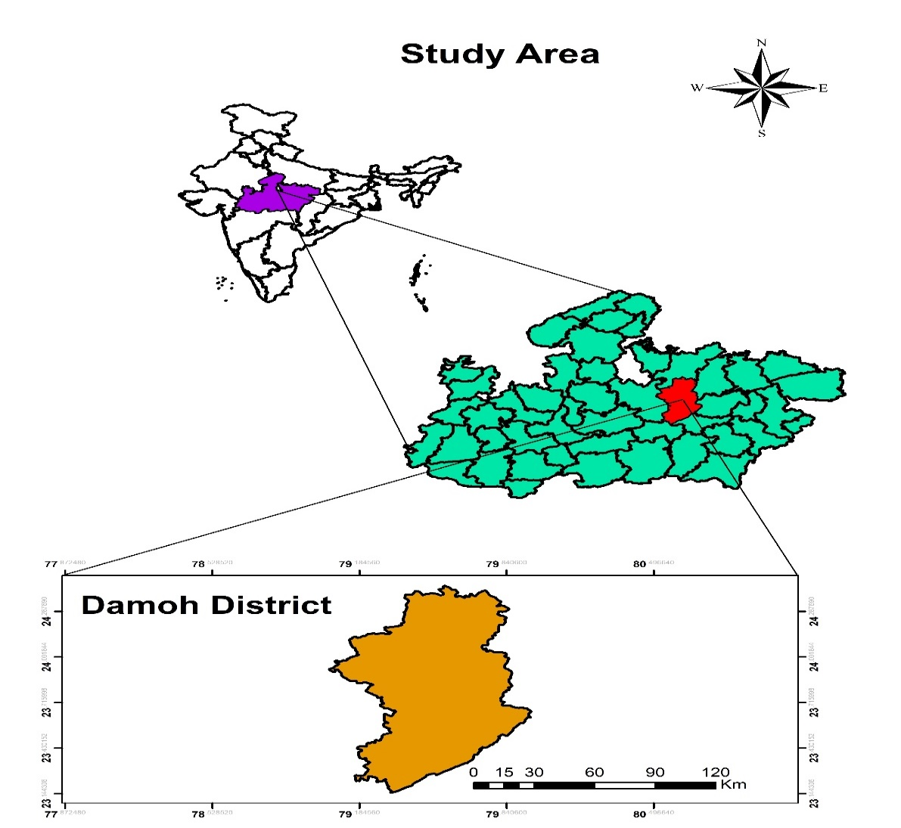
Figure 1 Map of study area

2.2. Ethnobotanical survey
Field Studies was conducted in regular intervals in different seasons between 2021 and 2022 to collect the primary data. The questionnaire was designed to obtain information about the locality; socio-demographic details (age, gender and educational background); types of skin disorders treated by the plants, local names of plants mentioned, parts used, method of preparation.
2.3. Quantitative Ethnobotany
Data collected through interviews of the informant were analyzed using four quantitative indices: (a) use value, (b) Frequency of Citation (FC) and (c) Relative frequency citation (RFC):
2.3.2. Use Value
According to (Phillips, O., 1994), the UV was calculated using the following formula:
UV =X/N
Where, “U” refers to the number of uses mentioned by the informants for a given species and “N” refers to the total number of informants interviewed. If a plant secures a high UV score that indicates there are many use reports for that plant, while a low score indicates fewer use reports cited by the informants.
2.3.3. Frequency of Citation (FC)
The FC was calculated as follows:
FC = (Number of times a particular species was mentioned/)
(total number of times that all species were mentioned) × 100.
2.3.4. Relative Frequency of Citation (RFC)
The RFC index, (Tardío, J., & Pardo-de-Santayana, M., 2008), was evaluated by dividing the number of informants who mentioned the use of the species (FC) by the total number of informants participating in the survey (N). The RFC index ranges from “0” when nobody referred to a plant as useful to “1” when all informants referred to a plant as useful.
RFC = FC/N.
2.4. Statistical analysis
All statistical analyses were performed using the Microsoft Excel for preparation of table and making of graph and plants were analyzed regarding their habits of plants, and plant parts used in treatment of skin diseases, frequency in families, and quantitative ethnobotany analysis including (a) use value, (b) Frequency of Citation (FC) and (c) Relative frequency citation (RFC).

3. results and discussion

3.1. Socio-demographic information
A total of 130 people who participated in the survey, 56 were women (43.08%) and 74 were men (56.92%). The family status is married category is (62.31%) and unmarried category is (37.69%). The Age classes is divided in five categories of age class <30 (24.62%) age class 30-39 (17.69%), age class 40-49 (24.62%), age class 50-59 (23.85%), and age class >60 (9.23%). Regarding the education level, the illiteracy rate is 19.23%; primary school level represented 33.08%, secondary school level represented 23.85%, tertiary school level represented 14.62%, while relatively high levels represented 09.23%. The occupation of informant is, farmer- 40.00%, labor-30.77%, students-24.62%, and traditional health has 04.62%. This all information is show in table 1.
Table 1 : Socio-demographic Characteristics of Participants

Factor | Categories | Total no. of persons | Percentage (%)
Sex | Male | 74 | 56.92%
 | Female | 56 | 43.08%
Family status | Married | 81 | 62.31%
 | Unmarried | 49 | 37.69%
Age classes | <30 | 32 | 24.62%
 | 30-39 | 23 | 17.69%
 | 40-49 | 32 | 24.62%
 | 50-59 | 31 | 23.85%
 | >60 | 12 | 9.23%
Educational Level | Illiterate | 25 | 19.23%
 | Primary | 43 | 33.08%
 | Secondary | 31 | 23.85%
 | Tertiary | 19 | 14.62%
 | Higher Education | 12 | 9.23%
Occupation | Farmar | 52 | 40.00%
 | Labor | 40 | 30.77%
 | Students | 32 | 24.62%
 | Traditional Health | 6 | 4.62%

3.2 Floristics Diversity of Plant Species
The data show a total of 36 plant families and 110 species exhibiting a wide range of species richness (fig.2). While many families are represented by only a single species, a few key families dominate the diversity landscape of this study area. High-Diversity Families are Mimosaceae is the most diverse family, acting as the primary contributor to species richness has 9 species, second most diverse family has Fabaceae, Moraceae 8 number of species, and third most Bignoniaceae, Caesalpiniaceae, Rubiaceae 7 number of species are precented. Mid-Range Diversity are families show moderate species variation, typically having between, Combretaceae 6 species, Anacardiaceae, Euphorbiaceae, Myrtaceae, Rutaceae: 4 species each. Low Diversity and Singleton Families A significant portion of the dataset consists of families with very low diversity, which is common in specific ecological niches: Families with 2–3 species: Includes Malvaceae, Meliaceae, Apocynaceae, and others. Singleton Families (1 species): 11 families (approx. 30% of the total) are represented by only a single species (e.g., Alangiaceae, Arecaceae, Cannabaceae). The majority of the families (over 50%) have 3 or fewer species, indicating that the ecosystem may be specialized or that certain families have adapted more successfully to the local environment than others.
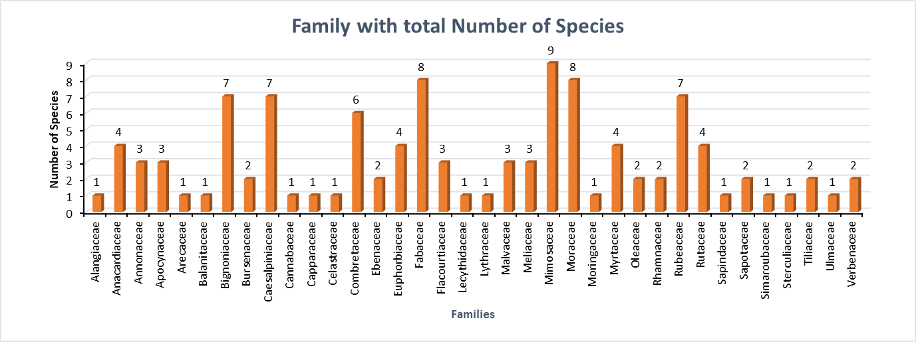

Fig. 2 Floristics Diversity of Plant Species
3.3 Plant Part used

The significance of medicinal plants in the forest region is reflected in the wide diversity of their applications. Various plant parts were used either in fresh or dried form, including roots (3%), bark (13%), stems (35%), leaf (12%), fruits (21%), seeds (6%), the whole plant (7%), flower (1%), and gum (2%) (Fig. 3).

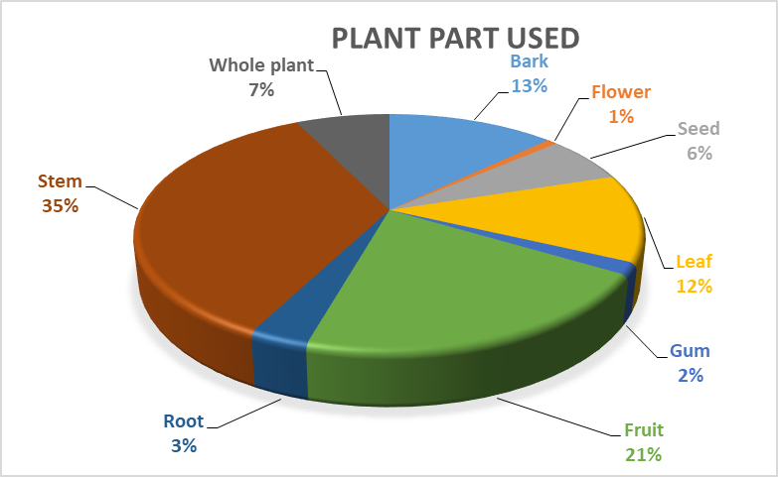
Fig. 3 Plant Part used

3.4 Frequency of Citation (FC), Relative Frequency of Citation (RFC) and Used Value (UV)

In the present study, the Frequency of Citation (FC) values ranged from 3 to 188. The highest FC was recorded for Diospyros melanoxylon Roxb. (188). The top 20 plant species with the highest FC values are illustrated in Fig. 5, while the FC, RFC values and UV of all recorded plant species are presented in Table 1. The Relative Frequency of Citation (RFC) values ranged from 0.003 to 0.794, with Diospyros melanoxylon Roxb. exhibiting the highest RFC value (0.794). The top 20 species based on RFC values are shown in Fig. 4. Used value range of 0.01 to 2.67 with Diospyros melanoxylon Roxb. exhibiting the highest UV value (2.67). The top 20 species based on values are shown in Fig. 4. Ethnomedicinal plant species with higher RFC values indicate their extensive utilization and widespread traditional knowledge among local communities.

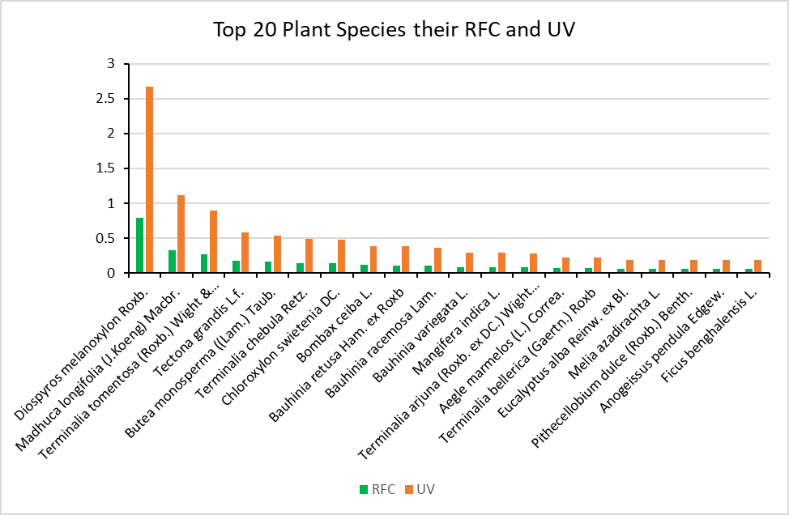
Fig. 4 Frequency of Citation (FC) and Relative Frequency of Citation (RFC)

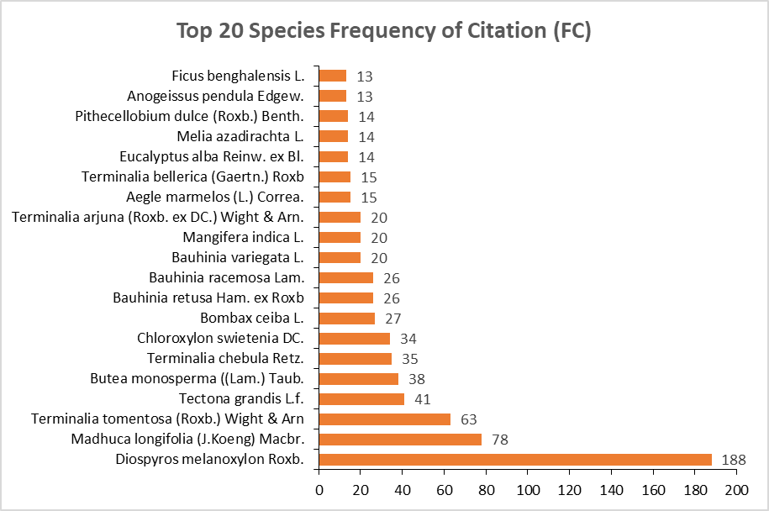

Fig. 5 Used Value (UV)

4. Discussion
The socio-demographic survey of 130 participants reveals a community with a deep-rooted connection to natural resources. The dominance of male informants (56.92%) over female informants (43.08%) often suggests gendered roles in resource collection or cultural norms regarding who speaks to researchers, a trend frequently observed in ethnobotanical studies in South Asia. Interestingly, the age distribution is relatively balanced, with nearly 73% of informants being over the age of 30. This is significant because traditional medicinal knowledge is often held by the elder generation; however, the presence of younger participants (24.62% under 30) suggests that this knowledge is still being transmitted to the youth. The high prevalence of farmers (40%) and laborers (30.77%) indicates a community whose livelihood is intimately tied to the land. Furthermore, the 19.23% illiteracy rate and the reliance on traditional health practitioners (4.62%) highlight the vital role that medicinal plants play as a primary or supplementary healthcare resource in areas where formal education and modern medical facilities may be less accessible. The study area exhibits high biodiversity, with 110 species spanning 36 families. The dominance of the Mimosaceae (9 species) and Fabaceae (8 species) families is consistent with global ethnobotanical patterns. The presence of "Singleton Families" (30% of total families) suggests a specialized ecosystem where specific unique niches are occupied by rare or highly specialized species. The analysis of plant parts used (Fig. 3) shows that stems (35%) and fruits (21%) are the most frequently utilized components, followed by bark and leaves.
While many ethnobotanical studies report leaves as the most used part due to their abundance and ease of collection, the high usage of stems and bark in this region suggests that the local community focuses on parts with high concentrations of secondary metabolites, such as alkaloids and tannins, which are often found in woody tissues. However, the relatively high use of bark and stems can pose a threat to plant conservation if not harvested sustainably, as it can lead to the girdling or death of the plant.
The quantitative indices provide a robust measure of the cultural and medicinal importance of specific species. Diospyros melanoxylon Roxb. emerged as the most significant species across all metrics: Frequency of Citation (FC): 188 Relative Frequency of Citation (RFC): 0.794 Use Value (UV): 2.67 A high RFC and UV for D. melanoxylon indicate not only that this plant is well-known by the majority of the community but also that it serves multiple medicinal or economic purposes. Plants with high UV are typically "generalist" remedies used for a wide range of ailments, or they are deeply embedded in the local economy (e.g., Tendu leaves used in the bidi industry). The correlation between high FC and UV values suggests a consensus among the informants regarding the efficacy of these plants, making them primary candidates for further pharmacological and phytochemical screening. similar work cared by many researchers of different part of country and worlds, (Hoffman, B., & Gallaher, T., 2007; de Albuquerque, Ahmad, M., et al., 2014; Ahmed, J., et al., 2018; Joshi, B. C., 2019; Sarkar, K., et al., 2023).

Table 2. All details about plant species

S.No. | Botanical name | Family | Local name | Voucher Number | Plant part used | Used category | FC | RFC | UV
1 | Acacia catechu (L.f.) Willd. | Mimosaceae | Khair | DHSGU/H/DM/208 | Bark | Dye | 3 | 0.014 | 0.05
2 | Acacia leucophlea (Roxb.) Willd. | Mimosaceae | Rinza | DHSGU/H/DM/209 | Bark | Dye | 8 | 0.033 | 0.11
3 | Acacia nilotica ( L.) Delile | Mimosaceae | Desi babool | DHSGU/H/DM/210 | Twig, Gum | Toothache, Asthma | 10 | 0.04 | 0.14
4 | Acacia senegal (L.) Willd. | Mimosaceae | Kumatiyo | DHSGU/H/DM/212 | Whole plant | Fuelwood | 4 | 0.015 | 0.05
5 | Adina cordifolia (Roxb.) Brandis | Rubeaceae | Haldu | DHSGU/H/DM/286 | Stem | Timber | 1 | 0.005 | 0.02
6 | Aegle marmelos (L.) Correa. | Rutaceae | Bel | DHSGU/H/DM/295 | Fruit | Cough, asthma | 15 | 0.066 | 0.22
7 | Ailanthus excelsa Roxb. | Simaroubaceae | Mahaneem | DHSGU/H/DM/306 | Leaf | Fuelwood | 4 | 0.018 | 0.06
8 | Alangium salviifolium (L.f.) Wangerin. | Alangiaceae | Akol | DHSGU/H/DM/13 | Root, Leaf | Fuelwood | 7 | 0.028 | 0.09
9 | Albizia lebbeck (L.) Benth. | Mimosaceae | Siris | DHSGU/H/DM/213 | Stem | Fuelwood | 10 | 0.043 | 0.14
10 | Albizia odoratissima (L.f.) Benth. | Mimosaceae | Safed siris | DHSGU/H/DM/214 | Stem | Fuelwood | 10 | 0.04 | 0.14
11 | Albizia procera (Roxb.) Benth. | Mimosaceae | Safed siris | DHSGU/H/DM/215 | Stem | Fuelwood | 10 | 0.044 | 0.15
12 | Alstonia scholaris (L.) R. Br. | Apocynaceae | Satpatti | DHSGU/H/DM/31 | Stem | Fuelwood | 4 | 0.015 | 0.05
13 | Annona reticulata L. | Annonaceae | Ramphal | DHSGU/H/DM/26 | Fruit | Food | 3 | 0.013 | 0.04
14 | Annona squamosa Linn. | Annonaceae | Sitaphal | DHSGU/H/DM/27 | Fruit | Food | 5 | 0.023 | 0.08
15 | Anogeissus latifolia (Roxb. Ex DC.) Wall. ex Guillem. & Perr. | Combretaceae | Dhavda | DHSGU/H/DM/103 | Stem | Timber | 4 | 0.018 | 0.06
16 | Anogeissus pendula Edgew. | Combretaceae | Kardhai | DHSGU/H/DM/104 | Stem | Timber | 13 | 0.057 | 0.19
17 | Azadirahta indica A. Juss. | Meliaceae | Neem | DHSGU/H/DM/203 | Whole plant | Many | 4 | 0.018 | 0.06
18 | Balanites aegyptiaca (L.) Delile. | Balanitaceae | Hingot | DHSGU/H/DM/71 | Fruit, Root | Leukoderma, abdominal pain | 2 | 0.008 | 0.03
19 | Bauhinia malabarica Roxb. | Caesalpiniaceae | Amli | DHSGU/H/DM/84 | Bark, leaf | Cough | 7 | 0.03 | 0.1
20 | Bauhinia purpurea L. | Caesalpiniaceae | Keolar | DHSGU/H/DM/85 | Bark, leaf | Cough | 8 | 0.033 | 0.11
21 | Bauhinia racemosa Lam. | Caesalpiniaceae | Astara | DHSGU/H/DM/86 | Whole plant | Eye infections | 26 | 0.108 | 0.36
22 | Bauhinia retusa Ham. ex Roxb | Caesalpiniaceae | Asto | DHSGU/H/DM/87 | Bark, leaf | Cough | 26 | 0.112 | 0.38
23 | Bauhinia variegata L. | Caesalpiniaceae | Kachnar | DHSGU/H/DM/89 | Bark | Leprosy | 20 | 0.086 | 0.29
24 | Bombax ceiba L. | Malvaceae | Semal | DHSGU/H/DM/191 | Root | Leucorrhoea | 27 | 0.113 | 0.38
25 | Boswellia serrata Roxb. ex Colebr. | Bursenaceae | Salai | DHSGU/H/DM/81 | Bark, gum | Sciatica | 6 | 0.026 | 0.09
26 | Bridelia retusa (L.) A.Juss. | Euphorbiaceae | Kasai | DHSGU/H/DM/135 | Stem | Fuelwood | 7 | 0.029 | 0.1
27 | Buchanania lanzan Spring. | Anacardiaceae | Achar | DHSGU/H/DM/22 | Fruit | Food | 5 | 0.02 | 0.07
28 | Butea monosperma ((Lam.) Taub. | Fabaceae | Palas | DHSGU/H/DM/147 | Stem and Leaf | Fuelwood and NTFP | 38 | 0.159 | 0.53
29 | Careya arborea Roxb. | Lecythidaceae | Kumbhi | DHSGU/H/DM/179 | Leaf, stem | Fodder, Fuelwood | 9 | 0.038 | 0.13
30 | Casearia elliptica Willd. | Flacourtiaceae | Girchhi | DHSGU/H/DM/164 | Stem | Fuelwood | 3 | 0.013 | 0.04
31 | Casearia graveolens Dalz. | Flacourtiaceae | Girchhi | DHSGU/H/DM/165 | Stem | Fuelwood | 3 | 0.013 | 0.04
32 | Cassia fistula L. | Caesalpiniaceae | Amaltas | DHSGU/H/DM/92 | Fruit | Dysentery, diabetes | 4 | 0.015 | 0.05
33 | Chloroxylon swietenia DC. | Rutaceae | Bhirra | DHSGU/H/DM/296 | Stem | Fuelwood | 34 | 0.144 | 0.48
34 | Cordia macleodii (Griff.) Hook.f. & Thomson | Boraginaceae | Dahimaan | DHSGU/H/DM/77 | Whole plant | Many | 1 | 0.006 | 0.02
35 | Cordia myxa L. | Boraginaceae | Rasalloo | DHSGU/H/DM/78 | Fruits | Dental pain. | 5 | 0.023 | 0.08
36 | Crateva adansonii odora (Buch.-Ham.) Jacobs | Capparaceae | Barna | DHSGU/H/DM/97 | Stem | Fuelwood | 2 | 0.008 | 0.03
37 | Dalbergia latifolia Roxb. | Fabaceae | Kala shisam | DHSGU/H/DM/152 | Stem | Fuelwood | 4 | 0.016 | 0.06
38 | Dalbergia Paniculata Roxb. | Fabaceae | Fasi | DHSGU/H/DM/153 | Stem | Fuelwood | 1 | 0.003 | 0.01
39 | Dalbergia sissoo Roxb. | Fabaceae | Sisoo | DHSGU/H/DM/154 | Stem | Fuelwood | 5 | 0.02 | 0.07
40 | Diospyros melanoxylon Roxb. | Ebenaceae | Tendu | DHSGU/H/DM/131 | Fruit, Leaf | Food and NTFP | 188 | 0.794 | 2.67
41 | Diospyros montana Roxb. | Ebenaceae | Bis Tendu | DHSGU/H/DM/132 | Stem | Fuelwood | 4 | 0.015 | 0.05
42 | Ehretia laevis Roxb. | Boraginaceae | Datranga | DHSGU/H/DM/79 | Stem | Fuelwood | 4 | 0.015 | 0.05
43 | Elaeodendron glaucum (Rottb.) Pers. | Celastraceae | Jamrasahi | DHSGU/H/DM/100 | Stem | Fuelwood | 5 | 0.023 | 0.08
44 | Erythrina suberosa Roxb. | Fabaceae | Gadahpalas | DHSGU/H/DM/156 | Stem | Fuelwood | 2 | 0.01 | 0.03
45 | Eucalyptus alba Reinw. ex Bl. | Myrtaceae | Safada | DHSGU/H/DM/231 | Leaf | Asthma, leucorrhoea | 14 | 0.058 | 0.19
46 | Eugenia heyneana Duthie | Myrtaceae | Kathjamun | DHSGU/H/DM/232 | Fruit | Food | 2 | 0.008 | 0.03
47 | Ficus arnottiana (Miq.) Miq. | Moraceae | bassari, Palhi | DHSGU/H/DM/221 | Stem | Fuelwood | 1 | 0.004 | 0.01
48 | Ficus benghalensis L. | Moraceae | Bargad | DHSGU/H/DM/222 | Whole plant | Religious | 13 | 0.057 | 0.19
49 | Ficus glomerata Roxb. | Moraceae | Duamr | DHSGU/H/DM/223 | Fruit | Food | 10 | 0.043 | 0.14
50 | Ficus microcarpa L. f. | Moraceae | Kamarup | DHSGU/H/DM/225 | Stem | Fuelwood | 4 | 0.018 | 0.06
51 | Ficus mollis Vahl | Moraceae | Chhota bargad | DHSGU/H/DM/226 | Stem | Fuelwood | 1 | 0.005 | 0.02
52 | Ficus racemosa L. | Moraceae | Goolar | DHSGU/H/DM/227 | Stem | Fuelwood | 4 | 0.015 | 0.05
53 | Ficus religiosa L. | Moraceae | Peepal | DHSGU/H/DM/228 | Whole plant | Religious | 8 | 0.033 | 0.11
54 | Flacourtia indica (Burm.f.) Merr. | Flacourtiaceae | Kaker | DHSGU/H/DM/166 | Roots | Fuelwood | 2 | 0.008 | 0.03
55 | Gardenia latifolia Aiton | Rubeaceae | Papra | DHSGU/H/DM/288 | Stem | Fuelwood | 4 | 0.015 | 0.05
56 | Gardenia turgida Roxb. | Rubeaceae | Safed pendra | DHSGU/H/DM/289 | Stem | Fuelwood | 4 | 0.015 | 0.05
57 | Garuga pinnata Roxb. | Bursenaceae | Kekada | DHSGU/H/DM/82 | Leaf |  | 4 | 0.019 | 0.06
58 | Gmelina arborea Roxb. | Verbenaceae | Ghamer | DHSGU/H/DM/323 | Stem | Fuelwood | 4 | 0.016 | 0.06
59 | Grewia asiatica L. | Tiliaceae | Phalsa | DHSGU/H/DM/317 | Fruit | Food | 4 | 0.019 | 0.06
60 | Grewia tiliifolia Vahl. | Tiliaceae | Daman | DHSGU/H/DM/319 | Stem | Fuelwood | 5 | 0.021 | 0.07
61 | Holarrhena pubescens (Buch.-Ham.) Wallich ex G.Don. | Apocynaceae | Doodhi | DHSGU/H/DM/37 | Fruit | Bark | 2 | 0.009 | 0.03
62 | Holoptelea integrifolia Planch. | Ulmaceae | Chirol | DHSGU/H/DM/321 | Stem | Fuelwood | 3 | 0.013 | 0.04
63 | Hymenodictyon orixense (Roxb.) Mabb. | Rubeaceae | Bhormal | DHSGU/H/DM/290 | Bark | Cuts | 2 | 0.008 | 0.03
64 | Ixora pavetta Andrews | Rubeaceae | Lokhandi | DHSGU/H/DM/291 | Stem | Fuelwood | 4 | 0.018 | 0.06
65 | Kydia calycina Roxb. | Malvaceae | Bharanga | DHSGU/H/DM/192 | Stem | Fuelwood | 3 | 0.013 | 0.04
66 | Lagerstroemia parviflora Roxb. | Lythraceae | Lendia | DHSGU/H/DM/186 | Stem | Fuelwood | 10 | 0.044 | 0.15
67 | Lannea coromandelica (Houtt.) Merr. | Anacardiaceae | Moyan | DHSGU/H/DM/23 | Bark | Wounds | 8 | 0.034 | 0.11
68 | Leucaena leucocephala (Lam.) de Wit | Mimosaceae | Sub-bul | DHSGU/H/DM/216 | Whole plant | Fuelwood | 5 | 0.02 | 0.07
69 | Limonia acidissima L. | Rutaceae | Kaith | DHSGU/H/DM/297 | Fruit | Food | 8 | 0.035 | 0.12
70 | Madhuca longifolia (J.Koeng) Macbr. | Sapotaceae | Mahua | DHSGU/H/DM/303 | Flower, seed | Food | 78 | 0.33 | 1.11
71 | Mallotus philippensis (Lam.) Mull. Arg. | Euphorbiaceae | Sindhur | DHSGU/H/DM/138 | Seed | Dye | 7 | 0.028 | 0.09
72 | Mangifera indica L. | Anacardiaceae | Aam | DHSGU/H/DM/24 | Fruit | Food | 20 | 0.086 | 0.29
73 | Melia azadirachta L. | Meliaceae | Bakan Neem | DHSGU/H/DM/204 | Leaf | Gastro-intestinal problems | 14 | 0.058 | 0.19
74 | Miliusa tomentosa (Roxb.) J. Sinclair | Annonaceae | Kari | DHSGU/H/DM/28 | Stem | Fuelwood | 4 | 0.019 | 0.06
75 | Millingtonia hortensis L.f. | Bignoniaceae | Akashneem | DHSGU/H/DM/72 | Stem | Fuelwood | 7 | 0.029 | 0.1
76 | Mimusops hexandra Roxb. | Sapotaceae | Khirni | DHSGU/H/DM/304 | Fruit | Food | 7 | 0.028 | 0.09
77 | Mitragyna parvifolia Roxb. Korth. | Rubeaceae | Mundi | DHSGU/H/DM/292 | Stem | Fuelwood | 8 | 0.033 | 0.11
78 | Moringa oleifera Lam. | Moringaceae | Sahjan and Munga | DHSGU/H/DM/230 | Whole plant | Many | 5 | 0.02 | 0.07
79 | Morus alba L. | Moraceae | Sehtoot | DHSGU/H/DM/229 | Fruit | Food | 7 | 0.028 | 0.09
80 | Naringi crenulata (Roxb.) D.H. Nicolson | Rutaceae | Bilsen | DHSGU/H/DM/300 | Bark | Boils | 3 | 0.011 | 0.04
81 | Nyctanthes arbor-tristis L. | Oleaceae | Parijat | DHSGU/H/DM/240 | Leaf | Sciatica and arthritis | 7 | 0.029 | 0.1
82 | Oroxylum indicum (L.) Kurz | Bignoniaceae | Bhesadand, Jai Mangal | DHSGU/H/DM/73 | Seed | Jaundice, arthritic | 1 | 0.003 | 0.01
83 | Phoenix loureirii Kunth | Arecaceae | Khajur | DHSGU/H/DM/43 | Fruit | Food | 7 | 0.03 | 0.1
84 | Phyllanthus emblica L. | Euphorbiaceae | Amla | DHSGU/H/DM/139 | Fruit | Food | 10 | 0.04 | 0.14
85 | Pithecellobium dulce (Roxb.) Benth. | Mimosaceae | Jangali jalebi, | DHSGU/H/DM/219 | Fruit | Food | 14 | 0.058 | 0.19
86 | Pongamia pinnata (L.) Pierre. | Fabaceae | Karanj | DHSGU/H/DM/160 | Seed and Bark | Skin disease | 11 | 0.048 | 0.16
87 | Prosopis juliflora (Sw.) DC. | Fabaceae | Subabool | DHSGU/H/DM/161 | Stem | Fuelwood | 4 | 0.015 | 0.05
88 | Psidium guajava L. | Myrtaceae | Amrood | DHSGU/H/DM/233 | Fruit | Food | 6 | 0.025 | 0.08
89 | Pterocarpus marsupium Roxb. | Fabaceae | Beeja | DHSGU/H/DM/162 | Wood | Diabetes | 2 | 0.008 | 0.03
90 | Ricinus communis L. | Euphorbiaceae | Arandi | DHSGU/H/DM/144 | Seeds | Stomach disorders and piles | 8 | 0.033 | 0.11
91 | Schleichera oleosa (Lour.) Oken. | Sapindaceae | Kusum | DHSGU/H/DM/302 | Stem | Fuelwood | 8 | 0.033 | 0.11
92 | Schrebera swietenioides Roxb. | Oleaceae | Mokha/Mokhdi | DHSGU/H/DM/241 | Stem | Fuelwood | 4 | 0.016 | 0.06
93 | Semicarpus anacardium L.f. | Anacardiaceae | Bhilama | DHSGU/H/DM/25 | Seed | Tonic | 8 | 0.035 | 0.12
94 | Soymida febrifuga (Roxb.) A. Juss. | Meliaceae | Rohani | DHSGU/H/DM/205 | Stem bark | Eye vision. | 5 | 0.02 | 0.07
95 | Spathodea campanulata | Bignoniaceae | Rugtoora | DHSGU/H/DM/74 | Whole plant | Fodder | 1 | 0.004 | 0.01
96 | Sterculia urens Roxb. | Sterculiaceae | Kuloo | DHSGU/H/DM/315 | Bark | Tonic | 2 | 0.008 | 0.03
97 | Stereospermum suaveolens (Roxb.) DC. | Bignoniaceae | Phendra | DHSGU/H/DM/75 | Leaf | Fodder | 1 | 0.005 | 0.02
98 | Syzigium cuminii (L.) Skeels | Myrtaceae | Jamun | DHSGU/H/DM/234 | Seed, Leaf and bark. | Diabetes | 10 | 0.04 | 0.14
99 | Tamarindus indica L. | Caesalpiniaceae | Imli | DHSGU/H/DM/94 | Fruits | Gastric problems | 11 | 0.045 | 0.15
100 | Tamilnadia uliginosa (Retz.) Tirveng. & Sastre | Rubeaceae | Pendra | DHSGU/H/DM/294 | Fruits | Diarrhoea, Cholera, Dysentery | 1 | 0.006 | 0.02
101 | Tectona grandis L.f. | Verbenaceae | Sagon | DHSGU/H/DM/325 | Stem | Timber | 41 | 0.173 | 0.58
102 | Terminalia arjuna (Roxb. ex DC.) Wight & Arn. | Combretaceae | Arjun | DHSGU/H/DM/106 | Leaf and bark | Ear pain, heart tonic | 20 | 0.083 | 0.28
103 | Terminalia bellerica (Gaertn.) Roxb | Combretaceae | Baheda | DHSGU/H/DM/107 | Fruit | Gastro-intestinal | 15 | 0.066 | 0.22
104 | Terminalia chebula Retz. | Combretaceae | Harra | DHSGU/H/DM/108 | Fruit | Gastro-intestinal | 35 | 0.146 | 0.49
105 | Terminalia tomentosa (Roxb.) Wight & Arn | Combretaceae | Saja | DHSGU/H/DM/109 | Stem | Timber | 63 | 0.267 | 0.9
106 | Thespesia populnea (L.) Soland. ex Correa | Malvaceae | Paras peepal | DHSGU/H/DM/199 | Seed | Sterility in women | 1 | 0.006 | 0.02
107 | Trema orientalis (L.) Bl. | Cannabaceae | Jivan | DHSGU/H/DM/95 | Stem | Fuelwood | 1 | 0.006 | 0.02
108 | Wrightia tinctoria R.Br. | Apocynaceae | Dudhi | DHSGU/H/DM/42 | Plant | Abdominal pains | 5 | 0.02 | 0.07
109 | Ziziphus rugosa Lam. | Rhamnaceae | Churna | DHSGU/H/DM/283 | Fruit | Improve digestion | 1 | 0.005 | 0.02
110 | Ziziphus xylopyrus (Retz.) Willd. | Rhamnaceae | Ghator | DHSGU/H/DM/285 | Fruit | Improve digestion | 1 | 0.005 | 0.02

5. Conclusion

The present study underscores the profound relationship between the local community and the surrounding forest ecosystem, highlighting a rich repository of traditional ecological knowledge. The socio-demographic profile reveals that while medicinal plant knowledge is distributed across genders and age groups, it is most deeply rooted among the elder, agrarian population, who rely on these resources for both primary healthcare and livelihood. The floristic survey, identifying 110 species across 36 families, demonstrates significant taxonomic diversity. The dominance of the Mimosaceae and Fabaceae families suggests these taxa are not only ecologically successful in the study area but are also culturally preferred for their therapeutic properties. The utilization pattern specifically the high reliance on stems (35%) and fruits (21%) indicates a sophisticated understanding of plant parts that yield the highest medicinal efficacy. The quantitative analysis via Frequency of Citation (FC) and Use Value (UV) provides a clear hierarchy of species importance. The exceptional values recorded for Diospyros melanoxylon Roxb. (FC = 188; UV = 2.67) designate it as the most culturally significant species in the region. Such high consensus among informants’ points toward a strong likelihood of pharmacological activity, making these top-ranked species prime candidates for future biochemical screening and drug discovery. However, the frequent use of bark and stems raises concerns regarding long-term ecological sustainability. To ensure the preservation of this natural pharmacy, there is an urgent need for conservation strategies that balance traditional harvesting practices with forest management. Integrating this indigenous knowledge into formal conservation frameworks will be essential for protecting both the biodiversity of the region and the cultural heritage of its people.

Consent (where ever applicable)

Not Applicable

Ethical approval (where ever applicable)

Not Applicable

References
Abbas, Z., Khan, S. M., Abbasi, A. M., Pieroni, A., Ullah, Z., Iqbal, M., et al. (2016). Ethnobotany of the Balti community, Tormik Valley, Karakorum Range, Baltistan, Pakistan. Journal of Ethnobiology and Ethnomedicine, 12, 38. https://doi.org/10.1186/s13002-016-0114-y
Abera, B. (2014). Medicinal plants used in traditional medicine by Oromo people, Ghimbi District, Southwest Ethiopia. Journal of Ethnobiology and Ethnomedicine, 10, 40. https://doi.org/10.1186/1746-4269-10-40
Adhikari, C., Devanand, Kumar, T., & Bishwas, A. J. (2021). Review on ethno-medicinal plants used for healing skin ailments in Madhya Pradesh, India. Indian Journal of Ecology, 48(3), 709–715. https://indianjournals.com/ijor.aspx?target=ijor:ije&volume=48&issue=3&article=009
Adhikari, C., Maurya, D., & Bishwas, A. J. (2023). An ethnobotanical documentation of wild plants used for the treatment of livestock ailments in Panna District of Madhya Pradesh, India. International Journal of Research and Analytical Reviews (IJRAR), 10(4), 252–261. https://ijrar.org/papers/IJRAR23D3011.pdf
Ahmed, J., Sharma, S., & Kumar, D. (2016). Quantitative ethno botanical approach to analyze local importance of tree species in North Western Himalaya: A case study of Ponda Watershed, J&K. Proceedings of the National Academy of Sciences, India Section B: Biological Sciences, 88(1). https://doi.org/10.1007/s40011-016-0828-6
Ahmad, M., Sultana, S., Fazl-i-Hadi, S., Ben Hadda, T., Rashid, S., Zafar, M., & Yaseen, G. (2014). An ethnobotanical study of medicinal plants in high mountainous region of Chail valley (District Swat-Pakistan). Journal of ethnobiology and ethnomedicine, 10(1), 36.
Amjad, M. S., & Arshad, M. (2014). Ethnobotanical inventory and medicinal uses of some important woody plant species of Kotli, Azad Kashmir, Pakistan. Asian Pacific Journal of Tropical Biomedicine, 4(12), 952–958.
Arshad, M., Ahmad, M., Ahmed, E., Saboor, A., Abbas, A., & Sadiq, S. (2014). An ethnobiological study in Kala Chitta hills of Pothwar region, Pakistan: Multinomial logit specification. Journal of Ethnobiology and Ethnomedicine, 10(1), 13.
Aswani, S., Lemahieu, A., & Sauer, W. H. H. (2018). Global trends of local ecological knowledge and future implications. PLoS ONE, 13(4), e0195440. https://doi.org/10.1371/journal.pone.0195440
Aziz, M. A., Adnan, M., Khan, A. H., Shahat, A. A., Al-Said, M. S., & Ullah, R. (2018). Traditional uses of medicinal plants practiced by the indigenous communities at Mohmand Agency, FATA, Pakistan. Journal of Ethnobiology and Ethnomedicine, 14, 2–16. https://doi.org/10.1186/s13002-017-0204-5
Bisen, N. K., Sarvade, S., Gaur, V. S., & Gautam, K. (2021). Ethnobotany of valuable medicinal plants available in Chhattisgarh plain region of Balaghat district, Madhya Pradesh. Indian Journal of Agricultural Research. https://doi.org/10.18805/ijare.a-5899
da Costa Ferreira, E., de Lucena, R. F. P., Bussmann, R. W., Paniagua-Zambrana, N. Y., & da Cruz, D. D. (2021). Temporal assessment of the medicinal plants trade in public markets of the state of Paraíba, northeastern Brazil. Journal of Ethnobiology and Ethnomedicine, 17, 70. https://doi.org/10.1186/s13002-021-00496-3
de Albuquerque, U. P., Soldati, G. T., Sieber, S. S., Ramos, M. A., de Sá, J. C., & de Souza, L. C. (2011). The use of plants in the medical system of the Fulni-ô people (NE Brazil): a perspective on age and gender. Journal of ethnopharmacology, 133(2), 866-873.
FAO. (n.d.). The role of medicinal plants in the health care and rural economy in the tribals of Satpura plateau region of Central India. https://www.fao.org/4/xii/0383-a1.htm
Faruque, M. O., Uddin, S. B., Barlow, J. W., Hu, S., Dong, S., Cai, Q., Li, X., & Hu, X. (2018). Quantitative ethnobotany of medicinal plants used by indigenous communities in the Bandarban district of Bangladesh. Frontiers in Pharmacology, 9. https://doi.org/10.3389/fphar.2018.00040
Heinrich, M., Ankli, A., Frei, B., Weimann, C., & Sticher, O. (1998). Medicinal plants in Mexico: Healers’ consensus and cultural importance. Social Science & Medicine, 47(11), 1859–1871. https://doi.org/10.1016/S0277-9536(98)00181-6
Hoffman, B., & Gallaher, T. (2007). Importance indices in ethnobotany. Ethnobotany Research and Applications, 5, 201–218. https://doi.org/10.17348/era.5.0.201-218
Joshi, B. C., Rawal, R. S., Chandra Sekar, K., & Pandey, A. (2019). Quantitative ethnobotanical assessment of woody species in a representative watershed of west Himalaya, India. Energy, Ecology and Environment, 4(2), 56-64.
Khakurel, D., Uprety, Y., Rokaya, M. B., Thapa-Parajuli, R. B., Ghimire, S. R., & Mainali, J. (2022). Diversity, distribution, and sustainability of traditional medicinal plants in Kaski district, western Nepal. Frontiers in Pharmacology, 13, 1076351. https://doi.org/10.3389/fphar.2022.1076351
Kunwar, R. M., Baral, B., Luintel, S., Uprety, Y., Poudel, R. C., Adhikari, B., et al. (2022). Ethnomedicinal landscape: Distribution of used medicinal plant species in Nepal. Journal of Ethnobiology and Ethnomedicine, 18, 34–11. https://doi.org/10.1186/s13002-022-00531-x
Lin, Y., Wang, S. P., Zhang, J., Zhai, C. J., Yuan, Z., & Li, X. (2021). Ethnobotanical survey of medicinal plants in Gaomi, China. Journal of Ethnopharmacology, 265, 113228. https://doi.org/10.1016/j.jep.2020.113228
Maurya, D., Adhikari, C., & Bishwas, A. J. (2025). Ethnobotanical study on wild edible plants traditionally used by local people of Damoh District, Madhya Pradesh, India. Journal of Biology and Nature, 17(2), 735–746. https://doi.org/10.56557/joban/2025/v17i29983
Maurya, D., Adhikari, C., Kumar, A., Malasiya, D., & Bishwas, A. J. (2025). Quantitative ethnobotanical assessment of medicinal plants used for skin diseases in Damoh District, Madhya Pradesh, India. Journal of Basic and Applied Research International, 31(6), 146–162.
Maurya, D., Adhikari, C., Kumar, T., & Bishwas, A. J. (2021). A review: Aganosma dichotoma (Roth) K. Schum.: Traditional use, phytochemical constituents and pharmacological properties. International Journal of Botany Studies, 6(6), 1276–1279. https://www.researchgate.net/publication/357200000_A_review_Aganosma_dichotoma_Roth_K_Schum_Traditional_use_phytochemical_constituents_and_pharmacological_properties
Maurya, D., Adhikari, C., Kumar, T., & Bishwas, A. J. (2023). The practice of using ethno-medicinal plants in maintaining oral health: Knowledge, perception and attitude of Damoh district Madhya Pradesh, India. International Journal of Research and Analytical Reviews (IJRAR), 10(4), 614–621. https://ijrar.org/papers/IJRAR23D2935.pdf
Maurya, D., Kumar, T., Adhikari, C., Kumar, A., & Bishwas, A. J. (2022). Medicinal plants and their traditional knowledge in past history and future perspective. In D. Das (Ed.), Medicinal plants and traditional knowledge in the Indian subcontinent (pp. 34–45). Shashwat Publication. https://shashwatpublication.com/product/medicinal-plants-and-traditional-knowledge-in-the-indian-subcontinent/
Patil, P. (2009). Status, utilization and diversity of medicinal plants of Pachmarhi Biosphere Reserve, India. Planta Medica, 75. https://doi.org/10.1055/s-0029-1234428
Phillips, O., Gentry, A. H., Reynel, C., Wilkin, P., & Gálvez-Durand, B. C. (1994). Quantitative ethnobotany and Amazonian conservation. Conservation Biology, 8(1), 225–248. http://www.jstor.org/stable/2386737
Sarkar, K., Roy, P., Panda, S., Choudhuri, C., & Chowdhury, M. (2023). Ethnomedicinal study on plant resources from sacred groves of Dakshin Dinajpur district, West Bengal, India. Ethnobotany Research and Applications, 25, 1-35.
Singh, A. K., & Varaprasad, K. S. (2011). Probable agricultural biodiversity heritage sites in India: X. The Bundelkhand region. Asian Agri-History, 15(2).
Sop, T. K., Oldeland, J., Bognounou, F., Schmiedel, U., & Thiombiano, A. (2012). Ethnobotanical knowledge and valuation of woody plants species: A comparative analysis of three ethnic groups from the sub-Sahel of Burkina Faso. Environment, Development and Sustainability, 14(5), 627–649.
Sulaiman, Shah, S., Khan, S., Bussmann, R. W., Ali, M., Hussain, D., & Hussain, W. (2020). Quantitative ethnobotanical study of indigenous knowledge on medicinal plants used by the tribal communities of Gokand Valley, District Buner, Khyber Pakhtunkhwa, Pakistan. Plants, 9(8), 1001. https://doi.org/10.3390/plants9081001
Tardío, J., & Pardo-de-Santayana, M. (2008). Cultural importance indices: A comparative analysis based on the useful wild plants of Southern Cantabria (Northern Spain). Economic Botany, 62(1), 24–39. https://doi.org/10.1007/s12231-007-9004-5
Teixidor-Toneu, I., Jordan, F. M., & Hawkins, J. A. (2018). Comparative phylogenetic methods and the cultural evolution of medicinal plant use. Nature Plants, 4, 754–761. https://doi.org/10.1038/s41477-018-0226-6
Trotter, R. T., & Logan, M. H. (2019). Informant consensus: A new approach for identifying potentially effective medicinal plants. In N. L. Etkin (Ed.), Plants and indigenous medicine and diet (pp. 91–112). Routledge. https://doi.org/10.4324/9781315060385
Turpin, G., Ritmejerytė, E., Jamie, J., Crayn, D., & Wangchuk, P. (2022). Aboriginal medicinal plants of Queensland: Ethnopharmacological uses, species diversity, and biodiscovery pathways. Journal of Ethnobiology and Ethnomedicine, 18, 54–15. https://doi.org/10.1186/s13002-022-00552-6
Uprety, Y., Asselin, H., Boon, E. K., Yadav, S., & Shrestha, K. K. (2010). Indigenous use and bio-efficacy of medicinal plants in the Rasuwa District, Central Nepal. Journal of Ethnobiology and Ethnomedicine, 6, 3. https://doi.org/10.1186/1746-4269-6-3
Uprety, Y., Asselin, H., Dhakal, A., & Julien, N. (2012). Traditional use of medicinal plants in the boreal forest of Canada: Review and perspectives. Journal of Ethnobiology and Ethnomedicine, 8, 7–14. https://doi.org/10.1186/1746-4269-8-7
Uprety, Y., Karki, S., Poudel, R. C., & Kunwar, R. M. (2022). Ethnoveterinary use of plants and its implication for sustainable livestock management in Nepal. Frontiers in Veterinary Science, 9, 930533. https://doi.org/10.3389/fvets.2022.930533
Verma, R. K. (2014). An ethnobotanical study of plants used for the treatment of livestock diseases in Tikamgarh district of Bundelkhand, Central India. Asian Pacific Journal of Tropical Biomedicine, 4(Suppl 1), S460–S467. https://doi.org/10.12980/apjtb.4.2014c1067
Verma, R. K. (2016). Ethnomedical knowledge of plants used by elderly learned & experienced knowledgeable persons in remote villages of Jhansi and Lalitpur districts of Bundelkhand, India. International Journal of Plant Sciences, 11(2), 345–354.
Wezel, A., & Lykke, A. M. (2006). Woody vegetation change in Sahelian West Africa: Evidence from local knowledge. Environment, Development and Sustainability, 8(4), 553–567.

