Review Article
Economic Impact of Lumpy Skin Disease on the Livestock Sector: A Narrative Review

Abstract
Lumpy skin disease (LSD), caused by the lumpy skin disease virus (LSDV), is a significant transboundary disease affecting cattle and water buffalo. Once confined to sub-Saharan Africa, it has rapidly spread to the Middle East, Europe, and Asia, creating major economic challenges for the global livestock sector. Although mortality is usually low, LSD causes substantial economic losses through reduced milk production, weight loss, hide damage, reproductive problems, and increased veterinary costs. This review aims to summarise current knowledge on the economic impact of LSD on the global livestock industry, examine economic assessment approaches, and identify key research gaps to guide future studies and policy decisions. A systematic literature search was conducted using PubMed, Web of Science, Scopus, and Google Scholar for studies published between 2010 and 2024. Studies were included if they reported economic losses, cost-benefit analyses of LSD control strategies, or economic assessment approaches related to livestock diseases. Most economic studies focus on direct losses such as mortality, milk production decline, and treatment costs, while indirect costs- including labour diversion, opportunity costs, and market disruptions- are often underestimated. The economic burden is particularly high in Asia and Africa, where smallholder farming systems dominate. Vaccination has been widely identified as the most cost-effective control strategy. Important research gaps remain, including the lack of standardized economic assessment frameworks, limited research on smallholder systems, and insufficient long-term economic studies. Addressing these gaps is essential for improving evidence-based policies and strengthening LSD control strategies.
Keywords: Lumpy skin disease, Economic impact, Cost-benefit analysis, Livestock economics, Smallholder farmers
1. Introduction
Lumpy skin disease (LSD), caused by lumpy skin disease virus (LSDV), has emerged as one of the most economically significant transboundary animal diseases affecting cattle and water buffalo globally (Akther et al., 2023). Originally endemic to sub-Saharan Africa since its first description in Zambia in 1929, LSD has undergone unprecedented geographic expansion, reaching the Middle East in 1989, Europe in 2012, and subsequently spreading across Asia to become a global concern by 2019 (Tuppurainen & Oura, 2012; Roche et al., 2020).
The economic significance of LSD extends beyond immediate production losses to encompass complex socioeconomic impacts affecting millions of livestock-dependent households worldwide. The disease is characterised by high morbidity rates (5-100%) but relatively low mortality (typically <5%), resulting in prolonged economic impacts through reduced milk production, weight loss, hide damage, and reproductive disorders (Bhuiyan et al., 2026; Das et al., 2021). In Asia alone, the economic impact of LSD has been estimated at USD 1.45 billion in direct losses of livestock and production (TAFS, 2024).
Despite growing recognition of LSD's economic importance, comprehensive economic assessments remain limited, particularly in smallholder farming systems that constitute the backbone of livestock production in developing countries (Saqib et al., 2023). Existing studies vary significantly in methodological approaches, scope, and geographic coverage, limiting the development of standardised economic models and evidence-based policy recommendations (Bhuiyan et al., 2026).
This review aims to synthesise current knowledge on the economic impact of LSD, analyse methodological approaches used in economic assessments, identify critical research gaps, and provide recommendations for future research priorities to support evidence-based decision-making in LSD control and prevention strategies.

2. Methodology
2.1 Literature Search Strategy
A comprehensive literature search was conducted using multiple electronic databases including PubMed/MEDLINE, Web of Science, Scopus, and Google Scholar. The search strategy employed combinations of keywords related to lumpy skin disease economic impact: ("lumpy skin disease" OR "LSDV") AND ("economic impact" OR "economic loss" OR "cost-benefit" OR "financial impact" OR "livestock economics"). The search was limited to articles published between January 2010 and December 2024 to capture recent developments following LSD's geographic expansion.
2.2 Inclusion and Exclusion Criteria
Studies were included if they: (1) provided quantitative or qualitative economic impact assessments of LSD; (2) reported cost-benefit analyses of LSD control measures; (3) described economic methodologies for livestock disease assessment; (4) were published in English in peer-reviewed journals or as grey literature from recognised institutions. Studies were excluded if they focused solely on clinical, epidemiological, or virological aspects without economic components.
2.3 Data Extraction and Analysis
Data were extracted on study characteristics, methodological approaches, economic indicators, and key findings. Economic data were standardised to USD where possible using contemporary exchange rates. Qualitative synthesis was conducted due to heterogeneity in methodological approaches and geographic contexts.

3. Economic Impact Assessment Methodologies
3.1 Direct Cost Assessment Approaches
Economic impact studies of LSD have employed various methodological frameworks, ranging from simple cost accounting to sophisticated stochastic modelling approaches. Direct cost assessments typically include mortality losses, production losses (primarily milk reduction), treatment costs, and veterinary expenses (Chouhan et al., 2022; Molla et al., 2017).
Mortality losses are generally calculated as the number of deaths multiplied by the average market value of affected animals, considering age, breed, and productive status. However, this approach often underestimates the true economic value, particularly for breeding animals and draft cattle in smallholder systems (Saqib et al., 2023).
Production losses, predominantly milk yield reduction, represent the most significant economic component in dairy systems. Studies report milk production decreases ranging from 20-65% during acute infection, with recovery periods extending 2-8 weeks post-recovery (Naidu et al., 2025; Rajendran et al., 2025). The duration and severity of production losses vary significantly based on cattle breed, management systems, and disease severity.
3.2 Indirect Cost Quantification
Indirect costs encompass opportunity costs, management time, market disruptions, and broader socioeconomic impacts. These costs are frequently underestimated or omitted in economic assessments despite their substantial contribution to total economic burden (Modethed et al., 2025).
Opportunity costs include foregone income from alternative livestock activities and labour allocation inefficiencies during outbreak management. Market disruptions manifest as reduced selling prices, delayed marketing, and trade restrictions, particularly affecting export-oriented operations (Hutchinson et al., 2024).
3.3 Stochastic Modelling Approaches
Recent studies have increasingly adopted stochastic modelling using Monte Carlo simulation to address uncertainty in disease parameters and economic variables (Naidu et al., 2025; Modethed et al., 2025). This approach allows incorporation of probability distributions for key variables including incidence rates, mortality, production losses, and market prices, providing more robust economic estimates with confidence intervals.
Sensitivity analysis using tornado diagrams has identified milk production losses, disease incidence rates, and recovery duration as the most influential factors affecting total economic losses (Naidu et al., 2025; Modethed et al., 2025; Rajendran et al., 2025).

4. Geographic Patterns of Economic Impact
4.1 African Context
In Ethiopia, the first comprehensive economic study by Gari et al. (2011) estimated annual financial costs of USD 6.43 per head for local zebu cattle and USD 58 per head for Holstein Friesian crossbred cattle in infected herds. A subsequent study by Molla et al. (2017) reported median economic losses of USD 1,176 per herd during outbreaks, with subsistence farms losing approximately USD 489 compared to USD 2,735 in commercial operations.
The variation in economic impact between production systems reflects differences in cattle value, production intensity, and market integration. Crossbred cattle consistently demonstrate higher economic losses due to greater susceptibility, higher production potential, and increased market value (Molla et al., 2017).
4.2 Asian Emergence and Economic Consequences
The introduction of LSD into Asia since 2019 has resulted in unprecedented economic losses due to the region's vast cattle populations and intensive production systems. India, hosting nearly 300 million cattle and buffalo, has experienced some of the most severe economic impacts globally (TAFS, 2024).
LSD transmission in South and Southeast Asia is strongly influenced by seasonal climatic conditions, with outbreaks peaking during pre-monsoon and monsoon periods due to increased vector activity (Bhuiyan, 2025). Naidu et al. (2025) conducted the most comprehensive economic assessment in Asia, estimating total economic losses of USD 2,440.29 million (90% CI: 2,162.55-2,716.15) across seven Indian states during the 2022-2023 outbreak period. Gujarat state reported the highest milk losses, with median reductions of 90 litres per animal, while crossbred cattle experienced disproportionately higher economic impacts due to greater productivity and market value.
In Bangladesh, Chouhan et al. (2022) reported the first economic assessment following LSD introduction in 2019, documenting attack rates of 34% with case fatality rates of 3.23% in Mymensingh and Gaibandha districts. However, comprehensive economic analysis was limited, highlighting the need for more detailed economic assessments in the country.
Pakistani studies indicate economic losses of approximately USD 100 per affected animal, with exotic cattle breeds showing higher mortality and productivity losses compared to indigenous breeds (Saqib et al., 2023). The study identified significant household-level impacts, with farmers experiencing reduced income, increased debt, and emotional stress.
4.3 Southeast Asian Spread and Trade Implications
The rapid spread of LSD across Southeast Asia since 2020 has created substantial economic disruptions beyond direct production losses (Wilhelm & Ward, 2023). Thailand experienced significant outbreaks in 2021, with economic losses ranging from USD 119.42 to USD 412.57 per farmer due to reduced milk production and market disruptions (WOAH, 2024).
Indonesia's first LSD cases in March 2022 resulted in substantial livestock losses by August 2023, leading to trade disruptions with Australia, an important player in the global beef industry (Hutchinson et al., 2024). These trade-related impacts demonstrate the broader economic consequences of LSD beyond farm-level losses.

5. Cost-Benefit Analysis of Control Strategies
5.1 Vaccination Economics
Vaccination represents the primary economically viable control strategy for LSD, with multiple studies demonstrating favourable benefit-cost ratios. Molla et al. (2017) reported benefit-cost ratios ranging from 1.4 to 8.1 for annual vaccination programmes in Ethiopian farming systems, with marginal rates of return reaching 3,400%.
The economic benefits of vaccination vary significantly based on production system intensity, disease risk, and vaccine costs. Gari et al. (2011) demonstrated that vaccination could reduce financial costs by 17% in local zebu herds and 31% in Holstein Friesian crossbred herds, with net benefits of USD 1 and USD 19 per head, respectively (Bhuiyan, 2025).
However, cost-effectiveness analyses are complicated by variations in vaccine efficacy, duration of immunity, and implementation costs. Tuppurainen et al. (2021) emphasised that vaccination decisions should consider epidemiological context, with different strategies appropriate for epidemic versus endemic situations.
5.2 Integrated Control Strategies
Limited economic analyses exist for integrated control approaches combining vaccination, vector control, and movement restrictions. The successful LSD control in Thailand through mass vaccination and movement restrictions demonstrated the effectiveness of coordinated interventions, but comprehensive economic evaluation remains lacking (Bhuiyan, 2025; Punyapornwithaya et al., 2024).
The economic rationale for integrated approaches includes potential synergistic effects and reduced probability of control failure, but these benefits require empirical quantification through properly designed economic studies (Tuppurainen et al., 2021).
5.3 DIVA Vaccine Development Economics
The development of Differentiate Infected from Vaccinated Animals (DIVA) vaccines represents a critical research priority with significant economic implications. Currently, no commercially available DIVA vaccines exist for LSDV, limiting trade opportunities and surveillance capabilities in vaccinated populations (Mazloum et al., 2023).
Recent research by Ronchi et al. (2024) demonstrated the development of DIVA-compatible inactivated vaccines using keyhole limpet hemocyanin as a positive marker. While promising, economic analyses of DIVA vaccine implementation, including development costs, production expenses, and companion diagnostic test requirements, remain limited.

6. Research Gaps and Limitations
6.1 Methodological Standardisation Gaps
Current economic assessment studies suffer from lack of standardised methodologies, limiting comparability across regions and production systems. Significant variations exist in cost categories included, time horizons considered, and economic indicators reported (Akther et al., 2023).
The absence of internationally standardised protocols for LSD economic assessment hampers evidence synthesis and meta-analyses. Development of standardised economic assessment frameworks, similar to those available for other livestock diseases, represents a critical research priority.
6.2 Smallholder System Assessment Limitations
Despite smallholder farmers comprising the majority of global cattle producers, economic impact studies predominantly focus on commercial or semi-intensive systems (Saqib et al., 2023). Smallholder systems present unique challenges including subsistence orientation, limited market integration, and diverse cattle functions beyond milk and meat production.
The economic value of cattle in smallholder systems extends beyond market prices to include draft power, social status, and risk mitigation, components rarely captured in conventional economic assessments (Molla et al., 2017). This limitation results in significant underestimation of LSD's economic impact in subsistence-oriented systems.
6.3 Long-term Economic Impact Studies
Most economic assessments focus on immediate or short-term impacts, typically covering the acute outbreak period and immediate recovery phase. Long-term consequences including reproductive effects, chronic productivity losses, and market structural changes receive limited attention.
The absence of longitudinal studies limits understanding of LSD's cumulative economic effects and recovery dynamics, information critical for investment planning and policy development (Modethed et al., 2024).
6.4 Regional Economic Variation Analysis
Limited research exists on intra-country and inter-regional economic impact variations despite significant differences in production systems, market access, and veterinary service availability. This gap limits the development of targeted control strategies and resource allocation decisions.
The need for region-specific economic assessments is particularly acute in large countries like India and China, where substantial variations in farming systems, cattle breeds, and economic conditions exist (Naidu et al., 2025).
6.5 Emerging Control Technology Economics
Economic analyses of emerging control technologies including novel vaccines, improved diagnostics, and digital surveillance systems remain limited. As these technologies advance from research to implementation, comprehensive economic evaluations will be essential for adoption decisions.
The economics of precision livestock farming applications for LSD surveillance and control represent a particularly understudied area with significant potential for improving cost-effectiveness of disease management (Tuppurainen et al., 2021).

7. Future Research Priorities
Future research on lumpy skin disease (LSD) should focus on developing standardised economic assessment frameworks to enable better comparison across studies and regions, including clear cost categories, appropriate methodologies, and guidelines for uncertainty analysis. Greater emphasis is also needed on smallholder-focused studies, particularly in regions where livestock play important socioeconomic roles, by capturing non-market cattle values, household-level impacts, and the cost-effectiveness of control measures in resource-limited settings. In addition, regional economic modelling should be strengthened to identify high-risk areas, understand variations in economic impact, and support targeted interventions and efficient resource allocation. Longitudinal studies are also essential to assess long-term economic consequences such as productivity losses, market changes, and recovery patterns. Furthermore, economic evaluation of emerging control technologies, including vaccines, diagnostics, and surveillance systems, should be prioritised to support cost-effective disease management strategies.

7.1 Standardised Frameworks and Methods
There is a need to develop internationally accepted economic assessment frameworks for LSD that include standardised cost components, consistent analytical methods, and practical guidelines for handling uncertainty and conducting cost-benefit analyses, particularly adaptable to both commercial and smallholder farming systems.

7.2 Smallholder and Regional Focus
Research should prioritise smallholder farming systems and regional economic modelling by assessing household-level impacts, identifying high-risk regions, and evaluating cost-effective control strategies suitable for different production systems and resource settings.
7.3 Long-term and Technology Evaluation
Future studies should include long-term economic assessments to understand cumulative impacts and recovery dynamics, along with comprehensive evaluation of emerging control technologies such as vaccines, diagnostics, and digital surveillance tools to ensure sustainable and economically viable disease control.

8. Policy Implications and Recommendations
The economic burden of LSD highlights the need for evidence-based policy development and efficient resource allocation. Governments and international organisations should invest in economic impact assessments, integrate economic considerations into disease control strategies, and support research addressing existing knowledge gaps. Strengthened international cooperation is also essential for harmonising methodologies, sharing data, and coordinating regional control efforts.
8.1 Evidence-Based Policy and Cooperation
Policies should be guided by strong economic evidence, supported by international collaboration in data sharing, methodological harmonisation, and coordinated research and control strategies to address the transboundary nature of LSD.
8.2 Capacity Building
Developing countries require capacity building in economic analysis, veterinary services, and farmer awareness to improve understanding of LSD impacts and enhance the effectiveness of control and prevention strategies.

9. Conclusions
Lumpy skin disease (LSD) has become a major transboundary livestock disease with significant global economic consequences. Although mortality is generally low, the disease causes severe production losses through reduced milk yield, weight loss, hide damage, reproductive inefficiency, and increased treatment costs. Indirect impacts such as market disruption and trade restrictions further intensify the overall economic burden, particularly in smallholder-based livestock systems in Africa and Asia.
Vaccination is consistently identified as the most cost-effective control strategy, but economic assessments vary widely in methods, scope, and data quality, limiting global comparability. Key research gaps include the lack of standardized economic evaluation frameworks, limited focus on smallholder systems, and insufficient long-term and regional studies. Addressing these gaps is essential for generating robust evidence to guide effective LSD control policies and improve livestock sector resilience worldwide.

References
Akther M., Akter S. H., Sarker S., Aleri J. W., Annandale H., Abraham S. & Uddin J. M. (2023). Global burden of lumpy skin disease, outbreaks, and future challenges. Viruses. 15(9): 1861.
​Bhuiyan, M. R. (2025). Seasonal epidemiology and vector ecology of lumpy skin disease in South and Southeast Asia: A comprehensive review of knowledge gaps and future perspectives. Bulgarian Journal of Veterinary Medicine. https://doi.org/10.15547/bjvm.2025-0096
​Bhuiyan, M.R., Ferdous, J., Shimi, S.S.A. and Sharma, S. (2026) ‘Clinical management of lumpy skin disease in a cross-breed heifer at Upazila Livestock Office and Veterinary Hospital, Daudkandi, Cumilla: A case report’, Asian Journal of Research in Animal and Veterinary Sciences, 9(2), pp. 330–338. https://doi.org/10.9734/ajravs/2026/v9i2416
Bhuiyan, M.R., Ferdous, J., Shimi, S.S.A. and Sharma, S., 2025. Clinical management of lumpy skin disease in a cross-breed heifer at Upazila Livestock Office and Veterinary Hospital, Daudkandi, Cumilla: A case report [Paper presentation]. In RUEC 1st International Research Conference 2025. https://ruec.org
​Chouhan C. S., Parvin M. S., Ali M. Y., Sadekuzzaman M., Chowdhury M. G. A., Ehsan M. A. & Islam M. T. (2022). Epidemiology and economic impact of lumpy skin disease of cattle in Mymensingh and Gaibandha districts of Bangladesh. Transboundary and Emerging Diseases. 69(6): 3405-3418.
​Das M., Chowdhury M. S. R., Akter S., Mondal A. K., Uddin M. J., Rahman M. M. & Rahman M. M. (2021). An updated review on lumpy skin disease: perspective of Southeast Asian countries. Journal of Advanced Biotechnology and Experimental Therapeutics. 4(3): 322-333.
​Gari G., Bonnet P., Roger F. & Waret-Szkuta A. (2011). Epidemiological aspects and financial impact of lumpy skin disease in Ethiopia. Preventive Veterinary Medicine. 102(4): 274-283.
​Hutchinson D., Li B., Lim S., Stone H. & MacIntyre C. R. (2024). Using EPIWATCH® open‐source surveillance to describe the epidemiology of lumpy skin disease outbreaks in South and Southeast Asia (2022–2023). Australian Veterinary Journal. 102(10): 524-529.
​Mazloum A., Van Schalkwyk A., Babiuk S., Venter E., Wallace D. B. & Sprygin A. (2023). Lumpy skin disease: history, current understanding and research gaps in the context of recent geographic expansion. Frontiers in Microbiology. 14: 1266759.
​Modethed W., Kreausukon K., Singhla T., Boonsri K., Pringproa K., Sthitmatee N., Vinitchaikul P., Srisawang S., Salvador R., Gubbins S. & Limon G. (2025). An evaluation of financial losses due to lumpy skin disease outbreaks in dairy farms of northern Thailand. Frontiers in Veterinary Science. 11: 1501460.
​Molla W., de Jong M. C., Gari G. & Frankena K. (2017). Economic impact of lumpy skin disease and cost effectiveness of vaccination for the control of outbreaks in Ethiopia. Preventive Veterinary Medicine. 147: 100-107.
​Naidu G. G., Shivappa R. R., Rajanna P. R., Gondali H., Devaraju M. H., Nagesh P. K. S., Gajendiran N., Kanani A., Bhatt L., Tapase J. & Arumugam S. (2025). Assessment of economic burden of lumpy skin disease in India using stochastic modeling. Scientific Reports. 15(1): 10160.
​Punyapornwithaya V., Arjkumpa O., Buamithup N., Jainonthee C., Salvador R. & Jampachaisri K. (2024). The impact of mass vaccination policy and control measures on lumpy skin disease cases in Thailand: insights from a Bayesian structural time series analysis. Frontiers in Veterinary Science. 10: 1301546.
​Rajendran V. O., Govindaraj G., Arivazhagan A., Premkumar D., Jayakumar V., Saravanan B. C., Nandi S., Panday S. & Singh B. R. (2025). Estimation of the economic impact of Lumpy Skin Disease (LSD) outbreaks (2022-23) in dairy cattle farmers of Uttar Pradesh, India. The Microbe. 100513.
​Roche X., Rozstalnyy A., TagoPacheco D., Pittiglio C., Kamata A., Beltran Alcrudo D., Bisht K., Karki S., Kayamori J., Larfaoui F. & Raizman E. (2021). Introduction and spread of lumpy skin disease in South, East and Southeast Asia: Qualitative risk assessment and management. Food & Agriculture Org.
​Ronchi G. F., Iorio M., Serroni A., Caporale M., Testa L., Palucci C., Antonucci D., Capista S., Traini S., Pinoni C. & Di Matteo I. (2024). The safety and efficacy of new DIVA inactivated vaccines against lumpy skin disease in calves. Vaccines. 12(12): 1302.
​Saqib S. E., Yaseen M., Visetnoi S., Sikandar & Ali S. (2023). Epidemiological and economic consequences of lumpy skin disease outbreaks on farm households in Khyber Pakhtunkhwa, Pakistan. Frontiers in Veterinary Science. 10: 1238771.
​TAFS (2024). TAFS Update – Lumpy Skin Disease March 2024. Available at: https://www.tafsforum.org/news/tafs-update---lumpy-skin-disease-march-2024 (Accessed: 15 March 2024).
​Tuppurainen E. S. M. & Oura C. A. L. (2012). Lumpy skin disease: an emerging threat to Europe, the Middle East and Asia. Transboundary and Emerging Diseases. 59(1): 40-48.
​Tuppurainen E., Dietze K., Wolff J., Bergmann H., Beltran-Alcrudo D., Fahrion A., Lamien C. E., Busch F., Sauter-Louis C., Conraths F. J. & De Clercq K. (2021). Vaccines and vaccination against lumpy skin disease. Vaccines. 9(10): 1136.
​Wilhelm L. & Ward M. P. (2023). The spread of lumpy skin disease virus across Southeast Asia: insights from surveillance. Transboundary and Emerging Diseases. 2023(1): 3972359.
​WOAH (2024). Final Report Study to assess the impact of Lumpy Skin Disease (LSD) in Asia. Available at: https://rr-asia.woah.org/app/uploads/2024/06/Final-Report_Study-to-assess-the-impact-of-LSD_June-2024.pdf (Accessed: 20 June 2024).

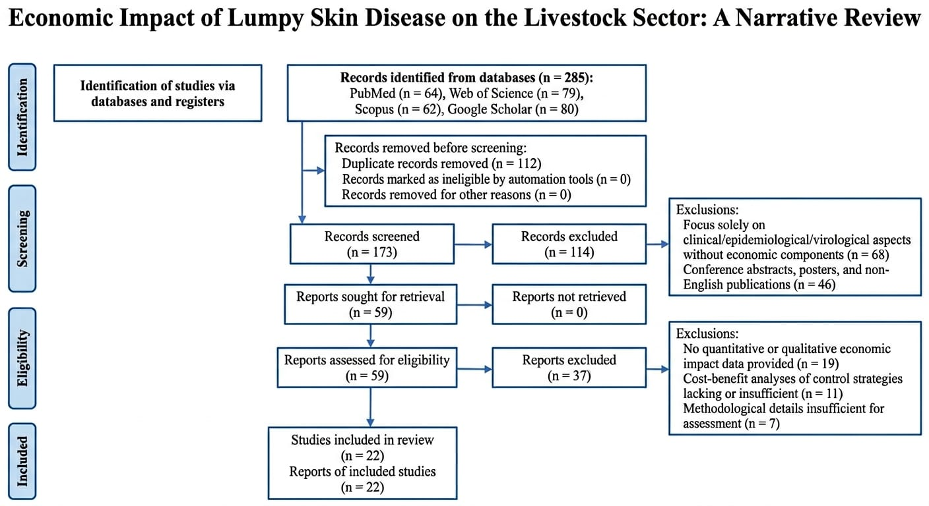

Figure 1: PRISMA flow diagram outlining the systematic literature search, screening, and inclusion process for the review on the economic impact of lumpy skin disease (2010–2026).

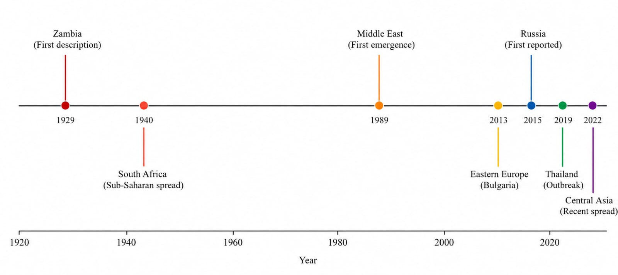

Figure 2: Timeline of Geographic Spread of Lumpy Skin Disease (1929–2022). Key expansion events derived from Tuppurainen & Oura (2012), Roche et al. (2021), Mazloum et al. (2023), and Bhuiyan (2025).
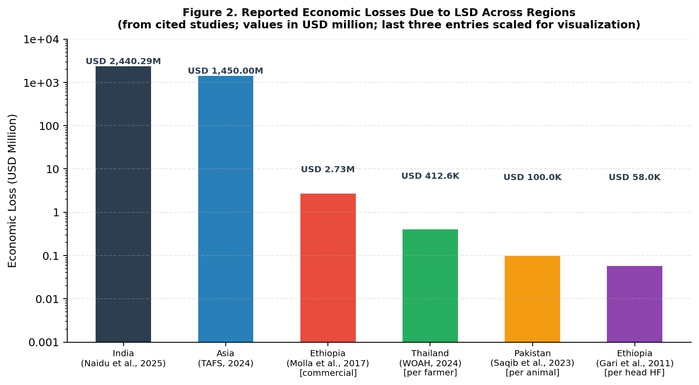

Figure 3: Reported Economic Losses Due to Lumpy Skin Disease Across Regions (logarithmic scale). Values represent total (national/regional) losses where applicable. Per-animal and per-farmer values are scaled for visualization. Sources: Naidu et al. (2025); TAFS (2024); Molla et al. (2017); WOAH (2024); Saqib et al. (2023); Gari et al. (2011).
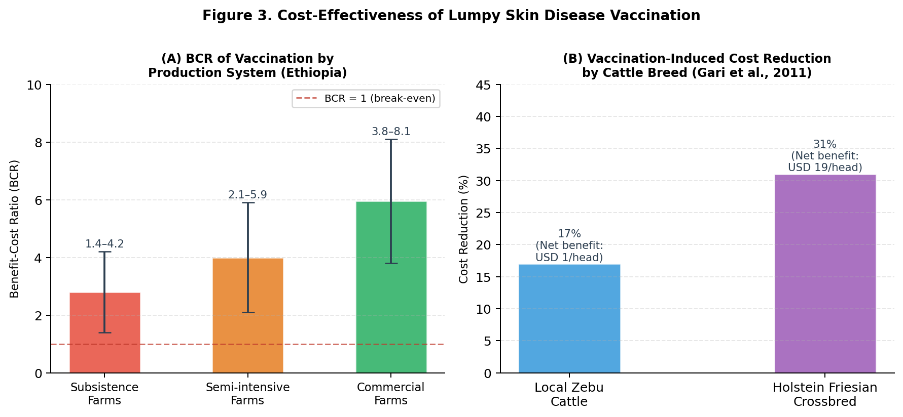

Figure 4. Cost-Effectiveness of Lumpy Skin Disease Vaccination. (A) Benefit-Cost Ratios (BCR) by production system in Ethiopia, showing ranges reported by Molla et al. (2017); error bars indicate minimum–maximum BCR. The dashed line represents BCR = 1 (economic break-even). (B) Vaccination-induced cost reduction by cattle breed, with net benefit per head shown; data from Gari et al. (2011).
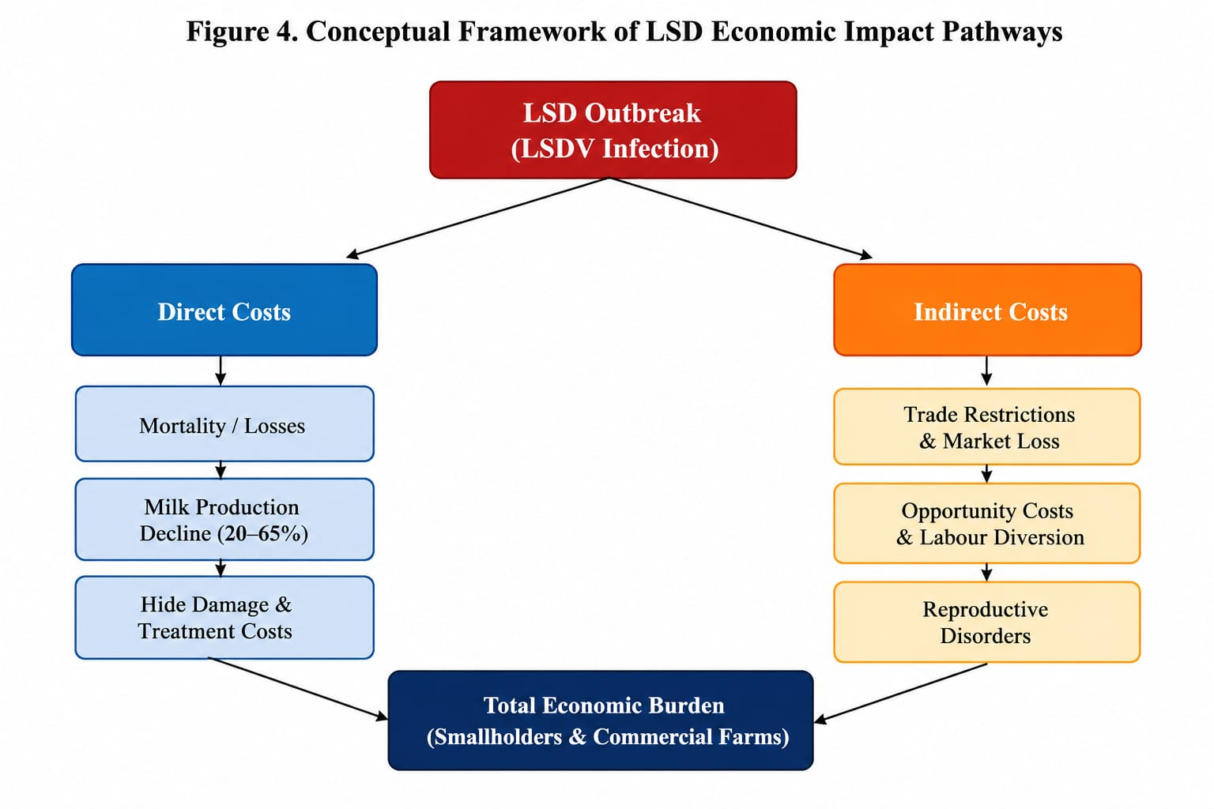

Figure 5. Conceptual Framework of Lumpy Skin Disease Economic Impact Pathways. The framework illustrates direct and indirect cost pathways from LSDV infection to total economic burden in both smallholder and commercial farming systems. Pathway components derived from Akther et al. (2023), Das et al. (2021), Saqib et al. (2023), and Modethed et al. (2025).

Table 1. Summary of Key Economic Studies on Lumpy Skin Disease (2010–2024)

Author(s) & Year | Country / Region | Study Design | Key Economic Findings | Control Strategy Evaluated | Reference
Africa
Gari et al. (2011) | Ethiopia | Cross-sectional survey | USD 6.43/head (Zebu); USD 58/head (HF crossbred) annually in infected herds | Vaccination (partial cost reduction: 17% Zebu, 31% HF) | Gari et al., 2011
Molla et al. (2017) | Ethiopia | Cost-benefit analysis | Median herd loss USD 1,176; Subsistence USD 489; Commercial USD 2,735 per outbreak | Annual vaccination; BCR 1.4–8.1; MRR up to 3,400% | Molla et al., 2017
Asia
Chouhan et al. (2022) | Bangladesh | Epidemiological survey | Attack rate 34%; CFR 3.23%; limited economic analysis | Not evaluated | Chouhan et al., 2022
Saqib et al. (2023) | Pakistan (KP) | Household survey | USD ~100/affected animal; higher losses in exotic breeds; household debt & emotional stress | Not evaluated | Saqib et al., 2023
Naidu et al. (2025) | India (7 states) | Stochastic Monte Carlo modelling | Total USD 2,440.29M (90% CI: 2,162.55–2,716.15M); Gujarat highest milk loss (90 L/animal) | Vaccination (economic rationale supported) | Naidu et al., 2025
Rajendran et al. (2025) | India (Uttar Pradesh) | Farm-level economic assessment | Significant milk production losses 2022–23; crossbred cattle disproportionately affected | Vaccination cost-effectiveness assessed | Rajendran et al., 2025
Southeast Asia
WOAH (2024) | Thailand | Regional assessment | Losses USD 119.42–412.57/farmer; reduced milk production & market disruption | Mass vaccination & movement restriction | WOAH, 2024
Modethed et al. (2025) | Thailand (Northern) | Stochastic modelling of dairy farms | Quantified financial losses in dairy farms; milk yield as primary loss driver | Economic rationale for vaccination confirmed | Modethed et al., 2025
Hutchinson et al. (2024) | Indonesia / SE Asia | Surveillance-based analysis | Trade disruptions with Australia; first LSD cases March 2022; substantial livestock losses | Epidemiological monitoring | Hutchinson et al., 2024
Global / Regional Estimates
TAFS (2024) | Asia (regional) | Regional economic report | Direct livestock & production losses: USD 1.45 billion in Asia | Regional vaccination recommended | TAFS, 2024
Punyapornwithaya et al. (2024) | Thailand (national) | Bayesian structural time series | Mass vaccination + movement restriction reduced LSD case counts significantly | Mass vaccination policy | Punyapornwithaya et al., 2024

Note: BCR = Benefit-Cost Ratio; CFR = Case Fatality Rate; HF = Holstein Friesian; KP = Khyber Pakhtunkhwa; MRR = Marginal Rate of Return. All monetary values in USD. Studies are grouped by geographic region. Data extracted from cited references only.

Table 2. Categories of Economic Losses Associated with Lumpy Skin Disease

Loss Category | Parameter | Reported Range / Value | Key Source(s) | Production System
Direct Economic Losses
Mortality | Case fatality rate | <5% (general); up to 10% in susceptible exotic breeds | Das et al. (2021); Saqib et al. (2023) | All systems
Milk production decline | % yield reduction | 20–65% during acute infection; recovery 2–8 weeks post-disease | Naidu et al. (2025); Rajendran et al. (2025) | Dairy farms
Hide/skin damage | Hide downgrading | Permanent scarring; significant market value loss in leather industry | Akther et al. (2023); Das et al. (2021) | Beef & mixed
Reproductive losses | Fertility reduction | Temporary infertility in bulls; abortion; extended calving interval | Das et al. (2021); Tuppurainen & Oura (2012) | Breeding herds
Veterinary & treatment costs | Per animal treatment | Variable; included in USD ~100/animal estimate (Pakistan) | Saqib et al. (2023); Chouhan et al. (2022) | All systems
Body weight loss | Weight reduction | Prolonged; contributes to reduced slaughter value | Molla et al. (2017); Gari et al. (2011) | Beef & mixed
Indirect Economic Losses
Trade restrictions | Export bans; price suppression | Indonesia–Australia trade disruption; regional market collapse | Hutchinson et al. (2024); TAFS (2024) | Commercial & export-oriented
Opportunity costs | Foregone income; labour diversion | Underestimated in most studies; significant in smallholder systems | Modethed et al. (2025); Saqib et al. (2023) | Smallholder
Market disruption | Delayed marketing; price reduction | USD 119.42–412.57/farmer in Thailand (market + production losses) | WOAH (2024); Wilhelm & Ward (2023) | All systems
Non-market values | Draft power; social status; risk mitigation | Rarely captured; underestimates burden in subsistence systems | Molla et al. (2017); Saqib et al. (2023) | Smallholder / subsistence

Note: All values derived from studies cited within this review. Non-market values (draft power, social function) are systematically underestimated in conventional economic assessments. Recovery period for milk production losses reported as 2–8 weeks post-recovery by Naidu et al. (2025) and Rajendran et al. (2025).

Table 3. Identified Research Gaps, Limitations, and Recommended Future Actions

Research Gap Area | Limitation Identified | Recommended Action | Key References Noting Gap
Methodological standardisation | No internationally accepted protocols for LSD economic assessment; incomparable results across regions | Develop standardised cost-category definitions, time horizons, and CBA templates aligned with OIE/FAO frameworks | Akther et al. (2023); Molla et al. (2017)
Smallholder system assessment | Studies focus on commercial/semi-intensive systems; subsistence farms underrepresented | Develop mixed-methods approaches capturing non-market cattle values (draft power, social capital, risk function) | Saqib et al. (2023); Molla et al. (2017); Gari et al. (2011)
Long-term / longitudinal studies | Most studies assess acute outbreak periods only; chronic and cumulative impacts ignored | Design cohort studies tracking herds for ≥3 years post-outbreak; include reproductive and structural market impacts | Modethed et al. (2025); Rajendran et al. (2025)
Regional economic variation | Intra-country economic heterogeneity not captured; especially in large countries (India, China) | Conduct sub-national economic assessments using geo-referenced production system data | Naidu et al. (2025); Roche et al. (2021)
DIVA vaccine economics | No commercially available DIVA vaccine; no economic evaluation of development and companion diagnostics | Comprehensive cost-effectiveness analysis including R&D, production, and surveillance costs | Mazloum et al. (2023); Ronchi et al. (2024)
Integrated control economics | No economic studies on combined vaccination + vector control + movement restriction strategies | Design field trials with economic component evaluating synergistic effects of integrated approaches | Tuppurainen et al. (2021); Punyapornwithaya et al. (2024)
Digital/precision surveillance economics | Economic value of early warning and digital surveillance systems not quantified | Health-economic modelling of surveillance investment versus outbreak prevention savings | Tuppurainen et al. (2021); Hutchinson et al. (2024)

Note: CBA = Cost-Benefit Analysis; DIVA = Differentiate Infected from Vaccinated Animals; FAO = Food and Agriculture Organization; OIE = World Organisation for Animal Health. All gaps identified from synthesis of the cited literature.

