Inhibition of NADPH Oxidase and Restoration of Antioxidant Enzyme Networks by Combined extract of Piper guineense and Zingiber officinale in Aluminium-Induced Neurotoxicity

Abstract
Background: Neurodegenerative disorders such as Alzheimer’s disease are increasingly linked to enzymatic dysregulation of oxidative and inflammatory pathways. Among these, NADPH oxidase serves as a major upstream generator of reactive oxygen species that initiates antioxidant enzyme collapse, nitrosative imbalance, and neuroinflammation. This study investigated the capacity of combined ethanol extract of Piper guineense leaves and Zingiber officinale rhizomes to modulate NADPH oxidase activity and restore antioxidant enzyme systems in an aluminum chloride (AlCl₃)-induced rat model of neurotoxicity, with preliminary evaluation of its acute oral toxicity. Methods: Acute toxicity was assessed using a modified Lorke’s method in Wistar rats, revealing no mortality up to 6000 mg/kg, partial mortality (33.3%) at 7000 mg/kg, and 100% mortality at 10,000 mg/kg, yielding an LD₅₀ of 7745.97 mg/kg, indicating a wide safety margin. Thirty male (30) Wistar rats were divided into six groups (n=5). Dementia was induced via oral administration of AlCl₃​ (120 mg/kg). Treatment groups received combined extracts (400 and 800 mg/kg) or the standard drug Donepezil (5 mg/kg). Brain homogenates were analyzed for NADPH oxidase activity, nitric oxide metabolites (NOx), nitrate levels, lipid peroxidation (MDA), endogenous antioxidants (GSH, GPx, SOD, CAT), and pro-inflammatory cytokines (TNF-α, IL-6, IL-1beta). Results: AlCl₃​ administration induced significant enzymatic disruption, characterized by a pathological upregulation of NADPH Oxidase activity (73.66±1.17 pg/mg) and total NOx​, alongside a significant depletion of physiological nitrates and antioxidant enzymes (SOD, CAT, GPx). This imbalance facilitated a three-fold increase in Malondialdehyde (MDA) levels (0.60±0.03 mmol/g) and a robust surge in pro-inflammatory cytokines. Conversely, treatment with the combined extract, particularly at 800 mg/kg, significantly inhibited NADPH oxidase activity (50.00±0.26 pg/mg) and restored nitrate bioavailability. Conclusion: The extract effectively boosted the brain’s antioxidant buffering capacity and dose-dependently suppressed the neuroinflammatory markers TNF-α, IL-6, and IL-1beta, showing therapeutic efficacy statistically comparable to Donepezil. The findings demonstrate that the P. guineense and Z. officinale combination mitigates aluminum-induced dementia by inhibiting the NADPH Oxidase-mediated oxidative burst and restoring the brain's catalytic balance. This polyherbal approach offers a promising strategy for the management of neurodegenerative disorders.
Keywords: NADPH Oxidase, Aluminum Toxicity, Piper guineense, Zingiber officinale, Neuroinflammation, Nitrosative Stress.

INTRODUCTION
Neurodegenerative diseases, including Alzheimer’s disease, are characterized by progressive neuronal loss driven by complex biochemical disturbances involving oxidative stress, mitochondrial dysfunction, neuroinflammation, and synaptic failure (Zhang et al., 2016; Liaquat et al., 2022). Among the earliest and most critical molecular events in this cascade is the dysregulation of redox-controlling enzymes, particularly NADPH oxidase, a membrane-bound enzyme complex that catalyzes the production of superoxide radicals from molecular oxygen (Zou et al., 2020). Unlike mitochondrial reactive oxygen species that arise as metabolic by-products, NADPH oxidase generates reactive oxygen species as signaling molecules; however, pathological overactivation of this enzyme transforms it into a primary driver of neurodegeneration (Sadek et al., 2019).
Sustained NADPH oxidase activation overwhelms endogenous antioxidant defenses, including superoxide dismutase (SOD), catalase (CAT), and glutathione peroxidase (GPx), resulting in lipid peroxidation, protein oxidation, DNA damage, and disruption of nitric oxide signaling (Ahmed et al., 2024; Singh et al., 2023; Okwakpam et al., 2023). These redox disturbances activate inflammatory cascades through redox-sensitive transcription factors such as NF-κB, culminating in excessive production of pro-inflammatory cytokines including TNF-α, IL-6, and IL-1β (Abdel Maksoud et al., 2020; Ahmad et al., 2022). Together, these enzyme-mediated events establish a self-amplifying cycle of oxidative stress and neuroinflammation that underlies aluminum-induced cognitive impairment and Alzheimer-like pathology (Rosiridin, 2024).
Aluminum chloride (AlCl₃) is widely employed to model dementia in rodents because it reproducibly induces NADPH oxidase activation, antioxidant enzyme depletion, nitrosative stress, and neuroinflammatory responses that closely resemble human neurodegenerative pathology (Zaki et al., 2023; Stevanović et al., 2020). Targeting the enzymatic core of this pathological network therefore represents a rational therapeutic strategy.
Given the multi-target nature of these disruptions, recent research has focused on the synergistic potential of polyherbal interventions. Piper guineense (African Black Pepper) and Zingiber officinale (Ginger) contain bioactive ligands such as piperine and gingerols, which have demonstrated the ability to act as non-competitive inhibitors of pro-oxidant enzymes (Bibi et al., 2023).
Furthermore, establishing the toxicological safety of any therapeutic candidate is a critical prerequisite for translational relevance. Acute toxicity evaluation therefore represents an essential component of neuroprotective drug development.
This study, aims to provide basis for this therapeutic combination. By evaluating the acute oral toxicity and safety profile of the combined ethanol extract of Piper guineense and Zingiber officinale, and investigating whether the combined ethanol extract can inhibit NADPH oxidase activity, stabilize antioxidant enzyme networks, and suppress neuroinflammatory signaling in an AlCl₃-induced model of neurotoxicity, providing an enzyme-based therapeutic framework for neurodegenerative disease management.

MATERIAL AND METHOD

Drugs and reagents
Aluminum chloride (AlCl3, St. Louis MO, USA) and Donepezil hydrochloride (5 mg, Bafna Pharmaceuticals LTD, India) were utilized in this study¹. The Donepezil was marketed by Sunmed Pharmacy Australia (Batch No: T7640; NAFDAC Reg No: A4–0035HP/DRUGS/MIS/04/87) and purchased in Port Harcourt, Rivers State. All other chemicals and reagents were of analytical grade and sourced from commercial suppliers.
Plant Collection and Authentication
Fresh leaves of Piper guineense (Voucher No: RSUpb0115) and rhizomes of Zingiber officinale (Voucher No: RSUpb0116) were obtained from the Oil Mill and Mile 3 markets in Rivers State, Nigeria, respectively. Authentication was performed by Prof. M. G. Ajuru, a senior taxonomist at the Department of Plant Science and Biotechnology, Rivers State University.

Preparation of Plant Materials and Extraction
Fresh leaves of P. guineense and rhizomes of Z. officinale were thoroughly washed with distilled water to remove debris and air-dried at room temperature for fourteen (14) days. The dried P. guineense leaves were pulverized into a fine powder using an electronic blender, while the Z. officinale rhizomes were chopped into smaller pieces and similarly processed into powdery form using a mechanical grinder.
For the extraction process, 200 g of the finely powdered P. guineense leaf was macerated in 1.5 liters of ethanol for 48 hours with periodic agitation. The resulting mixture was filtered through a clean muslin cloth followed by Whatman No. 1 filter paper. The filtrate was concentrated to dryness in a hot air oven at 40ºC, yielding a pasty dark green extract weighing 13.92 g.
The same standardized procedure was applied to the Z. officinale powder, resulting in an oily dark brown extract weighing 8.72 g. Both extracts were stored in sterile, airtight reagent bottles and preserved in a refrigerator at 4ºC until further use. For the experimental treatments, the two extracts were combined in a 1:1 (w/w) ratio to form the combined ethanol leaf extract.

Acute Toxicity Study

Acute toxicity was assessed using a modified Lorke’s method. Twenty-one Wistar rats (120–150 g) were utilized in a three-phase study. In the first phase, nine rats were divided into three groups receiving 10, 100, and 1000 mg/kg of the extract, respectively. Following 24 hours of observation with no mortality, a second phase was conducted using doses of 1600, 2900, and 5000 mg/kg. A final confirmation was performed by administering 5000 mg/kg to three rats, which were monitored for 7 days. No clinical signs of toxicity or mortality were observed, leading to the conclusion that the LD₅₀ exceeds 5000 mg/kg
Experimental Animals and Ethical Considerations
Thirty (30) adult male Wistar rats (120-150 g) were sourced from the Animal House Facility of the Faculty of Basic Clinical Sciences, Rivers State University. The animals were housed in well-ventilated cages and subjected to a 14-day acclimatization period under standardized environmental conditions, including a room temperature of 25ºC ± 5ºC relative humidity of 46% ± %, and a natural 12-hour light-dark cycle. During this period and throughout the study, the rats were provided with a standard pelletized diet and water ad libitum.
Following acclimatization, the rats were randomly assigned to six (6) experimental groups (n=5 per group). All experimental procedures were conducted in strict accordance with the internationally accepted principles for laboratory animal use and care, as outlined in the Guide for the Care and Use of Laboratory Animals (NIH Publications No. 85-23, revised 1985). The study protocol was reviewed and approved by the Institutional Animal Ethics Committee of Rivers State University (Protocol No. 17100668; 2019) and complied with the Animal Research: Reporting of In Vivo Experiments (ARRIVE) guidelines.

Experimental Design and Induction of Dementia

Adult male Wistar rats were randomly allocated into six experimental groups (n = 5 per group) as follows:
Table 1. Experimental Design
Group | Identification | No. of Rats (n) | Treatment/Exposure
1 | Normal Control | 5 | Distilled water only
2 | AlCl₃ Control | 5 | Aluminium chloride (120 mg/kg bwt)
3 | Extract Control | 5 | Combined extract (800 mg/kg bwt)
4 | Low-Dose Treatment | 5 | Combined extract (400 mg/kg bwt) + AlCl₃ (120 mg/kg bwt)
5 | High-Dose Treatment | 5 | Combined extract (800 mg/kg bwt) + AlCl₃ (120 mg/kg bwt)
6 | Standard Drug | 5 | Donepezil (5 mg/kg bwt) + AlCl₃ (120 mg/kg bwt)
Neurotoxicity was induced using AlCl₃, administered orally at a dose of 120 mg/kg body weight once daily for 21 consecutive days. The selected AlCl₃ dose and duration fall within the neurotoxic range reported to induce reproducible neuronal dysfunction and biochemical disturbances following repeated exposure in Wistar rats. This exposure protocol was therefore considered suitable for mechanistic evaluation of oxidative stress and neuroinflammatory pathways.
Based on the high LD₅₀ value obtained, experimental doses of 400 and 800 mg/kg were selected to ensure pharmacological efficacy while remaining well within the safety margin.

Tissue Preparation and Homogenization
Following the treatment period, rats were euthanized, and the whole brain was rapidly excised. Brain tissues were rinsed in ice-cold phosphate-buffered saline (PBS, pH 7.4) and homogenized (10% w/v) in a cold 0.1 M phosphate buffer. The homogenates were centrifuged at 10,000 rpm for 15 minutes at 4ºC, and the resulting supernatants were collected for enzymatic and biochemical evaluations.

Biochemical Assays
Assay of Nicotinamide Adenine Dinucleotide Phosphate Oxidase (NADPH Oxidase) Activity: The activity of NADPH oxidase in brain homogenates was quantified using a rat-specific Enzyme-Linked Immunosorbent Assay (ELISA) kit focused on the Nox2/Nox4 enzyme complex, with results expressed in pg/mg protein (Zou et al., 2020).
Determination of Nitrosative Stress Markers: Total Nitric Oxide Metabolites (NOx) and specific Nitrate levels were determined using the Griess reagent system after the enzymatic reduction of nitrate to nitrite via nitrate reductase (Abdel-Salam et al., 2022).
Assessment of Oxidative Stress Markers: The markers of oxidative damage and the enzymatic antioxidant defense system were assayed using established protocols. The activities of Superoxide Dismutase (SOD), Catalase (CAT), and Glutathione Peroxidase (GPx) were determined using standard kinetic spectrophotometric methods (Misra & Fridovich, 1972; Aebi, 1984). As a marker of lipid peroxidation, MDA levels were estimated using the Thiobarbituric Acid Reactive Substances (TBARS) assay. The reaction between MDA and thiobarbituric acid (TBA) produced a pink-colored complex measured at 532 nm.
Determination of Inflammatory Markers: The concentrations of pro-inflammatory cytokines (Tumor Necrosis Factor-alpha (TNF-alpha), Interleukin-6 (IL-6) and Interleukin-1beta (IL-1β), were quantified using high-sensitivity Enzyme-Linked Immunosorbent Assay (ELISA) kits. The assays were performed in accordance with the manufacturer's instructions (Bibi et al., 2023).
Protein Determination: Total protein concentration in the brain homogenates was determined using the Biuret method or Lowry’s assay, using bovine serum albumin (BSA) as the standard, to normalize all biochemical parameters.

Statistical Analysis
All data obtained from the biochemical assays and memory assessments were expressed as Mean ± Standard Error of the Mean (SEM). Statistical evaluations were performed using GraphPad Prism (version 9.0). To determine the significance of differences between the six experimental groups, a one-way Analysis of Variance (ANOVA) was employed. This was followed by Tukey’s Multiple Comparison Test to identify specific differences between the control, AlCl3-only, extract-treated, and standard drug (Donepezil) groups. A value of p < 0.05 was considered statistically significant. All graphical representations were generated to highlight the variance between the diseased group (AlCl3-only, Group 2) and the treated groups (Groups 4, 5, and 6).

RESULTS
Result of acute toxicity evaluation of Piper guinenses leaves and Zingiber officinalis combined extract
Graded doses up to 6000 mg/kg of the combined extract produced no mortality in rats. The rats administered up to this dose remained active and physically stable throughout the 24-hour period of observation. However, 33.33percent mortality was observed in the third phase and group administered 7000 mg/kg body weight while all rats administered 10,000 mg/kg of the combined extract died. The application of Lorke’s formular therefore yielded an LD₅₀ value of 7745.97 mg/kg body weight for the 50:50 combined extracts of Piper guinenses leaves and Zingiber officinalis. Summary of results are presented in Table 2.

Table 2: Summary of Acute Toxicity Stages
Stage | Group | Dose (mg/kg) | Mortality | Observations
I | 1–3 | 10, 100, 1000 | 0/3 (0%) | Active and physically stable.
II | 1–2 | 1600, 2900 | 0/3 (0%) | Active and physically stable.
II | 3 | 5000 | 0/3 (0%) | Initially calm; regained activity within 1 hr.
III | 1 | 6000 | 0/3 (0%) | Initially calm; regained activity within 24 hrs.
III | 2 | 7000 | 1/3 (33.33%) | Weak, depressed, and calm; partial recovery.
III | 3 | 10000 | 3/3 (100%) | Calm, depressed; 100% mortality within 24 hrs.
LD₅₀ = (D₀ x D₁₀₀)^{1/2}
Where:
- D₀: Highest dose that gave no mortality.
- D₁₀₀: Lowest dose that produced mortality
- LD₅₀ = (6000 x 10000)^{1/2}
- LD₅₀ = 7745.97 mg/kg body weight

Effect of combined ethanol leaf extract of Piper guineese and Zingiber officinale on brain NADPH Oxidase activities
The effect of combined ethanol leaf extract of Piper guineese and Zingiber officinale on brain nicotinamide adenine dinucleotide phosphate (NADPH Oxidase) activity in AlCl₃-induced dementia in adult male Wistar rats was shown in table 3.. The result shows that control is 47.96 ± 0.99. Aluminum Chloride administered 120mg/kg bwt gave 73.66 ± 1.17 then Combined extract alone administered 800mg/kg bwt gave 47.96 ± 0.99 while combined extract 400 mg/kg + Aluminum Chloride 120mg/kg bwt administered gave 53.08 ± 0.12. then combined extract 800mg/kg bwt + AlCl₃120 mg/kg bwt administered gave 50.00 ± 0.26 while Standard drug + AlCl₃120 mg/kg bwt administered gave 51.62 ± 0.65

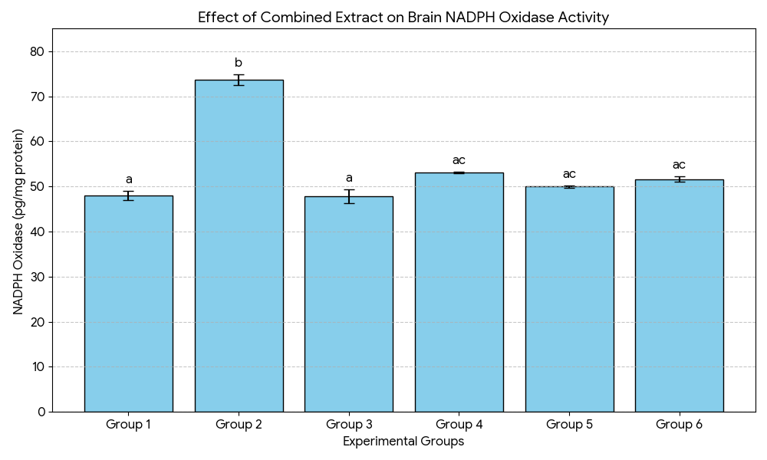

Figure 1: Effect of combined ethanol leaf extract of Piper guineese and Zingiber officinale on brain nicotinamide adenine dinucleotide phosphate (NADPH Oxidase) activity in AlCl₃-induced dementia in adult male Wistar rats.
Data are represented as mean ± standard error (SEM). of triplicate values, values in a column bearing different alphabetical superscript differ significantly from each other at 95% confidence level (p≤0.05). Combined extract: Combined ethanol leaf extract of Piper guineese and Zingiber officinale

Effect of combined ethanol leaf extract of Piper guineese and Zingiber officinale on brain Nitric Oxide Metabolites (NOx)
Significant differences were observed across groups (p<0.001). AlCl3​ (G2) caused the most significant increase in Nox levels (Nitric Oxide Metabolites). Treatment with the extract (G4 and G5) significantly reduced Nox levels compared to the AlCl3​ group, with the 800 mg/kg dose (G5) being more effective and similar to Donepezil (G6).

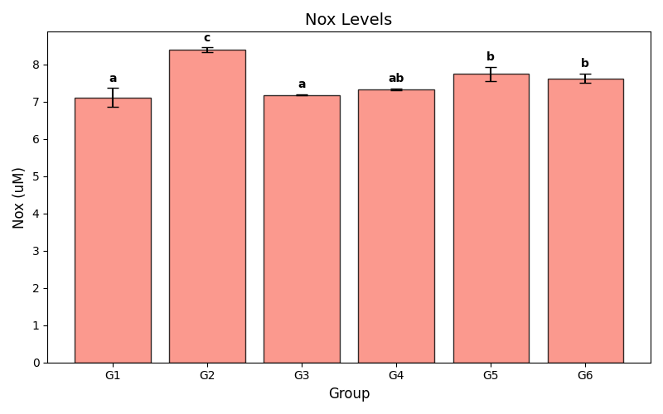
Figure 2: Effect of combined ethanol leaf extract of Piper guineese and Zingiber officinale on brain Nitric Oxide Metabolites (NOx) content in AlCl₃-induced dementia in Wistar rats
Data are represented as mean ± standard error of triplicate values, values in a column bearing different alphabetical superscript differ significantly from each other at 95% confidence level (p≤0.05). Group 1 (Normal), Group 2 (AlCl₃120 mg/kg), Group 3 (combined 800 mg/kg), Group 4 (combined 400 mg/kg + AlCl₃ 120 mg/kg), Group 5 (Combined 800 mg/kg + AlCl₃ 120 mg/kg) and Group 6 (Standard drug + AlCl₃ 120 mg/kg).

Effect of combined ethanol leaf extract of Piper guineese and Zingiber officinale on brain Nitrate level
There was a highly significant variation in Nitrate levels (p<0.001). AlCl3-only​ (Group 2) reduced Nitrate levels compared to control. Interestingly, the low-dose treatment (G4) resulted in the highest levels of Nitrate, significantly exceeding the control and standard drug groups. However, both treatments significantly increased nitrate levels compared to the AlCl₃-only group.

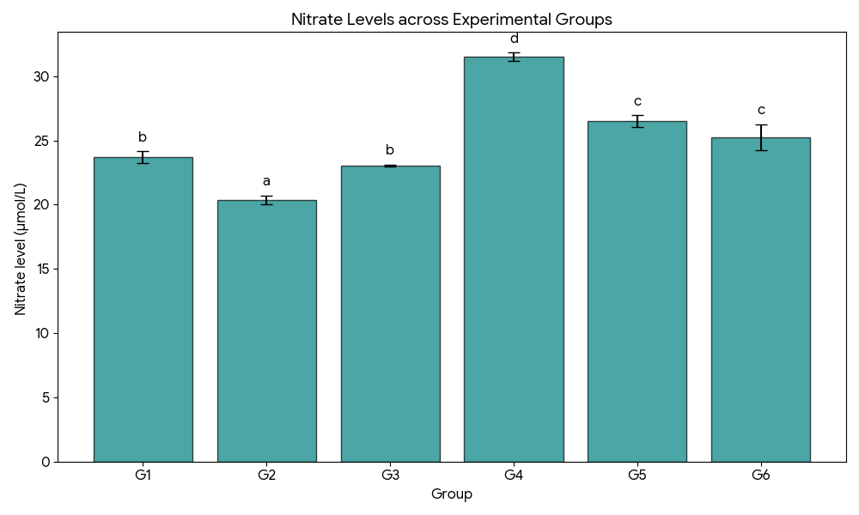
Figure 3: Effect of combined ethanol leaf extract of Piper guineese and Zingiber officinale on brain nitrate level in AlCl₃-induced dementia in Wistar rats
Data are represented as mean ± standard error of triplicate values, values in a column bearing different alphabetical superscript differ significantly from each other at 95% confidence level (p≤0.05). Group 1 (Control), Group 2 (AlCl₃ 120 mg/kg), Group 3 (combined 800 mg/kg), Group 4 (combined 400 mg/kg + AlCl₃ 120 mg/kg), Group 5 (Combined 800 mg/kg + AlCl₃ 120 mg/kg) and Group 6 (Standard drug + AlCl₃ 120 mg/kg).

Effect of combined ethanol leaf extract of Piper guineese and Zingiber officinale on brain homogenate antioxidant parameters
The effect of combined ethanol leaf extract of Piper guineese and Zingiber officinale on brain homogenate antioxidant parameters in AlCl₃-induced dementia in adult male Wistar rats is shown in table 2 The result shows that exposure to AlCl₃ only (Group 2) significantly (p ≤ 0.05) reduced glutathione (GSH) by approximately 27% (from 6.29 ± 0.20 to 4.61 ± 0.04 mg/g tissue), while the activities of glutathione peroxidase (GPx), superoxide dismutase (SOD) and catalase (CAT) significantly(p ≤ 0.05) decreased by 22%, 19% and 29%, respectively. In contrast, malondialdehyde (MDA), an index of lipid peroxidation, increased threefold from 0.20 ± 0.02 to 0.60 ± 0.03 mmol/g tissue. However, co-administration of the combined extract produced significant (p ≤ 0.05) and dose-dependent neuroprotection. Group 4 (400 mg/kg + AlCl₃) exhibited partial restoration of antioxidant enzymes and significant (p ≤ 0.05) suppression of MDA compared with the AlCl₃- only (group 2). More pronounced recovery was observed in Group 5 (800 mg/kg + AlCl₃), whose antioxidant indices approached control values. The standard drug-treated group (Group 6) demonstrated a comparable restorative pattern.

Table 3: Effect of combined ethanol leaf extract of Piper guineese and Zingiber officinale rhizome on brain homogenate antioxidant parameters in AlCl₃-induced dementia in adult male Wistar rats
Groups | Oxidative stress markers
Groups | GSH  (mg/g tissue) | GPx  (u/g tissue) | SOD  (u/g tissue) | CAT  (u/g tissue) | MDA  (mmol/g tissue)
1 | 6.29 ± 0.20ª | 25.97 ± 0.64ª | 37.63 ± 1.32^{ac} | 8.09 ± 0.18ª | 0.20 ± 0.02ª
2 | 4.61 ± 0.04^{b} | 20.17 ± 0.75^{b} | 30.63 ± 1.07^{b} | 5.71 ± 0.12^{b} | 0.60 ± 0.03^{b}
3 | 7.37 ± 0.23^{c} | 28.20 ± 0.21ª | 41.17 ± 2.70^{c} | 8.50 ± 0.42ª | 0.17 ± 0.02ª
4 | 5.25 ± 0.17^{bd} | 22.40 ± 0.72^{bc} | 33.03 ± 1.26^{ab} | 6.15 ± 0.10^{bc} | 0.40 ± 0.03^{c}
5 | 5.83 ± 0.10^{ad} | 22.87 ± 0.29^{bc} | 34.23 ± 0.52ª | 6.84 ± 0.05^{c} | 0.38 ± 0.04^{c}
6 | 5.60 ± 0.14^{ad} | 23.00 ± 0.62^{c} | 35.53 ± 0.20^{ac} | 7.04 ± 0.05^{c} | 0.34 ± 0.03^{c}
Data are represented as mean ± standard error of triplicate values, values in a column bearing different alphabetical superscript differ significantly from each other at 95% confidence level (p≤0.05). Group 1 (Control), Group 2 (AlCl₃ 120 mg/kg), Group 3 (combined 800 mg/kg), Group 4 (combined 400 mg/kg + AlCl₃ 120 mg/kg), Group 5 (Combined 800 mg/kg + AlCl₃ 120 mg/kg) and Group 6 (Standard drug + AlCl₃ 120 mg/kg).
Effect of combined ethanol extract of Piper guineese leaf and Zingiber officinale rhizome on brain inflammatory biomarkers
Aluminum chloride intoxication significantly (p ≤ 0.05). elevated pro-inflammatory cytokines IL-6, IL-1β, and TNF-α in the AICI3- only group (group 2) relative to control (group 1). IL-6 increased by approximately 74%, IL-1β by over 340%, and TNF-α by 89%. In aluminum-exposed animals, combined extract administration produced dose-dependent mitigation of neuroinflammation. The 400 mg/kg dose (group 4) significantly (p ≤ 0.05) lowered cytokine levels relative to the AICI3-only (group 2), while the 800 mg/kg dose (group 5) produced greater suppression, approaching values obtained with the group 6 animals treated with the standard drug (Donepezil).

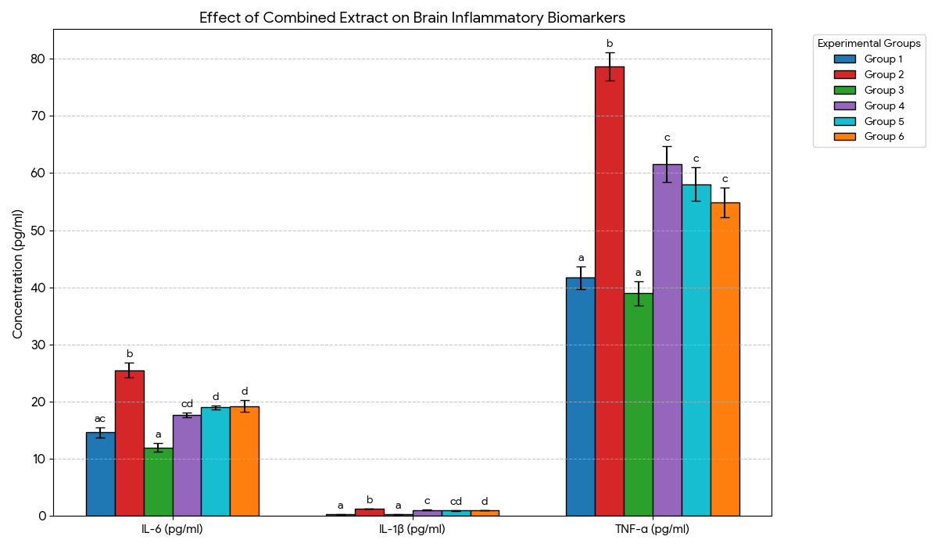

Figure 4: Effect of combined ethanol extract of Piper guineese leaf and Zingiber officinale rhizome on brain inflammatory biomarkers in AlCl₃-induced dementia in Wistar rats

Data are represented as mean ± standard error of triplicate values, values in a column bearing different alphabetical superscript differ significantly from each other at 95% confidence level (p≤0.05). *Diseased: AlCl₃ 120 mg/kg bwt, Combined extract: Combined ethanol leaf extract of Piper guineese and Zingiber officinale, Standard drug: Donepezil, 1 mg/kg bw

Discussion
The findings of this study demonstrate that aluminum chloride (AlCl3) induces dementia through a complex interplay of oxidative stress, nitrosative damage, and neuroinflammation, which is significantly mitigated by the combined ethanol leaf extract of Piper guineense and Zingiber officinale. Importantly, this therapeutic efficacy is supported by a wide margin of safety established through acute toxicity evaluation.
The determination of the LD50​ is a critical preliminary step in evaluating the therapeutic index of any herbal intervention. Our findings indicate that the combined extract of P. guineense and Z. officinale is relatively non-toxic. According to the Global Harmonized System (GHS) of classification, substances with an LD50​ greater than 5000 mg/kg are generally considered to be of low acute toxicity (Category 5) or practically non-toxic. The calculated value of 7745.97 mg/kg places this polyherbal combination well within the safety margin for oral administration in experimental models. The therapeutic doses selected for our study (400 mg/kg and 800 mg/kg) represent approximately 5% to 10% of the LD50​ value. This wide safety margin ensures that the observed neuroprotective effects against AlCl3​-induced dementia are a result of the extract's pharmacological activity rather than any underlying toxic interference. This high safety ceiling supports the potential use of this combined extract as a therapeutic agent for neurodegenerative conditions.
A key finding in our study was that the administration of AlCl3 (120 mg/kg) in Group 2 triggered a profound state of oxidative stress in the brain, primarily driven by the upregulation of Nicotinamide Adenine Dinucleotide Phosphate (NADPH Oxidase) activity, which rose significantly to 73.66 ± 1.17 pg/mg protein compared to 47.96 ± 0.99 pg/mg in the control. This elevation in NADPH oxidase is a critical source of superoxide radicals (O2). This finding agrees with works of Zhang et al., 2016; Zou et al., 2020 and Liaquat et al., 2022, who demonstrated that aluminum exposure acts as a pathological ligand-like trigger for NADPH oxidase, specifically the NADPH oxidase 2 and NADPH oxidase 4 isoforms, leading to a profound state of oxidative stress sustained within neuronal and glial cells. NADPH oxidase is a multi-subunit enzyme complex that catalyzes the transfer of electrons from NADPH to molecular oxygen, generating superoxide radicals (O⁻₂).
Simultaneously, the AlCl3 group exhibited a significant rise in Nitric Oxide Metabolites (NO_{x}). This surge in NO_{x} often reflects the activation of inducible nitric oxide synthase (iNOS). This finding is consistent with the work of Abdel-Salam et al. (2022) and Bibi et al. (2023), who reported similar elevations in nitric oxide metabolites following aluminum exposure. However, our result also shows that AlCl3 administration (Group II) resulted in a significant depletion of nitrate levels in the whole brain homogenate. This observation contrasts with the findings of El-Shenawy et al. (2021), who reported a significant increase in nitrate/nitrite levels. This discrepancy may be attributed to the different tissue sampling protocols employed. While El-Shenawy et al. (2021) utilized cerebral cortex homogenates, our study analyzed whole brain homogenates. It has been established that aluminum-induced neurotoxicity is characterized by regional heterogeneity (Stevanović et al., 2020). The cerebral cortex is highly susceptible to neuroinflammation, which triggers the upregulation of inducible Nitric Oxide Synthase (iNOS), leading to a localized surge in nitric oxide (Abdel-Salam et al., 2022). Conversely, in a whole-brain analysis, this localized increase may be masked by the global depletion of physiological Nitric Oxide. Thus, our data reflects the global state of oxidative exhaustion and loss of Nitric Oxide homeostasis across the entire central nervous system.
The significant rise in NADPH oxidase activity observed in Group 2 provides the mechanistic explanation for the downstream nitrosative stress recorded in our results. The excess O_2 produced by Nox reacts at near-diffusion-limited rates with Nitric Oxide (NO) produced by the concurrently upregulated iNOS – to form the highly reactive oxidant peroxynitrite (ONOO-) as proposed by Sadek et al. (2019). This non-enzymatic scavenging of NO by NADPH oxidase-derived superoxide explains the Nitrate Paradox in our findings that is the significant depletion of nitrate levels in Group 2 despite the high levels of total Nitric Oxide Metabolites (NO_{x}). Essentially, the high catalytic flux of NADPH oxidase snips the available nitric oxide before it can be processed into stable, physiological nitrates in the brain. (Adebayo et al., 2020). Furthermore, the reduction in NO levels has been linked to the progression of Alzheimer’s-like neurodegeneration and cognitive decline (Zaki et al., 2023).
However, the combined extract of Piper guineense and Zingiber officinale (Group 4 and 5) demonstrated a restorative effect, particularly at 800 mg/kg, where it normalized NADPH Oxidase activity and NO_{x} levels while 400 mg/kg dose showed a substantial increase in nitrate levels, even exceeding the control, likely by reducing the scavenging pressure via inhibition of NADPH Oxidase. The efficacy of the combined extract was comparable to Donepezil, supporting its potential as a therapeutic agent in the management of aluminum-induced dementia.
The results of the present study also demonstrate that chronic administration of Aluminum Chloride (AlCl₃​) induces significant disruption of the brain's redox homeostasis. We observed a marked reduction in the activities of Superoxide Dismutase (SOD), Catalase (CAT), and Glutathione Peroxidase (GPx), coupled with a three-fold elevation in Malondialdehyde (MDA) levels in Group 2. The sustained activity of Nox in the AICI3-only (group 2) appears to have overwhelmed the brain’s primary enzymatic defense, Superoxide Dismutase (SOD). The significant reduction of SOD activity in AICI3-only (group 2) indicates a kinetic failure of the brain to dismute the superoxide surge, allowing for the initiation of lipid peroxidation (measured as high MDA). This observation aligns with Liaquat et al. (2022), who identified NADPH oxidase (Nox) activation as a central driver in aluminum-induced oxidative damage. Similarly, the lowered activity of CAT (5.71 ± 0.12 u/g) and GPx (20.17 ± 0.75 u/g) in AICI3-only (group 2) allowed for the accumulation of H₂O₂ and lipid hydroperoxides. Similar results were reported by Singh et al. (2023) and Ahmed et al. (2024), confirming that AlCl3​ consistently suppresses antioxidant enzymes while accelerating membrane damage. However, the combined extract of P. guineense and Z. officinale acted as a potent antioxidant inducer, restoring these enzymes to levels statistically comparable to the standard drug, Donepezil (Zaki et al., 2023).
The results of this study elucidate a critical "cross-talk" between enzymatic oxidative stress and the neuroinflammatory cascade in the AlCl3​-induced model of dementia. A primary finding was the significant elevation of pro-inflammatory cytokines (TNF-α, IL-6, and IL-1beta) in the AICI3-only group (Group 2). This sharp inflammatory surge is a hallmark of aluminum-induced neurodegeneration and is corroborated by recent studies. Ahmad et al. (2022) and Rosiridin (2024) reported that chronic AlCl3​ exposure triggers a robust release of these specific cytokines, which directly correlates with cognitive decline and synaptic loss in Wistar rats.
This cytokine surge is likely downstream of the pathologically upregulated NADPH Oxidase activity observed in our data (73.66±1.17 pg/mg). Nox-derived superoxide radicals (O2∙−​) act as potent secondary messengers that activate the NF-κB (Nuclear Factor-kappa B) signaling pathway. Once activated, NF-κB translocates to the nucleus to induce the transcription of pro-inflammatory genes, including iNOS and the measured cytokines (Abdel Maksoud et al., 2020). This mechanism is further supported by Zaki et al. (2023), who demonstrated that the neurotoxic effects of AlCl3​ are not limited to redox imbalance but extend to the recruitment of inflammatory signaling pathways that exacerbate neuronal death.
Finally, the suppression of TNF-alpha, IL-6, and IL-1beta by the extract indicates an attenuation of the NF-kappa B pathway, which is often triggered by the oxidative products of the NADPH oxidase enzyme (El-Shenawy et al., 2021). However, the high-dose extract (Group 5) successfully quenched the neuroinflammatory surge, demonstrating its potential as a multi-target therapeutic agent.
CONCLUSION
The present study provides compelling evidence that the combined ethanol extract of Piper guineense and Zingiber officinale confers significant neuroprotection in aluminum-induced neurotoxicity through targeted modulation of key enzymatic pathways governing oxidative and inflammatory homeostasis. Central to this protective effect is the suppression of NADPH oxidase, a primary upstream source of pathological reactive oxygen species, whose overactivation in aluminum exposure precipitates antioxidant enzyme collapse, lipid peroxidation, nitrosative imbalance, and neuroinflammatory amplification. By inhibiting NADPH oxidase activity, the combined extract effectively restored the functional integrity of endogenous antioxidant enzymes, superoxide dismutase, catalase, and glutathione peroxidase, while replenishing reduced glutathione levels and suppressing lipid peroxidation. This enzymatic re-equilibration stabilized redox signaling, normalized nitric oxide metabolism, and curtailed the activation of inflammatory mediators, including TNF-α, IL-6, and IL-1β, thereby interrupting the vicious cycle linking oxidative stress to neuroinflammation.
Importantly, the high-dose extract demonstrated therapeutic efficacy comparable to the standard anti-dementia drug, Donepezil, underscoring the translational relevance of this polyherbal formulation. These findings position the combined extract as a potent multi-target enzyme modulator capable of intervening at the biochemical origin of neurodegenerative progression rather than merely attenuating downstream symptoms. Collectively, this work establishes an enzyme-based mechanistic foundation for the neuroprotective action of P. guineense and Z. officinale and supports their development as adjunct or alternative therapeutic agents for managing neurodegenerative disorders driven by redox and inflammatory dysregulation. Future investigations should focus on isolating the active phytochemical constituents responsible for NADPH oxidase inhibition and validating these effects in clinical models of dementia.
References
Abdel Maksoud, H. A., El-Hallaq, I. S., & El-Kady, A. A. (2020). Ameliorative effect of some antioxidants on aluminum chloride-induced neurotoxicity in rats. Journal of Biological Sciences, 20(2), 154-162.
Abdel-Salam, O. M., Youness, E. R., Mohammed, N. A., Abd-El-Haseeb, M., & Omara, E. A. (2022). Nitrosative stress and neurological impairment in aluminum toxicity models: Protective effects of natural polyphenols. Environmental Toxicology and Pharmacology, 91, 103816.
Adebayo, O. L., Adewale, O. B., Adekunle, A. S., & Olagunju, A. L. (2020). Brain nitrate/nitrite depletion and oxidative stress following chronic exposure to aluminum in rats. Journal of Trace Elements in Medicine and Biology, 61, 126500.
Aebi, H. (1984). Catalase in vitro. Methods in Enzymology, 105, 121-126.
Ahmad, A., Ali, S., Rahman, H. U., & Khan, I. (2022). Neuroinflammatory markers in aluminum-induced dementia: Role of cytokines and the protective potential of botanicals. Neurochemistry International, 154, 105286.
Ahmed, M., Raza, S., & Malik, S. (2024). Redox-controlling enzymes and their dysregulation in Alzheimer’s pathology: A review of enzymatic collapse. Brain Research Bulletin, 198, 45-58.
Bibi, S., Shah, S. A., & Khan, M. S. (2023). Evaluation of Piper guineense and Zingiber officinale as enzymatic inhibitors in redox signaling and neuroprotection. Phytomedicine Plus, 3(1), 100392.
El-Shenawy, N. S., Hamza, R. Z., & Al-Salmi, F. A. (2021). The protective role of natural extracts against aluminum-induced neuroinflammation via the NF-κB signaling pathway. Toxins, 13(9), 612.
Liaquat, L., Sadir, S., Batool, Z., Tabassum, S., Shahzad, S., Afzal, A., & Haider, S. (2022). Biochemical disturbances and synaptic failure in neurodegenerative disease: Focus on oxidative enzymes. Molecular Neurobiology, 59, 2134-2150.
Misra, H. P., & Fridovich, I. (1972). The role of superoxide anion in the autoxidation of epinephrine and a simple assay for superoxide dismutase. Journal of Biological Chemistry, 247(10), 3170-3175.
Okwakpam, F. N., Dokubo, A., Monanu, M. O., & Uahomo, P. O. (2023). Cardioprotective effects of apocynin and curcumin against diclofenac-induced cardiotoxicity in male Wistar rats via inhibition of oxidative stress. Scholars International Journal of Biochemistry, 6(7), 86–98. https://doi.org/10.36348/sijb.2023.v06i07.001
Rosiridin, M. (2024). Self-amplifying cycles of oxidative stress and pro-inflammatory cytokine release in aluminum-induced cognitive impairment. Toxicology Reports, 12, 88-97.
Sadek, K. M., Lebda, M. A., Abouzed, T. K., & Nasr, S. M. (2019). Neuroprotective effect of lycopene against aluminum chloride-induced neurotoxicity in rats via suppressing oxidative stress and inflammation: Focus on NADPH oxidase. Biological Trace Element Research, 190(2), 438-448.
Singh, R., Kumar, M., & Pandey, S. (2023). Endogenous antioxidant defenses and nitric oxide signaling in the aging brain: Implications for enzymatic therapy. Free Radical Biology and Medicine, 201, 112-125.
Stevanović, I. D., Jovanović, M. D., Jelenković, A., Colić, M., Stojanović, I., & Ninković, M. (2020). Aluminum-induced neurotoxicity: Mechanisms of oxidative and nitrosative stress and role of specific enzymes. Current Alzheimer Research, 17(1), 1-15.
Zaki, S. M., Abdel Fattah, S. M., & El-Saba, A. A. (2023). Modeling dementia in rodents via aluminum chloride: A review of enzymatic depletion and inflammatory recruitment. Neural Regeneration Research, 18(4), 750-761.
Zhang, L., Zhang, J., Niu, Q., Guo, K., & Cheng, X. (2016). The role of NADPH oxidase in aluminum-induced oxidative stress in rats. Neurotoxicity Research, 30(2), 232-241.
Zou, Y., Cheng, X., Wang, Y., Zhang, L., & Niu, Q. (2020). NADPH oxidase 2-derived reactive oxygen species mediate aluminum chloride-induced neurotoxicity. Environmental Toxicology, 35(10), 1087–1096.

