Original Research Article

DESIGN AND PERFORMANCE EVALUATION OF A SMALL SCALE WASTE-TO-ENERGY SYSTEM FOR RURAL COMMUNITIES

.
ABSTRACT

The project aims to design a torrefaction reactor and evaluate the energy content of torrefied coconut shells using artificial neutral network (ANNs), random forest and linear regression. The best method for predicting the HHV of coconut shell was determined. The designed reactor enables optimal torrefaction, facilitating the production of high-quality torrefied coconut shell. Machine learning algorithms, including Artificial Neural Networks (ANN), Random Forest, and Linear Regression, are employed to predict the Higher Heating Value (HHV) of the torrefied coconut shell. The evaluation reveals strong correlations between the predicted HHV values and the actual HHV values extracted from literature sources. The ANN model had the highest level of accuracy followed by the linear regression model and then the random forest model. The ANN achieved a Mean Absolute Error (MAE) of 1.399 and Mean Squared Error (MSE) of 4.083 for proximate datasets and a Mean Absolute Error (MAE) of 1.046 and Mean Squared Error (MSE) of 2.565 for ultimate datasets. Torrefied biomass feature importance analysis highlights the significant influence of fixed carbon, ash, and volatile matter on HHV prediction. The findings contribute to understanding the torrefaction process, optimising reactor design, and advancing machine learning techniques for predicting torrefied coconut shell's energy content. It was deduced that the R² of the empirical formula generated for HHV Proximate is better at predicting accurately the HHV of Coconut shell as it has a R² value of 0.9162 as compared to 0.9254 obtained for the ultimate on artificial neutral network (ANN).

Keywords: [Torrefaction, Coconut Shell, Artificial Neural Networks, Higher Heating Value, Machine Learning]

1. INTRODUCTION

Energy consumption is steadily increasing as the world's population and industrialization rise. Biomass is a renewable resource that has received a lot of attention recently as a result of increased energy demand and environmental concerns. Because it is carbon-neutral and generated sustainably, biomass is quickly becoming a key part of the energy mix. According to Bajwa using raw biomass fuels, on the other hand, has major effects during biomass thermal conversion (Bajwa et al., 2015).
Biomass is one of the most widely used renewable energy sources in the world. Torrefaction is a thermal treatment process that has gained attention in recent years, as it improves the properties of biomass by reducing its moisture content and increasing its energy density (Basu, 2013). However, accurate measurement of the heating value of torrefied biomass is essential for proper utilization in industrial applications (Tan et al., 2015).

Currently, the most widely used method for measuring the heating value of torrefied biomass is the bomb calorimeter. However, this method is time-consuming and expensive. An alternative approach is to predict the heating value from the proximate and ultimate analysis of the torrefied biomass using statistical and artificial intelligence (AI) techniques (Tumuluru et al., 2011).

Rationale: The prediction of the heating value of torrefied biomass from its proximate and ultimate analysis is an important research area as it can provide a quick and cost-effective means for determining the quality of torrefied biomass. This information can be used by industries that use torrefied biomass as a fuel source to optimize their processes and ensure a consistent and reliable fuel supply.

Therefore, the aim of this study is to develop and compare ANNs, random forest, and linear regression models for predicting the heating value of torrefied biomass from its proximate and ultimate analysis. The results of this study will provide valuable insights into the accuracy and efficiency of these techniques for predicting the heating value of torrefied biomass, and their potential for industrial applications.

Torrefaction is the slow heating of biomass at temperatures between 200°C and 300°C in an inert or oxygen-deficient atmosphere. Heating rate, reaction temperature, reactor environment, residence time, air pressure, feedstock flexibility, particle size, and moisture content are all factors that influence the torrefaction process. Before torrefaction, biomass is typically pre-dried to a moisture content of less than 10%. Furthermore, the particle size of the feedstock has an impact on the torrefaction process kinetics, reaction mechanisms, and residence duration for a given heating rate (Tumuluru et al., 2011). Moisture is evaporated during the torrefaction process, and some of the organic components of organic compounds that include hydrogen and oxygen are thermally destroyed, producing volatile organic chemicals (Beckman et al., 2012). At the end of the torrefaction process, a solid homogenous product with reduced moisture and higher energy content is created.

Aim Objective of the Study
Objectives of the study are to:
- design a reactor for torrefaction process
- simulate the designed torrefaction reactor using ANSYS tool
- employ Machine Learning Techniques: Artificial Neural Network (ANNs), random forest and linear regression to determine the higher heating value of torrefied biomass from proximate and ultimate analysis data.
- determine the most suitable model for predicting the heating value of torrefied biomass from its proximate and ultimate analysis.

1.2. Limitations of the study
- The process requires the use of specialised equipment, which can be expensive,
- The process is energy-intensive, and the energy input required to perform the torrefaction may offset some of the energy gains achieved by the use of torrefied biomass as a fuel.
- The need for specialised equipment, and the high energy input required to perform the torrefaction
- Regression models can be limited by the assumptions they make about the relationships between the inputs and outputs, which may not always hold in real-world scenarios.
- ANNs, on the other hand, can be difficult to interpret and can be sensitive to the choice of inputs, the training data, and the model parameters, which can affect the accuracy of the predictions.

2. literature review

Torrefaction of biomass beyond 250 °C is usually exothermic and the excess energy can be captured and utilized within the system. The thermal energy required for the drying and torrefaction processes can be potentially supplied by combustion of torgas (Nuries et al., 2012) which is yet to be verified for an integrated biomass torrefaction system. In addition, the scale-up studies would change the energy integration within the system along with the direct impacts on the equipment size and system parameters.

Biomass leftovers show particular potential among renewable energy sources because of their intrinsic ability to retain solar energy and their ability to be converted into convenient solid, liquid, and gaseous fuels. Coconut (Cocos nucifera L) is an agricultural product grown throughout the year in contrast with other fruits (Yerima and Grema, 2018). The major world coconut-producing countries are the Philippines, Indonesia, India, Malaysia, Hawaii, Africa, South America, the Pacific islands, and other locations with tropical climates. The world production of coconut accounts for almost ten million hectares in 92 countries, with 75% of the mass production from Asian countries (Yerima and Grema, 2018). Annually, a high amount of coconut fruits is processed for different purposes. Coconut is an excellent source of potassium and is used in many products. The economic importance and potentials of coconut fruit increase its demand. Hence, it contributes to the growth of coconut water, oil and milk processing industries, which discard coconut shells (see figure.1) globally as biomass waste in all tropical countries (Ahmed et al., 2020).

Malaysia has an interesting biomass-production potential as a positive energy trade balance region. It has the means of capitalizing the country on renewable energy resources to supplement limited petroleum and coal reserves. It has a healthy forest and agro-industries which generates a huge amount of biomass wastes due to the growing generation of agricultural products, particularly the palm family (Goh, 2019) for commercial applications in the industry. Malaysia was ranked the 12th major producing coconut country in the world (FOA, 2019) with about 517.6 k tons volume, and the crop stands as the fourth enormous industrial crop. Smallholders encounter hardship as a result of the decline in palm oil prices. This rise the market for coconuts, which makes its prices go up (Yun, 2019). The coconut industry is emerging in Malaysia and the demand is expanding exponentially. Coconut fruit was utilized for the production of oil only in the past two decades. Currently, apart from the usage of coconut fruit for oil, it is also used for health, beauty, energy, and foods (beverages, cooking oil, powdered milk, fresh milk, and coconut water. As a result, abundant biomass wastes are being generated from coconut industries.
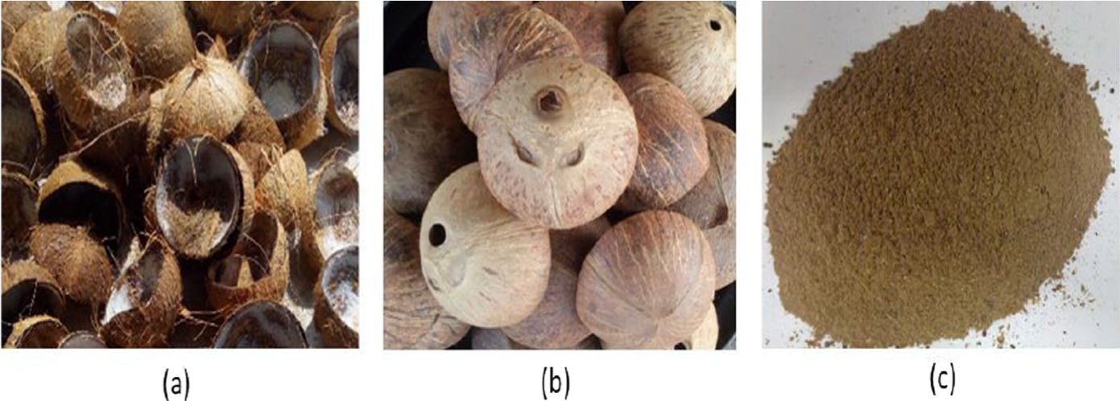
Figure.1. (a) As received coconut fibrous unclean, (b) cleaned, and (c) powdered coconut shell. (Rabi, et al. 2020)


Figure 2. Torrefied Coconut shell (Rabi, et al. 2020)

Understanding Coconut Fuel Production
Charcoal, an energy-dense fuel has an advantage over the use of raw biomass. Thus, reduces the emission of greenhouse gases into the atmosphere. The progress in climate change and economic growth can be achieved by a low-carbon economy. It was known that the coconut shells contain high lignin content (Basu, 2010), this makes it a promising viable alternative biomaterial for the production of charcoal and different raw materials in chemical industries. A more detailed understanding of the complex elements, functional groups, chemical structure, crystalline structure, and morphological composition of the biomass is important for charcoal production. This is important because it demonstrates how the biomass composition influences several factors. Preferably, coconut shells can be transformed to charcoal for additional value-added items using existing technologies for various applications. Coconut shells provide more or less significant benefits that constitute a viable feedstock for charcoal production. It is usable all year round, does not produce any net contribution to the atmosphere when carbonized properly. Furthermore, its usage reduces the dependence on non-renewable fuel, minimizes if not do away with the issue of waste disposal and increase energy supply. Generating effective techniques to utilize and convert biomass will reduce waste disposal and create revenues (Amin, 2019). For these reasons, the pyrolysis of coconut shells into charcoal provides a good base for solid products that can be used directly and serve as fuel.

Torrefaction Reactors
In as much as the torrefaction process is carried out to improve the energy density of biomass, such improvement is almost impossible to be done without an efficient torrefaction reactor. However, the importance of a reactor can be stretched to providing an enclosed environment with adequate pressure-temperature interaction. Also, it allows collection of torrefaction by-products which are in the form of solid residue, gaseous matter, liquid materials and the torrefied biomass itself. Furthermore, it moderate the oxygen exposure of the biomass which can pre-ignite the biomass throughput when superheated during the process. Torrefaction reactors vary in structure, production capacity, heating medium, size, feedstock e.t.c. The one we choose must be able to satisfy the job requirement (I.e. capacity of produce). Examples of torrefaction reactors are: Rotary drum (see fig. 3), Microwave (see fig. 4), Fixed bed (see fig. 5), Fluidized bed, Screw reactor and Multiple hearth furnace (Megan, 2016)
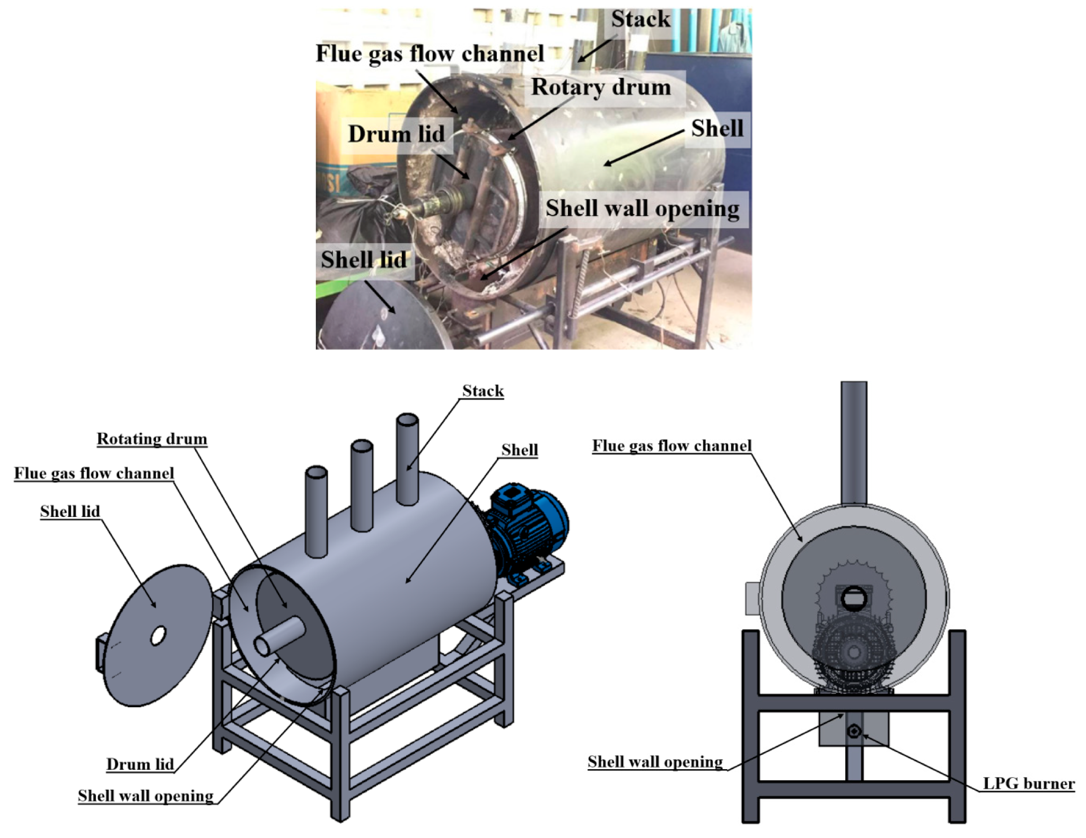
Figure 3. Rotary Drum Reactor (Nitipong, et al. 2020)

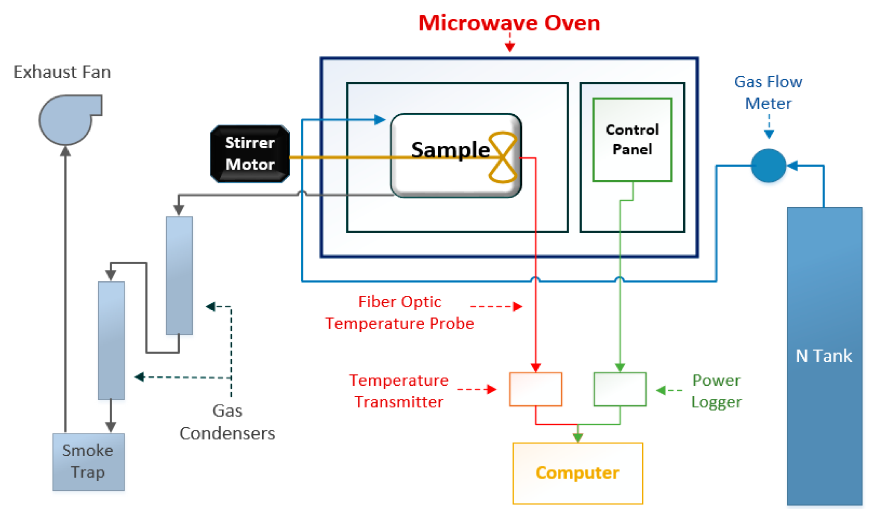
Fig 4 : Torrefaction process

Artificial Neural Network (ANN)
ANNs are complex models that can be used to model non-linear relationships between the inputs and outputs. ANNs can provide accurate predictions even when the relationships between the inputs and the heating value are complex and difficult to model using traditional regression models. The strength of ANNs lies in their ability to capture complex relationships and provide accurate predictions, even when the relationships between the inputs and outputs are not well understood.
Higher heating value (HHV) is a very useful parameter for assessing the design and large-scale operation of biomass-fueled energy systems. HHV provides an indication of biomass quality as it defines the optimum energy recovery potential of the biomass. Compared to the lower heating value (LHV), the HHV includes the latent heat of the evaporation of water in the fuel and the products of the reaction (Cai, et al. 2017).
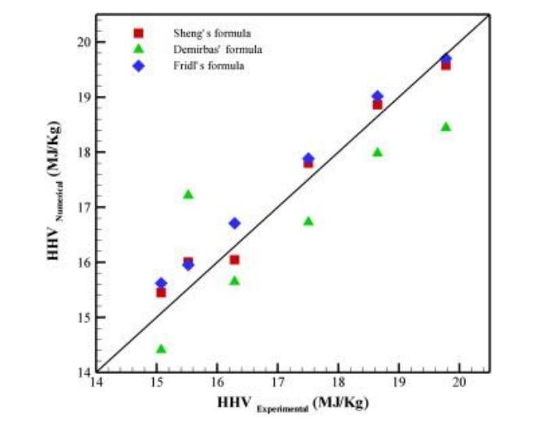
Figure 5. Differences between experimental and model HHV values. Reprinted/adapted with permission (Vaezi et al., 2012)

Data-driven machine learning (ML) has been shown to provide improved accuracy in predicting HHV values of different types of biomass materials (Ighalo, et al, 2020). Compared to empirical models, ML methods provide improved accuracy and can also be used to estimate the relative contribution of each input variable on the predicted HHV values. ML methods have been applied for HHV predictions of different types of biomasses (Taki, et al. 2022). However, a robust ML model considering different biomass classifications is scarcely reported. ANN methods are suitable for modelling input-output relationships of complex systems. In addition, they can learn and generalise from the examples provided during the training phase (Taki, et al. 2022).

Nhuchhen et al, used Microsoft Excel to develop linear and nonlinear correlations from proximate analysis of 250 biomass samples, including by-products of fruits, agri-wastes, wood chips/tree species, grasses/leaves/fibrous materials, briquettes/charcoals/pellets, and other waste materials. The results showed that the nonlinear correlation gave a better performance. Garcia et al. developed linear (Estiati, et al, 2016) and non-linear correlations (Garcia, et al, 2014) with MATLAB from ultimate and proximate analysis of 100 Spanish biomass samples including commercial fuels, industry wastes and forest wastes. Those proposed correlations are proved to be able to approximately estimate the HHV of biomass, but are not universal for various biomass and sometimes make large deviations due to the complex chemical and physical properties of biomass (Nchuhhen, et al, 2012). This indicates the complex nonlinear relation between HHV and ultimate and proximate analysis results cannot be well characterised by empirical linear or non-linear correlations. Thus, more advanced approaches are desirable to well characterise the complex nonlinear relation to develop a universal model for accurately estimating HHV of various biomass.

3. materials and methodology

The materials and method adopted for the design and thermal assessment of the designed fixed-bed torrefaction reactor from biomass were considered in this section. The method adopted and materials required for fabrication of the reactor are commercially available and affordable.

Design of a Reactor for Torrefaction of Biomass
In this study a fixed bed reactor type is designed for. A fixed bed reactor uses a stationary feedstock bed inside a cylindrical tank. Fixed bed reactors are an efficient and reliable type of chemical reactor that offer several advantages in terms of available capacity and desired product quality. Fixed bed reactors also provide good control over reaction conditions, such as temperature, pressure, and reactant flow rate. This level of control helps to ensure consistent product quality and allows for the optimization of the reaction process. Moreover, fixed-bed reactors are relatively easy to operate and maintain, making them suitable for continuous or semi-continuous production processes.

Geometric Specification of the Reactor
The mass of torrefied biomass to be produced in a batch was estimated to be 5 kg. This assumption was made from a literature review. According to Tumuluru et al. (2008) the loss in mass of biomass material during the torrefaction process is around 5 - 30%. Therefore, the initial mass of biomass material assumed to be loaded into the reactor was estimated to be 5.26 kg. For the sake of this design, it was assumed that the biomass in consideration is Obeche wood chips, though the reactor can be used for other biomass. By taking the bulk density of the wood chip as 150 kg m⁻³ (Oladeji, 2018), the volume of the reactor was estimated to be 0.0245 m³ (24.5L). Taking the ratio of the height to the diameter as 2, an inner diameter of 25cm and a height of 50cm were chosen for the torrefaction reactor.

Determination of Reactor Size
In the study, the reactor to be designed is cylindrical in shape. Equation 3.1 was used to determine the size(volume) of the reactor. The volume of the reactor is given as:
diameter of the bed, d is 0.25m; height of the bed, h is 0.5m
The volume of the cylinder, V = $π\frac{d^{2}}{4}h$ (3.1)
Thus the volume of the reactor is estimated as, V = $π×\frac{{0.25}^{2}}{4}×0.5$ = 0.0245$m^{3}$

Determination of Heat Content of Biomass
Heat content of biomass refers to the amount of energy it can release when burned or converted, determining its fuel value. Equation (3.2) was used to determine the heat content of the biomass.
Q = $m{c_{p}ΔT}_{}$ (3.2)
Where; m which is the mass of reactants (kg) is 5kg; Cp which is the specific heat capacity of reactants (J/kg-K) is 2.0 J/(kg K); ΔT which is the temperature change during the reaction (K) is 275°C/ 548K; Thus Q is obtained as 5480 J.

Determination of Heat Required for the Torrefaction Process
Determining the heat required for torrefaction involves calculating the thermal energy needed for biomass conversion. The formula in equation (3.3) is used to determine the heat required for torrefaction process
$heat required=\left(m_{feedstock }×H_{feedstock }\right)+ \left(m_{water }×H_{water}\right)+ \left(m_{air }×H_{air}\right)$ (3.3)
Where:
m_{feedstock} is mass flow rate of feedstock (kg/hr); H_{feedstock} is heat content of feedstock (kJ/kg); m_{water} is mass flow rate of water in feedstock (kg/hr); H_{water} is heat content of water (kJ/kg); m_{air} is mass flow rate of air (kg/hr); H_{air} is heat content of air (kJ/kg)
Taking the heat content of the wood chips as 1840.5 kJ/kg, the heat content of water is 2500 kJ/kg, the heat content of air is 1.005 kJ/kg-K, we can calculate the heat required as follows:
Heat required = $\left(7.36×5480\right)+\left(7.36×0.2×2500\right)+\left(7.36×0.8×1.005×(275-25)\right)$ = 45492.16kJ

Determination of the Thickness of Ceramic Fibre Insulation
Equation (3.3) shows the relationship between thermal resistance, thickness and thermal conductivity of a material. By derivation, the thickness of the insulator was derived from equation (3.3) which is as shown in equation (3.4)
R = $\frac{thickness}{ thermal conductivity}$ (3.3)
where R is thermal resistance
$thickness=R × thermal conductivity$ (3.4)
For our reactor design, a ceramic fibre with a thickness of 10 cm was considered.

Determination of the Diameter of the Gas Inlet Pipe of the Reactor
The diameter is calculated based on factors such as gas flow rate, pressure drop, and desired performance Equation (3.10) shows the relationships between all these factors.
V = $\frac{Q}{A}$ (3.5)
where
V is gas velocity; Q is gas flow rate; A is cross sectional area of the reactor
The gas inlet diameter can be calculated using the equation below:
d = $\sqrt{\frac{4Q}{πV}}$ (3.6)

Determination of Heating-Energy Requirement
The following assumptions were taken into consideration for the design calculation of the biochar production unit; One dimensional heat transfer from the sides of the square prism reactor, there is no heat flow in the axial direction, there is axial symmetry which means heating from all sides is equal, thermo-physical properties changes as a function of temperature, the flow is steady, and the means of heat transfer are by conduction and convection only. From the Fourier’s Law of conduction heat transfer; the rate of heat conduction is given in Eq. (3.7) as:
$Q = -kA\frac{dT}{dx}$ (3.7)

Where; Q is the rate of heat transfer which is the power of the heater, A is the constant surface area through which heat is transferred, dT is the change in temperature. In the case of a cylindrical object, we can assume that heat conduction occurs radially from the inner surface to the outer surface. Let's derive the equation for heat conduction through a cylindrical object.

This is the equation for the rate of heat conduction in a cylindrical object derived from Fourier's Law of conduction heat transfer. It takes into account the thermal conductivity (k), length (L), temperature difference (ΔT), and radii (r1 and r2) of the cylindrical object.

The temperature developed across the wall of the biomass torrefaction unit in this study is estimated using Eq. (3.9) as represented in Fig. 6. The equation is independent of thermal conductivity. Thus the rate of heat transfer is calculated using the Fourier’s equation given as follows:
$Q = -kA\frac{dT}{dx}$ (3.8)
where, $\frac{dT}{dx}$ is Temperature gradient
$\frac{dT}{dx}$ = $\frac{d}{dx} \left[( \frac{T_{2}- T_{1} }{L}x +T_{1})\right]$ = $\frac{T_{2}- T_{1} }{L}$ (3.9)
Therefore;
$Q = -kA\frac{dT}{dx}$ = $-kA(\frac{T_{2}- T_{1} }{L})$ (3.10)
where Q is the rate of heat transfer and is also the rating Power required of the heating element.

Ceramic Fibre Insulator
T_{o}
T_{C1}
T_{C2}
T_{∞1}
T_{∞2}
Stainless Steel
T_{S}

T_{i}
T_{∞1}
T_{i}
T_{S}
T_{C2}
T_{C1}
T_{o}
T_{∞2}
2mm
80mm
2mm
Figure 6: Temperature profile across the wall

Determination of Power Rating of the Heating Element
Since heat generated from the heater is travelling in two opposite directions, therefore from figure 6, and considering equation (3.11),
Q = Heat flow through insulating asbestos material to the outermost cover + Heat flow through the reactor chamber wall.

By using equation (3.12), the rate of heat transfer or power through the composite wall of the reactor is obtained as follows:
$Q = \frac{{(T}_{α1}- T_{α2})}{\frac{1}{h_{2}A} +\frac{L_{m}}{K_{m}A} + \frac{L_{C}}{K_{C}A} + \frac{L_{S}}{K_{S}A} + \frac{1}{h_{1}A}}$ (3.12)

where: Q is rate of heat transfer through a composite wall of the reactor, L_{C} is thickness of the insulating clay, L_{m} is thickness of the outer covering which is stainless steel, L_{S} is thickness of the inner chamber which stainless steel, K_{C} is Thermal conductivity of the insulating ceramic fibre, K_{S} is thermal conductivity of the stainless steel, T$α1$ is temperature at the core of the reactor, T$α2$ is the ambient temperature of the surrounding, h$1$ is convective heat transfer coefficient of air at T$α1$ and h₂ is convective heat transfer coefficient of air at T$α2$.

T$α1$ and T$α2$ are assumed as 300ºC and 25ºC respectively;
L_{m} - 2 mm = 0.002m;
L_{S} = 2 mm = 0.002m;
L_{C} = 75mm = 0.075m;
K_{C} = 0.15W/mK
K_{S} = 16W/mk;
h₂ = 14.4W/m²k
h₁ = 50W/m²k
Q = $\frac{(300-25)}{(\frac{1}{14.4} +\frac{0.002}{16} + \frac{0.05}{0.15} + \frac{0.002}{16} + \frac{1}{50})\frac{1}{0.49}}$
Q = 318.5 Watts

Mass Loss during Torrefaction
Mass loss is due to moisture loss and the thermal decomposition of biomass (Cardona, et al, 2019). The mass loss during torrefaction can be determined for each batch from every experimental run. The losses would be calculated on the basis of the mass of the batch before the torrefaction treatment using (Dirgantara, et al, 2020):
Mass loss = $\frac{Mass of raw biomass - Mass of torrefied biomass}{Mass of raw biomass}$ x 100% (3.13)

Effect of Torrefaction on the Proximate Analyses of Biomass
Proximate analyses of the biomass would be conducted before torrefaction and after torrefaction at different temperatures and residence times. The proximate analyses characterised the biomass samples in terms of the volatile matter, fixed carbon, and ash content. This would give an idea of the bulk components that composed the biomass. The procedures that can be used in carrying out the proximate

Material Selection and System Components

Criteria for Materials Selection
The criteria considered for material selection for the fixed-bed reactor design are as follows;
- Temperature Resistance: The material should have a high melting point and good thermal conductivity to ensure efficient heat transfer and prevent deformation or melting of the reactor's components. According to Ledin and Strezov (2014), the torrefaction temperature can range from 200°C to 320°C, and the reactor's materials should be able to withstand these temperatures without degradation.
- Thermal Stability: The material should have good thermal stability to prevent thermal expansion, contraction, or deformation, which can cause damage to the reactor's components or reduce its efficiency.
- Mechanical Strength: The material should have adequate mechanical strength to withstand the stresses and strains imposed by the torrefaction process. The material should be able to support its weight and that of the biomass while maintaining its shape and structural integrity. The reactor's materials should have high mechanical strength to withstand the weight of the biomass and the torrefaction temperature. Ledin and Strezov (2014)
- Durability: The material should have good wear and tear resistance to ensure a longer lifespan and reduce maintenance costs. The material should be able to withstand frequent use without experiencing significant wear or damage.
- Availability: The material should be readily available and accessible, preferably locally sourced, to reduce the cost and lead time of the reactor's construction. According to de Miguel Mercader et al. (2018), the availability of materials is a critical factor in designing torrefaction reactors in developing countries, where access to specialised materials may be limited.
- Cost-Effectiveness: The material should be cost-effective and within budget while still meeting the necessary requirements and specifications for the torrefaction reactor.
- Safety: The material should not pose any safety hazards to personnel or the environment during the torrefaction process. The material should be non-toxic, non-flammable, and not release any harmful gases or by-products during operation.

System Components
Ceramic Heating Band: Ceramic band heaters are designed with spirally wound inner resistance coils evenly threaded through interlocking insulated ceramic “tiles”. The ceramic core, or “mat” of tiles is housed beneath a stainless steel sheet with serrated edges. The notched edges fold over to secure the ends and a protective inner liner (to be removed at installation) secures the placement of the tiles. This combined assembly of the Ceramic Band Heater offers a flexible heating system that yields efficient transmission of conduction and radiated heat. The heat of the Ceramic Band originates from the inner coils that conduct heat at maximum temperatures. Ceramic Band DiagramedThe heated coils evenly deliver heat through the ceramic tiles which radiate energy to the barrel. We offer a variety of Ceramic Band styles from standard to custom configurations. When selecting a ceramic heater, select a heater that best matches the wattage requirements – to decrease the frequency of cycling and temperature overshooting, and thereby increase the life of the heater. A typical example of ceramic band is shown in figure 7

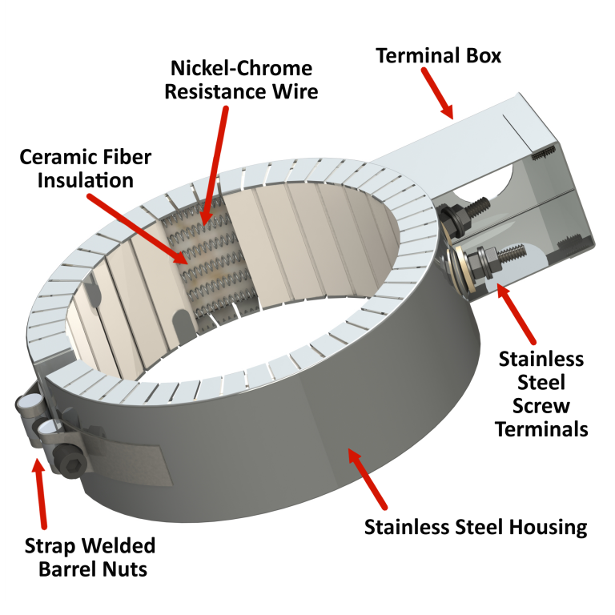
Figure 7. Diagram of Ceramic Heating Band (https://heatandsensortech.com/products/ceramic-heaters/)

Thermocouple: A Type K Thermocouple (Nickel-Chromium / Nickel-Alumel) is considered to be used in this design. The type K is the most common type of thermocouple. It’s inexpensive, accurate, reliable, and has a wide temperature range. Type K consists of the two metal alloys Chromel (90% Nickel, 10% Chromium) and also Alumel (95% Nickel, 2% Manganese, 2% Aluminium and 1% Silicon). Due to the thermocouple having a Nickel base; this means that it has good corrosive resistance-meaning that it can be widely used in many applications and situations. Maximum continuous temperature is around 1,100C. A typical example of the thermocouple is shown in figure 8

Figure 8: A Type-K Thermocouple

Table 1: Table for Parts, Components and Materials
S/N | Parts/ Components/Materials | Quantity | Dimension  (mm) | Cost Estimation (Naira)
1 | Stainless Steel (Diameter) | sheet | 10×1000×3000 | 50,000
2 | Ceramic Heating Band | 2 | 25×254×127 | 5200
3 | Caster Wheels | 3 | 125 | 9500
4 | Valves | 2 | - | 10000
5 | Gas Pipes (Carbon steel) | 1 | Ø17×2×500 | 10000
6 | Studs | 6 | 15×55(M14) | 5000
7 | Insulator (Ceramic Fibre) | 2 | 50×610×3600 | 4000
8 | Thermocouple | 1 |  | 4000
9 | Thermocouple Thermometer | 1 | - | 4000
10 | Digital Thermal Controller (PID) | 1 | - | 20000
11 | Nitrogen Gas | 1 (3kg) | - | 9000
 |  |  | Total | 130,700

Operating Principle of the Torrefaction Reactor

Operation of the Torrefaction Reactor
To carry out torrefaction with any biomass, the biomass would be placed in the torrefaction reactor until it was filled to about 90% of its volume. The cover of the torrefaction reactor vessel would then be fastened, and the reactor made airtight with the aid of studs. The container of the reactor is then closed. The electrical heating band would be turned on, and the required temperature for torrefaction would then be set on the temperature controller. The temperature change will be monitored with a digital thermometer and a thermocouple that would be placed directly in contact with the biomass. The output from the thermocouple is converted to temperature by a thermocouple thermometer. The setup would be heated to the required torrefaction temperature and maintained at that temperature for the desired residence time, after which the heater would be turned off. The setup would then be allowed to cool to room temperature. Thereafter, the torrefied biomass can be removed from the reactor and the necessary analysis can then be further carried out. The reactor design is shown in the subsequent Figures.

CAD Design of the Torrefaction Reactor
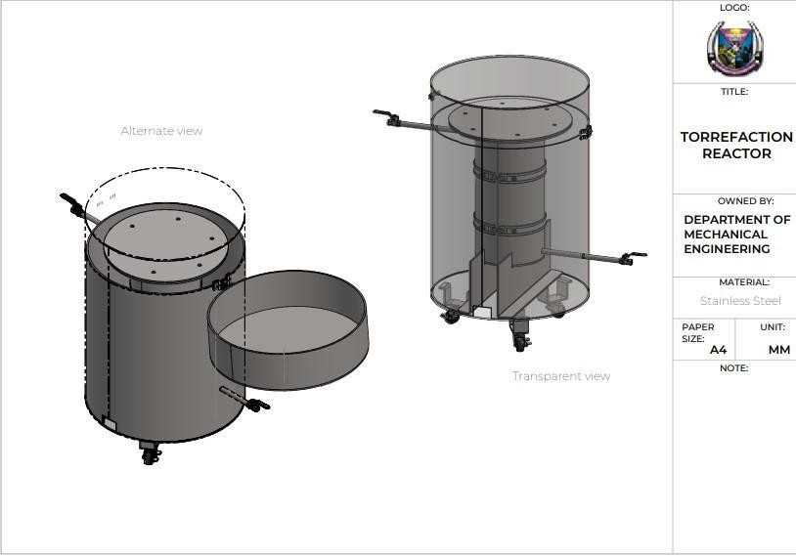
Figure 9. 3D Design of a Fixed-Bed Torrefaction Reactor

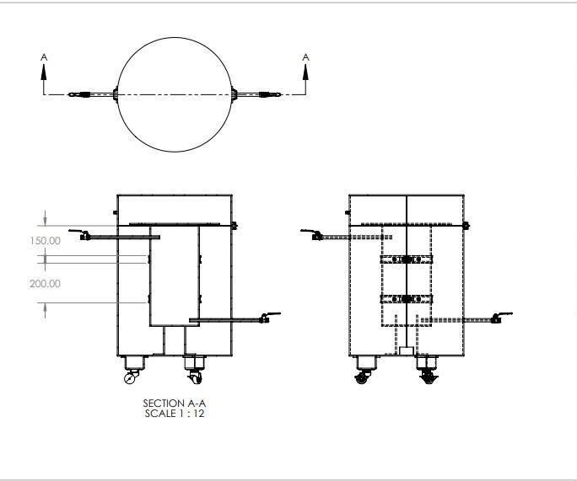
Figure 10. Sectional view of the Fixed-bed Torrefaction Reactor

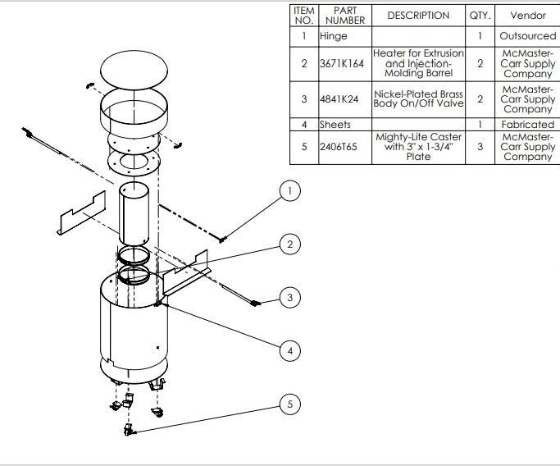
Figure 11. Exploded view of the Fixed-bed Torrefaction Reactor

Thermal Analysis and Simulation of the reactor
Thermal analysis and the simulation of the reactor is carried out to evaluate the designed reactor in order to ensure that the system combustion temperature is conserved. The structural analysis on the other hand helps in validating the mechanical integrity and stability of the reactor design. The reactor unit is modelled using Ansys steady-state thermal analysis tool. Each of the layers that make up the reactor are then assigned materials. The assigning of materials to each of the reactor parts gives properties such as thermal conductivity at a specific temperature which is required alongside the geometry of the model to carry out the simulation. The modelled reactor is then meshed as shown in Figure 12. The results of the simulation and thermal analysis are further discussed in chapter 4.
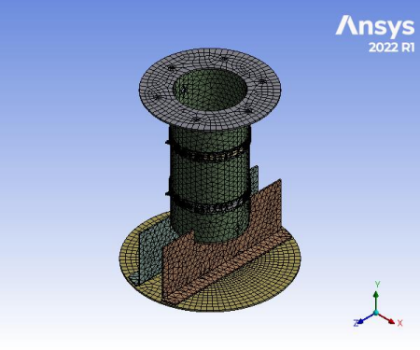
Figure 12: Meshed design of the reactor

Dataset Collection and Pre-Processing
A brief introduction of the present study modelling procedures is provided in Fig. 13. The start point of the present study is the samples collected from published literature. The proximate and ultimate analysis of those samples are normalised and divided into the training and application samples, respectively.
In this project, three machine learning algorithms were compared to predict the higher heating value of different biomass. The ML algorithms include tree-based ML models; random forests, and neural networks (artificial neural networks) and Linear regression. The datasets containing 527 instances of different biomass types studied were sourced from publications and compiled in an excel spreadsheet (see Appendix). Although some of the curated data had missing values, these were replaced with the average of the observation for the sake of model training. Furthermore, the dataset was split into features (fixed carbon (FC), volatile matter (VM), ash (AC), carbon (C), hydrogen (H), nitrogen (N), sulphur (S), and oxygen(O)) and target higher heating value (HHV).

Samples
In this study, the number of biomass types whose proximate and ultimate analysis were available from literature is limited, two training databases consisting of proximate and ultimate analysis are constructed from the available literature. The dataset obtained for proximate analysis includes 527 data points, while the dataset obtained for ultimate analysis includes 291 data points.
The difference in the number of data points between the two analyses was due to two major factors, which are differences in the availability of data sources and variations in the types of biomass samples analysed. Although the former is the major reason for the disparity in the figures obtained for the data points which is the variations in the availability of data sources for each type of analysis. For instance, some sources provided data for proximate analysis, but not for ultimate analysis, which resulted in more data points for proximate analysis. In the course of this study, It is worth mentioning that the quality and relevance of the data obtained is ultimately more important than the quantity of data obtained.

Second, the variation in the types of biomass samples analysed may also introduce bias or inconsistency in our results. For example, if certain types of biomass samples were overrepresented in one analysis compared to the other, this could skew the overall results and limit the generalizability of the conclusions drawn. Overall, it is important to interpret the results with caution, taking into consideration any potential biases or inconsistencies that may arise.

This assumption has been proved to be valid not in the present study but also in many previous studies (Hosseinpur, et al 2017, Akayya, 2016). The details about the training and application databases are introduced as follows.

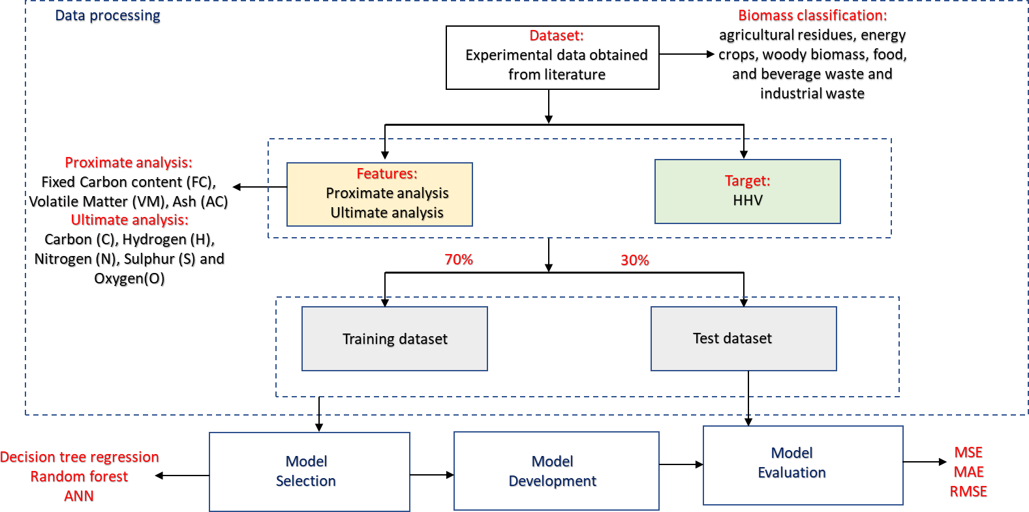
Figure 14. An Overview of the methodology used in the study (Afolabi et al., 2022)

Training and Test samples
The ratio of the training set to the test set was chosen to be 75/25, which means that 70% of the data was used for training the ML model and the remaining 25% was used for testing the model's performance. The “train_test_split” function from the “model_selection” module of the scikit-learn (sklearn) library was used to split the proximate and ultimate dataframe into training and testing sets for use in a machine learning model.

The reason for dividing the data into a training set and a test set is to evaluate the model's performance on data that it has not seen before. This is important because if the model performs well on the test set, it is likely to perform well on new, unseen data as well.

Randomly dividing the data into a training set and a test set is important to ensure that the samples used for training and testing are representative of the entire dataset. This helps to avoid bias in the model's performance evaluation.

Overview of Machine Learning Algorithms
In the present study, various machine learning approaches will be used to develop models for accurately predicting HHV from proximate and ultimate analysis using some open-source packages, Python Scikit learn and Tensorflow. The Scikit open-source package can be downloaded at https://scikit-learn.org/stable/. It is worth noting here that the hyper-parameter optimization of those approaches are carried out through trial-and-error tests with the help of Python Scikit learn GridSearchCV tool.

Artificial Neural Networks
ANN represents one of the most advanced ML algorithms suitable for evaluating the relationship between features and targets. Its self-adaptive nature and excellent generalisation ability in predicting the outputs of new datasets are the main advantages (Shenbagaraj, 2021). ANN has a universal function approximator that improves the approximation of complex nonlinear problems (Afolabi, 2020).
The ANN architecture used in this study is a four-layered model with one input layer, two hidden layers and one output layer, as depicted in Figure 15 The input layer consists of 9 hidden neurons from the input features (fixed carbon, volatile matter, ash, carbon, hydrogen, nitrogen, sulphur, and oxygen). The two hidden layers consist of 128 and 32 hidden neurons, respectively. It is worth noting that the hidden neurons are selected based on trial-and-error methods, while the output layer has one neuron from the target variable (higher heating value).
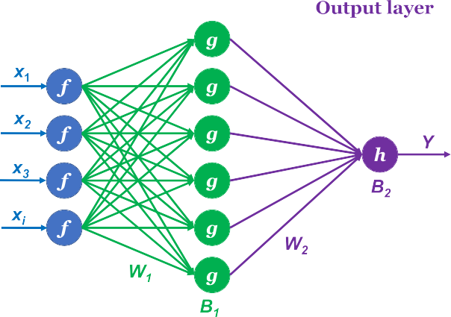
Fig. 15. The schematic topological architecture of the three-layers ANN model ((Afolabi et al., 2022))

The stepwise process carried out in the development of this ANN model is detailed as follows;
Data Collection: Gather a dataset that includes a representative sample of biomass samples with their corresponding HHV values. The dataset should cover a wide range of biomass types and characteristics to ensure the ANN's accuracy across different inputs.
Data Preprocessing: Clean and preprocess the dataset to ensure its quality and compatibility with the ANN. This step may involve removing duplicates, handling missing values, and normalising or standardising the input features and target variable.
Dataset Split: Divide the dataset into training, validation, and testing sets. The training set will be used to train the ANN, the validation set to fine-tune its parameters, and the testing set to evaluate its performance on unseen data.
Architecture Design: Determine the architecture of the ANN, including the number of layers, the number of neurons in each layer, and the activation functions to be used. This design should consider the complexity of the problem and the size of the dataset.
Model Training: Train the ANN using the training set. This involves feeding the input features of the biomass samples into the network, propagating the signals forward, calculating the prediction, comparing it with the actual HHV values, and adjusting the network's weights and biases through a process called backpropagation. This step is repeated iteratively until the network's performance converges to an optimal level.
Model Evaluation: Evaluate the trained ANN using the testing set. Calculate performance metrics, such as Mean Absolute Error (MAE), Root Mean Squared Error (RMSE), and coefficient of determination (R-squared), to assess how well the model predicts the HHV values of unseen biomass samples.
Model Deployment: Once satisfied with the ANN's performance, it can be deployed for predicting the HHV of biomass. New biomass samples can be fed into the trained network, and it will provide an estimate of their HHV based on the learned patterns from the training data.
Monitoring and Updating: Continuously monitor the performance of the deployed ANN and update it periodically with new data to maintain its accuracy and adapt to any changes in the biomass characteristics.

Random Forest
A random forest (RF) is a form of tree-based ensemble ML algorithm used for predicting continuous values. Random forest is an ensemble learning approach for classification and regression that operates by constructing a multitude of decision trees for training samples and obtaining the output signals that is the dominant mode of the classes and the average prediction of each tree for classification and regression, respectively. The figure 16 shows the schematic topological architecture of the random forest approach. It operates by constructing multiple decision trees for training features and obtaining the target values as an average prediction of each tree (Biau, 2015). The training datasets, which consist of ‘n’ total samples and ‘m’ features, are subjected to bootstrap sampling. In the sampling, a number of sample sets (n) are randomly generated from the original training datasets.

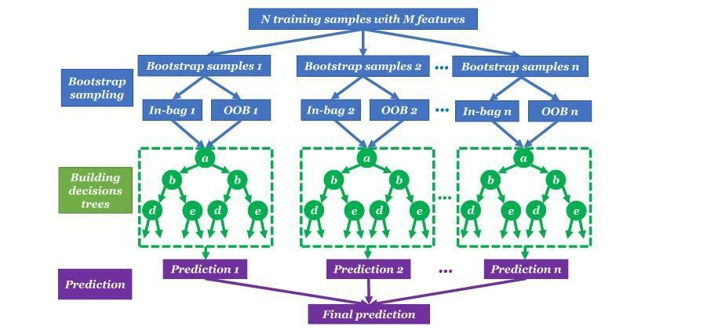
Figure 16: The schematic topological architecture of the random forest approach ((Afolabi et al., 2022))

The stepwise process carried out in the development of this Random Forest model is as follows;
Data Collection: Gather a dataset that includes samples of biomass along with their corresponding Higher Heating Value measurements. The dataset should also contain relevant features or variables that can potentially influence the HHV, such as moisture content, elemental composition, and physical characteristics of the biomass.
Data Preprocessing: Perform necessary preprocessing steps on the dataset. This may involve handling missing values, handling categorical variables (if any), and scaling or normalising numeric features.
Feature Selection: Analyse the dataset and select the most relevant features that are likely to have a significant impact on predicting HHV. This can be done using techniques such as correlation analysis or feature importance ranking.
Dataset Split: Divide the dataset into training and testing subsets. The training set will be used to train the Random Forest model, while the testing set will be used to evaluate its performance.
Model Training: Train a Random Forest model using the training dataset. The Random Forest algorithm constructs an ensemble of decision trees by randomly selecting subsets of features and samples. Each decision tree in the ensemble is trained independently on different subsets of the training data.
Model Evaluation: Evaluate the trained Random Forest model using the testing dataset. Calculate relevant evaluation metrics such as mean squared error (MSE) or R-squared to assess the model's predictive performance.
Model Optimization: If the model performance is not satisfactory, consider optimising the model further by adjusting hyperparameters or exploring different feature engineering techniques.
Prediction: Once the Random Forest model is deemed satisfactory, it can be used to make predictions on new, unseen biomass samples. Provide the relevant input features for the biomass sample, and the model will predict the corresponding Higher Heating Value.
Model Deployment: Finally, deploy the trained Random Forest model into a production environment, where it can be used to predict the Higher Heating Value of biomass samples in real-time applications.

Linear Regression
Linear regression is a supervised learning algorithm used for predicting a continuous output variable based on one or more input variables. It establishes a linear relationship between the dependent variable and one or more independent variables by fitting a best-fit line through the data points. The goal of linear regression is to find the line that best represents the relationship between the dependent variable and independent variables, in a way that minimises the distance between the predicted and actual values of the dependent variable.
In linear regression, the dependent variable is also known as the response variable or output variable, while the independent variables are known as the predictor variables or input variables. The best-fit line is represented by an equation of the form:

Y = a + bX (3.14)

where Y is the dependent variable, X is the independent variable, a is the intercept, and b is the slope of the line. The slope of the line represents the change in the dependent variable for a unit change in the independent variable, while the intercept represents the value of the dependent variable when the independent variable is equal to zero.

The stepwise process carried out in the development of this Linear Regression model is as follows;
Data Collection: Gather a dataset that includes samples of biomass with their corresponding HHV values. The dataset should ideally contain a sufficient number of observations to represent a diverse range of biomass samples.
Data Preprocessing: Clean the dataset by removing any missing values, outliers, or irrelevant variables. Perform data transformations if needed, such as scaling or normalisation, to ensure that the data is suitable for linear regression analysis.
Feature Selection: Identify the relevant features (independent variables) that may contribute to predicting the HHV. These features can include physical and chemical properties of the biomass, such as moisture content, ash content, volatile matter, and elemental composition.
Split the Data: Split the dataset into two subsets: a training set and a testing set. The training set will be used to train the linear regression model, while the testing set will be used to evaluate its performance.
Model Training: Apply linear regression to the training data, using the selected features as input variables and the HHV as the target variable. The linear regression model will learn the relationship between the input variables and the target variable through an optimization process.
Model Evaluation: Assess the performance of the trained model using the testing set. Calculate evaluation metrics such as mean squared error (MSE), root mean squared error (RMSE), or R-squared to measure how well the model predicts the HHV values.
Model Improvement: If the model's performance is not satisfactory, consider refining the model. This can involve adjusting the feature selection, incorporating additional relevant variables, or exploring more advanced regression techniques.
Model Deployment: Once you are satisfied with the model's performance, deploy it to make predictions on new, unseen biomass samples. Use the trained model to predict the HHV values of biomass based on their input features.
Model Maintenance and Monitoring: Regularly monitor the model's performance over time and update it as needed. As new data becomes available, retrain the model to incorporate the latest information and improve its prediction capabilities.

Empirical correlations
In the present study, the empirical linear and non-linear correlations are also carried out for comparisons with the modelling results of machine learning approaches. For the proximate and ultimate analysis, the correlations are expressed as the following respectively,
HHV = a₀ + a₁ x X_{FC} + a₂ x X_{VM} + a₃ x X_{ASH} (3.15)
where HHV is the higher heat value of biomass. X_{FC}, X_{VM} and X_{ASH} denote the mass fractions of fixed carbon, volatile matter and ash respectively.
HHV = a₀ + a₁ x X_{C} + a₂ x X_{H} + a₃ x X_{N} + a₄ x X_{O} + a₅ x X_{S} (3.16)
where HHV is the higher heat value of biomass. X_{C}, X_{H}, X_{N}, X_{O}, and X_{S} denote the mass fractions of carbon, hydrogen, nitrogen, oxygen and sulphur respectively.

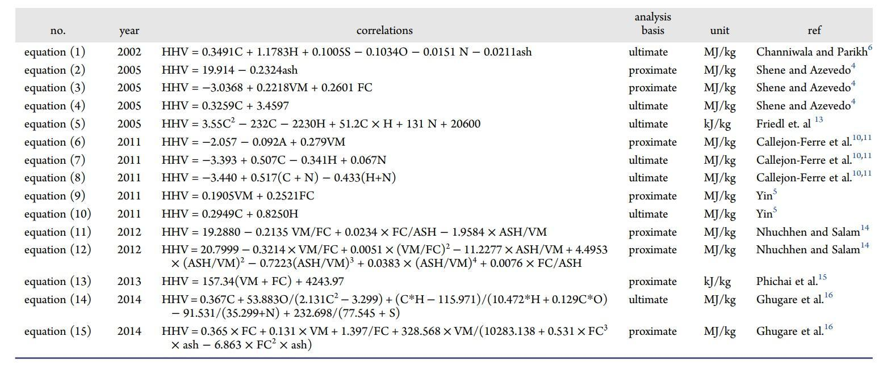
Figure 17.: Summary of Recent and Established Correlations Used for Predicting the HHV of

4. results and discussion

Simulation and Thermal Analysis
From the calculations, the estimated area of the reactor is 0.49 m². Since the heat flow across the wall is of paramount importance, the required power rating was calculated and was given as 318.5 Watts. Therefore, considering the ambient temperature of 25ºC and heat transfer coefficient of 14.4W/m^{2 o}C from the outer surface of the wall, and the estimated heat flow of 318.5 Watts from the inside of the reactor. The results of the simulation of the reactor is given in Figures 18 to 22 respectively.

Finite element analysis (FEA) was run on the torrefaction reactor with Stainless steel AISI 316 selected. Load distribution resulting from the volume/capacity of the torrefaction reactor behaviour under various loading conditions is reported as observed from the simulation software used for this study. Solidworks von mises analysis carried out showed stress distribution on the base materials. It was observed that a maximum stress distribution of 2551.7 MPa was obtained as shown in figure 21. This result gives a plus to the frame buildup of the part showing where highest stress is concentrated and also where lowest stress is concentrated. However, the stress obtained is allowable stress and the material is suitable for usage under designed loading conditions. Furthermore, displacement analysis was also checked to know the extent of elongation of the material under loading. The maximum elongation that can be obtained under loading condition is 2.4704 mm which is very minimal for any failure to occur or reduce life cycle of the base material this is shown in figure 19.

Factor of safety was observed to be 15 maximally. Technically, a factor of safety is the ability of a system's structural capacity to be viable beyond its expected or actual loads (Rutheravan, 2016); and with the result obtained in this work, this base part will perform as expected under the designed condition without failure. A maximum factor of safety of 15 indicates that the design or structure being analysed has a significant margin of safety. The factor of safety is a measure of how much stronger a structure or component is compared to the maximum load or stress it is expected to experience. In this case, a factor of safety of 15 means that the structure can withstand a load or stress up to 15 times greater than the maximum anticipated load without failure. This suggests a high level of structural integrity and indicates that the design has a substantial safety margin.

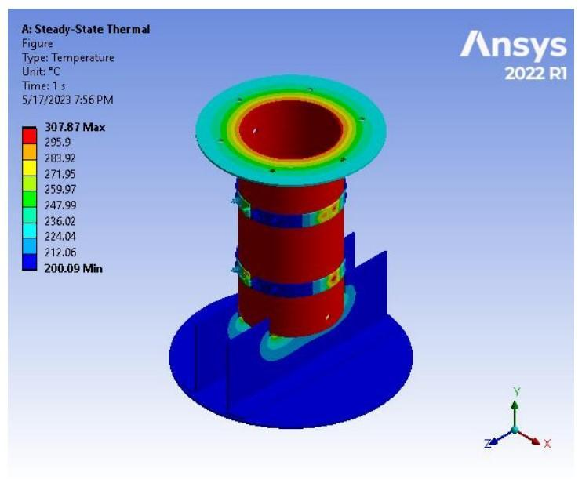
Figure 18: Steady state thermal showing temperature

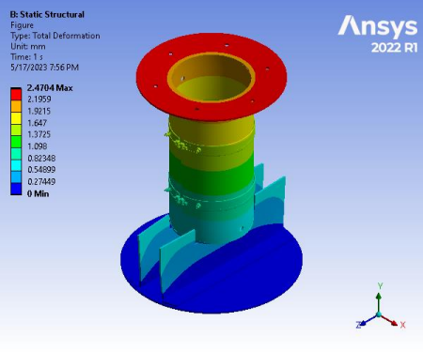
Figure 19: Static Structural showing total deformation

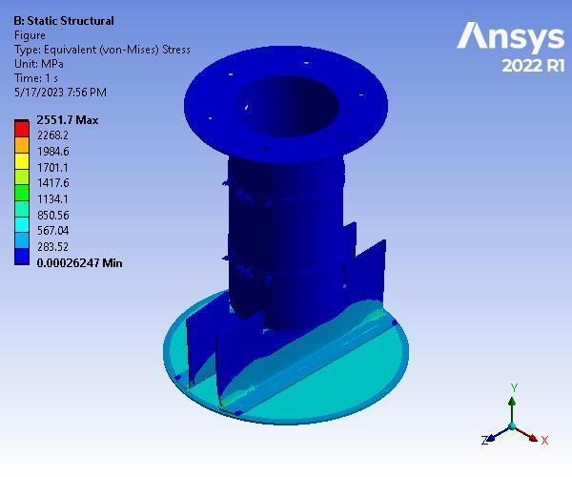

Figure 20: Static Structural showing equivalent stress

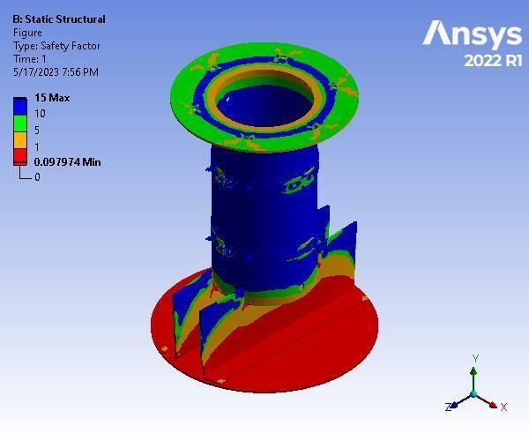

Figure 21: Static Structural showing factor of safety

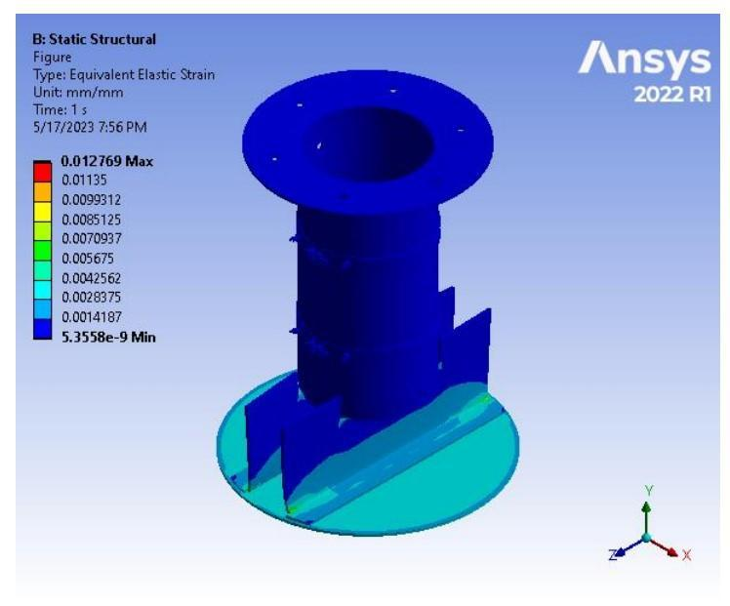

Figure 22: Static Structural showing factor of safety

Results of the Machine Learning Approaches
The performance of three different models, namely the linear regression model, random forest model, and artificial neural network (ANN), was evaluated for the given dataset. The accuracy and precision of each model were analysed to assess their predictive capabilities.

Linear Regression Model: The linear regression model achieved a Mean Absolute Error(MAE) of 1.402 and Mean Squared Error(MSE) of 4.148 for proximate datasets and a Mean Absolute Error(MAE) of 1.094 and Mean Squared Error(MSE) of 2.590 for ultimate datasets. This is shown in figure A-1 and A-2.
Although it provided a reasonable prediction accuracy, it exhibited limitations in capturing complex nonlinear relationships within the dataset. The model's simplicity and interpretability were its strengths, making it suitable for situations where the relationship between the input variables and the target variable is expected to be predominantly linear.

Random Forest Model: The random forest model demonstrated superior performance compared to the linear regression model, achieving a Mean Absolute Error(MAE) of 1.451 and Mean Squared Error(MSE) of 4.276 for proximate datasets and a Mean Absolute Error(MAE) of 1.067 and Mean Squared Error(MSE) of 2.557 for ultimate datasets. This is shown in figure A-3 and A-4.
Its ability to handle nonlinear relationships and capture interactions among variables contributed to its enhanced predictive power. The model's ensemble nature and robustness to outliers and noise were its notable strengths. However, the interpretability of the random forest model may be limited due to its complex structure.

Artificial Neural Network (ANN): The ANN model outperformed both the linear regression and random forest models, achieving a Mean Absolute Error(MAE) of 1.399 and Mean Squared Error(MSE) of 4.083 for proximate datasets and a Mean Absolute Error(MAE) of 1.046 and Mean Squared Error(MSE) of 2.565 for ultimate datasets. This is shown in figure A-5 and A-6.
With its ability to learn complex patterns and nonlinear relationships, the ANN model proved to be highly effective in capturing the underlying dynamics of the dataset. Its flexibility and adaptability allowed it to handle a wide range of data types and produce accurate predictions. However, the ANN model's black-box nature and high computational requirements were identified as potential limitations.

Comparison of Model Performance: A comparison of the models' performance revealed that the ANN model yielded the highest accuracy and precision by predicting 92% of data from Literature, followed by the linear regression model by predicting 82% of data from Literature, while the random forest model exhibited relatively lower accuracy and precision by predicting 70% of data from Literature. The ANN model's ability to handle complex relationships and capture intricate patterns in the data contributed to its superior performance.

Empirical Formula Evaluation/Correlation
The Higher Heating Value (HHV) of a fuel is a crucial parameter for estimating its energy content and combustion efficiency. In this study, an empirical formula correlation was developed to predict the HHV of a fuel based on proximate analysis data and ultimate analysis data obtained from the literature. The objective was to establish a relationship between the HHV derived from literature sources and the HHV predicted using readily available fuel composition data.
The collected literature values of HHV as shown in Appendix were compared with the HHV values predicted using the derived HHV predictive model attained in this work. Through the linear regression model, two empirical formula correlations were derived and given as follows:

HHV Predicted Ultimate:
HHV predicted Ultimate = a * (Carbon) + b * (Hydrogen) + c * (Nitrogen) + d * (Sulphur) + e * (Oxygen)

The coefficients (a, b, c, d, e) in the equation were determined through the linear regression model, and their values were found to be:
a = 0.321, b = 0.671, c = -0.178, d = -0.074, e = 1.196 and intercept = 3.345
Hence, HHV Predicted Ultimate = 0.321C + 0.671H - 0.178N - 0.0740 + 1.196S + 3.345

HHV Predicted Proximate:
HHV predicted Proximate = f * (Volatile Matter) + g * (Fixed Carbon) + h * (Ash)
The values of coefficients (f, g, h) in the equation were found to be:
f = 0.208, g = 0.405, h = 0.025, Intercept = -3.979
Hence, HHV Predicted Proximate = 0.208VM + 0.405FC + 0.025ASH - 3.979

From figure A-10, we can infer that the correlation equation showed a strong correlation between the HHV predicted using proximate analysis data and ultimate analysis data and the HHV derived from literature sources. The coefficient of determination (R-squared value) for both the proximate predicted HHV and the Ultimate predicted HHV is very close although the R² value for ultimate predicted HHV is higher.

The coefficient of determination (R-squared value) for the proximate predicted HHVwas found to be 0.7115 as shown in figure A-12, indicating that 71% of the variance in the HHV values could be explained by the correlation equation.
The coefficient of determination (R-squared value) for the ultimate predicted HHVwas found to be 0.734 as shown in figure A-14, indicating that 73.4% of the variance in the HHV values could be explained by the correlation equation. Hence, both the proximate analysis data and ultimate analysis data exhibit strong correlations with the HHV derived from literature sources, as indicated by the high R-squared values. The ultimate analysis data, in particular, demonstrates a slightly stronger association with HHV values.

The empirical formula correlations developed in this study provides a reliable and convenient method for estimating the HHV of a biomass based on readily available proximate analysis data and ultimate analysis data. The correlation equation demonstrated a strong correlation with the HHV values derived from literature sources, and its high coefficient of determination indicates its predictive accuracy. This correlation can be utilised in various applications, such as energy calculations, fuel quality assessment, and combustion efficiency evaluations.

5. conclusion

In this study, the focused was on the design of a torrefaction reactor and the evaluation of torrefied coconut shell energy content using machine learning algorithms, including Artificial Neural Networks (ANN), Random Forest, and Linear Regression.

The torrefaction reactor that facilitates the torrefaction of coconut shell biomass was successfully designed. The reactor design is crucial for achieving optimal torrefaction results and ensuring the production of high-quality torrefied pinewood. The performance evaluation results using ANSYS tool revealed that the designed reactor is suitable enough to produce biomass at a temperature range of 250 - 3000C.

This project successfully designed a reactor for torrefaction that efficiently transfers heat using a heating band. The evaluation of literature compared to the predicted higher heating value (HHV) using proximate and ultimate analysis of coconut shell revealed a high level of accuracy, with a determinant of 0.9162 for proximate and 0.9254 for ultimate analysis. The ultimate analysis method was chosen as the preferred approach due to its reliability and precision.
Furthermore, three prediction methods were considered, linear regression, random forest, and artificial neural network (ANN). Among these, the ANN model demonstrated superior performance and accuracy in predicting the HHV. Its ability to capture complex relationships and patterns within the data made it the most suitable choice for this project.

Competing interests

The authors declare that no competing interests exist. The authors have no financial, personal, or professional relationships that could have appeared to influence the work reported in this study.

References

Afolabi, I.C.; Popoola, S.I.; Bello, O.S. Machine learning approach for prediction of paracetamol adsorption efficiency on chemically modified orange peel. Spectrochim. Acta Part A Mol. Biomol. Spectrosc. 2020, 243, 118769. [CrossRef]

Afolabi, I.C.; Popoola, S.I.; Bello, O.S. Modelling pseudo-second-order kinetics of orange peel-paracetamol adsorption process using artificial neural network. Chemom. Intell. Lab. Syst. 2020, 203, 104053. [CrossRef]

Basu, P. (2018) Biomass Gasification, Pyrolysis and Torrefaction: Practical Design and Theory. 3rd Edition, Academic Press, Elsevier.

Biau, G.; Devroye, L.; Lugosi, G. Consistency of random forests and other averaging classifiers. J. Mach. Learn. Res. 2008, 9, 2015–2033.

Cai, J.; He, Y.; Yu, X.; Banks, S.W.; Yang, Y.; Zhang, X.; Yu, Y.; Liu, R.; Bridgwater, A.V. Review of physicochemical properties and analytical characterization of lignocellulosic biomass. Renew. Sustain. Energy Rev. 2017, 76, 309–322. [CrossRef]

Ighalo, J.O.; Adeniyi, A.G.; Marques, G. Application of linear regression algorithm and stochastic gradient descent in a machine- learning environment for predicting biomass higher heating value. Biofuels Bioprod. Biorefin. 2020, 14, 1286–1295. [CrossRef]

Nhuchhen, D. R., & Abdul Salam, P. (2012). Estimation of higher heating value of biomass from proximate analysis: A new approach. Fuel (London, England), 99, 55–63. https://doi.org/10.1016/j.fuel.2012.04.015

Nieto, P.J.G.; García-Gonzalo, E.; Lasheras, F.S.; Paredes-Sánchez, J.P.; Fernández, P.R. Forecast of the higher heating value in biomass torrefaction by means of machine learning techniques. J. Comput. Appl. Math. 2019, 357, 284–301. [CrossRef]

O’Brien, M. L. (2016). Design of a mobile torrefaction reactor for in-situ conversion of agricultural waste to solid biofuel. Massachusetts Institute of Technology.

Shenbagaraj, S.; Sharma, P.K.; Sharma, A.K.; Raghav, G.; Kota, K.B.; Ashokkumar, V. Gasification of food waste in supercritical water: An innovative synthesis gas composition prediction model based on Artificial Neural Networks. Int. J. Hydrogen Energy 2021, 46, 12739–12757. [CrossRef]

Sheng, C.; Azevedo, J.L.T. Estimating the higher heating value of biomass fuels from basic analysis data. Biomass Bioenergy 2005, 28, 499–507. [CrossRef]

Shoulaifar, T. K. (2016). Chemical Changes in Biomass during Torrefaction. Unpublished. https://doi.org/10.13140/RG.2.1.2720.2644

Taki, M.; Rohani, A. Machine learning models for prediction the Higher Heating Value (HHV) of Municipal Solid Waste (MSW) for waste-to-energy evaluation. Case Stud. Therm. Eng. 2022, 31, 101823. [CrossRef]

Tan, P.; Zhang, C.; Xia, J.; Fang, Q.Y.; Chen, G. Estimation of higher heating value of coal based on proximate analysis using support vector regression. Fuel Process. Technol. 2015, 138, 298–304. [CrossRef]

Tumuluru JS, K Xingya, S Sokhansanj, LC Jim, T Bi, and S Melin (2008) “Effect of Storage Temperature On Off-gassing and Physical Properties of Wood Pellets,” ASABE, Providence, Rhode Island, June 29 – July 2, 2008, ASABE Paper No. 084248

Vaezi, M.; Passandideh-Fard, M.; Moghiman, M.; Charmchi, M. On a methodology for selecting biomass materials for gasification purposes. Fuel Process. Technol. 2012, 98, 74–81. [CrossRef]

APPENDIX
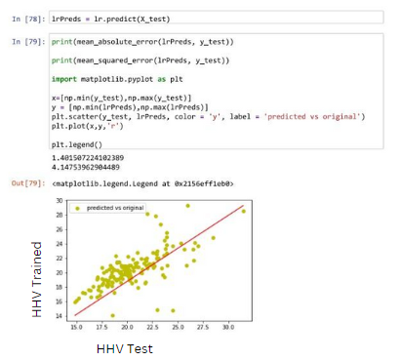
Figure A-1: Evaluation of MAE and MSE of proximate from Linear regression
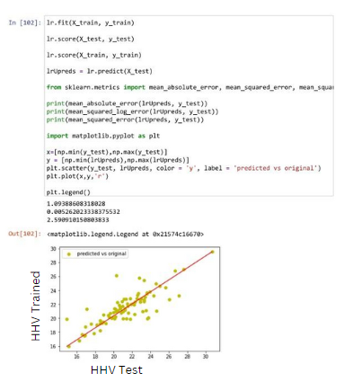
Figure A-2: Evaluation for MAE and MSE of Ultimate from Linear regression

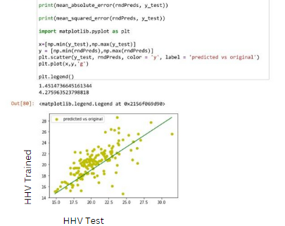
Figure A-3: Code for MAE and MSE of proximate from random forest
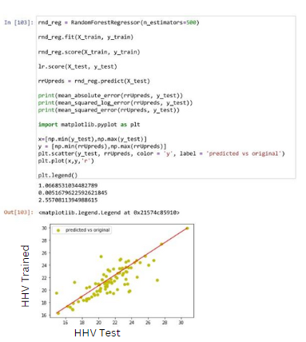
Figure A-4: Code for MAE and MSE of ultimate from random forest

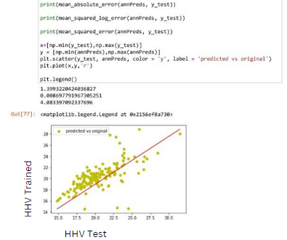
Figure A-5: Code for MAE and MSE of proximate from ANN

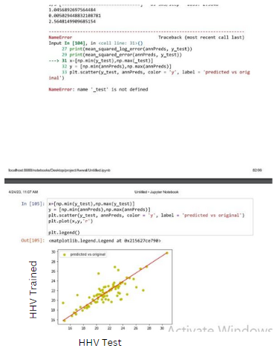
Figure A-6: Code for MAE and MSE of ultimate from ANN

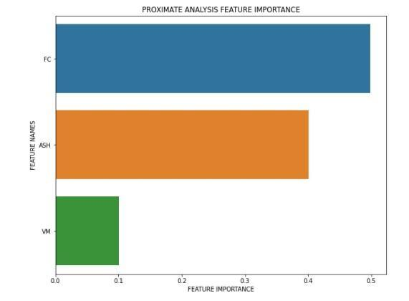
Figure A-7: Feature Importance of Proximate Analysis
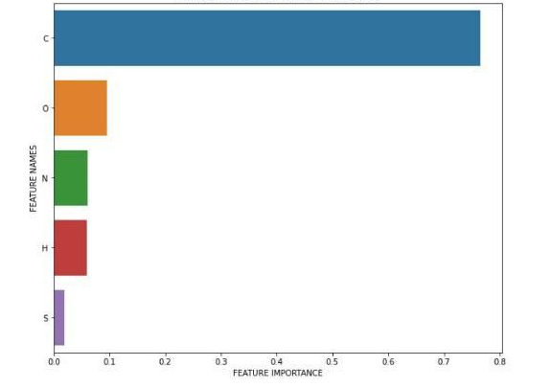
Figure A-8: Feature Importance of Ultimate Analysis

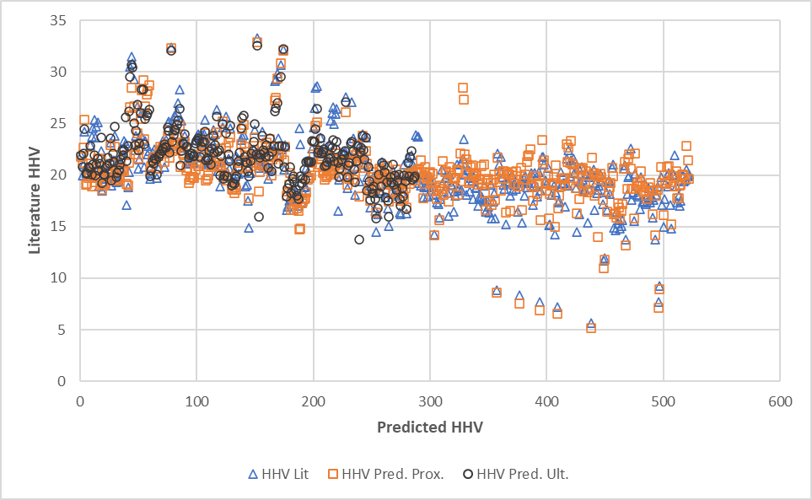
Figure A-9: Comparison between HHV Literature and HHV Predicted Proximate and Ultimate
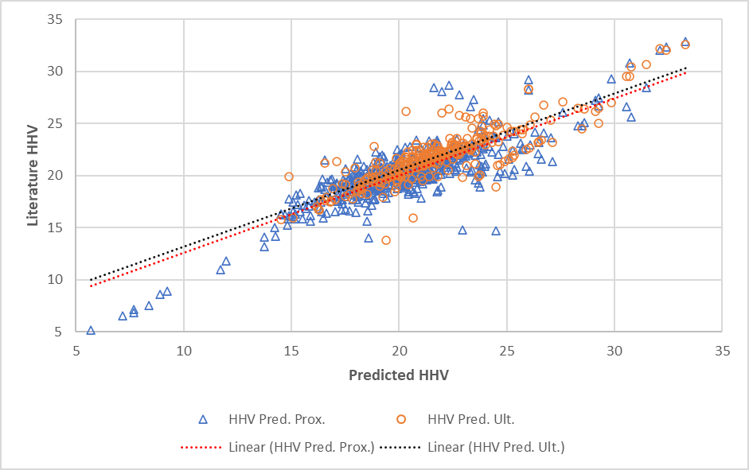
Figure A-10: Correlation between HHV Literature and HHV Predicted Proximate and Ultimate

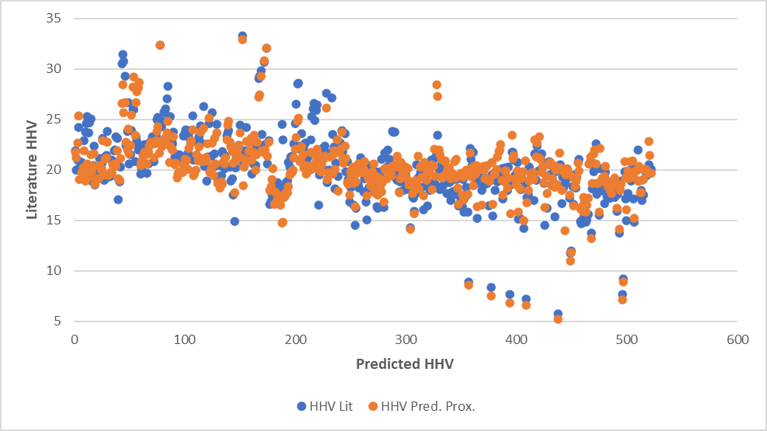
Figure A-11: Comparison between HHV Literature and HHV Predicted Proximate
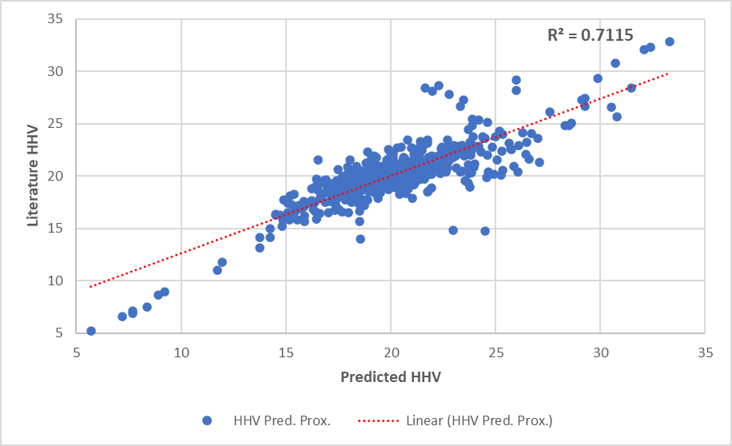
Figure A-12: Correlation between HHV Literature and HHV Predicted Proximate

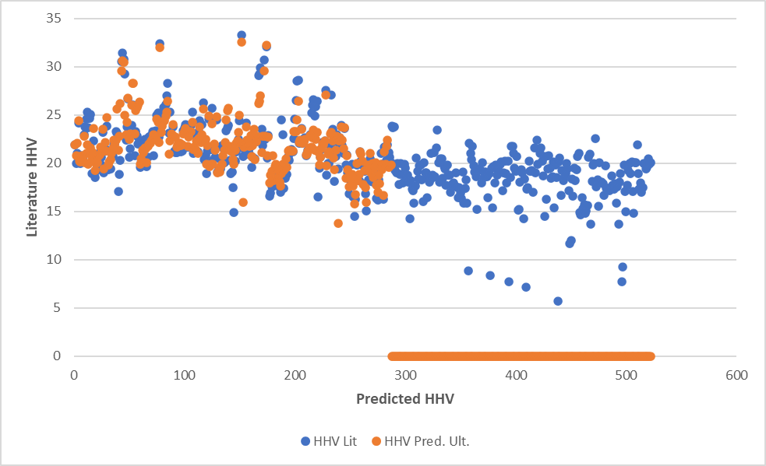
Figure A-13: Comparison between HHV Literature and HHV Predicted Ultimate
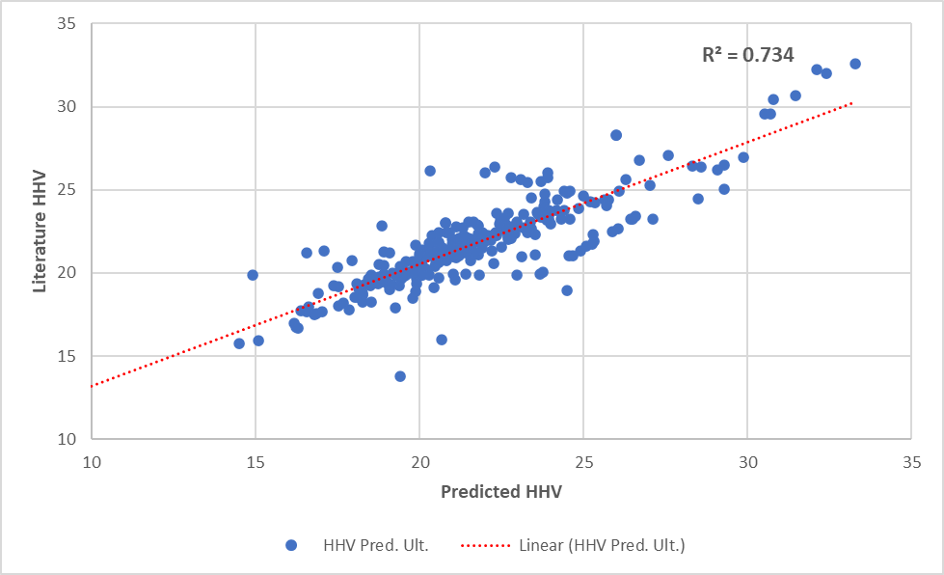
Figure A-14: Correlation between HHV Literature and HHV Predicted Ultimate

