Review Article
Microplastics in Agroecosystems: Effects on Soil Microbiome, Nutrient Dynamics, and Fungal Interactions

Abstract
Microplastics (MPs) have emerged as pervasive contaminants in agricultural soils, posing significant threats to soil health, microbial functionality, and sustainable crop production. This review comprehensively evaluates the sources, characteristics, detection approaches, and functional impacts of MPs on soil ecosystems, with a particular focus on microbiome dynamics, nutrient cycling, and fungal interactions. Major input pathways, including plastic mulching, organic amendments, irrigation, and atmospheric deposition, contribute to MP accumulation, reaching thousands of particles per kilogram of soil. Experimental evidence (0.1-1% w/w) demonstrates substantial reductions in key enzymatic activities (10-35%) and alterations in carbon use efficiency (10-25%), indicating impaired microbial metabolism. MPs significantly disrupt nitrogen cycling, causing 15-40% declines in nitrogen fixation, 10-25% inhibition of nitrification, and shifts in functional gene abundance (nifH, amoA). Furthermore, MPs modify soil physicochemical properties and reshape rhizosphere interactions, adversely affecting plant growth and microbial colonization. Fungal systems, particularly basidiomycetes, exhibit altered biomass (10-30%), reduced mycorrhizal associations (15-25%), and limited polymer degradation potential (5-15%), highlighting both ecological risks and bioremediation prospects. Additionally, MP exposure compromises biofertilizer efficiency, reducing microbial viability (15-35%) and root colonization (20-40%). The potential transfer of MPs into the food chain raises critical concerns for food safety and human health. Despite growing evidence, major gaps remain in long-term field validation, methodological standardization, and risk assessment. Future research integrating multi-omics approaches and MP-resilient microbial and fungal systems is essential to mitigate impacts and ensure sustainable agroecosystem functioning.
Keywords: - Agricultural soils, Fungal interactions, Microplastics, Nutrient cycling, Soil health, Soil microbiome

1. Introduction
MPs (particles <5 mm) have emerged as a global environmental concern due to their persistence, ubiquity, and long-term ecological risks (Ziani et al. 2023). Global estimates suggest that agricultural soils may contain between 1.5 and 6.6 million tons of MPs, potentially exceeding the total load present on ocean surfaces, highlighting soils as a dominant yet under-recognised sink of plastic pollution (Kedzierski et al. 2023; Aslam et al. 2026).
Field-scale investigations across different continents reveal widespread contamination. A global synthesis of 223 sampling sites reported median concentrations of approximately 1167 particles per kg of soil, with values reaching up to 13,000 particles per kg in intensively managed agricultural systems (Büks & Kaupenjohann, 2020). In some regions, such as China, concentrations exceeding 18,000 particles per kg have been recorded, particularly in intensively cultivated farmlands (Zhou et al. 2018). Moreover, recent national-level assessments in Europe indicate that up to 76% of soils may contain detectable MPs, emphasizing their pervasive distribution across land-use systems (Palazot et al. 2024).
Agricultural practices are the primary contributors to this accumulation. Plastic mulching, sewage sludge application, compost amendments, coated fertilizers, and irrigation with contaminated water act as major input pathways (Mohasin et al. 2025). Emerging evidence also indicates that controlled-release fertilizers and organic amendments significantly contribute to microplastic (MP) loading in soils, further complicating nutrient management systems. These inputs result in the continuous buildup of MPs in soil matrices, where they interact with minerals, organic matter, and microbial communities under highly heterogeneous conditions (Sarfraz et al. 2025).
The soil microbiome, comprising bacteria, fungi, and other microorganisms, plays a fundamental role in ecosystem functioning through nutrient cycling, organic matter decomposition, and plant growth promotion (Zhan, 2024). However, the functional consequences of MP exposure on microbial metabolism, enzymatic activities, and symbiotic associations remain largely unexplored. Recent global assessments suggest that MPs may even influence plant productivity by reducing photosynthetic efficiency by 7–12%, potentially leading to significant crop yield losses worldwide (Zhu et al. 2025). Therefore, understanding the interaction between MPs and soil microbiome at a global scale is essential for evaluating long-term ecological risks, particularly in agricultural systems.
In the Indian context, MP contamination in agricultural soils is an emerging but underexplored issue. India, being one of the largest consumers of plastic in agriculture, especially for mulching, irrigation pipes, and fertilizer packaging, faces a significant risk of soil MP accumulation (Anand & Sheel, 2025). Recent studies from states such as Punjab, Haryana, and Maharashtra have reported detectable levels of MPs in intensively cultivated soils, with concentrations ranging from 300 to over 3000 particles per kg depending on cropping systems and management practices (Anand & Sheel, 2025).
The widespread use of polyethene mulch in vegetable cultivation and horticulture has been identified as a major contributor. The application of untreated or partially treated sewage sludge and compost in peri-urban agriculture introduces secondary MPs into soil systems. River irrigation, particularly from polluted rivers such as the Ganga and Yamuna, further enhances MP input into farmlands (Anand & Sheel, 2025; Yacoub & Han, 2026). India's diverse agro-climatic conditions influence the fragmentation and persistence of plastics. High temperatures and UV exposure accelerate the breakdown of macroplastics into MPs, while monsoonal dynamics facilitate their redistribution within soil profiles. Despite these factors, systematic large-scale monitoring of soil MPs in India remains limited (Anand & Sheel, 2025).
From a microbiological perspective, Indian soils, rich in microbial diversity and heavily reliant on biofertilizers and organic inputs, may be particularly vulnerable to MP-induced functional disruptions (Ghosh et al. 2025). Changes in microbial enzymatic activity, nitrogen cycling efficiency, and mycorrhizal associations could directly impact crop productivity and soil fertility (Bhattacharyya & Furtak, 2022). However, experimental evidence from Indian agroecosystems is still scarce, highlighting a critical research gap.
Furthermore, although MPs are widely reported in agricultural soils, their functional impacts on soil microbial communities remain poorly understood in agroecosystems. Existing studies mainly focus on occurrence and sources, while microbial responses and ecosystem-level effects are still largely unexplored. Therefore, the present study aims to investigate the interaction between MPs and soil microbiome, with special emphasis on microbial activity, enzymatic functions, and nutrient dynamics. This study will provide essential baseline data and contribute to the development of sustainable strategies for managing MP stress in agricultural soils.
2. Sources and Accumulation of MPs in Agricultural Soils
MPs in agricultural soils originate from diverse sources such as plastic mulching, organic amendments (compost and sludge), irrigation water, and atmospheric deposition, leading to their continuous input into soil systems (Table 1 and Figure 1). Over time, these particles accumulate due to their persistence and limited degradation, resulting in long-term alterations in soil structure, microbial dynamics, and nutrient cycling processes (Riveros et al. 2022; Omidoyin & Jho, 2023).

Table 1. Sources of MPs in Agricultural Soils
Source | Type of Plastic | Concentration Range | Remarks | References
Plastic Mulching | PE | 500–2000 particles/kg | Major contributor | Zhang et al. 2020a; Steinmetz et al. 2016
Sewage Sludge | PE, PP, PET | 1000–24000 particles/kg | High contamination | Nizzetto et al. 2016; Corradini et al. 2019
Compost | PE, PP | 200–900 particles/kg | Secondary source | Weithmann et al. 2018; Gui et al. 2021
Irrigation Water | Mixed | 10–10000 particles/m³ | Diffuse input | Li et al. 2018; Zhang et al. 2019
Atmospheric Deposition | Fibers | 50–700 particles/m²/day | Continuous input | Dris et al. 2016; Allen et al. 2019
2.1 Plastic Mulching
Plastic mulch films are widely used to enhance crop productivity by conserving soil moisture, suppressing weeds, and improving temperature regimes (Bahadur et al. 2018). However, their extensive and repeated use has led to a significant accumulation of plastic residues in agricultural soils. Field studies have reported that 10–30% of mulch film residues remain in soil after each cropping cycle, particularly under conventional retrieval practices (Kumar & Sheela, 2020). Over time, these residual plastics undergo fragmentation into MPs due to the combined effects of ultraviolet (UV) radiation, thermal oxidation, mechanical tillage, and microbial weathering processes (Bai et al. 2024).
Recent experimental data indicate that polyethylene (PE)-based mulch films can degrade into particles <5 mm within 1–3 years under field conditions, depending on climate and soil properties (Yin et al. 2019; Bandyopadhyay et al. 2923). In intensively cultivated systems, MP concentrations derived from mulch films alone have been reported to reach 500–2000 particles per kg of soil (Qiang et al. 2023). Furthermore, studies demonstrate that smaller fragments (<1 mm) exhibit higher surface area and reactivity, thereby exerting stronger interactions with soil microbial communities (Han et al. 2024).
In the Indian scenario, long-term use of plastic mulching in vegetable crops such as tomato, chilli, and cucurbits has shown a visible accumulation of plastic residues in the topsoil (0–15 cm) (www.indiawaterportal.org; www.agriplast.co.in). High temperature and solar radiation conditions prevalent in Indian agroecosystems accelerate the fragmentation process, leading to faster generation of MPs compared to temperate regions. Despite this, efficient recovery and recycling mechanisms remain limited, resulting in progressive buildup of MPs in agricultural fields.
Such accumulation not only alters soil physical properties such as bulk density and porosity but also creates novel microhabitats (plastisphere) that influence microbial colonization and activity (Amaral-Zettler et al. 2020). Consequently, plastic mulch-derived MPs constitute a major and ongoing source of contamination, with significant implications for soil health, microbial function, and long-term agricultural sustainability.
2.2 Organic Amendments
Application of compost and sewage sludge represents a significant secondary pathway for MP entry into agricultural soils (Zhang et al 2020a). Recent studies indicate that sewage sludge may contain between 1,000 and 24,000 MP particles per kilogram (dry weight), depending on treatment efficiency and the source of wastewater (Di Bella et al. 2022; Kwiatkowska & Ormaniec, 2024). When such sludge is applied as a soil amendment, a substantial fraction of these particles is directly transferred into soil systems, leading to cumulative loading over time. Similarly, compost derived from municipal solid waste has been reported to contain 200–900 particles per kg, largely dominated by polyethylene (PE), polypropylene (PP), and polyester fibers (Ayoub et al. 2025).
Experimental field trials have demonstrated that repeated application of sludge over 3–5 years can increase soil MP concentrations by 2–5 times compared to untreated soils (Ramage et al. 2025). Long-term amendment studies in Europe and China report accumulation rates of up to 0.5–1.5 tons of plastic residues per hectare in intensively managed fields (Steinmetz et al. 2016; Ren et al. 2024). Moreover, MPs introduced via organic amendments are often smaller (<1 mm), making them more bioavailable and reactive within soil matrices.
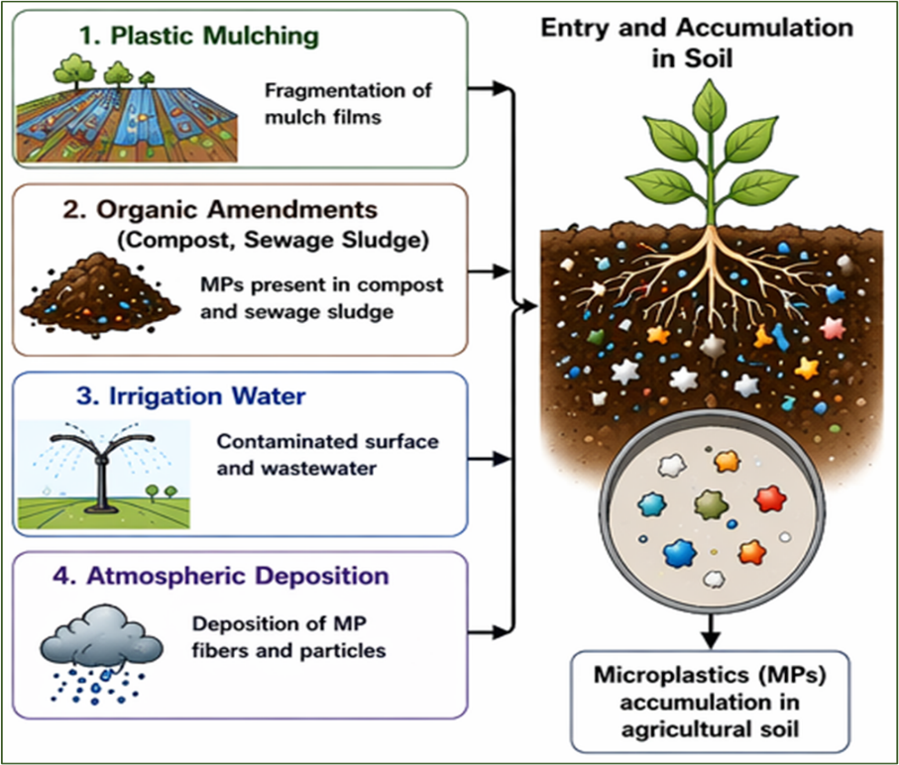
Figure 1 Sources and pathways of MPs in agricultural soil
From a functional perspective, these amendment-derived MPs can adsorb heavy metals, antibiotics, and persistent organic pollutants, thereby acting as vectors that alter microbial community structure and enzymatic activities (Li et al. 2022).
2.3 Irrigation and Atmospheric Deposition
Irrigation water has recently been identified as a significant pathway for MP entry into agricultural soils. Studies have reported that wastewater and river water used for irrigation may contain between 10 to 10,000 MP particles per cubic meter, depending on pollution levels (McGinnis, 2021). Continuous irrigation with such contaminated water can lead to the gradual accumulation of MPs in soil profiles over time. In particular, peri-urban and wastewater-fed agricultural systems show higher levels of contamination due to direct exposure to untreated or partially treated effluents (Ali et al. 2026).
Atmospheric deposition is another emerging but less recognized source of MPs in soils. Airborne MP fibers and particles originating from urban emissions, textile industries, and road dust can settle onto agricultural land. Recent studies estimate atmospheric deposition rates ranging from 50 to 700 particles per square meter per day, indicating a continuous and diffuse input pathway (Dris et al. 2016; Allen et al. 2019; Brahney et al. 2020).
3. Characteristics and Classification of MPs
3.1 Classification Based on Origin
MPs are primarily categorized into primary and secondary types depending on their source. Primary MPs are intentionally manufactured in microscopic sizes for use in products such as cosmetics, industrial abrasives, and resin pellets (Mathew et al. 2024). These particles enter the environment directly without undergoing prior fragmentation. In contrast, secondary MPs are generated through the breakdown of larger plastic materials under environmental conditions such as ultraviolet radiation, temperature fluctuations, mechanical stress, and microbial degradation (Mishra et al. 2025). In agricultural soils, secondary MPs are more dominant, largely originating from plastic mulching films, irrigation pipes, and other plastic residues (Huang et al. 2020).
3.2 Classification Based on Size
The size of MPs is a critical parameter that determines their mobility, bioavailability, and ecological effects. Generally, MPs are defined as particles smaller than 5 mm, but they are further subdivided into larger MPs (1–5 mm) and smaller MPs (<1 mm) (Scheurer & Bigalke, 2018). An emerging category, nanoplastics (<1000 nm), has gained attention due to their ability to penetrate biological membranes and interact at the cellular level (Dai et al. 2022). Smaller particles possess a higher surface area-to-volume ratio, which enhances their chemical reactivity and potential toxicity in soil environments.
3.3 Classification Based on Shape and Morphology
MPs exhibit a wide range of shapes, including fibers, fragments, films, pellets, and foams, each influencing their environmental behaviour differently (Rochman et al. 2019). Fibrous MPs, commonly derived from synthetic textiles, are easily transported through soil and water systems (Rochman et al. 2019). Fragmented particles result from the breakdown of rigid plastics and often display irregular shapes with rough surfaces. Film-like MPs are typically associated with degraded agricultural mulching materials, while spherical pellets or beads are linked to industrial and cosmetic sources (Rochman et al. 2019). Foam particles, often originating from polystyrene products, are lightweight and highly dispersible (Ghoshal et al. 2023). These morphological differences significantly affect microbial colonization, adsorption of pollutants, and persistence in soil.
3.4 Classification Based on Polymer Composition
MPs are composed of various synthetic polymers, each exhibiting distinct physicochemical properties and environmental stability. Commonly identified polymers include polyethene (PE), polypropylene (PP), polystyrene (PS), polyvinyl chloride (PVC), and polyethylene terephthalate (PET) (Özteki̇n & Sponza, 2023). The chemical structure of these polymers, including the type of bonds and functional groups present, determines their resistance to degradation, interaction with soil organic matter, and affinity for pollutants. For instance, hydrophobic polymers such as PE and PP tend to accumulate persistent organic pollutants, whereas more polar polymers may interact differently with soil components (Prajapati et al. 2022).
3.5 Classification Based on Surface Characteristics
Surface properties of MPs play a crucial role in governing their interactions within soil ecosystems. Factors such as hydrophobicity, surface charge, roughness, and porosity influence their capacity to adsorb contaminants and support microbial colonization (Cowger et al. 2020). Weathering processes often increase surface roughness and introduce oxygen-containing functional groups, thereby enhancing the adsorption of heavy metals and organic pollutants (Cowger et al. 2020). Additionally, MPs may contain additives such as plasticizers, stabilizers, and flame retardants, which can leach into the surrounding environment and contribute to toxicity (Iftikhar et al. 2024).
4. Detection and Quantification Methods of MPs
4.1 Sample Preparation and Extraction Techniques
The initial step in MP analysis involves the removal of organic matter and the separation of plastic particles from soil. Commonly, chemical digestion methods using hydrogen peroxide (H₂O₂), Fenton’s reagent, or enzymatic treatments are applied to eliminate organic residues without damaging plastic polymers (Thomas et al. 2020). Following digestion, density separation is widely employed using high-density salt solutions such as sodium chloride (NaCl), zinc chloride (ZnCl₂), or sodium iodide (NaI), allowing lighter MP particles to float and be isolated from heavier mineral components. Studies have shown that high-density solutions like ZnCl₂ improve recovery efficiency, particularly for high-density polymers such as PVC and PET (Thomas et al. 2020).
4.2 Microscopic Identification
After extraction, MPs are often initially identified using microscopy (Table 2) based on visual characteristics such as shape, size, and colour. Fluorescence staining techniques, particularly using Nile Red dye, have gained popularity for enhancing the detection of MPs, especially smaller particles, by causing them to fluoresce under specific wavelengths (Sturm et al. 2021). However, visual identification alone is prone to misclassification, necessitating further confirmatory analysis.
4.3 Spectroscopic Techniques
Advanced spectroscopic methods provide precise identification of polymer types (Table 2). Fourier Transform Infrared Spectroscopy (FTIR) is one of the most widely used techniques, enabling the identification of polymer-specific functional groups through infrared absorption spectra. Micro-FTIR imaging further allows analysis of particles as small as 10–20 µm (Zhang et al. 2024). Similarly, Raman Spectroscopy offers high spatial resolution and can detect particles down to the micrometre and even submicrometer scale (Zhang et al. 2024). Raman spectroscopy is particularly advantageous for coloured or dark particles, where FTIR may have limitations.
4.4 Thermal and Chromatographic Methods
Thermal degradation-based techniques are increasingly used for quantitative analysis (Table 2). Gas Chromatography–Mass Spectrometry, particularly when coupled with pyrolysis (Py-GC-MS), enables the identification and quantification of polymers by their characteristic thermal degradation products (Zeng et al. 2026). This method provides highly accurate polymer-specific quantification, even in complex environmental samples. Other techniques, such as thermogravimetric analysis (TGA) and differential scanning calorimetry (DSC), are also used to study thermal properties and polymer composition (Zeng et al. 2026).
4.5 Emerging and Advanced Approaches
Recent advancements include the use of hyperspectral imaging, automated MP recognition using machine learning, and combined techniques such as FTIR imaging and Raman mapping for high-throughput analysis. Additionally, microfluidic devices and nanoplastic detection methods are being developed to address limitations in detecting particles at the nanoscale (Zeng et al. 2026).
4.6 Quantification Approaches and Standardization Challenges
MPs in soil are typically quantified in terms of particle number (particles/kg of soil) or mass concentration (mg/kg). However, variability in sampling methods, extraction efficiency, and analytical techniques often leads to inconsistencies across studies (Stock et al. 2019). Recent research emphasizes the need for standardized protocols and reference materials to ensure comparability of results. Recovery rates, contamination control, and procedural blanks are critical factors that must be carefully managed during analysis (Zeng et al. 2026).

Table 2. Analytical Techniques for Detection and Quantification of MPs in Soil Systems
Method | Principle | Detection Limit | Advantage | Limitation | Reference
FTIR | IR absorption | ~10 µm | Polymer identification | Time-consuming | Hidalgo-Ruz et al. 2012; Zeng et al. 2026
Raman | Light scattering | ~1 µm | High resolution | Expensive | Araujo et al. 2018; Zeng et al. 2026
Py-GC-MS | Thermal degradation | Very low | Quantitative analysis | Complex | Dümichen et al. 2015; Zeng et al. 2026
Microscopy | Visual identification | >50 µm | Simple and rapid | Low accuracy | Masura et al. 2015; Zeng et al. 2026
5. Impact of MPs on Soil Physicochemical Properties
MPs in agricultural soils significantly alter physicochemical properties, influencing soil structure, water dynamics, and chemical behaviour (Scheurer & Bigalke, 2018). Their effects depend on particle size, shape, concentration, and polymer type. MPs can modify soil aggregation and structure by disrupting natural binding agents such as organic matter and microbial exudates, often reducing aggregate stability (Han et al. 2024). However, fibrous MPs may sometimes enhance aggregation through physical entanglement. Changes in bulk density and porosity are also reported, with low-density polymers (e.g., polyethylene) generally decreasing bulk density and increasing porosity, which can improve aeration but may reduce water retention capacity (de Souza Machado et al. 2018).
In terms of soil water dynamics, MPs can alter water infiltration and holding capacity. Film-like particles may obstruct pore spaces, leading to uneven water distribution, while increased porosity in some cases enhances drainage. These changes directly affect plant water availability (Wang et al. 2023a). MPs also influence soil chemical properties, including pH, nutrient availability, and contaminant behaviour. Weathered MPs develop reactive surfaces that adsorb nutrients and pollutants such as heavy metals and organic contaminants, potentially reducing nutrient bioavailability while acting as carriers of toxic substances. Additionally, plastic additives can leach into the soil, contributing to chemical stress (Chia et al. 2022). Furthermore, MPs impact soil organic matter and carbon dynamics by affecting microbial activity and decomposition processes, thereby altering carbon mineralization rates (Hu et al. 2021). Overall, these physicochemical changes can have cascading effects on soil fertility and ecosystem functioning.
6. Soil Microbiome: Structure and Functional Importance
Soil microbial communities comprise bacteria, fungi, actinomycetes, and protozoa, which collectively regulate essential ecosystem functions. A single gram of fertile soil may contain up to 10⁹ bacterial cells along with extensive fungal hyphal networks, reflecting immense biological complexity (Torsvik & Øvreås, 2002; Whitman et al. 1998). These microorganisms play a crucial role in organic matter decomposition, nutrient mineralization, soil aggregation, and plant–microbe interactions (van der Heijden et al. 2008).
Microbial biomass carbon typically constitutes about 1–5% of total soil organic carbon and is widely used as a sensitive indicator of soil health (Jenkinson & Ladd, 1981; Wardle, 1992). Functionally, soil microbes are central to biogeochemical cycles; biological nitrogen fixation contributes approximately 50–200 kg N ha⁻¹ year⁻¹ depending on ecosystem conditions (Galloway et al. 2004; Peoples et al. 2009). Fungal communities are responsible for nearly 70–90% of lignocellulosic decomposition in terrestrial ecosystems (Baldrian, 2008), while mycorrhizal associations can enhance plant nutrient uptake efficiency by 20–80% (Smith & Read, 2008).
However, emerging environmental stressors such as MPs have been shown to alter microbial community composition and reduce soil enzymatic activities under experimental conditions, often by 10–30% at concentrations ranging from 0.1–1% (w/w) (Rillig et al. 2019a; Fei et al. 2020; de Souza Machado et al. 2018). These alterations can disrupt nutrient cycling processes and ultimately affect soil fertility and ecosystem functioning. Therefore, maintaining a stable and functional soil microbiome is essential for sustaining agricultural productivity and ecological resilience.
7. MPs–Microbiome Interactions
7.1 Physical Interactions
Experimental studies report that incorporation of MPs (0.1–1% w/w) can reduce soil bulk density by 5–15% while increasing porosity, thereby modifying aeration and moisture regimes (Figure 2). Fiber-type MPs, in particular, enhance water retention but may create heterogeneous microhabitats, disrupting microbial spatial distribution. Such physical changes can influence oxygen diffusion and root–microbe interactions, ultimately affecting microbial activity and nutrient cycling processes (de Souza Machado et al. 2018; Rillig et al. 2019b; Lehmann et al. 2020).
7.2 Chemical Interactions
MPs act as vectors for chemical contaminants due to their high surface area and hydrophobicity (Figure 2). They can adsorb heavy metals (e.g., Cd, Pb) and organic pollutants (e.g., PAHs, pesticides), often increasing their persistence in soil. Additionally, MPs release additives such as phthalates and bisphenol A (BPA), which are known to exhibit toxic effects on soil microbes. Studies indicate that these chemical interactions can suppress microbial enzymatic activities (e.g., dehydrogenase, urease) by 10–25% and alter microbial metabolic pathways, leading to reduced soil biochemical functionality (Hüffer et al. 2017; Wang et al. 2019; Guo et al. 2020; Fei et al. 2020).
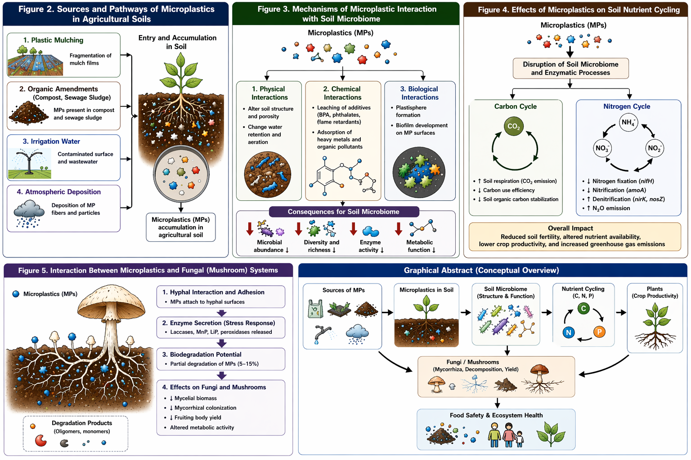
Figure 2 MP interaction with soil microbiome
7.3 Biological Interactions
MPs provide novel ecological niches for microbial colonization, forming specialized communities known as the “plastisphere.” These communities differ significantly from native soil microbiota in both composition and function (Figure 2). Research indicates that plastisphere-associated microbes are often enriched with opportunistic and stress-tolerant taxa, particularly Proteobacteria and Actinobacteria, with reported increases of 20–40% in relative abundance under MP exposure. Furthermore, MPs can act as carriers for pathogenic microorganisms, potentially influencing plant health and soil disease dynamics. The formation of plastisphere biofilms also alters microbial communication and gene exchange, including horizontal gene transfer, with studies suggesting a 2–3 fold increase in gene transfer frequency on plastic surfaces. Additionally, extracellular enzyme activities associated with plastisphere communities may differ by 15–25%, indicating functional divergence that could have long-term ecological consequences (Zettler et al. 2013; Amaral-Zettler et al. 2020; Rillig et al. 2019b; Fei et al. 2020).

Table 3. Microbial & Enzymatic Effects of MPs in Soil
Parameter | Change (%) | Mechanism | Impact | References
Dehydrogenase | ↓ 10–35% | Toxicity, ROS generation | Respiration ↓ | Hu et al. 2021; Zhou et al. 2020
Urease | ↓ 15–30% | Additive stress, enzyme inhibition | N cycling ↓ | Huang et al. 2019; Fei et al. 2020
Phosphatase | ↓ 10–25% | Substrate blockage, toxicity | P availability ↓ | Zhang et al. 2021a; Liu et al. 2022
Microbial biomass | ↓ 10–30% | Oxidative stress, membrane damage | Soil fertility ↓ | de Souza Machado et al. 2018; Qi et al. 2020
8. Functional Impact on Microbial Metabolism
8.1 Enzymatic Activity
MPs significantly influence key soil enzymes such as dehydrogenase, urease, phosphatase, and β-glucosidase, which are critical indicators of microbial metabolic activity (Table 3). Experimental studies have reported a 10–35% reduction in dehydrogenase activity under MP concentrations of 0.1–1% (w/w), indicating suppressed microbial respiration (Hu et al. 2021; Zhou et al. 2020). Urease and phosphatase activities, essential for nitrogen and phosphorus mineralization, have shown declines of 15–30%, likely due to toxic additives (e.g., phthalates, BPA) leaching from MPs (Huang et al. 2019; Fei et al. 2020). Additionally, MPs may physically block enzyme-substrate interactions by adsorbing organic matter, thereby reducing catalytic efficiency and nutrient turnover rates (de Souza Machado et al. 2018; Qi et al. 2020).
8.2 Carbon Cycling
MPs alter soil carbon dynamics by affecting microbial respiration, carbon mineralization, and organic matter decomposition (Figure 3). Studies indicate that MP contamination can increase basal soil respiration by 5–20% due to stress-induced microbial activity, while long-term exposure may reduce carbon use efficiency (CUE) by 10–25%. MPs also interfere with the breakdown of complex organic substrates, particularly lignocellulosic material, by disrupting fungal activity. This results in altered CO₂ flux and potential destabilization of soil organic carbon pools. Furthermore, MPs may act as carbon substrates for certain microbial taxa, shifting community composition and metabolic pathways (de Souza Machado et al. 2018; Rillig et al. 2019a; Ren et al. 2020; Zhang et al. 2022).
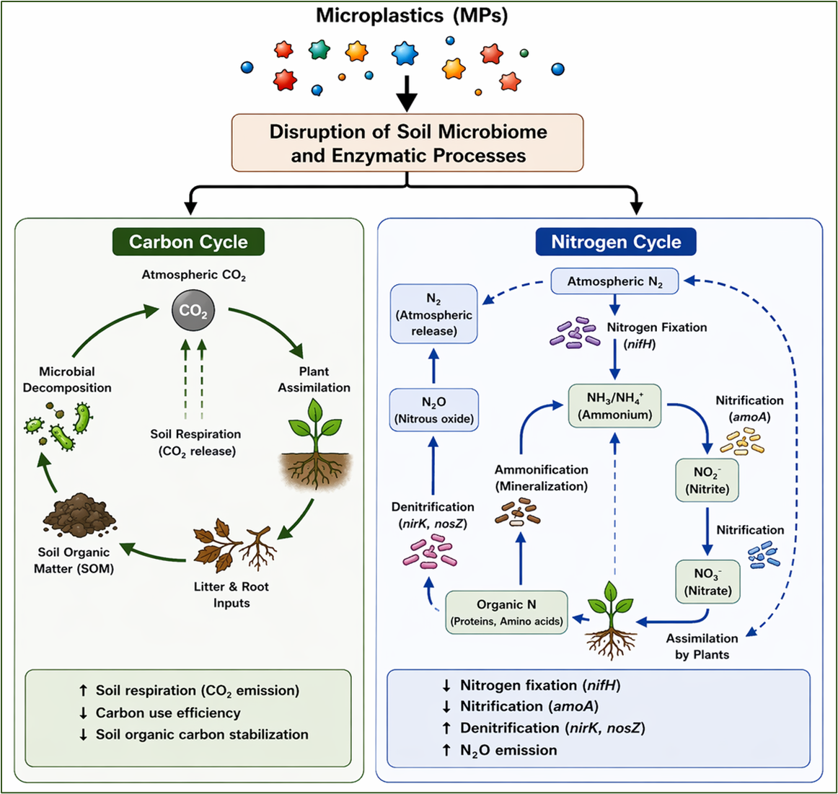
Figure 3 Effect of MPs on soil nutrient cycling
8.3 Stress Responses
Exposure to MPs induces oxidative stress in soil microorganisms through the generation of reactive oxygen species (ROS). Studies report a 20–50% increase in antioxidant enzyme activities such as catalase and superoxide dismutase under MP stress conditions. At the molecular level, MPs influence gene expression related to stress tolerance, metabolism, and membrane transport. Functional genes involved in nutrient cycling and stress adaptation may be upregulated or downregulated, indicating metabolic shifts. Additionally, chronic exposure to MPs can lead to reduced microbial diversity and selection of stress-resistant populations, potentially impacting long-term soil ecosystem stability (Fei et al. 2020; Wang et al. 2021a; Yang et al. 2022; Rillig et al. 2019b).
9. Impact of MPs on Nitrogen Cycle
9.1 Nitrogen Fixation
MPs negatively influence biological nitrogen fixation by affecting diazotrophic microbial communities (Figure 3 and Table 4). Experimental studies report a 15–40% reduction in nitrogenase activity under MP exposure (0.1–1% w/w), primarily due to physical obstruction and toxic additive release (Wang et al. 2024). MPs can reduce the abundance of key nitrogen-fixing bacteria such as Rhizobium and Azotobacter, leading to decreased N input into soil systems. Additionally, symbiotic associations between legumes and rhizobia may be disrupted, affecting nodulation efficiency by up to 20–30% under stress conditions (Wang et al. 2023b).
9.2 Nitrification and Denitrification
MPs alter nitrification and denitrification processes (Figure 3 and Table 4) by influencing ammonia-oxidizing bacteria (AOB), ammonia-oxidizing archaea (AOA), and denitrifiers. Studies indicate that MP contamination can reduce nitrification rates by 10–25% through suppression of AOB populations, while in some cases stimulating denitrification due to localized anaerobic microenvironments. Denitrification enzyme activity (DEA) has been reported to increase by 5–15%, potentially enhancing N₂O emissions, a potent greenhouse gas. These changes may disrupt nitrogen availability and lead to increased nitrogen losses from soil (Fei et al. 2020; Ren et al. 2020; Rillig et al. 2019a; Liu et al. 2022).
9.3 Functional Genes
At the molecular level, MPs significantly influence nitrogen cycling genes, affecting key functional groups involved in nitrogen transformations. The abundance of nifH (nitrogen fixation marker gene) has been reported to decline under MP stress (Ren et al. 2020; Liu et al. 2022). Similarly, amoA genes associated with ammonia oxidation may decrease, indicating impaired nitrification processes (Fei et al. 2020; Wang et al. 2021b). In contrast, denitrification genes such as nirK and nosZ often show variable responses, with some studies reporting upregulation under MP-induced stress conditions, possibly due to the formation of anaerobic microenvironments (Liu et al. 2022; Rillig et al. 2019b). These gene-level alterations reflect shifts in microbial metabolic pathways and highlight the potential long-term impact of MPs on nitrogen cycling efficiency and soil fertility.
Table 4. Nitrogen Cycle Impact of MPs in Soil
Process | Change (%) | Gene Affected | Outcome | Reference
Nitrogen Fixation | ↓ 15–40% | nifH ↓ | N input ↓ | Sun et al. 2022
Nitrification | ↓ 10–25% | amoA ↓ | NH₄⁺ oxidation ↓ | Liu et al. 2021
Denitrification | ↑ 5–15% | nirK, nosZ | N₂O emission ↑ | Zhang et al. 2020b
10. Interaction of MPs with Plants and Rhizosphere
MPs significantly influence plant systems by altering rhizosphere dynamics, which directly affects plant growth, nutrient uptake, and plant–microbe interactions. Studies indicate that MPs can modify soil physical and chemical conditions, leading to changes in root architecture, including reduced root length, biomass, and surface area under higher MP concentrations (de Souza Machado et al. 2019; Qi et al. 2018). These effects are primarily attributed to physical obstruction and altered soil structure, which limit root penetration and access to water and nutrients (Rillig et al. 2019a).
In the rhizosphere, MPs interfere with root exudation and microbial assembly, thereby reshaping microbial community composition. Experimental evidence shows that MPs can significantly alter rhizosphere microbial diversity and metabolomic profiles, as observed in crop systems like lettuce, where biodegradable MPs influenced both microbial consortia and plant metabolic responses (Qi et al. 2018; Huang et al. 2019). Additionally, MPs influence key soil parameters such as pH, porosity, and nutrient availability, which indirectly regulate microbial activity and plant–microbe signalling processes (de Souza Machado et al. 2019; Rillig et al. 2019b).
MPs also act as vectors for contaminants and pathogens, carrying heavy metals, pesticides, and antibiotic residues into the rhizosphere. This can enhance toxicity and promote the proliferation of soil-borne pathogens, thereby increasing plant stress and disease susceptibility (Guo et al. 2020; Zhu et al. 2022). Moreover, emerging evidence suggests that smaller particles, especially nanoplastics, can be taken up by plant roots and potentially translocated within plant tissues, raising concerns about food chain transfer and physiological disruption (Li et al. 2020; Sun et al. 2020).
At the ecosystem level, MPs disrupt plant–microbiome interactions, including beneficial associations such as rhizobacteria and mycorrhizal fungi, which are essential for nutrient cycling and plant health. These disruptions can reduce nutrient acquisition efficiency and weaken plant resilience to environmental stress (Rillig et al. 2019b; de Souza Machado et al. 2019). Overall, MP–plant–rhizosphere interactions are complex and multi-layered, involving physical interference, chemical contamination, and biological alterations, ultimately impacting plant productivity and soil ecosystem stability.
11. Mushroom–MPs Interaction
Fungi, particularly basidiomycetes, play a crucial role in soil ecosystems through decomposition, nutrient cycling, and symbiotic associations. Recent studies suggest that MPs directly and indirectly influence fungal growth, metabolism, and ecological function (Figure 4). Experimental evidence indicates that MP concentrations of 0.1–1% (w/w) can alter fungal biomass by 10–30%, depending on polymer type and environmental conditions (Rillig et al. 2019b; de Souza Machado et al. 2018; Fei et al. 2020; Wang et al. 2021b).
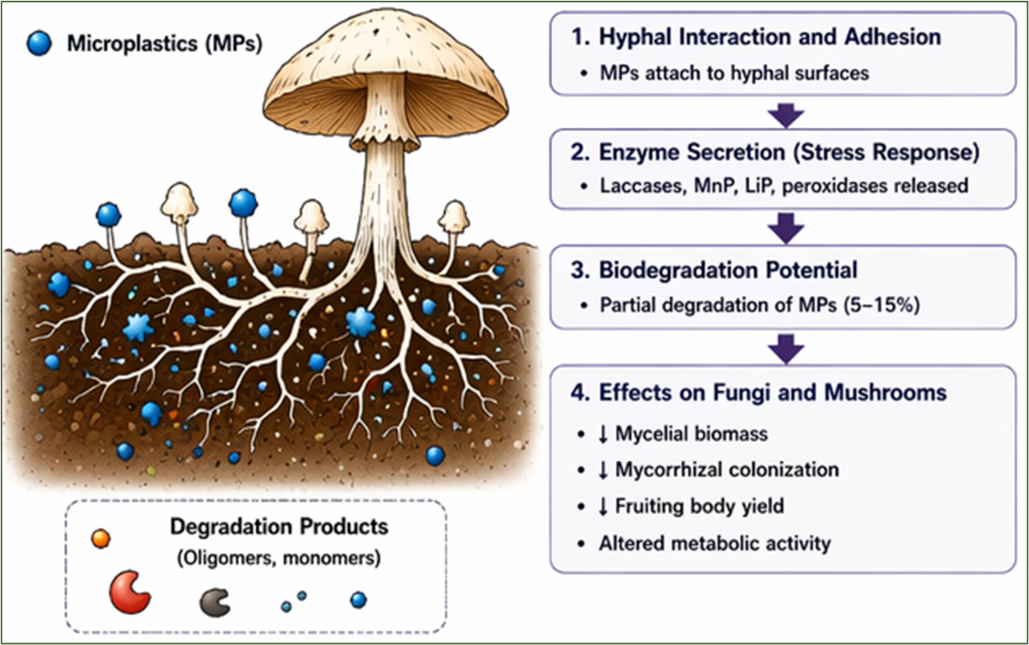
Figure 4 Interaction between MPs and fungal (Mushroom) system
11.1 Hyphal Interaction with MPs
Fungal hyphae actively interact with MPs through physical entanglement and surface colonization. Studies using polyethylene (PE) and polystyrene (PS) MPs have shown that hyphal networks can adhere to and penetrate MP surfaces, forming biofilm-like structures. This interaction may alter hyphal extension rates by 5–20% and disrupt normal soil exploration patterns. Additionally, MPs can create physical barriers in soil pores, limiting hyphal spread and reducing nutrient foraging efficiency. In ectomycorrhizal systems, MP presence has been reported to reduce root colonization efficiency by approximately 15–25%, thereby affecting plant–fungus symbiosis (Huang et al. 2019; Lehmann et al. 2020; Qi et al. 2020).
11.2 Enzymatic Degradation Potential
Basidiomycetes produce extracellular ligninolytic enzymes such as laccase, manganese peroxidase (MnP), and lignin peroxidase (LiP), which are capable of degrading complex aromatic polymers (Kirk & Farrell, 1987; Pointing, 2001). Studies have demonstrated that certain fungi, particularly white-rot fungi such as Phanerochaete chrysosporium and Trametes versicolor, can partially degrade synthetic polymers including polyethylene and polyurethane, with degradation efficiencies typically ranging from 5–15% over several weeks (Tokiwa et al. 2009; Restrepo-Flórez et al. 2014). MP exposure has also been shown to induce laccase activity by 20–40%, suggesting a stress-responsive metabolic adaptation in fungal systems (Rillig et al. 2019b; Zhang et al. 2021b). However, degradation is often incomplete, leading to the formation of smaller plastic fragments rather than full mineralization (Gewert et al. 2015).
11.3 Impact on Fruiting Bodies
MP stress can significantly influence mushroom development, yield, and biochemical composition. Controlled studies report a 10–25% reduction in fruiting body biomass under MP exposure, likely due to impaired nutrient uptake and metabolic stress (de Souza Machado et al. 2018; Qi et al. 2020; Rillig et al. 2019b). MPs may also accumulate in fungal tissues, raising concerns about food safety and trophic transfer, as demonstrated in soil–plant–microbe interaction studies (Wang et al. 2021b; Li et al. 2020). Additionally, stress-induced changes in secondary metabolite production, including phenolics and antioxidants, have been observed, with variations ranging from 10–30%, indicating altered metabolic pathways under environmental stress (Zhang et al. 2021b; Chen et al. 2020). These changes may affect the nutritional and medicinal value of edible mushrooms. Overall, mushroom–MP interactions represent a critical but underexplored area, with implications for soil health, sustainable agriculture, and food safety.
12. Biofertilizer Efficiency under MP Stress
Biofertilizers rely on the activity, survival, and functional efficiency of beneficial microorganisms such as Rhizobium, Azotobacter, Azospirillum, phosphate-solubilizing bacteria (PSB), and mycorrhizal fungi. However, the presence of MPs in soil can significantly disrupt these processes through multiple physical, chemical, and biological mechanisms (Rillig et al. 2019a; de Souza Machado et al. 2018).
Recent studies indicate that MP contamination (0.1–1% w/w) can reduce microbial viability by 15–35%, primarily due to toxic additives such as phthalates and bisphenol A (BPA), as well as increased oxidative stress (Wang et al. 2021a; Huang et al. 2019; Chen et al. 2020). MPs can also adsorb essential nutrients and organic substrates, limiting their bioavailability to beneficial microbes, thereby reducing microbial metabolic activity and overall biofertilizer efficiency (Qi et al. 2020). Colonization efficiency of biofertilizer microbes, particularly in the rhizosphere, is also adversely affected. Experimental evidence suggests that root colonization by Rhizobium and Azospirillum may decrease by 20–40% under MP stress, leading to reduced nodulation and impaired nitrogen fixation (de Souza Machado et al. 2018; Lehmann et al. 2020). Similarly, arbuscular mycorrhizal fungi (AMF) show a decline of 15–25% in root colonization rates, affecting phosphorus uptake and plant growth (Rillig et al. 2019b; van Kleunen et al. 2020).
MPs further influence nutrient cycling by altering microbial enzyme activities involved in nitrogen and phosphorus transformations. Urease and phosphatase activities have been reported to decline by 10–30%, directly impacting nutrient mineralization rates (Fei et al. 2020; Zhang et al. 2021a). In addition, MPs may create physical barriers in soil microhabitats, limiting microbial mobility and access to plant roots (de Souza Machado et al. 2018).
At the functional level, these changes collectively reduce biofertilizer efficiency, leading to decreased plant growth promotion and soil fertility. Some studies have reported a 10–20% reduction in crop yield in MP-contaminated soils where biofertilizers were applied, highlighting the agricultural significance of this issue (Qi et al. 2020; Rillig et al. 2019a). Overall, the interaction between MPs and biofertilizers represents a critical emerging challenge, emphasizing the need for developing MP-resilient microbial formulations and sustainable soil management strategies.
13. Food Safety and Human Health Implications
MPs in agricultural soils pose emerging risks to food safety and human health through their entry into the food chain and potential toxicological effects. Recent studies confirm that MPs, particularly nano-sized particles, can be taken up by plant roots and translocated to aerial tissues, including edible parts, thereby enabling their direct transfer to humans via food consumption (Li et al. 2020; Sun et al. 2020; Jiang et al. 2019). Experimental evidence in crops such as wheat and lettuce has demonstrated the accumulation of plastic particles in root and shoot systems, highlighting a potential pathway for dietary exposure (Li et al. 2020).
In addition to direct uptake, MPs act as vectors for hazardous substances, including heavy metals, pesticides, and persistent organic pollutants (POPs). Due to their hydrophobic surfaces and large surface area, MPs adsorb these contaminants and facilitate their accumulation in plant tissues (Hüffer et al. 2017; Tourinho et al. 2019). This co-transport mechanism increases the risk of chemical exposure beyond the plastic particles themselves. Studies have also shown that MPs can carry antibiotic residues and pathogenic microorganisms, contributing to the spread of antibiotic resistance genes (ARGs) and posing indirect health risks (Zhang et al. 2020c; Chen et al. 2021).
From a toxicological perspective, ingestion of MPs has been associated with oxidative stress, inflammation, and cellular damage in mammalian systems (Wright & Kelly, 2017; Prata et al. 2020). Laboratory studies indicate that nano- and MPs can cross biological barriers, accumulate in tissues, and interfere with metabolic processes (Jin et al. 2019). Furthermore, additives present in plastics, such as plasticizers (e.g., phthalates) and stabilizers, can leach out and act as endocrine-disrupting chemicals, affecting hormonal balance and increasing the risk of chronic diseases (Rochester & Bolden, 2015).
Another critical concern is the role of MPs in food chain biomagnification. As MPs move from soil to plants and then to animals and humans, their concentration and associated contaminants may increase across trophic levels (Wang et al. 2021b). Edible fungi and crops grown in contaminated soils may serve as important entry points, especially in agricultural systems with intensive plastic use (Qi et al. 2020). Overall, the presence of MPs in soil–plant systems represents a growing threat to food safety and public health. Although current evidence highlights significant risks, there remains a need for long-term, field-based studies and standardized risk assessment frameworks to better understand exposure pathways and develop mitigation strategies.
14. Environmental and Agricultural Implications
The accumulation of MPs in agricultural soils has significant environmental and agronomic consequences, affecting soil quality, crop productivity, and ecosystem sustainability. Studies report that MPs can alter soil structure, reduce aggregate stability, and disrupt water retention, ultimately influencing soil fertility and plant growth (de Souza Machado et al. 2018; Rillig et al. 2019a; Boots et al. 2019). These physical changes may lead to reduced crop yields, particularly under higher MP concentrations (Qi et al. 2020).
MPs also impact soil biodiversity and ecosystem functioning by modifying microbial community composition and interfering with key processes such as nutrient cycling and organic matter decomposition (Wang et al. 2021b; Fei et al. 2020; Zhang et al. 2021a). This can result in decreased efficiency of carbon and nitrogen cycling, thereby affecting long-term soil health (Chen et al. 2020). From an environmental perspective, MPs act as vectors for pollutants, facilitating the transport of heavy metals, pesticides, and organic contaminants across soil and water systems (Hüffer et al. 2017; Tourinho et al. 2019). Their persistence and resistance to degradation contribute to long-term contamination and potential accumulation in terrestrial ecosystems (Gewert et al. 2015).
In agriculture, widespread use of plastic-based inputs such as mulching films and irrigation systems accelerates MP accumulation, raising concerns about sustainable farming practices (Steinmetz et al. 2016; Liu et al. 2014). Overall, MPs pose a growing threat to environmental stability and agricultural productivity, highlighting the need for improved management strategies and alternative biodegradable materials (Rillig et al. 2019a; Qi et al. 2020).
15. Conclusion
MPs are emerging as critical contaminants in agricultural soils, exerting significant impacts on soil health, microbial dynamics, and crop productivity. This review demonstrates that MPs alter soil physicochemical properties, disrupt microbial community structure, and interfere with essential processes such as nutrient cycling and organic matter decomposition. Their interactions with fungi, particularly basidiomycetes, and beneficial rhizosphere microorganisms can impair growth, enzymatic activity, and symbiotic efficiency, ultimately reducing the effectiveness of biofertilizers and plant productivity. MPs pose serious food safety concerns due to their uptake and translocation in plants, as well as their role as vectors for toxic substances, including heavy metals, pesticides, and antibiotic resistance genes. The potential for bioaccumulation and trophic transfer highlights risks to human health and ecosystem stability. Although certain fungi exhibit limited potential for plastic degradation, incomplete breakdown and secondary pollution remain challenges. Overall, MPs represent a growing threat to sustainable agriculture and environmental health. Addressing this issue requires integrated strategies, including reduced plastic use, development of biodegradable alternatives, and comprehensive long-term research to better understand their ecological and health implications.
Data availability -All data supporting the findings of this study are available within the paper.
Declarations
Ethical approval -This study does not involve any human or animal testing.
Consent for participation -Not applicable.
Consent for publication -All the authors have given appropriate consent for the publication of the article.
5. References
Ali, L., Julfikar Ali, M., & Maidul Islam, M. (2026). Evaluating urban wastewater potential for sustainable agriculture in East Kolkata wetlands. Environment, Development and Sustainability, 1-33.
Allen, S., Allen, D., Phoenix, V. R., Le Roux, G., Jiménez, P. D., Simonneau, A., Binet, S., & Galop, D. (2019). Atmospheric transport and deposition of microplastics in a remote mountain catchment. Nature Geoscience, 12, 339–344.
Amaral-Zettler, L. A., Zettler, E. R., & Mincer, T. J. (2020). Ecology of the plastisphere. Nature Reviews Microbiology, 18(3), 139-151.
Anand, V., & Sheel, R. (2025). Microplastic contamination in agricultural soils across India: a systematic review. International Journal of Environment and Climate Change, 15(2), 486-503.
Araujo, C. F., Nolasco, M. M., Ribeiro, A. M. P., & Ribeiro-Claro, P. J. A. (2018). Identification of microplastics using Raman spectroscopy: Latest developments and future prospects. Water Research, 142, 426–440.
Aslam, I., Bux, N., Yu, X., Bi, M., Guo, H., Niu, Y., ... & Wang, T. (2026). Microplastics in agricultural soils: Impacts on soil microbial communities, nutrient cycling, earthworm health, and soil ecosystem functions. Environmental Chemistry and Ecotoxicology.
Ayoub, I. B., Ara, S., & Lone, S. A. (2025). Deciphering the impact of microplastics (MPs) on Himalayan agricultural soils: Current knowledge and future perspectives. Journal of Hazardous Materials Advances, 100991.
Bahadur, S., Pradhan, S., Verma, S., Maurya, R., & Verma, S. K. (2018). Role of plastic mulch in soil health and crop productivity. Climate change and its implications on crop production and food security, 338-344.
Bai, R., Li, Z., Liu, Q., Liu, Q., Cui, J., & He, W. (2024). The reciprocity principle in mulch film deterioration and microplastic generation. Environmental Science: Processes & Impacts, 26(1), 8-15.
Baldrian, Petr. (2008). Enzymes of saprotrophic basidiomycetes. FEMS Microbiology Reviews, 32(3), 501–521.
Bandyopadhyay, A., Sinha, A., Thakur, P., Thakur, S., & Ahmed, M. (2023). A review of soil pollution from LDPE mulching films and the consequences of the substitute biodegradable plastic on soil health. Int. J. Exp. Res. Rev, 32, 15-39.
Bhattacharyya, S. S., & Furtak, K. (2022). Soil–Plant–Microbe interactions determine soil biological fertility by altering rhizospheric nutrient cycling and biocrust formation. Sustainability, 15(1), 625.
Boots, B., Russell, C.W., & Green, D.S. (2019). Effects of microplastics in soil ecosystems. Environmental Science & Technology, 53, 11496–11506.
Brahney, J., Hallerud, M., Heim, E., Hahnenberger, M., & Sukumaran, S. (2020). Plastic rain in protected areas of the United States. Science, 368(6496), 1257–1260.
Büks, F., & Kaupenjohann, M. (2020). Global concentrations of microplastics in soils–a review. Soil, 6(2), 649-662.
Chen, Q., Allgeier, A., Yin, D., & Hollert, H. (2021). Leaching of endocrine-disrupting chemicals from plastics. Water Research, 196, 117–124.
Chen, Q., An, X., Li, H., Su, L., Ma, Y., & Zhu, D. (2020). Long-term effects of microplastics on soil microbial metabolism. Environmental Pollution, 259, 113–123.
Chia, R. W., Lee, J. Y., Jang, J., Kim, H., & Kwon, K. D. (2022). Soil health and microplastics: a review of the impacts of microplastic contamination on soil properties. Journal of Soils and Sediments, 22(10), 2690-2705.
Corradini, F., Meza, P., Eguiluz, R., Casado, F., Huerta-Lwanga, E., & Geissen, V. (2019). Evidence of microplastic accumulation in agricultural soils from sewage sludge disposal. Environmental Pollution, 254, 113078.
Cowger, W., Gray, A., Christiansen, S. H., DeFrond, H., Deshpande, A. D., Hemabessiere, L., ... & Primpke, S. (2020). Critical review of processing and classification techniques for images and spectra in microplastic research. Applied Spectroscopy, 74(9), 989-1010.
Dai, S., Ye, R., Huang, J., Wang, B., Xie, Z., Ou, X., ... & Tian, B. (2022). Distinct lipid membrane interaction and uptake of differentially charged nanoplastics in bacteria. Journal of Nanobiotechnology, 20(1), 191.
de Souza Machado, A. A., Lau, C. W., Kloas, W., Bergmann, J., Bachelier, J. B., Faltin, E., Becker, R., Görlich, A. S., & Rillig, M. C. (2018). Microplastics can change soil properties and affect plant performance. Environmental Science & Technology, 52(17), 9656–9665.
de Souza Machado, Anderson Augusto, Lau, Christian W., Till, Julia, Kloas, Werner, Lehmann, Anika, Becker, Roland, & Rillig, Matthias C. (2019). Impacts of microplastics on the soil biophysical environment. Environmental Science & Technology, 53, 6044–6052.
Di Bella, G., Corsino, S. F., De Marines, F., Lopresti, F., La Carrubba, V., Torregrossa, M., & Viviani, G. (2022). Occurrence of microplastics in waste sludge of wastewater treatment plants: comparison between membrane bioreactor (MBR) and conventional activated sludge (CAS) technologies. Membranes, 12(4), 371.
Dris, R., Gasperi, J., Saad, M., Mirande, C., & Tassin, B. (2016). Synthetic fibers in atmospheric fallout: A source of microplastics in the environment? Marine Pollution Bulletin, 104(1–2), 290–293.
Dümichen, E., Eisentraut, P., Bannick, C. G., Barthel, A. K., Senz, R., & Braun, U. (2015). Fast identification of microplastics in complex environmental samples by a thermal degradation method. Analytical and Bioanalytical Chemistry, 407(29), 8925–8937.
Fei, Y., Huang, S., Zhang, H., Tong, Y., Wen, D., Xia, X., Wang, H., & Luo, Y. (2020). Response of soil enzyme activities and bacterial communities to microplastics. Science of the Total Environment, 707, 135634.
Galloway, James N., Dentener, Frank J., Capone, Douglas G., Boyer, Elizabeth W..,& Charles J. (2004). Nitrogen cycles: Past, present, and future. Biogeochemistry, 70(2), 153–226.
Gewert, B., Plassmann, M.M., & MacLeod, M. (2015). Pathways for degradation of plastic polymers floating in the marine environment. Environmental Science: Processes & Impacts, 17, 1513–1521.
Ghosh, S., Verma, D., Kumar, K., Pramanik, R., Balo, S., Mahata, D., ... & Mani, A. (2025). Microplastics in agricultural soils: an emerging threat to soil health, microbial ecology, crop productivity, and food safety. Int J Plant Soil Sci, 37(5), 61-74.
Ghoshal, T., Parmar, P. R., Bhuyan, T., & Bandyopadhyay, D. (2023). Polystyrene foams: Materials, technology, and applications. In Polymeric Foams: Fundamentals and Types of Foams (Volume 1) (pp. 121-141). American Chemical Society.
Gui, J., Sun, Y., Wang, J., Chen, X., & Li, J. (2021). Microplastics in composting systems: Sources, fate, and impact. Journal of Hazardous Materials, 416, 125779.
Guo, Xiaolei, Chen, Chen, Wang, Jian, & Li, Yuhong. (2020). Interaction of microplastics with heavy metals and their combined effects on soil organisms. Science of the Total Environment, 703, 134–145.
Guo, Xiaolei, Wang, Jianlong, & Chen, Guibin. (2020). Sorption of hydrophobic organic compounds by microplastics: A review. Chemosphere, 246, 125–136.
Han, L., Chen, L., Feng, Y., Kuzyakov, Y., Chen, Q. A., Zhang, S., ... & Rillig, M. C. (2024). Microplastics alter soil structure and microbial community composition. Environment International, 185, 108508.
Hidalgo-Ruz, V., Gutow, L., Thompson, R. C., & Thiel, M. (2012). Microplastics in the marine environment: A review of the methods used for identification and quantification. Environmental Science & Technology, 46(6), 3060–3075.
Hu, L., Cang, L., Wang, X., Zhou, D., & Chen, Y. (2021). Microplastics in soil: Effects on soil microbial activity and enzyme function. Soil Biology and Biochemistry, 161, 108385.
Huang, Y., Liu, Q., Jia, W., Yan, C., & Wang, J. (2020). Agricultural plastic mulching as a source of microplastics in the terrestrial environment. Environmental Pollution, 260, 114096.
Huang, Y., Zhao, Y., Wang, J., Zhang, M., Jia, W., & Qin, X. (2019). LDPE microplastic films alter microbial community composition and enzymatic activities in soil. Environmental Pollution, 254, 112983.
Hüffer, T., Metzelder, F., Sigmund, G., Slawek, S., Schmidt, T.C., & Hofmann, T. (2017). Polyethylene microplastics influence pollutant adsorption. Environmental Science & Technology, 51, 136–144.
Iftikhar, A., Qaiser, Z., Sarfraz, W., Ejaz, U., Aqeel, M., Rizvi, Z. F., & Khalid, N. (2024). Understanding the leaching of plastic additives and subsequent risks to ecosystems. Water Emerging Contaminants & Nanoplastics, 3(1), N-A.
India water portal. (2022, May 07). Accessed via- https://www.indiawaterportal.org/agriculture/farm/microplastics-contaminating-our-soil
Jenkinson, David S., & Ladd, James N. (1981). Microbial biomass in soil: Measurement and turnover. In E. A. Paul & J. N. Ladd (Eds.), Soil Biochemistry (Vol. 5, pp. 415–471). Marcel Dekker.
Jiang, X., Chen, H., Liao, Y., Ye, Z., Li, M., & Klobučar, G. (2019). Ecotoxicity and genotoxicity of polystyrene microplastics in plants. Chemosphere, 237, 124–131.
Jin, Y., Xia, J., Pan, Z., Yang, J., Wang, W., & Fu, Z. (2019). Polystyrene microplastics induce microbiota dysbiosis. Environmental Science & Technology, 53, 3790–3799.
Kedzierski, M., Cirederf-Boulant, D., Palazot, M., Yvin, M., & Bruzaud, S. (2023). Continents of plastics: An estimate of the stock of microplastics in agricultural soils. Science of the Total Environment, 880, 163294.
Kirk, T.K., & Farrell, R.L. (1987). Enzymatic “combustion”: the microbial degradation of lignin. Annual Review of Microbiology, 41, 465–505.
Kumar, M. V., & Sheela, A. M. (2020). Effect of plastic film mulching on the distribution of plastic residues in agricultural fields. Chemosphere, 273, 128590-128590.
Kwiatkowska, K., & Ormaniec, P. (2024). Microbial succession on microplastics in wastewater treatment plants: exploring the complexities of microplastic-microbiome interactions. Microbial Ecology, 87(1), 105.
Lehmann, A., Fitschen, K., & Rillig, M.C. (2020). Abiotic and biotic factors influencing microplastic effects on soil organisms. Soil Biology and Biochemistry, 147, 107–112.
Li, J., Liu, H., & Chen, J. P. (2018). Microplastics in freshwater systems: A review on occurrence, environmental effects, and methods for microplastics detection. Water Research, 137, 362–374.
Li, L., Luo, Y., Li, R., Zhou, Q., Peijnenburg, W.J.G.M., Yin, N., Yang, J., Tu, C., & Zhang, Y. (2020). Effective uptake of microplastics by crop plants. Science of the Total Environment, 700, 134–455.
Li, Z., Junaid, M., Chen, G., & Wang, J. (2022). Interactions and associated resistance development mechanisms between microplastics, antibiotics and heavy metals in the aquaculture environment. Reviews in Aquaculture, 14(2), 1028-1045.
Liu, E., He, W., & Yan, C. (2014). Long-term plastic mulch use impacts soil properties. Soil and Tillage Research, 142, 1–7.
Liu, H., Yang, X., Liu, G., Liang, C., Xue, S., Chen, H., Ritsema, C. J., & Geissen, V. (2022). Response of soil enzymes and nutrients to microplastics contamination. Journal of Hazardous Materials, 423, 127056.
Liu, X., Wang, J., Liu, H., & Zhang, C. (2021). Microplastics influence nitrification processes and ammonia-oxidizing microorganisms in soil. Environmental Pollution, 287, 117643.
Masura, J., Baker, J., Foster, G., & Arthur, C. (2015). Laboratory methods for the analysis of microplastics in the marine environment: Recommendations for quantifying synthetic particles. NOAA Technical Memorandum.
Mathew, J. T., Inobeme, A., Adetuyi, B. O., Adetunji, C. O., Popoola, O. A., Olaitan, F. Y., ... & Yerima, M. B. (2024). General introduction of microplastic: uses, types, and generation. In Microplastic pollution (pp. 3-21). Singapore: Springer Nature Singapore.
McGinnis, L. G. (2021). Microplastic in agricultural tile drainage and stream water during periods of high and low flow. Illinois State University.
Mishra, S. K., Chowdhury, S. D., Bhunia, P., Sarkar, A., Surampalli, R. Y., & Zhang, T. C. (2025). Degradation of plastics and formation of primary and secondary microplastics. Microplastics in the Environment: Fate, Impacts, Removal, and Management, 43-68.
Mohasin, M., Habib, K., Rao, P. S., Ahmad, M., & Siddiqui, S. (2025). Microplastics in agricultural soils: sources, impacts, and mitigation strategies. Environmental Monitoring and Assessment, 197(6), 684.
Nizzetto, L., Futter, M., & Langaas, S. (2016). Are agricultural soils dumps for microplastics of urban origin? Environmental Science & Technology, 50(20), 10777–10779.
Omidoyin, K. C., & Jho, E. H. (2023). Effect of microplastics on soil microbial community and microbial degradation of microplastics in soil: a review. Environmental Engineering Research, 28(6).
Özteki̇n, R. U. K. İ. Y. E., & Sponza, D. T. (2023). Removal mechanisms of polyethylene, polypropylene, polyvinyl chloride, polyamide (nylon), polystyrene and polyethylene terephthalate in wastewater treatment plants by chemical, photocatalytic, biodegradation and hybrid processes. Int J Environ Eng Dev, 1, 206-238.
Palazot, M., Soccalingame, L., Froger, C., Jolivet, C., Bispo, A., Kedzierski, M., & Bruzaud, S. (2024). First national reference of microplastic contamination of French soils. Science of The Total Environment, 918, 170564.
Pointing, S.B. (2001). Feasibility of bioremediation by white-rot fungi. Applied Microbiology and Biotechnology, 57, 20–33.
Prajapati, A., Narayan Vaidya, A., & Kumar, A. R. (2022). Microplastic properties and their interaction with hydrophobic organic contaminants: a review. Environmental Science and Pollution Research, 29(33), 49490-49512.
Prata, J.C., da Costa, J.P., Lopes, I., Duarte, A.C., & Rocha-Santos, T. (2020). Environmental exposure to microplastics: human health risks. Science of the Total Environment, 702, 134455.
Qi, Y., Yang, X., Pelaez, A. M., Lwanga, E. H., Beriot, N., Gertsen, H., Garbeva, P., & Geissen, V. (2020). Macro- and microplastics in soil-plant system: Effects on soil microbial biomass and function. Journal of Hazardous Materials, 384, 121412.
Qi, Yibing, Yang, Xiaomei, Pelaez, Ana M., Lwanga, Esperanza H., Beriot, Nicolas, Gertsen, Henk, Garbeva, Paolina, & Geissen, Violette. (2018). Macro- and microplastics in soil–plant system: Effects on plant growth and rhizosphere microbiome. Environmental Science & Technology, 52, 9656–9665.
Qiang, L., Hu, H., Li, G., Xu, J., Cheng, J., Wang, J., & Zhang, R. (2023). Plastic mulching, and occurrence, incorporation, degradation, and impacts of polyethylene microplastics in agroecosystems. Ecotoxicology and Environmental Safety, 263, 115274.
Ramage, S. J., Coull, M., Cooper, P., Campbell, C. D., Prabhu, R., Yates, K., ... & Pagaling, E. (2025). Microplastics in agricultural soils following sewage sludge applications: Evidence from a 25-year study. Chemosphere, 376, 144277.
Ren, S., Wang, K., Zhang, J., Li, J., Zhang, H., Qi, R., ... & Chadwick, D. R. (2024). Potential sources and occurrence of macro-plastics and microplastics pollution in farmland soils: A typical case of China. Critical reviews in environmental science and technology, 54(7), 533-556.
Ren, Xiaoyan, Tang, Jing, Liu, Xuhui, Liu, Feng, & Li, Dawei. (2020). Effects of microplastics on soil microbial activity and carbon cycling. Journal of Hazardous Materials, 385, 121–128.
Restrepo-Flórez, J.M., Bassi, A., & Thompson, M.R. (2014). Microbial degradation and deterioration of polyethylene – A review. International Biodeterioration & Biodegradation, 88, 83–90.
Rillig, M.C., Lehmann, A., de Souza Machado, A.A., & Yang, G. (2019b). Microplastic effects on plants. New Phytologist, 223(3), 1066–1070.
Rillig, Matthias C., Ryo, Masahiro, Lehmann, Anika, Aguilar-Trigueros, Carlos A., Buchert, Stephan, Wulf, Anne, Iwasaki, Akihiro, Roy, Joydeep, & Yang, Guangshui. (2019a). The role of multiple global change factors in driving soil functions and microbial biodiversity. Soil Biology & Biochemistry, 130, 117–123.
Riveros, G., Urrutia, H., Araya, J., Zagal, E., & Schoebitz, M. (2022). Microplastic pollution on the soil and its consequences on the nitrogen cycle: a review. Environmental Science and Pollution Research, 29(6), 7997-8011.
Rochester, J.R., & Bolden, A.L. (2015). Bisphenol S and F: endocrine disruptors. Environmental Health Perspectives, 123, 643–650.
Rochman, C. M., Brookson, C., Bikker, J., Djuric, N., Earn, A., Bucci, K., ... & Hung, C. (2019). Rethinking microplastics as a diverse contaminant suite. Environmental toxicology and chemistry, 38(4), 703-711.
Roy, A. (2026, February 26). Mulching in Agriculture: Types, Benefits & Techniques (2026). Accessed via- https://www.agriplast.co.in/blog/mulching-in agriculture.
Sarfraz, U., Qian, Y., Yu, Q., Cao, Y., Jiang, X., Mahreen, N., ... & Zhu, X. (2025). Microplastic effects on soil nitrogen storage, nitrogen emissions, and ammonia volatilization in relation to soil health and crop productivity: mechanism and future consideration. Frontiers in Plant Science, 16, 1621542.
Scheurer, M., & Bigalke, M. (2018). Microplastics in Swiss floodplain soils. Environmental science & technology, 52(6), 3591-3598.
Smith, Sally E., & Read, David J. (2008). Mycorrhizal Symbiosis (3rd ed.). Academic Press.
Steinmetz, Z., Wollmann, C., Schaefer, M., Buchmann, C., David, J., Tröger, J., ... & Schaumann, G. E. (2016). Plastic mulching in agriculture. Trading short-term agronomic benefits for long-term soil degradation?. Science of the total environment, 550, 690-705.
Stock, F., Kochleus, C., Bänsch-Baltruschat, B., Brennholt, N., & Reifferscheid, G. (2019). Sampling techniques and preparation methods for microplastic analyses in the aquatic environment–A review. TrAC Trends in Analytical Chemistry, 113, 84-92.
Sturm, M. T., Horn, H., & Schuhen, K. (2021). The potential of fluorescent dyes—comparative study of Nile red and three derivatives for the detection of microplastics. Analytical and bioanalytical chemistry, 413(4), 1059-1071.
Sun, X., Yuan, X., Jia, Y., Feng, L., Zhu, F., Dong, S., Liu, J., Kong, X., & Tian, H. (2020). Differentially charged nanoplastics demonstrate distinct accumulation in plants. Nature Nanotechnology, 15, 755–760.
Sun, Y., Chen, Q., Zhao, Y., & Li, Y. (2022). Microplastics regulate nitrogen fixation and associated microbial functional genes in agricultural soils. Journal of Hazardous Materials, 424, 127318.
Thomas, D., Schütze, B., Heinze, W. M., & Steinmetz, Z. (2020). Sample preparation techniques for the analysis of microplastics in soil—a review. Sustainability, 12(21), 9074.
Tokiwa, Y., Calabia, B.P., Ugwu, C.U., & Aiba, S. (2009). Biodegradability of plastics. International Journal of Molecular Sciences, 10, 3722–3742.
Torsvik, Viggó, & Øvreås, Lise. (2002). Microbial diversity and function in soil: From genes to ecosystems. Current Opinion in Microbiology, 5(3), 240–245.
Tourinho, P.S., Kočí, V., Loureiro, S., & van Gestel, C.A.M. (2019). Partitioning of chemical contaminants to microplastics. Environmental Pollution, 252, 1246–1256.
van der Heijden, Marcel G. A., Bardgett, Richard D., & van Straalen, Nico M. (2008). The unseen majority: Soil microbes as drivers of plant diversity and productivity. Ecology Letters, 11(3), 296–310.
van Kleunen, M., Brumer, A., Gutbrodt, B., & Zhang, Z. (2020). A microplastic used as infill material in artificial sport turfs reduces plant growth. Plants, People, Planet, 2, 157–166.
Wang, F., Pei, L., Zhang, S., Sun, J., & Han, L. (2024). Microplastics affect ecosystem multifunctionality: increasing evidence from soil enzyme activities. Land Degradation & Development, 35(15), 4379-4405.
Wang, F., Wong, C.S., Chen, D., Lu, X., Wang, F., & Zeng, E.Y. (2021b). Interaction of microplastics with soil biota: Effects on microbial community structure and function. Environmental Pollution, 268, 115–123.
Wang, Fang, Zhang, Ming, Sha, Wei, Wang, Yuxin, Hao, Huiling, & Zhang, Hao. (2019). Sorption behaviour and mechanisms of organic contaminants to microplastics. Science of the Total Environment, 650, 2080–2087.
Wang, Jinyu, Liu, Xuhui, Liu, Guangming, Zhang, Zhenyu, Wu, Hao, Cui, Beibei, & Xing, Baoshan. (2021a). Size effects of microplastics on soil microbial communities and enzyme activities. Journal of Hazardous Materials, 403, 123–133.
Wang, Q., Feng, X., Liu, Y., Li, W., Cui, W., Sun, Y., ... & Xing, B. (2023b). Response of peanut plant and soil N-fixing bacterial communities to conventional and biodegradable microplastics. Journal of hazardous materials, 459, 132142.
Wang, Z., Li, W., Li, W., Yang, W., & Jing, S. (2023a). Effects of microplastics on the water characteristic curve of soils with different textures. Chemosphere, 317, 137762.
Wardle, David A. (1992). A comparative assessment of factors affecting microbial biomass carbon and nitrogen levels in soil. Biological Reviews, 67(3), 321–358.
Weithmann, N., Möller, J. N., Löder, M. G. J., Piehl, S., Laforsch, C., & Freitag, R. (2018). Organic fertilizer as a vehicle for the entry of microplastic into the environment. Science Advances, 4(4), eaap8060.
Whitman, William B., Coleman, David C., & Wiebe, William J. (1998). Prokaryotes: The unseen majority. Proceedings of the National Academy of Sciences, 95(12), 6578–6583.
Wright, S.L., & Kelly, F.J. (2017). Plastic and human health: a micro issue? Environmental Science & Technology, 51, 6634–6647.
Yacoub, M., & Han, B. (2026). Terrestrial Microplastic Pollution: Occurrence, Fate, and Ecological Effects on Soil Systems. Microplastics, 5(2), 67.
Yang, Yuxin, Liu, Wei, Zhang, Zhen, Grossart, Hans-Peter, & Gadd, Geoffrey M. (2022). Microplastics provide new microbial niches and affect microbial functional diversity. Environmental Science & Technology, 56(4), 213–223.
Yin, M., Li, Y., Fang, H., & Chen, P. (2019). Biodegradable mulching film with an optimum degradation rate improves soil environment and enhances maize growth. Agricultural Water Management, 216, 127-137.
Zeng, G., Zhao, B., Deng, C., Zhu, C., Cheng, M. M. C., & Gao, P. X. (2026). Microplastic Detection and Monitoring in Biological and Environmental Systems: A Mini Review of Techniques and Strategies. International Journal of High Speed Electronics and Systems, 35(01), 2640001.
Zettler, Erik R., Mincer, Tracy J., & Amaral-Zettler, Linda A. (2013). Life in the “plastisphere”: Microbial communities on plastic marine debris. Environmental Science & Technology, 47(13), 7137–7146.
Zhan, C. (2024). Microbial decomposition and soil health: Mechanisms and ecological implications. Molecular Soil Biology, 15.
Zhang, C., Chen, X., Wang, J., Tan, L., & Wang, J. (2021b). Microplastics in soils: effects on microbial activity and enzyme systems. Science of the Total Environment, 780, 146–155.
Zhang, L., Xie, Y., Liu, J., Zhong, S., Qian, Y., & Gao, P. (2020a). An overlooked entry pathway of microplastics into agricultural soils from application of sludge-based fertilizers. Environmental Science & Technology, 54(7), 4248-4255.
Zhang, M., Zhao, Y., Qin, X., & Huang, Y. (2020b). Effects of microplastics on denitrification and greenhouse gas emissions in soil ecosystems. Science of the Total Environment, 740, 140216.
Zhang, Ming, Zhao, Yuxin, Qin, Xiaoyan, Jia, Wei, Chai, Liang, Huang, Mingxin, & Huang, Ying. (2022). Microplastics influence soil carbon cycling and microbial metabolic functions. Science of the Total Environment, 806, 150–160.
Zhang, Q., Xu, E. G., Li, J., Chen, Q., Ma, L., Zeng, E. Y., & Shi, H. (2019). A review of microplastics in table salt, drinking water, and air: Direct human exposure. Environmental Pollution, 248, 20–26.
Zhang, S., Yang, X., Gertsen, H., Peters, P., Salánki, T., & Geissen, V. (2021a). Microplastics affect soil enzyme activities and nutrient cycling. Environmental Pollution, 268, 115800.
Zhang, Y., Lu, J., Wu, J., Wang, J., & Luo, Y. (2020c). Microplastics as vectors of antibiotics and ARGs. Journal of Hazardous Materials, 392, 122–129.
Zhang, Z., Geng, Y., Zhou, W., Shao, X., Lin, H., & Zhou, Y. (2024). Development of a multi-spectroscopy method coupling μ-FTIR and μ-Raman analysis for one-stop detection of microplastics in environmental and biological samples. Science of the Total Environment, 917, 170396.
Zhou, Q., Zhang, H., Fu, C., Zhou, Y., Dai, Z., Li, Y., ... & Luo, Y. (2018). The distribution and morphology of microplastics in coastal soils adjacent to the Bohai Sea and the Yellow Sea. Geoderma, 322, 201-208.
Zhou, Y., Liu, X., Wang, J., & Zhang, C. (2020). Microplastics influence enzyme activities and microbial communities in soil. Chemosphere, 248, 126010.
Zhu, Deyi, Chen, Qi, An, Xiaoyan, Yang, Xinyu, Christie, Peter, & Ke, Xiang. (2022). Exposure of soil microbial communities to microplastics and associated contaminants. Journal of Hazardous Materials, 424, 127–456.
Zhu, R., Zhang, Z., Zhang, N., Zhong, H., Zhou, F., Zhang, X., ... & Xing, B. (2025). A global estimate of multiecosystem photosynthesis losses under microplastic pollution. Proceedings of the National Academy of Sciences, 122(11), e2423957122.
Ziani, K., Ioniță-Mîndrican, C. B., Mititelu, M., Neacșu, S. M., Negrei, C., Moroșan, E., ... & Preda, O. T. (2023). Microplastics: a real global threat for environment and food safety: a state of the art review. Nutrients, 15(3), 617.

