Original Research Article
Allelopathic Effects of Azadirachta indica A.Juss. Aqueous Leaf Extracts on Seed Germination and Seedling Growth in Mung and Barley

Abstract
The allelopathic effects of aqueous leaf extract of Azadirachta indica A.Juss. (Neem) on the seed germination and seedling growth of two economically important crops mung bean (Vigna radiata (L.) R. Wilczek) barley (Hordeum vulgare L.) were investigated. Aqueous leaves extract of Neem was tested for its allelopathic activity on the seed germination and seedling growth of two economically important crops mung bean and Barley. The findings show that leaves extract of Neem possess high potential inhibitory activity in both radicle and plumule growth and higher concentration results to greater inhibition in germination rate. Seedling vigour index and tolerance index also decreased with increasing concentration of neem allelochemicals for both species ranging from 3% to 12%, mung bean recorded a higher reduction indicating its lower tolerance level against neem allelochemicals. In conclusion, the results indicate that A. indica is a promising natural source of allelochemicals (azadirachtin) that could be used in sustainable agriculture, such as weed management and crop protection, and the study suggests that more research is needed to understand the specific compounds and their potential environmental effects.
Keywords: Azadirachtin, Allelopathy, Vigna radiata, Hordeum vulgare, Radicle, Plumule, Vigor index, Tolerance index, Sustainable agriculture
Introduction
The term "allelopathy" was first introduced by Australian scientist Hans Molisch in 1937.Allelopathy is an ecological phenomenon by which one organism produces biochemicals that influence the growth, survival, development, and reproduction of other organism. These biochemicals are known as allelochemicals and have beneficial or detrimental effects on the target plants. Plant allelopathy is one of the modes of interaction between receptor and donor plants and may exert either positive effects (e.g., for agricultural management, such as weed control, crop protection, or crop re-establishment) or negative effects (e.g., autotoxicity, soil sickness, or biological invasion) (Cheng & Cheng,2015). Neem (Azadirachta indica A. Juss.) is an important tree due to its religious, medicinal and food values. It has many therapeutic properties against skin, diabetic, anti-inflammatory, anti-cancer and gastro-intestinal disorders (Alzohairy,2016). Besides it the leaf extract has many other biological activities. It is widely used in traditional medicine and agriculture, is a significant source of allelochemicals like azadirachtin and nimbin (Juma et al.,2022). Extracts from Neem leaves have demonstrated inhibitory effects on the germination and growth of various crops including wheat, maize, chickpea, green gram, and barley (Kaushal et al., 2024). Studies reveal that such extracts may delay or completely inhibit seed germination, reduce shoot and root elongation, and disrupt metabolic pathways crucial for plant development (Saxena et al., 2018). Understanding allelopathic interactions offers promising opportunities in ecological management, sustainable agriculture, and weed control strategies, providing an environmentally friendly alternative to synthetic chemicals (Mushtaq et al., 2020). The current research focuses on evaluating the allelopathic effects of Neem leaf extracts on mung bean (Vigna radiata (L.) R.Wilczekm and barley (Hordeum vulgare L.), two economically important and allelopathically sensitive crops. Mung bean is a protein-rich legume valued for nitrogen fixation and drought tolerance, widely cultivated across India (Singh et al., 2020). Barley is an ancient cereal crop used in the food, feed, and brewing industries, and is recognized for its ecological adaptability (Megersa and Tadese, 2021). This research aims to evaluate the allelopathic effects of varying Neem extract concentrations on the germination and seedling growth of mung bean and barley.
Materials and methods
Azadirachta indica (A. Juss.) leaves that were fresh and in good condition were gathered from the Botanical Garden of Fakir Mohan University in Balasore, Odisha. To prepare the aqueous extract, 500 grams of fresh leaves were chopped into small pieces and grounded into a fine powder using a mortar and pestle. The powders were then weighed using an electronic weighing balance. Then, 10 grams of powdered leaf material was added to 100 ml of distilled water in a conical flask. The mixture was kept in a dark place for 24 hours for extraction. After that, the extract was filtered using Whatman filter paper, and the filtered liquid was collected. Varying concentrations of Neem leaf extract were made by adding the extract to distilled water to create five treatments: 0% (distilled water only, used as the control or T1), 3% (T2), 6% (T3), 9% (T4), and 12% (T5). This experiment was conducted in a CRD design. Two test crops were taken: Barley from the Poaceae family and Mung bean from the Fabaceae family for this experimentation. After five minutes of soaking in a 0.5% mercuric chloride solution, the seeds were repeatedly washed with distilled water. Twenty seeds were dispersed across the petri dishes lined with tissue paper. The three replications were prepared. The treatments were administered fully at room temperature, which was between 25 -30°C. To allow for the final seed to germinate, the experiment was conducted over ten days. Parameter like seed germination percentage, radicle length and plumule length, Vigour index (Ramamoorthy, 2002) and Tolerance index (Hakmaoui et al., 2007) were recorded using standard protocols.
Germination
This study demonstrates that Neem extract significantly affects seed germination and early growth in both Mung and Barley. When tested under different doses of the Neem leaves extract, we observed reduced seed germination, and the effect became stronger as the concentration increased. Barley was more affected than Mung, suggesting it is more sensitive to the compounds in the extract. As the concentration of the extract increased, seed germination decreased. Barley showed higher sensitivity than mung bean. Notably, at low concentrations (3%), the extract appeared to stimulate growth in barley, with radicle and plumule lengths exceeding the control group. This suggests that in small doses, Neem may have a stimulatory effect, though the overall trend is inhibitory as dosage increases.
Radicle (Root) length
In both plants, the control group exhibited the longest radicle growth. As the concentration of the Neem extract increased, radicle growth gradually decreased. This shows that the extract had a stronger inhibitory effect at higher concentrations. The biggest reduction in root growth for Vigna radiata was seen at 3% concentration, while for Hordeum vulgare, the strongest effect occurred at 12%.
Plumule (Shoot) length
Average shoot length, its inhibition for Mung (Vigna radiata) and Barley (Hordeum vulgare) are shown in Table 1. For Mung, the longest shoots were seen at the 3% concentration of Neem extract, measuring 2.8 cm. In Barley, the longest shoots were also at the 3% concentration, reaching 11 cm. The greatest decrease in shoot length for Mung happened at the 6% concentration, where the length dropped to just 2 cm. Interestingly, for Barley, the control group had the shortest shoots, measuring only 6 cm. Overall, both plants were affected by the Neem extract at varying concentrations, but the differences in their shoot lengths weren’t very large across the treatments.
Index analysis
Salam and Noguchi (2010) found that Neem leaves extract had stronger effects at higher concentrations. They also saw that root growth was more affected than shoot growth. This suggests that Neem leaves may have chemicals that slow down plant growth. Ahangar et al. (2013) also found that extracts from Neem and Eucalyptus reduce seed germination and shortened the roots and shoots of wheat plants. After comprehensive analysis of the Vigour and Tolerance indices for both crops revealed that while the Vigour Index(VI) was higher in mung bean than in barley but the Tolerance Index(TI) showed the opposite trend (Plotted in fig 4.a and fig 4.b).
Table 1: Effect of varying concentration of Azadirachta indica on germination and growth of Green gram(Vigna) and Barley(Hordeum)
Crop | Barley
Day | Number of seeds germinated |  |  |  |  | Radicle length (cm) |  |  |  |  |  |  |  |  | Plumule length (cm)
Day | Varying concentration of Azadirachta indica
 | Control | 3% | 6% | 9% | 12% | Control | 3% |  | 6% |  | 9% |  | 12% |  | Control | 3% | 6% | 9% | 12%
Day 1 | 0 | 0 | 0 | 0 | 0 | 0 | 0 |  | 0 |  | 0 |  | 0 |  | 0 | 0 | 0 | 0 | 0
Day 2 | 7 | 4 | 9 | 4 | 6 | 0 | 0 |  | 0 |  | 0 |  | 0 |  | 0.7 | 0.9 | 0.8 | 0.4 | 0.6
Day 3 | 8 | 6 | 9 | 5 | 7 | 0.6 | 1 |  | 0.9 |  | 1 |  | 1.2 |  | 2.8 | 1.2 | 1.6 | 1.1 | 1.5
Day 4 | 9 | 12 | 9 | 9 | 8 | 1 | 4.6 |  | 2.8 |  | 1.9 |  | 2.4 |  | 2.9 | 1.2 | 1.8 | 1.2 | 1.6
Day 5 | 9 | 12 | 9 | 9 | 8 | 1.3 | 4.6 |  | 3.2 |  | 2.1 |  | 2.6 |  | 3.2 | 2.4 | 2.3 | 1.8 | 2
Day 6 | 9 | 13 | 10 | 9 | 10 | 1.9 | 6.8 |  | 4.2 |  | 2.8 |  | 3.4 |  | 5 | 5.5 | 3.8 | 2.6 | 3.2
Day 7 | 9 | 13 | 10 | 11 | 10 | 2 | 7 |  | 4.3 |  | 2.8 |  | 3.6 |  | 6 | 8 | 4.5 | 4.4 | 4.6
Day 8 | 10 | 13 | 10 | 11 | 10 | 2.1 | 6.8 |  | 2.8 |  | 3 |  | 3 |  | 6.2 | 10.3 | 9 | 7 | 9
Day 9 | 11 | 13 | 10 | 11 | 10 | 2.4 | 7.5 |  | 3.7 |  | 4 |  | 3.1 |  | 6.2 | 11.8 | 11.2 | 7 | 5
Day 10 | 11 | 13 | 10 | 11 | 10 | 2.6 | 8 |  | 4.2 |  | 4.1 |  | 3.2 |  | 6 | 11 | 9.3 | 7 | 6.5
Crop | Green Gram
Day | Number of seeds germinated |  |  |  |  | Radicle length (cm) |  |  |  |  |  |  |  |  | Plumule length (cm)
Day | Varying concentration of Azadirachta indica
 | Control | 3% | 6% | 9% | 12% | Control | 3% |  | 6% |  | 9% |  | 12% |  | Control | 3% | 6% | 9% | 12%
Day 1 | 0 | 0 | 0 | 0 | 0 | 0 |  | 0 |  | 0 |  | 0 |  | 0 | 0 | 0 | 0 | 0 | 0
Day 2 | 9 | 4 | 9 | 7 | 3 | 1.1 |  | 1 |  | 0.7 |  | 0.7 |  | 0.5 | 0 | 0 | 0 | 0 | 0
Day 3 | 10 | 5 | 9 | 7 | 4 | 3.4 |  | 2 |  | 1.8 |  | 1.9 |  | 1.4 | 0 | 0 | 0 | 0 | 0
Day 4 | 15 | 5 | 11 | 9 | 4 | 7.1 |  | 3.1 |  | 2.3 |  | 2.6 |  | 1.8 | 1 | 0 | 0 | 0 | 0
Day 5 | 20 | 6 | 15 | 10 | 5 | 7.3 |  | 4.5 |  | 3.6 |  | 2.7 |  | 1.9 | 1.6 | 1 | 1.4 | 1 | 1.1
Day 6 | 20 | 10 | 15 | 15 | 5 | 14.2 |  | 6.3 |  | 9.1 |  | 8.7 |  | 7.3 | 2 | 1 | 1.6 | 2 | 1.3
Day 7 | 20 | 13 | 16 | 15 | 5 | 15 |  | 7.8 |  | 14.5 |  | 8.9 |  | 7.3 | 2.1 | 1.9 | 2 | 2 | 1.9
Day 8 | 20 | 14 | 17 | 15 | 6 | 19.8 |  | 10.5 |  | 17 |  | 9 |  | 11.3 | 2 | 2.8 | 2 | 2.1 | 2.1
Day 9 | 20 | 14 | 17 | 15 | 6 | 19.8 |  | 13 |  | 17 |  | 14.4 |  | 11.8 | 2.1 | 2.8 | 2 | 2.1 | 2.2
Day 10 | 20 | 16 | 17 | 15 | 7 | 19.8 |  | 13 |  | 17 |  | 14.5 |  | 13.3 | 2.1 | 2.8 | 2 | 2.1 | 2.2

Table 2: Germination %, Vigour index and Tolerance index of Green gram and Barley
Concentration of neem extract | Barley |  |  | Green Gram
Concentration of neem extract | Germination % | Vigour index | Tolerance index | Germination % | Vigour index | Tolerance index
Control | 55 | 290.9 | 123.07 | 100 | 1204 | 69.34
3% | 65 | 640.9 | 307.6 | 80 | 588 | 65.6
6% | 50 | 352 | 161.5 | 85 | 799 | 85.8
9% | 55 | 298.1 | 157.6 | 75 | 560.25 | 73.2
12% | 50 | 282.5 | 123 | 35 | 235.9 | 67.1

Fig. 1. Numbers of seed germinated in different concentration in 10 days of Green gram
Fig. 2. Numbers of seed germinated in different concentration in 10 days of Barley

Fig. 3. Showing germination % in different concentration of both Barley and Green gram
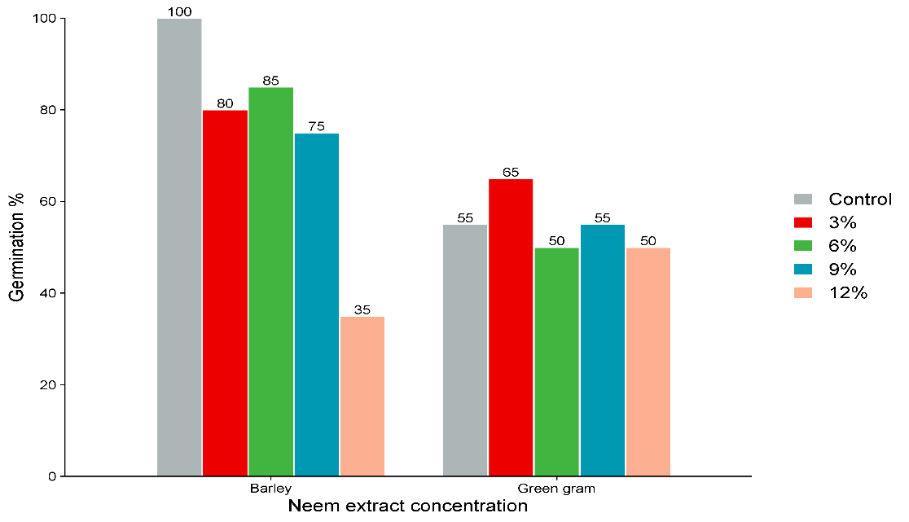
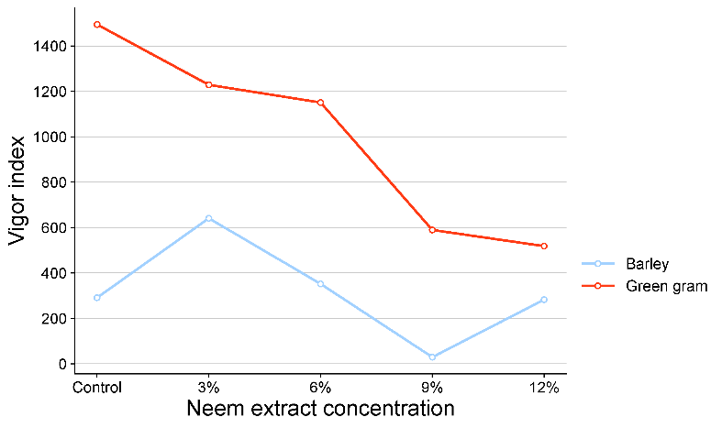
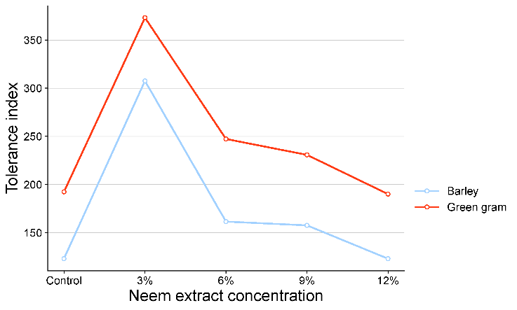
Fig. 4.a Fig. 4.b
Fig. 4.a. Vigor index of both Barley and Green gram in different concentration of neem extract 4.b. Tolerance index of both Barley and Green gram in different concentration of neem extract

Figure 5: Effect of varying concentration of Azadirachta indica on germination and growth of Mung bean (Vigna radiata L.) & Barley (Hordeum vulgare L.)

Effect of varying concentration of Azadirachta indica on germination and growth
 | Mung bean (Vigna radiata L.) | Barley (Hordeum vulgare L.)
Day  1 | 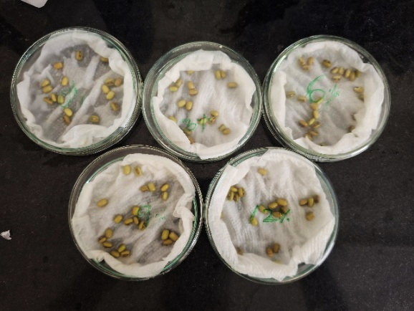 | 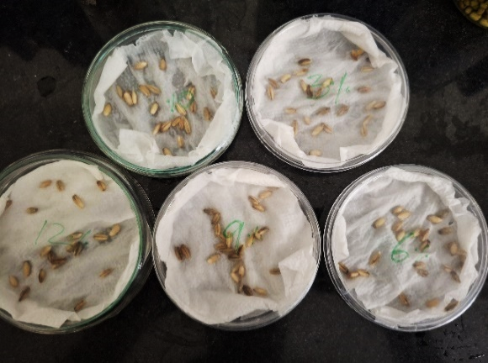
Day  2 | 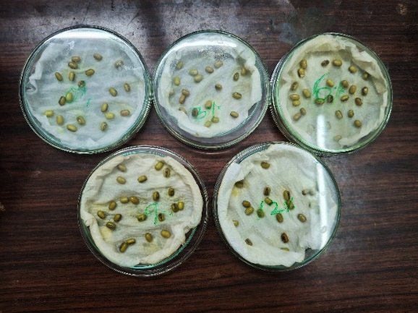 | 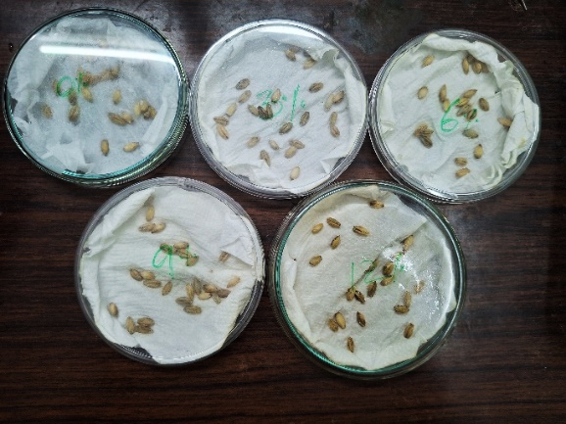
Day  3 | 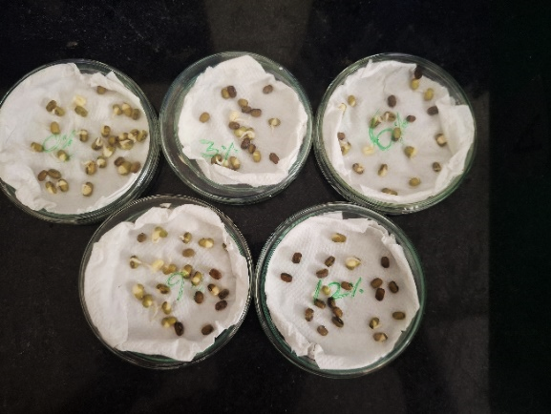 | 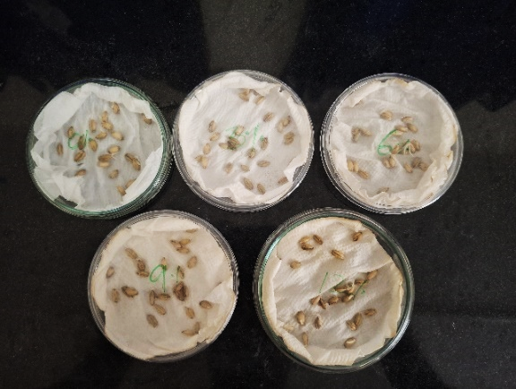
Day  4 | 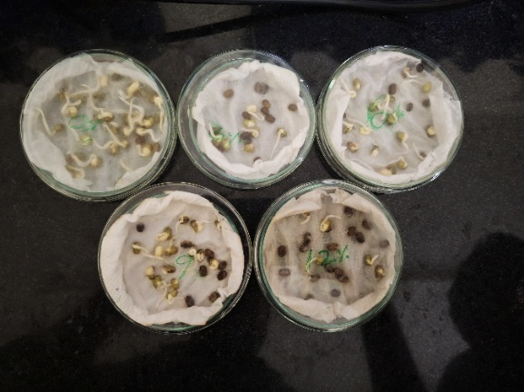 | 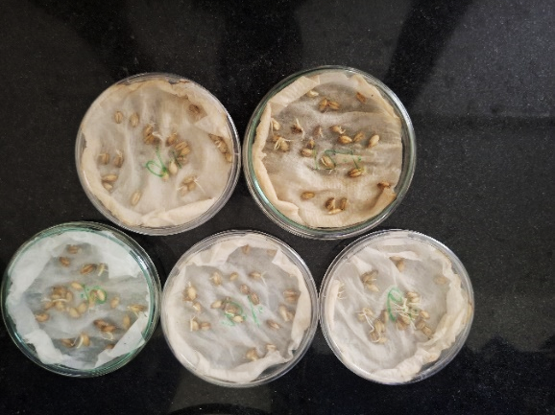
Day  5 | 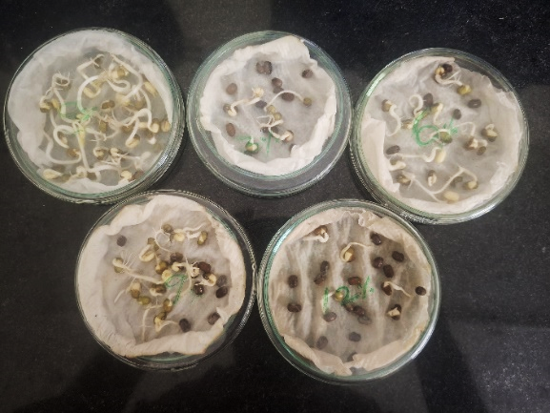 | 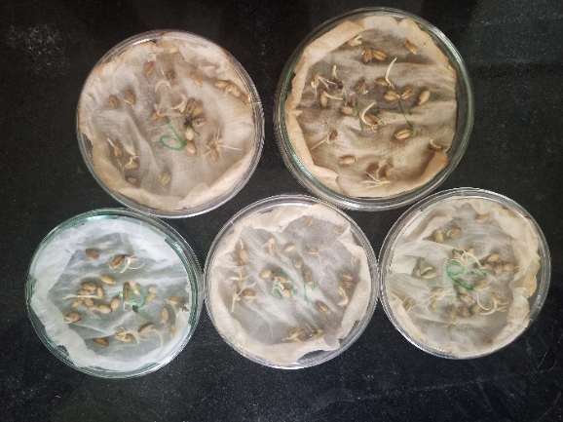
Day  6 | 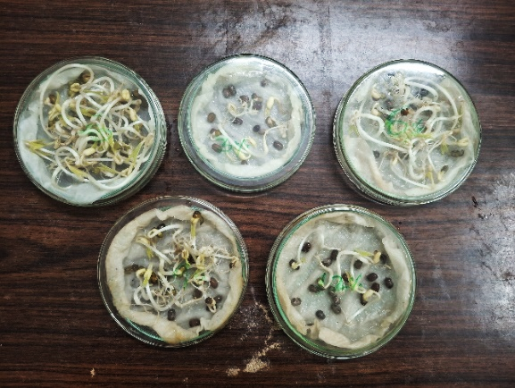 | 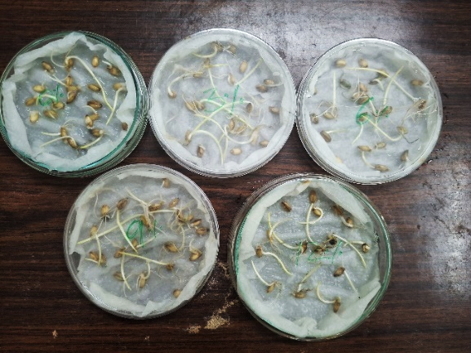
Day  7 | 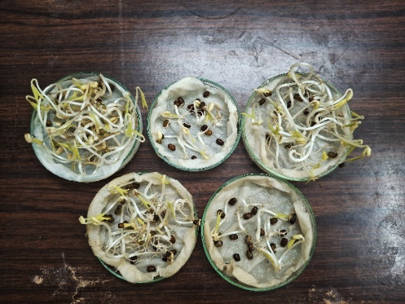 | 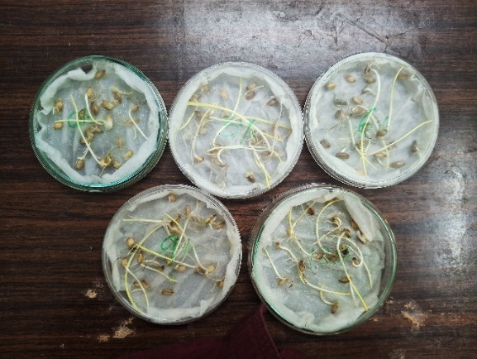
Day  8 | 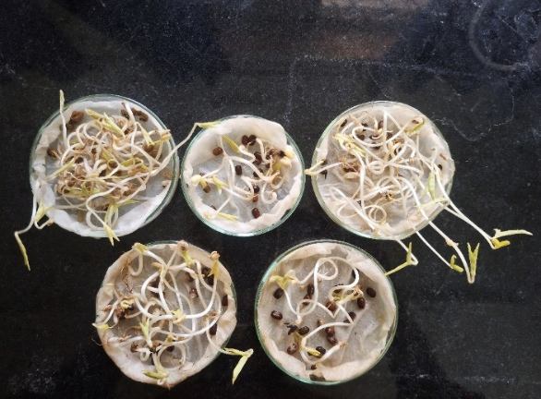 | 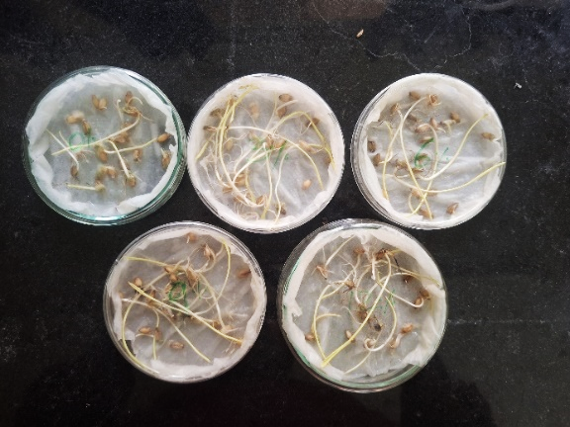
Day 9 | 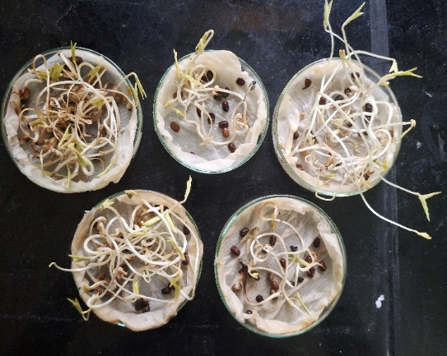 | 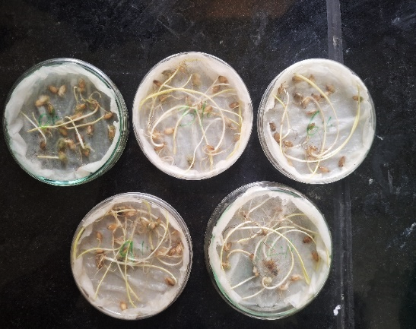
Day  10 | 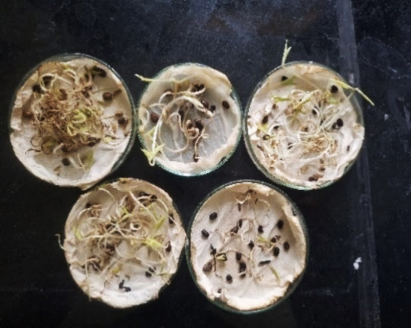 | 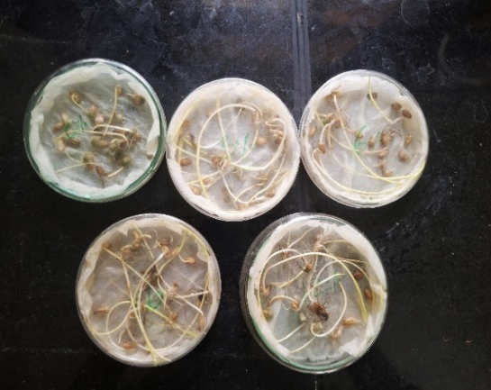

Figure 6: Final growth of Mung bean seedlings after treatment (Day 10)
Mung bean (Vigna radiata L.)
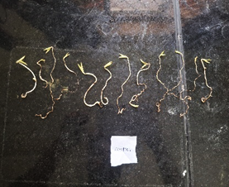  Control | 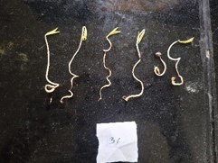  3% | 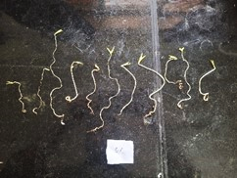  6%
 | 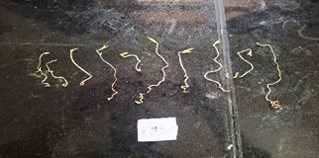  9% | 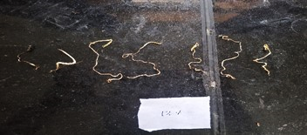  12%
Figure 7: Final growth of Barley seedlings after treatment (Day 10)

Barley (Hordeum vulgare L.)
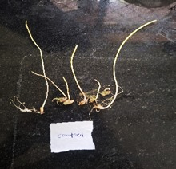  Control | 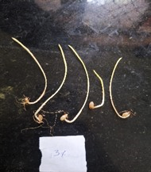  3% | 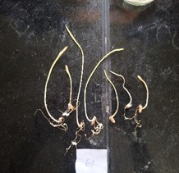  6%
 | 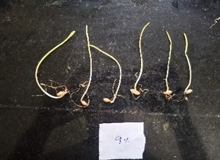  9% | 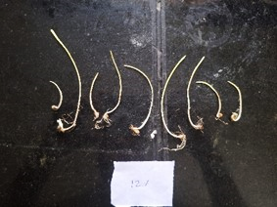  12%

Results
During the 10 days of observation, germination percentage, plumule length, radicle length, seedling vigor index, and tolerance index for both barley (Hordeum vulgare L.) and mung bean (Vigna radiata L.) were positively affected by leaf extract of Azadirachta indica in concentrations of 3, 6, 9, and 12 % (Tables 1–2; Figures 1–7). In mung bean, the highest germination percentage was reached with the 6% concentration treatment in the Extract treated groups and was subsequently closest to the untreated control after 10 days. The 6% treatment was followed by the 9%, 3%, and 12% treatments, respectively (fig.1). For barley, the highest germination rate was for the 3% treatment. There was a progressive and significant decline from 3% to 12%. This shows that mung bean has a greater allelopathic sensitivity than barley at the moderate to high concentration range of the extracts(fig.2). The 12% treatment caused both species to show the least amount of germination. This is strong evidence of high concentration phytotoxicity(fig.3). Plumule and radicle lengths followed a generally decreasing trend with increasing extract concentrations in both species; however, radicle elongation was more severely suppressed than plumule growth across all treatments, consistent with the direct and prolonged exposure of the radicle tip to allelochemical solutions during the bioassay (Fig. 6,7; Table 1). The mean germination percentage, vigour index (VI), and tolerance index (TI) summarized in Table 2 and plotted in Figures 3,4 and 5 respectively for further corroborated these findings. In the bar graph (Fig.3), barley showed highest germination at 6% extract treatment, while mung bean responded best at 3% than control, confirming the species-specific differential response. Line graphs of both vigour index (Fig.4.a) and tolerance index (Fig.4.b) showed a consistent trend of monotonic decline from 3% to 12% concentration in both species. The mung bean showed a steeper rate of decline than barley, indicative of gradually deteriorating seedling establishment capacity with increasing allelopathic stress.

Discussion:
The concentration-dependent allelopathic effects observed in the present study are attributable to the complex phytochemical profile of Azadirachta indica leaf extracts, which are rich in azadirachtin, nimbin, nimbidin, flavonoids, tannins, and phenolic acids (Biswas et al., 2002). The near-control germination performance of mung bean at 6% concentration of extract is in agreement with the hormesis hypothesis that subinhibitory concentrations of allelochemicals could induce compensatory physiological responses (or transiently enhance stress-adaptive pathways), thus maintaining normal germination without phytotoxic damage(Casas et al., 2024); Di Filippo-Herrera et al., 2021). On the other hand, Barley shows higher sensitivity to phenolic allelochemicals and higher permeability of seed coat, which explains its stronger inhibition at higher concentration and its maximum germination at the lowest concentration tested (3%)(Patane et al., 2023; Asghari et al., 2025). The preferential suppression of radicle rather than plumule elongation in both species is well documented in allelopathy bioassays and is mechanistically associated with disruption of polar auxin transport, inhibition of indole-3-acetic acid (IAA) oxidase activity and induction of oxidative stress through the generation of reactive oxygen species (ROS) in actively dividing root meristematic cells(Salman et al., 2017; Torawane et al., 2021). Both vigour index and tolerance index decreased gradually, from 3% to 12%, in both species, showing the tolerance and vigour of seedlings and is being gradually affected even by concentrations that are not enough to completely inhibit germination (Moosavi et al., 2011; Patane et al., 2023). The comparatively greater tolerance of barley may reflect more robust antioxidant enzyme activity and enhanced capacity for vacuolar sequestration of phenolic toxins (Mohagheghian et al., 2025). The results are of practical importance to neem integrated agroforestry systems, as leachate leaves from leaf litter can be similar to those simulated herein and should be taken into account when selecting companion or rotation crops, especially pulse crops like mung bean, near neem stands (Elavazhagan et al., 2015; Cheema & Khaliq, 2000). Moreover, the high inhibition at 9% and 12% concentrations indicate that neem leaf aqueous extract may also be used as an eco-friendly, natural, pre-emergent weed management tool in cereal cropping systems (Ashrafi et al., 2009; Duke et al., 2006).
Conclusion:
Overall, the results suggest that Azadirachta indica naturally releases certain plant chemicals (allelochemicals) that influence plant development. It shows strong allelopathic effects which are concentration dependent on the germination and early plant growth of barley and mung bean and which are clearly species-specific. The vigour index and tolerance index of both the species were found to be decreasing in a monotonous progression with the increase in extract concentration, thereby further supporting the phytotoxic effect of the allelochemicals of neem on seedling establishment. The present findings indicate that the extracts from leaves of A. indica have potential as natural bioherbicidal agents and the study also indicates that excessive mulching of neem leaves or agroforestry system in mung bean field needs to be taken care of. These substances could serve as eco-friendly herbicides or growth regulators. However, further more research is needed to figure out specifically which compounds are responsible, how they work, and what long-term effects they might have on the environment.

References
Ahanger, F.A., Rao, R. J. & Mamta K (2013). Allelopathic effect of Aqueous extracts of Neem (Azadirachta indica) and Eucalyptus citroides on the growth and germination of wheat (Triticum aestivum var. desi) Journal of environmental science. 4(2):169-172
Alzohairy MA. Therapeutics Role of Azadirachta indica (Neem) and Their Active Constituents in Diseases Prevention and Treatment. Evid Based Complement Alternat Med. 2016;2016:7382506. doi: 10.1155/2016/7382506. Epub 2016 Mar 1. PMID: 27034694; PMCID: PMC4791507.
Cheng F and Cheng Z (2015) Research Progress on the use of Plant Allelopathy in Agriculture and the Physiological and Ecological Mechanisms of Allelopathy. Front. Plant Sci. 6:1020. doi: 10.3389/fpls.2015.01020.
Juma, P., Njau, N., Micheni, C. M., Khan, H. A., Mitalo, O. W., & Odongo, D. (2022). Trends in neem (Azadirachta indica)-based botanical pesticides. In New and future development in biopesticide research: biotechnological exploration (pp. 137-156). Singapore: Springer Nature Singapore.
Kaushal, K., Rajani, K., Kumar, R. R., Ranjan, T., Kumar, A., Ahmad, M. F., ... & Kumar, A. (2024). Physio-biochemical responses and crop performance analysis in chickpea upon botanical priming. Scientific Reports, 14(1), 9342.
Megersa, A., & Tadese, B. (2021). Effect of botanicals seed priming on yield and yield components of malt barley (Hordeum vulgare L.).
Mushtaq, W., Siddiqui, M. B., & Hakeem, K. R. (2020). Allelopathy. Springer International Publishing.
Salam, M. A., & Kato-Noguchi, H. (2010). Evaluation of allelopathic potential of neem (Azadirachta indica. A. Juss) against seed germination and seedling growth of different test plant species. Int. J. Sustain. Agric, 2(2), 20-25.
Saxena, R. C., Jilani, G., & Kareem, A. A. (2018). Effects of neem on stored grain insects. In Focus on phytochemical pesticides (pp. 97-112). CRC Press.
Singh, H., Cheema, H. K., & Singh, R. (2020). Field evaluation of horticultural mineral oils and botanicals against bean thrips, Megalurothrips distalis (Karny)(Thysanoptera: Thripidae), in summer mung bean. Egyptian Journal of Biological Pest Control, 30(1), 124.
Ramamoorthy, V., Raguchander, T., & Samiyappan, R. (2002). Induction of defense-related proteins in tomato roots treated with Pseudomonas fluorescens Pf1 and Fusarium oxysporum f. sp. lycopersici. Plant and soil, 239(1), 55-68.
Hakmaoui, A., Ater, M., Boka, K., & Baron, M. (2007). Copper and cadmium tolerance, uptake and effect on chloroplast ultrastructure. Studies on Salix purpurea and Phragmites australis. Zeitschrift für Naturforschung C, 62(5-6), 417-426.

Biswas, K., Chattopadhyay, I., Banerjee, R.K., & Bandyopadhyay, U. (2002). Biological activities and medicinal properties of neem (Azadirachta indica). Current Science, 82(11), 1336–1345.
Casas, V. J. M., Melencion, M. G., Toledo, J. M. S., Lituañas, C. R. M., Pescadero, I. R., & Acma, F. M. (2024). ALLELOPATHIC EFFECT OF Piper aduncum L. LEAF EXTRACT ON THE SEED GERMINATION OF Vigna radiata L. AS MODEL ORGANISM. Kragujevac Journal of Science, 46(2).
Di Filippo-Herrera, D. A., Hernández-Herrera, R. M., Ocampo-Alvarez, H., Sánchez-Hernández, C. V., Muñoz-Ochoa, M., & Hernández-Carmona, G. (2021). Seaweed liquid extracts induce hormetic growth responses in mung bean plants. Journal of Applied Phycology, 33(2), 1263-1272.
Patanè, C., Pellegrino, A., Cosentino, S. L., & Testa, G. (2023). Allelopathic effects of Cannabis sativa L. aqueous leaf extracts on seed germination and seedling growth in durum wheat and barley. Agronomy, 13(2), 454.
Asghari, J., & Tewari, J. P. (2025). Allelopathic potentials of eight barley cultivars on Brassica jucea (L) Czern. and Setaria viridis (L) p. Beauv. Journal of Agricultural Science and Technology, 9(2), 165-176.
Salman, M., Salameh, N., & Abu-Romman, S. (2017). Germination and seedling growth of barley as affected by'Artemisia annua'water extract. Plant Omics, 10(1), 1-6.
Torawane, S. D., & Mokat, D. N. (2021). Allelopathic potential of weed Neanotis lancifolia (Hook. f.) WH Lewis on seed germination and metabolism of mungbean and rice. Allelopathy Journal, 52(2), 277-290.
Moosavi, A., AFSHARI, R. T., Asadi, A., & Gharineh, M. H. (2011). Allelopathic effects of aqueous extract of leaf stem and root of sorghum bicolor on seed germination and seedling growth of Vigna radiata L. Notulae Scientia Biologicae, 3(2), 114-118.
Mohagheghian, B., Saeidi, G., & Arzani, A. (2025). Phenolic compounds, antioxidant enzymes, and oxidative stress in barley (Hordeum vulgare L.) genotypes under field drought-stress conditions. BMC Plant Biology, 25(1), 709.
Elavazhagan, P. (2015). ALLELOPATHIC POTENTIAL OF EXTRACTS AND LEACHATES OF AZADIRACHTA INDICA A. JUSS LEAVES ON GERMINATION AND GROWTH OF ELEUSINE CORACANA (L.) GAERTNER. Kongunadu Research Journal, 2(2), 129-132.
Cheema, Z. A., & Khaliq, A. (2000). Use of sorghum allelopathic properties to control weeds in irrigated wheat in a semi arid region of Punjab. Agriculture, ecosystems & environment, 79(2-3), 105-112.
Ashrafi, Z. Y., Sadeghi, S., Alizade, H. M., Mashhadi, H. R., & Mohamadi, E. R. (2009). Study of bioassay the allelopathical effect of Neem (Azadirachta indica) n-hexane, acetone and water-soluble extracts on six weeds. International Journal of Biology, 1(1), 71.
Duke, S. O., Dayan, F. E., Rimando, A. M., Schrader, K. K., Aliotta, G., Oliva, A., & Romagni, J. G. (2002). Chemicals from nature for weed management. Weed science, 50(2), 138-151.

